Project 906 |  |  | OMB No. 0535-0218 Approval Expires 5/31/2023
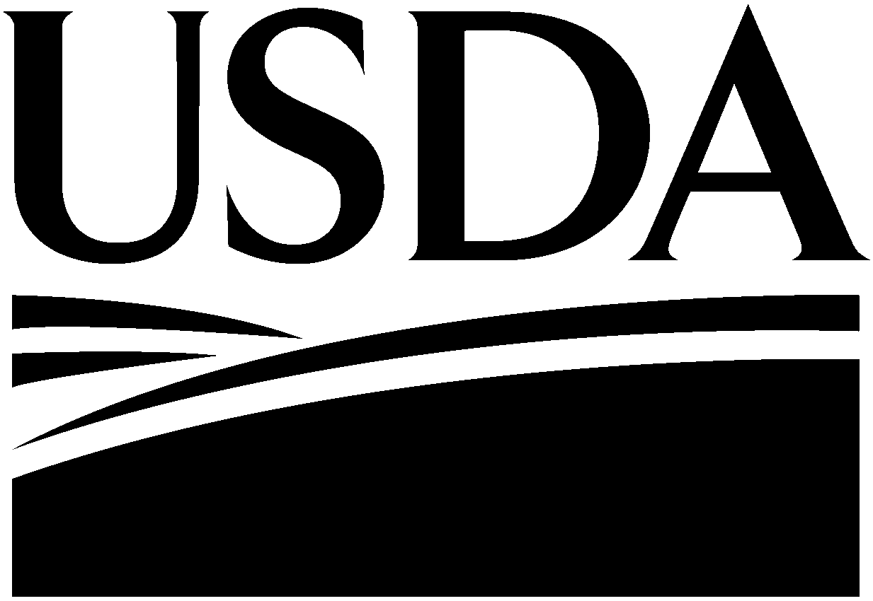 | 2020 Agricultural Resource Management Survey – (ARMS) Phase 2  Consent Form |  |  |  |  | NATIONAL  AGRICULTURAL  STATISTICS  SERVICE
Soybean Production Practices Report |  |  |  | U.S Department of Agriculture  Room 5030, South Building  1400 Independence Ave., S.W.  Washington, DC 20250-2000  Phone: 1-800-727-9540  Fax: 1-202-690-2090  Email: nass@nass.usda.gov

 | STATE  ___ ___ | POID  ____ ____ ____ ____ ____ ____ ____ ____ ____

The National Agricultural Statistics Service (NASS) of the U.S. Department of Agriculture is conducting a survey of the Agricultural Resource Management Survey (ARMS) for the 2020 crop year. The survey will be conducted from October 2020 through December 2020.

By providing verbal consent, the Owner agrees to allow the caretaking company listed below to provide the necessary information for the completion of the ARMS for the selected operation to the National Agricultural Statistics Service. In accordance with the Confidential Information Protection provisions of Title V, Subtitle A, Public Law 107-347 and other applicable Federal laws, your responses will be kept confidential and will not be disclosed in identifiable form to anyone other than employees or agents. By law, every employee and agent has taken an oath and is subject to a jail term, a fine, or both is he or she willfully discloses ANY identifiable information about you or your operation. Response is voluntary. Results of the survey, showing State and National level results for the selected commodities will be available at the end of July 2021. According to the Paperwork Reduction Act of 1995, an agency may not conduct or sponsor, and a person is not required to respond to, a collection of information unless it displays a valid OMB control number. The valid OMB control number for this information collection is 0535-0218. The time required to complete this information collection is estimated to average 50 minutes for Soybeans questionnaires responses. This includes the time for reviewing instructions, searching existing data sources, gathering and maintaining the data needed, and completing and reviewing the collection of information.
 | Operation Name: | ____________________________________________________________
 | Owner Name: | ____________________________________________________________
 | Owner Address: | ____________________________________________________________
 |  | ____________________________________________________________
 | Owner Signature: | ____________________________________________________________
 | Date: | ________________
 | Operator/Owner provided consent over the telephone.
 | Caretaking  Company Name: | ____________________________________________________________
 | Caretaking  Company Address: | ____________________________________________________________
 |  | ____________________________________________________________
 | Phone Number: | ______________________________

NASDA Field Enumerator: __________________________________________

