Attachment J Gold Evaluation Worksheet

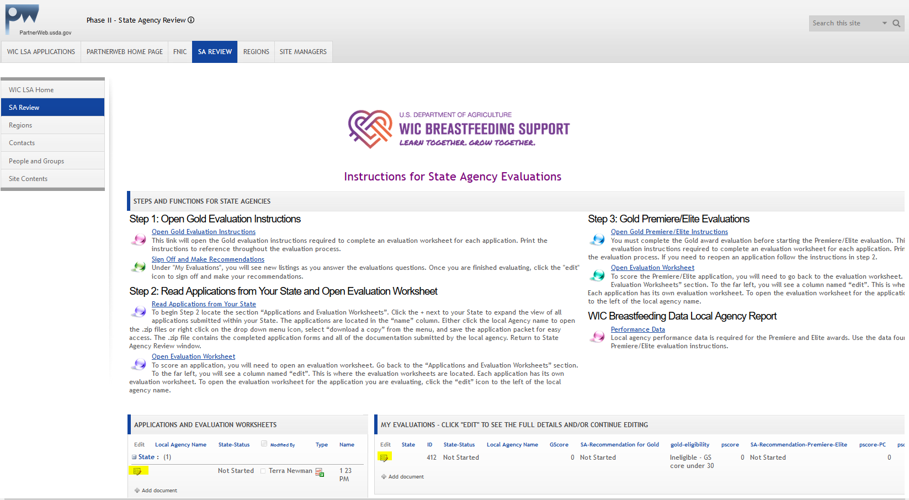

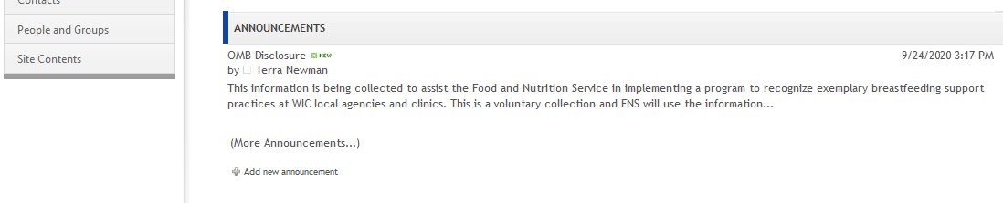



In accordance to Section 231 of the Healthy, Hunger-Free Kids Act of 2010 (HHFKA) (Public Law 111–296), this information is being collected to assist the Food and Nutrition Service in implementing a program to recognize exemplary breastfeeding support practices at WIC local agencies and clinics. This is a voluntary collection, but failure to provide the requested information in full will prevent applicants from being considered for recognition. FNS will use the information to improve the delivery and tailoring of WIC services and increase satisfaction of both staff and participants. This collection requests only minimal personally identifiable information (email address) which will not be used routinely to retrieve records under the Privacy Act of 1974. According to the Paperwork Reduction Act of 1995, an agency may not conduct or sponsor, and a person is not required to respond to, a collection of information unless it displays a valid OMB control number. The valid OMB control number for this information collection is 0584-0591. The time required to complete this information collection is estimated to average 1.2 hours per response, including the time for reviewing instructions, searching existing data sources, gathering and maintaining the data needed, and completing and reviewing the collection of information. Send comments regarding this burden estimate or any other aspect of this collection of information, including suggestions for reducing this burden, to: U.S. Department of Agriculture, Food and Nutrition Service, Office of Policy Support, 1320 Braddock Place, 5th floor, Alexandria, VA 22314 ATTN: PRA (0584-0591). Do not return the completed form to this address.

