Request for Non-Substantive Change to the
2020 Census Participant Statistical Areas Program (PSAP)
OMB Control No. 0607-1003
U.S. Department of Commerce
U.S. Census Bureau
Purpose
The U.S. Census Bureau offers a once-per-decade opportunity for regional planning agencies (RPAs), councils of governments (COGs), tribal, state, county, and local governments (including the District of Columbia and Puerto Rico) to review and update selected statistical areas planned for the 2020 Census data tabulation. Attached for approval are eight verification phase related materials for the 2020 Census Participant Statistical Areas Program (PSAP).
Table 1 lists these eight newly added and revised materials. Table 2, included after the eight materials, lists the four previous non-substantive change requests.
Background
The current PSAP OMB collection was approved on 02/05/2018 for three years with an expiration date of 02/28/2021. This non-substantive change is a request to submit revised copies of the three PSAP verification phase closeout communications (e.g., two emails and one letter) from the currently approved collection and to provide copies of the five newly added email communications provided to participants between January 2020 and April 2020.
There is no substantive change to the program resulting from this submission. The revisions of existing materials and introduction of new communication does not change the content or objective of the program. The revisions to existing material were necessary to reflect the most current program information (e.g., removal of phone number) and the additional communications were necessary to quickly inform participants of important developments.
Burden
The burden of the 2020 Census PSAP is unchanged by this update.
Table 1: Newly Added and Revised Materials for Approval
Material | Description of material | Action for this NSC
Email (January 16, 2020): Subject: **Alert** Stop using GUPS for PSAP verification  . | Census Bureau informed participants using the Geographic Update Partnership Software (GUPS) to stop using the software because of an issue with the version (e.g., v11.1.0-3). | Add new document (new email communication).
Email (January 17, 2020): Subject: **UPDATE** New GUPS released for PSAP verification – Ready for Download and Installation | Census Bureau informed participants of the resolution of the GUPS issue and instructed participants to download and install the new GUPS version (v11.1.0-5). | Add new document (new email communication).
Email (February 11, 2020): Subject: **IMPORTANT – ACTION REQUESTED** Additional CDPs added for PSAP verification | Census Bureau informed a small number of affected participants (e.g., 131 individuals in 88 participating agencies) of the delineation of additional census designated places (CDPs) after the creation of the verification materials, and the need for the affected participants to review these CDPs while completing their verification review. | Add new document (new email communication)
Email (February 26, 2020): Subject: GUPS Guidance for the PSAP Criteria Review Tool | Census Bureau informed participants of action to take while executing the PSAP Criteria Review Tool, specifically to add “NA” to criteria failure “Warnings” not caused by their verification work. | Add new document (new email communication).
Email (April 8, 2020): Subject: **IMPORTANT – PSAP Verification Phase Deadline Extended** | Because of the COVID-19 pandemic, the Census Bureau informed participants who had not yet made a verification phase submission, or who had not indicated they had no changes to report, that they would accept PSAP verification submissions or email responses regarding PSAP verification through May 15, 2020. | Add new document (new email communication).
E-1250 | Email to PSAP Primary Official contacts to closeout verification phase. | Revise previously submitted document from November 2019 NSC by removing a phone number that is no longer in service.
E-1250-PR | Email to Puerto Rico PSAP Primary Official contacts to closeout verification phase. | Revise previously submitted document from November 2019 NSC by removing a phone number that is no longer in service.
L-1250 | Letter to PSAP Primary Official contacts to closeout verification phase. | Revise previously submitted document from November 2019 NSC by removing a phone number that is no longer in service. Note we did not revise the L-1250-PR because we had no participants in Puerto Rico that could not receive the E-1250-PR.

Attachment 1 of 8
January 16, 2020
Subject: **Alert** Stop using GUPS for PSAP verification
Dear PSAP Participants:
Yesterday, the U.S. Census Bureau distributed an email invitation to participate in the 2020 Census Participant Statistical Areas Program (PSAP) Verification Phase. Since that time, an issue was discovered in the version (e.g., v11.1.0-3) of the Geographic Update Partnership Software (GUPS) used to make and submit 2020 statistical area corrections.
If you have already downloaded and installed this new version of GUPS, please stop using the software immediately. If you have not downloaded the new version, please wait. As soon as we have a resolution to the issue, another email with instructions to proceed will be distributed. Please continue to review the 2020 statistical areas using TIGERweb and the Online PDF maps, as this issue does not affect those products.
We apologize for the inconvenience this issue causes. Thank you for patience in waiting for a resolution and ultimately for your participation in the PSAP. If you have questions regarding this communication, please email us at <geo.psap@census.gov> or call us at 1-844-788-4921.

Participant Statistical Areas Program (PSAP)
U.S. Census Bureau
Toll-Free: (844) 788-4921
Email: <GEO.PSAP@census.gov>
PSAP website

Attachment 2 of 8
January 17, 2020
Subject: **UPDATE** New GUPS released for PSAP verification – Ready for Download and Installation
Dear PSAP Participants:

With this email update, the U.S. Census Bureau announces that we have corrected the Geographic Update Partnership Software (GUPS) issue that was the subject of the alert message sent Thursday, January 16 (see below). A new version has been released for use in the verification phase of the 2020 Census Participant Statistical Areas Program (PSAP). If your review of the 2020 statistical areas concludes corrections are necessary, or if you previously downloaded and installed the earlier version of GUPS for PSAP verification, please proceed with downloading and installing the new version (v11.1.0-5) of GUPS from the PSAP website
<https://www.census.gov/programs-surveys/decennial-census/about/psap.html>.
IMPORTANT: In order to perform and submit corrections to the 2020 statistical areas, participants must use this updated version of the GUPS.
Thank you for patience while waiting for this resolution and ultimately for your participation in the PSAP. If you have questions regarding this communication, please email us at <geo.psap@census.gov> or call us at 1-844-788-4921.
Participant Statistical Areas Program (PSAP)
U.S. Census Bureau
Toll-Free: (844)788-4921
Email: GEO.PSAP@census.gov
PSAP Home Page
_____________________________________________________________________________
January 16, 2020
Subject: **Alert** Stop using GUPS for PSAP verification
Dear PSAP Participants:
Yesterday, the U.S. Census Bureau distributed an email invitation to participate in the 2020 Census Participant Statistical Areas Program (PSAP) Verification Phase. Since that time, an issue was discovered in the version (e.g., v11.1.0-3) of the Geographic Update Partnership Software (GUPS) used to make and submit 2020 statistical area corrections.
If you have already downloaded and installed this new version of GUPS, please stop using the software immediately. If you have not downloaded the new version, please wait. As soon as we have a resolution to the issue, another email with instructions to proceed will be distributed. Please continue to review the 2020 statistical areas using TIGERweb and the Online PDF maps, as this issue does not affect those products.
We apologize for the inconvenience this issue causes. Thank you for patience in waiting for a resolution and ultimately for your participation in the PSAP. If you have questions regarding this communication, please email us at <geo.psap@census.gov> or call us at 1-844-788-4921.
Participant Statistical Areas Program (PSAP)
U.S. Census Bureau
Toll-Free: (844)788-4921
Email: GEO.PSAP@census.gov
PSAP Home Page

Attachment 3 of 8
February 11, 2020
Subject: **IMPORTANT – ACTION REQUESTED** Additional CDPs added for PSAP verification
Dear PSAP Participant:
The U.S. Census Bureau delineated additional census designated places (CDPs) after the creation of the materials used for the 2020 Census Participant Statistical Areas Program (PSAP) Verification Phase. One or more additional CDPs were delineated in the county or counties for which you are listed as either the PSAP primary official or technical participant.
We request that you review these additional CDPs as part of your ongoing PSAP verification work; however, they do not appear within resources provided for PSAP Verification, including TIGERweb, the Online PDF maps, or the files used within the Geographic Update Partnership Software (GUPS). As a result, we request you to take the following action:
- Review the attached Adobe Acrobat® Portable Document Format (PDF) file to locate the additional CDPs created within your county or counties.
  - The file is sorted by STCOU_CODE and then by CDP_CODE which alphabetically groups the additional CDPs by state and county for ease of locating your county or counties.
- Navigate to the following location <https://www2.census.gov/geo/maps/DC2020/PSAPV/CDP/> to locate CDP-specific PDF maps that exist within your county or counties.
  - The maps are stored within a state level subfolder (e.g., st05_ar for the state of Arkansas).
  - The map names are PSAPV20CDP<STATEFP><PLACEFP>_<CDP_NAME>.pdf, where STATEFP is the two-digit state Federal Information Processing Series (FIPS) code in which the CDP exists and the PLACEFP is the five digit place FIPS code of the CDP (e.g., PSAPV20CDP0519720_Drasco.pdf).
- Review the boundary and name of the additional CDP(s) within your county or counties to confirm they accurately reflect the community they seek to define.
  - To assist with your review, use the CDP Quick Reference Guide (G-615) for a summary of CDP requirements located on the PSAP website
<https://www.census.gov/programs-surveys/decennial-census/about/psap.html>.
- Notify us by email at <GEO.PSAP@census.gov> if you believe corrections are necessary to these additional CDPs . If we do not hear from you before the 90-day PSAP verification timeframe expires, we assume you approve of these additional CDPs.
  - NOTE: Since these CDPs do not appear in the files used within the GUPS, the Census Bureau must make the corrections for you.
Thank you for your participation in the PSAP. Refer to the contact information in the signature of this email for questions regarding this communication.
Participant Statistical Areas Program (PSAP)
U.S. Census Bureau
Toll-Free: (844) 788-4921
Email: <GEO.PSAP@census.gov>
PSAP website

Attachment 4 of 8
February 26, 2020
Subject: GUPS Guidance for the PSAP Criteria Review Tool
Dear PSAP Participant:
Thank you for notifying us that you intend to submit changes to your statistical areas during the verification phase.
We want to inform you of a situation that you may encounter when preparing your verification submission using the Geographic Update Partnership Software (GUPS). You may have criteria failure “Warnings” that are not a result of your verification work and if so, you may provide the generic justification “NA” to quickly and uniformly justify those failures.
For some background, GUPS performs quality checks on the whole county or whole tribal area, not just on your edits, to ensure the housing and population counts satisfy pre-established criteria requirements for each statistical area type. GUPS executes these checks within the PSAP Criteria Review Tool prior to exporting a completed project for submission to the Census Bureau. All criteria failures must be resolved either by applying a justification or by modifying the failing statistical area(s) within the PSAP Criteria Review Tool. See below for a visual of the PSAP Criteria Review Tool window with the NA justification applied and with the preset justification choices displayed.
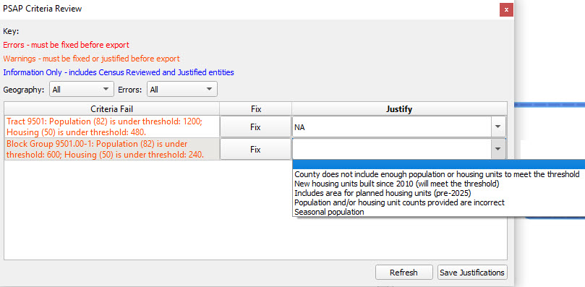
Thank you for your participation in PSAP. If you have questions regarding this communication, please email us at <geo.psap@census.gov> or call us at 1-844-788-4921.
Participant Statistical Areas Program (PSAP)
U.S. Census Bureau
Toll-Free: (844) 788-4921
Email: <GEO.PSAP@census.gov>
PSAP website
Attachment 5 of 8
April 8, 2020
Subject: **IMPORTANT – PSAP Verification Phase Deadline Extended**
Dear PSAP Participant:
Given the effect of COVID 19 on our nation, we hope this message finds you coping as well as you can during these uncertain times.
The U.S. Census Bureau has not yet received the PSAP verification phase submission for your county(s) or tribal area(s) or an email indicating that you have no corrections to submit. If you need additional time to complete the evaluation of your statistical areas and submit updates or to report no corrections are necessary, the Census Bureau will accept submissions and email responses through May 15, 2020.
Though a deadline extension is in place, please complete your verification work and make your submission or notify us that you do not intend to make a submission as soon as possible. Submitting in advance of May 15, 2020, allows us more time to review and resolve any questions that arise as we evaluate and process your submission.
We will attempt to process submissions received after the deadline, but cannot guarantee we can complete the corrections you request unless you meet the new deadline. We will process submissions received after May 15, 2020, in the order of receipt.
Thank you for your participation in the PSAP. Refer to the contact information in the signature of this email for questions regarding this communication.
Participant Statistical Areas Program (PSAP)
U.S. Census Bureau
Toll-Free: (844) 788-4921
Email: <GEO.PSAP@census.gov>
PSAP website

Attachment 6 of 8
E-1250
Subject: 2020 Census Participant Statistical Areas Program – Verification Phase Close-out

<MONTH DATE, YEAR>
Entity ID: <ENTITY_ID>
<FIRST NAME, LAST NAME>
<POSITION>
<DEPARTMENT>
<ADDRESS>
<CITY, STATEABBR ZIP>

FROM THE ASSOCIATE DIRECTOR FOR DECENNIAL CENSUS PROGRAMS

Dear PSAP Participant:

The U.S. Census Bureau has finalized the 2020 Census Participant Statistical Areas Program (PSAP) statistical geographic areas, incorporating updates submitted during the verification phase, where appropriate. The 2020 Census PSAP is now complete. Thank you for your participation.

The information provided during 2020 Census PSAP ensures the accuracy and completeness of statistical areas used to tabulate data for the 2020 Census, the American Community Survey (ACS), the Economic Census, and potentially other census surveys. For questions or additional information, contact the Census Bureau PSAP team by email at <geo.psap@census.gov> or visit the PSAP website at <https://www.census.gov/programs-surveys/decennial-census/about/psap.html>.

Attachment 7 of 8
E-1250-PR
Asunto: Programa de Áreas Estadísticas Participantes del Censo del 2020 – Cierre de la Fase de Verificación

<MONTH DATE, YEAR>
Identificación de la Entidad: <ENTITY_ID>
<FIRST NAME, LAST NAME>
<POSITION>
<DEPARTMENT>
<ADDRESS>
<CITY, STATEABBR ZIP>

DEL DIRECTOR ASOCIADO PARA PROGRAMAS DEL CENSO DECENAL

Estimado participante del Programa PSAP:

La Oficina del Censo de los EE. UU. ha finalizado el Programa de Áreas Estadísticas Participantes (PSAP) del Censo del 2020 para áreas geográficas estadísticas, incorporando actualizaciones enviadas durante la fase de verificación donde fuera necesario. El PSAP del Censo del 2020 ahora está completo. Gracias por su participación.

La información proporcionada durante el PSAP del Censo del 2020 asegura que las áreas estadísticas usadas para tabular los datos del Censo del 2020, la Encuesta sobre la Comunidad de Puerto Rico (PRCS), el Censo Económico y potencialmente otras encuestas censales sean precisas y estén completas. Para preguntas o información adicional, comuníquese con el equipo del PSAP de la Oficina del Censo por correo electrónico a <geo.psap@census.gov> o visite el sitio web del PSAP en <https://www.census.gov/programs-surveys/decennial-census/about/psap.html>.

Attachment 8 of 8

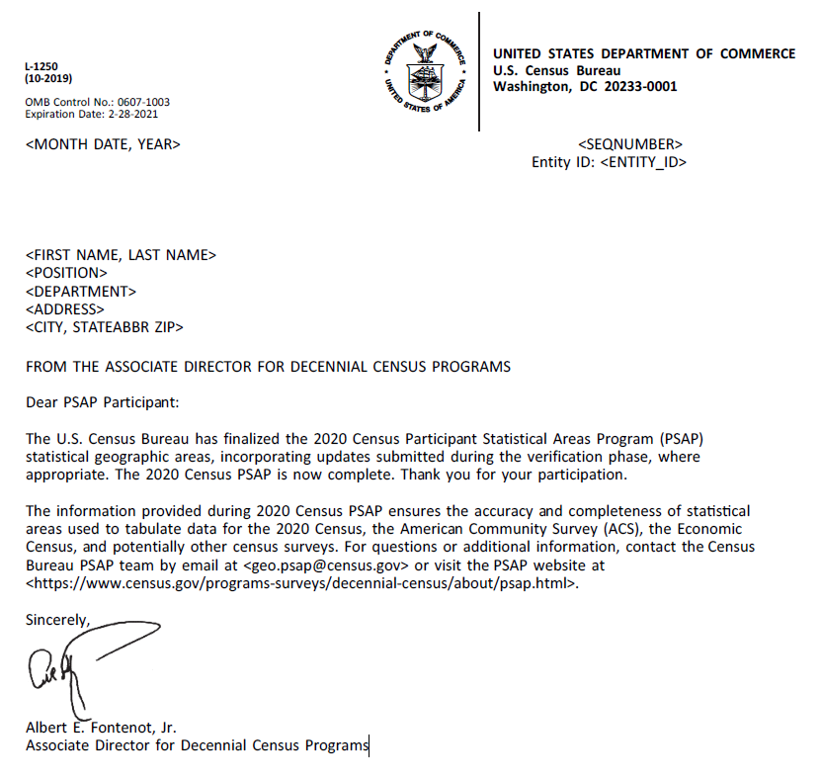

Table 2: Previously Submitted NSCs
Title | Document | Document Type | Date Uploaded
NSC for FRN reference on letters | PSAP_NSC_04112018.docx | Justification for No Material/Nonsubstantive Change | 05/04/2018
NSC2_PSAP_July2018_revised letters and info guide | NSC2_PSAP_revisedletters_July2018.pdf | Justification for No Material/Nonsubstantive Change | 06/22/2018
NSC PSAP Delineation Materials | PSAP NSC Delineation Materials 112818.pdf | Justification for No Material/Nonsubstantive Change | 11/28/2018
PSAP Verification Phase NSC | PSAP Verification Phase NSC Nov 2019_V2.pdf | Justification for No Material/Nonsubstantive Change | 01/06/2020

