[Note: bracketed text will not be visible to participants]

[Appendix L: Online Survey Formats]

[Figure F-1. Durham Cigarettes]
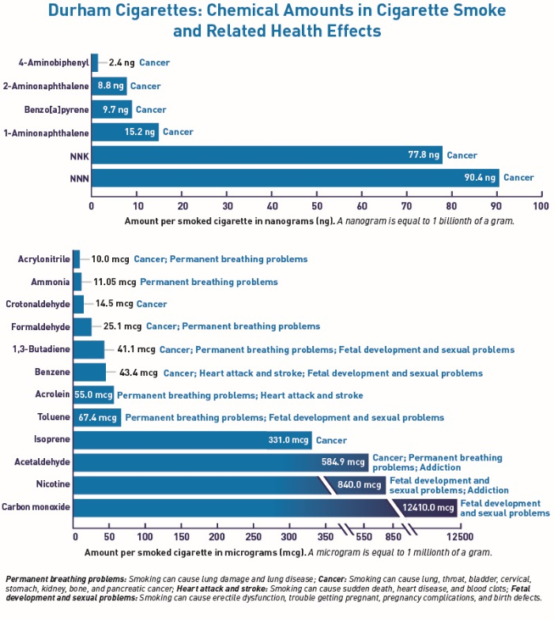

[Figure F-2. Chemicals in Smoke]
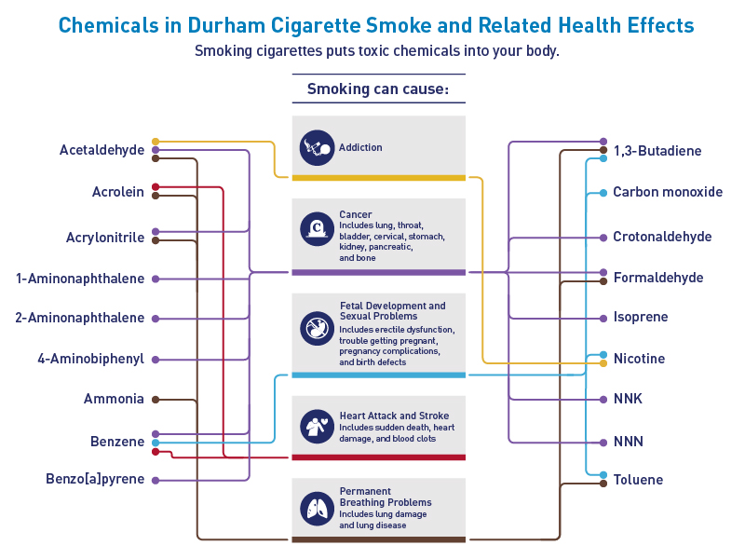

[Figure F-3. Durham Cigarettes]
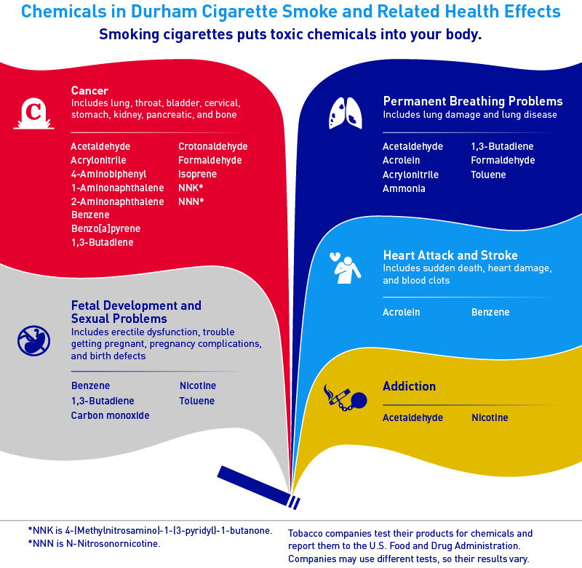
[Figure F-4. Durham Cigarettes]
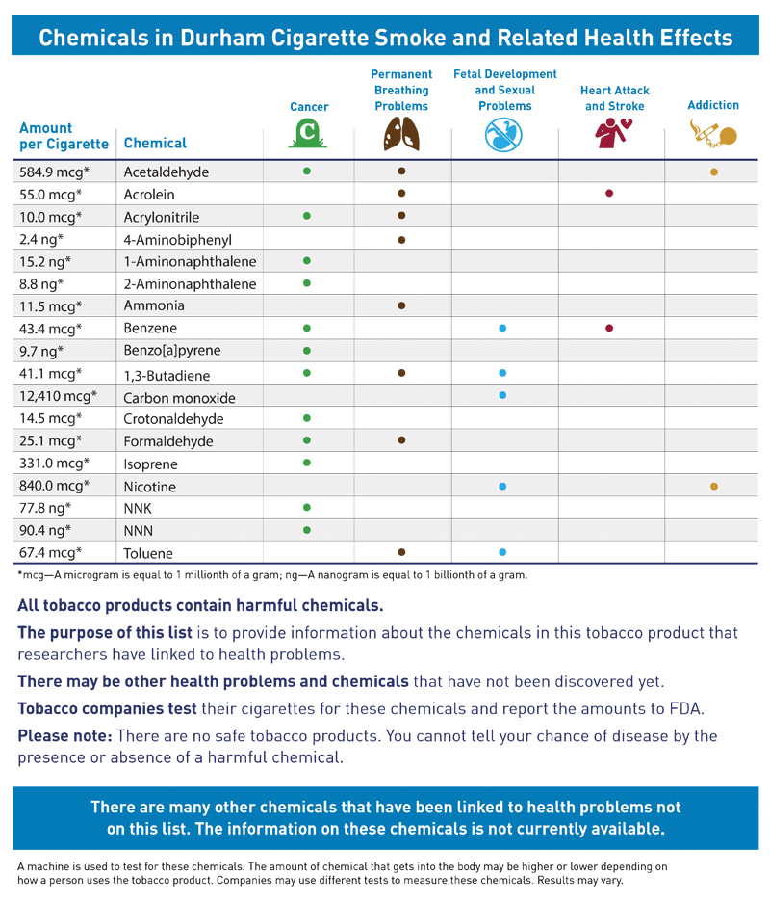
[Figure F-5. Chemical Compounds Found in Cigarette Smoke]
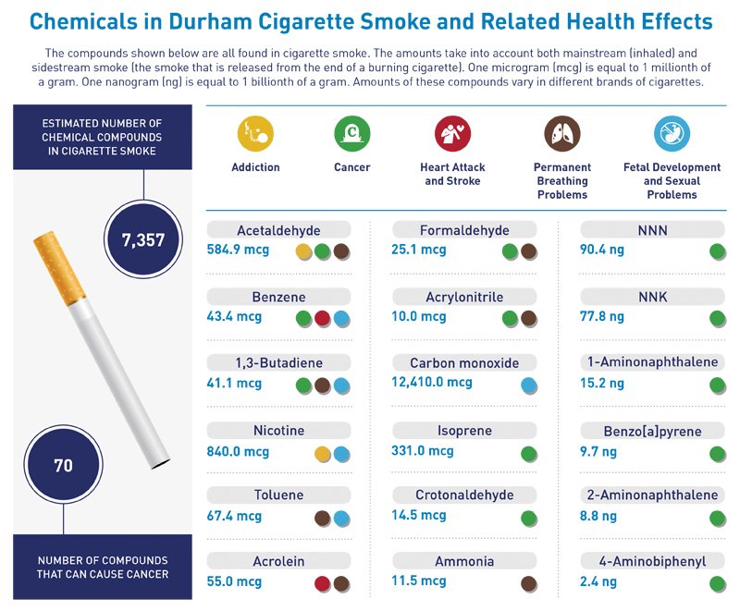

[Figure F-6. Wildcard]
