DEPARTMENT OF HEALTH & HUMAN SERVICES Public Health Service
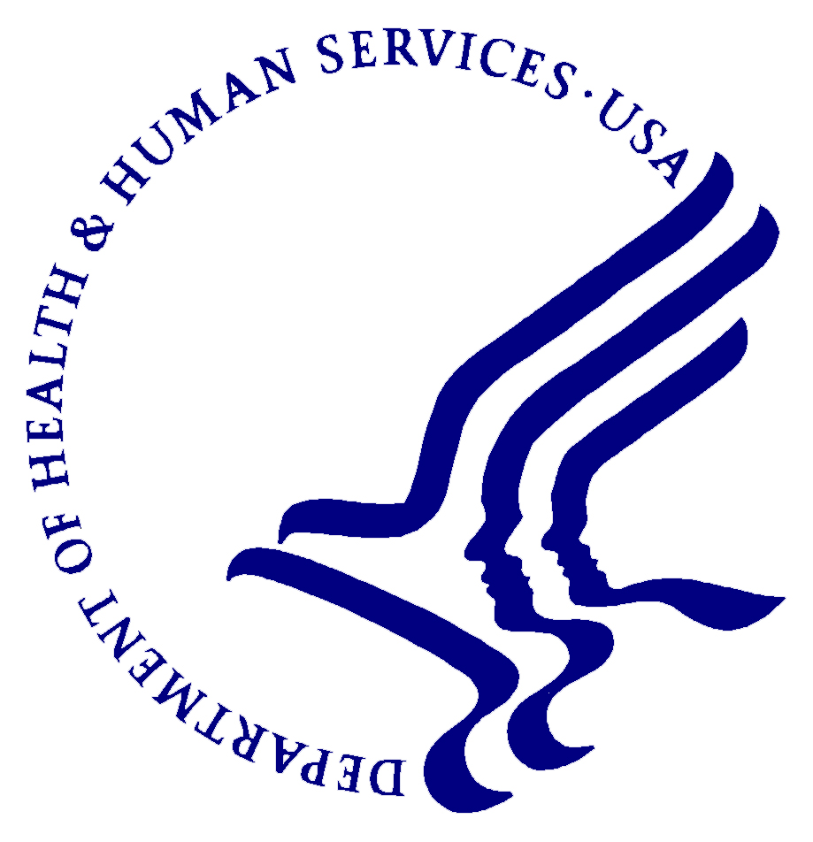

________________________________________________________________________________________________
Centers for Disease Control
and Prevention (CDC)
National Institute for Occupational
Safety and Health (NIOSH)
1095 Willowdale Road
Morgantown, WV 26505-2888

Month XX, 20XX

Dear ______________,

We are writing to invite you to participate in a research study being conducted by the National Institute for Occupational Safety and Health (NIOSH) to understand the long-term respiratory health effects among former styrene-exposed workers. NIOSH is a public health agency within the Centers for Disease Control and Prevention (CDC). NIOSH is responsible for conducting research and making recommendations for the prevention of work-related illnesses and injuries. NIOSH is not part of the Occupational Safety and Health Administration (OSHA) and does not enforce workplace health and safety laws.

In the past, NIOSH investigators have conducted mortality studies for a cohort of 5,204 workers exposed to styrene at two reinforced plastic boatbuilding plants in Kelso and Bellingham, Washington during 1959–1978. Workers with high styrene exposures had two times higher death rates from chronic obstructive pulmonary disease (COPD) compared with the general population. Additionally, NIOSH published a paper in 2017 that identified multiple cases of respiratory disease among styrene-exposed workers. Now, NIOSH is conducting a research study to understand the long-term respiratory health effects in styrene-exposed workers. NIOSH will be conducting medical testing for members of the NIOSH boatbuilder cohort and former employees of Uniflite and Tollycraft companies. Because you worked for one of these companies and are part of the NIOSH boatbuilder cohort, we are inviting you to take part in this research study involving medical testing for lung disease. Your participation is completely voluntary.

The medical survey is FREE and will be offered on Month XX, 2020 or Month XX, 20XX. The medical survey will include a private interview about your health and work history, breathing tests, color vision test, and a blood sample. You can choose to participate in some or all of the study procedures offered. You may drop out of the study at any time, for any reason without consequences to you. The private interview and breathing tests will take place at the location. We expect the medical survey to take approximately 2.5 to 3 hours. We have enclosed an informational handout that describes the study. If you decide to take part in the study, we will compensate you for your time and effort with a $50 GIFT CARD to a local merchant. It is important that you know that your medical test results will only be available to you, and if you wish, your personal physician.

If you would like to schedule an appointment for the medical survey, please contact us at 1-800-232-2114. If you have any questions about this research study, you can either contact us at 1-800-232-2114 or email Dr. Tomasi at yxc4@cdc.gov.

Sincerely,

Suzanne Tomasi, DVM, MPH, DACVPM
Project Officer
yxc4@cdc.gov

