**Permit to Import Biological Agents or Vectors of Human Disease**

The new database, “Electronic Import Permit Program portal (eIPP)” will capture all information from the Permit to Import Biological Agents or Vectors of Human Disease as noted below in the screenshots.

For Section A,

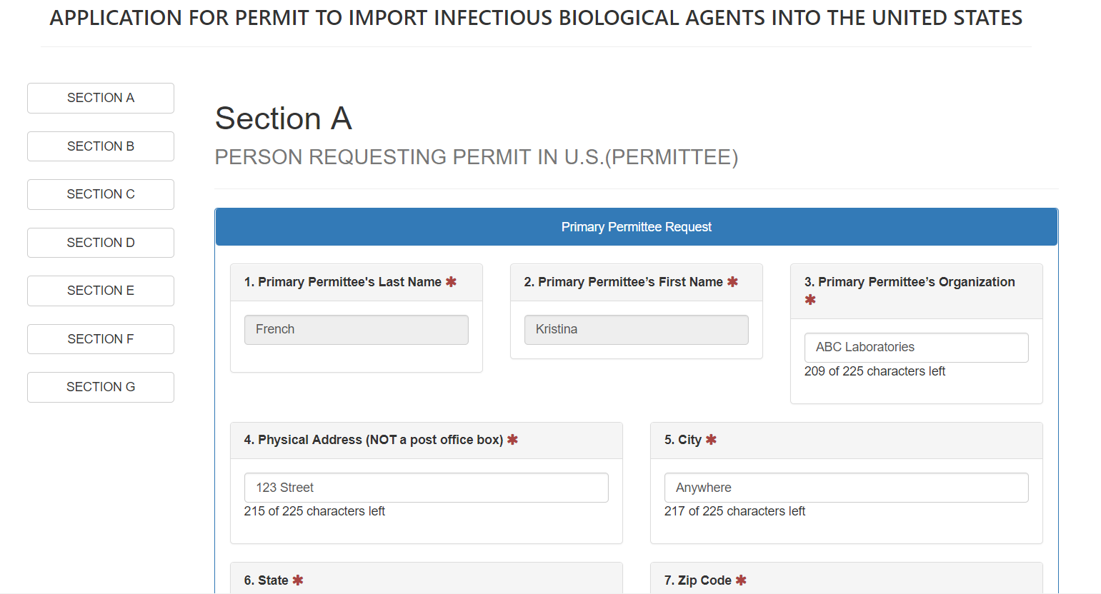

For Section B,

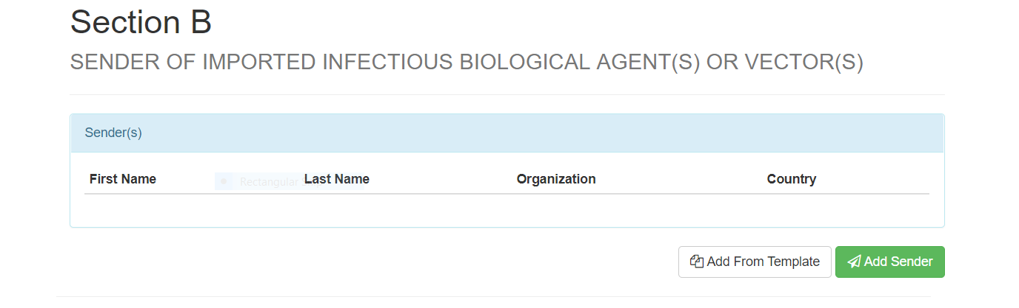

For Sections C &D,

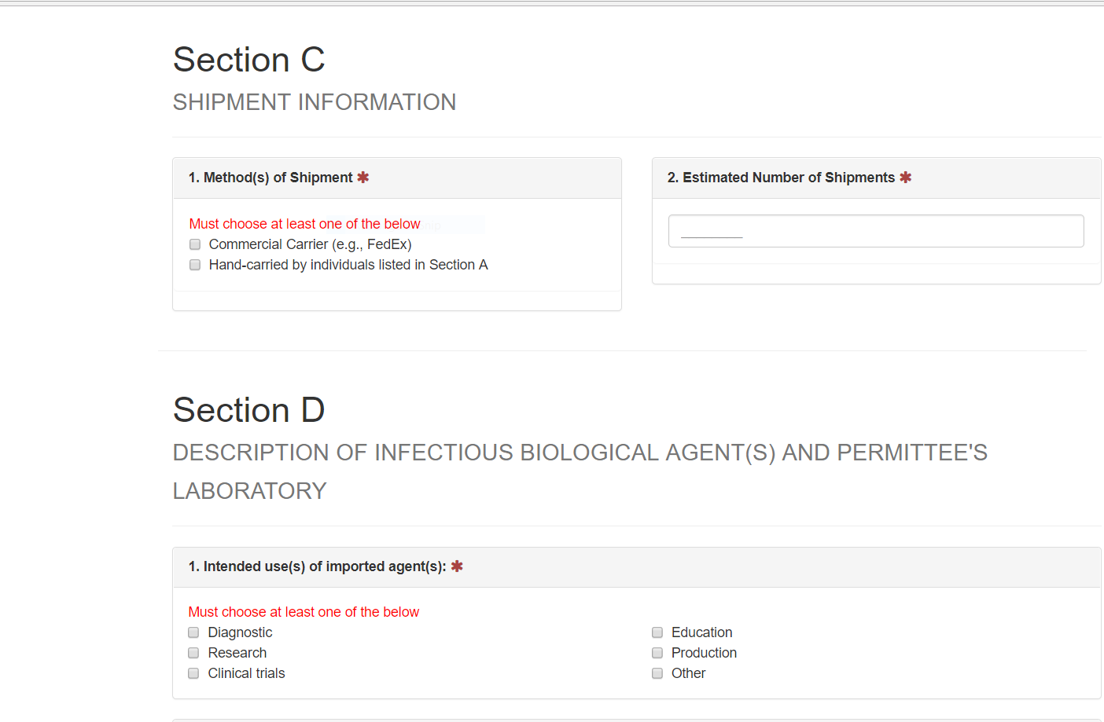

For Section E,

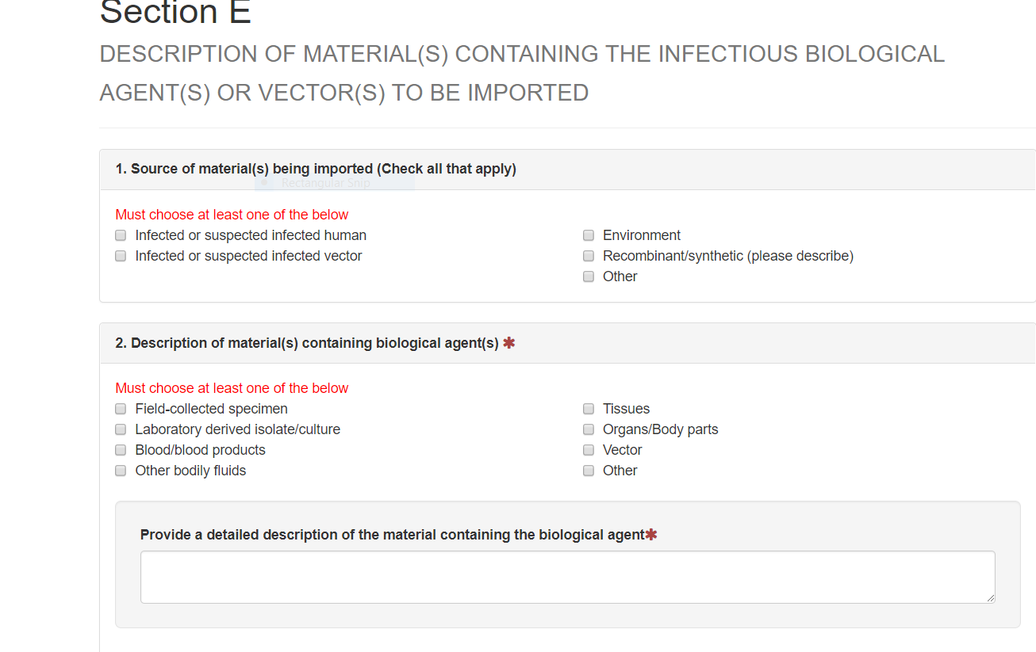

For Section F,

For Section G,

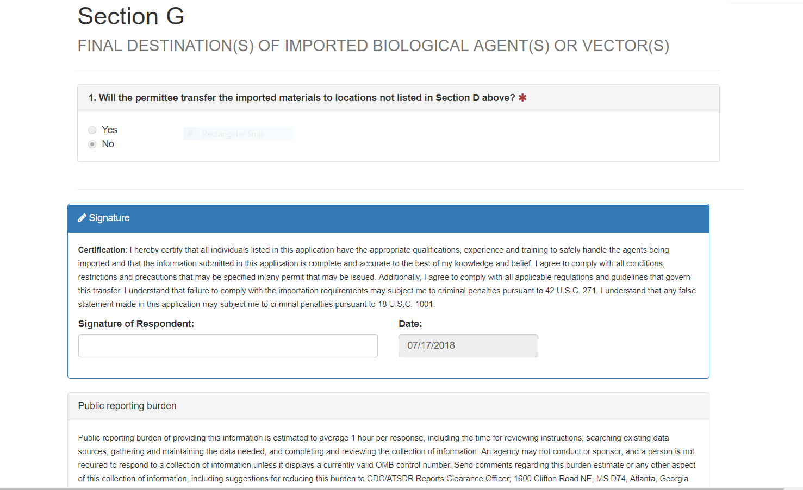

The new database, “Electronic Import Permit Program portal (eIPP)” will capture all information from the Application for Permit to Import or Transfer Live Bats as noted below in the screenshots.

For Section A,

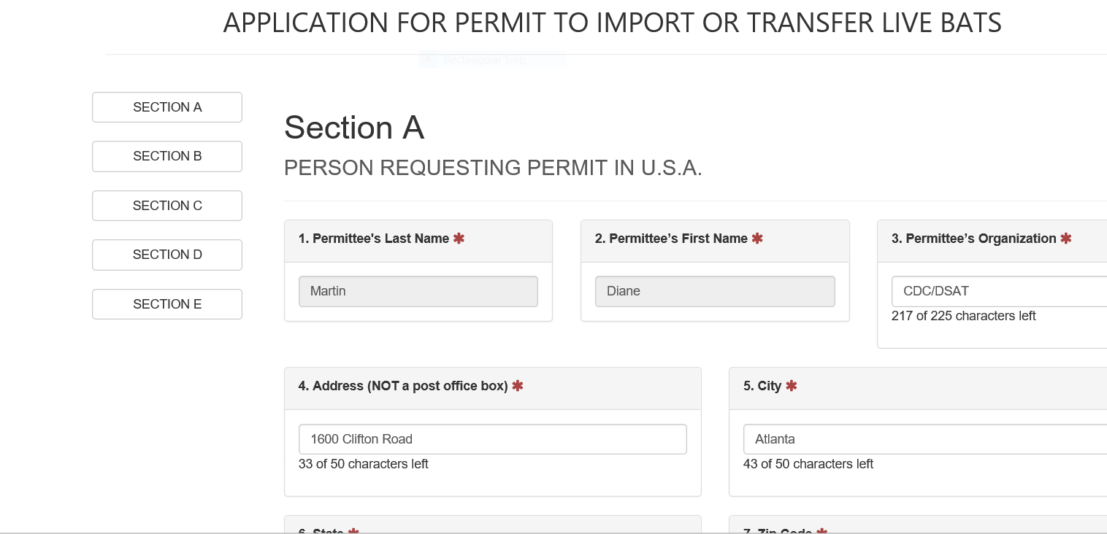

For Section B,

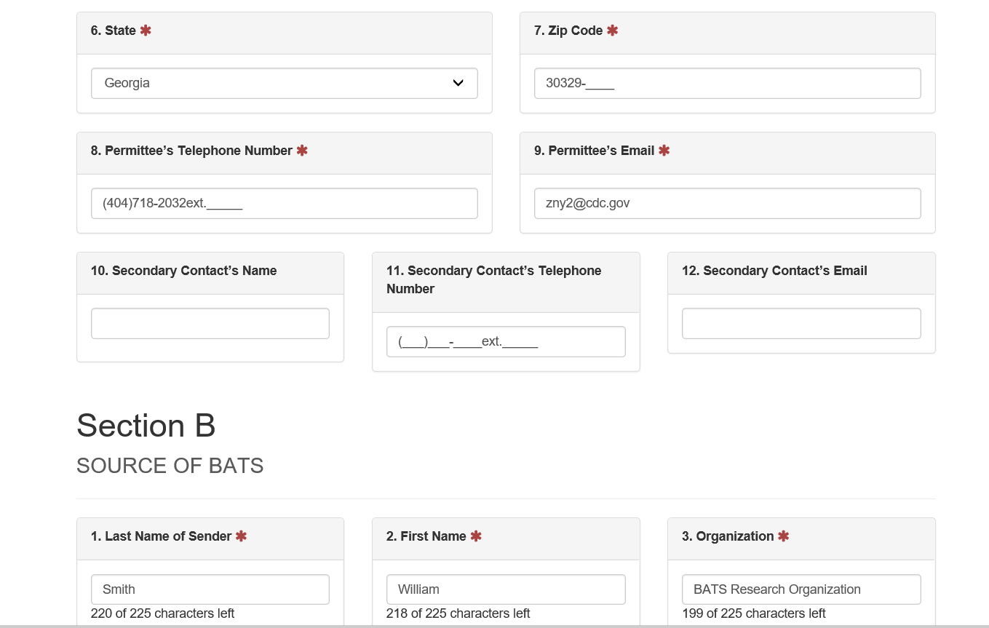

For Section C,

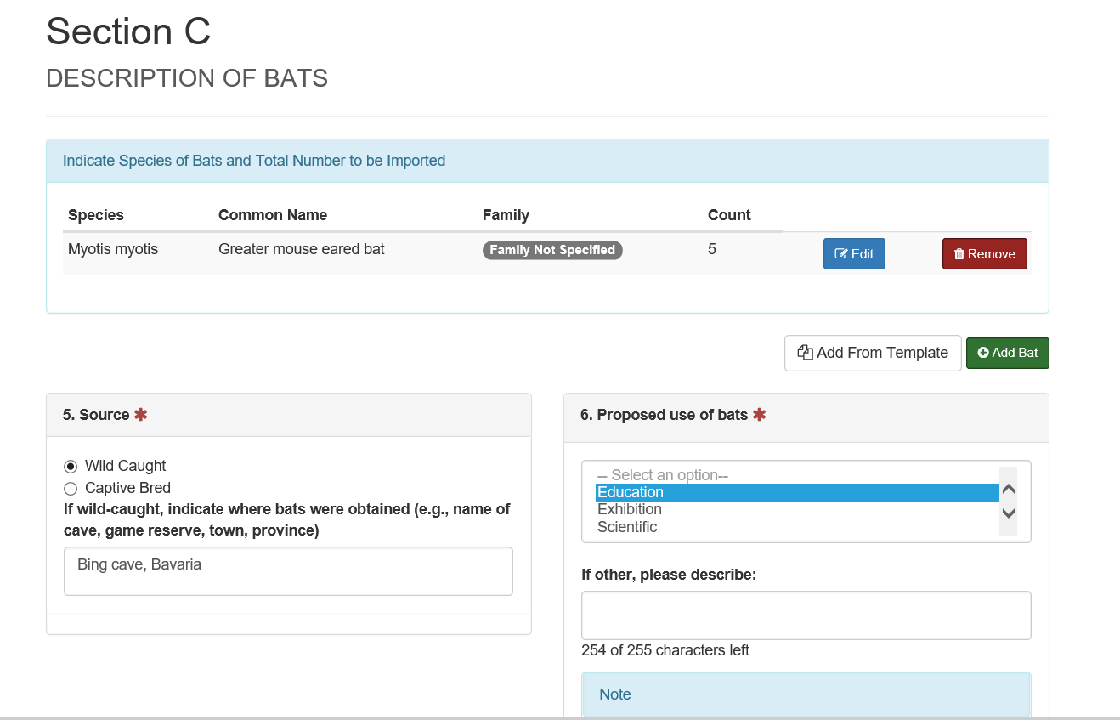

For Section D,

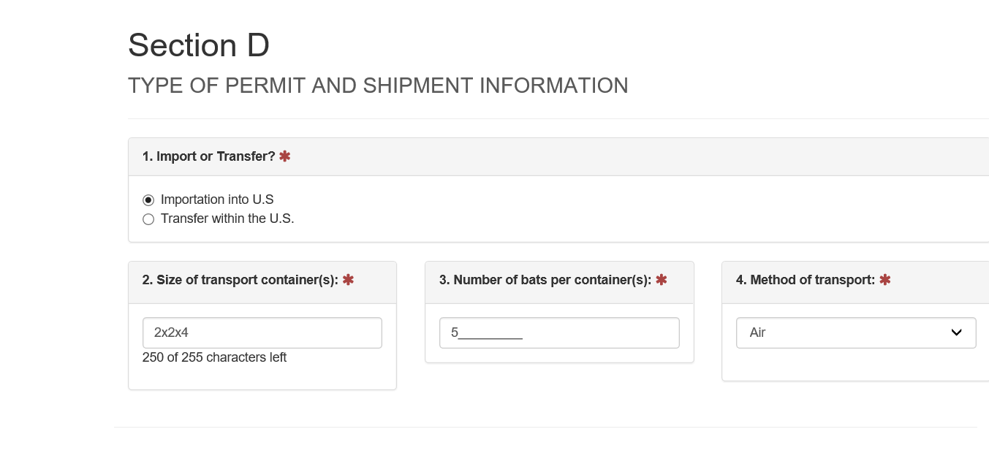

For Section E,

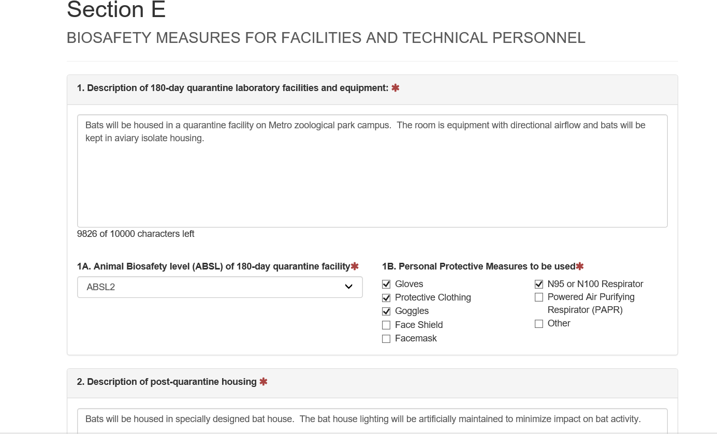

For Section F,

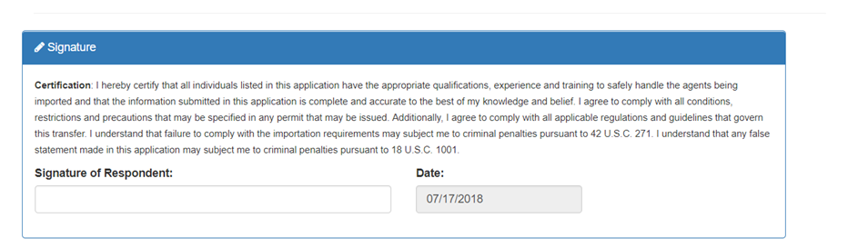

The new database, “Electronic Import Permit Program portal (eIPP)” will capture all information from the Application for Permit to Import Infectious Human Remains into the United States as noted below in the screenshots.



