ATTACHMENT 7: NBCCEDP Clinic-Level Data Instrument (Screenshots)

Prepared with “dummy” data

Welcome Screen
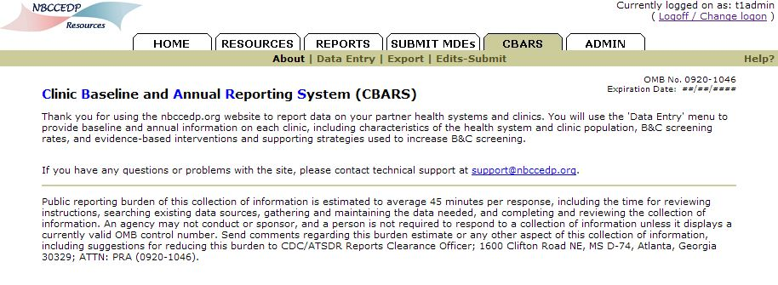
Health System Data
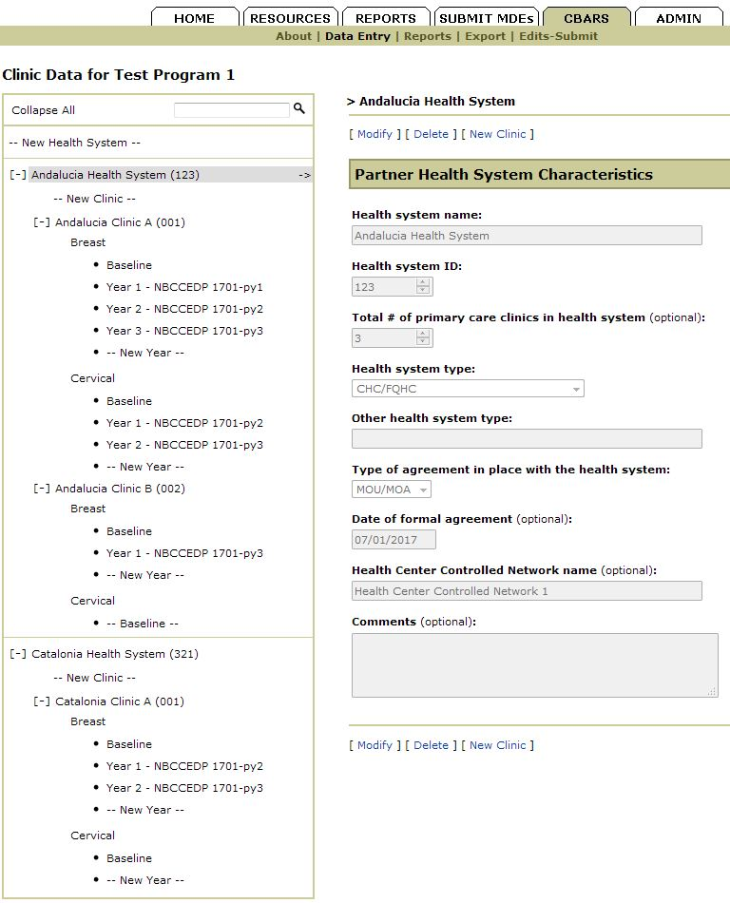
Clinic Data - Characteristics
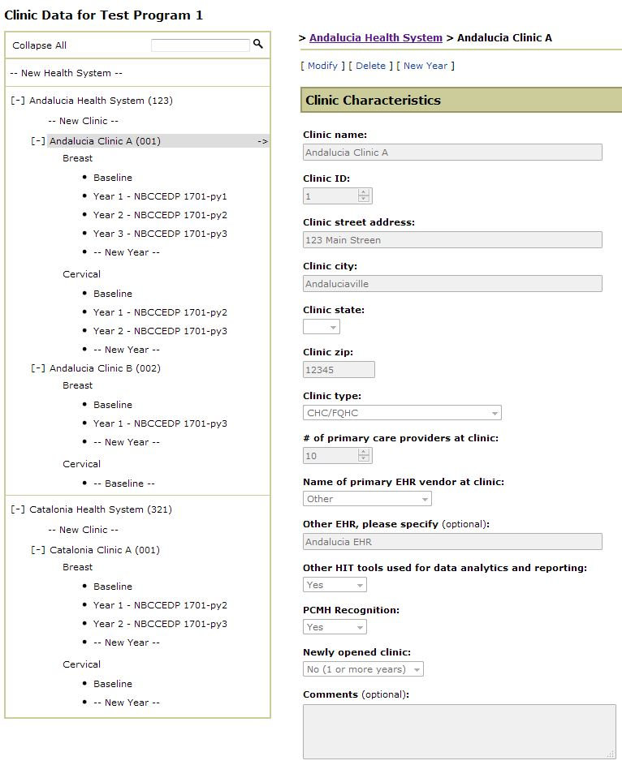

Clinic Data – Characteristics, continued
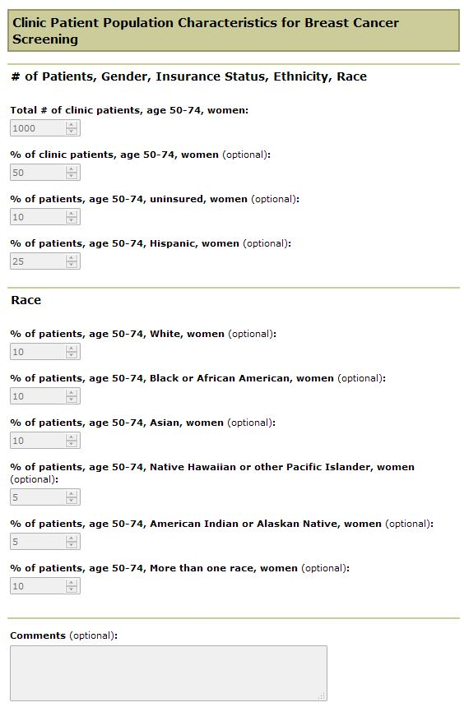

Clinic Data – Characteristics, continued
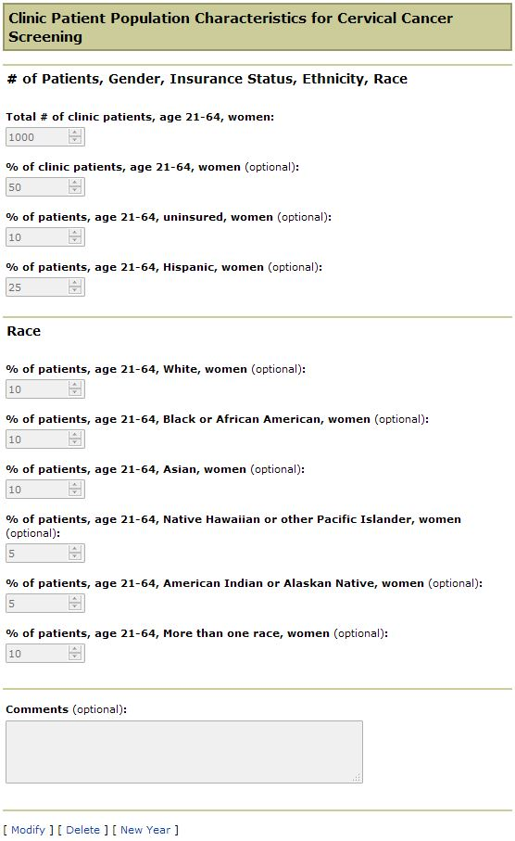

Clinic Data – Baseline Breast
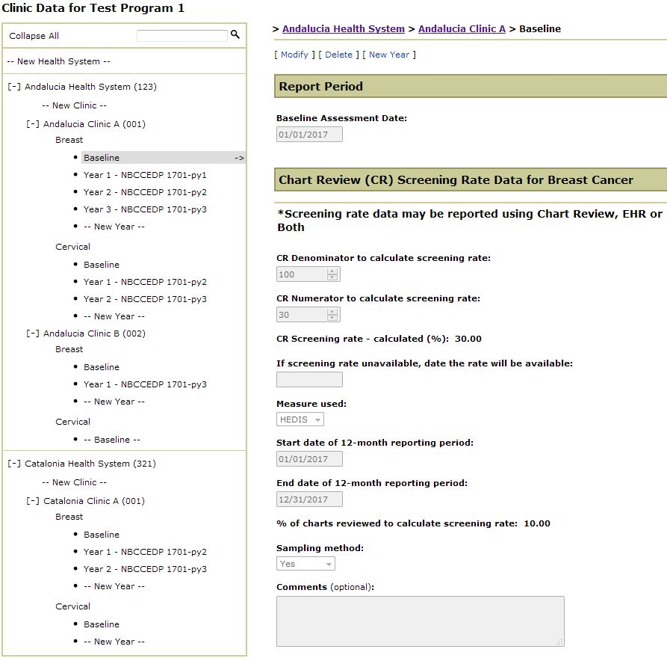

Clinic Data – Baseline Breast, continued
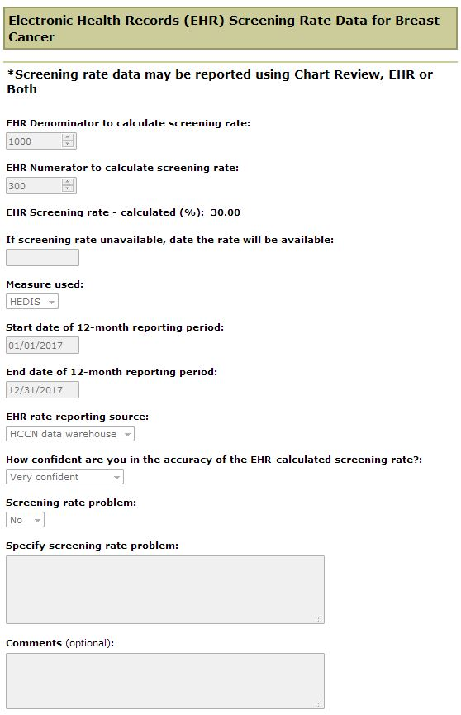

Clinic Data – Baseline Breast, continued
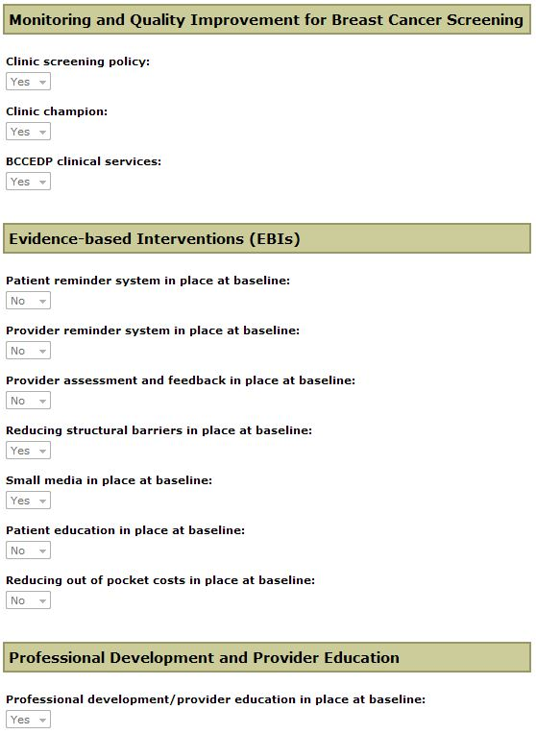

Clinic Data – Baseline Breast, continued
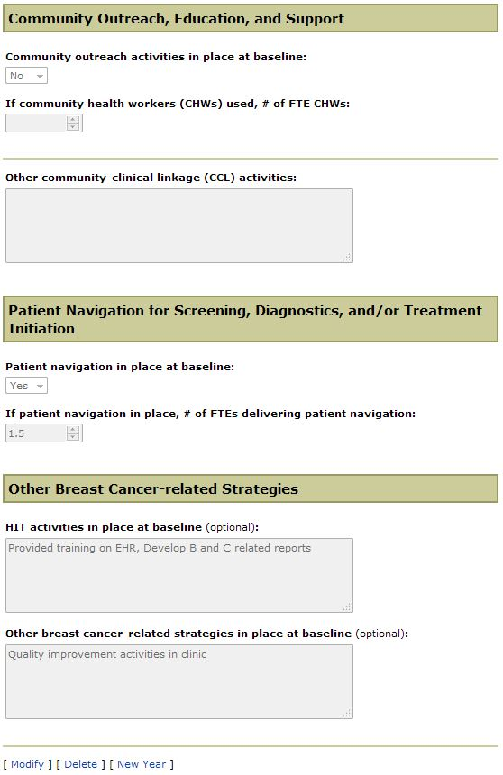

Clinic Data – Annual Breast
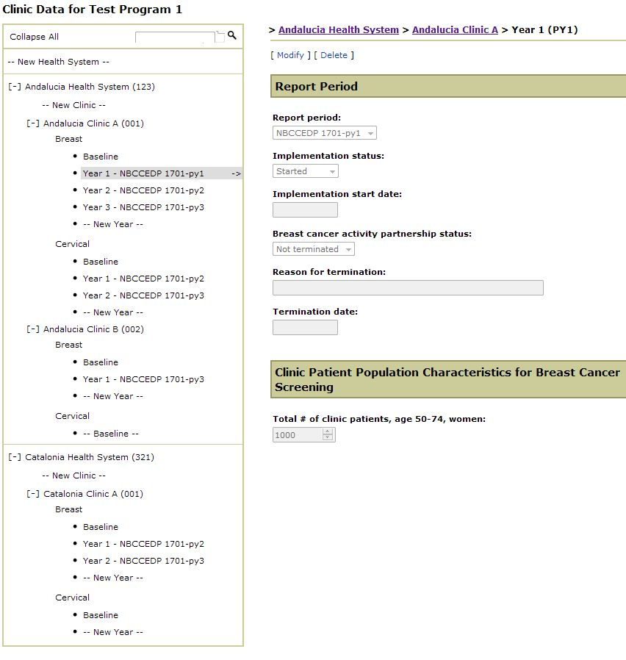
Clinic Data – Annual Breast, continued
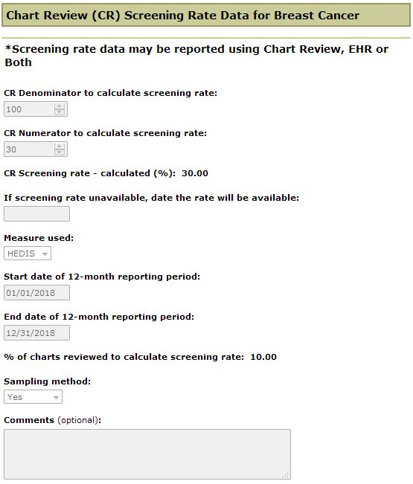

Clinic Data – Annual Breast, continued
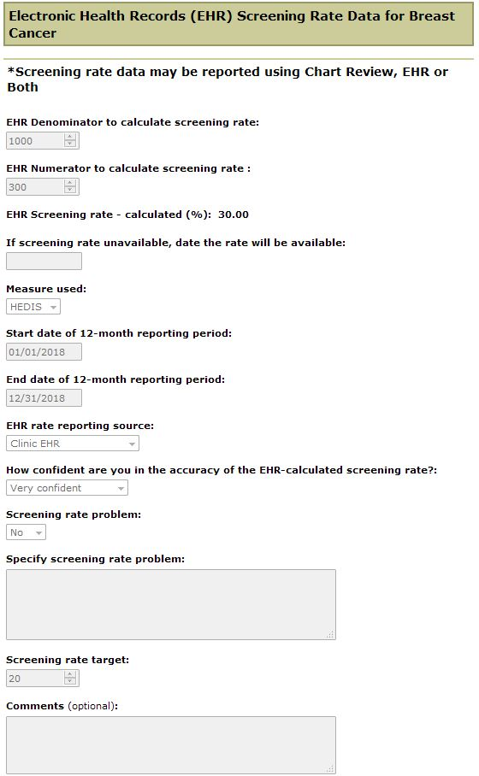

Clinic Data – Annual Breast, continued
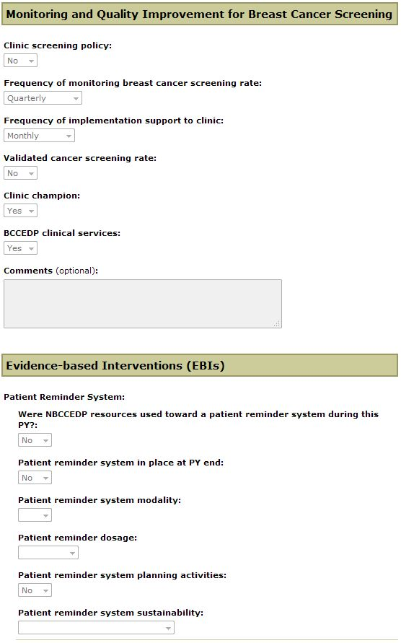

Clinic Data – Annual Breast, continued
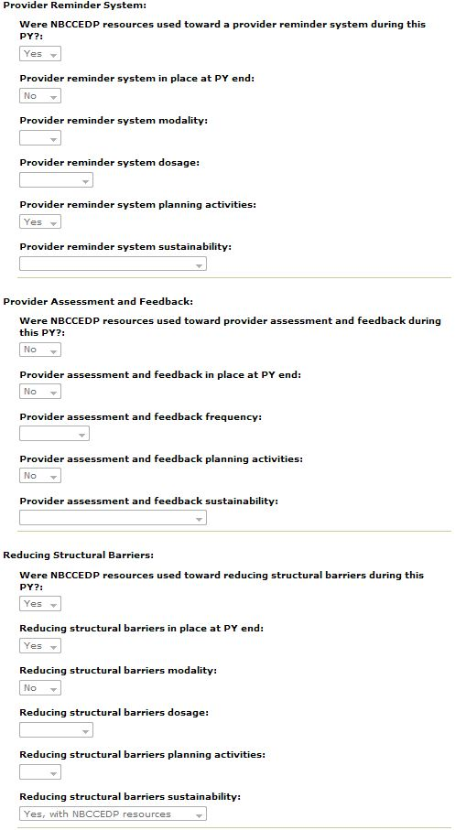
Clinic Data – Annual Breast, continued
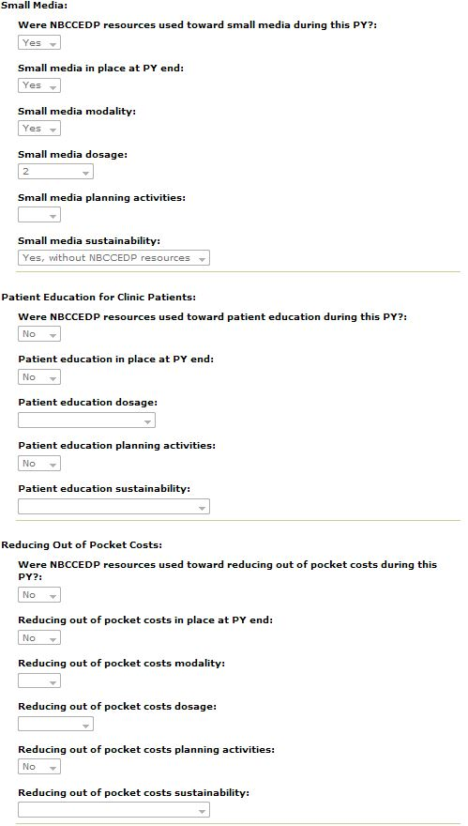

Clinic Data – Annual Breast, continued
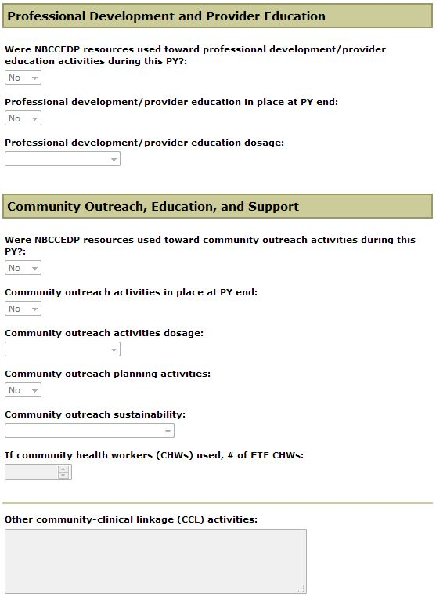

Clinic Data – Annual Breast, continued
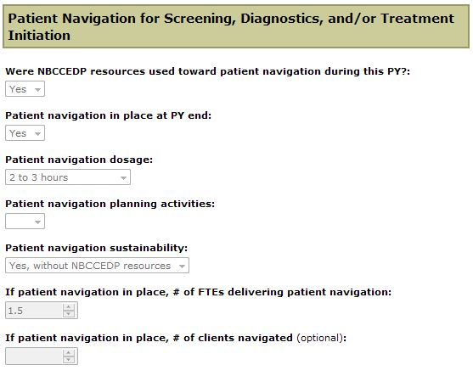

Clinic Data – Annual Breast, continued
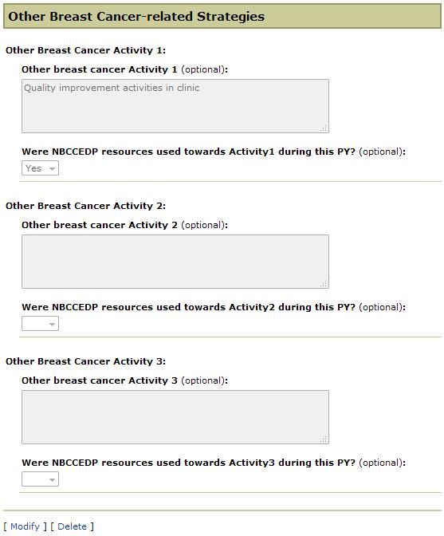

Clinic Data – Baseline Cervical
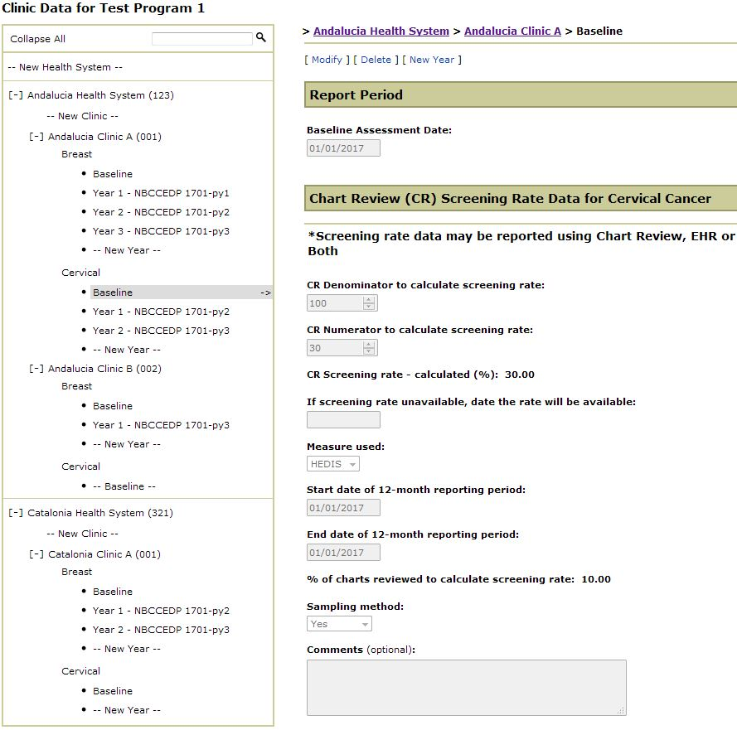

Clinic Data – Baseline Cervical, continued
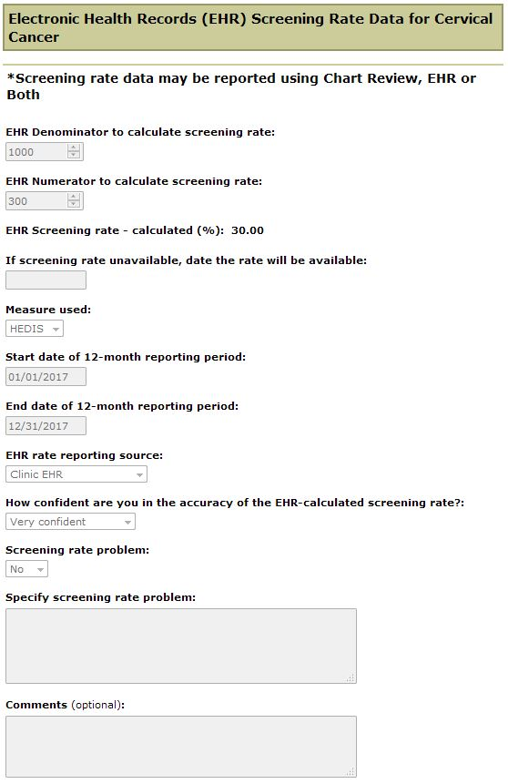

Clinic Data – Baseline Cervical, continued
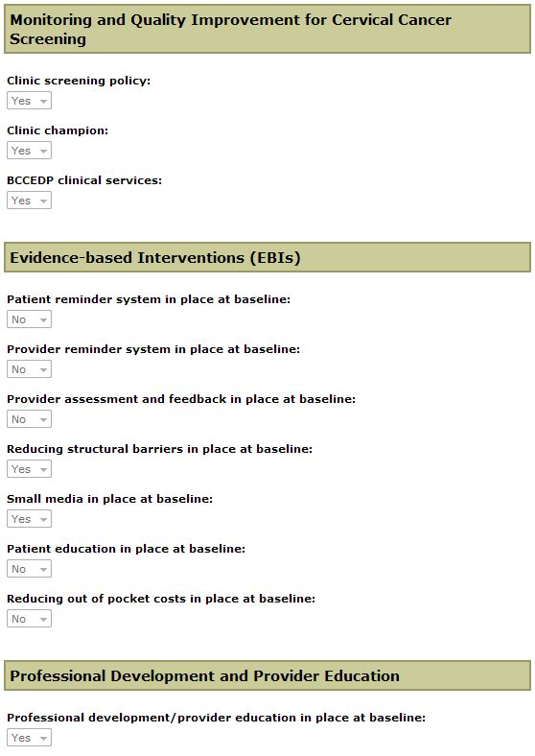

Clinic Data – Baseline Cervical, continued
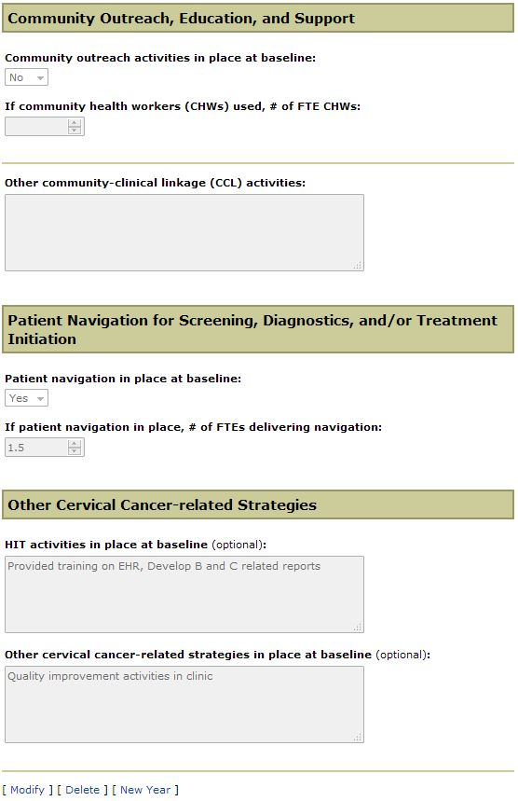

Clinic Data – Annual Cervical
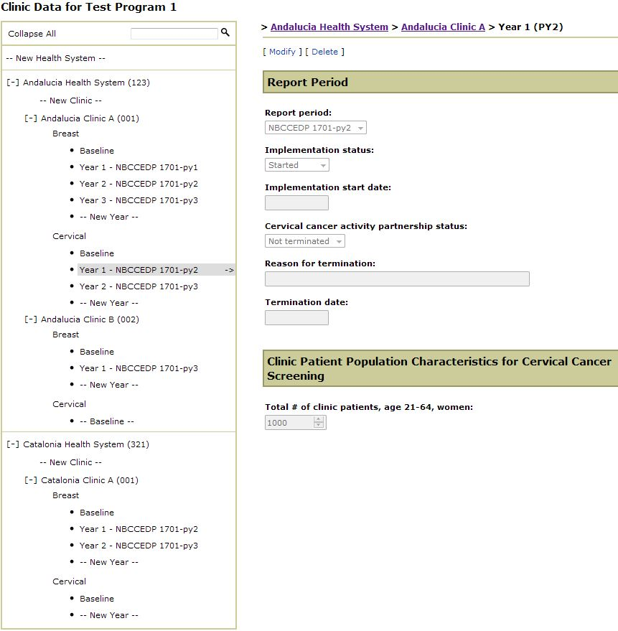

Clinic Data – Annual Cervical, continued
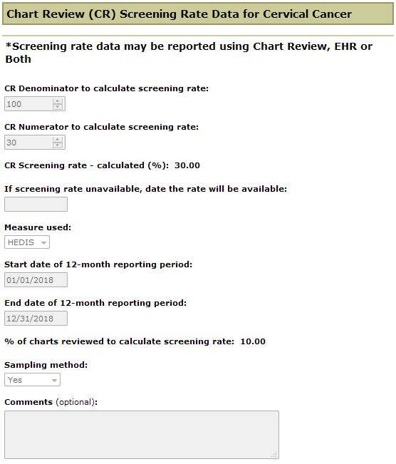

Clinic Data – Annual Cervical, continued
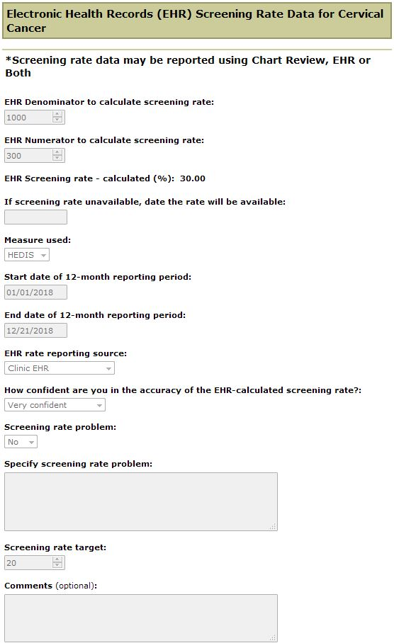

Clinic Data – Annual Cervical, continued
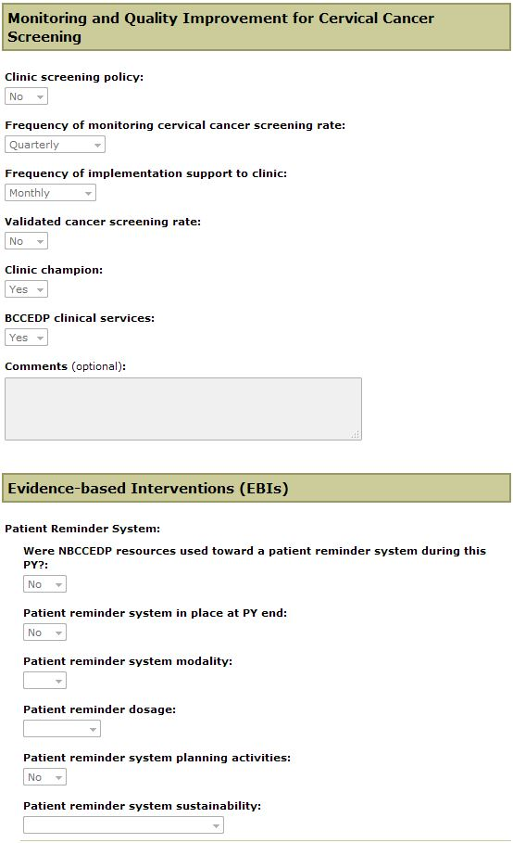

Clinic Data – Annual Cervical, continued
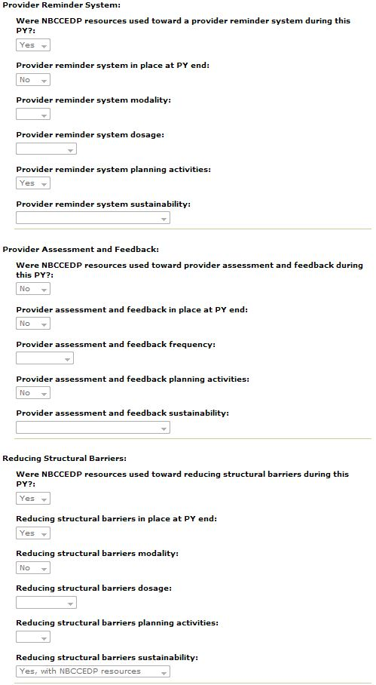
Clinic Data – Annual Cervical, continued
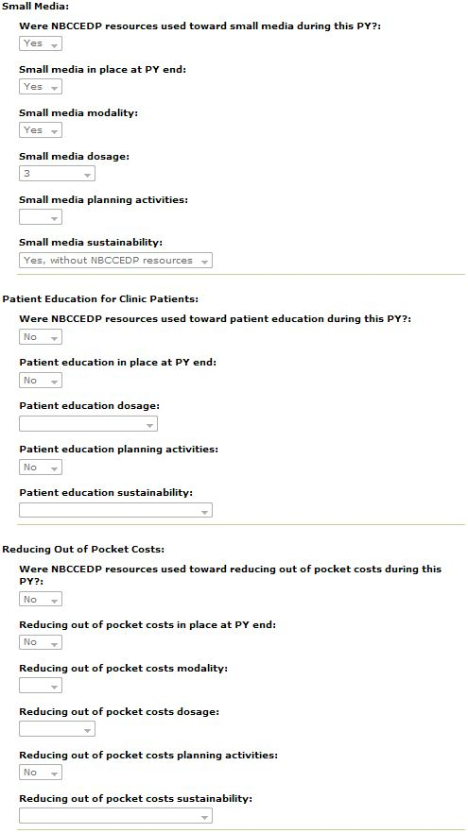

Clinic Data – Annual Cervical, continued
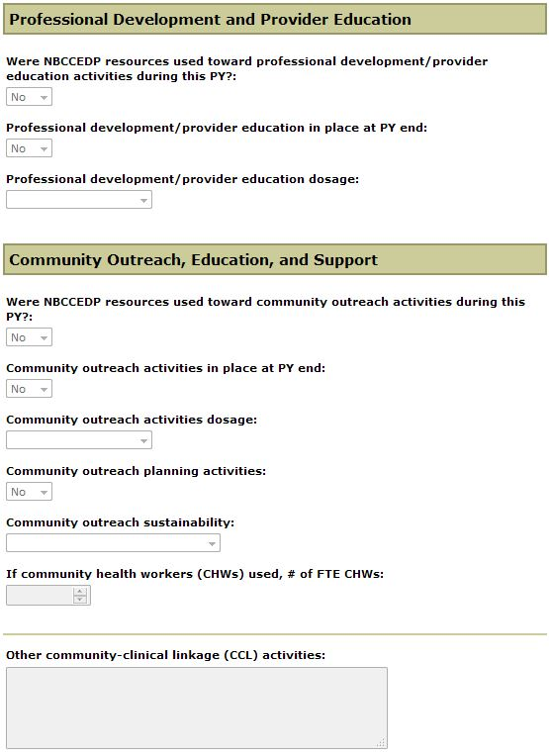

Clinic Data – Annual Cervical, continued
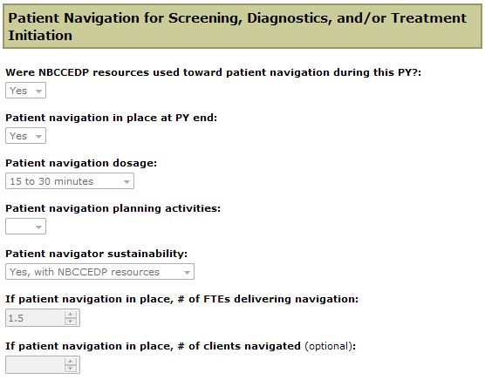

Clinic Data – Annual Cervical, continued
