Network of Minority Health Research Investigators (NMRI) Survey



## OMB #0925-0748

Expiration Date: 2/2023

# Network of Minority Health Research Investigators (NMRI) Survey

## Public reporting burden for this collection of information is estimated to average 30 minutes per response, including the time for reviewing instructions, searching existing data sources, gathering and maintaining the data needed, and completing and reviewing the collection of information. An agency may not conduct or sponsor, and a person is not required to respond to, a collection of information unless it displays a currently valid 0MB control number. Send comments regarding this burden estimate or any other aspect of this collection of information, including suggestions for reducing this burden, to: NIH, Project Clearance Branch, 6705 Rockledge Drive, MSC 7974, Bethesda, MD 20892-7974, ATTN: PRA (0925-0748). Do not return the completed form to this address.

Please take a moment to answer these questions to help make the Network more helpful for all members.

Click if you wish to submit a new Survey

Click if you are a returning member and wish to update your Survey

1/1

Network of Minority Health Research Investigators (NMRI) Survey

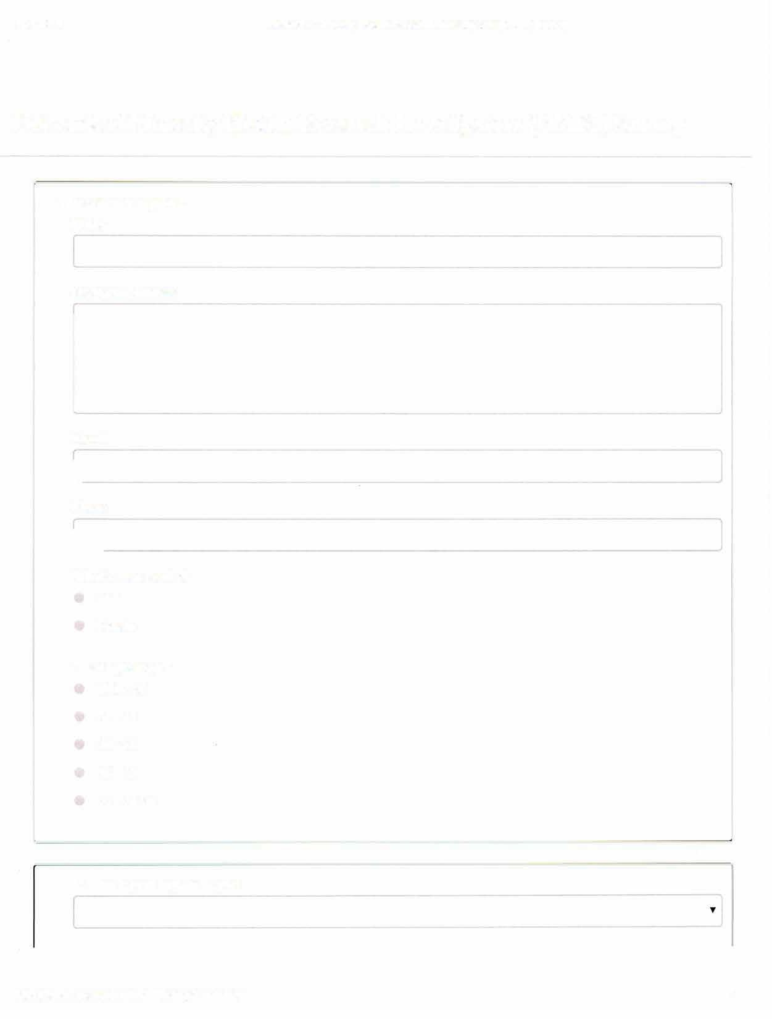

# Network of Minority Health Research Investigators (NMRI) Survey

This section is required.

Name

Institution Address

Email

L

Phone

L

What is your gender? U Male

0 Female

What is your age?

*0* Under 30 0 31-45 0 46-55 0 56-65

0 66-Above

I. What is your highest degree?

117

Network of Minority Health Research Investigators **(NMRI)** Survey

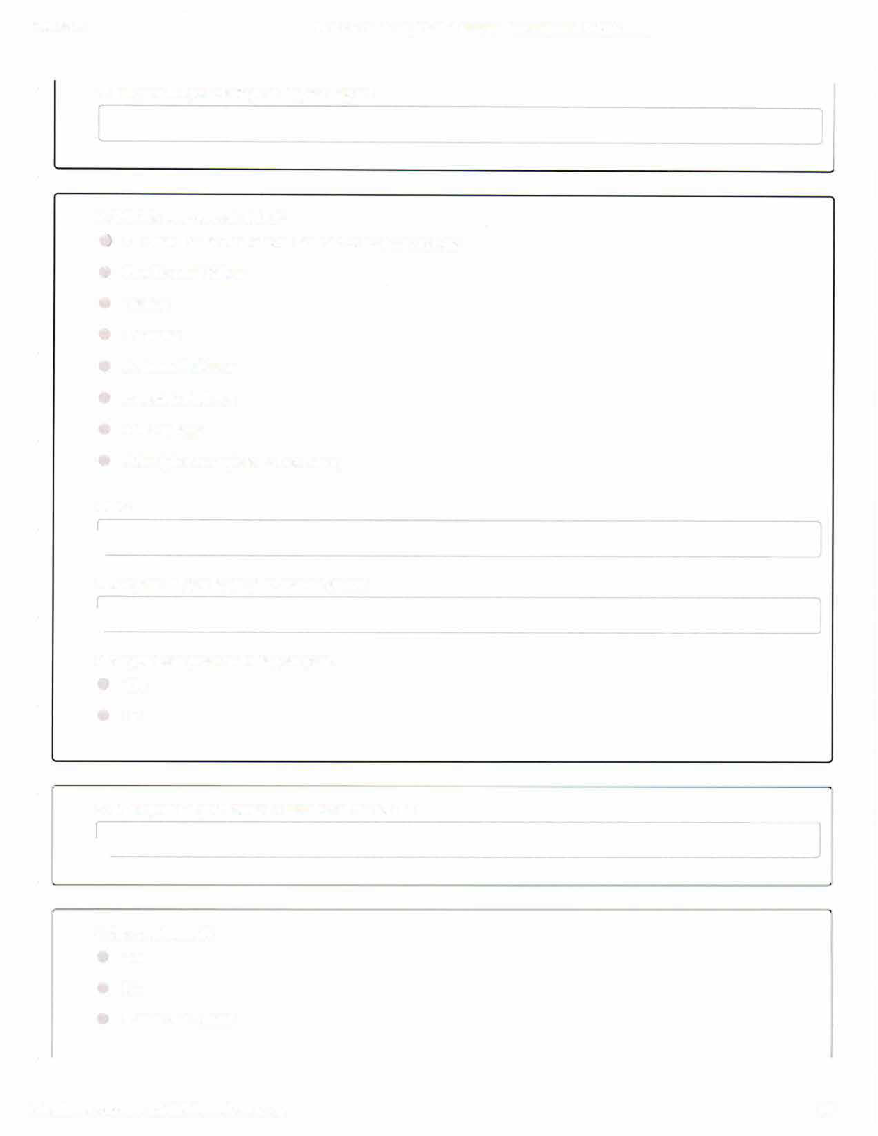

What year did you reach your highest degree?

2. What is your current status?

## l Graduate/Health Professional Students or Medical Students G Post Doctoral Fellow

(J Trainee

## **0** Instructor

**0** Assistant Professor

## **0** Associate Professor U Full Professor

**0** Other (please complete the box below)

Other

l

What year did you begin your current status?

l

Have you been promoted this past year?

**0** Yes

0 No

3. What year did you become a member of the NMRI?

L

1. **Are you tenured?**

**0** Yes

## (' No

**0** Tenure Not Offered

**2/7**

Network of Minority Health Research Investigators (NMRI) Survey

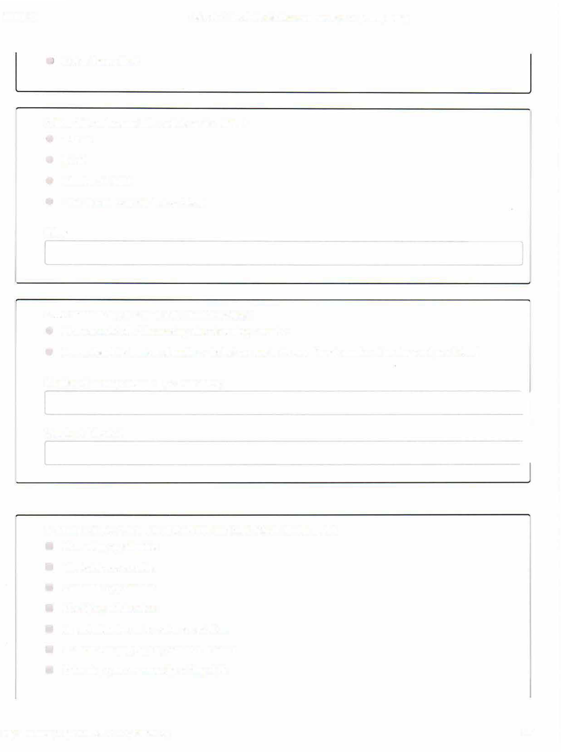

## C Not on Tenure Track

1. **How did you become informed about the NMRI?**

## 0 Website

**0** Email

## C. Member ofNMRI

0 Other (please complete the box below)

Other

1. **How often have you attended the NMRI meetings?**

## U I have attended all ofthe meetings since becoming a member

**0** I have attended X number of meetings, the last one was in the year [Supply number of meetings and year below]

Number of meetings attended (X from above)

Year Last Attended

1. **What motivates you to attend the NRMI meeting? (check all that apply)**

## **U** Networking opportunities U Mentorship opportunities

**0** Leadership opportunities

## **0** Identifying collaborations

(J Opportunities for oral or poster presentations (J Assistance in applying for promotion or tenure [J Enhancing grant or manuscript writing skills

**3/7**

Network of Minority Health Research Investigators (NMRI) Survey



[J Developing management skills

Other

L_

1. **On a scale of 1-10, with IO being the most opportunity for professional growth, rate your professional development associated with attending the annual NMRI meetings**

|  |  |
| --- | --- |
| (J | 2 |
| G | 3 |
| **0** | 4 |
| CJ | 5 |
| 0 | 6 |
| 0 | 7 |
| (J | 8 |
| **c,** | 9 |
| 0 | 10 |

Indicate the most important ways that NMRI has helped you in your career development

l**l** Found collaborator(s)

**0** Found mentor(s)

[J Helped with success in grant application

(J Helped with success in manuscript publication [J Helped develop management skills

0 Assisted in applying for promotion or tenure

Other

If you have achieved tenure or have been promoted, give up to three specific examples of how NMRI has contributed to supporting you in this process

4/7

Network of Minority Health Research Investigators (NMRI) Survey



9. Have you participated in the NMRI mentorship program?

) As a Mentor

0 As aMentee

0 Both

0 No

Were you satisfied with the program?

0 Yes

U No

Have you solicited a member of NMRI to review your dossier or write a letter in support of your promotion?

0 Yes

0 No

|  |  |  |  |
| --- | --- | --- | --- |
| **10. How many grants have you submitted since the last academic year?** | | |  |
|  | This is the original free-response box which will be moved underneath multiple choice (check all that apply) as an option. | | |
|  | **□ NIH K Award (Please specify below.)**  **□ NIH R03**  **□ NIH R01**  **□ Other NIH R mechanism (Please specify below.)**  **□ Non – NIH Federal (NSF, DoD, USDHHS) (Please specify below.)**  **□ Non-Federal (i.e. Gifts and Foundation) (Please specify below.)**  **□ None**  **□ Other (Please specify below.)**  **Specification**   |  | | --- | |  |   **How many grants have you been awarded since the last academic year?** |  |  |

|  |
| --- |
| This is the original free-response box which will be moved underneath multiple choice (check all that apply) as an option. |

**□ NIH K Award (Please specify below.)**

**□ NIH R03**

**□ NIH R01**

**□ Other NIH R mechanism (Please specify below.)**

**□ Non – NIH Federal (NSF, DoD, USDHHS) (Please specify below.)**

**□ Non-Federal (i.e. Gifts and Foundation) (Please specify below.)**

**□ None**

**□ Other (Please specify below.)**

**Specification**

|  |
| --- |
|  |



Total funding awarded in the past year (in Dollars)

Current total funding (in Dollars)

11. How many manuscripts have you published in the last academic year?

How many have been published in top-tier journals in your field?

Which Journals?

12. Are you planning to attend a future NMRI meeting?

**0 Yes**

**(J No**

13. If you are not planning to attend a future NMRI meeting, please state why

14. Final comments

6/7

Network of Minority Health Research Investigators (NMRI) Survey

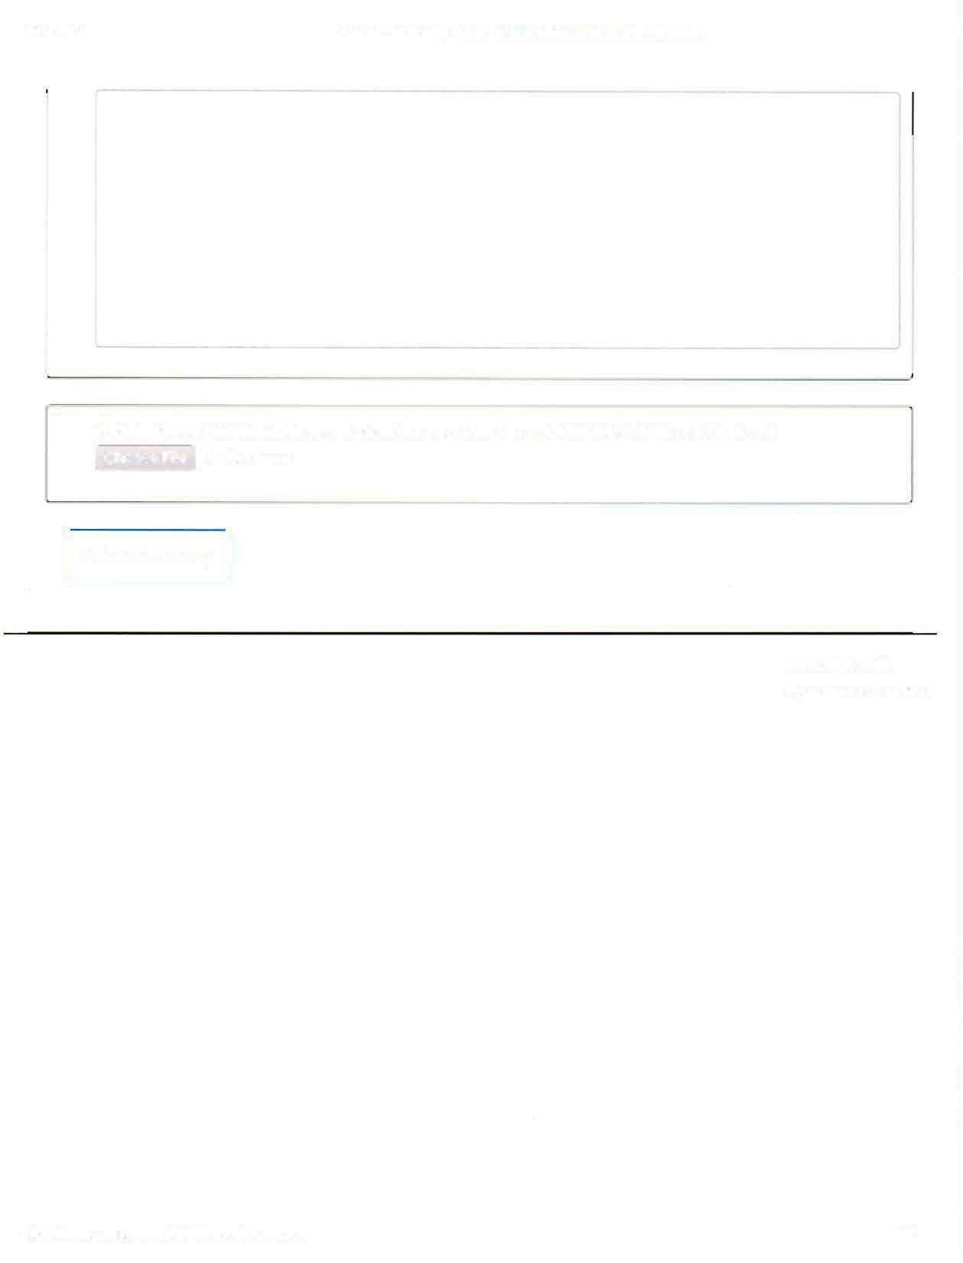

I Choose File I No file chosen

**15. Submit your NIH Biosketch or equivalent (no more than 5 pages) (PDF, DOC, RTF, or TXT please)**

[ Submit Survey ]

***717***