Registration and Customer Service Screens
Address Confirmation Code (ACC)

Table of Contents
1. User Search Identity Container 3
2. Search Results with No Active Account and Expired code 3
3. ACMGMT Standard Account Summary Page with Active Code 4
4. ACMGMT Extra Security Account Summary Page 4
5. Send ACC – Privacy Act Warning Notice 5
6. Send ACC Error - Mailing Address 6
7. Send ACC Error - Phone Number 7
8. Send ACC Error - Email Address 8
7. Privacy Act 9
8. Enter ACC - Same Session 10
9. Enter ACC Error - Same Session 10
10. Enter ACC in Subsequent Session - Cannot Resend Code 11
11. Enter ACC Subsequent Session Error - Cannot Resend Code 11
12. ACC Code Will be Snail Mailed – Mailing Address Verified 12
13. Final Confirmation - ACC Code Matches SSA Records 12
14. Cancel Code 13
15. Cancel Code – Confirmation 13
16. Search Results with No Active Account, On-Phone SSN with No Code 14
17. Search Results with No Active Account, On-Phone with Active Code 14
18. Search Results with No Active Account, OnPhone, search by Username 15
19. ACMGMT - Standard Account Summary Page, On-Phone with No Code 15
20. ACMGMT - Standard Account Summary Page, On-Phones with Expired Code 16
21. Search Results with No Active Account, In-Person SSN with Active Code 16

- User Search Identity Container
Displays the new Elevated Phone Identity Verification container.
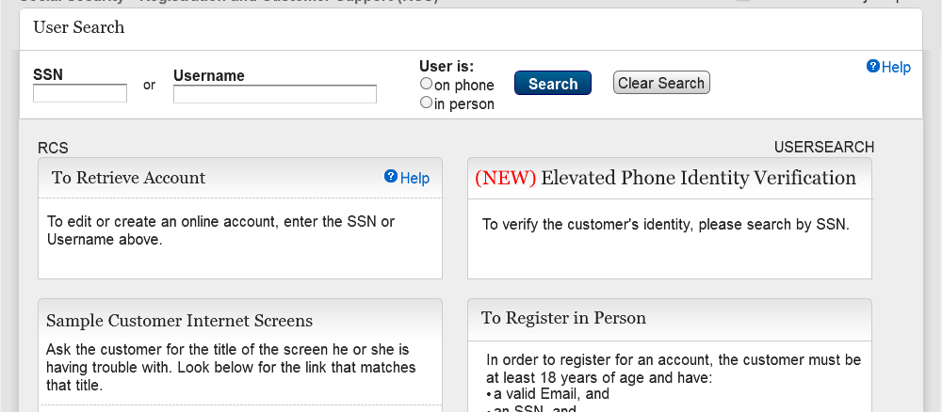

- Search Results with No Active Account and Expired code
Displays the search result with no user account and expired confirmation code.
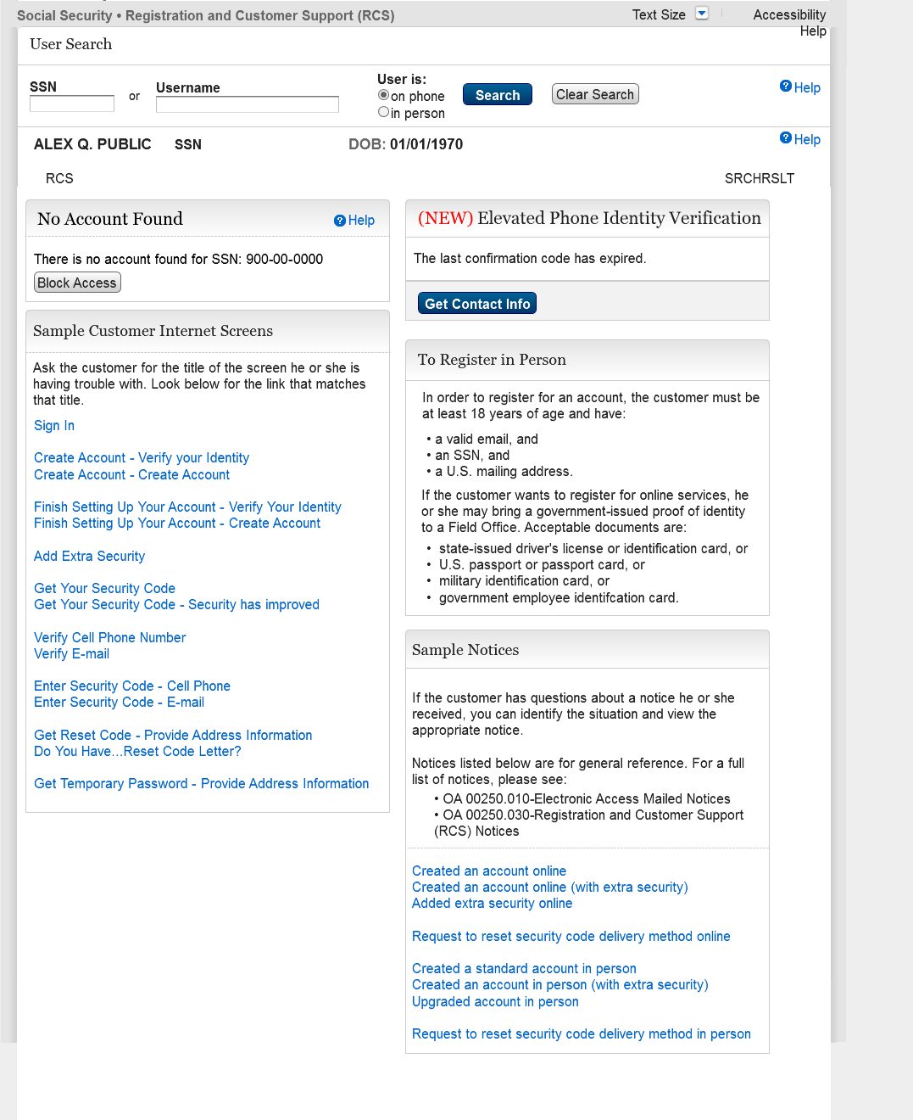
- ACMGMT Standard Account Summary Page with Active Code
Displays Account Management screen with an active account confirmation code.
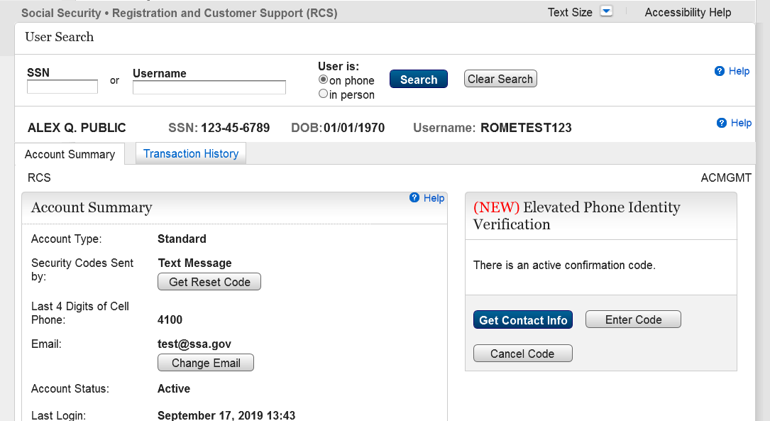

- ACMGMT Extra Security Account Summary Page
Displays Account Management screen with extra security and no confirmation code issued.
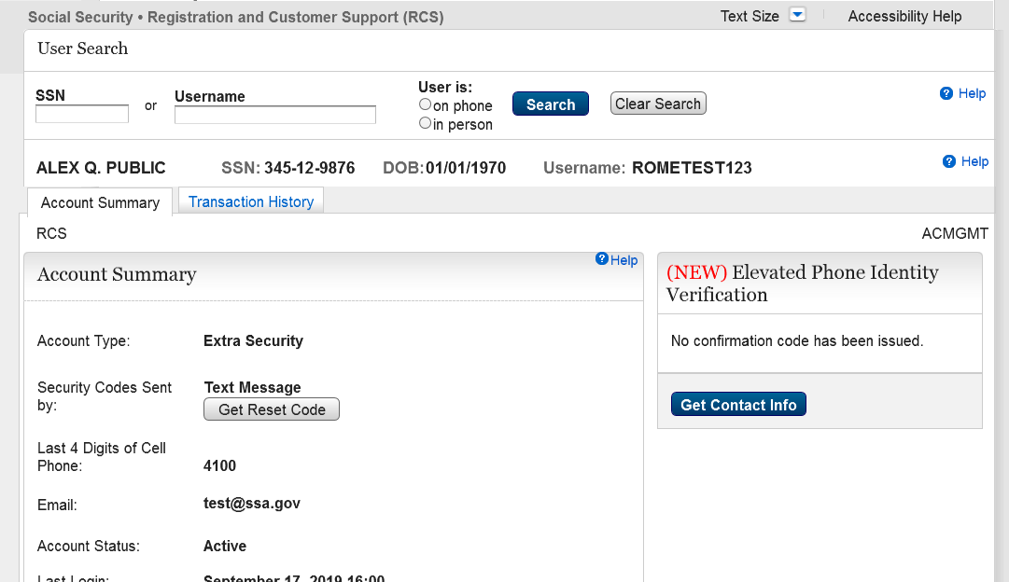
- Send ACC – Privacy Act Warning Notice
This page with the banner is displayed when Get Contact Info button is selected for the first time. The customer will have the option to either get the Privacy Act emailed or read aloud.
The customer will have the ability to receive the ACC code from the following:
- Text Message – User will receive code via sms text.
- Email Address – User will receive code via email.
- Mailing Address – User must provide address.
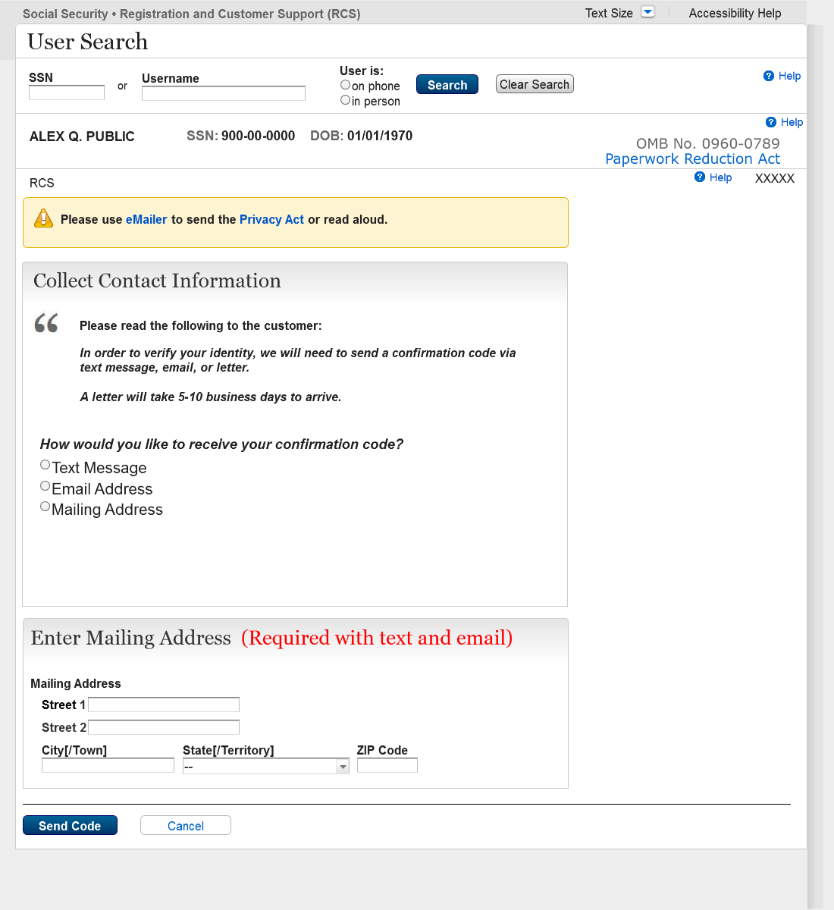

- Send ACC Error - Mailing Address
This page is displayed when Mailing Address was selected, and system was unable to verify Mailing Address.
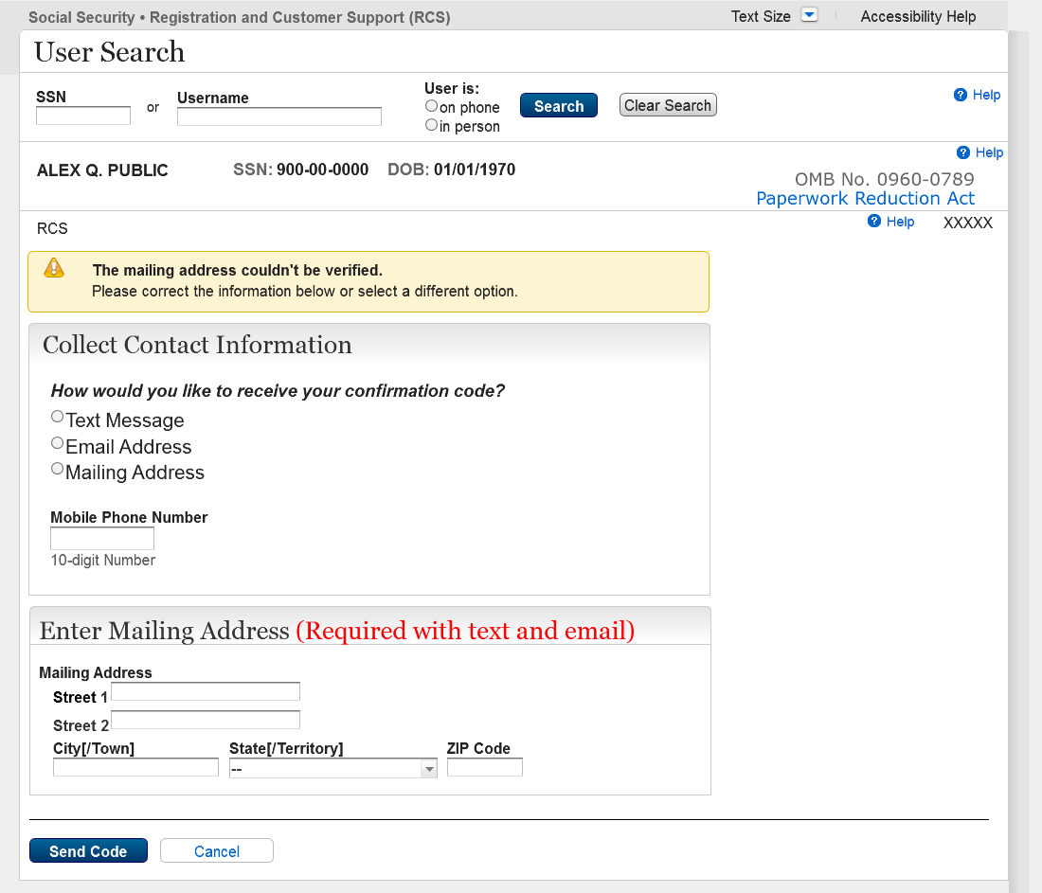

- Send ACC Error - Phone Number
This page is displayed when Phone Number was selected, and system was unable to verify Phone Number.
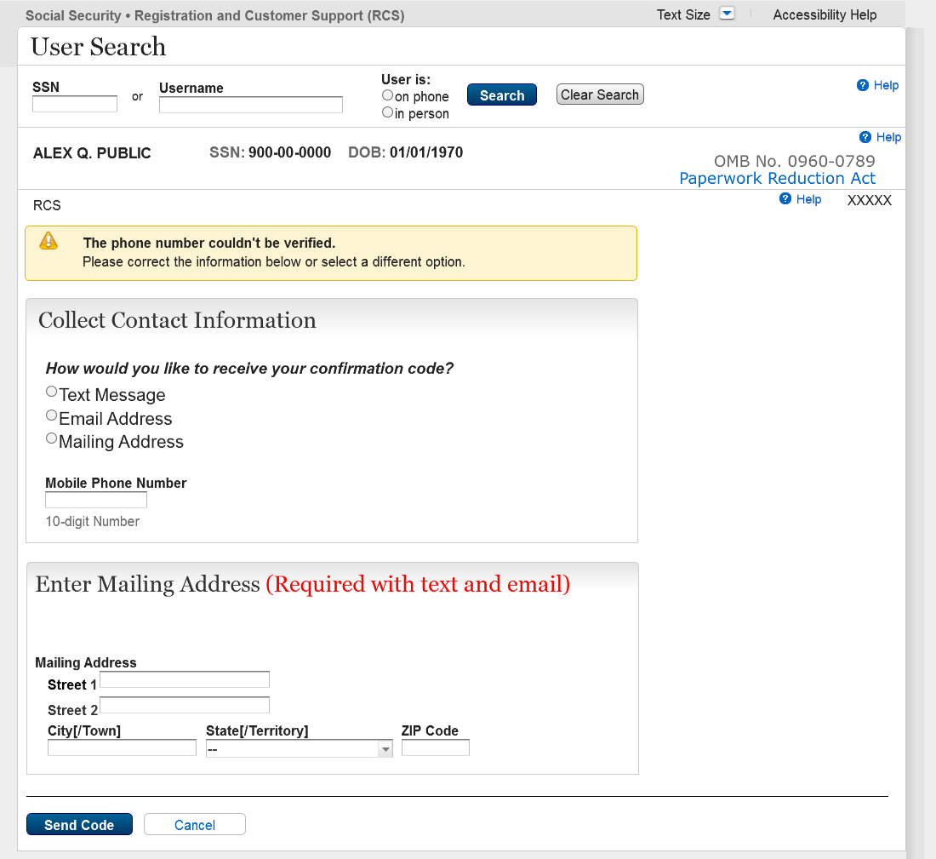

- Send ACC Error - Email Address
This page is displayed when Email Address was selected, and system was unable to verify Email Address.
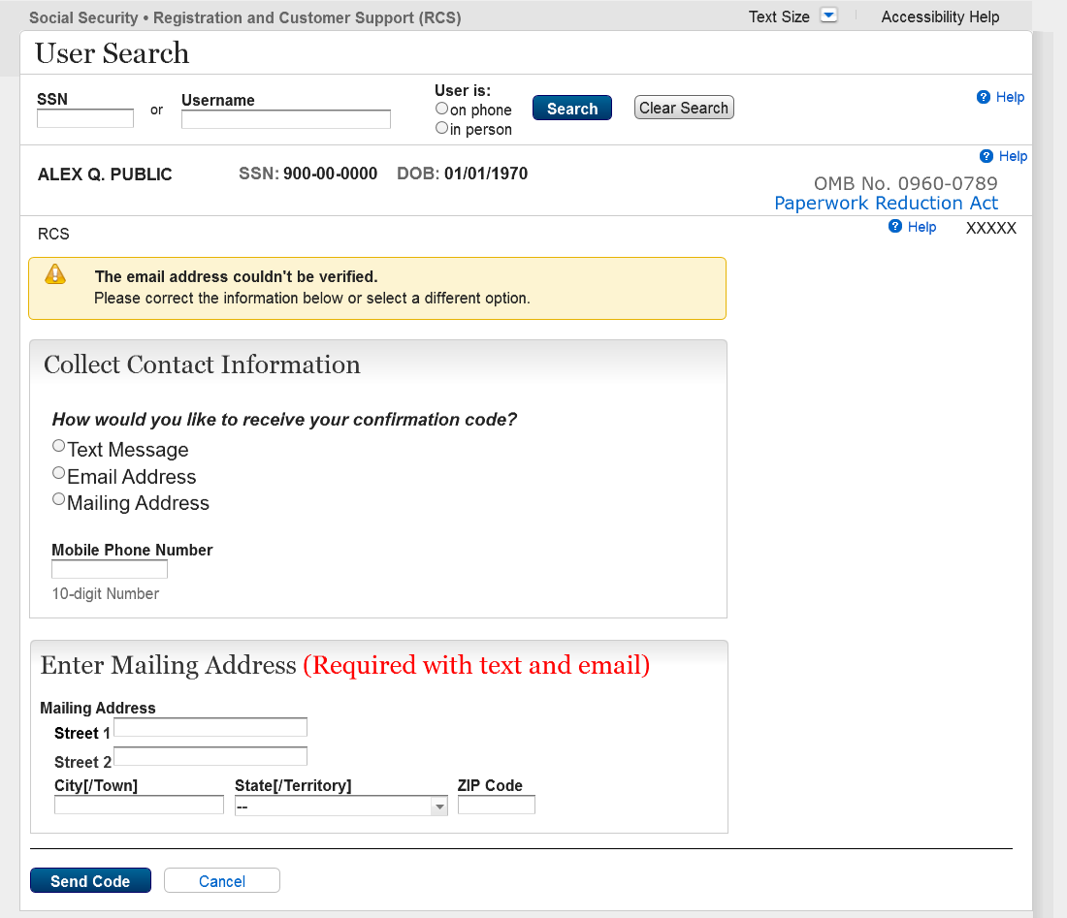

- Privacy Act
Updated Privacy Message.
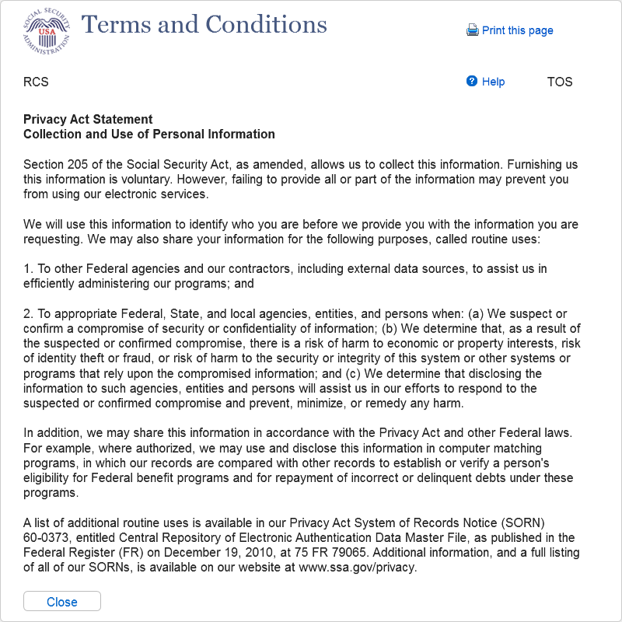
- Enter ACC - Same Session
This page is displayed when user has selected either Text Message or Email address to receive ACC within the same session.
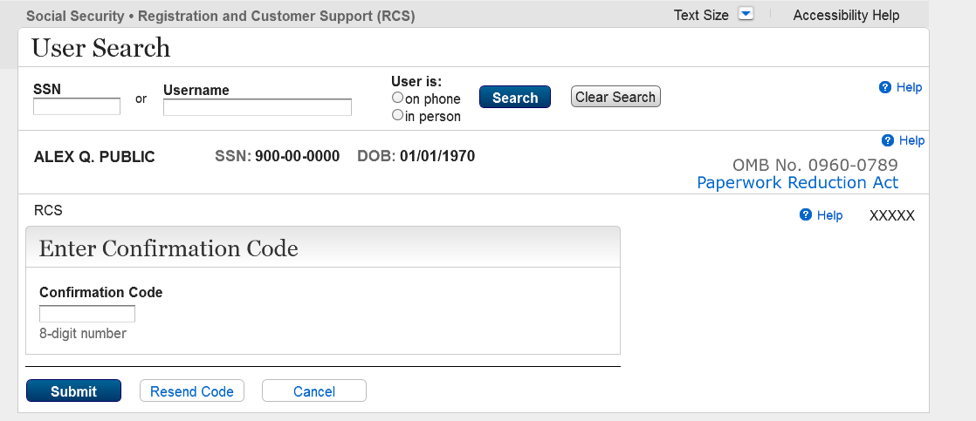

- Enter ACC Error - Same Session
This page is displayed when user receives an Error message and has selected either Text Message or Email Address to receive ACC within the same session.
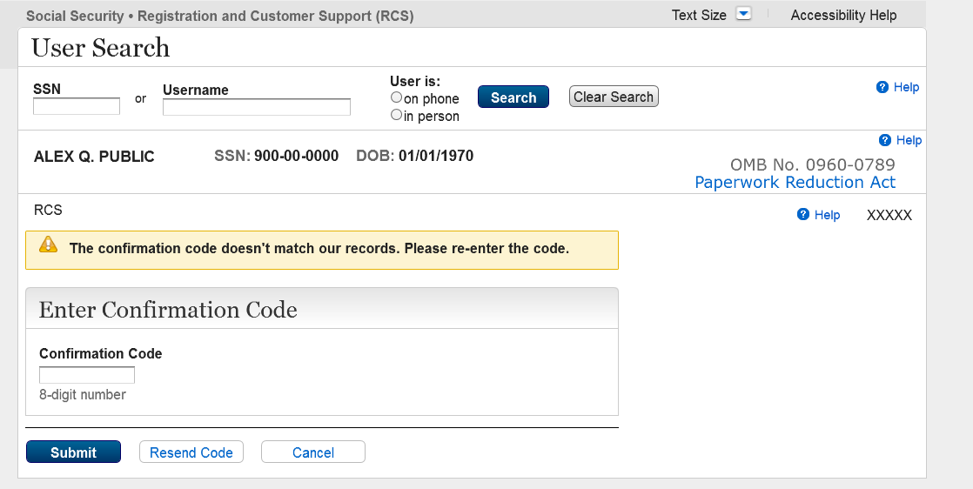
- Enter ACC in Subsequent Session - Cannot Resend Code
This page is displayed when user returns with an ACC in a different session.
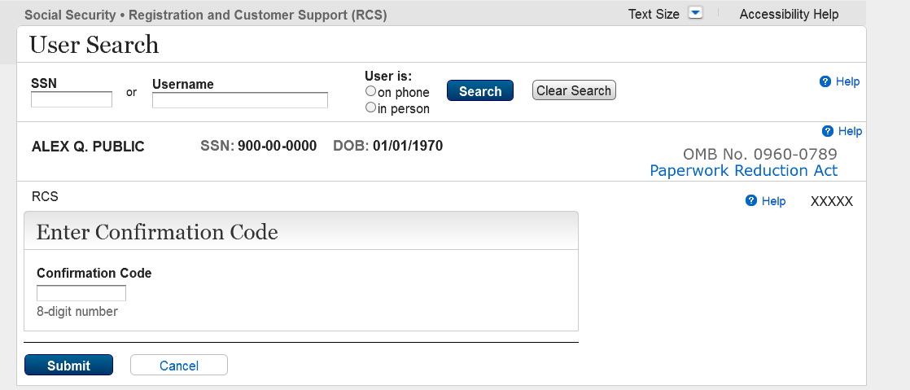

- Enter ACC Subsequent Session Error - Cannot Resend Code
This page is displayed when user receives an error message when confirmation code does not match.
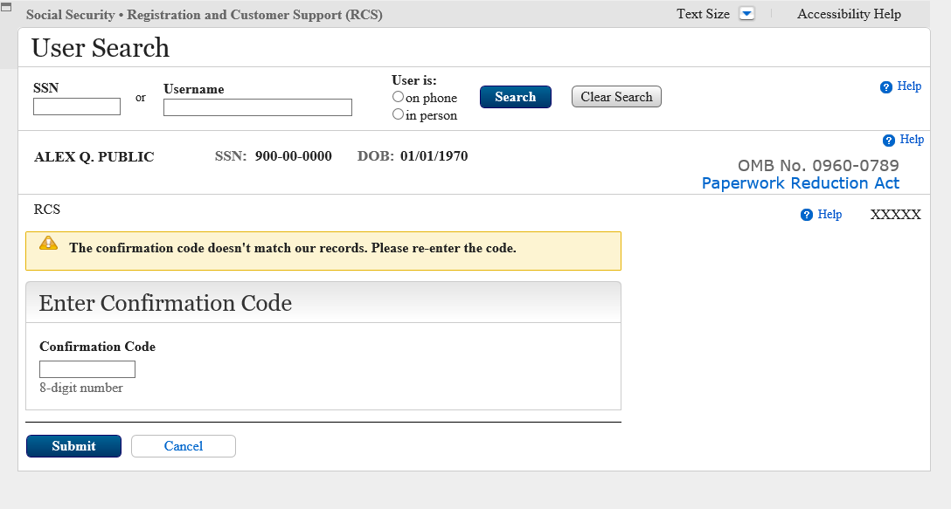

- ACC Code Will be Snail Mailed – Mailing Address Verified
This page is displayed when the mailing address has been verified.
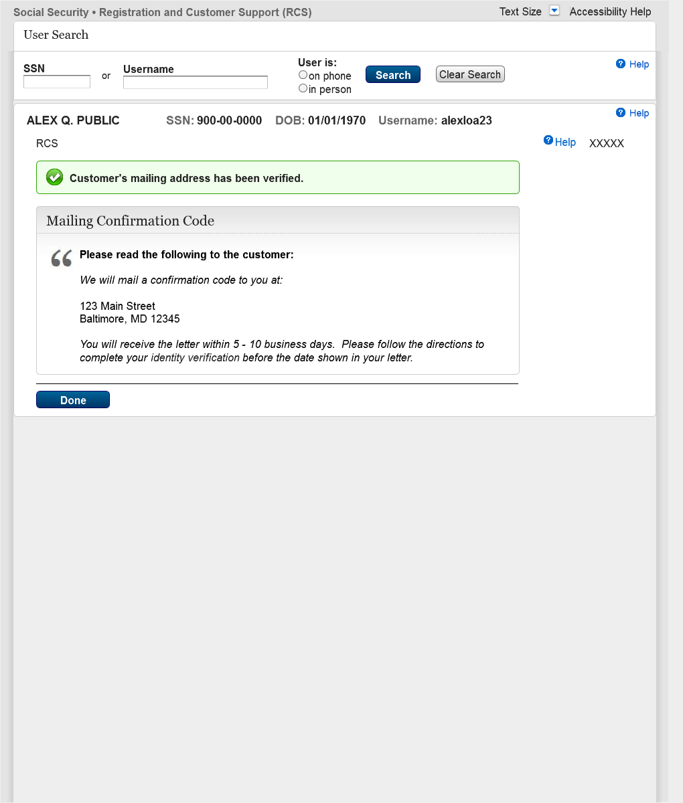

- Final Confirmation - ACC Code Matches SSA Records
This page is displayed when the confirmation code matches.
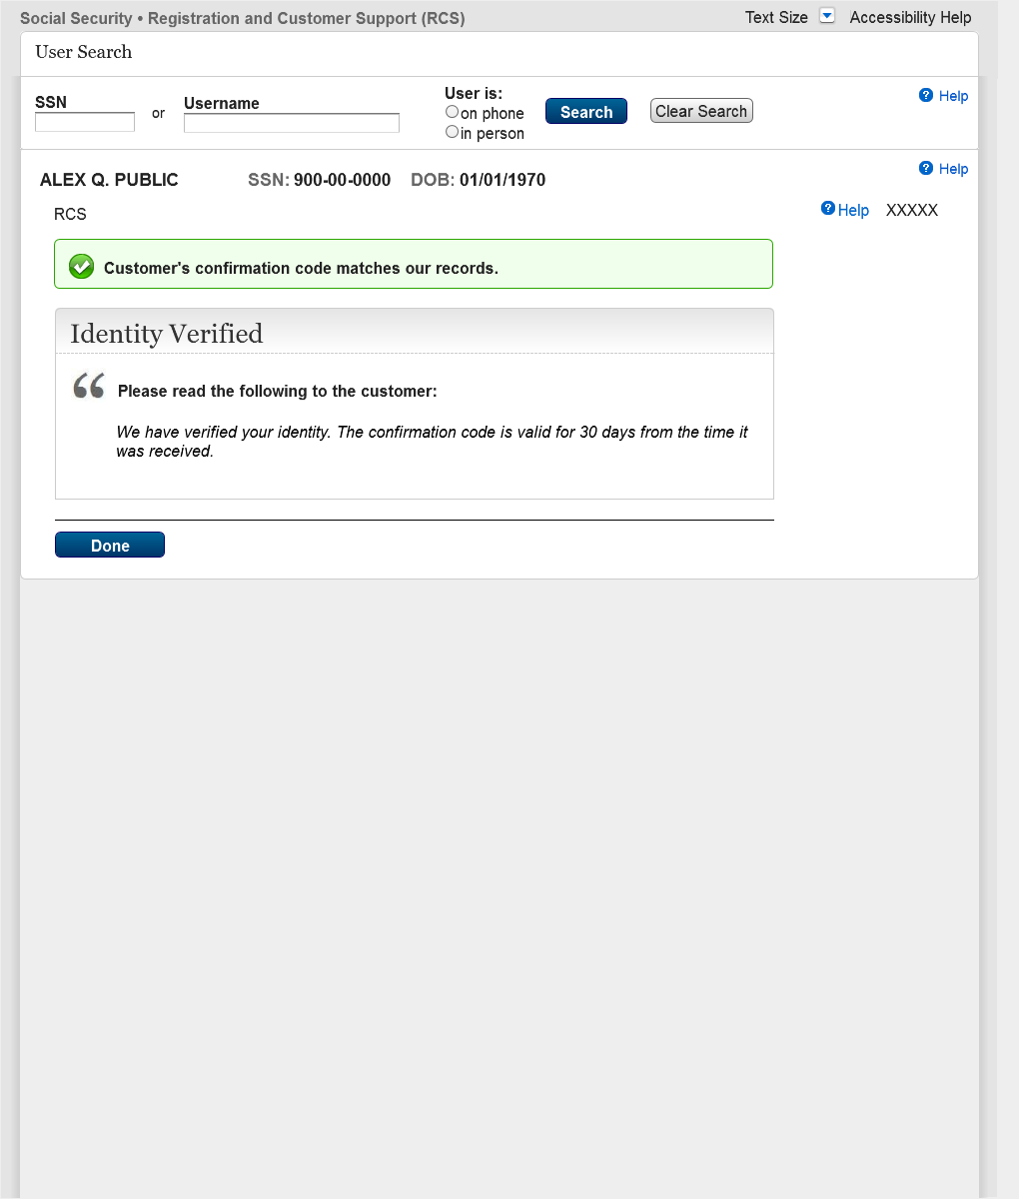
- Cancel Code
This page is displayed when user wants to cancel confirmation code.
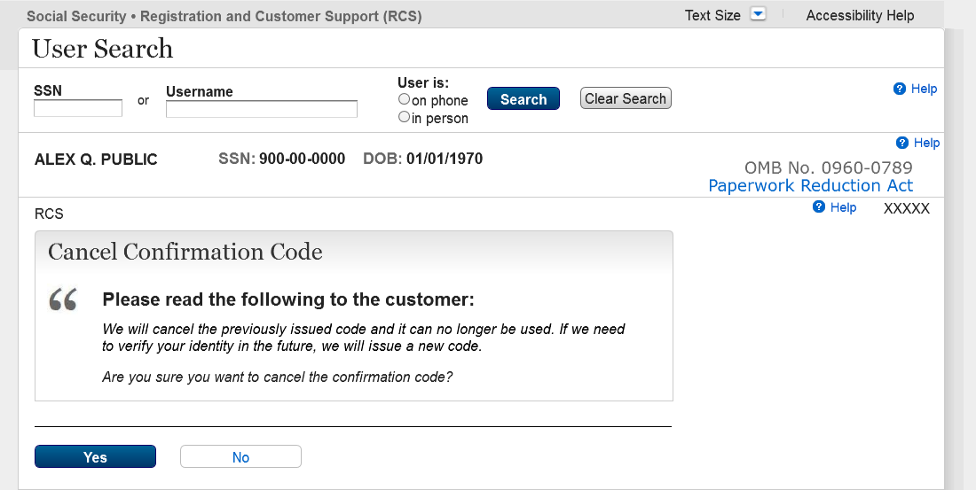

- Cancel Code – Confirmation
This page is displayed when confirmation code is cancelled.
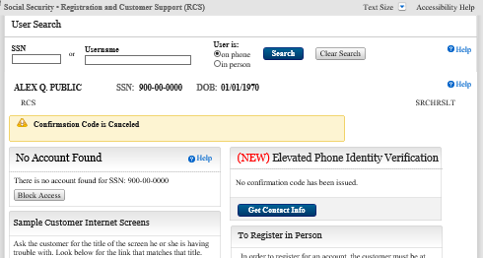

- Search Results with No Active Account, On-Phone SSN with No Code
This page is displayed when there is no active account, and no confirmation code has been sent.
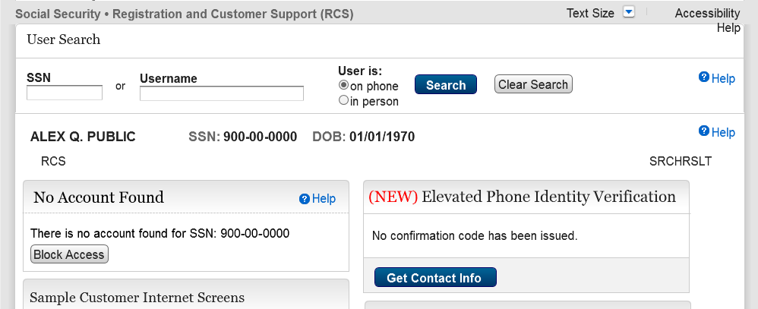

- Search Results with No Active Account, On-Phone with Active Code
This page is displayed when there is no active account, but confirmation code has been sent.
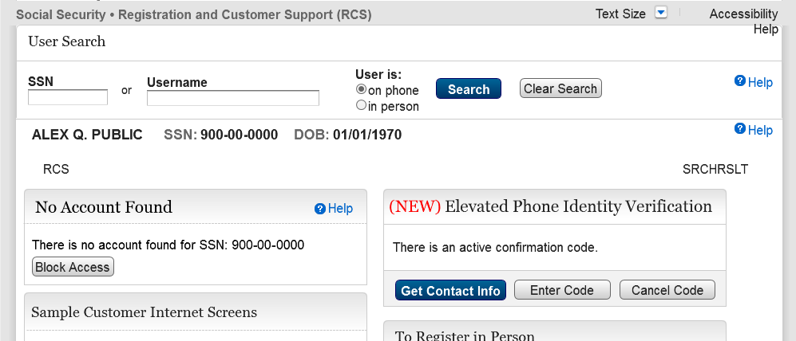
- Search Results with No Active Account, OnPhone, search by Username
This page is displayed when username is not returned, and no confirmation code has been sent.
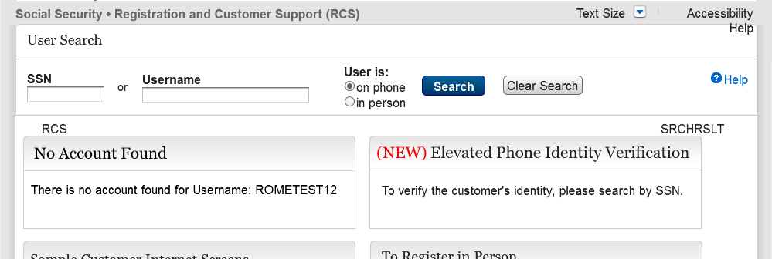

- ACMGMT - Standard Account Summary Page, On-Phone with No Code
This page is displayed when user with an account can request a confirmation code.
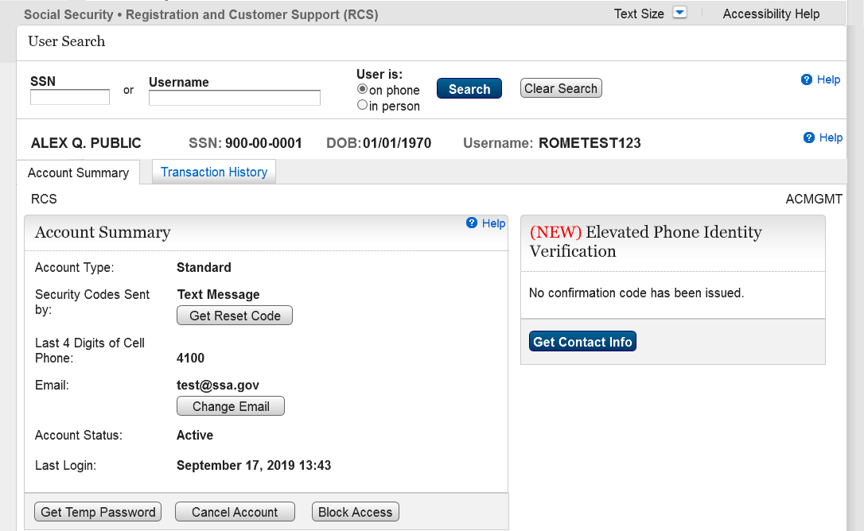

- ACMGMT - Standard Account Summary Page, On-Phones with Expired Code
This page is displayed when user with an account can request a confirmation code.
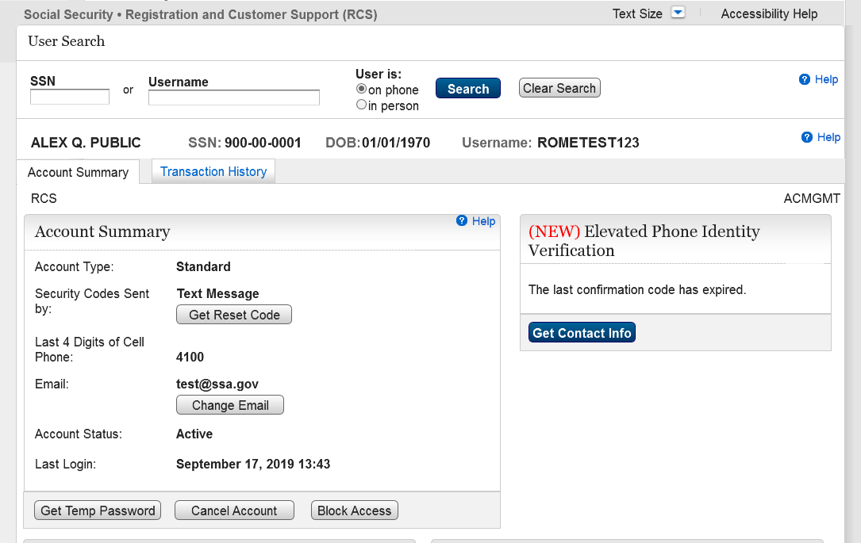

- Search Results with No Active Account, In-Person SSN with Active Code
This page is displayed when user in person can cancel code.
