ATTACHMENT 1
CLASSROOM/HOME VISITOR SAMPLING FORM FROM Early Head Start STAFF

NOTE: For each selected center, a member of the Baby FACES study team will request a list of all classrooms and an indication of the classrooms that include at least one child funded fully or partially by Early Head Start (EHS), (including EHS, EHS Expansion, and EHS-CC Partnership funds) from EHS staff (typically the On-Site Coordinator or center director). The attached classroom sampling form (table 1) is an example of the information required for classroom sampling. A member of the Baby FACES team will also request a list of all EHS home visitors in the program. Table 2 in the attached form is an example of the information required for selecting home visitors. EHS staff may provide this information in various formats such as print outs from an administrative record system or photocopies of hard copy list or records. Therefore, EHS staff will not physically fill out the attached classroom sampling form. The study team member will data enter the information into a computer.

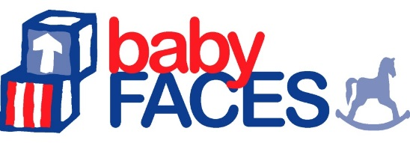
BABY FACES 2020
CLASSROOM/HOME VISITOR SAMPLING FORM

Program: [EHS Program] | Center selected for child-level sampling? Yes / No
Center: [Center Name]
Center Phone: [Phone #]
INSTRUCTIONS: Please enter into the sampling website the information below for each classroom in this center.
Table 1.
 | CLASSROOMS
 |  |  |  |  |  |  | Selected Classrooms Only
 | A | B | C | D | E | F | G | H |  |  | I
 | Lead Teacher  First Name Last Name | Classroom Type  (Select Only One)  Part Day AM,  Part Day PM, Full Day,  Dual Session | Total number of children enrolled | Number of enrolled children funded fully or partially by EHS | Is this an infant classroom, a toddler classroom, or a mixed classroom?  I = all younger than 15 months  T = all 15 months or older  M= children both younger and older than 15 months | Check box if selected | Check box if any Spanish instruction | Class Start Time |  |  | Class End Time
1
2
3
4
5
6
7
INSTRUCTIONS: Please enter into the sampling website the information below for each home visitor caseload that contains at least one EHS funded child.
Table 2.
 |  | HOME VISITORS
 | A |  | B | C | D | E
 | Home Visitor  First Name Last Name |  | Indicate if HV serves children only (C), pregnant women only (P),  or a mix (M) | Total number of families enrolled | Number of EHS-funded families in caseload | Check box if HV selected for study
1
2
3
4
5
6
7
8
9

This collection of information is voluntary and will be used to describe the characteristics of children and families served by Early Head Start, and the characteristics and features of programs and staff that serve them. Public reporting burden for this collection of information is estimated to average 10 minutes per response, including the time for reviewing instructions, gathering and maintaining the data needed, and reviewing the collection of information. An agency may not conduct or sponsor, and a person is not required to respond to, a collection of information unless it displays a currently valid OMB control number. The OMB number for this information collection is 0970-0354 and the expiration date is XX/XX/XXXX.

