Instrument 6 - Providers Discussion Guide
Communications Focus Groups for Remaking the Safety Net
Paperwork Reduction Act of 1995 (Pub. L. 104-13) STATEMENT OF PUBLIC BURDEN: Through this information collection, ACF is gathering information to provide constituent research designed to understand target audiences with experience with economic and social safety net programming. The focus group and research will help identify experiences and perception of participants, and identify ways for the Office of Family Assistance (OFA) to produce communications messaging about safety net programming in a clear and resonant manner. The focus group will assist the program office in; (1) gathering feedback on safety net programming, (2) creating resonant communications messages, and (3) identifying trustworthy and relevant channels for communication with program service providers and beneficiaries. Public reporting for this collection of information is estimated to average 2 hours per respondent, including time for reviewing instructions, gathering and maintaining the data needed, and reviewing the collection of information. This collection of information is not required to retain a benefit. An agency may not conduct or sponsor, and a person is not required to respond to, a collection of information subject to the requirements of the Paperwork Reduction Act of 1995, unless it displays a currently valid OMB control number. The OMB # for this collection is 0970-0531 and the expiration date is 7/31/2022. If you have any comments on this collection of information, please contact Lizeth Hester, Program Specialist, Training and Technical Assistance - Office of Family Assistance, Lizeth.Hester@acf.hhs.gov (202) 205-8283.

INTRODUCTION (5 Minutes)
[MODERATOR INTRODUCES THEMSELVES AND BRIEFS PARTICIPANT AS TO PURPOSE AND MANNER OF ONLINE FOCUS GROUP. INFORM PARTICIPANTS THE DISCUSSION IS RECORDED FOR THE PURPOSE OF DEVELOPING A REPORT AND OTHER RESEARCHERS ARE CURRENTLY OBSERVING THE GROUP. INFORM PARTICIPANTS THAT THE GROUP IS PART OF A PROJECT OF THE FEDERAL GOVERNMENT, AND THAT THEIR RESPONSES WILL IN NO WAY IMPACT THEIR ORGANIZATION’S ELIGIBILITY FOR GRANTS, CONTRACTS, ETC. ALL INFORMATION DISCUSSED WILL BE KEPT CONFIDENTIAL AND NOT TIED BACK TO THEM INDIVIDUALLY. REMIND PARTICIPANTS THAT INFORMATION DISCUSSED IN THE SESSION SHOULD NOT BE DISCUSSED WITH ANYONE AFTER THE FOCUS GROUP].
Thank you for joining me today. We are going to spend our time together today talking about your experiences working with clients in need of your professional assistance and aid, whether financial aid, rehabilitation, or some other form of support like housing support, employment, child welfare assistance, etc. As a part of our discussion we will discuss the current Safety Net resources offered by the government, your role in administering resources or supporting client groups who are utilizing these resources, and how you see these resources impacting your clients’ lives.
Additionally, I will also share some new ideas with you and get your feedback on them.
These new ideas are in the process of development. That said part of the goal of our time together today is to understand how you perceive these ideas and discuss any adjustments you might make to them.
Before we dive in, let’s begin with a round of introductions. Tell me a little about who you are, what your job title is, and what you enjoy most about your job.

EXPERIENCES PROVIDING SAFETY NET PROGRAMS (15 minutes)
Thank you for sharing a bit about yourself with the group. It’s nice to meet each of you! Let’s talk some about your experience working with clients.
- Tell me what it is like to provide services and support to your clients. [PROBE FOR DAY-TO-DAY EXPERIENCE AND EMOTIONAL REACTIONS]
- What is the biggest challenge you face while providing support or care to your clients?
  - [PROBE]: How would you resolve this challenge if it were up to you?
- Are existing support services, whether government-sponsored or community-driven, sufficient in helping your client(s) overcome challenges and become independent and financially secure? Why or why not?
  - [IF NO, PROBE]: What specific services or support structures need to change?
- In an ideal world, how would you ensure your clients overcome challenges and achieve long-term independence or success?

MeSSAGE MAP TESTING [35 MINUTES)
Next, I want to share some concepts and ideas with you. They are strategies or points of view that could guide how government and organizations can partner to help people succeed.

[READ RSN DESCRIPTOR:]
This project is about a new government effort called Remaking the Safety Net. The safety net is made up of more than 80 distinct government programs, totaling more than $1 trillion in benefits, goods, and services. But these programs are uncoordinated, and too often fail to help people achieve independence. Remaking the Safety net envisions a system that is designed and operated so it helps people grow their capacity to the point they no longer need safety net programs.

- Based on what I have shared, in your opinion, what is the “safety net?”
- What does “remaking the safety net” mean to you?
- Do these statements ring true to you? Why or why not?

Next, I am going to share some specific messages for “Remaking the Safety Net.” The first message is the foundation or core of the strategy. It is a mission statement of sorts.

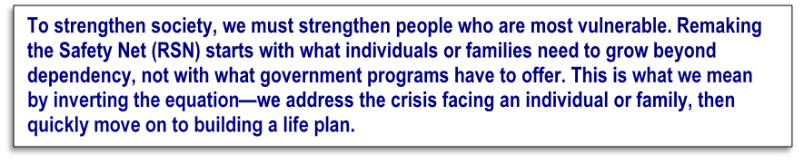

- What does this statement mean to you?
- What do you like/dislike/find confusing about this statement?
- Is this different than how you see the safety net currently operating? Why or why not?
[PROBE FOR UNDERSTANDING OF SPECIFIC TERMS]:
- Is it important to “remake” the safety net? Why or why not? What barriers exist to remaking the safety net?
- What impact do you think these ideas would have on your clients?
- [PROBE:] How might it change their current experiences with the safety net?
- What is missing from this statement if anything?
Now I would like to share some other parts of this new strategy with you. There are seven (7) parts of this concept. I will give you a few minutes to read through each concept before moving on to the next.
[SHOW REMAINING MESSAGE MAP COMPONENTS ON SCREEN ONE AT A TIME. AFTER SHOWING EACH NEW IDEA, ASK]:
- What does this mean to you? What is this idea communicating?
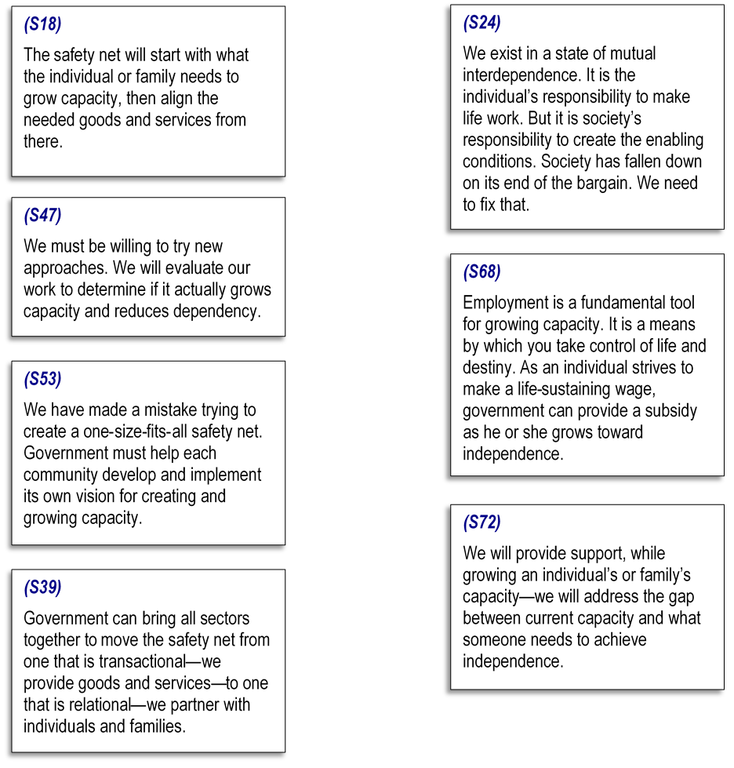
Ok, great! After reading through these ideas tell me…
- What stands out to you most?
- What is being communicated here? What is the overall message?
  - [PROBE FOR CLARITY IN COMMUNICATIONS—HOW ARE THEY INTERPRETING THE MESSAGE AND DOES THAT MIRROR ITS INTENDED PURPOSE]
- Is this message relevant to you/your organization? Why or why not?
- Think about the goals you/your organization have for your clients’ future. Would putting these ideas into action help or hinder those goals? Why?
- Are there any ideas presented that ring true? That you agree with? Are there any you do not agree with or seem unrealistic?
- Do these ideas sound different than your experience with the safety net as it exists today?
- [S47 PROBE]: Do you believe it is time to try “new approaches” to help your clients and people like your clients? Why or why not?
    - What might this look like? How would you determine its success?
- [S39 PROBE]: This statement says government can unite all sectors to move from a system that is transactional to one that is relational, to create a partnership with individuals and families. What does this mean to you?
- Do your clients feel they are in a partnership with the government and/or community programs they work with? If YES, can you briefly explain what that partnership looks like? If NO, is a partnership a reasonable goal—and what might it look like?
- [S72 PROBE]: What does it mean to grow an individual’s or family’s capacity? How do we address the gap between current capacity and what someone needs to achieve independence?
Now that you have had a few minutes to review these statements, I want you to do an activity with me. Ideally, you will need a sheet of paper and pen or you could also use the notes function on your phone or MS Word on your computer, whatever works best for you.
- First, take a few minutes to review the statements again…
  - First, write down a few phrases or ideas from these statements you really like. If there are no phrases or ideas you like, do not write down anything at all.
  - Next, is there anything you dislike? Write down any phrases or ideas you dislike.
  - Finally, is there anything you find confusing or need more information to understand it better? Write down these phrases or ideas.
Thank you for writing down all those phrases and ideas for me…
- What did you like/dislike/find confusing? Why?
Ok, just a few more questions to wrap up our review of these ideas…
- Is this different from how you see the safety net currently operating? Why or why not?
- Think back to your current role supporting clients and the challenges they face. Would putting these ideas into action help your clients solve some of their current problems? What about in the future/long-term?

“DESIGN A SAFETY NET” CREATIVE EXERCISE (20 Minutes)
So far, I have shared some messaging for a new way of thinking about helping your clients and others experiencing hardships achieve independence. But of course, these are only ideas in an early phase of development. It may not be exactly what you envision to better help your clients achieve ultimate success.
For this exercise, take a few minutes to think about what you feel your clients need most. How would you remake the safety net? This is not a time to hold back. I want to know exactly what has to happen to make the safety net work better—money, time, legislative hurdles, or other restrictions do not apply right now.
Take a few moments to write down how you would Remake the Safety Net. Think about:
- How can government or community programs do a better job of helping people grow out of dependency?
- What programs might work together to better support clients? What services would they offer? How might they work together?
- You are in charge—what is the biggest change you would make to government or community programs so that they do a better job for people like your clients? It could be program changes, policy changes, whatever you think needs to be done differently.
- What messaging would exist around these new ideas to get your clients on board?
[GO AROUND GROUP TO SHARE IDEAS]
Thank you for sharing these ideas. They are very useful to us and may help further shape the ideas behind this new approach to the safety net.

SAFETY NET STRATEGY AND IDEATION RECAP (5 minutes)
Let us wrap up our discussion…
- Based on all that we have discussed today, what is your opinion of the “Remaking the Safety Net” strategy and the ideas included in it?
- In what specific areas of the existing system do you see this new strategy helping most?
  - What are the biggest benefits of a new approach like this?
- If changes like this were made to Safety Net resources, how would you learn about them? [PROBE FOR SPECIFIC MESSAGING SOURCES SUCH AS EMAIL/NEWSLETTER, DEDICATED WEBSITE, EDUCATIONAL PROGRAMS (SUCH AS SEMINARS), EDUCATIONAL MATERIALS, PROFESSIONAL ASSOCIATION, ETC.]
- What would help you spread the word to colleagues and clients about this new way of thinking about the safety net?
- If changes like these were made, what resources would you want made available to you to share with your clients?
- Is there anything else you would like to share with us today about existing government support programs or the “Remaking the Safety Net” strategy?

CLOSING
[THANK PARTICIPANTS, EXIT INSTRUCTIONS] [END FILMING/RECORDING]

