Strengthening Our Circle
September 2020

Top Updates
- Grantee Glance: As mentioned on the Monthly Call ANA is creating short surveys to gain more information from grantees in order to better understand and meet the needs of our grantees. The purpose of this month’s survey is to provide ANA with information on best practices combating COVID-19 and adapting and potential visits by ANA staff. Your participation is voluntary, and the information provided will be kept private. Here is a link to the survey.
- Closeout Procedure: Projects ending in September, 2020 will have to complete several programmatic and financial reports for their closeout. As a reminder, the final OPR semi-annual report is due no later than 30 days after the end of the project period, and the Annual Data Report (ADR) is due no later than 90 days after the end of the project period. The second semi-annual Financial Status Report is due 30 days after the end of the project period and the final SF-425 financial report is due 90 days after the end of the project. If you purchased equipment for your project, you must also file an SF-428, Tangible Personal Property Report. Please look out for any closeout correspondence from your program specialist.
- No Cost Extensions (NCE): Grantees that anticipate an extension to their project after their closeout date may request an NCE. This allows grantees up to 12 months to complete incomplete activities with their remaining funds. Please reach out to your program specialist to receive more information on how to request and submit an NCE. The NCE due date for 9/30 grantees is August 14.
- OPR Update: As a reminder, grantees funded in FY2018 or after should use the OPR awarded 2018+ form found in the OLDC.
- Training and Technical Assistance (TTA): All ANA grantees are entitled to TTA free of charge. Technical Assistance is available to grantees to help you address project challenges, navigate the amendment process, and manage your community-based projects. During the public health emergency, all TTA services will be available electronically. For more information on TTA, please reach out to your program specialist. Currently all TTA is being provided electronically.
- Grantee Volunteers Wanted: ANA is proud of all the hard work that our grantees are doing in their communities and would like to feature a grantee during the Commissioner’s Monthly Grantee Call. We need a volunteer for the month of September. ANA will provide a template to help grantees to prepare for the verbal presentation which will be no longer than 5-10 minutes. Please contact your Program Specialist if you would like to present during a future ANA Grantee Call.

News & Opportunities
- Grant Opportunity: The Bureau of Indian Affairs announced that the Office of Indian Energy and Economic Development (IEED) is soliciting applications to the Living Languages Grant Program (LLGP). This $3 Million grant program will fund between 15 and 60 grants, ranging from $25,000-$200,000, to federally recognized American Indian tribes and Alaska Native entities to document, preserve and revitalize Native languages and build active speaker capacity. Applications will be accepted until 11:59 p.m. ET on August 24, 2020. IEED’s solicitation for LLGP funding and details on how to apply can be found in the Federal Register and at Grants.Gov.
- Grant Opportunity: The Department of Education is issuing a notice inviting applications for new awards for fiscal year (FY) 2020 for Indian Education Discretionary Grants Programs. The purposes of this program are to (1) support schools that use Native American and Alaska Native languages as the primary language of instruction; (2) maintain, protect, and promote the rights and freedom of Native Americans and Alaska Natives to use, practice, maintain, and revitalize their languages, as envisioned in the Native American Languages Act of 1990 (25 U.S.C. 2901, et seq.); and (3) support the Nation's First Peoples' efforts to maintain and revitalize their languages and cultures, and to improve educational opportunities and student outcomes within Native American and Alaska Native communities. Please see the Federal Register and the announcement at Grants.Gov. The deadline for this funding opportunity is August 28, 2020.
- Grantee Highlights: Please send any project highlights, milestones, event photos, or media coverage to your assigned Program Specialist so ANA can tweet, share on our Facebook and/or blog about them. Please be sure you include the signed photo release waiver. Follow ANA’s Twitter @ANA_ACFgov and our Facebook account, @Administration for Native Americans - ANA.

Upcoming Reports
Report Name | Type of Report | Reporting Period | Report Due Date | Where to Submit
OPR* | Objective Progress Report | Semi-Annually | 9/30 Grantees were due 5/30, 7/1 Grantees were due 7/30 | Online Data Collection (OLDC) Please note grantees funded in FY18 and after, should use the OPR for 2018+
Quarterly SF-425 (FCTR)* | Federal Cash Transaction Report | Quarterly | All Grantees: 1/30, 4/30, 7/30 and 10/30 | Payment Management System (PMS)
Semi-Annual SF-425 | Federal Financial Report | Semi-Annually | 9/30 Grantees: were due 5/30, 7/1 Grantees: were due 7/30 | If awarded after 2016, submit to PMS. If awarded earlier, then submit as a Grant Note in Grant Solutions
*If you received a 2019 ANA award, you will not be required to report your first Semi-Annual OPR until 6 months into the project. You will have to complete the Quarterly SF-425 Federal Cash Transaction Report (FCTR) in the Payment Management System (PMS).
For more information on reporting requirements, please visit our Reporting Requirements page.

Commissioner’s Monthly Grantee Call
The last grantee call was held on July 28, 2020. We wish to acknowledge thank all who participated! We would also like to thank the Kula No Na Po’e Hawaii for volunteering to share their ANA funded project. So that we can acknowledge all participants, it is important to clearly pronounce the name of your organization and spell it out in order to be included in the call. If you were on the call, but your organization is not listed, please let us know. As a reminder, the monthly grantee call is held on the 4th Tuesday of every month at 3PM ET. Also, please let us know if you find the calls helpful, or contact your assigned Program Specialist if you need any clarification or wish to discuss any specific topic from the call.
Aaniiih Nakoda College
Alaska Native Justice Center
Aleutian Pribilof Islands Association
American Indian Family Center
American Indian Health and Family Services
American Indian Science and Engineering Society
Angoon Community Association
Aroostook Band of Micmacs
Bdote Learning Center
Bois Forte Tribal Government
Capacity Builders Incorporated
Cherokee Nation
Chippewa Cree Tribe
Choctaw Nation of Oklahoma
Clare Swan Early Learning Center
Confederated Northern Mariana Islands Public School Systems
Confederated Salish and Kootenai Tribes
Coquille Indian Tribe
Cow Creek Band of Umpqua Tribe of Indians
Eastern Shawnee Tribe of Oklahoma
Federated Indians of Graton Rancheria
Fond du Lac Reservation
Great Lakes Indian Fish and Wildlife Commission
Halua Hula O Ka’eo
Hālau Keʻalaokamaile
Hawaiian Community Assets
High Bridge Area Chambers of Commerce
INPEACE
Ka'ehu
Kai Loa Incorporated
Kanehunamoku Voyaging Academy
Keres Children’s Learning Center
Ketchikan Indian Community
Kiowa Tribe
Kula No Na Po'e Hawaii
Little Traverse Band of Odawa Indians
Lower Elwha K'lallam Tribe
Native American Youth and Family Center
Michigan Indian Legal Services
Migizi Communications
National Women's Indian Health Resource Center
Native American Connections
Native American Indian Center of Central Ohio
Native Pride
Northwest Portland Area Indian Health Board
Ohkay Owingeh Tribal Administration
Ohogamiut Traditional Council
Oklahoma Native Assets Coalition
Papahana Kuaola
Para I Probechu’n I Taotao-Ta
Partners in Development Foundation
Pascua Yaqui Tribe
Riverside San Bernardino County Indian Health
Rural America Initiatives
Salish Kootenai College
San Carlos Apache Language Preservation
Sanctuary Incorporated
Spokane Tribe of Indians
Sun’aq Tribe of Kodiak
Sustainable Molokai
Thlopthlocco Tribal Town
Tolowa Dee-ni' Nation
Tunica-Biloxi Tribe
Turtle Mountain Community College
Waadookodading
White Mountain Apache Tribe
Wopanaak Language Reclamation Project

Upcoming ANA Events
The 2020 HHS Annual Regional Tribal Consultation sessions will be virtual this year. These sessions are designed to provide Tribal leaders with the opportunity to address HHS on how the Department can improve Tribal outreach and coordination and to discuss programmatic and policy issues and concerns with Tribes. Please see below for the dates for each respective consultation session:

- August 18, 2020: Region 10
- August 26, 2020: Region 4
- August 27, 2020: Region 2
- September 1, 2020: Region 1

Details, points of contact, and draft agendas can be found at the registration link . In addition, we ask that if Tribal leaders are sending a representative to speak on their behalf at either session(s), they must provide a letter of delegation. These letters can be uploaded at the time of registration. In addition, please do not hesitate to contact Consultation@hhs.gov with any questions. We look forward to seeing you at these session(s).

Tip of the Month

Filling out the SF-424A

The SF-424A is a common financial form that grantees will complete during the course of their ANA project. The SF-424A differs from the SF-424 in that it gives more information on how the federal and non-federal shares are broken down into categories. While the form looks like a lot of work, this example from our Grants Management Toolkit is a great reference:
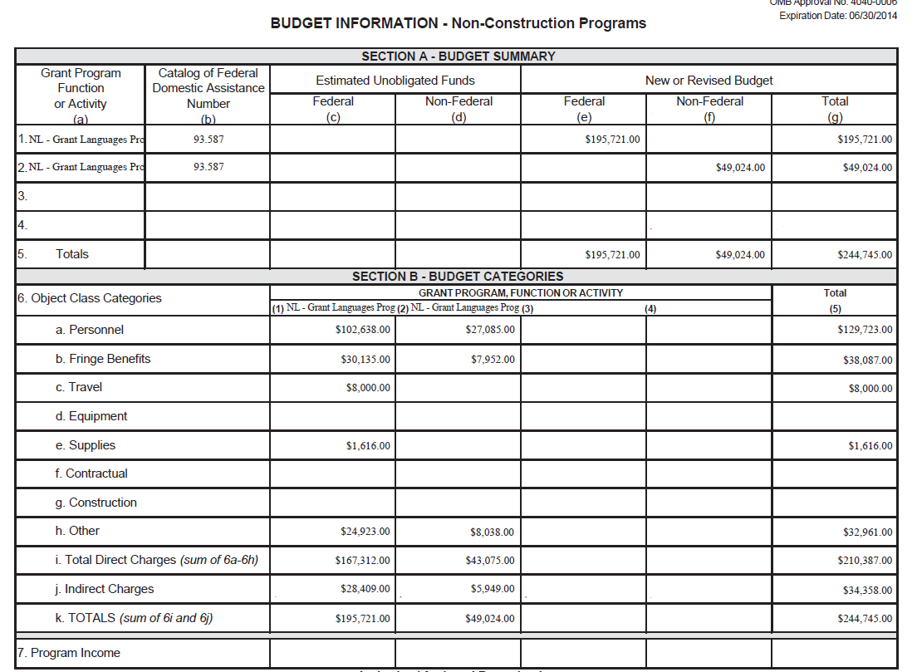

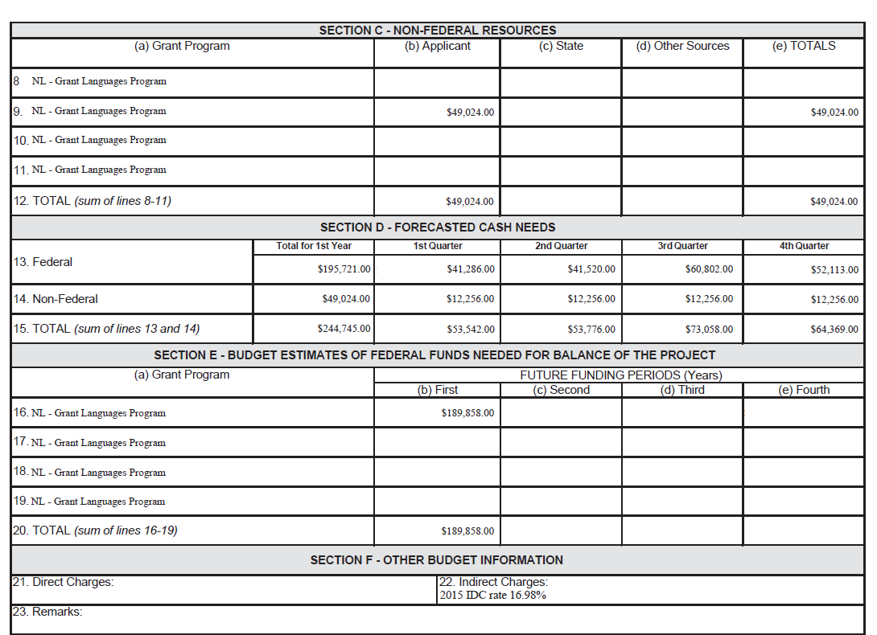

Questions?
If you are running into problems or have any questions regarding your project, reporting requirements, or are experiencing technical issues, please contact your Program Specialist, Grant Management Specialist, and/or your Training and Technical Assistance Provider. Each person is only a phone call away. We are happy to help.
*If you have a question about anything contained in the message above, please contact your program specialist directly.

