*NATIONAL CENTER FOR EDUCATION STATISTICS NATIONAL ASSESSMENT OF EDUCATIONAL PROGRESS*

*National Assessment of Educational Progress (NAEP)*

*2021*

*Appendix J1*

*2021 Student Questionnaires*

*OMB# 1850-0928 v.20*



June 2020

Table of Contents

Student Questionnaires

**Student Login Screen** 3

**Appendix J1-1**: Summary of Changes Operational Grade 4 CORE 4

**Appendix J1-2**: Operational Grade 4 CORE 8

**Appendix J1-3**: Summary of Changes Operational Grade 8 CORE 12

**Appendix J1-4**: Operational Grade 8 CORE 18

**Appendix J1-5**: Summary of Changes Operational Grade 4 Mathematics 25

**Appendix J1-6**: Operational Grade 4 Mathematics 31

**Appendix J1-7**: Summary of Changes Operational Grade 8 Mathematics 35

**Appendix J1-8**: Operational Grade 8 Mathematics 42

**Appendix J1-9**: Summary of Changes Operational Grade 4 Reading 48

**Appendix J1-10**: Operational Grade 4 Reading 52

**Appendix J1-11**: Summary of Changes Operational Grade 8 Reading 57

**Appendix J1-12**: Operational Grade 8 Reading 63

**Appendix J1-13**: Summary of Changes Operational Grade 8 Civics 69

**Appendix J1-14**: Operational Grade 8 Civics 76

**Appendix J1-15**: Summary of Changes Operational Grade 8 US History 83

**Appendix J1-16**: Operational Grade 8 US History 90

**Appendix J1-17**: Summary of Operational Grade 4 Debrief 97

**Appendix J1-18**: Operational Grade 4 Debrief 98

**Appendix J1-19**: Summary of Operational Grade 8 Debrief 99

**Appendix J1-20**: Operational Grade 8 Debrief 100

### **Student Login Screen**

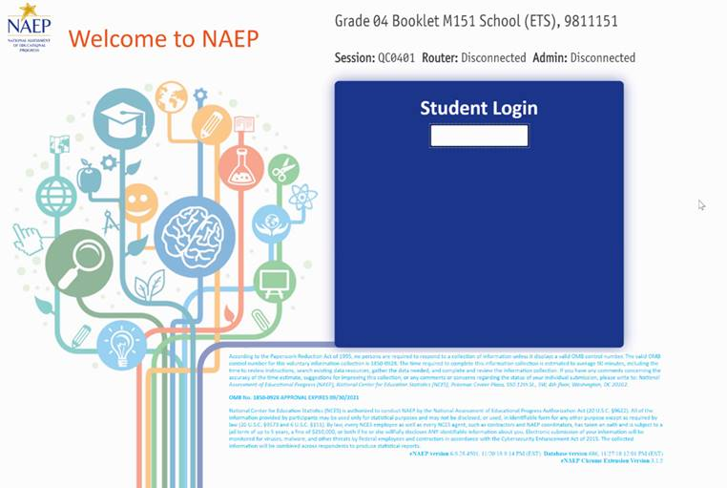

NOTE: The final version of the login screen was not available for this amendment and will be included in Amendment 2 scheduled to be submitted in October 2020. The Blue text will be revised with the updated language below.

According to the Paperwork Reduction Act of 1995, no persons are required to respond to a collection of information unless it displays a valid OMB control number. The valid OMB control number for this voluntary information collection is 1850-0928. The time required to complete this information collection is estimated to average 90 minutes, including the time to review instructions, search existing data resources, gather the data needed, and complete and review the information collection. If you have any comments concerning the accuracy of the time estimate, suggestions for improving this collection, or any comments or concerns regarding the status of your individual submission, please write to: *National Assessment of Educational Progress (NAEP), National Center for Education Statistics (NCES), Potomac Center Plaza, 550 12th St., SW, 4th floor, Washington, DC 20202.*

**OMB No. 1850-0928 APPROVAL EXPIRES 4/30/2023**

National Center for Education Statistics (NCES) is authorized to conduct NAEP by the National Assessment of Educational Progress Authorization Act (20 U.S.C. §9622)and to collect students’ education records from education agencies or institutions for the purposes of evaluating federally supported education programs under the Family Educational Rights and Privacy Act (FERPA, 34 CFR §§ 99.31(a)(3)(iii) and 99.35). All of the information provided by participants may be used only for statistical purposes and may not be disclosed, or used, in identifiable form for any other purpose except as required by law (20 U.S.C. §9573 and 6 U.S.C. §151). By law, every NCES employee as well as every NCES agent, such as contractors and NAEP coordinators, has taken an oath and is subject to a jail term of up to 5 years, a fine of $250,000, or both if he or she willfully discloses ANY identifiable information about you. Electronic submission of your information will be monitored for viruses, malware, and other threats by Federal employees and contractors in accordance with the Cybersecurity Enhancement Act of 2015. The collected information will be combined across respondents to produce statistical reports.

### **Appendix J1-1**: Summary of Changes Operational Grade 4 CORE

|  |  |  |  |
| --- | --- | --- | --- |
| **2021 Operational Grade 4 Core Student** | | | |
| **Previous item** | **2021 item** | **D/A/ R/NC+** | **Rationale** |
| (2019 Grade 4) | **Issue:** Race/Ethnicity | NC | N/A |
| (2019 Grade 4) | **Issue:** Race/Ethnicity | NC | N/A |
| (2019 Grade 4) | **Issue:** Socioeconomic Status | NC | N/A |

|  |  |  |  |
| --- | --- | --- | --- |
| **2021 Operational Grade 4 Core Student** | | | |
| **Previous item** | **2021 item** | **D/A/ R/NC+** | **Rationale** |
| (2019 Grade 4) | **Issue:** Socioeconomic Status | R | To keep student burden low, sub-items b and e were dropped. |
| (2019 Grade 4) | N/A | D | To keep student burden low, this item was dropped. |
| (2019 Grade 4) | **Issue:** School Climate | NC | N/A |
| (2019 Grade 4) | N/A | D | To keep student burden low, this item was dropped. |

|  |  |  |  |
| --- | --- | --- | --- |
| **2021 Operational Grade 4 Core Student** | | | |
| **Previous item** | **2021 item** | **D/A/ R/NC+** | **Rationale** |
| (2019 Grade 4) | **Issue:** Socioeconomic Status | NC | N/A |
| (2019 Grade 4) | **Issue:** Technology Use | NC | N/A |
| (2019 Grade 4) | N/A | D | To keep student burden low, this item was dropped. |

|  |  |  |  |
| --- | --- | --- | --- |
| **2021 Operational Grade 4 Core Student** | | | |
| **Previous item** | **2021 item** | **D/A/ R/NC+** | **Rationale** |
| (2019 Grade 4) | N/A | D | To keep student burden low, this item was dropped. |
| (2019 Grade 4) | **Issue:** Desire for Learning | NC | N/A |
| (2019 Grade 4) | **Issue:** Grit | NC | N/A |
|  | | | |
| **Previous item** | **2021 item** | **D/A/ R/NC+** | **Rationale** |
| (2019 Grade 4) | N/A | D | To keep student burden low, this item was dropped. |

### **Appendix J1-2**: Operational Grade 4 CORE

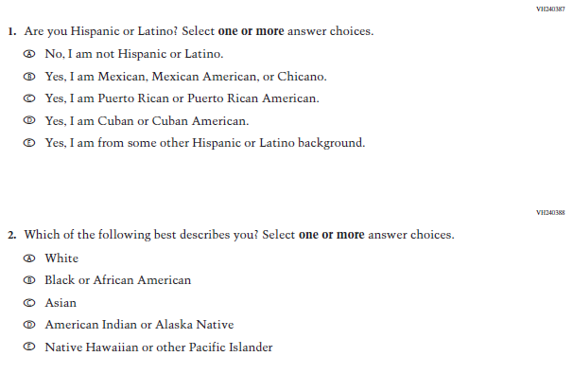

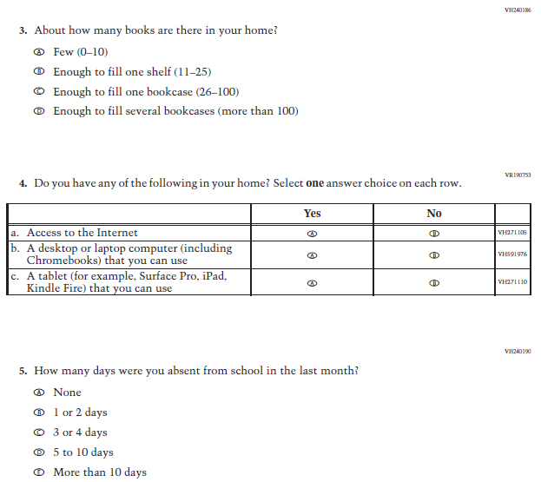

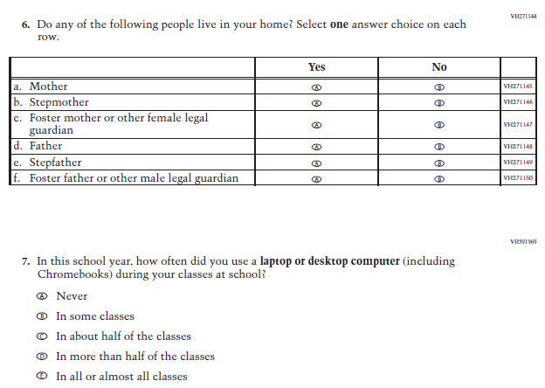

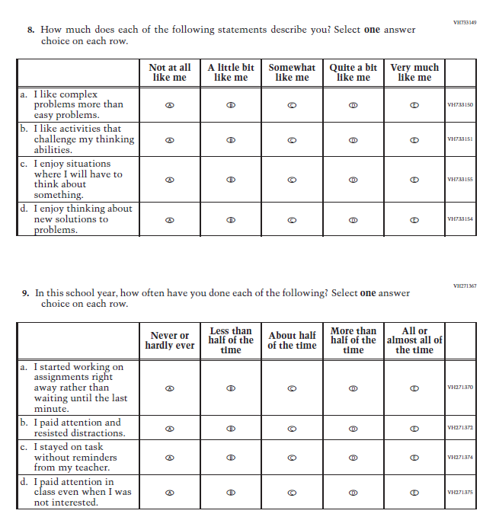

|  |  |  |  |
| --- | --- | --- | --- |
| **2021 Operational Grade 8 Core Student** | | | |
| **Previous item** | **2021 item** | **D/A/ R/NC+** | **Rationale** |
| (2019 Grade 8) | **Issue:** Race/Ethnicity | NC | N/A |
| (2019 Grade 8) | **Issue:** Race/Ethnicity | NC | N/A |
| (2019 Grade 8) | **Issue:** Socioeconomic Status | NC | N/A |

### **Appendix J1-3**: Summary of Changes Operational Grade 8 CORE

|  |  |  |  |
| --- | --- | --- | --- |
| **2021 Operational Grade 8 Core Student** | | | |
| **Previous item** | **2021 item** | **D/A/ R/NC+** | **Rationale** |
| (2019 Grade 8) | **Issue:** Socioeconomic Status | NC | N/A |
| (2019 Grade 8) | **Issue:** Technology Use | NC | N/A |
| (2019 Grade 8) | **Issue:** School Climate | NC | N/A |
| (2019 Grade 8) | **Issue:** Socioeconomic Status | NC | N/A |

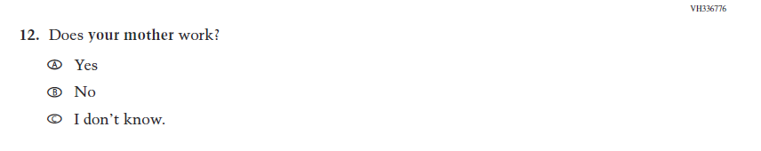

|  |  |  |  |
| --- | --- | --- | --- |
| **2021 Operational Grade 8 Core Student** | | | |
| **Previous item** | **2021 item** | **D/A/ R/NC+** | **Rationale** |
| (2019 Grade 8) | **Issue:** Socioeconomic Status | NC | N/A |
| (2019 Grade 8) | **Issue:** Socioeconomic Status | NC | N/A |
| (2019 Grade 8) | **Issue:** Socioeconomic Status | NC | N/A |
| (2019 Grade 8) | **Issue:** Socioeconomic Status | NC | N/A |

| **2021 Operational Grade 8 Core Student** | | | |
| --- | --- | --- | --- |
| **Previous item** | **2021 item** | **D/A/ R/NC+** | **Rationale** |
| (2019 Grade 8) | **Issue:** Socioeconomic Status | NC | N/A |
| (2019 Grade 8) | **Issue:** Technology Use | NC | N/A |
| (2019 Grade 8) | **Issue:** Technology Use | NC | N/A |
| (2019 Grade 8) | **Issue:** Grit | NC | N/A |
| (2019 Grade 8) | **Issue:** Desire for Learning | NC | N/A |
| (2019 Grade 8) | **Issue:** Grit | NC | N/A |
| (2019 Grade 8) | N/A | D | To keep student burden low, this item was dropped. |
| (2019 Grade 8) | **Issue:** Educational Experiences | NC | N/A |

### **Appendix J1-4**: Operational Grade 8 CORE

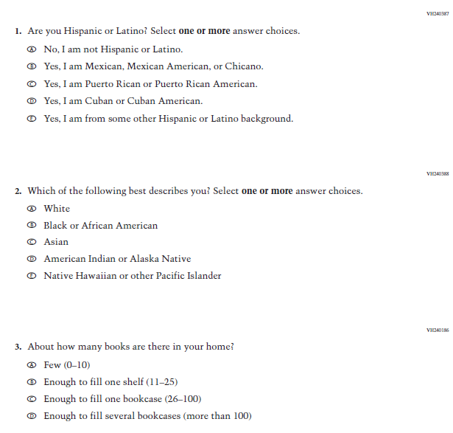

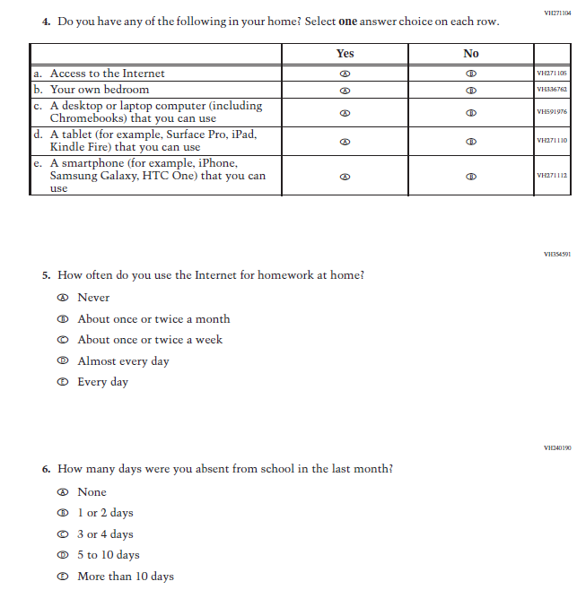

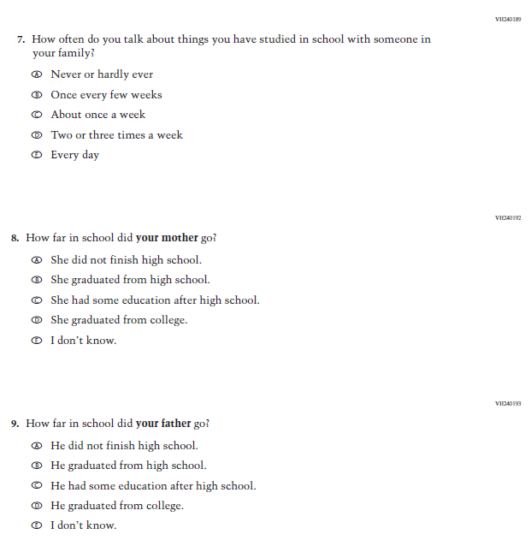

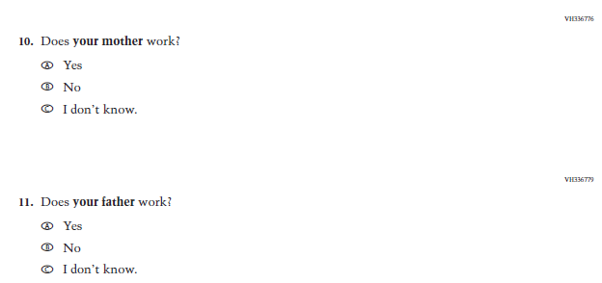

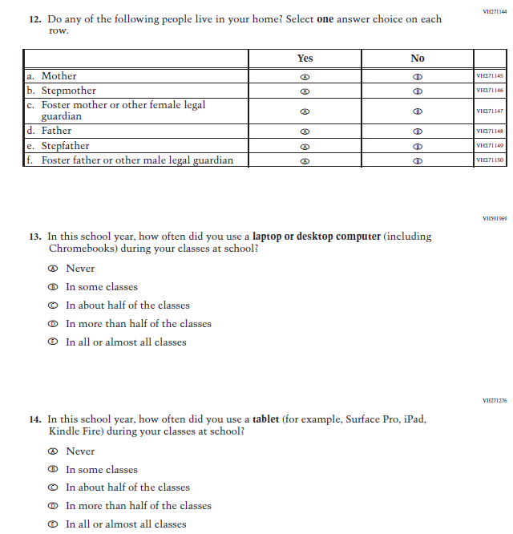

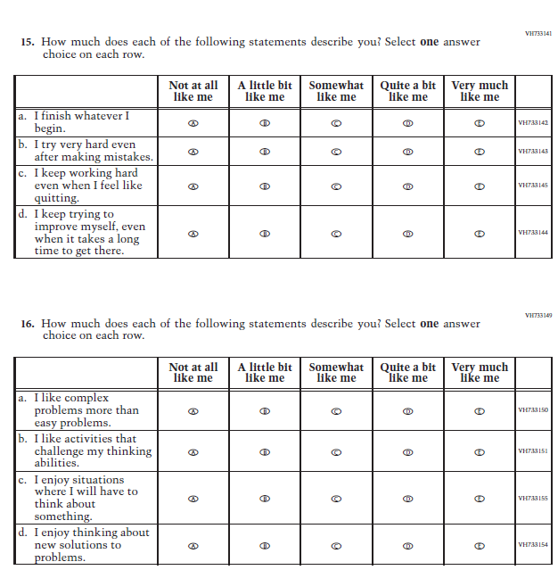

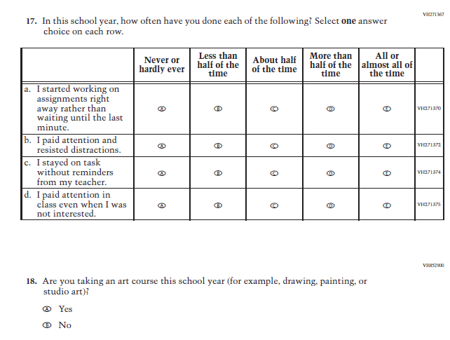

### **Appendix J1-5**: Summary of Changes Operational Grade 4 Mathematics

| **2021 Operational Grade 4 Mathematics Student** | | | |
| --- | --- | --- | --- |
| **Previous item** | **2021 item** | **D/A/ R/NC+** | **Rationale** |
| (2019 Grade 4) | **Issue:**  Organization of Instruction | NC | N/A |
| (2019 Grade 4) | **Issue:** Resources for Learning and Instruction | NC | N/A |
| ((2019 Grade 4) | **Issue:** Resources for Learning and Instruction | NC | N/A |
| (2019 Grade 4) | **Issue:** Resources for Learning and Instruction | NC | N/A |
| (2019 Grade 4) | **Issue:** Resources for Learning and Instruction | NC | N/A |
| (2019 Grade 4) | **Issue:**  Resources for Learning and Instruction | NC | N/A |
| (2019 Grade 4) | **Issue:** Resources for Learning and Instruction | NC | N/A |

|  |  |  |  |
| --- | --- | --- | --- |
| **2021 Operational Grade 4 Mathematics Student** | | | |
| **Previous item** | **2021 item** | **D/A/ R/NC+** | **Rationale** |
| (2019 Grade 4) | N/A | D | To keep student burden low, this item was dropped. |
| (2019 Grade 4) | N/A | D | To keep student burden low, this item was dropped. |
| (2019 Grade 4) | **Issue:** Student Factors | NC | N/A |

| **2021 Operational Grade 4 Mathematics Student** | | | |
| --- | --- | --- | --- |
| **Previous item** | **2021 item** | **D/A/ R/NC+** | **Rationale** |
| (2019 Grade 4) | N/A | D | To keep student burden low, this item was dropped. |
| (2019 Grade 4) | **Issue:** Student Factors | NC | N/A |

|  |  |  |  |
| --- | --- | --- | --- |
| **2021 Operational Grade 4 Mathematics Student** | | | |
| **Previous item** | **2021 item** | **D/A/ R/NC+** | **Rationale** |
| (2019 Grade 4) | **Issue:** Student Factors | NC | N/A |

### **Appendix J1-6**: Operational Grade 4 Mathematics

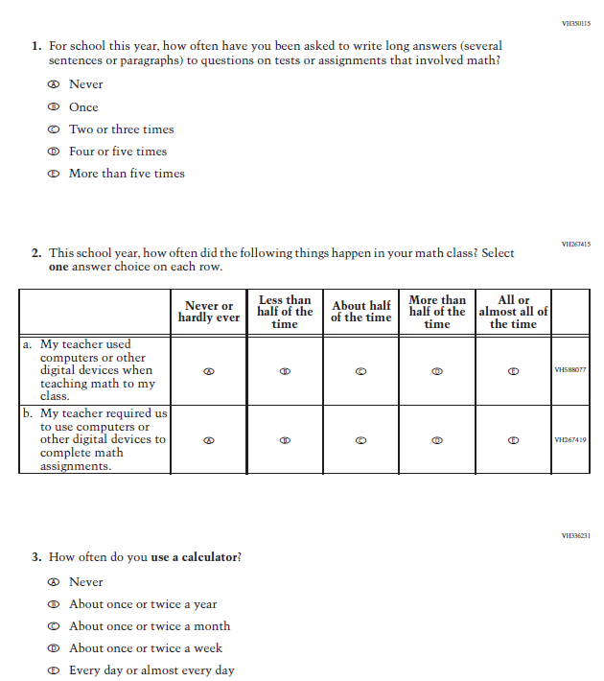

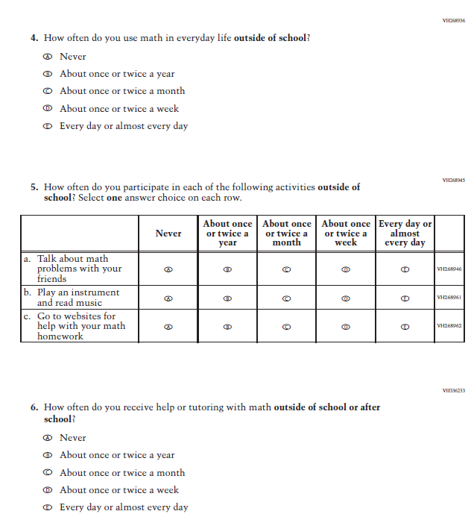

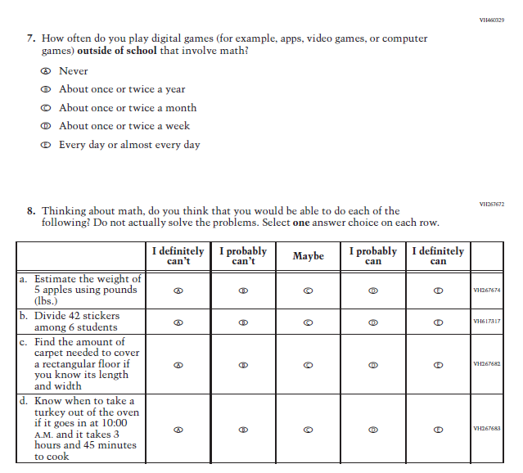

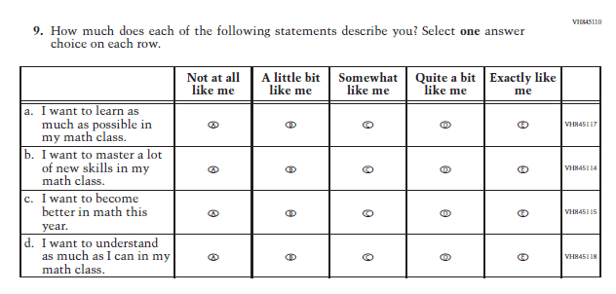

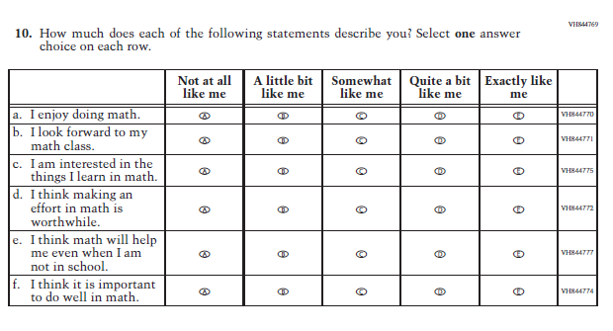

### **Appendix J1-7**: Summary of Changes Operational Grade 8 Mathematics

| **2021 Operational Grade 8 Mathematics Student** | | | |
| --- | --- | --- | --- |
| **Previous item** | **2021 item** | **D/A/ R/NC+** | **Rationale** |
| (2019 Grade 8) | **Issue:** Organization of Instruction | NC | N/A |
| (2019 Grade 8) | **Issue:** Organization of Instruction | NC | N/A |
| (2019 Grade 8) | **Issue:** Organization of Instruction | NC | N/A |

|  |  |  |  |
| --- | --- | --- | --- |
| **2021 Operational Grade 8 Mathematics Student** | | | |
| **Previous item** | **2021 item** | **D/A/ R/NC+** | **Rationale** |
| (2019 Grade 8) | **Issue:** Resources for Learning and Instruction | A: sub-item “b”  NC for SL and sub-items “a” and “c” | The “Scientific (not graphing) calculator” sub-item was dropped previously due to an oversight and is being reinstated to capture calculator features in mathematics as students progress from K to 12. |
| (2019 Grade 8) | **Issue:** Resources for Learning and Instruction | R | To keep student burden low, sub-items a and b were dropped. |

|  |  |  |  |
| --- | --- | --- | --- |
| **2021 Operational Grade 8 Mathematics Student** | | | |
| **Previous item** | **2021 item** | **D/A/ R/NC+** | **Rationale** |
| (2019 Grade 8) | N/A | D | To keep student burden low, this item has been dropped. |
| (2019 Grade 8) | **Issue:** Resources for Learning and Instruction | NC | N/A |
| (2019 Grade 8) | **Issue:** Resources for Learning and Instruction | NC | N/A |
| (2019 Grade 8) | **Issue:** Resources for Learning and Instruction | NC | N/A |

| **2021 Operational Grade 8 Mathematics Student** | | | |
| --- | --- | --- | --- |
| **Previous item** | **2021 item** | **D/A/ R/NC+** | **Rationale** |
| (2019 Grade 8) | N/A | D | To keep student burden low, this item was dropped. |
| (2019 Grade 8) | N/A | D | To keep student burden low, this item was dropped. |
| (2019 Grade 8) | N/A | D | To keep student burden low, this item was dropped. |
| (2019 Grade 8) | N/A | D | To keep student burden low, this item was dropped. |
| (2019 Grade 8) | **Issue:** Resources for Learning and Instruction | NC | N/A |
| (2019 Grade 8) | **Issue:** Student factors | NC | N/A |
| (2019 Grade 8) | N/A | D | To keep student burden low, this item was dropped. |
| (2019 Grade 8) | **Issue:** Student factors | NC | N/A |
| (2019 Grade 8) | **Issue:** Student Factors | NC | N/A |
| (2019 Grade 8) | **Issue:** Student Factors | NC | N/A |

### **Appendix J1-8**: Operational Grade 8 Mathematics

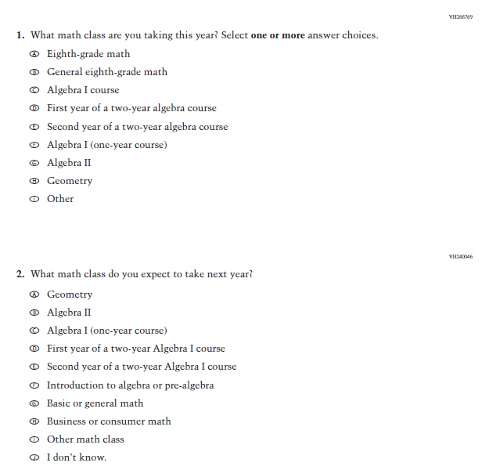

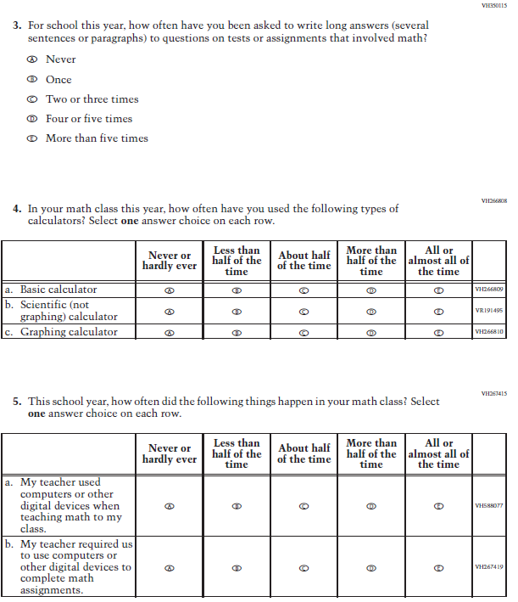

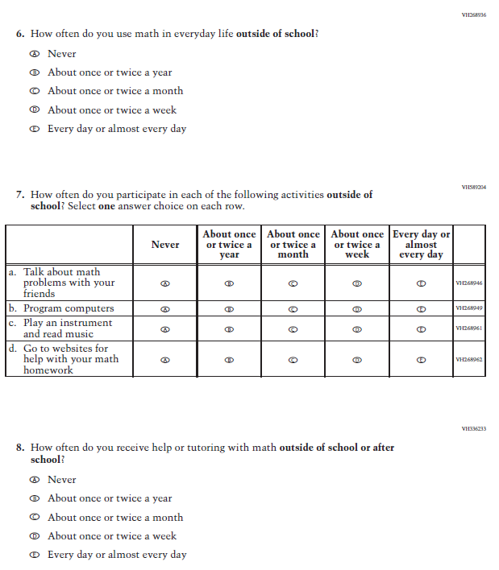

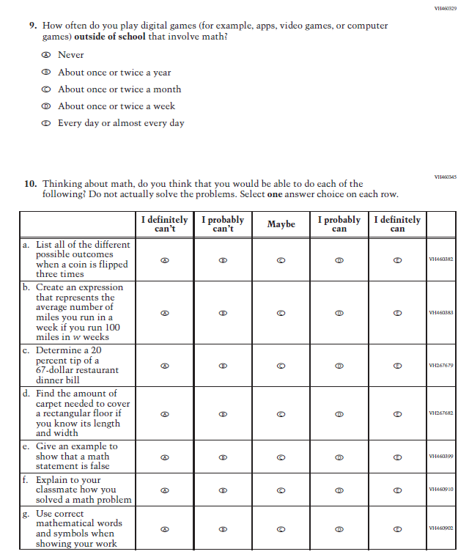

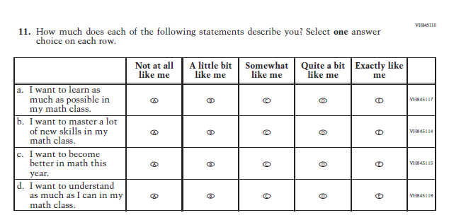

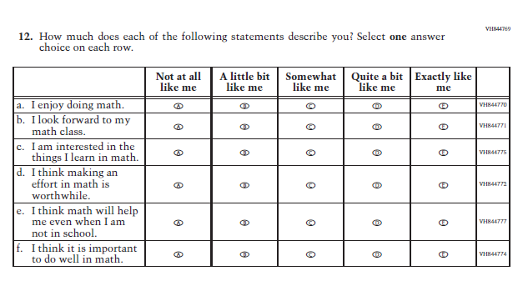

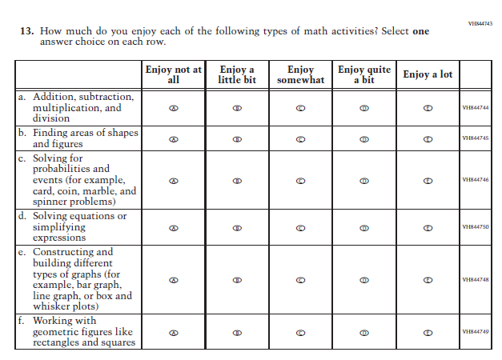

### **Appendix J1-9**: Summary of Changes Operational Grade 4 Reading

| **2021 Operational Grade 4 Reading Student** | | | |
| --- | --- | --- | --- |
| **Previous item** | **2021 item** | **D/A/ R/NC+** | **Rationale** |
| (2019 Grade 4) | **Issue:** Organization of Instruction | NC | N/A |
| (2019 Grade 4) | **Issue:** Organization of Instruction | NC | N/A |
| (2019 Grade 4) | **Issue:** Organization of Instruction | NC | N/A |
| (2019 Grade 4) | **Issue:** Organization of Instruction | NC | N/A |
| (2019 Grade 4) | N/A | D | To keep student burden low, this item was dropped. |
| (2019 Grade 4) | **Issue:** Resources for Learning and Instruction | NC | N/A |
| (2019 Grade 4) | **Issue:** Student Factors | NC | N/A |
| (2019 Grade 4) | N/A | D | To keep student burden low, this item was dropped. |
| (2019 Grade 4) | **Issue:** Student Factors | NC | N/A |
| (2019 Grade 4) | **Issue:** Student Factors | NC | N/A |
| (2019 Grade 4) | **Issue:** Student Factors | NC | N/A |
| (2019 Grade 4) | **Issue:** Resources for Learning and Instruction | NC | N/A |
| (2019 Grade 4) | **Issue:** Student Factors | R | To keep student burden low, sub-items b, d, and e were dropped. |

### **Appendix J1-10**: Operational Grade 4 Reading

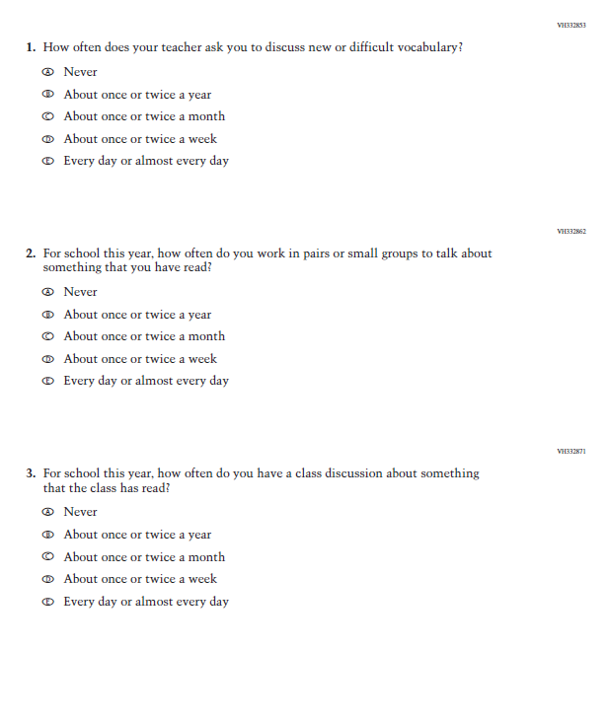

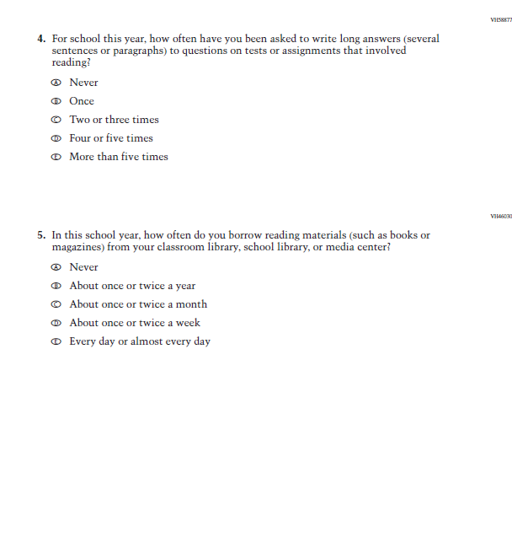

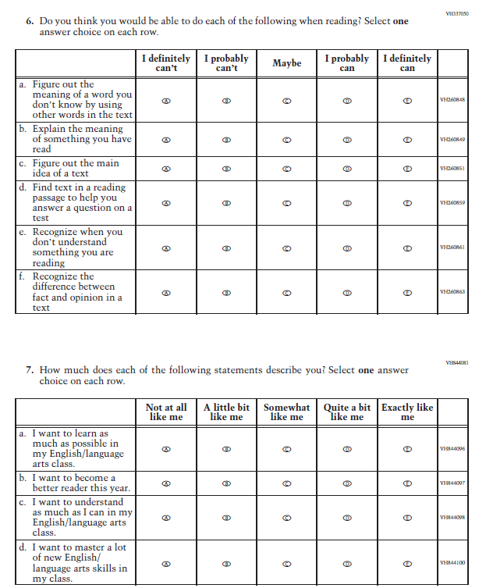

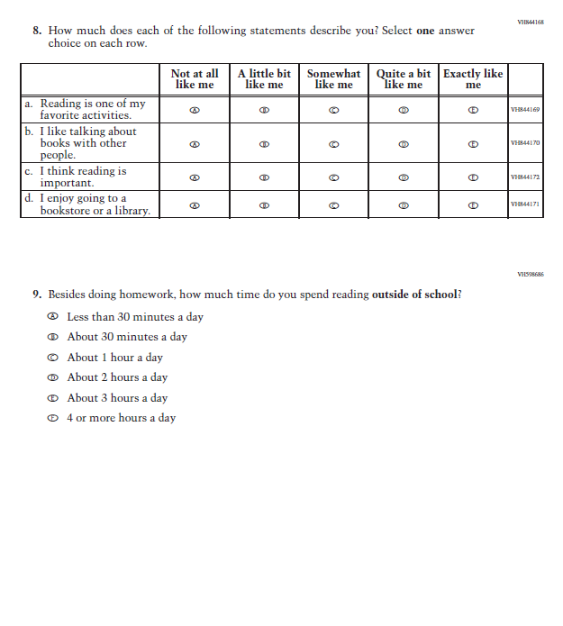

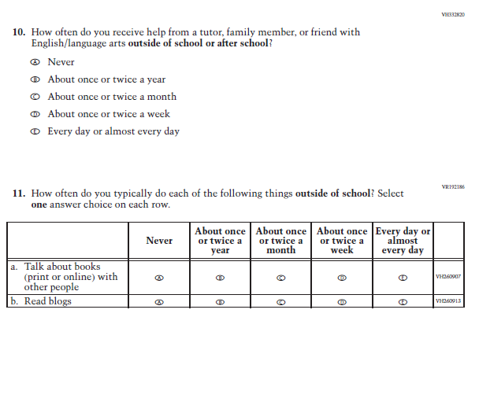

### **Appendix J1-11**: Summary of Changes Operational Grade 8 Reading

| **2021 Operational Grade 8 Reading Student** | | | |
| --- | --- | --- | --- |
| **Previous item** | **2021 item** | **D/A/ R/NC+** | **Rationale** |
| (2019 Grade 8) | **Issue:** Organization of Instruction | NC | N/A |
| (2019 Grade 8) | **Issue:** Organization of Instruction | NC | N/A |
| (2019 Grade 8) | **Issue:** Organization of Instruction | NC | N/A |
| (2019 Grade 8) | **Issue:** Organization of Instruction | NC | N/A |
| (2019 Grade 8) | N/A | D | To keep student burden low, this item was dropped. |
| (2019 Grade 8) | N/A | D | To keep student burden low, this item was dropped. |
| (2019 Grade 8) | **Issue:** Student Factors | NC | N/A |
| (2019 Grade 8) | **Issue:** Student Factors | NC | N/A |
| (2019 Grade 8) | N/A | D | To keep student burden low, this item was dropped. |
| (2019 Grade 8) | **Issue:** Student Factors | NC | N/A |
| (2019 Grade 8) | **Issue:** Student Factors | NC | N/A |
| (2019 Grade 8) | **Issue:** Student Factors | NC | N/A |
| (2019 Grade 8) | **Issue:** Student Factors | NC | N/A |
| (2019 Grade 8) | **Issue:** Resources for Learning and Instruction | NC | N/A |
| (2019 Grade 8) | **Issue:** Student Factors | R | To keep student burden low, sub-items d and e were dropped. |

.

### **Appendix J1-12**: Operational Grade 8 Reading

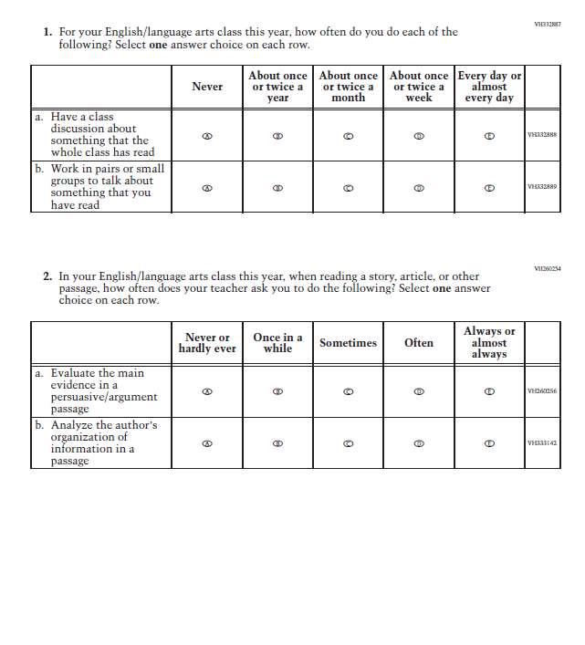

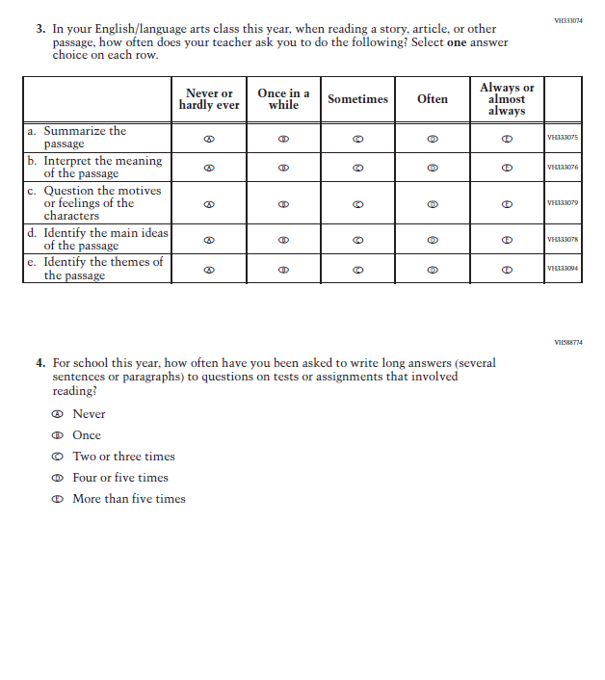

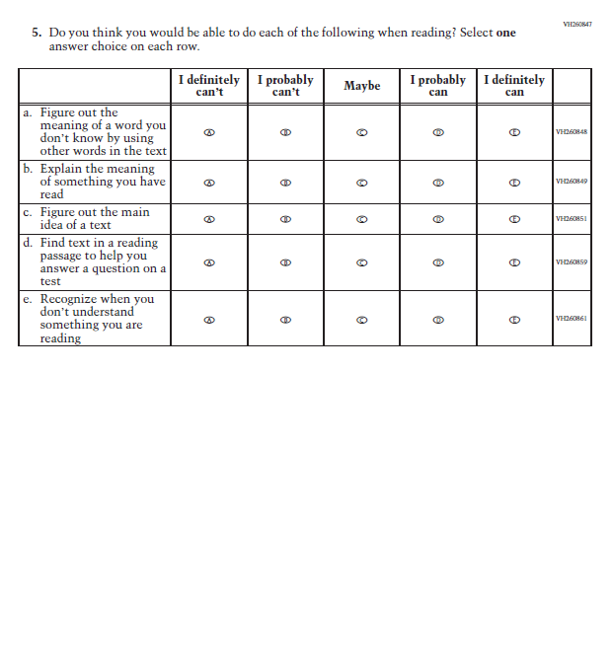

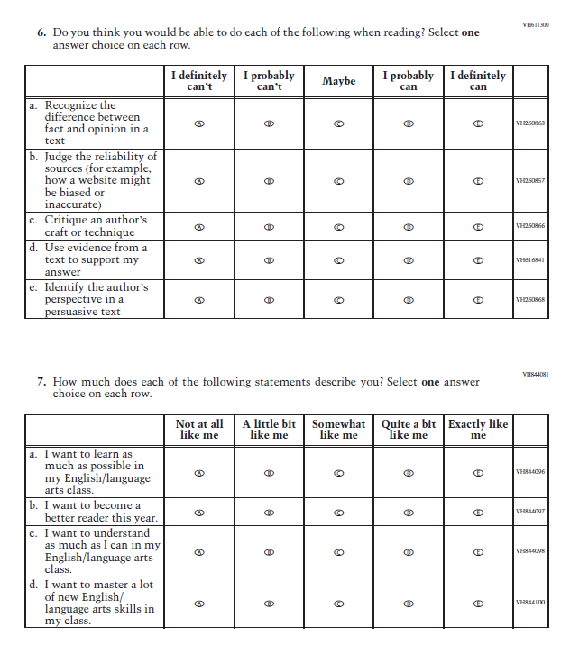

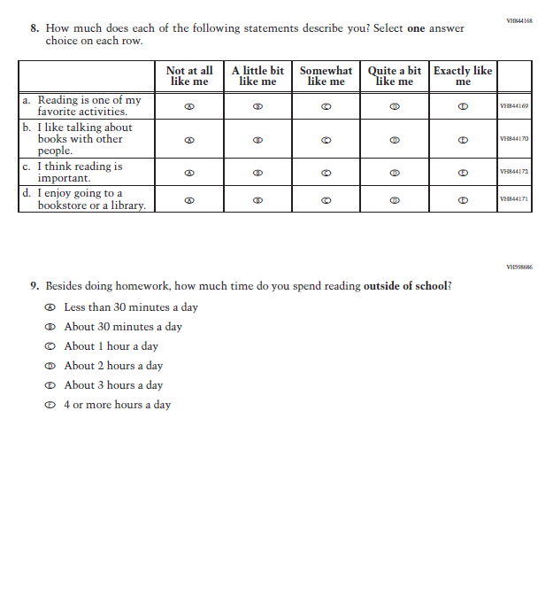

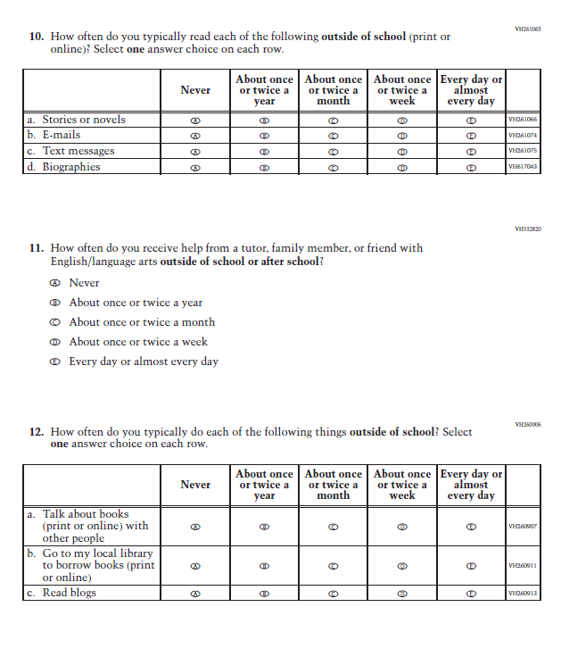

### **Appendix J1-13**: Summary of Changes Operational Grade 8 Civics

| **2021 Operational Grade 8 Civics Student** | | | |
| --- | --- | --- | --- |
| **Previous item** | **2021 item** | **D/A/ R/NC+** | **Rationale** |
| (2018 Grade 8) | **Issue**: Organization of Instruction | NC | N/A |
| (2018 Grade 8) | **Issue**: Organization of Instruction | NC | N/A |
| (2018 Grade 8) | N/A | D | To keep student burden low, this item was dropped. |
| (2018 Grade 8) | N/A | D | To keep student burden low, this item was dropped. |
| (2018 Grade 8) | **Issue**: Organization of Instruction | R | To keep student burden low, sub-items b and d were dropped. |
| (2018 Grade 8) | **Issue:** Organization of Instruction | R | To keep student burden low, sub-items a and d were dropped. |
| (2018 Grade 8) | **Issue**: Organization of Instruction | NC | N/A |
| (2018 Grade 8) | **Issue**: Student Factors | NC | N/A |
| (2018 Grade 8) | **Issue**: Student Factors | NC | N/A |
| (2018 Grade 8) | N/A | D | To keep student burden low, this item was dropped. |
| (2018 Grade 8) | **Issue**: Student Factors | NC | N/A |
| (2018 Grade 8) | **Issue**: Student Factors | R | To keep student burden low, sub-items a, b, and c were dropped. |
| (2018 Grade 8) | **Issue**: Student Factors | NC | N/A |
| (2018 Grade 8) | **Issue**: Resources for Learning and Instruction | NC | N/A |
| (2018 Grade 8) | N/A | D | To keep student burden low, this item was dropped. |

### **Appendix J1-14**: Operational Grade 8 Civics

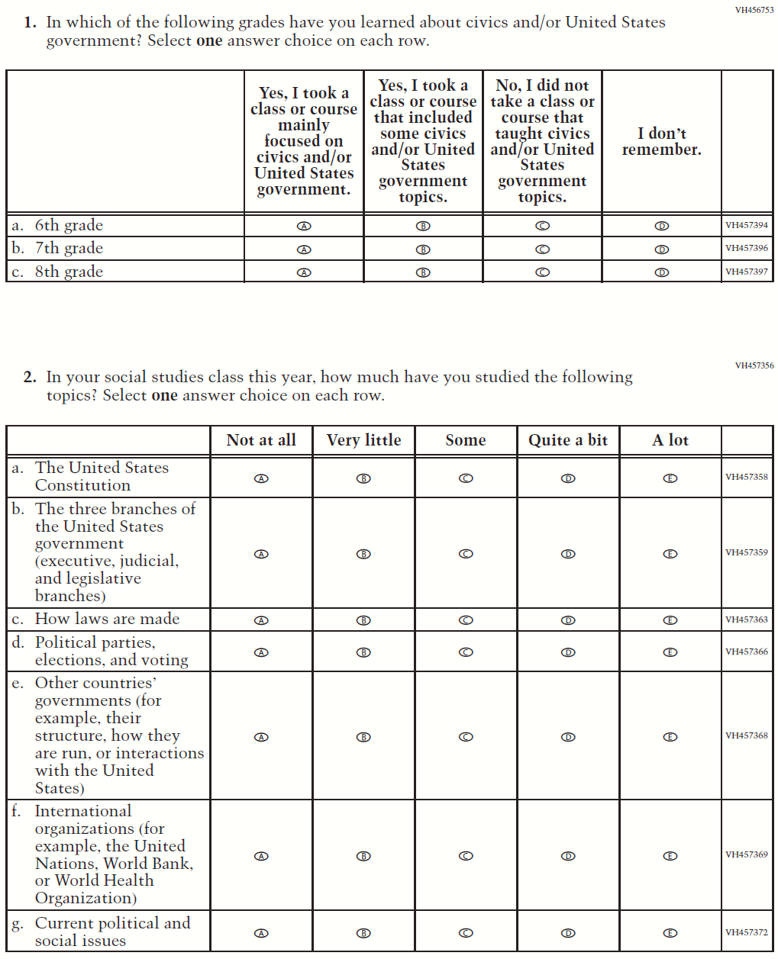

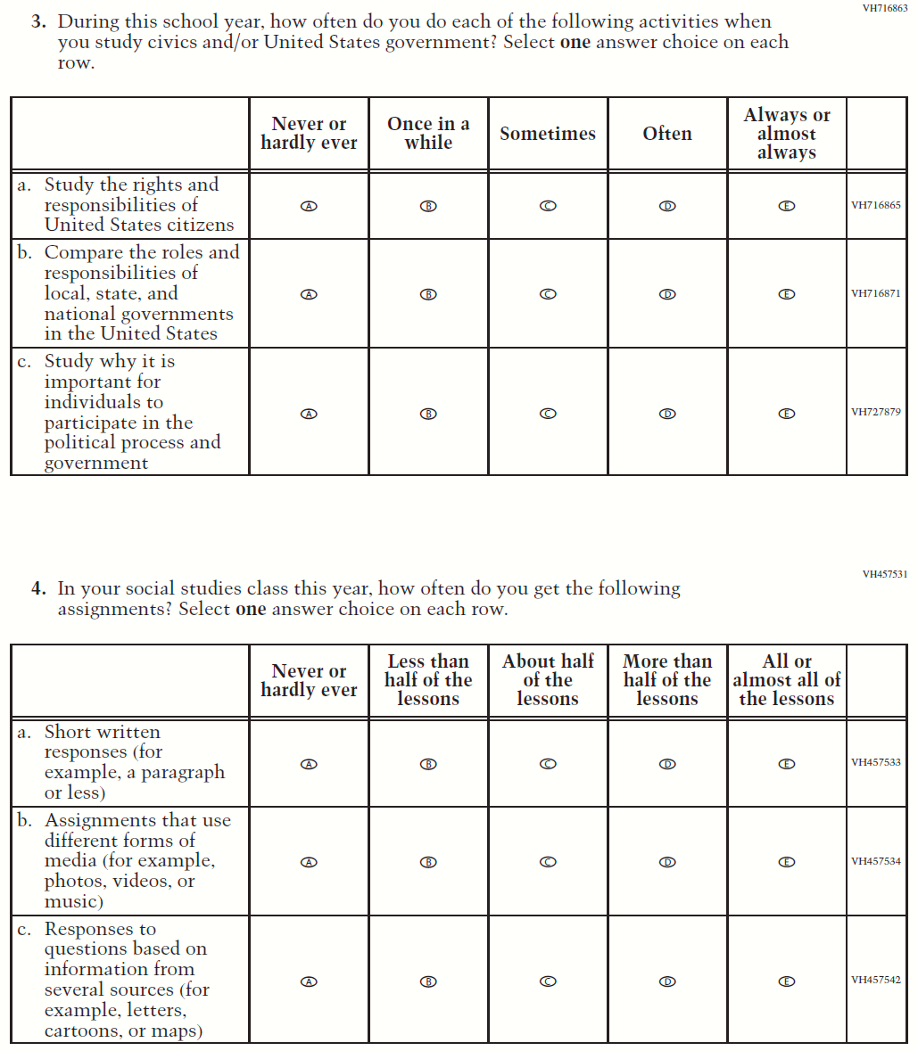

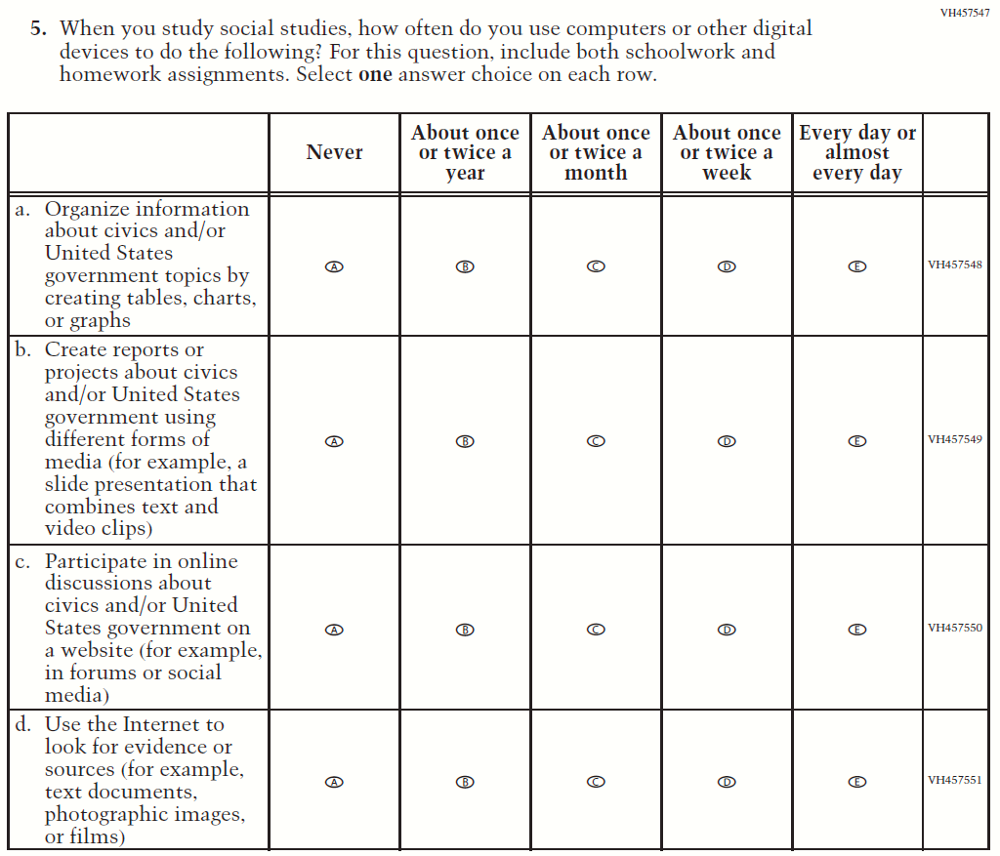

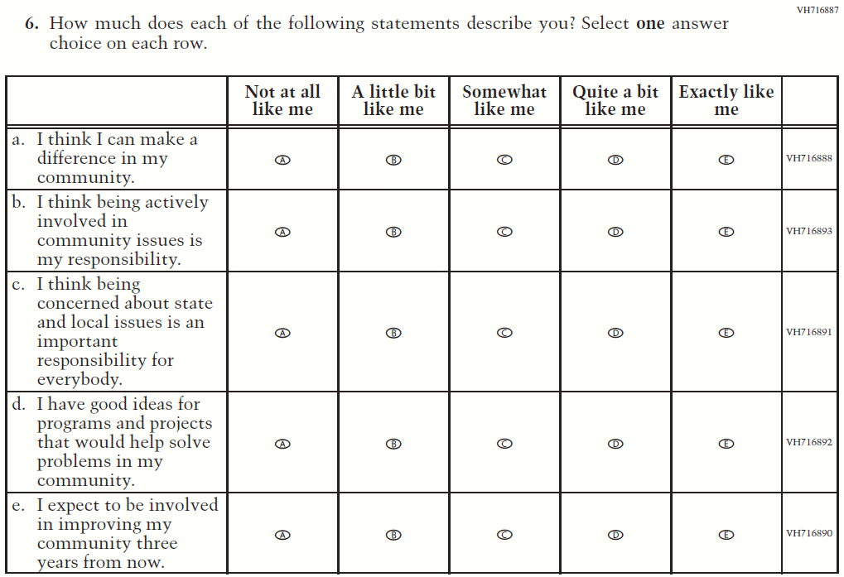

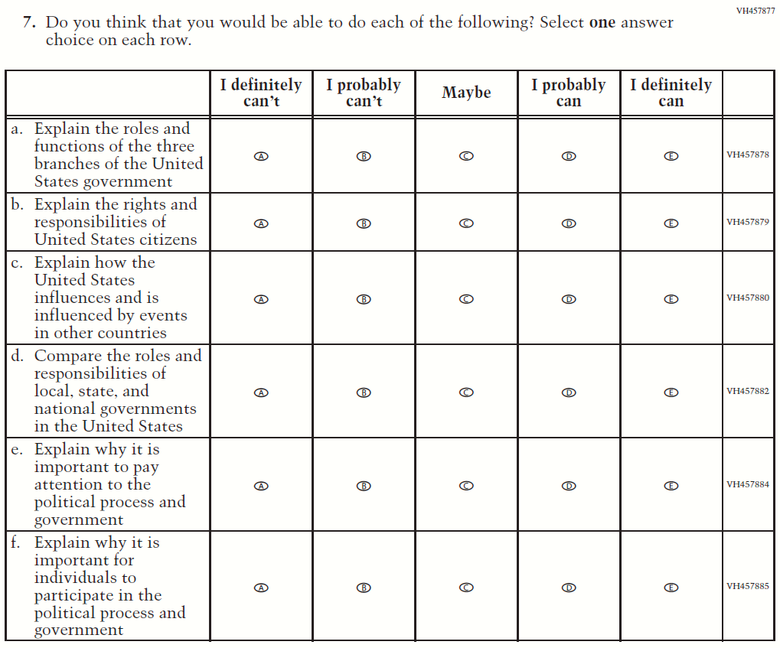

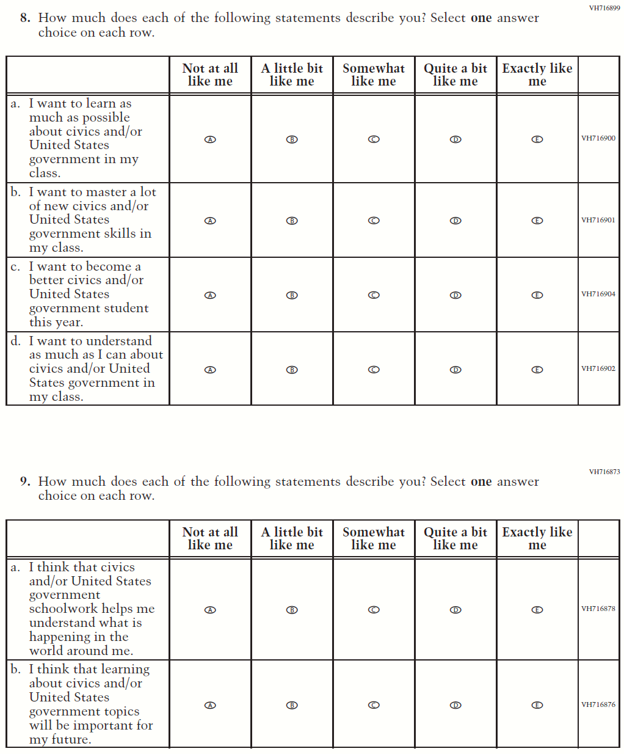

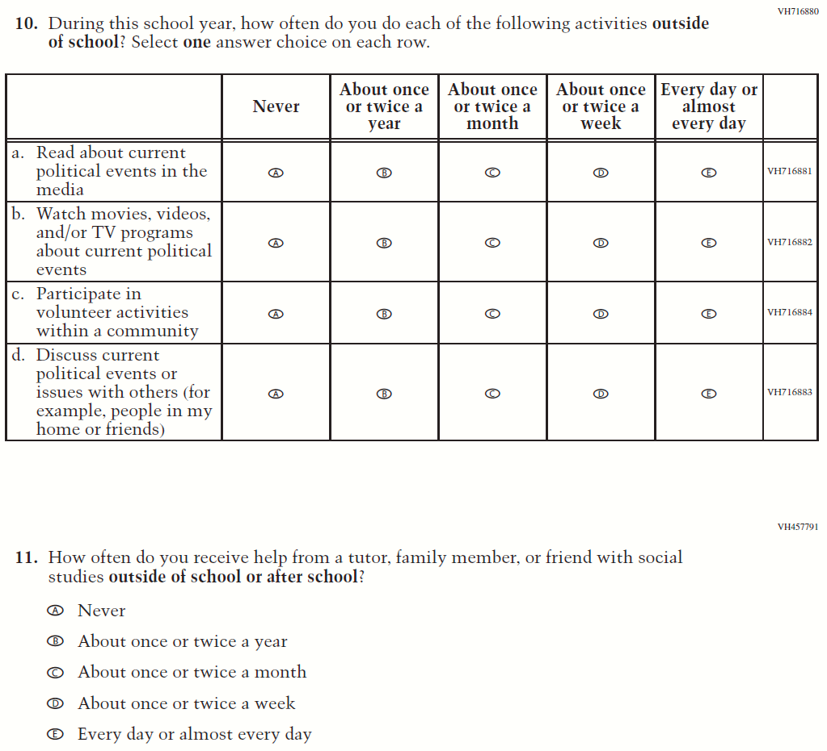

### **Appendix J1-15**: Summary of Changes Operational Grade 8 US History

| **2021 Operational Grade 8 U.S. History Student** | | | |
| --- | --- | --- | --- |
| **Previous item** | **2021 item** | **D/A/ R/NC+** | **Rationale** |
| (2018 Grade 8) | **Issue**: Organization of Instruction | NC | N/A |
| (2018 Grade 8) | **Issue**: Organization of Instruction | NC | N/A |
| (2018 Grade 8) | N/A | D | To keep student burden low, this item was dropped. |
| (2018 Grade 8) | N/A | D | To keep student burden low, this item was dropped. |
| (2018 Grade 8) | **Issue**: Organization of Instruction | NC | N/A |
| (2018 Grade 8) | **Issue:** Organization of Instruction | R | To keep student burden low, sub-items a and d were dropped. |
| (2018 Grade 8) | N/A | D | To keep student burden low, this item was dropped. |
| (2018 Grade 8) | **Issue**: Student Factors | NC | N/A |
| (2018 Grade 8) | **Issue**: Student Factors | NC | N/A |
| (2018 Grade 8) | N/A | D | To keep student burden low, this item was dropped. |
| (2018 Grade 8) | **Issue**: Student Factors | NC | N/A |
| (2018 Grade 8) | N/A | D | To keep student burden low, this item was dropped. |
| (2018 Grade 8) | **Issue**: Student Factors | R | To keep student burden low, sub-items c and d were dropped. |
| (2018 Grade 8) | **Issue**: Resources for Learning and Instruction | NC | N/A |
| (2018 Grade 8) | N/A | D | To keep student burden low, this item was dropped. |

### **Appendix J1-16**: Operational Grade 8 US History

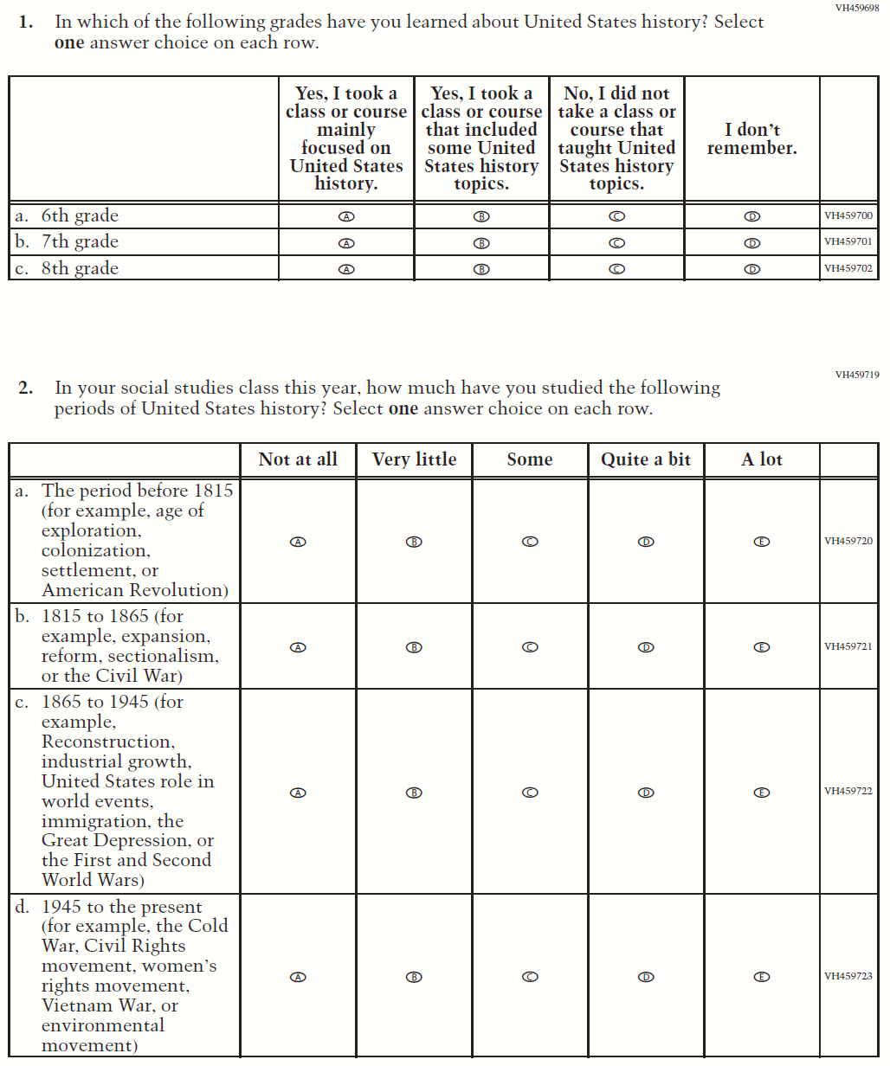

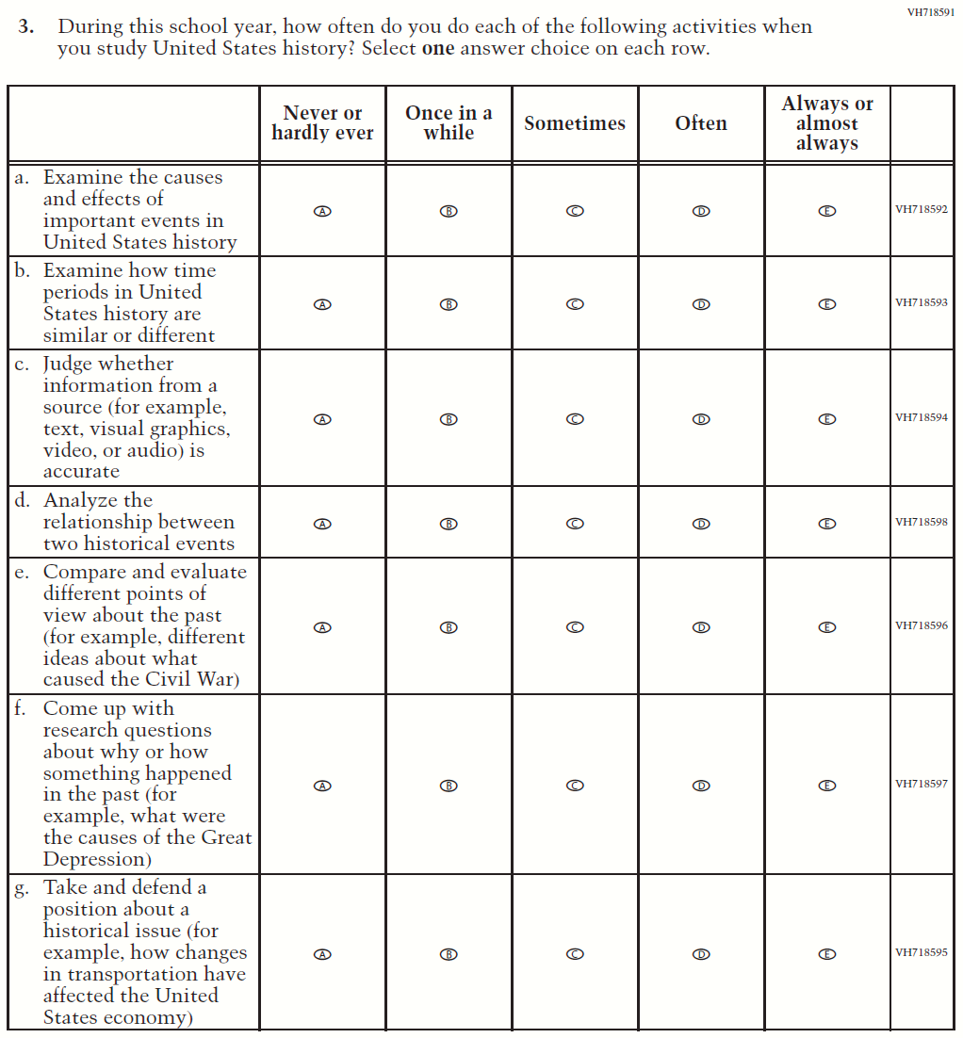

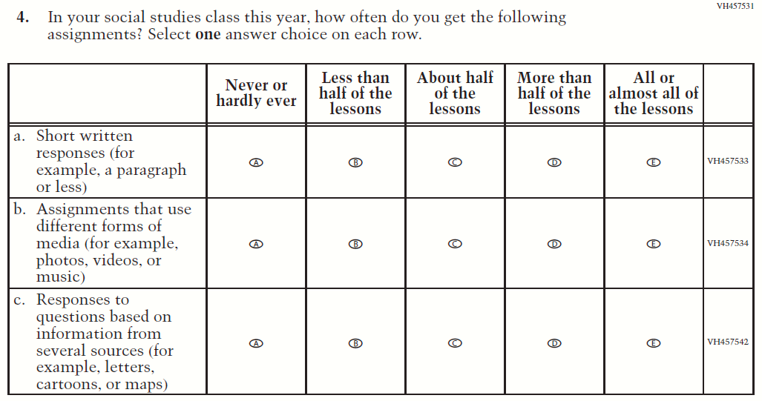

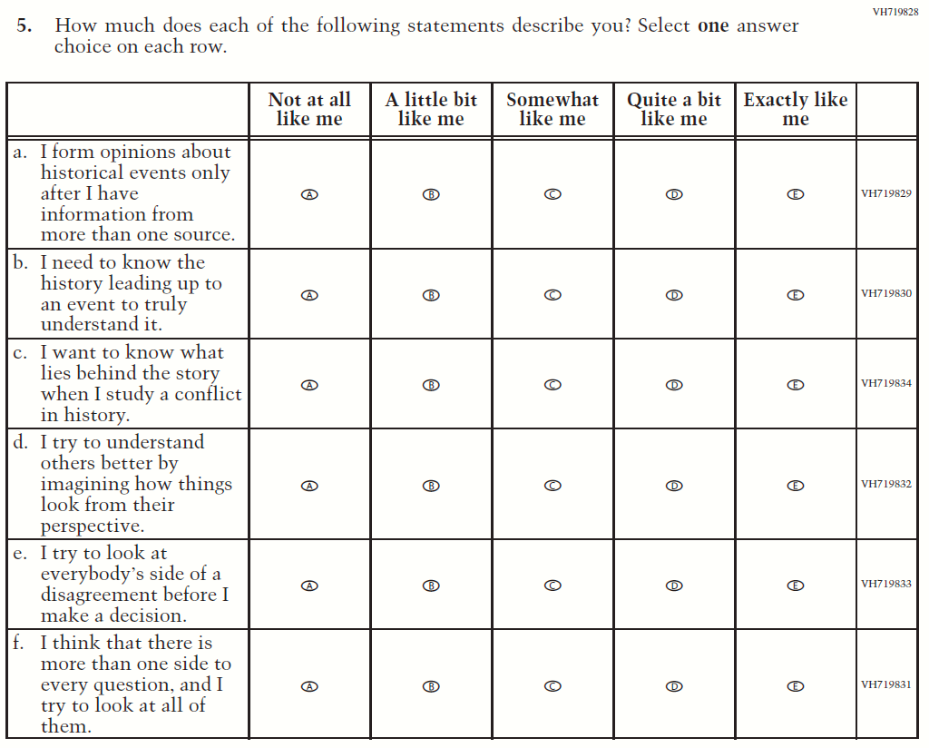

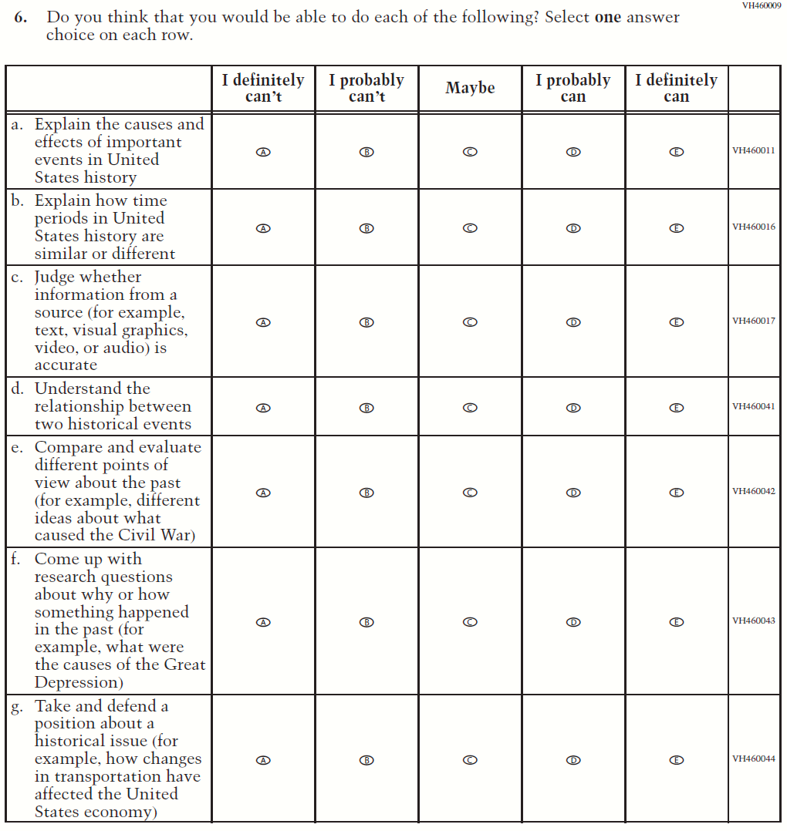

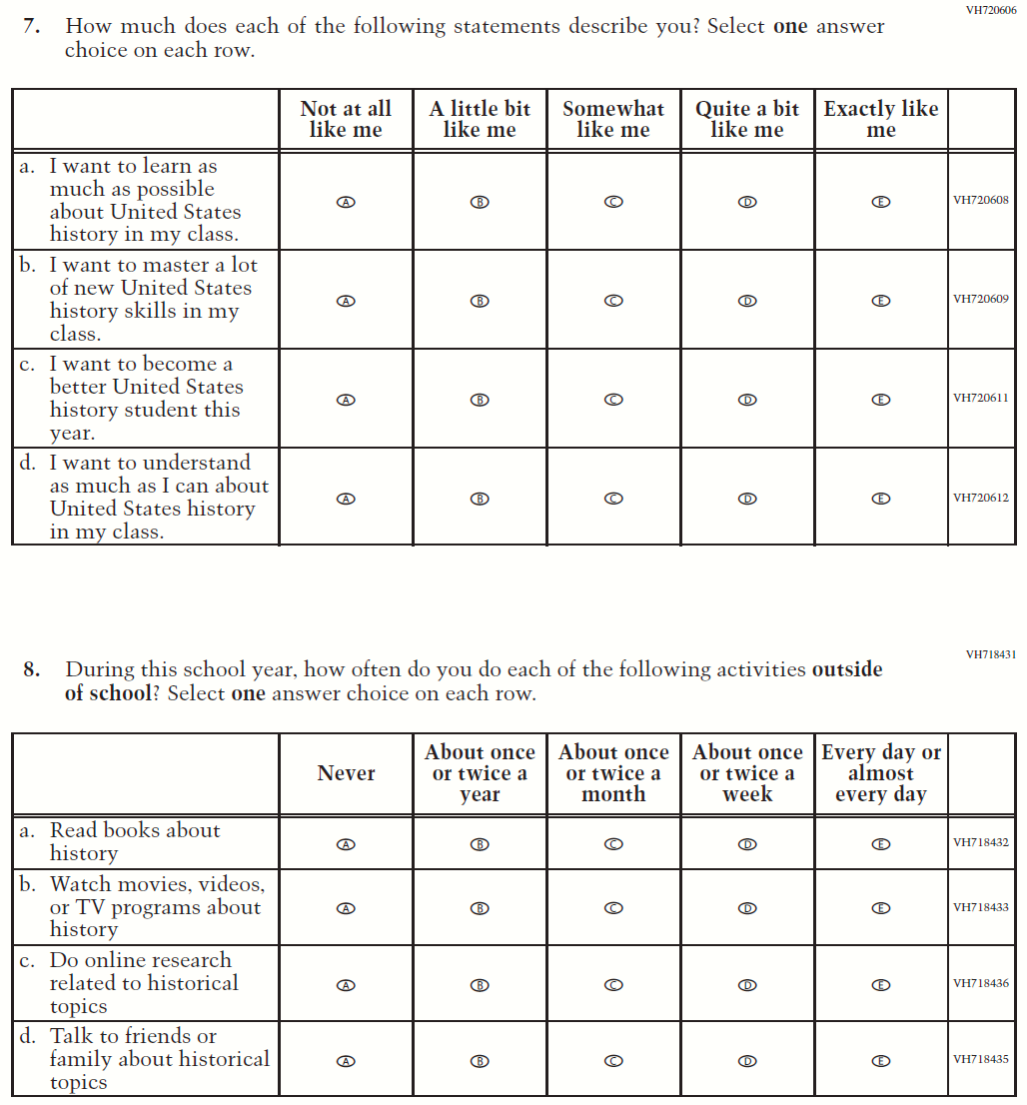

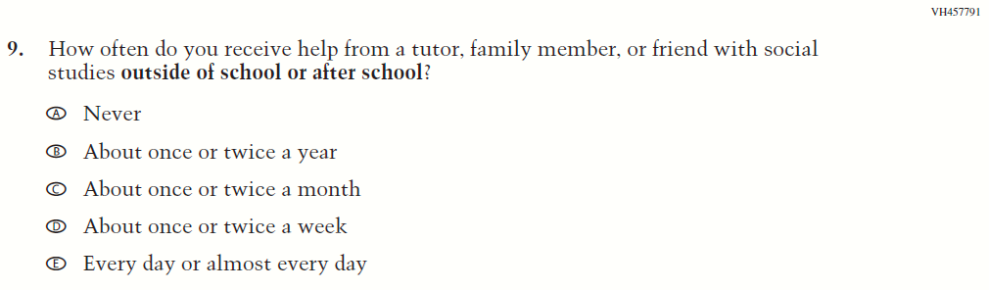

### **Appendix J1-17**: Summary of Operational Grade 4 Debrief

| **2021 Operational Grade 4 Debrief Student** | | | |
| --- | --- | --- | --- |
| **Previous item** | **2021 item** | **D/A/ R/NC+** | **Rationale** |
| (2019 Grade 4, 8, and 12) | N/A | D | To keep student burden low, this item was dropped. |
| (2019 Grade 4, 8, and 12) | **Issue:** Debrief | NC | N/A |

### **Appendix J1-18**: Operational Grade 4 Debrief

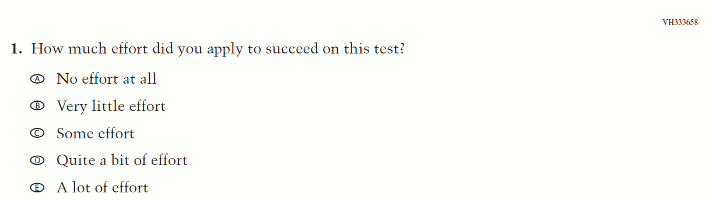

### **Appendix J1-19**: Summary of Operational Grade 8 Debrief

| **2021 Operational Grade 8 Debrief Student** | | | |
| --- | --- | --- | --- |
| **Previous item** | **2021 item** | **D/A/ R/NC+** | **Rationale** |
| (2019 Grade 4, 8, and 12) | **Issue:** Debrief | NC | N/A |
| (2019 Grade 4, 8, and 12) | **Issue:** Debrief | NC | N/A |

### **Appendix J1-20**: Operational Grade 8 Debrief

