NATIONAL CENTER FOR EDUCATION STATISTICS NATIONAL ASSESSMENT OF EDUCATIONAL PROGRESS

National Assessment of Educational Progress (NAEP)
2021

Appendix J-S

2021 Spanish Questionnaires

OMB# 1850-0928 v.20



June 2020

Table of Contents
Student Login Screen 4
Appendix J-1-s: Spanish Translations of Student Questionnaires 6
Appendix J-1a-s-BL: Summary of Changes Operational Grade 4 CORE 7
Appendix J-1a-s-BL: Operational Grade 4 CORE 12
Appendix J-1b-s-PR: Summary of Changes Operational Grade 4 CORE 16
Appendix J-1b-s-PR: Operational Grade 4 CORE 21
Appendix J-1c-s-BL: Summary of Changes Operational Grade 8 CORE 25
Appendix J-1c-s-BL: Operational Grade 8 CORE 32
Appendix J-1d-s-PR: Summary of Changes Operational Grade 8 CORE 38
Appendix J-1d-s-PR: Operational Grade 8 CORE 44
Appendix J-1e-s-BL: Summary of Changes Operational Grade 4 Mathematics 50
Appendix J-1e-s-BL: Operational Grade 4 Mathematics 55
Appendix J-1f-s-PR: Summary of Changes Operational Grade 4 Mathematics 59
Appendix J-1f-s-PR: Operational Grade 4 Mathematics 64
Appendix J-1g-s-BL: Summary of Changes Operational Grade 8 Mathematics 68
Appendix J-1g-s-BL: Operational Grade 8 Mathematics 77
Appendix J-1h-s-PR: Summary of Changes Operational Grade 8 Mathematics 82
Appendix J-1h-s-PR: Operational Grade 8 Mathematics 90
Appendix J-1i-s-BL: Summary of Changes Operational Grade 4 Reading 95
Appendix J-1i-s-BL: Operational Grade 4 Reading 100
Appendix J-1j-s-BL: Summary of Changes Operational Grade 8 Reading 104
Appendix J-1j-s-BL: Operational Grade 8 Reading 110
Appendix J-1k-s-BL: Operational Grade 8 Civics 115
Appendix J-1l-s-BL: Operational Grade 8 US History 122
Appendix J-1m-s-BL: Summary of Operational Grade 4 Debrief 128
Appendix J-1m-s-BL: Operational Grade 4 Debrief 129
Appendix J-1n-s-PR: Summary of Operational Grade 4 Debrief 130
Appendix J-1n-s-PR: Operational Grade 4 Debrief 131
Appendix J-1o-s-BL: Summary of Operational Grade 8 Debrief 132
Appendix J-1o-s-BL: Operational Grade 8 Debrief 133
Appendix J-1p-s-PR: Summary of Operational Grade 8 Debrief 134
Appendix J-1p-s-PR: Operational Grade 8 Debrief 135
Teacher Login Screen 136
Appendix J-2-s: Spanish Translations of Teacher Questionnaires 138
Appendix J-2a-s-PR: Summary of Changes Operational Grade 4 CORE 139
Appendix J-2a-s-PR: Operational Grade 4 CORE 147
Appendix J-2b-s-PR: Summary of Changes Operational Grade 8 CORE 154
Appendix J-2b-s-PR: Operational Grade 8 CORE 162
Appendix J-2c-s-PR: Summary of Changes Operational Grade 4 Mathematics 170
Appendix J-2c-s-PR: Operational Grade 4 Mathematics 176
Appendix J-2d-s-PR: Summary of Changes Operational Grade 8 Mathematics 182
Appendix J-2d-s-PR: Operational Grade 8 Mathematics 189
School Administrator Login Screen 195
Appendix J-3-s: Spanish Translations of School Questionnaires 197
Appendix J-3a-s-PR: Summary of Changes Operational Grade 4 CORE 198
Appendix J-3a-s-PR: Operational Grade 4 CORE 209
Appendix J-3b-s-PR: Summary of Changes Operational Grade 8 CORE 219
Appendix J-3b-s-PR: Operational Grade 8 CORE 230
Appendix J-3d-s-PR: Summary of Changes Operational Grade 4 Mathematics 240
Appendix J-3d-s-PR: Operational Grade 4 Mathematics 243
Appendix J-3d-s-PR: Summary of Changes Operational Grade 8 Mathematics 246
Appendix J-3d-s-PR: Operational Grade 8 Mathematics 249

Student Login Screen

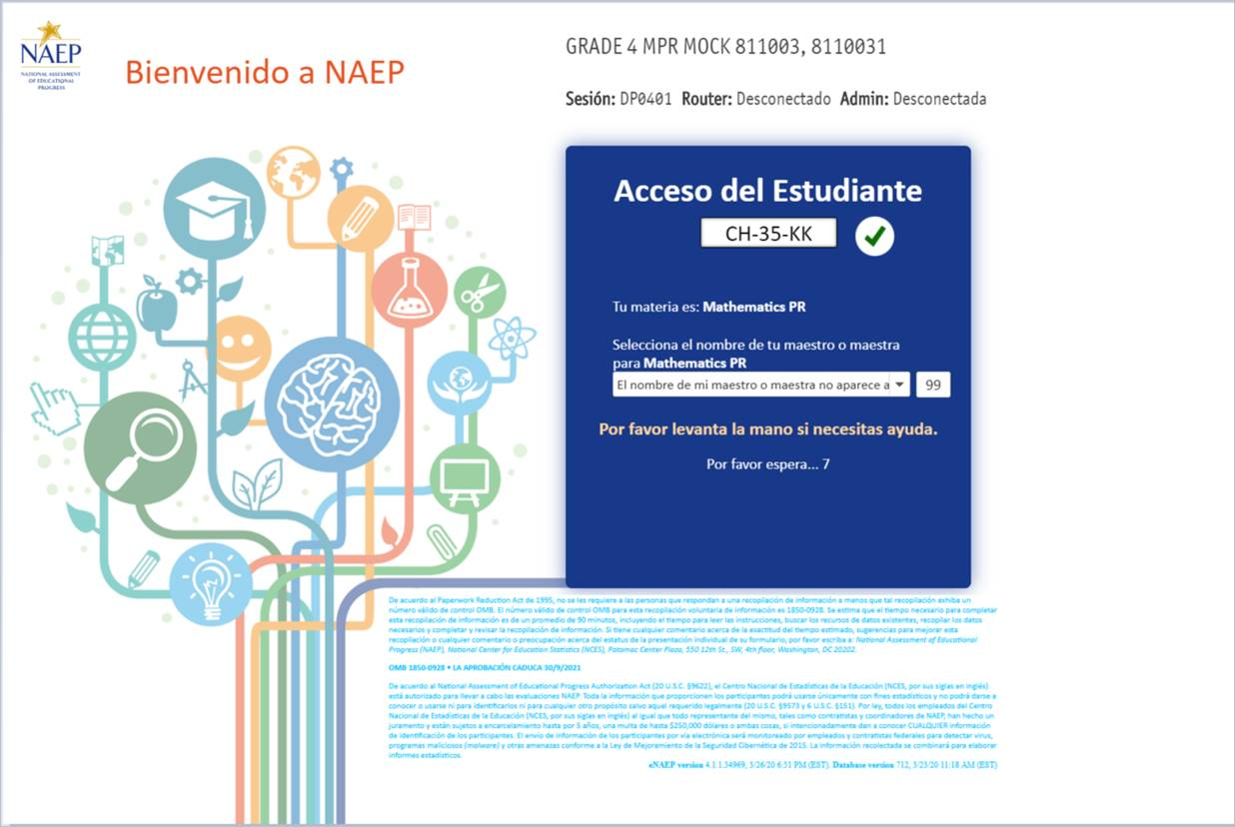
NOTE: The final version of the login screen was not available for this amendment and will be included in Amendment 2 scheduled to be submitted in October 2020. The Blue text will be revised with the updated language below.
De acuerdo al Paperwork Reduction Act de 1995, no se les requiere a las personas que respondan a una recopilación de información a menos que tal recopilación exhiba un número válido de control OMB. El número válido de control OMB para esta recopilación voluntaria de información es 1850-0928. Se estima que el tiempo necesario para completar esta recopilación de información es de un promedio de 110 minutos, incluyendo el tiempo para leer las instrucciones, buscar los recursos de datos existentes, recopilar los datos necesarios y completar y revisar la recopilación de información. Si tiene cualquier comentario acerca de la exactitud del tiempo estimado, sugerencias para mejorar esta recopilación o cualquier comentario o preocupación acerca del estatus de la presentación individual de su formulario, por favor escriba a: National Assessment of Educational Progress (NAEP), National Center for Education Statistics, Potomac Center Plaza, 550 12th St., SW, 4th floor, Washington, D.C. 20202.
OMB 1850-0928 • LA APROBACIÓN CADUCA 30/4/2023
El Centro Nacional para Estadísticas de la Educación (NCES, por sus siglas en inglés) está autorizado por la Ley de Autorización para la Evaluación Nacional del Progreso Educativo (20 U.S.C.§9622) para administrar NAEP y para administrar NAEP y para recopilar los expedientes educativos de los estudiantes de agencias o instituciones educativas con el propósito de evaluar programas de educación apoyados por el gobierno federal conforme a la Ley de Derechos Educativos y Privacidad Familiar (FERPA, por sus siglas en inglés; 34 CFR §§ 99.31(a)(3)(iii) y 99.35). Toda la información que proporcionen los participantes podrá usarse únicamente con fines estadísticos y no podrá darse a conocer o usarse ni para identificarlos ni para cualquier otro propósito salvo aquel requerido legalmente (20 U.S.C. §9573 y 6 U.S.C. §151). Por ley, todos los empleados de NCES al igual que todo representante del mismo, tales como contratistas y coordinadores de NAEP, han hecho un juramento y están sujetos a encarcelamiento hasta por 5 años, una multa de hasta $250,000 dólares o ambas cosas, si intencionadamente dan a conocer CUALQUIER información que lo identifique. El envío de su información por vía electrónica será monitoreado por empleados y contratistas federales para detectar virus, programas maliciosos (malware) y otras amenazas conforme
Appendix J-1-s: Spanish Translations of Student Questionnaires

Appendix J-1a-s-BL: Summary of Changes Operational Grade 4 CORE
2021 Operational Grade 4 Core Student – Bilingual
Previous item | 2021 item | D/A/R/NC+ | Rationale
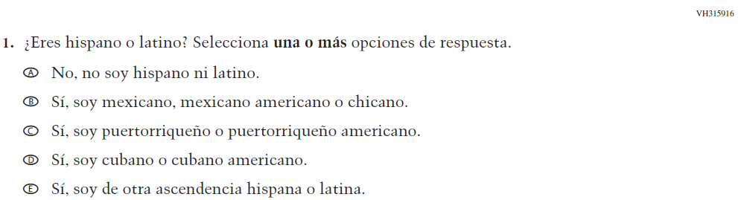  (2019 Operational Grade 4 Student Core - Bilingual) | \  Issue: Race/Ethnicity | NC | N/A
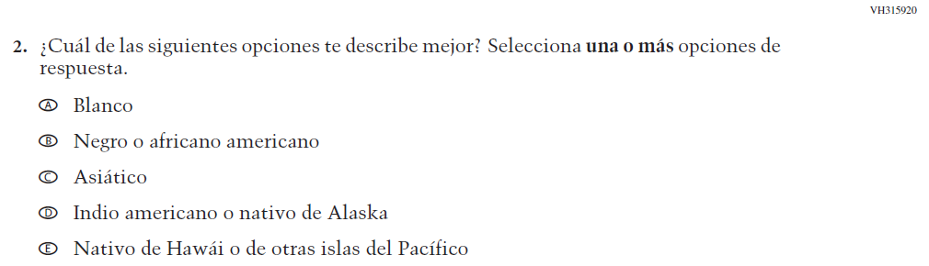  (2019 Operational Grade 4 Student Core - Bilingual) | Issue: Race/Ethnicity | NC | N/A
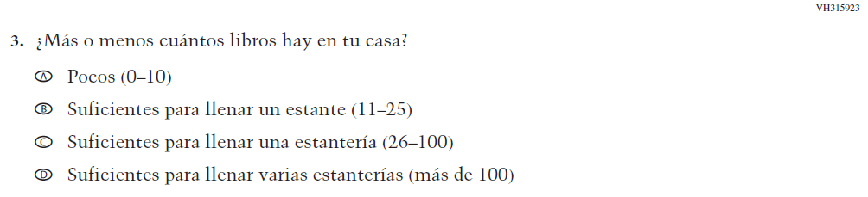  (2019 Operational Grade 4 Student Core - Bilingual) | Issue: Socioeconomic Status | NC | N/A

2021 Operational Grade 4 Core Student – Bilingual
Previous item | 2021 item | D/A/R/NC+ | Rationale
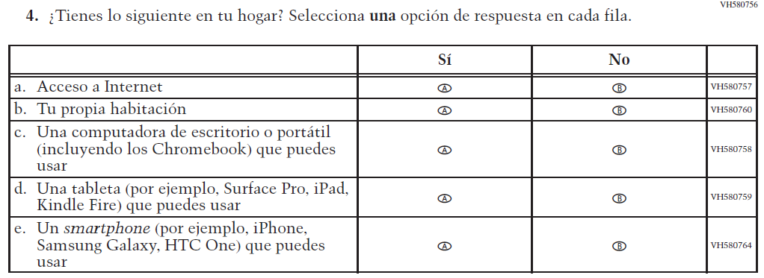  (2019 Operational Grade 4 Student Core - Bilingual) | 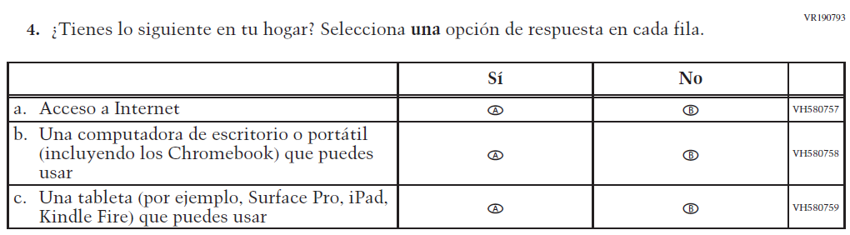  Issue: Socioeconomic Status | R | To keep student burden low, sub-items b and e were dropped.
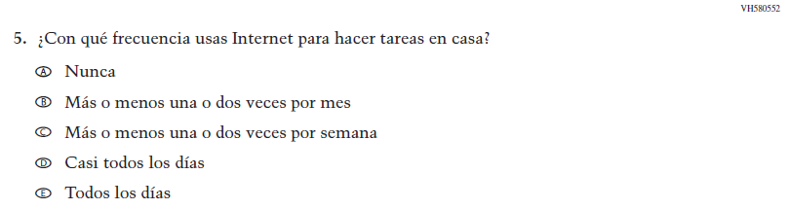  (2019 Operational Grade 4 Student Core - Bilingual) | N/A | D | To keep student burden low, this item was dropped.
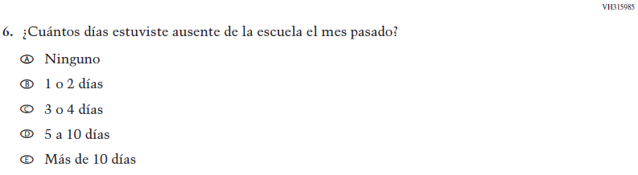  (2019 Operational Grade 4 Student Core - Bilingual) | 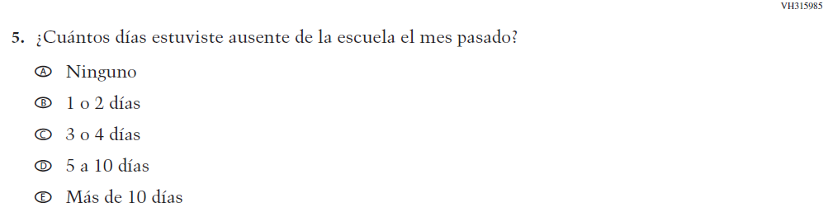  Issue: School Climate | NC | N/A

2021 Operational Grade 4 Core Student – Bilingual
Previous item | 2021 item | D/A/R/NC+ | Rationale
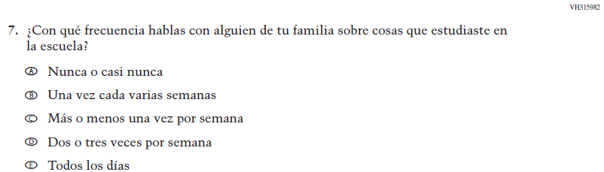  (2019 Operational Grade 4 Student Core - Bilingual) | N/A | D | To keep student burden low, this item was dropped.
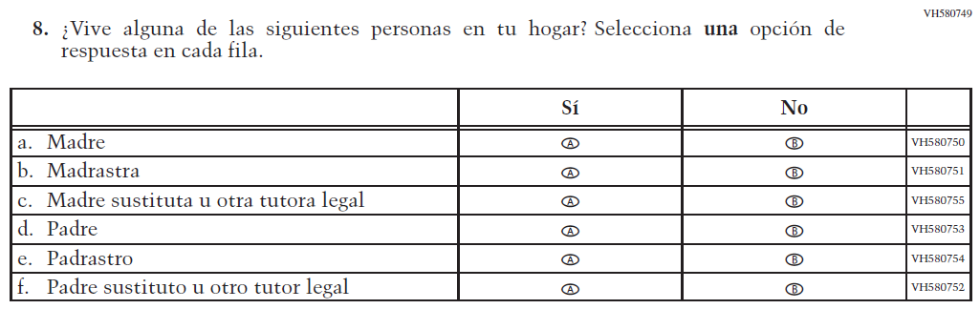  (2019 Operational Grade 4 Student Core - Bilingual) | 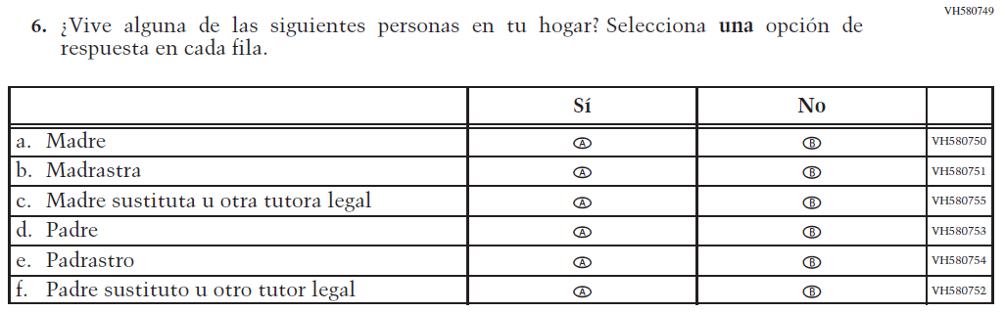  Issue: Socioeconomic Status | NC | N/A
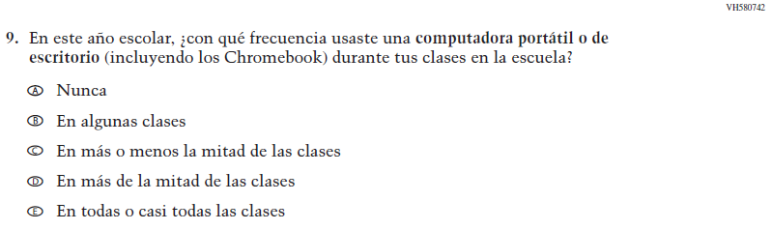  (2019 Operational Grade 4 Student Core - Bilingual) | 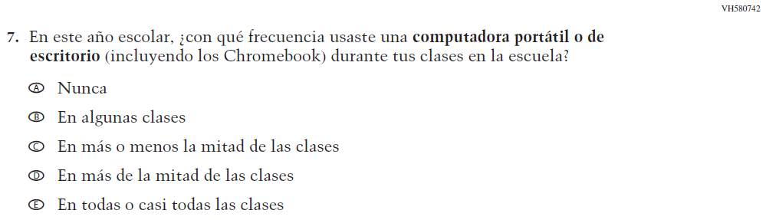  Issue: Technology Use | NC | N/A

2021 Operational Grade 4 Core Student – Bilingual
Previous item | 2021 item | D/A/R/NC+ | Rationale
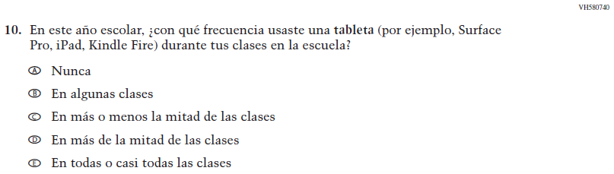  (2019 Operational Grade 4 Student Core - Bilingual) | N/A | D | To keep student burden low, this item was dropped.
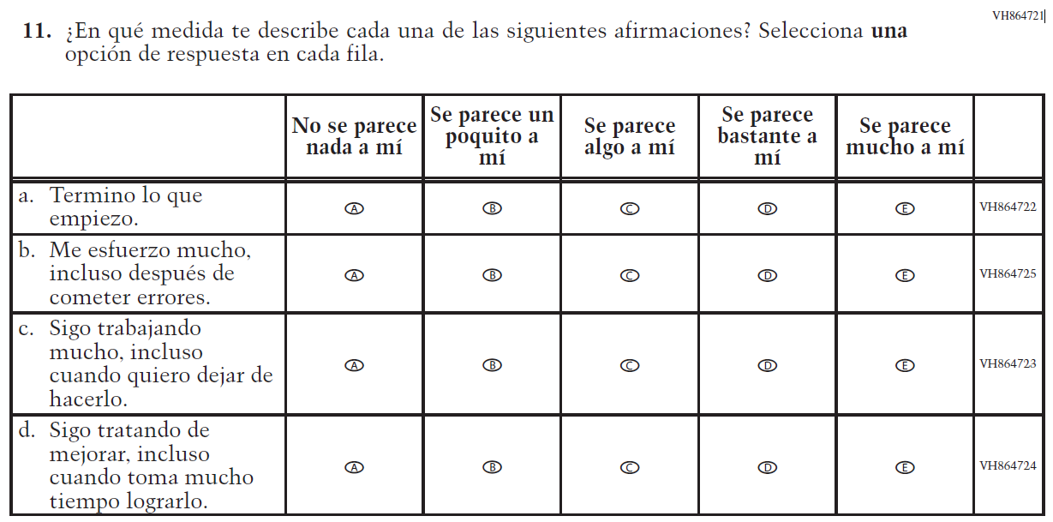  (2019 Operational Grade 4 Student Core - Bilingual) | N/A | D | To keep student burden low, this item was dropped.
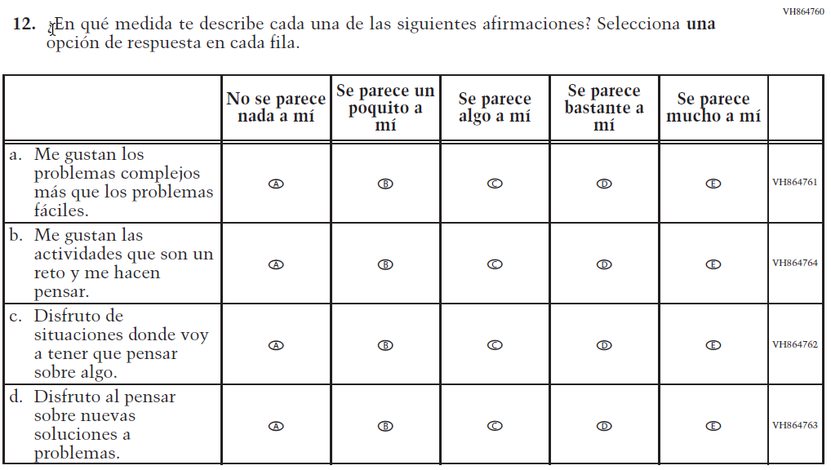  (2019 Operational Grade 4 Student Core - Bilingual) | 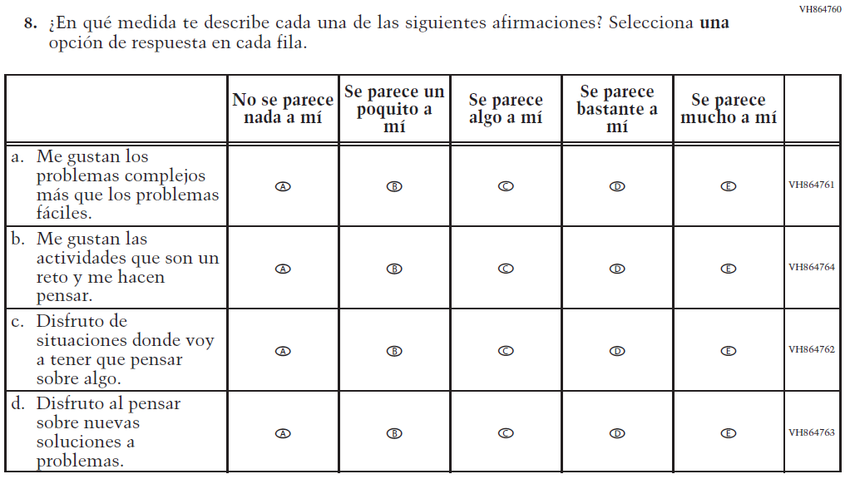  Issue: Desire for Learning | NC | N/A

2021 Operational Grade 4 Core Student – Bilingual
Previous item | 2021 item | D/A/R/NC+ | Rationale
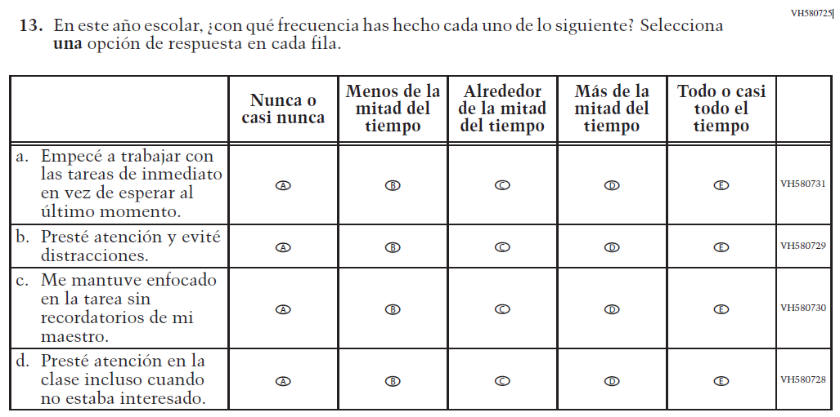  (2019 Operational Grade 4 Student Core - Bilingual) | 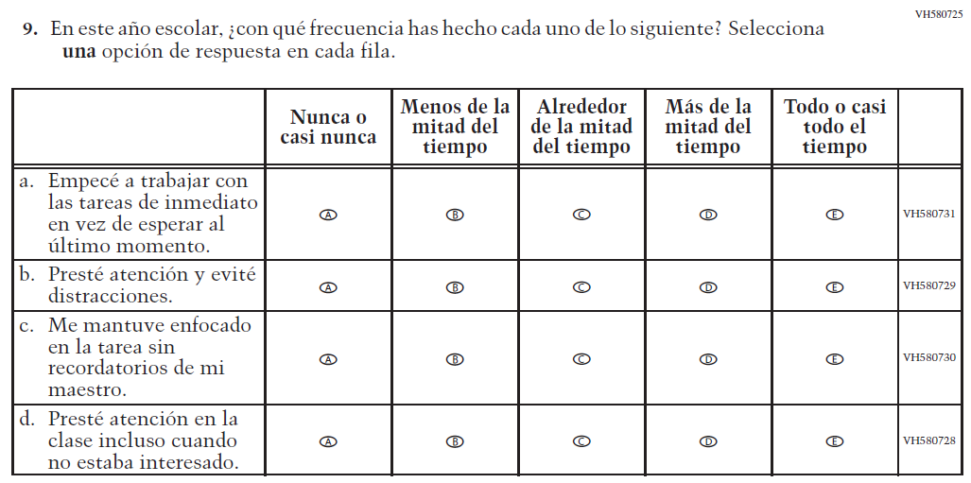  Issue: Grit | NC | N/A
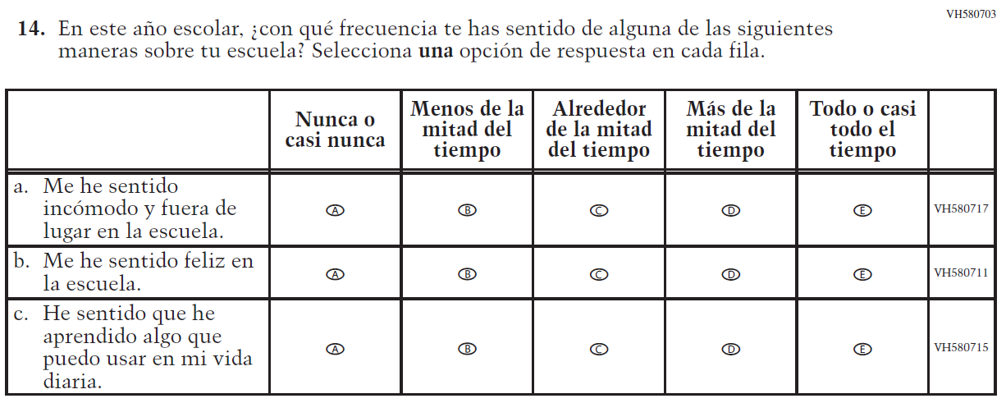  (2019 Operational Grade 4 Student Core - Bilingual) | N/A | D | To keep student burden low, this item was dropped.

Appendix J-1a-s-BL: Operational Grade 4 CORE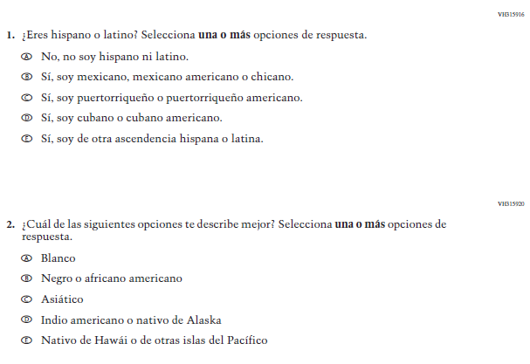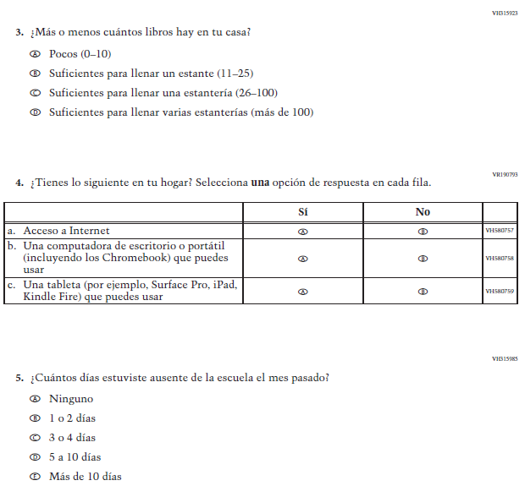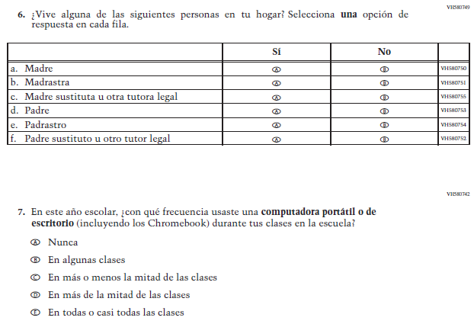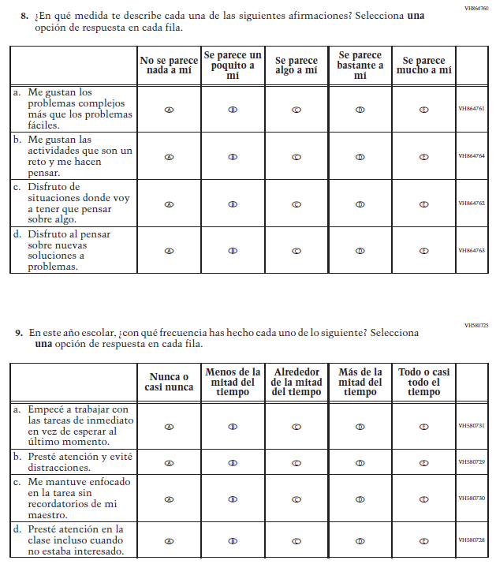

Appendix J-1b-s-PR: Summary of Changes Operational Grade 4 CORE
2021 Operational Grade 4 Core Student – Puerto Rico

Previous item | 2021 item | D/A/ R/NC+ | Rationale
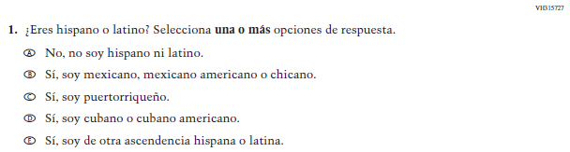  (2019 Operational Grade 4 Student Core – Puerto Rico) | 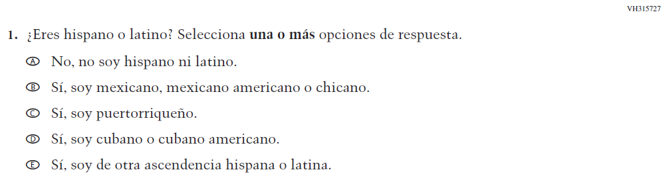  Issue: Race/Ethnicity | NC | N/A
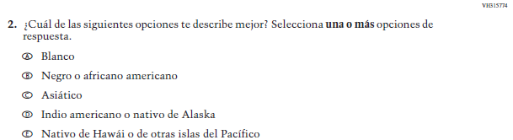  (2019 Operational Grade 4 Student Core – Puerto Rico) | 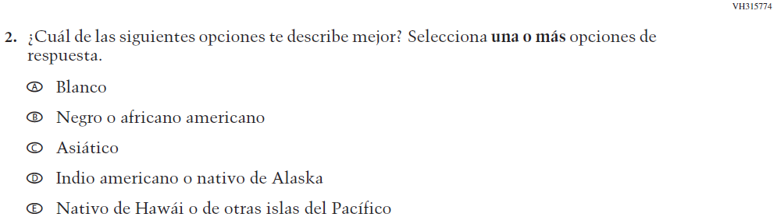  Issue: Race/Ethnicity | NC | N/A
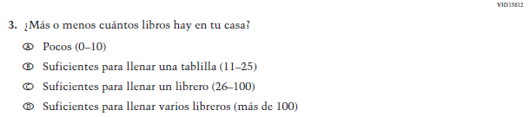  (2019 Operational Grade 4 Student Core – Puerto Rico) | 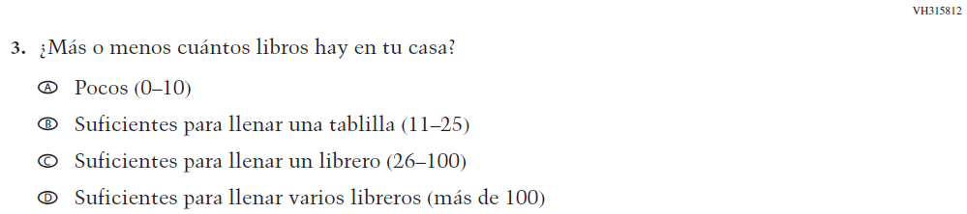  Issue: Socioeconomic Status | NC | N/A
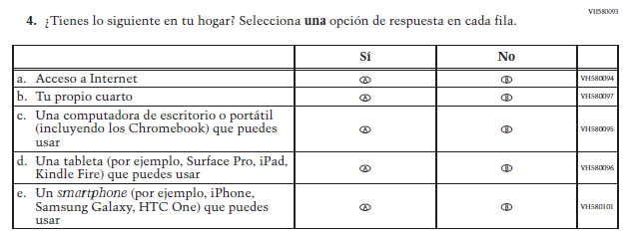  (2019 Operational Grade 4 Student Core – Puerto Rico) | 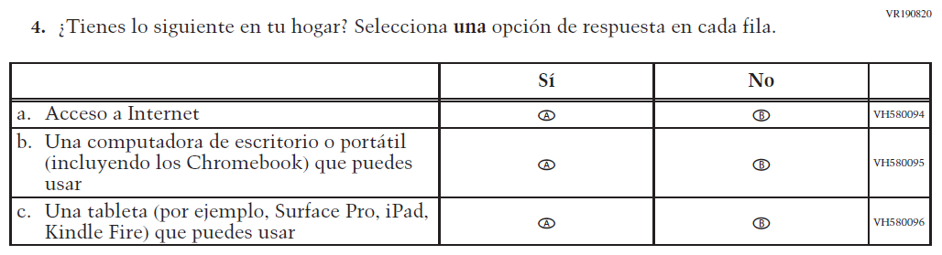  Issue: Socioeconomic Status | R | To keep student burden low, sub-items b and e were dropped.
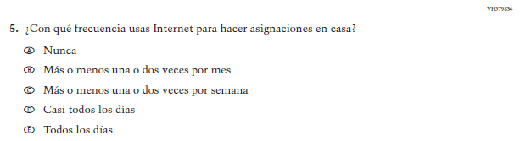  (2019 Operational Grade 4 Student Core – Puerto Rico) | N/A | D | To keep student burden low, this item was dropped.
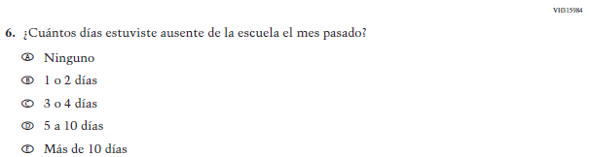  (2019 Operational Grade 4 Student Core – Puerto Rico) | 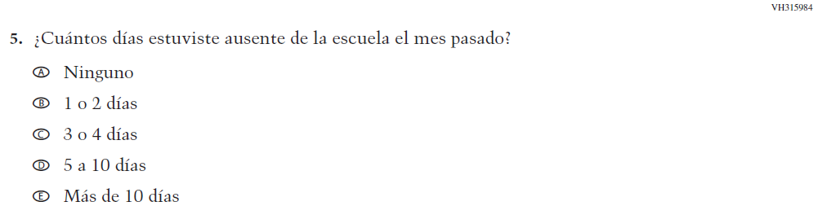  Issue: School Climate | NC | N/A

2021 Operational Grade 4 Core Student – Puerto Rico

Previous item | 2021 item | D/A/ R/NC+ | Rationale
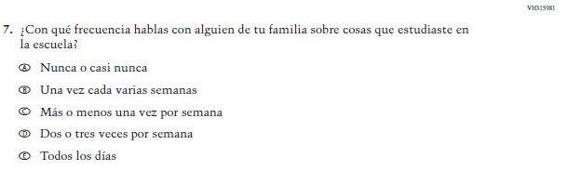  (2019 Operational Grade 4 Student Core – Puerto Rico) | N/A | D | To keep student burden low, this item was dropped.
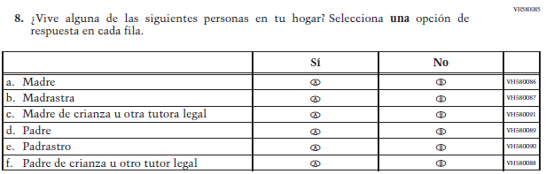  (2019 Operational Grade 4 Student Core – Puerto Rico) | 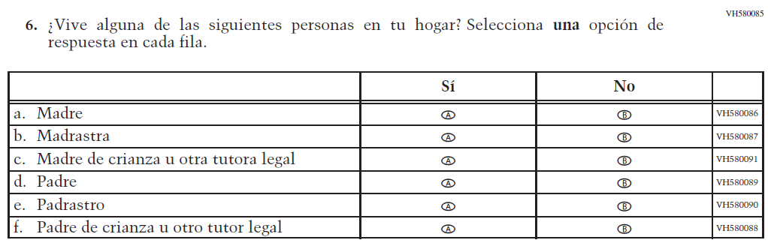  Issue: Socioeconomic Status | NC | N/A
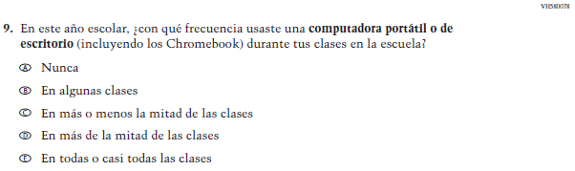  (2019 Operational Grade 4 Student Core – Puerto Rico) | 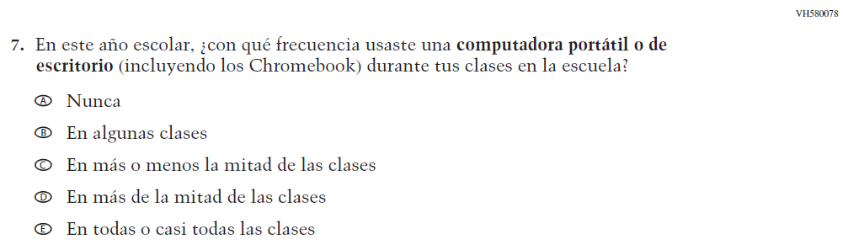  Issue: Technology Use | NC | N/A
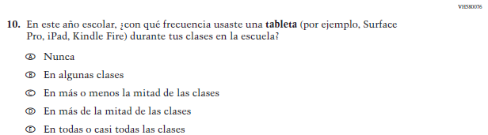  (2019 Operational Grade 4 Student Core – Puerto Rico) | N/A | D | To keep student burden low, this item was dropped.

2021 Operational Grade 4 Core Student – Puerto Rico

Previous item | 2021 item | D/A/ R/NC+ | Rationale
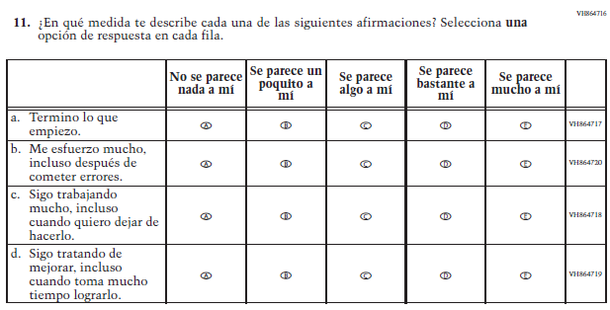  (2019 Operational Grade 4 Student Core – Puerto Rico) | N/A | D | To keep student burden low, this item was dropped.
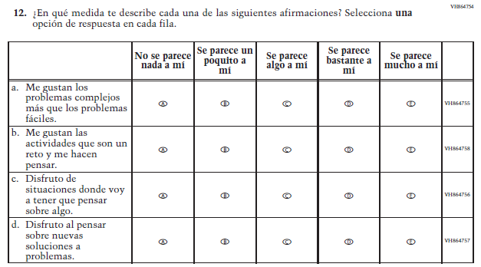  (2019 Operational Grade 4 Student Core – Puerto Rico) | 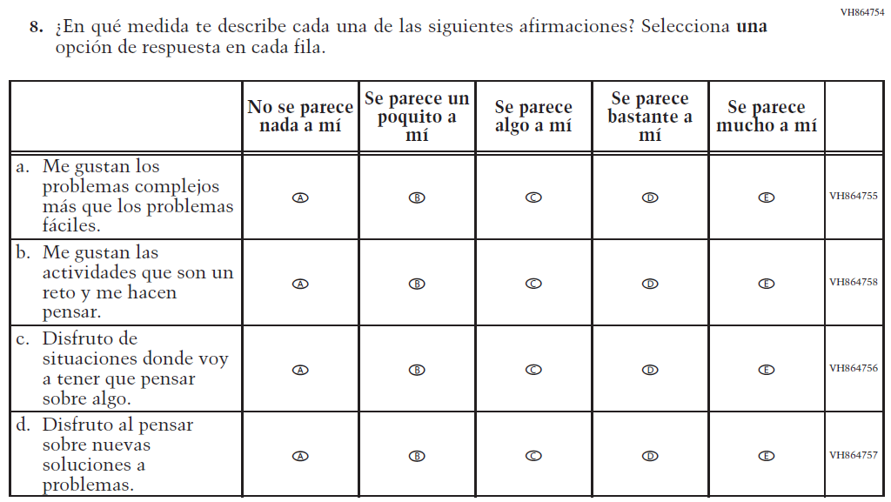  Issue: Desire for Learning | NC | N/A

2021 Operational Grade 4 Core Student – Puerto Rico

Previous item | 2021 item | D/A/ R/NC+ | Rationale
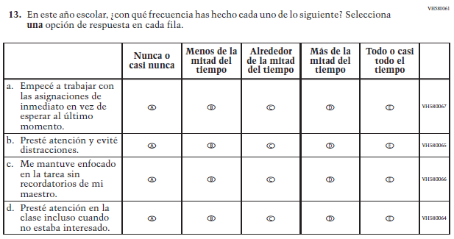  (2019 Operational Grade 4 Student Core – Puerto Rico) | 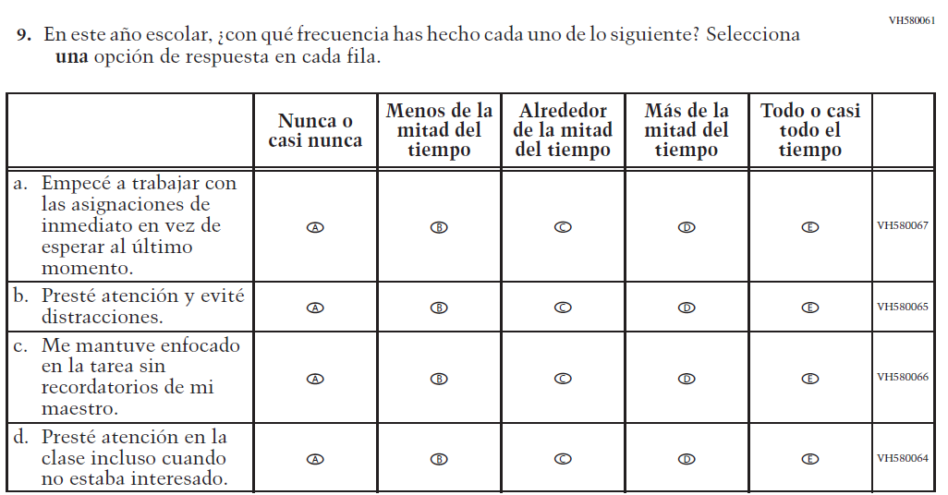  Issue: Grit | NC | N/A
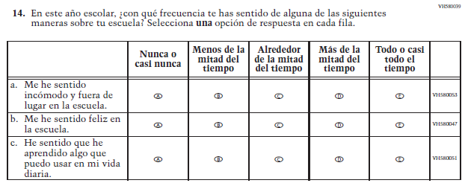  (2019 Operational Grade 4 Student Core – Puerto Rico) | N/A | D | To keep student burden low, this item was dropped.

Appendix J-1b-s-PR: Operational Grade 4 CORE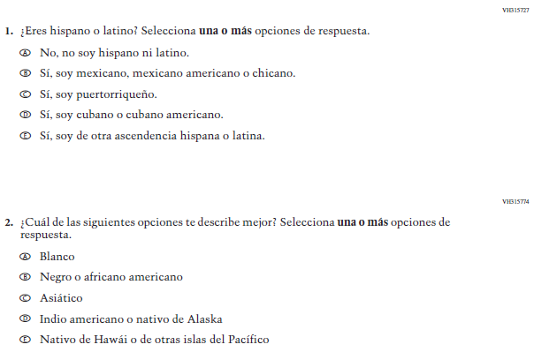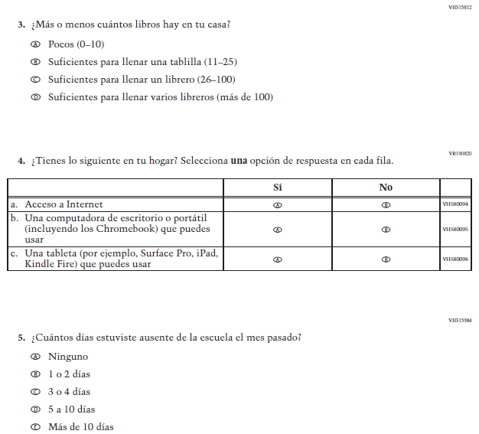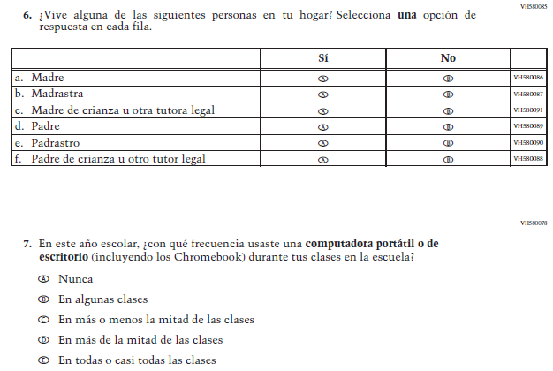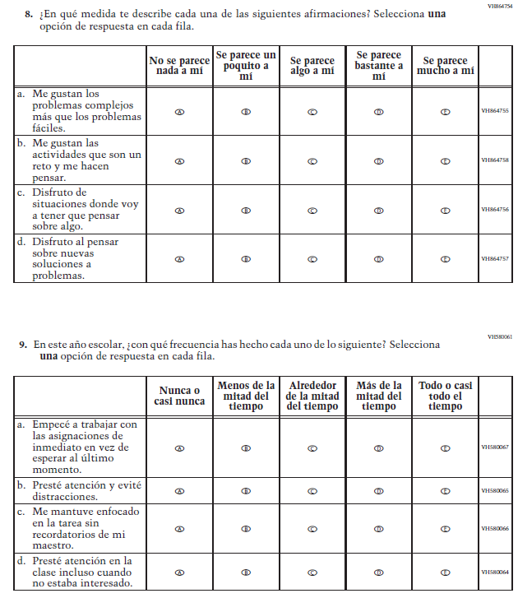

Appendix J-1c-s-BL: Summary of Changes Operational Grade 8 CORE
2021 Operational Grade 8 Core Student – Bilingual
Previous item | 2021 item | D/A/R/NC+ | Rationale
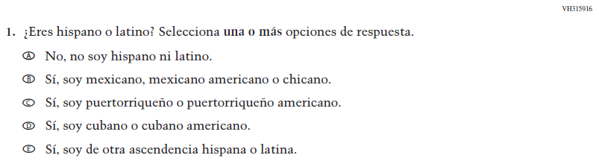  (2019 Operational Grade 8 Student Core - Bilingual) | Issue: Race/Ethnicity | NC | N/A
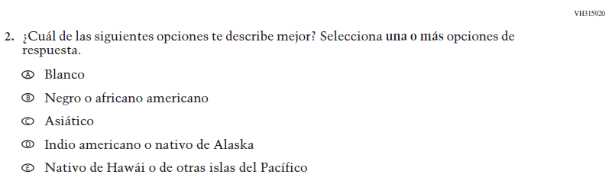  (2019 Operational Grade 8 Student Core - Bilingual) | Issue: Race/Ethnicity | NC | N/A
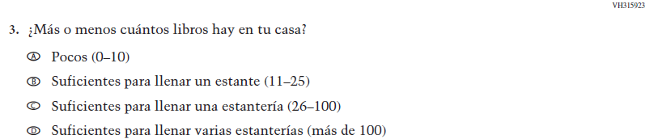  (2019 Operational Grade 8 Student Core - Bilingual) | Issue: Socioeconomic Status | NC | N/A

2021 Operational Grade 8 Core Student – Bilingual
Previous item | 2021 item | D/A/R/NC+ | Rationale
(2019 Operational Grade 8 Student Core - Bilingual) | 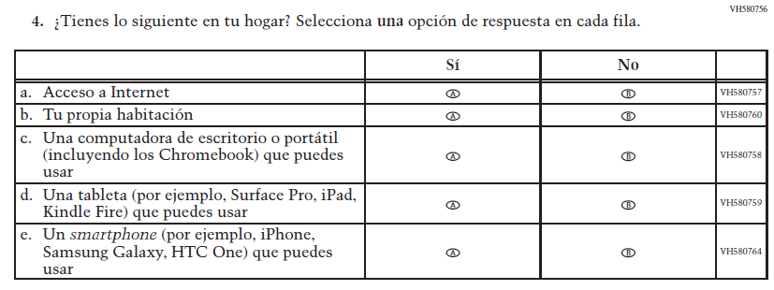  Issue: Socioeconomic Status | NC | N/A
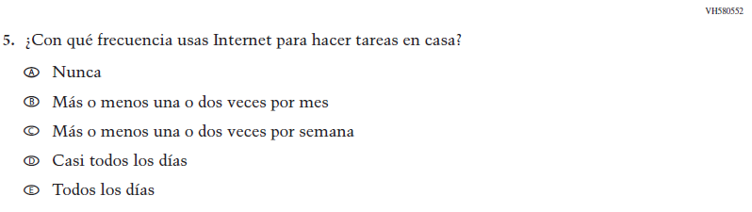  (2019 Operational Grade 8 Student Core - Bilingual) | Issue: Technology Use | NC | N/A
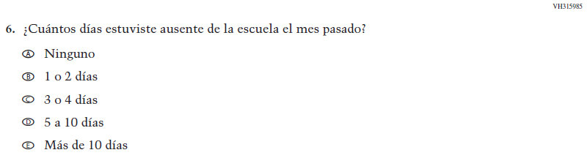  (2019 Operational Grade 8 Student Core - Bilingual) | Issue: School Climate | NC | N/A

2021 Operational Grade 8 Core Student – Bilingual
Previous item | 2021 item | D/A/R/NC+ | Rationale
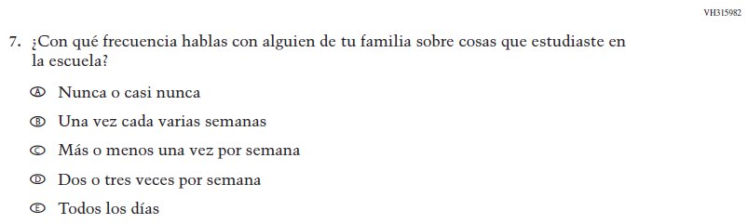  (2019 Operational Grade 8 Student Core - Bilingual) | Issue: Socioeconomic Status | NC | N/A
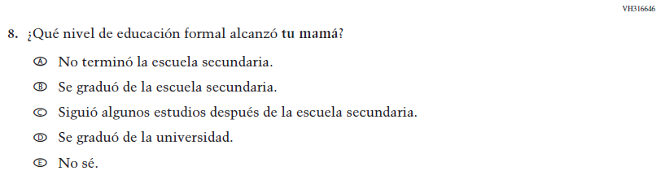  (2019 Operational Grade 8 Student Core - Bilingual) | Issue: Socioeconomic Status | NC | N/A
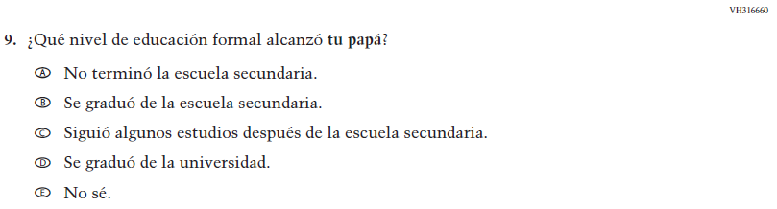  (2019 Operational Grade 8 Student Core - Bilingual) | Issue: Socioeconomic Status | NC | N/A

2021 Operational Grade 8 Core Student – Bilingual
Previous item | 2021 item | D/A/R/NC+ | Rationale
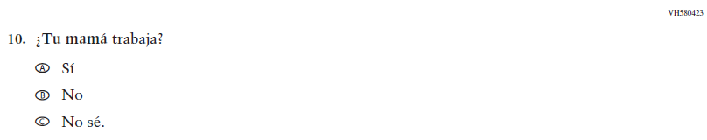  (2019 Operational Grade 8 Student Core - Bilingual) | Issue: Socioeconomic Status | NC | N/A
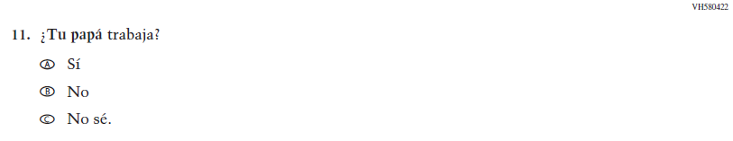  (2019 Operational Grade 8 Student Core - Bilingual) | Issue: Socioeconomic Status | NC | N/A
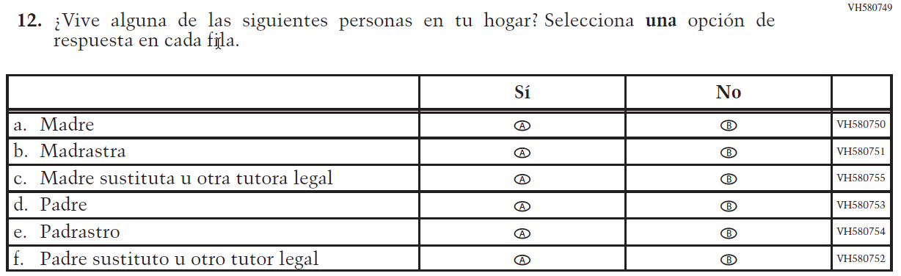  (2019 Operational Grade 8 Student Core - Bilingual) | 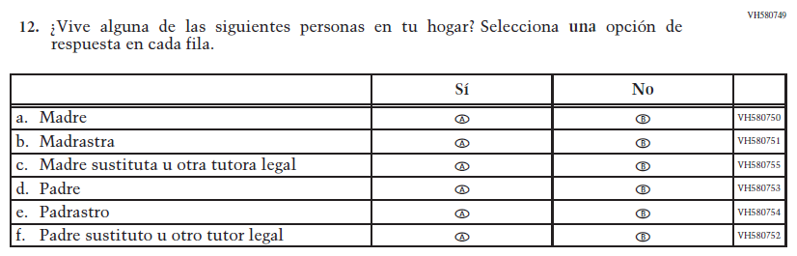  Issue: Socioeconomic Status | NC | N/A

2021 Operational Grade 8 Core Student – Bilingual
Previous item | 2021 item | D/A/R/NC+ | Rationale
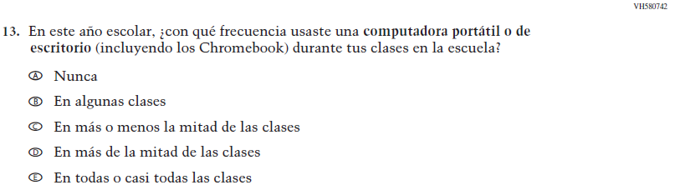  (2019 Operational Grade 8 Student Core - Bilingual) | Issue: Technology Use | NC | N/A
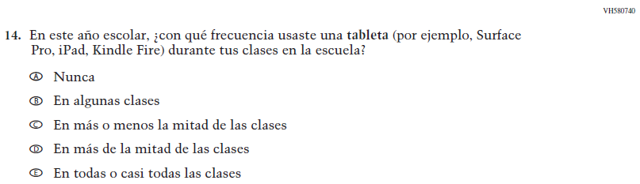  (2019 Operational Grade 8 Student Core - Bilingual) | Issue: Technology Use | NC | N/A
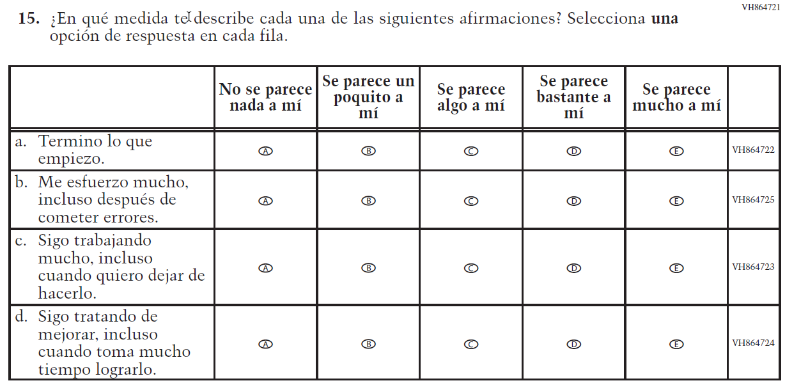  (2019 Operational Grade 8 Student Core - Bilingual) | 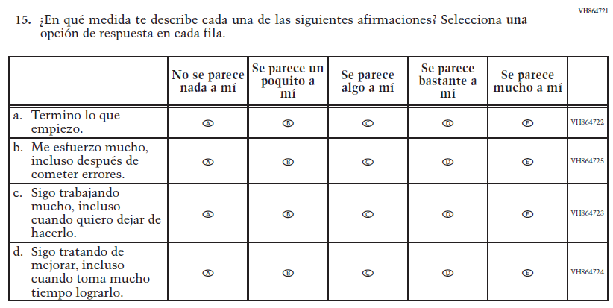  Issue: Grit | NC | N/A

2021 Operational Grade 8 Core Student – Bilingual
Previous item | 2021 item | D/A/R/NC+ | Rationale
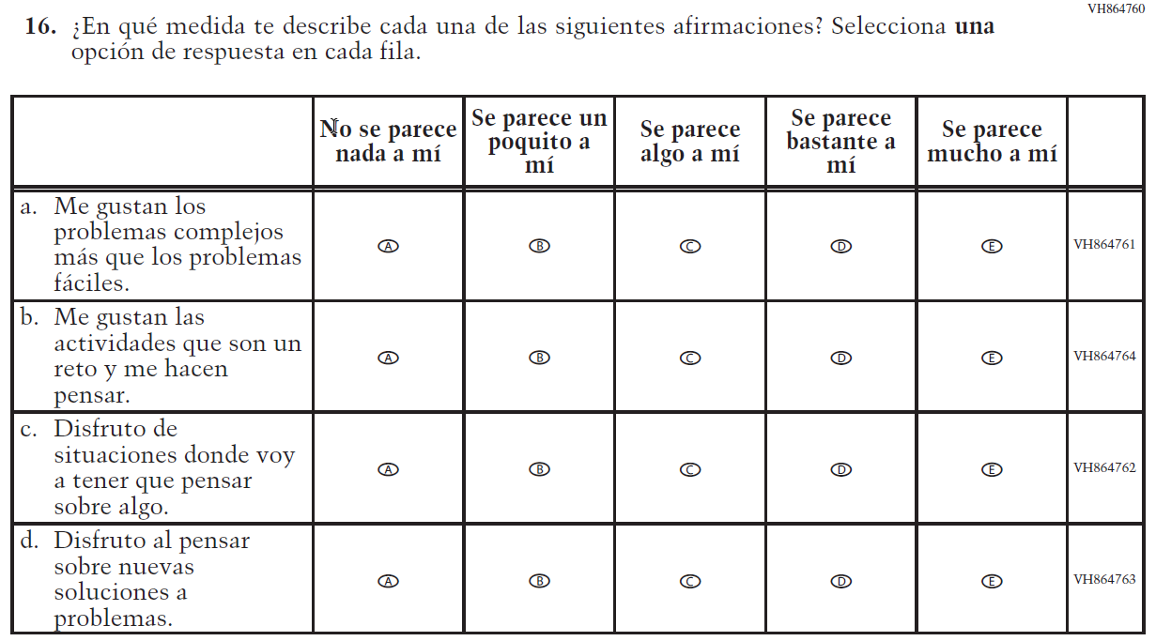  (2019 Operational Grade 8 Student Core - Bilingual) | 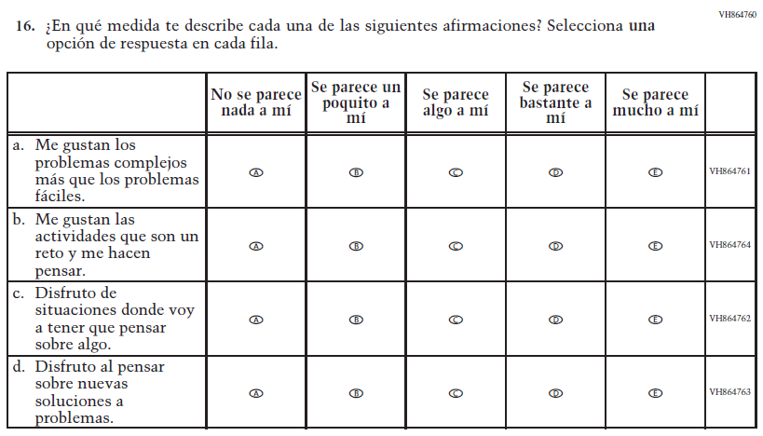  Issue: Desire for Learning | NC | N/A
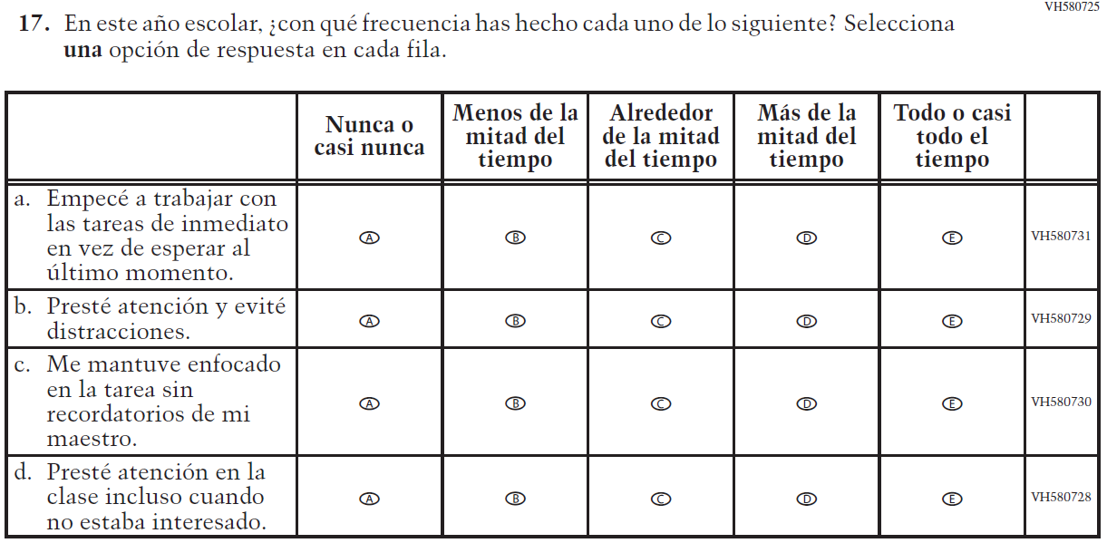  (2019 Operational Grade 8 Student Core - Bilingual) | Issue: Grit | NC | N/A

2021 Operational Grade 8 Core Student – Bilingual
Previous item | 2021 item | D/A/R/NC+ | Rationale
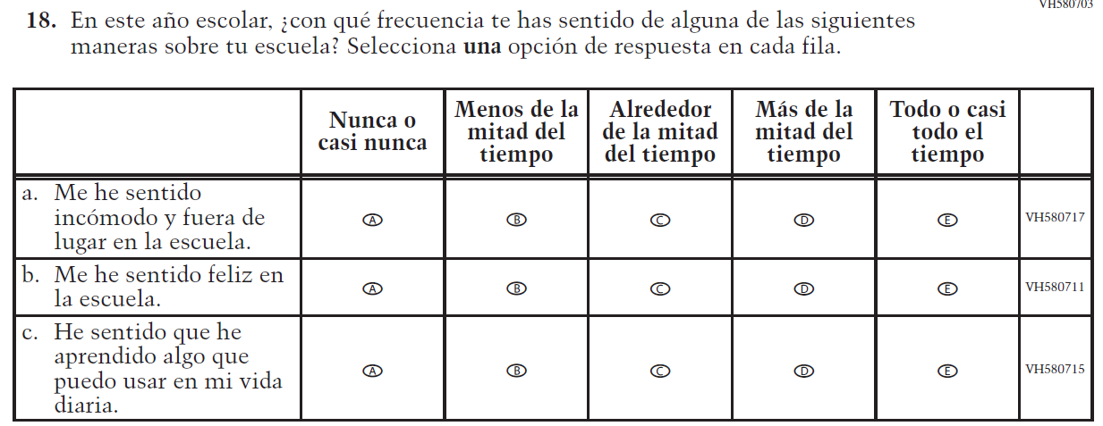  (2019 Operational Grade 8 Student Core - Bilingual) | N/A | D | To keep student burden low, this item was dropped.
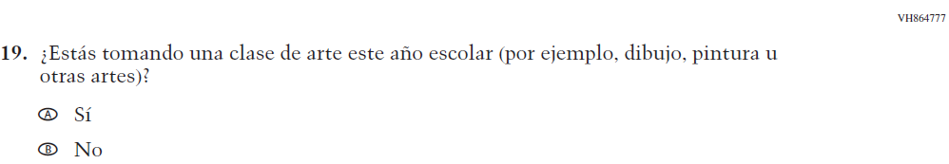  (2019 Operational Grade 8 Student Core - Bilingual) | 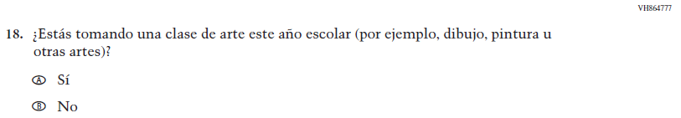  Issue: Educational Experiences | NC | N/A

Appendix J-1c-s-BL: Operational Grade 8 CORE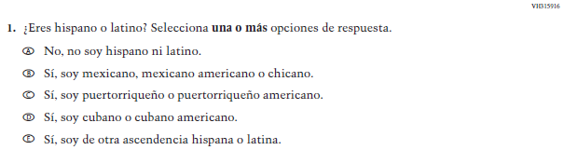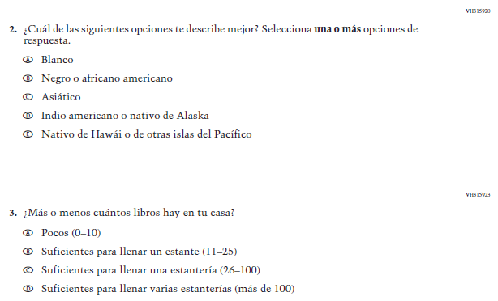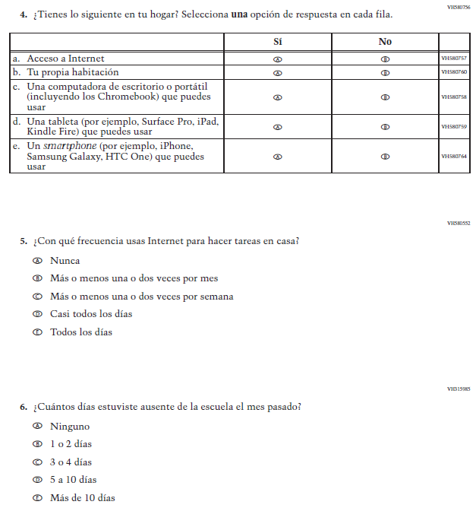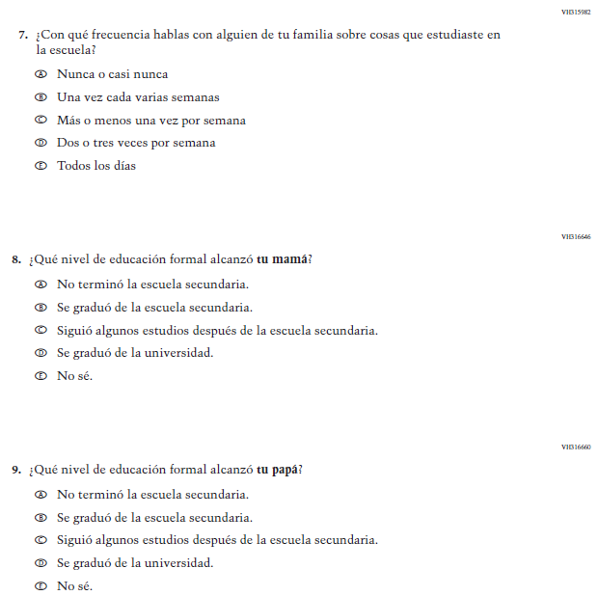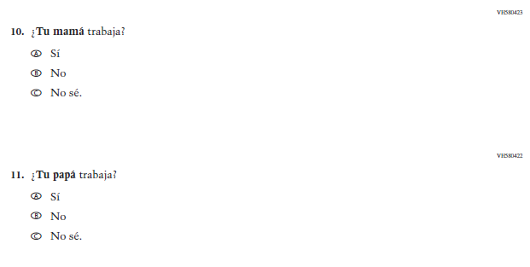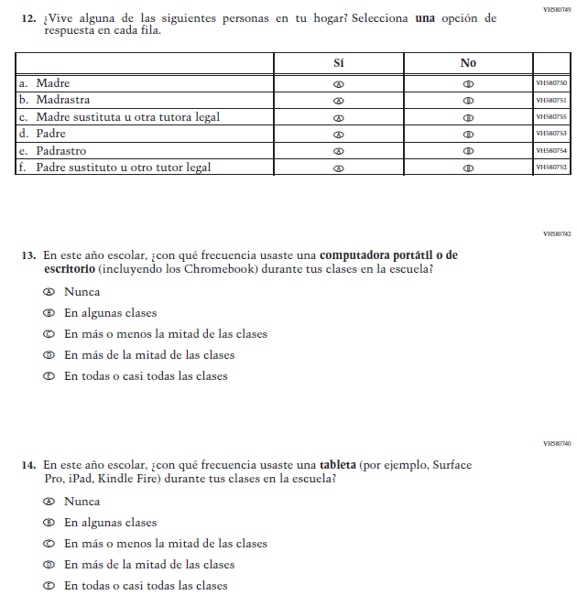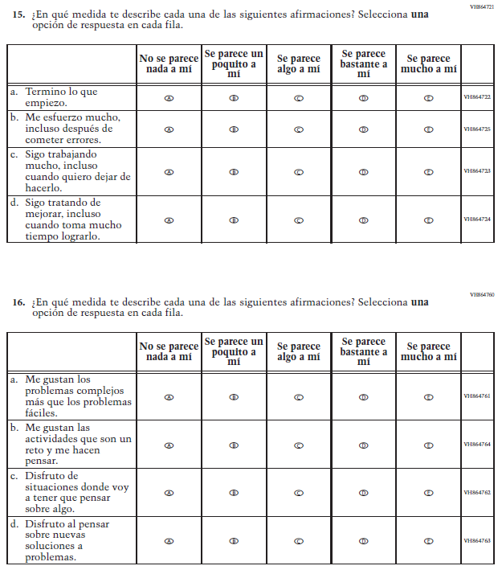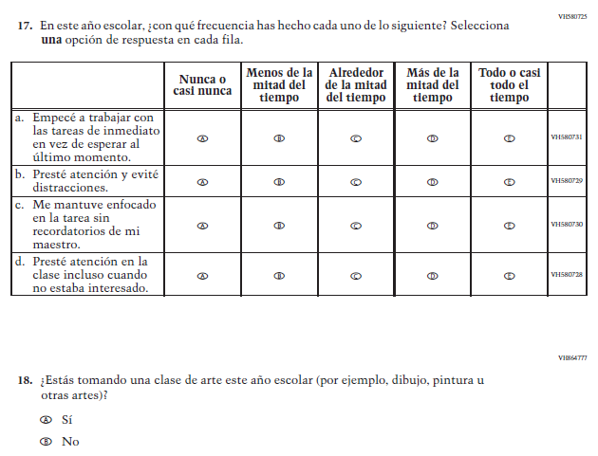

Appendix J-1d-s-PR: Summary of Changes Operational Grade 8 CORE
2021 Operational Grade 8 Core Student – Puerto Rico

Previous item | 2021 item | D/A/ R/NC+ | Rationale
(2019 Operational Grade 8 Student Core – Puerto Rico) | 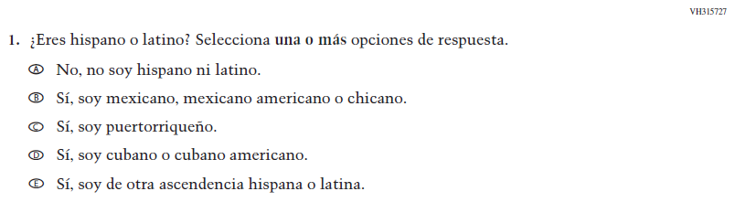  Issue: Race/Ethnicity | NC | N/A
(2019 Operational Grade 8 Student Core – Puerto Rico) | 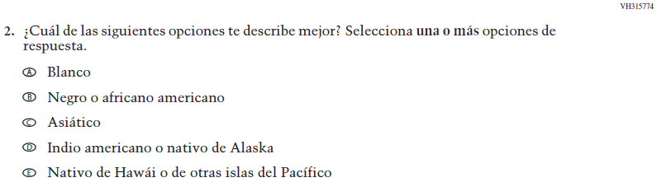  Issue: Race/Ethnicity | NC | N/A
(2019 Operational Grade 8 Student Core – Puerto Rico) | 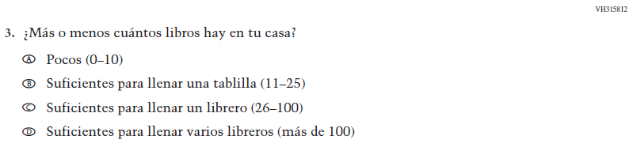  Issue: Socioeconomic Status | NC | N/A
(2019 Operational Grade 8 Student Core – Puerto Rico) | Issue: Socioeconomic Status | NC | N/A
(2019 Operational Grade 8 Student Core – Puerto Rico) | Issue: Technology Use | NC | N/A
(2019 Operational Grade 8 Student Core – Puerto Rico) | Issue: School Climate | NC | N/A
(2019 Operational Grade 8 Student Core – Puerto Rico) | Issue: Socioeconomic Status | NC | N/A
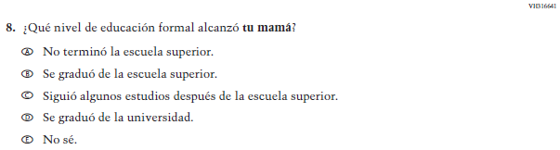  (2019 Operational Grade 8 Student Core – Puerto Rico) | Issue: Socioeconomic Status | NC | N/A
2021 Operational Grade 8 Core Student – Puerto Rico

Previous item | 2021 item | D/A/ R/NC+ | Rationale
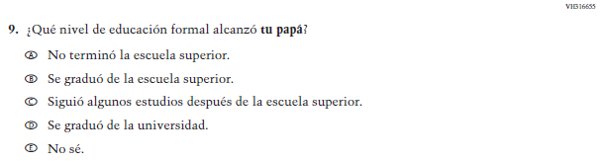  (2019 Operational Grade 8 Student Core – Puerto Rico) | Issue: Socioeconomic Status | NC | N/A
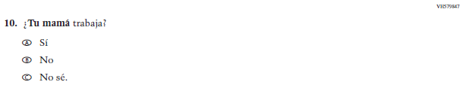  (2019 Operational Grade 8 Student Core – Puerto Rico) | Issue: Socioeconomic Status | NC | N/A
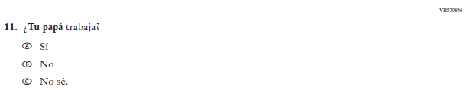  (2019 Operational Grade 8 Student Core – Puerto Rico) | Issue: Socioeconomic Status | NC | N/A
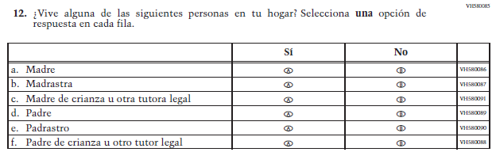  (2019 Operational Grade 8 Student Core – Puerto Rico) | Issue: Socioeconomic Status | NC | N/A

2021 Operational Grade 8 Core Student – Puerto Rico

Previous item | 2021 item | D/A/ R/NC+ | Rationale
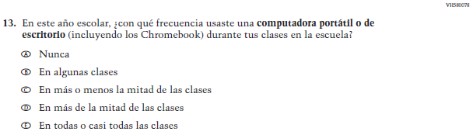  (2019 Operational Grade 8 Student Core – Puerto Rico) | Issue: Technology Use | NC | N/A
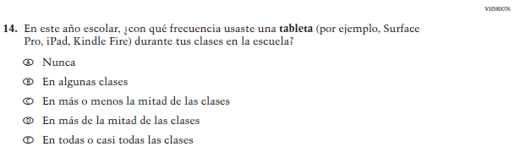  (2019 Operational Grade 8 Student Core – Puerto Rico) | Issue: Technology Use | NC | N/A
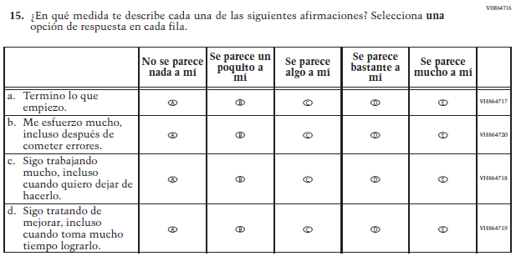  (2019 Operational Grade 8 Student Core – Puerto Rico) | Issue: Grit | NC | N/A

2021 Operational Grade 8 Core Student – Puerto Rico

Previous item | 2021 item | D/A/ R/NC+ | Rationale
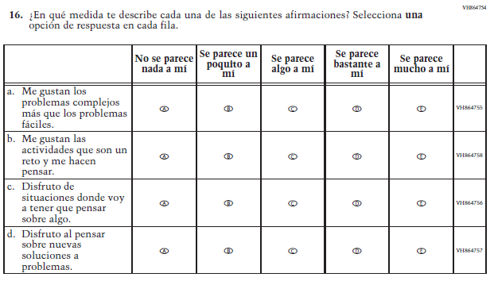  (2019 Operational Grade 8 Student Core – Puerto Rico) | Issue: Desire for Learning | NC | N/A
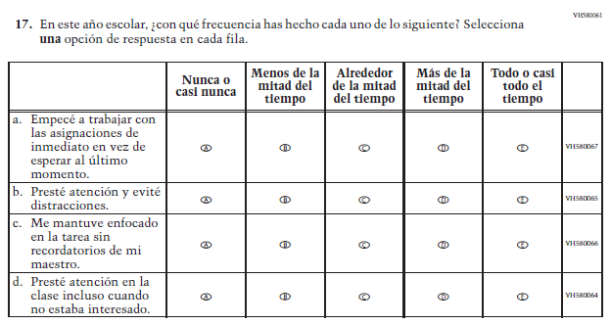  (2019 Operational Grade 8 Student Core – Puerto Rico) | Issue: Grit | NC | N/A

2021 Operational Grade 8 Core Student – Puerto Rico

Previous item | 2021 item | D/A/ R/NC+ | Rationale
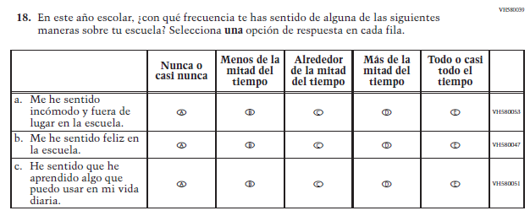  (2019 Operational Grade 8 Student Core – Puerto Rico) | N/A | D | To keep student burden low, this item was dropped.
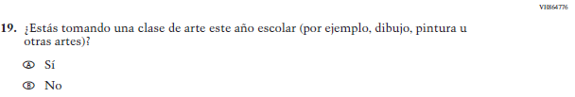  (2019 Operational Grade 8 Student Core – Puerto Rico) | 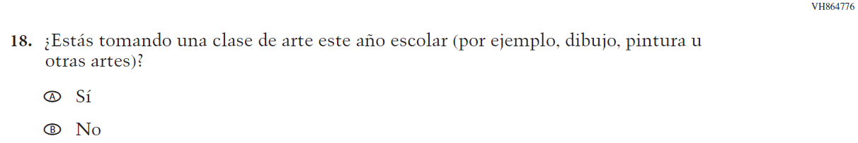  Issue: Educational Experiences | NC | N/A

Appendix J-1d-s-PR: Operational Grade 8 CORE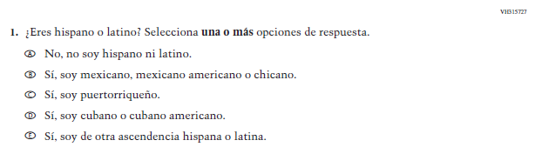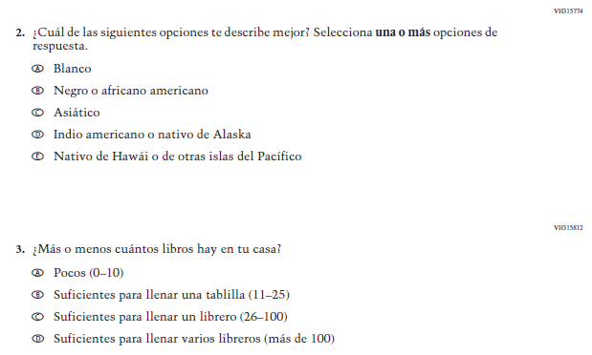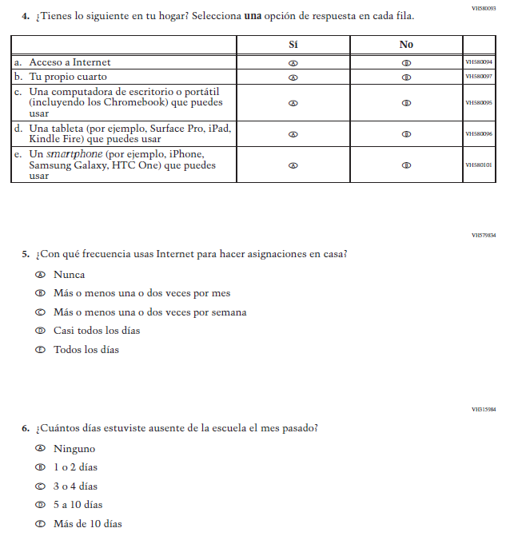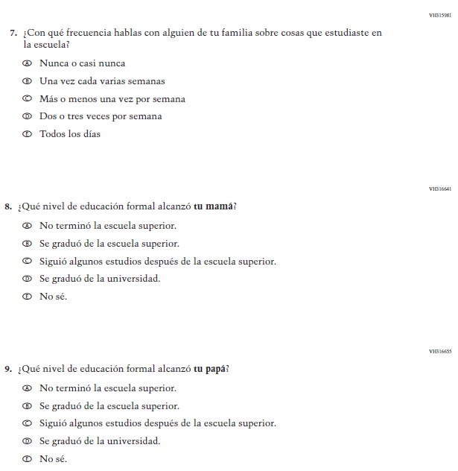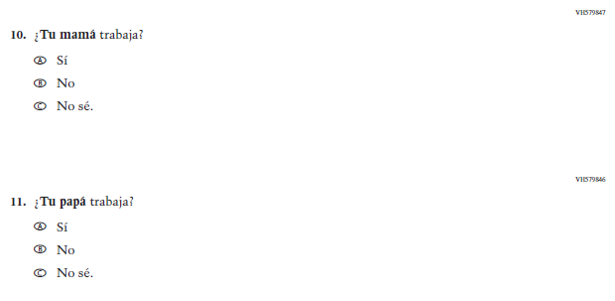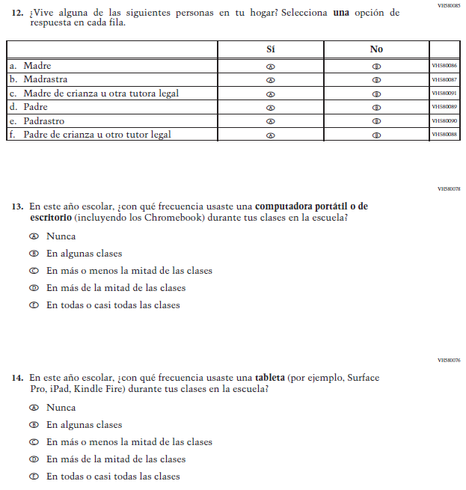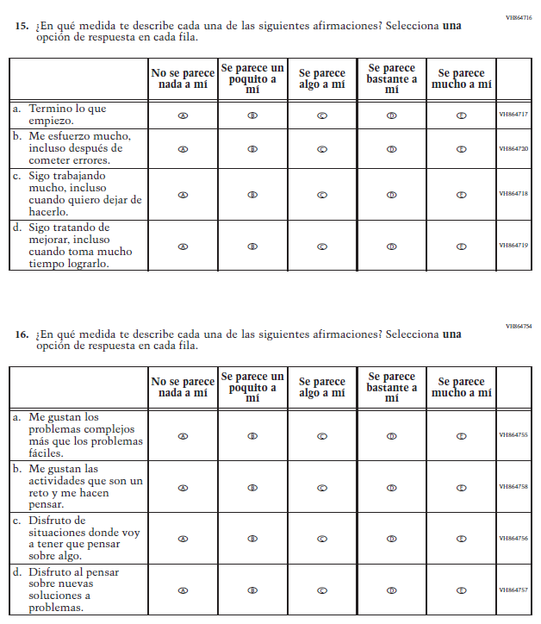

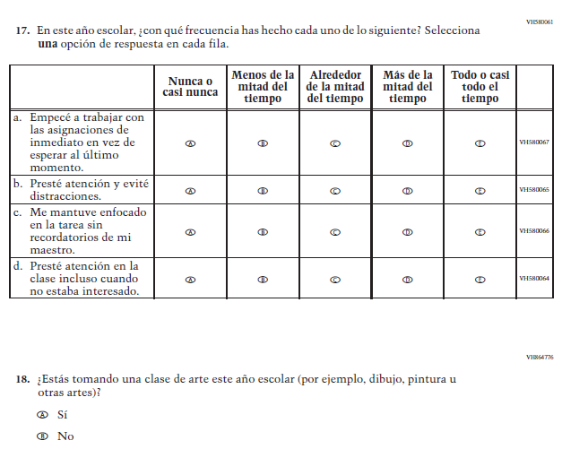

Appendix J-1e-s-BL: Summary of Changes Operational Grade 4 Mathematics
2021 Operational Grade 4 Mathematics Student – Bilingual
Previous item | 2021 item | D/A/R/NC+ | Rationale
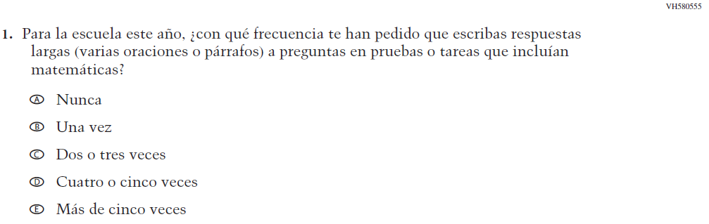  (2019 Operational Grade 4 Student Mathematics - Bilingual) | Issue: Organization of Instruction | NC | N/A
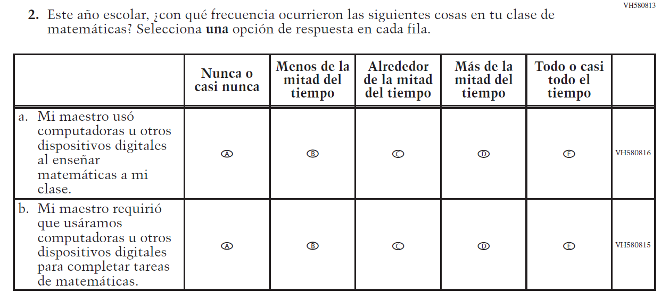  (2019 Operational Grade 4 Student Mathematics - Bilingual) | Issue: Resources for Learning and Instruction | NC | N/A

2021 Operational Grade 4 Mathematics Student – Bilingual
Previous item | 2021 item | D/A/R/NC+ | Rationale
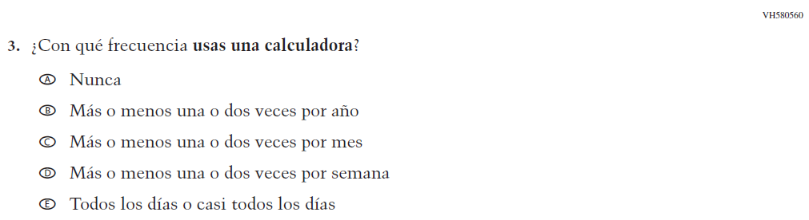  (2019 Operational Grade 4 Student Mathematics - Bilingual) | Issue: Resources for Learning and Instruction | NC | N/A
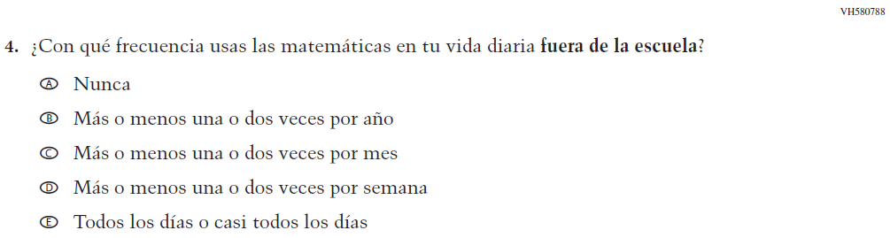  (2019 Operational Grade 4 Student Mathematics - Bilingual) | Issue: Resources for Learning and Instruction | NC | N/A
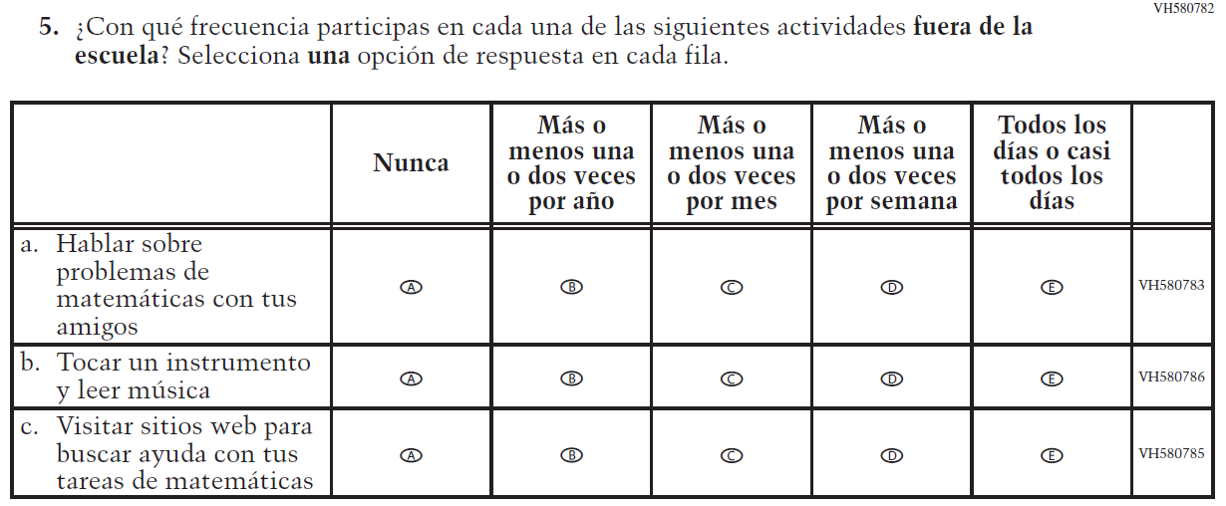  (2019 Operational Grade 4 Student Mathematics - Bilingual) | Issue: Resources for Learning and Instruction | NC | N/A

2021 Operational Grade 4 Mathematics Student – Bilingual
Previous item | 2021 item | D/A/R/NC+ | Rationale
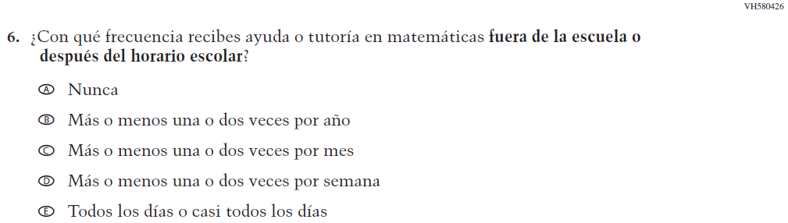  (2019 Operational Grade 4 Student Mathematics - Bilingual) | Issue: Resources for Learning and Instruction | NC | N/A
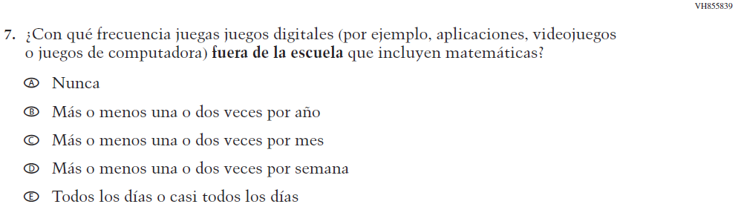  (2019 Operational Grade 4 Student Mathematics - Bilingual) | Issue: Resources for Learning and Instruction | NC | N/A
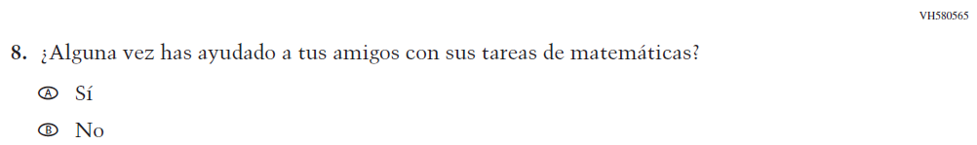  (2019 Operational Grade 4 Student Mathematics - Bilingual) | N/A | D | To keep student burden low, this item was dropped.
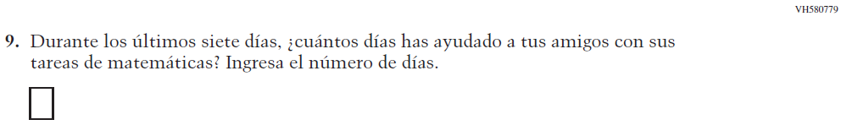  (2019 Operational Grade 4 Student Mathematics - Bilingual) | N/A | D | To keep student burden low, this item was dropped.

2021 Operational Grade 4 Mathematics Student – Bilingual
Previous item | 2021 item | D/A/R/NC+ | Rationale
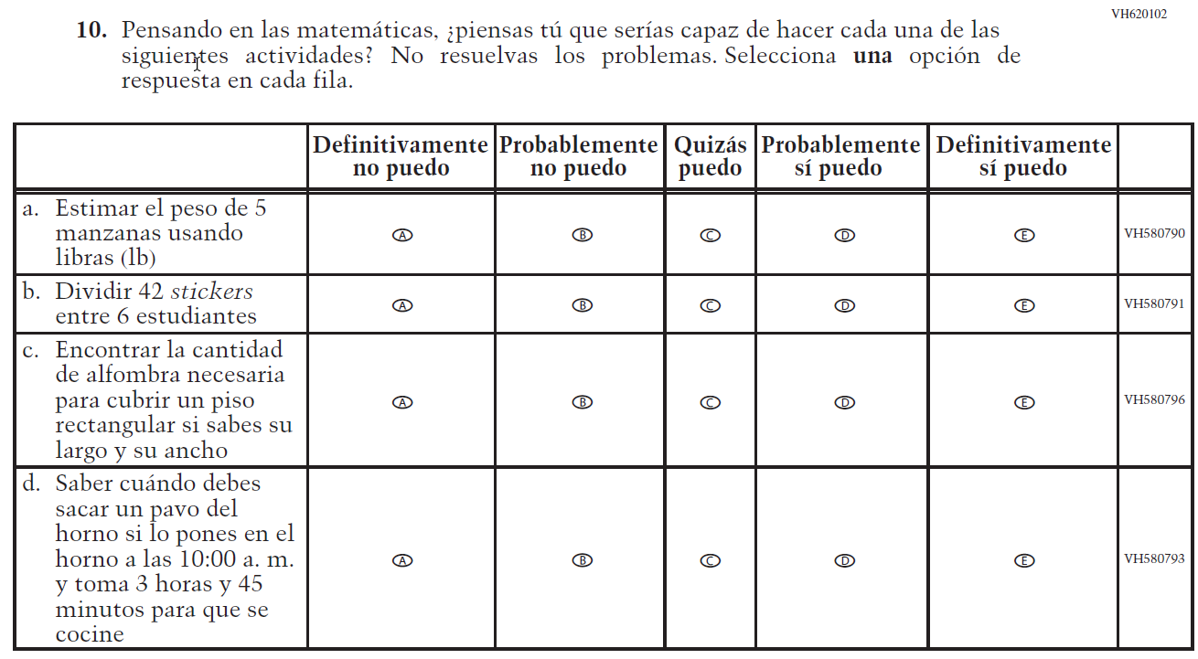  (2019 Operational Grade 4 Student Mathematics - Bilingual) | 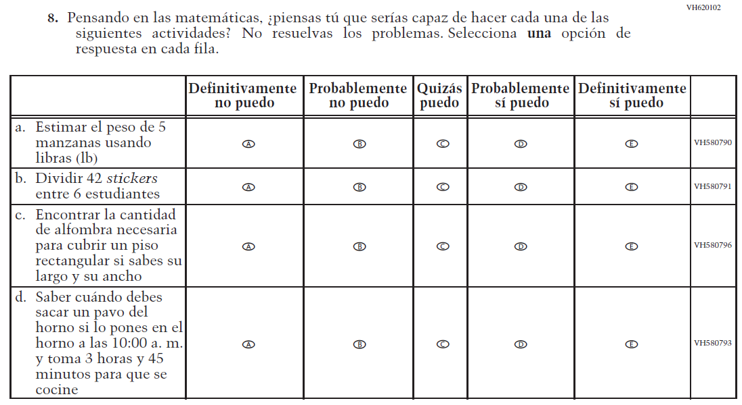  Issue: Student Factors | NC | N/A
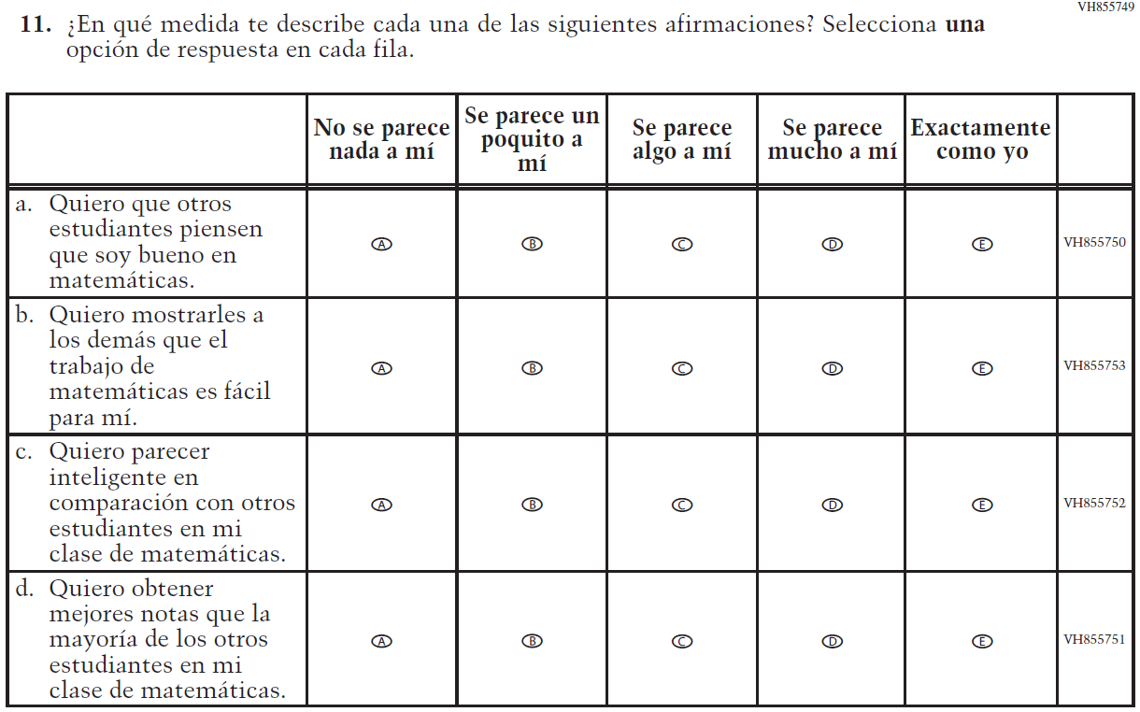  (2019 Operational Grade 4 Student Mathematics - Bilingual) | N/A | D | To keep student burden low, this item was dropped.

2021 Operational Grade 4 Mathematics Student – Bilingual
Previous item | 2021 item | D/A/R/NC+ | Rationale
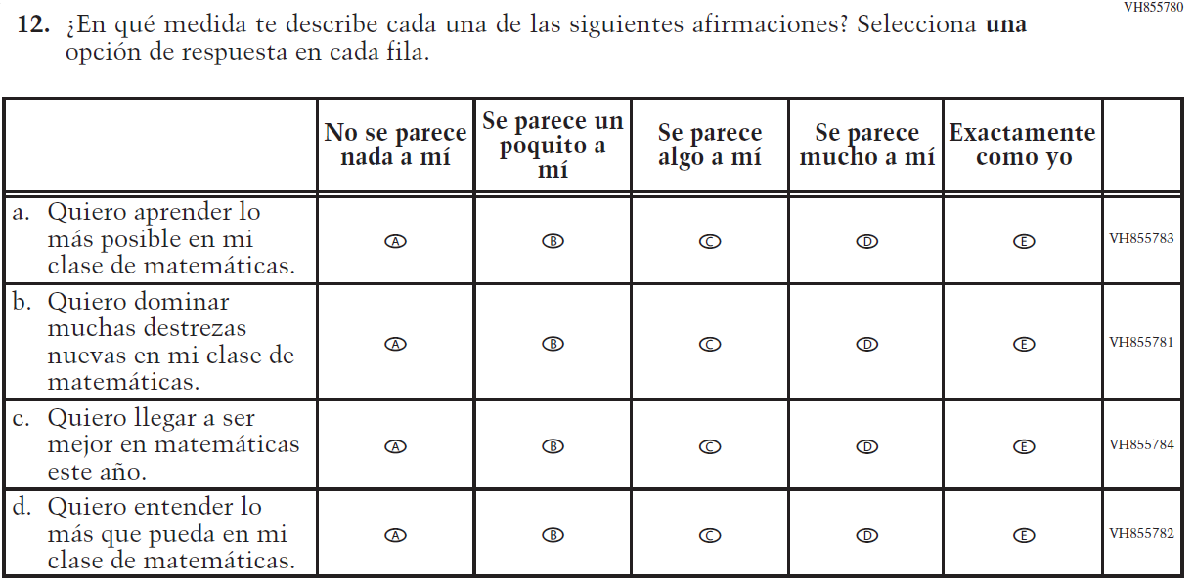  (2019 Operational Grade 4 Student Mathematics - Bilingual) | 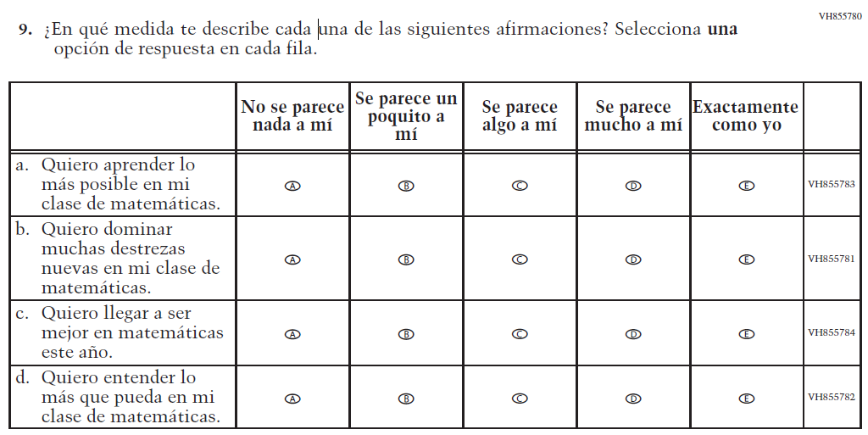  Issue: Student Factors | NC | N/A
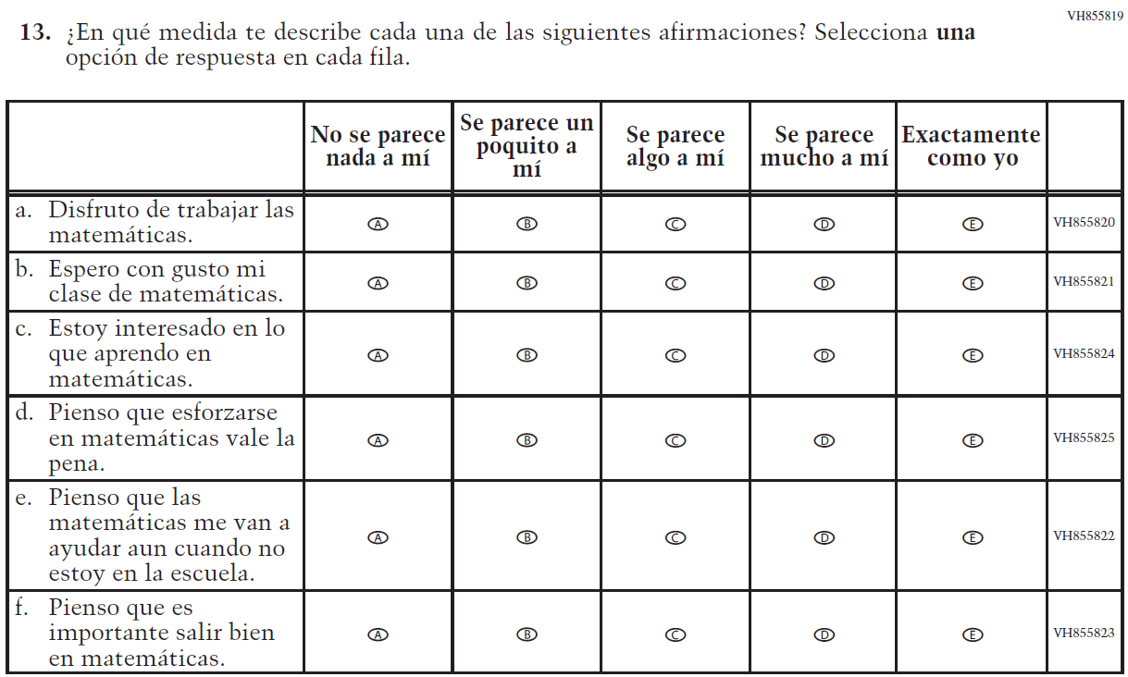  (2019 Operational Grade 4 Student Mathematics - Bilingual) | 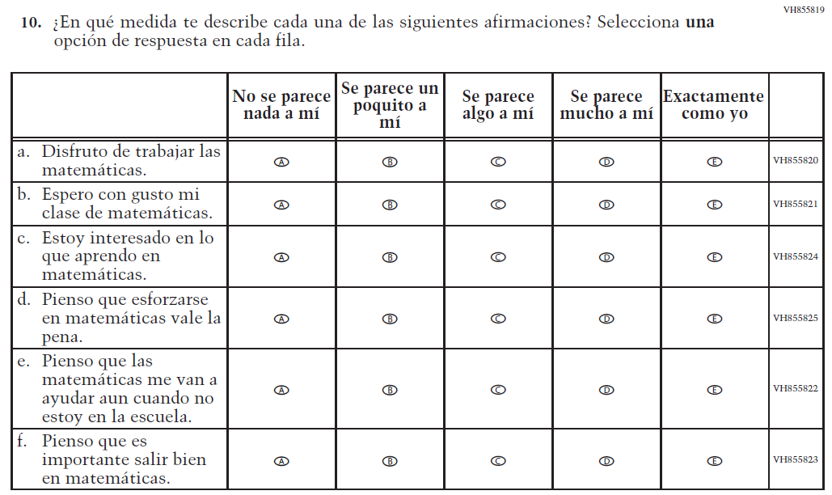  Issue: Student Factors | NC | N/A

Appendix J-1e-s-BL: Operational Grade 4 Mathematics
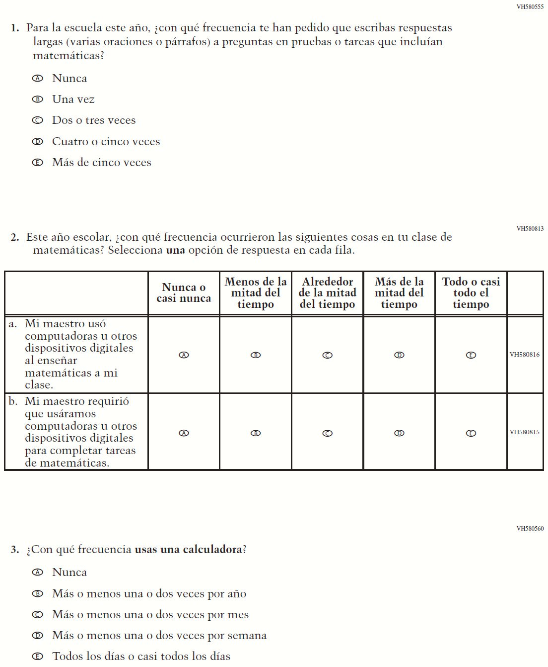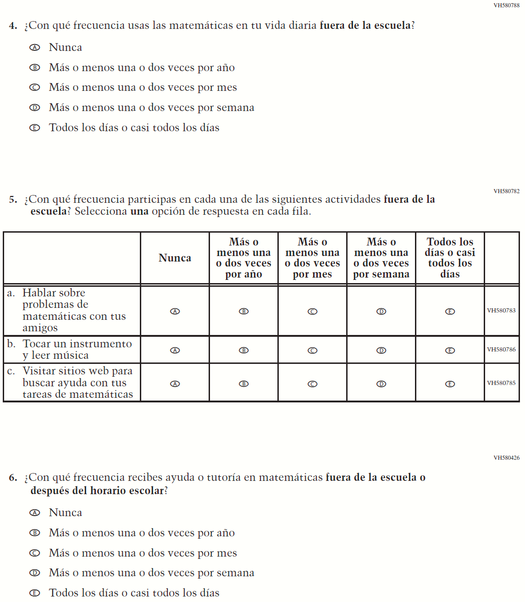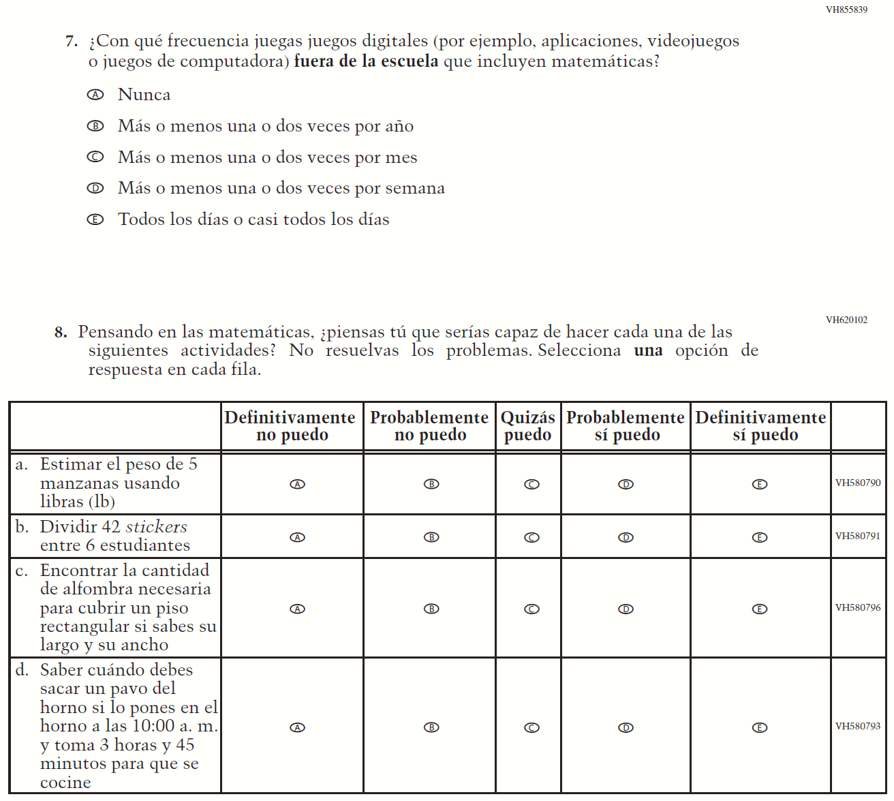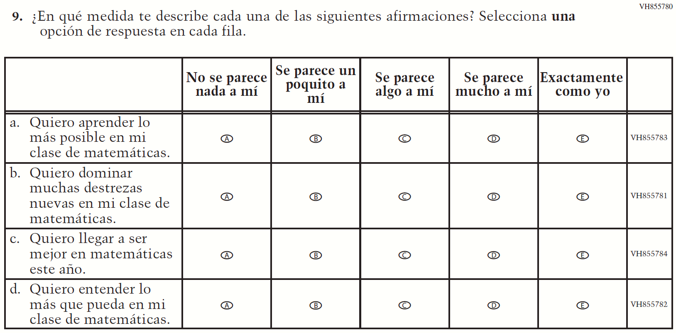

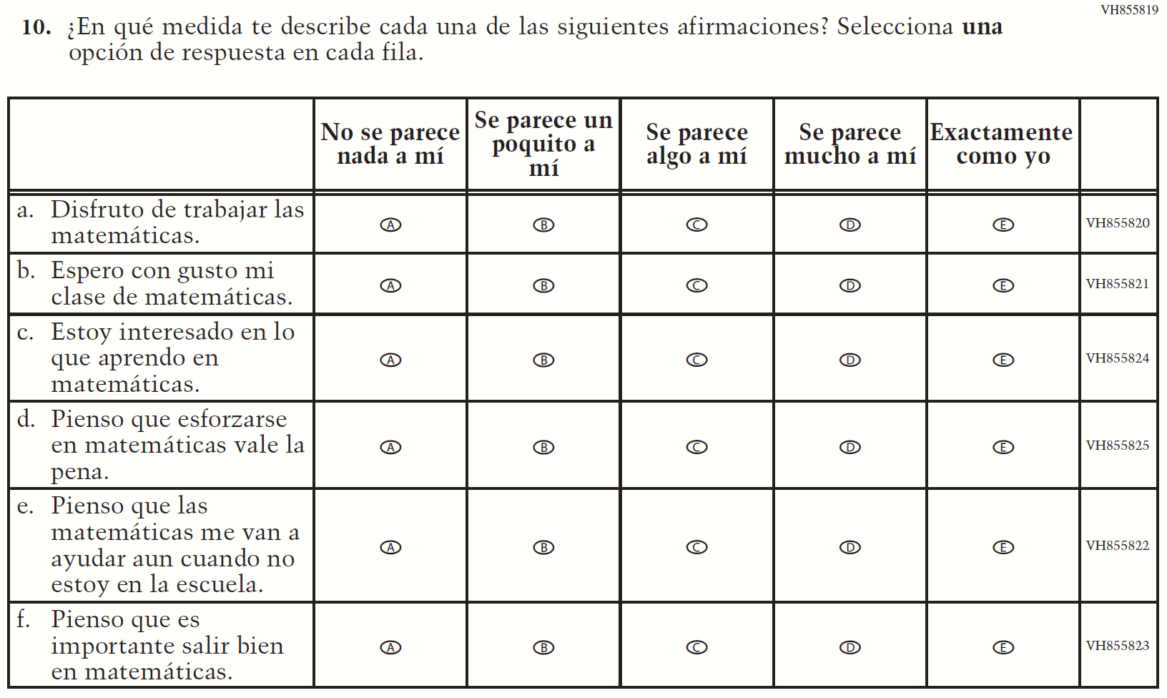

Appendix J-1f-s-PR: Summary of Changes Operational Grade 4 Mathematics
2021 Operational Grade 4 Mathematics Student – Puerto Rico

Previous item | 2021 item | D/A/ R/NC+ | Rationale
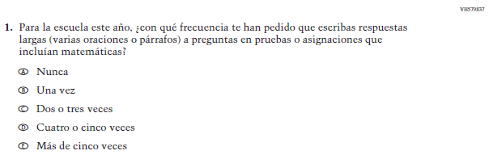  (2019 Operational Grade 4 Student Mathematics – Puerto Rico) | Issue: Organization of Instruction | NC | N/A
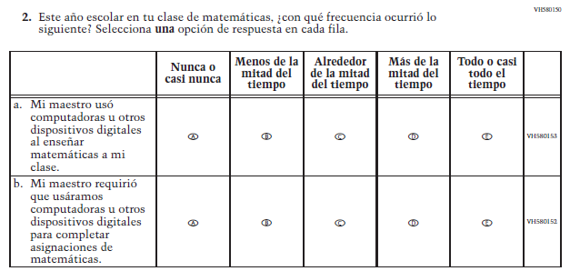  (2019 Operational Grade 4 Student Mathematics – Puerto Rico) | Issue: Resources for Learning and Instruction | NC | N/A
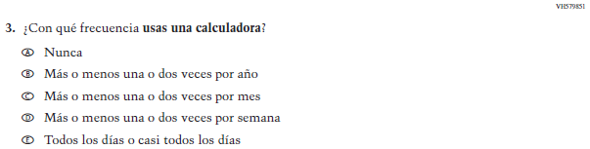  (2019 Operational Grade 4 Student Mathematics – Puerto Rico) | Issue: Resources for Learning and Instruction | NC | N/A
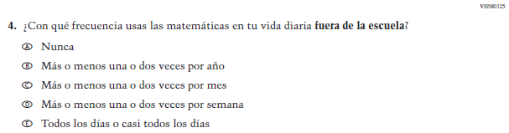  (2019 Operational Grade 4 Student Mathematics – Puerto Rico) | Issue: Resources for Learning and Instruction | NC | N/A
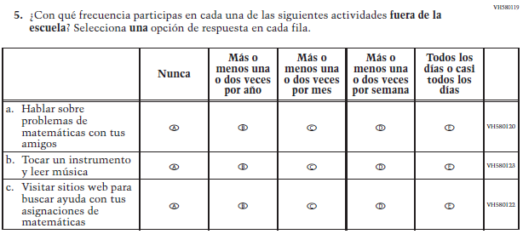  (2019 Operational Grade 4 Student Mathematics – Puerto Rico) | Issue: Resources for Learning and Instruction | NC | N/A
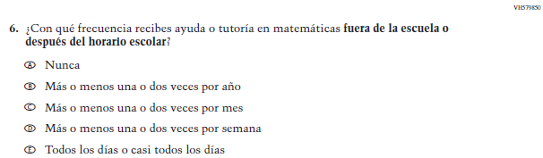  (2019 Operational Grade 4 Student Mathematics – Puerto Rico) | Issue: Resources for Learning and Instruction | NC | N/A

2021 Operational Grade 4 Mathematics Student – Puerto Rico

Previous item | 2021 item | D/A/ R/NC+ | Rationale
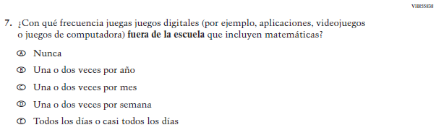  (2019 Operational Grade 4 Student Mathematics – Puerto Rico) | Issue: Resources for Learning and Instruction | NC | N/A
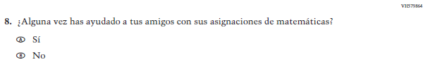  (2019 Operational Grade 4 Student Mathematics – Puerto Rico) | N/A | D | To keep student burden low, this item was dropped.
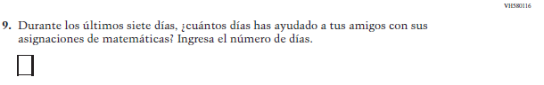  (2019 Operational Grade 4 Student Mathematics – Puerto Rico) | N/A | D | To keep student burden low, this item was dropped.
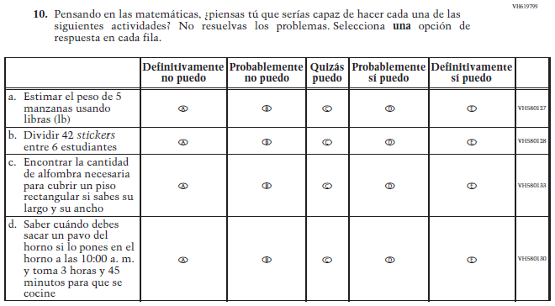  (2019 Operational Grade 4 Student Mathematics – Puerto Rico) | 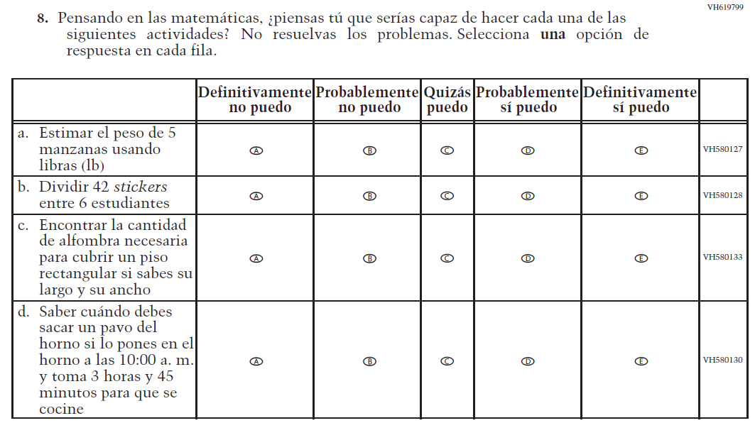  Issue: Student Factors | NC | N/A

2021 Operational Grade 4 Mathematics Student – Puerto Rico

Previous item | 2021 item | D/A/ R/NC+ | Rationale
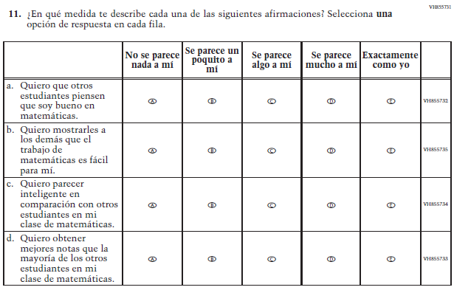  (2019 Operational Grade 4 Student Mathematics – Puerto Rico) | N/A | D | To keep student burden low, this item was dropped.
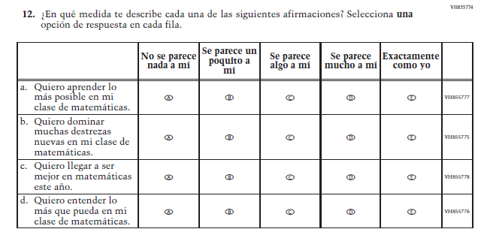  (2019 Operational Grade 4 Student Mathematics – Puerto Rico) | 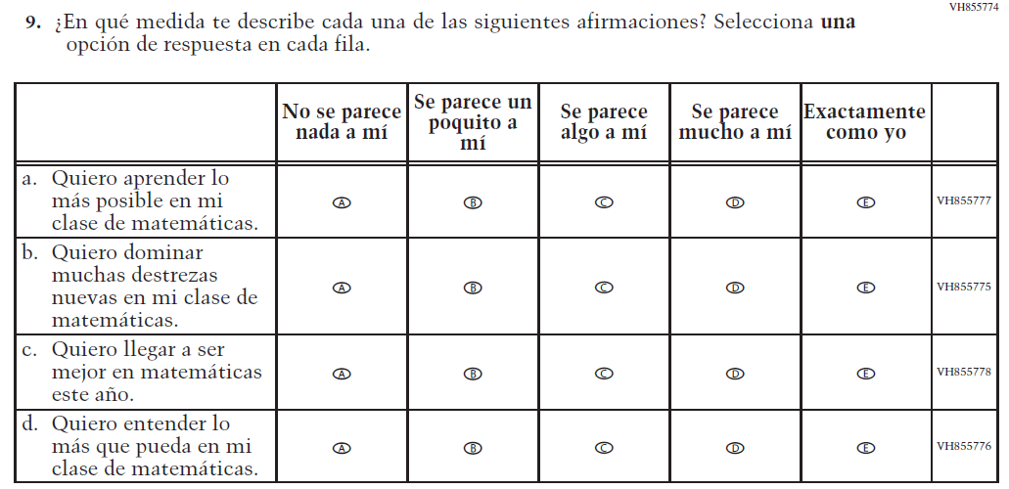  Issue: Student Factors | NC | N/A

2021 Operational Grade 4 Mathematics Student – Puerto Rico

Previous item | 2021 item | D/A/ R/NC+ | Rationale
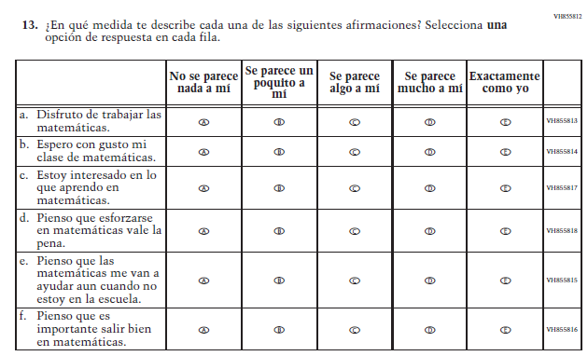  (2019 Operational Grade 4 Student Mathematics – Puerto Rico) | 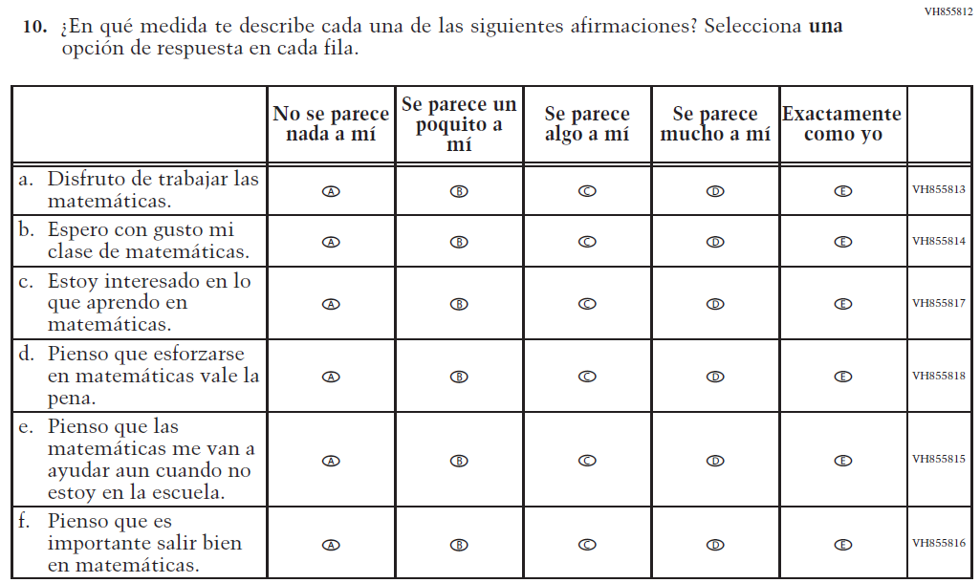  Issue: Student Factors | NC | N/A

Appendix J-1f-s-PR: Operational Grade 4 Mathematics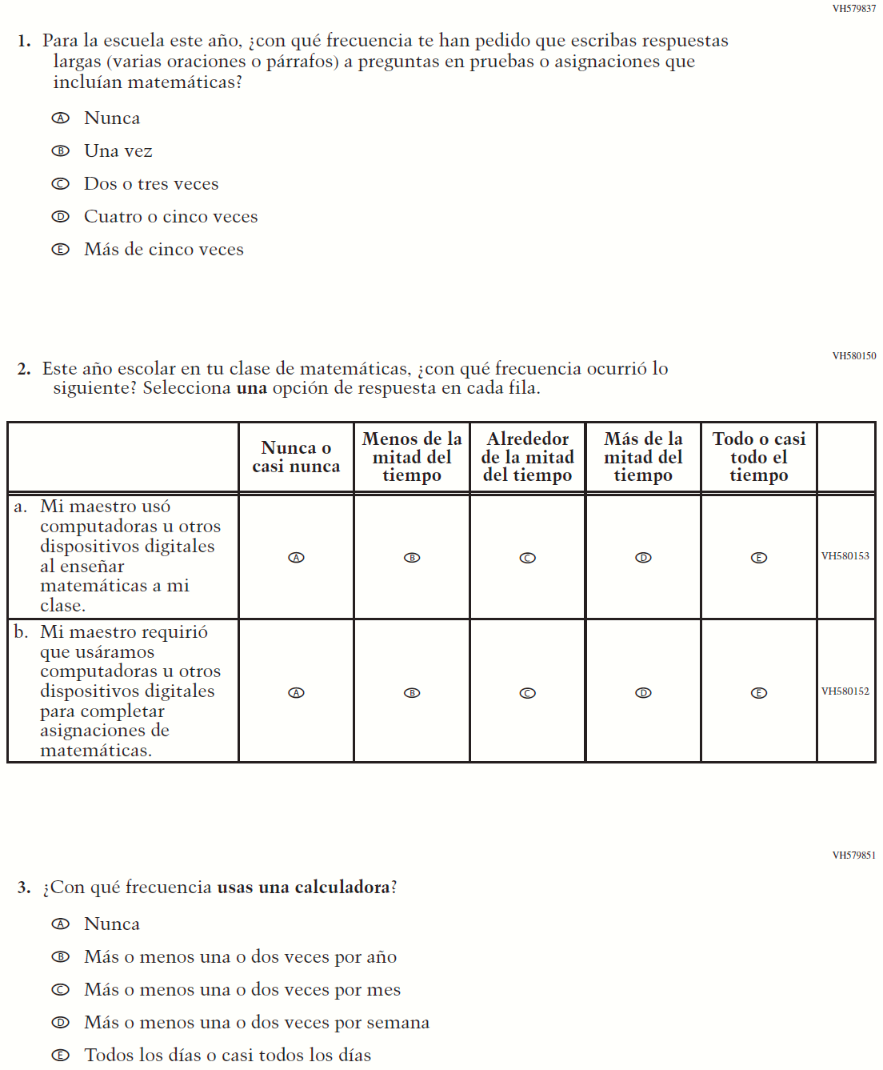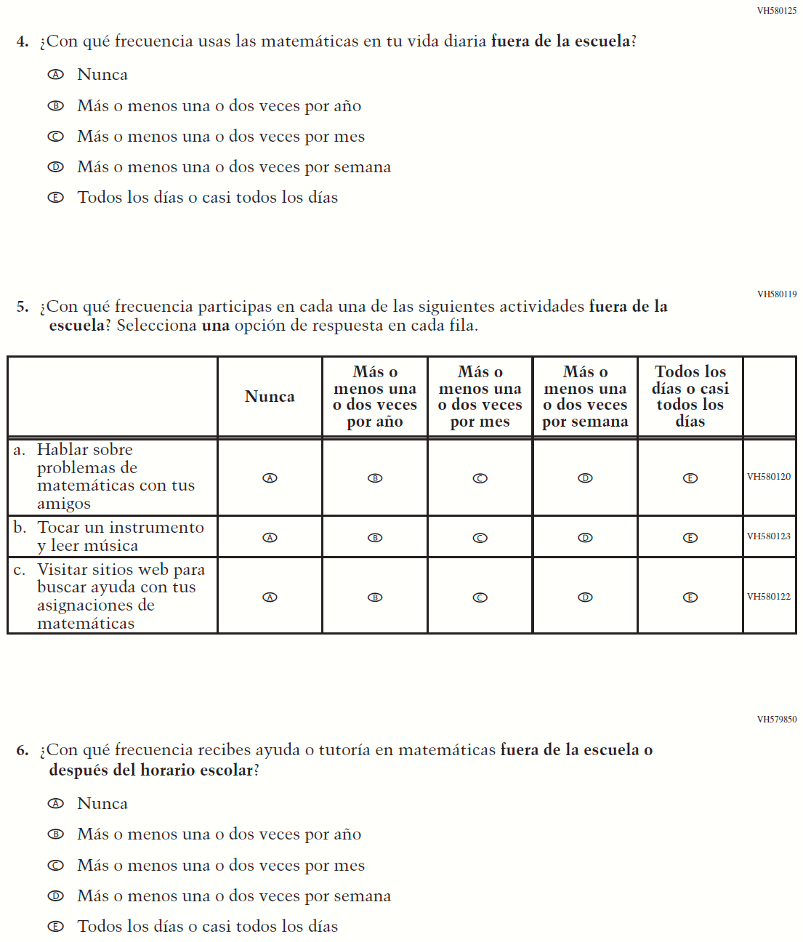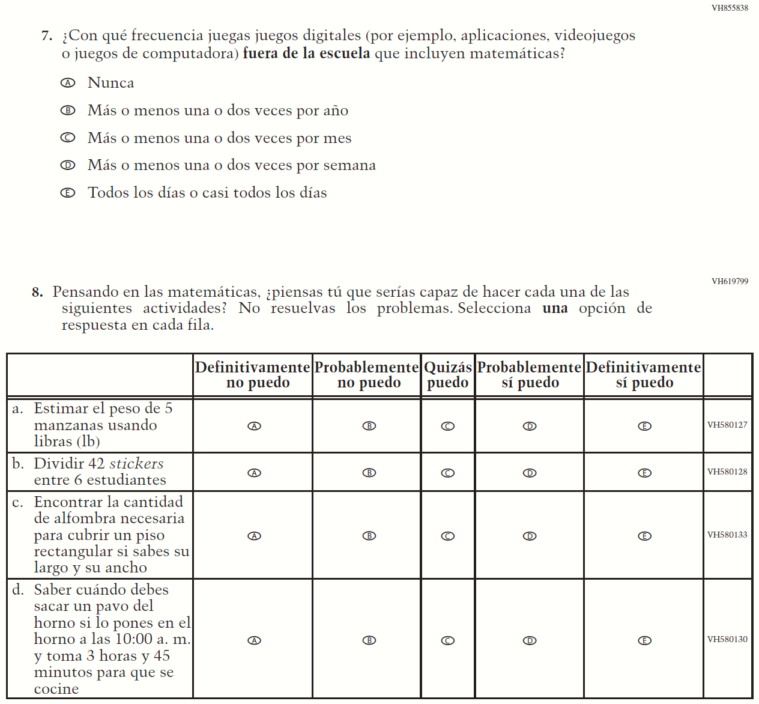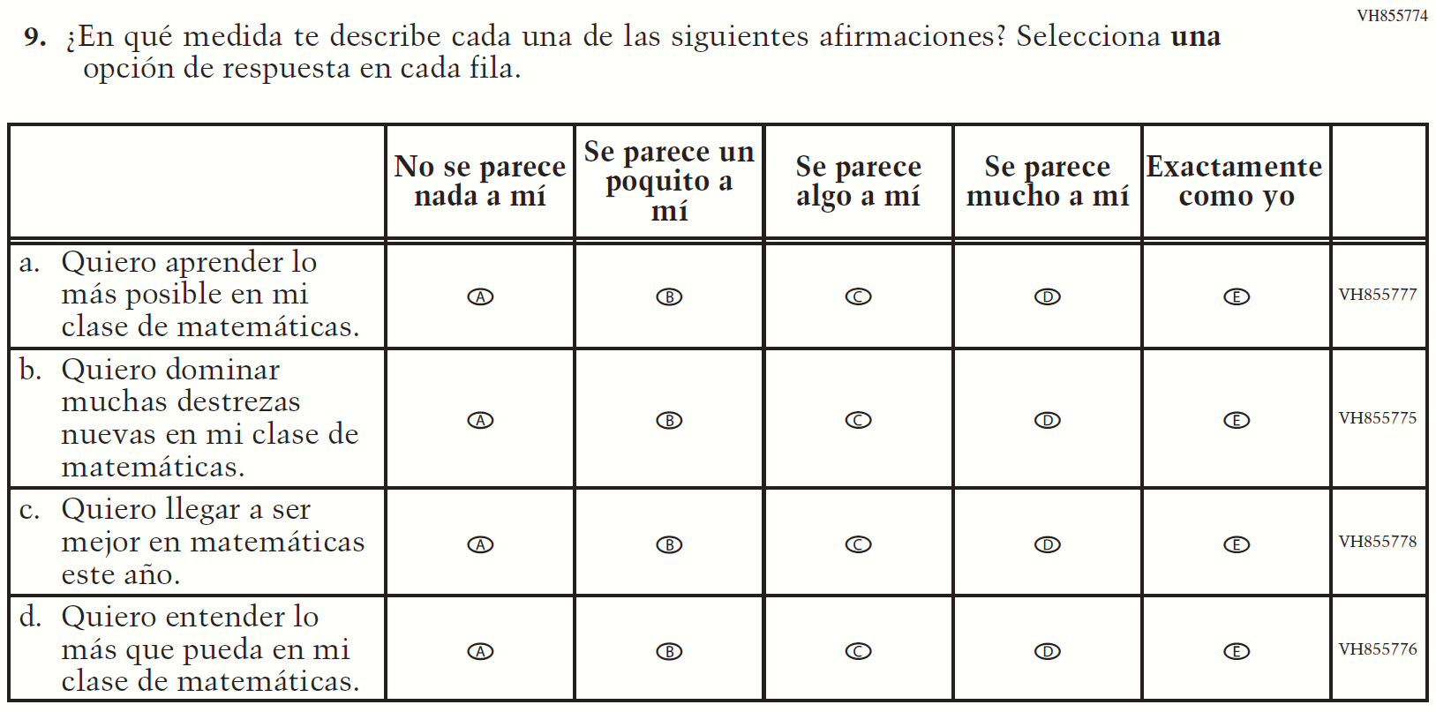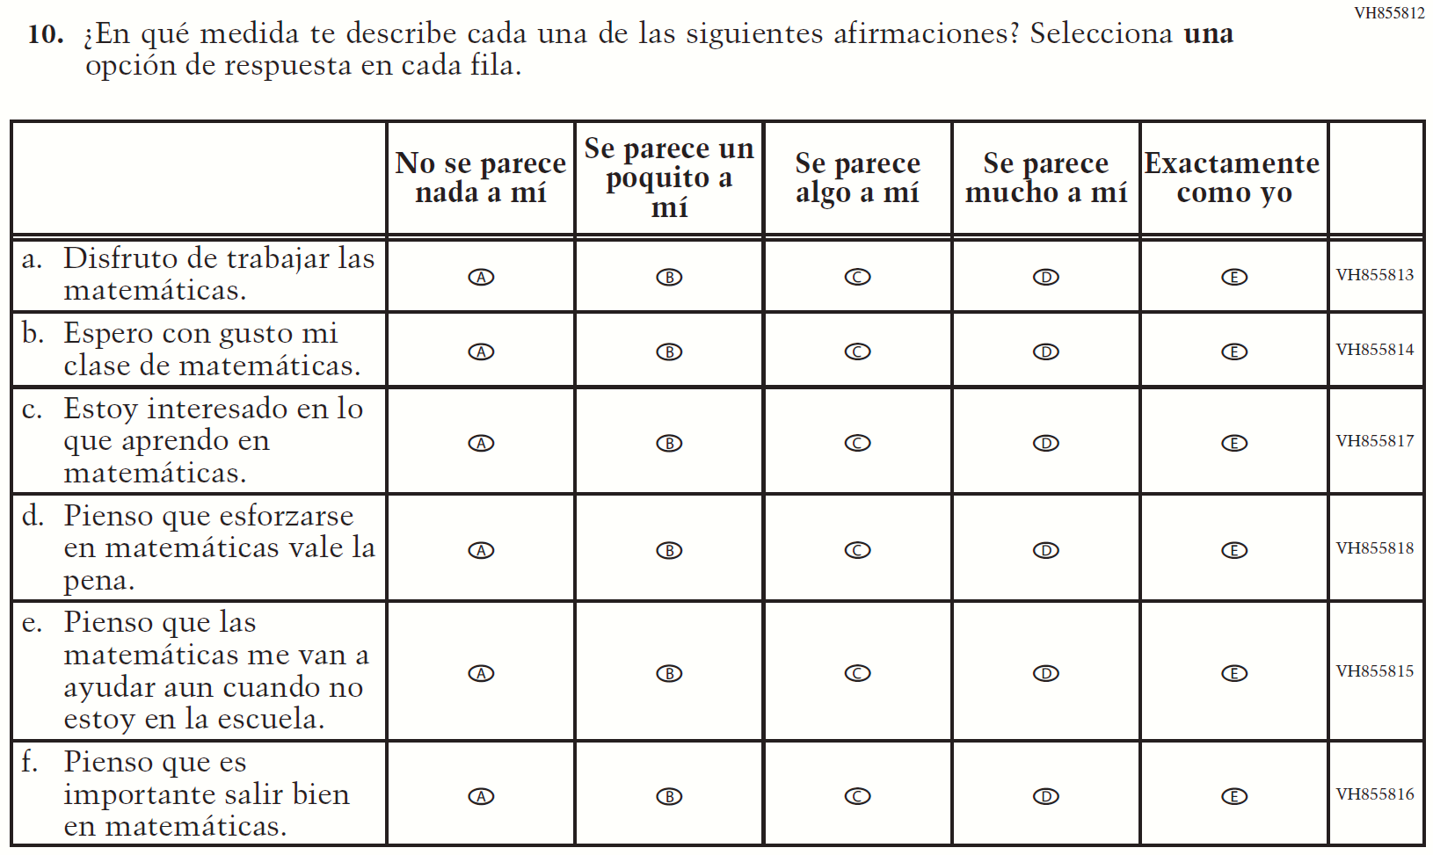

Appendix J-1g-s-BL: Summary of Changes Operational Grade 8 Mathematics
2021 Operational Grade 8 Mathematics Student – Bilingual
Previous item | 2021 item | D/A/R/NC+ | Rationale
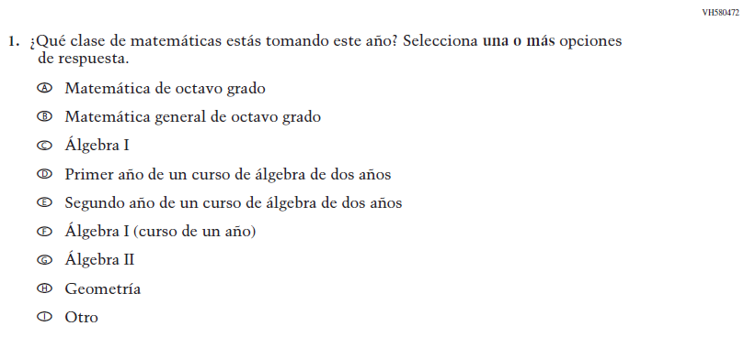  (2019 Operational Grade 8 Student Mathematics - Bilingual) | Issue: Organization of Instruction | NC | N/A
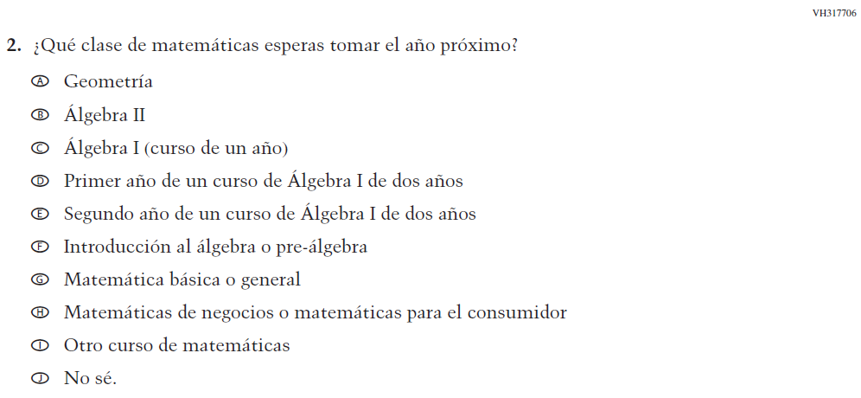  (2019 Operational Grade 8 Student Mathematics - Bilingual) | 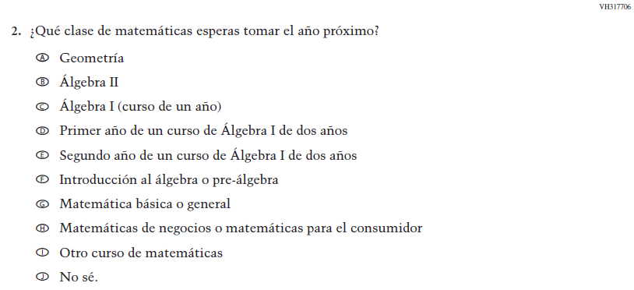  Issue: Organization of Instruction | NC | N/A

2021 Operational Grade 8 Mathematics Student – Bilingual
Previous item | 2021 item | D/A/R/NC+ | Rationale
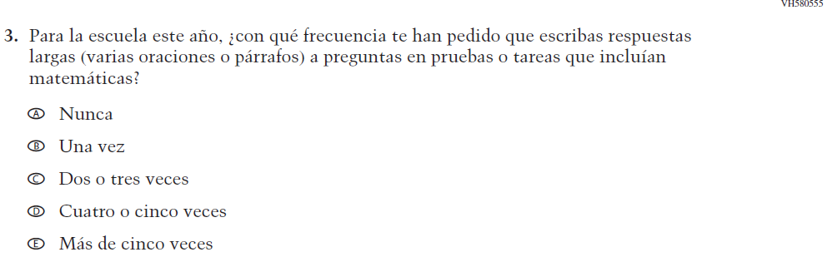  (2019 Operational Grade 8 Student Mathematics - Bilingual) | Issue: Organization of Instruction | NC | N/A
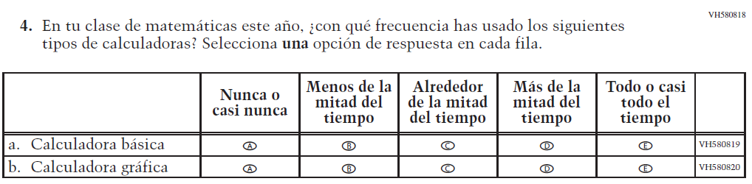  (2019 Operational Grade 8 Student Mathematics - Bilingual) | 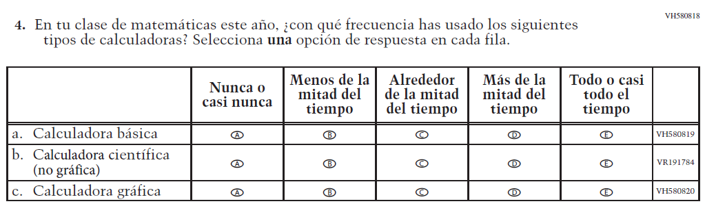  Issue: Resources for Learning and Instruction | A: sub-item “b”  NC for SL and sub-items “a” and “c” | The “Scientific (not graphing) calculator” sub-item was dropped previously due to an oversight and is being reinstated to capture calculator features in mathematics as students progress from K to 12.

2021 Operational Grade 8 Mathematics Student – Bilingual
Previous item | 2021 item | D/A/R/NC+ | Rationale
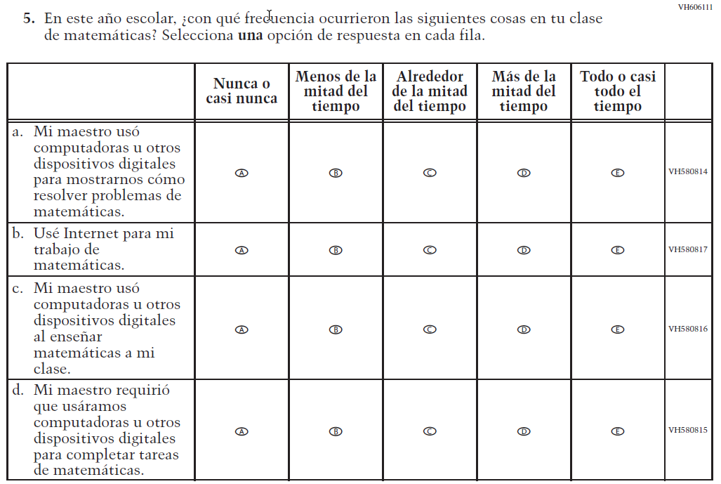  (2019 Operational Grade 8 Student Mathematics - Bilingual) | 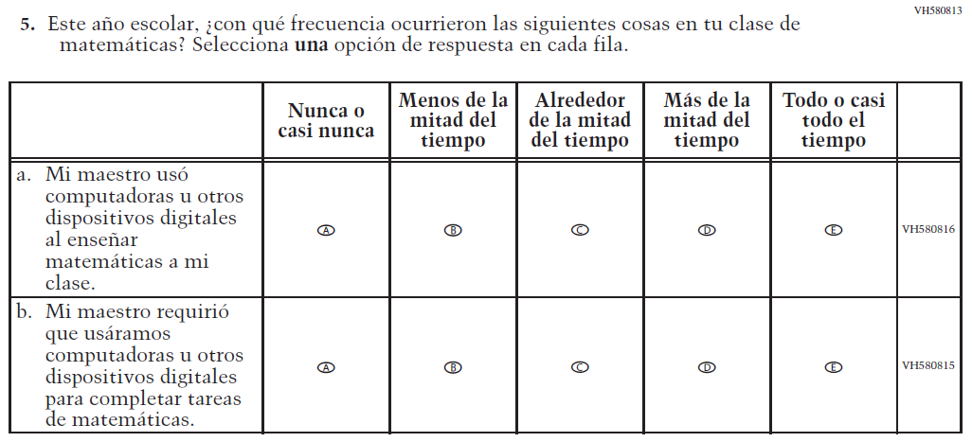  Issue: Resources for Learning and Instruction | R | To keep student burden low, sub-items a and b were dropped.
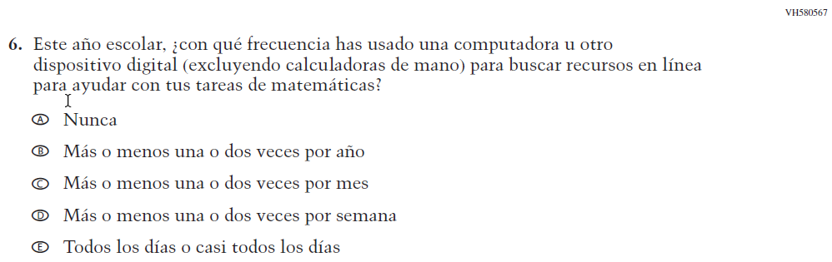  (2019 Operational Grade 8 Student Mathematics - Bilingual) | N/A | D | To keep student burden low, this item was dropped.

2021 Operational Grade 8 Mathematics Student – Bilingual
Previous item | 2021 item | D/A/R/NC+ | Rationale
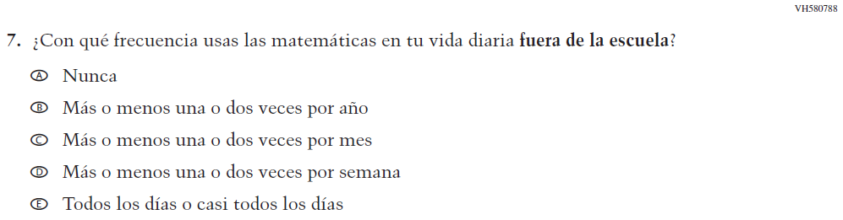  (2019 Operational Grade 8 Student Mathematics - Bilingual) | 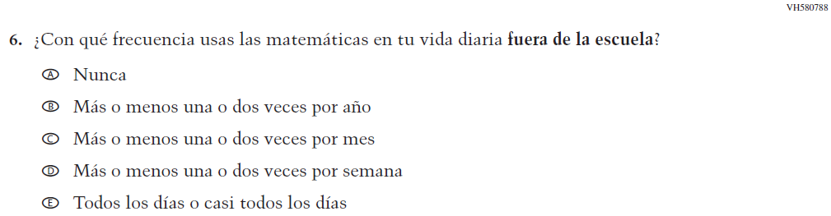  Issue: Resources for Learning and Instruction | NC | N/A
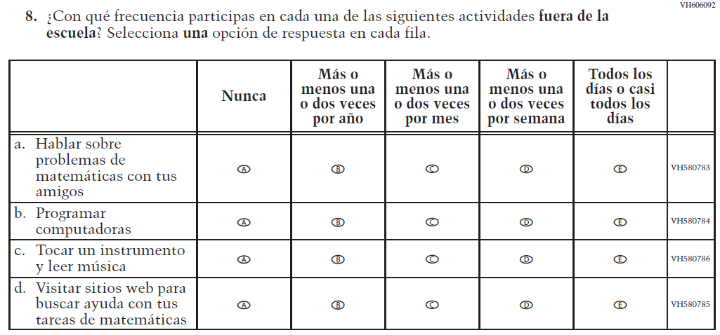  (2019 Operational Grade 8 Student Mathematics - Bilingual) | 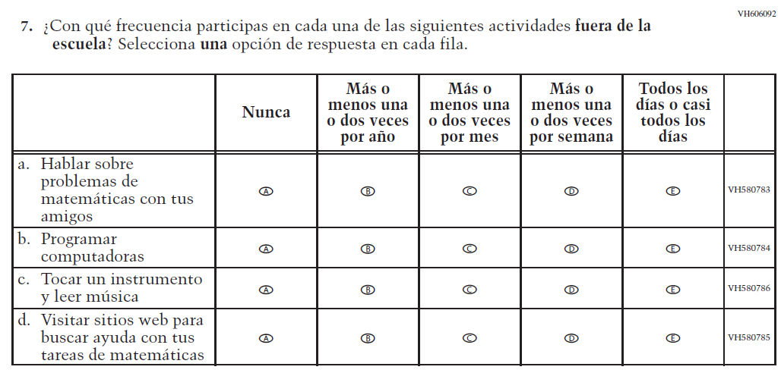  Issue: Resources for Learning and Instruction | NC | N/A

2021 Operational Grade 8 Mathematics Student – Bilingual
Previous item | 2021 item | D/A/R/NC+ | Rationale
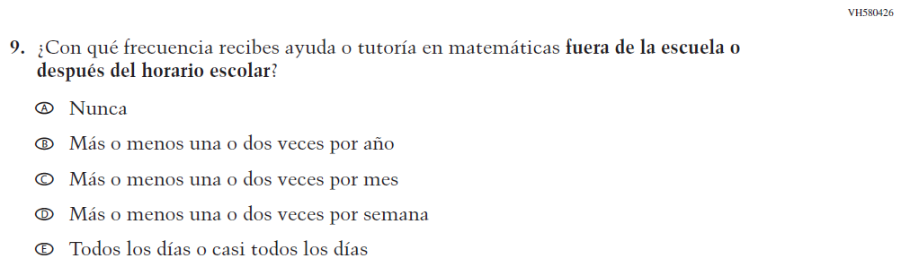  (2019 Operational Grade 8 Student Mathematics - Bilingual) | 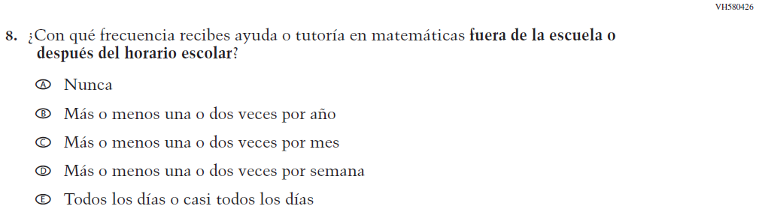  Issue: Resources for Learning and Instruction | NC | N/A
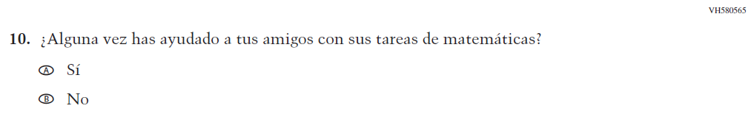  (2019 Operational Grade 8 Student Mathematics - Bilingual) | N/A | D | To keep student burden low, this item was dropped.
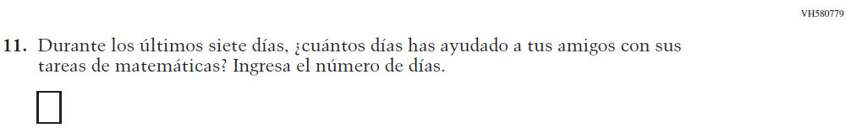  (2019 Operational Grade 8 Student Mathematics - Bilingual) | N/A | D | To keep student burden low, this item was dropped.
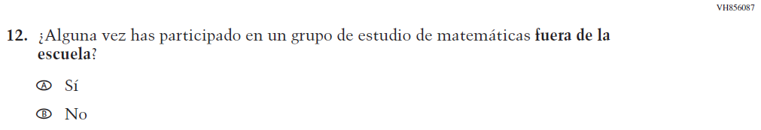  (2019 Operational Grade 8 Student Mathematics - Bilingual) | N/A | D | To keep student burden low, this item was dropped.

2021 Operational Grade 8 Mathematics Student – Bilingual
Previous item | 2021 item | D/A/R/NC+ | Rationale
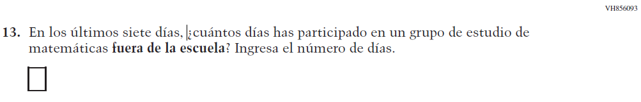  (2019 Operational Grade 8 Student Mathematics - Bilingual) | N/A | D | To keep student burden low, this item was dropped.
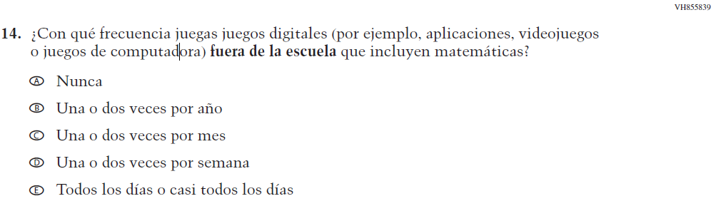  (2019 Operational Grade 8 Student Mathematics - Bilingual) | 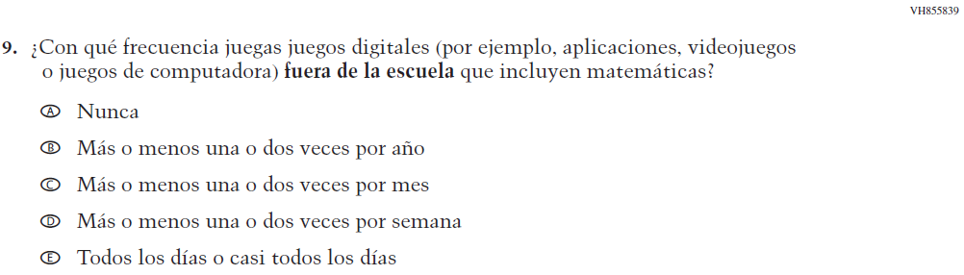  Issue: Resources for Learning and Instruction | NC | N/A

2021 Operational Grade 8 Mathematics Student – Bilingual
Previous item | 2021 item | D/A/R/NC+ | Rationale
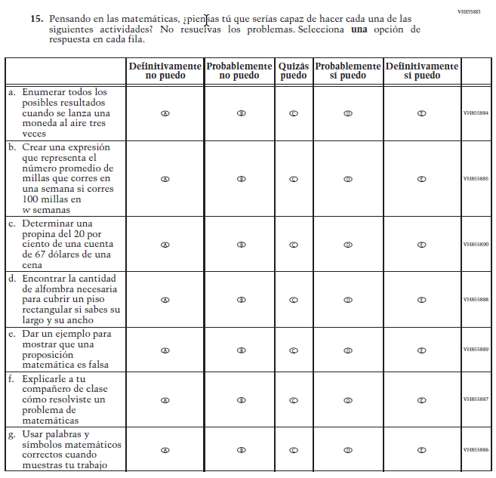  (2019 Operational Grade 8 Student Mathematics - Bilingual) | 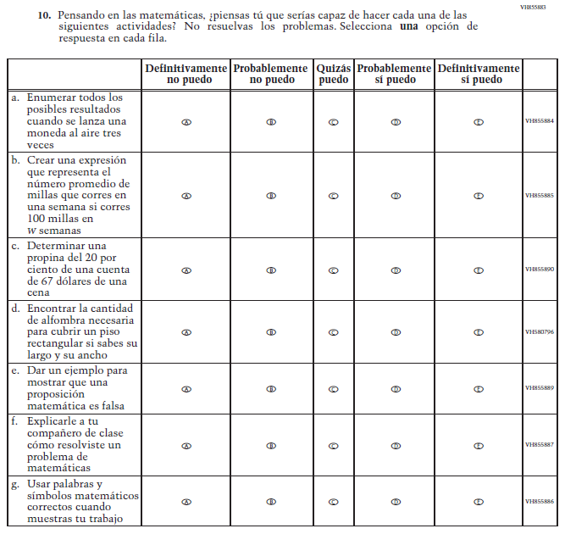  Issue: Student factors | NC | N/A

2021 Operational Grade 8 Mathematics Student – Bilingual
Previous item | 2021 item | D/A/R/NC+ | Rationale
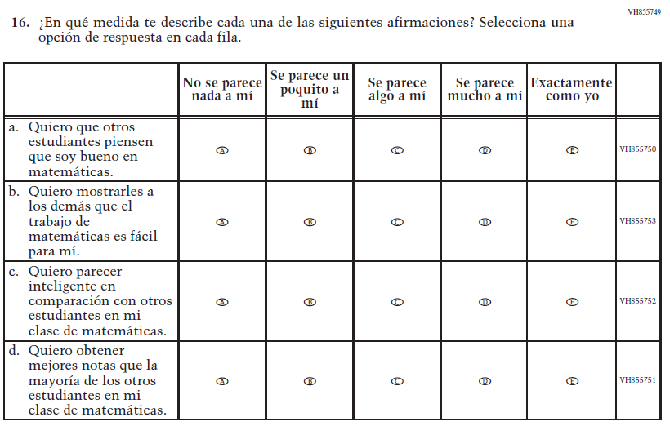  (2019 Operational Grade 8 Student Mathematics - Bilingual) | N/A | D | To keep student burden low, this item was dropped.
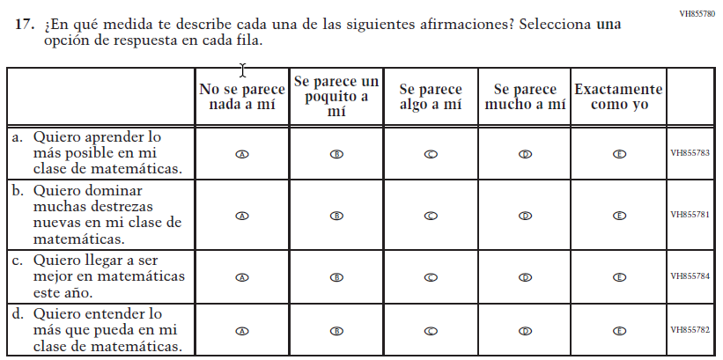  (2019 Operational Grade 8 Student Mathematics - Bilingual) | 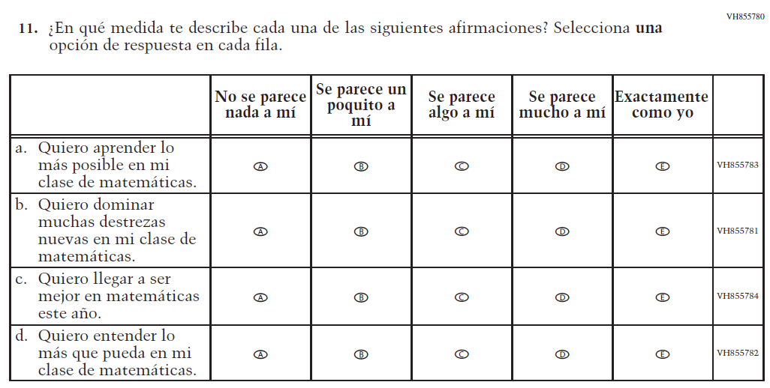  Issue: Student Factors | NC | N/A

2021 Operational Grade 8 Mathematics Student – Bilingual
Previous item | 2021 item | D/A/R/NC+ | Rationale
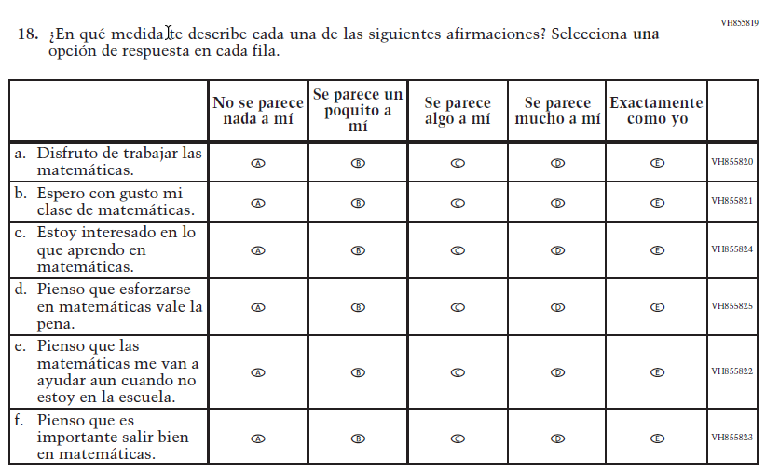  (2019 Operational Grade 8 Student Mathematics - Bilingual) | 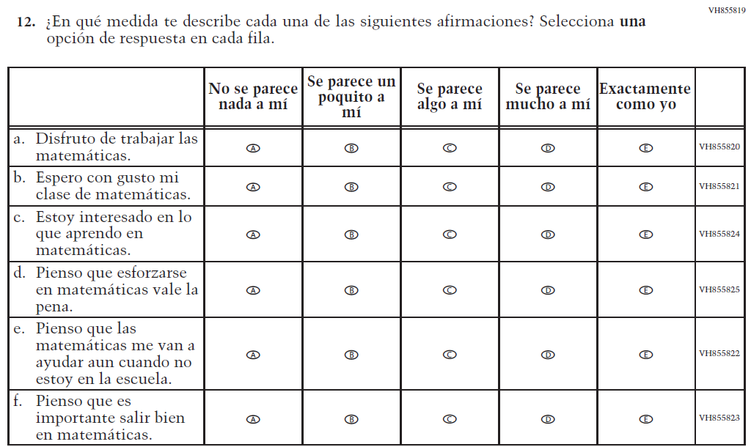  Issue: Student Factors | NC | N/A
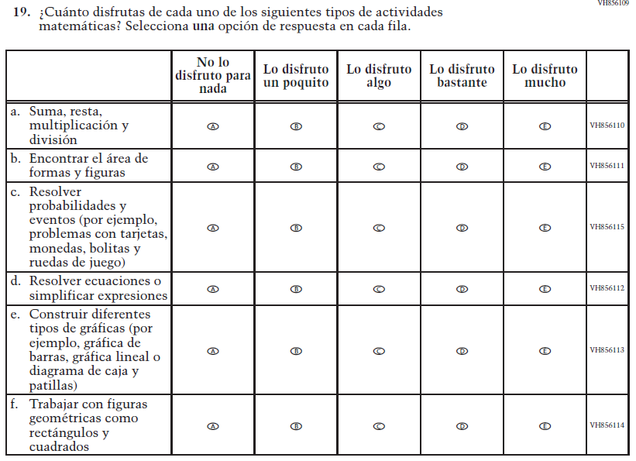  (2019 Operational Grade 8 Student Mathematics - Bilingual) | 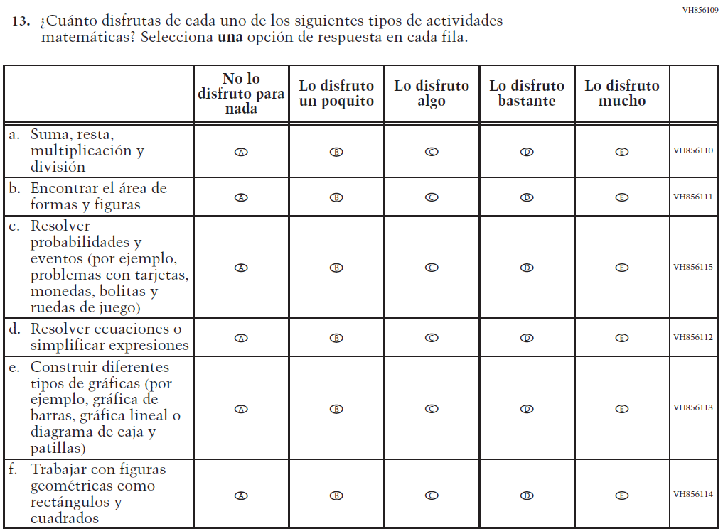  Issue: Student Factors | NC | N/A

Appendix J-1g-s-BL: Operational Grade 8 Mathematics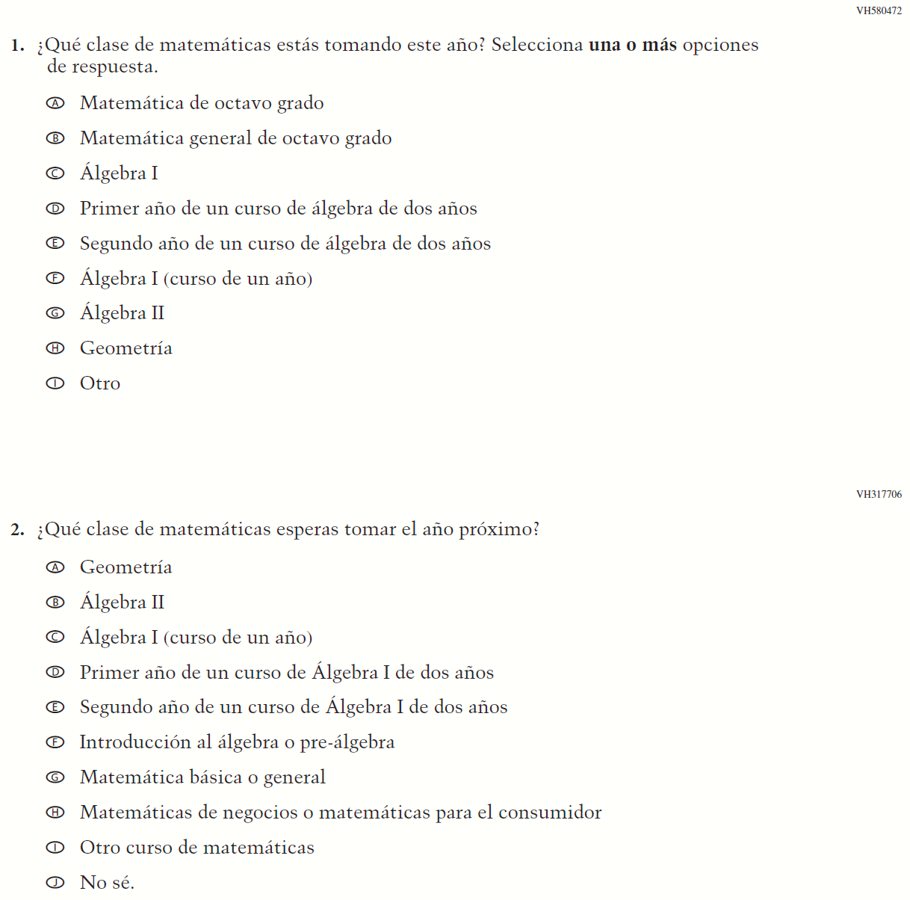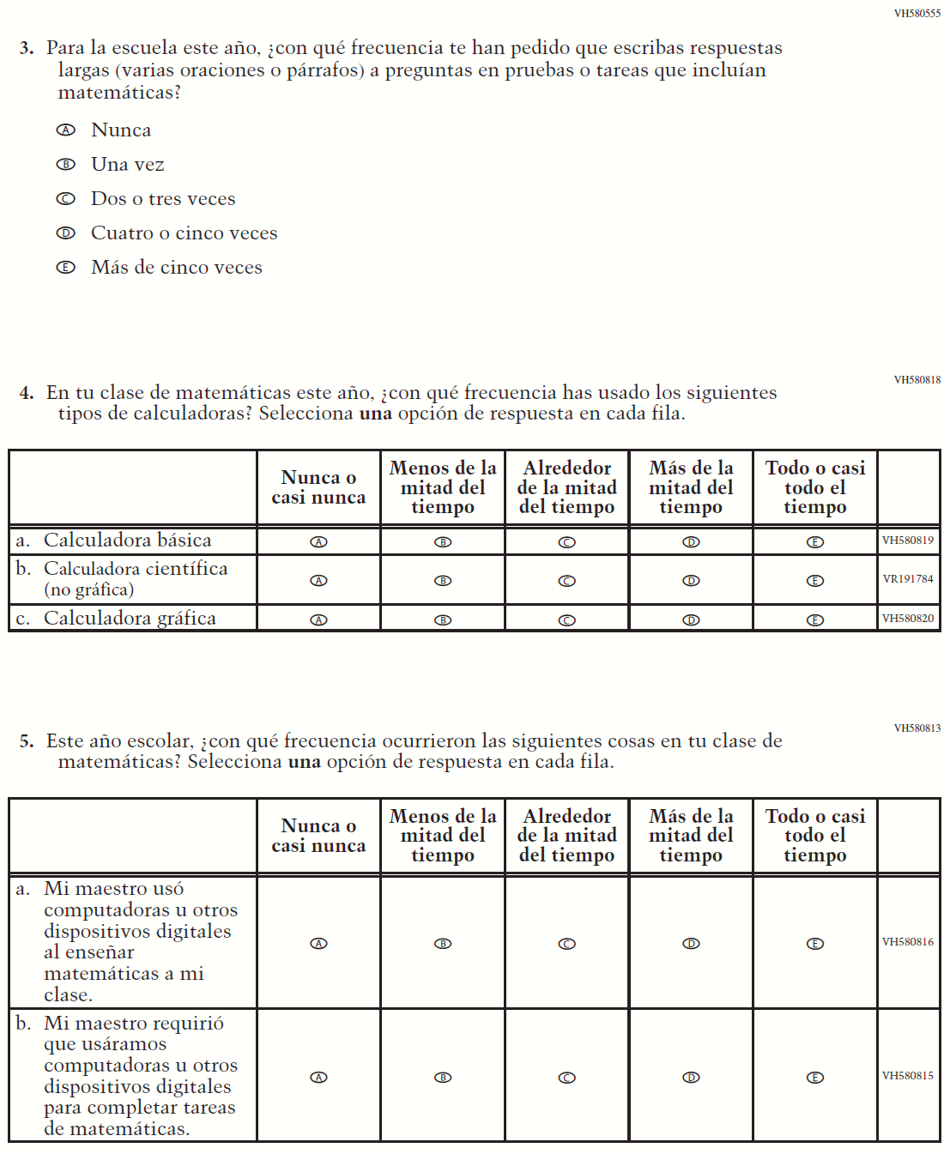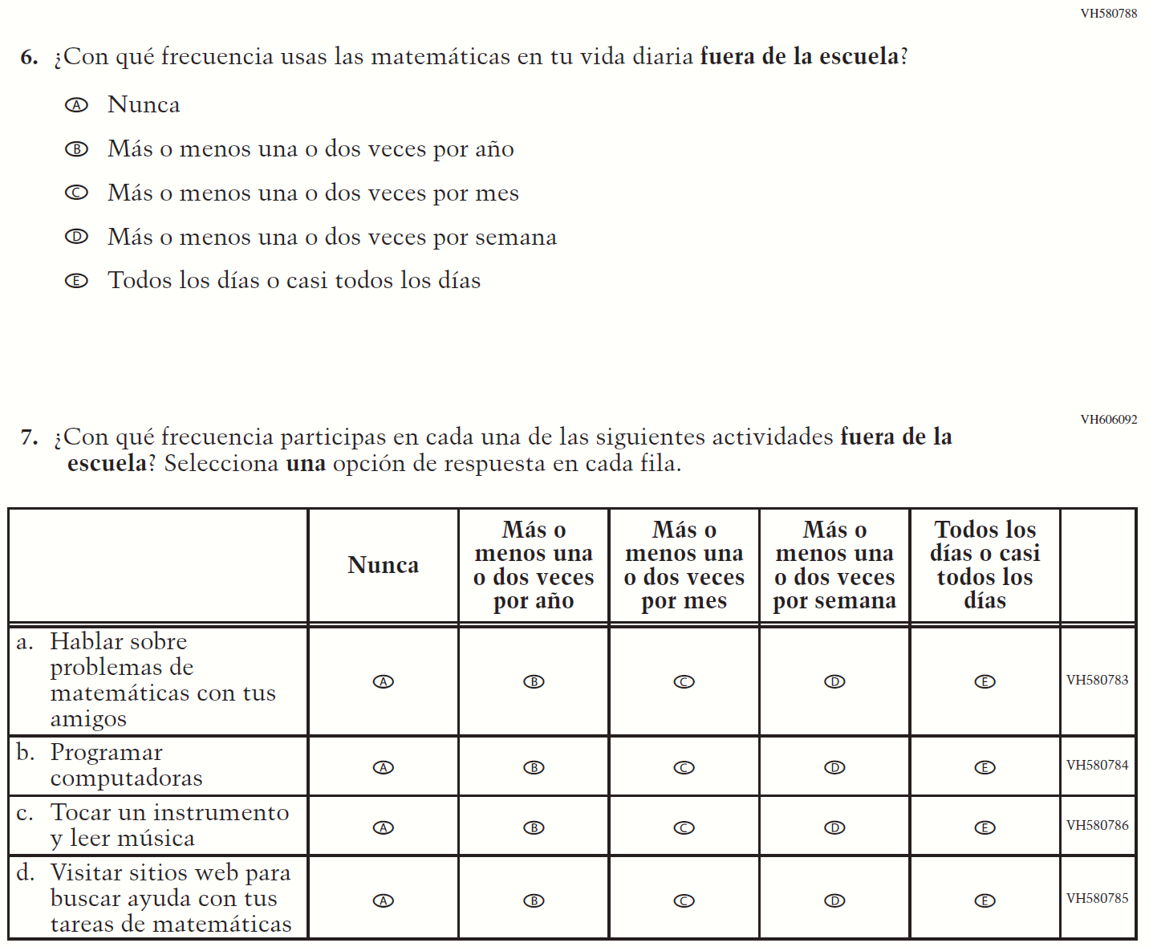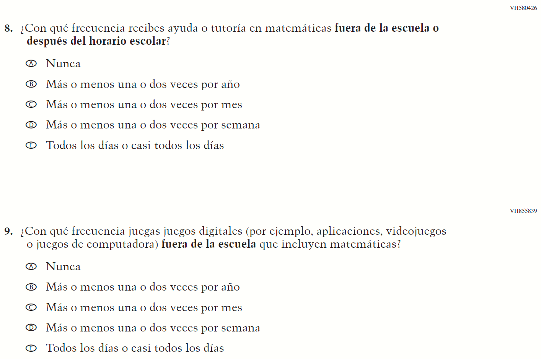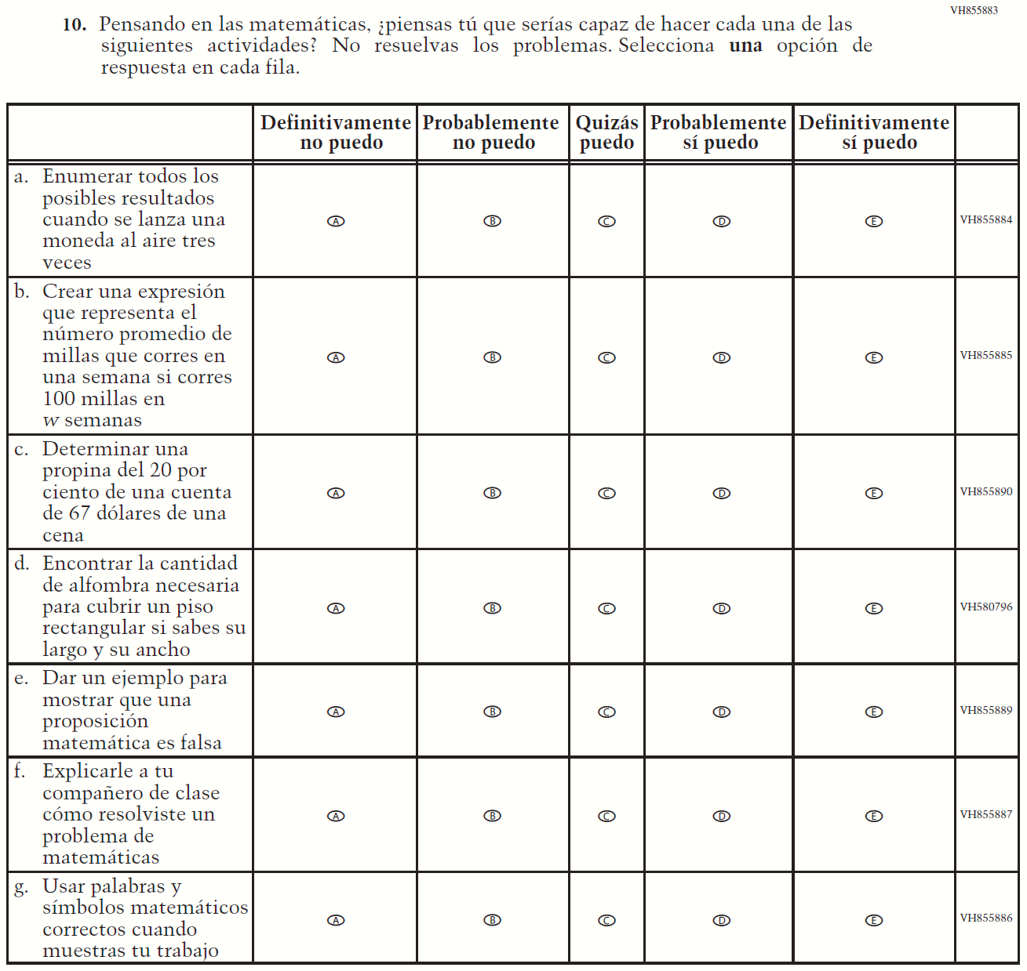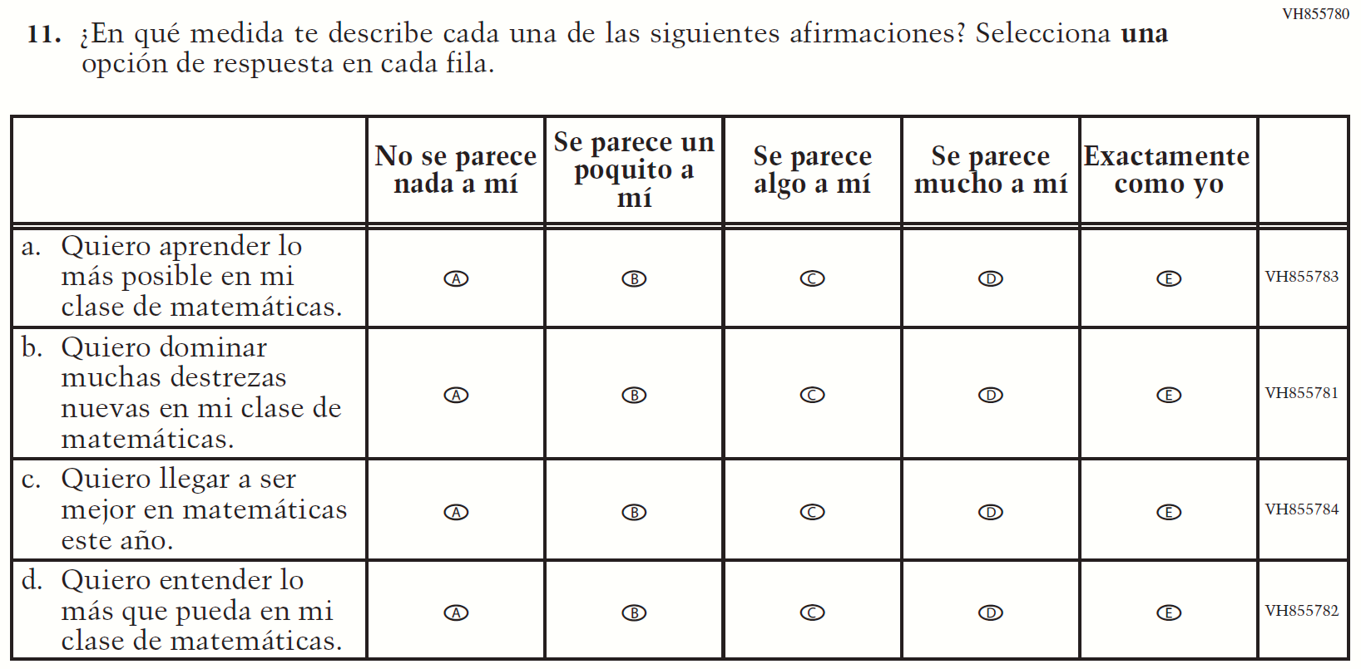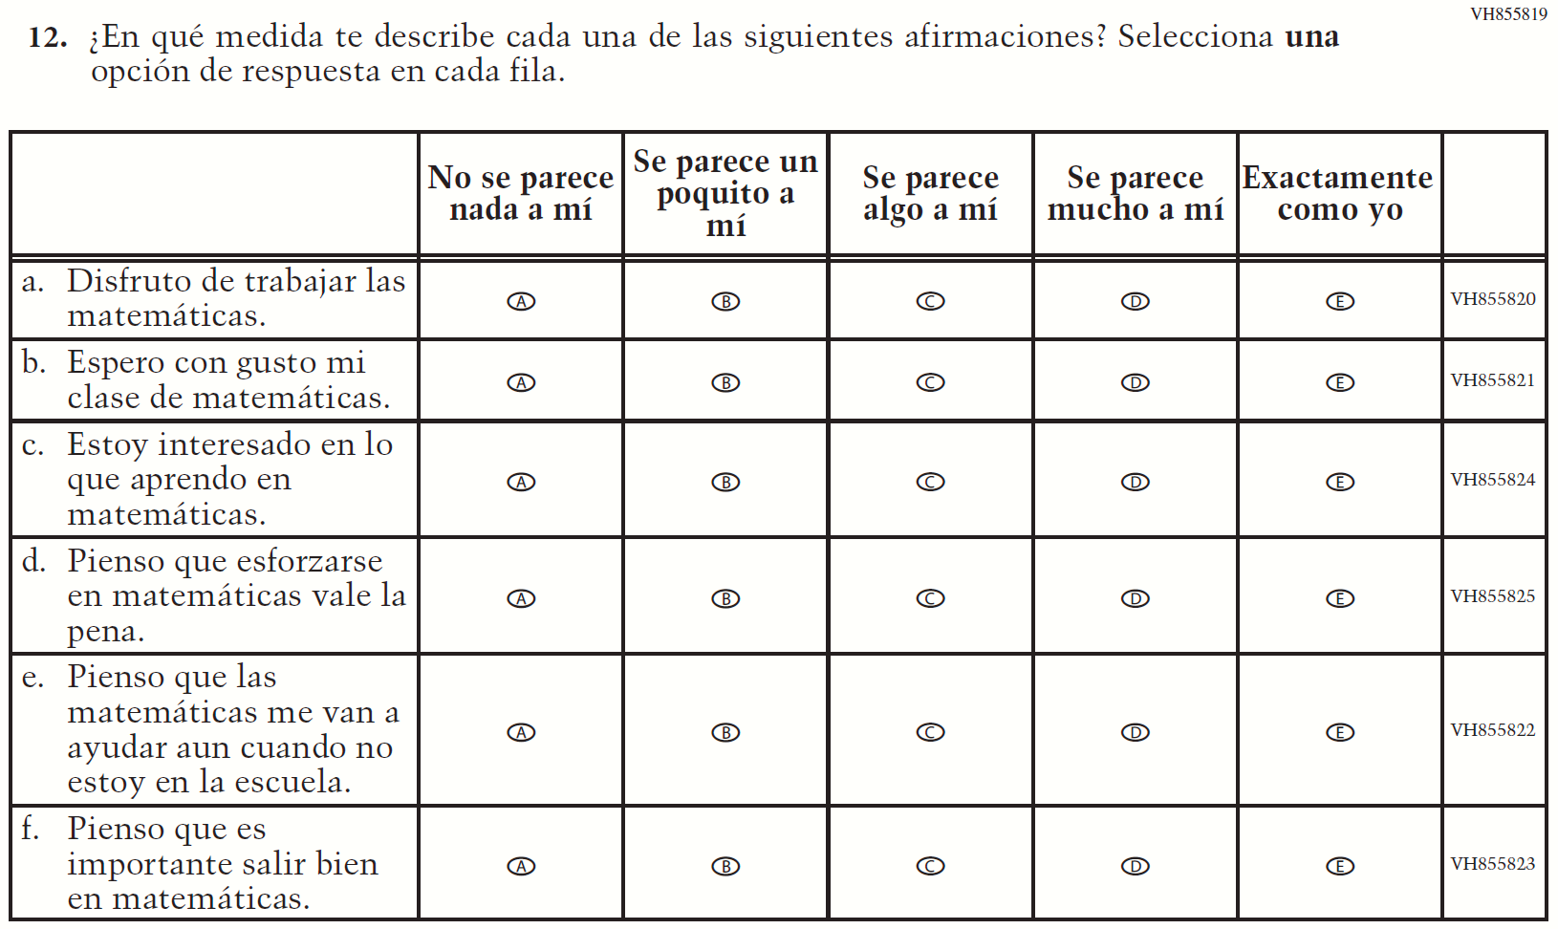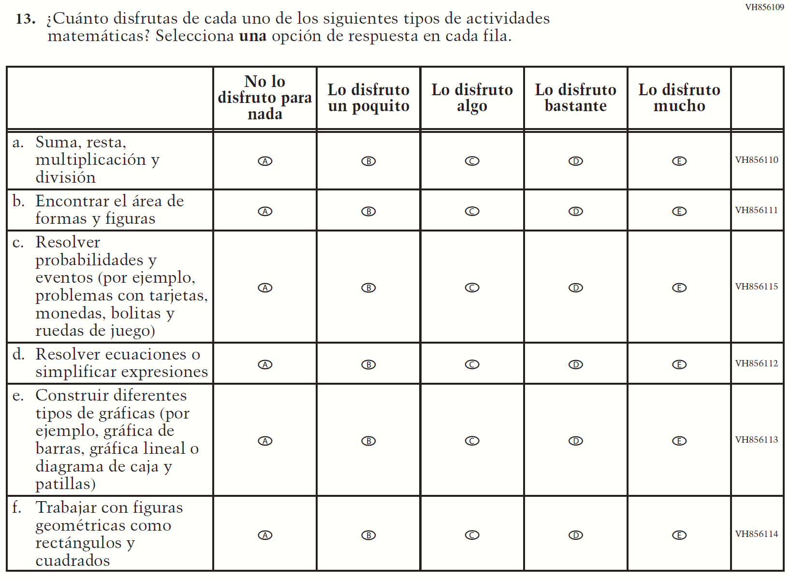

Appendix J-1h-s-PR: Summary of Changes Operational Grade 8 Mathematics
2021 Operational Grade 8 Mathematics Student – Puerto Rico

Previous item | 2021 item | D/A/ R/NC+ | Rationale
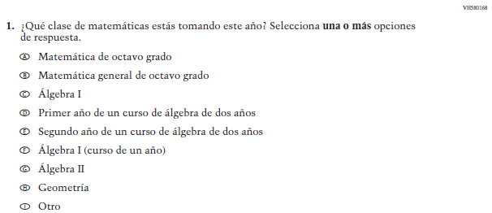  (2019 Operational Grade 8 Student Mathematics – Puerto Rico) | Issue: Organization of Instruction | NC | N/A
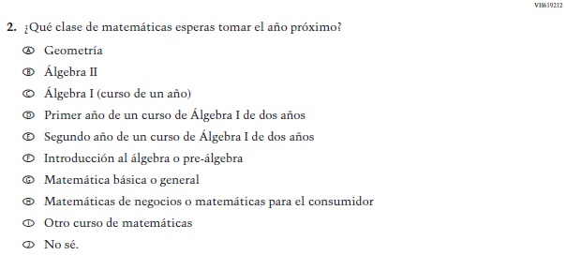  (2019 Operational Grade 8 Student Mathematics – Puerto Rico) | Issue: Organization of Instruction | NC | N/A
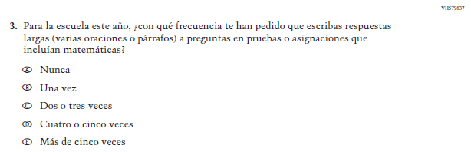  (2019 Operational Grade 8 Student Mathematics – Puerto Rico) | Issue: Organization of Instruction | NC | N/A
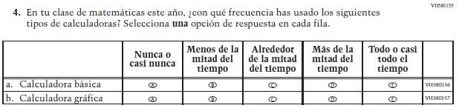  (2019 Operational Grade 8 Student Mathematics – Puerto Rico) | 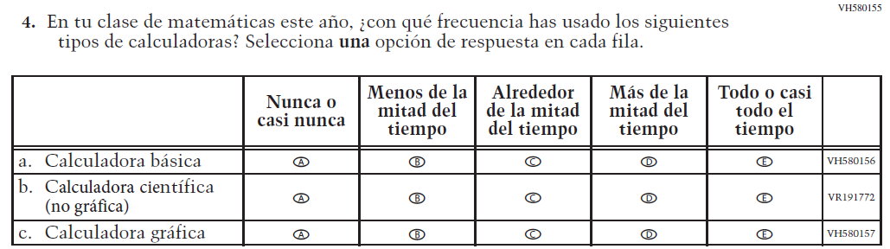  Issue: Resources for Learning and Instruction | A: sub-item “b”  NC for SL and sub-items “a” and “c” | The “Scientific (not graphing) calculator” sub-item was dropped previously due to an oversight and is being reinstated to capture calculator features in mathematics as students progress from K to 12.
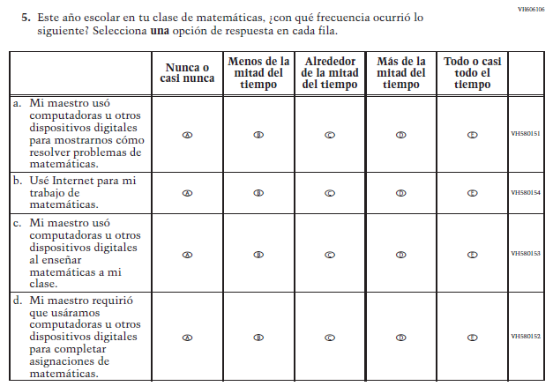  (2019 Operational Grade 8 Student Mathematics – Puerto Rico) | 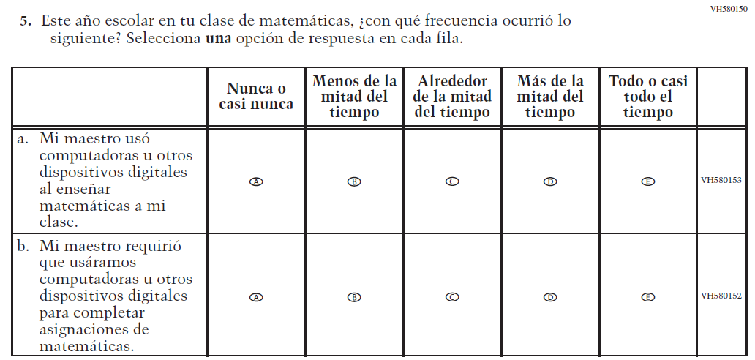  Issue: Resources for Learning and Instruction | R | To keep student burden low, sub-items a and b were dropped.
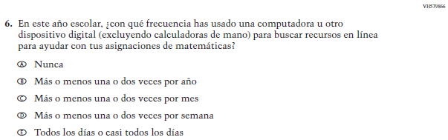  (2019 Operational Grade 8 Student Mathematics – Puerto Rico) | N/A | D | To keep student burden low, this item was dropped.
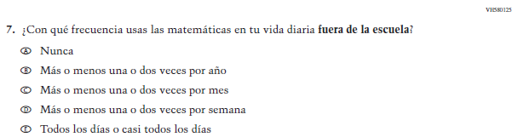  (2019 Operational Grade 8 Student Mathematics – Puerto Rico) | 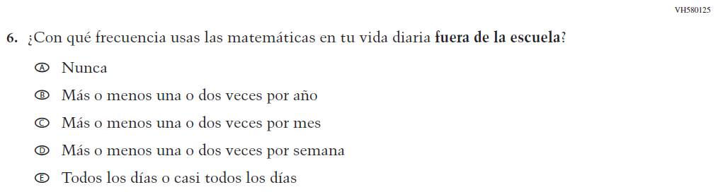  Issue: Resources for Learning and Instruction | NC
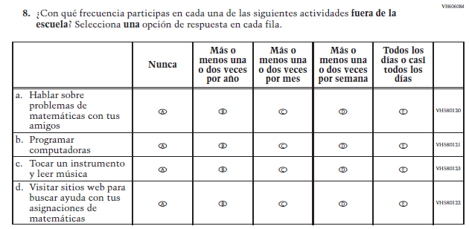  (2019 Operational Grade 8 Student Mathematics – Puerto Rico) | 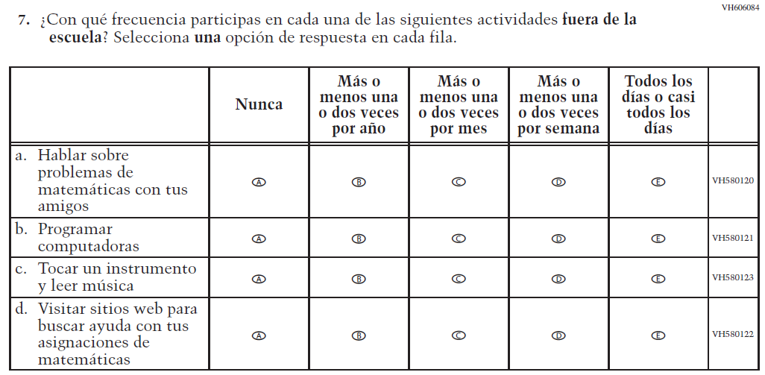  Issue: Resources for Learning and Instruction | NC | N/A
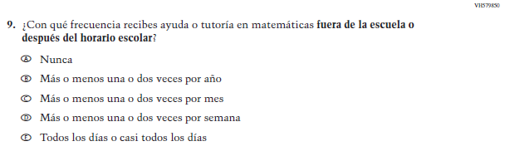  (2019 Operational Grade 8 Student Mathematics – Puerto Rico) | 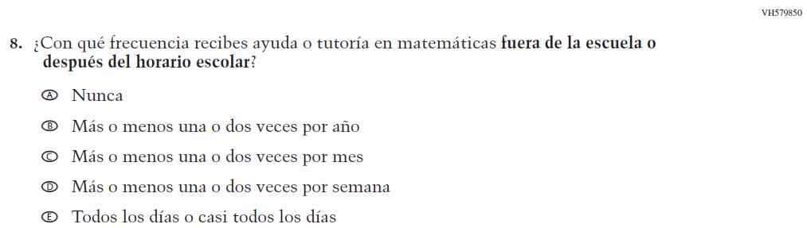  Issue: Resources for Learning and Instruction | NC | N/A

2021 Operational Grade 8 Mathematics Student – Puerto Rico

Previous item | 2021 item | D/A/ R/NC+ | Rationale
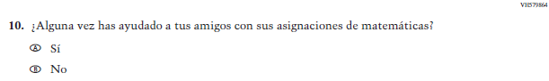  (2019 Operational Grade 8 Student Mathematics – Puerto Rico) | N/A | D | To keep student burden low, this item was dropped.
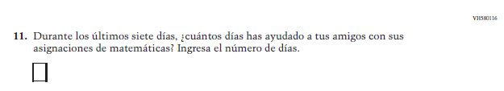  (2019 Operational Grade 8 Student Mathematics – Puerto Rico) | N/A | D | To keep student burden low, this item was dropped.
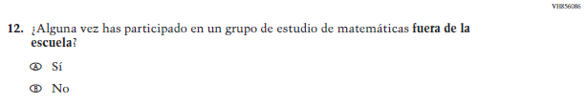(2019 Operational Grade 8 Student Mathematics – Puerto Rico) | N/A | D | To keep student burden low, this item was dropped.
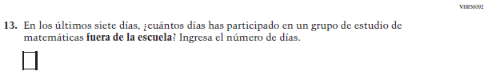  (2019 Operational Grade 8 Student Mathematics – Puerto Rico) | N/A | D | To keep student burden low, this item was dropped.

2021 Operational Grade 8 Mathematics Student – Puerto Rico

Previous item | 2021 item | D/A/ R/NC+ | Rationale
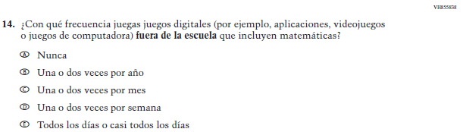  (2019 Operational Grade 8 Student Mathematics – Puerto Rico) | 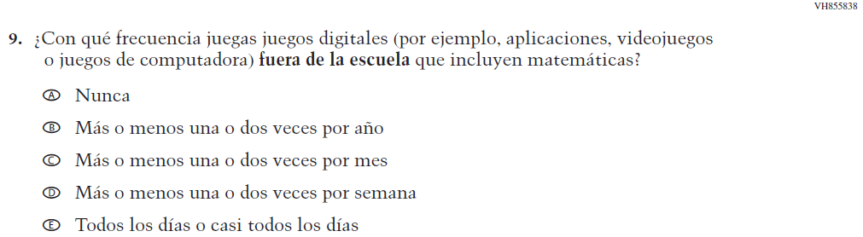  Issue: Resources for Learning and Instruction | NC | N/A
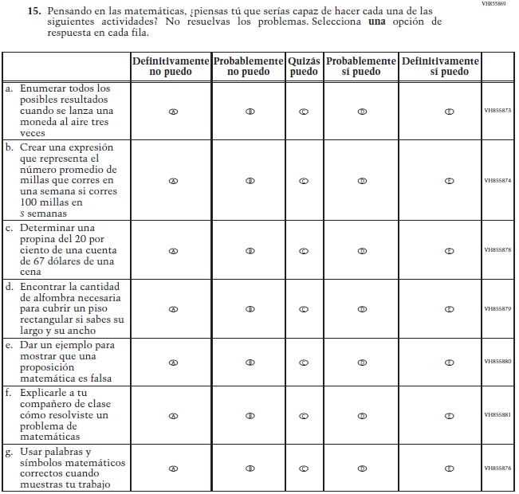  (2019 Operational Grade 8 Student Mathematics – Puerto Rico) | 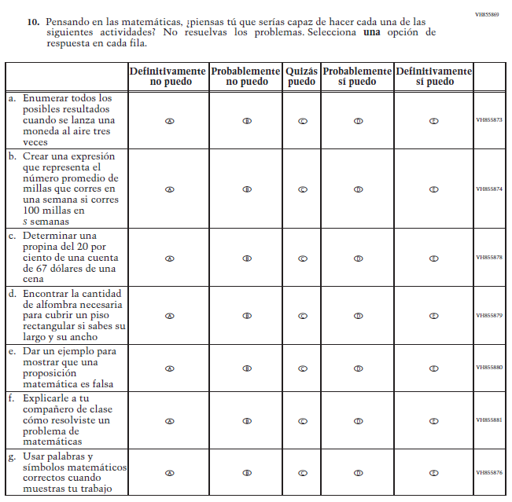  Issue: Student factors | NC | N/A

2021 Operational Grade 8 Mathematics Student – Puerto Rico

Previous item | 2021 item | D/A/ R/NC+ | Rationale
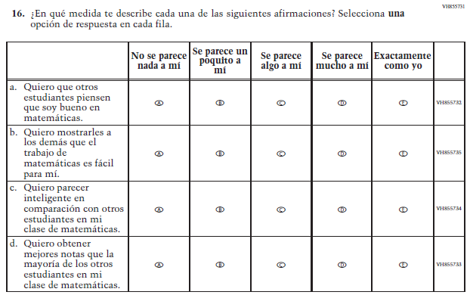  (2019 Operational Grade 8 Student Mathematics – Puerto Rico) | N/A | D | To keep student burden low, this item was dropped.
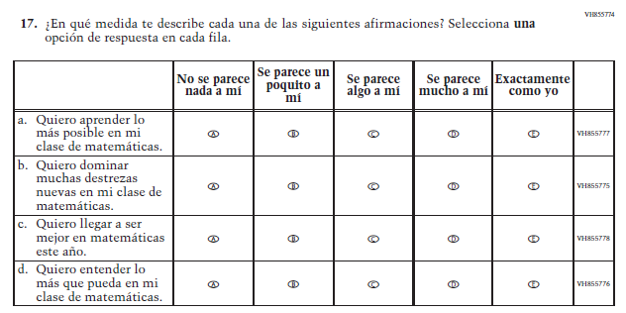  (2019 Operational Grade 8 Student Mathematics – Puerto Rico) | 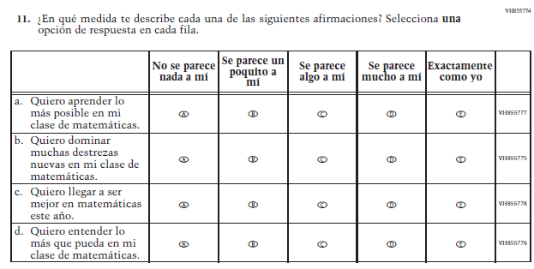  Issue: Student Factors | NC | N/A

2021 Operational Grade 8 Mathematics Student – Puerto Rico

Previous item | 2021 item | D/A/ R/NC+ | Rationale
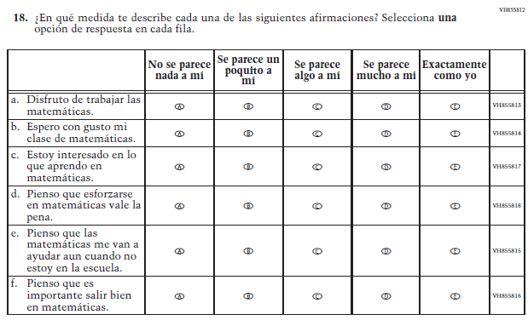  (2019 Operational Grade 8 Student Mathematics – Puerto Rico) | 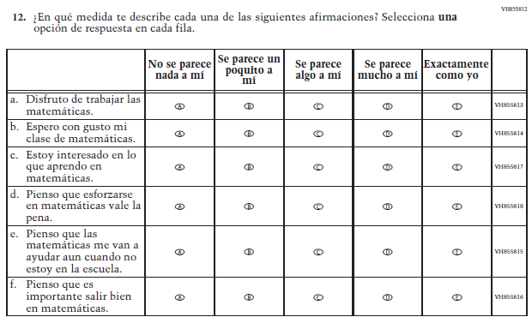  Issue: Student Factors | NC | N/A
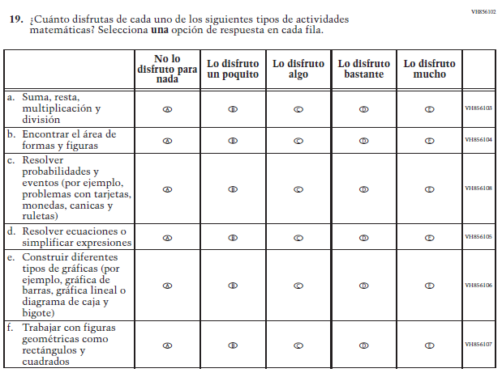  (2019 Operational Grade 8 Student Mathematics – Puerto Rico) | 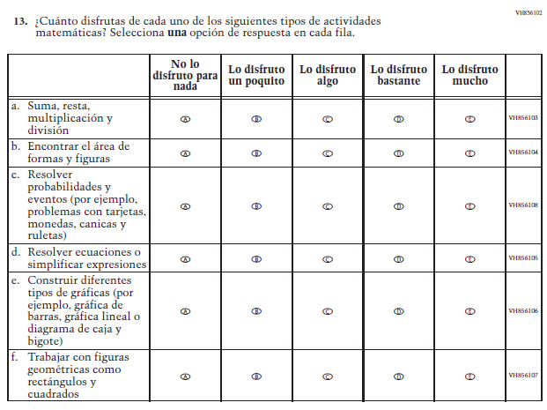  Issue: Student Factors | NC | N/A

Appendix J-1h-s-PR: Operational Grade 8 Mathematics

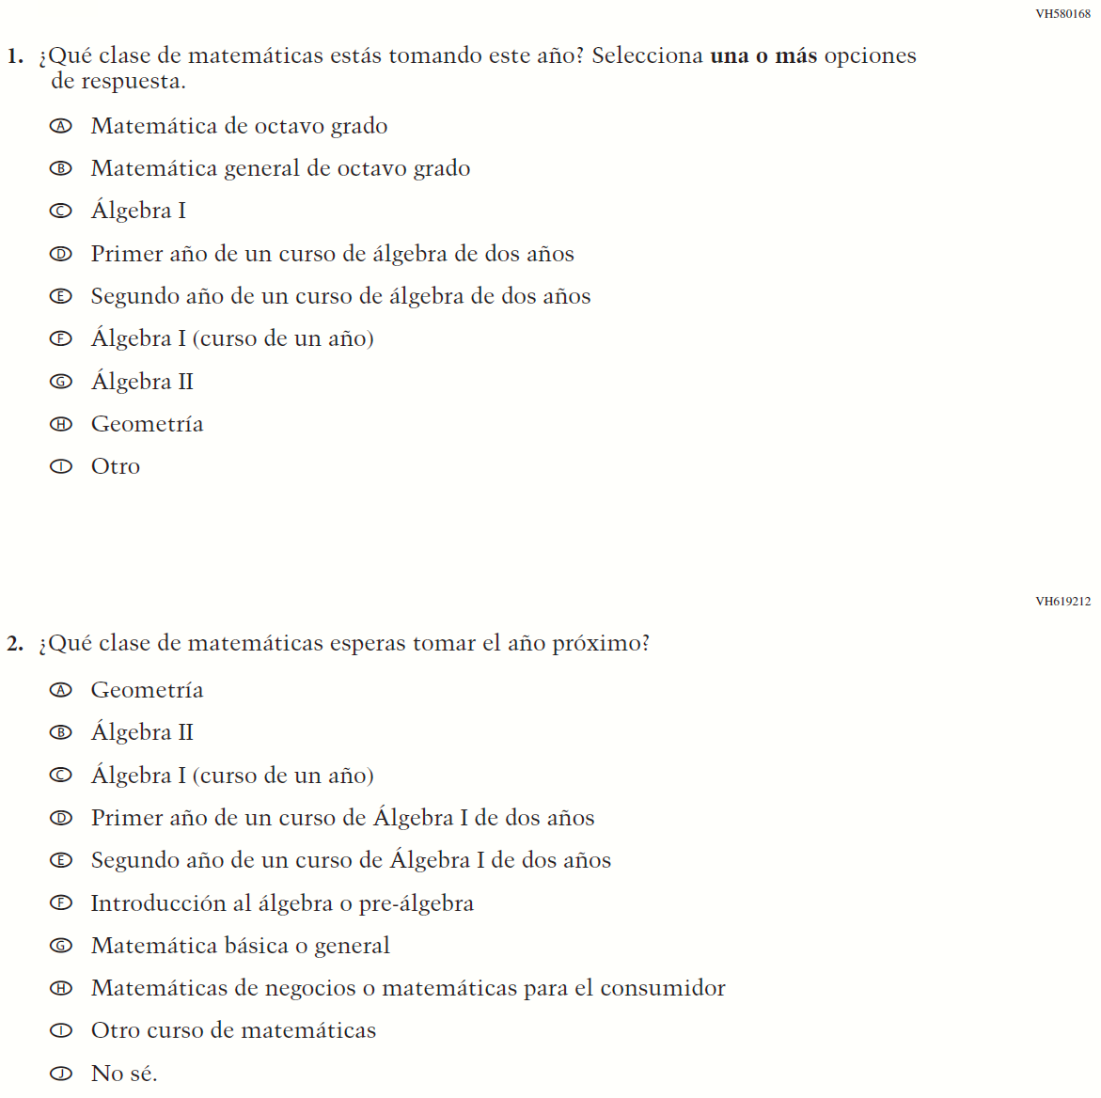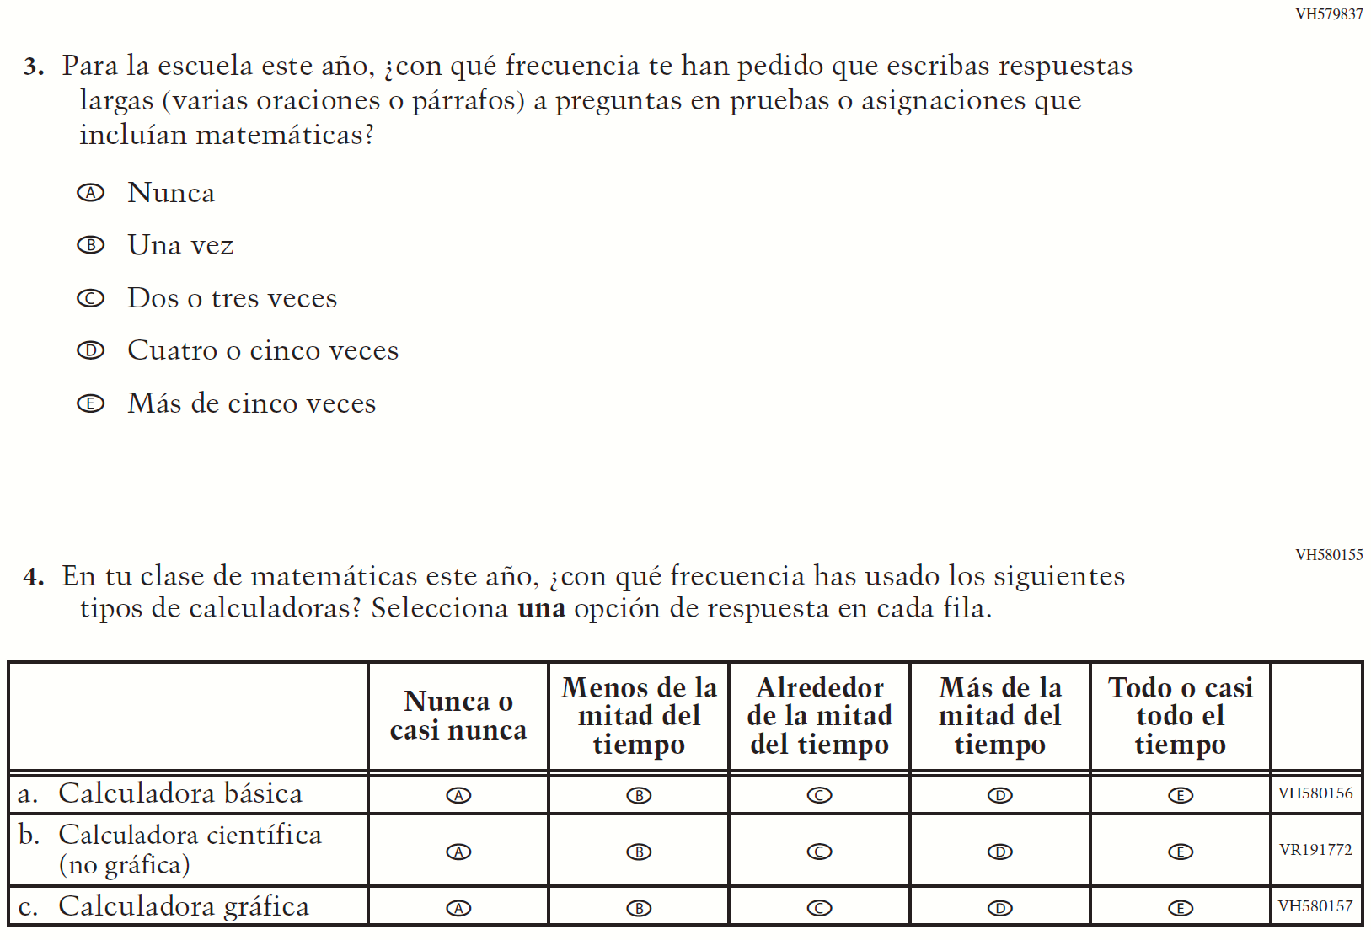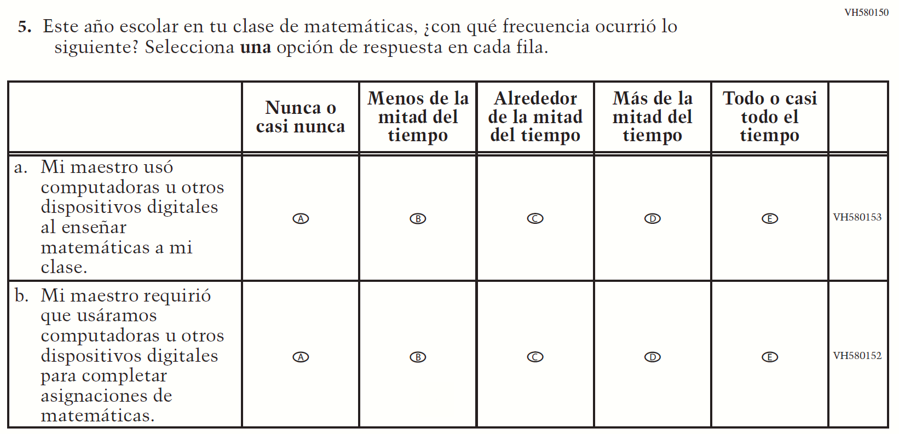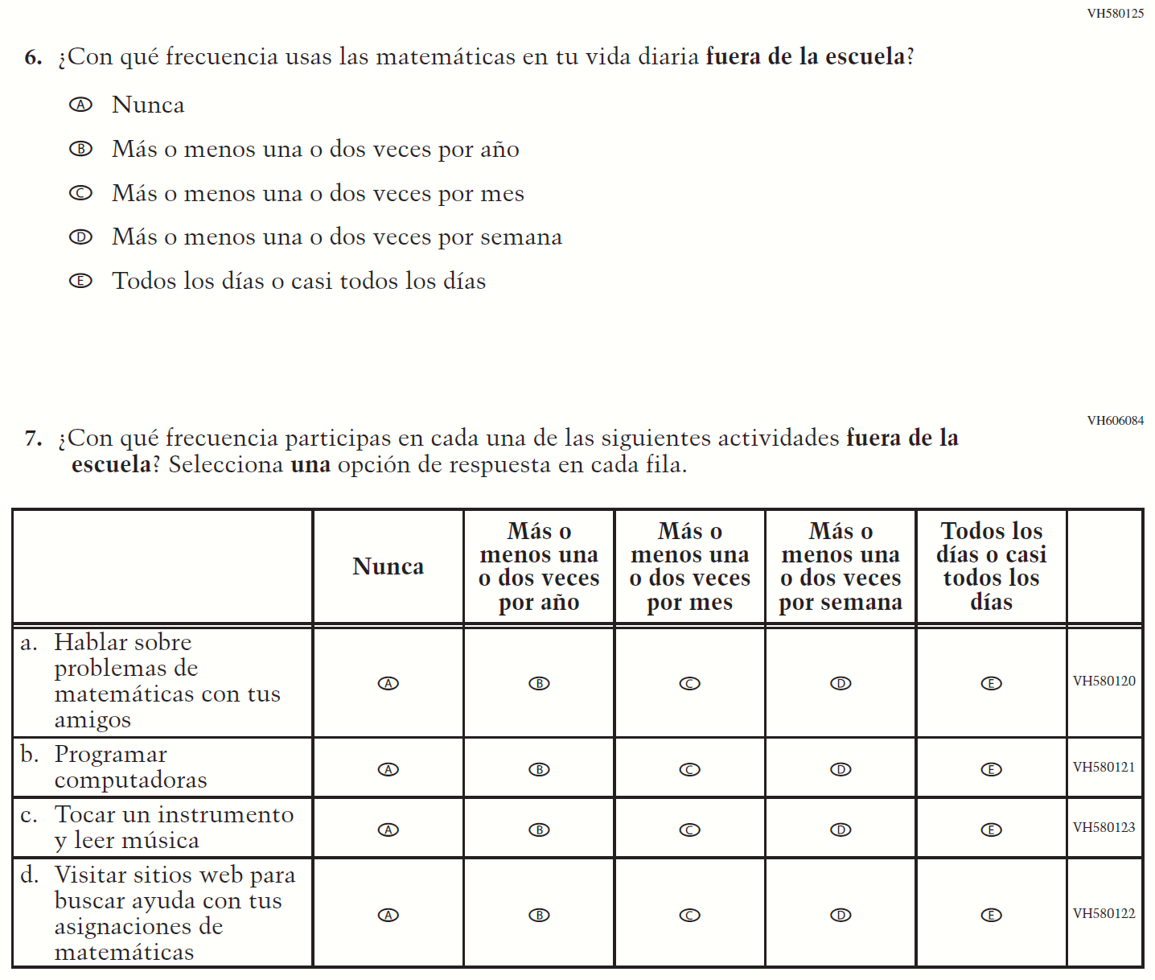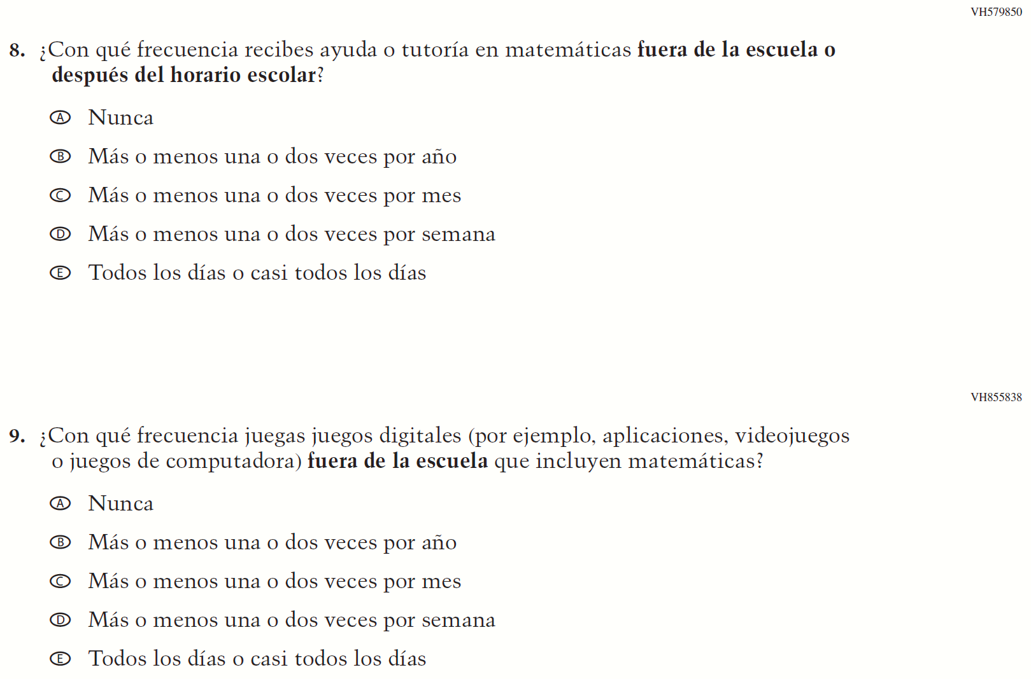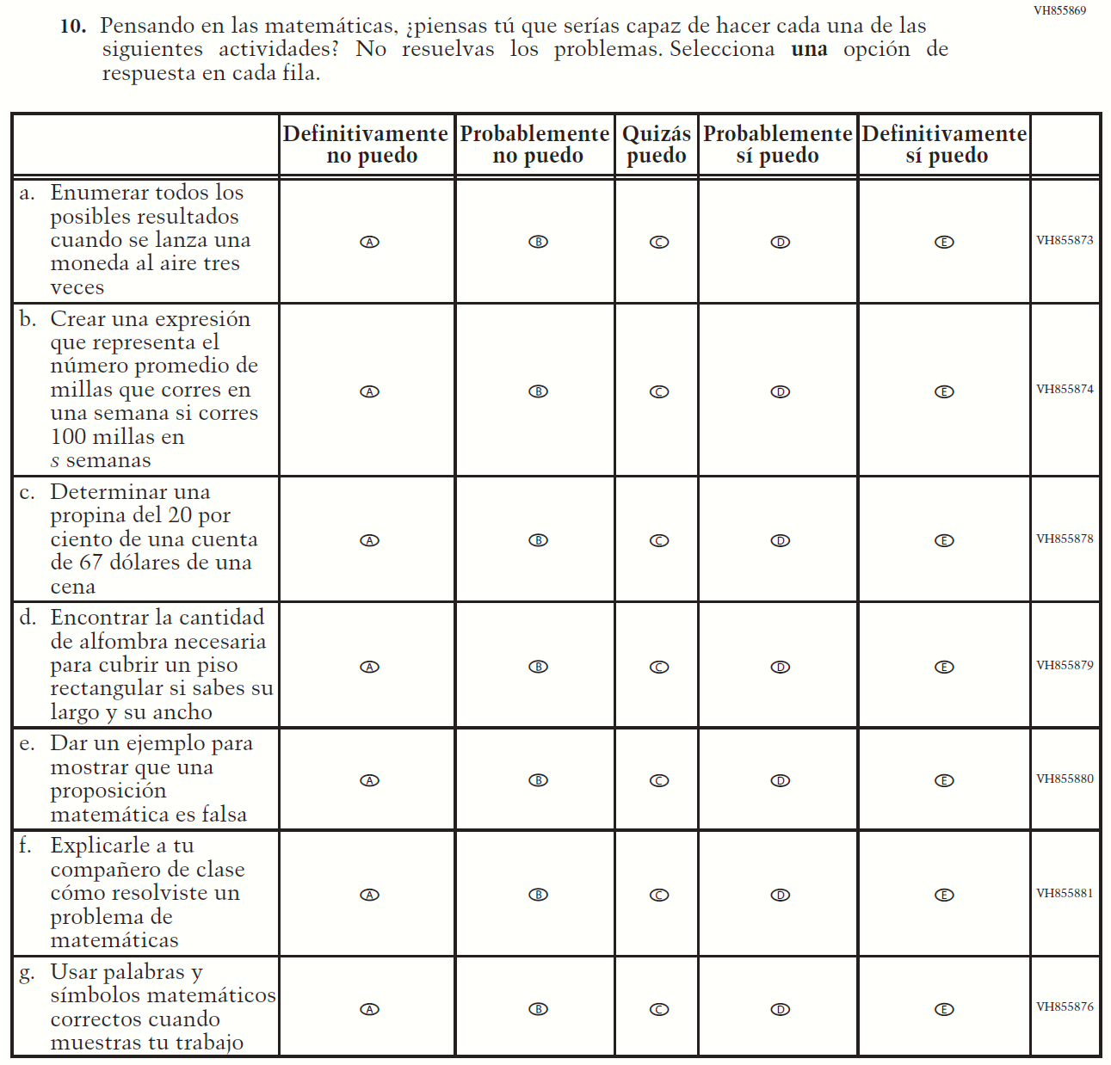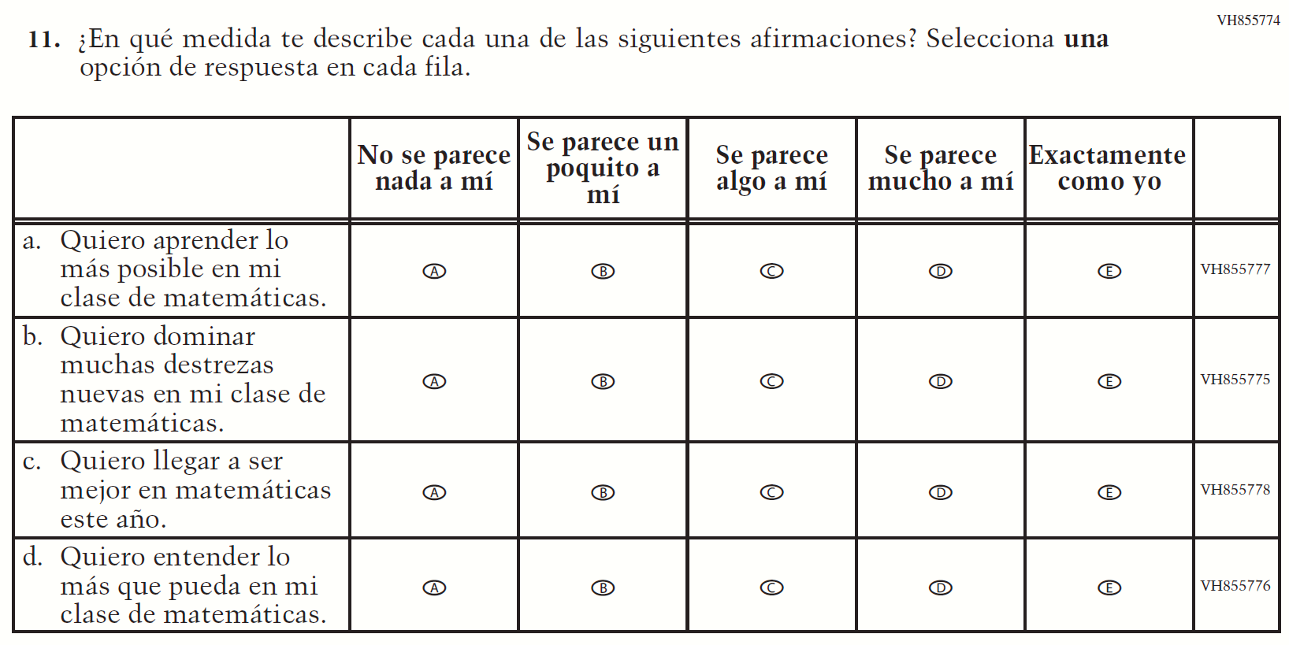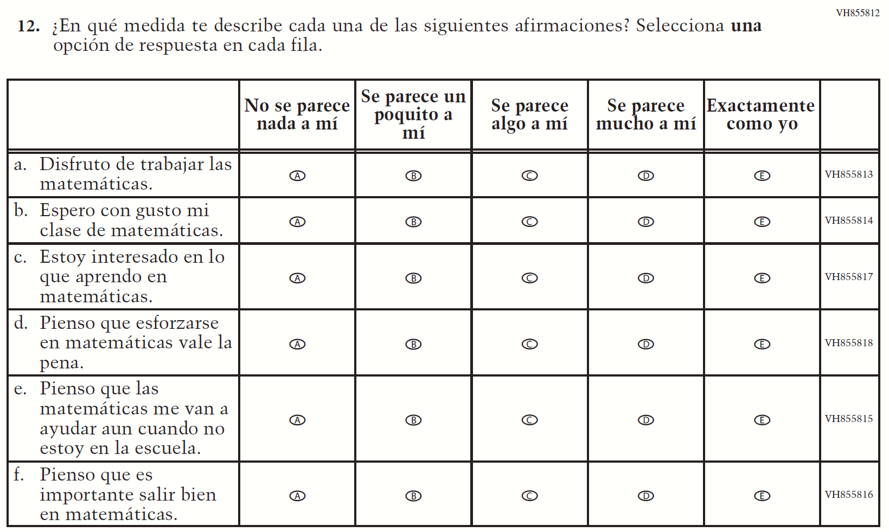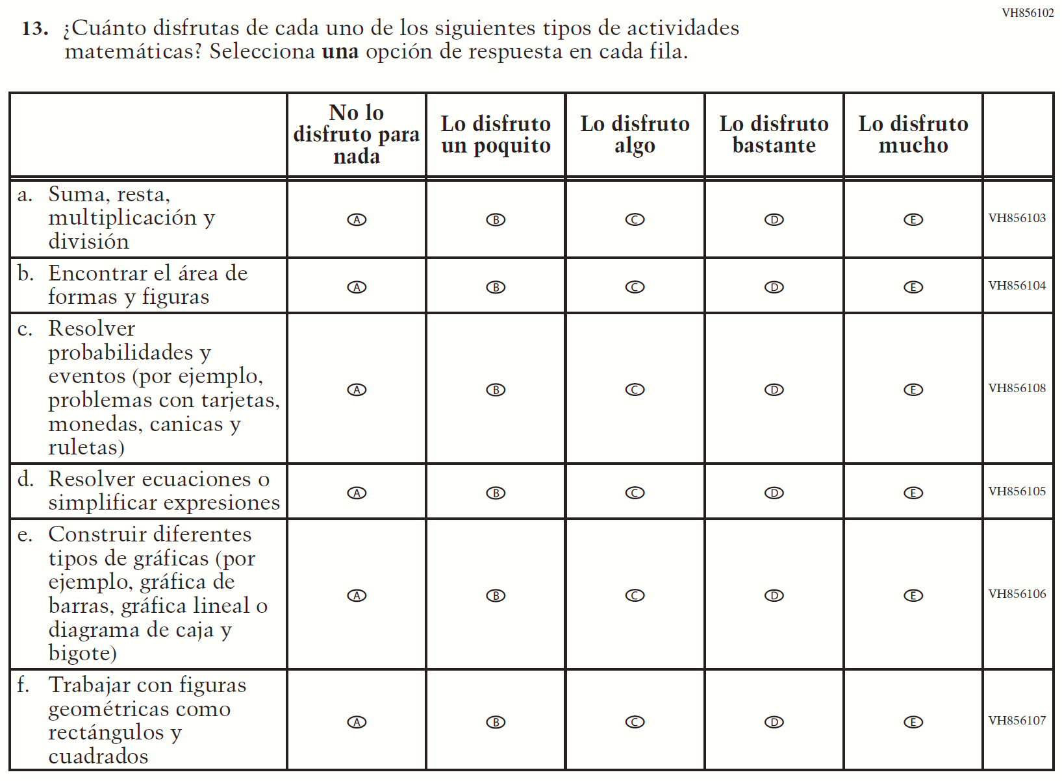

Appendix J-1i-s-BL: Summary of Changes Operational Grade 4 Reading
2021 Operational Grade 4 Reading Student – Bilingual
Previous item | 2021 item | D/A/R/NC+ | Rationale
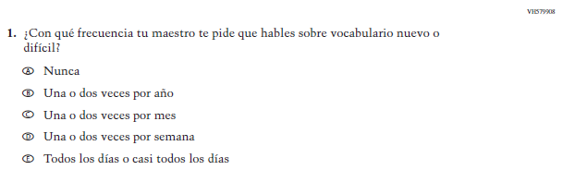  (2019 Operational Grade 4 Student Reading - Bilingual) | 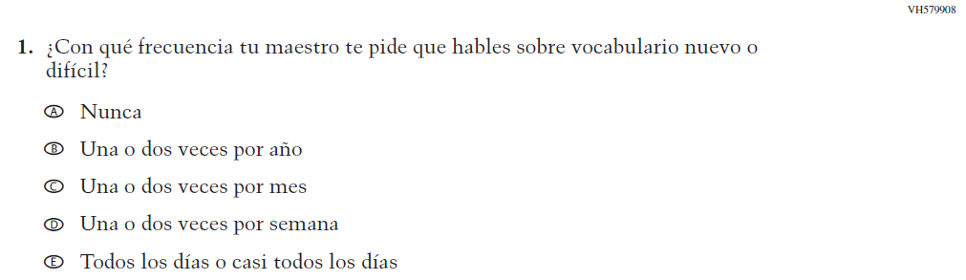  Issue: Organization of Instruction | NC | N/A
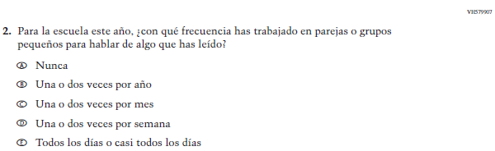  (2019 Operational Grade 4 Student Reading - Bilingual) | 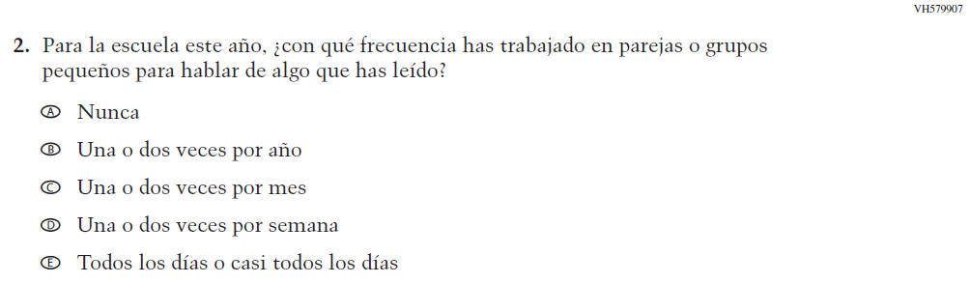  Issue: Organization of Instruction | NC | N/A
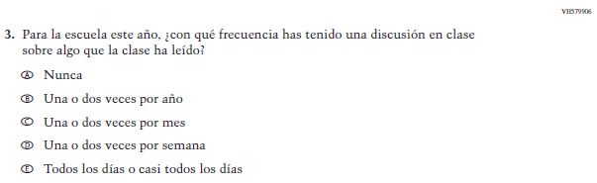  (2019 Operational Grade 4 Student Reading - Bilingual) | 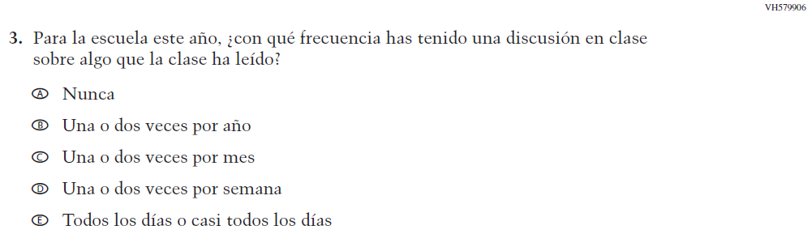  Issue: Organization of Instruction | NC | N/A
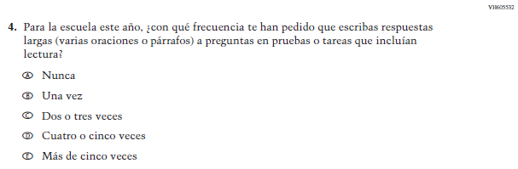  (2019 Operational Grade 4 Student Reading - Bilingual) | 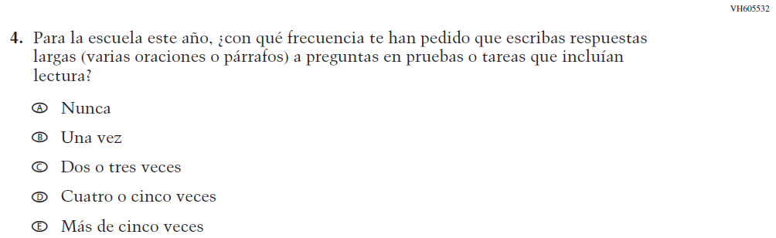  Issue: Organization of Instruction | NC | N/A

2021 Operational Grade 4 Reading Student – Bilingual
Previous item | 2021 item | D/A/R/NC+ | Rationale
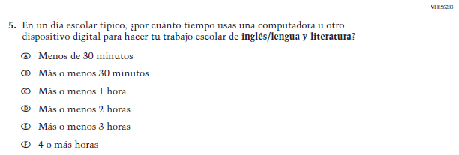  (2019 Operational Grade 4 Student Reading - Bilingual) | N/A | D | To keep student burden low, this item was dropped.
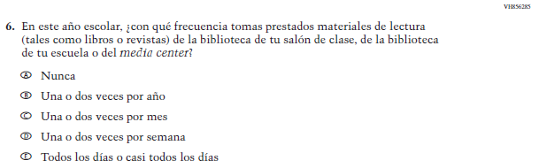  (2019 Operational Grade 4 Student Reading - Bilingual) | 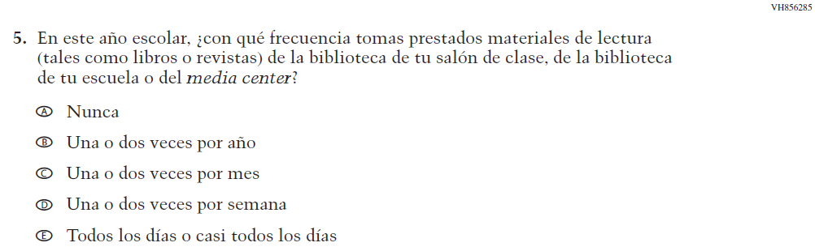  Issue: Resources for Learning and Instruction | NC | N/A
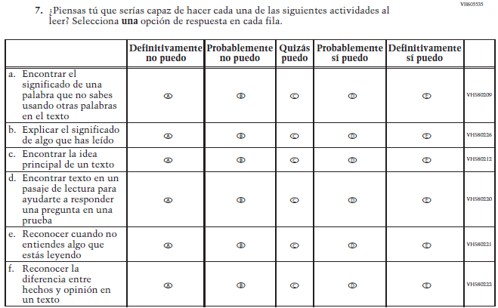  (2019 Operational Grade 4 Student Reading - Bilingual) | 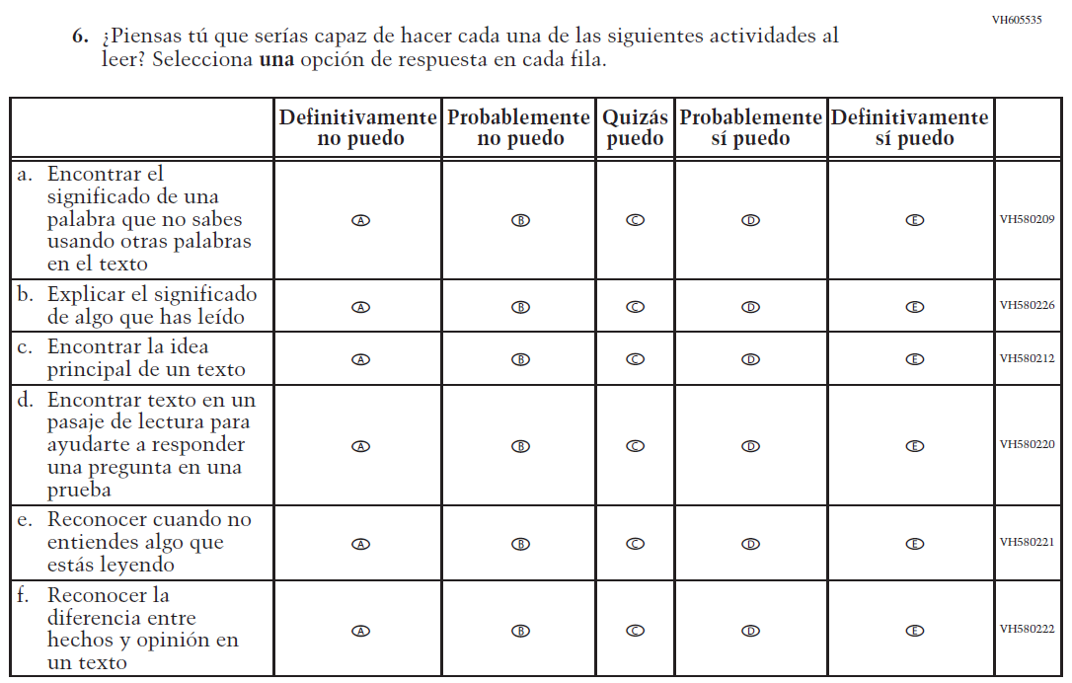  Issue: Student Factors | NC | N/A

2021 Operational Grade 4 Reading Student – Bilingual
Previous item | 2021 item | D/A/R/NC+ | Rationale
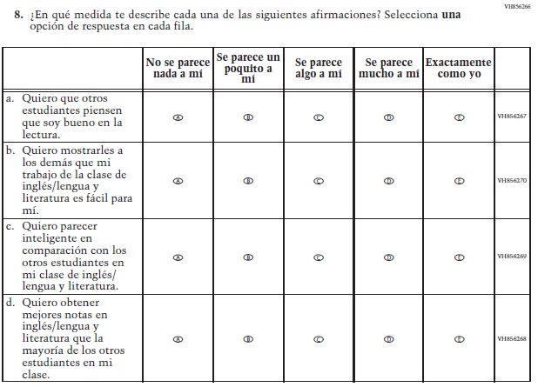  (2019 Operational Grade 4 Student Reading - Bilingual) | N/A | D | To keep student burden low, this item was dropped.
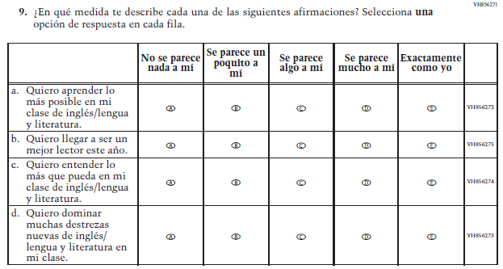  (2019 Operational Grade 4 Student Reading - Bilingual) | 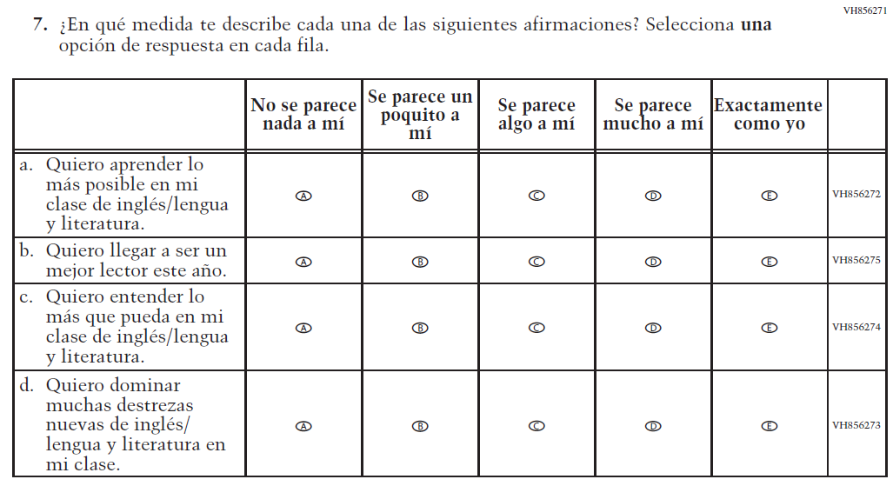  Issue: Student Factors | NC | N/A

2021 Operational Grade 4 Reading Student – Bilingual
Previous item | 2021 item | D/A/R/NC+ | Rationale
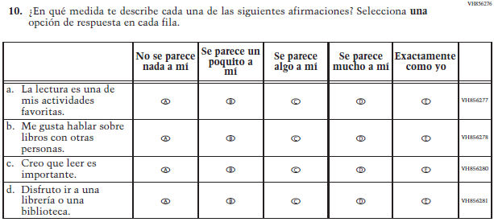  (2019 Operational Grade 4 Student Reading - Bilingual) | 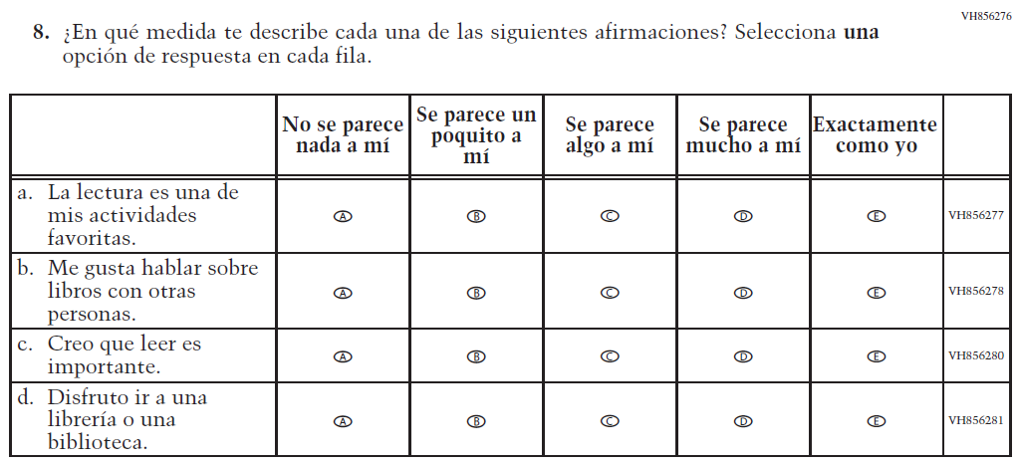  Issue: Student Factors | NC | N/A
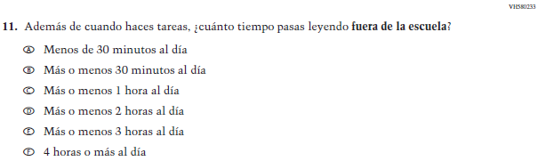  (2019 Operational Grade 4 Student Reading - Bilingual) | 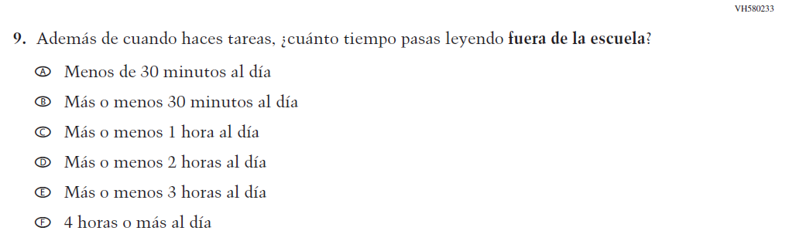  Issue: Student Factors | NC | N/A
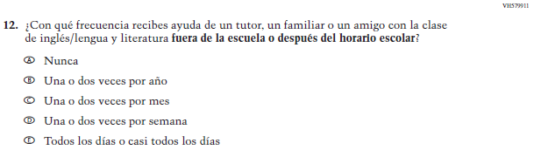  (2019 Operational Grade 4 Student Reading - Bilingual) | 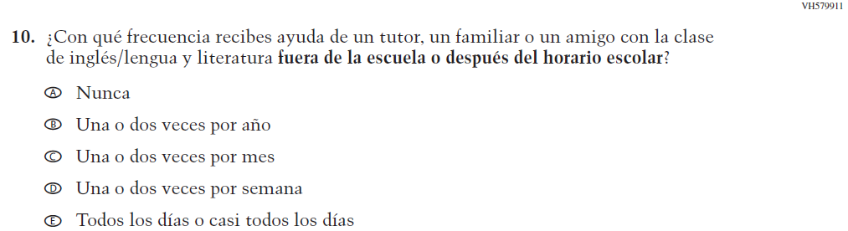  Issue: Resources for Learning and Instruction | NC | N/A

2021 Operational Grade 4 Reading Student – Bilingual
Previous item | 2021 item | D/A/R/NC+ | Rationale
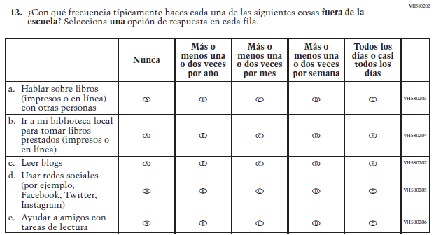  (2019 Operational Grade 4 Student Reading - Bilingual) | 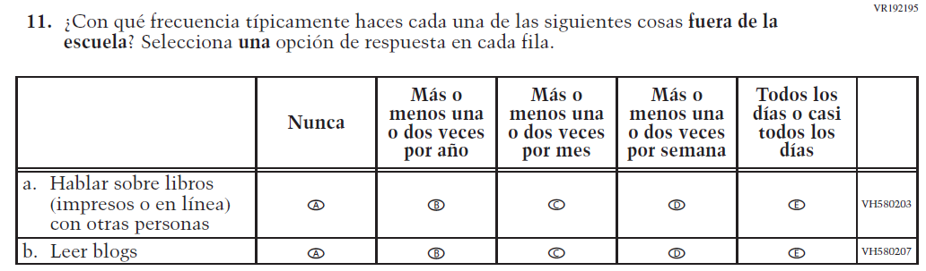  Issue: Student Factors | R | To keep student burden low, sub-items b, d, and e were dropped.

Appendix J-1i-s-BL: Operational Grade 4 Reading
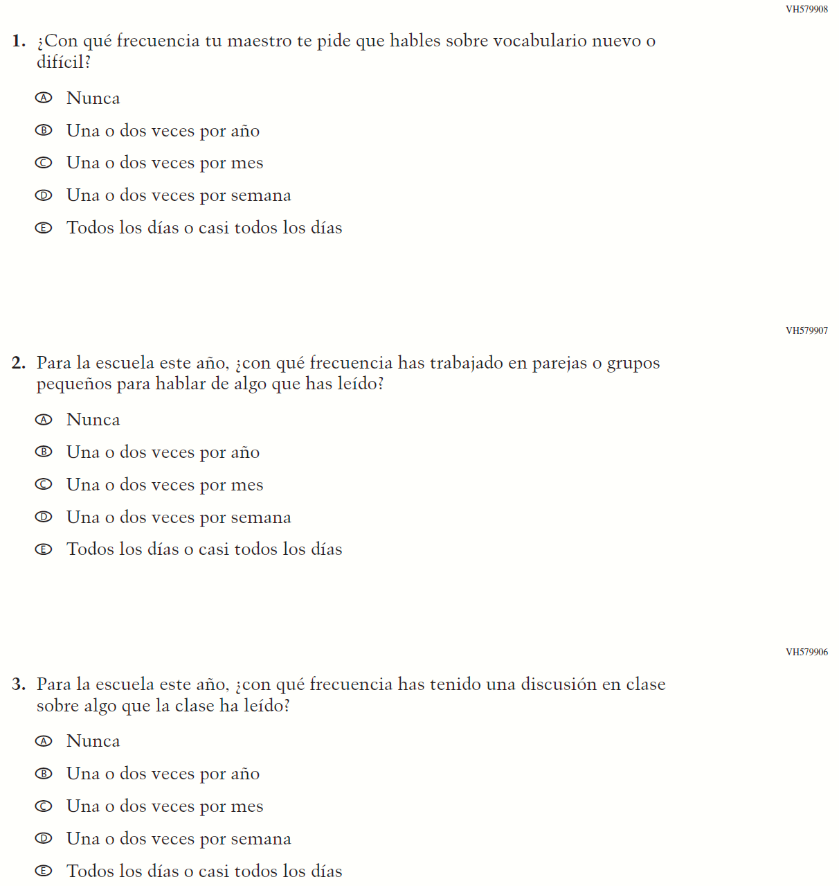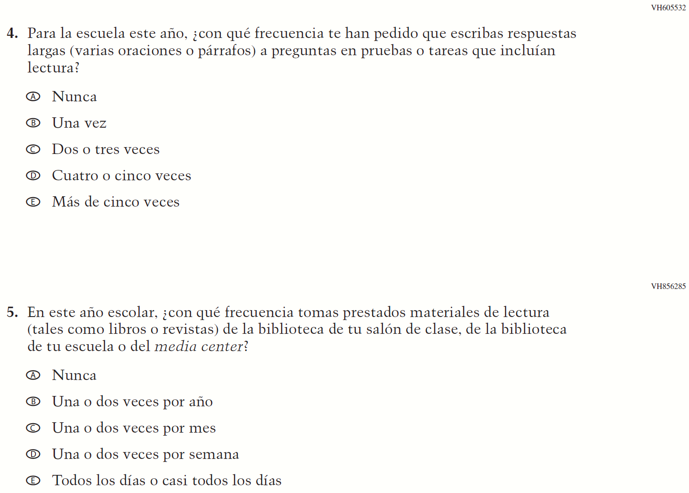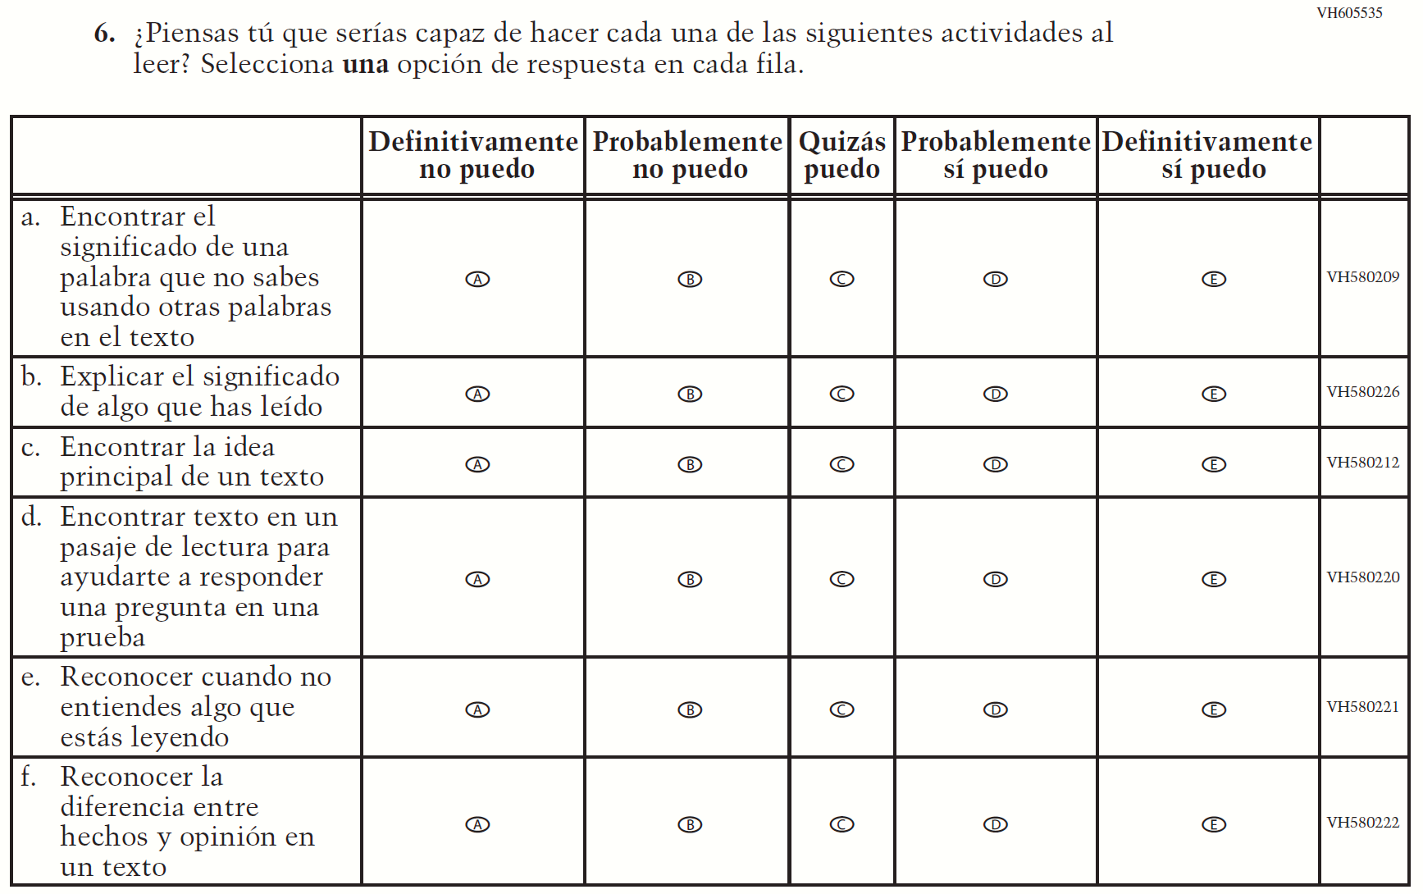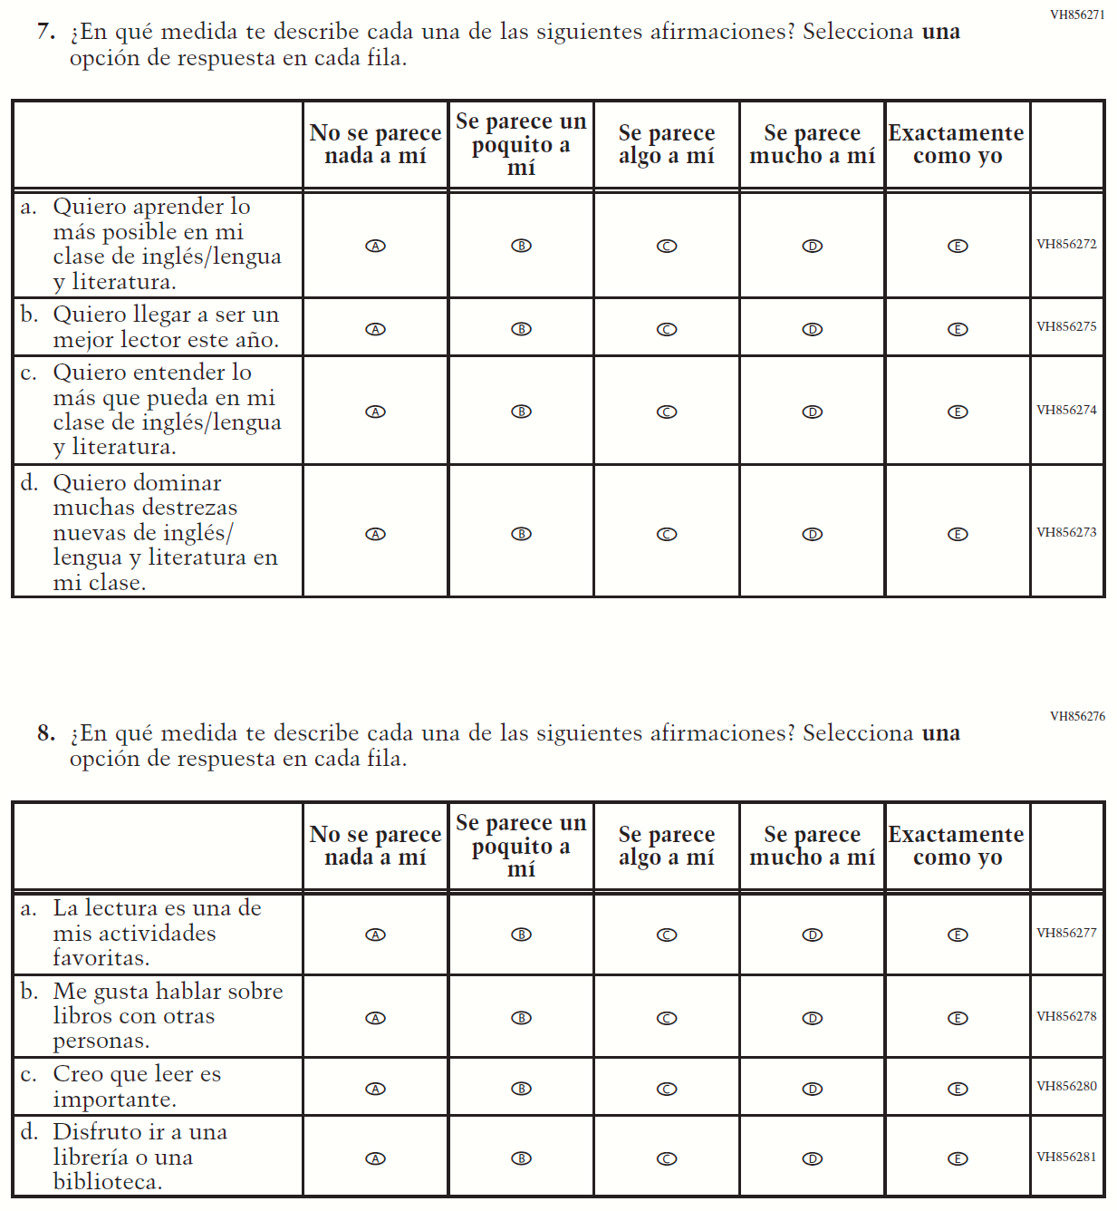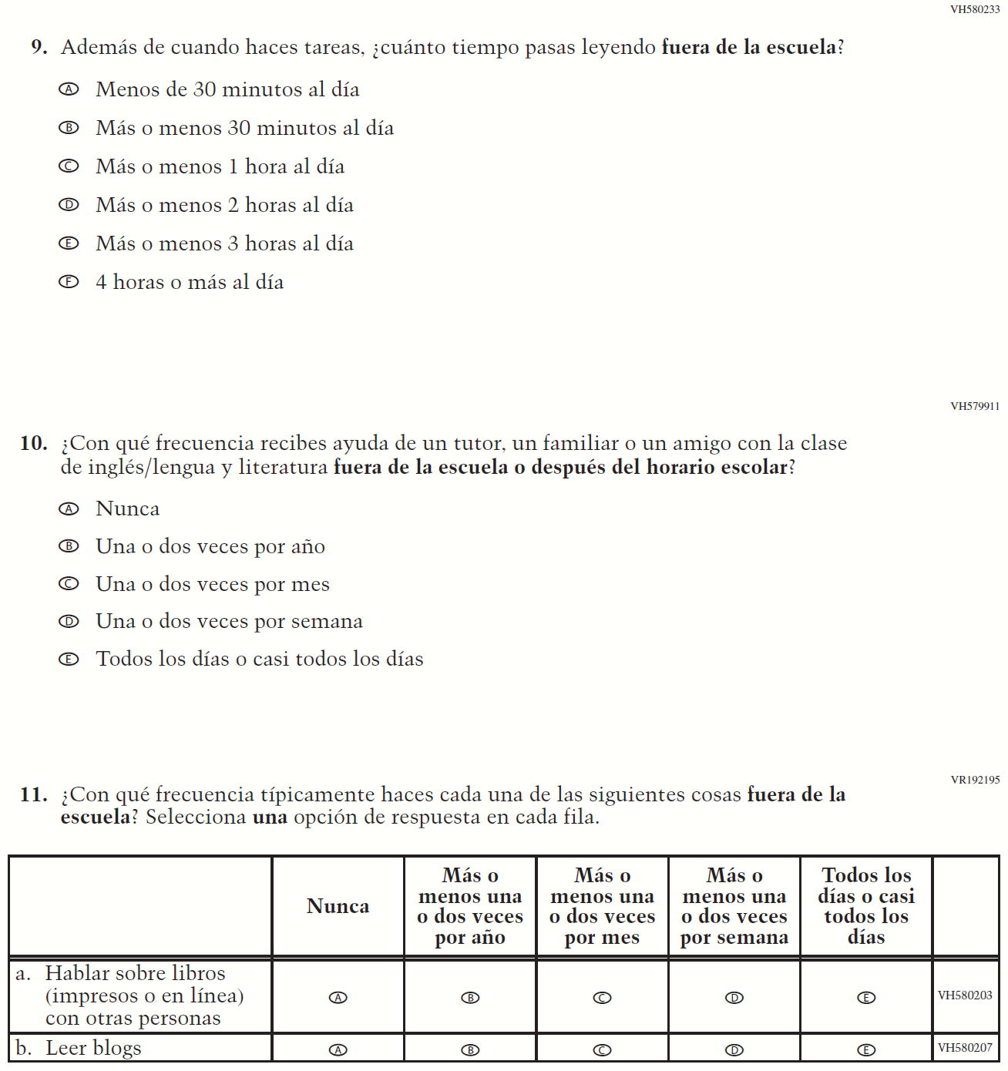

Appendix J-1j-s-BL: Summary of Changes Operational Grade 8 Reading
2021 Operational Grade 8 Reading Student – Bilingual

Previous item | 2021 item | D/A/ R/NC+ | Rationale
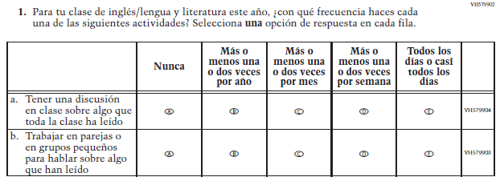  (2019 Operational Grade 8 Student Reading – Bilingual) | 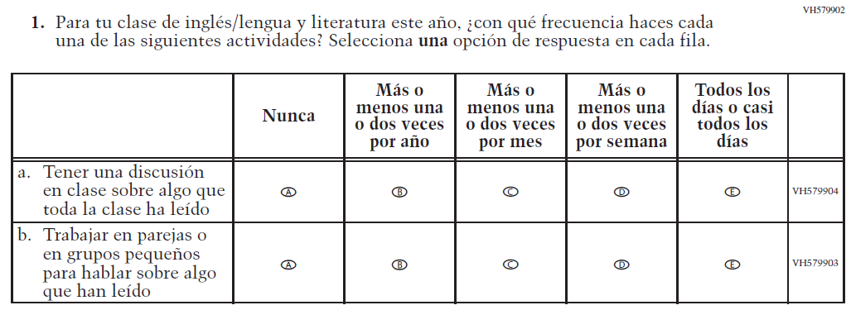  Issue: Organization of Instruction | NC | N/A
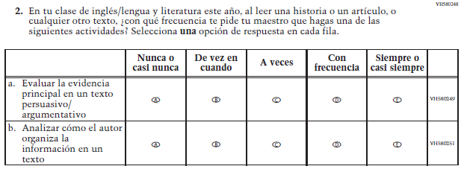  (2019 Operational Grade 8 Student Reading – Bilingual) | 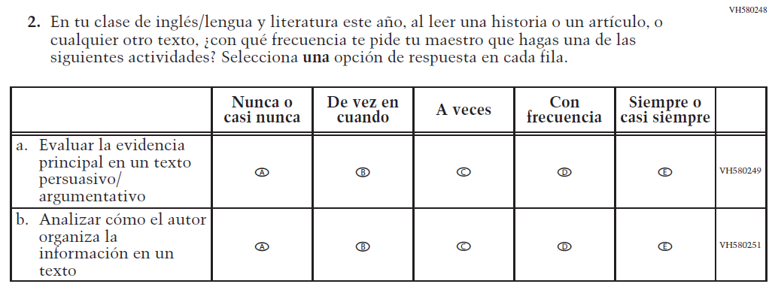  Issue: Organization of Instruction | NC | N/A
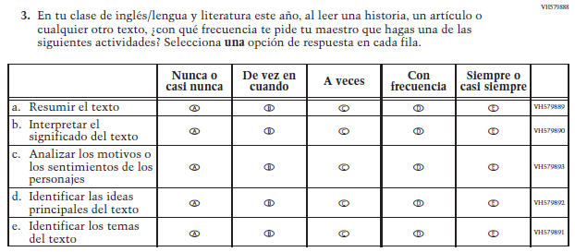  (2019 Operational Grade 8 Student Reading – Bilingual) | 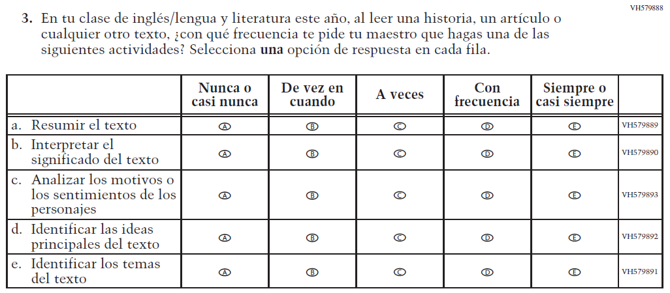  Issue: Organization of Instruction | NC | N/A
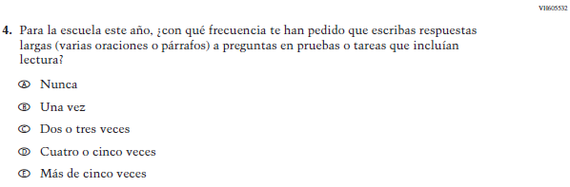  (2019 Operational Grade 8 Student Reading – Bilingual) | 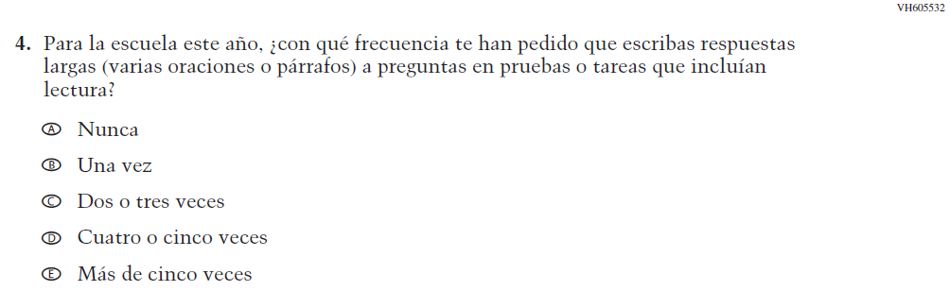  Issue: Organization of Instruction | NC | N/A
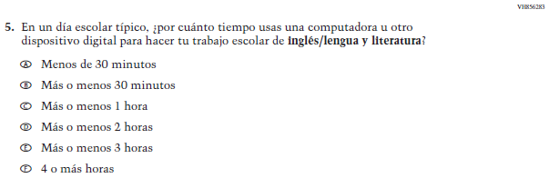  (2019 Operational Grade 8 Student Reading – Bilingual) | N/A | D | To keep student burden low, this item was dropped.
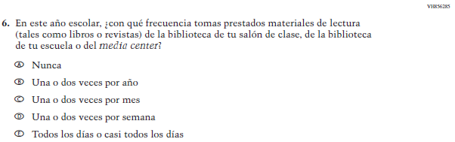  (2019 Operational Grade 8 Student Reading – Bilingual) | N/A | D | To keep student burden low, this item was dropped.

2021 Operational Grade 8 Reading Student – Bilingual

Previous item | 2021 item | D/A/ R/NC+ | Rationale
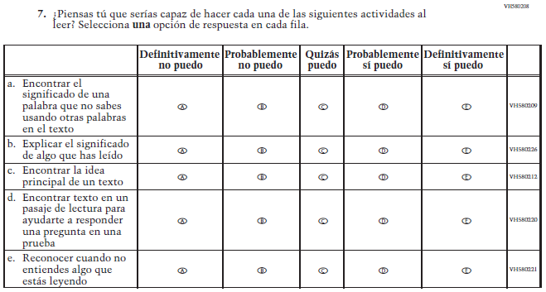  (2019 Operational Grade 8 Student Reading – Bilingual) | 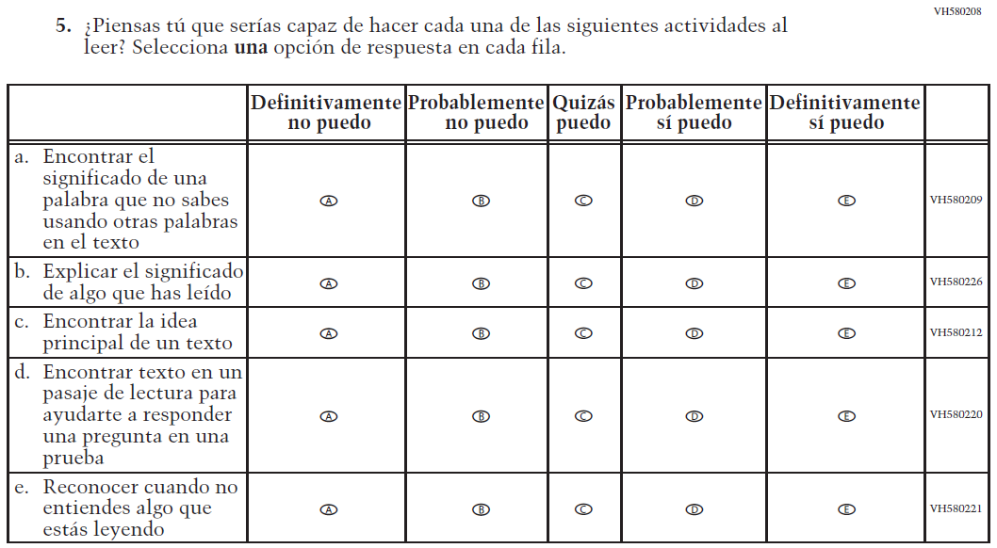  Issue: Student Factors | NC | N/A
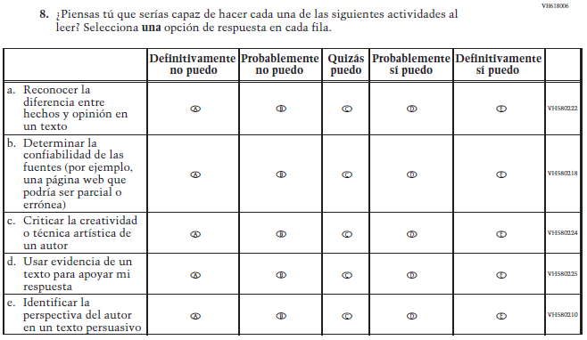  (2019 Operational Grade 8 Student Reading – Bilingual) | 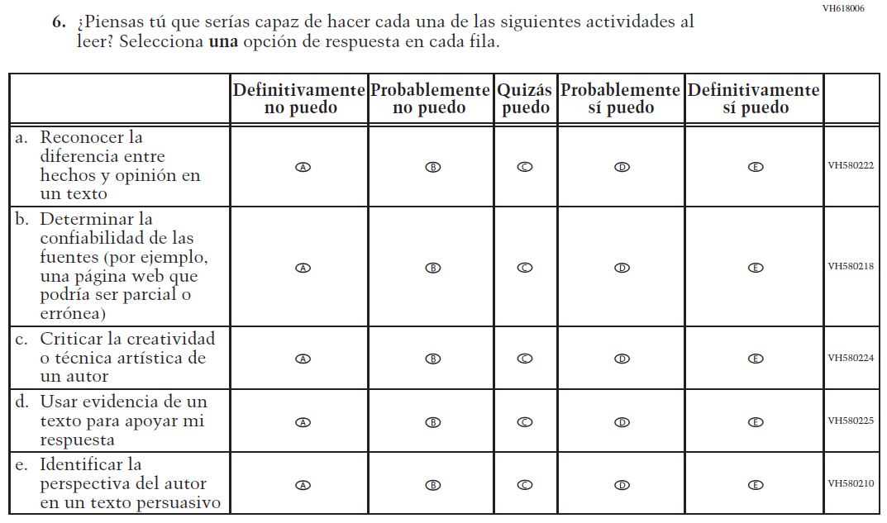  Issue: Student Factors | NC | N/A

2021 Operational Grade 8 Reading Student – Bilingual

Previous item | 2021 item | D/A/ R/NC+ | Rationale
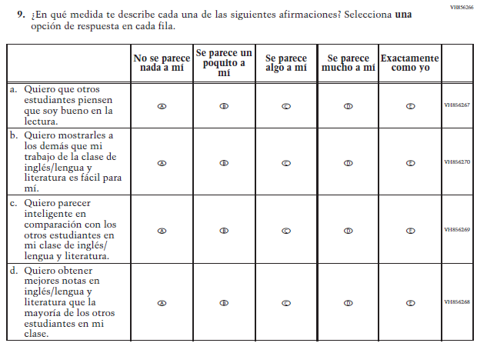  (2019 Operational Grade 8 Student Reading – Bilingual) | N/A | D | To keep student burden low, this item was dropped.
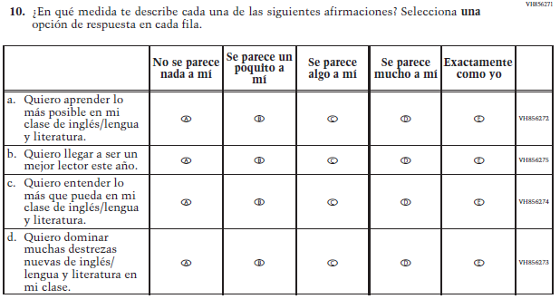  (2019 Operational Grade 8 Student Reading – Bilingual) | 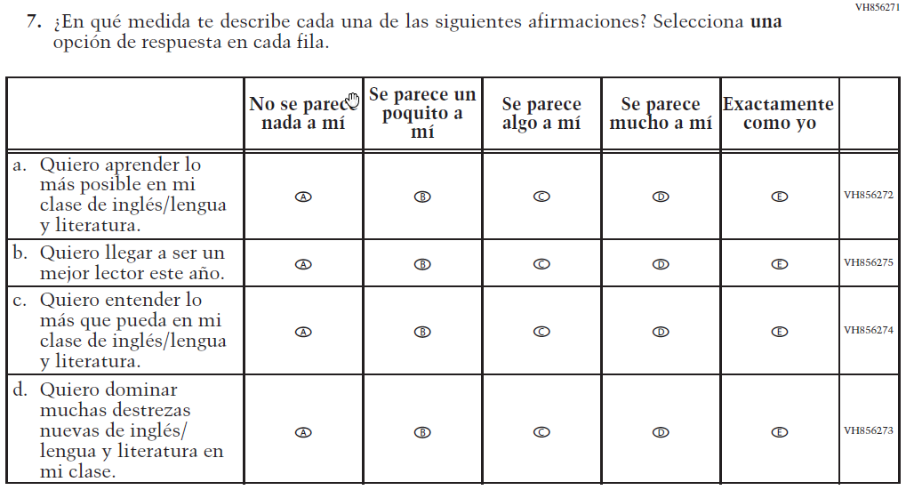  Issue: Student Factors | NC | N/A

2021 Operational Grade 8 Reading Student – Bilingual

Previous item | 2021 item | D/A/ R/NC+ | Rationale
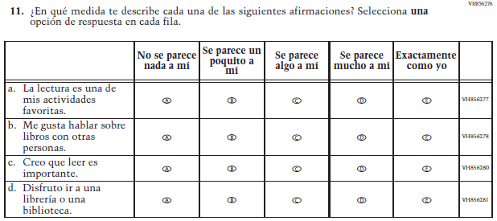  (2019 Operational Grade 8 Student Reading – Bilingual) | 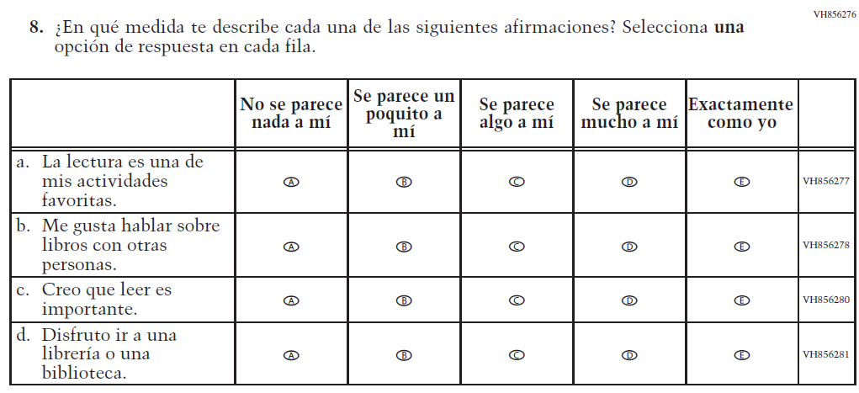  Issue: Student Factors | NC | N/A
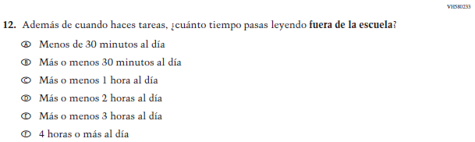  (2019 Operational Grade 8 Student Reading – Bilingual) | 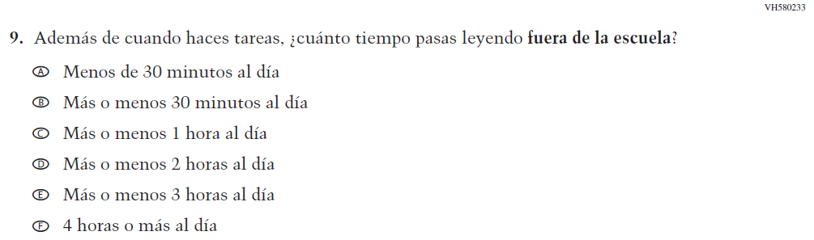  Issue: Student Factors | NC | N/A
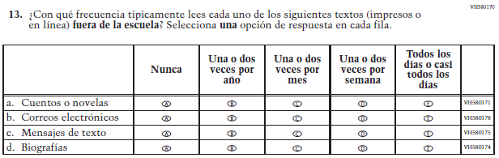  (2019 Operational Grade 8 Student Reading – Bilingual) | 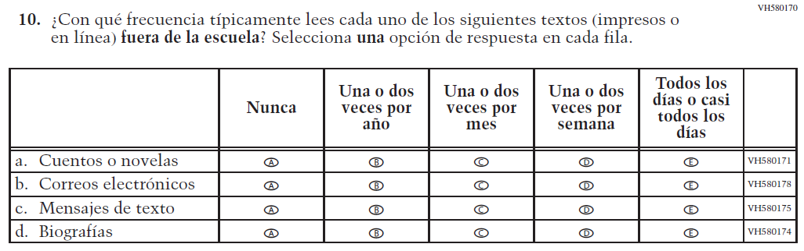  Issue: Student Factors | NC | N/A

2021 Operational Grade 8 Reading Student – Bilingual

Previous item | 2021 item | D/A/ R/NC+ | Rationale
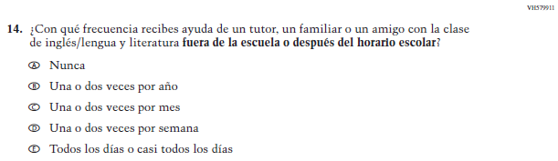  (2019 Operational Grade 8 Student Reading – Bilingual) | 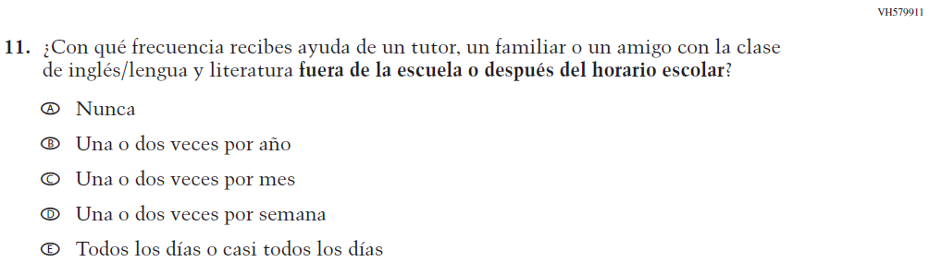  Issue: Resources for Learning and Instruction | NC | N/A
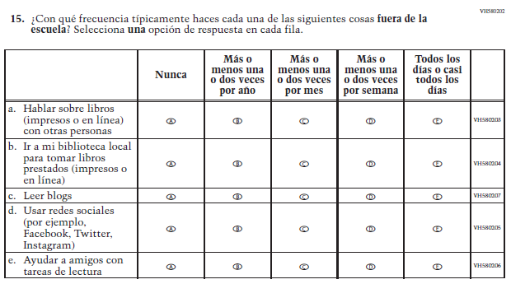  (2019 Operational Grade 8 Student Reading – Bilingual) | 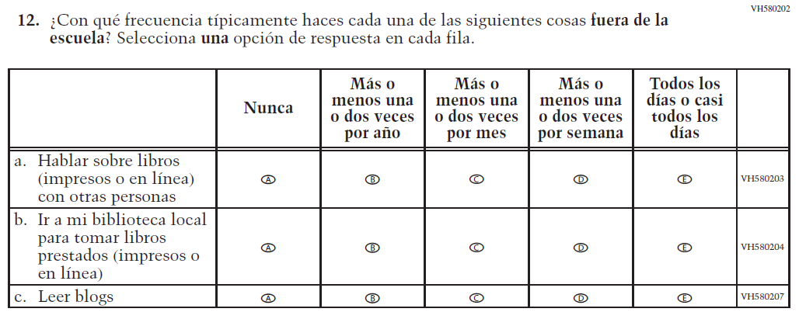  Issue: Student Factors | R | To keep student burden low, sub-items d and e were dropped.

Appendix J-1j-s-BL: Operational Grade 8 Reading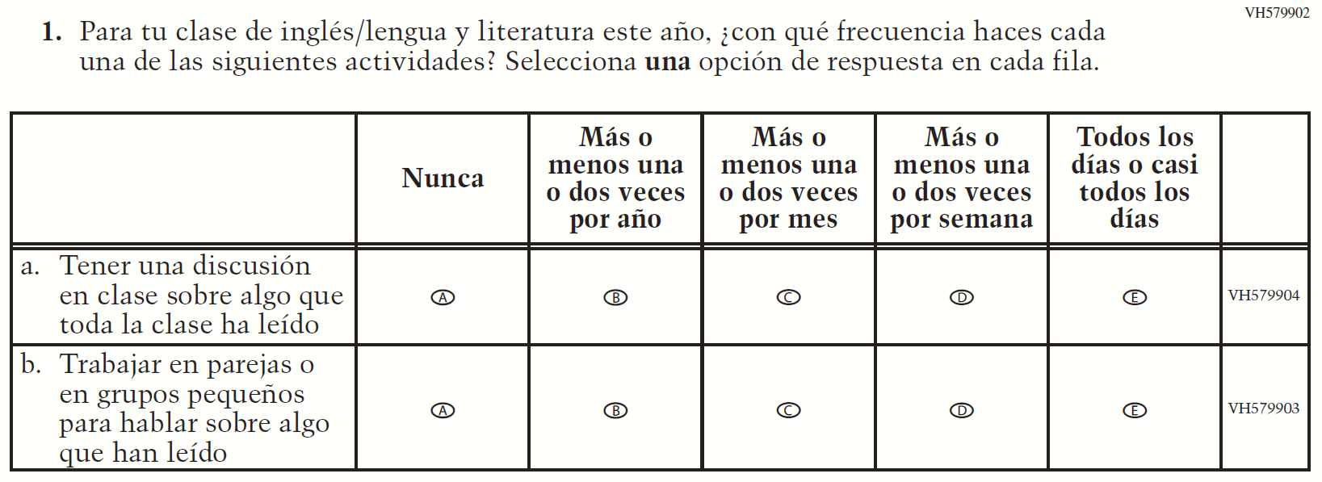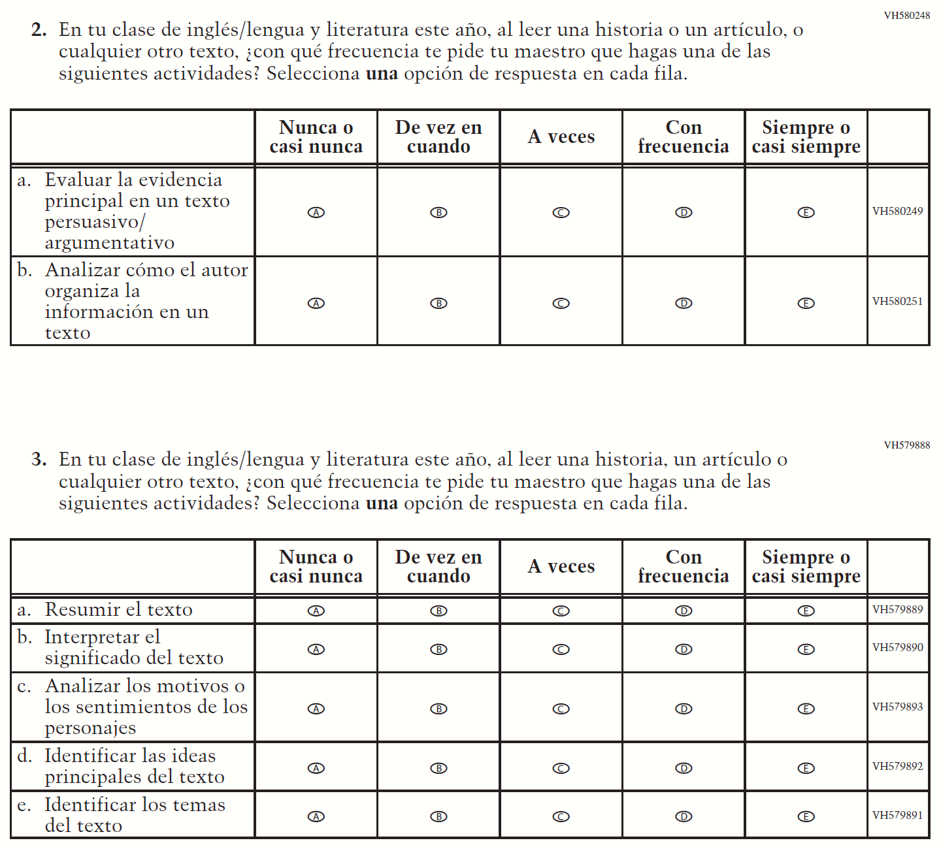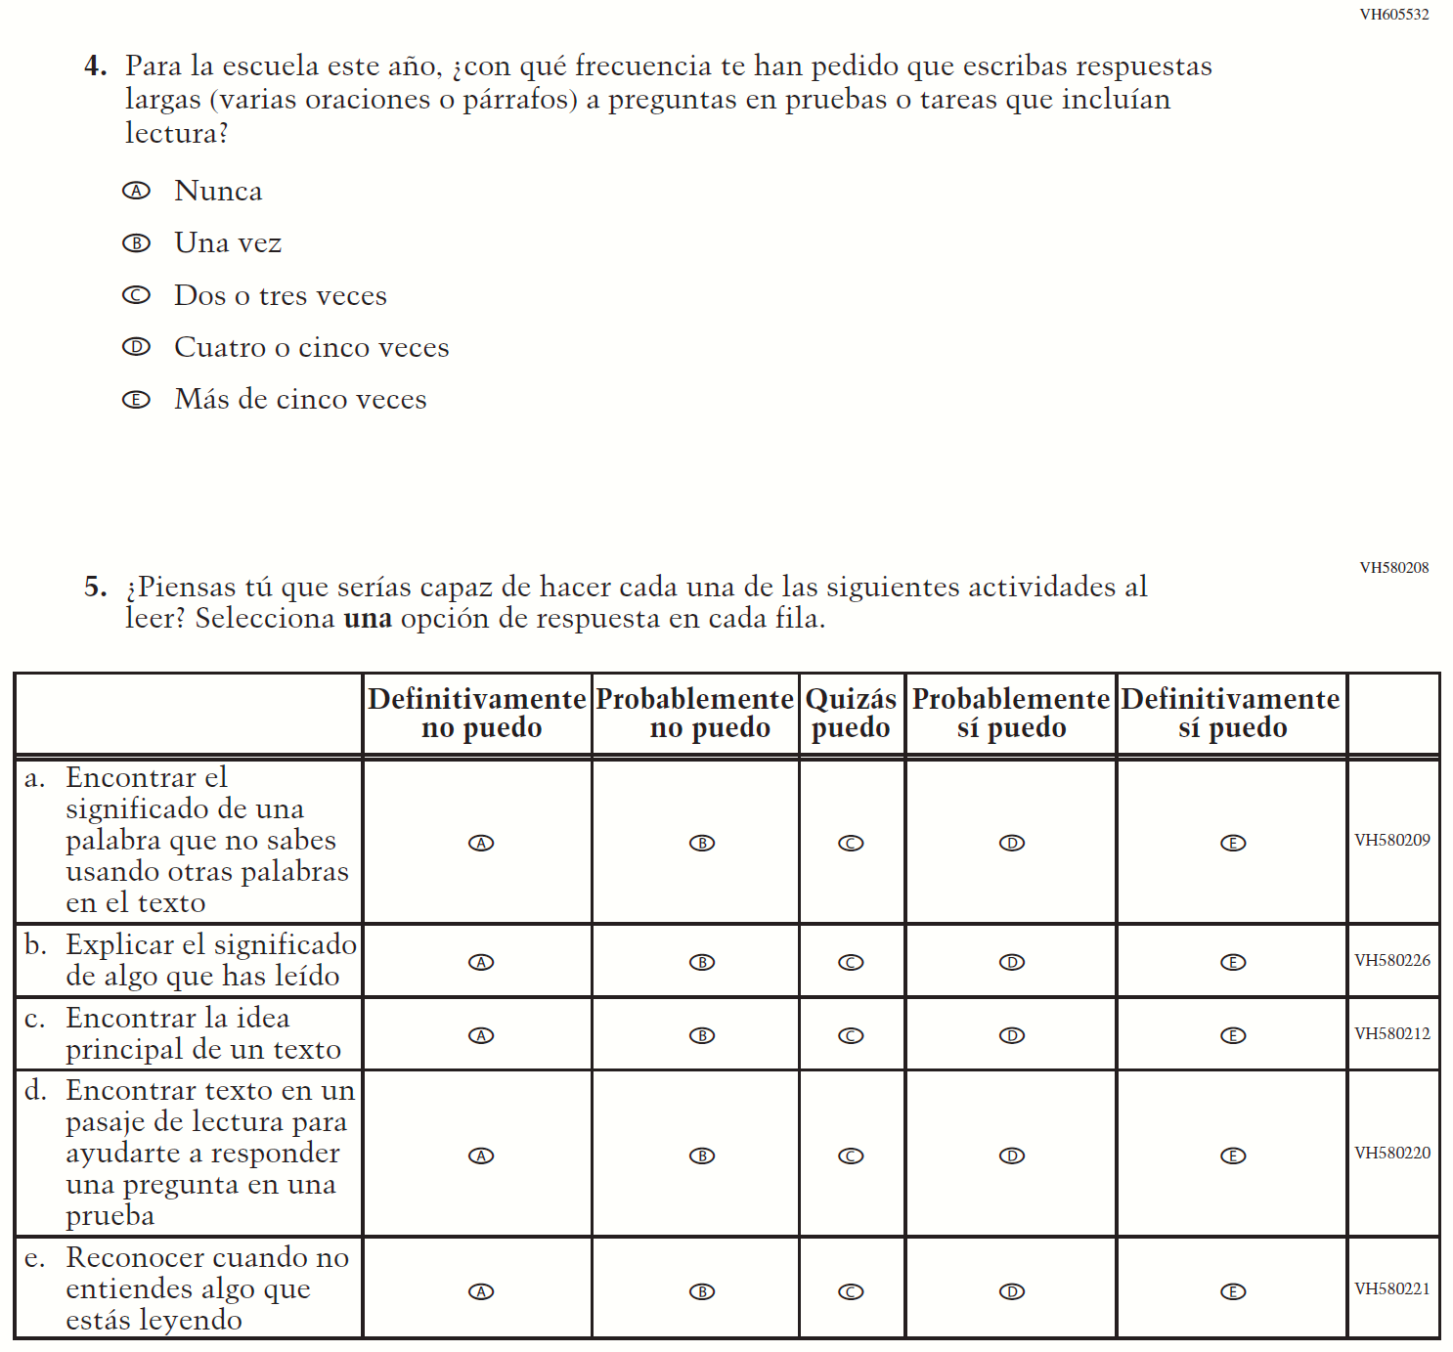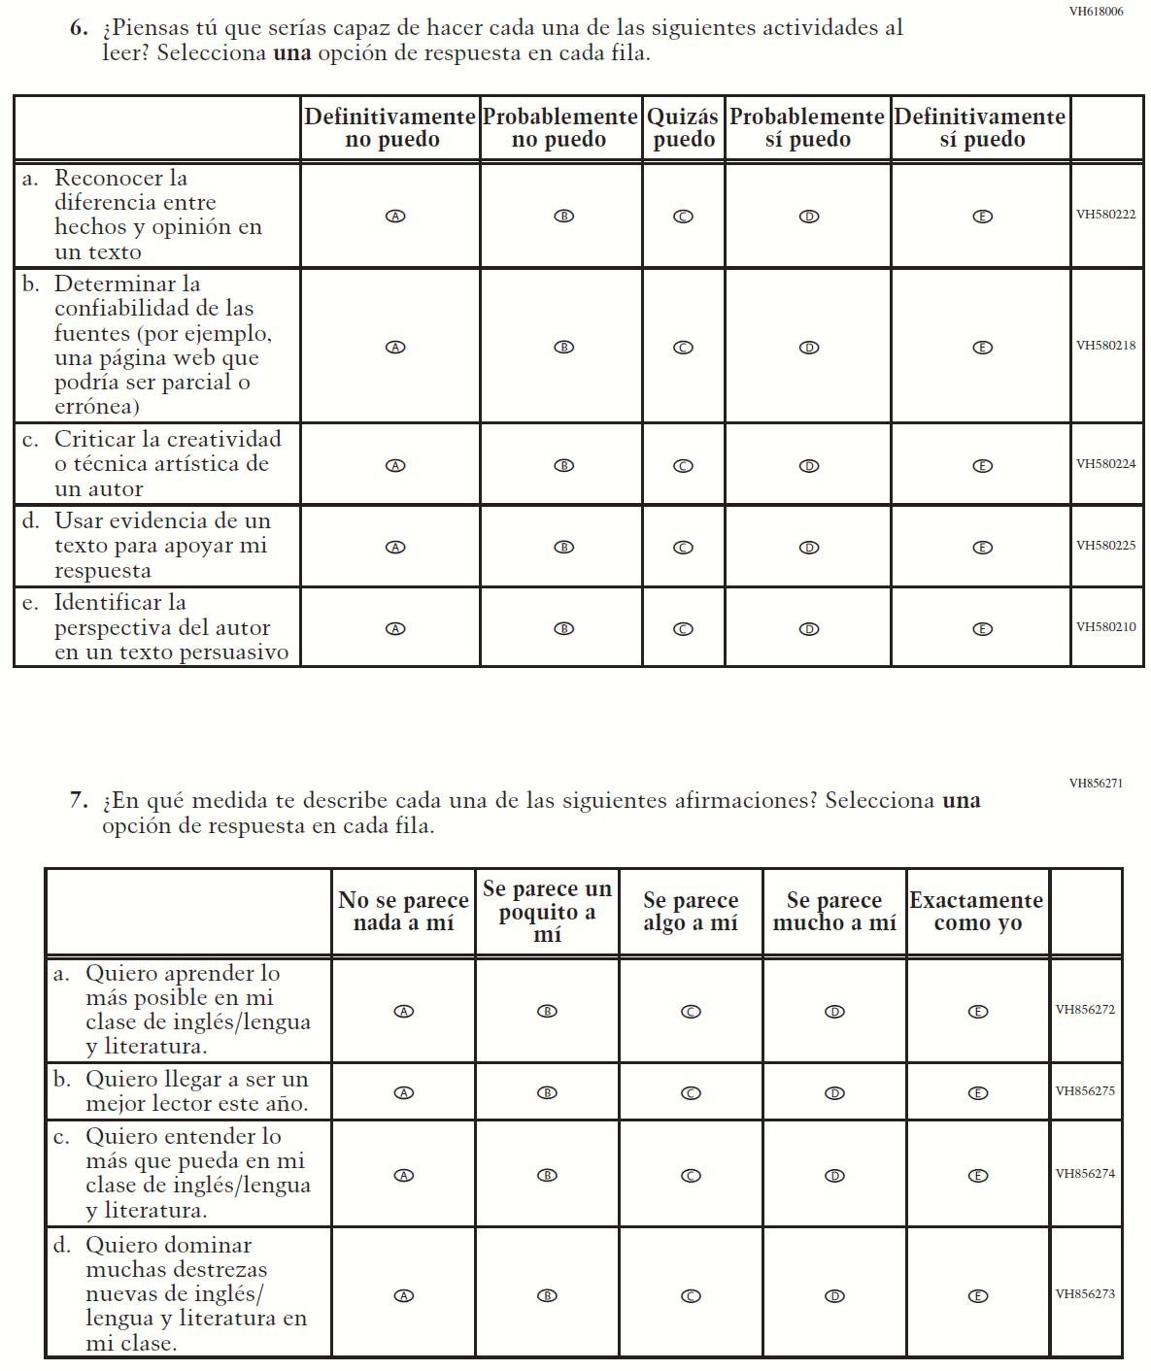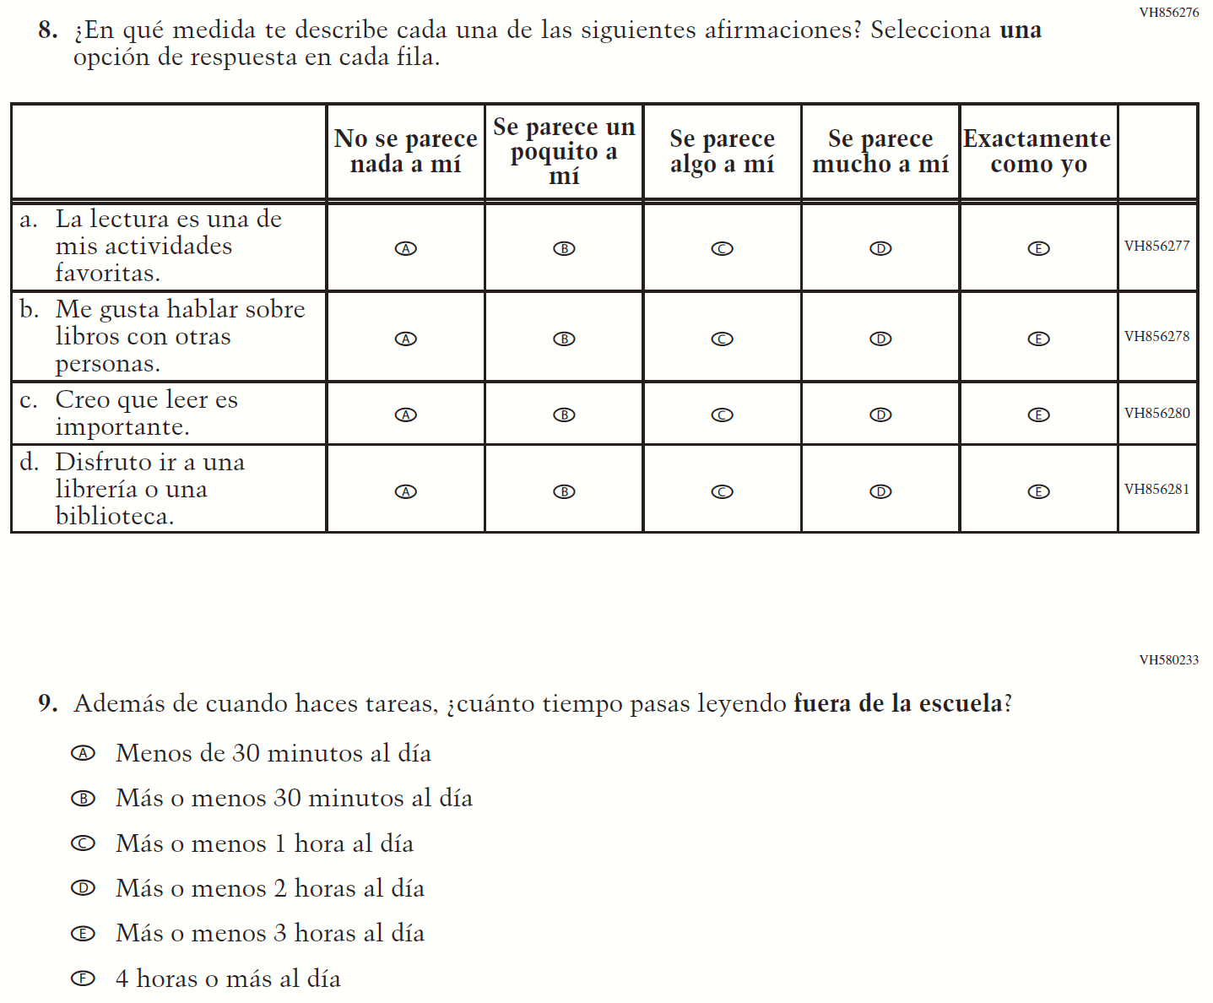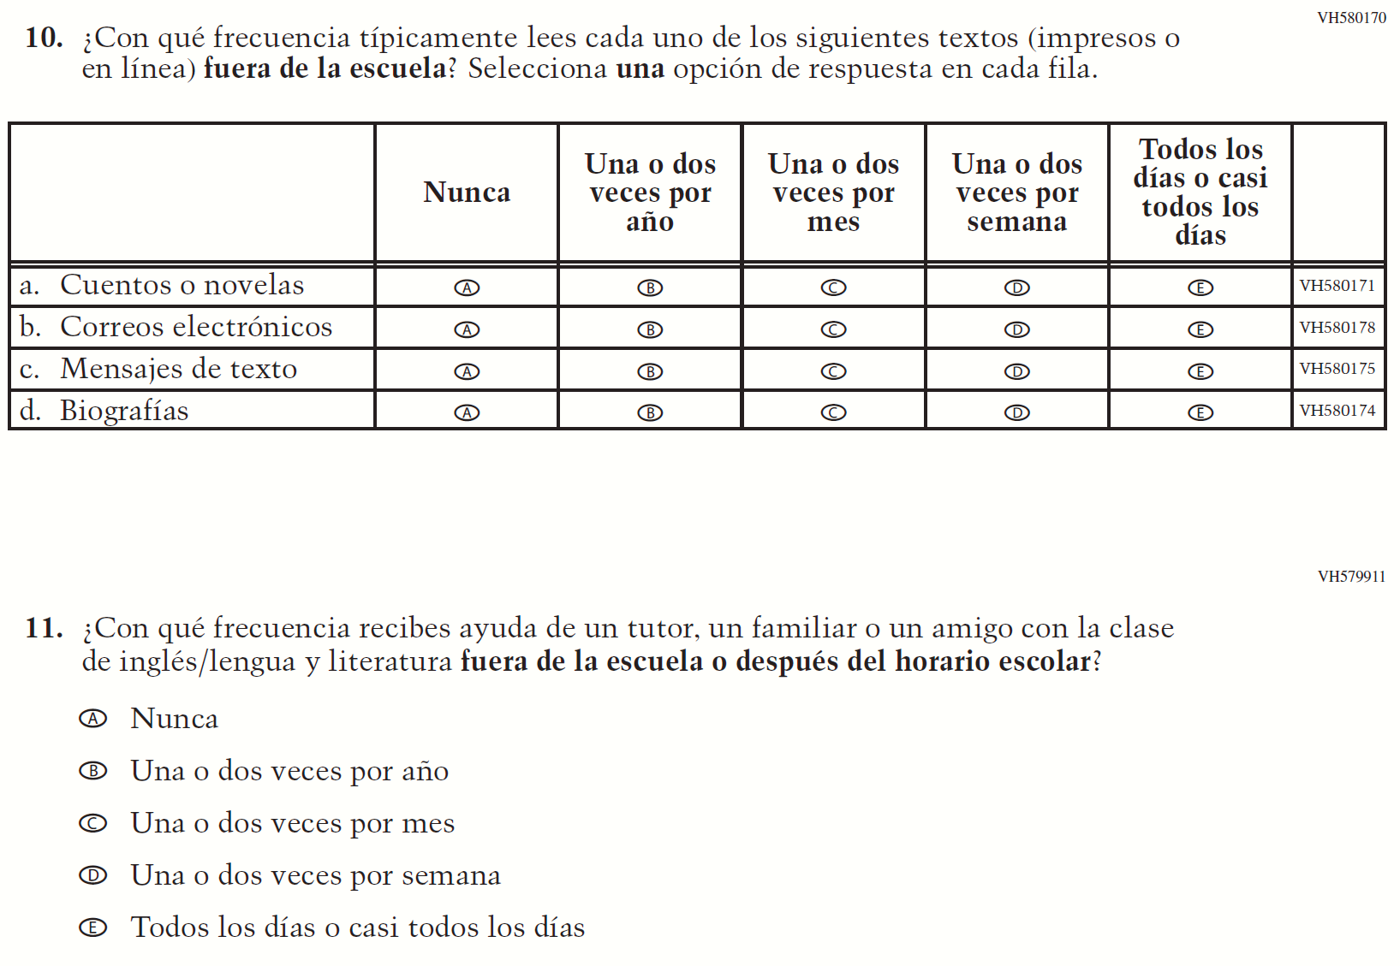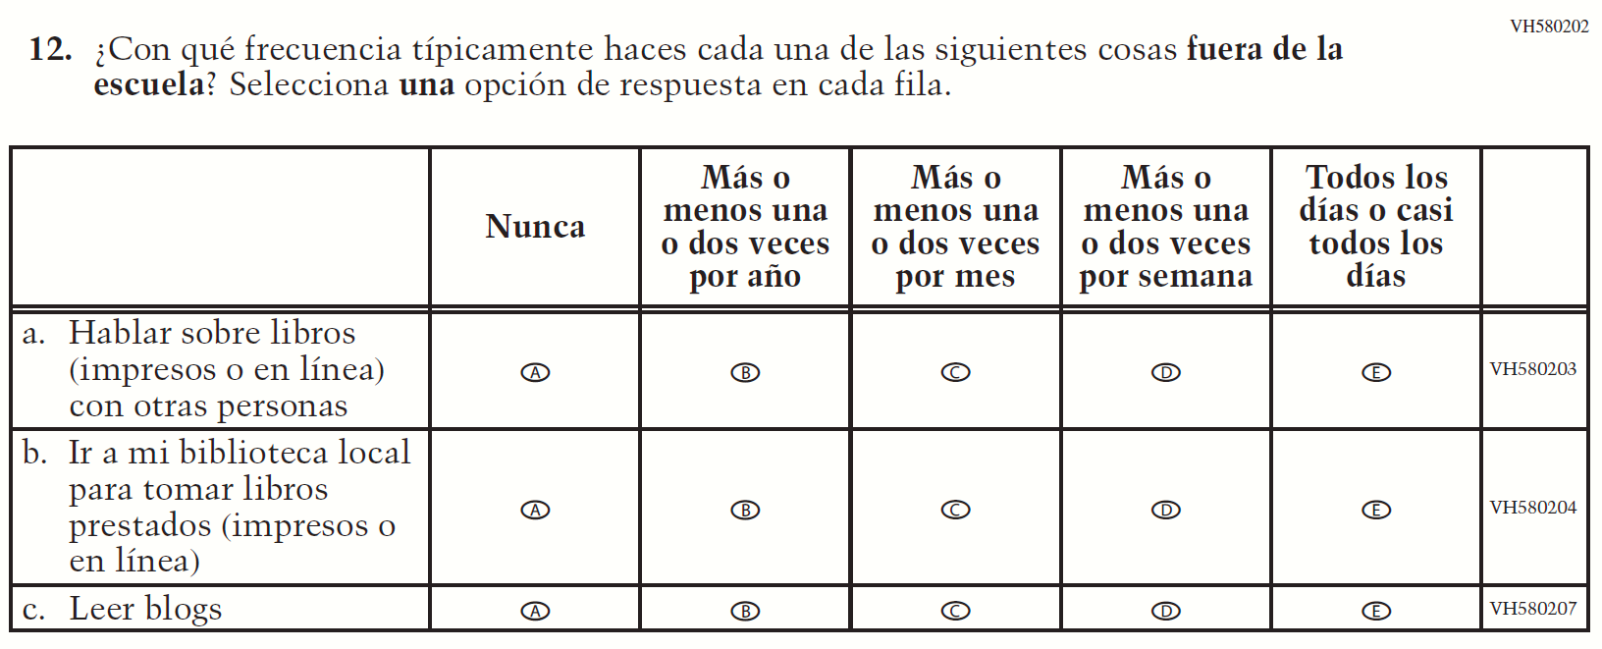

Appendix J-1k-s-BL: Operational Grade 8 Civics
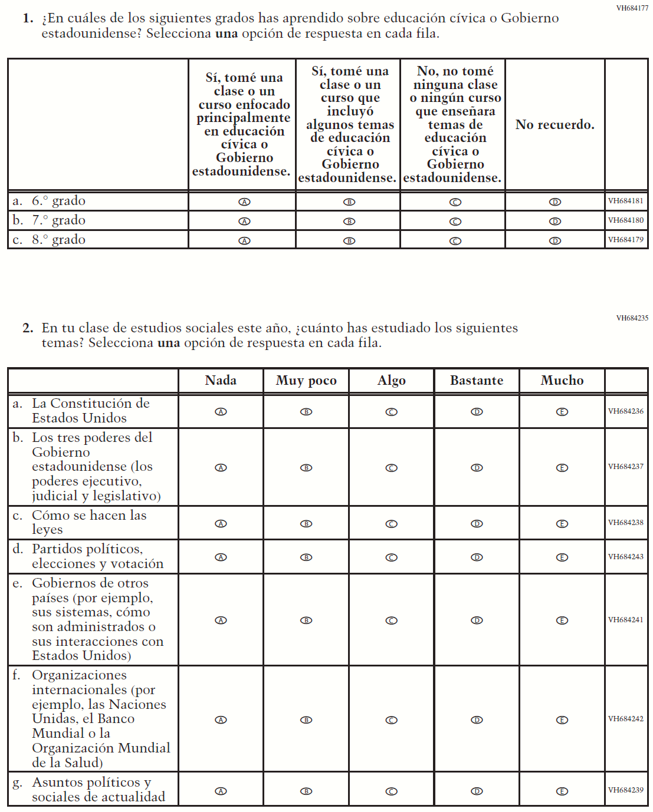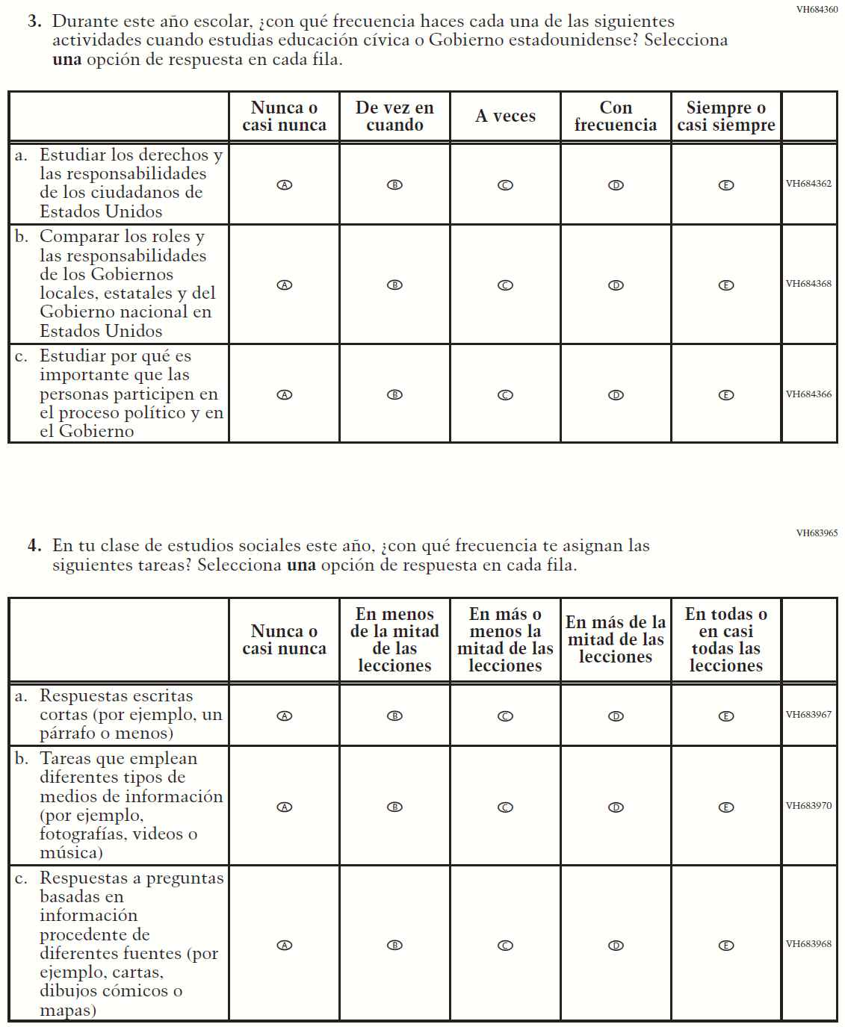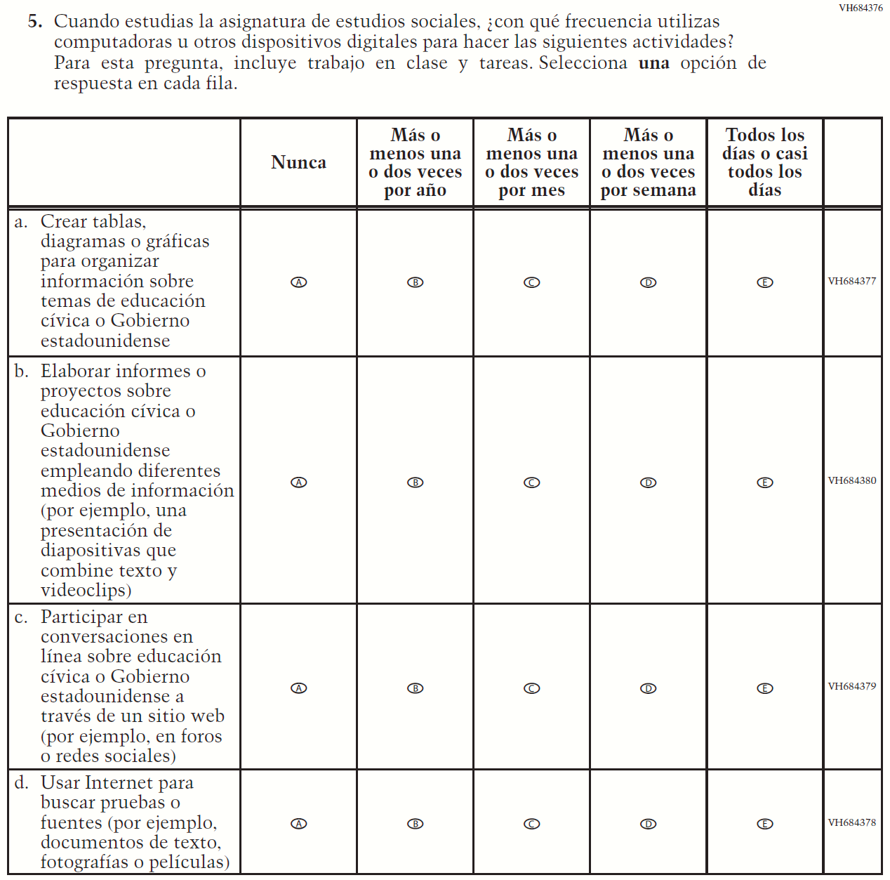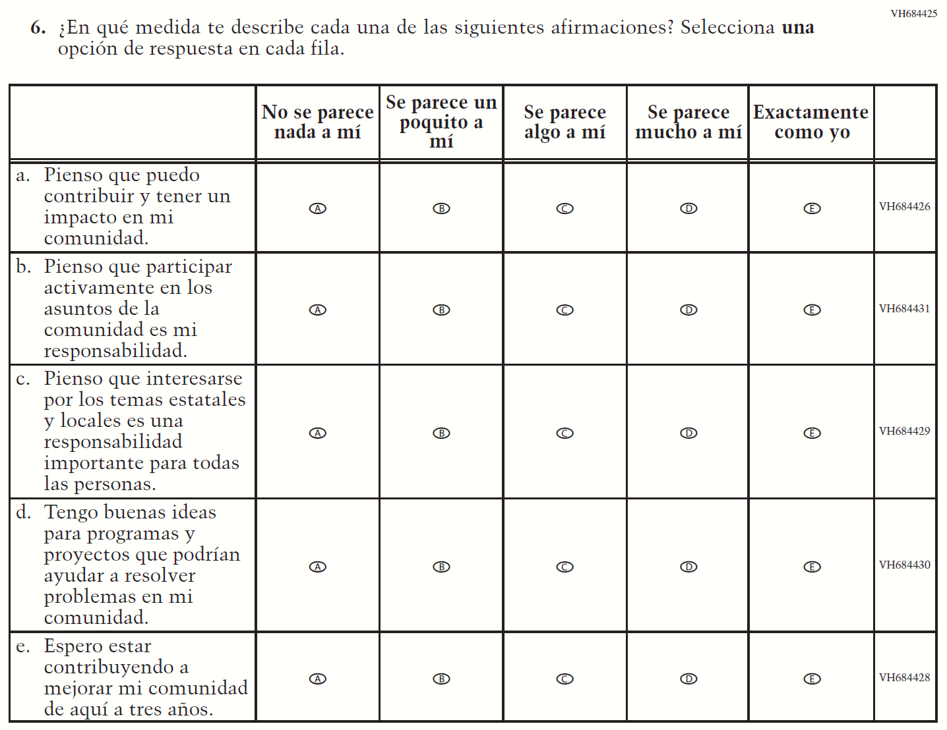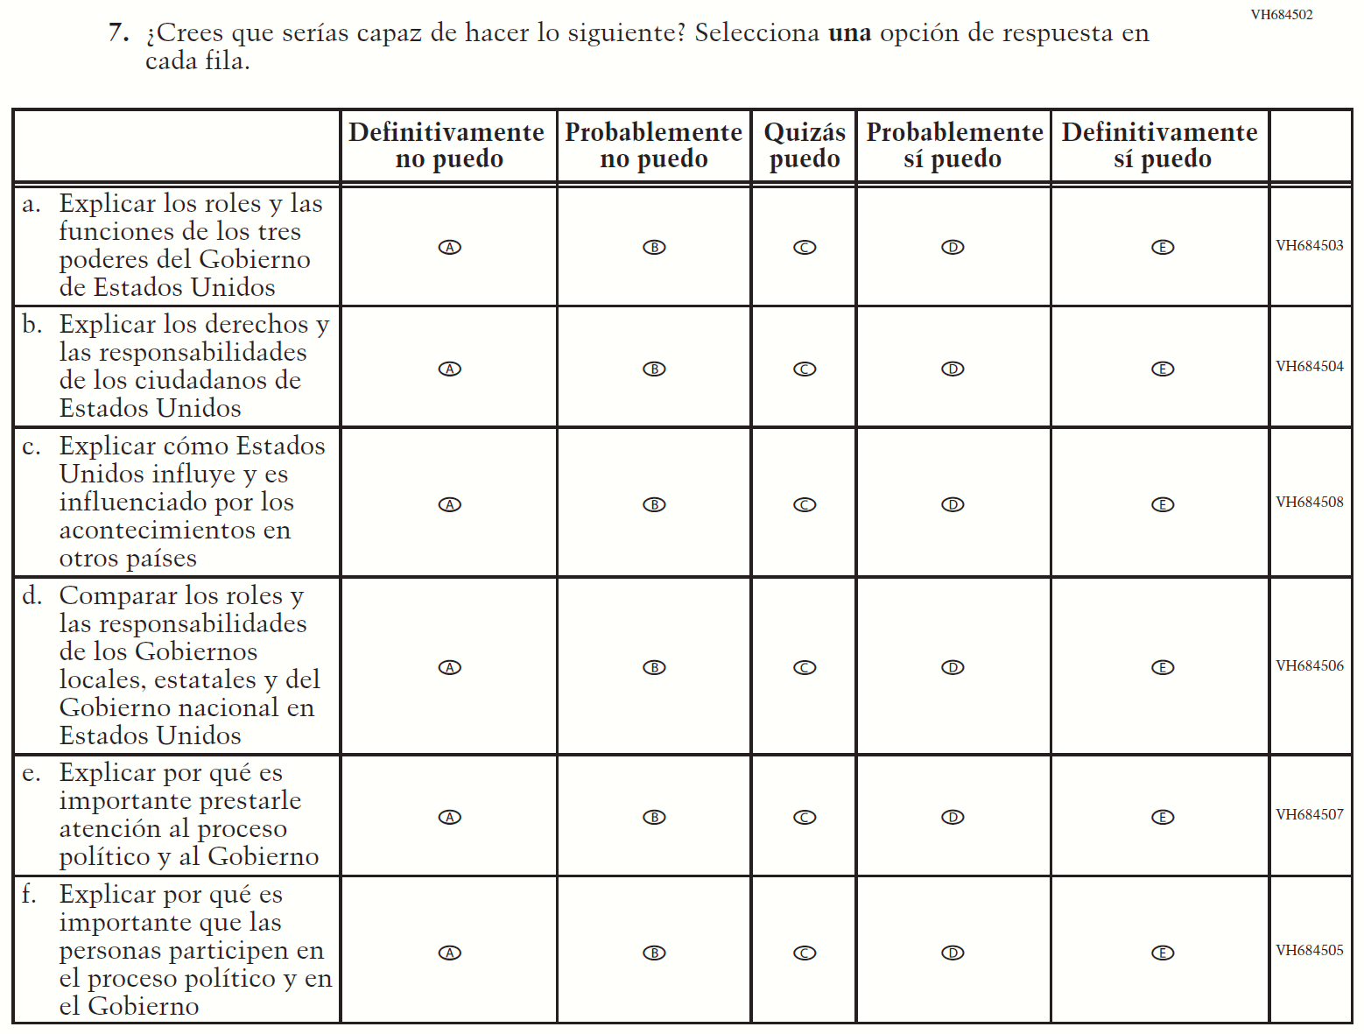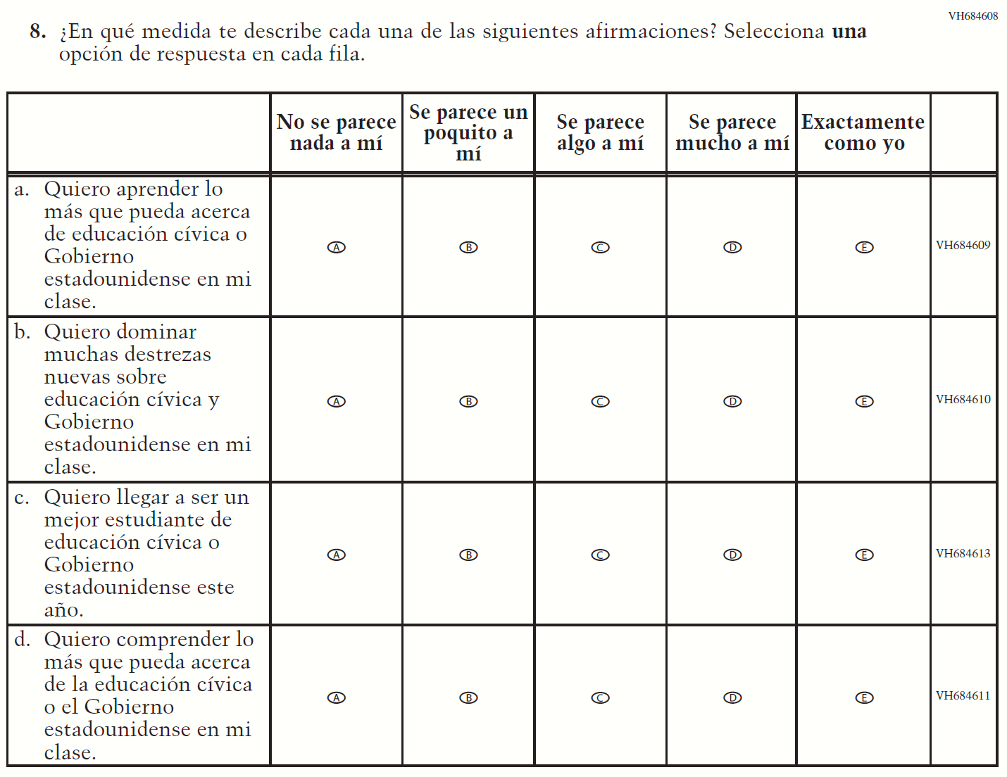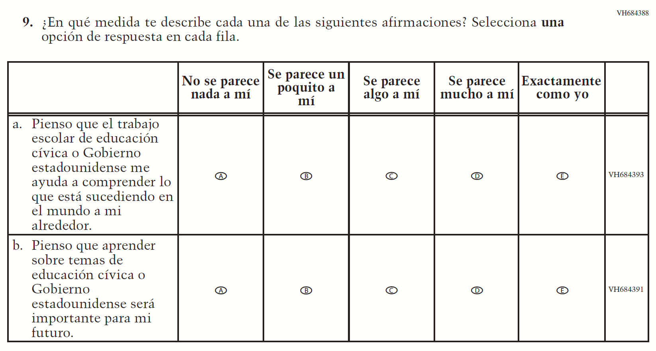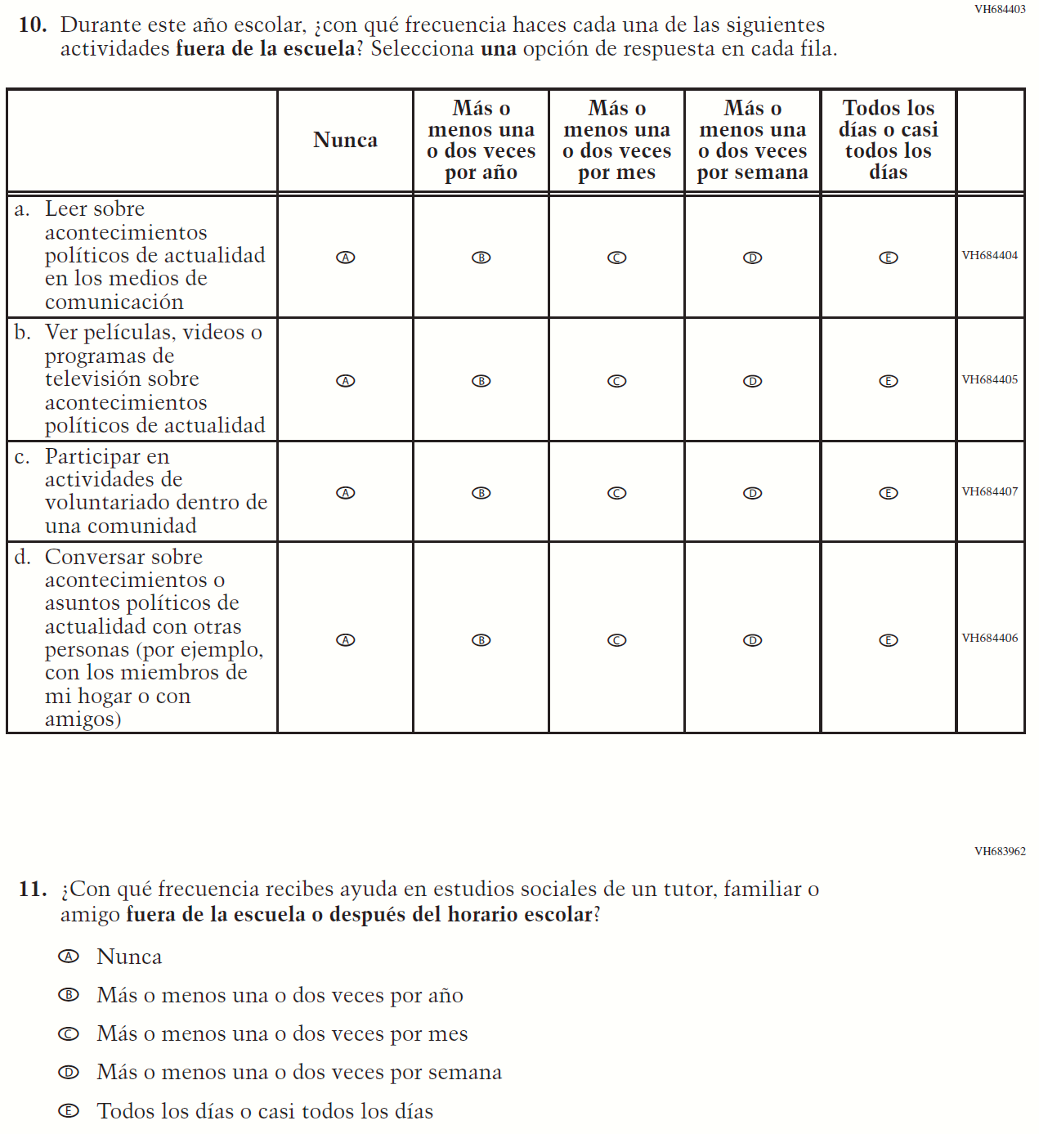

Appendix J-1l-s-BL: Operational Grade 8 US History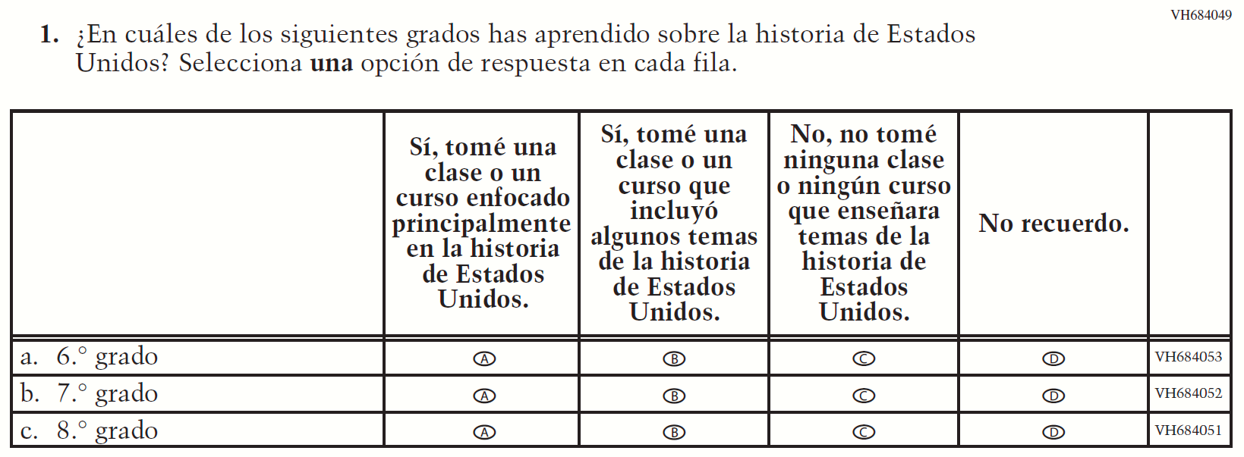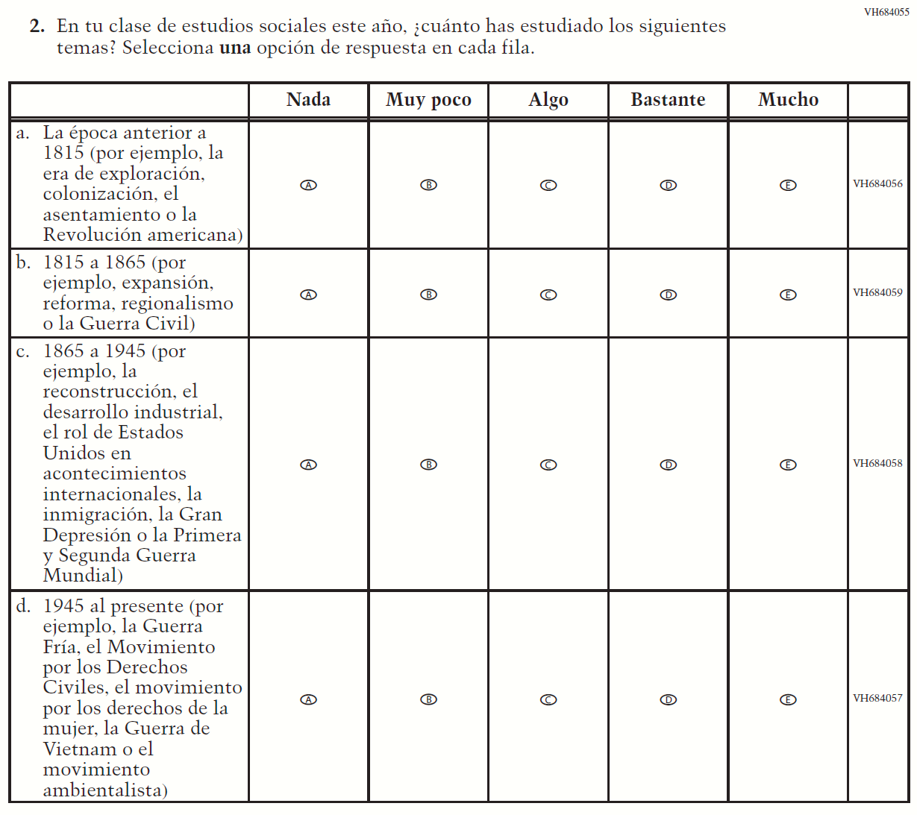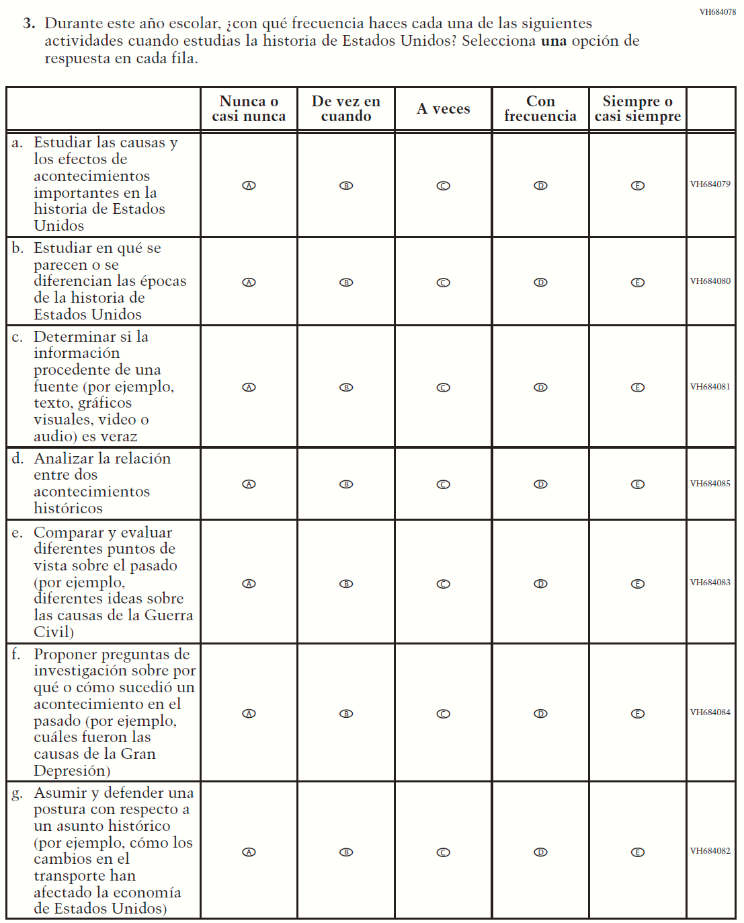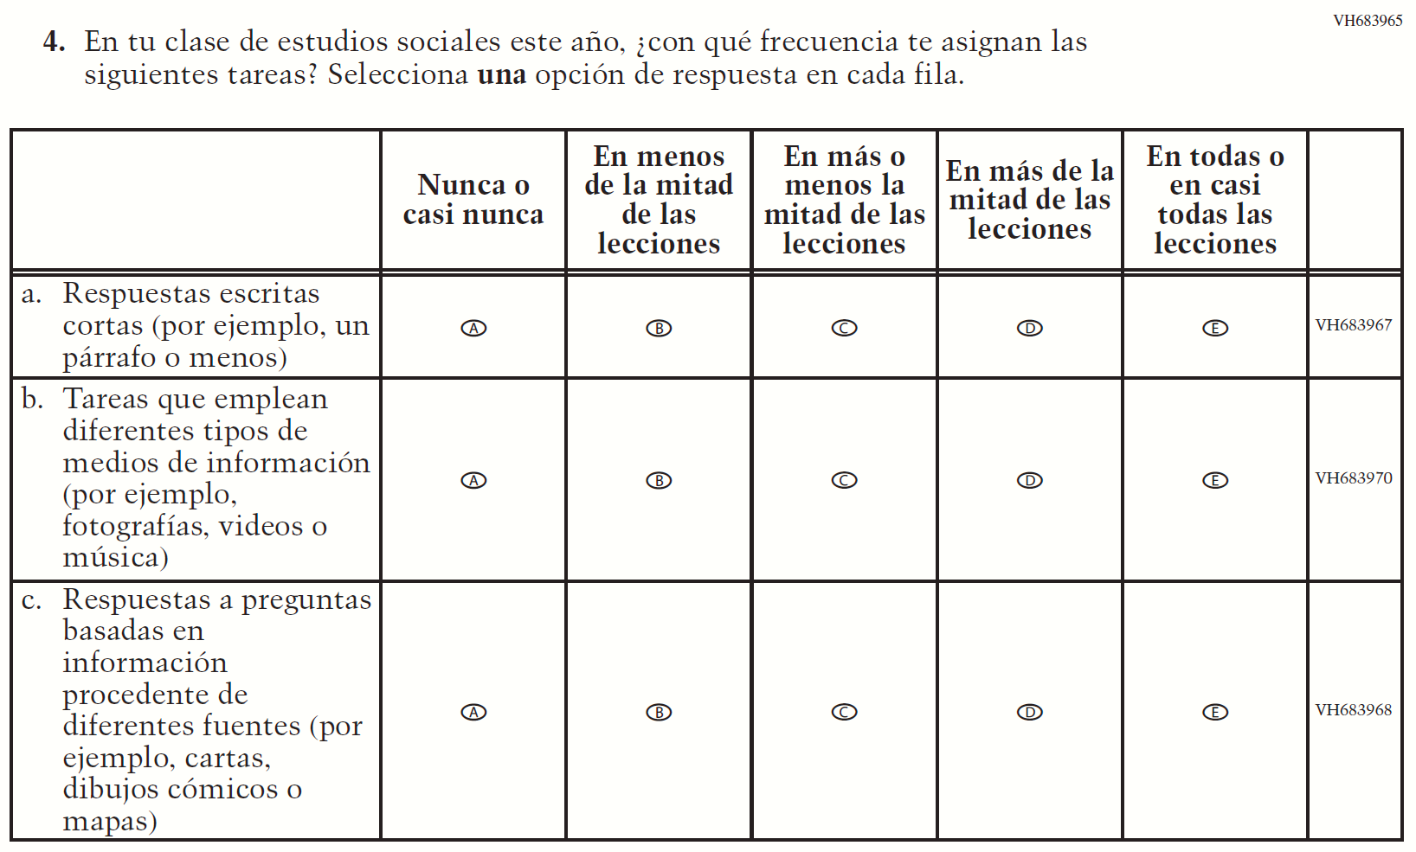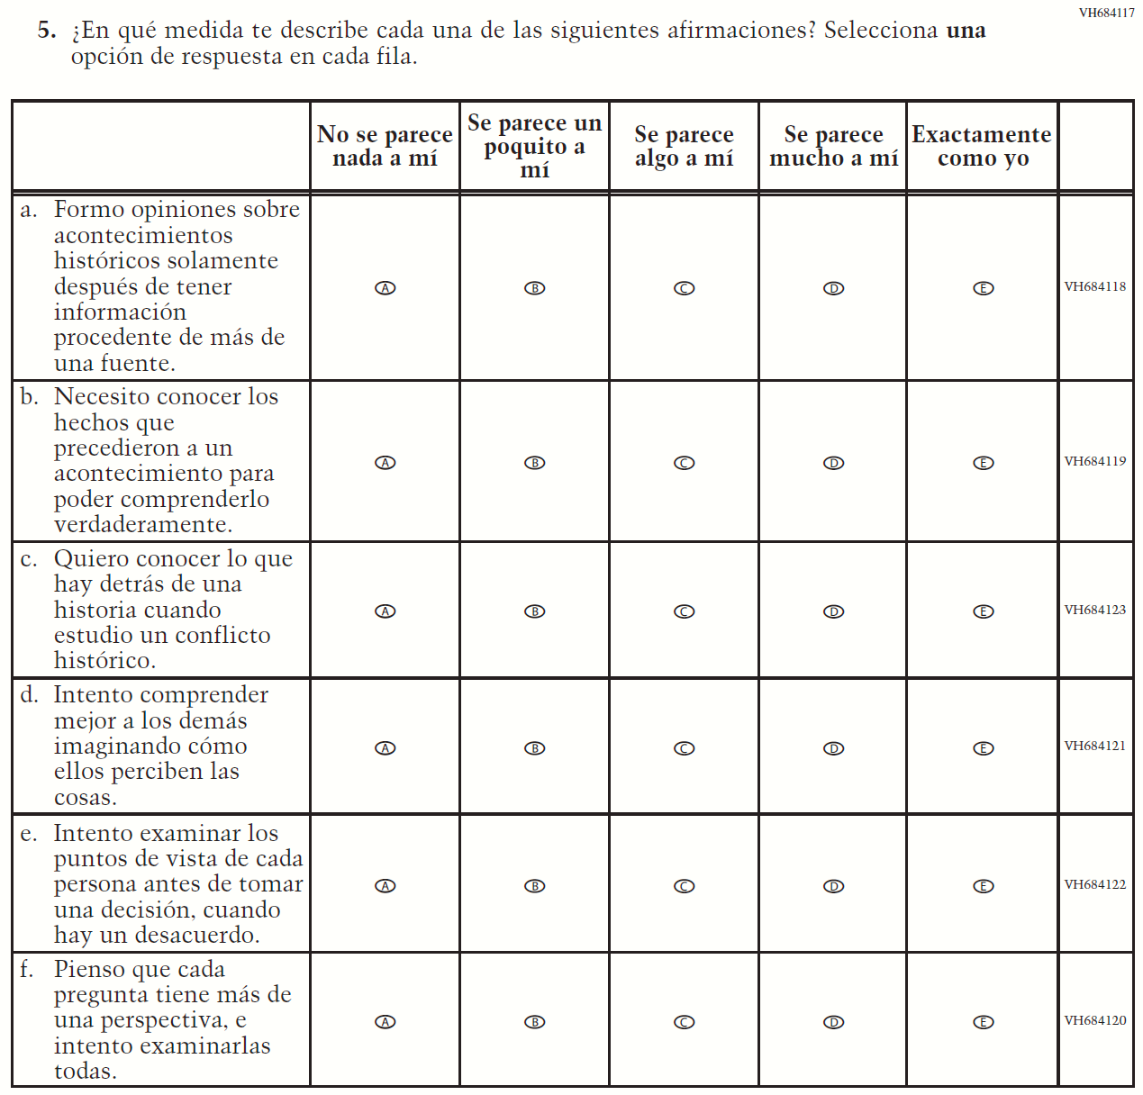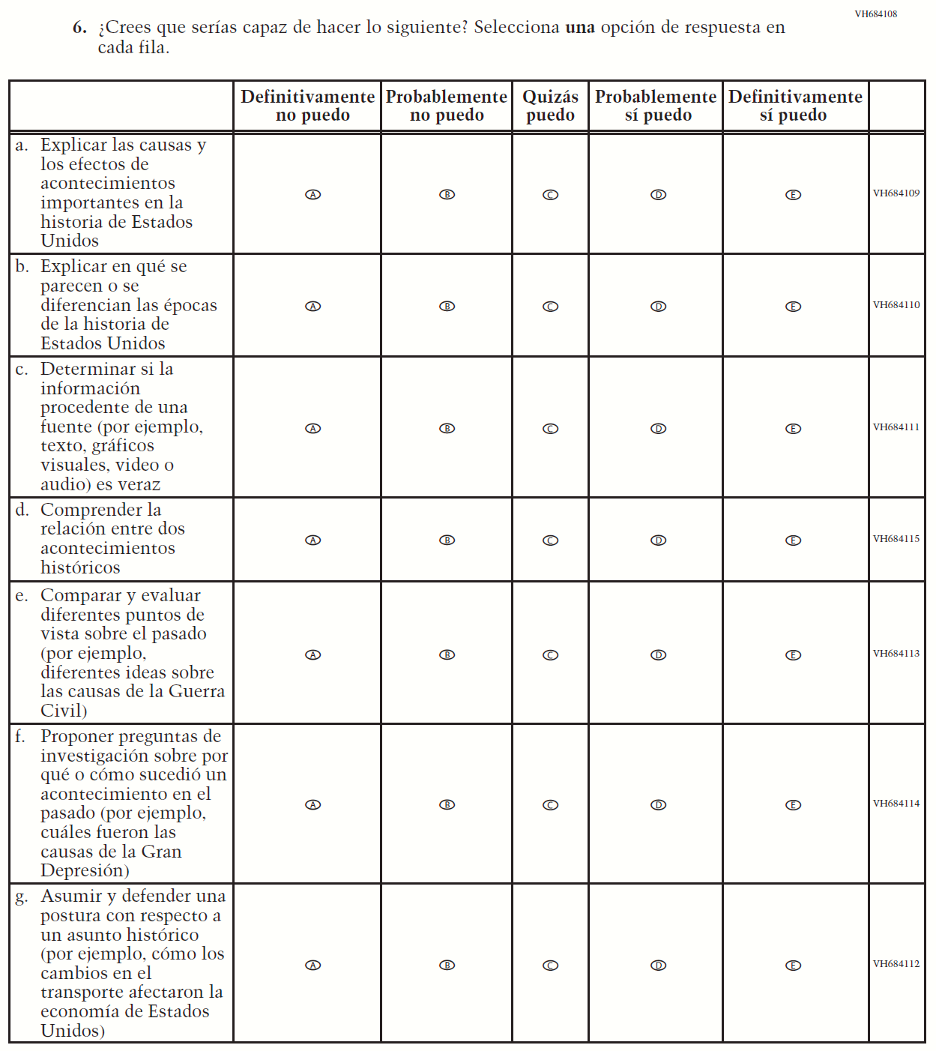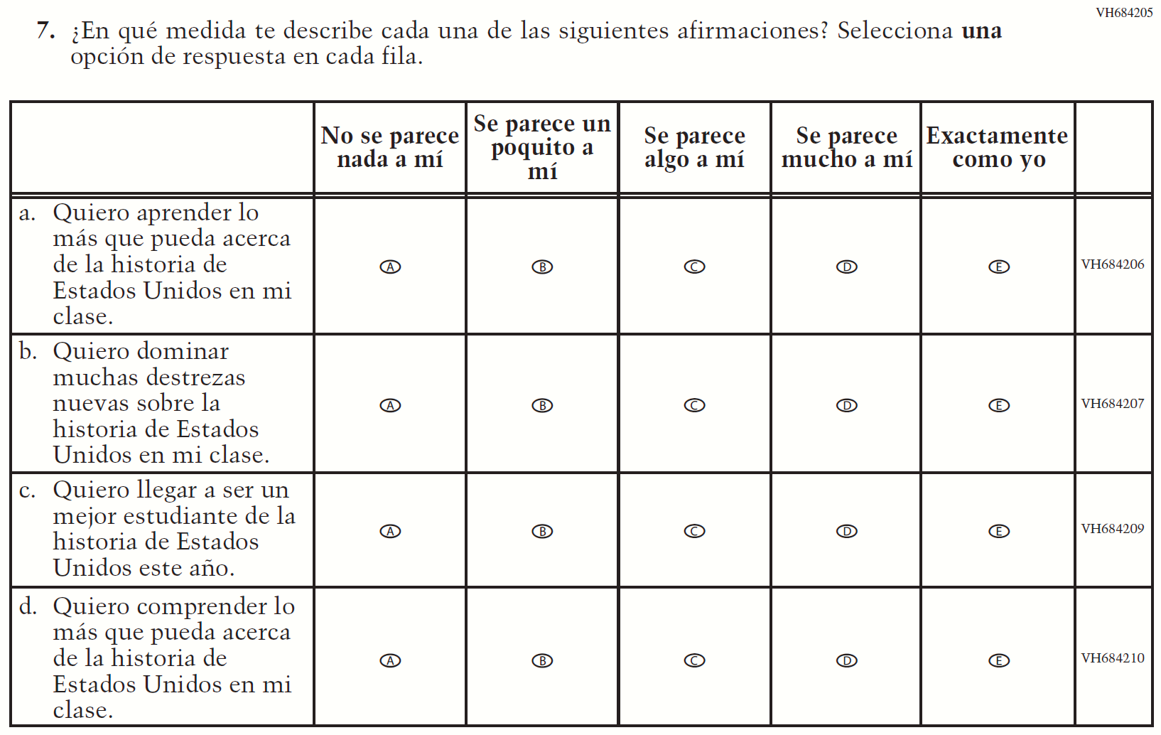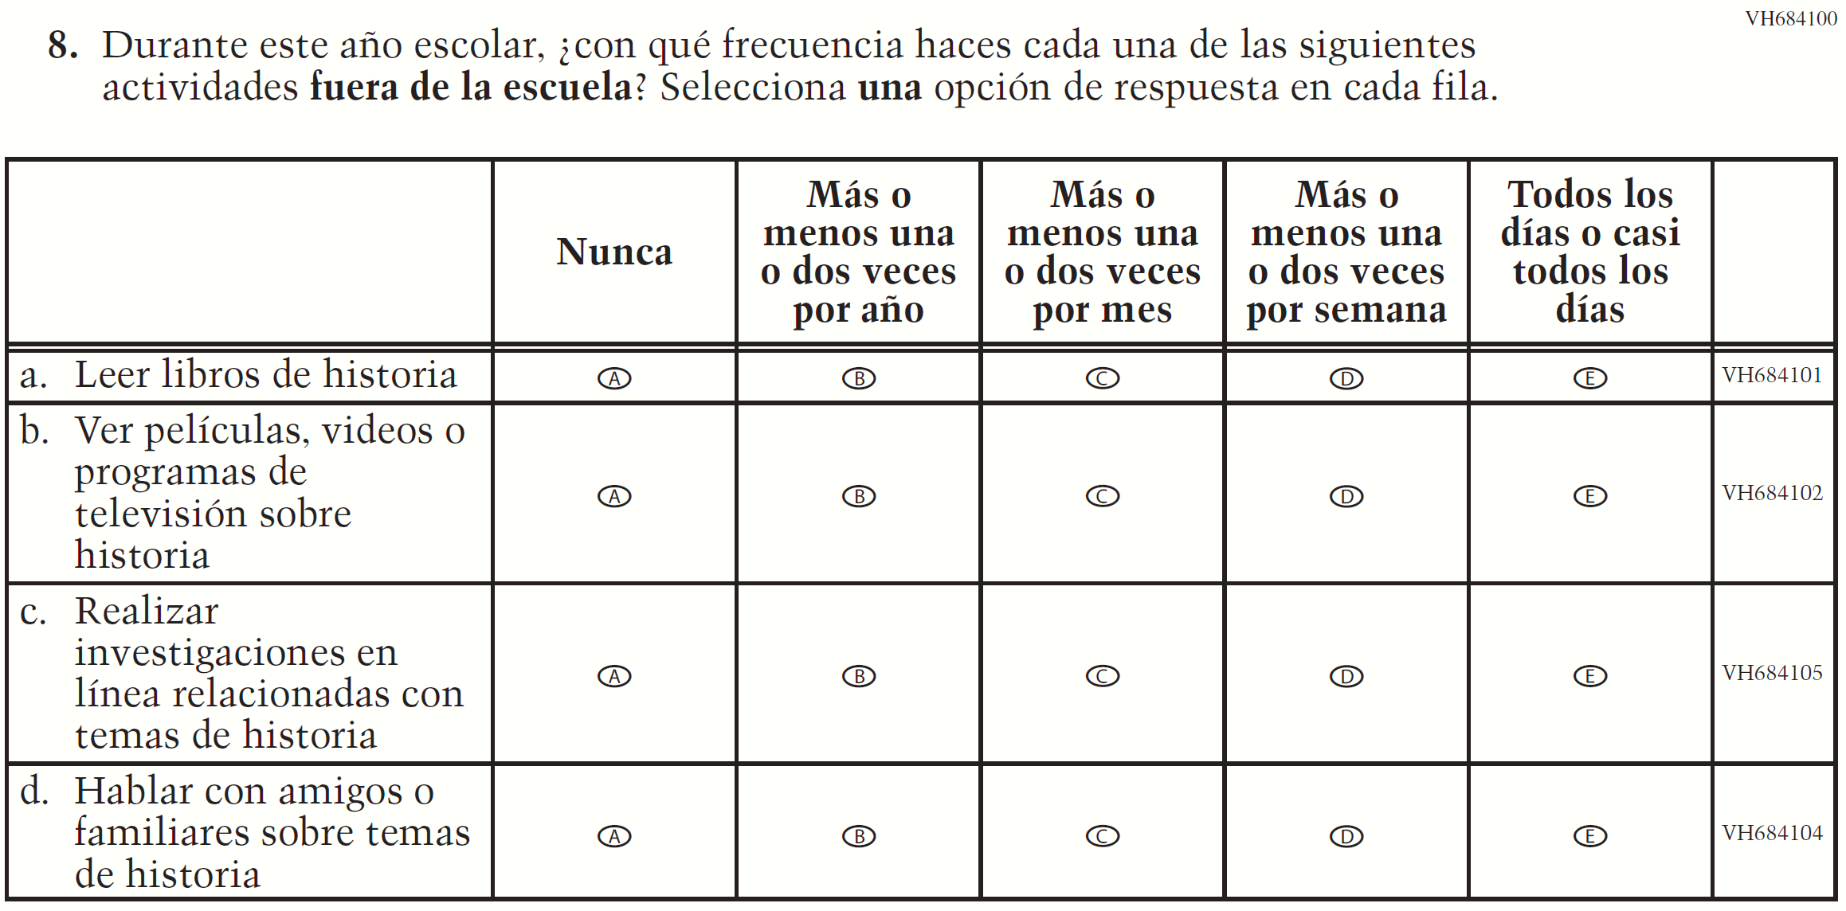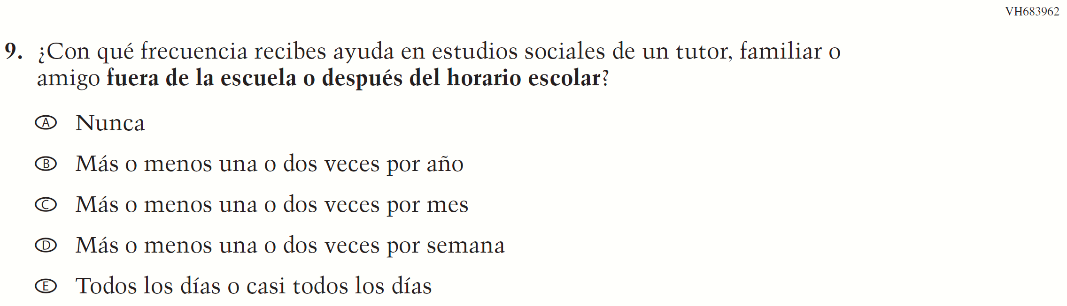

Appendix J-1m-s-BL: Summary of Operational Grade 4 Debrief
2021 Operational Grade 4 Debrief Student –Bilingual
Previous item | 2021 item | D/A/R/NC+ | Rationale
VH580900  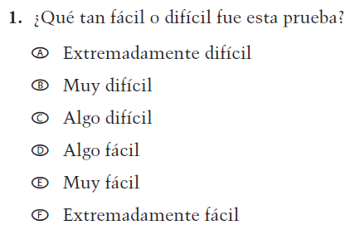  (2019 Operational Grade 4 and 8 Student Debrief- Bilingual) | N/A | D | To keep student burden low, this item was dropped.
VH580572  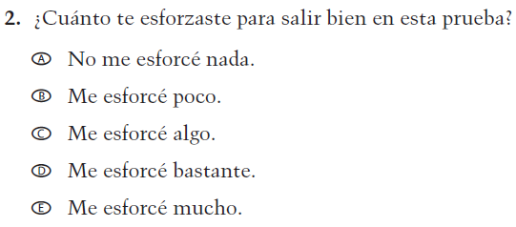  (2019 Operational Grade 4 and 8 Student Debrief- Bilingual) | VH580572  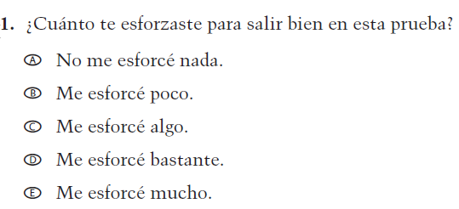  Issue: Debrief | NC | N/A

Appendix J-1m-s-BL: Operational Grade 4 Debrief
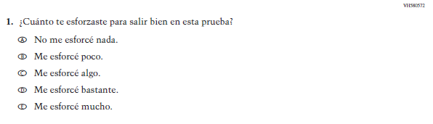

Appendix J-1n-s-PR: Summary of Operational Grade 4 Debrief
2021 Operational Grade 4 Debrief Student – Puerto Rico

Previous item | 2021 item | D/A/ R/NC+ | Rationale
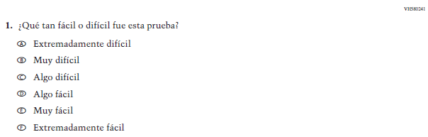  (2019 Operational Grade 4 and 8 Student Debrief – Puerto Rico) | N/A | D | To keep student burden low, this item was dropped.
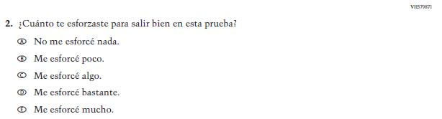  (2019 Operational Grade 4 and 8 Student Debrief – Puerto Rico) | 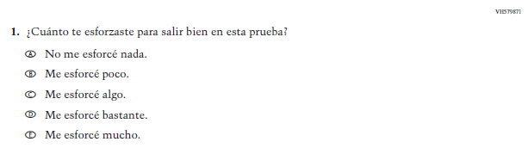  Issue: Debrief | NC | N/A

Appendix J-1n-s-PR: Operational Grade 4 Debrief
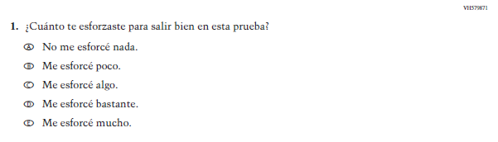

Appendix J-1o-s-BL: Summary of Operational Grade 8 Debrief
2021 Operational Grade 8 Debrief Student – Bilingual
Previous item | 2021 item | D/A/R/NC+ | Rationale
VH580900  (2019 Operational Grade 4 and 8 Student Debrief- Bilingual) | VH580900  Issue: Debrief | NC | N/A
VH580572  (2019 Operational Grade 4 and 8 Student Debrief- Bilingual) | VH580572  Issue: Debrief | NC | N/A

Appendix J-1o-s-BL: Operational Grade 8 Debrief
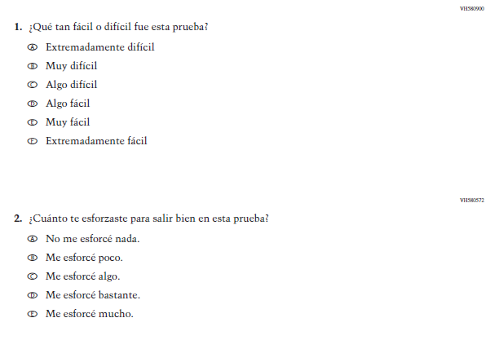

Appendix J-1p-s-PR: Summary of Operational Grade 8 Debrief
2021 Operational Grade 8 Debrief Student – Puerto Rico

Previous item | 2021 item | D/A/ R/NC+ | Rationale
(2019 Operational Grade 4 and 8 Student Debrief – Puerto Rico) | Issue: Debrief | NC | N/A
(2019 Operational Grade 4 and 8 Student Debrief – Puerto Rico) | Issue: Debrief | NC | N/A

Appendix J-1p-s-PR: Operational Grade 8 Debrief
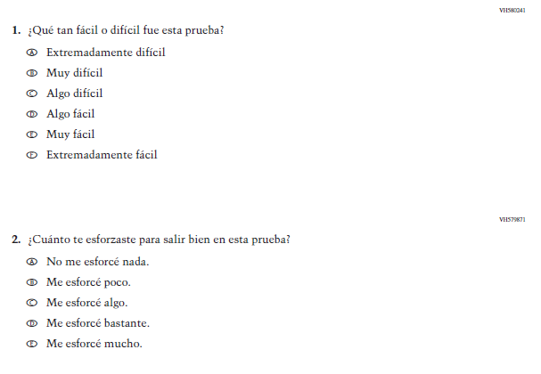

Teacher Login Screen

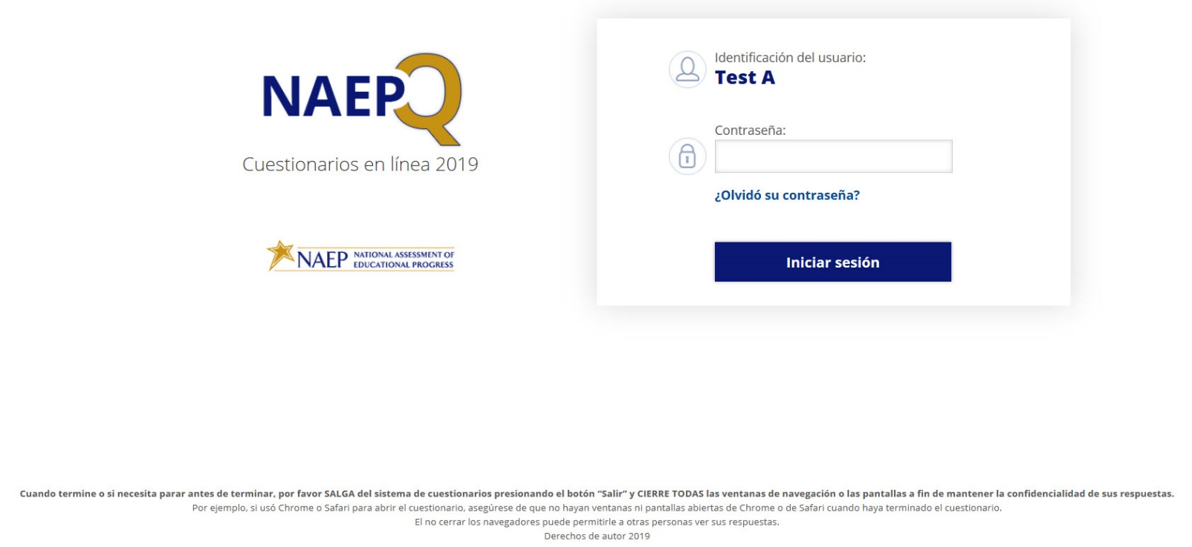
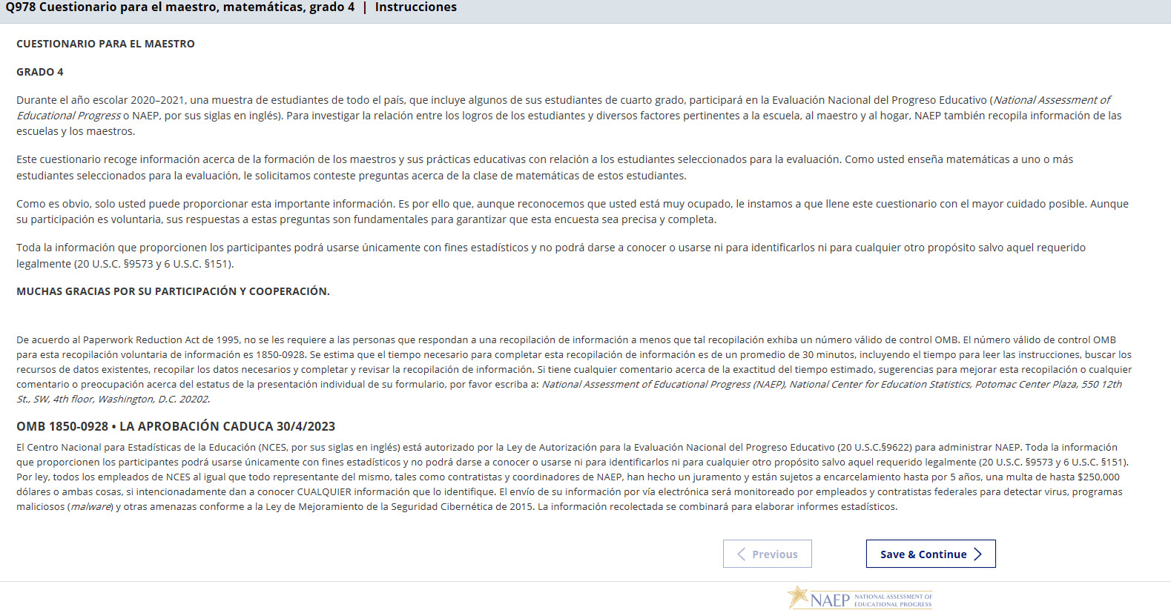
NOTE: The final version of the login screen was not available for this amendment and will be included in Amendment 2 scheduled to be submitted in October 2020. The OMB text will be revised with the updated language below.
De acuerdo al Paperwork Reduction Act de 1995, no se les requiere a las personas que respondan a una recopilación de información a menos que tal recopilación exhiba un número válido de control OMB. El número válido de control OMB para esta recopilación voluntaria de información es 1850-0928. Se estima que el tiempo necesario para completar esta recopilación de información es de un promedio de 30 minutos, incluyendo el tiempo para leer las instrucciones, buscar los recursos de datos existentes, recopilar los datos necesarios y completar y revisar la recopilación de información. Si tiene cualquier comentario acerca de la exactitud del tiempo estimado, sugerencias para mejorar esta recopilación o cualquier comentario o preocupación acerca del estatus de la presentación individual de su formulario, por favor escriba a: National Assessment of Educational Progress (NAEP), National Center for Education Statistics, Potomac Center Plaza, 550 12th St., SW, 4th floor, Washington, D.C. 20202.
OMB 1850-0928 • LA APROBACIÓN CADUCA 30/4/2023
El Centro Nacional para Estadísticas de la Educación (NCES, por sus siglas en inglés) está autorizado por la Ley de Autorización para la Evaluación Nacional del Progreso Educativo (20 U.S.C.§9622) para administrar NAEP y para administrar NAEP y para recopilar los expedientes educativos de los estudiantes de agencias o instituciones educativas con el propósito de evaluar programas de educación apoyados por el gobierno federal conforme a la Ley de Derechos Educativos y Privacidad Familiar (FERPA, por sus siglas en inglés; 34 CFR §§ 99.31(a)(3)(iii) y 99.35). Toda la información que proporcionen los participantes podrá usarse únicamente con fines estadísticos y no podrá darse a conocer o usarse ni para identificarlos ni para cualquier otro propósito salvo aquel requerido legalmente (20 U.S.C. §9573 y 6 U.S.C. §151). Por ley, todos los empleados de NCES al igual que todo representante del mismo, tales como contratistas y coordinadores de NAEP, han hecho un juramento y están sujetos a encarcelamiento hasta por 5 años, una multa de hasta $250,000 dólares o ambas cosas, si intencionadamente dan a conocer CUALQUIER información que lo identifique. El envío de su información por vía electrónica será monitoreado por empleados y contratistas federales para detectar virus, programas maliciosos (malware) y otras amenazas conforme a la Ley de Mejoramiento de la Seguridad Cibernética de 2015. La información recolectada se combinará para elaborar informes estadísticos.

Appendix J-2-s: Spanish Translations of Teacher Questionnaires

Appendix J-2a-s-PR: Summary of Changes Operational Grade 4 CORE
2021 Operational Grade 4 Core Teacher – Puerto Rico
Previous item | 2021 item | D/A/R/NC+ | Rationale
VH835832  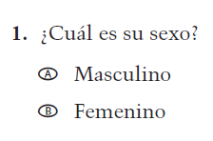  (2019 Operational Grade 4 Teacher Core – Puerto Rico) | VH835832  Issue: Gender | NC | N/A
VH319761  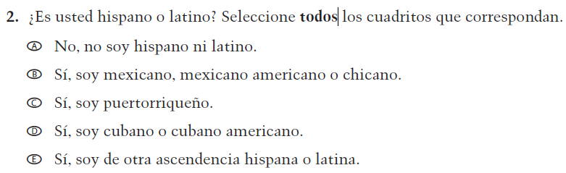  (2019 Operational Grade 4 Teacher Core – Puerto Rico) | VH319761  Issue: Race/Ethnicity | NC | N/A
VH319763  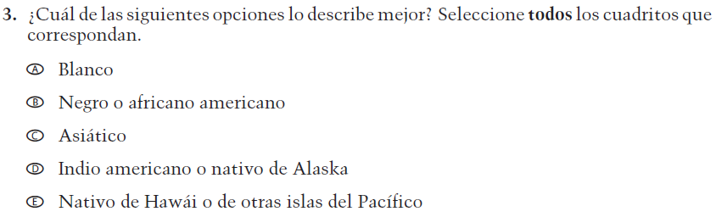  (2019 Operational Grade 4 Teacher Core – Puerto Rico) | VH319763  Issue: Race/Ethnicity | NC | N/A

2021 Operational Grade 4 Core Teacher – Puerto Rico
Previous item | 2021 item | D/A/R/NC+ | Rationale
VH319764  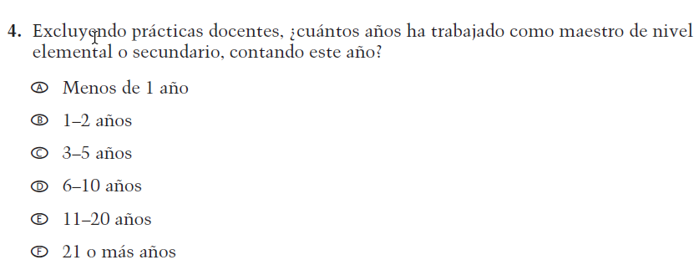  (2019 Operational Grade 4 Teacher Core – Puerto Rico) | VH319764  Issue: Teacher Preparation | NC | N/A
VH835831  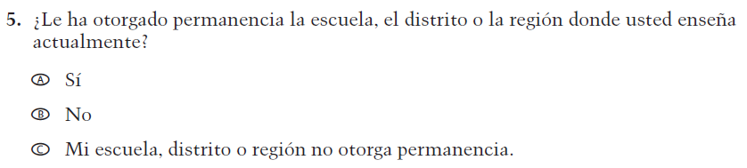  (2019 Operational Grade 4 Teacher Core – Puerto Rico) | VH835831  Issue: Teacher Preparation | NC | N/A
VH319767  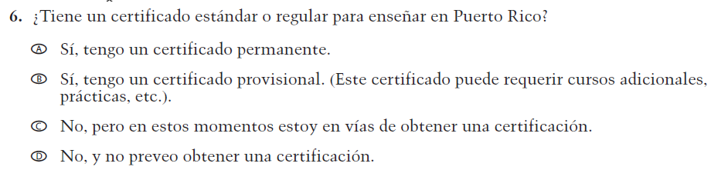  (2019 Operational Grade 4 Teacher Core – Puerto Rico) | VH319767  Issue: Teacher Preparation | NC | N/A

2021 Operational Grade 4 Core Teacher – Puerto Rico
Previous item | 2021 item | D/A/R/NC+ | Rationale
VH319769  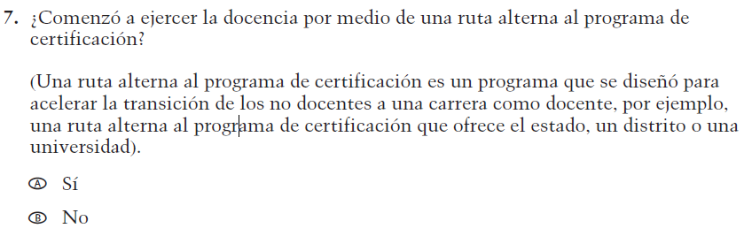  (2019 Operational Grade 4 Teacher Core – Puerto Rico) | VH319769  Issue: Teacher Preparation | NC | N/A
VH319773  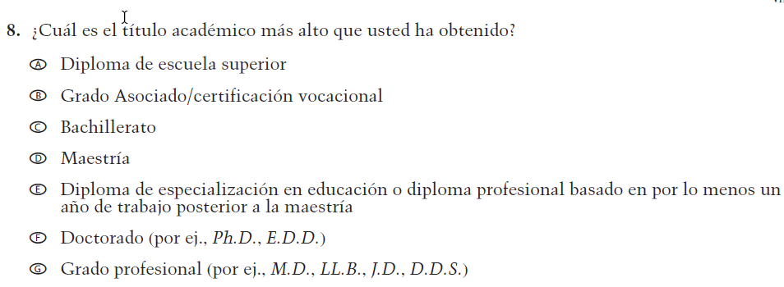  (2019 Operational Grade 4 Teacher Core – Puerto Rico) | VH319773  Issue: Teacher Preparation | NC | N/A
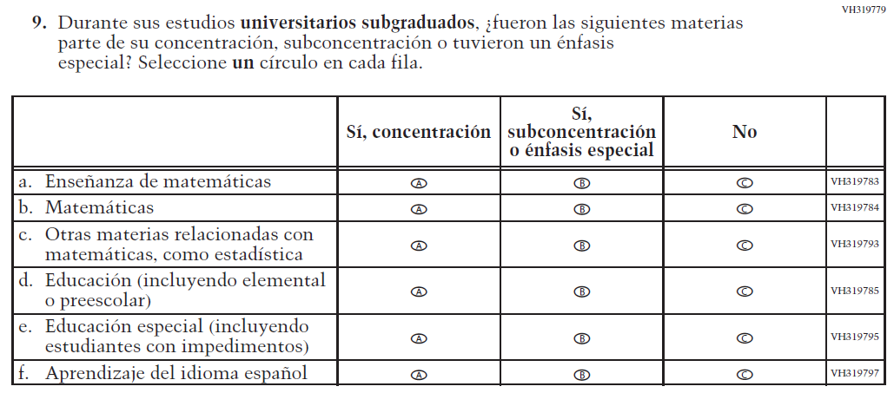  (2019 Operational Grade 4 Teacher Core – Puerto Rico) | Issue: Teacher Preparation | NC | N/A

2021 Operational Grade 4 Core Teacher – Puerto Rico
Previous item | 2021 item | D/A/R/NC+ | Rationale
VH319827  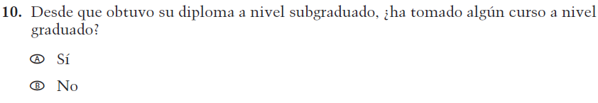  (2019 Operational Grade 4 Teacher Core – Puerto Rico) | VH319827  Issue: Teacher Preparation | NC | N/A
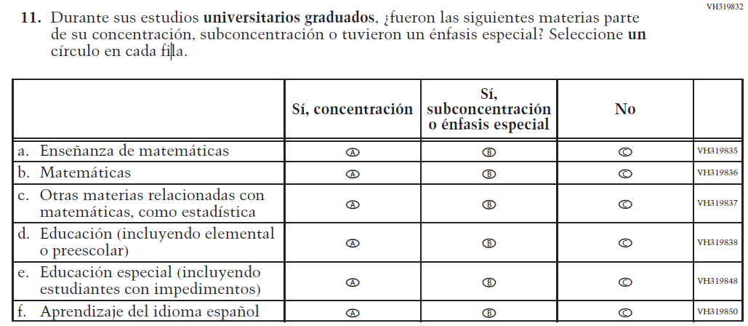  (2019 Operational Grade 4 Teacher Core – Puerto Rico) | Issue: Teacher Preparation | NC | N/A
VH579698  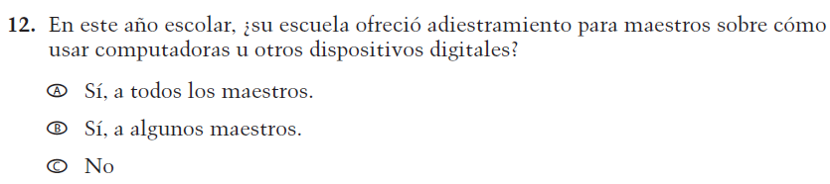  (2019 Operational Grade 4 Teacher Core – Puerto Rico) | VH579698  Issue: Technology Use | NC | N/A

2021 Operational Grade 4 Core Teacher – Puerto Rico
Previous item | 2021 item | D/A/R/NC+ | Rationale
VH579699  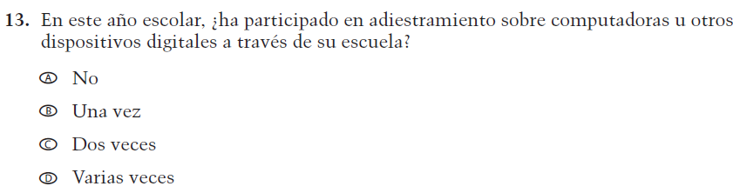  (2019 Operational Grade 4 Teacher Core – Puerto Rico) | VH579699  Issue: Technology Use | NC | N/A
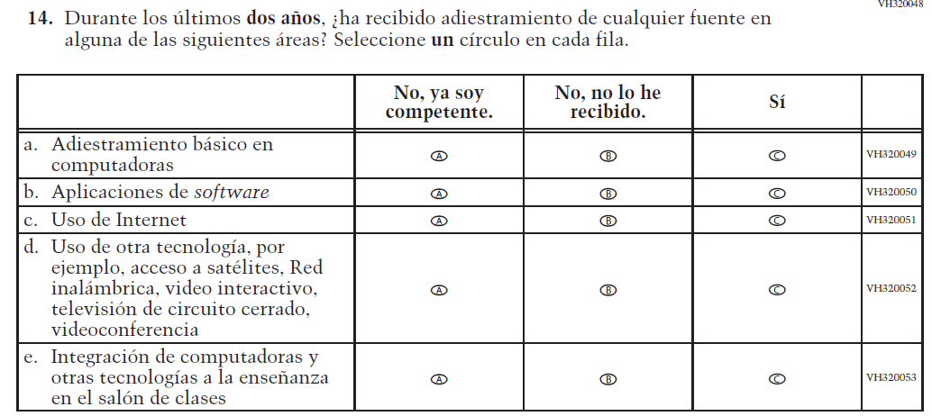  (2019 Operational Grade 4 Teacher Core – Puerto Rico) | Issue: Technology Use | NC | N/A
VH893860  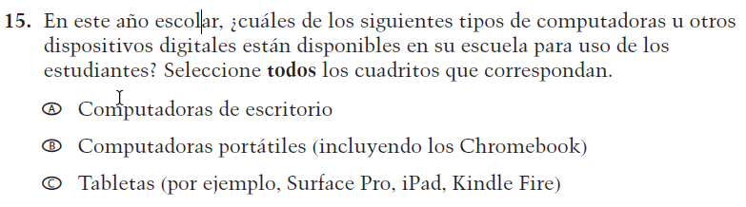  (2019 Operational Grade 4 Teacher Core – Puerto Rico) | VH893860  Issue: Technology Use | NC | N/A

2021 Operational Grade 4 Core Teacher – Puerto Rico
Previous item | 2021 item | D/A/R/NC+ | Rationale
VH579690  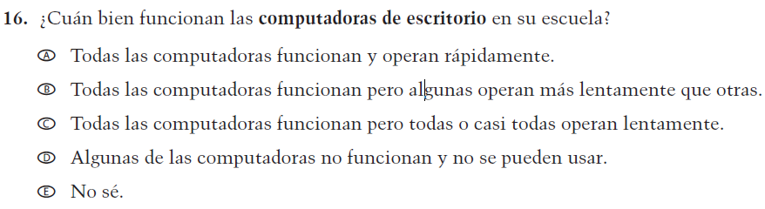  (2019 Operational Grade 4 Teacher Core – Puerto Rico) | VH579690  Issue: Technology Use | NC | N/A
VH579692  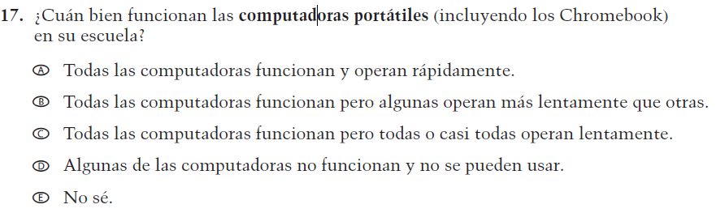  (2019 Operational Grade 4 Teacher Core – Puerto Rico) | VH579692  Issue: Technology Use | NC | N/A
VH579694  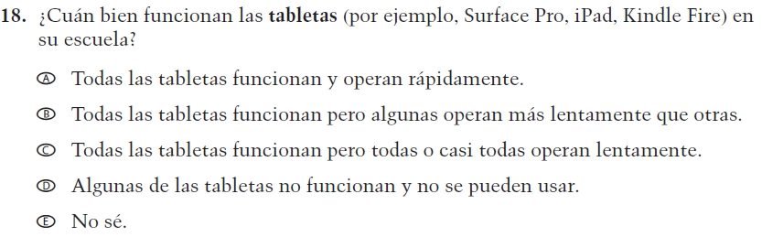  (2019 Operational Grade 4 Teacher Core – Puerto Rico) | VH579694  Issue: Technology Use | NC | N/A

2021 Operational Grade 4 Core Teacher – Puerto Rico
Previous item | 2021 item | D/A/R/NC+ | Rationale
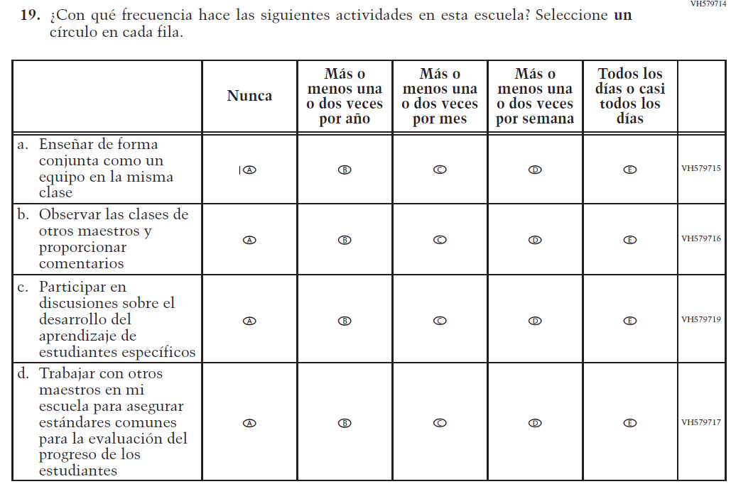  (2019 Operational Grade 4 Teacher Core – Puerto Rico) | Issue: School Climate | NC | N/A
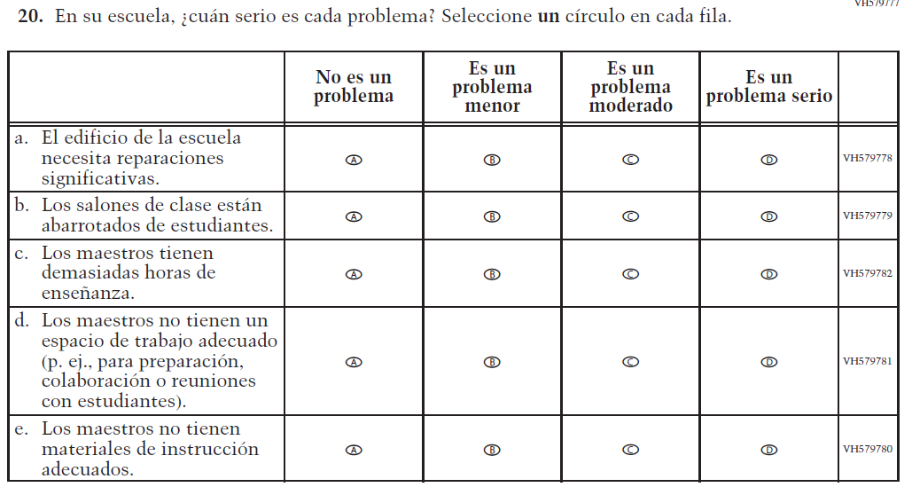  (2019 Operational Grade 4 Teacher Core – Puerto Rico) | Issue: School Climate | NC | N/A

2021 Operational Grade 4 Core Teacher – Puerto Rico
Previous item | 2021 item | D/A/R/NC+ | Rationale
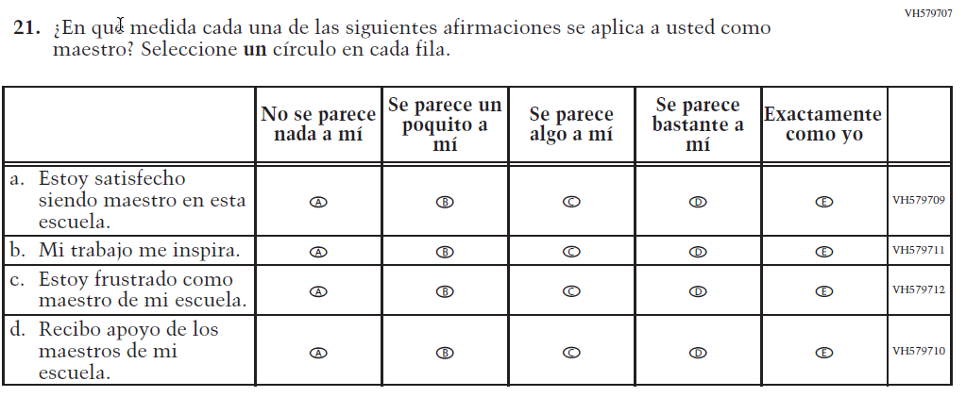  (2019 Operational Grade 4 Teacher Core – Puerto Rico) | Issue: School Climate | NC | N/A
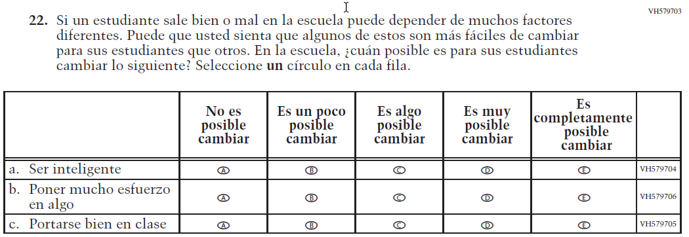  (2019 Operational Grade 4 Teacher Core – Puerto Rico) | Issue: School Climate | NC | N/A

Appendix J-2a-s-PR: Operational Grade 4 CORE
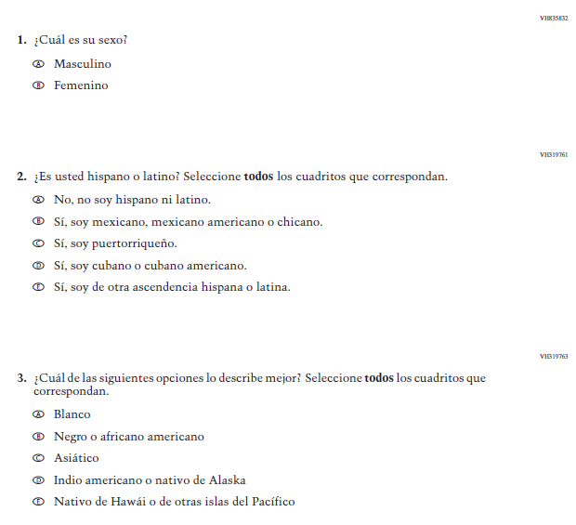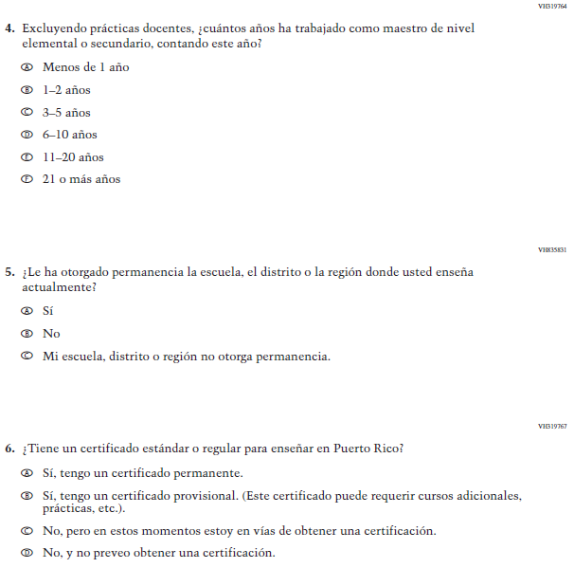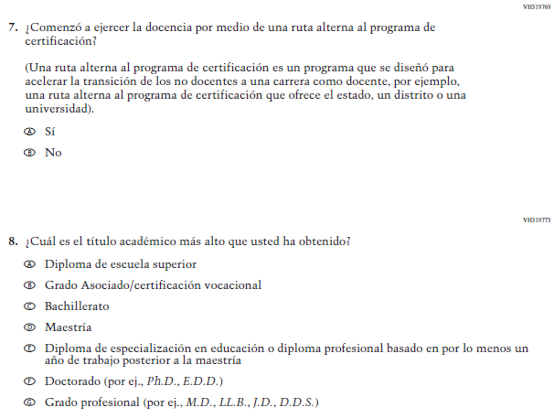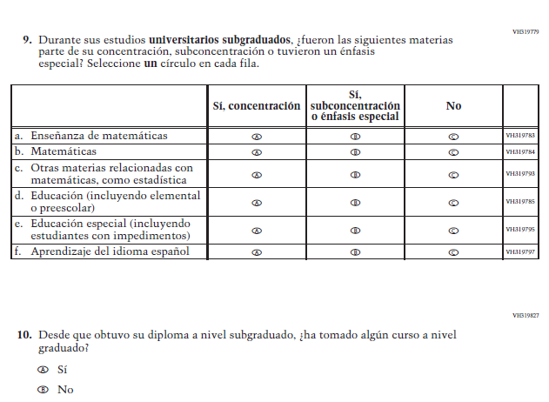
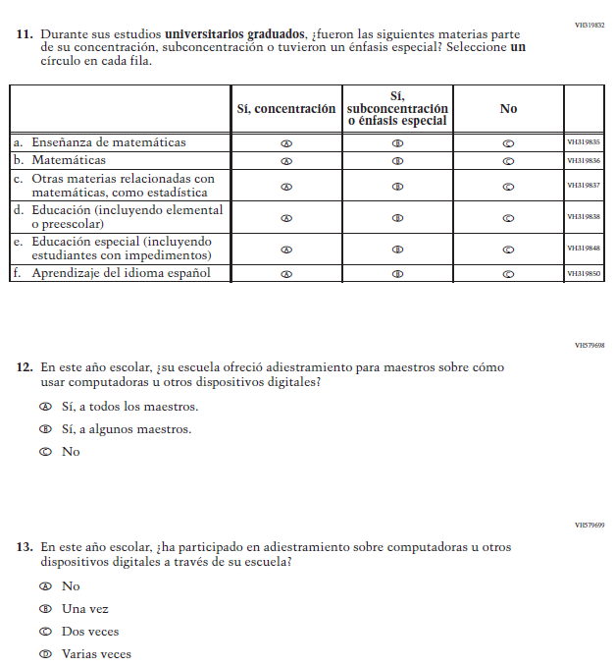
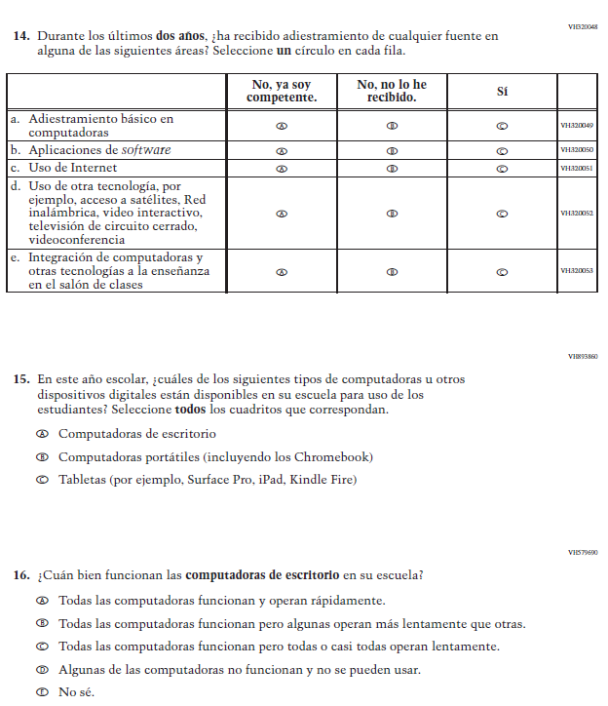
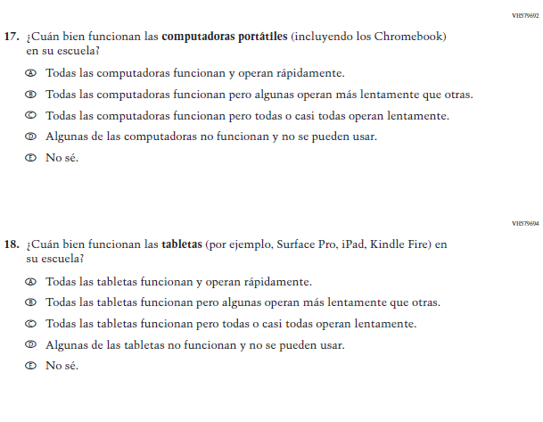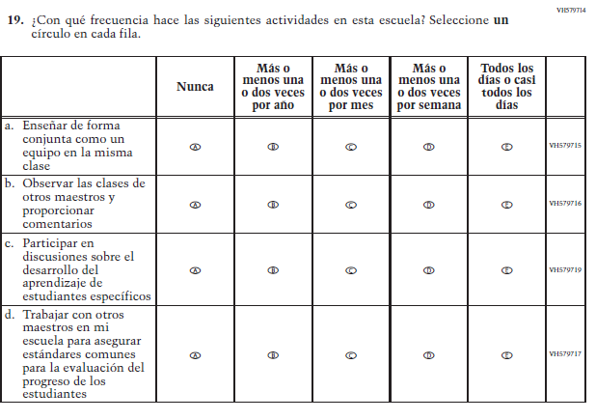
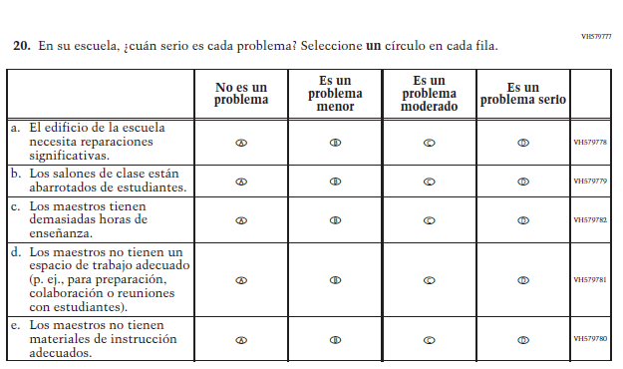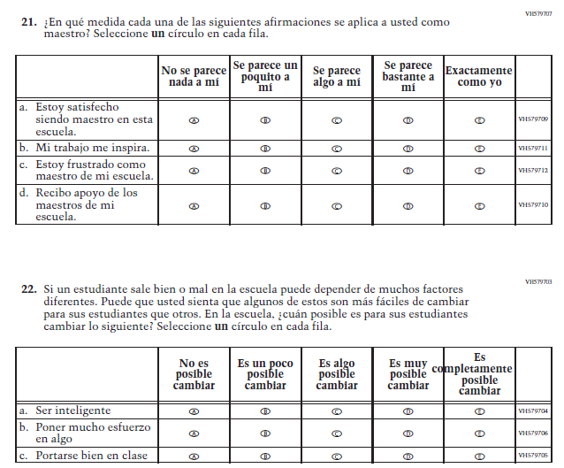

Appendix J-2b-s-PR: Summary of Changes Operational Grade 8 CORE
2021 Operational Grade 8 Core Teacher – Puerto Rico
Previous item | 2021 item | D/A/R/NC+ | Rationale
VH835832  (2019 Operational Grade 8 Teacher Core – Puerto Rico) | VH835832  Issue: Gender | NC | N/A
VH319761  (2019 Operational Grade 8 Teacher Core – Puerto Rico) | VH319761  Issue: Race/Ethnicity | NC | N/A
VH319763  (2019 Operational Grade 8 Teacher Core – Puerto Rico) | VH319763  Issue: Race/Ethnicity | NC | N/A

2021 Operational Grade 8 Core Teacher – Puerto Rico
Previous item | 2021 item | D/A/R/NC+ | Rationale
VH319764  (2019 Operational Grade 8 Teacher Core – Puerto Rico) | VH319764  Issue: Teacher Preparation | NC | N/A
VH319892  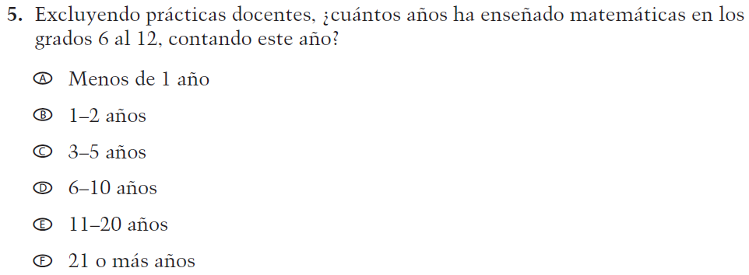  (2019 Operational Grade 8 Teacher Core – Puerto Rico) | VH319892  Issue: Teacher Preparation | NC | N/A
VH835831  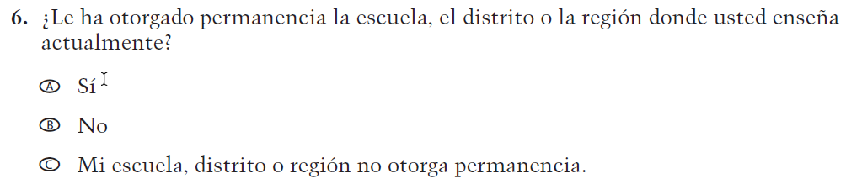  (2019 Operational Grade 8 Teacher Core – Puerto Rico) | VH835831  Issue: Teacher Preparation | NC | N/A

2021 Operational Grade 8 Core Teacher – Puerto Rico
Previous item | 2021 item | D/A/R/NC+ | Rationale
VH319767  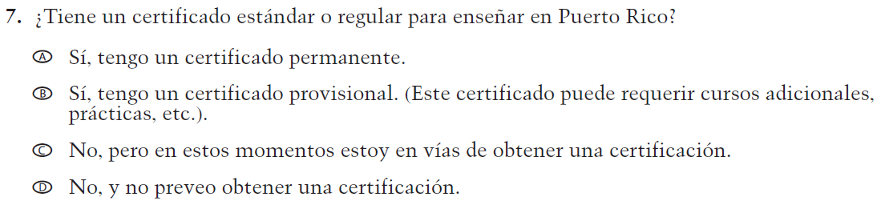  (2019 Operational Grade 8 Teacher Core – Puerto Rico) | VH319767  Issue: Teacher Preparation | NC | N/A
VH319769  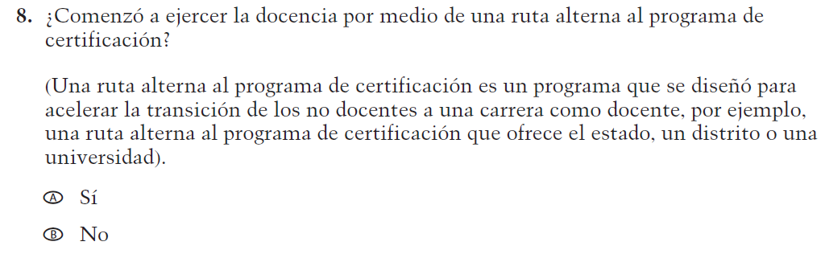  (2019 Operational Grade 8 Teacher Core – Puerto Rico) | VH319769  Issue: Teacher Preparation | NC | N/A
VH319773  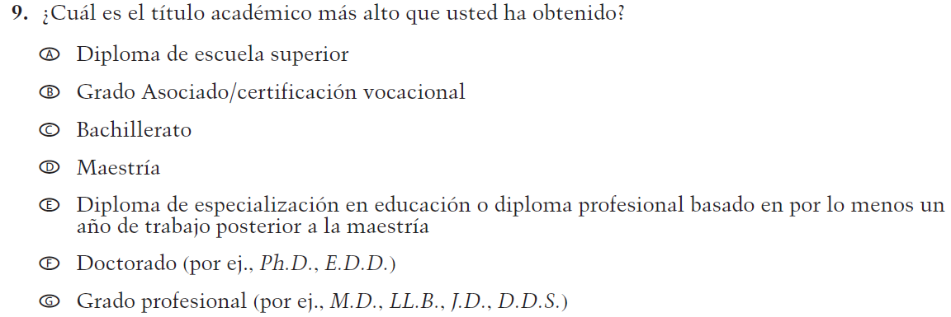  (2019 Operational Grade 8 Teacher Core – Puerto Rico) | VH319773  Issue: Teacher Preparation | NC | N/A

2021 Operational Grade 8 Core Teacher – Puerto Rico
Previous item | 2021 item | D/A/R/NC+ | Rationale
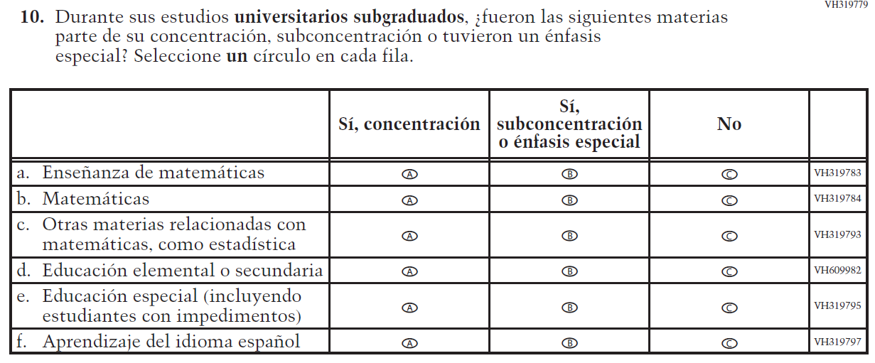  (2019 Operational Grade 8 Teacher Core – Puerto Rico) | Issue: Teacher Preparation | NC | N/A
VH319827  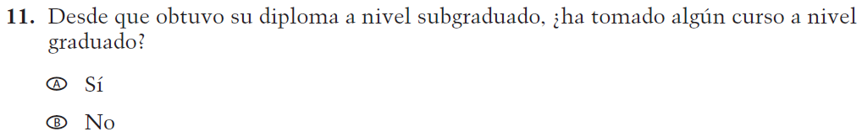  (2019 Operational Grade 8 Teacher Core – Puerto Rico) | VH319827  Issue: Teacher Preparation | NC | N/A
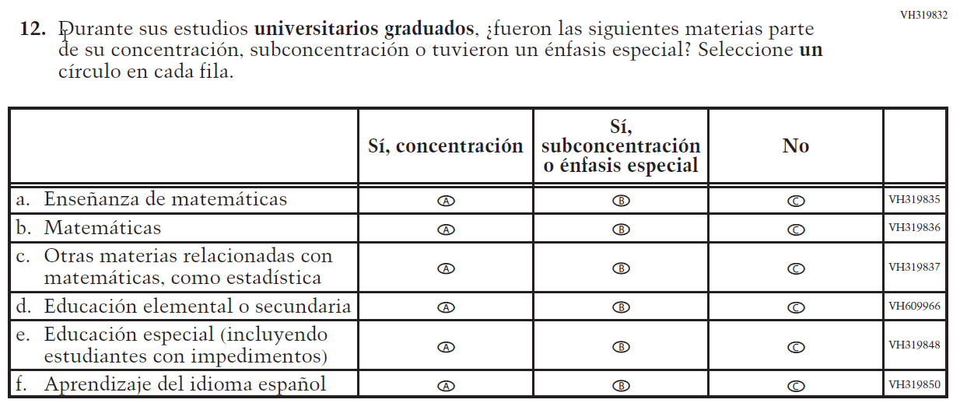  (2019 Operational Grade 8 Teacher Core – Puerto Rico) | Issue: Teacher Preparation | NC | N/A

2021 Operational Grade 8 Core Teacher – Puerto Rico
Previous item | 2021 item | D/A/R/NC+ | Rationale
VH579698  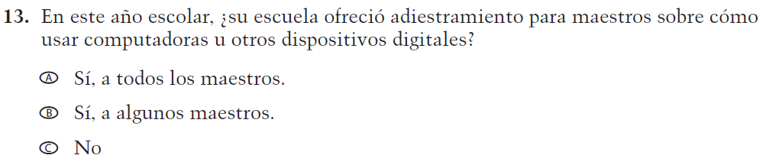  (2019 Operational Grade 8 Teacher Core – Puerto Rico) | VH579698  Issue: Technology Use | NC | N/A
VH579699  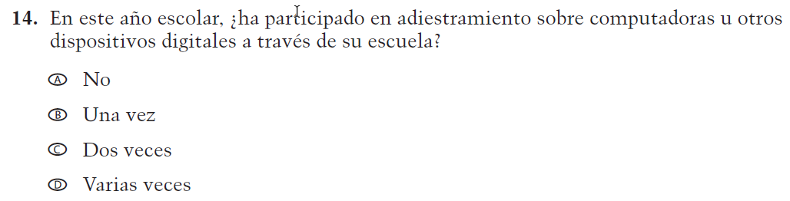  (2019 Operational Grade 8 Teacher Core – Puerto Rico) | VH579699  Issue: Technology Use | NC | N/A
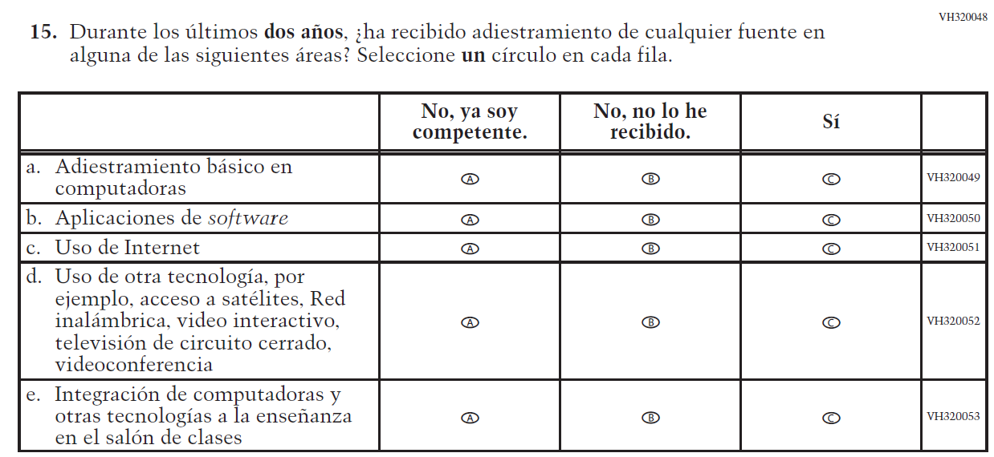  (2019 Operational Grade 8 Teacher Core – Puerto Rico) | Issue: Teacher Preparation | NC | N/A

2021 Operational Grade 8 Core Teacher – Puerto Rico
Previous item | 2021 item | D/A/R/NC+ | Rationale
VH893860  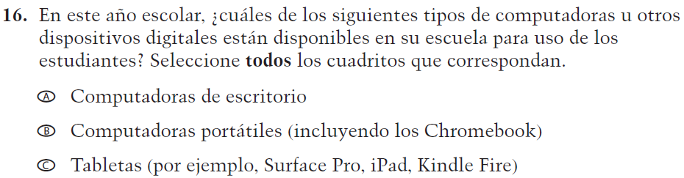  (2019 Operational Grade 8 Teacher Core – Puerto Rico) | VH893860  Issue: Technology Use | NC | N/A
VH579690  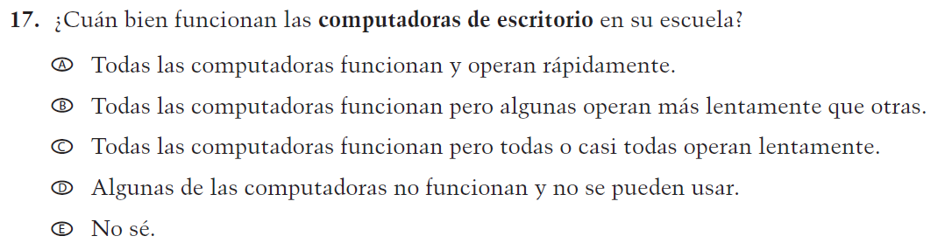  (2019 Operational Grade 8 Teacher Core – Puerto Rico) | VH579690  Issue: Technology Use | NC | N/A
VH579692  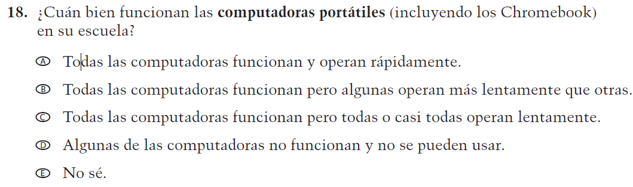  (2019 Operational Grade 8 Teacher Core – Puerto Rico) | VH579692  Issue: Technology Use | NC | N/A
VH579694  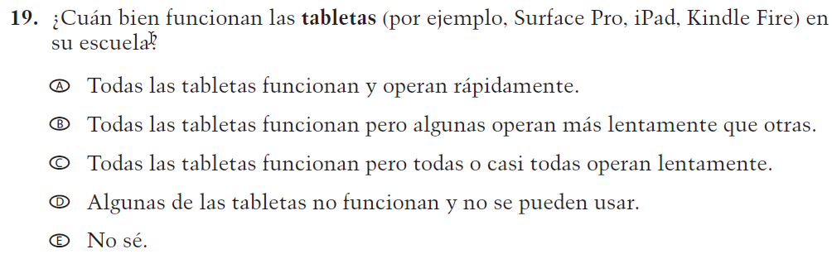  (2019 Operational Grade 8 Teacher Core – Puerto Rico) | VH579694  Issue: Technology Use | NC | N/A

2021 Operational Grade 8 Core Teacher – Puerto Rico
Previous item | 2021 item | D/A/R/NC+ | Rationale
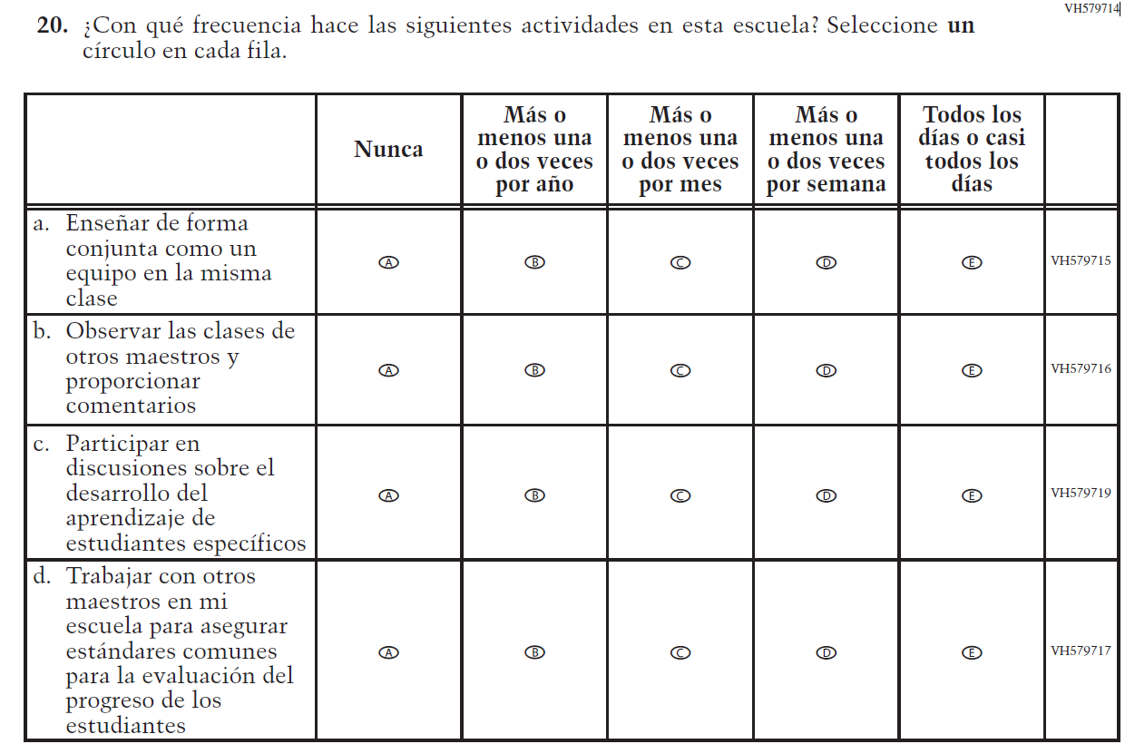  (2019 Operational Grade 8 Teacher Core – Puerto Rico) | Issue: School Climate | NC | N/A
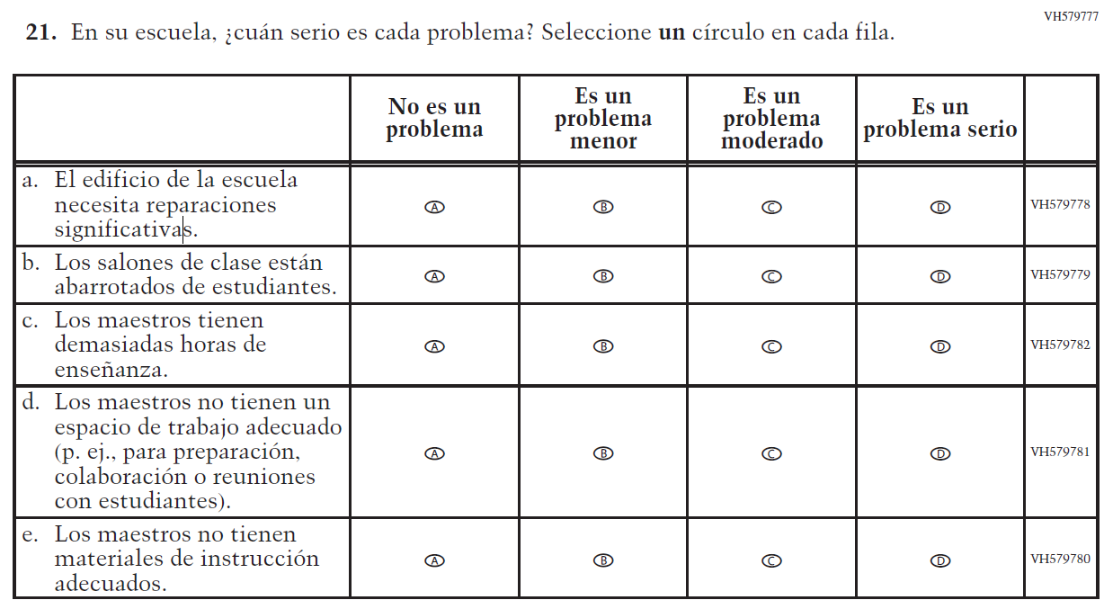  (2019 Operational Grade 8 Teacher Core – Puerto Rico) | Issue: School Climate | NC | N/A

2021 Operational Grade 8 Core Teacher – Puerto Rico
Previous item | 2021 item | D/A/R/NC+ | Rationale
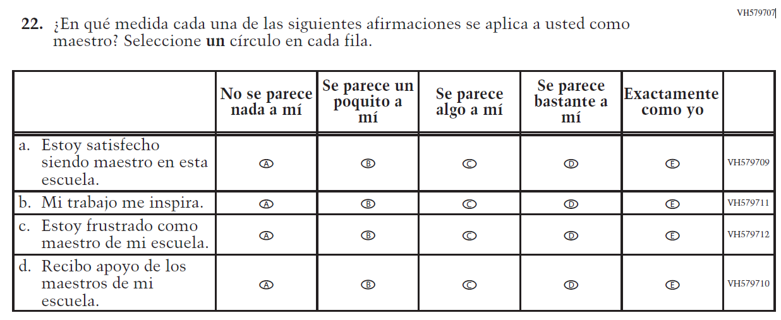  (2019 Operational Grade 8 Teacher Core – Puerto Rico) | Issue: School Climate | NC | N/A
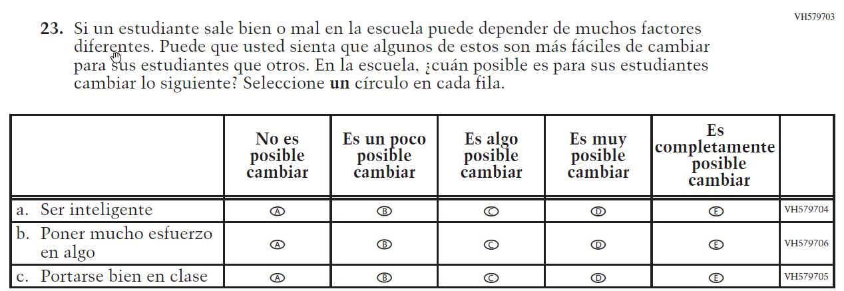  (2019 Operational Grade 8 Teacher Core – Puerto Rico) | Issue: Desire for Learning | NC | N/A

Appendix J-2b-s-PR: Operational Grade 8 CORE
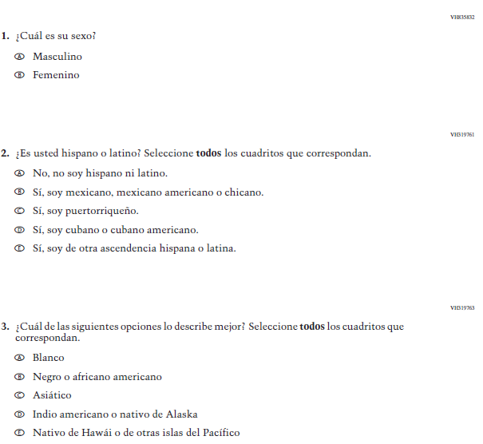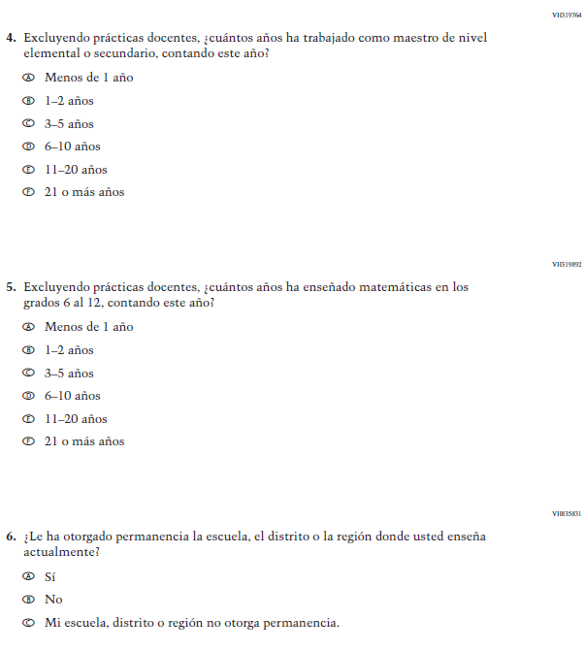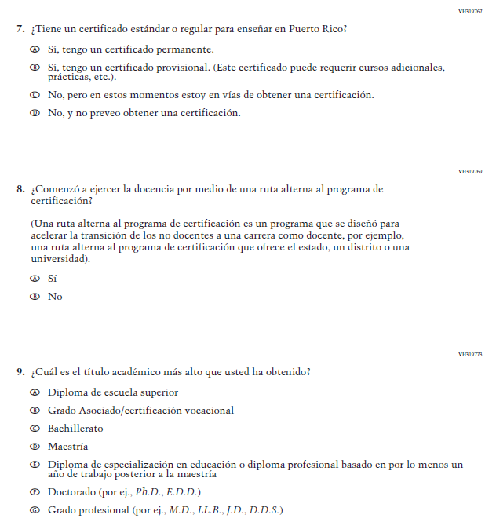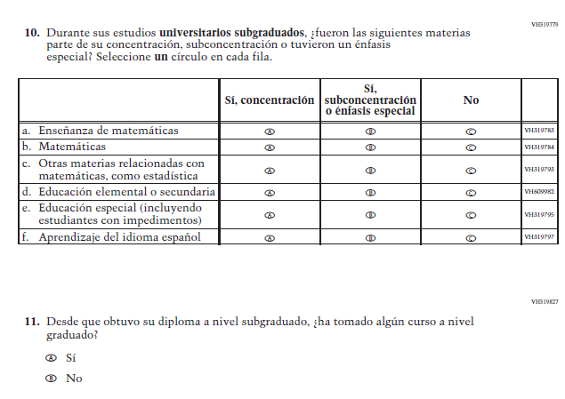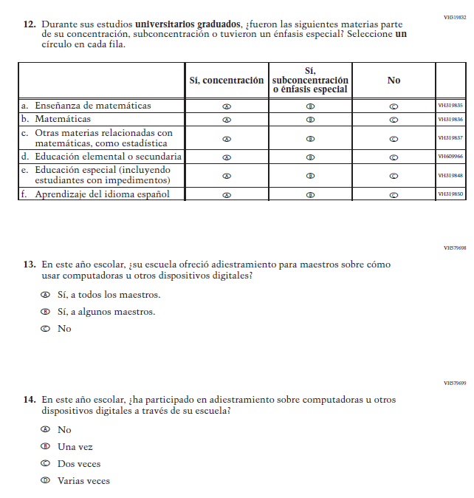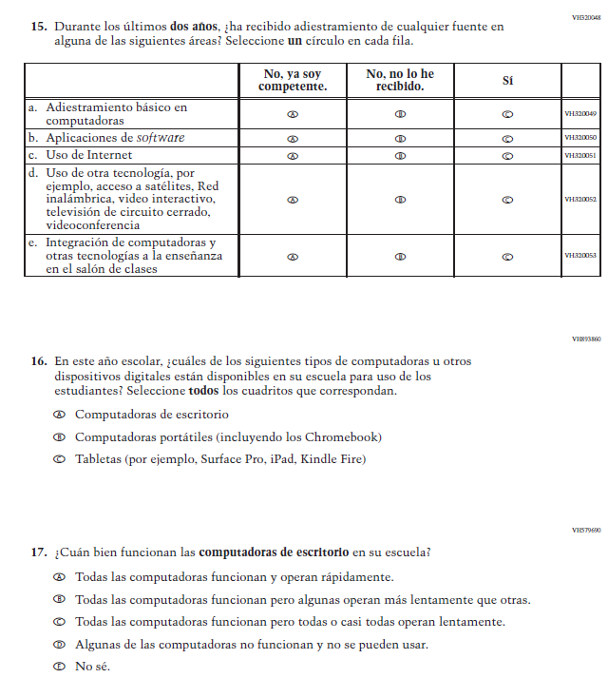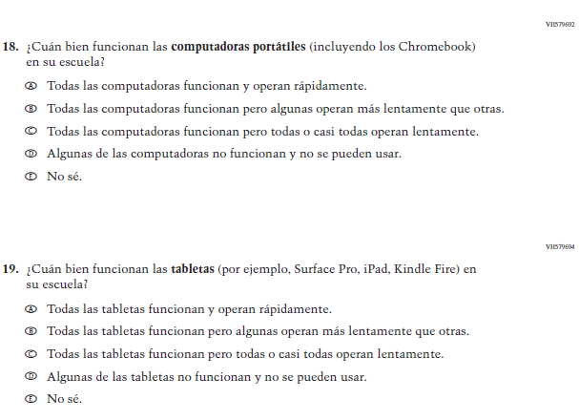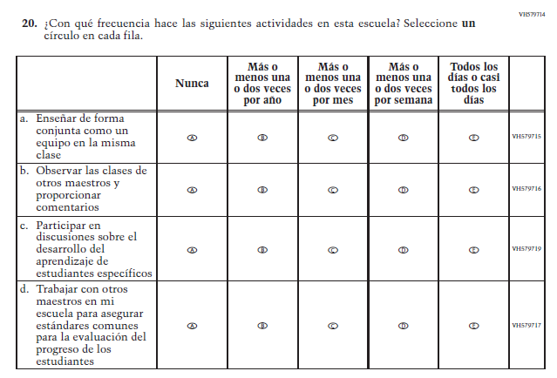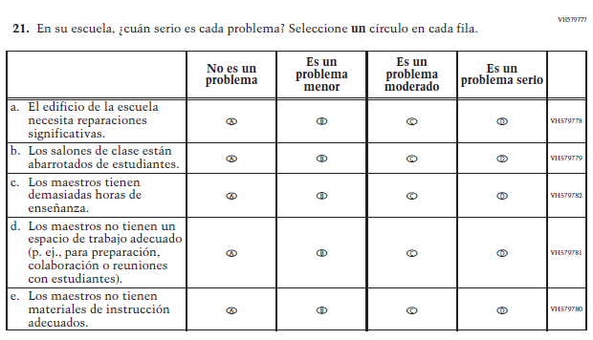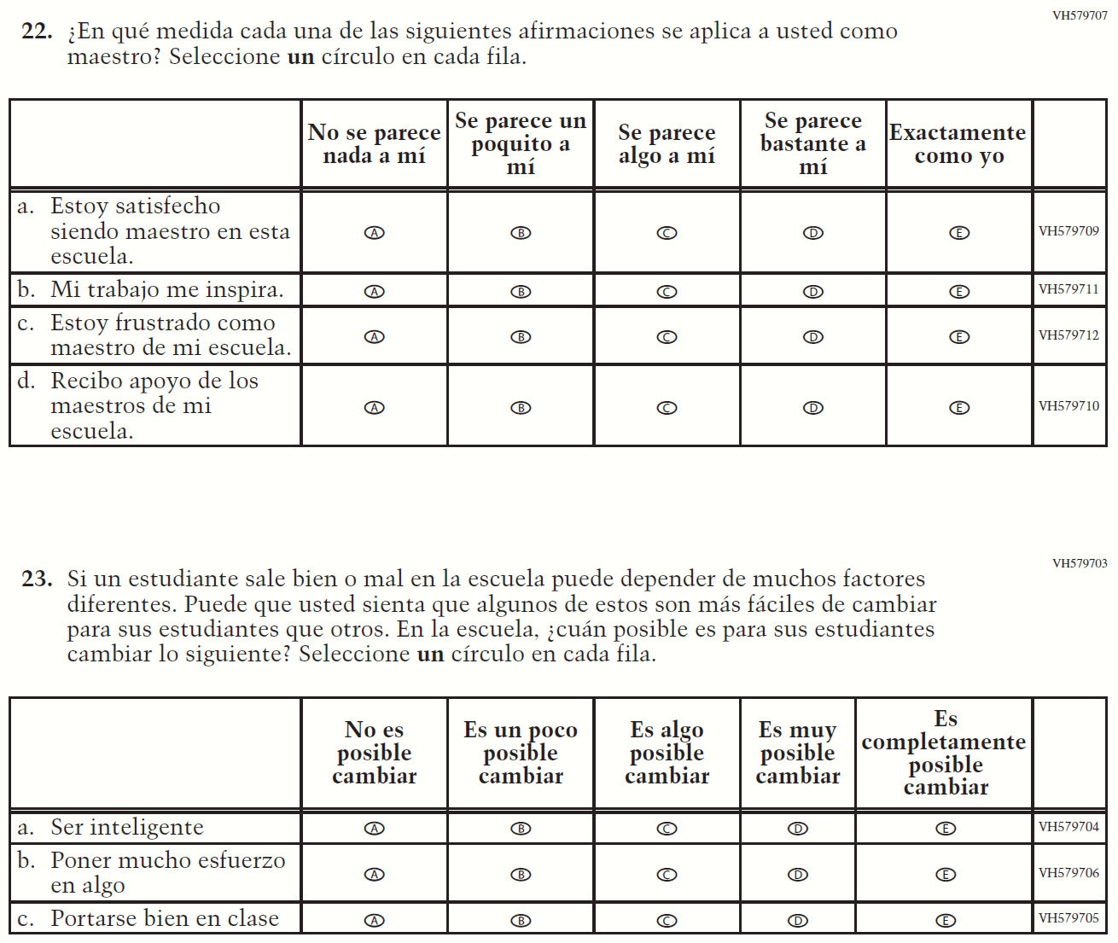

Appendix J-2c-s-PR: Summary of Changes Operational Grade 4 Mathematics
2021 Operational Grade 4 Mathematics Teacher – Puerto Rico
Previous item | 2021 item | D/A/R/NC+ | Rationale
VH320096  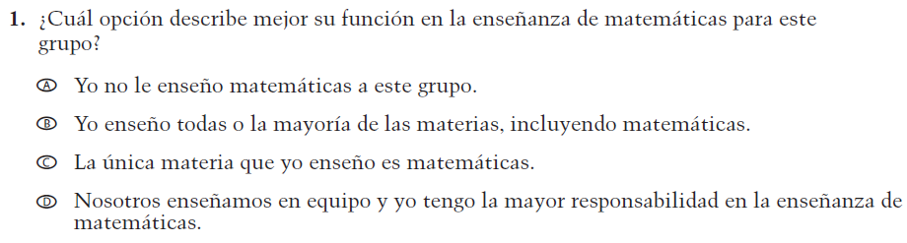  (2019 Operational Grade 4 Teacher Mathematics – Puerto Rico) | VH320096  Issue: Resources for Learning and Instruction | NC | N/A
VH579728  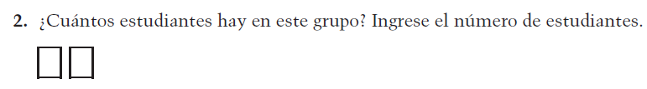  (2019 Operational Grade 4 Teacher Mathematics – Puerto Rico) | VH579728  Issue: Resources for Learning and Instruction | NC | N/A
VH857347  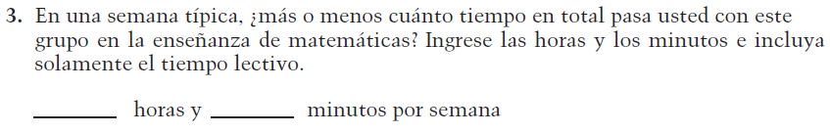  (2019 Operational Grade 4 Teacher Mathematics – Puerto Rico) | VH857347  Issue: Resources for Learning and Instruction | N/C | N/A
VH320121  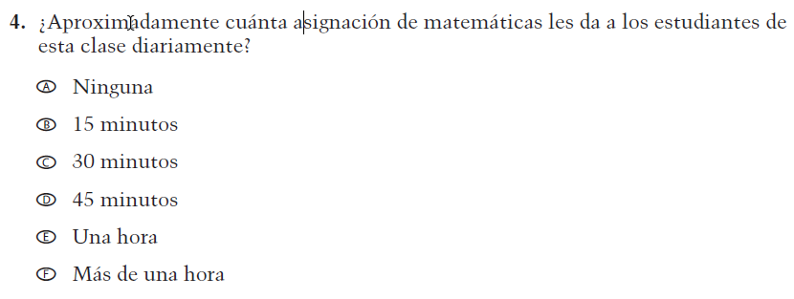  (2019 Operational Grade 4 Teacher Mathematics – Puerto Rico) | VH320121  Issue: Organization of Instruction | NC | N/A

2021 Operational Grade 4 Mathematics Teacher – Puerto Rico
Previous item | 2021 item | D/A/R/NC+ | Rationale
VH320125  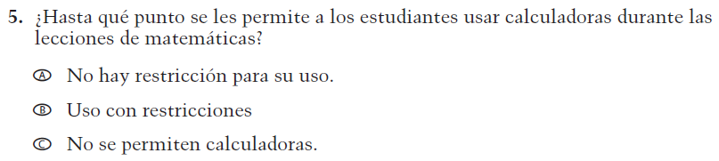  (2019 Operational Grade 4 Teacher Mathematics – Puerto Rico) | VH320125  Issue: Organization of Instruction | NC | N/A
VH320129  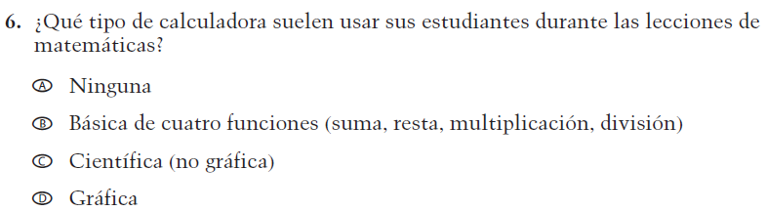  (2019 Operational Grade 4 Teacher Mathematics – Puerto Rico) | VH320129  Issue: Resources for learning and instruction | NC | N/A
VH320132  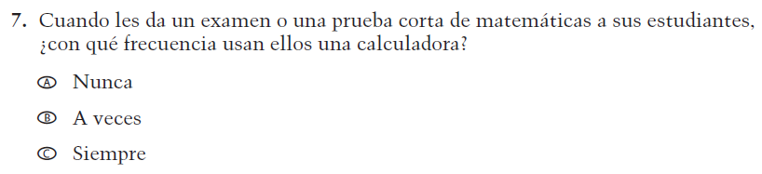  (2019 Operational Grade 4 Teacher Mathematics – Puerto Rico) | VH320132  Issue: Organization of Instruction | NC | N/A
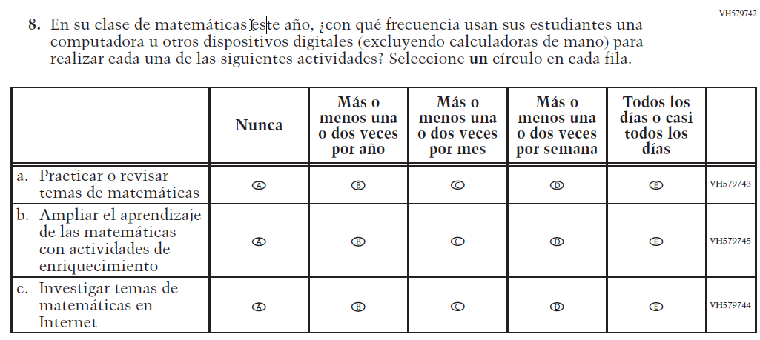  (2019 Operational Grade 4 Teacher Mathematics – Puerto Rico) | Issue: Organization of Instruction | NC | N/A

2021 Operational Grade 4 Mathematics Teacher – Puerto Rico
Previous item | 2021 item | D/A/R/NC+ | Rationale
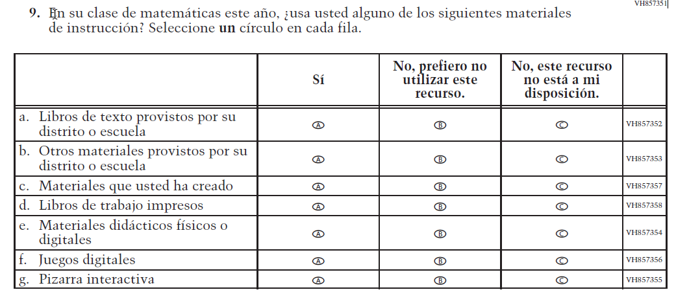  (2019 Operational Grade 4 Teacher Mathematics – Puerto Rico) | Issue: Resources for Learning and Instruction | NC | N/A
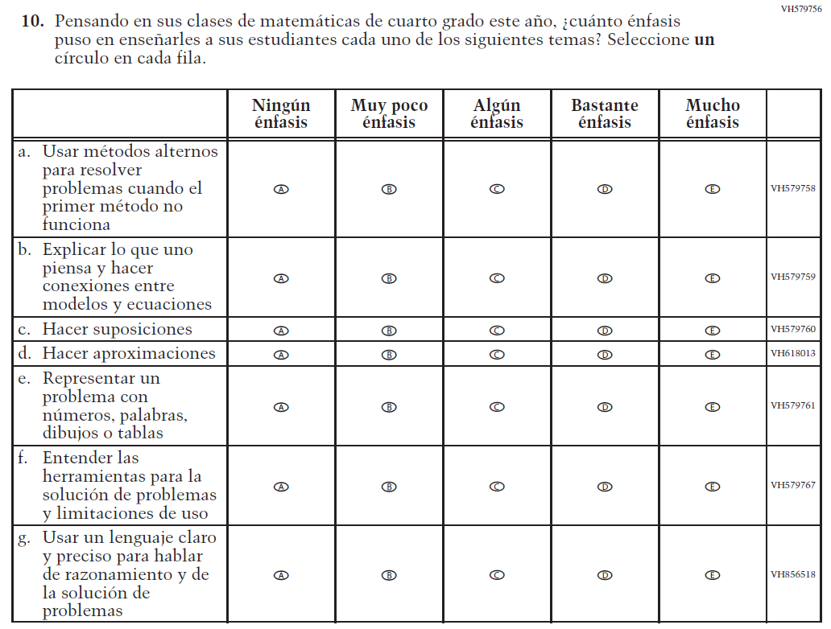  (2019 Operational Grade 4 Teacher Mathematics – Puerto Rico) | Issue: Organization of Instruction | NC | N/A

2021 Operational Grade 4 Mathematics Teacher – Puerto Rico
Previous item | 2021 item | D/A/R/NC+ | Rationale
VH320151  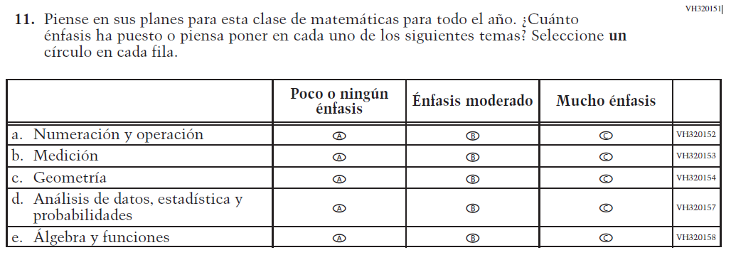  (2019 Operational Grade 4 Teacher Mathematics – Puerto Rico) | VH320151  Issue: Organization of Instruction | NC | N/A
VH320200  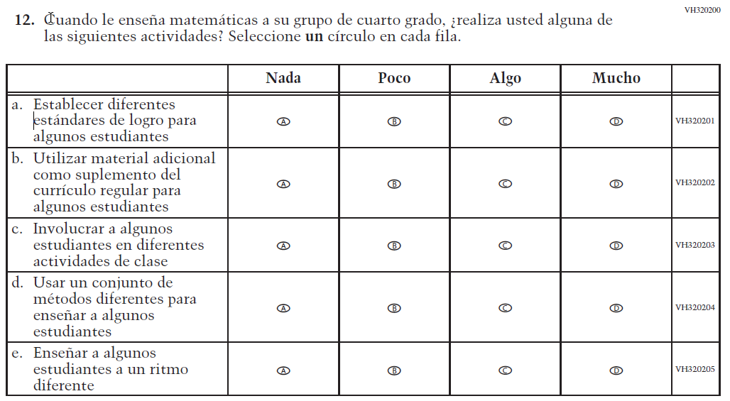  (2019 Operational Grade 4 Teacher Mathematics – Puerto Rico) | VH320200  Issue: Organization of Instruction | NC | N/A

2021 Operational Grade 4 Mathematics Teacher – Puerto Rico
Previous item | 2021 item | D/A/R/NC+ | Rationale
VH579746  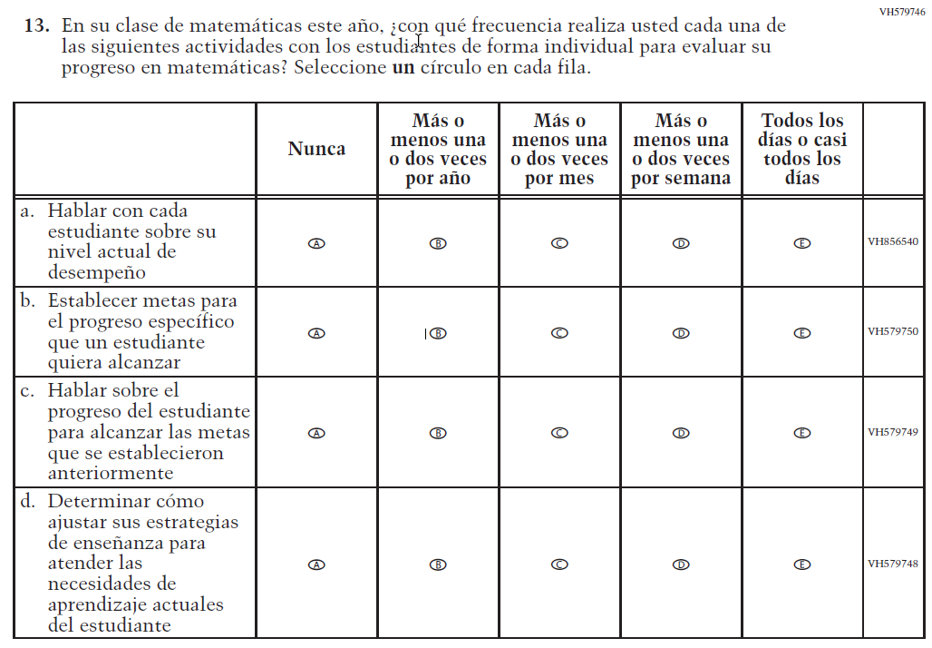  (2019 Operational Grade 4 Teacher Mathematics – Puerto Rico) | VH579746  Issue: Organization of Instruction | NC | N/A
VH579768  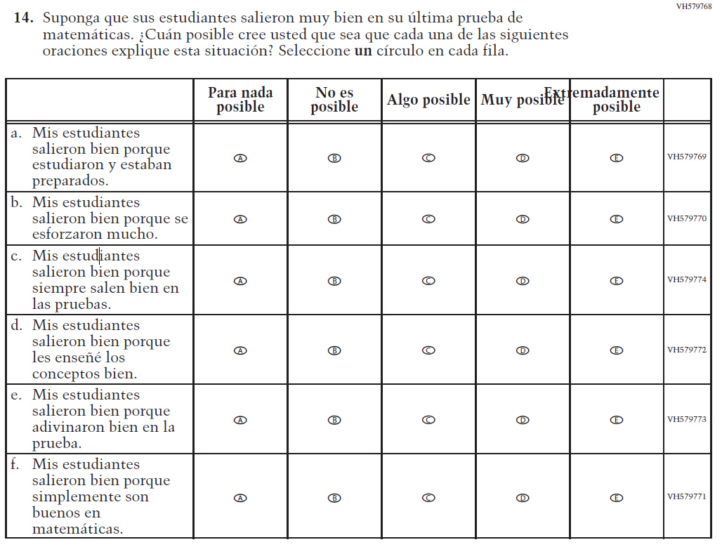  (2019 Operational Grade 4 Teacher Mathematics – Puerto Rico) | VH579768  Issue: Teacher Preparation | NC | N/A

2021 Operational Grade 4 Mathematics Teacher – Puerto Rico
Previous item | 2021 item | D/A/R/NC+ | Rationale
VH579775  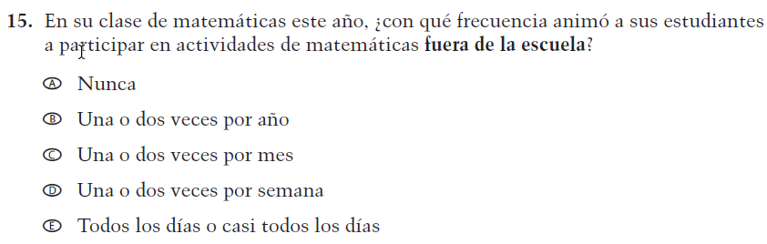  (2019 Operational Grade 4 Teacher Mathematics – Puerto Rico) | VH579775  Issue: Resources for Learning and Instruction | NC | N/A
VH579776  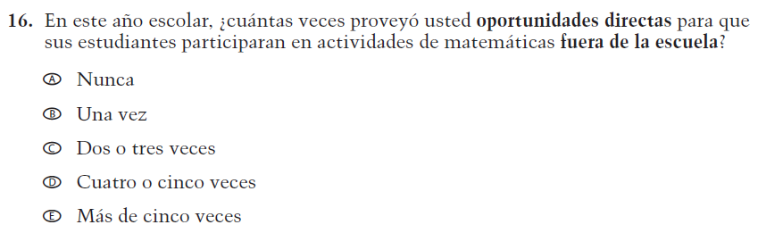  (2019 Operational Grade 4 Teacher Mathematics – Puerto Rico) | VH579776  Issue: Resources for Learning and Instruction | NC | N/A

Appendix J-2c-s-PR: Operational Grade 4 Mathematics
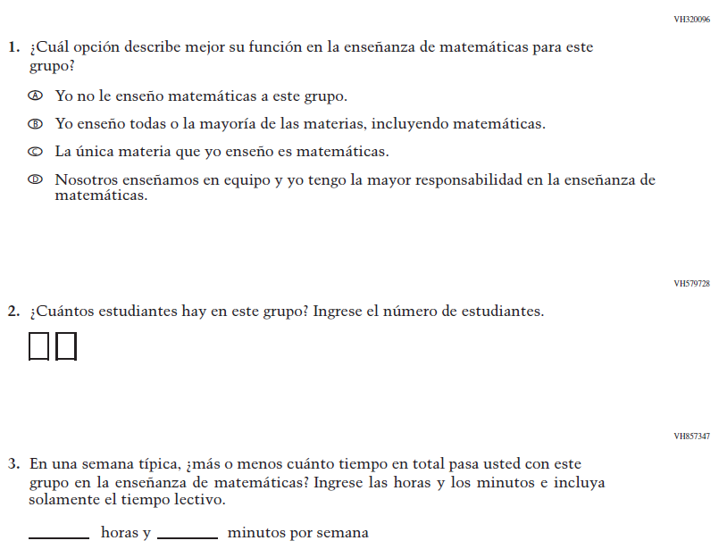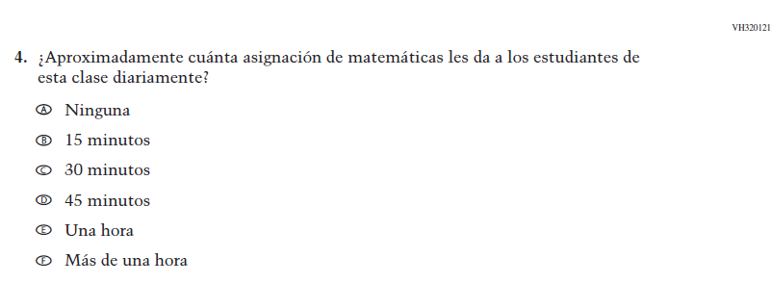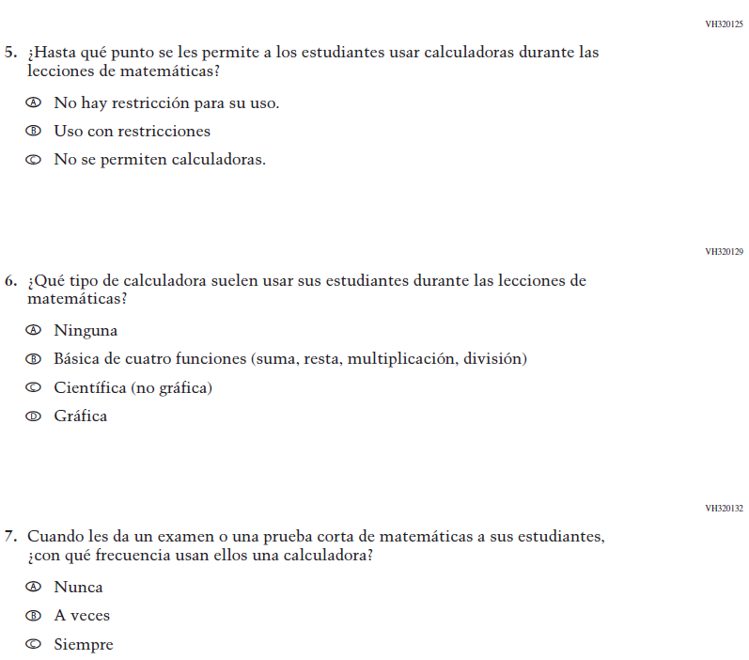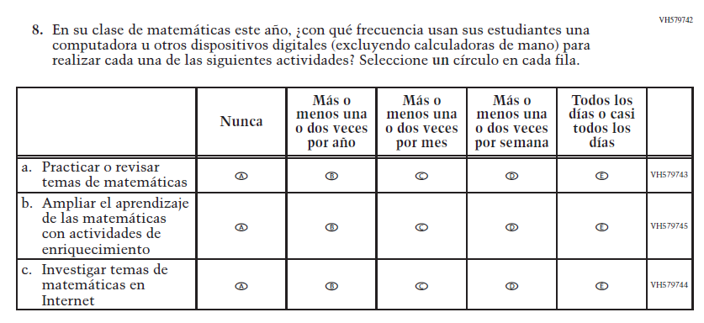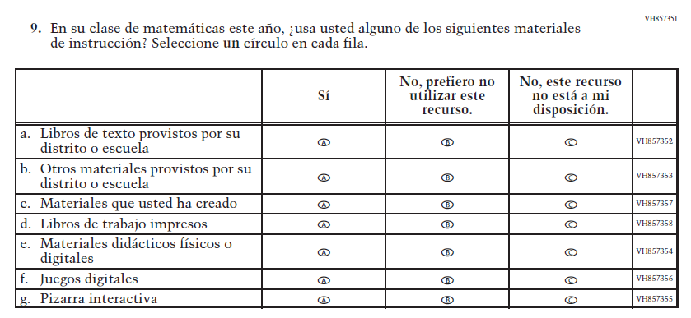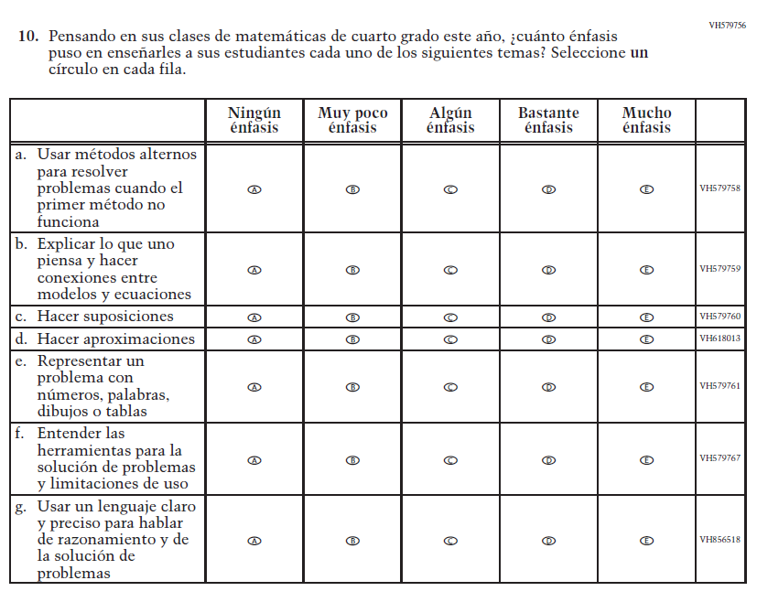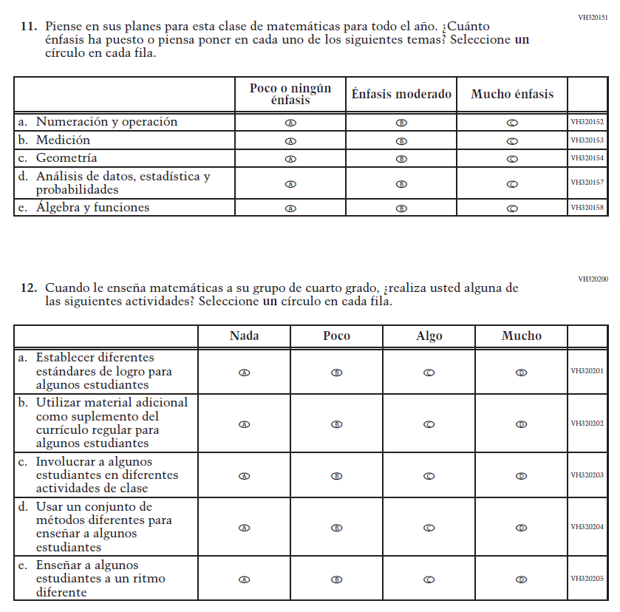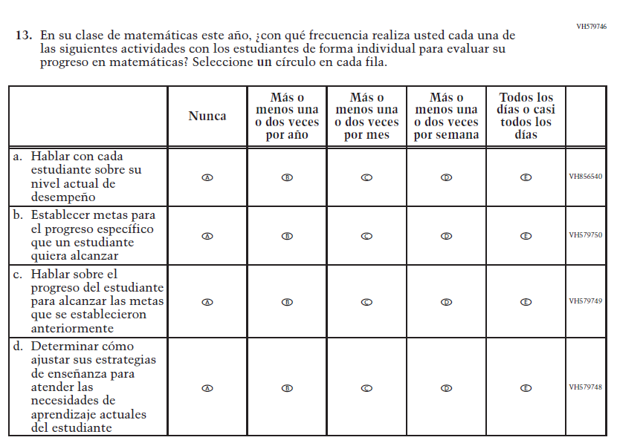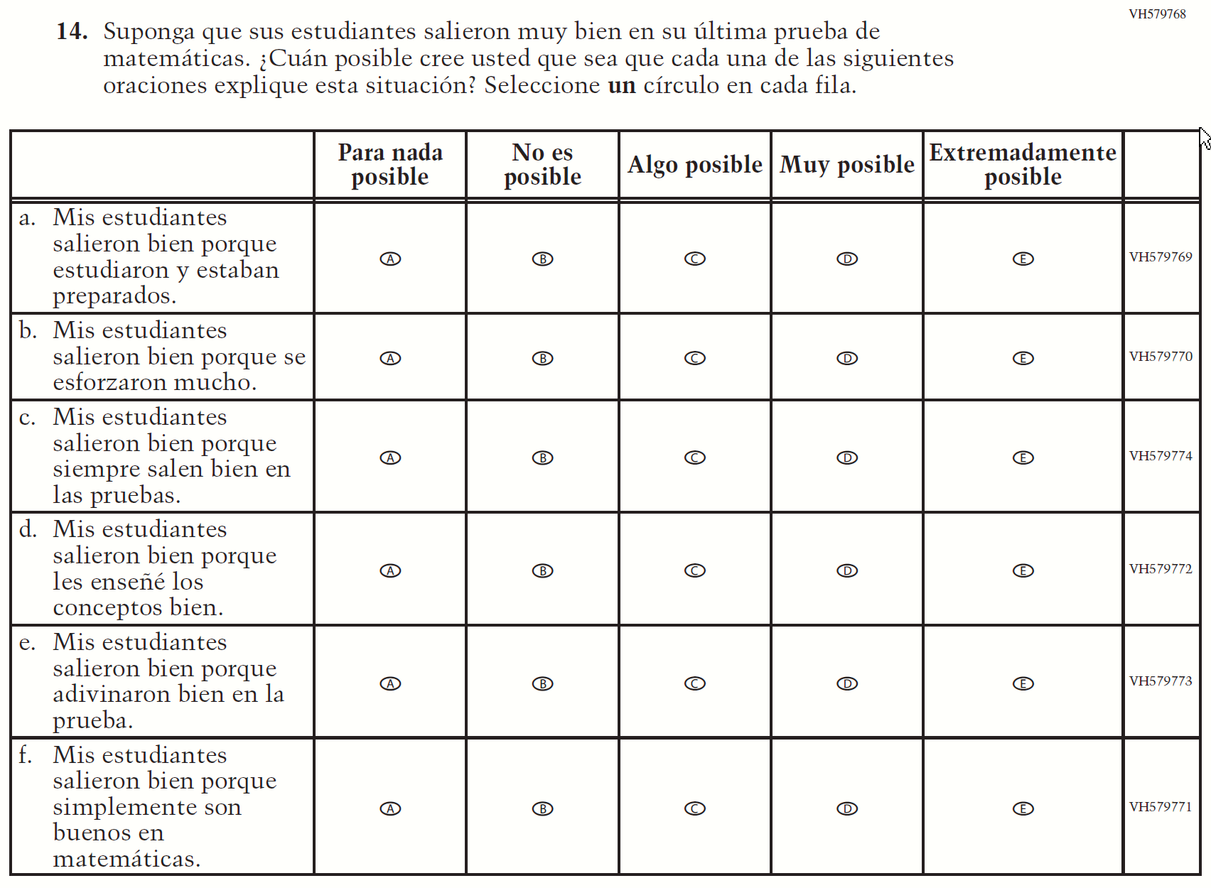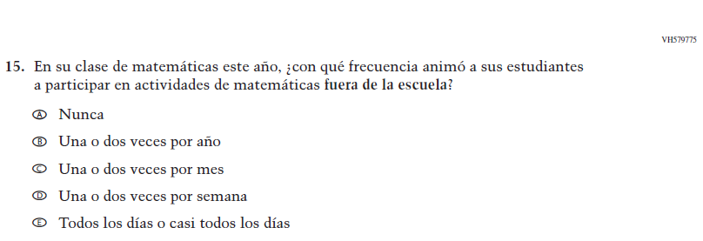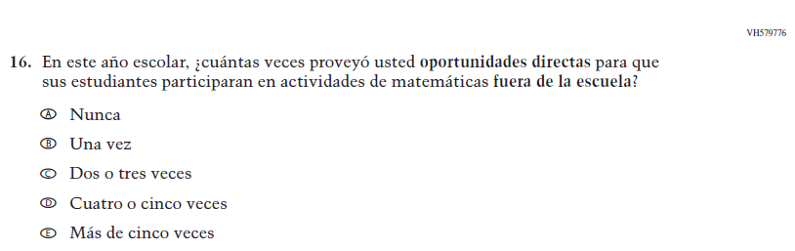

Appendix J-2d-s-PR: Summary of Changes Operational Grade 8 Mathematics
2021 Operational Grade 8 Mathematics Teacher – Puerto Rico
Previous item | 2021 item | D/A/R/NC+ | Rationale
VH320096  (2019 Operational Grade 8 Teacher Mathematics – Puerto Rico) | VH320096  Issue: Resources for Learning and Instruction | NC | N/A
VH579728  (2019 Operational Grade 8 Teacher Mathematics – Puerto Rico) | VH579728  Issue: Resources for Learning and Instruction | NC | N/A
VH857347  (2019 Operational Grade 8 Teacher Mathematics – Puerto Rico) | VH857347  Issue: Resources for Learning and Instruction | N/C | N/A
VH320121  (  2019 Operational Grade 8 Teacher Mathematics – Puerto Rico) | VH320121  Issue: Organization of Instruction | NC | N/A

2021 Operational Grade 8 Mathematics Teacher – Puerto Rico
Previous item | 2021 item | D/A/R/NC+ | Rationale
VH320125  (2019 Operational Grade 8 Teacher Mathematics – Puerto Rico) | VH320125  Issue: Organization of Instruction | NC | N/A
VH320129  (2019 Operational Grade 8 Teacher Mathematics – Puerto Rico) | VH320129  Issue: Resources for Learning and Instruction | NC | N/A
VH320132  (2019 Operational Grade 8 Teacher Mathematics – Puerto Rico) | VH320132  Issue: Organization of Instruction | NC | N/A
(2019 Operational Grade 8 Teacher Mathematics – Puerto Rico) | Issue: Organization of Instruction | NC | N/A

2021 Operational Grade 8 Mathematics Teacher – Puerto Rico
Previous item | 2021 item | D/A/R/NC+ | Rationale
(2019 Operational Grade 8 Teacher Mathematics – Puerto Rico) | Issue: Resources for Learning and Instruction | NC | N/A
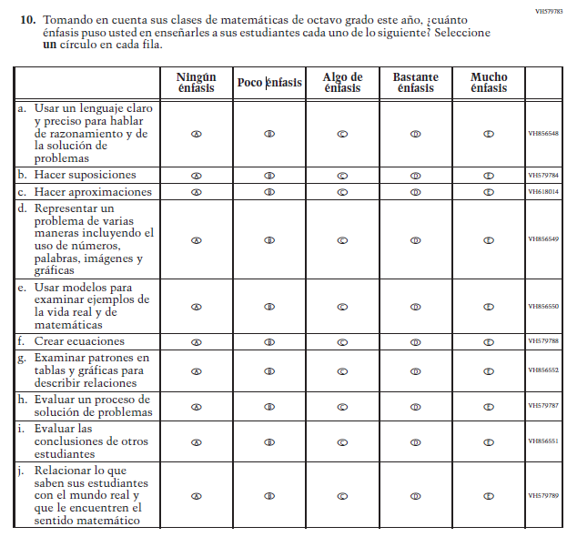  (2019 Operational Grade 8 Teacher Mathematics – Puerto Rico) | Issue: Organization of Instruction | NC | N/A

2021 Operational Grade 8 Mathematics Teacher – Puerto Rico
Previous item | 2021 item | D/A/R/NC+ | Rationale
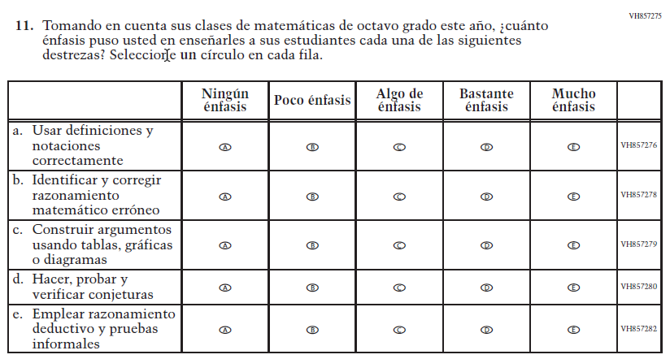  (2019 Operational Grade 8 Teacher Mathematics – Puerto Rico) | Issue: Organization of Instruction | NC | N/A
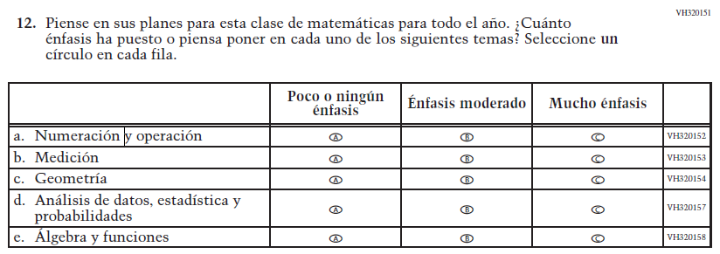  (2019 Operational Grade 8 Teacher Mathematics – Puerto Rico) | Issue: Organization of Instruction | NC | N/A

2021 Operational Grade 8 Mathematics Teacher – Puerto Rico
Previous item | 2021 item | D/A/R/NC+ | Rationale
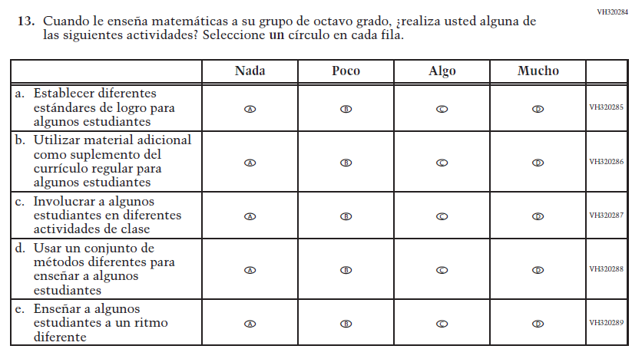  (2019 Operational Grade 8 Teacher Mathematics – Puerto Rico) | Issue: Organization of Instruction | NC | N/A
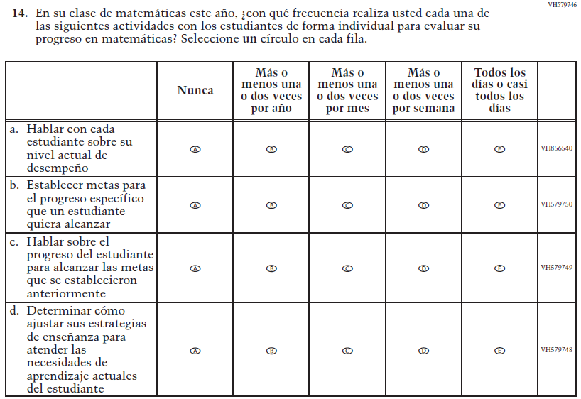  (2019 Operational Grade 8 Teacher Mathematics – Puerto Rico) | Issue: Organization of Instruction | NC | N/A

2021 Operational Grade 8 Mathematics Teacher – Puerto Rico
Previous item | 2021 item | D/A/R/NC+ | Rationale
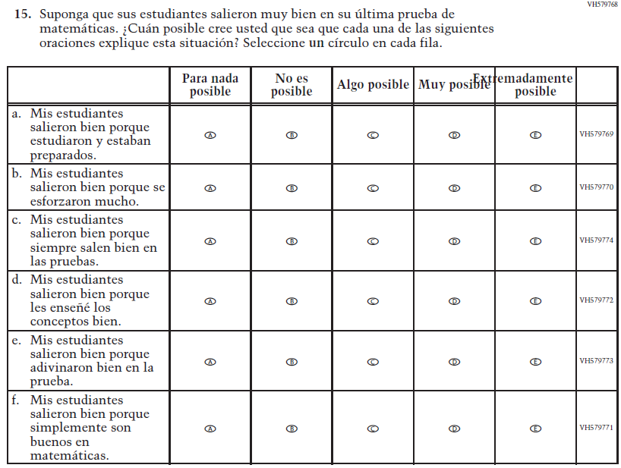  (2019 Operational Grade 8 Teacher Mathematics – Puerto Rico) | Issue: Teacher Preparation | NC | N/A
VH579775  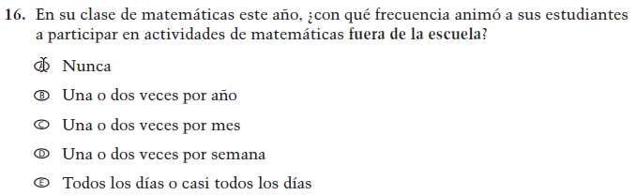  (2019 Operational Grade 8 Teacher Mathematics – Puerto Rico) | VH579775  Issue: Resources for Learning and Instruction | NC | N/A

2021 Operational Grade 8 Mathematics Teacher – Puerto Rico
Previous item | 2021 item | D/A/R/NC+ | Rationale
VH579776  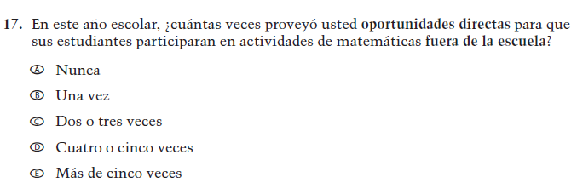  (2019 Operational Grade 8 Teacher Mathematics – Puerto Rico) | VH579776  Issue: Resources for Learning and Instruction | NC | N/A
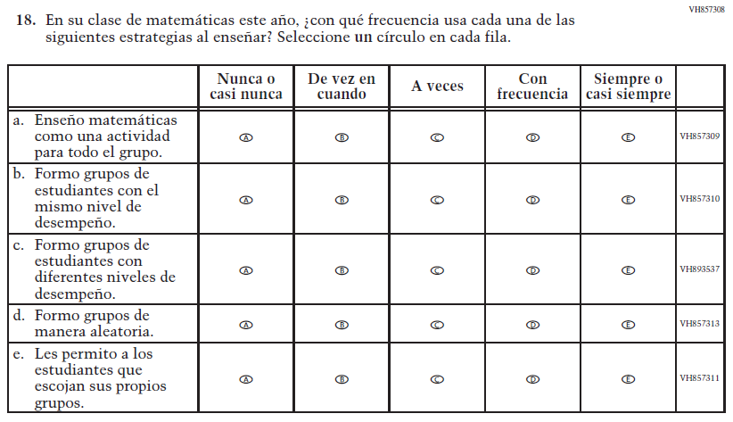  (2019 Operational Grade 8 Teacher Mathematics – Puerto Rico) | Issue: Organization of Instruction | NC | N/A

Appendix J-2d-s-PR: Operational Grade 8 Mathematics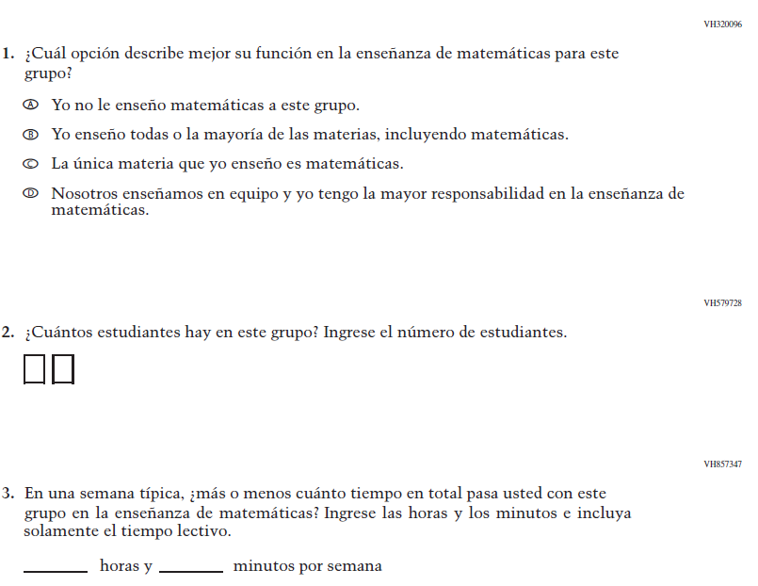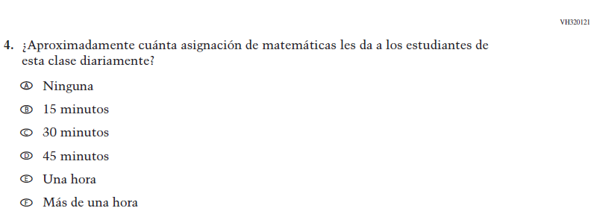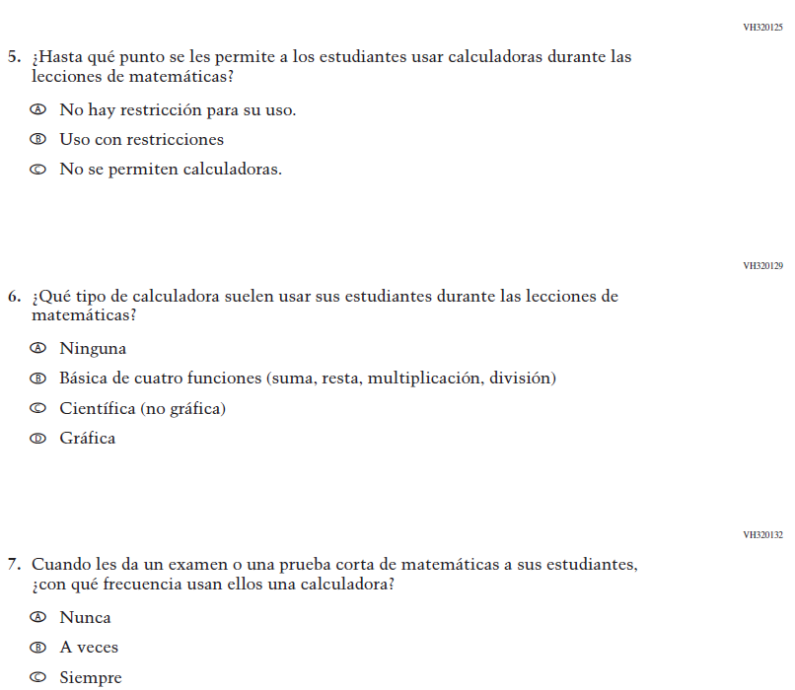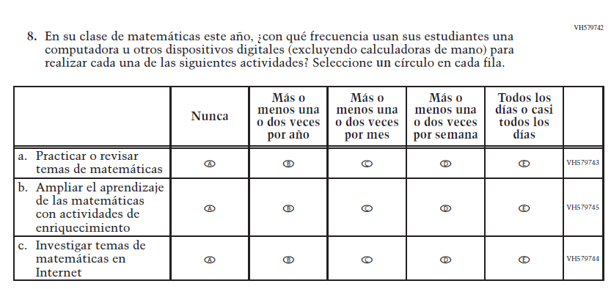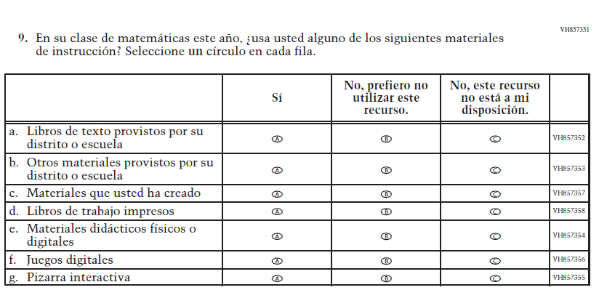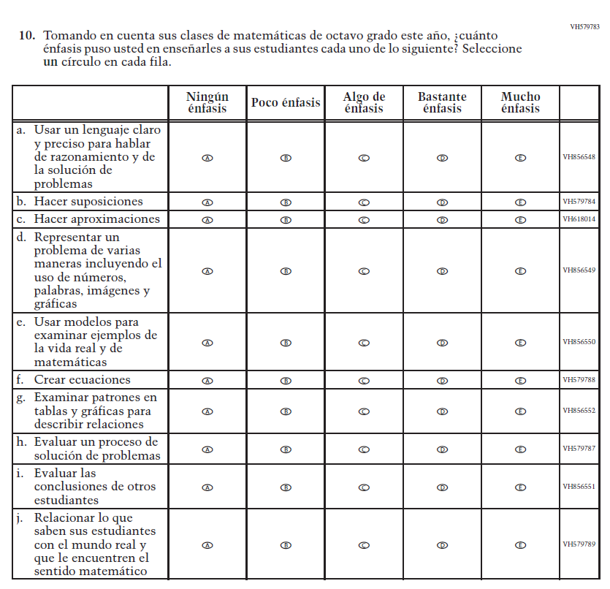
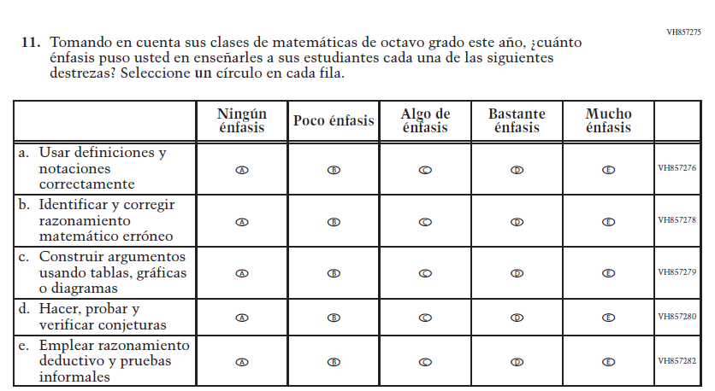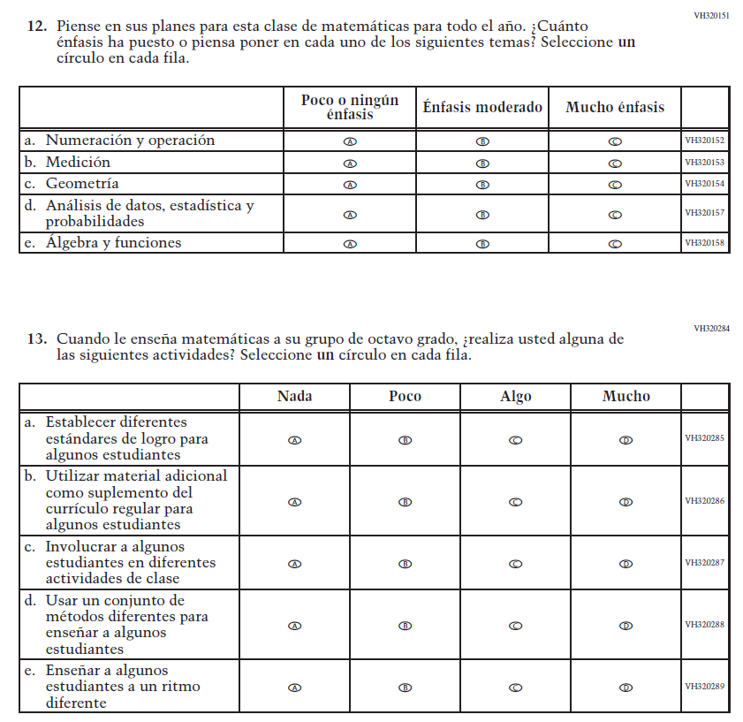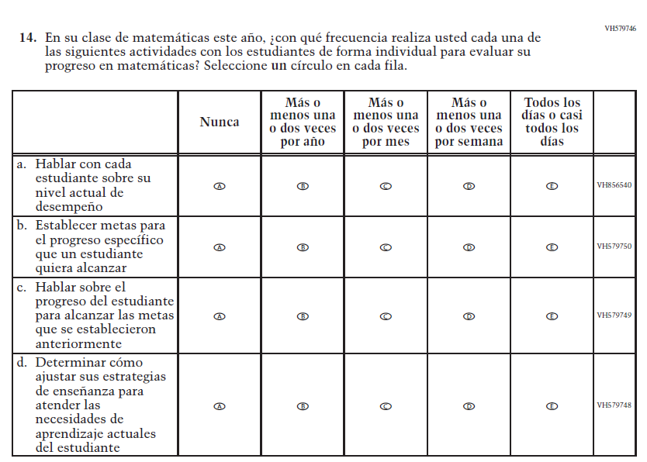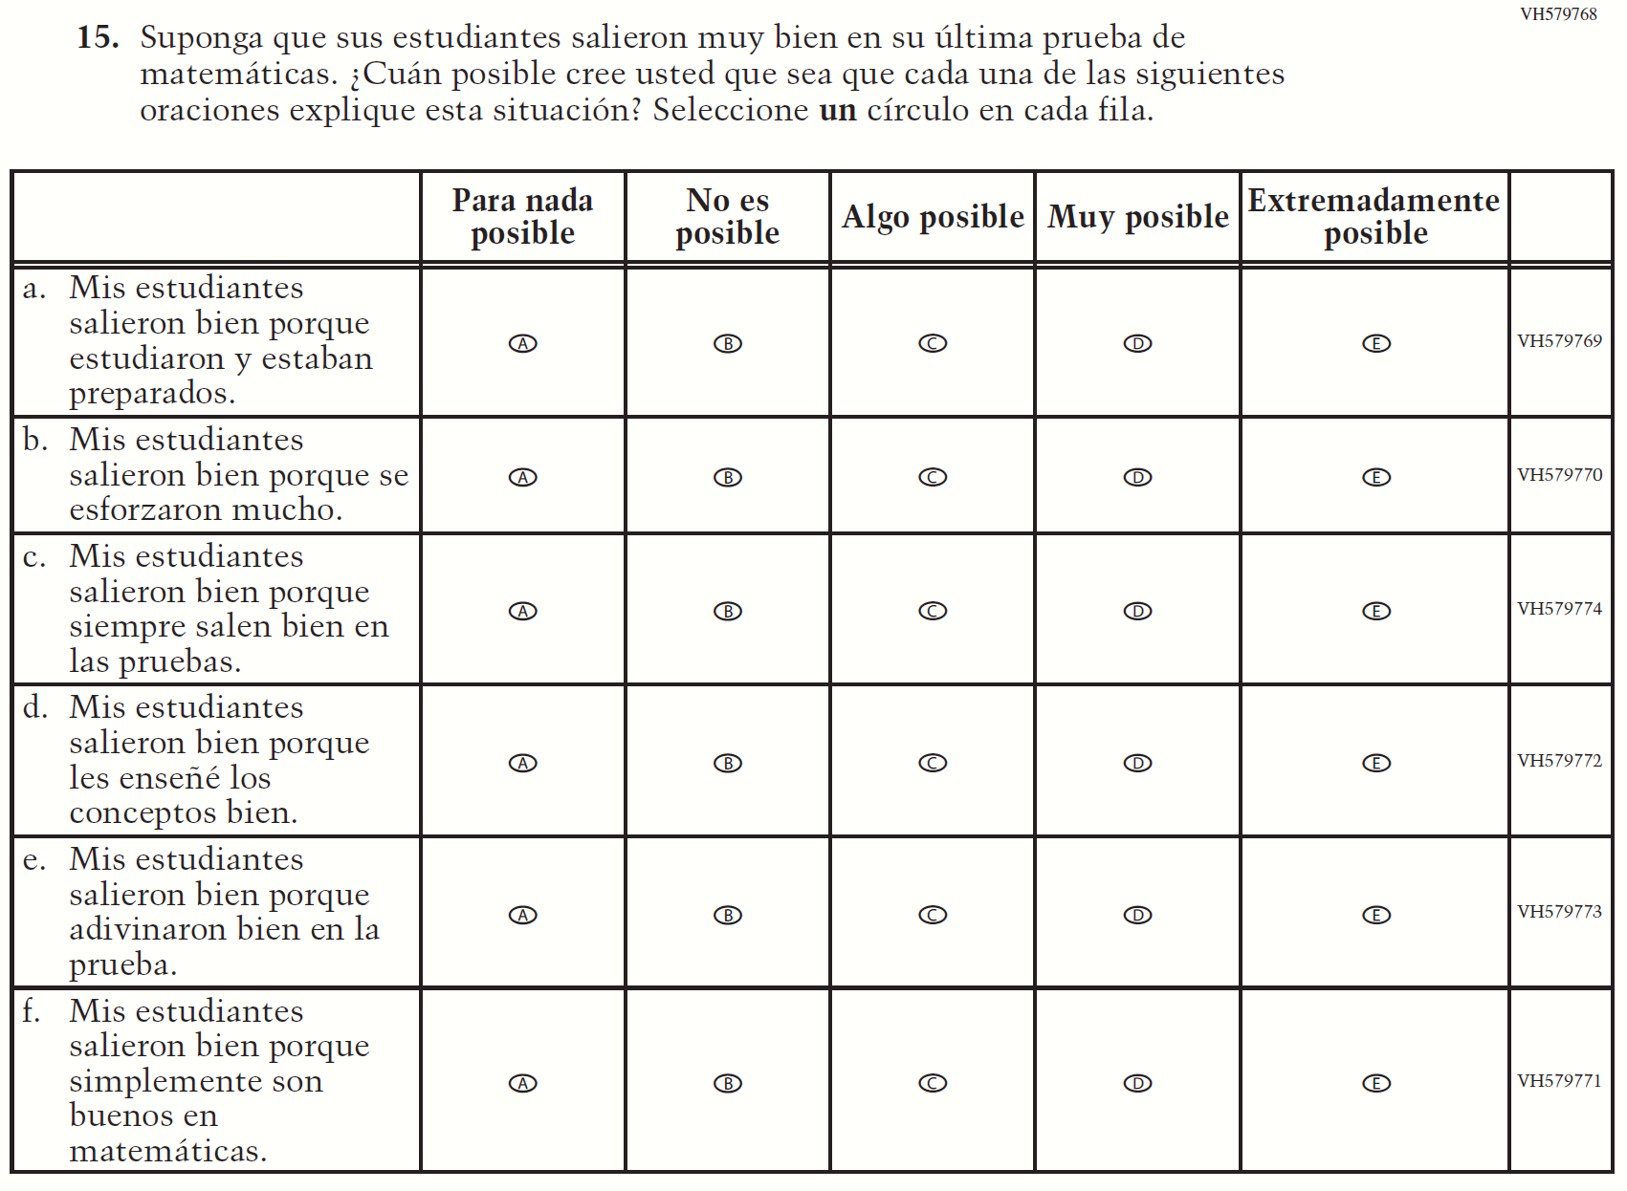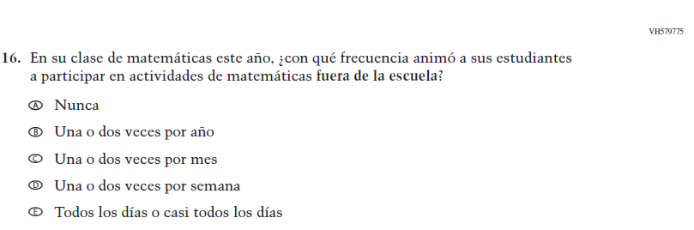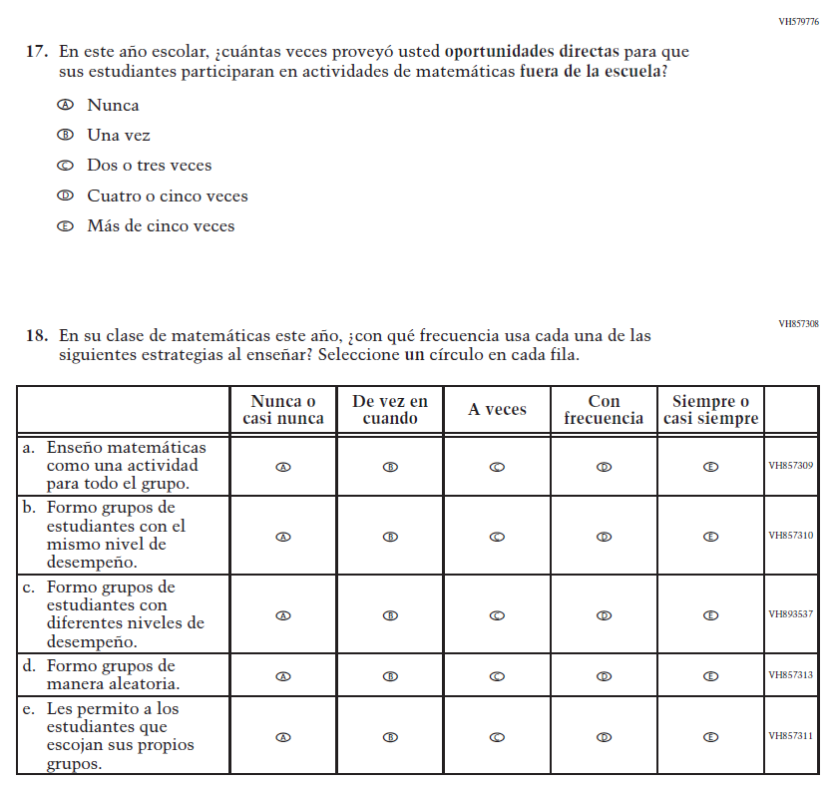

School Administrator Login Screen

NOTE: The final version of the login screen was not available for this amendment and will be included in Amendment 2 scheduled to be submitted in October 2020 The OMB text will be revised with the updated language below.
De acuerdo al Paperwork Reduction Act de 1995, no se les requiere a las personas que respondan a una recopilación de información a menos que tal recopilación exhiba un número válido de control OMB. El número válido de control OMB para esta recopilación voluntaria de información es 1850-0928. Se estima que el tiempo necesario para completar esta recopilación de información es de un promedio de 30 minutos, incluyendo el tiempo para leer las instrucciones, buscar los recursos de datos existentes, recopilar los datos necesarios y completar y revisar la recopilación de información. Si tiene cualquier comentario acerca de la exactitud del tiempo estimado, sugerencias para mejorar esta recopilación o cualquier comentario o preocupación acerca del estatus de la presentación individual de su formulario, por favor escriba a: National Assessment of Educational Progress (NAEP), National Center for Education Statistics, Potomac Center Plaza, 550 12th St., SW, 4th floor, Washington, D.C. 20202.
OMB 1850-0928 • LA APROBACIÓN CADUCA 30/4/2023
El Centro Nacional para Estadísticas de la Educación (NCES, por sus siglas en inglés) está autorizado por la Ley de Autorización para la Evaluación Nacional del Progreso Educativo (20 U.S.C.§9622) para administrar NAEP y para administrar NAEP y para recopilar los expedientes educativos de los estudiantes de agencias o instituciones educativas con el propósito de evaluar programas de educación apoyados por el gobierno federal conforme a la Ley de Derechos Educativos y Privacidad Familiar (FERPA, por sus siglas en inglés; 34 CFR §§ 99.31(a)(3)(iii) y 99.35). Toda la información que proporcionen los participantes podrá usarse únicamente con fines estadísticos y no podrá darse a conocer o usarse ni para identificarlos ni para cualquier otro propósito salvo aquel requerido legalmente (20 U.S.C. §9573 y 6 U.S.C. §151). Por ley, todos los empleados de NCES al igual que todo representante del mismo, tales como contratistas y coordinadores de NAEP, han hecho un juramento y están sujetos a encarcelamiento hasta por 5 años, una multa de hasta $250,000 dólares o ambas cosas, si intencionadamente dan a conocer CUALQUIER información que lo identifique. El envío de su información por vía electrónica será monitoreado por empleados y contratistas federales para detectar virus, programas maliciosos (malware) y otras amenazas conforme a la Ley de Mejoramiento de la Seguridad Cibernética de 2015. La información recolectada se combinará para elaborar informes estadísticos.

Appendix J-3-s: Spanish Translations of School Questionnaires

Appendix J-3a-s-PR: Summary of Changes Operational Grade 4 CORE
2021 Operational Grade 4 Core School – Puerto Rico
Previous item | 2021 item | D/A/R/NC+ | Rationale
VH835832  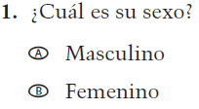  (2019 Operational Grade 4 School Core – Puerto Rico) | VH835832  Issue: Gender | NC | N/A
VH318287  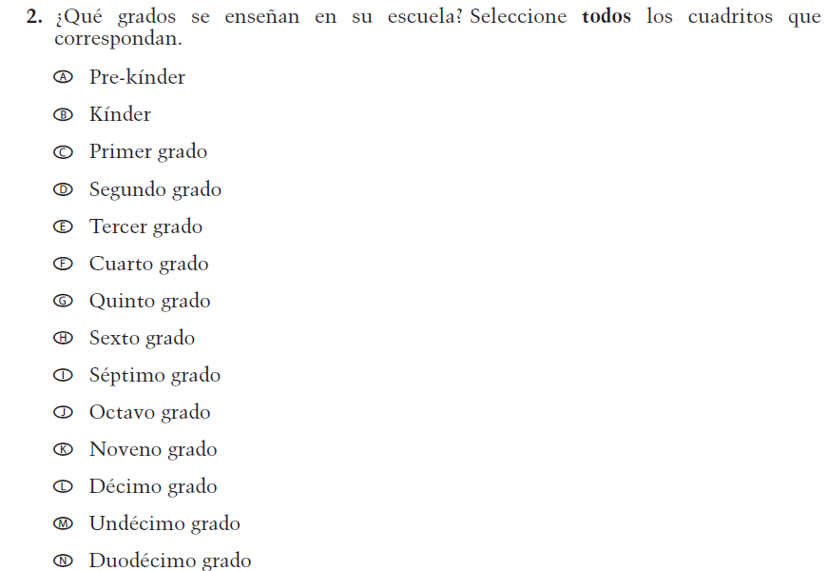  (2019 Operational Grade 4 School Core – Puerto Rico) | VH318287  Issue: School Climate | NC | N/A

2021 Operational Grade 4 Core School – Puerto Rico
Previous item | 2021 item | D/A/R/NC+ | Rationale
VH893344  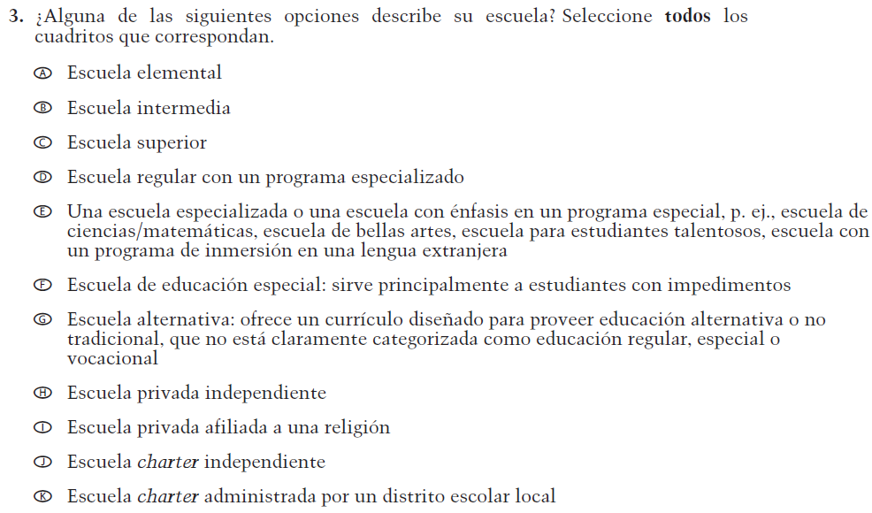  (2019 Operational Grade 4 School Core – Puerto Rico) | VH893344  Issue: School Climate | NC | N/A
VH835855  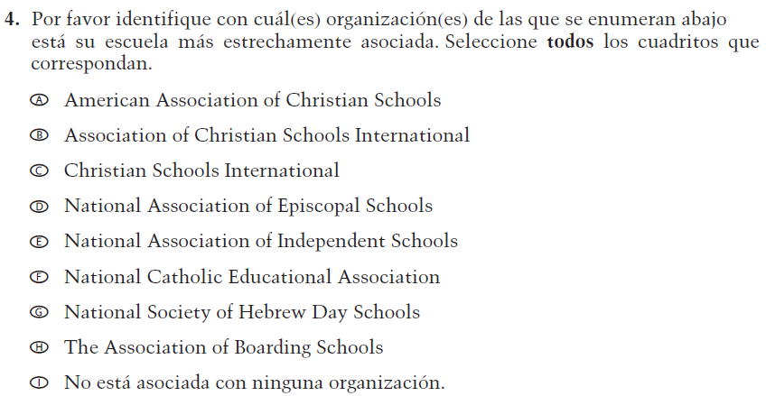  (2019 Operational Grade 4 School Core – Puerto Rico) | VH835855  Issue: School Climate | NC | N/A

2021 Operational Grade 4 Core School – Puerto Rico
Previous item | 2021 item | D/A/R/NC+ | Rationale
VH318289  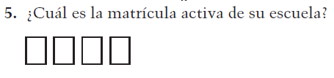  (2019 Operational Grade 4 School Core – Puerto Rico) | VH318289  Issue: School Climate | NC | N/A
VH318292  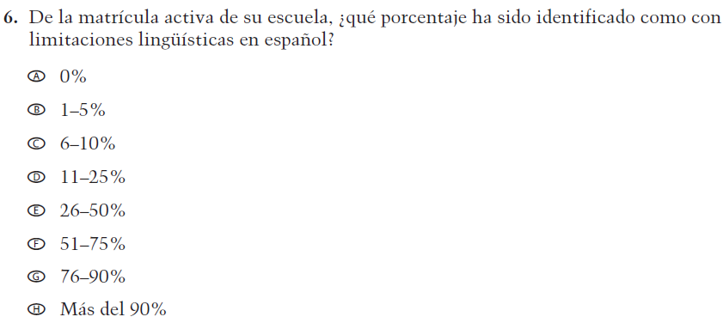  (2019 Operational Grade 4 School Core – Puerto Rico) | VH318292  Issue: School Climate | NC | N/A
VH318291  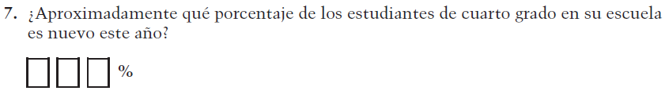  (2019 Operational Grade 4 School Core – Puerto Rico) | VH318291  Issue: School Climate | NC | N/A

2021 Operational Grade 4 Core School – Puerto Rico
Previous item | 2021 item | D/A/R/NC+ | Rationale
VH318298  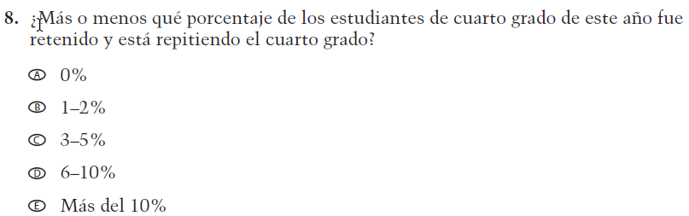  (2019 Operational Grade 4 School Core – Puerto Rico) | VH318298  Issue: School Climate | NC | N/A
VH318293  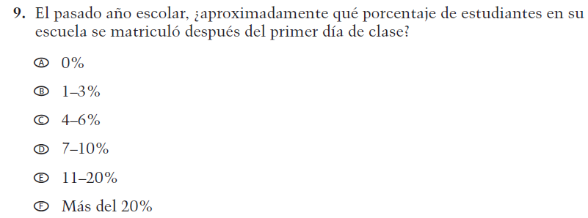  (2019 Operational Grade 4 School Core – Puerto Rico) | VH318293  Issue: School Climate | NC | N/A
VH318294  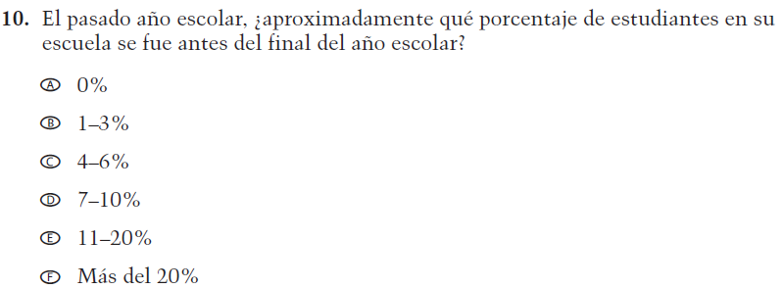  (2019 Operational Grade 4 School Core – Puerto Rico) | VH318294  Issue: School Climate | NC | N/A

2021 Operational Grade 4 Core School – Puerto Rico
Previous item | 2021 item | D/A/R/NC+ | Rationale
VH318297  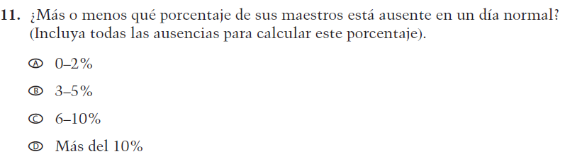  (2019 Operational Grade 4 School Core – Puerto Rico) | VH318297  Issue: School Climate | NC | N/A
VH318299  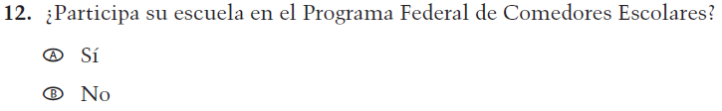  (2019 Operational Grade 4 School Core – Puerto Rico) | VH318299  Issue: Socioeconomic Status | NC | N/A
VH318300  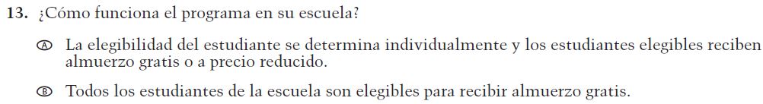  (2019 Operational Grade 4 School Core – Puerto Rico) | VH318300  Issue: Socioeconomic Status | NC | N/A
VH318303  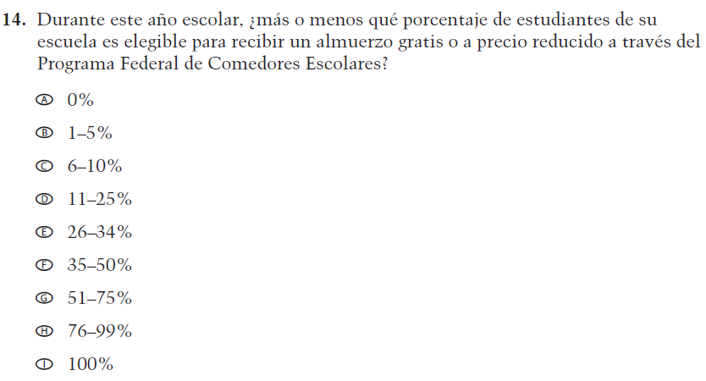  (2019 Operational Grade 4 School Core – Puerto Rico) | VH318303  Issue: Socioeconomic Status | NC | N/A

2021 Operational Grade 4 Core School – Puerto Rico
Previous item | 2021 item | D/A/R/NC+ | Rationale
VH318304  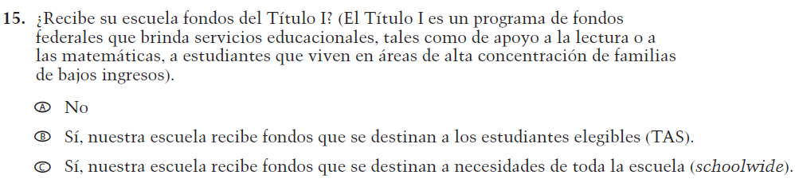  (2019 Operational Grade 4 School Core – Puerto Rico) | VH318304  Issue: Socioeconomic Status | NC | N/A
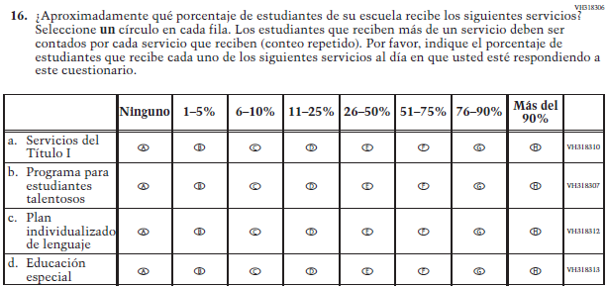  (2019 Operational Grade 4 School Core – Puerto Rico) | 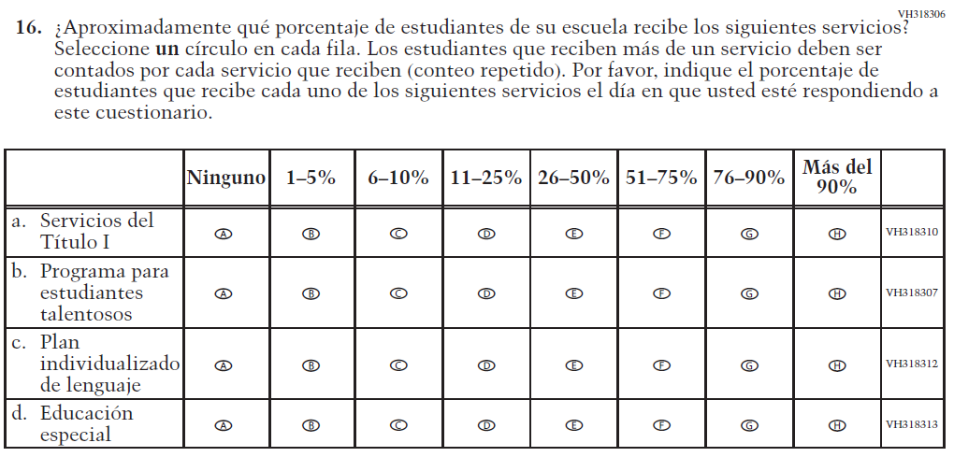  Issue: School Climate | R - “al día en que usted” changed to “el día en que usted” in SL  NC – subitems a through d | To correct a grammar error.
VH318316  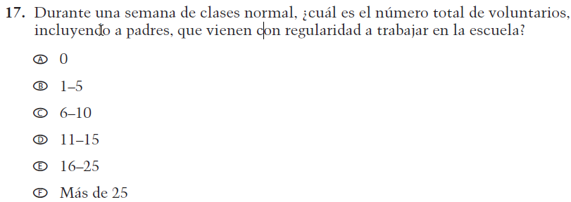  (2019 Operational Grade 4 School Core – Puerto Rico) | VH318316  Issue: School Climate | NC | N/A

2021 Operational Grade 4 Core School – Puerto Rico
Previous item | 2021 item | D/A/R/NC+ | Rationale
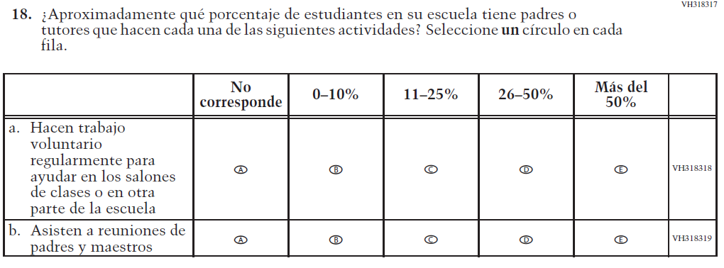  (2019 Operational Grade 4 School Core – Puerto Rico) | Issue: School Climate | NC | N/A
VH318321  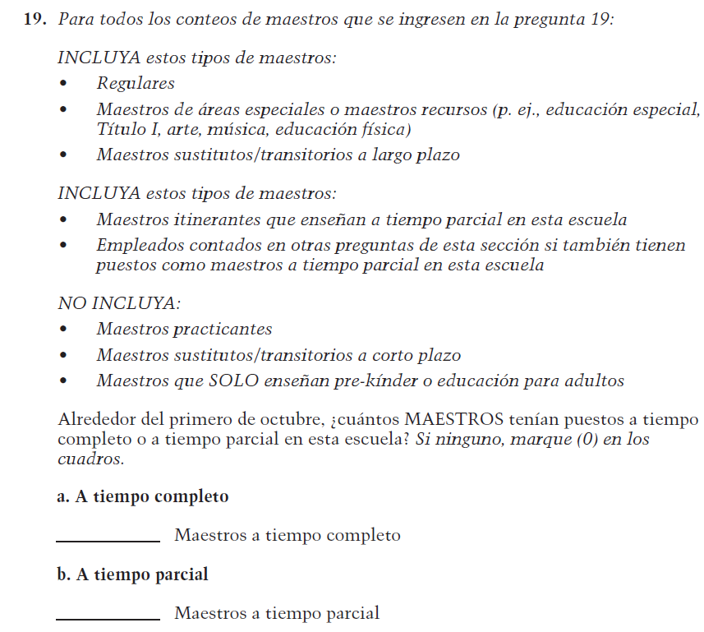  (2019 Operational Grade 4 School Core – Puerto Rico) | VH318321  Issue: School Climate | NC | N/A

2021 Operational Grade 4 Core School – Puerto Rico
Previous item | 2021 item | D/A/R/NC+ | Rationale
VH835853  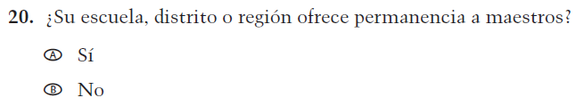  (2019 Operational Grade 4 School Core – Puerto Rico) | VH835853  Issue: School Climate | NC | N/A
VH893347  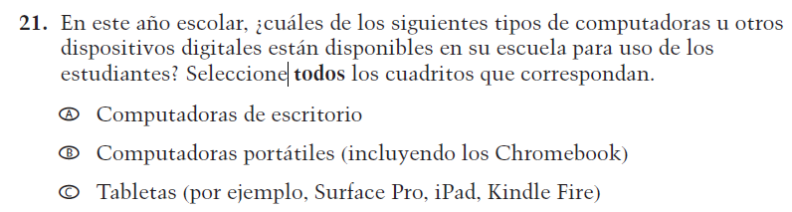  (2019 Operational Grade 4 School Core – Puerto Rico) | VH893347  Issue: Technology Use | NC | N/A
VH579614  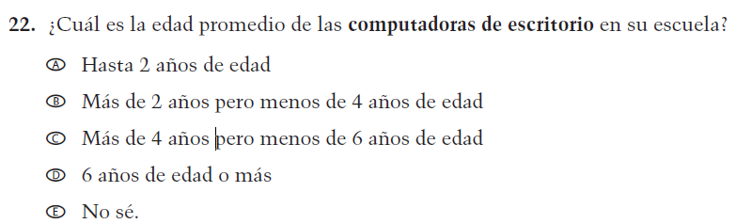  (2019 Operational Grade 4 School Core – Puerto Rico) | VH579614  Issue: Technology Use | NC | N/A

2021 Operational Grade 4 Core School – Puerto Rico
Previous item | 2021 item | D/A/R/NC+ | Rationale
VH893348  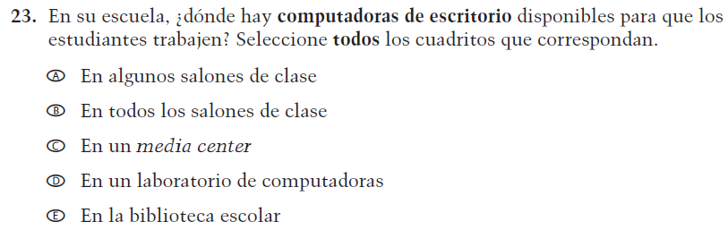  (2019 Operational Grade 4 School Core – Puerto Rico) | VH893348  Issue: Technology Use | NC | N/A
VH579616  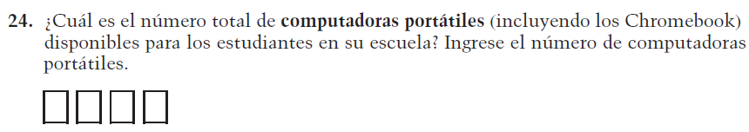  (2019 Operational Grade 4 School Core – Puerto Rico) | VH579616  Issue: Technology Use | NC | N/A
VH579617  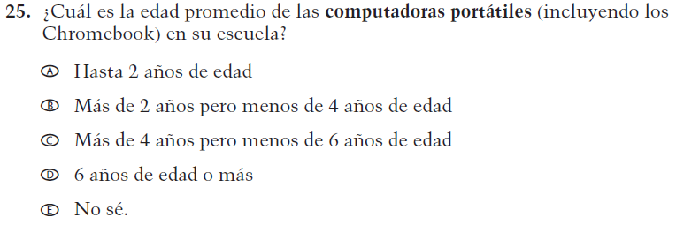  (2019 Operational Grade 4 School Core – Puerto Rico) | VH579617  Issue: Technology Use | NC | N/A

2021 Operational Grade 4 Core School – Puerto Rico
Previous item | 2021 item | D/A/R/NC+ | Rationale
VH893351  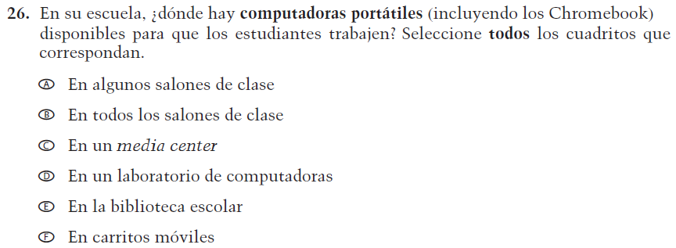  (2019 Operational Grade 4 School Core – Puerto Rico) | VH893351  Issue: Technology Use | NC | N/A
VH579619  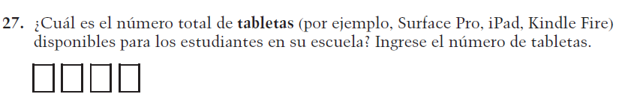  (2019 Operational Grade 4 School Core – Puerto Rico) | VH579619  Issue: Technology Use | NC | N/A
VH579620  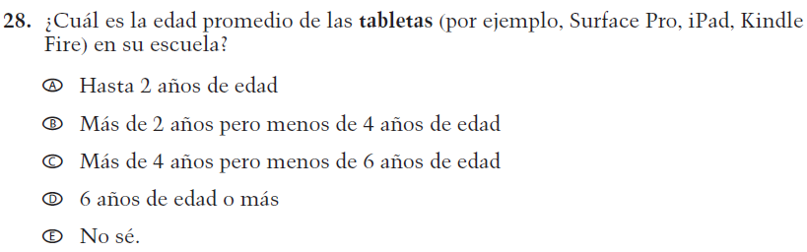  (2019 Operational Grade 4 School Core – Puerto Rico) | VH579620  Issue: Technology Use | NC | N/A

2021 Operational Grade 4 Core School – Puerto Rico
Previous item | 2021 item | D/A/R/NC+ | Rationale
VH893352  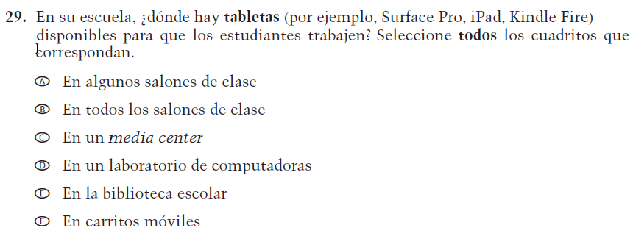  (2019 Operational Grade 4 School Core – Puerto Rico) | VH893352  Issue: Technology Use | NC | N/A
VH579601  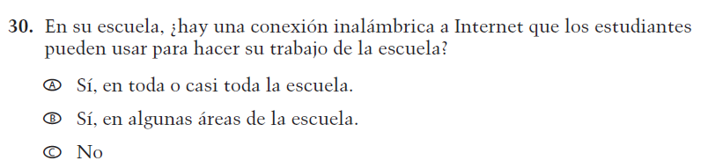  (2019 Operational Grade 4 School Core – Puerto Rico) | VH579601  Issue: Technology Use | NC | N/A

Appendix J-3a-s-PR: Operational Grade 4 CORE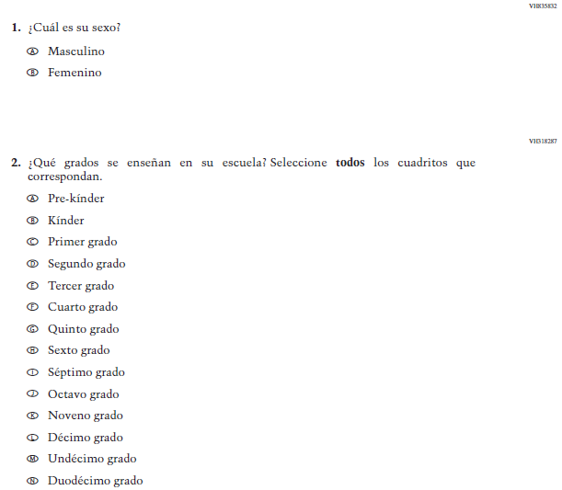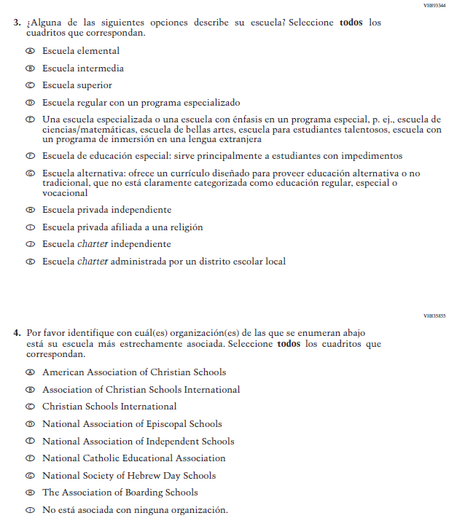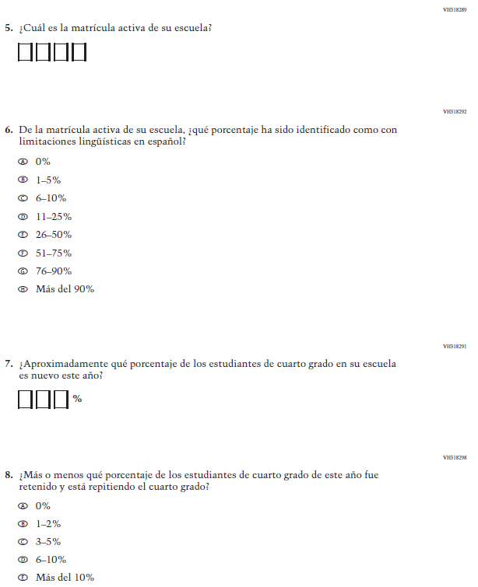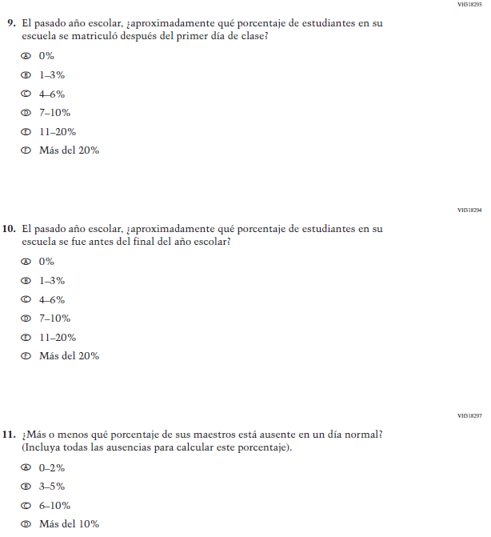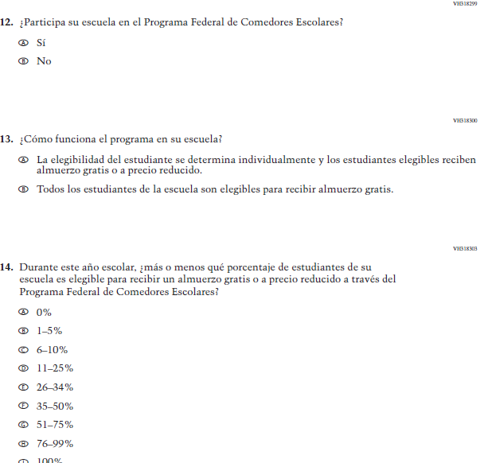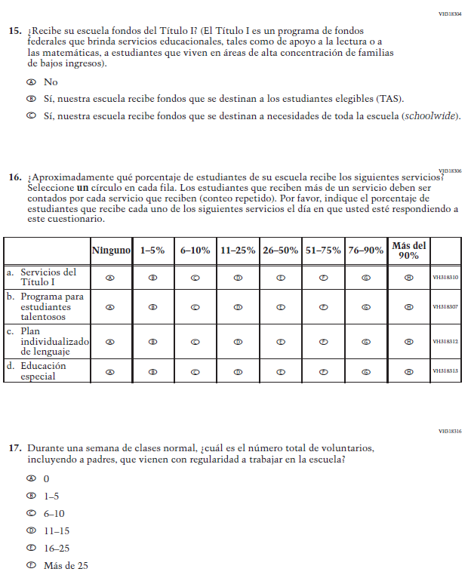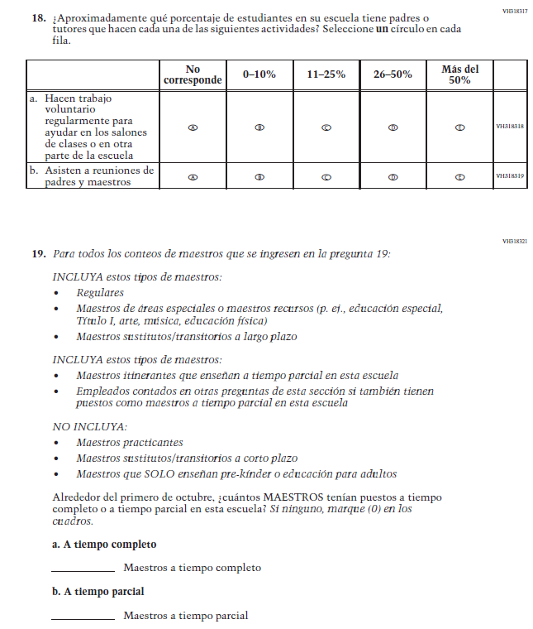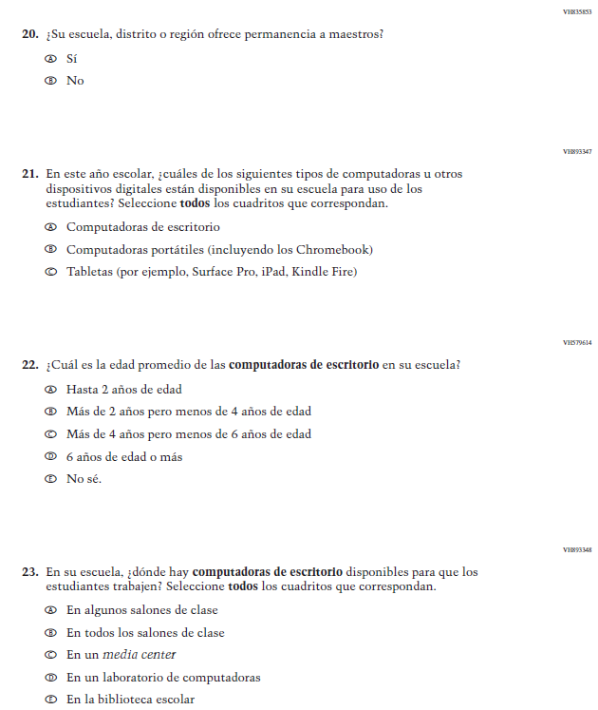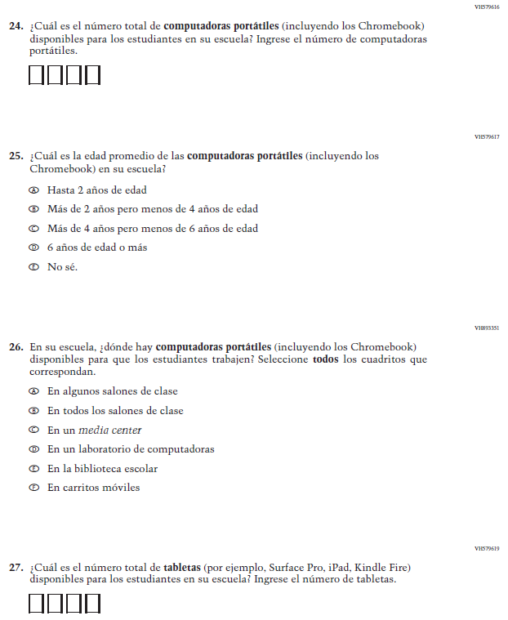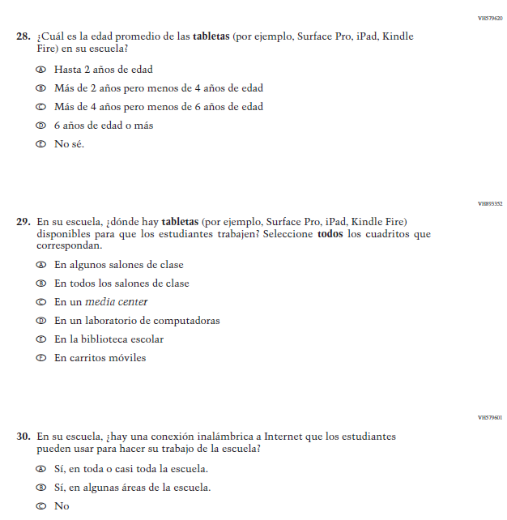

Appendix J-3b-s-PR: Summary of Changes Operational Grade 8 CORE
2021 Operational Grade 8 Core School – Puerto Rico
Previous item | 2021 item | D/A/R/NC+ | Rationale
VH835832  (2019 Operational Grade 8 School Core – Puerto Rico) | VH835832  Issue: Gender | NC | N/A
VH318287  (2019 Operational Grade 8 School Core – Puerto Rico) | VH318287  Issue: School Climate | NC | N/A

2021 Operational Grade 8 Core School – Puerto Rico
Previous item | 2021 item | D/A/R/NC+ | Rationale
VH893344  (2019 Operational Grade 8 School Core – Puerto Rico) | VH893344  Issue: School Climate | NC | N/A
VH835855  (2019 Operational Grade 8 School Core – Puerto Rico) | VH835855  Issue: School Climate | NC | N/A

2021 Operational Grade 8 Core School – Puerto Rico
Previous item | 2021 item | D/A/R/NC+ | Rationale
VH318289  (2019 Operational Grade 8 School Core – Puerto Rico) | VH318289  Issue: School Climate | NC | N/A
VH318292  (2019 Operational Grade 8 School Core – Puerto Rico) | VH318292  Issue: School Climate | NC | N/A
VH318558  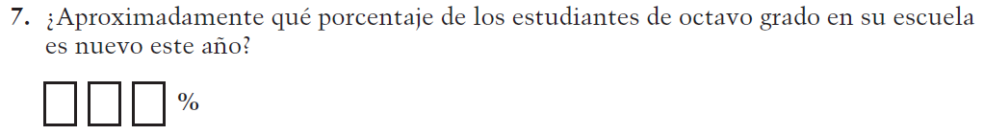  (2019 Operational Grade 8 School Core – Puerto Rico) | VH318558  Issue: School Climate | NC | N/A

2021 Operational Grade 8 Core School – Puerto Rico
Previous item | 2021 item | D/A/R/NC+ | Rationale
VH319391  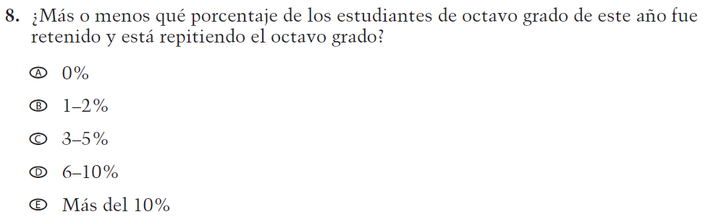  (2019 Operational Grade 8 School Core – Puerto Rico) | VH319391  Issue: School Climate | NC | N/A
VH318293  (2019 Operational Grade 8 School Core – Puerto Rico) | VH318293  Issue: School Climate | NC | N/A
VH318294  (2019 Operational Grade 8 School Core – Puerto Rico) | VH318294  Issue: School Climate | NC | N/A

2021 Operational Grade 8 Core School – Puerto Rico
Previous item | 2021 item | D/A/R/NC+ | Rationale
VH318297  (2019 Operational Grade 8 School Core – Puerto Rico) | VH318297  Issue: School Climate | NC | N/A
VH318299  (2019 Operational Grade 8 School Core – Puerto Rico) | VH318299  Issue: Socioeconomic Status | NC | N/A
VH318300  (2019 Operational Grade 8 School Core – Puerto Rico) | VH318300  Issue: Socioeconomic Status | NC | N/A
VH318303  (2019 Operational Grade 8 School Core – Puerto Rico) | VH318303  Issue: Socioeconomic Status | NC | N/A

2021 Operational Grade 8 Core School – Puerto Rico
Previous item | 2021 item | D/A/R/NC+ | Rationale
VH318304  (2019 Operational Grade 8 School Core – Puerto Rico) | VH318304  Issue: Socioeconomic Status | NC | N/A
(2019 Operational Grade 8 School Core – Puerto Rico) | Issue: School Climate | R - “al día en que usted” changed to “el día en que usted” in SL  NC – subitems a through d | To correct a grammar error.
VH318316  (2019 Operational Grade 8 School Core – Puerto Rico) | VH318316  Issue: School Climate | NC | N/A

2021 Operational Grade 8 Core School – Puerto Rico
Previous item | 2021 item | D/A/R/NC+ | Rationale
(2019 Operational Grade 8 School Core – Puerto Rico) | Issue: School Climate | NC | N/A
VH318321  (2019 Operational Grade 8 School Core – Puerto Rico) | VH318321  Issue: School Climate | NC | N/A

2021 Operational Grade 8 Core School – Puerto Rico
Previous item | 2021 item | D/A/R/NC+ | Rationale
VH835853  (2019 Operational Grade 8 School Core – Puerto Rico) | VH835853  Issue: School Climate | NC | N/A
VH893347  (2019 Operational Grade 8 School Core – Puerto Rico) | VH893347  Issue: Technology Use | NC | N/A
VH579614  (2019 Operational Grade 8 School Core – Puerto Rico) | VH579614  Issue: Technology Use | NC | N/A

2021 Operational Grade 8 Core School – Puerto Rico
Previous item | 2021 item | D/A/R/NC+ | Rationale
VH893348  (2019 Operational Grade 8 School Core – Puerto Rico) | VH893348  Issue: Technology Use | NC | N/A
VH579616  (2019 Operational Grade 8 School Core – Puerto Rico) | VH579616  Issue: Technology Use | NC | N/A
VH579617  (2019 Operational Grade 8 School Core – Puerto Rico) | VH579617  Issue: Technology Use | NC | N/A

2021 Operational Grade 8 Core School – Puerto Rico
Previous item | 2021 item | D/A/R/NC+ | Rationale
VH893351  (2019 Operational Grade 8 School Core – Puerto Rico) | VH893351  Issue: Technology Use | NC | N/A
VH579619  (2019 Operational Grade 8 School Core – Puerto Rico) | VH579619  Issue: Technology Use | NC | N/A
VH579620  (2019 Operational Grade 8 School Core – Puerto Rico) | VH579620  Issue: Technology Use | NC | N/A

2021 Operational Grade 8 Core School – Puerto Rico
Previous item | 2021 item | D/A/R/NC+ | Rationale
VH893352  (2019 Operational Grade 8 School Core – Puerto Rico) | VH893352  Issue: Technology Use | NC | N/A
VH579601  (2019 Operational Grade 8 School Core – Puerto Rico) | VH579601  Issue: Technology Use | NC | N/A

Appendix J-3b-s-PR: Operational Grade 8 CORE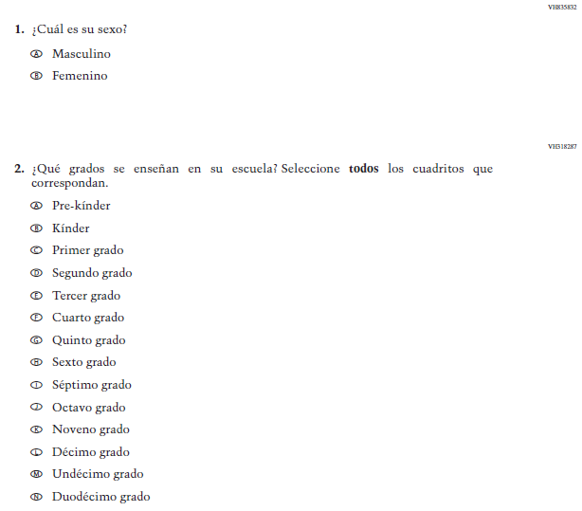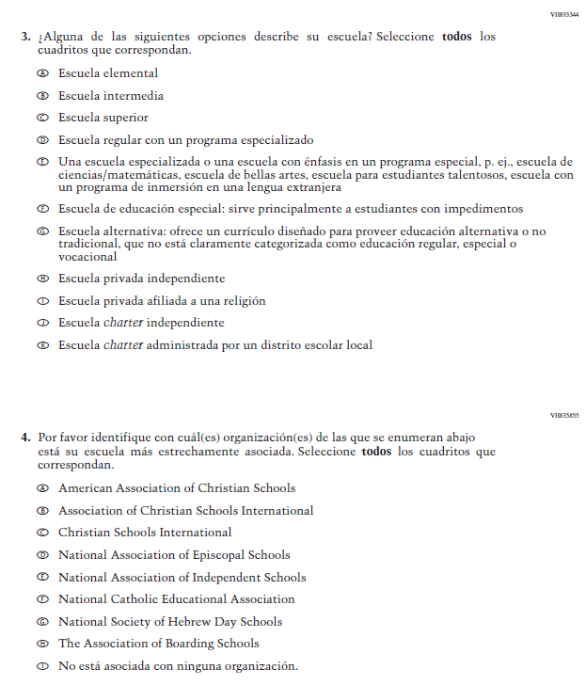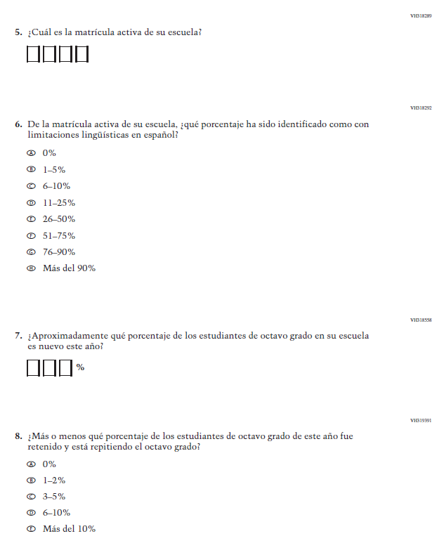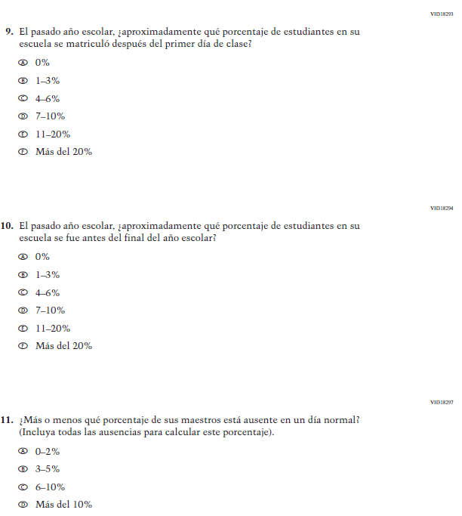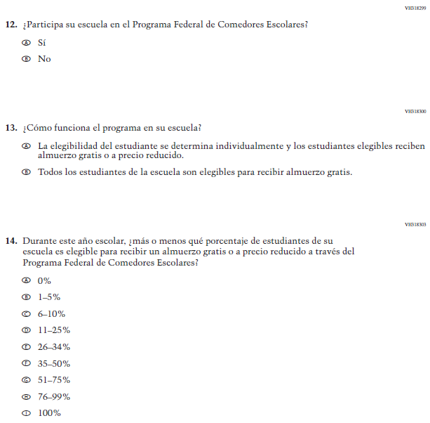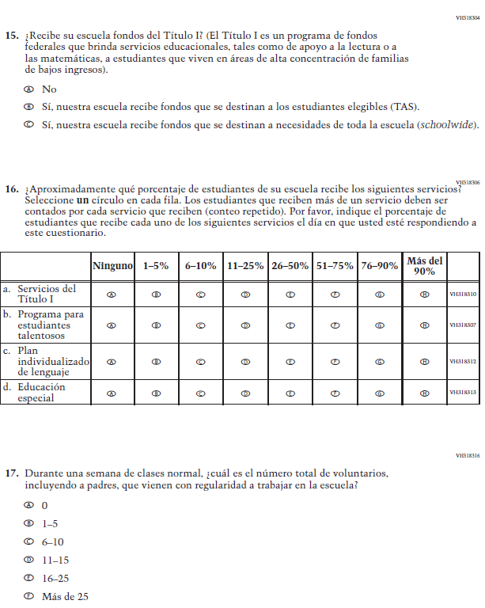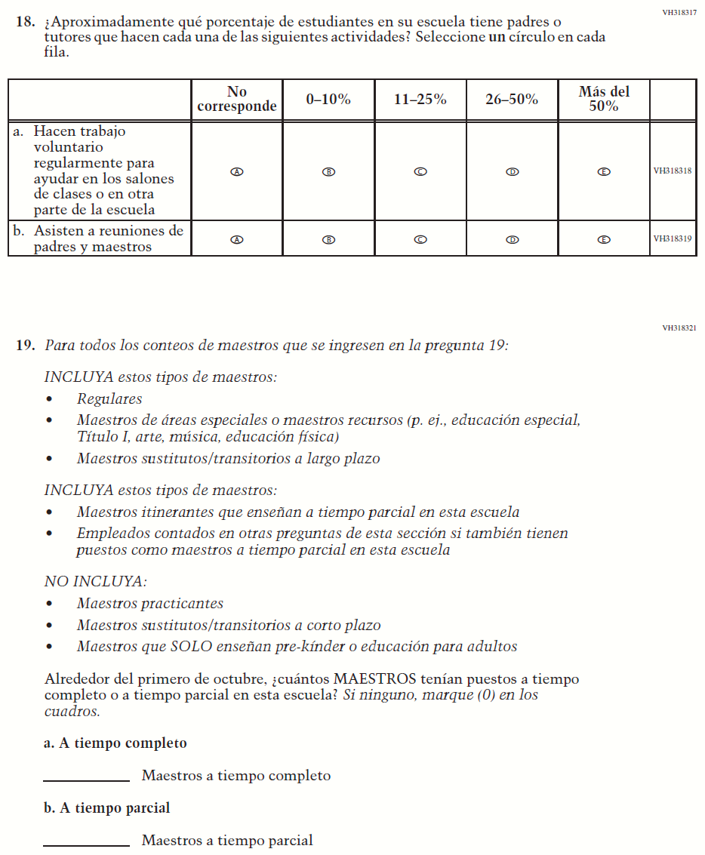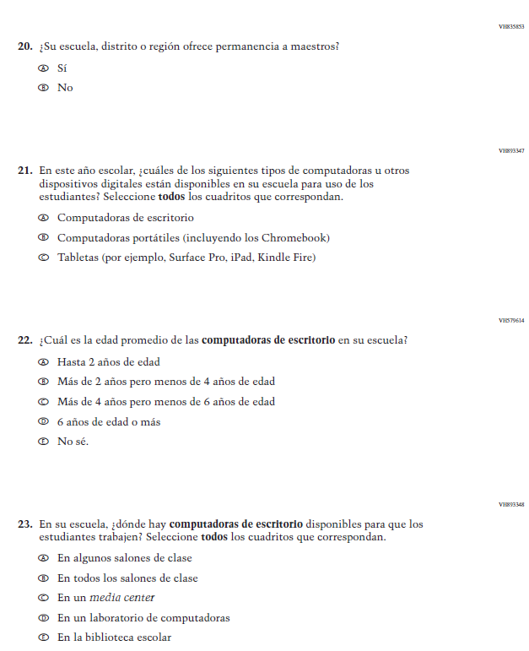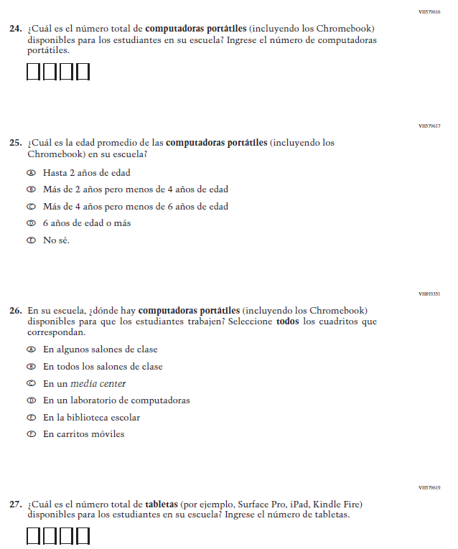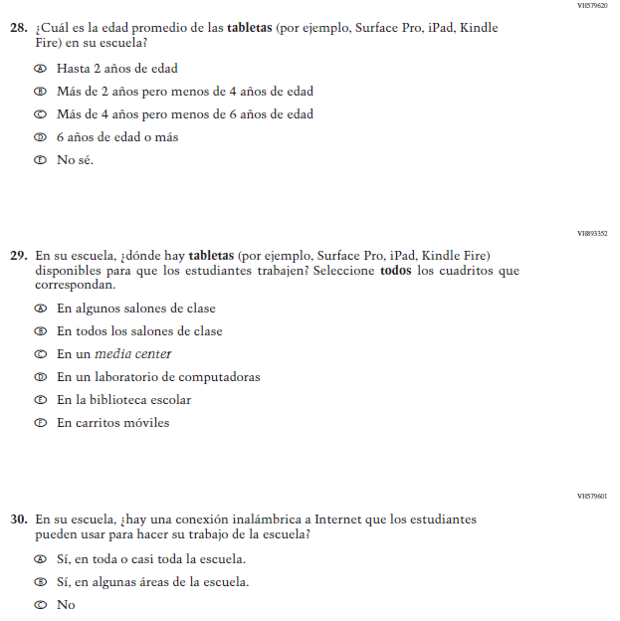

Appendix J-3d-s-PR: Summary of Changes Operational Grade 4 Mathematics
2021 Operational Grade 4 Mathematics School – Puerto Rico
Previous item | 2021 item | D/A/R/NC+ | Rationale
VH579623  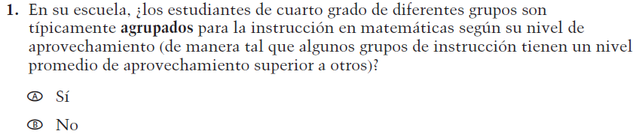  (2019 Operational Grade 4 School Mathematics – Puerto Rico) | VH579623  Issue: Resources for Learning and Instruction | NC | N/A
VH857365  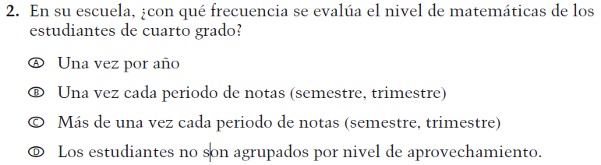  (2019 Operational Grade 4 School Mathematics – Puerto Rico) | VH857365  Issue: Organization of Instruction | NC | N/A
VH579648  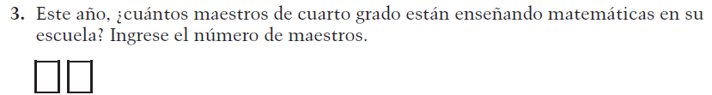  (2019 Operational Grade 4 School Mathematics – Puerto Rico) | VH579648  Issue: Resources for Learning and Instruction | N/C | N/A
VH318441  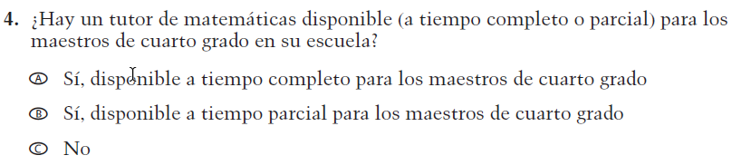  (2019 Operational Grade 4 School Mathematics – Puerto Rico) | VH318441  Issue: Resources for Learning and Instruction | NC | N/A

2021 Operational Grade 4 Mathematics School – Puerto Rico
Previous item | 2021 item | D/A/R/NC+ | Rationale
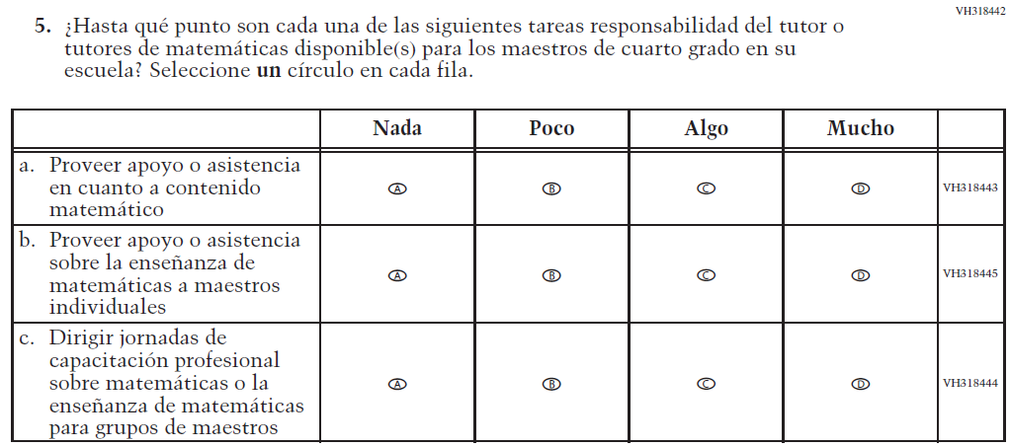  (2019 Operational Grade 4 School Mathematics – Puerto Rico) | Issue: Resources for Learning and Instruction | NC | N/A
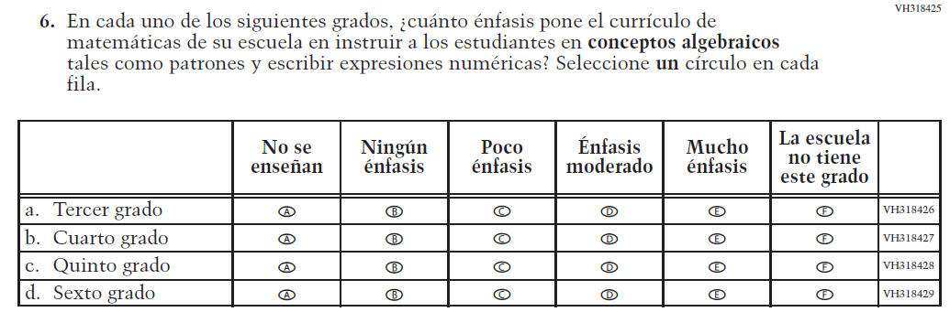  (2019 Operational Grade 4 School Mathematics – Puerto Rico) | Issue: Organization of Instruction | NC | N/A
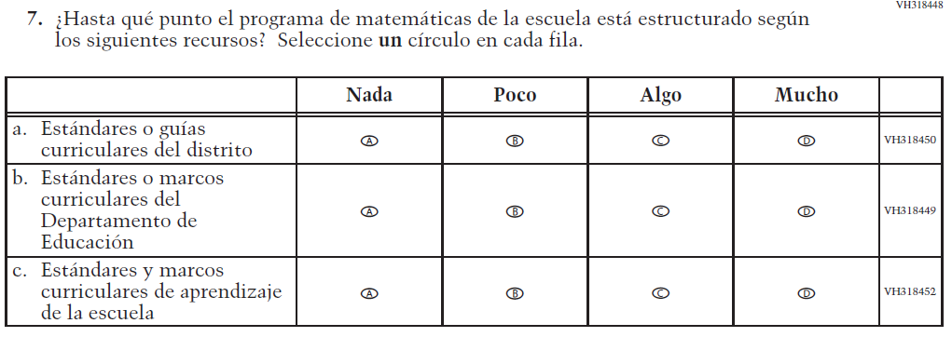  (2019 Operational Grade 4 School Mathematics – Puerto Rico) | Issue: Organization of Instruction | NC | N/A

2021 Operational Grade 4 Mathematics School – Puerto Rico
Previous item | 2021 item | D/A/R/NC+ | Rationale
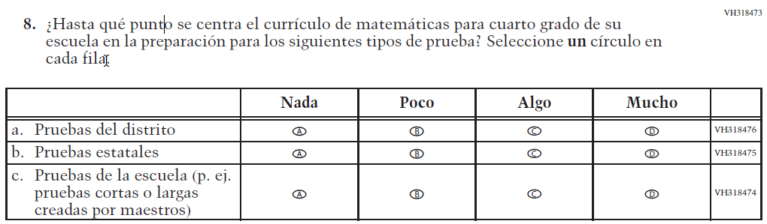  (2019 Operational Grade 4 School Mathematics – Puerto Rico) | Issue: Organization of Instruction | NC | N/A
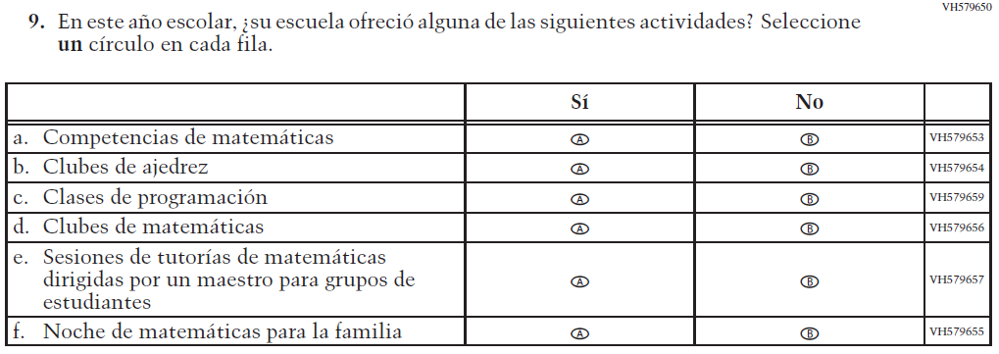  (2019 Operational Grade 4 School Mathematics – Puerto Rico) | Issue: Resources for Learning and Instruction | NC | N/A

Appendix J-3d-s-PR: Operational Grade 4 Mathematics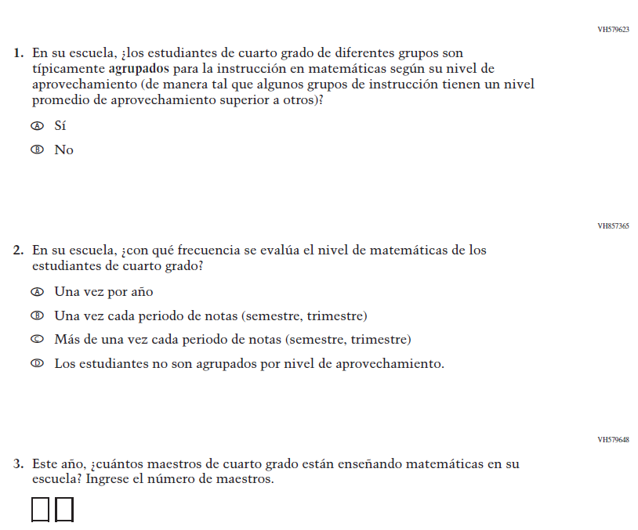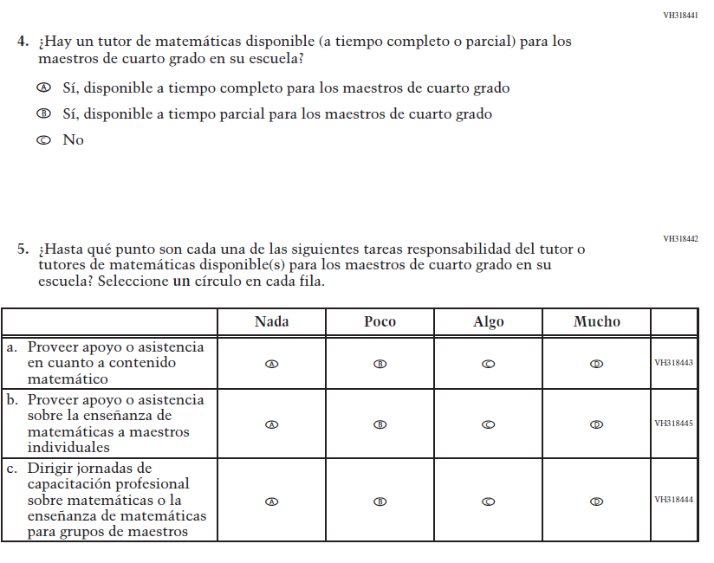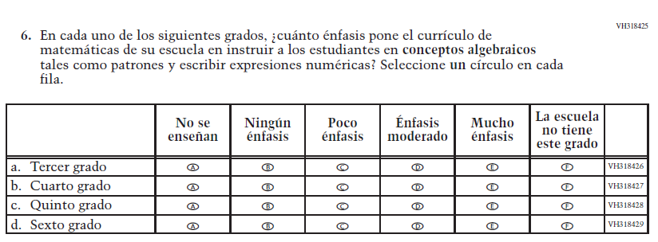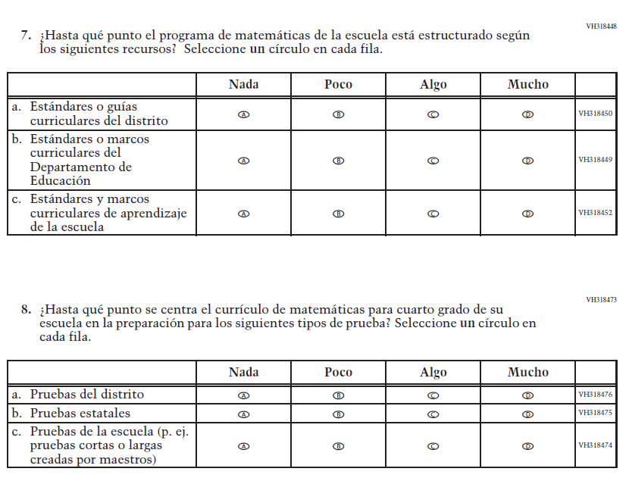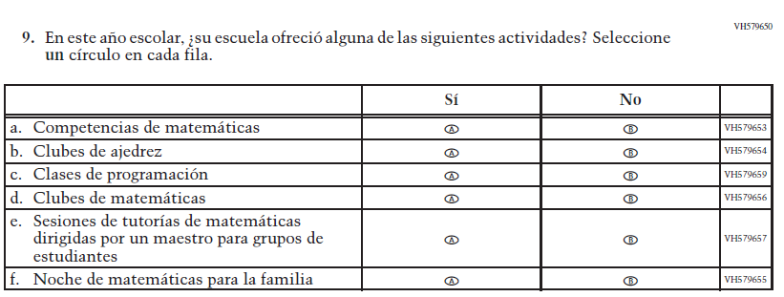

Appendix J-3d-s-PR: Summary of Changes Operational Grade 8 Mathematics
2021 Operational Grade 8 Mathematics School – Puerto Rico
Previous item | 2021 item | D/A/R/NC+ | Rationale
VH610664  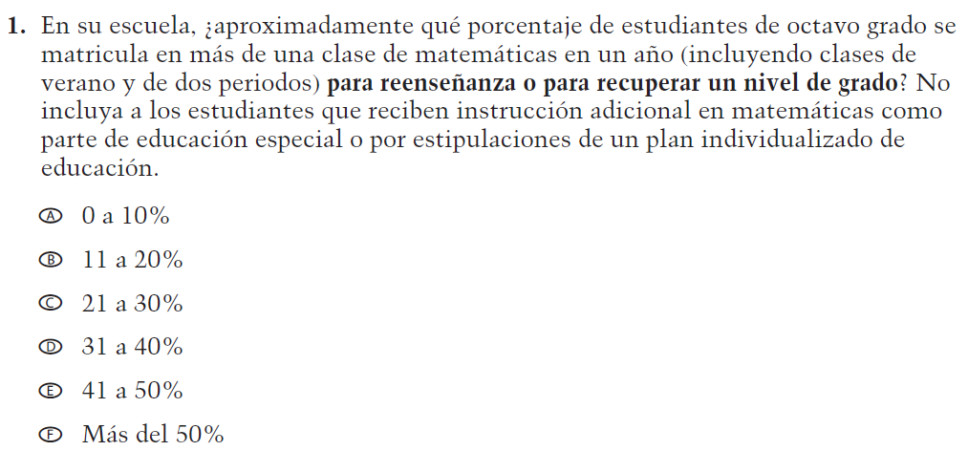  (2019 Operational Grade 8 School Mathematics – Puerto Rico) | VH610664  Issue: Organization of Instruction | NC | N/A
VH610661  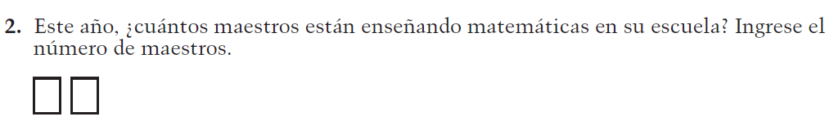  (2019 Operational Grade 8 School Mathematics – Puerto Rico) | VH610661  Issue: Resources for Learning and Instruction | NC | N/A
VH857377  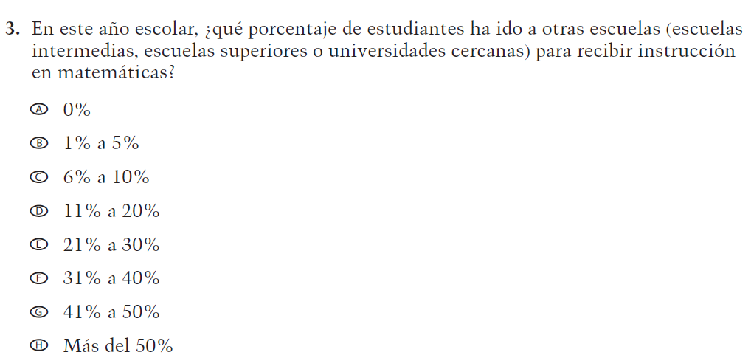  (2019 Operational Grade 8 School Mathematics – Puerto Rico) | VH857377  Issue: Resources for Learning and Instruction | N/C | N/A

2021 Operational Grade 8 Mathematics School – Puerto Rico
Previous item | 2021 item | D/A/R/NC+ | Rationale
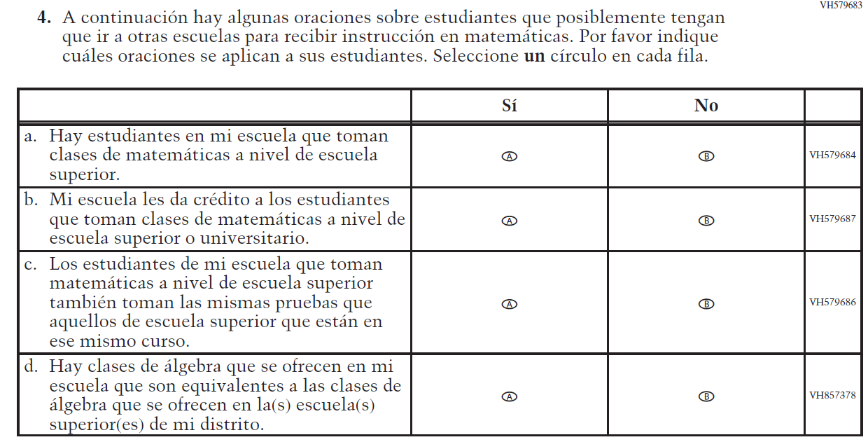  (2019 Operational Grade 8 School Mathematics – Puerto Rico) | Issue: Resources for Learning and Instruction | NC | N/A
VH318639  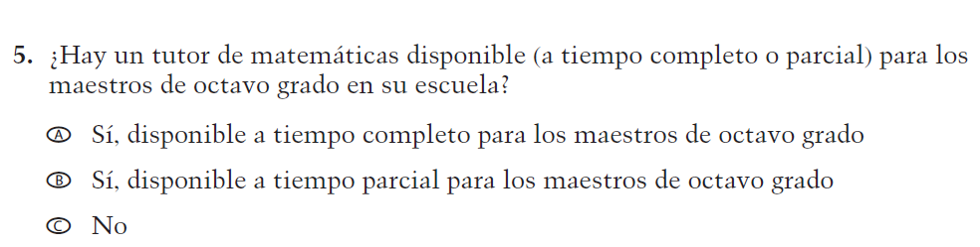  (2019 Operational Grade 8 School Mathematics – Puerto Rico) | VH318639  Issue: Resources for Learning and Instruction | NC | N/A
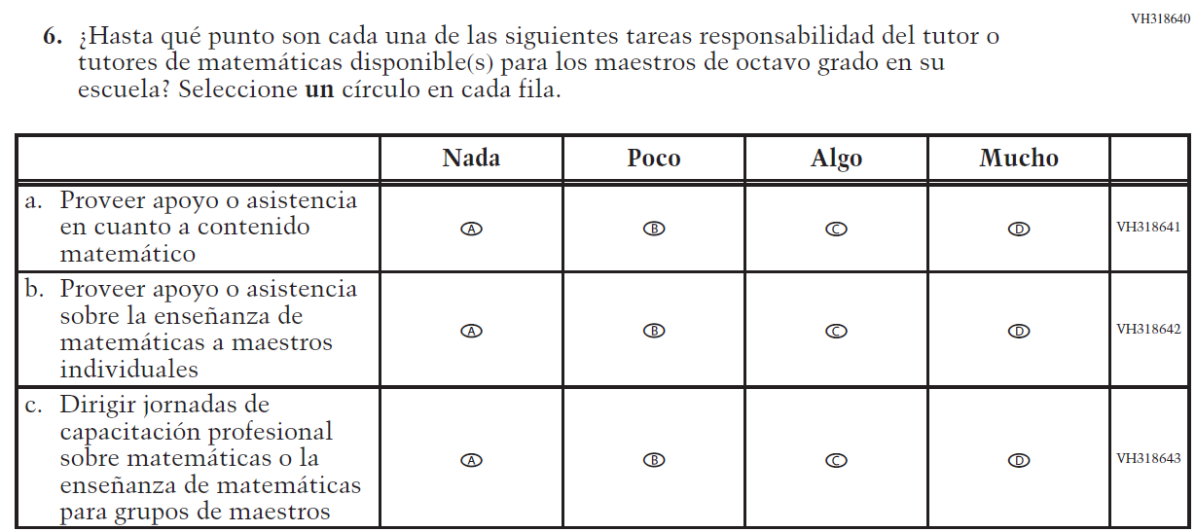  (2019 Operational Grade 8 School Mathematics – Puerto Rico) | Issue: Resources for Learning and Instruction | NC | N/A

2021 Operational Grade 8 Mathematics School – Puerto Rico
Previous item | 2021 item | D/A/R/NC+ | Rationale
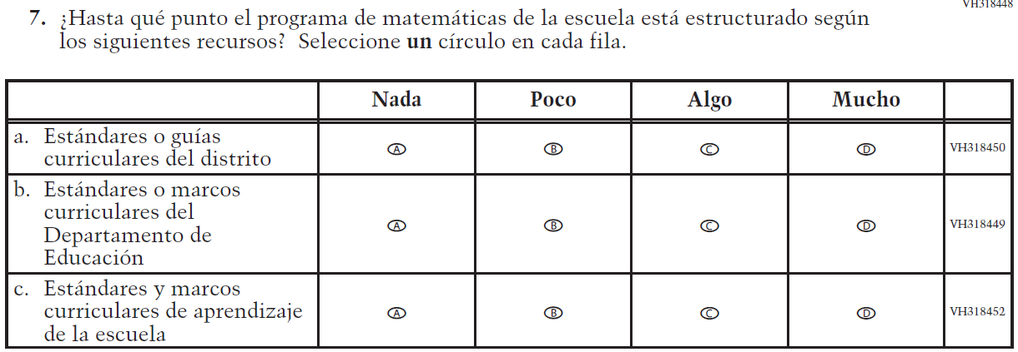  (2019 Operational Grade 8 School Mathematics – Puerto Rico) | Issue: Organization of Instruction | NC | N/A
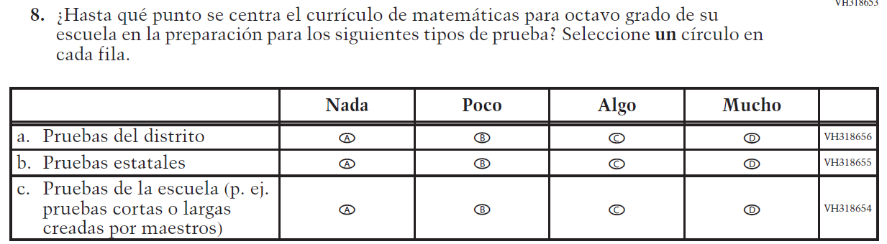  (2019 Operational Grade 8 School Mathematics – Puerto Rico) | Issue: Organization of Instruction | NC | N/A
(2019 Operational Grade 8 School Mathematics – Puerto Rico) | Issue: Resources for Learning and Instruction | NC | N/A

Appendix J-3d-s-PR: Operational Grade 8 Mathematics