Early Childhood Longitudinal Study, Kindergarten Class of 2022-23 (ECLS-K:2023)

Kindergarten and First-Grade Field Test Data Collection, National Sampling, and National Recruitment

OMB# 1850-0750 v.22

Attachment A-1
K-1 Field Test Respondent Materials

National Center for Education Statistics
U.S. Department of Education

September 2020
revised November 2020

Table of Contents
NOTE: In this list, materials being translated into Spanish are denoted with an asterisk (“*”). The Spanish translations will be provided in the March 2021 change memo.
Section Page
ECLS Study Overview Field Test 1
School District Recruitment Letter Field Test 5
ECLS Coronavirus Protocols Overview Field Test 8
School District Nonresponse Letter Field Test 9
School Recruitment Letter Field Test 11
Recruitment Follow–up Letter for Pending/Refusal Schools Field Test 14
Recruitment Email Template for Difficult-to-Reach Principals Field Test 16
Recruitment Email Template School Staff Considering Participation Field Test 18
Recruitment Email Template Follow–up to Address Concerns Field Test 20
Recruitment Email Template Follow–up after Cooperation Achieved Field Test 21
Follow–up Letter for Participating but Difficult to Contact Schools Field Test 22
Spring Email for School Coordinators Field Test 24
School Coordinator Responsibilities Checklist Field Test 26
Summer Email for School Coordinators Field Test 29
School Coordinator Email Announcing E–filing Field Test 31
Instructions for School Coordinators to E–file Child List Field Test 32
Email Providing MyECLS PIN to School Coordinators, School Administrators, and Teachers Field Test 33
Email Providing Secondary MyECLS PIN to School Administrators Field Test 34
School Coordinator Email: Tracking Form Availability Field Test 35
School Coordinator Email: Study Activities Package Arrival Notification Field Test 36
School Coordinator Guide for Encouraging Participation Field Test 38
School Administrator Notification Email Field Test 41
Teacher Notification Email Field Test 42
Parent Notification Email Field Test 43
School Coordinator Study Activities Package Cover Letter Field Test 44
School Administrator Welcome Letter Field Test 46
School Administrator Survey Worksheet Field Test 47
Teacher Welcome Letter Field Test 49
Teacher Fact Sheet Field Test 51
Parent Welcome Letter Field Test 53
Parent Fact Sheet Field Test 55
Explicit Consent Form for Parents Field Test 57
Implicit Consent Form for Parents Field Test 58
Postcard Providing MyECLS PIN to Parents Field Test 59
First Consent and Survey Completion Reminder Email for School Coordinators Field Test 60
First Consent and Survey Completion Reminder Email for Parents (attached to first SC email) Field Test 62
First Consent and Survey Completion Reminder Text Message for Parents (attached to first SC email) Field Test 64
First Survey Completion Reminder Email for Teachers and School Administrator (attached to first SC email) Field Test 65
Second Consent and Survey Completion Reminder Email for School Coordinators Field Test 67
Second Consent and Survey Completion Reminder Email for Parents (attached to second SC email) Field Test 68
Second Consent and Survey Completion Reminder Text Message for Parents (attached to second SC email) Field Test 69
Second Survey Completion Reminder Email for Teachers and School Administrator (attached to second SC email) Field Test 70
Third Survey Completion Reminder Email for School Coordinators Field Test 71
Third Survey Completion Reminder Email for Parents (attached to third SC email) Field Test 72
Third Survey Reminder Text Message for Parents (attached to third SC email) Field Test 73
Third Survey Completion Reminder Email for Teachers and School Administrator (attached to third SC email) Field Test 74
Fourth Survey Completion Reminder Email for School Coordinators Field Test 75
Fourth Survey Completion Reminder Email for Parents (attached to fourth SC email) Field Test 76
Fourth Survey Completion Reminder Text for Parents (attached to fourth SC email) Field Test 77
Fourth Survey Completion Reminder Email for Teachers and School Administrator (attached to fourth SC email) Field Test 78
School, School Administrator, School Coordinator, and Teacher Thank You Letter Field Test 79
Thank You Email for School Coordinators Field Test 80
Thank You Email for Parents Field Test 81
Notification of Feedback Questions for School Coordinator Field Test 82
Notification of Feedback Questions for School Administrator, Teachers, and Parents Field Test 83
Certification of Contribution Field Test 84
Study Letterhead Field Test 85

ECLS Study Overview
Field Test

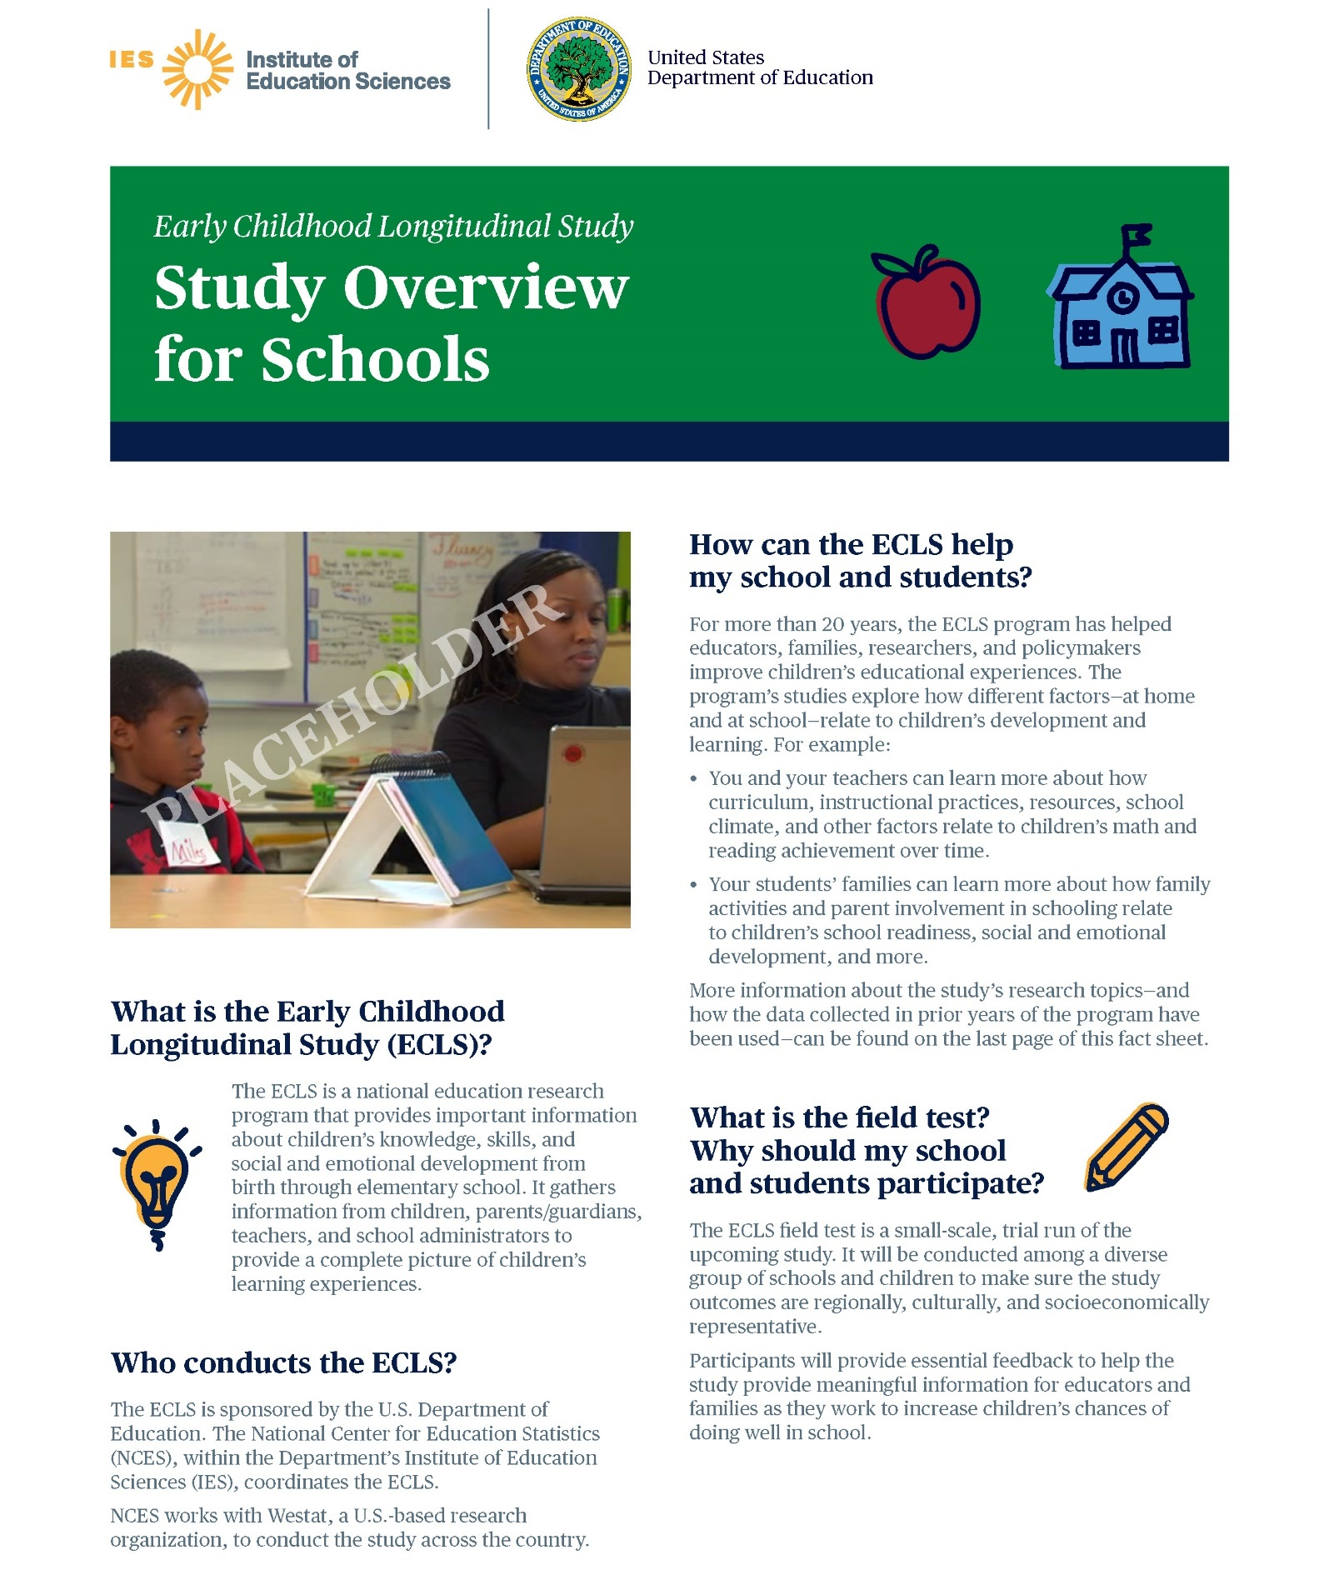

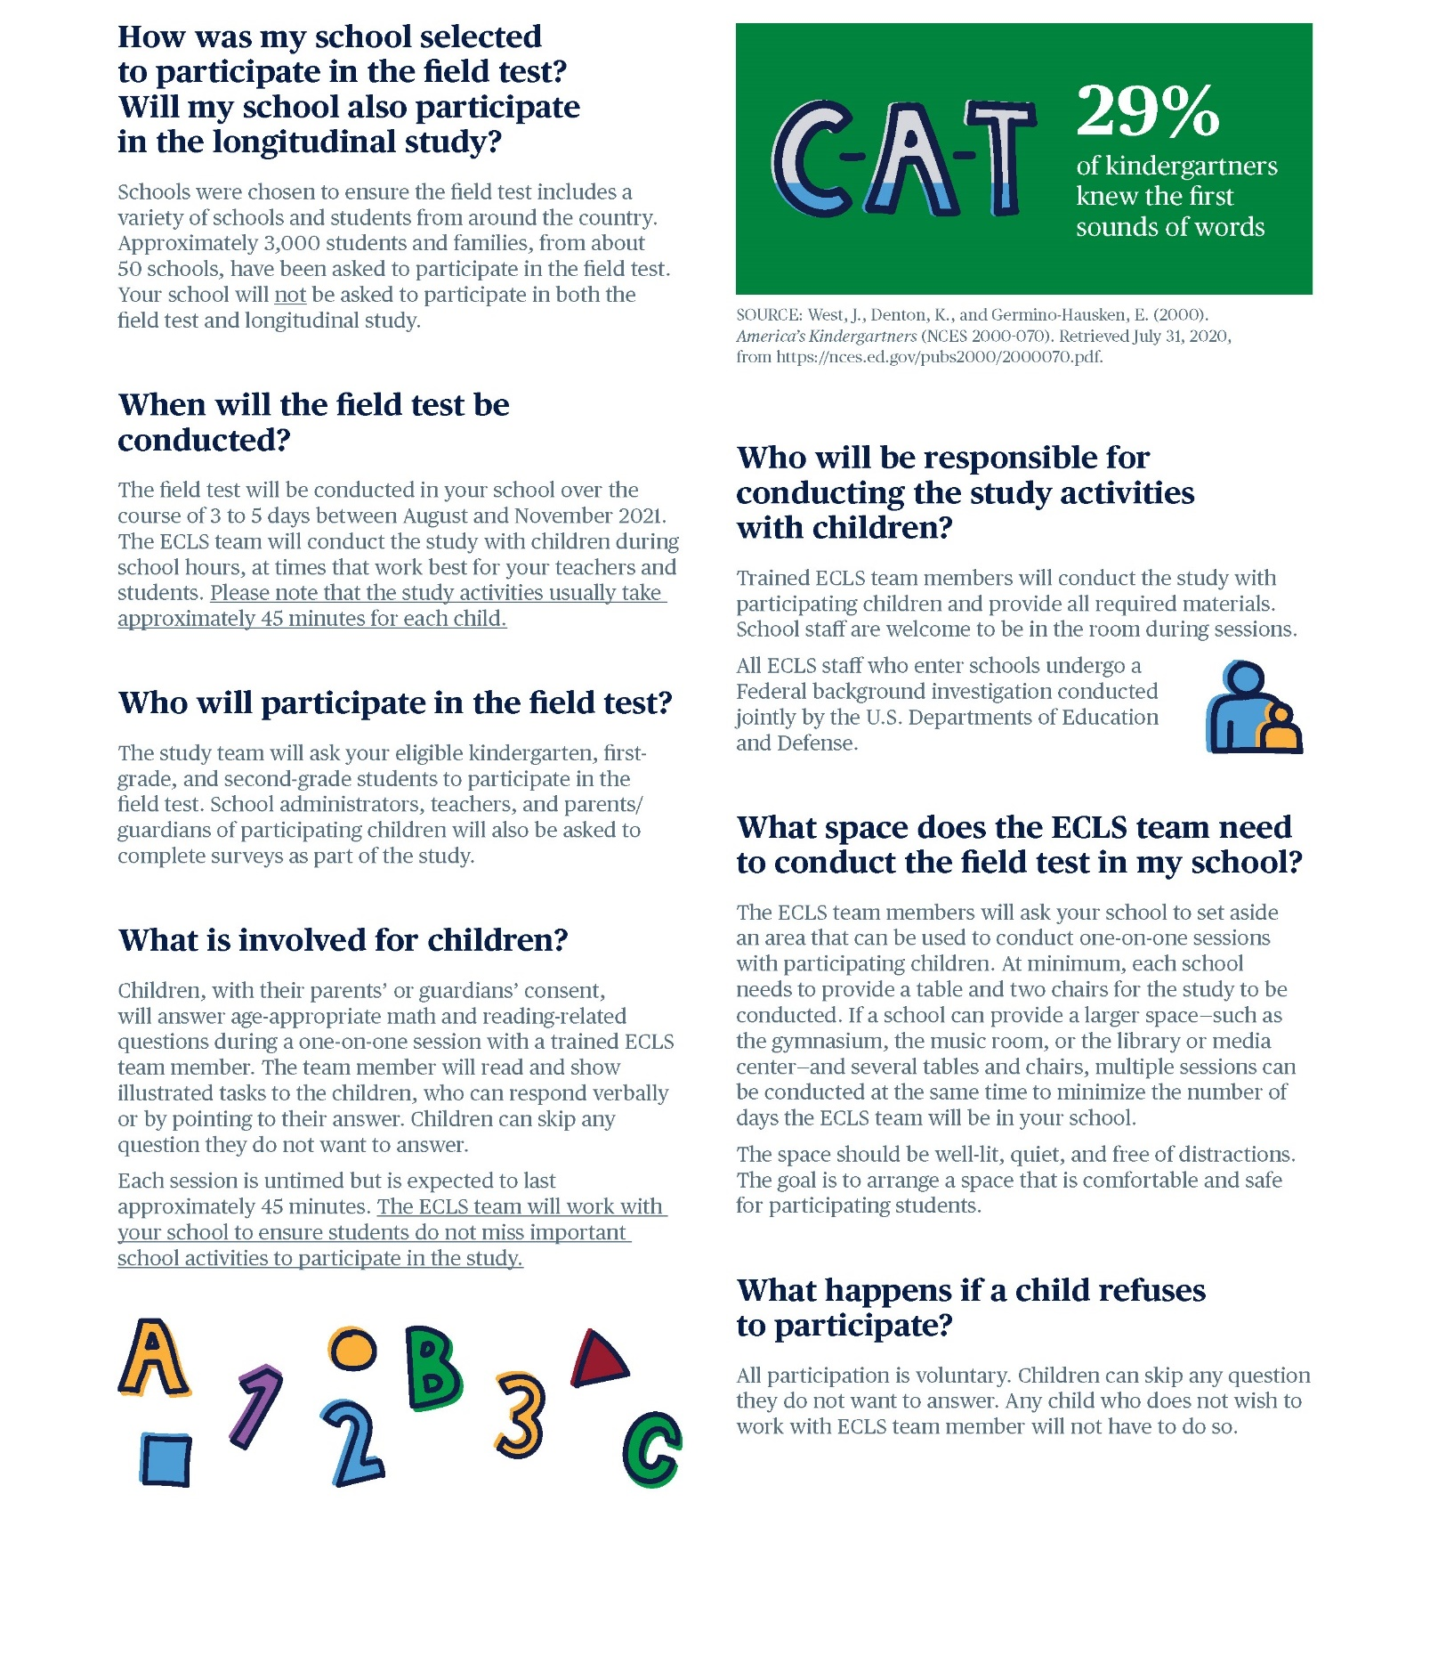

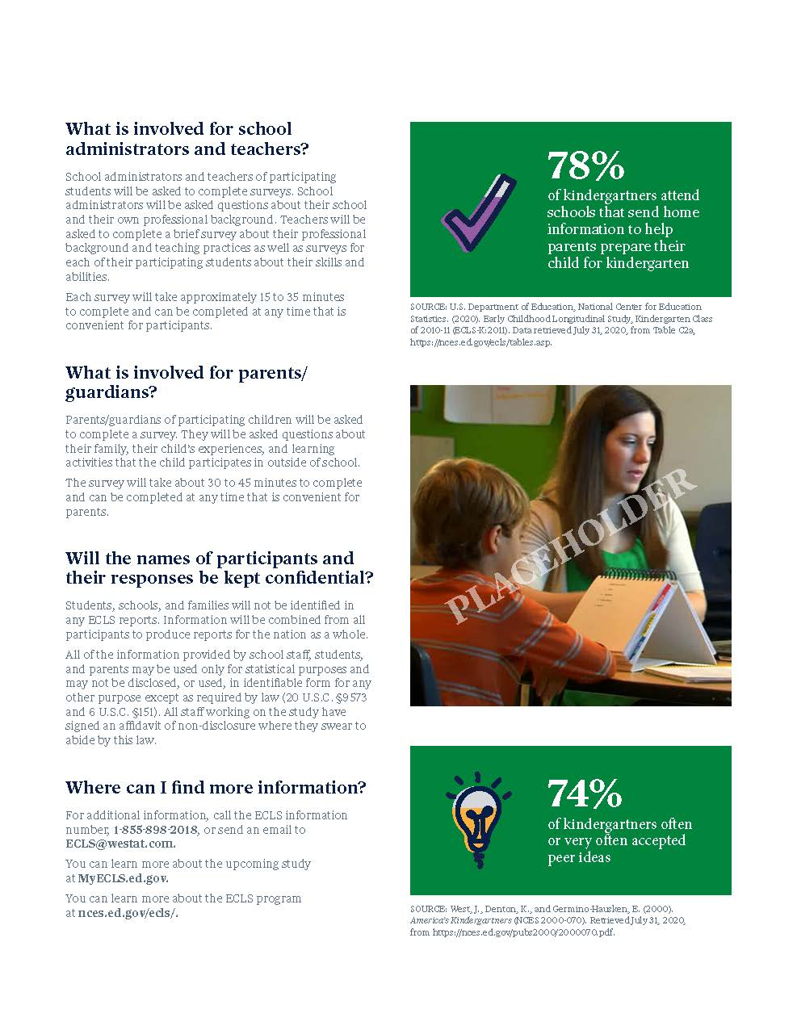
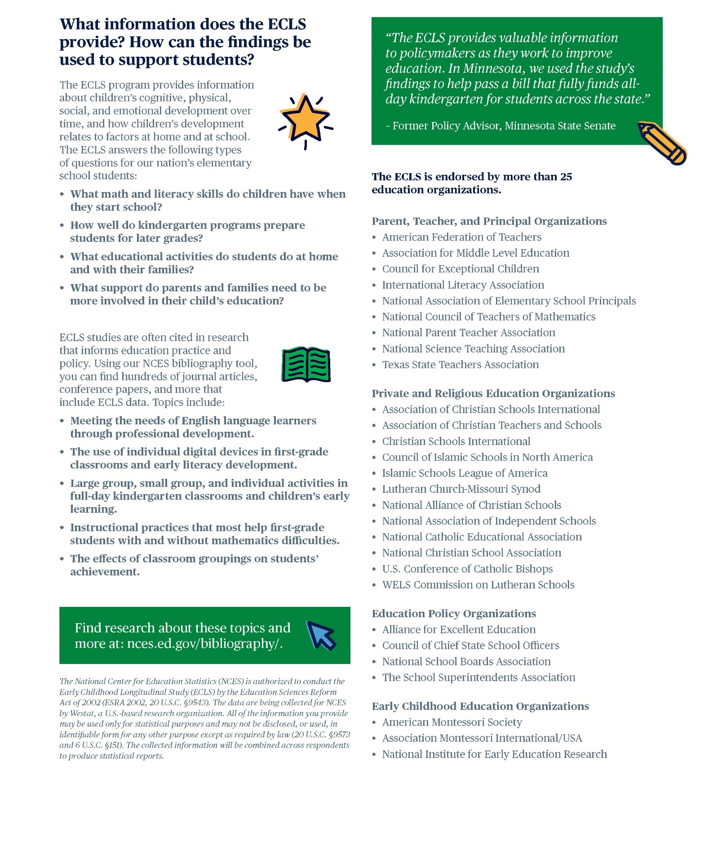

School District Recruitment Letter
Field Test
[DATE]
[TITLE] [NAME FIRST] [NAME LAST]
[TITLE/DEPARTMENT]
[SCHOOL DISTRICT]
[ADDRESS 1]
[CITY], [STATE] [ZIP CODE]

Dear [TITLE] [NAME LAST]:

The U.S. Department of Education is preparing to work with a new cohort of elementary-aged students for a national education research study called the Early Childhood Longitudinal Study (ECLS). This study will help improve educational experiences and outcomes for all students in the United States. In order to inform the national data collections, a field test of study activities is planned for the fall of 2021.The enclosed Study Overview provides more details about the study and what is involved for the participants.

The current ECLS is the fourth cohort in the series of early childhood longitudinal studies that make up the ECLS research program. For more than 20 years, the ECLS program has helped educators, families, researchers, and policymakers better understand and improve children’s educational experiences from birth through elementary school. For more details about the ECLS program, visit nces.ed.gov/ecls.

[IF CORONAVIRUS NEEDS TO BE ADDRESSED] As we make plans for the fall 2021 data collection, the coronavirus pandemic continues to pose significant challenges for state agencies, districts, and schools, while also affecting us all personally. As the situation with the coronavirus pandemic evolves, please know that we recognize these challenges and are implementing processes and procedures to protect the health and safety of students, school staff, and the ECLS staff. We will follow recommended guidance from health experts and work closely with our state, district, and school partners to determine how to best proceed with the study in schools. The enclosed Coronavirus Safety Planning fact sheet provides more details the safety measures that are currently planned.

The ECLS field test study activities will include one-on-one child assessments conducted by trained ECLS staff and self-administered web surveys completed by school administrators, teachers, and parents of sampled children. The ECLS field test will be conducted among a diverse group of schools and children to ensure that the study outcomes are regionally, culturally, and socioeconomically representative. Participants will provide essential feedback that will inform the national data collection.

Some schools in your district have been randomly selected to participate in the field test phase of the ECLS in fall 2021, and I am writing to ask for your district’s support of the study and the selected schools’ participation. While the study is voluntary, by permitting our staff to contact selected schools in your district to discuss participation and encouraging those schools to participate, you will help ensure a successful data collection.

Study staff will be contacting you soon to discuss the participation of the selected schools in your district, as well as any special approval processes that may be required, such as research applications or district-specific consent forms. <To help ensure that our study clearance request packages are properly developed and submitted for your district’s formal review process, I am asking you to designate a staff person who can serve as our central point of contact.>

The following school(s) in your district will be contacted to discuss participation. If allowed by your district, these schools, as well as school staff, teachers, and parents, will be provided with monetary tokens of appreciation in recognition of the time spent participating in the study.

<LIST SAMPLED SCHOOLS>

The ECLS is conducted by the National Center for Education Statistics (NCES), within the U.S. Department of Education’s Institute of Education Sciences (IES). NCES is working with Westat, a U.S.-based research organization, to conduct this voluntary study. Additional specific study information is available on the ECLS website, MyECLS.ed.gov. If you have questions or need assistance, please call 1-855-898-2018 or email ECLS@westat.com. You may also reach the ECLS Study Director, Jill McCarroll, at 202-304-2920 or jill.mccarroll@ed.gov.

Thank you for your time and support of this important national education research study.
Sincerely,

James Lynn Woodworth
Commissioner
National Center for Education Statistics, Institute of Education Sciences

Enclosure:
ECLS Study Overview
[Coronavirus Safety Planning fact sheet]
The National Center for Education Statistics (NCES) was established in 1867 to collect and provide to Congress and the public information on the condition of the education system in the United States. NCES, part of the U.S. Department of Education’s Institute of Education Sciences (IES), is the sole Federal statistical agency responsible for meeting Congressional mandates to collect, analyze, and report information on the condition of education in the United States.

NCES needs the support of all involved in the education process to complete the studies it conducts related to Congressional mandates for information about education in the country as a whole. The longitudinal studies including those in the ECLS program collect nationally representative data from students and from their families, teachers, schools, and school systems. These data provide rich information that can be used to study how students’ backgrounds and school experiences are related to education and life outcomes. The studies are comprehensive in approach, covering an expansive array of research and policy issues central to the future of education.

NCES has produced some of the most widely used and cited longitudinal studies on education in the United States. All data collections conducted by NCES are reviewed and approved by the Federal Office of Management and Budget (OMB) to ensure minimal burden on the part of the public and to prevent duplicate data collections by multiple Federal agencies. NCES data are used not only by government agencies but also by think tanks from both sides of the aisle and researchers at leading universities from across the country. NCES also produces resources for teachers and families. For example, the nces.ed.gov/nceskids website is a resource to learn more about education in the United States and to play fun educational games.

ECLS Tokens of Appreciation

If district policy permits, each school community will receive the following to recognize the time spent participating in the ECLS field test:
- Each school will receive $10 per participating student.
- School administrators will receive $25 to thank them for completing a web survey.
- School coordinators, who will act as a liaison between the school and the study, will receive $65 to assist with study activities.
- Participating teachers will receive $20 for a survey they complete about themselves and $7 for each survey they complete for participating students.
- School administrators, school coordinators, and teachers will also receive a Certificate of Contribution from the U.S. Department of Education.
- For schools that require explicit parent consent for children’s participation and that have obtained 100 percent returned forms, the study will also sponsor a food event at the school.
- Participating families will receive <a $15 Visa© card and> a pad of sticky notes with the IES and U.S. Department of Education logos as a thank you for completing a web-based survey.

The National Center for Education Statistics (NCES) is authorized to conduct the Early Childhood Longitudinal Study (ECLS) by the Education Sciences Reform Act of 2002 (ESRA 2002, 20 U.S.C. §9543). The data are being collected for NCES by Westat, a U.S.-based research organization. All of the information you provide may be used only for statistical purposes and may not be disclosed, or used, in identifiable form for any other purpose except as required by law (20 U.S.C. §9573 and 6 U.S.C. §151). The collected information will be combined across respondents to produce statistical reports.

ECLS Coronavirus Protocols Overview
Field Test

Coronavirus Safety Planning
The coronavirus pandemic continues to pose significant challenges for state agencies, districts, and schools, while also affecting us all personally. We recognize these challenges and are implementing approaches to conduct upcoming education studies in schools in a manner that aims to protect the health and safety of students and school staff, as well as the Early Childhood Longitudinal Study (ECLS) study staff. We will follow recommended guidance from health experts and work closely with our state, district, and school partners to determine how to best proceed with the fall 2021 field test in schools. While safety guidelines may change as we approach the start of the 2021 school year, measures that are currently planned include the following:

Provided Personal Protective Equipment (PPE)
Requiring the use of PPE by study staff when visiting schools, such as:
- Masks <accompanied by relevant graphic>
- Sanitizing wipes/spray for study staff use <accompanied by relevant graphic>
To the extent federal, state, or local agencies recommend the use of additional PPE, the ECLS team will be provided with and use the same.

Sanitizing and PPE Protocols
Implementing safety protocols before and after each study session in schools, such as:
- Sanitizing study materials <accompanied by relevant graphic>
- Replacing study staff masks <accompanied by relevant graphic>
All used PPE will be discarded in trash bags provided by study staff and removed from the school by study staff.

Coronavirus Safety Protocol Training
Training of study staff on the use of coronavirus safety protocols, including the following:
- Proper donning and removal of PPE <accompanied by relevant graphic>
- Proper disposal of used PPE <accompanied by relevant graphic>
- Sanitizing study materials <accompanied by relevant graphic>
- Other school protocols <accompanied by relevant graphic>

School Protocols
In addition to implementing the protocols listed above, we will discuss any and all school-specific required coronavirus protocols. These may include but are not limited to the following:
- Temperature checks and other symptom assessments of study staff upon arrival at the school <accompanied by relevant graphic>
- Additional school-required PPE <accompanied by relevant graphic>
- Additional sanitizing requirements<accompanied by relevant graphic>

School District Nonresponse Letter
Field Test

[DATE]
[TITLE] [NAME FIRST] [NAME LAST]
[TITLE/DEPARTMENT]
[SCHOOL DISTRICT]
[ADDRESS 1]
[CITY], [STATE] [ZIP CODE]

Dear [TITLE] [NAME LAST]:

We recently contacted your district about the U.S. Department of Education’s Early Childhood Longitudinal Study (ECLS). I am contacting you again to consider lending your support to the study and allowing your district’s sampled schools to participate in the study in the fall of 2021.

[IF CORONAVIRUS NEEDS TO BE ADDRESSED] As we make plans for the fall 2021 data collection, the coronavirus pandemic continues to pose significant challenges for state agencies, districts, and schools, while also affecting us all personally. As the situation with the coronavirus pandemic evolves, please know that we recognize these challenges and are implementing processes and procedures to protect the health and safety of students, school staff, and the ECLS staff. We will follow recommended guidance from health experts and work closely with our state, district, and school partners to determine how to best proceed with the study in schools. The enclosed Coronavirus Safety Planning fact sheet provides more details the safety measures that are currently planned.

About the ECLS research program: Over its rich 20-year history, the ECLS program’s studies have been important sources of data for researchers and policymakers to use in order to address key issues related to children’s development and learning including literacy in the home; school support of families; the teaching of reading and mathematics; and the associations between physical exercise, childhood obesity, and well-being. Researchers using ECLS data have published their findings widely in scientific journals, and the popular press has reported on these findings. The results from these research studies are available for districts, schools, and the general public to read about on the ECLS program’s website, nces.ed.gov/ecls.

<INSERT INFOGRAPHIC HERE: EITHER USE OF TECHNOLOGY, SCHOOL SUPPORT OF FAMILIES, AND/OR MATERIALS SENT HOME.>

Why it is important to participate: We need the support of all involved in the education process to collect nationally representative data from children and from their families, teachers, and schools. We will not be able to understand the current experiences and skills of children without a sample of schools that includes a diverse group of children and teachers in the United States today.

What is involved for the selected schools, staff, and families: We are asking the selected schools to participate in the field test phase of the ECLS, which will be conducted among a diverse group of schools and children to ensure that the study outcomes are regionally, culturally, and socioeconomically representative. Participants will provide essential feedback that will inform the national data collection.
- Age-appropriate and engaging assessments in mathematics and reading will be conducted with children by trained ECLS staff and will be scheduled at a time convenient for the school, between August and November 2021. Most children will be out of the classroom for approximately 45 minutes. Teachers do not need to be present during the sessions.
- School administrators will be asked to complete web surveys about their background and the school environment. Teachers of the participating children will be asked to complete web surveys about their background, the school environment, their classrooms, and skills of the sampled children. If allowed by district policy, school administrators and teachers will receive a monetary token of appreciation as a recognition of their time and effort. They, along with school coordinators, will also receive a Certificate of Contribution from the U.S. Department of Education.
- For schools that require explicit parent consent for children’s participation and that have obtained 100 percent returned forms, the study will also sponsor a food event at the school.
- Parents of the sampled children will be asked to complete a web survey about their child’s home environment, health, early care and education, and skills. Parents will receive <a $15 Visa© card and> a pad of sticky notes with the Institute of Education Sciences (IES) and U.S. Department of Education logos for their time.

The ECLS is conducted by the National Center for Education Statistics (NCES), within the U.S. Department of Education’s Institute of Education Sciences (IES). NCES is working with Westat, a U.S.-based research organization, to conduct this voluntary study.

A Westat representative of the ECLS will call you soon to discuss your decision. For additional information, please reach out to the ECLS team at ECLS@westat.com or 1-855-898-2018, or visit the study website at MyECLS.ed.gov. To contact the ECLS Study Director, Jill McCarroll, please call 202-304-2920 or email jill.mccarroll@ed.gov. Thank you for your time and consideration.

Sincerely,
James Lynn Woodworth
Commissioner
National Center for Education Statistics, Institute of Education Sciences

Enclosure:
ECLS Study Overview
[Coronavirus Safety Planning fact sheet]

The National Center for Education Statistics (NCES) is authorized to conduct the Early Childhood Longitudinal Study (ECLS) by the Education Sciences Reform Act of 2002 (ESRA 2002, 20 U.S.C. §9543). The data are being collected for NCES by Westat, a U.S.-based research organization. All of the information you provide may be used only for statistical purposes and may not be disclosed, or used, in identifiable form for any other purpose except as required by law (20 U.S.C. §9573 and 6 U.S.C. §151). The collected information will be combined across respondents to produce statistical reports.

School Recruitment Letter
Field Test
<Date>

<Addressee’s Name
School
Address
Address 2
City, State, ZIP>

Dear <School Administrator>:

Your school has been chosen by the U.S. Department of Education to participate in a field test for the upcoming Early Childhood Longitudinal Study, or the ECLS, happening in the fall of 2021. <District approver’s name at your district’s office/Your district office> has been notified about this study and is aware that you are being contacted and asked to participate. The enclosed Study Overview provides more details about the study and what is involved for the participants.

The current ECLS is the fourth cohort in the series of early childhood longitudinal studies that make up the ECLS program. For more than 20 years, the ECLS program has helped educators, families, researchers, and policymakers better understand and improve children’s educational experiences from birth through elementary school. The program provides valuable information about children’s learning and development. For more details about the ECLS program, visit nces.ed.gov/ecls.

[IF CORONAVIRUS NEEDS TO BE ADDRESSED] As we make plans for the fall 2021 data collection, the coronavirus pandemic continues to pose significant challenges for state agencies, districts, and schools, while also affecting us all personally. As the situation with the coronavirus pandemic evolves, please know that we recognize these challenges and are implementing processes and procedures to protect the health and safety of students, school staff, and the ECLS staff. We will follow recommended guidance from health experts and work closely with you to determine how to best proceed with the study in your school. The enclosed Coronavirus Safety Planning fact sheet provides more details the safety measures that are currently planned.

I encourage you and your school to participate in the field test phase of the study. While participation is voluntary, the selected schools, students, and families need to be included to ensure that the study outcomes are regionally, culturally, and socioeconomically representative. Participants will provide essential feedback that will inform the national data collection.
- The field test will be conducted in the fall of 2021 in approximately 50 selected schools.
- Selected kindergarten, first-grade, and second-grade children will be asked to complete age-appropriate and engaging math and reading assessments with a trained ECLS team member. The child sessions will be scheduled at a time convenient for the school. Each child session is untimed but is expected to take approximately 45 minutes for most children. Your teachers will not need to take time away from their students for study activities and we will work with them to minimize classroom disruptions.
- You, as well as the parents and teachers of the selected students, will be asked to complete web surveys.
- <For your time and effort, we will provide you, your school, the school’s coordinator to the study, <and>teachers<, and parents> a monetary token of appreciation. More details are provided on the back of this letter.>

The ECLS is conducted by the National Center for Education Statistics (NCES), within the U.S. Department of Education’s Institute of Education Sciences (IES). We have partnered with Westat, a U.S.-based research organization, to carry out the study in participating schools.

A study representative will contact you about the study within the next few days. In the meantime, if you have questions or need assistance, please call the ECLS team at 1-855-898-2018 or email ECLS@westat.com. Additional specific study information is available on the ECLS website, MyECLS.ed.gov.

Thank you for your support of this important program!
Sincerely,

James Lynn Woodworth
Commissioner
National Center for Education Statistics, Institute of Education Sciences
U.S. Department of Education

Enclosure:
ECLS Study Overview
[Coronavirus Safety Planning fact sheet]

Your school community will receive the following to recognize the time spent participating in the study:
- <You will receive $25 to complete a school administrator survey.
- Your school will receive $10 per participating student.
- Your school coordinator, who will act as a liaison between your school and the study, will receive $65.
- Participating teachers will receive $20 for a survey they complete about themselves and $7 for each survey they complete for participating students.>
- School administrators, school coordinators, and teachers will <also> receive a Certificate of Contribution from the U.S. Department of Education.
- For schools that require explicit parent consent for children’s participation and that have obtained 100 percent returned forms, the study will also sponsor a food event at the school.
- Parents will receive <a $15 Visa© card and> a pad of sticky notes with the IES and U.S. Department of Education logos as a thank you for completing a web survey.

The National Center for Education Statistics (NCES) is authorized to conduct the Early Childhood Longitudinal Study (ECLS) by the Education Sciences Reform Act of 2002 (ESRA 2002, 20 U.S.C. §9543). The data are being collected for NCES by Westat, a U.S.-based research organization. All of the information you provide may be used only for statistical purposes and may not be disclosed, or used, in identifiable form for any other purpose except as required by law (20 U.S.C. §9573 and 6 U.S.C. §151). The collected information will be combined across respondents to produce statistical reports.

Recruitment Follow–up Letter for Pending/Refusal Schools
Field Test

[DATE]
[TITLE] [NAME FIRST] [NAME LAST]
[TITLE/DEPARTMENT]
[SCHOOL DISTRICT]
[ADDRESS 1]
[CITY], [STATE] [ZIP CODE]

Dear [TITLE] [NAME LAST]:
We recently contacted your school about the U.S. Department of Education’s Early Childhood Longitudinal Study (ECLS). I am contacting you again to consider lending your support to the study and allowing your school to participate in the study in the fall of 2021.

[IF CORONAVIRUS NEEDS TO BE ADDRESSED] As we make plans for the fall 2021 data collection, the coronavirus pandemic continues to pose significant challenges for state agencies, districts, and schools, while also affecting us all personally. As the situation with the coronavirus pandemic evolves, please know that we recognize these challenges and are implementing processes and procedures to protect the health and safety of students, school staff, and the ECLS staff. We will follow recommended guidance from health experts and work closely with you to determine how to best proceed with the study in your school. The enclosed Coronavirus Safety Planning fact sheet provides more details the safety measures that are currently planned.

About the ECLS research program: Over its rich 20-year history, the ECLS program’s studies have been important sources of data for researchers and policymakers to use in order to address key issues related to children’s development and learning including literacy in the home; school support for families; the teaching of reading and mathematics; and the associations between physical exercise, childhood obesity, and well-being. Researchers using ECLS data have published their findings widely in scientific journals, and the popular press has reported on these findings. The results from these studies are available for districts, schools, and the general public to read about on the ECLS program’s website, nces.ed.gov/ecls.

<INSERT INFOGRAPHIC HERE: EITHER USE OF TECHNOLOGY, SCHOOL SUPPORT OF FAMILIES, AND/OR MATERIALS SENT HOME.>

Why it is important to participate: We need the support of all involved in the education process to collect nationally representative data from children and from their families, teachers, and schools. We will not be able to understand the current experiences and skills of children without a sample of schools that includes a diverse group of children and teachers in the United States today. The enclosed Study Overview provides more details about the study and what is involved for the participants.

What is involved for the selected schools, staff, and families: We are asking the selected schools to participate in the field test phase of the ECLS, which will be conducted among a diverse group of schools and children to ensure that the study outcomes are regionally, culturally, and socioeconomically representative. Participants will provide essential feedback that will inform the national data collection.
- Age-appropriate and engaging assessments in mathematics and reading will be conducted with children by trained ECLS staff and will be scheduled at a time convenient for the school between August and November 2021. Most children will be out of the classroom for approximately 45 minutes. Teachers do not need to be present during the sessions and we will work with them to minimize classroom disruptions.
- School administrators will be asked to complete web surveys about their background and the school environment. Teachers of the participating children will be asked to complete web surveys about their background, the school environment, their classrooms, and skills of the sampled children. <Monetary tokens of appreciation will be distributed as a recognition of time and effort spent.> School administrators, school coordinators, and teachers will <also> receive a Certificate of Contribution from the U.S. Department of Education. For schools that require explicit parent consent for children’s participation and that have obtained 100 percent returned forms, the study will also sponsor a food event (such as a pizza or ice cream party) at the school.
- Parents of the sampled children will be asked to complete a web survey about their child’s home environment, health, early care and education, and skills. Parents will receive <a $15 Visa© card and> a pad of sticky notes with the Institute of Education Sciences (IES) and U.S. Department of Education logos for their time.

The ECLS is conducted by the National Center for Education Statistics (NCES), within the U.S. Department of Education’s Institute of Education Sciences (IES). NCES is working with Westat, a U.S.-based research organization, to conduct this voluntary study. A Westat representative of ECLS will call you soon to discuss your decision. For additional information, please reach out to the ECLS team at ECLS@westat.com or 1-855-898-2018, or visit the ECLS project-specific website at MyECLS.ed.gov. Thank you for your time and consideration.

Sincerely,
James Lynn Woodworth
Commissioner
National Center for Education Statistics, Institute of Education Sciences

Enclosure:
ECLS Study Overview
[Coronavirus Safety Planning fact sheet]

The National Center for Education Statistics (NCES) is authorized to conduct the Early Childhood Longitudinal Study (ECLS) by the Education Sciences Reform Act of 2002 (ESRA 2002, 20 U.S.C. §9543). The data are being collected for NCES by Westat, a U.S.-based research organization. All of the information you provide may be used only for statistical purposes and may not be disclosed, or used, in identifiable form for any other purpose except as required by law (20 U.S.C. §9573 and 6 U.S.C. §151). The collected information will be combined across respondents to produce statistical reports.

Recruitment Email Template for Difficult-to-Reach Principals
Field Test

SUBJECT: Participation in the U.S. Department of Education’s ECLS

Dear [SCHOOL ADMIN NAME]:

My name is [RECRUITER NAME] and I have recently been trying to reach you to discuss the U.S. Department of Education’s Early Childhood Longitudinal Study (ECLS), happening in the fall of 2021. [Your [SECRETARY / ADMINISTRATIVE ASSISTANT / RECEPTIONIST] has been very gracious in receiving my calls and suggested I use email to contact you.] [IF DISTRICT APPROVAL OBTAINED: I spoke with [NAME], [TITLE] of [DISTRICT/DIOCESE NAME], about your school’s selection for the ECLS field test. [He/She] approved my contacting you directly.]

[IF CORONAVIRUS NEEDS TO BE ADDRESSED] As we make plans for the fall 2021 data collection, the coronavirus pandemic continues to pose significant challenges for state agencies, districts, and schools, while also affecting us all personally. As the situation with the coronavirus pandemic evolves, please know that we recognize these challenges and are implementing processes and procedures to protect the health and safety of students, school staff, and the ECLS staff. We will follow recommended guidance from health experts and work closely with you to determine how to best proceed with the study in your school.

Why is it Important for My School to Participate?
- Your school was selected because of a variety of factors, including geographic location, school size, and the makeup of the school population you serve.
- We are asking the selected schools to participate in the field test phase of the ECLS, which will be conducted among a diverse group of schools and children to ensure that the study outcomes are regionally, culturally, and socioeconomically representative. Participants will provide essential feedback.
- We need representation from all types of schools in the United States―public, religiously-affiliated private schools, and independent private schools.
What is Involved for the Selected Schools, Staff, and Families?
- Selected kindergarten, first-grade, and second-grade children participate in an engaging, one-on-one assessment in reading and math. Each child session is untimed but should take about 45 minutes for most children.
- Local ECLS staff will administer each child’s session and the study will provide all materials for the school visits. Teachers do not need to be present and we will work with them to minimize disruptions to their classrooms.
- You are asked to complete a web survey on school characteristics and your background. The teachers of sampled children are asked to complete web surveys about their experiences, classroom characteristics, and the selected children. The parents of sampled children are asked to complete web surveys about their household and the child.

What Else Should I Know about the Study?
- [IF INCENTIVES ARE ALLOWED:] There is no cost involved―in fact, the school, the school’s coordinator to the study, teachers, and parents will all receive a monetary token of appreciation for participation.
- School, child, teacher, and parent names will not be published in any reports nor will individual child assessment scores be reported.
- All ECLS staff who enter schools undergo a Federal background investigation conducted jointly by the U.S. Departments of Education and Defense and have signed a pledge of confidentiality.

What is the Next Step?
Please identify a convenient time when we can discuss your ECLS participation. If you would rather appoint another staff member to serve as the contact, I would be glad to work with that person to make arrangements.

Need More Information about the Study?
Refer to the attached ECLS Study Overview or visit the study website, MyECLS. If you have questions, please feel free to contact me directly.

Sincerely,
[NAME], ECLS Representative
[PHONE NUMBER]

One reason why the ECLS program is so important? It helps us understand the role of schools and teachers across the United States.
<INSERT INFOGRAPHIC HERE: EITHER USE OF TECHNOLOGY, SCHOOL SUPPORT OF FAMILIES, AND/OR MATERIALS SENT HOME.>

Attachment
ECLS Study Overview
[Coronavirus Safety Planning fact sheet]

The ECLS is conducted by the National Center for Education Statistics (NCES), within the U.S. Department of Education’s Institute of Education Sciences (IES).
The National Center for Education Statistics (NCES) is authorized to conduct the Early Childhood Longitudinal Study (ECLS) by the Education Sciences Reform Act of 2002 (ESRA 2002, 20 U.S.C. §9543). The data are being collected for NCES by Westat, a U.S.-based research organization. All of the information you provide may be used only for statistical purposes and may not be disclosed, or used, in identifiable form for any other purpose except as required by law (20 U.S.C. §9573 and 6 U.S.C. §151). The collected information will be combined across respondents to produce statistical reports.

Recruitment Email Template School Staff Considering Participation
Field Test

SUBJECT: Participation in the U.S. Department of Education’s ECLS

Dear [SCHOOL ADMIN NAME]:

Thank you for taking your valuable time to speak with me today concerning the participation of [SCHOOL NAME] in the U.S. Department of Education’s Early Childhood Longitudinal Study (ECLS), happening in the fall of 2021. As you will be speaking with [your teachers/your board] about the study, I am including a brief overview of what is involved as well as attaching an ECLS Study Overview for you to pass along. As we discussed, your staff’s time involvement is minimal, but their support is vital.

[IF CORONAVIRUS NEEDS TO BE ADDRESSED] As we make plans for the fall 2021 data collection, the coronavirus pandemic continues to pose significant challenges for state agencies, districts, and schools, while also affecting us all personally. As the situation with the coronavirus pandemic evolves, please know that we recognize these challenges and are implementing processes and procedures to protect the health and safety of students, school staff, and the ECLS staff. We will follow recommended guidance from health experts and work closely with you to determine how to best proceed with the study in your school.

Why is it Important for My School to Participate?
- Your school was selected because of a variety of factors, including geographic location, school size, and the makeup of the school population you serve.
- We are asking the selected schools to participate in the field test phase of the ECLS, which will be conducted among a diverse group of schools and children to ensure that the study outcomes are regionally, culturally, and socioeconomically representative. Participants will provide essential feedback to help improve the national data collection.
- We need representation from all types of schools in the United States―public, religiously-affiliated private schools, and independent private schools.

What is Involved for the Selected Schools, Staff, and Families?
- Selected kindergarten, first-grade, and second-grade children participate in an engaging, one-on-one assessment in reading and math. Each child session is untimed but should take about 45 minutes for most children.
- Local ECLS staff will administer each child’s session and the study will provide all materials for the school visits. Teachers do not need to be present and we will work with them to minimize disruptions to their classrooms.
- The school administrator is asked to complete a web survey on school characteristics and his or her background. The teachers of sampled children are asked to complete web surveys about their experiences, classroom characteristics, and the selected children. The parents of sampled children are asked to complete web surveys about their household and the child.

What Else Should I Know about the Study?
- [IF INCENTIVES ARE ALLOWED:] There is no cost involved―in fact, the school, the school’s coordinator to the study, teachers, and parents will all receive a monetary token of appreciation for participation.
- School, child, teacher, and parent names will not be published in any reports nor will individual child assessment scores be reported.
- All ECLS staff who enter schools undergo a Federal background investigation conducted jointly by the U.S. Departments of Education and Defense and have signed a pledge of confidentiality.

Need More Information about the Study?
Refer to the attached ECLS Study Overview or visit the study website, MyECLS. If you have questions, please feel free to contact me directly.

What is the Next Step?
I will contact you on [DATE] to obtain additional school information, including the contact information for the person you designate to help with study arrangements.

Sincerely,
[NAME], ECLS Representative
[PHONE NUMBER]

One reason why the ECLS program is so important? It helps us understand the role of schools and teachers across the United States.
<INSERT INFOGRAPHIC HERE: EITHER USE OF TECHNOLOGY, SCHOOL SUPPORT OF FAMILIES, AND/OR MATERIALS SENT HOME.>

Attachment
ECLS Study Overview
[Coronavirus Safety Planning fact sheet]

The ECLS is conducted by the National Center for Education Statistics (NCES), within the U.S. Department of Education’s Institute of Education Sciences (IES).
The National Center for Education Statistics (NCES) is authorized to conduct the Early Childhood Longitudinal Study (ECLS) by the Education Sciences Reform Act of 2002 (ESRA 2002, 20 U.S.C. §9543). The data are being collected for NCES by Westat, a U.S.-based research organization. All of the information you provide may be used only for statistical purposes and may not be disclosed, or used, in identifiable form for any other purpose except as required by law (20 U.S.C. §9573 and 6 U.S.C. §151). The collected information will be combined across respondents to produce statistical reports.

Recruitment Email Template Follow–up to Address Concerns
Field Test

SUBJECT: Participation in the U.S. Department of Education’s ECLS

Dear [SCHOOL ADMIN NAME]:

Thank you so much for taking the time to speak with me today. I am writing to summarize some of the details of our discussion and to provide more information about [CONCERN].

[DETAILED RESPONSE TO CONCERN]

For more than 20 years, the ECLS program has helped educators, families, researchers, and policymakers better understand and improve children’s educational experiences from birth through elementary school. This is [SCHOOL NAME]’s opportunity to contribute to the interests of the broader educational community, while also contributing to research that can help your particular school, teachers, and students.

One reason why the ECLS program is so important? It helps us understand the role of schools and teachers across the United States.
<INSERT INFOGRAPHIC HERE: EITHER USE OF TECHNOLOGY, SCHOOL SUPPORT OF FAMILIES, AND/OR MATERIALS SENT HOME.>

Please visit the study website MyECLS for more information or contact me with any questions you may have. I will call you again in a few days and look forward to working with you.

Sincerely,

[NAME], ECLS Representative
[PHONE NUMBER]

The ECLS is conducted by the National Center for Education Statistics (NCES), within the U.S. Department of Education’s Institute of Education Sciences (IES).
The National Center for Education Statistics (NCES) is authorized to conduct the Early Childhood Longitudinal Study (ECLS) by the Education Sciences Reform Act of 2002 (ESRA 2002, 20 U.S.C. §9543). The data are being collected for NCES by Westat, a U.S.-based research organization. All of the information you provide may be used only for statistical purposes and may not be disclosed, or used, in identifiable form for any other purpose except as required by law (20 U.S.C. §9573 and 6 U.S.C. §151). The collected information will be combined across respondents to produce statistical reports.

Recruitment Email Template Follow–up after Cooperation Achieved
Field Test

SUBJECT: Participation in the U.S. Department of Education’s ECLS

Dear [SCHOOL ADMIN NAME]:

Thank you for taking your valuable time to speak with me today concerning the participation of [SCHOOL NAME] in the U.S. Department of Education’s Early Childhood Longitudinal Study (ECLS). I am so pleased that your school will assist us in gathering important information that will be used to improve education for our nation’s students. As we discussed, your staff’s time involvement is minimal, but their support is vital. To summarize our discussion today:

[SUMMARY OF DISCUSSION]

I look forward to working with you and your staff. I will contact [SCHOOL COORDINATOR NAME] on [DATE OR TIMEFRAME] to discuss the fall study activities and to make preliminary arrangements. In the meantime, please feel free to contact me with questions, or visit the study website MyECLS for more information about next steps.

[IF CORONAVIRUS NEEDS TO BE ADDRESSED] As the situation with the coronavirus pandemic evolves, please know that we recognize these challenges and are implementing processes and procedures to protect the health and safety of students, school staff, and the ECLS staff. We will follow recommended guidance from health experts and work closely with you to determine how to best proceed with the study in your school.

Sincerely,

[NAME], ECLS Representative
[PHONE NUMBER]

The ECLS is conducted by the National Center for Education Statistics (NCES), within the U.S. Department of Education’s Institute of Education Sciences (IES).
The National Center for Education Statistics (NCES) is authorized to conduct the Early Childhood Longitudinal Study (ECLS) by the Education Sciences Reform Act of 2002 (ESRA 2002, 20 U.S.C. §9543). The data are being collected for NCES by Westat, a U.S.-based research organization. All of the information you provide may be used only for statistical purposes and may not be disclosed, or used, in identifiable form for any other purpose except as required by law (20 U.S.C. §9573 and 6 U.S.C. §151). The collected information will be combined across respondents to produce statistical reports.

Follow–up Letter for Participating but Difficult to Contact Schools
Field Test

[DATE]
[TITLE] [NAME FIRST] [NAME LAST]
[TITLE/DEPARTMENT]
[SCHOOL DISTRICT]
[ADDRESS 1]
[CITY], [STATE] [ZIP CODE]

Dear [TITLE] [NAME LAST]:
We recently contacted you about a new cohort of the U.S. Department of Education’s Early Childhood Longitudinal Study (ECLS). As the ECLS Project Director for Westat, the U.S.-based research organization conducting the field test phase of this study on behalf of the National Center for Education Statistics (NCES), I want to thank you for agreeing to participate in the ECLS.

As the data collection period draws closer, it is critical that we <confirm the ECLS study visit dates for your school / receive the child list for sampling>. Your school represents other schools in the U.S. that have a student body like yours and it is so important that we field test the study activities to ensure the study outcomes are regionally, culturally, and socioeconomically representative for the national data collection. As a reminder:
- We will schedule the fall school visit at a time convenient for your school, between August and November 2021. Local ECLS staff will administer each child’s session. Teachers do not need to be present and we will work with them to minimize classroom disruptions. The burden on your school staff is minimal.
- We will work with your school staff to schedule the child sessions at convenient times to minimize the amount of class time that children miss. Most children will be out of the classroom for approximately 45 minutes.
- <In recognition of the school staff’s time and effort, your school will receive $10 per participating kindergarten, first-grade, and second-grade child. School administrators will receive $25 for completing the school survey. Your school’s ECLS school coordinator, who will act as a liaison between your school and the study, will receive $65, and teachers will receive $20 for completing the teacher background survey and an additional $7 for each survey about a study child that they complete.> School administrators, school coordinators, and teachers will <also> receive a Certificate of Contribution from the U.S. Department of Education. < For schools that require explicit parent consent for children’s participation and that have obtained 100 percent returned forms, the study will also sponsor a food event (such as a pizza or ice cream party) at the school.> Parents asked to complete the survey will receive <a $15 Visa © card and> a pad of sticky notes with the IES and U.S. Department of Education logos.

[IF CORONAVIRUS NEEDS TO BE ADDRESSED]: As the situation with the coronavirus pandemic evolves, please know that we recognize these challenges and are implementing processes and procedures to protect the health and safety of students, school staff, and the ECLS staff. We will follow recommended guidance from health experts and work closely with you to determine how to best proceed with the study in your school.

The ECLS team wants to make your school’s participation as easy and efficient as possible. We are available to help review your calendar to find a time to visit your school to conduct the study activities and can aid in compiling and submitting the child list that we need in order to select students for the study. Please reach out to your ECLS representative, <team leader name>, at <email address>. You can also contact the ECLS team at 1–855–898–2018 or ECLS@westat.com with any questions. There are detailed tips for completing the study activities on the ECLS website, MyECLS.ed.gov.

Thank you for your time and consideration.
Sincerely,

Elizabeth Bissett
Project Director, ECLS
Westat

One reason the ECLS program is so important? It helps us understand the role of schools and teachers across the United States.
<INSERT INFOGRAPHIC HERE: EITHER USE OF TECHNOLOGY, SCHOOL SUPPORT OF FAMILIES, AND/OR MATERIALS SENT HOME.>
The National Center for Education Statistics (NCES) is authorized to conduct the Early Childhood Longitudinal Study (ECLS) by the Education Sciences Reform Act of 2002 (ESRA 2002, 20 U.S.C. §9543). The data are being collected for NCES by Westat, a U.S.-based research organization. All of the information you provide may be used only for statistical purposes and may not be disclosed, or used, in identifiable form for any other purpose except as required by law (20 U.S.C. §9573 and 6 U.S.C. §151). The collected information will be combined across respondents to produce statistical reports.

Spring Email for School Coordinators
Field Test
SUBJECT: Early Childhood Longitudinal Study (ECLS) Study Participation

Dear <SC NAME>:
As you may be aware, <SCHOOL ADMIN NAME> has agreed to allow <SCHOOL NAME> to participate in the fall 2021 field test phase of the U.S. Department of Education’s Early Childhood Longitudinal Study (ECLS) and has named you to serve as the school’s liaison with the ECLS staff who will work with your school. For over 20 years, the ECLS program’s studies have been important sources of data to address key issues including those related to children’s development and learning including literacy in the home; the teaching of reading and mathematics; and the associations between physical exercise, childhood obesity, and well-being.

ECLS study staff will be visiting your school in the fall of 2021 to conduct the field test study activities. It is so important that we conduct this trial run of the ECLS study activities to ensure that the national study outcomes are regionally, culturally, and socioeconomically representative.

[IF CORONAVIRUS NEEDS TO BE ADDRESSED] As the situation with the coronavirus pandemic evolves, please know that we recognize these challenges and are implementing processes and procedures to protect the health and safety of students, school staff, and the ECLS staff. We will follow recommended guidance from health experts and work closely with you to determine how to best proceed with the study in your school.

What Will You be Asked to Do?
- At the beginning of the 2021–22 school year, you will be asked to provide a list of kindergarten, first-grade, and second-grade children at your school. From this list, the ECLS team will select children to participate in the study.
- Once the children are selected for the study, an ECLS representative will call you to discuss the study activities that need completion prior to our visit to your school, including the most efficient method of contacting parents and gaining consent for their child’s participation, working with selected children’s teachers to invite them to complete web surveys, and the logistics for our visit to your school.
- We will work with you to schedule the child sessions at convenient times to minimize the amount of class time that children miss. The sessions are conducted by trained ECLS staff, so there is nothing that you or their teachers need to do to administer them. You will be asked to provide logistical support during the days ECLS staff are visiting your school.
- You may be asked to follow-up with teachers and parents to ask them to complete their web surveys.
- <To thank you for your help, you will receive $65.> You will <also> receive a Certificate of Contribution from the U.S. Department of Education. <For schools that return 100 percent of their parental consent forms, the study will also sponsor a food event (such as a pizza or ice cream party) at the school.>

Need More Information about the Study?
- Refer to the attached ECLS Study Overview and School Coordinator Responsibilities Checklist.
- The study website MyECLS contains more details about the study and additional findings from previous ECLS studies.

Questions or Need Help?
- The U.S. Department of Education is working with Westat, a U.S.-based research organization, to conduct the study. Please contact the ECLS team at ECLS@westat.com or call 1-855-898-2018.

Thank you and have a wonderful summer,
The ECLS Project Staff

Attachments
ECLS Study Overview
School Coordinator Responsibilities Checklist
[Coronavirus Safety Planning fact sheet]

The ECLS is conducted by the National Center for Education Statistics (NCES), within the U.S. Department of Education’s Institute of Education Sciences (IES).
The National Center for Education Statistics (NCES) is authorized to conduct the Early Childhood Longitudinal Study (ECLS) by the Education Sciences Reform Act of 2002 (ESRA 2002, 20 U.S.C. §9543). The data are being collected for NCES by Westat, a U.S.-based research organization. All of the information you provide may be used only for statistical purposes and may not be disclosed, or used, in identifiable form for any other purpose except as required by law (20 U.S.C. §9573 and 6 U.S.C. §151). The collected information will be combined across respondents to produce statistical reports.

School Coordinator Responsibilities Checklist
Field Test

U.S. Department of Education
Early Childhood Longitudinal Study (ECLS)
School Coordinator Responsibilities Checklist
Overview

As the school coordinator, your efforts and support are crucial to the success of the ECLS. Thank you in advance for your help preparing for this important study!

In late August or early September 2021, you will be responsible for:

- Preparing and submitting the child list to MyECLS.ed.gov.
The child list should include all kindergarten (including those in transitional kindergartens and pre-first grade classrooms), first–grade, and second–grade students in your school who speak English well enough to participate in the study activities; are not excluded from standardized assessments based on their IEP; and who do not require assessment in Braille, Sign Language, or Large Print. Include each child’s month and year of birth, grade, and sex. The list will be used by ECLS staff to select the children, and their parents and teachers, to participate in the ECLS. Please submit this list electronically; instructions are posted on the MyECLS.ed.gov website on the “Submit Child List” page. It is very important that the list is prepared carefully and accurately.

- Determining consent requirements and updating MyECLS.ed.gov.
There are two types of parental consent used for the ECLS: implicit consent and explicit consent. Details about consent are displayed on the “School Information” page of the MyECLS website. The Parent Portal on the ECLS website allows parents to provide consent electronically for their children to participate. The ECLS team can also provide paper consent forms as necessary. Please confirm which type of consent is required for child participation in the ECLS in your school and how paper consent forms (if being used for any parents in your school) will be distributed; we will update MyECLS with the consent requirements.

Leading up to the visit to your school, you will be responsible for:

- Collecting and confirming child and teacher information.
After the children are selected for participation, you will receive an email informing you that the Child Tracking Form is available to download from the MyECLS website. This form allows you to compile child and teacher information in advance of the study activities call with an ECLS representative.

- Participating in a study activities call with an ECLS representative.
The ECLS representative assigned to your school will contact you to go over the status of the preliminary tasks, discuss child and teacher participation, and work with you to arrange logistics for the school visit such as arranging a room for the child sessions and determining where ECLS staff should park when they arrive at the school. The representative can field any questions you may have about any of the ECLS procedures.

- Receiving and checking the ECLS study activities package.
You will receive a FedEx package with the following materials:
- School Administrator packet,
- Parent packets,
- Teacher packets, and
- A cover letter with a list of included materials.
The parent and teacher materials include welcome letters with instructions for using the MyECLS website to complete study activities, informational fact sheets, and the monetary tokens of appreciation for parents and teachers (if allowed by the school and district). Parent packets will also contain unique PINs to access the MyECLS website. PINs for school administrators and teachers will be emailed to them directly. If your school has chosen to use paper consent forms, the parent packets will also contain a consent form. Please ensure that there are parent and teacher packets for each selected child.

- Notifying parents and teachers and distributing survey information.
You are responsible for distributing the parent and teacher packets that will be included in the study activities package. In the event that you believe certain selected children are not eligible to participate or if a parent or teacher refuses to participate, be sure to let the ECLS representative know.

You will receive email templates for you to send to selected school staff and parents to notify them about the ECLS. When emailing school administrators, teachers, and parents, please help us to maintain confidentiality by not revealing the names of study participants. We encourage you to send individual emails or, if you choose to send a group email, please be sure to blind-copy recipients so that they cannot see the names and email addresses of others included on the message.

- Encouraging consent and participation from parents and school staff and updating status on MyECLS.ed.gov.
The success of the study relies on children, parents, teachers, and the school administrator. Please encourage them to participate and notify the ECLS representative as soon as possible about any problems affecting participation in your school. You can check the completion of surveys on the School, Teacher, and Parent Information pages in the MyECLS website.

[IF CORONAVIRUS NEEDS TO BE ADDRESSED] As the situation with the coronavirus pandemic evolves, please reassure parents that we are employing study processes and procedures aimed to protect the health and safety of students and school staff. We will follow recommended guidance from health experts and work closely with the school to determine how to best proceed safely with the study in your school.

It is also very important that you update consent information on the Parent Information page of the website, particularly for parents providing consent through the return of paper forms. The ECLS representative assigned to your school will follow up with you on consent progress prior to and on the school visit days.

Please check the MyECLS website regularly throughout the study period to determine which parents and teachers need prompting to complete their surveys.

- Reserving space for the child sessions.
Three to five study team members will need approximately 4 consecutive days to assess all participating students. Please reserve space for the ECLS team to conduct the sessions with children. The sessions can take place in one large room with separate tables or in smaller rooms that accommodate only one or two pairs of ECLS study staff member and child. The space should be well-lit, quiet, free of distractions, and have two chairs and a table for each member of the study team. The goal is to arrange a space that is comfortable and safe for participating children. Internet access is not required.

On the ECLS school visit days, you will be responsible for:

- Working with the ECLS team and providing support, as needed.
Please plan to meet with the ECLS team before the first child session each day the ECLS study team is in your school in order to walk through the plan for the day. Show the reserved location to the team and make sure that they are introduced to all relevant staff members and, if possible, to the children involved in the study. You should also make sure that the procedure for getting children to and from class is clear. As the school coordinator, you are asked to assist the team as needed and help resolve any unforeseen issues. If you are unable to meet with the team on any of the school visit days, please designate an alternate staff member to take your place. Please deliver to the ECLS representative any paper parent consent forms that you have collected.

- Debriefing with the ECLS representative and returning completed paper surveys.
At the end of each day ECLS staff are in your school, please plan to meet with the ECLS representative for 5–10 minutes to debrief about the day’s activities. The ECLS representative will provide you with any paper surveys that have been requested for you to distribute to school staff. Please return any surveys that were completed on paper by school staff.

After the ECLS school visit, you will be responsible for:

- Storing the tracking forms and ECLS team materials in the ECLS Storage envelope until December 31, 2021.
Please securely store the Child Tracking Form, Child Information Sheet, and Child Sign–out sheets until December 31, 2021 in the red storage envelope provided by the ECLS representative. After that date, the materials should be shredded.

Thank you for your help with the ECLS study activities!

The National Center for Education Statistics (NCES) is authorized to conduct the Early Childhood Longitudinal Study (ECLS) by the Education Sciences Reform Act of 2002 (ESRA 2002, 20 U.S.C. §9543). The data are being collected for NCES by Westat, a U.S.-based research organization. All of the information you provide may be used only for statistical purposes and may not be disclosed, or used, in identifiable form for any other purpose except as required by law (20 U.S.C. §9573 and 6 U.S.C. §151). The collected information will be combined across respondents to produce statistical reports.

Summer Email for School Coordinators
Field Test

SUBJECT: Upcoming ECLS Study Activities in Your School
Dear <SC NAME>:
Thank you again for agreeing to take part in the U.S. Department of Education’s important study, the Early Childhood Longitudinal Study (ECLS). We are asking selected schools to participate in the field test phase of the ECLS, which will be conducted among a diverse group of schools and children to make sure the study outcomes are regionally, culturally, and socioeconomically representative. Participants will provide essential feedback to help improve the national data collection.

We look forward to visiting your school on <ASSESSMENT START DATE> through <ASSESSMENT END DATE> to complete the planned study activities. If for any reason these dates no longer work for your school, please contact us at 1-855-898-2018 or ECLS@westat.com.

What’s Next?
- At the beginning of the 2021–22 school year, you will receive an email inviting you to log in to the study website, MyECLS, and provide a list of all of the kindergarten, first-grade, and second-grade children in your school so that we can select children to participate in the study activities.
- We plan to contact you on <PREASSESSMENT CALL DATE> to discuss the study arrangements in more detail, including the most efficient method of contacting parents and gaining consent for their child’s participation, working with teachers who were identified during sampling to invite them to the study and to complete their web surveys, and school visit logistics.

[IF THE CORONAVIRUS PANDEMIC NEEDS TO BE ADDRESSED] As we make plans for the fall 2021 data collection, the coronavirus pandemic continues to pose significant challenges for state agencies, districts, and schools, while also affecting us all personally. As the situation with the coronavirus pandemic evolves, please know that we recognize these challenges and are implementing processes and procedures to protect the health and safety of students, school staff, and the ECLS staff. We will follow recommended guidance from health experts and work closely with you to determine how to best proceed with the study in your school.

<To thank you for your help, you will receive $65.> You will <also> receive a Certificate of Contribution from the U.S. Department of Education. < For schools that require explicit parent consent for children’s participation and that have obtained 100 percent returned forms, the study will also sponsor a food event (such as a pizza or ice cream party) at the school.>

Need More Information about the Study?
- Refer to the attached ECLS Study Overview and School Coordinator Responsibilities Checklist.
- Feel free to contact the ECLS team at ECLS@westat.com or 1-855-898-2018 or visit the ECLS website at MyECLS.

We look forward to working with you and your school!

Thank you and have a wonderful rest of your summer,
The ECLS Team
Attachments
ECLS Study Overview
School Coordinator Responsibilities Checklist

The ECLS is conducted by the National Center for Education Statistics (NCES), within the U.S. Department of Education’s Institute of Education Sciences (IES).
The National Center for Education Statistics (NCES) is authorized to conduct the Early Childhood Longitudinal Study (ECLS) by the Education Sciences Reform Act of 2002 (ESRA 2002, 20 U.S.C. §9543). The data are being collected for NCES by Westat, a U.S.-based research organization. All of the information you provide may be used only for statistical purposes and may not be disclosed, or used, in identifiable form for any other purpose except as required by law (20 U.S.C. §9573 and 6 U.S.C. §151). The collected information will be combined across respondents to produce statistical reports.

School Coordinator Email Announcing E–filing
Field Test

SUBJECT: Time to Submit the ECLS Child List!

Dear <SC NAME>:

Thank you again for your support for the Early Childhood Longitudinal Study (ECLS) at your school!

In order to select children to participate in the ECLS, we need a list of all eligible kindergarten (including transitional kindergarten and pre-first grade), first-grade, and second-grade children at your school.

Detailed instructions about how to submit your list are included in the attached document, “ECLS E-Filing Instructions.” Be sure to include all children in kindergarten, first grade, and second grade, according to the guidelines in the attachment.

Upload the child list on the MyECLS website: MyECLS. This is a secure website with content tailored for each school. For security purposes, your PIN to use to access the website will be sent shortly in a separate email.

Please submit the child list no later than <DATE = 1 WEEK BEFORE PREASSESSMENT CALL DATE, AFTER 8/23/2021>. Please upload your school’s list as soon as possible so that selected children, their teachers, and their parents/guardians can be notified about the study well in advance of our visit to your school.

We have attached to this email an overview of your responsibilities as a school coordinator. <As a reminder, you will receive <$65 and> a Certificate of Contribution as a thank you for supporting the study. < Your school will receive $10 per participating child.>

If you have any questions about the instructions, please contact the ECLS team at ECLS@westat.com or call 1-855-898-2018. The e- filing instructions are also posted on MyECLS.

We look forward to working with you. We will be in touch again soon to prepare for the school visit.

Sincerely,
The ECLS Team

Attachments
ECLS E-Filing Instructions
School Coordinator Responsibilities Checklist

The ECLS is conducted by the National Center for Education Statistics (NCES), within the U.S. Department of Education’s Institute of Education Sciences (IES).
The National Center for Education Statistics (NCES) is authorized to conduct the Early Childhood Longitudinal Study (ECLS) by the Education Sciences Reform Act of 2002 (ESRA 2002, 20 U.S.C. §9543). The data are being collected for NCES by Westat, a U.S.-based research organization. All of the information you provide may be used only for statistical purposes and may not be disclosed, or used, in identifiable form for any other purpose except as required by law (20 U.S.C. §9573 and 6 U.S.C. §151). The collected information will be combined across respondents to produce statistical reports.

Instructions for School Coordinators to E–file Child List
Field Test

Steps for preparing an Electronic Child List (E-File)

Step 1: Identify ALL children at your school who meet the eligibility criteria listed below

- Currently enrolled in kindergarten (including transitional kindergarten and pre-first classrooms), first grade, or second grade. Please include students from all classes that make up these grades.
- Speak English well enough to participate in the study activities.
- Are not excluded from standardized assessments based on their IEP.
- Do not require assessment in Braille, Sign Language, or Large Print.

Step 2: Download the Excel template from the Submit Child List page on the MyECLS website (MyECLS.ed.gov). Save the Excel spreadsheet template to your computer.

Step 3: In the downloaded spreadsheet template, list each of the eligible children along with their grade and demographic information (see Figure 1 below for an example)

Using the electronic listing form template provided on the MyECLS.ed.gov website, list children in your school who are eligible for the ECLS along with their demographic information.
- Child first name
- Child middle name (not required; leave blank if no middle name)
- Child last name
- Month of birth (M or MM; must be submitted in numeric format, not text)
- Year of birth (YYYY)
- Grade (K, 1, or 2)
- Sex (1 = Female; 2 = Male)

Figure 1: Example of Electronic Child List

Child First Name | Child Middle Name | Child Last Name | Month of Birth | Year of Birth | Grade | Sex
Ted | Brian | Brooks | 5 | 2016 | K | 2
Jeffrey |  | Jenkins | 3 | 2016 | K | 2
Rose | Ann | Matthews | 8 | 2015 | 1 | 1
Jennifer | Lynn | Trader | 4 | 2015 | 1 | 1
José |  | Rodriguez | 5 | 2014 | 2 | 2
Step 4: Upload your completed Child List spreadsheet by selecting the Submit button on the Upload Child List page on the MyECLS website. Navigate to your saved spreadsheet and select Submit.
If at any point you have any difficulties with this process, please do not hesitate to contact the ECLS Team for assistance at 1-855-898-2018 or send an email to ECLS@westat.com.

The National Center for Education Statistics (NCES) is authorized to conduct the Early Childhood Longitudinal Study (ECLS) by the Education Sciences Reform Act of 2002 (ESRA 2002, 20 U.S.C. §9543). The data are being collected for NCES by Westat, a U.S.-based research organization. All of the information you provide may be used only for statistical purposes and may not be disclosed, or used, in identifiable form for any other purpose except as required by law (20 U.S.C. §9573 and 6 U.S.C. §151). The collected information will be combined across respondents to produce statistical reports.

Email Providing MyECLS PIN to School Coordinators,
School Administrators, and Teachers
Field Test

SUBJECT: Important ECLS Information

Dear <SC/SA/TEACHER NAME>:

Please use this PIN to access the secure study website.

PIN: <PIN>

When you first log in to the website using your PIN, you will be prompted to enter your email address and create a password to securely access the website in the future. You will no longer need this PIN once you have created a password.

Your password must be at least 8 characters in length and must contain a combination of 3 of the following 4 types: upper case letters, lower case letters, numbers, or special characters.

If you need technical assistance at any time, please do not hesitate to contact the ECLS team at 1-855-898-2018 or via email at ECLS@westat.com.

Sincerely,
The ECLS Team

The ECLS is conducted by the National Center for Education Statistics (NCES), within the U.S. Department of Education’s Institute of Education Sciences (IES).
The National Center for Education Statistics (NCES) is authorized to conduct the Early Childhood Longitudinal Study (ECLS) by the Education Sciences Reform Act of 2002 (ESRA 2002, 20 U.S.C. §9543). The data are being collected for NCES by Westat, a U.S.-based research organization. All of the information you provide may be used only for statistical purposes and may not be disclosed, or used, in identifiable form for any other purpose except as required by law (20 U.S.C. §9573 and 6 U.S.C. §151). The collected information will be combined across respondents to produce statistical reports.

Email Providing Secondary MyECLS PIN to School Administrators
Field Test

SUBJECT: ECLS Secondary Login Details

Dear <SA NAME>:

If you have designated a school staff member to help you complete some sections of the School Administrator Survey, please forward this secondary PIN to that person. This PIN will allow that person to have limited access to the secure study website.

SECONDARY PIN: <PIN>

When your designee first logs in to the website using this PIN, he or she will be prompted to enter his or her email address and create a password to securely access the website in the future. He or she will no longer need this PIN after he or she has created a password.

The designee’s password must be at least 8 characters in length and must contain a combination of 3 of the following 4 types: upper case letters, lower case letters, numbers, or special characters.

If you need technical assistance at any time, please do not hesitate to contact the ECLS team at 1-855-898-2018 or via email at ECLS@westat.com.

Sincerely,
The ECLS Team

The ECLS is conducted by the National Center for Education Statistics (NCES), within the U.S. Department of Education’s Institute of Education Sciences (IES).
The National Center for Education Statistics (NCES) is authorized to conduct the Early Childhood Longitudinal Study (ECLS) by the Education Sciences Reform Act of 2002 (ESRA 2002, 20 U.S.C. §9543). The data are being collected for NCES by Westat, a U.S.-based research organization. All of the information you provide may be used only for statistical purposes and may not be disclosed, or used, in identifiable form for any other purpose except as required by law (20 U.S.C. §9573 and 6 U.S.C. §151). The collected information will be combined across respondents to produce statistical reports.

School Coordinator Email: Tracking Form Availability
Field Test

SUBJECT: ECLS Child Tracking Form Now Available

Dear <SC NAME>:

Thank you very much for submitting your child list for the ECLS. Your school’s sample of children has been selected, and the Child Tracking Form is now available. Please use this form to record child-specific information that will help guide the study activity logistics.

The ECLS representative will call you on <PREASSESSMENT CALL DATE>. In preparation for this call, please do the following:
- Download or print the Child Tracking Form from the Documents page of MyECLS and complete the primary teacher, home language, and accommodation information for each sampled child. You will share this information with the ECLS representative during the call. Instructions for completing the form are on the website.
- Review the School Information page on MyECLS and note any needed changes to communicate to the ECLS representative during your call.
- Reserve space for the child sessions from <ASSESSMENT START DATE> through <ASSESSMENT END DATE>. When arranging for space for the study, remember that the ideal location for the child sessions is one large room like the gymnasium, the music room, the library or media center, or any other similar space where several sessions could be conducted simultaneously. The space should be well-lit, quiet, free of distractions, and have two chairs and a table for each member of the ECLS team. The goal is to arrange a space that is comfortable and safe for participating children.

If you have any questions about these instructions, or if you need to change the dates for the school visit that are noted above, please contact the ECLS team at ECLS@westat.com or call 1-855-898-2018.

Sincerely,
The ECLS Team

The ECLS is conducted by the National Center for Education Statistics (NCES), within the U.S. Department of Education’s Institute of Education Sciences (IES).
The National Center for Education Statistics (NCES) is authorized to conduct the Early Childhood Longitudinal Study (ECLS) by the Education Sciences Reform Act of 2002 (ESRA 2002, 20 U.S.C. §9543). The data are being collected for NCES by Westat, a U.S.-based research organization. All of the information you provide may be used only for statistical purposes and may not be disclosed, or used, in identifiable form for any other purpose except as required by law (20 U.S.C. §9573 and 6 U.S.C. §151). The collected information will be combined across respondents to produce statistical reports.

School Coordinator Email: Study Activities Package Arrival Notification
Field Test
SUBJECT: ECLS study activities package is on the way!

Dear <SC NAME>:

Thank you very much for talking to the ECLS representative on <PREASSESSMENT CALL DATE>. As we discussed, your study activities package is on the way, so please be on the lookout for it.

The package will contain:
- For your use, a green ECLS folder containing a welcome letter<; a check for $65;> and a guide for encouraging the participation of school administrators, teachers, and parents.
- A School Administrator Packet containing a welcome letter inviting the school administrator to complete a web survey, <a check for $25,> an ECLS Study Overview, and a school administrator survey worksheet.
- Teacher Packets for the primary and special education teachers of sampled children, each containing a welcome letter inviting them to complete the web teacher background survey and individual surveys for the participating children they teach<, a check for $20 for each background survey plus $7 for each child-level survey,> and an ECLS teacher fact sheet.
- Parent Packets for parents of sampled children, each containing a welcome letter inviting them to complete a web survey, <a Visa© card for $15,> a pad of sticky notes with the IES and U.S. Department of Education logos,> <a consent form for their child’s participation, an ECLS parent fact sheet, and a sealed post card containing the PIN to access the secure MyECLS website.

Note that the school administrator and teachers will receive their PINs to access the secure MyECLS website via email.

When you receive the study activities package containing the materials listed above, please ensure that you have received a parent and teacher packet for each selected child and that the materials in the parent and teacher packets are complete. Then, please:
- Notify the school administrator, teachers, and parents that they will be receiving the packets (draft emails are attached for you to use),
- Distribute the packets to the selected school administrator, teachers, and parents, and,
- Encourage them to participate by using the strategies outlined in the attached guide.

When emailing school administrators, teachers, and parents, please help us to maintain confidentiality by not revealing the names of study participants. We encourage you to send individual emails or, if you choose to send a group email, please be sure to blind-copy recipients so that they cannot see the names and email addresses of others included on the message.

The ECLS school visit will be here before we know it! If you haven’t done so already, please reserve space for the ECLS team to conduct the sessions with participating children.

If you do not receive your package, if you have any questions about these materials, or if you need to change the dates above, please contact the ECLS team at ECLS@westat.com or call 1-855-898-2018.

Sincerely,
The ECLS Team

Attachments
Guide for Encouraging Participation in the ECLS
School Administrator Notification Email
Teacher Notification Email
Parent Notification Email

The ECLS is conducted by the National Center for Education Statistics (NCES), within the U.S. Department of Education’s Institute of Education Sciences (IES).
The National Center for Education Statistics (NCES) is authorized to conduct the Early Childhood Longitudinal Study (ECLS) by the Education Sciences Reform Act of 2002 (ESRA 2002, 20 U.S.C. §9543). The data are being collected for NCES by Westat, a U.S.-based research organization. All of the information you provide may be used only for statistical purposes and may not be disclosed, or used, in identifiable form for any other purpose except as required by law (20 U.S.C. §9573 and 6 U.S.C. §151). The collected information will be combined across respondents to produce statistical reports.

School Coordinator Guide for Encouraging Participation
Field Test

Guide for Encouraging Participation in the ECLS

The following suggestions are helpful ideas for how you can encourage participation and ensure a successful study administration in your school. Remember, results from the Early Childhood Longitudinal Study (ECLS) will provide information about children’s cognitive skills, their social and emotional development over time, and how their development relates to factors at home and at school. The success of the study relies on the participation of children, parents, and teachers, as well as your assistance in securing their participation.
- It is important that selected children participate in the ECLS because they represent many other children like them across the country.
- Teachers supply information about the knowledge and skills of participating children that provides a more complete picture of what our nation’s elementary school-aged children know and can do.
- Parents contribute vital information about children’s home, early care, and preschool experiences, which helps us understand how those experiences are related to children’s skills as they enter school.

Notify selected children’s parents, teachers. and the school administrator about the study before you distribute their participation packets. Providing advanced notice increases the likelihood that they will pay attention to the printed materials. We have provided emails for you to use to complete this task.

When emailing school administrators, teachers, and parents, please help us to maintain confidentiality by not revealing the names of study participants. We encourage you to send individual emails or, if you choose to send a group email, please be sure to blind-copy recipients so that they cannot see the names and email addresses of others included on the message.

Remind the school administrator, parents, and teachers that the last day for completing their surveys is November 30, 2021 on a regular basis using the email and text messages that we will provide to you. Email reminders are especially helpful because they can immediately access MyECLS.ed.gov and the web survey from a link provided in the messages. Again, please send individual emails or blind-copy recipients.

Support school administrators, parents, and teachers by answering questions, as appropriate, about their survey participation. Consider offering a time and space for parents to complete the surveys at your school, especially those who may not have convenient access to the Internet or a computer to complete the web survey.

Emphasize the importance of the study and their contribution to it when communicating with parents and teachers. Talking points are provided on the back of this document.

Remember that the ECLS team is here to help! If you have any questions or concerns, please contact your ECLS representative directly, call the ECLS team at 1-855-898-2018, or send an email to ECLS@westat.com.

Talking Points for Parents
- It is important that every selected child participates in the ECLS because he or she represents many other children like him or her across the country. Together, the participating children will demonstrate what children in the United States know and can do during the elementary school years.
- By completing the web survey, you will help the study provide results about the relationship between children’s early learning experiences and their skills in school.
- It will take you only 30-45 minutes to complete the parent survey.
- It is important to be honest and accurate to ensure that the ECLS can provide valuable results.
- Our principal, teachers, and staff can gain a better understanding of children’s skills and abilities, which can help us improve classroom activities and better meet children’s needs.
- Educators and policymakers can use the results of the ECLS to make informed decisions about how to improve early childhood education for future generations.
- Results from studies like this help the U.S. Department of Education better support our teachers and families. For example, the website nces.ed.gov/nceskids was created as a place to learn more about recent developments in education and a source of fun, educational games.
- [IF THE CORONAVIRUS PANDEMIC NEEDS TO BE ADDRESSED] As we make plans for the fall 2021 data collection, the coronavirus pandemic continues to pose significant challenges for state agencies, districts, and schools, while also affecting us all personally. As the situation with the coronavirus pandemic evolves, please know that we recognize these challenges and are implementing processes and procedures to protect the health and safety of students, school staff, and the ECLS staff. We will follow recommended guidance from health experts and work closely with you to determine how to best proceed with the study in your school.

Talking Points for Teachers
- ECLS results can help you, our staff, and our principal gain a better understanding of children’s skills and abilities, which can help us improve classroom activities and better meet children’s needs.
- By completing the web surveys, you help ensure that the ECLS can provide a more complete picture of what our country’s elementary–aged children know and can do as they enter school.
- It will take approximately 25 minutes to complete the teacher survey and approximately 15 minutes to complete each child-level survey.
- As district or school policy allows, to thank you for your time and effort, teachers will receive $20 for the teacher background survey plus an additional $7 for each child–level survey. Teachers will also receive a Certificate of Contribution from the U.S. Department of Education.
- Educators and policymakers can use the ECLS results to make informed decisions about how to improve early childhood education for future generations.
- Results from studies like this help the U.S. Department of Education better support our teachers and families. For example, the website nces.ed.gov/nceskids was created as a place to learn more about recent developments in education and as a source of fun, educational games.
- [IF THE CORONAVIRUS PANDEMIC NEEDS TO BE ADDRESSED] As we make plans for the fall 2021 data collection, the coronavirus pandemic continues to pose significant challenges for state agencies, districts, and schools, while also affecting us all personally. As the situation with the coronavirus pandemic evolves, please know that we recognize these challenges and are implementing processes and procedures to protect the health and safety of students, school staff, and the ECLS staff. We will follow recommended guidance from health experts and work closely with you to determine how to best proceed with the study in your school.

The National Center for Education Statistics (NCES) is authorized to conduct the Early Childhood Longitudinal Study (ECLS) by the Education Sciences Reform Act of 2002 (ESRA 2002, 20 U.S.C. §9543). The data are being collected for NCES by Westat, a U.S.-based research organization. All of the information you provide may be used only for statistical purposes and may not be disclosed, or used, in identifiable form for any other purpose except as required by law (20 U.S.C. §9573 and 6 U.S.C. §151). The collected information will be combined across respondents to produce statistical reports.

School Administrator Notification Email
Field Test

SUBJECT: Participation in the U.S. Department of Education’s ECLS
Dear <NAME>:
As you may be aware, our school is one of about 50 schools across the United States that has accepted an invitation from the U.S. Department of Education to participate in the Early Childhood Longitudinal Study (ECLS) field test. As part of this study, school administrators are asked to complete a web survey about our school. Information you provide, combined with information from our teachers and students, their parents/ guardians, and other school administrators like you, will help ensure that the study outcomes are regionally, culturally, and socioeconomically representative for the national data collection.

I will soon provide you with a packet of ECLS information, including a welcome letter, ECLS Study Overview, and survey worksheet. <To thank you for your help, your packet will also contain a check for $25.> At the conclusion of the study, you will <also> receive a Certificate of Contribution from the U.S. Department of Education. < For schools that require explicit parent consent for children’s participation and that have obtained 100 percent returned forms, the study will also sponsor a food event (such as a pizza or ice cream party) at the school.>

Please log on to the study website, MyECLS, to complete your survey. You will be emailed a PIN to access the secure portion of this website in a separate email sent directly from the ECLS project team at Westat, the U.S.-based research organization that will be collecting the data. Please complete your survey by November 30, 2021.

If you have questions, you may contact me directly, or feel free to contact the ECLS team at ECLS@westat.com or 1-855-898-2018 or visit the ECLS website at MyECLS.
Thank you for your time and for supporting this important study.
Sincerely,
<School Coordinator name>

The ECLS is conducted by the National Center for Education Statistics (NCES), within the U.S. Department of Education’s Institute of Education Sciences (IES).
The National Center for Education Statistics (NCES) is authorized to conduct the Early Childhood Longitudinal Study (ECLS) by the Education Sciences Reform Act of 2002 (ESRA 2002, 20 U.S.C. §9543). The data are being collected for NCES by Westat, a U.S.-based research organization. All of the information you provide may be used only for statistical purposes and may not be disclosed, or used, in identifiable form for any other purpose except as required by law (20 U.S.C. §9573 and 6 U.S.C. §151). The collected information will be combined across respondents to produce statistical reports.

Teacher Notification Email
Field Test

SUBJECT: Participation in the U.S. Department of Education’s ECLS

Dear colleague:
Our school is one of about 50 schools across the United States that has accepted an invitation from the U.S. Department of Education to participate in the Early Childhood Longitudinal Study (ECLS) field test. Information you provide, combined with information from your students, their parents/ guardians, and the school administrator, will help ensure that the study outcomes are regionally, culturally, and socioeconomically representative for the national data collection.

Study activities with selected students in your class will take place from <START ASSESSMENT DATE> to <END ASSESSMENT DATE>. Trained ECLS staff will be coming to our school to conduct these sessions.

Below are the key things you need to know about the study. I will also provide you with an information packet soon.
- Some or all of your students have been selected to participate in the ECLS. The assessments are individually-administered by ECLS staff and are expected to take about 45 minutes for most children. ECLS staff will work with you to pull the selected students from your class at times that are convenient for you and the students.
- As the teacher of participating students, you are asked to complete web surveys about their skills and abilities as well as provide information about your teacher training and education. <Your packet will include a check for $20 for the survey on your background as well as $7 for each survey about a participating child that you are asked to complete.> At the conclusion of the study, you will <also> receive a Certificate of Contribution from the U.S. Department of Education. Please complete your surveys by November 30, 2021.
- Parents are also asked to complete a web survey for their child. Together, these surveys provide important contextual data on children’s early learning environments.
- <Our school will receive $10 per participating child.> <For schools that return 100 percent of their parental consent forms, the study will also sponsor a food event (such as a pizza or ice cream party) at the school.>

Please log on to the study website, MyECLS, to complete your survey. You will be emailed a PIN to access the secure portion of this website in a separate email directly from the ECLS project team at Westat, the U.S.-based research organization that will be collecting the data.
If you have questions, you may contact me directly, or feel free to contact the ECLS team at ECLS@westat.com or 1-855-898-2018 or visit the ECLS website at MyECLS. If any parents ask you about the study, please encourage them to participate and direct them to me if they have any questions or concerns.
Thank you for your time and for supporting this important study.
Sincerely,
<School Coordinator name>

The ECLS is conducted by the National Center for Education Statistics (NCES), within the U.S. Department of Education’s Institute of Education Sciences (IES).
The National Center for Education Statistics (NCES) is authorized to conduct the Early Childhood Longitudinal Study (ECLS) by the Education Sciences Reform Act of 2002 (ESRA 2002, 20 U.S.C. §9543). The data are being collected for NCES by Westat, a U.S.-based research organization. All of the information you provide may be used only for statistical purposes and may not be disclosed, or used, in identifiable form for any other purpose except as required by law (20 U.S.C. §9573 and 6 U.S.C. §151). The collected information will be combined across respondents to produce statistical reports.

Parent Notification Email
Field Test

SUBJECT: Participation in the U.S. Department of Education’s ECLS
Dear Parent/Guardian:
Our school has agreed to participate in the U.S. Department of Education’s Early Childhood Longitudinal Study (ECLS). Results from the study will provide parents/guardians, teachers, and policymakers with valuable information that can be used to improve children’s elementary education and experiences.
Kindergarten, first-grade, and second-grade children, including your child, have been selected to participate in the field test phase of the study to test the study instruments. Parents are also asked to complete a 30-45 minute web survey to provide a more complete picture of their child’s learning and development.
I will be sending an ECLS information packet home with your child this week. Please watch for it. You can also learn more about the study here: MyECLS. The packet will include a PIN for you to use to access the secure portion of this website, where you can <provide consent for your child’s participation and> complete your survey. A <$15 Visa© card and a> pad of sticky notes with the IES and U.S. Department of Education logos are included in the information packet to thank you for your time and effort. Please complete your survey by November 30, 2021.
The study is voluntary, but I encourage you to participate. <Our school will receive $10 per participating child.> <For schools that return 100 percent of their parental consent forms, the study will also sponsor a food event (such as a pizza or ice cream party) at the school.> Our school supports the goals of this valuable study and we are hopeful that every selected teacher, parent, and child from our school will participate.
If you have questions, you may contact me directly, or feel free to contact the ECLS team at ECLS@westat.com or 1-855-898-2018.
Sincerely,
<School Coordinator name>

The ECLS is conducted by the National Center for Education Statistics (NCES), within the U.S. Department of Education’s Institute of Education Sciences (IES).
The National Center for Education Statistics (NCES) is authorized to conduct the Early Childhood Longitudinal Study (ECLS) by the Education Sciences Reform Act of 2002 (ESRA 2002, 20 U.S.C. §9543). The data are being collected for NCES by Westat, a U.S.-based research organization. All of the information you provide may be used only for statistical purposes and may not be disclosed, or used, in identifiable form for any other purpose except as required by law (20 U.S.C. §9573 and 6 U.S.C. §151). The collected information will be combined across respondents to produce statistical reports.

School Coordinator Study Activities Package Cover Letter
Field Test

[DATE]
[SC NAME]
[SCHOOL NAME]
[ADDRESS]
[CITY], [STATE] [ZIP CODE]

Dear <SC NAME>:

Thank you again for agreeing to serve as the school coordinator for the U.S. Department of Education’s Early Childhood Longitudinal Study (ECLS). Enclosed is the Study Activities Package, which includes materials for you, as well as packets for you to distribute to the school administrator, teachers, and parents.

Contents of this Package:
- Enclosed with this letter you should find <a check for $65 to thank you for your time and effort and> a guide for encouraging the participation of school administrators, teachers, and parents.
- A School Administrator Packet containing a welcome letter inviting the school administrator to complete a web survey, <a check for $25,> an ECLS Study Overview, and a school administrator survey worksheet.
- Teacher Packets for the primary and special education teachers of selected children, each containing a welcome letter inviting them to complete teacher background and child-level web surveys<, a check for $20 for each teacher-level survey plus $7 for each child-level survey,> and an ECLS teacher fact sheet.
- Parent Packets for parents of sampled children, each containing a welcome letter inviting them to complete a web survey, <a Visa© card for $15,> a pad of sticky notes with the IES and U.S. Department of Education logos> <a consent form for their child’s participation, an ECLS parent fact sheet, and a sealed postcard containing the PIN to access the secure MyECLS website.

Note that the school administrator and teachers will receive their PINs to access the secure MyECLS website via email.

Instructions:
- Ensure that you have received a parent and teacher study packet for each selected child and that the materials in the parent and teacher packets are complete.
- Notify the school administrator, teachers, and parents that you will be distributing study packets to them. Use the emails that were attached to the notification email that you recently received. When emailing school administrators, teachers, and parents, please help us to maintain confidentiality by not revealing the names of study participants. We encourage you to send individual emails or, if you choose to send a group email, please be sure to blind-copy recipients so that they cannot see the names and email addresses of others included on the message.
- Distribute the packets to the school administrator and to selected teachers and parents.
- Encourage the school administrator, teachers, and parents to participate by using the strategies outlined in the enclosed guide. We will also provide you with reminder emails and text messages for this purpose.
- If you haven’t done so already, please reserve space for the ECLS child sessions.

The success of the study relies on the participation of children, teachers, and parents. Please notify the ECLS representative as soon as possible about any problems affecting participation in your school. The ECLS team will be happy to assist you in following-up with teachers and parents about the completion of the surveys.

If you have any questions about these instructions, please do not hesitate to contact the ECLS team at ECLS@westat.com or call 1-855-898-2018.

Sincerely,
The ECLS Team

Enclosures
Guide for Encouraging Participation
School Administrator Packet
Teacher Packets
Parent Packets

The National Center for Education Statistics (NCES) is authorized to conduct the Early Childhood Longitudinal Study (ECLS) by the Education Sciences Reform Act of 2002 (ESRA 2002, 20 U.S.C. §9543). The data are being collected for NCES by Westat, a U.S.-based research organization. All of the information you provide may be used only for statistical purposes and may not be disclosed, or used, in identifiable form for any other purpose except as required by law (20 U.S.C. §9573 and 6 U.S.C. §151). The collected information will be combined across respondents to produce statistical reports.

School Administrator Welcome Letter
Field Test
<Date>

Dear School Administrator:
As you may recall, your school has agreed to participate in the U.S. Department of Education’s field test for the Early Childhood Longitudinal Study, or the ECLS. We have enclosed the ECLS Study Overview that contains the details about the study, since it has been some time since your school decided to participate in this important study.

What do I need to know?
Westat, the U.S-based research organization collecting the data, will be working with your participating teachers, families, and students to coordinate the child sessions and responses to surveys.
- Child assessments will be conducted in your school this fall, over the course of 3 to 5 days. As a reminder, most children’s individual session will take about 45 minutes and the ECLS team will work with teachers to minimize the amount of class time that children miss. The study activities are conducted by trained ECLS staff, so there is nothing that the children’s teachers need to do to administer the sessions. Visit our study website at MyECLS.ed.gov to watch a video that includes an example of a child session in progress.
- <To thank you for your help, you will receive $25.> At the conclusion of the study, you will <also> receive a Certificate of Contribution from the U.S. Department of Education.
- Teachers and parents are asked to complete web surveys at a time and place that is convenient for them.
- <For schools that return 100 percent of their parental consent forms, the study will also sponsor a food event (such as a pizza or ice cream party) at the school.>

What do I need to do?
As part of the study, we are asking school administrators to complete web surveys. Please log on to the study website (MyECLS.ed.gov) and complete your survey by November 30, 2021.
- You will be asked for a unique PIN when you first log on to the website. Your unique PIN will be emailed directly to you from Westat, or you may have already received it.
- After you enter the unique PIN, you will then be asked to enter your email address and a password. The log on process will keep your data secure each time you visit the website.

Enclosed is a worksheet that provides more details on the content of the school administrator survey. After reviewing the survey content, you may decide to ask another school staff person to complete some of the survey sections on your behalf. A separate email with a second, unique PIN to access the MyECLS website and the survey will be sent to you. If you have identified someone else to answer survey questions, please forward the email with the second PIN to him or her. He or she should not be given your unique PIN, as that will allow him or her to access portions of the survey that should be completed only by you.

If you have any questions, please contact the ECLS team at ECLS@westat.com or call 1-855-898-2018. Thank you for your participation in the ECLS.

Sincerely,
Elizabeth Bissett
Project Director, ECLS
Westat

Enclosures
ECLS Study Overview
School Administrator Survey Worksheet
The National Center for Education Statistics (NCES) is authorized to conduct the Early Childhood Longitudinal Study (ECLS) by the Education Sciences Reform Act of 2002 (ESRA 2002, 20 U.S.C. §9543). The data are being collected for NCES by Westat, a U.S.-based research organization. All of the information you provide may be used only for statistical purposes and may not be disclosed, or used, in identifiable form for any other purpose except as required by law (20 U.S.C. §9573 and 6 U.S.C. §151). The collected information will be combined across respondents to produce statistical reports.

School Administrator Survey Worksheet
Field Test

ECLS School Administrator Survey Worksheet

The ECLS school administrator web survey is designed to be completed by the principals/school administrators at participating schools. The survey includes a broad range of questions about the school setting, policies and practices at both the school level and in specific grades, as well as questions about the principal and the teaching staff. The survey is divided into eight separate sections, described below.

The ECLS anticipates that some school administrators will need help from other school staff to complete some of the sections. Each school administrator will receive a unique PIN to log in to the MyECLS website to complete the web survey. If you need help completing any of the sections, we have provided you with a second PIN that should be given to your designee to log on to the study website. For security purposes, please do not share your PIN with anyone.

Instructions for Completing the School Administrator Survey

- Review the survey section descriptions below to determine if you will need to ask a knowledgeable staff member (your designee) to complete any of the sections on your behalf. You can also ask your designee to complete only portions of sections, as needed. All sections except for Section H can be completed by your designee, if you choose to delegate them. Section H is about you and must be completed by you; it is accessible on the MyECLS website only with your PIN.
  - The survey asks for details that might require you to review your school’s records. For this reason, it may be easier to complete the survey while at school.
  - The individual survey sections can be completed in any order. The survey sections can be completed all at once or over the course of multiple sessions. Each section can be completed entirely by you or your designee, or by both of you.

- Log on to the study website, MyECLS.ed.gov, and enter your PIN. On your first visit, you will be asked to enter your email address and a password to ensure the security of your data.
  - If you would like someone else to answer certain sections of the survey, please provide him or her with the second PIN and instructions for logging on to the site.
  - While the survey may be completed on any device, we recommend using your desktop or laptop computer. Some of the questions are easier to read on a larger screen.

- After logging on to the MyECLS website, indicate who will complete each of the survey sections. For sections A through G, you can indicate yourself, a designee, or both. This will make it clear to your designee the sections that he or she is asked to complete.

Survey Section Descriptions
- Section A – School Characteristics asks for basic school information and enrollment, a demographic breakdown of your student population, and information about your school’s participation in the USDA – reimbursable breakfast and lunch programs. The types of questions include the average daily attendance; the percentage of students in various racial/ethnic groups, with special needs, and eligible for select programs; and the number of children qualified to receive federally-reimbursable meals served.
- Section B – School Facilities and Resources covers your school’s facilities, including the availability of dedicated rooms, such as a cafeteria or music room, as well as the use of computers.
- Section C – School-Family-Community Connections asks for information about the school’s interaction with parents, the neighborhood where the school is located, safety and emergency procedures, and problems that may be occurring within your school. Specific questions include the availability of programs or services for parents, methods used to communicate with parents, instances of crime in the surrounding community and within the school, and the frequency of emergency drill practice.
- Section D – School Policies and Practices asks about practices and policies related to student promotion and retention, suspensions, and benchmarks for student success in various subject areas. Specific questions include the implementation of student-focused special programs, and the number of students assigned suspensions by gender and race/ethnicity.
- Section E – School Programs for Particular Populations covers information about the school’s programs for various populations, including homeless students, English language learners, students with disabilities, and students in special education. Types of questions include the percentage of students who are English language learners (in the school and in kindergarten), and the percentage of kindergartners with IEPs or receiving special/additional instruction.
- Section F – Federal Programs asks questions pertaining to public schools including the use of Title I and Title III funds, actions taken in response to the need for improvement, and state assessments. Administrators from private schools will be asked one question in this section and then will be skipped out of the remainder of the questions in Section F.
- Section G – Staffing and Teacher Characteristics covers the characteristics of staff at your school, including the number of staff members in various capacities, the primary roles of various staff members, and the demographics of your school staff.
- Section H – School Administrator Characteristics asks questions about you, the designated school administrator, including your educational background, training, and time spent on various tasks. This section must be completed by you, the school administrator (principal).

The National Center for Education Statistics (NCES) is authorized to conduct the Early Childhood Longitudinal Study (ECLS) by the Education Sciences Reform Act of 2002 (ESRA 2002, 20 U.S.C. §9543). The data are being collected for NCES by Westat, a U.S.-based research organization. All of the information you provide may be used only for statistical purposes and may not be disclosed, or used, in identifiable form for any other purpose except as required by law (20 U.S.C. §9573 and 6 U.S.C. §151). The collected information will be combined across respondents to produce statistical reports.

Teacher Welcome Letter
Field Test
<Date>

Dear Teacher:

The U.S. Department of Education has chosen our school and students to participate in an exciting study. The study is called the Early Childhood Longitudinal Study, or the ECLS. For more than 20 years, it has helped improve education for children from birth through elementary school. We can use results from the ECLS to support students’ learning and development.

What do I need to know?
You and your students have been selected to participate in the ECLS field test, which is a trial run for an upcoming national data collection. The study is voluntary, but I encourage you to participate.
- Your students will be asked to do engaging age-appropriate math and reading-related activities during one-on-one sessions with an ECLS team member. The session will last about 45 minutes for most children and the ECLS team will work with you to minimize the amount of class time that children miss. Visit our study website at MyECLS.ed.gov to watch a video that includes an example of a child session in progress.
- You will be asked to complete web surveys about you and your classroom, as well as about the participating children. Parents of participating children will also be asked to complete a web survey.
- <You and our school will receive money to recognize the time spent participating in the study.> At the conclusion of the study, you will <also> receive a Certificate of Contribution from the U.S. Department of Education. <Participating families will also receive a monetary token of appreciation.>
- The data you provide, combined with information from the selected children, parents, and school administrator, will help ensure that the study outcomes are regionally, culturally, and socioeconomically representative for the national data collection.

What do I need to do?
Please log on to the study website below and complete your surveys by November 30, 2021.
- ECLS website: MyECLS.ed.gov
- You will be asked for a unique PIN when you first log on to the website. In a few days, your unique PIN will be emailed directly to you from an ECLS staff member from Westat, a U.S.-based research organization that is collecting the data in our school.
- After you enter the unique PIN, you will then be asked to enter your email address and a password. The log on process will keep your data secure each time you visit the website.
- Note that the surveys can be completed at your convenience and do not have to be done all at once.

You can find more information about what is involved in the ECLS and how the results can inform instruction in the fact sheet I provided. A list of endorsing organizations is on the back of this letter.

The ECLS is conducted by the National Center for Education Statistics (NCES), within the U.S. Department of Education’s Institute of Education Sciences (IES). If you have any questions, please contact the ECLS team at ECLS@westat.com or call 1-855-898-2018.

Thank you for taking the time to consider participating in this important study!

Sincerely,
<School Coordinator name>

Enclosure
ECLS teacher fact sheet
Endorsing Organizations

The ECLS is endorsed by more than 25 education organizations.

Parent, Teacher, and Principal Organizations  - American Federation of Teachers  - Association for Middle Level Education  - Council for Exceptional Children  - International Literacy Association  - National Association of Elementary School Principals  - National Council of Teachers of Mathematics  - National Parent Teacher Association  - National Science Teaching Association  - Texas State Teachers Association | Private and Religious Education Organizations  - Association of Christian Schools International  - Association of Christian Teachers and Schools  - Christian Schools International  - Council of Islamic Schools in North America  - Islamic Schools League of America  - Lutheran Church – Missouri Synod  - National Alliance of Christian Schools  - National Association of Independent Schools  - National Catholic Educational Association  - National Christian School Association  - U.S. Conference of Catholic Bishops  - WELS Commission on Lutheran Schools | Education Policy Organizations  - Alliance for Excellent Education  - Council of Chief State School Officers  - National School Boards Association  - The School Superintendents Association  Early Childhood Education Organizations  - American Montessori Society  - Association Montessori International/USA  - National Institute for Early Education Research

“The Early Childhood Longitudinal Study provides valuable information to policymakers as they work to improve education. In Minnesota, for example,
we used the study’s findings in 2013 to help pass a bill that fully funds
all-day kindergarten for students across the state.”

~ Former Policy Advisor, Minnesota Senate

Results from studies like the ECLS help the U.S. Department of Education better support our teachers and families. For example, the website nces.ed.gov/nceskids was created as a place to learn more about recent developments in education and as a source of fun, educational games.

The National Center for Education Statistics (NCES) is authorized to conduct the Early Childhood Longitudinal Study (ECLS) by the Education Sciences Reform Act of 2002 (ESRA 2002, 20 U.S.C. §9543). The data are being collected for NCES by Westat, a U.S.-based research organization. All of the information you provide may be used only for statistical purposes and may not be disclosed, or used, in identifiable form for any other purpose except as required by law (20 U.S.C. §9573 and 6 U.S.C. §151). The collected information will be combined across respondents to produce statistical reports.

Teacher Fact Sheet
Field Test

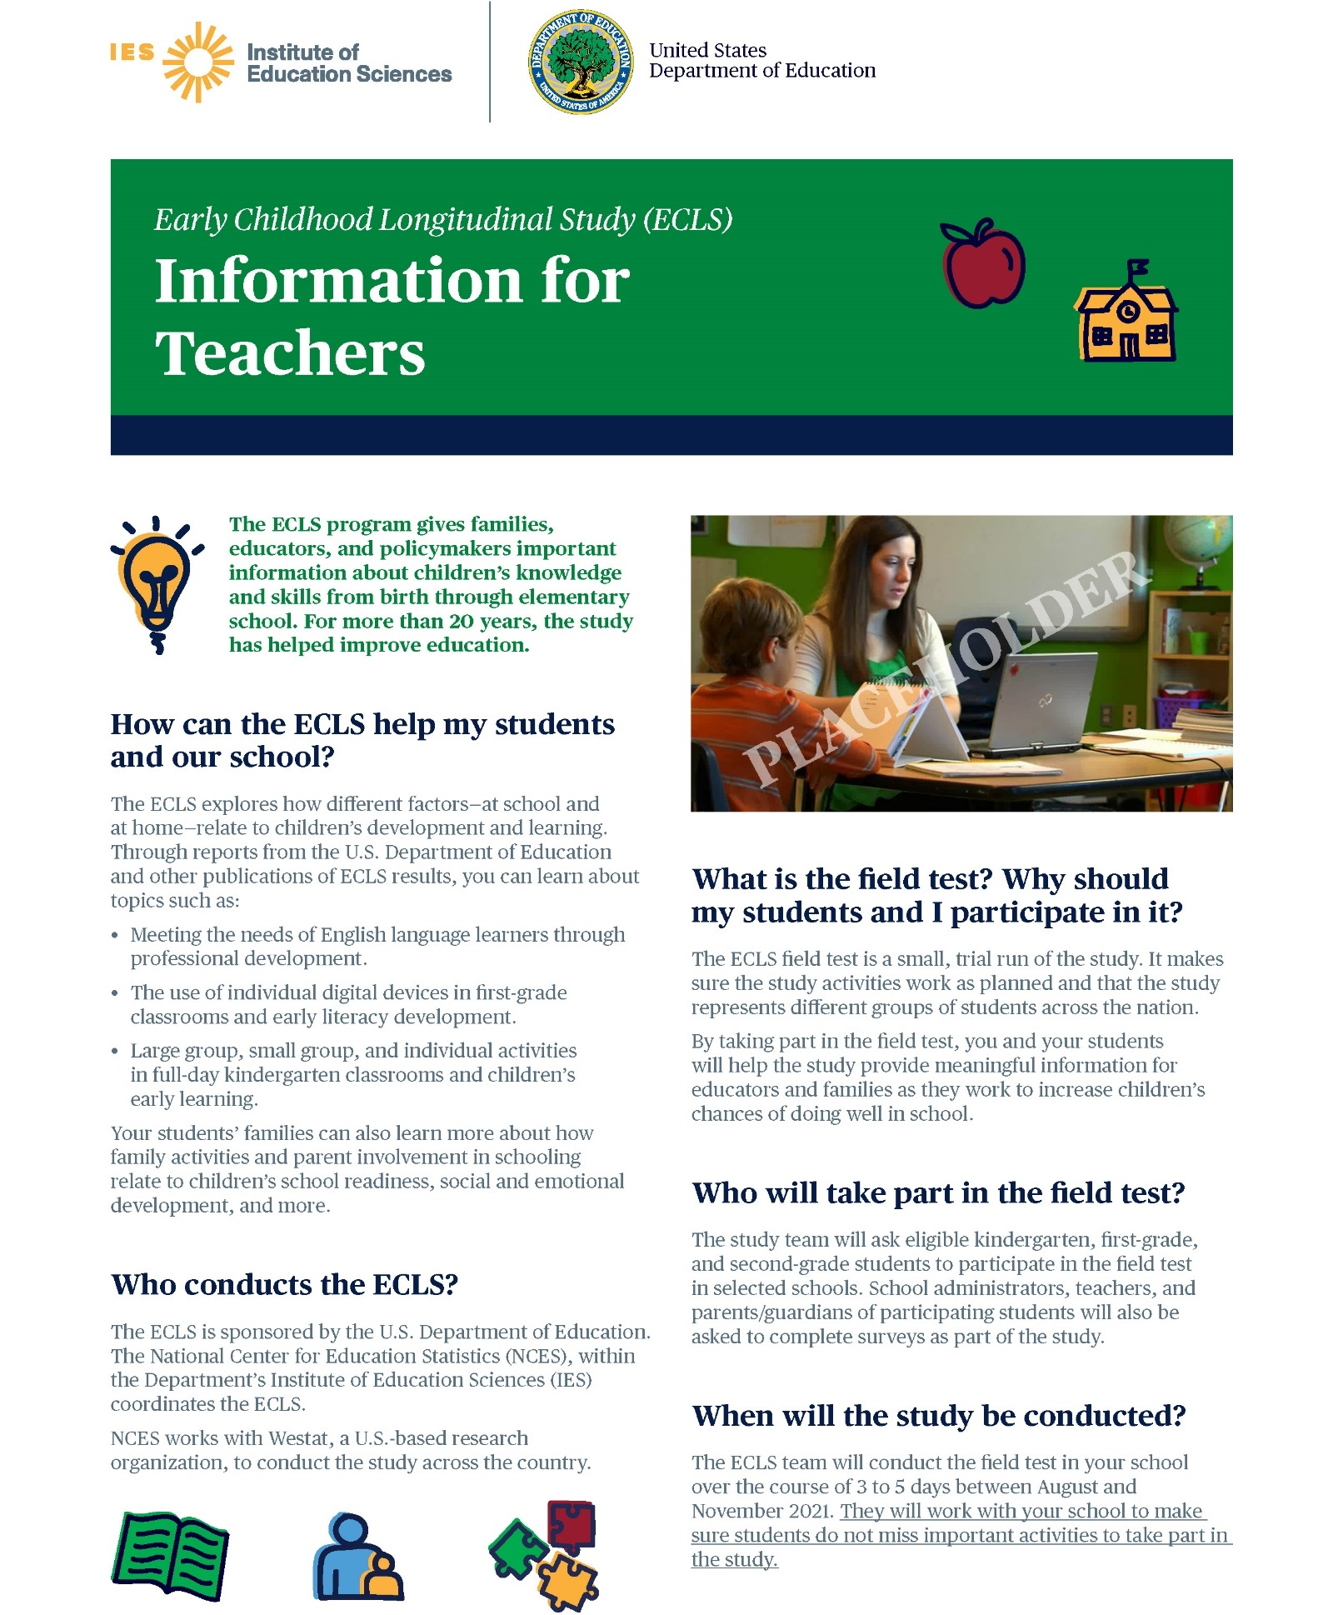
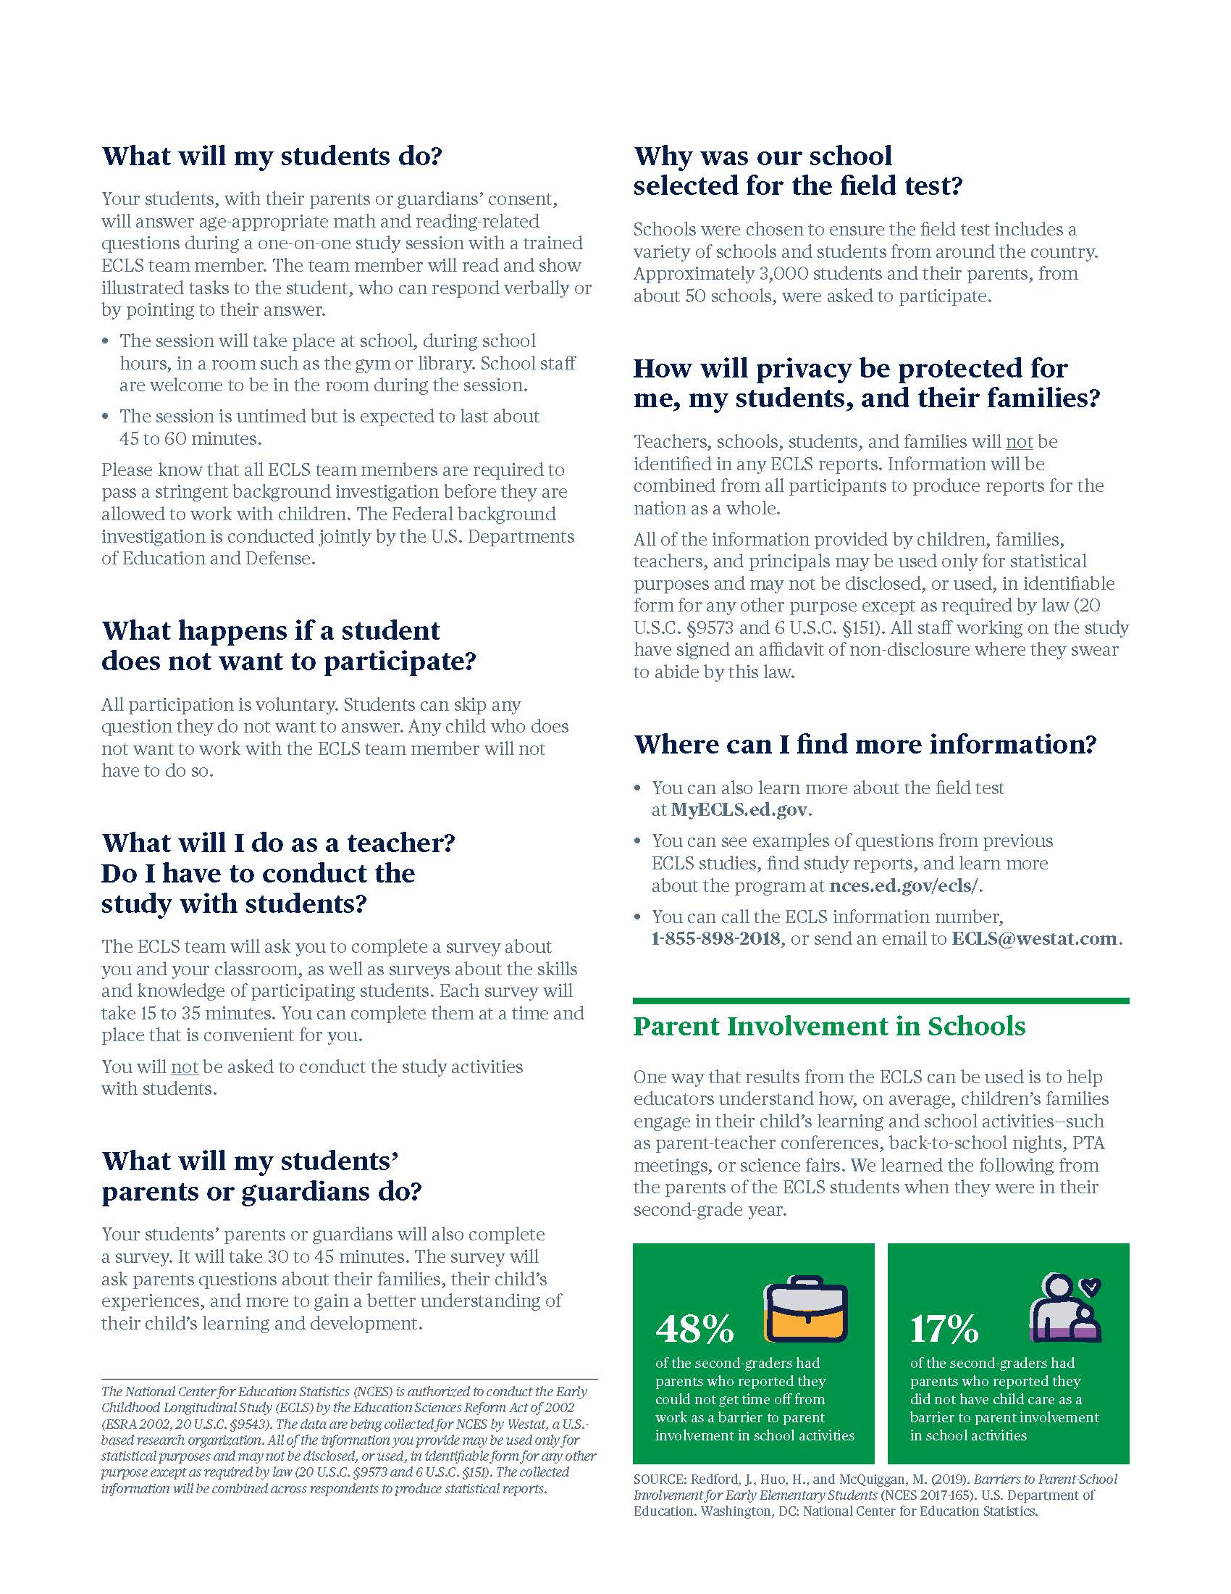

Parent Welcome Letter
Field Test
<Date>

Dear Parent/Guardian:

The U.S. Department of Education has chosen our school and students to participate in an exciting study. The study is called the Early Childhood Longitudinal Study, or the ECLS. For more than 20 years, it has helped improve education for children from birth through elementary school. Our school can use results from the ECLS to support our students’ learning and development.

What do I need to know?
Your child and family have been selected to participate in the ECLS field test, which is a trial-run for an upcoming national data collection. The study is voluntary, but I encourage you to participate.
- Your child will be asked to do engaging, age-appropriate math and reading-related activities during a one-on-one session with an ECLS team member. The session will last about 45 minutes for most children and the ECLS team will work with teachers to minimize the amount of class time that children miss. Children who participated in previous ECLS sessions report enjoying the activities and enjoying the one-on-one attention. Visit our study website at MyECLS.ed.gov to watch a video that includes an example of a child session in progress.
- You will be asked to complete a web survey. You will receive a <$15 Visa © card and a> pad of sticky notes with the IES and U.S. Department of Education logos for participating in the study. Note that the survey can be completed at your convenience and does not have to be done all at once.
- Your child’s teacher will also be asked to complete web surveys about his or her teaching background, the classroom, and each of the children selected from our school.
- <Our school will receive $10 per participating child and teachers will also receive a monetary token of appreciation.> <For schools that return 100 percent of their parental consent forms, the study will also sponsor a food event (such as a pizza or ice cream party) for children at the school.>
- A list of organizations that have endorsed the ECLS is included on the back of this letter.

What do I need to do?
Please log on to the study website below to <provide consent for your child to participate in the study as soon as possible and> complete your survey. Parent/guardian surveys are due by November 30, 2021.
- ECLS website: MyECLS.ed.gov
- You will be asked for a unique PIN when you first log on to the website. The PIN can be found in the sealed postcard provided in this packet.
- After you enter the unique PIN, you will then be asked to enter your email address and a password. The log on process will keep your data secure each time you visit the website.

The ECLS is conducted by the National Center for Education Statistics (NCES), within the U.S. Department of Education’s Institute of Education Sciences (IES). NCES is working with Westat, a U.S.-based research organization, to conduct this voluntary study. If you have any questions, please contact the ECLS team at ECLS@westat.com or call 1-855-898-2018.

Thank you for participating in this important study!

Sincerely,
<School Coordinator name>

Enclosure
ECLS parent fact sheet
Endorsing Organizations

The ECLS is endorsed by more than 25 education organizations.

Parent, Teacher, and Principal Organizations  - American Federation of Teachers  - Association for Middle Level Education  - Council for Exceptional Children  - International Literacy Association  - National Association of Elementary School Principals  - National Council of Teachers of Mathematics  - National Parent Teacher Association  - National Science Teaching Association  - Texas State Teachers Association | Private and Religious Education Organizations  - Association of Christian Schools International  - Association of Christian Teachers and Schools  - Christian Schools International  - Council of Islamic Schools in North America  - Islamic Schools League of America  - Lutheran Church – Missouri Synod  - National Alliance of Christian Schools  - National Association of Independent Schools  - National Catholic Educational Association  - National Christian School Association  - U.S. Conference of Catholic Bishops  - WELS Commission on Lutheran Schools | Education Policy Organizations  - Alliance for Excellent Education  - Council of Chief State School Officers  - National School Boards Association  - The School Superintendents Association  Early Childhood Education Organizations  - American Montessori Society  - Association Montessori International/USA  - National Institute for Early Education Research

“The Early Childhood Longitudinal Study provides valuable information to policymakers as they work to improve education. In Minnesota, for example,
we used the study’s findings in 2013 to help pass a bill that fully funds
all-day kindergarten for students across the state.”

~ Former Policy Advisor, Minnesota Senate

Results from studies like the ECLS help the U.S. Department of Education better support our teachers and families. For example, the website nces.ed.gov/nceskids was created as a place to learn more about recent developments in education and as a source of fun, educational games.

The National Center for Education Statistics (NCES) is authorized to conduct the Early Childhood Longitudinal Study (ECLS) by the Education Sciences Reform Act of 2002 (ESRA 2002, 20 U.S.C. §9543). The data are being collected for NCES by Westat, a U.S.-based research organization. All of the information you provide may be used only for statistical purposes and may not be disclosed, or used, in identifiable form for any other purpose except as required by law (20 U.S.C. §9573 and 6 U.S.C. §151). The collected information will be combined across respondents to produce statistical reports.

Parent Fact Sheet
Field Test

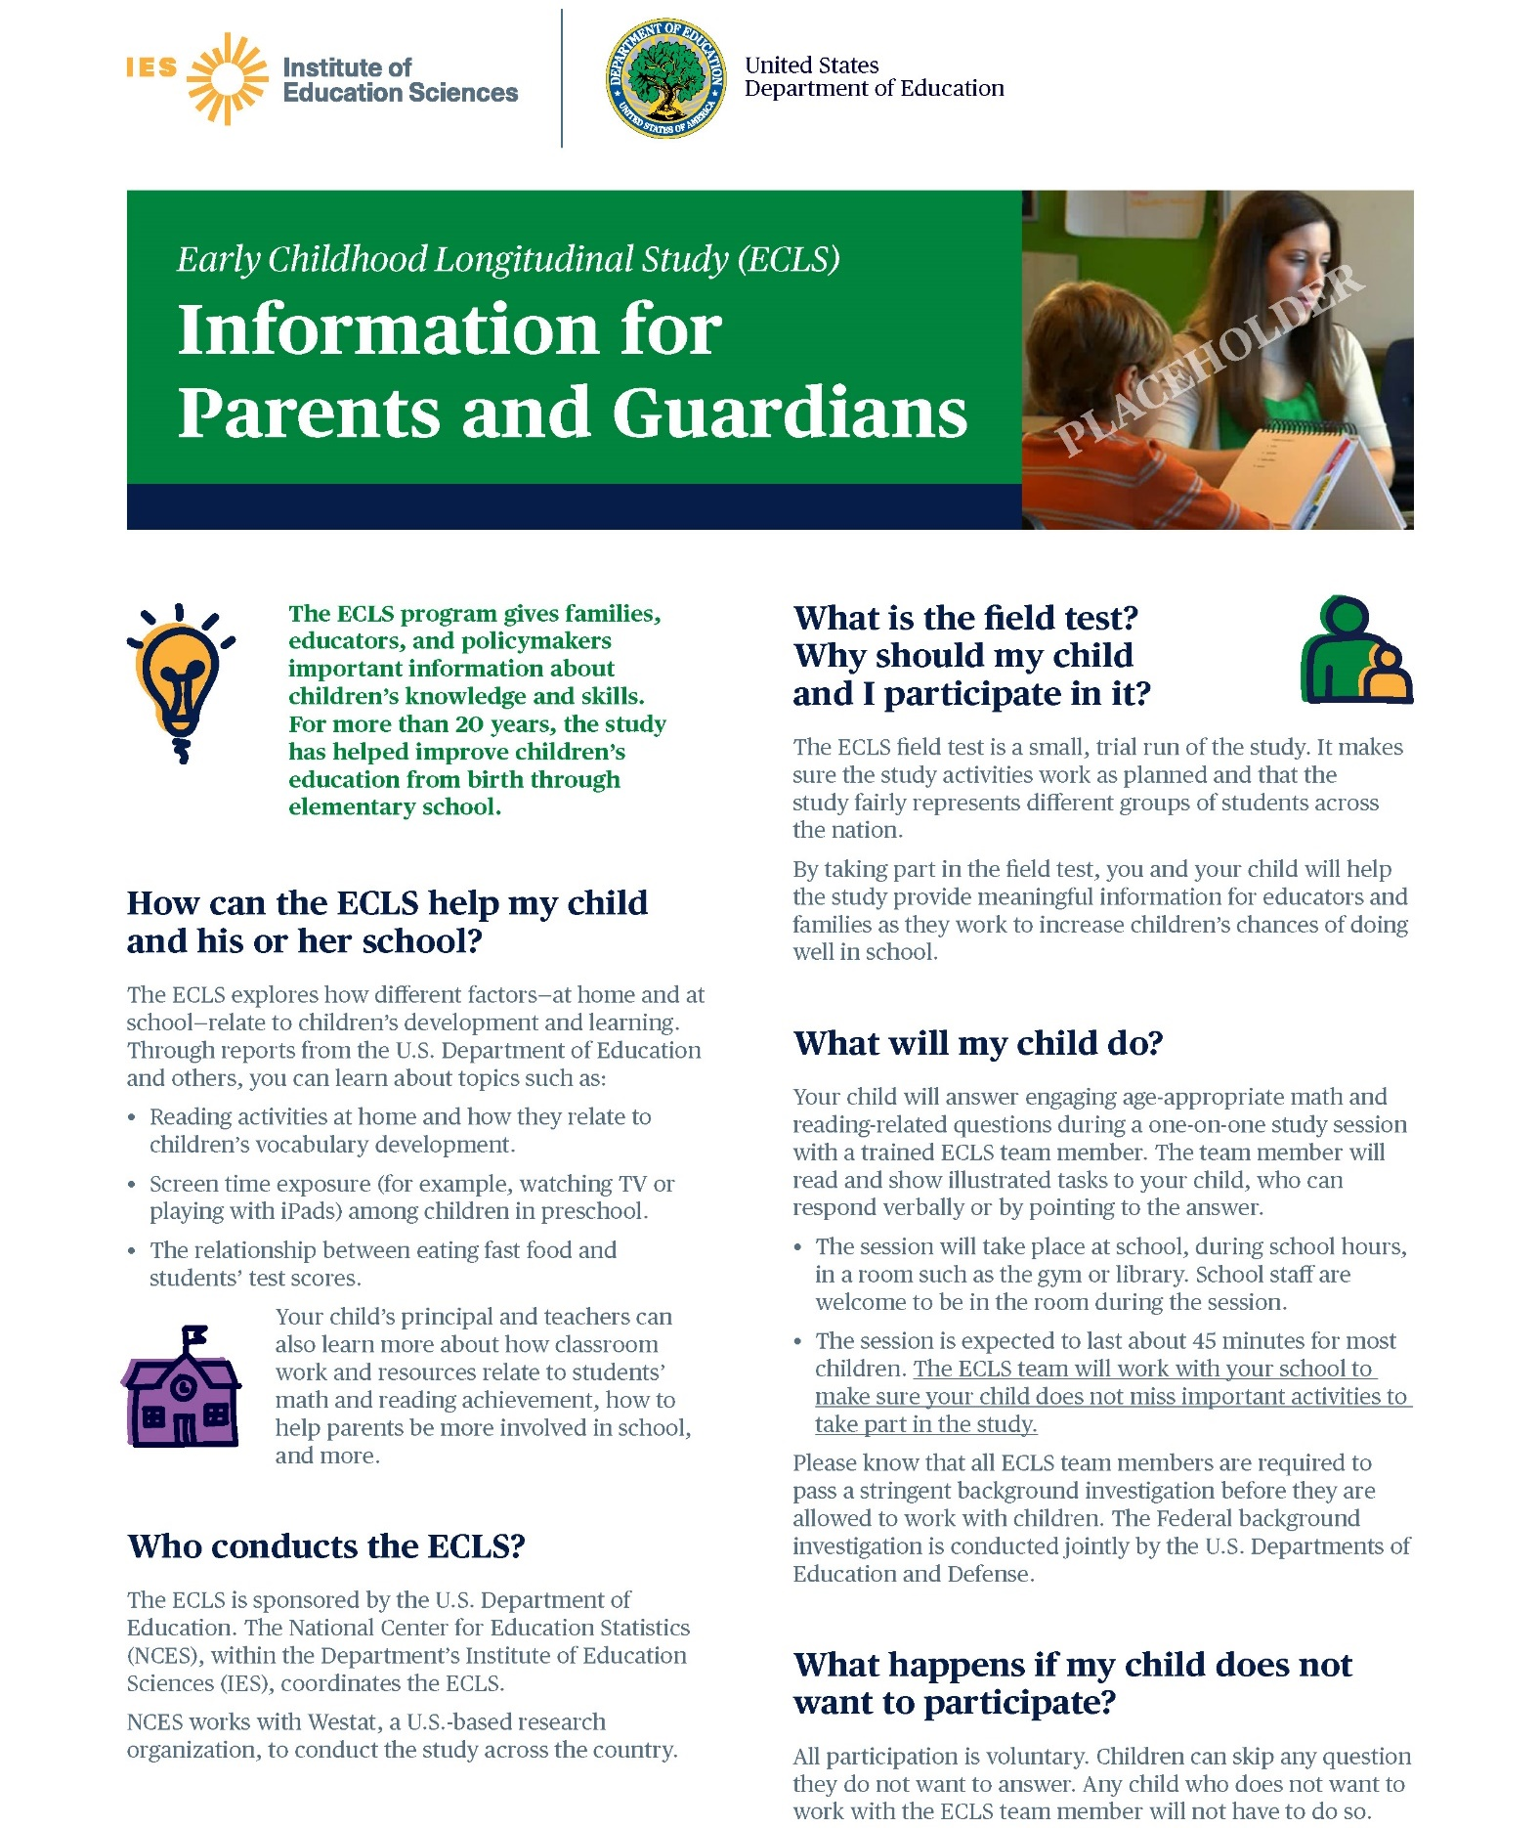

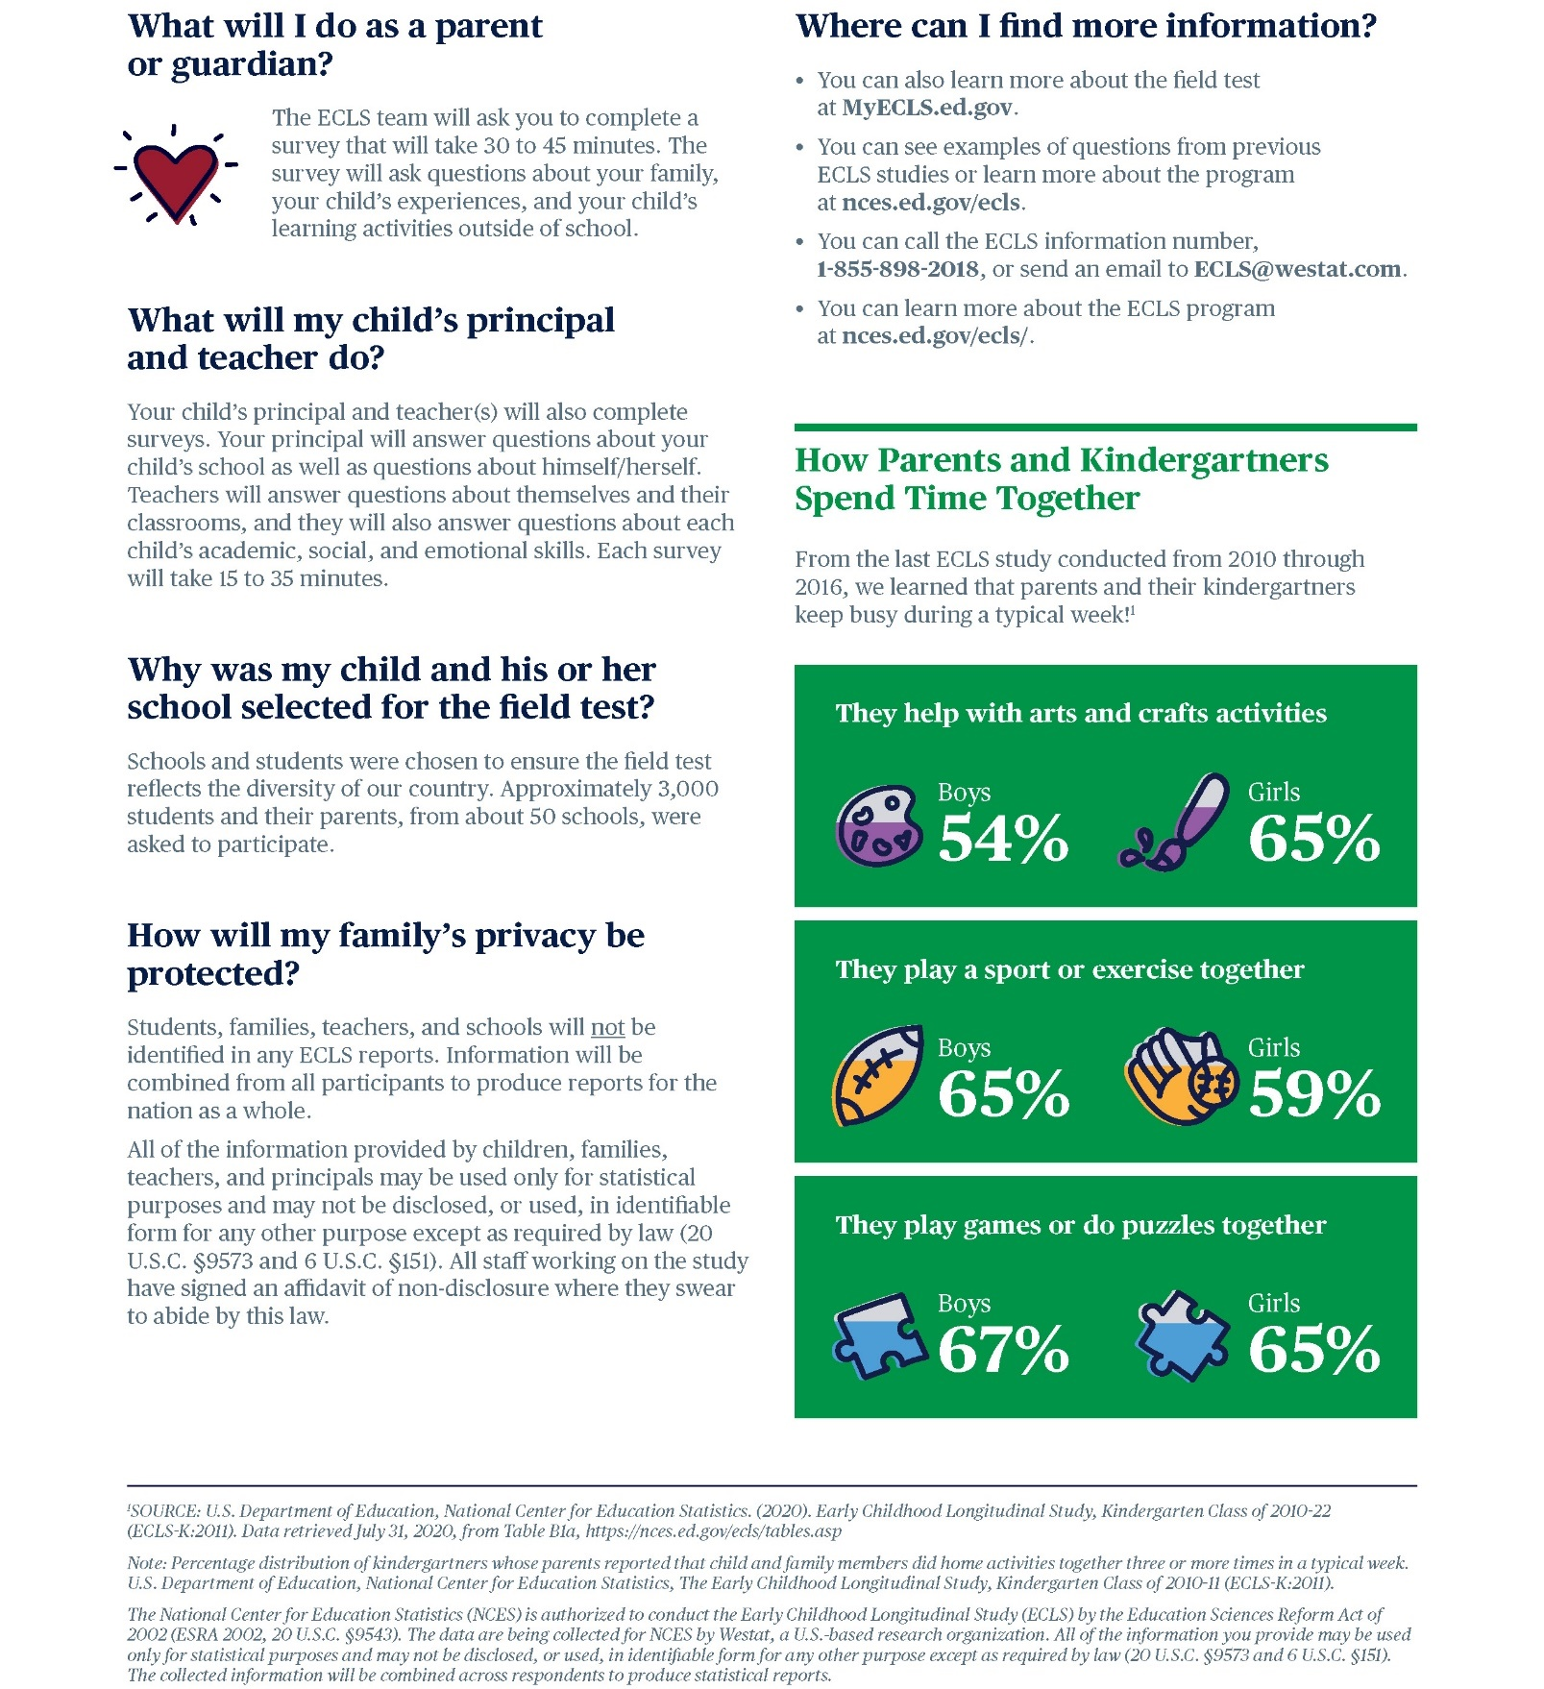

Explicit Consent Form for Parents
Field Test

The Early Childhood Longitudinal Study (ECLS)
Parent/Guardian Consent Form

Your child’s school has agreed to participate in the U.S. Department of Education's Early Childhood Longitudinal Study (ECLS), a nationwide study of elementary-aged children and their schools, teachers, and parents/guardians. We would like to invite you and your child to join others from your school in participating in this important study.

The study will take place in your child’s school. It is expected that most children will take about 45 minutes to complete the activities, which consist of engaging age- and grade-appropriate reading and math items. Your child will complete the study activities with an ECLS team member who has undergone a Federal background investigation. Children may decline to answer any of the questions they do not wish to answer, and their responses will not be associated with their names or provided to school staff. School staff, including teachers, are welcome to observe the sessions.

If you have any questions, please refer to the enclosed materials and do not hesitate to email the ECLS team at ECLS@westat.com or call 1-855-898-2018.

PLEASE CHECK ONE:

Yes, I give permission for my child to participate in the ECLS. I have read this permission form and understand what my child is being asked to do.
No, I do not give permission for my child to participate in the ECLS.

PLEASE SIGN YOUR NAME BELOW:

____________________________________________ Date of signature: ______/_______/_________
(Signature of parent or guardian)

PLEASE PRINT:

Child name: _____________________________________________

School name: ______________________________________________

Parent name: __________________________

Parent telephone: _________________________________________
Parent email: ______________________________________________
FOR OFFICE/TL USE ONLY: Child ID: |  |  |  |  |  |  |  | C

Implicit Consent Form for Parents
Field Test

The Early Childhood Longitudinal Study (ECLS)
Parent/Guardian Consent Form

Your child’s school has agreed to participate in the U.S. Department of Education's Early Childhood Longitudinal Study (ECLS), a nationwide study of elementary-aged children and their schools, teachers, and parents/guardians. We would like to invite you and your child to join others from your school in participating in this important study.

The study will take place in your child’s school. It is expected that most children will take about 45 minutes to complete the activities, which consist of engaging age- and grade-appropriate reading and math items. Your child will complete the study activities with an ECLS team member who has undergone a Federal background investigation. Children may decline to answer any of the questions they do not wish to answer, and their responses will not be associated with their names or provided to school staff. School staff, including teachers, are welcome to observe the sessions.

If you have any questions, please refer to the enclosed materials and do not hesitate to email the ECLS team at ECLS@westat.com or call 1-855-898-2018.call

If you give permission for your child to participate in the ECLS, you do not need to return this form.

If you do not give permission for your child to participate in the ECLS, please check the box below, and sign and return this form to your child’s school as soon as possible.

No, I do not give permission for my child to participate in the ECLS.

____________________________________________ Date of signature: ______/_______/_________
(Signature of parent or guardian)

PLEASE PRINT:

Child name: _____________________________________________

School name: ______________________________________________

Parent name: __________________________

Parent telephone: _________________________________________
Parent email: ______________________________________________

FOR OFFICE/TL USE ONLY: Child ID: |  |  |  |  |  |  |  | C

Postcard Providing MyECLS PIN to Parents
Field Test

FRONT COVER LABELED WITH PARENT ID AND NAME

INSIDE:
Please use this PIN to access the secure study website.

PIN: <PIN>

When you first log in to the website using your PIN, you will be prompted to enter your email address and create a password to securely access the website in the future.

Your password must be at least 8 characters in length and must contain a combination of 3 of the following 4 types: upper case letters, lower case letters, numbers, or special characters.

If you need technical assistance at any time, please do not hesitate to contact the ECLS team at 1-855-898-2018 or via email at ECLS@westat.com.

Sincerely,
The ECLS Team

The ECLS is conducted by the National Center for Education Statistics (NCES), within the U.S. Department of Education’s Institute of Education Sciences (IES).
The National Center for Education Statistics (NCES) is authorized to conduct the Early Childhood Longitudinal Study (ECLS) by the Education Sciences Reform Act of 2002 (ESRA 2002, 20 U.S.C. §9543). The data are being collected for NCES by Westat, a U.S.-based research organization. All of the information you provide may be used only for statistical purposes and may not be disclosed, or used, in identifiable form for any other purpose except as required by law (20 U.S.C. §9573 and 6 U.S.C. §151). The collected information will be combined across respondents to produce statistical reports.

First Consent and Survey Completion Reminder Email
for School Coordinators
Field Test

Subject: ECLS Consent and Survey Completion Reminder

Dear <School Coordinator name>:

Thank you for your work so far to ensure the ECLS study’s success in your school! It is now time to check on the status of consent forms and survey completion by selected parents, teachers, and the school administrator.

Where to Monitor the Status of Consent Forms and Surveys:
- The MyECLS website contains all the information you need to review the return of parental consent forms and completed surveys. If you have received paper consent forms, then you will need to update the consent information in the system. Electronic consent status will be automatically updated by our system.
- Log on to the website using your email address and the password you created. If you forgot your password, there is a link to set-up a new password.
How to Follow up with Parents and School Staff:
- <DISPLAY FOR SCHOOLS WITH EXPLICIT CONSENT: Focus first on parental consent.
  - On MyECLS, note the parents who have not yet provided consent for their child to participate. It is critical we get permission to assess as many children as possible from your school. <For schools that return 100 percent of their parental consent forms, regardless of whether or not parents consent to participate, the study will also sponsor a food event (such as a pizza or ice cream party) at the school.>
  - You may also consider following-up with parents who opted their child out of participation. Perhaps additional study information would help convince them of the importance of participation from all members of the school community.
- DISPLAY FOR SCHOOLS WITH IMPLICIT CONSENT: Focus first on parental consent.
  - On MyECLS, note the parents who opted their child out of participation. It is critical we get permission to assess as many children as possible from your school. Perhaps additional study information would help convince refusing parents of the importance of participation from all members of the school community.>
- Review the completion status of the parent and school staff surveys. Note those parents and school staff who have not yet completed their surveys.
- Use the materials attached to this email to contact parents and school staff and remind them to complete the consent forms and surveys. When emailing school administrators, teachers, and parents, please help us to maintain confidentiality by not revealing the names of study participants. We encourage you to send individual emails or, if you choose to send a group email, please be sure to blind-copy recipients so that they cannot see the names and email addresses of others included on the message.
Materials Attached to This Email:
- Reminder emails for parents: Send to parents who still need to <provide consent and/or> complete a survey. Language for text messages is also included if that is the preferred method of communication.
- Reminder emails for school staff: Send to school staff who still need to complete surveys.
- Guide for Encouraging Participation: Includes suggestions for following-up with school staff and parents.

Our ECLS team members want to support you in following-up with parents and school staff. Please email or call your ECLS Representative to discuss how we can help make the study a success in your school.
Questions or Need Help?
- Please contact the ECLS team at ECLS@westat.com or call 1-855-898-2018.

Thank you again for all you are doing to support the ECLS.
Sincerely,
The ECLS Team

Attachments:
Consent and Survey Reminder Email and Text Message for Parents
Survey Reminder Email for Teachers and School Administrator
Guide for Encouraging Participation

The ECLS is conducted by the National Center for Education Statistics (NCES), within the U.S. Department of Education’s Institute of Education Sciences (IES).
The National Center for Education Statistics (NCES) is authorized to conduct the Early Childhood Longitudinal Study (ECLS) by the Education Sciences Reform Act of 2002 (ESRA 2002, 20 U.S.C. §9543). The data are being collected for NCES by Westat, a U.S.-based research organization. All of the information you provide may be used only for statistical purposes and may not be disclosed, or used, in identifiable form for any other purpose except as required by law (20 U.S.C. §9573 and 6 U.S.C. §151). The collected information will be combined across respondents to produce statistical reports.

First Consent and Survey Completion Reminder Email for
Parents (attached to first SC email)
Field Test

Subject: Reminder to complete your ECLS <consent form and> survey!
Dear parent/guardian:
Thank you for reviewing the materials I sent home about the Early Childhood Longitudinal Study (ECLS), conducted by the U.S. Department of Education. Our school supports the goals of this valuable study and we are hopeful that every selected teacher, parent, and child from our school will participate.
What Are Parents Being Asked To Do?
- <Provide consent for your child’s participation. Without your consent, your child will not be able to participate in the study activities.> <For schools that return 100 percent of their parental consent forms, the study will also sponsor a food event (such as a pizza or ice cream party) at the school.>
- Complete a survey about your child and your family. The information you provide will be combined with information from all other participants to produce reports for the nation as a whole. Students, schools, and families will not be identified in any of the reports.
- The survey can be completed whenever is convenient for you. It does not need to be completed all at once.

If you have already <provided consent and> completed the survey, thank you for your time and effort.

How to <Provide Consent and> Complete the Survey:
- Visit the MyECLS website.
  - For your first visit, you will be prompted to enter a PIN. Your unique PIN was enclosed in the study materials I recently sent home. If you cannot find the PIN, please contact the ECLS helpdesk at ECLS@westat.com or call 1-855-898-2018. After entering the PIN, you will be prompted to enter your email address and a password of your choosing. The log on process will keep your data secure each time you visit the website.
  - Once you’ve created your login information, access the MyECLS website with your email address and password.
- The website contains a link to <provide consent and to> the survey you are being asked to complete. <Please log on to the website and provide your consent for your child’s participation as soon as possible.> Complete the survey before Tuesday, November 30.

How to Get More Information about the Study:
- Refer to the introductory letter and ECLS parent fact sheet that I sent home recently for a brief overview of the study. A <Visa© card worth $15 and a> pad of sticky notes with the IES and U.S. Department of Education logos to thank you for your time completing these surveys was also included in the package. <Our school will receive $10 per participating child and teachers will also receive a monetary token of appreciation.>
- The MyECLS website contains more details about the study, including a video that shows part of a child session in action, and additional findings from previous ECLS studies.

Questions or Need Help?
- The U.S. Department of Education is working with Westat, a U.S.-based research organization, to conduct the study. Please contact the ECLS team at ECLS@westat.com or call 1-855-898-2018.

You can also reach out to me if you have any questions about the study activities for you or your child.
Sincerely,
<School Coordinator name>

Why is the ECLS program so important? It helps us understand more about
schools, children, and their families across the United States.
<INSERT INFOGRAPHIC HERE: EITHER USE OF TECHNOLOGY, SCHOOL SUPPORT OF FAMILIES, MATERIALS SENT HOME, BARRIERS TO PARTICIPATION, CHILDREN GOING TO SCHOOL, AND/OR COMMON ACTIVITIES FOR NEW FAMILIES.>

The ECLS is conducted by the National Center for Education Statistics (NCES), within the U.S. Department of Education’s Institute of Education Sciences (IES).
The National Center for Education Statistics (NCES) is authorized to conduct the Early Childhood Longitudinal Study (ECLS) by the Education Sciences Reform Act of 2002 (ESRA 2002, 20 U.S.C. §9543). The data are being collected for NCES by Westat, a U.S.-based research organization. All of the information you provide may be used only for statistical purposes and may not be disclosed, or used, in identifiable form for any other purpose except as required by law (20 U.S.C. §9573 and 6 U.S.C. §151). The collected information will be combined across respondents to produce statistical reports.

First Consent and Survey Completion Reminder Text Message for
Parents (attached to first SC email)
Field Test

Our school is participating in the U.S. Department of Education’s Early Childhood Longitudinal Study (ECLS). The study activities will occur in our school beginning on <assessment date>. Please don’t forget to visit MyECLS to <provide consent for your child to participate and> complete the parent survey. An information packet and email from <School Coordinator name> have directions. Please call the ECLS team at 1-855-898-2018 with questions. Thank you!

First Survey Completion Reminder Email for Teachers and School Administrator (attached to first SC email)
Field Test

Subject: Reminder to complete your ECLS survey!
Dear colleagues:
I am reaching out to remind you that our school has been selected to participate in the Early Childhood Longitudinal Study (ECLS), conducted by the U.S. Department of Education.
What Are School Staff Being Asked To Do?
Teachers:
- Complete a survey about your background and classroom practices.
- Complete surveys about each of the selected children in your classroom.
- Introduce the ECLS team to your students when they arrive at our school on <assessment date>. All study activities will be completed by the ECLS team.
School administrators:
- Complete a survey about your background and the school.

How to Complete the Surveys:
- Visit the MyECLS website.
  - For your first visit, you will be prompted to enter the unique PIN you were provided in an email a few weeks ago. If you cannot find the PIN, please contact the ECLS team at ECLS@westat.com or call 1-855-898-2018. After entering the PIN, you will be prompted to enter your email address and a password of your choosing. The log on process will keep your data secure each time you visit the website.
  - Once you’ve created your login information, access the MyECLS website with your email address and password.
- The website contains links to each of the surveys you are being asked to complete. Please log on to the website and complete the surveys before Tuesday, November 30. Note that the surveys can be completed at your convenience and do not have to be done all at once.
- <To thank you for your help, your packet will also contain a monetary token of appreciation.> At the conclusion of the study, you will <also> receive a Certificate of Contribution from the U.S. Department of Education. <For schools that return 100 percent of their returned parental consent forms, the study will also sponsor a food event (such as a pizza or ice cream party) at the school.>

How to Get More Information about the Study:
- Refer to the introductory letter and ECLS Study Overview that you recently received for a brief overview of the study and its components.
- The MyECLS website contains more details about the study and additional findings from ECLS studies.

Questions or Need Help?
- The U.S. Department of Education is working with Westat, a U.S.-based research organization, to conduct the study. Please contact the ECLS team at ECLS@westat.com or call 1-855-898-2018.

You can also reach out to me if you have any questions about our school’s participation. If any parents ask you about the study, please encourage them to participate and direct them to me for any questions.
Sincerely,
<School Coordinator name>

Why is the ECLS program so important? It helps us understand more about
schools, teachers, and students across the United States.
<INSERT INFOGRAPHIC HERE: EITHER USE OF TECHNOLOGY, SCHOOL SUPPORT OF FAMILIES, AND/OR MATERIALS SENT HOME.>

The ECLS is conducted by the National Center for Education Statistics (NCES), within the U.S. Department of Education’s Institute of Education Sciences (IES).
The National Center for Education Statistics (NCES) is authorized to conduct the Early Childhood Longitudinal Study (ECLS) by the Education Sciences Reform Act of 2002 (ESRA 2002, 20 U.S.C. §9543). The data are being collected for NCES by Westat, a U.S.-based research organization. All of the information you provide may be used only for statistical purposes and may not be disclosed, or used, in identifiable form for any other purpose except as required by law (20 U.S.C. §9573 and 6 U.S.C. §151). The collected information will be combined across respondents to produce statistical reports.

Second Consent and Survey Completion Reminder Email for
School Coordinators
Field Test

Subject: ECLS Consent and Survey Completion Reminder

Dear <School Coordinator name>:

Thank you for all you are doing to make the ECLS a success! Now that a couple of weeks have gone by, it is time to check on the status of the study <consent forms and> surveys.

What Do I Need To Do?
- Review the MyECLS website to see which parents still need to complete their <consent forms and> surveys or that may have refused consent. Without parental consent, we will not be able to include these children in the study. <For schools that return 100 percent of their parental consent forms, regardless of whether or not parents consent to participate, the study will also sponsor a food event (such as a pizza or ice cream party) at the school.>
- Check to see if the school administrator and teachers have completed their surveys.
- Email the attached reminders to those parents and school staff who have not yet completed the survey <and/or provided their consent>. (Text reminders for parents are also attached if you prefer to send texts.) The last day for completing the surveys is Tuesday, November 30.

When emailing school administrators, teachers, and parents, please help us to maintain confidentiality by not revealing the names of study participants. We encourage you to send individual emails or, if you choose to send a group email, please be sure to blind-copy recipients so that they cannot see the names and email addresses of others included on the message.

- Please continue to update MyECLS as appropriate (for example, with <consent status or> child-specific information).

Our ECLS team members want to assist you in these efforts. Please email or call your ECLS Representative to discuss how we can help follow-up with parents and school staff.

Do Your Parents or School Staff Need Help Completing the Survey?
- Anyone who needs help accessing the MyECLS website or has questions about <providing consent or> completing surveys can contact the ECLS team at ECLS@westat.com or call 1-855-898-2018.

We want to hear from as many of your school staff and parents as possible! Thank you for helping us meet that goal.

Sincerely,
The ECLS Team

Attachments:
Consent and Survey Reminder Email and Text Message for Parents
Survey Reminder Email for Teachers and School Administrator
Guide for Encouraging Participation

The ECLS is conducted by the National Center for Education Statistics (NCES), within the U.S. Department of Education’s Institute of Education Sciences (IES).
The National Center for Education Statistics (NCES) is authorized to conduct the Early Childhood Longitudinal Study (ECLS) by the Education Sciences Reform Act of 2002 (ESRA 2002, 20 U.S.C. §9543). The data are being collected for NCES by Westat, a U.S.-based research organization. All of the information you provide may be used only for statistical purposes and may not be disclosed, or used, in identifiable form for any other purpose except as required by law (20 U.S.C. §9573 and 6 U.S.C. §151). The collected information will be combined across respondents to produce statistical reports.

Second Consent and Survey Completion Reminder Email
for Parents (attached to second SC email)
Field Test

Subject: Reminder to complete your ECLS <consent form and> survey!

Dear parent/guardian:
I appreciate your family’s participation in the U.S. Department of Education’s Early Childhood Longitudinal Study (ECLS), which is being conducted in our school this year! We look forward to learning more about what our country’s young students know and can do so we can better meet their needs.
To Participate:
- Log on to the MyECLS website to <provide consent for your child’s participation and> complete the parent survey if you have not done so already. All the details you need to <provide consent and> complete the survey were provided in the materials I sent home a couple of weeks ago along with <a Visa© card for $15 and> a pad of sticky notes with the IES and U.S. Department of Education logos to thank you for your time and effort.
- As a reminder, the last day to complete your parent survey is November 30.
- <For schools that return 100 percent of their parental consent forms, the study will also sponsor a food event (such as a pizza or ice cream party) at the school.> <Our school will receive $10 per participating child.>

Questions, Need Help, or Forgot Your Log–In Information?
For any questions, please email the ECLS team at ECLS@westat.com or call 1-855-898-2018. You can also reach out to me if you have any questions about the study activities for you or your child.

Why is the ECLS program so important? It helps us understand more about
schools, children, and their families across the United States.
<INSERT INFOGRAPHIC HERE: EITHER USE OF TECHNOLOGY, SCHOOL SUPPORT OF FAMILIES, MATERIALS SENT HOME, BARRIERS TO PARTICIPATION, CHILDREN GOING TO SCHOOL, AND/OR COMMON ACTIVITIES FOR NEW FAMILIES.>

You can find more findings from the previous ECLS studies, and other U.S. Department of Education surveys, on the MyECLS homepage.

Sincerely,
<School Coordinator name>

The ECLS is conducted by the National Center for Education Statistics (NCES), within the U.S. Department of Education’s Institute of Education Sciences (IES).
The National Center for Education Statistics (NCES) is authorized to conduct the Early Childhood Longitudinal Study (ECLS) by the Education Sciences Reform Act of 2002 (ESRA 2002, 20 U.S.C. §9543). The data are being collected for NCES by Westat, a U.S.-based research organization. All of the information you provide may be used only for statistical purposes and may not be disclosed, or used, in identifiable form for any other purpose except as required by law (20 U.S.C. §9573 and 6 U.S.C. §151). The collected information will be combined across respondents to produce statistical reports.

Second Consent and Survey Completion Reminder Text Message
for Parents (attached to second SC email)
Field Test

Hello! Please don’t miss out on participating in the U.S. Department of Education’s Early Childhood Longitudinal Study (ECLS). The last day to complete your survey is November 30. Your information packet and email from <School Coordinator name> have directions on how to visit the MyECLS website to< provide consent and> complete the survey. Please let us know if you have any questions or call the ECLS team at 1-855-898-2018.

Second Survey Completion Reminder Email for Teachers and
School Administrator (attached to second SC email)
Field Test

Subject: Reminder to complete your ECLS survey!

Dear colleagues:

I appreciate your willingness to participate in the U.S. Department of Education’s Early Childhood Longitudinal Study (ECLS)! We look forward to learning more about what our country’s youngest students know and can do—and the factors that may impact their skills and abilities—in elementary school. As part of the study, our school staff have been asked to complete web surveys.

How to Complete the Surveys:
- Visit the MyECLS website and enter the unique PIN you were provided in an email a few weeks ago. If you cannot find the email containing the PIN, please contact the ECLS helpdesk at ECLS@westat.com or call 1-855-898-2018.
- After entering the PIN, you will be prompted to enter your email address and a password of your choosing. The log on process will keep your data secure each time you visit the website. On future visits to the website, enter your email address and password to gain access.
- The website contains links to each of the surveys you are being asked to complete. Please log on to the website and complete the surveys before Tuesday, November 30.
- <To thank you for your help, you have received a monetary token of appreciation.> At the conclusion of the study, you will <also> receive a Certificate of Contribution from the U.S. Department of Education. <For schools that return 100 percent of their parental consent forms, the study will also sponsor a food event (such as a pizza or ice cream party) at the school.>

Questions or Need Help?
- Please contact the ECLS team at ECLS@westat.com or call 1-855-898-2018.

You can also reach out to me if you have any questions. If parents ask you about the study, please encourage them to participate and direct them to me for any questions.

Thank you again!

Sincerely,
<School Coordinator name>

Why is the ECLS program so important? It helps us understand more about
schools, teachers, and students across the United States.
<INSERT INFOGRAPHIC HERE: EITHER USE OF TECHNOLOGY, SCHOOL SUPPORT OF FAMILIES, AND/OR MATERIALS SENT HOME.>

The ECLS is conducted by the National Center for Education Statistics (NCES), within the U.S. Department of Education’s Institute of Education Sciences (IES).
The National Center for Education Statistics (NCES) is authorized to conduct the Early Childhood Longitudinal Study (ECLS) by the Education Sciences Reform Act of 2002 (ESRA 2002, 20 U.S.C. §9543). The data are being collected for NCES by Westat, a U.S.-based research organization. All of the information you provide may be used only for statistical purposes and may not be disclosed, or used, in identifiable form for any other purpose except as required by law (20 U.S.C. §9573 and 6 U.S.C. §151). The collected information will be combined across respondents to produce statistical reports.

Third Survey Completion Reminder Email for School Coordinators
Field Test

Subject: ECLS—Survey Completion Reminder

Dear <School Coordinator name>:

We do not have much longer until the ECLS ends. Please help us collect the remaining survey data from your school’s parents and staff.

What Do I Need To Do?
- Review the MyECLS website to see which parents and school staff still need to complete their surveys.
- Email the attached reminders to those parents and school staff who have not yet completed the survey. (Text reminders for parents are also attached if you prefer texting.) The last day for completing the surveys is Tuesday, November 30.

When emailing school administrators, teachers, and parents, please help us to maintain confidentiality by not revealing the names of study participants. We encourage you to send individual emails or, if you choose to send a group email, please be sure to blind-copy recipients so that they cannot see the names and email addresses of others included on the message.

Our ECLS team members want to assist you in these efforts. Please email or call your ECLS Representative to discuss how we can help follow-up with parents and school staff.

Do Parents or School Staff Need Help Completing the Survey?
- Anyone who needs help to access the MyECLS website or to complete the surveys can contact the ECLS team at ECLS@westat.com or call 1-855-898-2018.

We want to hear from as many of your school staff and parents as possible! Thank you for helping us meet that goal.

Sincerely,
The ECLS Team

Attachments:
Survey Reminder Email and Text Message for Parents
Survey Reminder Email for Teachers and School Administrator
Guide for Encouraging Participation

The ECLS is conducted by the National Center for Education Statistics (NCES), within the U.S. Department of Education’s Institute of Education Sciences (IES).
The National Center for Education Statistics (NCES) is authorized to conduct the Early Childhood Longitudinal Study (ECLS) by the Education Sciences Reform Act of 2002 (ESRA 2002, 20 U.S.C. §9543). The data are being collected for NCES by Westat, a U.S.-based research organization. All of the information you provide may be used only for statistical purposes and may not be disclosed, or used, in identifiable form for any other purpose except as required by law (20 U.S.C. §9573 and 6 U.S.C. §151). The collected information will be combined across respondents to produce statistical reports.

Third Survey Completion Reminder Email for Parents
(attached to third SC email)
Field Test

Subject: ECLS parent survey data collection ending soon!

Dear parent/guardian:

Thanks again for participating in the U.S. Department of Education’s Early Childhood Longitudinal Study (ECLS)!

I know you are very busy, but I want to remind you that the last day for completing your parent survey is quickly approaching. We would like to have all surveys completed by November 30. Don’t let the opportunity to participate in this valuable study pass you by!

To Participate: Log on to the MyECLS website to complete the parent survey if you have not done so already. All the details you need to complete the survey were provided in the materials I sent home several weeks ago along with a <Visa© card for $15 and a> pad of sticky notes with the IES and U.S. Department of Education logos to thank you for your time and effort.

Questions, Need Help, or Forgot Your Log-In Information? For any questions, please email the ECLS team at ECLS@westat.com or call 1-855-898-2018. You can also reach out to me if you have any questions about the study activities for you or your child.

Why is the ECLS program so important? It helps us understand more about
schools, children, and their families across the United States.
<INSERT INFOGRAPHIC HERE: EITHER USE OF TECHNOLOGY, SCHOOL SUPPORT OF FAMILIES, MATERIALS SENT HOME, BARRIERS TO PARTICIPATION, CHILDREN GOING TO SCHOOL, AND/OR COMMON ACTIVITIES FOR NEW FAMILIES.>

Please reach out to me if you have any questions about the study activities for you or your child.

Sincerely,
<School Coordinator name>
The ECLS is conducted by the National Center for Education Statistics (NCES), within the U.S. Department of Education’s Institute of Education Sciences (IES).
The National Center for Education Statistics (NCES) is authorized to conduct the Early Childhood Longitudinal Study (ECLS) by the Education Sciences Reform Act of 2002 (ESRA 2002, 20 U.S.C. §9543). The data are being collected for NCES by Westat, a U.S.-based research organization. All of the information you provide may be used only for statistical purposes and may not be disclosed, or used, in identifiable form for any other purpose except as required by law (20 U.S.C. §9573 and 6 U.S.C. §151). The collected information will be combined across respondents to produce statistical reports.

Third Survey Reminder Text Message for Parents
(attached to third SC email)
Field Test

We know you are very busy, but the last day for completing your Early Childhood Longitudinal Study (ECLS) survey is November 30. Please visit the MyECLS website to complete your survey, if you have not already done so. Please contact <School Coordinator name> or call the ECLS team at 1-855-898-2018 if you have any questions.

Third Survey Completion Reminder Email for Teachers and School Administrator (attached to third SC email)
Field Test

Subject: ECLS survey collection ending soon!

Dear colleagues:

I know you are very busy, but I want to remind you that the last day for completing the ECLS survey(s) is quickly approaching. We would like to have all surveys completed by November 30. If you could find time to complete the survey, it would go a long way toward helping the study provide valuable information for parents, schools, researchers, and policymakers.

How to Complete the Surveys:
- Visit the MyECLS website to complete the survey(s) if you have not done so already. All the details you need to do so were provided in the materials I distributed several weeks ago.
- The website contains links to each of the surveys you are being asked to complete. <To thank you for your help, your packet received a monetary token of appreciation.> At the conclusion of the study, you will <also> receive a Certificate of Contribution from the U.S. Department of Education. <For schools that return 100 percent of their parental consent forms, the study will also sponsor a food event (such as a pizza or ice cream party) at the school.>

Questions or Need Help?
- Please contact the ECLS team at ECLS@westat.com or call 1-855-898-2018.

You can also reach out to me if you have any questions. If parents ask you about the study, please encourage them to participate and direct them to me for any questions.

Sincerely,
<School Coordinator name>

Why is the ECLS program so important? It helps us understand more about
schools, teachers, and students across the United States.
<INSERT INFOGRAPHIC HERE: EITHER USE OF TECHNOLOGY, SCHOOL SUPPORT OF FAMILIES, AND/OR MATERIALS SENT HOME.>

The ECLS is conducted by the National Center for Education Statistics (NCES), within the U.S. Department of Education’s Institute of Education Sciences (IES).
The National Center for Education Statistics (NCES) is authorized to conduct the Early Childhood Longitudinal Study (ECLS) by the Education Sciences Reform Act of 2002 (ESRA 2002, 20 U.S.C. §9543). The data are being collected for NCES by Westat, a U.S.-based research organization. All of the information you provide may be used only for statistical purposes and may not be disclosed, or used, in identifiable form for any other purpose except as required by law (20 U.S.C. §9573 and 6 U.S.C. §151). The collected information will be combined across respondents to produce statistical reports.

Fourth Survey Completion Reminder Email for School Coordinators
Field Test

Subject: ECLS—One Last Survey Reminder

Dear <School Coordinator name>:

Thank you for all you have done to make the ECLS a success in your school!

This is the final reminder to check on the completion of the parent and school staff surveys. If the school administrator, parents, and teachers still need to complete their surveys, please remind them that the last day is Tuesday, November 30.

Email and text message reminders are attached for you to send. When emailing school administrators, teachers, and parents, please help us to maintain confidentiality by not revealing the names of study participants. We encourage you to send individual emails or, if you choose to send a group email, please be sure to blind-copy recipients so that they cannot see the names and email addresses of others included on the message.

If you have any questions, please contact the ECLS team at ECLS@westat.com or call 1-855-898-2018.

Thank you!

Sincerely,
The ECLS Team

Attachments
Survey Reminder Emails and Text Messages for Parents
Survey Reminder Emails for Teachers
Guide for Encouraging Participation

The ECLS is conducted by the National Center for Education Statistics (NCES), within the U.S. Department of Education’s Institute of Education Sciences (IES).
The National Center for Education Statistics (NCES) is authorized to conduct the Early Childhood Longitudinal Study (ECLS) by the Education Sciences Reform Act of 2002 (ESRA 2002, 20 U.S.C. §9543). The data are being collected for NCES by Westat, a U.S.-based research organization. All of the information you provide may be used only for statistical purposes and may not be disclosed, or used, in identifiable form for any other purpose except as required by law (20 U.S.C. §9573 and 6 U.S.C. §151). The collected information will be combined across respondents to produce statistical reports.

Fourth Survey Completion Reminder Email for Parents
(attached to fourth SC email)
Field Test

Subject: ECLS—One Last Survey Reminder

Dear parent/guardian:

We are making every effort to finish strong for the U.S. Department of Education’s Early Childhood Longitudinal Study (ECLS)! If you have not already completed your parent survey, please do so today. The ECLS team is really counting on your participation!
To Participate: Log on to the MyECLS website to complete the parent survey. All the details you need to complete the survey were provided in the materials I sent home a several weeks ago along with a <Visa© card for $15 and a> pad of sticky notes with the IES and U.S. Department of Education logos to thank you for your time and effort.

Questions, Need Help, or Forgot Your Log-In Information? For any questions, please email the ECLS team at ECLS@westat.com or call 1-855-898-2018. You can also reach out to me if you have any questions about the study activities for you or your child.

Did You Know?
Why is the ECLS program so important? It helps us understand more about
schools, children, and their families across the United States.
<INSERT INFOGRAPHIC HERE: EITHER USE OF TECHNOLOGY, SCHOOL SUPPORT OF FAMILIES, MATERIALS SENT HOME, BARRIERS TO PARTICIPATION, CHILDREN GOING TO SCHOOL, AND/OR COMMON ACTIVITIES FOR NEW FAMILIES.>

Please reach out to me if you have any questions about the study activities for you or your child.

Sincerely,
<School Coordinator name>

The ECLS is conducted by the National Center for Education Statistics (NCES), within the U.S. Department of Education’s Institute of Education Sciences (IES).
The National Center for Education Statistics (NCES) is authorized to conduct the Early Childhood Longitudinal Study (ECLS) by the Education Sciences Reform Act of 2002 (ESRA 2002, 20 U.S.C. §9543). The data are being collected for NCES by Westat, a U.S.-based research organization. All of the information you provide may be used only for statistical purposes and may not be disclosed, or used, in identifiable form for any other purpose except as required by law (20 U.S.C. §9573 and 6 U.S.C. §151). The collected information will be combined across respondents to produce statistical reports.

Fourth Survey Completion Reminder Text for Parents
(attached to fourth SC email)
Field Test

We are making every effort to finish strong for the U.S. Department of Education’s Early Childhood Longitudinal Study (ECLS)! If you have not already completed your parent survey, please do so today by visiting the MyECLS website. We are really counting on your participation! Please contact <School Coordinator name> or call the ECLS team at 1-855-898-2018 if you have any questions. Thank you!

Fourth Survey Completion Reminder Email for Teachers and School Administrator (attached to fourth SC email)
Field Test

Subject: ECLS—One Last Survey Reminder

Dear colleagues:

We are making every effort to finish strong for the U.S. Department of Education’s Early Childhood Longitudinal Study (ECLS)! If you have not already completed your surveys, please do so today. We are really counting on your participation!
How to Complete the Surveys:
- Visit the MyECLS website and enter the unique PIN you were provided in an email several weeks ago. If you cannot find the email containing the PIN, please contact the ECLS team at ECLS@westat.com or call 1-855-898-2018.
- After successfully entering the PIN, you will be prompted to enter your email address and a password of your choosing. The log on process will keep your data secure each time you visit the website.
- The website contains links to each of the surveys you are being asked to complete. <To thank you for your help, you received a monetary token of appreciation.> At the conclusion of the study, you will <also> receive a Certificate of Contribution from the U.S. Department of Education.

Questions or Need Help?
- Please contact the ECLS team at ECLS@westat.com or call 1-855-898-2018.

You can also reach out to me if you have any questions about your or our students’ participation.

Sincerely,
<School Coordinator name>

Why is the ECLS program so important? It helps us understand more about
schools, teachers, and students across the United States.
<INSERT INFOGRAPHIC HERE: EITHER USE OF TECHNOLOGY, SCHOOL SUPPORT OF FAMILIES, AND/OR MATERIALS SENT HOME.>

The ECLS is conducted by the National Center for Education Statistics (NCES), within the U.S. Department of Education’s Institute of Education Sciences (IES).
The National Center for Education Statistics (NCES) is authorized to conduct the Early Childhood Longitudinal Study (ECLS) by the Education Sciences Reform Act of 2002 (ESRA 2002, 20 U.S.C. §9543). The data are being collected for NCES by Westat, a U.S.-based research organization. All of the information you provide may be used only for statistical purposes and may not be disclosed, or used, in identifiable form for any other purpose except as required by law (20 U.S.C. §9573 and 6 U.S.C. §151). The collected information will be combined across respondents to produce statistical reports.

School, School Administrator, School Coordinator,
and Teacher Thank You Letter
Field Test

[DATE]
[TITLE] [NAME FIRST] [NAME LAST]
[TITLE/DEPARTMENT]
[SCHOOL DISTRICT]
[ADDRESS 1]
[CITY], [STATE] [ZIP CODE]

Dear <NAME>,

Thank you for participating in the U.S. Department of Education’s Early Childhood Longitudinal Study (ECLS). Enclosed <is a check for <INCENTIVE AMOUNT>/a Certificate of Contribution> as a token of our appreciation for <your/your school’s> participation in this important study of education.

The study has been very successful because of the cooperation and participation of the children, parents, schools, school administrators, and teachers selected to take part. You can find further information about the study at nces.ed.gov/ecls/.

Thank you again for your support of the ECLS. If you have any questions or concerns, please contact the ECLS team at 1-855-898-2018 or ECLS@westat.com.

Sincerely,
The ECLS Team

The National Center for Education Statistics (NCES) is authorized to conduct the Early Childhood Longitudinal Study (ECLS) by the Education Sciences Reform Act of 2002 (ESRA 2002, 20 U.S.C. §9543). The data are being collected for NCES by Westat, a U.S.-based research organization. All of the information you provide may be used only for statistical purposes and may not be disclosed, or used, in identifiable form for any other purpose except as required by law (20 U.S.C. §9573 and 6 U.S.C. §151). The collected information will be combined across respondents to produce statistical reports.

Thank You Email for School Coordinators
Field Test

SUBJECT: Thank you from the ECLS!
Dear <SCHOOL COORDINATOR NAME>:
Thank you so very much for all your help in coordinating the Early Childhood Longitudinal Study (ECLS) in your school. We truly couldn’t have done it without you!
We hope you will give our thanks to the participating teachers, parents, and children. An email for parents is attached for you to distribute. Please help us to maintain confidentiality by sending these emails individually or, if sending a group email, be sure to blind-copy recipients so that they cannot see the names and email addresses of others included on the message. The school administrator and teachers have been sent a separate letter of thanks, along with their Certificate of Contribution.
You can find further information about the study at nces.ed.gov/ecls/. If you have any questions or concerns, please contact the ECLS team at 1-855-898-2018 or ECLS@westat.com.

Thank you again for your support of the ECLS.

Sincerely,
The ECLS Team

Attachments
Thank You Email Template for Parents

The ECLS is conducted by the National Center for Education Statistics (NCES), within the U.S. Department of Education’s Institute of Education Sciences (IES).
The National Center for Education Statistics (NCES) is authorized to conduct the Early Childhood Longitudinal Study (ECLS) by the Education Sciences Reform Act of 2002 (ESRA 2002, 20 U.S.C. §9543). The data are being collected for NCES by Westat, a U.S.-based research organization. All of the information you provide may be used only for statistical purposes and may not be disclosed, or used, in identifiable form for any other purpose except as required by law (20 U.S.C. §9573 and 6 U.S.C. §151). The collected information will be combined across respondents to produce statistical reports.

Thank You Email for Parents
Field Test

SUBJECT: Thank you for participating in the ECLS!

Dear parents/guardians:

On behalf of the U.S. Department of Education, our school, and—most importantly—our students, I want to thank you for participating in the Early Childhood Longitudinal Study (ECLS).

You can find further information about the study on the National Center for Education Statistics website at nces.ed.gov/ecls/. If you have any questions or concerns about the study, please contact the ECLS team at 1-855-898-2018 or ECLS@westat.com.

Thank you again for your support of this important study!

Sincerely,
<SC Name>

The ECLS is conducted by the National Center for Education Statistics (NCES), within the U.S. Department of Education’s Institute of Education Sciences (IES).
The National Center for Education Statistics (NCES) is authorized to conduct the Early Childhood Longitudinal Study (ECLS) by the Education Sciences Reform Act of 2002 (ESRA 2002, 20 U.S.C. §9543). The data are being collected for NCES by Westat, a U.S.-based research organization. All of the information you provide may be used only for statistical purposes and may not be disclosed, or used, in identifiable form for any other purpose except as required by law (20 U.S.C. §9573 and 6 U.S.C. §151). The collected information will be combined across respondents to produce statistical reports.

Notification of Feedback Questions for School Coordinator
Field Test

SUBJECT: Please provide feedback on the ECLS experience
Dear <SCHOOL COORDINATOR NAME>:
Thank you very much for all your help in coordinating the ECLS team’s visit to your school to conduct the study activities. Our team enjoyed their visit and meeting you, the school staff, and of course the students!
Now that the school visit has concluded, we want to provide you, the school administrator, teachers, and parents the chance to provide feedback on the study activities, surveys, and the MyECLS website. We welcome your honest feedback and suggestions so that we can improve the study procedures and activities for the ECLS data collection that will occur in schools across the country, beginning in the fall of 2022. Please send the attached email to your school administrator, as well as participating teachers and parents. To help us to maintain confidentiality, please send these emails individually or, if sending a group email, be sure to blind-copy recipients so that they cannot see the names and email addresses of others included on the message.
To view the feedback questions, please log onto MyECLS using your email address and password. Once logged on, go to the “After the School Visit” page to see the questions. We are interested in hearing your perspective on how the study was conducted in your school and on your role as the school coordinator for the ECLS.
Thank you again for your support of the ECLS.

Sincerely,
The ECLS Team

Attachments
Feedback Email for the School Administrator, Teachers, and Parents

The ECLS is conducted by the National Center for Education Statistics (NCES), within the U.S. Department of Education’s Institute of Education Sciences (IES).
The National Center for Education Statistics (NCES) is authorized to conduct the Early Childhood Longitudinal Study (ECLS) by the Education Sciences Reform Act of 2002 (ESRA 2002, 20 U.S.C. §9543). The data are being collected for NCES by Westat, a U.S.-based research organization. All of the information you provide may be used only for statistical purposes and may not be disclosed, or used, in identifiable form for any other purpose except as required by law (20 U.S.C. §9573 and 6 U.S.C. §151). The collected information will be combined across respondents to produce statistical reports.

Notification of Feedback Questions for School Administrator,
Teachers, and Parents
Field Test

SUBJECT: Please provide feedback on the ECLS experience
Dear ECLS participant,
Thank you very much for participating in the ECLS. If you have not yet had a chance to complete your survey, please do so at your earliest convenience.
Now that the school visit has concluded, we want to provide you the chance to provide feedback on the study activities, surveys, and the MyECLS website. We welcome your honest feedback and suggestions so that we can improve the study procedures and activities for the ECLS data collection that will occur in schools across the country, beginning in the fall of 2022.
To view the feedback questions, please log onto MyECLS using your email address and password. Once logged on, the feedback questions appear at the bottom of the page. We are interested in hearing your perspective on how the study was conducted in your school and any feedback you would like to share on the ECLS surveys.
If you need help logging onto the website, please contact the ECLS team at ECLS@westat.com or call 1-855-898-2018.

Thank you again for your support of the ECLS.

Sincerely,
The ECLS Team

The ECLS is conducted by the National Center for Education Statistics (NCES), within the U.S. Department of Education’s Institute of Education Sciences (IES).
The National Center for Education Statistics (NCES) is authorized to conduct the Early Childhood Longitudinal Study (ECLS) by the Education Sciences Reform Act of 2002 (ESRA 2002, 20 U.S.C. §9543). The data are being collected for NCES by Westat, a U.S.-based research organization. All of the information you provide may be used only for statistical purposes and may not be disclosed, or used, in identifiable form for any other purpose except as required by law (20 U.S.C. §9573 and 6 U.S.C. §151). The collected information will be combined across respondents to produce statistical reports.

Certification of Contribution
Field Test

PAGE WILL BE LANDSCAPE. TOP OF THE PAGE WILL CONTAIN THE U.S DEPARTMENT OF EDUCATION AND IES LOGOS, AS ON THE STUDY LETTERHEAD. (See below for an example.) THE STUDY NAME WILL NOT BE USED.
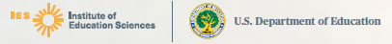

[RESPONDENT NAME]

The United States Department of Education’s National Center for Education Statistics (NCES) within the Institute of Education Sciences (IES) recognizes and thanks you for your contributions.
By participating in our education study, you have given back to your community and the national educational system. Your support will help educators, families, and researchers improve schools and classrooms for future generations of students in this country. Thank you again for your interest and help with our study!

__________________________
James Lynn Woodworth
Commissioner
National Center for Education Statistics,
Institute of Education Sciences

Study Letterhead
Field Test

