Early Childhood Longitudinal Study, Kindergarten Class of 2022-23 (ECLS-K:2023)

Kindergarten and First-Grade Field Test Data Collection,
National Sampling, and National Recruitment

OMB# 1850-0750 v.22

Attachment A-5
K-1 Field Test Infographics

National Center for Education Statistics
U.S. Department of Education

September 2020

Table of Contents
Section Page
Plan for Distributing Infographics 1
Social/Academic Skills 2
Activities with Children 3
Use of Technology 4
School Support of Families/Materials Sent Home 5
Barriers to Participation 6
Children Going to School 7
Common Activities for Families 8

Plan for Distributing Infographics

 | Social /Academic skills | Activities with children | Use of tech | School support of families | Materials sent home | Barriers to participation | Children going to school | Common activities for families
Study homepage
*MyECLS log in screen (Attachment F) | X |  |  | X | X |  | X
District/School recruitment materials
District/School nonresponse letters/emails (Attachment A-1) |  |  | X | X | X |  | X
School administrator, teacher, and parent materials
ECLS study overview (Attachment A-1 and A-2) | X (selected) |  |  | X |  | X (tentative)
Teacher fact sheet (Attachment A-1 and A-2) |  |  |  |  |  | X (selected)
Teacher web portal (Attachment F) |  |  | X
Teacher/School administrator survey reminder letters/ emails (Attachment A-1) |  |  | X | X | X |  | X
*Parent fact sheet (Attachment A-1 and A-2) |  | X (selected)
*Parent web portal (Attachment F) |  |  |  |  |  | X |  | X
*Parent consent/ survey reminder letters/emails (Attachment A-1) |  |  | X | X | X | X | X | X

Note: Based on future edits and the final selections/layout, some of the final colors/design may change somewhat. Any style changes would still maintain the integrity of the design and IES guidelines. Materials would simply be adjusted so that they flow well in context of the website, fact sheet, letter, or email.

Sizes of the infographics may seem small within this document, but the actual sizes of these graphics will be larger within the context of the site layout and follow best practices for web. Sizes of images and text, as well as overall layout, would adjust depending on screen size so that all is still readable and user-friendly. (For reference, the small source text below the infographics is 16px on a desktop/laptop.)
Animation: To better show the relationship of the percentage to the graphic, as a user scrolls down and the graphics come into view, the icons would animate and “fill” with the gold or bright color in front of the grey.

Finally, in this list, materials being translated into Spanish are denoted with an asterisk (“*”). The Spanish translations will be provided in the March 2021 change memo.

Social / Academic Skills

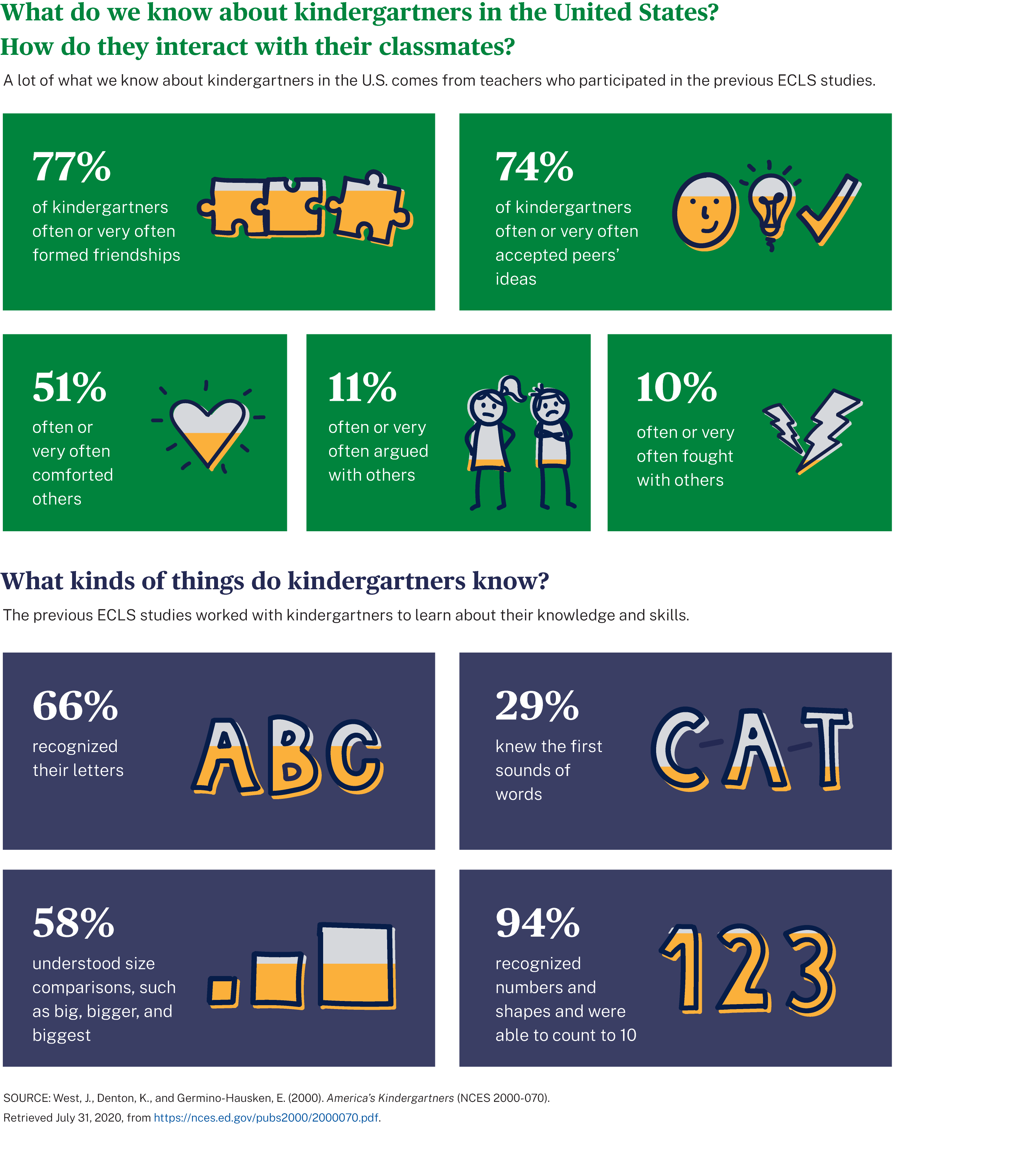

Activities with Children

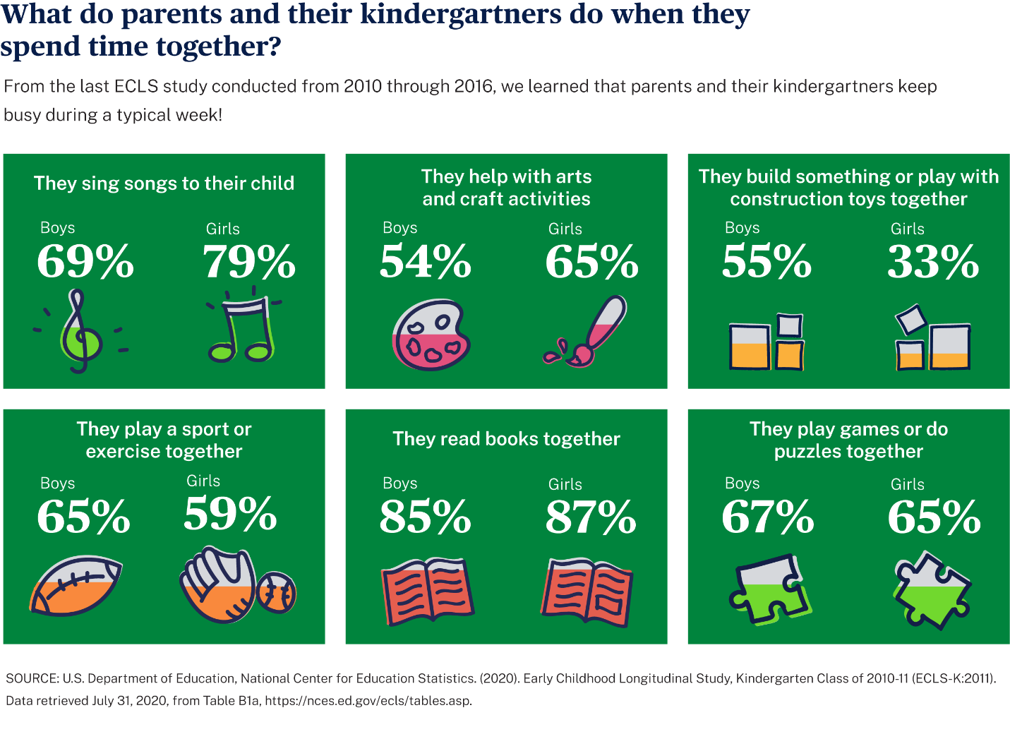

Use of Technology

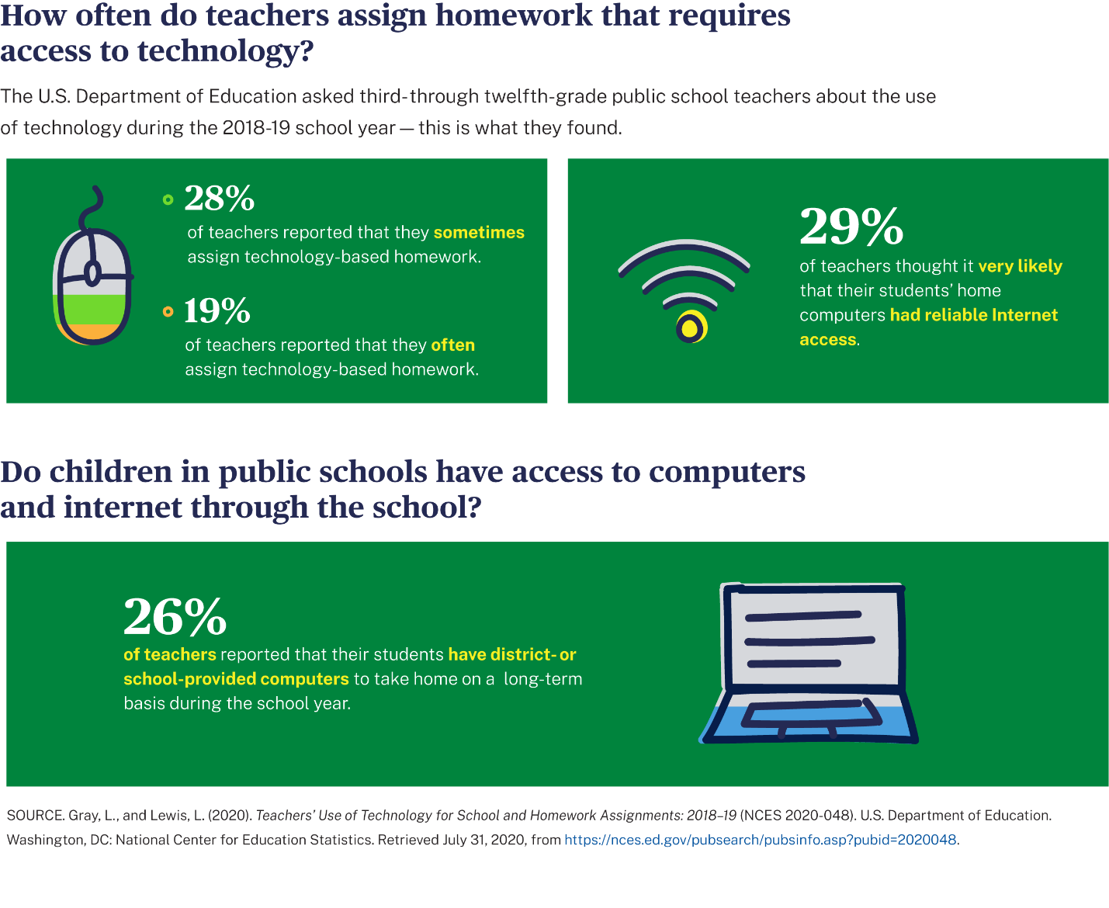

School Support of Families / Materials Sent Home

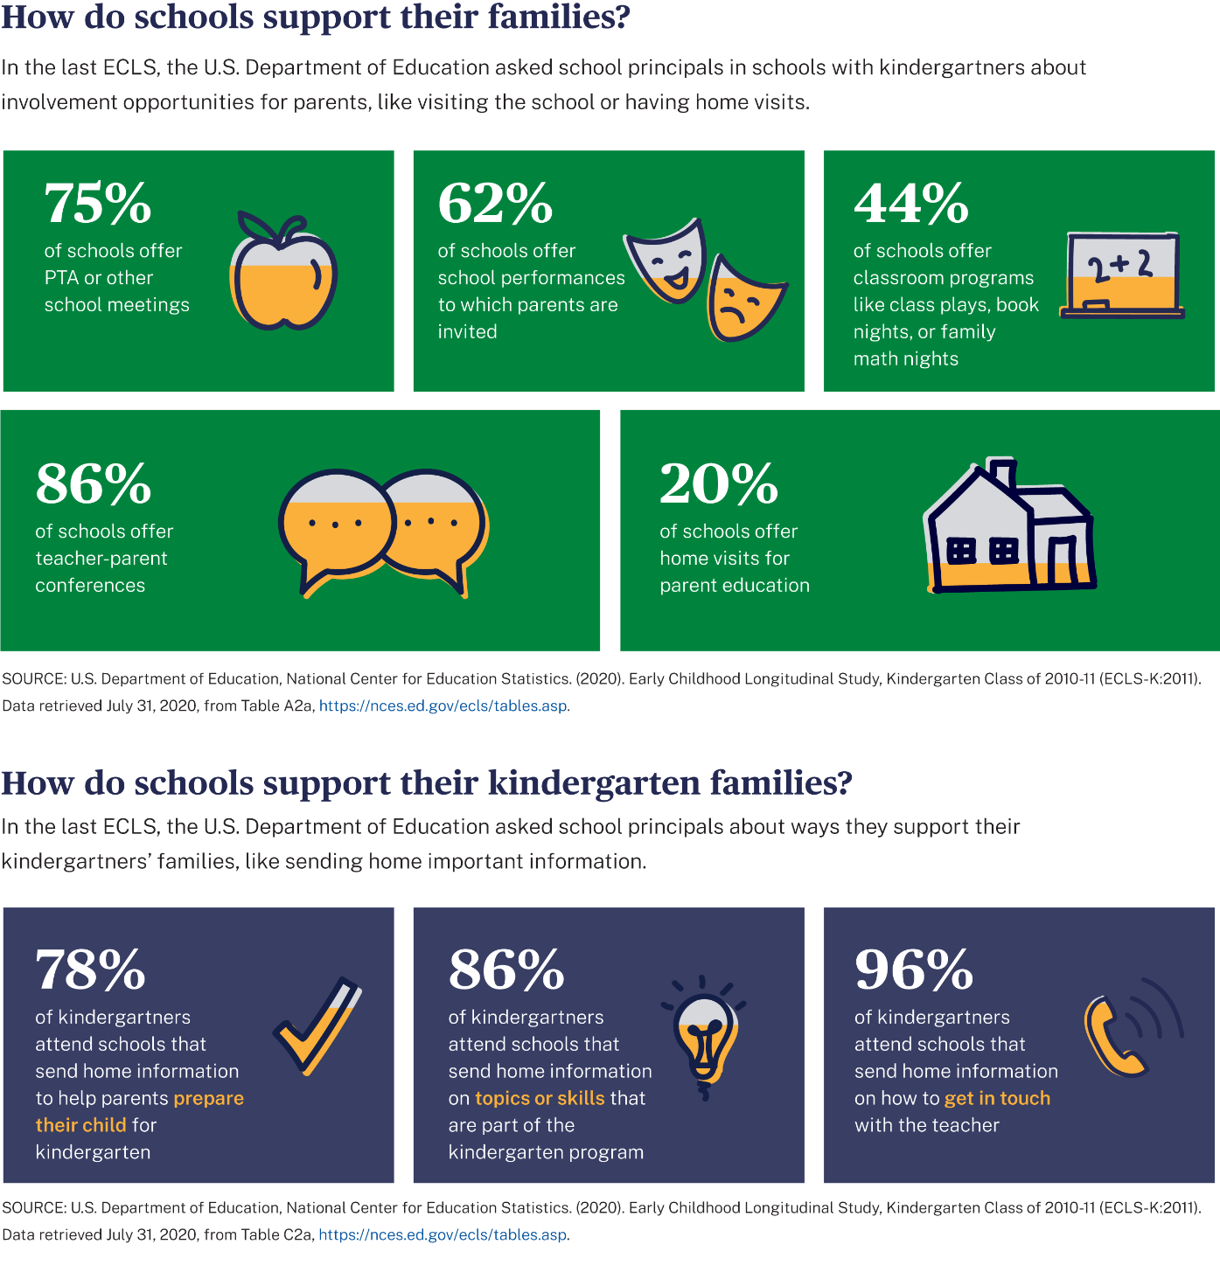

Barriers to Participation

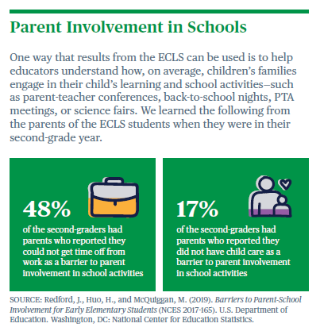
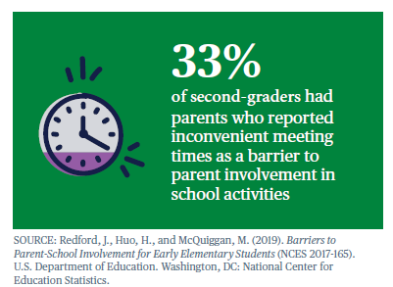

Children Going to School
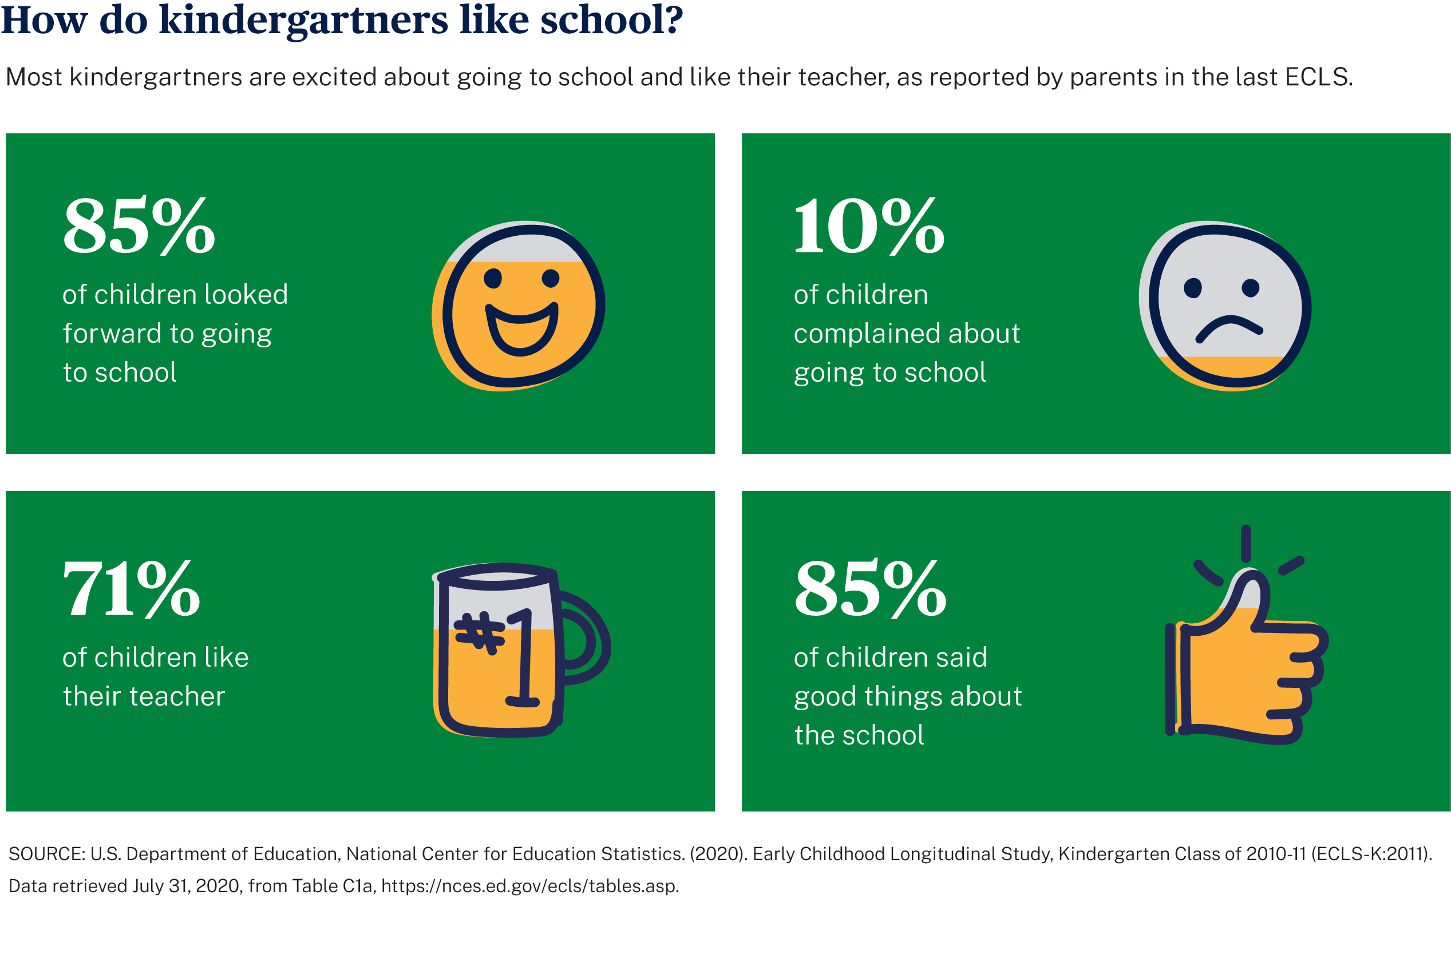

Common Activities for Families

