Early Childhood Longitudinal Study, Kindergarten Class of 2022-23 (ECLS-K:2023)

Kindergarten and First-Grade Field Test Data Collection, National Sampling, and National Recruitment

OMB# 1850-0750 v.22

Attachment F
MyECLS Website Screens

National Center for Education Statistics
U.S. Department of Education

September 2020
revised November 2020

MyECLS Website Screens

NOTE: In this list, materials being translated into Spanish are denoted with an asterisk (“*”). The Spanish translations will be provided in the March 2021 change memo.
1. *STUDY HOME / LOG-IN SCREEN 4
1.1 Overview/Log-in Section 6
1.2 “Why Should I Participate?” Section 10
1.3 Participation Steps Section 11
1.4 Findings Section 14
1.5 More Information Section 18
2. SCHOOL COORDINATOR PORTAL 23
2.1 Overview Section 23
2.2 To Do Section 24
2.3 More Information Section 27
2.4 To Do Tabs 30
SUBMIT CHILD LIST TAB 30
PREPARE FOR SCHOOL VISIT TAB 33
DOCUMENTS TAB 37
SCHOOL INFORMATION TAB 40
CHILD INFORMATION TAB 44
PARENT INFORMATION TAB 45
TEACHER INFORMATION TAB 48
SCHOOL VISIT TAB 51
AFTER THE SCHOOL VISIT TAB 52
3. SCHOOL ADMINISTRATOR PORTAL 66
3.1 Overview Section 66
3.2 Survey Section 68
3.3 Feedback Questions Section 70
3.4 More Information Section 82
4. TEACHER PORTAL 84
4.1 Overview Section 84
4.2 Surveys Section 86
4.3 Feedback Questions Section 89
4.4 More Information Section 95
5. *PARENT PORTAL 98
5.1 Overview Section 98
5.2 Consent Section 100
5.3 Parent Survey Section 104
5.4 Contact Information Screen 106
5.5 Feedback Questions Section 107
5.6 More Information Section 112

STUDY HOME / LOG-IN SCREEN

This screen will be available as follows:
Spring 2021 (field test district and school recruitment) | Field test district and school staff
Fall 2021 (field test data collection; national district and school recruitment) | Field test district and school staff;  Field test school coordinators, school administrators, teachers, and parents (with credentials required to move beyond this page); and  National district and school staff
Spring 2022 (national district and school recruitment) | National district and school staff

The study home/log-in screen has four sections: Overview/log-in section (including the “Why Should I Participate?” section), Participation Steps section (field test and/or national), Findings section, and More Information section (field test and/or national). The log-in page will be translated into English and Spanish; a language toggle appears in the upper right.

This landing page, with the same URL, will be used for both the field test data collection and the national district and school recruitment. The sections are identical for both efforts except for the Participation Steps and More Information sections. In spring 2021, only the field test participation steps and materials will display. Both field test and national participation steps and materials will display in fall 2021. Then, in spring 2022, only the national participation steps and materials will display.

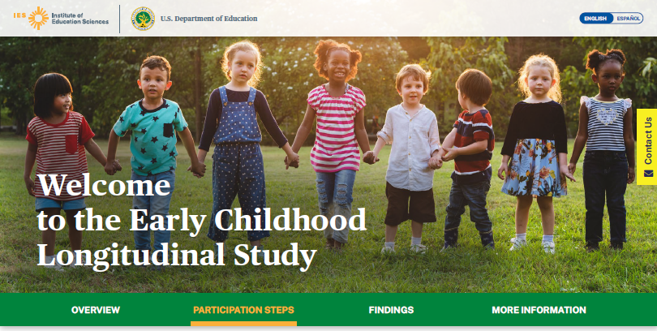

Welcome to the Early Childhood Longitudinal Study

The green banner displays buttons to navigate to different sections of the screen: Overview, Participation Steps, Findings, and More Information.
- “Overview” navigates to the overview section: “What is the ECLS?,” Log-in fields, and “Why Should I participate?”.
- “Participation Steps” navigates to the “Participation Steps” section.
- “Findings” navigates to the “Study Findings” section.
- “More Information” navigates to the materials for districts and schools.

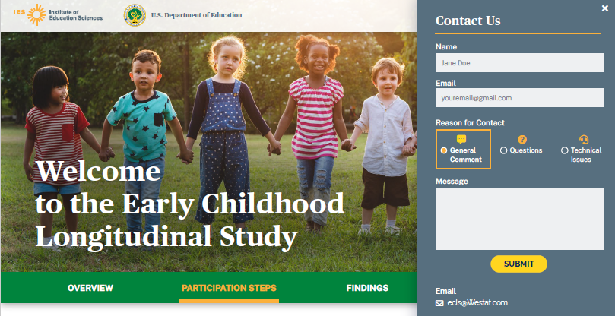

A tab to “Contact us” appears on the right-hand side of the screen. Selecting the “Contact Us” tab opens the “Contact Us” window. Completing the fields in the “Contact Us” window sends a message to ECLS@westat.com.

1.1 Overview/Log-in Section

Display a banner at the top of the page regarding the coronavirus pandemic:
The coronavirus pandemic continues to pose significant challenges for state agencies, districts, and schools, while also affecting us all personally. We recognize these challenges and we are implementing approaches to conduct ECLS activities in schools in a manner that aims to protect the health and safety of students, school staff, and ECLS staff. We will follow recommended guidance from health experts and school-specific safety precautions when our staff visit schools in fall 2021.

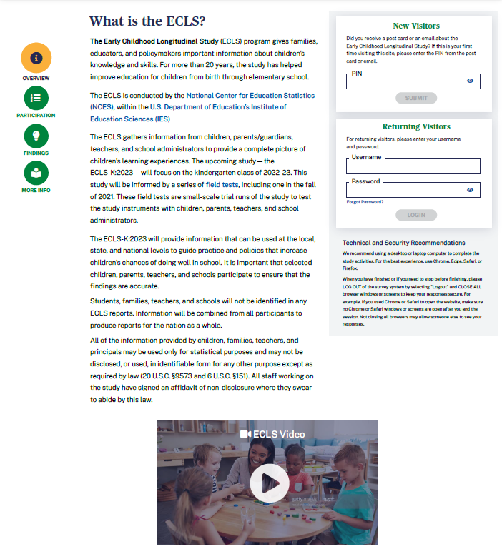

The left-hand side of the screen displays information about the ECLS. Use the navigation buttons on the left to skip to each section: Overview, Participation, Findings, and More Info.

What is the ECLS?
The Early Childhood Longitudinal Study (ECLS) program gives families, educators, and policymakers important information about children’s knowledge and skills. For more than 20 years, the study has helped improve education for children from birth through elementary school.
The ECLS is conducted by the National Center for Education Statistics (NCES) [LINK TO NCES WEBSITE https://nces.ed.gov/ecls/], within the U.S. Department of Education’s [LINK TO DEPARTMENT OF EDUCATION SITE https://www.ed.gov/] Institute of Education Sciences (IES) [LINK TO IES SITE https://ies.ed.gov/].

The ECLS gathers information from children, parents/guardians, teachers, and school administrators to provide a complete picture of children’s learning experiences. The upcoming study - the ECLS-K:2023 - will focus on the kindergarten class of 2022-23. This study will be informed by a series of field tests [LINK TO https://nces.ed.gov/ecls/datainformation2023.asp], including one in the fall of 2021. These field tests are small-scale trial runs of the study to test the study instruments with children, parents, teachers, and school administrators.

The ECLS-K:2023 will provide information that can be used at the local, state, and national levels to guide practice and policies that increase children’s chances of doing well in school. It is important that selected children, parents, teachers, and schools participate to ensure that the findings are accurate.

Students, families, teachers, and schools will not be identified in any ECLS reports. Information will be combined from all participants to produce reports for the nation as a whole.

All of the information provided by children, families, teachers, and principals may be used only for statistical purposes and may not be disclosed, or used, in identifiable form for any other purpose except as required by law (20 U.S.C. §9573 and 6 U.S.C. §151). All staff working on the study have signed an affidavit of non-disclosure where they swear to abide by this law.

A thumbnail of the ECLS video displays below the text. This is a recruitment video that gives an overview of the ECLS program and ECLS-K:2023 study. See the video script in Attachment A-3.

The right-hand side of the screen displays log-in fields for visitors with credentials.

New Visitors
Did you receive a post card or email about the Early Childhood Longitudinal Study (ECLS)? If this is your first time visiting this site, please enter the PIN from the post card or email.

Returning Visitors
For returning visitors, please enter your username and password.
Forgot Password? [LINK]

There is a PIN field for first-time visitors and there are username and password fields for returning visitors.
- First-time visitors will enter a PIN and then immediately will be prompted to create a username and password.
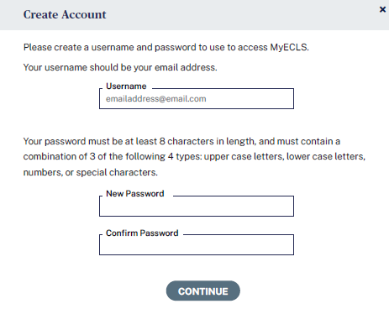
You will be prompted to change your password every 60 days.
Please create a username and password to use to access MyECLS. Your username should be your email address.
Your password must be at least 8 characters in length and must contain a combination of 3 of the following 4 types: upper case letters, lower case letters, numbers, or special characters. You will be prompted to change your password every 60 days.

- When the “Forgot Password?” link is selected, a temporary password will be sent to the user’s email address (username).
- Users will be prompted to reset passwords every 60 days.

The following messages will appear around the log-in fields on the landing page or on a pop-up window (1-7, 12, 13) or will appear in a new pop-up window (8-11).
- A message for invalid PIN entry (too few/many digits or not recognized):
“The PIN you entered is not recognized. Please enter the valid 4-digit PIN provided in the ECLS email or post card. If you need assistance, call us at 855-898-2018 or email ecls@westat.com.”
- A message for invalid email address at account creation (no @ symbol, no .com/.org/etc. extension, contains a space or invalid characters):
“The email address you entered is not valid. Please enter a valid email address.”
- A message for invalid password creation (either initially or upon reset):
“The password you entered does not meet the minimum requirements. Your password must be at least 8 characters in length and must contain a combination of 3 of the following 4 types: upper case letters, lower case letters, numbers, or special characters. It must not be identical to a previous password.”
- A message for non-matching passwords at password creation (either initially or upon reset):
“The passwords you entered do not match. Please try again. Your password must be at least 8 characters in length and must contain a combination of 3 of the following 4 types: upper case letters, lower case letters, numbers, or special characters. It must not be identical to a previous password.”
- A message if the user enters a PIN associated with an ID for which an account (username and password) has already been created:
“We already have an account on file for this username. Please log in using the username and password you created. If you have forgotten your password, select the Forgot Password link. If you need assistance, call us at 855-898-2018 or email ecls@westat.com.”
- A message for unrecognized username:
“The username you entered is not recognized. Please enter the email address you used to create this account. If you have forgotten what email address was used to create your account, or the email address is no longer valid, please call us at 855-898-2018 or email ecls@westat.com.”
- A message for unrecognized password:
“The password you entered is not valid. Please try again or select the Forgot Password link.”
- Message pop-up box for when the user clicks the forgot password link:
“Please enter the email address you used to create your account for the MyECLS Portal. You will receive an email containing a link to reset your password. The link is valid for one use and expires in 5 days. If you need assistance, call us at 855-898-2018 or email ecls@westat.com.”
Username/Email [FIELD]
Continue [BUTTON]
- Message box for log-in using the reset password link that the user received in an email after selecting the “forgot password” link:
“To continue, please create a new password. Your password must be at least 8 characters in length and must contain a combination of 3 of the following 4 types: upper case letters, lower case letters, numbers, or special characters.”
New Password [FIELD]
Confirm Password [FIELD]
Continue [BUTTON]
- An alert that the password will expire soon (passwords expire every 60 days). This message will display upon log-in within 7 days of the expiration date. The user can cancel, since he or she is not required to change passwords until the 60-day expiration:
“Your password will expire in X days. Please create a new password. Your password must be at least 8 characters in length, and must contain a combination of 3 of the following 4 types: upper case letters, lower case letters, numbers, or special characters. It must not be identical to a previous password.”
New Password [FIELD]
Confirm Password [FIELD]
Cancel [BUTTON]
Continue [BUTTON]
- An alert that the password has expired and the user must create a new one (passwords expire every 60 days):
“Your password has expired. Please create a new password. Your password must be at least 8 characters in length and must contain a combination of 3 of the following 4 types: upper case letters, lower case letters, numbers, or special characters. It must not be identical to a previous password.”
New Password [FIELD]
Confirm Password [FIELD]
Continue [BUTTON]
- Message for if a user attempts to continue without entering anything in the username or password fields (at account creation, or reset):
“You must enter a username and password to access the MyECLS website.”
- Message for a disabled account (e.g., parent assigned final refusal status code, parent of child who moved and was not followed, teacher no longer linked to study children, school administrator or school coordinator has changed).
“Your MyECLS Portal account has been disabled. If you need assistance, call us at 855-898-2018 or email ecls@westat.com.”

Below the log-in fields, display “Technical and Security Recommendations”:
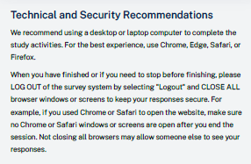
We recommend using a desktop or laptop computer to complete the study activities. For the best experience, use Chrome, Edge, Safari, or Firefox.

When you have finished or if you need to stop before finishing, please LOG OUT of the survey system by selecting "Logout" and CLOSE ALL browser windows or screens to keep your responses secure. For example, if you used Chrome or Safari to open the website, make sure no Chrome or Safari windows or screens are open after you end the session. Not closing all browsers may allow someone else to see your responses.

When the respondent logs in, “Browser Recommendations” will appear:
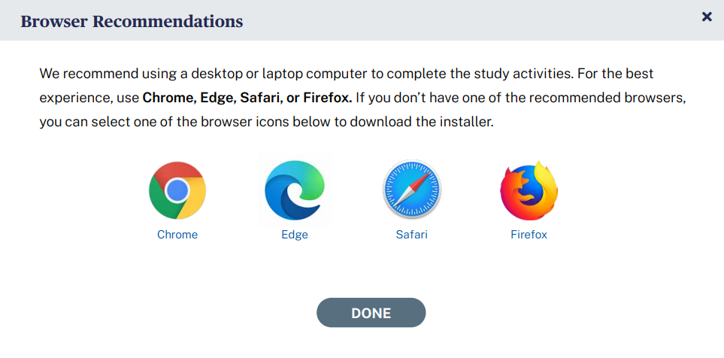
We recommend using a desktop or laptop computer to complete the study activities. For the best experience, use Chrome, Edge, Safari, or Firefox. If you don’t have one of the recommended browsers, you can select one of the browser icons below to download the installer.

Chrome Edge Safari Firefox

1.2 “Why Should I Participate?” Section

Below the overview and log-in section, the user can scroll down to “Why Should I Participate?” (Note: the watermark on the photograph image will not display on the website.)
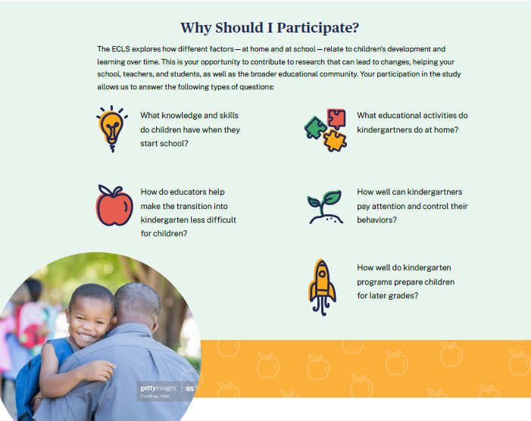

Why Should I Participate?

The ECLS explores how different factors—at home and at school—relate to children’s development and learning over time. This is your opportunity to contribute to research that can lead to changes, helping your school, teachers, and students, as well as the broader educational community. Your participation in the study allows us to answer the following types of questions:
- What knowledge and skills do children have when they start school?
- What educational activities do kindergartners do at home?
- How do educators help make the transition into kindergarten less difficult for children?
- How well can kindergartners pay attention and control their behaviors?
- How well do kindergarten programs prepare children for later grades?

1.3 Participation Steps Section

This section will have different displays for the field test and national studies. In spring 2021, only the field test participation steps will display. Both field test and national steps will display in fall 2021. Then, in spring 2022, only the national steps will display. Note that the watermark will not appear on the photograph images.
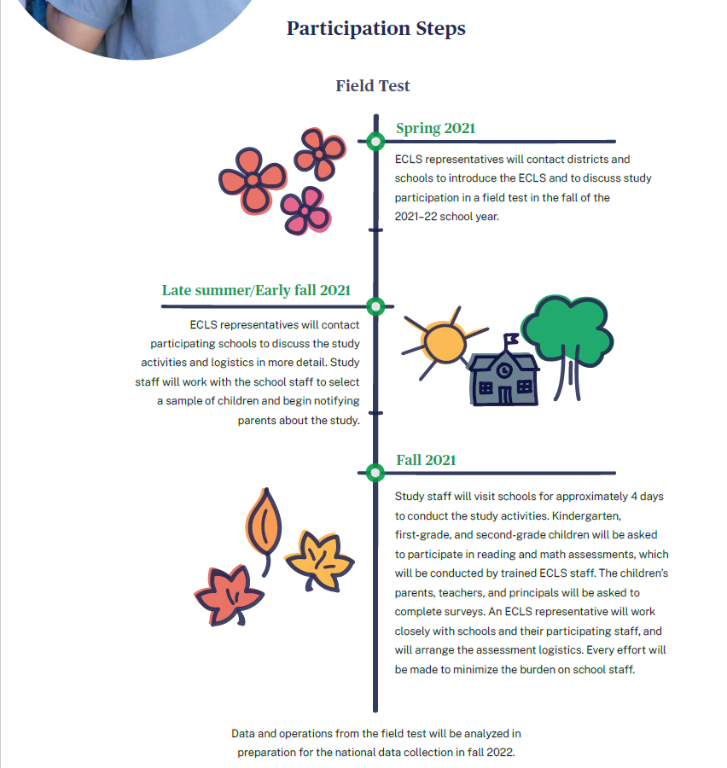

Participation Steps
Field Test

Spring 2021: ECLS representatives will contact districts and schools to introduce the ECLS and to discuss study participation in a field test in the fall of the 2021-22 school year.

Late summer/Early fall 2021: ECLS representatives will contact participating schools to discuss the study activities and logistics in more detail. Study staff will work with the school staff to select a sample of children and begin notifying parents about the study.

Fall 2021: Study staff will visit schools for approximately 4 days to conduct the study activities. Kindergarten, first-grade, and second-grade children will be asked to participate in reading and math assessments, which will be conducted by trained ECLS staff. The children’s parents, teachers, and principals will be asked to complete surveys. An ECLS representative will work closely with schools and their participating staff, and will arrange the assessment logistics. Every effort will be made to minimize the burden on school staff.

Data and operations from the field test will be analyzed in preparation for the national data collection in fall 2022.

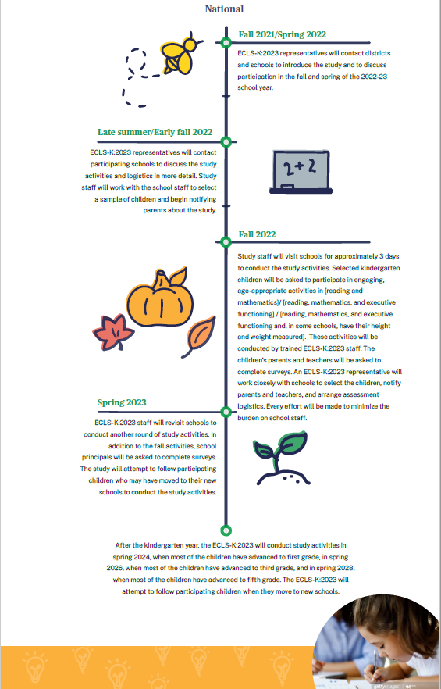
National
Fall 2021/Spring 2022: ECLS-K:2023 representatives will contact districts and schools to introduce the study and to discuss participation in the fall and spring of the 2022-23 school year.

Late summer/Early fall 2022: ECLS-K:2023 representatives will contact participating schools to discuss the study activities and logistics in more detail. Study staff will work with the school staff to select a sample of children and begin notifying parents about the study.

Fall 2022: Study staff will visit schools for approximately 3 days to conduct the study activities. Selected kindergarten children will be asked to participate in engaging, age-appropriate activities in [reading and mathematics]/ [reading, mathematics, and executive functioning] / [reading, mathematics, and executive functioning and, in some schools, have their height and weight measured]. These activities will be conducted by trained ECLS-K:2023 staff. The children’s parents and teachers will be asked to complete surveys. An ECLS-K:2023 representative will work closely with schools to select the children, notify parents and teachers, and arrange assessment logistics. Every effort will be made to minimize the burden on school staff.

Spring 2023: ECLS-K:2023 staff will revisit schools to conduct another round of study activities. In addition to the fall activities, school principals will be asked to complete surveys. The study will attempt to follow participating children who may have moved to their new schools to conduct the study activities.

After the kindergarten year, the ECLS-K:2023 will conduct study activities in spring 2024, when most of the children have advanced to first grade, in spring 2026, when most of the children have advanced to third grade, and in spring 2028, when most of the children have advanced to fifth grade. The ECLS-K:2023 will attempt to follow participating children when they move to new schools.

1.4 Findings Section

See Attachment A-5 for details on the final infographics including their final text; those that appear below in the screenshots are in draft form. The infographics to be included in the “Findings” section include those on the following topics: social and academic skills, school supports for families, materials sent home from schools to parents/guardians, and children’s transition to school. The top of the page has the following text:

Findings
What we learned from ECLS students, parents, and schools

The three sets of infographics display on three tabs: “Social & Academic Skills,” “Children Going to School,” and School Support of Families.” The first tab displays the “Social and Academic Skills” infographic.

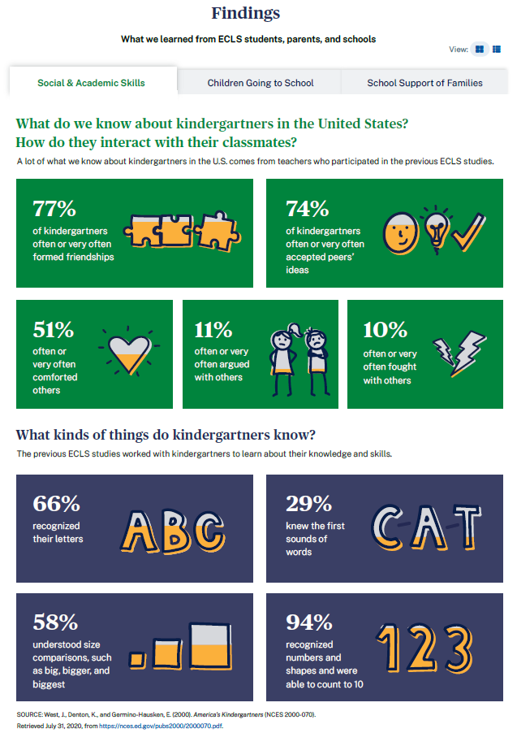

Social & Academic Skills

What do we know about kindergartners in the United States? How do they interact with their classmates?
A lot of what we know about kindergartners in the U.S. comes from teachers and parents who participated in the previous ECLS studies.
- 77% of kindergartners often or very often formed friendships
- 74% of kindergartners often or very often accepted peers’ ideas
- 51% often or very often comforted others
- 11% often or very often argued with others
- 10% often or very often fought with others

What kinds of things do kindergartners know?
The previous ECLS studies worked with kindergartners to learn about their knowledge and skills.
- 66% recognized their letters
- 29% knew the first sounds of words
- 58% understood size comparisons such as big, bigger, and biggest
- 94% recognized numbers and shapes and were able to count to 10
SOURCE: West, J., Denton, K., and Germino-Hausken, E. (2000). America’s Kindergartners (NCES 2000-070). Retrieved July 31, 2020, from https://nces.ed.gov/pubs2000/2000070.pdf.
The second tab displays the “Children Going to School” infographic.
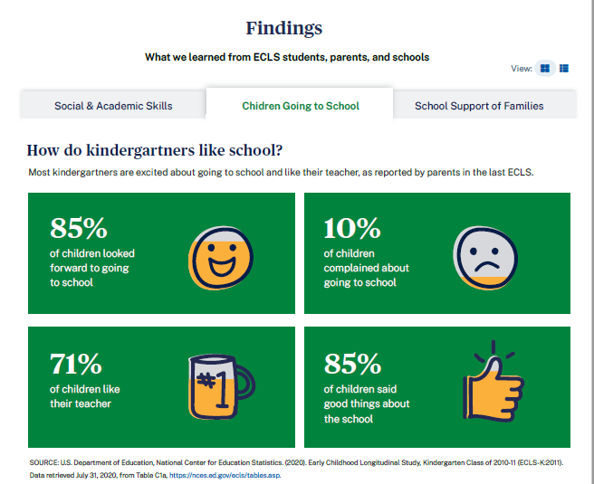

Children Going to School

How do kindergartners like school?
Most kindergartners are excited about going to school and like their teacher, as reported by parents in the last ECLS.
- 85% of children looked forward to going to school
- 10% of children complained about going to school
- 71% of children like their teacher
- 85% of children said good things about the school
SOURCE: U.S. Department of Education, National Center for Education Statistics. (2020). Early Childhood Longitudinal Study, Kindergarten Class of 2010-11 (ECLS-K:2011). Data retrieved July 31, 2020, from Table C1a, https://nces.ed.gov/ecls/tables.asp.
The third tab displays the “School Support of Families” and “Materials Sent Home” infographics.
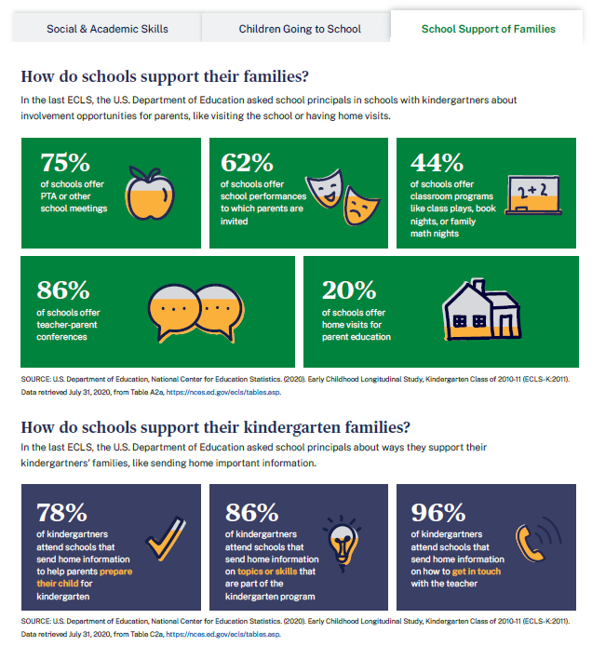

School Support of Families

How do schools support their families?
In the last ECLS, the U.S. Department of Education asked school principals in schools with kindergartners about involvement opportunities for parents, like visiting the school or having home visits.
- 75% of schools offer PTA or other school meetings
- 62% of schools offer school performances to which parents are invited
- 44% of schools offer classroom programs like class plays, book nights, or family math nights
- 86% of schools offer teacher-parent conferences
- 20% of schools offer home visits for parent education
SOURCE: U.S. Department of Education, National Center for Education Statistics. (2020). Early Childhood Longitudinal Study, Kindergarten Class of 2010-11 (ECLS-K:2011). Data retrieved July 31, 2020, from Table A2a, https://nces.ed.gov/ecls/tables.asp.

How do schools support their kindergarten families?
In the last ECLS, the U.S. Department pf Education asked school principals about ways they support their kindergartners’ families, like sending home important information.
- 78% of kindergartners attend schools that send home information to help parents prepare their child for kindergarten
- 86% of kindergartners attend schools that send home information on topics or skills that are part of the kindergarten program
- 96% of kindergartners attend schools that send home information on how to get in touch with the teacher
SOURCE: U.S. Department of Education, National Center for Education Statistics. (2020). Early Childhood Longitudinal Study, Kindergarten Class of 2010-11 (ECLS-K:2011). Data retrieved July 31, 2020, from Table C2a, https://nces.ed.gov/ecls/tables.asp.

1.5 More Information Section

This section will display field test district and school letters and the field test Study Overview during the spring 2021 field test recruitment period. National letters and the national Study Overview will be added for the national recruitment period beginning in fall 2021. The field test materials will be removed at the end of the field test in fall 2021. Note that the watermark will not appear on the photograph image on the website.

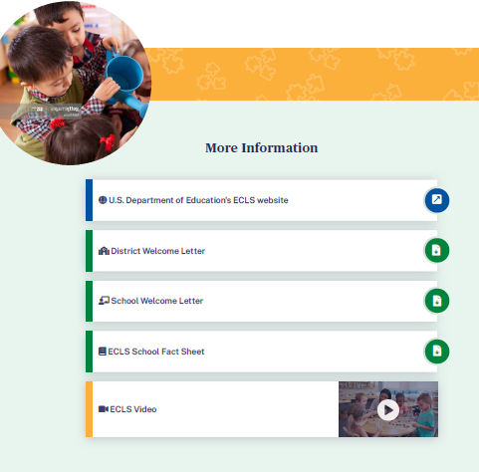

More Information
- The U.S. Department of Education’s ECLS website [https://nces.ed.gov/ecls]
- District Welcome Letter [LINK TO LETTER]
- School Welcome Letter [LINK TO LETTER]
- ECLS School Fact Sheet [LINK TO FACT SHEET]
- ECLS video [LINK TO VIDEO]

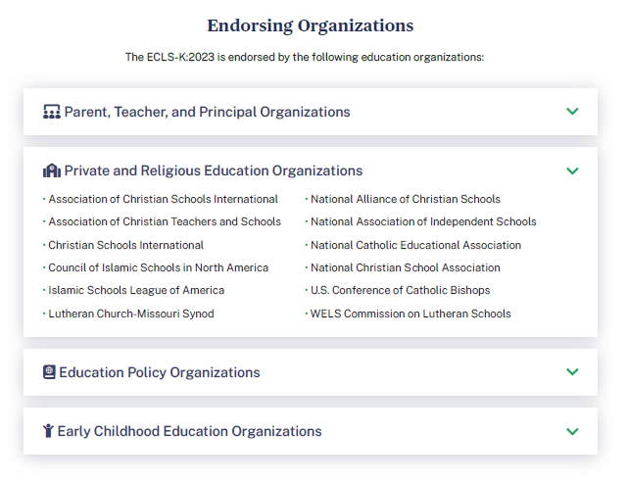

The list of endorsing organizations is divided by type. Each type category is expandable and collapsible.

The ECLS-K:2023 is endorsed by the following education organizations:

Parent, Teacher, and Principal Organizations
- American Federation of Teachers
- Association for Middle Level Education
- Council for Exceptional Children
- International Literacy Association
- National Association of Elementary School Principals
- National Council of Teachers of Mathematics
- National Parent Teacher Association
- National Science Teaching Association
- Texas State Teachers Association

Private and Religious Education Organizations
- Association of Christian Schools International
- Association of Christian Teachers and Schools
- Christian Schools International
- Council of Islamic Schools in North America
- Islamic Schools League of America
- Lutheran Church-Missouri Synod
- National Alliance of Christian Schools
- National Association of Independent Schools
- National Catholic Educational Association
- National Christian School Association
- U.S. Conference of Catholic Bishops
- WELS Commission on Lutheran Schools

Education Policy Organizations
- Alliance for Excellent Education
- Council of Chief State School Officers
- National School Boards Association
- The School Superintendents Association

Early Childhood Education Organizations
- American Montessori Society
- Association Montessori International/USA
- National Institute for Early Education Research

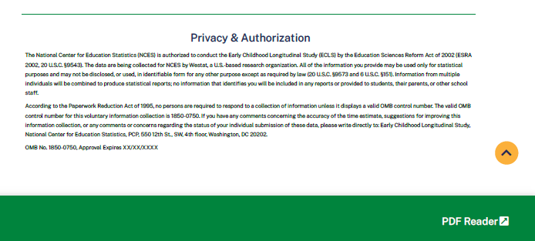

This language appears at the bottom of the log-in page, directly on the screen.
The National Center for Education Statistics (NCES) is authorized to conduct the Early Childhood Longitudinal Study (ECLS) by the Education Sciences Reform Act of 2002 (ESRA 2002, 20 U.S.C. §9543). The data are being collected for NCES by Westat, a U.S.-based research organization. All of the information you provide may be used only for statistical purposes and may not be disclosed, or used, in identifiable form for any other purpose except as required by law (20 U.S.C. §9573 and 6 U.S.C. §151). Information from multiple individuals will be combined to produce statistical reports; no information that identifies you will be included in any reports or provided to students, their parents, or other school staff.
According to the Paperwork Reduction Act of 1995, no persons are required to respond to a collection of information unless it displays a valid OMB control number. The valid OMB control number for this voluntary information collection is 1850-0750. If you have any comments concerning the accuracy of the time estimate, suggestions for improving this information collection, or any comments or concerns regarding the status of your individual submission of these data, please write directly to: Early Childhood Longitudinal Study, National Center for Education Statistics, PCP, 550 12th St., SW, 4th floor, Washington, DC 20202.
OMB No. 1850-0750, Approval Expires XX/XX/XXXX
v.X

SCHOOL COORDINATOR PORTAL
The screens appearing in this section (“2. SCHOOL COORDINATOR PORTAL”) are for the field test only. National screens for the school coordinator will come in a future OMB package when clearance is sought for those data collection activities. The School Coordinator Portal has three sections: Overview, To Do (which contains links to other tabs), and More Information. Use the navigation icons on the left to skip to each section: Overview, To Do, and More Info.

2.1 Overview Section
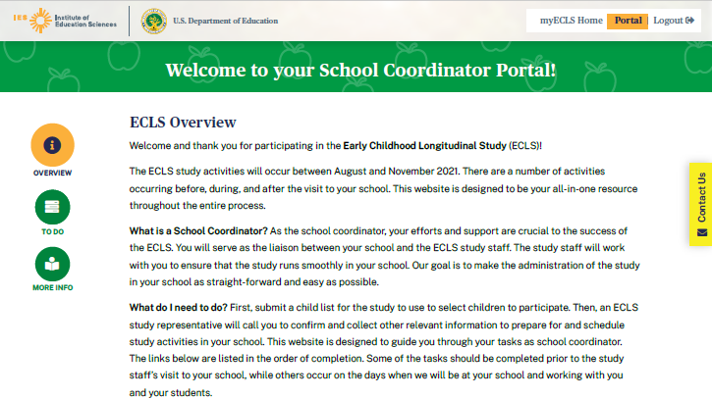
Welcome to your School Coordinator Portal!

ECLS Overview
Welcome and thank you for participating in the Early Childhood Longitudinal Study (ECLS)!

The ECLS study activities will occur between August and November 2021. There are a number of activities occurring before, during, and after the visit to your school. This website is designed to be your all-in-one resource throughout the entire process.

What is a School Coordinator? As the school coordinator, your efforts and support are crucial to the success of the ECLS. You will serve as the liaison between your school and the ECLS study staff. The study staff will work with you to ensure that the study runs smoothly in your school. Our goal is to make the administration of the study in your school as straightforward and easy as possible.

What do I need to do? First, submit a child list for the study to use to select children to participate. Then, an ECLS study representative will call you to confirm and collect other relevant information to prepare for and schedule study activities in your school. This website is designed to guide you through your tasks as school coordinator. The links below are listed in the order of completion. Some of the tasks should be completed prior to the study staff’s visit to your school, while others occur on the days when we will be at your school and working with you and your students.

2.2 To Do Section
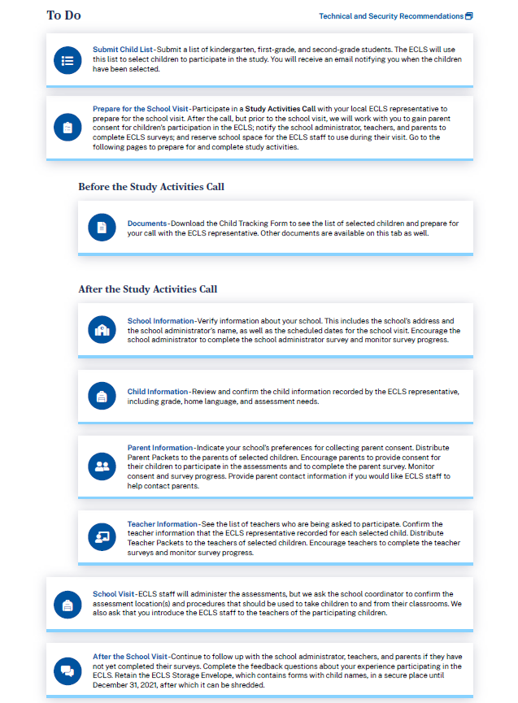

The To Do list displays as an accordion, allowing the user to expand and collapse the tasks. Tasks are checked off as they are completed. Only the School Information, Submit Child List, and Documents screens are available prior to the child list being submitted and finalized. Each of the items includes a link to a tab. The details of each tab are displayed on the following pages.

To Do

Above the To Do sections, display a link to “Technical and Security Recommendations.” Display the following pop-up window when “Technical and Security Recommendations” is selected:
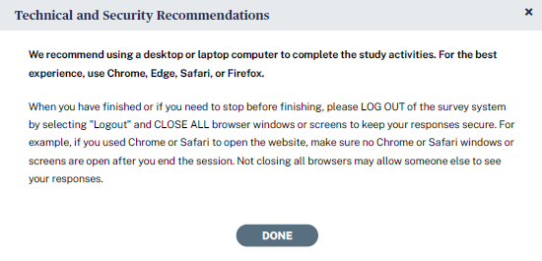

We recommend using a desktop or laptop computer to complete the study activities. For the best experience, use Chrome, Edge, Safari, or Firefox.

When you have finished or if you need to stop before finishing, please LOG OUT of the survey system by selecting "Logout" and CLOSE ALL browser windows or screens to keep your responses secure. For example, if you used Chrome or Safari to open the website, make sure no Chrome or Safari windows or screens are open after you end the session. Not closing all browsers may allow someone else to see your responses.

Submit Child List – Submit a list of kindergarten, first-grade, and second-grade students. The ECLS will use this list to select children to participate in the study. You will receive an email notifying you when the children have been selected.

Prepare for the School Visit – Participate in a Study Activities Call with your local ECLS representative to prepare for the school visit. After the call, but prior to the school visit, we will work with you to gain parent consent for children’s participation in the ECLS; notify the school administrator, teachers, and parents to complete ECLS surveys; and reserve school space for the ECLS staff to use during their visit. Go to the following pages to prepare for and complete study activities.

Before the Study Activities Call
- Documents – Download the Child Tracking Form to see the list of selected children and prepare for your call with the ECLS representative. Other documents are available on this tab as well.

After the Study Activities Call
- School Information – Verify information about your school. This includes the school’s address and the school administrator’s name, as well as the scheduled dates for the the school visit. Encourage the school administrator to complete the school administrator survey and monitor survey progress.
- Child Information – Review and confirm the child information recorded by the ECLS representative, including grade, home language, and assessment needs.
- Parent Information – Indicate your school’s preferences for collecting parent consent. Distribute Parent Packets to the parents of selected children. Encourage parents to provide consent for their children to participate in the assessments and to complete the parent survey. Monitor consent and survey progress. Provide parent contact information if you would like ECLS staff to help contact parents.
- Teacher Information – See the list of teachers who are being asked to participate. Confirm the teacher information that the ECLS representative recorded for each selected child. Distribute Teacher Packets to the teachers of selected children. Encourage teachers to complete the teacher surveys and monitor survey progress.
School Visit - ECLS staff will administer the assessments, but we ask the school coordinator to confirm the assessment location(s) and procedures that should be used to take children to and from their classrooms. We also ask that you introduce the ECLS staff to the teachers of the participating children.
After the School Visit - Continue to follow up with the school administrator, teachers, and parents if they have not yet completed their surveys. Complete the feedback questions about your experience participating in the ECLS. Retain the ECLS Storage Envelope, which contains forms with child names, in a secure place until December 31, 2021, after which it can be shredded.

Example of a completed to-do list:
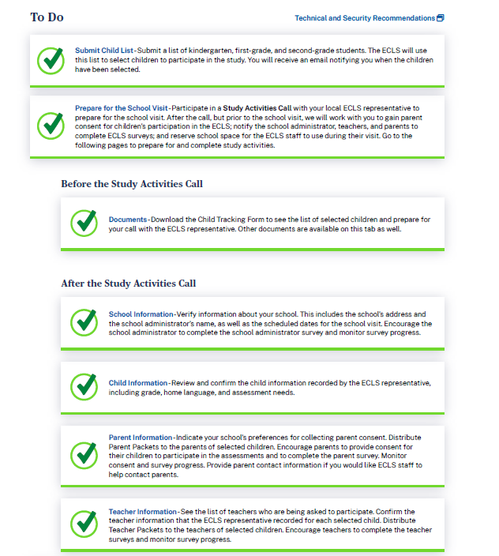

2.3 More Information Section

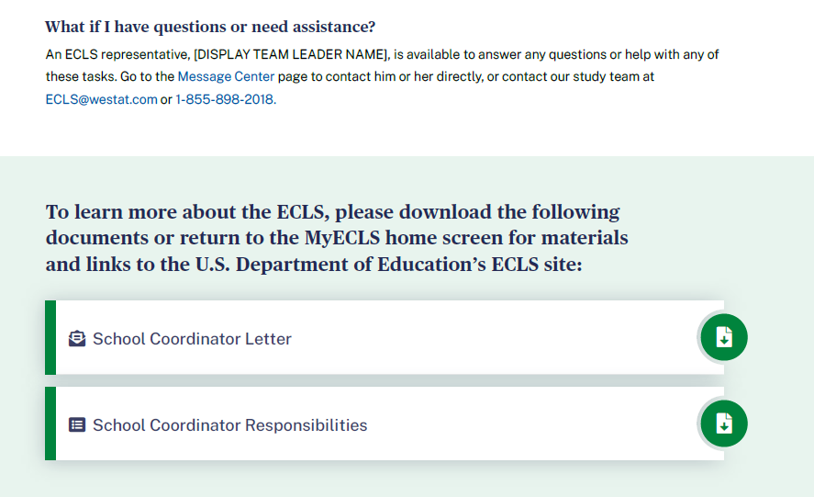
What if I have questions or need assistance?
An ECLS representative, [DISPLAY TEAM LEADER NAME], is available to answer any questions or help with any of these tasks. Go to the Message Center [DISPLAY LINK] page to contact him or her directly, or contact our study team at ECLS@westat.com or 1-855-898-2018.

To learn more about the ECLS, please download the following documents or return to the MyECLS home screen for materials and links to the U.S. Department of Education’s ECLS site:
- School Coordinator Letter [LINK TO LETTER]
- School Coordinator Responsibilities [LINK TO RESPONSIBILITIES]

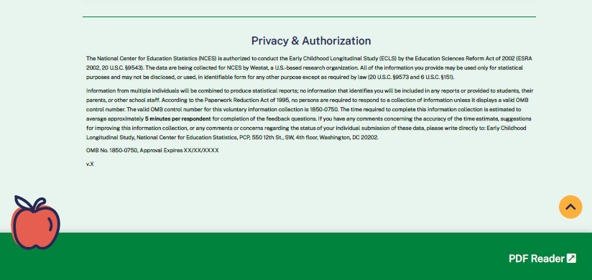

This language appears at the bottom of the School Coordinator Portal page, directly on the screen.
The National Center for Education Statistics (NCES) is authorized to conduct the Early Childhood Longitudinal Study (ECLS) by the Education Sciences Reform Act of 2002 (ESRA 2002, 20 U.S.C. §9543). The data are being collected for NCES by Westat, a U.S.-based research organization. All of the information you provide may be used only for statistical purposes and may not be disclosed, or used, in identifiable form for any other purpose except as required by law (20 U.S.C. §9573 and 6 U.S.C. §151).

Information from multiple individuals will be combined to produce statistical reports; no information that identifies you will be included in any reports or provided to students, their parents, or other school staff. According to the Paperwork Reduction Act of 1995, no persons are required to respond to a collection of information unless it displays a valid OMB control number. The valid OMB control number for this voluntary information collection is 1850-0750. The time required to complete this information collection is estimated to average approximately 5 minutes per respondent for completion of the feedback questions. If you have any comments concerning the accuracy of the time estimate, suggestions for improving this information collection, or any comments or concerns regarding the status of your individual submission of these data, please write directly to: Early Childhood Longitudinal Study, National Center for Education Statistics, PCP, 550 12th St., SW, 4th floor, Washington, DC 20202.
OMB No. 1850-0750, Approval Expires XX/XX/XXXX
v.X

2.4 To Do Tabs
When a user clicks on a tab in the To Do Section, a box with tabs that match the links in that section appears. Users can click on each tab to see detailed instructions. (They can also click on the links in the To Do section to display that particular tab.)

SUBMIT CHILD LIST TAB
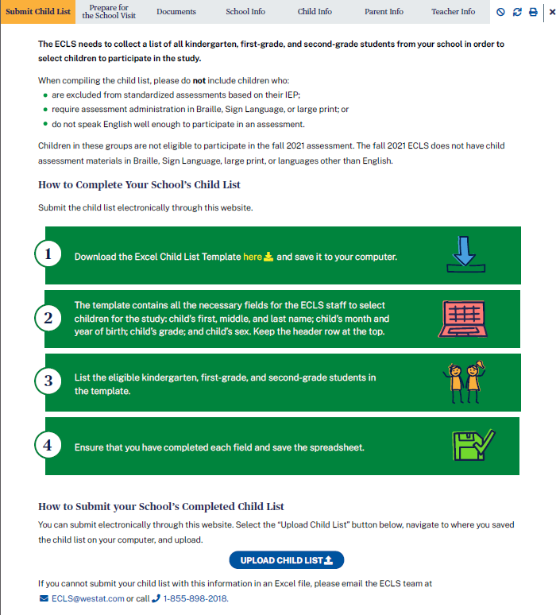

The ECLS needs to collect a list of all kindergarten, first-grade, and second-grade students from your school in order to select children to participate in the study.
When compiling the child list, please do not include children who:
- are excluded from standardized assessments based on their IEP;
- require assessment administration in Braille, Sign Language, or large print; or
- do not speak English well enough to participate in an assessment.
Children in these groups are not eligible to participate in the fall 2021 assessment. The fall 2021 ECLS does not have child assessment materials in Braille, Sign Language, large print, or languages other than English.
How to Complete Your School’s Child List
Submit the child list electronically through this website.
- Download the Excel Child List Template here [DISPLAY LINK] and save it to your computer.
- The template contains all the necessary fields for the ECLS staff to select children for the study: child’s first, middle, and last name; child’s month and year of birth; child’s grade; and child’s sex. Keep the header row at the top.
- List the eligible kindergarten, first-grade, and second-grade students in the template.
- Ensure that you have completed each field and save the spreadsheet.
The Child List Template is a spreadsheet with a header row displaying labels for the following columns:
- Child First Name
- Child Middle Name
- Child Last Name
- Month of Birth
- Year of Birth
- Grade
- Sex

Child First Name | Child Middle Name | Child Last Name | Month of Birth | Year of Birth | Grade | Sex
Ted | Brian | Brooks | 5 | 2012 | K | M

How to Submit your School’s Completed Child List
You can submit electronically through this website. Select the “Upload Child List” button below, navigate to where you saved the child list on your computer, and upload.
Display “Upload Child List” button. Selecting the “upload child list” button allows the user to browse his or her saved files and choose one to upload.
If you cannot submit your child list with this information in an Excel file, please email the ECLS team at ECLS@westat.com or call 1-855-898-2018.
The following text will display on the screen once the list is submitted successfully.
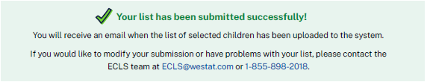
Your list has been submitted successfully! You will receive an email when the list of children selected for the study has been uploaded to the system.
If you would like to modify your submission or have problems with your list, please contact the ECLS team at ECLS@westat.com or 1-855-898-2018.

PREPARE FOR SCHOOL VISIT TAB
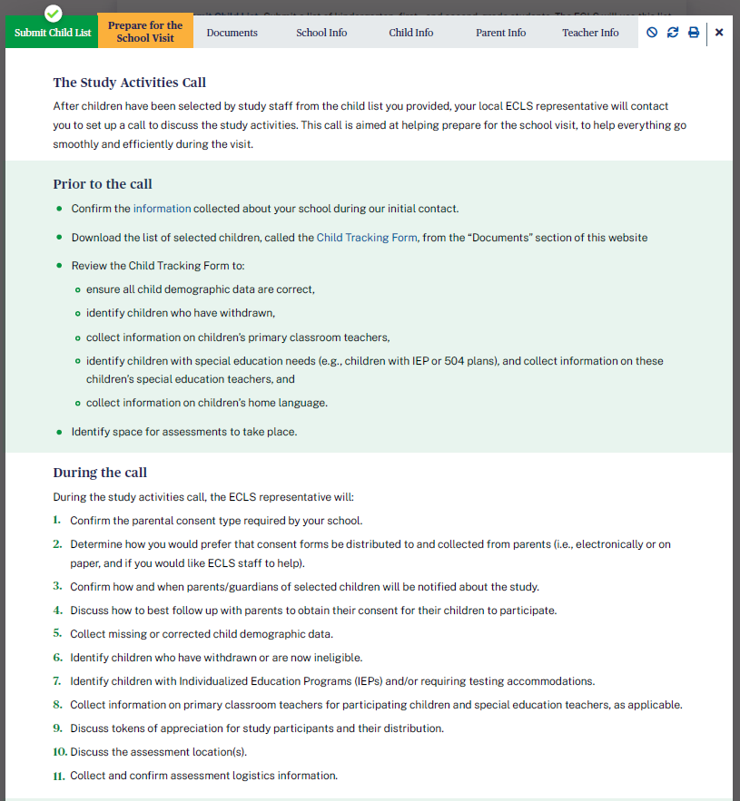
The Study Activities Call
After children have been selected by study staff from the child list you provided, your local ECLS representative will contact you to set up a call to discuss the study activities. This call is aimed at helping prepare for the school visit, to help everything go smoothly and efficiently during the visit.
Prior to the call
- Confirm the information [DISPLAY LINK TO SCHOOL INFO TAB] collected about your school during our initial contact.
- Download the list of selected children, called the Child Tracking Form [DISPLAY LINK TO CHILD TRACKING FORM], from the “Documents” section of this website.
- Review the Child Tracking Form to:
  - ensure all child demographic data are correct,
  - identify children who have withdrawn,
  - collect information on children’s primary classroom teachers,
  - identify children with special education needs (e.g., children with IEP or 504 plans), and collect information on these children’s special education teachers, and
  - collect information on children’s home language.
- Identify space for assessments to take place.

During the call
During the study activities call, the ECLS representative will:
- Confirm the parental consent type required by your school.
- Determine how you would prefer that consent forms be distributed to and collected from parents (i.e., electronically or on paper, and if you would like ECLS staff to help).
- Confirm how and when parents/guardians of selected children will be notified about the study.
- Discuss how to best follow up with parents to obtain their consent for their children to participate.
- Collect missing or corrected child demographic data.
- Identify children who have withdrawn or are now ineligible.
- Identify children with Individualized Education Programs (IEPs) and/or requiring testing accommodations.
- Collect information on primary classroom teachers for participating children and special education teachers, as applicable.
- Discuss tokens of appreciation for study participants and their distribution.
- Discuss the assessment location(s).
- Collect and confirm assessment logistics information.

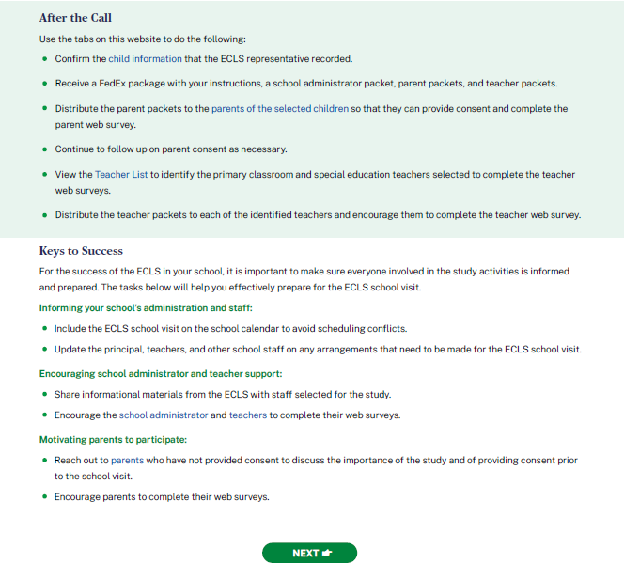
After the Call:
Use the tabs on this website to do the following:
- Confirm the child information [DISPLAY LINK TO CHILD INFO TAB] that the ECLS representative recorded.
- Receive a FedEx package with your instructions, a school administrator packet, parent packets, and teacher packets.
- Distribute the parent packets to the parents of the selected children [DISPLAY LINK TO PARENT INFO TAB] so that they can provide consent and complete the parent web survey.
- Continue to follow up on parent consent as necessary.
- View the Teacher List [DISPLAY LINK TO TEACHER INFO TAB] to identify the primary classroom and special education teachers selected to complete the teacher web surveys.
- Distribute the teacher packets to each of the identified teachers and encourage them to complete the teacher web survey.

Keys to Success:
For the success of the ECLS in your school, it is important to make sure everyone involved in the study activities is informed and prepared. The tasks below will help you effectively prepare for the ECLS school visit.
Informing your school’s administration and staff:
- Include the ECLS school visit on the school calendar to avoid scheduling conflicts.
- Update the principal, teachers, and other school staff on any arrangements that need to be made for the ECLS school visit.

Encouraging school administrator and teacher support:
- Share informational materials from the ECLS with staff selected for the study.
- Encourage the school administrator [DISPLAY LINK TO SCHOOL INFO TAB] and teachers [DISPLAY LINK TO TEACHER INFO TAB] to complete their web surveys.

Motivating parents to participate:
- [IF CONSENT TYPE = EXPLICIT, DISPLAY:] Reach out to parents [DISPLAY LINK TO PARENT INFO TAB] who have not provided consent to discuss the importance of the study and of providing consent prior to the school visit.
- Encourage parents to complete their web surveys.

NEXT BUTTON MOVES ON TO THE DOCUMENTS TAB.

DOCUMENTS TAB
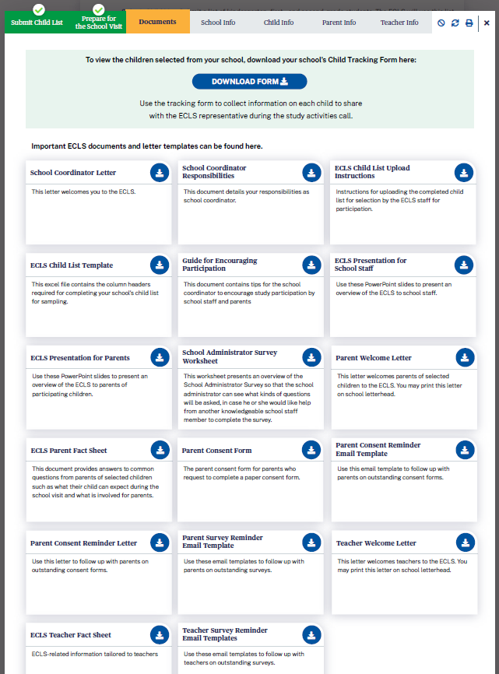
To view the children selected from your school, download your school's Child Tracking Form here: DISPLAY DOWNLOAD FORM BUTTON. Use the tracking form to collect information on each child to share with the ECLS representative during the study activities call.
The Child Tracking Form is a spreadsheet displaying a table with prefilled information on selected children from the uploaded child list, plus empty columns* for the school coordinator (SC) to collect additional information:
- Child name (last, first)
- Child ID
- Child month of birth
- Child year of birth
- Child sex
- Child grade
- Child’s home language*
- Primary classroom teacher name*
- Classroom*
- Teacher email address*
- Accommodations needed?*

Important ECLS documents and letter templates can be found here:
File Name | Description
School Coordinator Welcome Letter | This letter welcomes you to the ECLS.
School Coordinator Responsibilities | This document details your responsibilities as school coordinator.
ECLS Child List Upload Instructions | Instructions for uploading the completed child list for selection by the ECLS staff for participation.
ECLS Child List Template | This excel file contains the column headers required for completing your school’s child list for sampling.
Guide for Encouraging Participation | This document contains tips for the school coordinator to encourage study participation by school staff and parents.
ECLS Presentation for School Staff | Use these PowerPoint slides to present an overview of the ECLS to school staff.
ECLS Presentation for Parents | Use these PowerPoint slides to present an overview of the ECLS to parents of participating children.
School Administrator Survey Worksheet | This worksheet presents an overview of the School Administrator Survey so that the school administrator can see what kinds of questions will be asked, in case he or she would like help from another knowledgeable school staff member to complete the survey.
Parent Welcome Letter [EXPLICIT OR IMPLICIT; INCENTIVES OR NON] | This letter welcomes parents of selected children to the ECLS. You may print this letter on school letterhead.
ECLS Parent Fact Sheet | This document provides answers to common questions from parents of selected children such as what their child can expect during the school visit and what is involved for parents.
Parent Consent Form [EXPLICIT OR IMPLICIT DEPENDING ON THE SCHOOL’S CHOICE ON THE SCHOOL INFO SCREEN] | The parent consent form for parents who request to complete a paper consent form.
[DISPLAY IF CONSENT TYPE = EXPLICIT:] Parent Consent Reminder Email Template | Use this email template to follow up with parents on outstanding consent forms.
[DISPLAY IF CONSENT TYPE = EXPLICIT:] Parent Consent Reminder Letter | Use this letter to follow up with parents on outstanding consent forms.
Parent Survey Reminder Email Templates | Use these email templates to follow up with parents on outstanding surveys.
Teacher Welcome Letter | This letter welcomes teachers to the ECLS. You may print this letter on school letterhead.
ECLS Teacher Fact Sheet | ECLS-related information tailored to teachers
Teacher Survey Reminder Email Templates | Use these email templates to follow up with teachers on outstanding surveys.

SCHOOL INFORMATION TAB

The School Information (“School Info”) tab has three sections, which can be expanded and collapsed: School Information, School Administrator Survey Status, and School Assessment Information.

SCHOOL INFORMATION SECTION

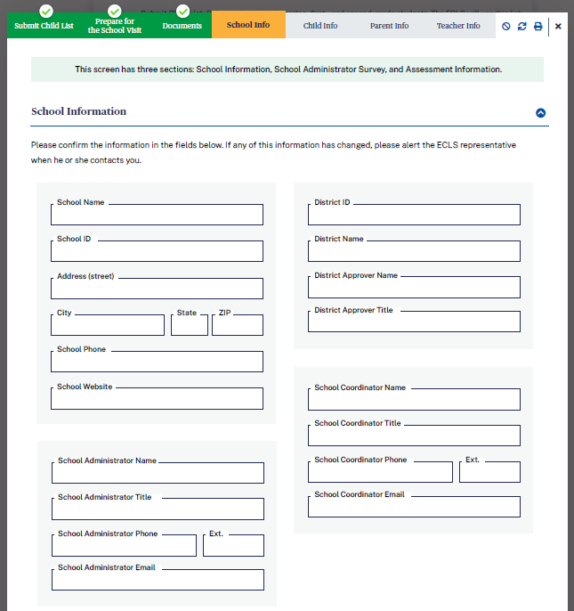

Display information prefilled from the recruitment phase.

This screen has three sections: School Information, School Administrator Survey, and School Questions.

School Information

Please confirm the information in the fields below. If any of this information has changed, please alert the ECLS representative when he or she contacts you.
- School Name
- School ID
- Address (street, city, state, ZIP)
- School Phone
- School Website
- District fields. Do not display if the school is private.
  - District ID
  - District Name
  - District Approver Name
  - District Approver Title
- School Administrator Name
- School Administrator Title
- School Administrator Phone
- School Administrator Phone ext.
- School Administrator Email
- School Coordinator Name
- School Coordinator Title
- School Coordinator Phone
- School Coordinator Phone ext.
- School Coordinator Email

SCHOOL ADMINISTRATOR SURVEY STATUS SECTION (with example text):

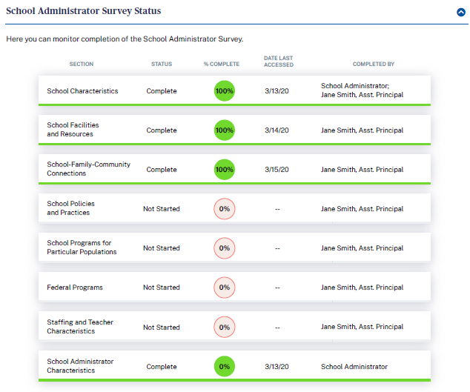

School Administrator Survey Status
Here you can monitor completion of the School Administrator Survey.

Section | Status | % Complete | Date Last Accessed | Completed by
- School Characteristics | Complete | 100% | 3/13/20 | School Administrator; Other School Staff: Jane Smith, Assistant Principal
- School Facilities and Resources | Complete | 100% | 3/14/20 | Other School Staff: Jane Smith, Assistant Principal
- School-Family-Community Connections | In-progress | 50% | 3/15/20
- School Policies and Practices | Not started | 0%
- School Programs for Particular Populations | Not started | 0%
- Federal Programs | Not started | 0%
- Staffing and Teacher Characteristics | Not started | 0%
- School Administrator Characteristics | Complete | 100% | 3/13/20 | School Administrator

SCHOOL ASSESSMENT INFORMATION SECTION (with example text):

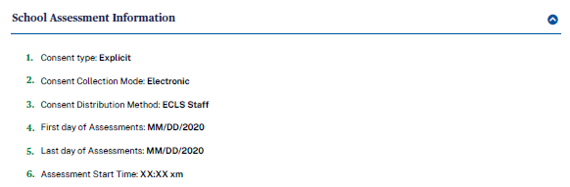

School Assessment Information
Display information recorded by the ECLS representative.
- Consent type: Explicit or Implicit
- Consent Collection Mode: Electronic or Paper
- Consent Distribution Method: ECLS Staff or School Staff
- First day of Assessments
- Last day of Assessments
- Assessment Start Time

CHILD INFORMATION TAB

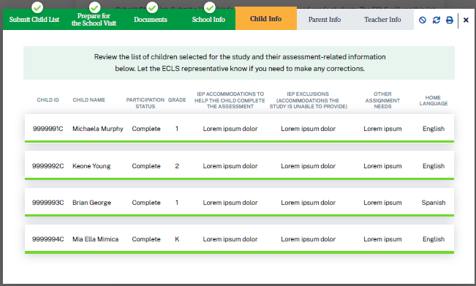
Review the list of children selected for the study and their assessment-related information below. Let the ECLS representative know if you need to make any corrections.
Display a list of children in child ID order with the following columns. Display the ECLS representative’s entries.
- Child ID
- Child Name
- Participation Status
- Grade (Kindergarten, First Grade, or Second Grade)
- IEP accommodations to help the child complete the assessment
- IEP exclusions (accommodations the ECLS is unable to provide)
- Other Assessment Needs
- Home Language

PARENT INFORMATION TAB

The Parent Information (“Parent Info”) tab has two sections: Parent Consent, and Parent Information and Survey Tracking.

PARENT CONSENT SECTION
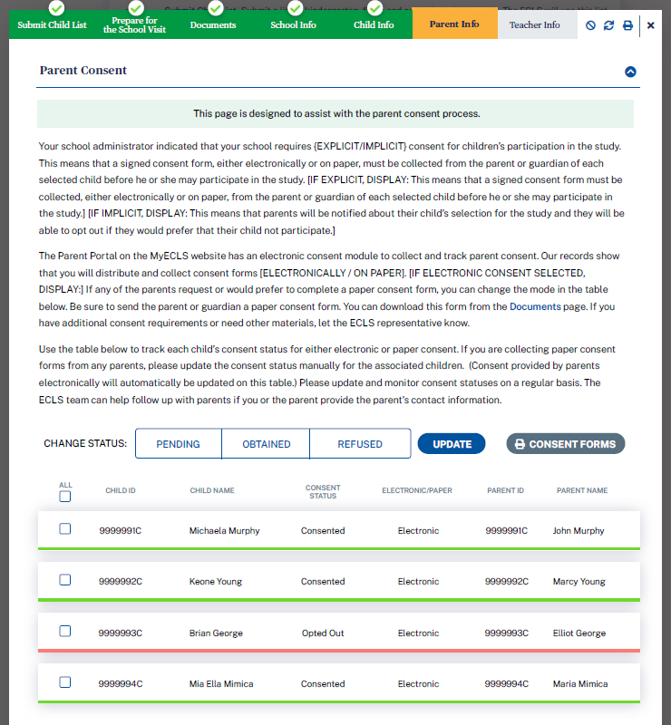
Parent Consent
This page is designed to assist with the parent consent process.
Your school administrator indicated that your school requires {EXPLICIT/IMPLICIT} consent for children’s participation in the study. [IF EXPLICIT, DISPLAY: This means that a signed consent form must be collected, either electronically or on paper, from the parent or guardian of each selected child before he or she may participate in the study.] [IF IMPLICIT, DISPLAY: This means that parents will be notified about their child’s selection for the study and they will be able to opt out if they would prefer that their child not participate.]
The Parent Portal on the MyECLS website has an electronic consent module to collect and track parent consent. Our records show that you will distribute and collect consent forms [ELECTRONICALLY / ON PAPER]. [IF ELECTRONIC CONSENT SELECTED, DISPLAY:] If any of the parents request or would prefer to complete a paper consent form, you can change the mode in the table below. Be sure to send the parent or guardian a paper consent form. You can download this form from the Documents [LINK TO DOCUMENTS PAGE] page. If you have additional consent requirements or need other materials, let the ECLS representative know.
Use the table below to track each child’s consent status for either electronic or paper consent. If you are collecting paper consent forms from any parents, please update the consent status manually for the associated children. (Consent provided by parents electronically will automatically be updated on this table.) Please update and monitor consent statuses on a regular basis. The ECLS team can help follow up with parents if you or the parent provide the parent’s contact information.
Display a list of children along with child ID, child name, consent status, consent delivery method, parent ID, parent name.

Consent delivery method is either electronic or paper, as recorded on the School Information Screen.
- If electronic, child consent status will update automatically as the electronic forms are signed.
- If paper, or for individual parents who prefer to provide paper, the school coordinator or ECLS representative will update child consent status as the forms are received.

The electronic or paper column is prefilled based on the school’s selection but can be updated manually for individual children.

The checkbox in the far left column allows the user to select the row to update consent status or to print consent forms. The checkbox in the header row allows the user to select all rows.

Display a consent status update button above the table. The options include:
- Pending
- Obtained
- Refused

Apply the selection to selected children in the consent status column.

Display a “print consent forms” button above the table. Selecting the print button allows the user to print consent forms for selected children.

Child ID | Child Name | Electronic or Paper | Consent Status | Parent ID | Parent Name
9999001C | Child Name | Electronic | C_Consent | 9999001P | Parent Name

PARENT INFORMATION AND SURVEY TRACKING SECTION
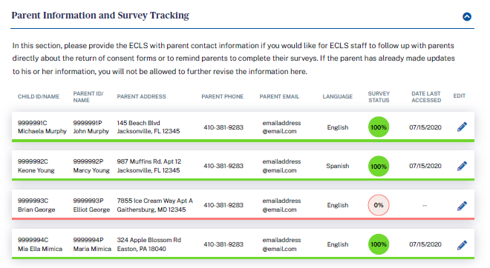

Parent Information and Survey Tracking

In this section, please provide the ECLS with parent contact information if you would like for ECLS staff to follow up with parents directly about the return of consent forms or to remind parents to complete their surveys. If the parent has already made updates to his or her information, you will not be allowed to further revise the information here.

Child ID/Name | Parent ID/Name | Parent Address | Parent Phone | Parent Email | Language | Survey Status | Date Last Accessed | Edit
9999  001C  Child Name | 9999001P  Parent Name | 123 Main St | 301-555-1212 | Parent  @gmail  .com | English | 75 | 3/15/20 | Edit icon

Fill parent columns as parent information is recorded in the Parent Portal. Allow updates to the parent address/phone/email fields on this screen by the SC. If the parent has recorded information or made updates, do not allow updates by the SC.

TEACHER INFORMATION TAB

The Teacher Information (“Teacher Info”) tab has three sections: Teacher List, Child-Teacher Link, and Track Teacher Surveys.

TEACHER LIST SECTION

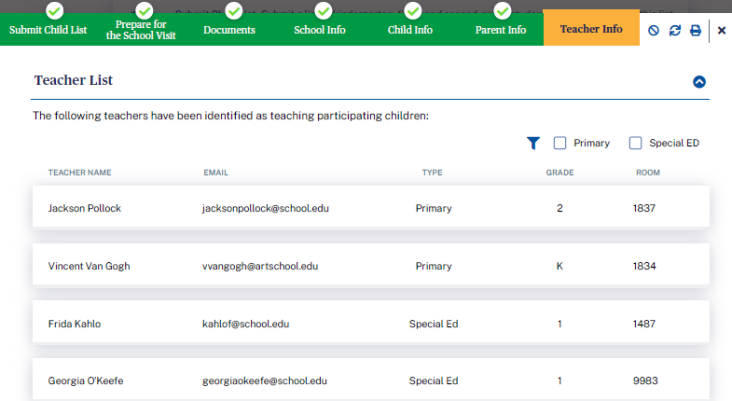

Teacher List

The following teachers have been identified as teaching participating children:

Display a list of teachers, as recorded by the ECLS representative.

Teacher Name | Email Address | Type | Grade | Room
Teacher Name | teacher@gmail.com | Primary or Special Ed | K, 1, or 2 | 123

CHILD-TEACHER LINK SECTION

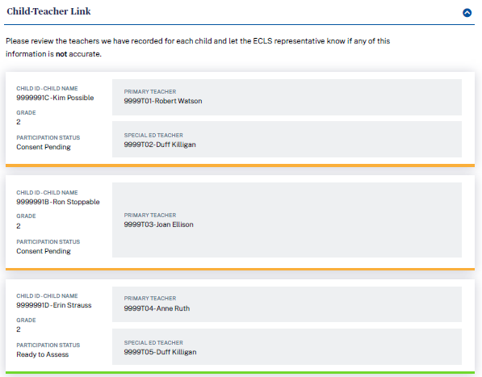

Display a list of children. For each child, display a primary classroom teacher, as recorded by the ECLS representative. For each child with an IEP on file, also display the special education teacher, as recorded by the ECLS representative.

Child-Teacher Link

Please review the teachers we have recorded for each child and let the ECLS representative know if any of this information is not accurate.

Child  ID | Child Name | Participation Status | Grade | Primary Teacher ID | Primary Teacher Name | Special Ed Teacher ID | Special Ed Teacher Name
9999001C | Child One | Consent Pending | K | 9999T01 – P01 | Teacher Name | 9999T01 – S01 | Teacher Name
9999002C | Child Two | Consent Pending | K | 9999T01 – P01 | Teacher Name | N/A | N/A
9999003C | Child Three | Ready to Assess | 1 | 9999T02 – P01 | Teacher Name | 9999T02 – S01 | Teacher Name

TEACHER SURVEY SECTION
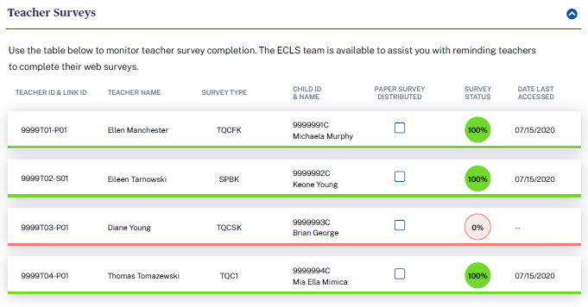
Teacher Surveys
Use the table below to monitor teacher survey completion. The ECLS team is available to assist you with reminding teachers to complete their web surveys.
- Teacher ID and link ID
- Teacher Name
- Survey type: For teacher-level surveys, display TQA or SPA. These are the abbreviations used for the teacher-level surveys. For child-level surveys, display TQC or SPB. These are the abbreviations used for the child-level surveys.
- Child ID and name: For child-level surveys, display child ID and name, else display “n/a”.
- Paper survey distributed: Checked if the ECLS representative has distributed paper surveys
- Survey Status (% complete)
- Date Last Accessed

Teacher  ID & Link ID | Teacher Name | Survey Type | Child ID and Name | Paper Survey Distributed | Survey Status | Date Last Accessed
9999T01-P01/S01 | Teacher Name | TQA/TQC/SPA/SPB | 9999001C  Child Name | CHECK-BOX | 100% | 3/15/20

SCHOOL VISIT TAB
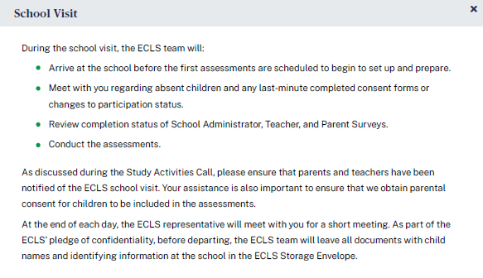
School Visit
During the school visit, the ECLS team will:
- Arrive at the school before the first assessments are scheduled to begin to set up and prepare.
- Meet with you regarding absent children and any last-minute completed consent forms or changes to participation status.
- Review completion status of School Administrator, Teacher, and Parent Surveys.
- Conduct the assessments.

As discussed during the Study Activities Call, please ensure that parents and teachers have been notified of the ECLS school visit. Your assistance is also important to ensure that we obtain parental consent for children to be included in the assessments.
At the end of each day, the ECLS representative will meet with you for a short meeting. As part of the ECLS’ pledge of confidentiality, before departing, the ECLS team will leave all documents with child names and identifying information at the school in the ECLS Storage Envelope.

AFTER THE SCHOOL VISIT TAB
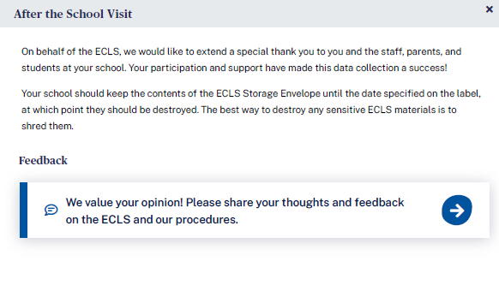
After the School Visit
On behalf of the ECLS, we would like to extend a special thank you to you and the staff, parents, and students at your school. Your participation and support have made this data collection a success!
Your school should keep the contents of the ECLS Storage Envelope until the date specified on the label, at which point they should be destroyed. The best way to destroy any sensitive ECLS materials is to shred them.
FEEDBACK SECTION
These 18 questions are designed to solicit feedback from the field test school coordinator respondents to inform the national data collection.

Display this section after the school visit is completed [date TBD].

DISPLAY: We value your opinion! Please share your thoughts and feedback on the ECLS and our procedures.

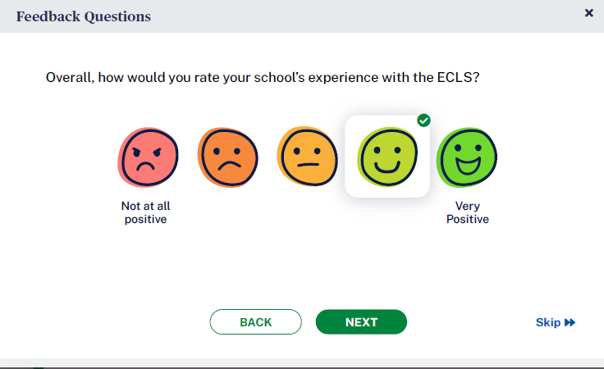
- Overall, how would you rate your school’s experience with the ECLS?
1 Not at all positive 2 3 4 5 Very positive

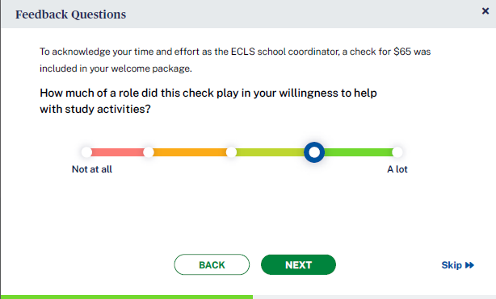
- [IF INCENTIVE RULE ON DISTRICT INFO AND SCHOOL INFO SCREENS = INCENTIVES ALLOWED, DISPLAY:] To acknowledge your time and effort as the ECLS school coordinator, a check for $65 was included in your welcome package.
How much of a role did this check play in your willingness to help with study activities?
1 Not at all 2 3 4 5 A lot

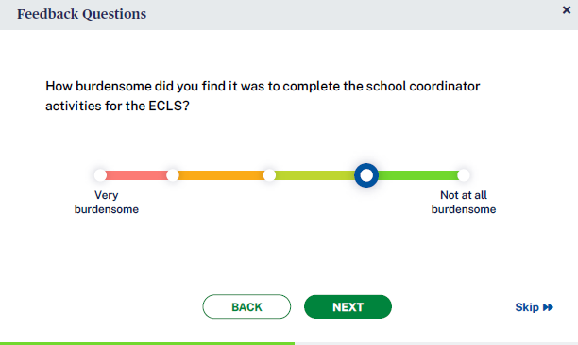
- How burdensome did you find it was to complete the school coordinator activities for the ECLS?
1 Very burdensome 2 3 4 5 Not at all burdensome

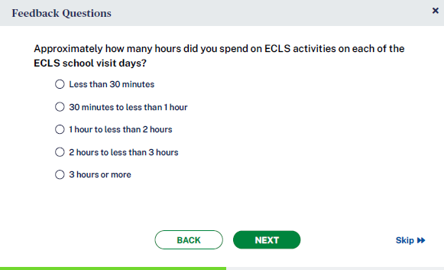
- Approximately how many hours did you spend on ECLS activities on each of the ECLS school visit days?
Less than 30 minutes
30 minutes to less than 1 hour
1 hour to less than 2 hours
2 hours to less than 3 hours
3 hours or more

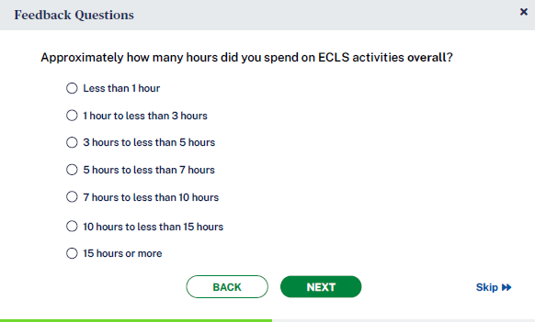
- Approximately how many hours did you spend on ECLS activities overall?
Less than 1 hour
1 hour to less than 3 hours
3 hours to less than 5 hours
5 hours to less than 7 hours
7 hours to less than 10 hours
10 hours to less than 15 hours
15 hours or more

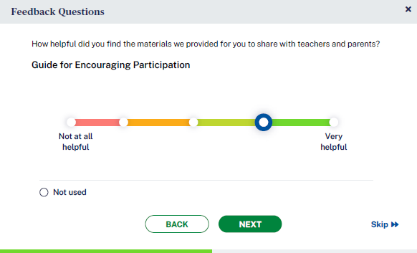
- How helpful did you find the materials we provided for you to share with teachers and parents?
  - Guide for Encouraging Participation
0 Not Used
1 Not at all helpful 2 3 4 5 Very helpful
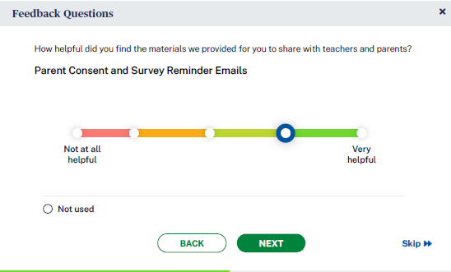
  - Parent Consent and Survey Reminder Emails
0 Not Used
1 Not at all helpful 2 3 4 5 Very helpful

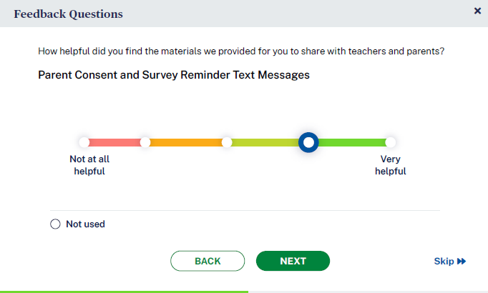
  - Parent Consent and Survey Reminder Text Messages
0 Not Used
1 Not at all helpful 2 3 4 5 Very helpful

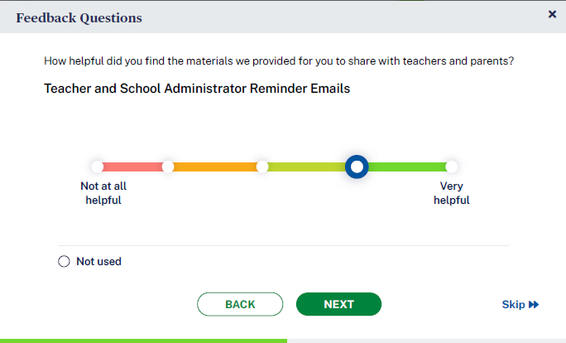
  - Teacher and School Administrator Reminder Emails
0 Not Used
1 Not at all helpful 2 3 4 5 Very helpful

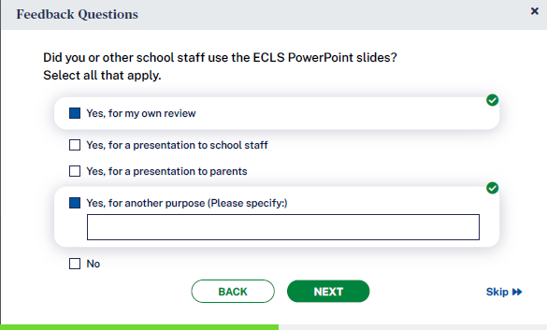
- Did you or other school staff use the ECLS PowerPoint slides? Select all that apply.
  - Yes, for my own review
  - Yes, for a presentation to school staff
  - Yes, for a presentation to parents
  - Yes, for another purpose (Please specify:)
  - No [GO TO Q9]

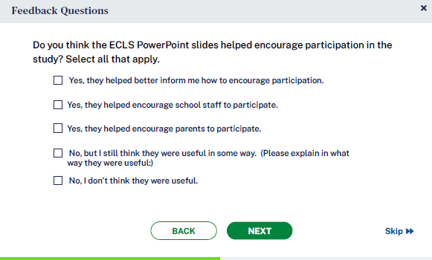
- IF YES (Q7= a, b, c, or d): Do you think the ECLS PowerPoint slides helped encourage participation in the study? Select all that apply. [GO TO Q10]
  - Yes, they helped better inform me how to encourage participation.
  - Yes, they helped encourage school staff to participate.
  - Yes, they helped encourage parents to participate.
  - No, but I still think they were useful in some way. (Please explain in what way they were useful:)
  - No, I don’t think they were useful.

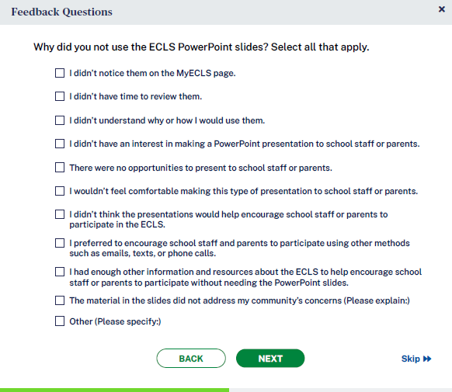
- IF NO (Q7=e): Why did you not use the ECLS PowerPoint slides? Select all that apply. [GO TO Q12]
  - I didn’t notice them on the MyECLS page.
  - I didn’t have time to review them.
  - I didn’t understand why or how I would use them.
  - I didn’t have an interest in making a PowerPoint presentation to school staff or parents.
  - There were no opportunities to present to school staff or parents.
  - I wouldn’t feel comfortable making this type of presentation to school staff or parents.
  - I didn’t think the presentations would help encourage school staff or parents to participate in the ECLS.
  - I preferred to encourage school staff and parents to participate using other methods such as emails, texts, or phone calls.
  - I had enough other information and resources about the ECLS to help encourage school staff or parents to participate without needing the PowerPoint slides.
  - The material in the slides did not address my community’s concerns (Please explain:)
  - Other (Please specify:)

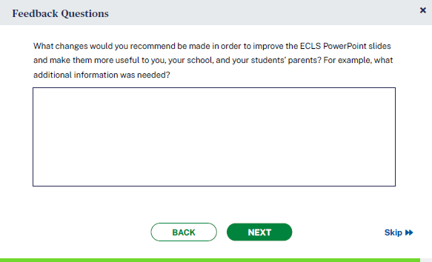
- [IF Q7=YES (a, b, c, or d):] What changes would you recommend be made in order to improve the ECLS PowerPoint slides and make them more useful to you, your school, and your students’ parents? For example, what additional information was needed? [OPEN TEXT ENTRY FIELD.]

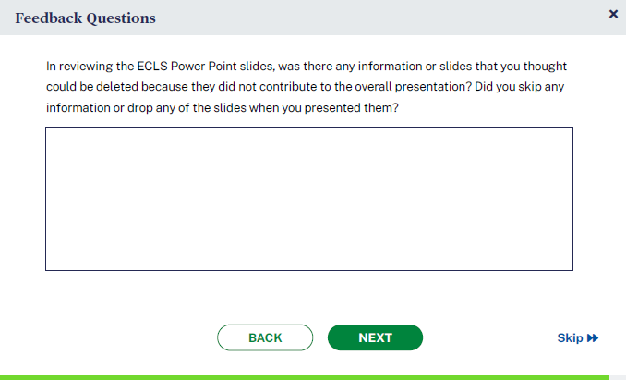
- [IF Q7=YES (a, b, c, or d):] In reviewing the ECLS PowerPoint slides, was there any information or slides that you thought could be deleted because they did not contribute to the overall presentation? Did you skip any information or drop any of the slides when you presented them?

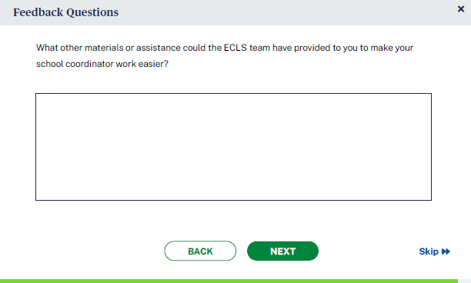
- What other materials or assistance could the ECLS team have provided to you to make your school coordinator work easier? [OPEN TEXT ENTRY FIELD.]

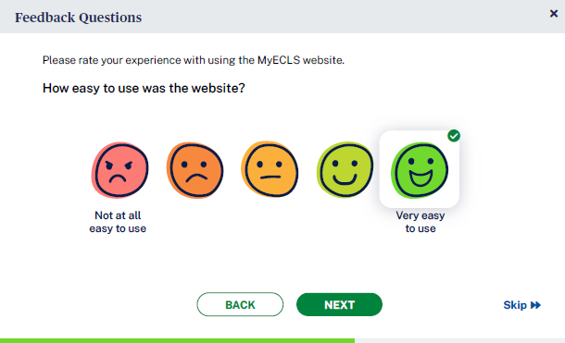
- Please rate your experience with using the MyECLS website.
a. How easy to use was the website?
- Not at all easy to use 2 3 4 5 Very easy to use

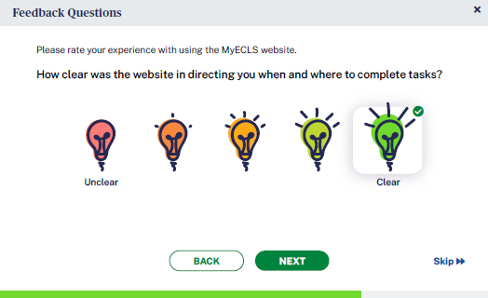
b. How clear was the website in directing you when and where to complete tasks?
- Unclear 2 3 4 5 Clear

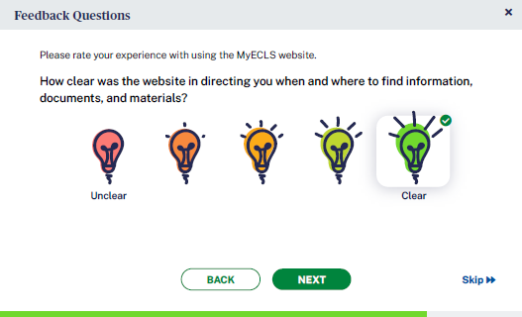
c. How clear was the website in directing you when and where to find information, documents, and materials?
- Unclear 2 3 4 5 Clear

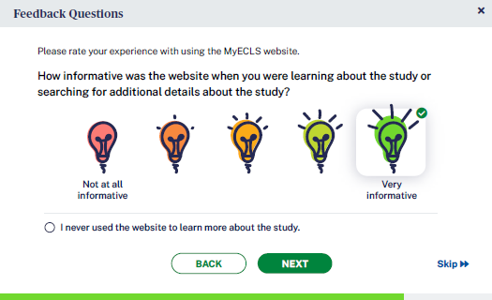
- How informative was the website when you were learning about the study or searching for additional details about the study?
0 I never used the website to learn more about the study.
- Not at all informative 2 3 4 5 Very informative

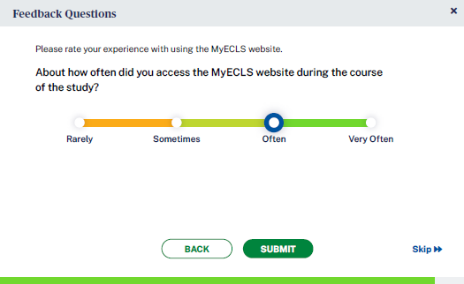
- About how often did you access the MyECLS website during the course of the study?
Rarely
Sometimes
Often
Very Often
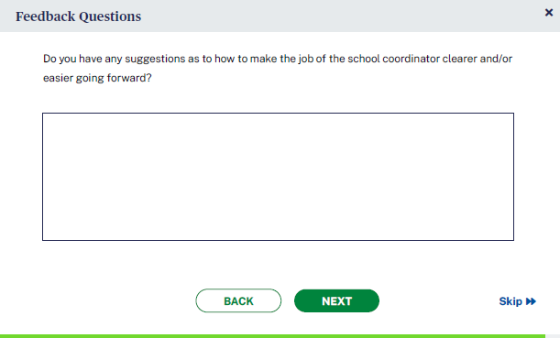
- Do you have any suggestions as to how to make the job of the school coordinator clearer and/or easier going forward? [OPEN TEXT ENTRY FIELD.]

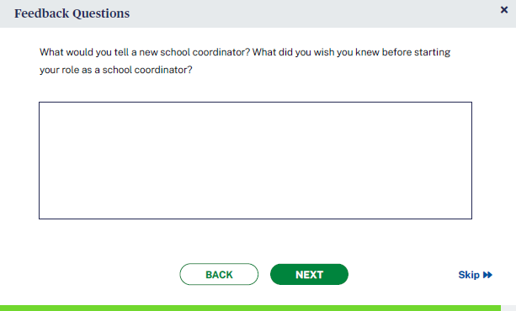
- What would you tell a new school coordinator? What did you wish you knew before starting your role as a school coordinator? [OPEN TEXT ENTRY FIELD.]

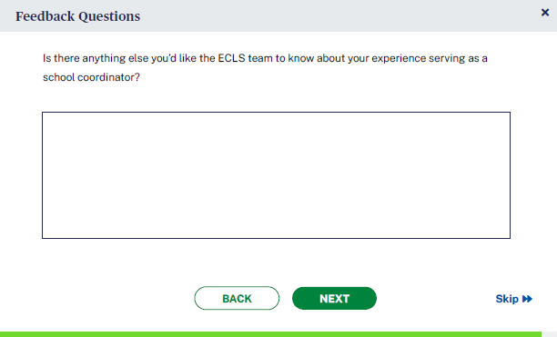
- Is there anything else you’d like the ECLS team to know about your experience serving as a school coordinator? [OPEN TEXT ENTRY FIELD.]

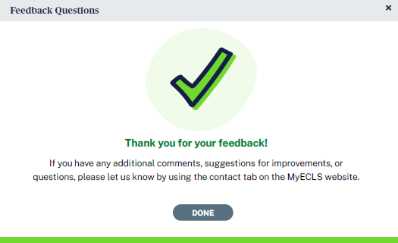
Thank you for your feedback. If you have any additional comments, suggestions for improvements, or questions, please let us know by using the contact tab on the MyECLS website.
“DONE” BUTTON [WHEN SELECTED, RETURN TO THE PORTAL AND COLLAPSE THIS SECTION AND MARK AS COMPLETED

SCHOOL ADMINISTRATOR PORTAL

The screens appearing in this section (“3. SCHOOL ADMINISTRATOR PORTAL”) are for the field test only. National screens for the school coordinator will come in a future OMB package when clearance is sought for those data collection activities.

The School Administrator Portal has four sections: Overview, Survey, Feedback Questions, and More Information. Use the navigation icons on the left to skip to each section. The Feedback icon appears once that section is available, later in the data collection period.

This portal is available to the School Administrators, as well as to a person he or she designates to complete sections of the School Administrator Survey. Note that some text on this screen is to be displayed to only the school administrator log-in, while some text may be displayed to both the school administrator and the secondary log-in (designee).

3.1 Overview Section
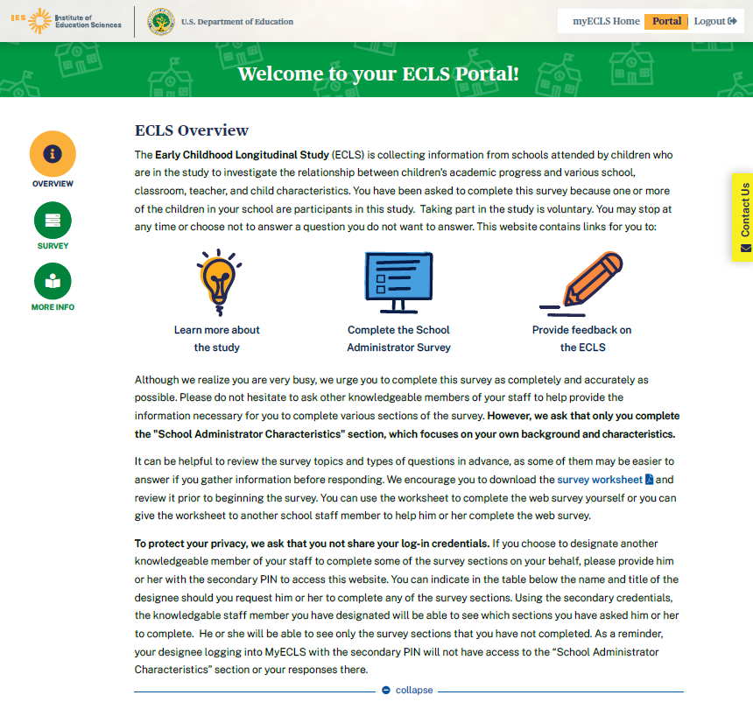

Welcome to your ECLS portal!

ECLS Overview

The Early Childhood Longitudinal Study (ECLS) is collecting information from schools attended by children who are in the study to investigate the relationship between children's academic progress and various school, classroom, teacher, and child characteristics. You have been asked to complete this survey because one or more of the children in your school are participants in this study. Taking part in the study is voluntary. You may stop at any time or choose not to answer a question you do not want to answer. This website contains links for you to:
- Learn more about the study
- Complete the School Administrator Survey
- Provide feedback on the ECLS

DISPLAY FOR SCHOOL ADMINISTRATOR ONLY: Although we realize you are very busy, we urge you to complete this survey as completely and accurately as possible. Please do not hesitate to ask other knowledgeable members of your staff to help provide the information necessary for you to complete various sections of the survey. However, we ask that only you complete the “School Administrator Characteristics” section which focuses on your own background and characteristics.
It can be helpful to review the survey topics and types of questions in advance, as some of them may be easier to answer if you gather information before responding. We encourage you to download the survey worksheet [DISPLAY LINK TO SAQ WORKSHEET] and review it prior to beginning the survey. You can use the worksheet to complete the web survey yourself or you can give the worksheet to another school staff member to help him or her complete the web survey.

The worksheet (see Attachment A-1) will display each section and a description of the types of items that appear in each section. There will also be a reminder that only the principal can and should respond to section H (the section about school administrator/principal background).

DISPLAY FOR SCHOOL ADMINISTRATOR ONLY: To protect your privacy, we ask that you not share your log-in credentials. If you choose to designate another knowledgeable member of your staff to complete some of the survey sections on your behalf, please provide him or her with the secondary PIN to access this website. You can indicate in the table below the name and title of the designee should you request him/her to complete any of the survey sections. Using the secondary credentials, the knowledgable staff member you have designated will be able to see which sections you have asked him or her to complete. He or she will be able to see only the survey sections that you have not completed. As a reminder, your designee logging into MyECLS with the secondary PIN will not have access to the “School Administrator Characteristics” section or your responses there.

3.2 Survey Section
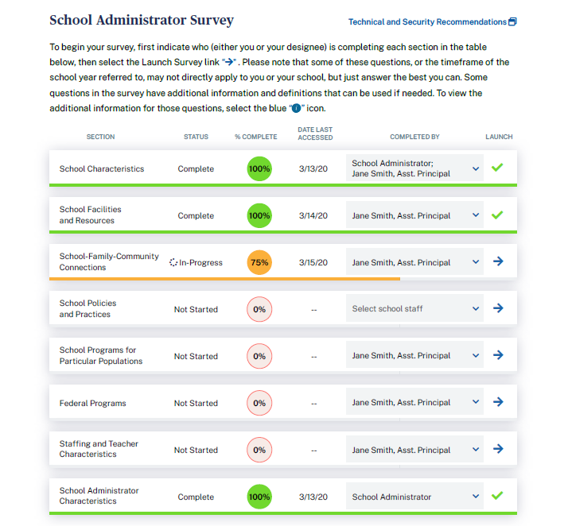

School Administrator Survey

To begin your survey, first indicate who (either you or your designee) is completing each section in the table below, then select the Launch Survey link [DISPLAY ICON]. Please note that some of these questions, or the timeframe of the school year referred to, may not directly apply to you or your school, but just answer the best you can. Some questions in the survey have additional information and definitions that can be used if needed. To view the additional information for those questions, select the blue “i” icon [DISPLAY ICON].

Fields to enter the other school staff name and title:
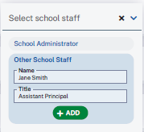

Display as a pop-up when “Technical and Security Recommendations” is selected:

We recommend using a desktop or laptop computer to complete the study activities. For the best experience, use Chrome, Edge, Safari, or Firefox.

When you have finished or if you need to stop before finishing, please LOG OUT of the survey system by selecting "Logout" and CLOSE ALL browser windows or screens to keep your responses secure. For example, if you used Chrome or Safari to open the website, make sure no Chrome or Safari windows or screens are open after you end the session. Not closing all browsers may allow someone else to see your responses.

Display survey sections. Only the school administrator can see all 8 sections. The secondary (designee’s) log-in cannot see section H, as this section is to be completed only by the school administrator.

Survey Section table, with example text:
Section | Status | Percent Complete | Date Last Accessed | Completed by | Launch
- School Characteristics | Complete | 100 | 3/13/20 | School Administrator; Other School Staff: Jane Smith, Assistant Principal
- School Facilities and Resources | Complete | 100 | 3/14/20 | Other School Staff: Jane Smith, Assistant Principal
- School-Family-Community Connections | In-progress | 50 | 3/15/20 | Other School Staff: Jane Smith, Assistant Principal | Launch Survey
- School Policies and Practices | Not started | 0 |  | Other School Staff: Jane Smith, Assistant Principal | Launch Survey
- School Programs for Particular Populations | Not started | 0 |  | Other School Staff: Jane Smith, Assistant Principal | Launch Survey
- Federal Programs | Not started | 0 |  | Other School Staff: Jane Smith, Assistant Principal | Launch Survey
- Staffing and Teacher Characteristics | Not started | 0 |  | Other School Staff: Jane Smith, Assistant Principal | Launch Survey
- School Administrator Characteristics | Complete | 100 | 3/13/20 | School Administrator

3.3 Feedback Questions Section
Display for school administrator role only. These 15 questions are designed to solicit feedback from the field test school administrator respondents to inform the national data collection.

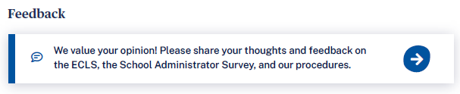
We value your opinion! Please share your thoughts and feedback on the ECLS, the School Administrator Survey, and our procedures.

- Overall, how would you rate your school’s experience with the ECLS?
1 Not at all positive 2 3 4 5 Very positive

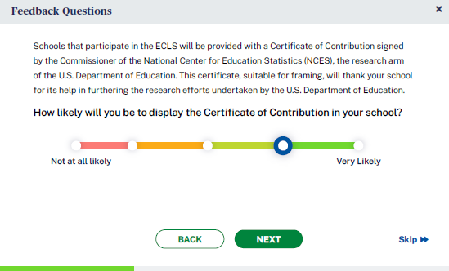
- Schools that participate in the ECLS will be provided with a Certificate of Contribution signed by the Commissioner of the National Center for Education Statistics (NCES), the research arm of the U.S. Department of Education. This certificate, suitable for framing, will thank your school for its help in furthering the research efforts undertaken by the U.S. Department of Education.

How likely will you be to display the Certificate of Contribution in your school?
1 Not at all likely 2 3 4 5 Very likely

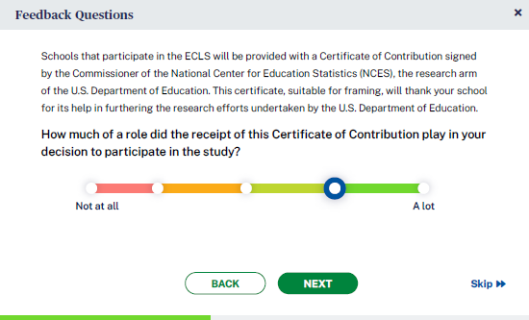
- How much of a role did the receipt of this Certificate of Contribution play in your decision to participate in the study?
1 Not at all 2 3 4 5 A lot

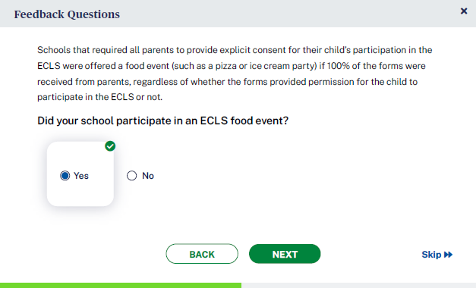
- [IF CONSENT TYPE = EXPLICIT, DISPLAY]: Schools that required all parents to provide explicit consent for their child’s participation in the ECLS were offered a food event (such as a pizza or ice cream party) if 100% of the forms were received from parents, regardless of whether the forms provided permission for the child to participate in the ECLS or not.

Did your school participate in an ECLS food event?
Yes, No

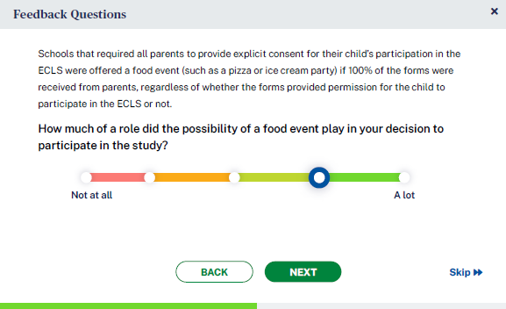
- [IF CONSENT TYPE = EXPLICIT, DISPLAY]: How much of a role did the possibility of a food event play in your decision to participate in the study?
1 Not at all 2 3 4 5 A lot

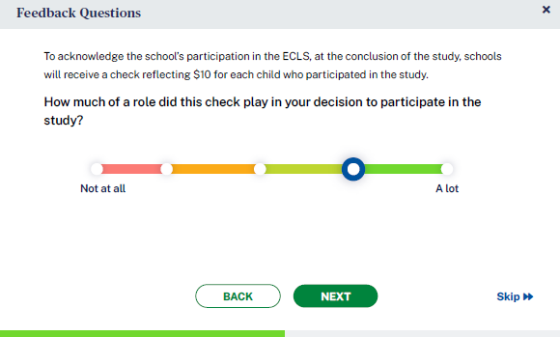
- [IF INCENTIVE RULE ON DISTRICT INFO AND SCHOOL INFO SCREENS = INCENTIVES ALLOWED, DISPLAY:] To acknowledge the school’s participation in the ECLS, at the conclusion of the study, schools will receive a check reflecting $10 for each child who participated in the study.

How much of a role did this check play in your decision to participate in the study?
1 Not at all 2 3 4 5 A lot

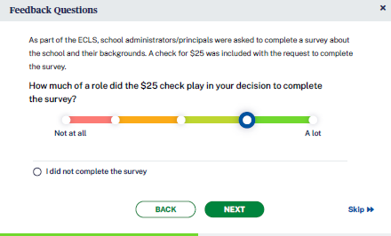
- [IF INCENTIVE RULE ON DISTRICT INFO AND SCHOOL INFO SCREENS = INCENTIVES ALLOWED, DISPLAY:] As part of the ECLS, school administrators/principals were asked to complete a survey about the school and their backgrounds. A check for $25 was included with the request to complete the survey.

How much of a role did the $25 check play in your decision to complete the survey?
0 I did not complete the survey [SKIP TO Q13]
- Not at all 2 3 4 5 A lot

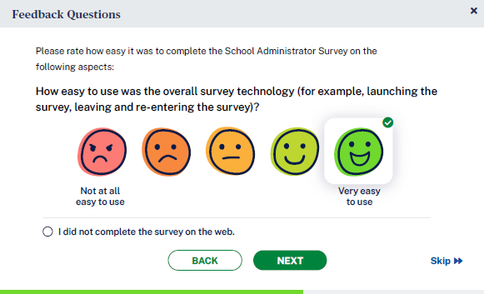
- Please rate how easy it was to complete the School Administrator Survey on the following aspects:
I did not complete the survey on the web. [SKIP TO Q11]

- How easy to use was the overall survey technology (for example, launching the survey, leaving and re-entering the survey)?
1 Not at all easy to use 2 3 4 5 Very easy to use

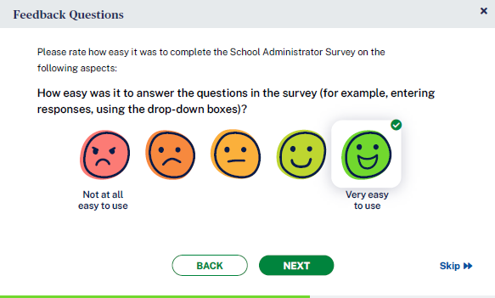
- How easy was it to answer the questions in the survey (for example, entering responses, using the drop-down boxes)?
1 Not at all easy to use 2 3 4 5 Very easy to use

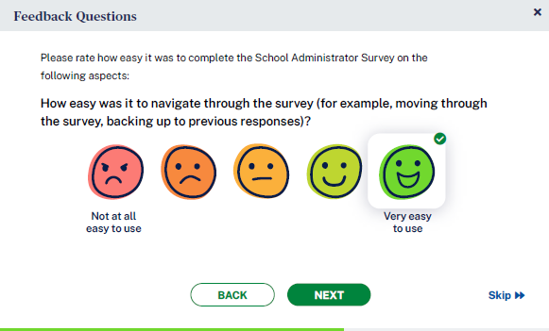
- How easy was it to navigate through the survey (for example, moving through the survey, backing up to previous responses)?
1 Not at all easy to use 2 3 4 5 Very easy to use

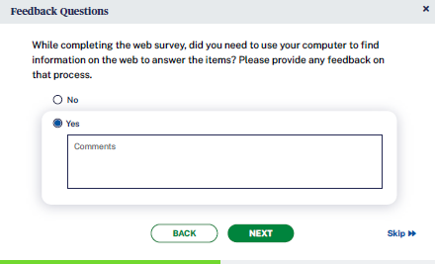
- While completing the web survey, did you need to use your computer to find information on the web to answer the items? Please provide any feedback on that process.
No
Yes (COMMENT FIELD)

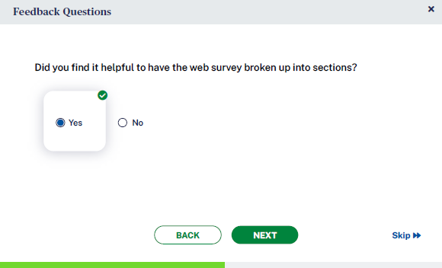
- Did you find it helpful to have the web survey broken up into sections?
Yes No

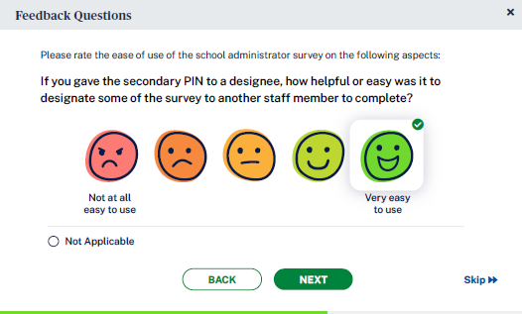
- If you gave the secondary PIN to a designee, how helpful or easy was it to designate some of the survey to another staff member to complete?
0 not applicable 1 Not at all easy/helpful 2 3 4 5 Very easy/helpful

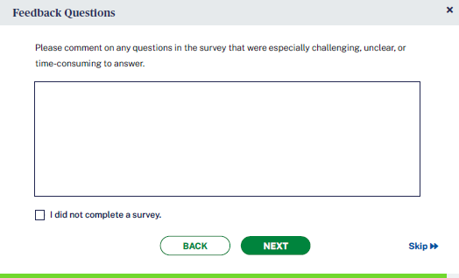
- Please comment on any questions in the survey that were especially challenging, unclear, or time-consuming to answer.
[OPEN TEXT ENTRY FIELD]
0 I did not complete a survey.

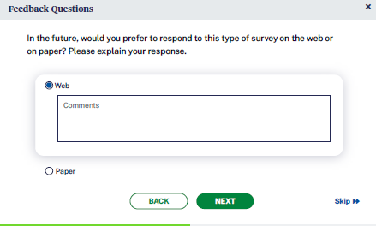
- In the future, would you prefer to respond to this type of survey on the web or on paper? Please explain your response.
- Web
- Paper
COMMENT FIELD FOR EACH

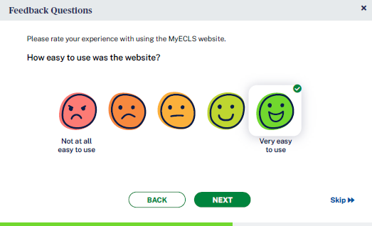
- Please rate your experience with using the MyECLS website.

- How easy to use was the website?
1 Not at all easy to use 2 3 4 5 Very easy to use

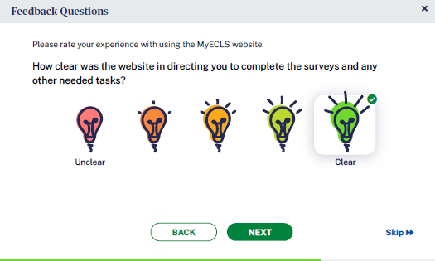
- How clear was the website in directing you to complete the survey and any other needed tasks?
1 Unclear 2 3 4 5 Clear

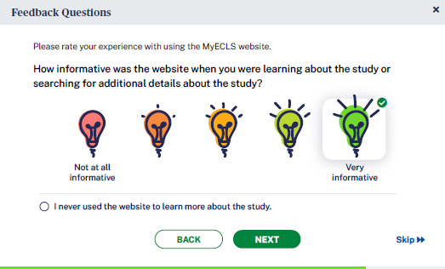
- How informative was the website when you were learning about the study or searching for additional details about the study?
0 I never used the website to learn more about the study.
1 Not at all informative 2 3 4 5 Very informative

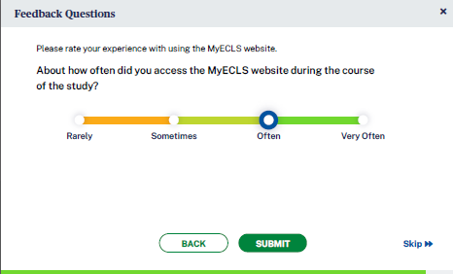
- About how often did you access the MyECLS website during the course of the study?
Rarely
Sometimes
Often
Very often

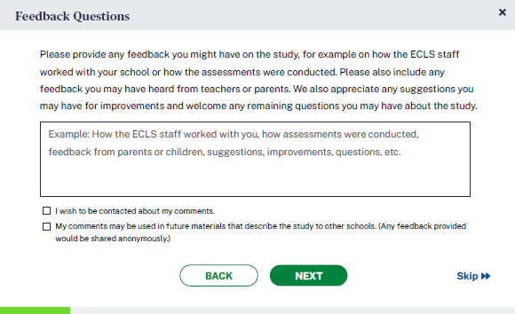
- Please provide any feedback you might have on the study, for example on how the ECLS staff worked with your school or how the assessments were conducted. Please also include any feedback you may have heard from teachers or parents. We also appreciate any suggestions you may have for improvements and welcome any remaining questions you may have about the study.

OPEN TEXT ENTRY FIELD Example: How the ECLS staff worked with you, how assessments were conducted, feedback from parents or children, suggestions, improvements, questions, etc.
- I wish to be contacted about my comments.
- My comments may be used in future materials that describe the study to other schools. (Any feedback provided would be shared anonymously.)

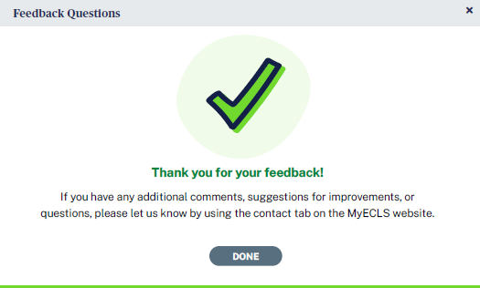
Thank you for your feedback! If you have any additional comments, suggestions for improvements, or questions, please let us know by using the contact tab on the MyECLS website.

“DONE” BUTTON. When selected, return to the portal, collapse this section, and mark as completed.

3.4 More Information Section

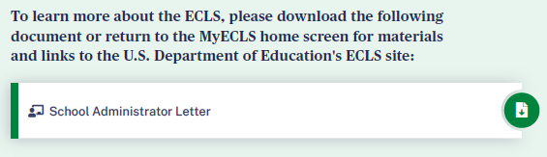
To learn more about the ECLS, please download the following document or return to the MyECLS home screen for materials and links to the U.S. Department of Education’s ECLS site:
- School Administrator Letter [LINK TO LETTER]
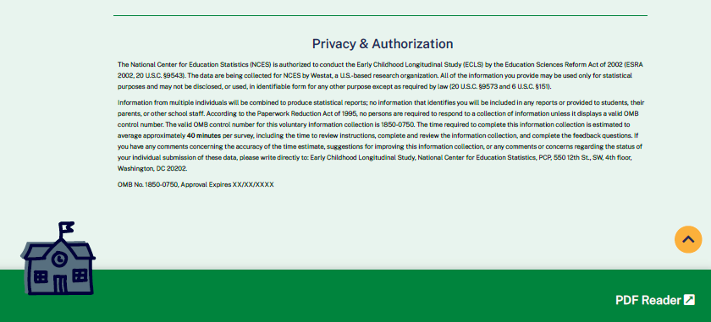

This language appears at the bottom of the School Administrator Portal page, directly on the screen.
The National Center for Education Statistics (NCES) is authorized to conduct the Early Childhood Longitudinal Study (ECLS) by the Education Sciences Reform Act of 2002 (ESRA 2002, 20 U.S.C. §9543). The data are being collected for NCES by Westat, a U.S.-based research organization. All of the information you provide may be used only for statistical purposes and may not be disclosed, or used, in identifiable form for any other purpose except as required by law (20 U.S.C. §9573 and 6 U.S.C. §151).

Information from multiple individuals will be combined to produce statistical reports; no information that identifies you will be included in any reports or provided to students, their parents, or other school staff. According to the Paperwork Reduction Act of 1995, no persons are required to respond to a collection of information unless it displays a valid OMB control number. The valid OMB control number for this voluntary information collection is 1850-0750. The time required to complete this information collection is estimated to average approximately 40 minutes per survey, including the time to review instructions, complete and review the information collection, and complete the feedback questions. If you have any comments concerning the accuracy of the time estimate, suggestions for improving this information collection, or any comments or concerns regarding the status of your individual submission of these data, please write directly to: Early Childhood Longitudinal Study, National Center for Education Statistics, PCP, 550 12th St., SW, 4th floor, Washington, DC 20202.

OMB No. 1850-0750, Approval Expires XX/XX/XXXX
v.X

TEACHER PORTAL

The screens appearing in this section (“4. TEACHER PORTAL”) are for the field test only. National screens for the school coordinator will come in a future OMB package when clearance is sought for those data collection activities.

The Teacher Portal has four sections: Overview, Surveys, Feedback Questions, and More Information. Use the navigation icons on the left to skip to each section. The Feedback icon appears once that section is available, later in the data collection period, after the school visit..

The infographics that will appear on this portal will be on the topic of the use of technology. Infographics can be reviewed in Attachment A-5.

4.1 Overview Section

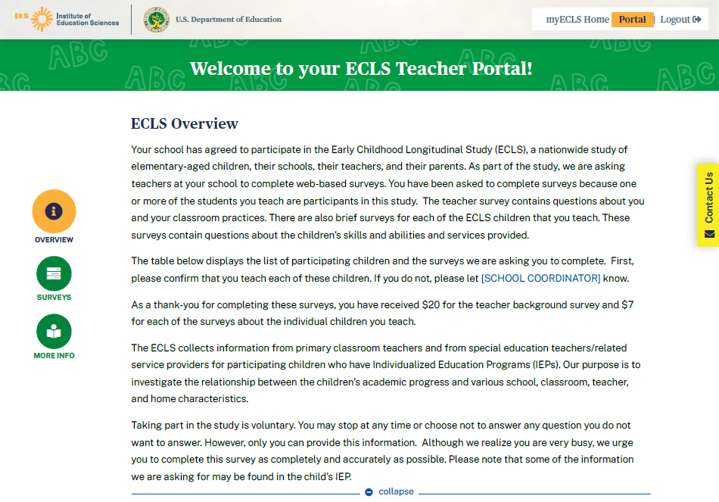
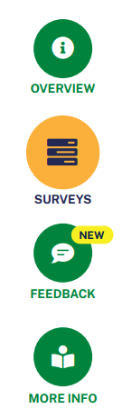

Welcome to your ECLS Teacher Portal!

ECLS Overview
Your school has agreed to participate in the Early Childhood Longitudinal Study (ECLS), a nationwide study of elementary-aged children, their schools, their teachers, and their parents. As part of the study, we are asking teachers at your school to complete web-based surveys. You have been asked to complete surveys because one or more of the students you teach are participants in this study. The teacher survey contains questions about you [IF TEACHER LINK ID = P (PRIMARY), DISPLAY: and your classroom practices]. There are also brief surveys for each of the ECLS children that you teach. [IF TEACHER LINK ID = P (PRIMARY), DISPLAY: These surveys contain questions about the children’s skills and abilities.] [IF TEACHER LINK ID = S (SPECIAL ED), DISPLAY: These surveys contain questions about services provided.] [IF TEACHER LINK ID = BOTH P AND S, DISPLAY: These surveys contain questions about the children’s skills and abilities and services provided.]

The table below displays the list of participating children and the surveys we are asking you to complete. First, please confirm that you teach each of these children. If you do not, please let [SCHOOL COORDINATOR] know.

[IF INCENTIVE RULE ON DISTRICT INFO AND SCHOOL INFO SCREENS = INCENTIVES ALLOWED, DISPLAY: As a thank-you for completing these surveys, you have received $20 for the teacher background survey and $7 for each of the surveys about the individual children you teach.]

[IF TEACHER LINK ID = P (PRIMARY), DISPLAY: The ECLS collects information from teachers of children who are in the study to investigate the relationship between children’s academic progress and various school, classroom, teacher, and home characteristics.

Taking part in the study is voluntary. You may stop at any time or choose not to answer a question you do not want to answer. However, only you can provide this information. Although we realize you are very busy, we urge you to complete these surveys as completely and accurately as possible.]

[IF TEACHER LINK ID = S (SPECIAL ED), DISPLAY: The ECLS collects information from the special education teachers/related service providers of participating children who have Individualized Education Programs (IEPs). We are gathering information from these children’s regular classroom teachers as well. Our purpose is to investigate the relationship between the children’s academic progress and various school, classroom, teacher, and home characteristics.
Taking part in the study is voluntary. You may stop at any time or choose not to answer any question you do not want to answer. However, only you can provide this information. Although we realize you are very busy, we urge you to complete this survey as completely and accurately as possible. Please note that some of the information we are asking for may be found in the child’s IEP.]
[IF TEACHER HAS BOTH P (PRIMARY) AND S (SPECIAL ED) LINK IDS, DISPLAY: The ECLS collects information from primary classroom teachers and from special education teachers/related service providers for participating children who have Individualized Education Programs (IEPs). Our purpose is to investigate the relationship between the children’s academic progress and various school, classroom, teacher, and home characteristics.
Taking part in the study is voluntary. You may stop at any time or choose not to answer any question you do not want to answer. However, only you can provide this information. Although we realize you are very busy, we urge you to complete this survey as completely and accurately as possible. Please note that some of the information we are asking for may be found in the child’s IEP.]

4.2 Surveys Section
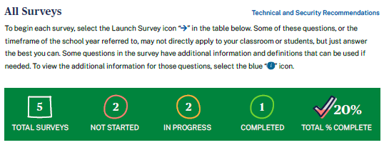

All Surveys
To begin each survey, select the Launch Survey icon [DISPLAY ICON] in the table below. Some of these questions, or the timeframe of the school year referred to, may not directly apply to your classroom or students, but just answer the best you can. Some questions in the survey have additional information and definitions that can be used if needed. To view the additional information for those questions, select the blue “i” icon [DISPLAY ICON].

Display as a pop-up window when “Technical and Security Recommendations” is selected:

We recommend using a desktop or laptop computer to complete the study activities. For the best experience, use Chrome, Edge, Safari, or Firefox.

When you have finished or if you need to stop before finishing, please LOG OUT of the survey system by selecting "Logout" and CLOSE ALL browser windows or screens to keep your responses secure. For example, if you used Chrome or Safari to open the website, make sure no Chrome or Safari windows or screens are open after you end the session. Not closing all browsers may allow someone else to see your responses.

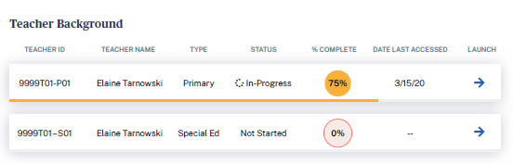

Teacher Background (with example text):
Teacher ID | Teacher Name | Type | Status | % Complete | Date Last Accessed | Launch
9999T01 – P01 | Teacher Name | Primary | In-progress | 75 | 3/15/20 | Launch Survey
9999T01 – S01 | Teacher Name | Special Ed | Not Started | 0 |  | Launch Survey

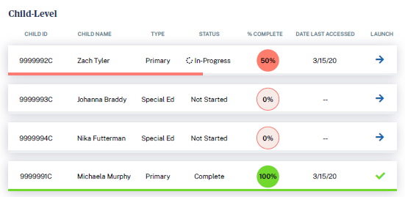

When the teacher is assigned more than 10 child-level surveys, filters appear to allow the teacher to filter the list by survey type and status.
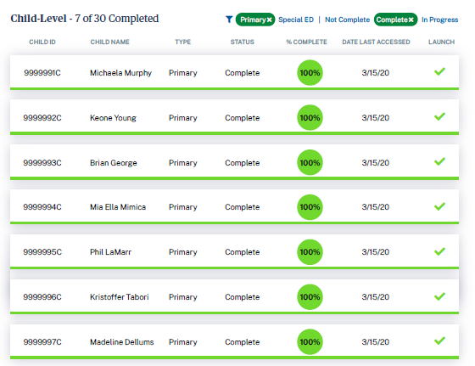

Child-level (with example text):
Child ID | Child Name | Type | Status | % Complete | Date Last Accessed | Launch
9999991C | Child 1 Name | Primary | Complete | 100 | 3/13/20
9999992C | Child 2 Name | Primary | In-progress | 50 | 3/16/20 | Launch Survey
9999993C | Child 3 Name | Primary | Not started | 0 | N/A | Launch Survey
9999993C | Child 3 Name | Special Ed | Not started | 0 | N/A | Launch Survey

4.3 Feedback Questions Section
These 7 questions are designed to solicit feedback from the field test teacher respondents to inform the national data collection.

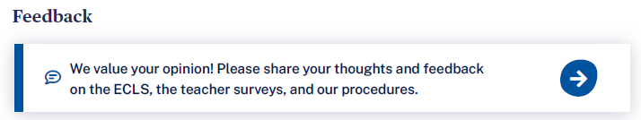
We value your opinion! Please share your thoughts and feedback on the ECLS, the teacher surveys, and our procedures.

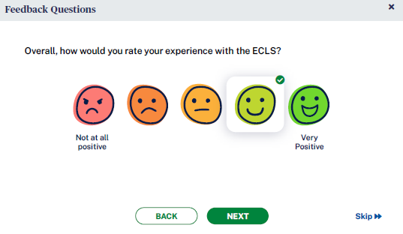
- Overall, how would you rate your experience with the ECLS?

1 Not at all positive 2 3 4 5 Very positive

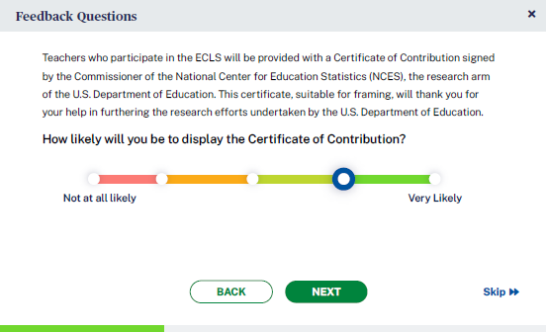
- Teachers who participate in the ECLS will be provided with a Certificate of Contribution signed by the Commissioner of the National Center for Education Statistics (NCES), the research arm of the U.S. Department of Education. This certificate, suitable for framing, will thank you for your help in furthering the research efforts undertaken by the U.S. Department of Education.

How likely will you be to display the Certificate of Contribution?
1 Not at all likely 2 3 4 5 Very likely

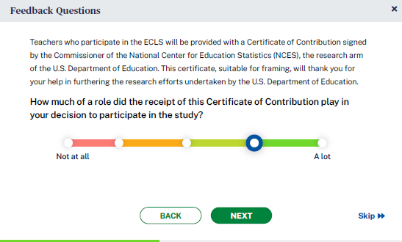
- How much of a role did the receipt of this Certificate of Contribution play in your decision to participate in the study?
1 Not at all 2 3 4 5 A lot

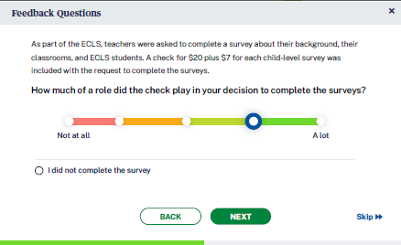
- [IF INCENTIVE RULE ON DISTRICT INFO AND SCHOOL INFO SCREENS = INCENTIVES ALLOWED, DISPLAY:] As part of the ECLS, teachers were asked to complete a survey about their background, their classrooms, and ECLS students. A check for $20 plus $7 for each child-level survey was included with the request to complete the surveys.

How much of a role did the check play in your decision to complete the surveys?
0 I did not complete the survey
- Not at all 2 3 4 5 A lot

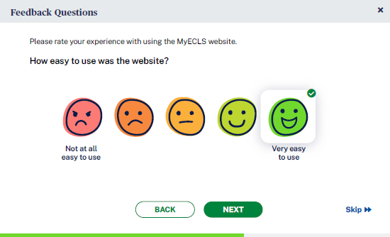
- Please rate your experience with using the MyECLS website.

- How easy to use was the website?
- Not at all easy to use 2 3 4 5 Very easy to use

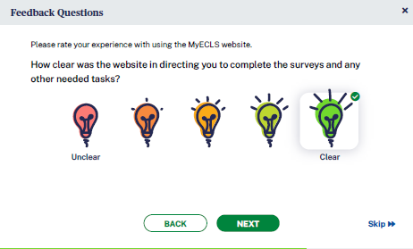
- How clear was the website in directing you to complete the surveys and any other needed tasks?
- Unclear 2 3 4 5 Clear

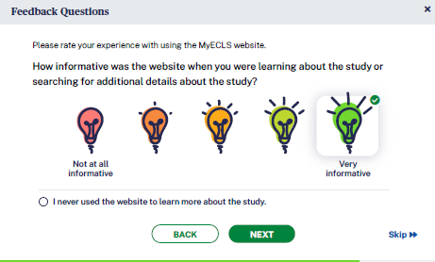
- How informative was the website when you were learning about the study or searching for additional details about the study?
- I never used the website to learn more about the study.
- Not at all informative 2 3 4 5 Very informative

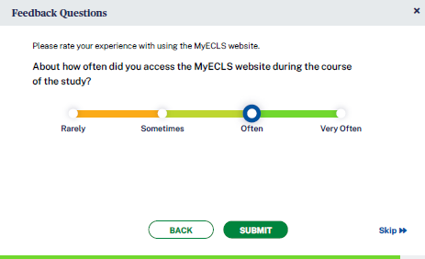
- About how often did you access the MyECLS website during the course of the study?
Rarely
Sometimes
Often
Very Often

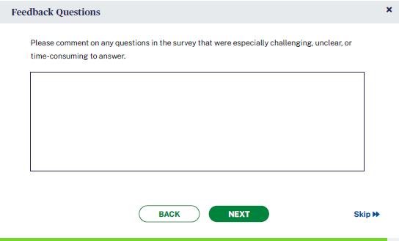
- Please comment on any questions in the survey that were especially challenging, unclear, or time-consuming to answer. [OPEN TEXT ENTRY FIELD.]

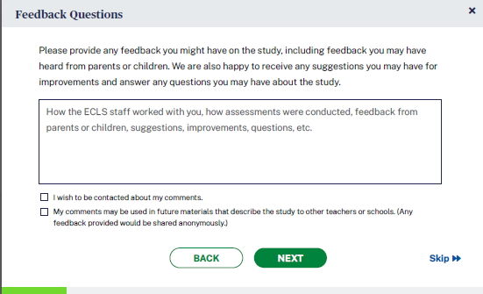
- Please provide any feedback you might have on the study, including feedback you may have heard from parents or children. We are also happy to receive any suggestions you may have for improvements and answer any questions you may have about the study.

[OPEN TEXT ENTRY FIELD.]Example: How the ECLS staff worked with you, how assessments were conducted, feedback from parents or children, suggestions, improvements, questions, etc.
- I wish to be contacted about my comments.
- My comments may be used in future materials that describe the study to other teachers or schools. (Any feedback provided would be shared anonymously.)

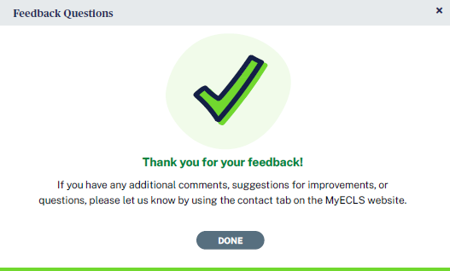
Thank you for your feedback. If you have any additional comments, suggestions for improvements, or questions, please let us know by using the contact tab on the MyECLS website.
“DONE” BUTTON [When selected, return to the portal and collapse this section and mark as completed.]

4.4 More Information Section

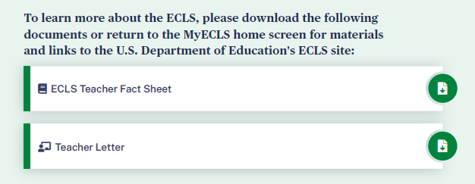
To learn more about the ECLS, please download the following documents or return to the MyECLS home screen for materials and links to the U.S. Department of Education’s ECLS site:
- ECLS Teacher Fact Sheet [LINK TO TEACHER FACT SHEET]
- Teacher Letter [LINK TO LETTER]

Display “Use of Technology” infographic. The final version of this infographic can be viewed in Attachment A-5.
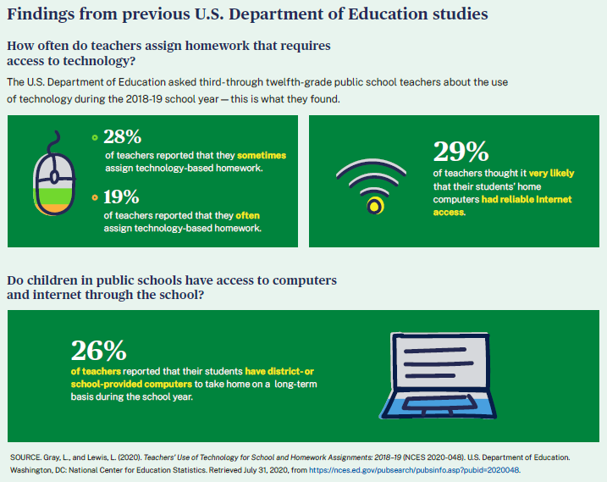
Findings from previous U.S. Department of Education studies
How often do teachers assign homework that requires access to technology?
The U.S. Department of Education asked third- through twelfth-grade public school teachers about the use of technology during the 2018-19 school year – this is what they found.
- 28% of teachers reported that they sometimes assign technology-based homework.
- 19% of teachers reported that they often assign technology-based homework.
- 29% of teachers thought it very likely that their students’ home computers had reliable internet access.
Do children in public schools have access to computers and internet through the school?
- 26% of teachers reported that their students have district- or school-provided computers to take home on a long-term basis during the school year.

SOURCE: Use of Technology for School and Homework Assignments: 2018–19 (NCES 2020-048). U.S. Department of Education. Washington, DC: National Center for Education Statistics. Retrieved July 31, 2020, from https://nces.ed.gov/pubsearch/pubsinfo.asp?pubid=2020048.

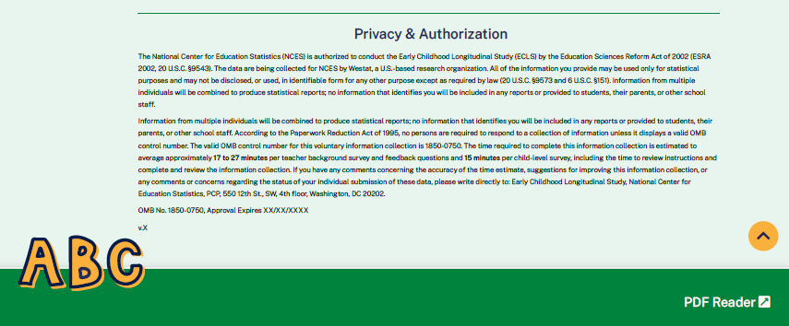

This language appears at the bottom of the Teacher Portal page, directly on the screen.

The National Center for Education Statistics (NCES) is authorized to conduct the Early Childhood Longitudinal Study (ECLS) by the Education Sciences Reform Act of 2002 (ESRA 2002, 20 U.S.C. §9543). The data are being collected for NCES by Westat, a U.S.-based research organization. All of the information you provide may be used only for statistical purposes and may not be disclosed, or used, in identifiable form for any other purpose except as required by law (20 U.S.C. §9573 and 6 U.S.C. §151). Information from multiple individuals will be combined to produce statistical reports; no information that identifies you will be included in any reports or provided to students, their parents, or other school staff.

Information from multiple individuals will be combined to produce statistical reports; no information that identifies you will be included in any reports or provided to students, their parents, or other school staff. According to the Paperwork Reduction Act of 1995, no persons are required to respond to a collection of information unless it displays a valid OMB control number. The valid OMB control number for this voluntary information collection is 1850-0750. The time required to complete this information collection is estimated to average approximately 17 to 27 minutes per teacher background survey and feedback questions and 15 minutes per child-level survey, including the time to review instructions and complete and review the information collection. If you have any comments concerning the accuracy of the time estimate, suggestions for improving this information collection, or any comments or concerns regarding the status of your individual submission of these data, please write directly to: Early Childhood Longitudinal Study, National Center for Education Statistics, PCP, 550 12th St., SW, 4th floor, Washington, DC 20202.

OMB No. 1850-0750, Approval Expires XX/XX/XXXX
v.X

PARENT PORTAL

The screens appearing in this section (“5. PARENT PORTAL”) are for the field test only. National screens for the school coordinator will come in a future OMB package when clearance is sought for those data collection activities.

The Parent Portal has six sections: Overview, Consent, Surveys, Contact Information, Feedback Questions, and More Information. Use the navigation icons on the left to skip to each section. Each section displays as an accordion, allowing the user to expand and collapse each section. Once consent is recorded, contact info is provided, and survey is completed, each section will be marked as complete. The Feedback icon appears once that section is available, later in the data collection period. This portal is intended for the parents or guardians of selected children.

The infographics that will appear on this portal will be on the topic of barriers to participation in school events. Final infographics can be reviewed in Attachment A-5.

5.1 Overview Section 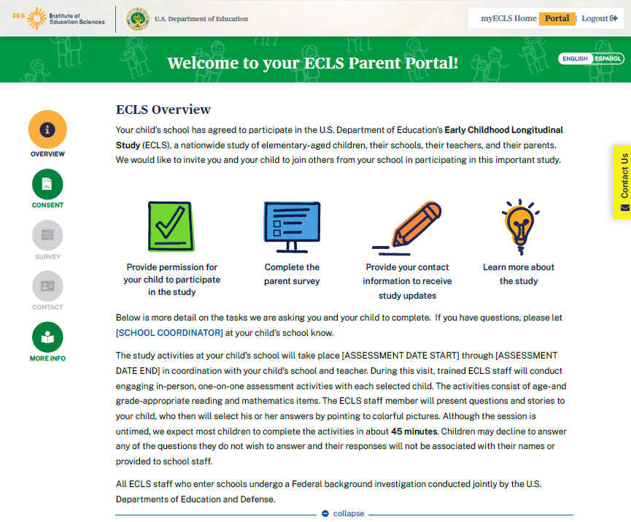

Welcome to your ECLS Parent Portal!
DISPLAY ENGLISH/SPANISH TOGGLE BUTTONS.

ECLS Overview

Your child’s school has agreed to participate in the U.S. Department of Education's Early Childhood Longitudinal Study (ECLS), a nationwide study of elementary-aged children, their schools, their teachers, and their parents. We would like to invite you and your child to join others from your school in participating in this important study.

Display with icons:
- Provide permission for your child to participate in the study
- Complete the parent survey
- Provide your contact information to receive study updates
- Learn more about the study

Below is more detail on the tasks we are asking you and your child to complete. If you have questions, please let [SCHOOL COORDINATOR] at your child’s school know. When the user hovers over “school coordinator”, the SC phone number and email address recorded on the School Information Screen will display.
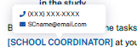
The study activities at your child’s school will take place [ASSESSMENT DATE START] through [ASSESSMENT DATE END] in coordination with your child’s school and teacher. During this visit, trained ECLS staff will conduct engaging in-person, one-on-one assessment activities with each selected child. The activities consist of age- and grade-appropriate reading and mathematics items. The ECLS staff member will present questions and stories to your child, who then will select his or her answers by pointing to colorful pictures. Although the session is untimed, we expect most children to complete the activities in about 45 minutes. Children may decline to answer any of the questions they do not wish to answer and their responses will not be associated with their names or provided to school staff.

All ECLS staff who enter schools undergo a Federal background investigation conducted jointly by the U.S. Departments of Education and Defense.

5.2 Consent Section

The consent section will be expanded when the user first accesses the portal. It will collapse and be marked as complete once consent is provided. There are three screens for parents in schools with explicit consent and three screens for those with implicit consent.

Explicit Consent screens 1-3:

SCREEN 1:
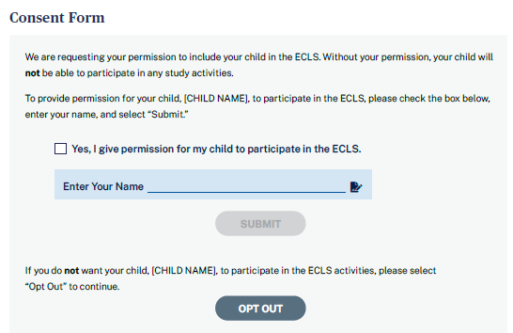

We are requesting your permission to include your child in the ECLS. Without your permission, your child will not be able to participate in any study activities.
To provide permission for your child, [CHILD NAME], to participate in the ECLS, please check the box below, enter your name, and select “Submit.”
[CHECK BOX] Yes, I give permission for my child to participate in the ECLS.
ENTER YOUR NAME FIELD / SUBMIT BUTTON
If you do not want your child, [CHILD NAME], to participate in the ECLS activities, please select “Opt Out” to continue.
OPT OUT BUTTON
- If “submit” is selected, update child consent status to 2-obtained and return to the Parent Portal. The consent section will be collapsed and marked as complete and the parent survey section will be expanded.
- If “opt-out” is selected, go to screen 2.

SCREEN 2:
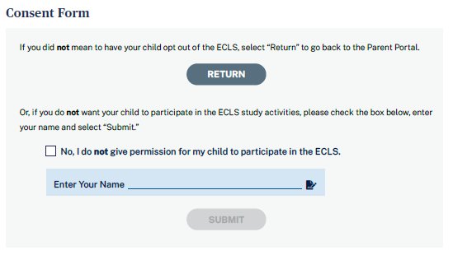

If you did not mean to have your child opt out of the ECLS, select “Return” to go back to the Parent Portal.

RETURN BUTTON

Or, if you do not want your child to participate in the ECLS study activities, please check the box below, enter your name, and select “Submit.”

[CHECK BOX] No, I do not give permission for my child to participate in the ECLS.

ENTER YOUR NAME / SUBMIT BUTTON
- If ‘’submit” is selected, update the child consent status to 3-refused and go to screen 3.
- If “return” is selected, return to screen 1.

SCREEN 3:
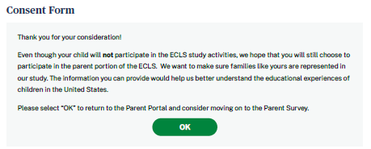

Thank you for your consideration!
Even though your child will not participate in the ECLS study activities, we hope that you will still choose to participate in the parent portion of the ECLS. We want to make sure families like yours are represented in our study. The information you can provide would help us better understand the educational experiences of children in the United States.
Please select “OK” to return to the Parent Portal and consider moving on to the Parent Survey.
OK BUTTON
- When the “OK” button is selected, return to the Parent Portal. The consent section will be collapsed and marked as complete and the parent survey section will be expanded.

Implicit Consent screens 4-6:

SCREEN 4
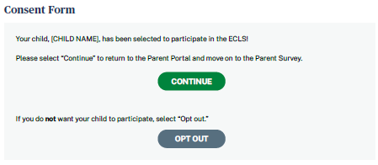

Your child, [CHILD NAME], has been selected to participate in the ECLS!
Please select “Continue” to return to the Parent Portal and move on to the Parent Survey.
CONTINUE BUTTON
If you do not want your child to participate, select “Opt out.”
OPT OUT BUTTON
- If the “continue” button is selected, return to the Parent Portal. The consent section will be collapsed and the parent survey section will be expanded.
- If the “opt out” button is selected, go to screen 5.

SCREEN 5
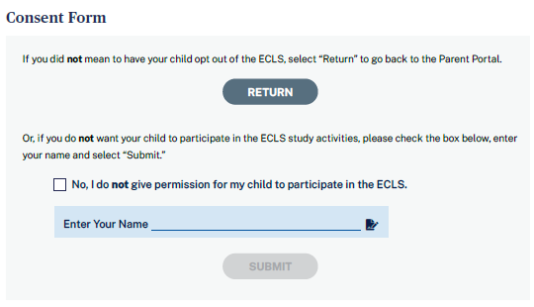

If you did not mean to have your child opt out of the ECLS, select “Return” to go back to the Parent Portal.

RETURN BUTTON

Or, if you do not want your child to participate in the ECLS study activities, please check the box below, enter your name and select “Submit.”

[CHECK BOX] No, I do not give permission for my child to participate in the ECLS.

ENTER YOUR NAME / SUBMIT BUTTON
- If ‘’submit” is selected, update the child consent status to 3-refused and go to screen 6.
- If “return” is selected, return to screen 4.

SCREEN 6
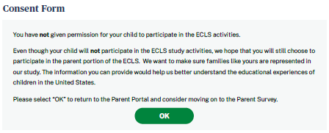

You have not given permission for your child to participate in the ECLS activities.
Even though your child will not participate in the ECLS study activities, we hope that you will still choose to participate in the parent portion of the ECLS. We want to make sure families like yours are represented in our study. The information you can provide would help us better understand the educational experiences of children in the United States.
Please select “OK” to return to the Parent Portal and consider moving on to the Parent Survey.
OK BUTTON
- When the “OK” button is selected, return to the Parent Portal. The consent section will be collapsed and marked as complete (see screenshot below, with a check mark image and the text “Consent Given” or “Consent Not Provided”) and the parent survey section will be expanded.

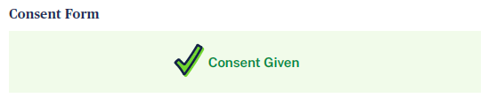

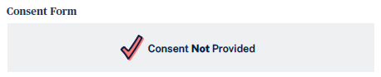

5.3 Parent Survey Section
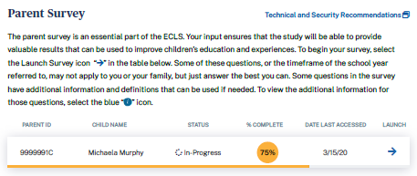
Parent Survey
The parent survey is an essential part of the ECLS. Your input ensures that the study will be able to provide valuable results that can be used to improve children’s education and experiences. To begin your survey, select the Launch Survey icon [DISPLAY ICON] in the table below. Some of these questions, or the timeframe of the school year referred to, may not apply to you or your family, but just answer the best you can. Some questions in the survey have additional information and definitions that can be used if needed. To view the additional information for those questions, select the blue “i” icon [DISPLAY ICON].

Display as a pop-up window when “Technical and Security Recommendations” is selected:

We recommend using a desktop or laptop computer to complete the study activities. For the best experience, use Chrome, Edge, Safari, or Firefox.

When you have finished or if you need to stop before finishing, please LOG OUT of the survey system by selecting "Logout" and CLOSE ALL browser windows or screens to keep your responses secure. For example, if you used Chrome or Safari to open the website, make sure no Chrome or Safari windows or screens are open after you end the session. Not closing all browsers may allow someone else to see your responses.

Parent ID | Child Name | Status | % Complete | Date Last Accessed | Launch
9999001P | Child Name | In-progress | 75 | 3/15/20 | Launch Survey

5.4 Contact Information Screen
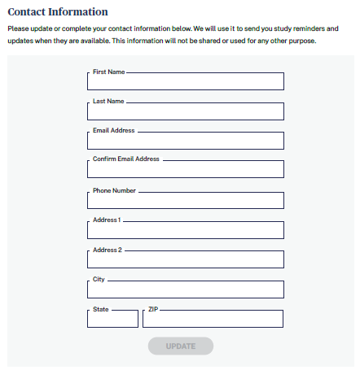
Contact Information
Please update or complete your contact information below. We will use it to send you study reminders and updates when they are available. This information will not be shared or used for any other purpose.

First Name
Last Name
Email Address
Confirm Email Address
Phone Number
Address 1
Address 2
City
State
ZIP

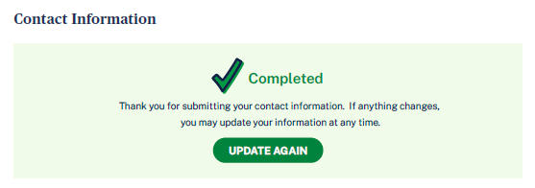
WHEN UPDATE BUTTON IS SELECTED, DISPLAY: Thank you for submitting your contact information. If anything changes, you may update your information at any time.
UPDATE AGAIN BUTTON

5.5 Feedback Questions Section
These 9 questions are designed to solicit feedback from the field test parent respondents to inform the national data collection.

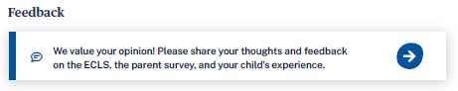
We value your opinion! Please share your thoughts and feedback on the ECLS, the parent survey, and your child’s experience.

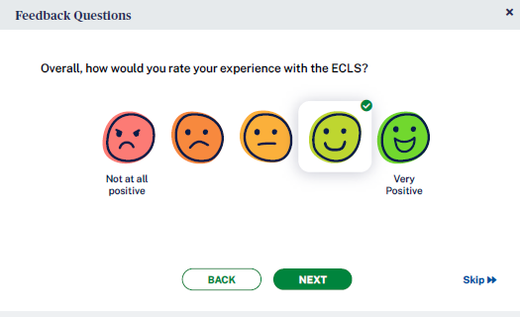
- Overall, how would you rate your experience with the ECLS?

1 Not at all positive 2 3 4 5 Very positive

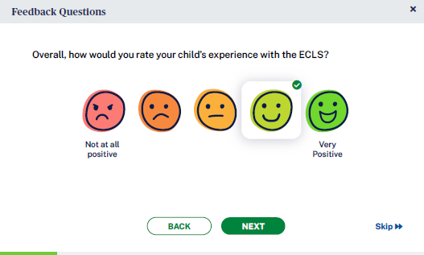
- Overall, how would you rate your child’s experience with the ECLS?

1 Not at all positive 2 3 4 5 Very positive

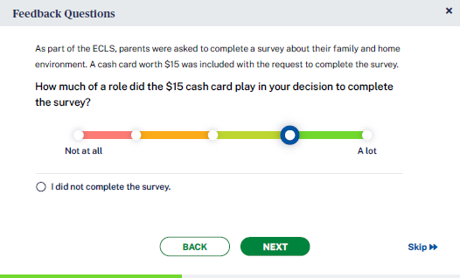
- [IF PARENT IS IN SCHOOL THAT RECEIVES PARENT INCENTIVES, DISPLAY:] As part of the ECLS, parents were asked to complete a survey about their family and home environment. A cash card worth $15 was included with the request to complete the survey.

How much of a role did the $15 cash card play in your decision to complete the survey?
- I did not complete the survey
- Not at all 2 3 4 5 A lot

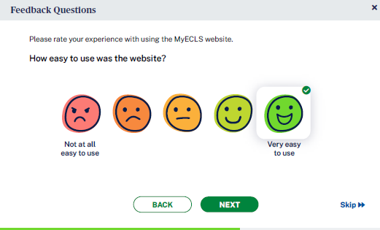
- Please rate your experience with using the MyECLS website.
  - How easy to use was the website?
- Not at all easy to use 2 3 4 5 Very easy to use

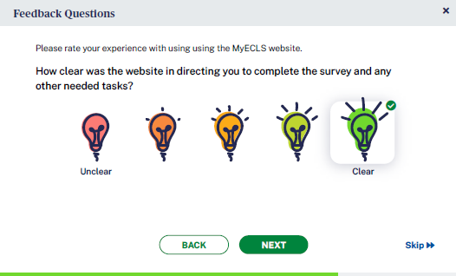
- How clear was the website in directing you to complete the survey and any other needed tasks?
- Unclear 2 3 4 5 Clear

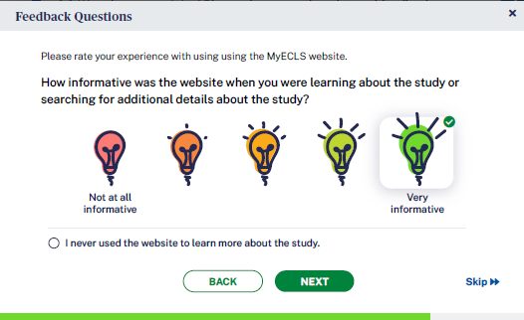
- How informative was the website when you were learning about the study or searching for additional details about the study?
0 I never used the website to learn more about the study.
- Not at all informative 2 3 4 5 Very informative

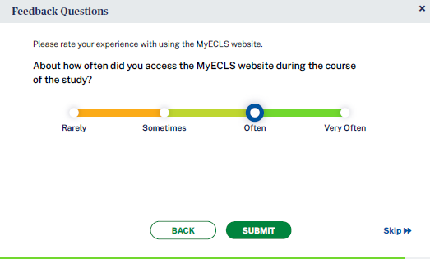
- About how often did you access the MyECLS website during the course of the study?
Rarely
Sometimes
Often
Very Often

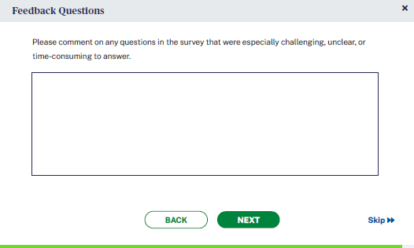
- Please comment on any questions in the survey that were especially challenging, unclear, or time-consuming to answer. [OPEN TEXT ENTRY FIELD]

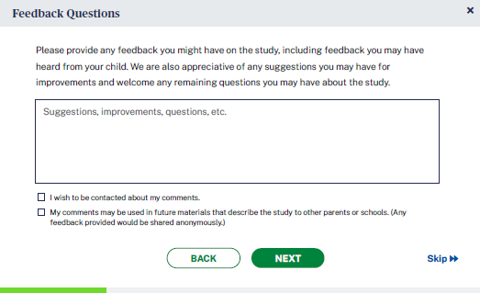
- Please provide any feedback you might have on the study, including feedback you may have heard from your child. We are also appreciative of any suggestions you may have for improvements and welcome any remaining questions you may have about the study.

[OPEN TEXT ENTRY FIELD.] Suggestions, improvements, questions, etc.
- I wish to be contacted about my comments.
- My comments may be used in future materials that describe the study to other parents or schools. (Any feedback provided would be shared anonymously.)

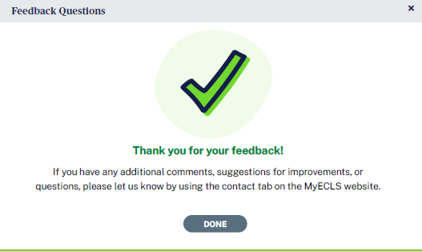
Thank you for your feedback. If you have any additional comments, suggestions for improvements, or questions, please let us know by using the contact tab on the MyECLS website.
“DONE” BUTTON [WHEN SELECTED, RETURN TO THE PORTAL AND COLLAPSE THIS SECTION AND MARK AS COMPLETED]

5.6 More Information Section

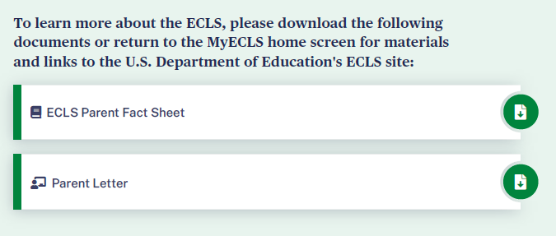
To learn more about the ECLS, please download the following documents or return to the MyECLS home screen for materials and links to the U.S. Department of Education’s ECLS site:
- ECLS Parent Fact Sheet [LINK TO PARENT FACT SHEET]
- Parent Letter [LINK TO LETTER]

Display “Common Activities for Families” infographic.
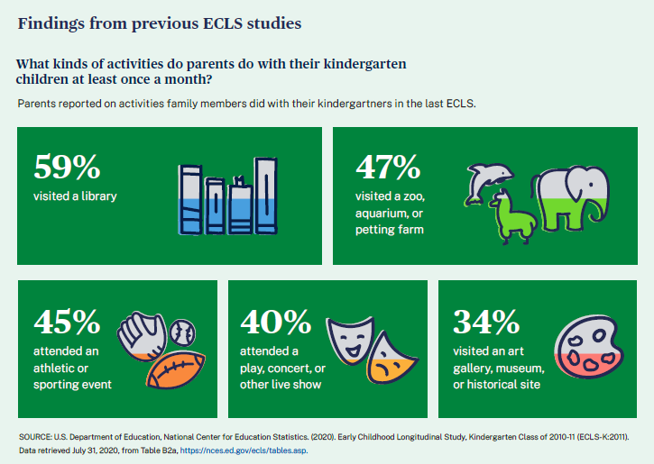
Findings from previous ECLS studies
What kinds of activities do parents do with their kindergarten children at least once a month?
Parents reported on activities family members did with their kindergartners in the last ECLS.
- 59% visited a library
- 47% visited a zoo, aquarium, or petting farm
- 45% attended an athletic or sporting event
- 40% attended a play, concert, or other live show
- 34% visited an art gallery, museum, or historical site
SOURCE: U.S. Department of Education, National Center for Education Statistics. (2020). Early Childhood Longitudinal Study, Kindergarten Class of 2010-11 (ECLS-K:2011). Data retrieved July 31, 2020, from Table B2a, https://nces.ed.gov/ecls/tables.asp.

Display “Barriers to Participation” infographic.
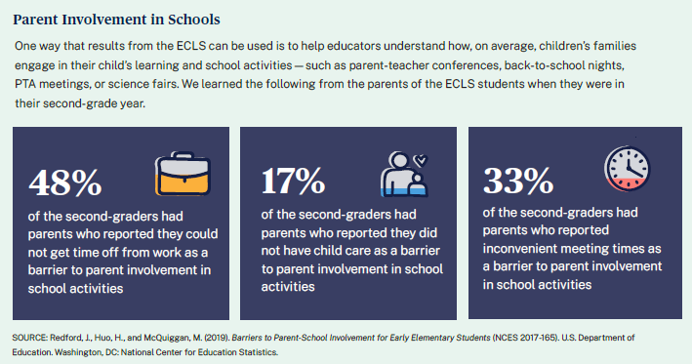
Parent Involvement in Schools
One way that results from the ECLS can be used is to help educators understand how, on average, children’s families engage in their child’s learning and school activities – such as parent-teacher conferences, back-to-school nights, PTA meetings, or science fairs. We learned the following from the parents of the ECLS students when they were in their second-grade year.
- 48% of the second-graders had parents who reported they could not get time off from work as a barrier to parent involvement in school activities
- 17% of the second-graders had parents who reported they did not have child care as a barrier to parent involvement in school activities
- 33% of the second-graders had parents who reported inconvenient meeting times as a barrier to parent involvement in school activities.
SOURCE: Redford, J., Huo, H., and McQuiggan, M. (2019). Barriers to Parent-School Involvement for Early Elementary Students (NCES 2017-165). U.S. Department of Education. Washington, DC: National Center for Education Statistics. Retrieved July 31, 2020, from https://nces.ed.gov/pubsearch/pubsinfo.asp?pubid=2017165.

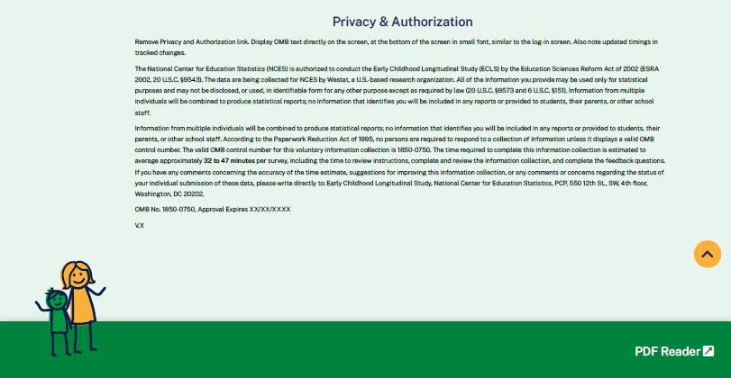

This language appears at the bottom of the Parent Portal page, directly on the screen.

The National Center for Education Statistics (NCES) is authorized to conduct the Early Childhood Longitudinal Study (ECLS) by the Education Sciences Reform Act of 2002 (ESRA 2002, 20 U.S.C. §9543). The data are being collected for NCES by Westat, a U.S.-based research organization. All of the information you provide may be used only for statistical purposes and may not be disclosed, or used, in identifiable form for any other purpose except as required by law (20 U.S.C. §9573 and 6 U.S.C. §151). Information from multiple individuals will be combined to produce statistical reports; no information that identifies you will be included in any reports or provided to students, their parents, or other school staff.

Information from multiple individuals will be combined to produce statistical reports; no information that identifies you will be included in any reports or provided to students, their parents, or other school staff. According to the Paperwork Reduction Act of 1995, no persons are required to respond to a collection of information unless it displays a valid OMB control number. The valid OMB control number for this voluntary information collection is 1850-0750. The time required to complete this information collection is estimated to average approximately 32 to 47 minutes per survey, including the time to review instructions, complete and review the information collection, and complete the feedback questions. If you have any comments concerning the accuracy of the time estimate, suggestions for improving this information collection, or any comments or concerns regarding the status of your individual submission of these data, please write directly to: Early Childhood Longitudinal Study, National Center for Education Statistics, PCP, 550 12th St., SW, 4th floor, Washington, DC 20202.
OMB No. 1850-0750, Approval Expires XX/XX/XXXX
V.X

