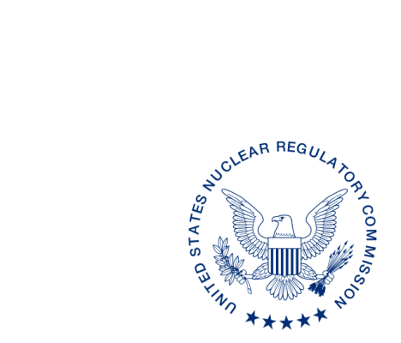
UNITED STATES
NUCLEAR REGULATORY COMMISSION
WASHINGTON, D.C. 20555-0001

ALL AGREEMENT STATES

INFORMATION REQUEST: STATUS OF CURRENT COMPLEX DECOMMISSIONING AND URANIUM RECOVERY SITES (STC-16-086)

Purpose: To update the status of decommissioning activities at materials and uranium recovery sites in Agreement States. This information will be used to update the U.S. Nuclear Regulatory Commission’s (NRC) annual report titled, “Status of the Decommissioning Program,” as well as the NRC’s public Web site.

Background: Since the early 1990s, the NRC has prepared an annual report providing the status of NRC’s decommissioning program. In 2006, the Commission directed the staff to expand its discussion of Agreement State decommissioning/reclamation activities to present a national perspective on decommissioning. With this in mind, the NRC staff requested that the Agreement States provide a listing of all “complex” sites undergoing decommissioning and a listing of uranium recovery sites undergoing reclamation, for inclusion in the NRC’s annual report, “Status of the Decommissioning Program.” The NRC regards complex sites as those that are required to provide a decommissioning plan or sites that require formal NRC or State approval prior to being decommissioned. This information was placed into a database for publication on the NRC’s public Web site to ensure openness and provide a national perspective on decommissioning. However, in order to reduce the burden on the Agreement States, the NRC is only requesting a list of complex and uranium recovery sites undergoing decommissioning and a point of contact in the Agreement State that an interested individual could contact for further information. The information will be made available to the public by the NRC in order to ensure openness and promote communication to enhance public knowledge of the national decommissioning program.

Discussion: We are requesting your assistance by asking that you provide a list of sites and a point of contact for all complex sites undergoing decommissioning. For States with uranium recovery authority, we also ask that you include information for those facilities undergoing decommissioning/reclamation and request that you make a note of this designation within your submittal. If you do not have any decommissioning or uranium recovery sites, please send a response to indicate this. We would appreciate receiving your response* by MONTH XX, 20XX.

Please have the designated State point-of-contact direct all responses and questions with respect to this correspondence to Mr. Dominick Orlando, Office of Nuclear Material Safety and Safeguards, at the telephone number or e-mail address listed.

POINT OF CONTACT: Dominick Orlando
E-MAIL: Dominick.orlando@nrc.gov
TELEPHONE: (301) 415-6749

Kevin Williams, Director
Division of Material Safety, Security, State
and Tribal Programs
Office of Nuclear Material Safety
and Safeguards

INFORMATION REQUEST: STATUS OF CURRENT COMPLEX DECOMMISSIONING AND URANIUM RECOVERY SITES (STC-16-086) DATE

ADAMS Accession No.: ML20232A660 *via email
OFFICE | NMSS* | NMSS* | NMSS* | NMSS*
NAME | NOrlando | RvonTill | THolahan | KWilliams
DATE | 8/19/2020 | 8/20/2020
OFFICIAL RECORD COPY

* This information request has been approved by OMB 3150-0206, expiration MM/DD/YYYY. The estimated annual burden per response to comply with this voluntary collection is approximately 2 hours per Agreement State with sites undergoing decommissioning and 0.5 hours for Agreement States without sites undergoing decommissioning. Send comments regarding the burden estimate to the Information Services Branch (T-2 F43), U.S. Nuclear Regulatory Commission, Washington, DC 20555-0001, or by e-mail to infocollects.resource@nrc.gov, and to the Desk Officer, Office of Information and Regulatory Affairs, NEOB-10202 (3150-0206), Office of Management and Budget, Washington, DC 20503. If a means used to impose an information collection does not display a currently valid OMB control number, the NRC may not conduct or sponsor, and a person is not required to respond to the information collection.

