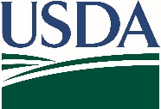
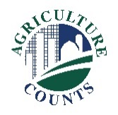
United States Department of Agriculture
National Agricultural Statistics Service

December 28, 2018

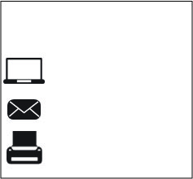
Dear Sir or Madam,
What should I do next?
Complete your survey in one of the following ways:
Online at www.agcounts.usda.gov beginning on Friday, December 28, 2018. Online reporting is fast, cost-effective, and secure. All you need is the 17-digit survey code on the enclosed form to begin.

By mail. Complete the survey questionnaire and mail it back in the envelope provided.

The U.S. Department of Agriculture’s National Agricultural Statistics Service (NASS) is conducting a study to measure agricultural activity in the United States. Please respond to the enclosed survey even if you do not consider yourself to be a farmer.
If you are not familiar with NASS, we are the federal statistical agency responsible for providing official U.S. statistics about agriculture. The data we produce is unbiased and available to everyone equally to help farmers, businesses, organizations, and many others make informed business decisions. All information is kept private as required by federal law.
If you need assistance completing your form, call toll free (888) 424-7828. You will need the survey code found on your mailing label.
The results of this survey will be kept confidential and available in aggregate form only, ensuring that no individual operation or producer can be identified, as required by federal law.
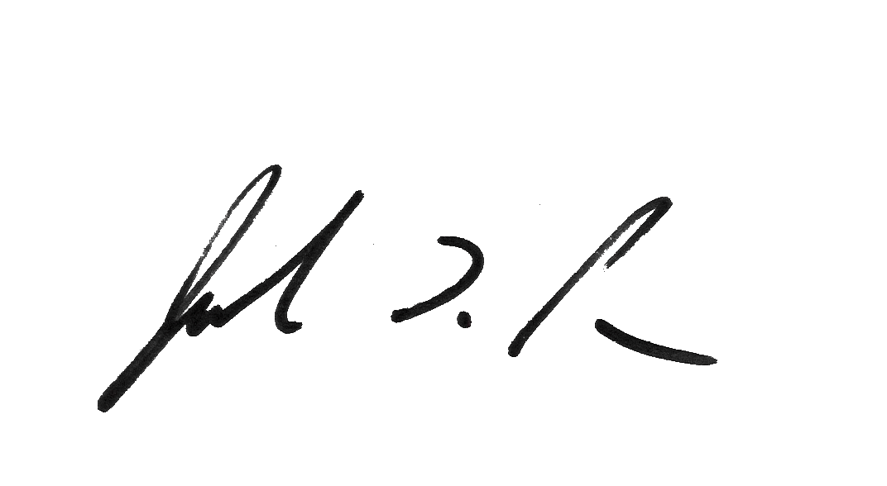
Thank you for participating and for your support of U.S. agriculture. If you have any questions, please feel free to contact us at (888) 424-7828.
Sincerely,

Joseph L. Parsons
Chair, Agricultural Statistics Board

Enclosure

