HBIIP Online Application Screenshots
Present splash page with disclaimer language. Will be updated to include OMB control language and number.
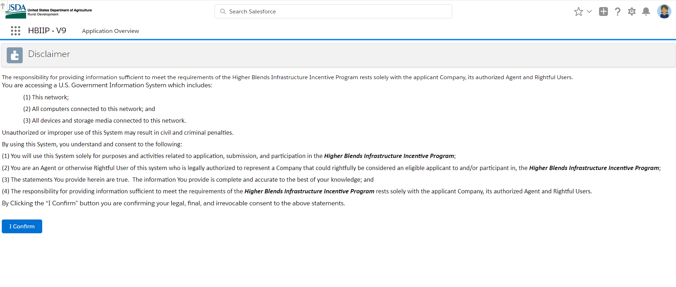
Company Information – Applicant Information page requiring TIN, DUNS and SAM numbers.
And identifying Type of Applicant:
Owner of 10 fueling stations or fewer; Owner of greater than 10 fueling stations;
Fleet facility/facilities; and Fuel distribution facility.
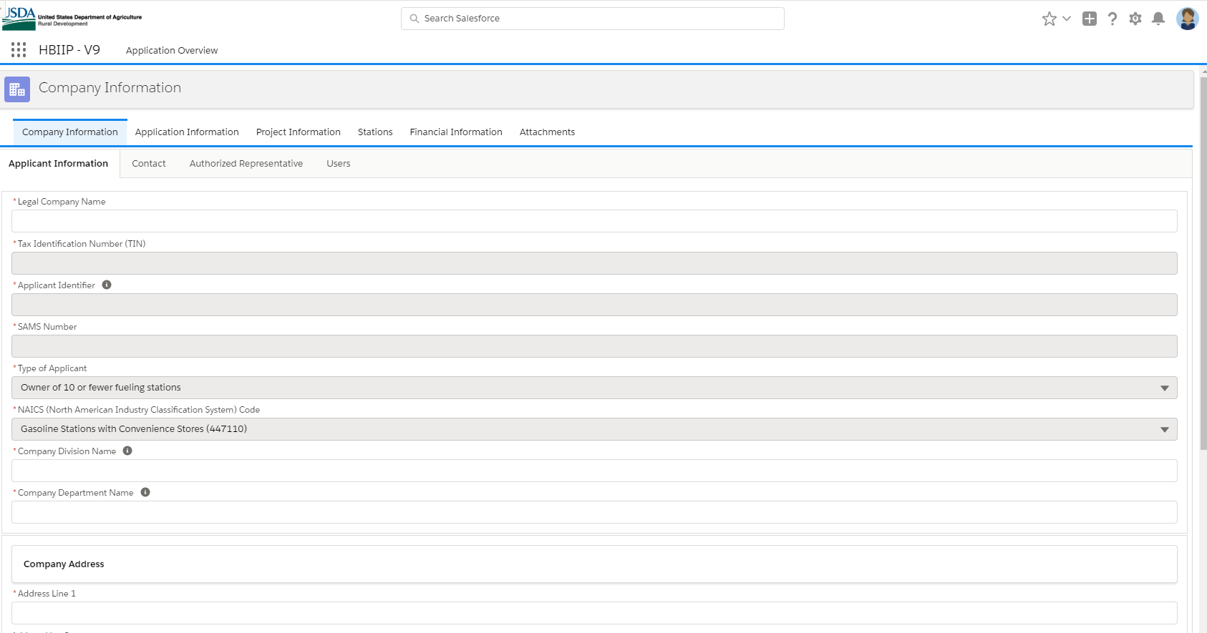

Company Information – Contact page.
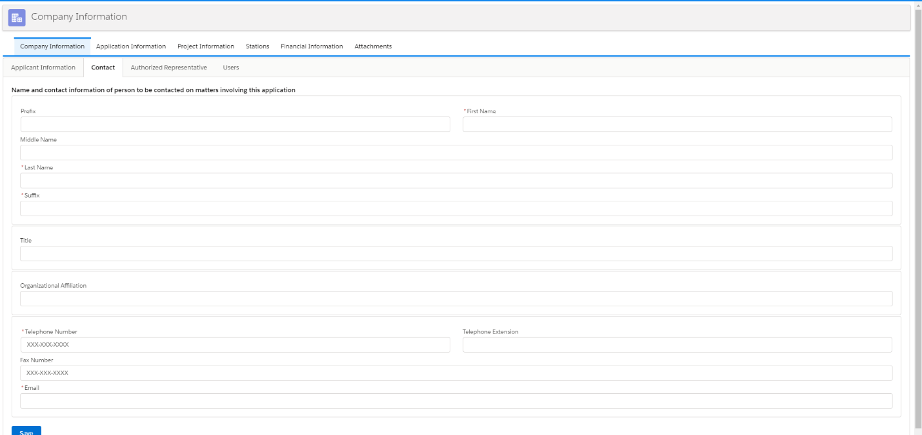

Company Information – Authorized Representative

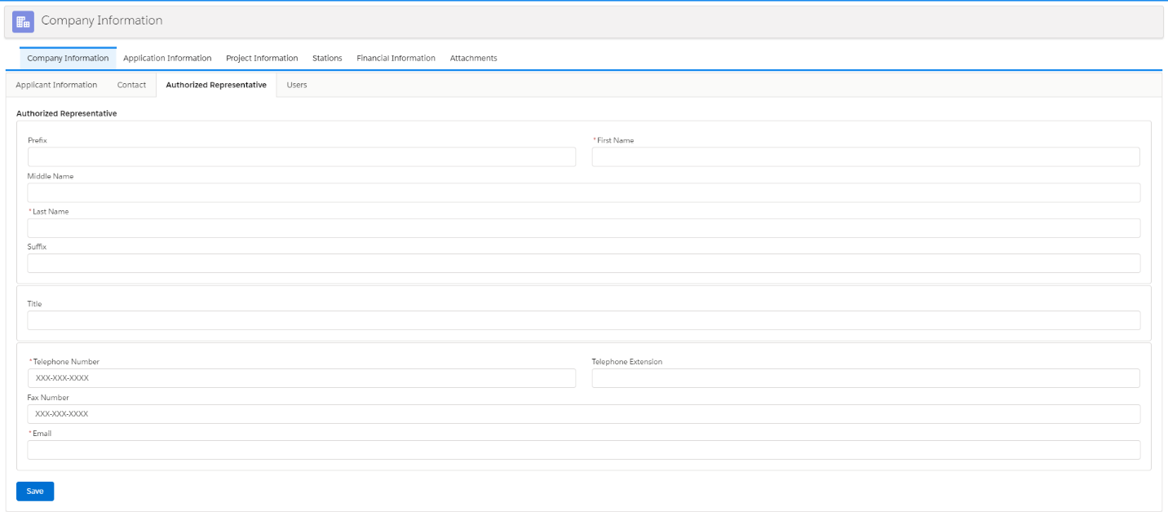

Company Information – Users
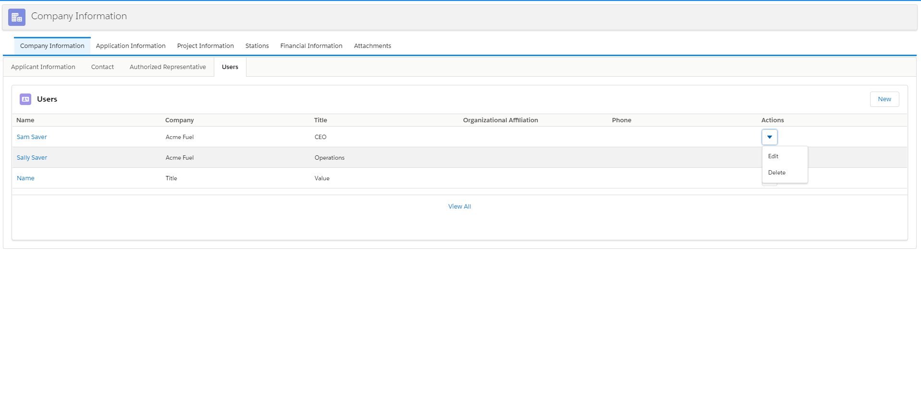
Application Information page soliciting/providing relevant program information from SF424; including check and date procedure for Executive Order 12372.
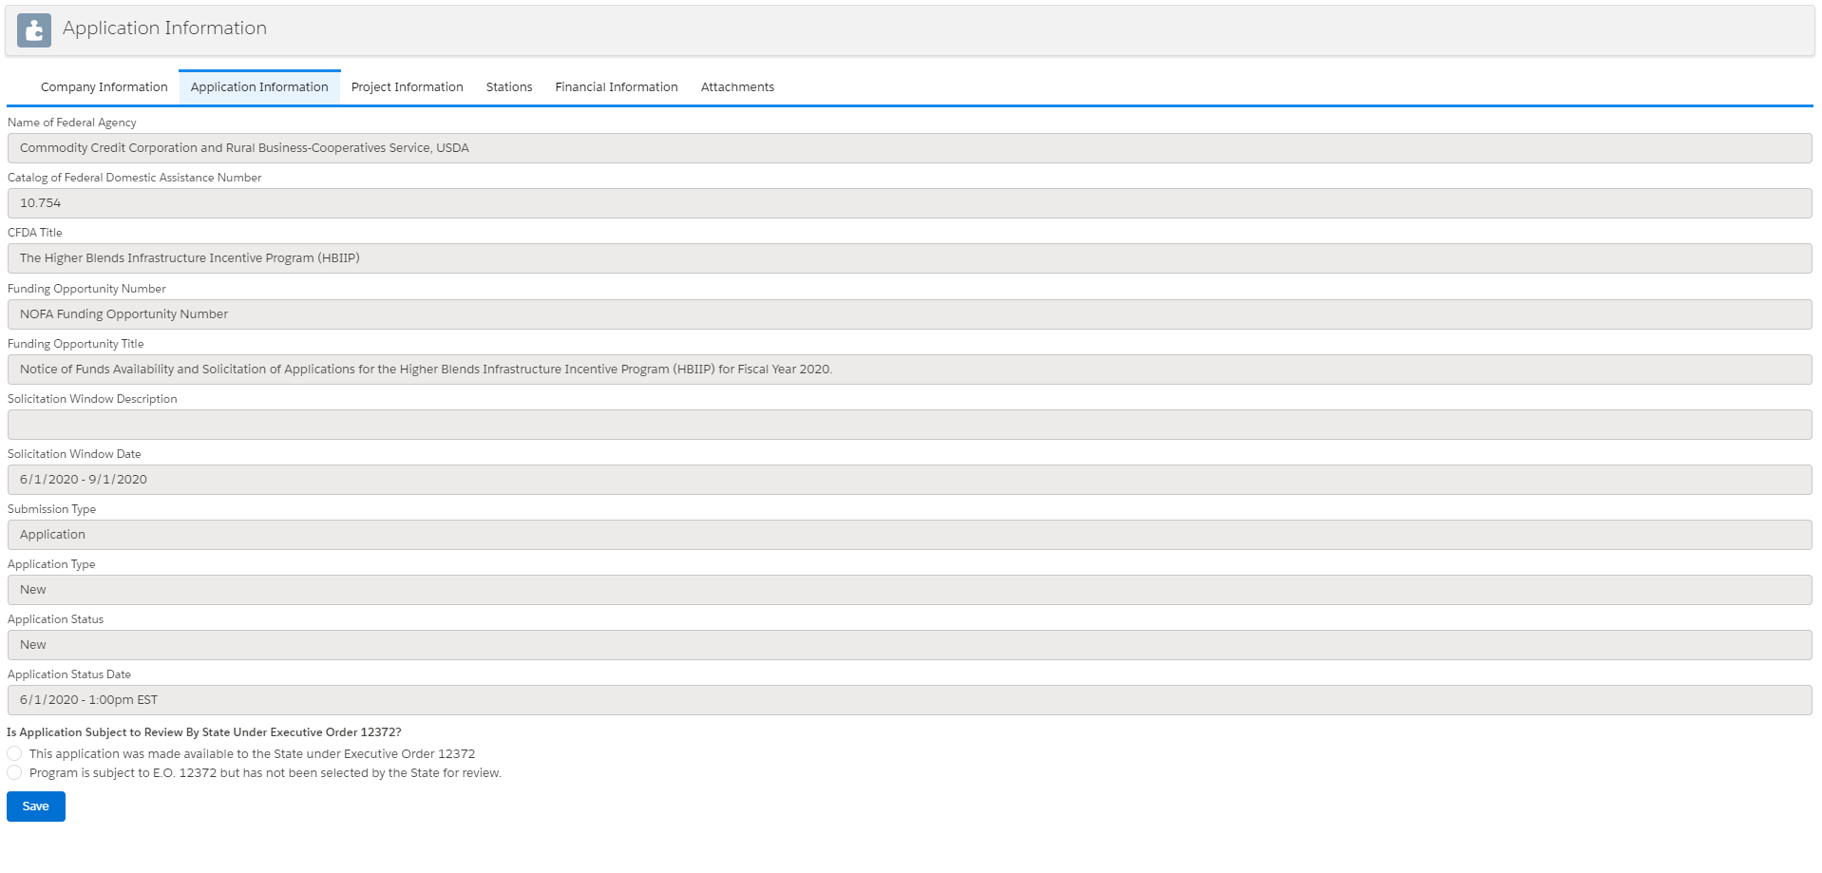

Project details including Federal funds, Applicant funds, State, Local and Other will be calculated elsewhere in the application and solicited from the user.

Stat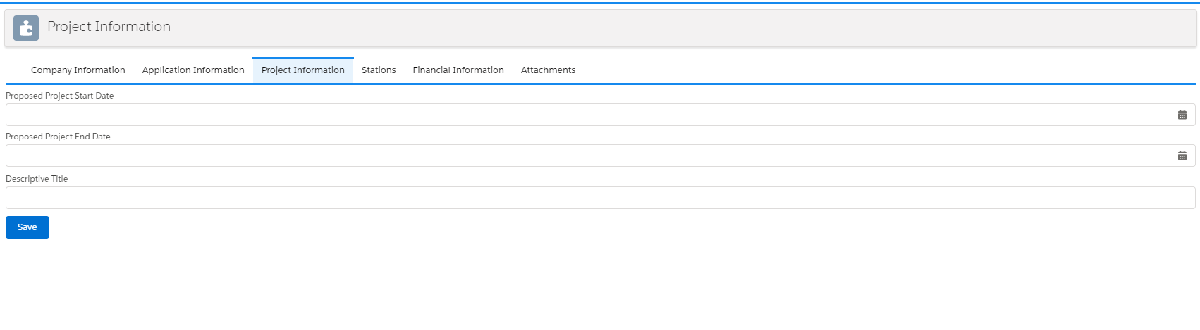
Station Rollup page with Summary totals and buttons to add/edit individual station pages.
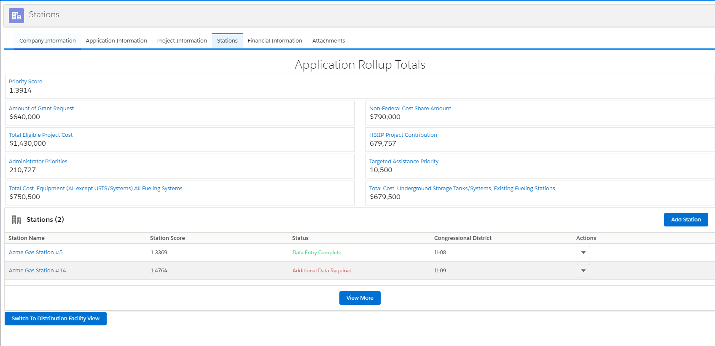

Individual Station Information – Basic Information 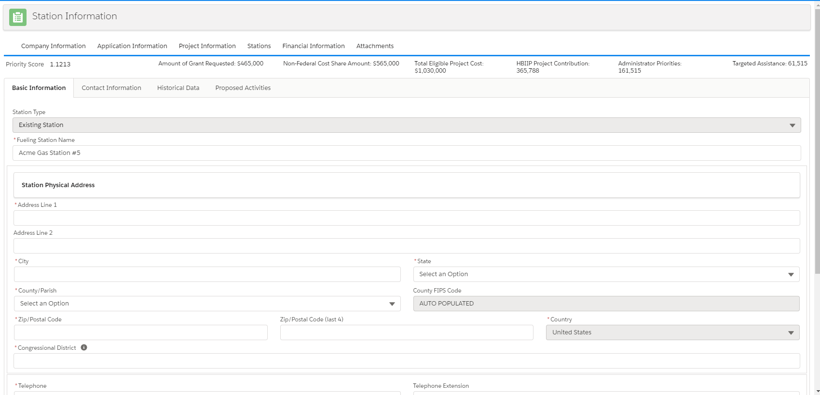

Station Information – Contact Information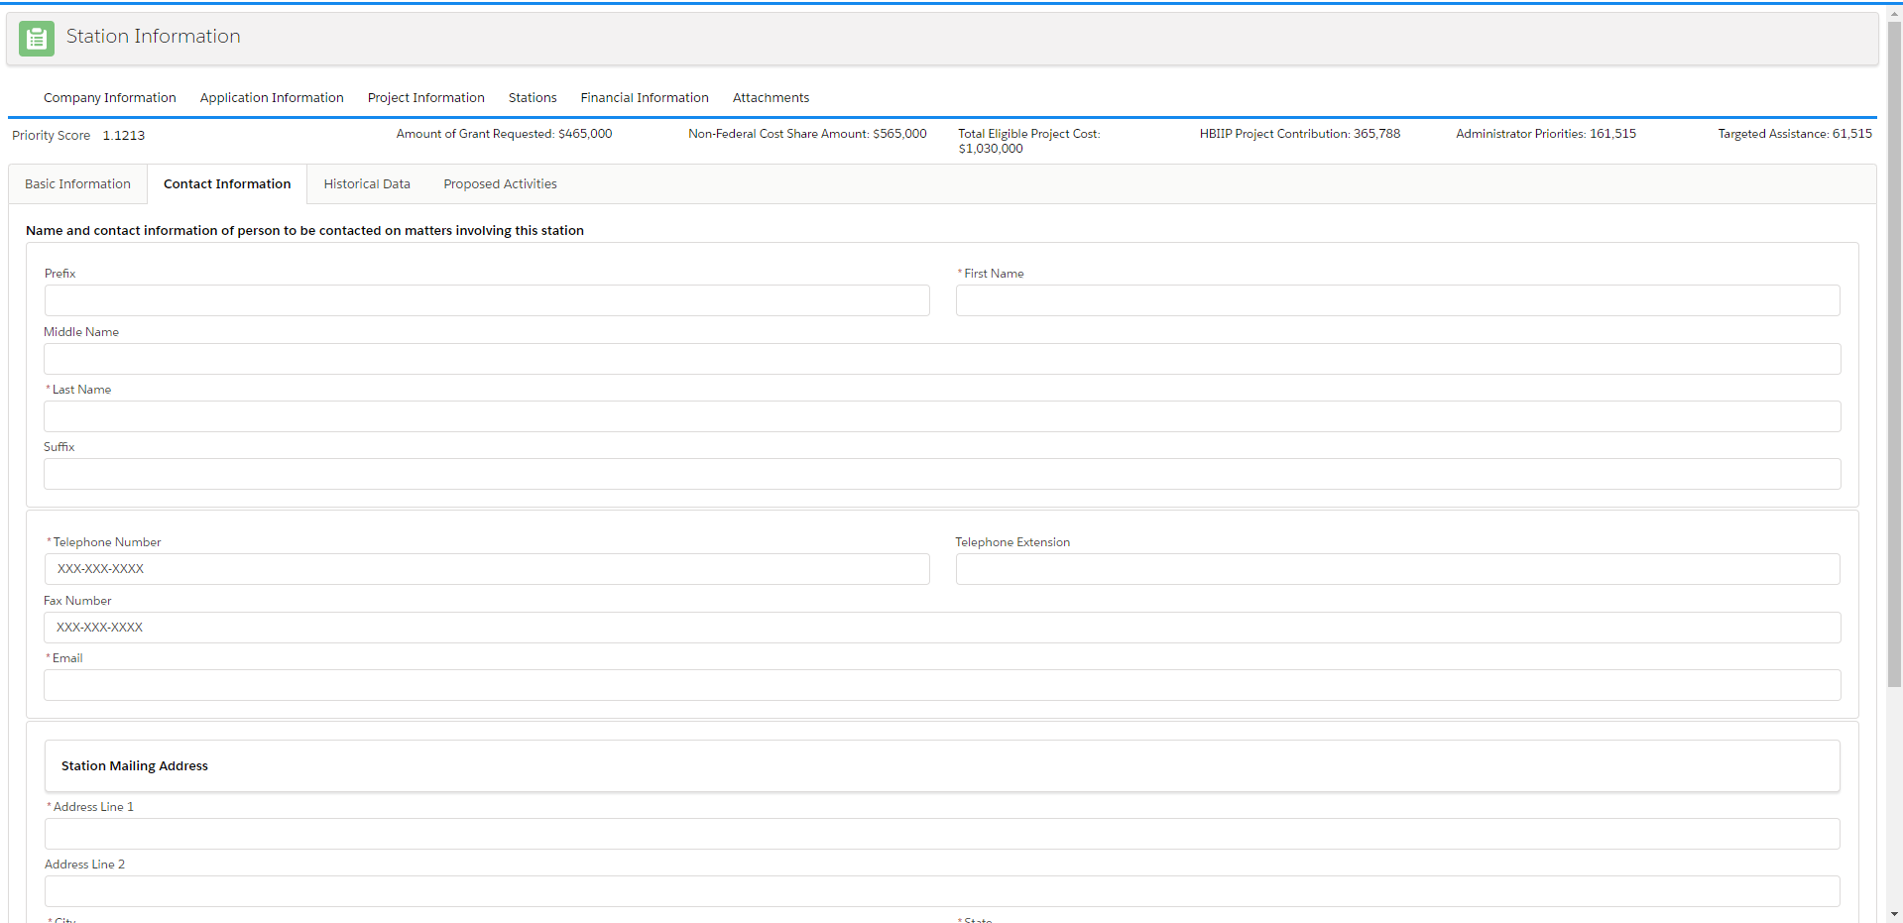

Station Information – Historical Data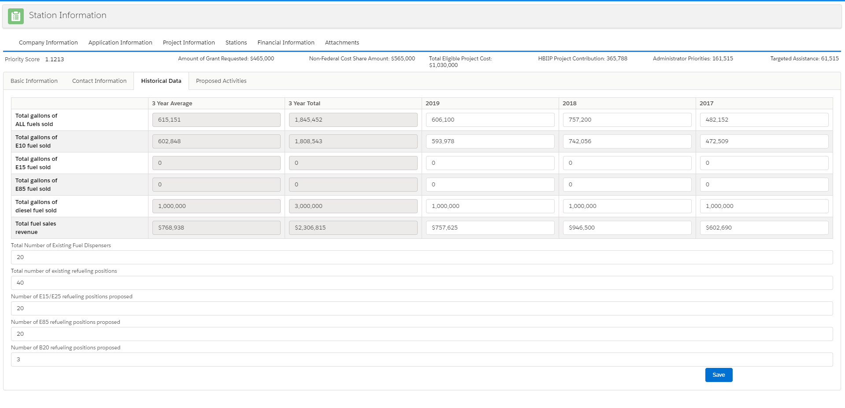
Station Information – Proposed Activities (1 for existing stations includes USTS activities; 1 for new construction stations that grays out/hides USTS activities).
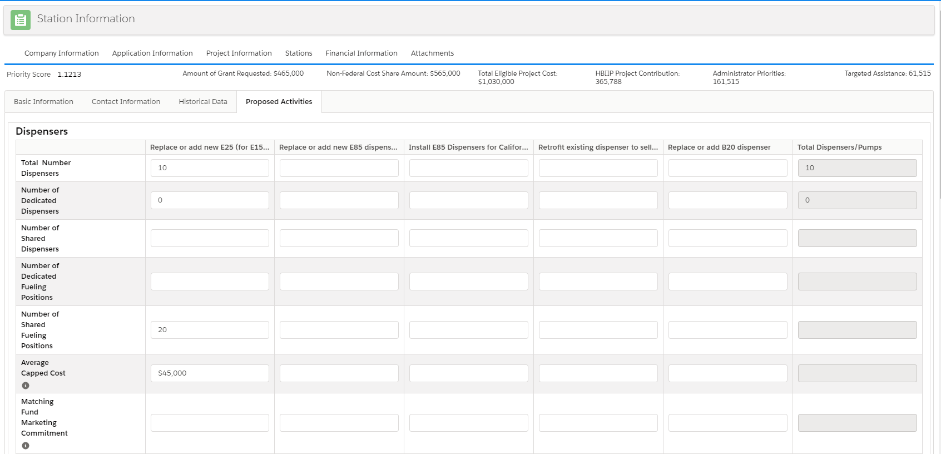

Fuel Distribution Information – Fuel Data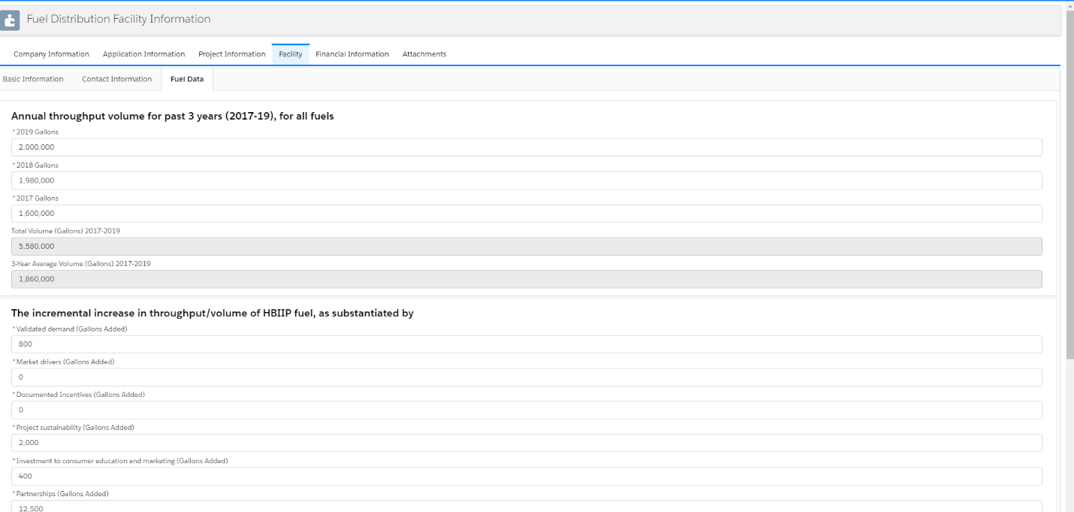

Financial Information, SF 424C
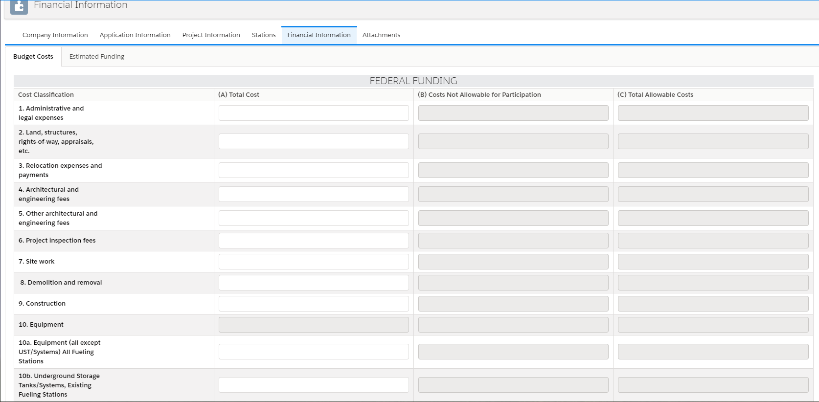

Attachments - Upload page for required supporting information:
- Loan Delinquency explanation (if applicable);
- Technical Report (up to 25 pages);
- Environmental Review documents;
- Matching Funds Verification/Certification;
- SF 424D – Construction Certification; and
- Fuel Distribution Facility Supporting Documents (up to 15 pages).

