PI IC Survey Form Am Samoa LL Cost Earnings 20202028_DK_MP3_070620

AMERICAN SAMOAN LONGLINE COST-EARNINGS QUESTIONNAIRE

XXXX (survey year) OPERATION

Date of interview: ____________________

Vessel Name: ______________________

Vessel’s permit number: ______________

Interviewee’s name:________________________ Contact (phone): _______________

Interviewee position (check all if apply)
Vessel/business owner
Agent
Operator Captain

I. About the owner OR owner operator

- How many fishing vessels do you (or the company you work for) own? _______ vessel(s)
How many vessels fish in Am. Samoa Longline Fishery _______
How many vessels fish in other fisheries _______

- When did you (or your company) start longline fishing in Am. Samoa? _________yr

- In XXXX(Year of survey), does your household (or the fishing company you work for) have other income sources besides the fishing business in Am. Samoa?
No
Yes. Income from longline fishing was _______% of the total household income

- Do the vessel owner live in Am. Samoa? Yes No

- How long have you (or the fishing company you work for) owned this vessel? _________ yrs

- Is this vessel operated by a hired captain or by owner?
by hired captain
by owner

- If it was operated by a hired a captain, how did you find the captain for this vessel– write down the details _____________________

II. About the Vessel

- When was the vessel built? ___________ year

- When was the vessel purchased?___________ year

- What was the vessel purchasing price? $______________;

10a: Did the vessel purchase price included permit: Yes No. If No, the price for the permit $_____________ (for lease purchase free from initial allocation)

- What was the start-up costs (to get it ready for fishing first time after purchase) $______________

- What is the vessel current (appraisal) value? $_____________ and when was the last appraisal performed __________ (year)?

12a. When was the last major upgrade (not including the state-up costs) that would have changed the vessel market value ______ (year)? and the costs for the upgrades $ _________

- How much you think your vessel (include all gears and equipment and permit) could be sold for? $_____________

13a. How much you think your permit could be sold for? $_________

- What is the vessel length? _____________ ft

- What is the vessel width/beam? _____________ ft

- Holding capacity of fuel: ____________ Gallons?

- Holding capacity of fish:___________ (lbs)

III. About Vessel Operation and Fish Sold in XXXX(Year of survey)

- How many trips this vessels landed in XXXX(Year of survey) __________________ trips

- What areas did this vessels operated (fishing) in XXXX(Year of survey) (check all if apply)
American Samoa EEZ
Other EEZ _________ (i.e. Cook Islands)
High Sea

- Where do you usually sell/distribute fish landed by this vessel? What was the % among those outlets?
Give away to friend to family ________ %
Sell to the Cannery _________ %
Sell to restaurant _________%
Other distributors or brokers (list the name(s) _______

IV. About Labor Costs in XXXX(Year of survey)

- How many crew do the vessel usually had __________ (NOT including captain)?

- How many crew are foreign __________ (NOT including captain)?

- On average, how long of the crew have been working with this vessel/company?
_________ yr

- What is the longest time a current crew has been working with this vessel? _________ yr

- How captain was paid?
By shares ______ % of GROSS revenue
______ % of NET revenue
Flat rate $______
Flat rate with bonus (details: $______ + )

- If shares by net revenue, which of the following trip expenses do you include as the trip costs?
Trip costs (fuel, bait, gears, provision, fishing gears, freon, engine oil, communications)
Agent fee, insurance, parts for repairs
Any others ______

- Does all the crew get pay by the same method?

If YES
By shares ______ % of GROSS revenue
______ % of NET revenue
Flat rate $_______ per month or year
Flat rate with bonus $_______ + _________ bonus

If NO, (means that each crew paid differently), please fill out the table below

Position | Shares or flat | If share  by Net Revenue | If flat rate  Trip or  Month | Flat  rate $ | Bonuses  (how) | Initial payment  (get this crew) | What year
Owner operator | Share  Flat | Net Rev  Rev | month  Trip
Hired captain | Share  Flat | Net Rev  Rev | month  Trip
Crewmember 1 | Share  Flat | Net Rev  Rev | month  Trip
Crewmember 2 | Share  Flat | Net Rev  Rev | month  Trip
Crewmember 3 | Share  Flat | Net Rev  Rev | month  Trip
Crewmember 4 | Share  Flat | Net Rev  Rev | month  Trip
Crewmember 5 | Share  Flat | Net Rev  Rev | month  Trip
Crewmember 6 | Share  Flat | Net Rev  Rev | month  Trip

- As an owner of a fishing vessel, do you hire an agent to take care of the fishing business?
Yes
No

If NO, what types of works that the owner usually takes care of?
Book keeping
Buying parts
Look for crew and captain
Getting the boats ready to depart (such as getting supplies, parts, call PIRO)
Others __________ ?

V. About Trip Costs

- Does trip cost varied by trip by trip?
If Yes. The main reasons for the variation by trip length? Or others ?

- To list the costs of one trip in Jun and the one of the last trip landed XXXX(Year of survey)
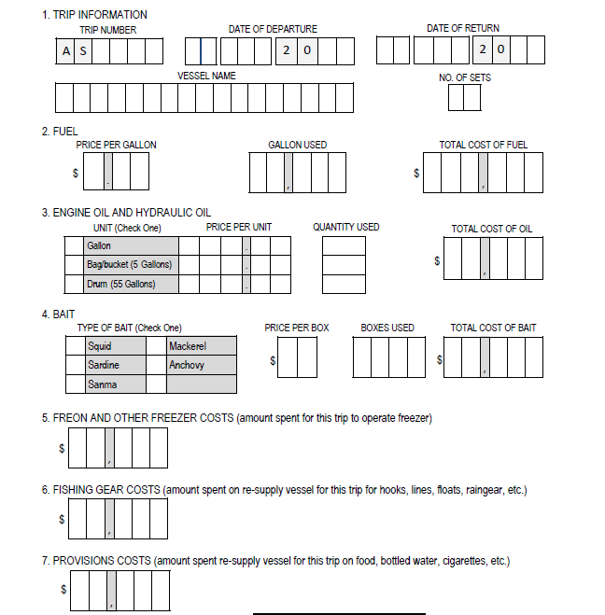
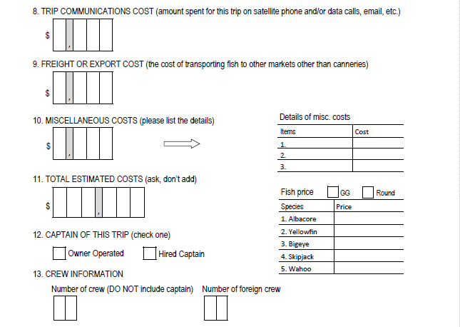

VI. Fixed Costs

- Total mooring fees (port fees for all the trips before departures) in XXXX(Year of survey)? $ ___________

- Did you hire someone to do XXXX(Year of survey) bookkeeping or share bookkeepers with other family business?
Yes. Pay $ ___________ a month/year
No. Owner does it.
No. It is done by the agent.
No. Share with business $ __________ of total

- What were your insurance costs per year for this vessel (or for the all ______ the fishing vessels) in XXXX(Year of survey)? $ ________________
This includes (Check if all apply)
Vessel only
Liability only (“P” and “I”)
Vessel and liability
Pollution
Health (Please specify who is covered) __________________

- Did you have any vessel loan payments in XXXX(Year of survey)? Yes No

If yes 1) How much were your payments in XXXX(Year of survey)? $_______________

- When did you last dry dock your vessel? ______________ yr

- When do you plan for the next dry dock? ______________yr

- How much it costs in in total for the last drydock $ ____________ …

Please list the major repairs in the dry dock and the cost associated with the report (if the data are available)
cost $________________ for ___________________________________________

cost $________________ for ___________________________________________

cost $________________ for ___________________________________________

cost $________________ for ___________________________________________

- Have you overhauled your engine in the past? Yes No

If yes 1) When did you last overhaul your engine? ______________ yr

2) How much did it cost $ ____________________

3) How often do you overhaul your engine? _______ yrs

- Do you have any routine repairs and maintenance in trip or annual base? Yes No
If YES, does it include in the trip costs above? Yes No
If NOT, how much it costs? $_______________ in XXXX(Year of survey)

- Beside the routine repairs and maintenance list above, do you have any major repairs and upgrades and maintenance works done in XXXX(Year of survey) for this vessel? If yes, the cost is $________________

Please list the major repairs and the cost associated with the report (if the data are available)
cost $________________ for ___________________________________________

cost $________________ for ___________________________________________

cost $________________ for ___________________________________________

cost $________________ for ___________________________________________

- Are there any other vessel costs which I haven’t included? Yes No

If yes (Please list)______________________________________ $________________

- Open Ended Questions? Is there anything else you would like to say? (present challenges, comments on fishing management)

We appreciate the confidential nature of the data being collected by this survey. NMFS will handle individual survey data as confidential business information and a form of protected personal information and will maintain the confidentiality of the information consistent with legal authorities available to it, including but not limited to the Privacy Act (5 U.S.C. Section 552a) and the Trade Secrets Act (18 U.S.C. Section 1905). NMFS will protect individual survey data from public disclosure to the extent permitted by law and it has instituted procedures to provide that protection.

Paperwork Reduction Act Statement. NOAA’s National Marine Fisheries Service (NMFS) is collecting this economic information to improve its ability to conduct the analyses required by the Magnuson-Stevens Fishery Conservation and Management Act (MSA) and other applicable law. NMFS and the Regional Fishery Management Councils will use this information to monitor, explain and predict changes in the economic performance and impacts of commercial fisheries. Among other things, this will enable fisheries managers and the public to more fully consider the economic effects of proposed and existing regulations for federally managed fisheries.

A Federal agency may not conduct or sponsor, and a person is not required to respond to, nor shall a person be subject to a penalty for failure to comply with an information collection subject to the requirements of the Paperwork Reduction Act of 1995 unless the information collection has a currently valid OMB Control Number. The approved OMB Control Number for this information collection is 0648-0773 and its expiration data is XX/XX/2023. Without this approval, we could not conduct this information collection. Public reporting for this information collection is estimated to be approximately 60 minutes per response, including the time for reviewing instructions, searching existing data sources, gathering and maintaining the data needed, and completing and reviewing the information collection. All responses to this information collection are voluntary. Send comments regarding this burden estimate or any other aspect of this information collection, including suggestions for reducing this burden to the NOAA Fisheries at: 1845 Wasp Blvd., Building 176, Honolulu, HI 96818, Attn: Minling Pan, and Minling.Pan@noaa.gov if desired.

