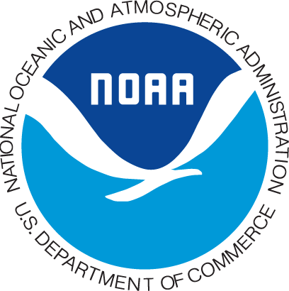
Golden Crab
Economic
Survey

Sponsored by
NOAA Fisheries

Last week a questionnaire seeking information on your business
REMINDER
expenditures was mailed to you. If you have already completed
and returned the questionnaire to us, please accept our sincere thanks.
If not, please do so today. The number of golden crab fishermen is
very small so it is extremely important that we hear from you.
Your response ensures that the study accurately results reflect the
economics of the fishery and will aid NOAA and the South Atlantic
Fishery Management Council in the policy-making process.

If by some chance you did not receive the questionnaire,
or it got misplaced, please call
1-866-xxx-xxx

