date

«Primary_Mailing_Recipient»
«Street_Address»
«City», «State» «Zipcode»

Dear <recipient>:

We want to thank you for your participation in the Economic Expenditure Survey of Golden Crab Fishermen in the U.S. South Atlantic Region. The information will help our researchers conduct economic and statistical analyses on the golden crab fishery.

If you have any further questions, please contact me at (305) 361-4468.

Thank you very much.

Sincerely yours,
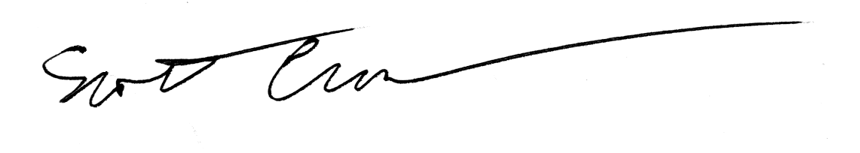
Scott Crosson
Resource Economist

