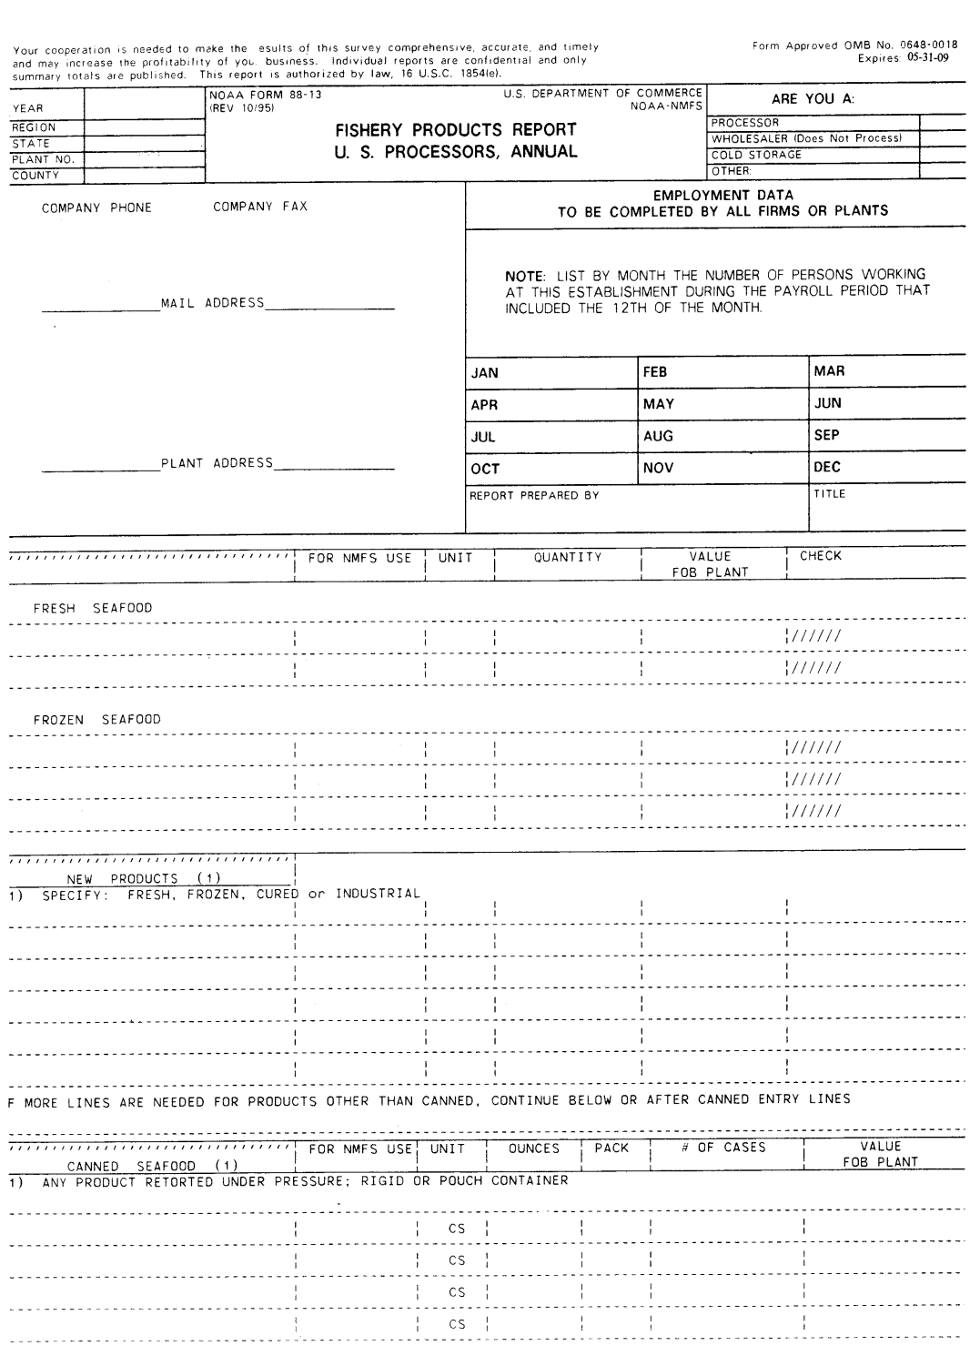
Pre-printed items are products that were reported last year. Simply fill in the quantity and value. Please cross out a product if you do not process it anymore.
- If you are new to the survey or do not have products on record for the survey, your form will only have a section for Products. Please report EVERY product you produce.
Please enter monthly employment information here (including administrative staff and yourself) and write your name.

Please provide a telephone number or e-mail address as well.
Space for company phone and fax number
Your Company’s Name
Your Company’s Mailing Address
Plant’s Physical Address
Please report any new or re-introduced products in this section. Please provide as much detail as possible, especially in terms of units (lbs., oz., gallons, etc.).
If a product you normally process was not processed in the previous year, it is not included in the pre-printed list. If you started processing it again, please report it here in the new products section.
- If you are new to the survey and there are no products listed already, please list ALL products you currently process
If you produce any canned products, please list them under “Canned Seafood” and include can size, number of cans in a case, and number of cases.
Pre-Printed
Your company name, mailing address, plant address and phone/fax number will be pre-printed on your form. Please check to make sure the information is correct and write in any changes as needed.
Thank you very much for your participation. We greatly appreciate your cooperation and time. This form summarizes some key points to help you complete the survey.

Please see page 2 for PRA Statement
Under quantity please provide the weight of the processed product. Value is the amount of money obtained for the product only, without shipping, retail, etc.
Cod Fillet 0820101160 LB
Shrimp Headless 7381201130 LB
Crab King Cooked Legs 7090202033 LB
Federal agency may not conduct or sponsor, and a person is not required to respond to, nor shall a person be subject to a penalty for failure to comply with an information collection subject to the requirements of the Paperwork Reduction Act of 1995 unless the information collection has a currently valid OMB Control Number. The approved OMB Control Number for this information collection is 0648-0018. Without this approval, we could not conduct this survey. Public reporting for this information collection is estimated to be approximately 30 minutes per response, including the time for reviewing instructions, searching existing data sources, gathering and maintaining the data needed, and completing and reviewing the information collection. All responses to this information collection are voluntary. Send comments regarding this burden estimate or any other aspect of this information collection, including suggestions for reducing this burden to the NOAA Fisheries Melissa Yencho at: 1315 East-West Highway, SSMC-3 F/ST-1, Silver Spring, MD 20910, Attn: Fishery Products Report/Melissa Yencho, melissa.yencho@noaa.gov.

