Qualitative research to understand consumer opinions and preferences for emerging
HIV prevention products among MSM in Atlanta, Houston, and Miami

Attachment 7: Product Graphics

Pictures for administering each prototype
Weekly pill
- We will need 5 copies, like we have for the prototypes
- The picture can be printed on a 4X6 cardstock
- Only this picture needs to be included on the cardstock
- Pass this picture around with prototype prior to reading description in IDI or FG guide.
- Collect picture and prototype after discussions about this prototype is completed

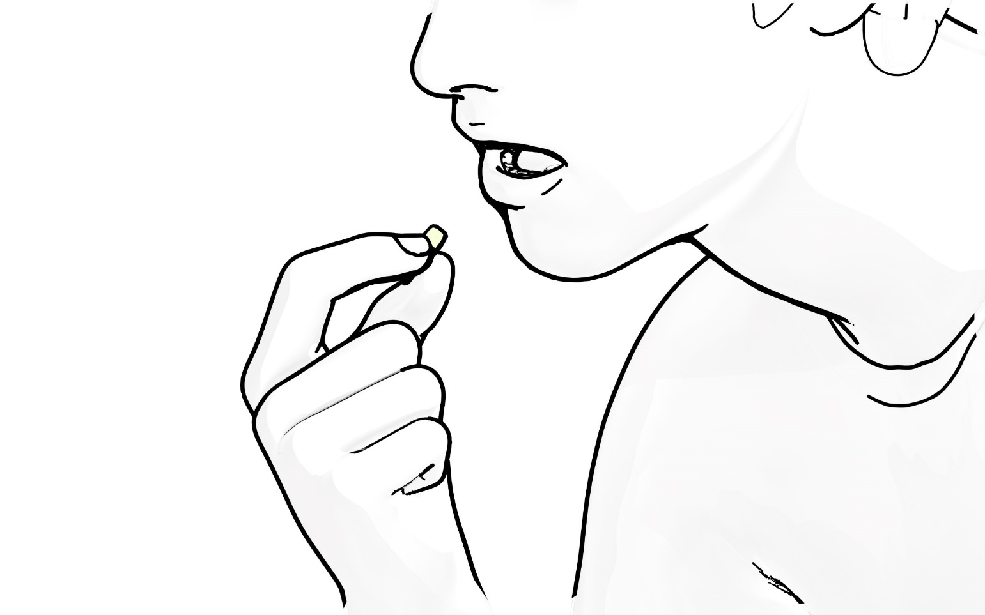
Intermittent or sexual event-specific oral pill
- We will need 5 copies, like we have for the prototypes
- The picture can be printed on a 4X6 cardstock
- Only this picture needs to be included on the cardstock
- Pass this picture around with prototype prior to reading description in IDI or FG guide.
- Collect picture and prototype after discussions about this prototype is completed

Anal suppository
- We will need 5 copies, like we have for the prototypes
- The picture can be printed on a 4X6 cardstock
- Only this picture needs to be included on the cardstock
- Pass this picture around with prototype prior to reading description in IDI or FG guide.
- Collect picture and prototype after discussions about this prototype is completed
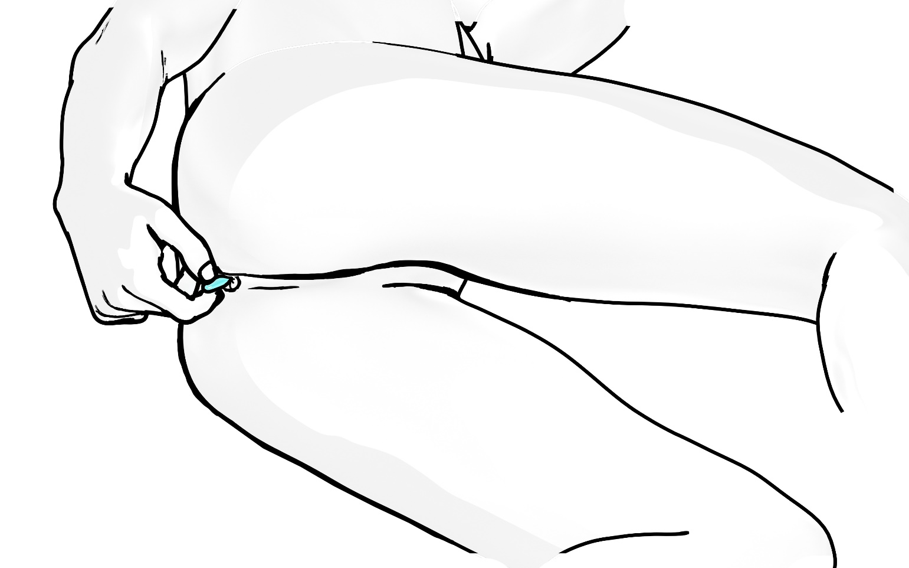

Anal douching
- We will need 5 copies, like we have for the prototypes
- The picture can be printed on a 4X6 cardstock
- Only this picture needs to be included on the cardstock
- Pass this picture around with prototype prior to reading description in IDI or FG guide.
- Collect picture and prototype after discussions about this prototype is completed
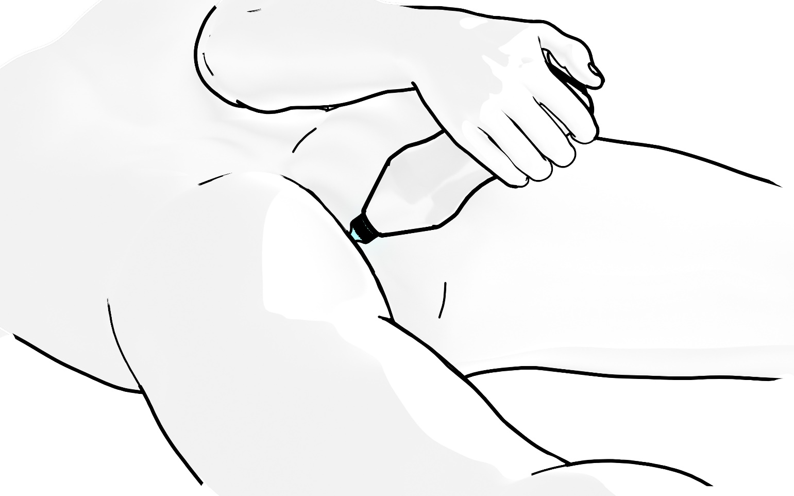

Injection or shot
- We will need 5 copies, like we have for the prototypes
- The picture can be printed on a 4X6 cardstock
- Only this picture needs to be included on the cardstock
- Pass this picture around with prototype prior to reading description in IDI or FG guide.
- Collect picture and prototype after discussions about this prototype is completed
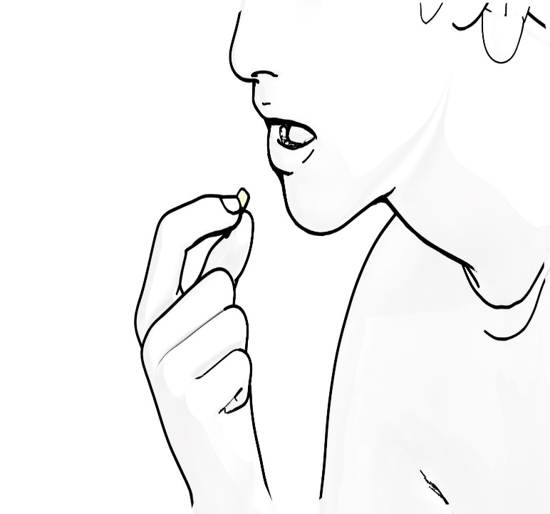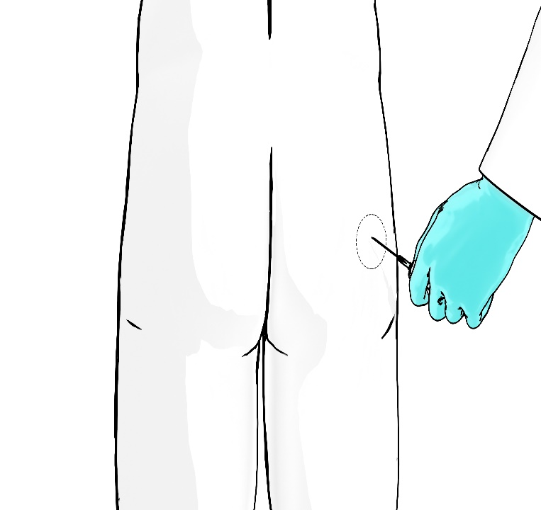

Implant
- We will need 5 copies, like we have for the prototypes
- The picture can be printed on a 4X6 cardstock
- Only this picture needs to be included on the cardstock
- Pass this picture around with prototype prior to reading description in IDI or FG guide.
- Collect picture and prototype after discussions about this prototype is completed
