SUBJECT: Register for the Implementation Science Consortium in Cancer

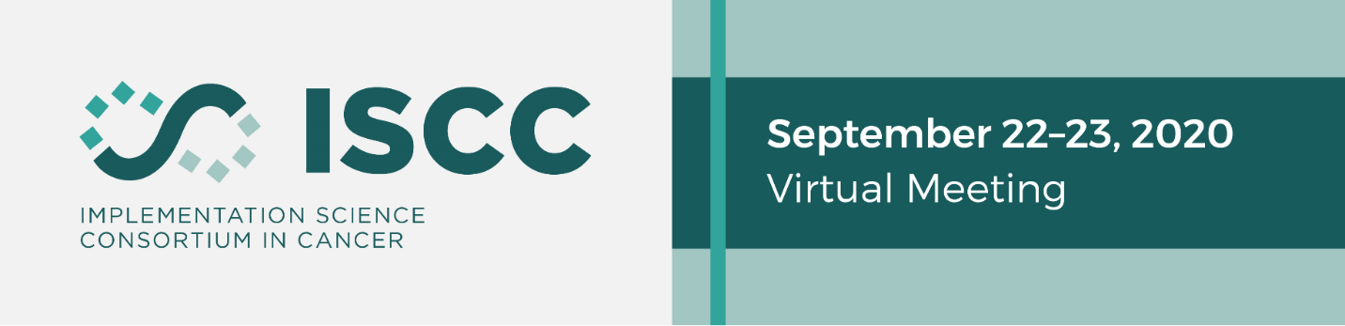
We are excited to announce the Second Annual Implementation Science Consortium in Cancer (ISCC) Meeting will be held virtually from September 22-23, 2020.

The 2020 ISCC will be a working meeting that will focus on short-term and long-term cancer control priorities; challenges and opportunities during the COVID-19; synergies and gaps in the implementation science space across NCI-funded initiatives; discussion on infrastructures for cross collaboration. The event will feature a variety of presentations and discussion sessions, as well as pre-work prior to encourage more engagement and discussion during each virtual meeting.

Register

Please direct any inquiries about the event to ISC3@icf.com

2019 ISCC Meeting Report

