Myofascial Pain Workshop

Registration Form Screenshots – 7/2/2020

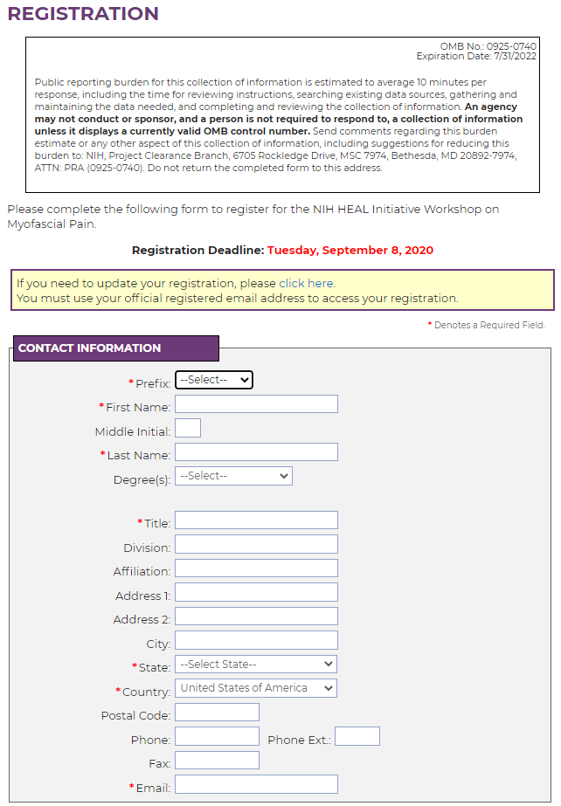

Figure 1. Registration Page - Part 1 of 2

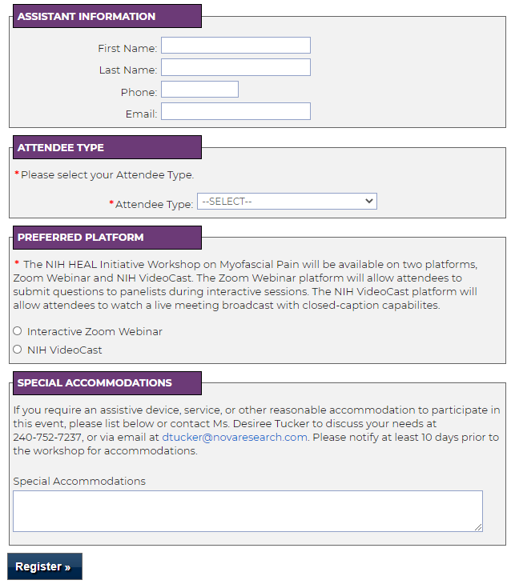

Figure 2. Registration Page - Part 2 of 2