**Permits Online (PONL)**

**Amended Application for Brewery or Brewpub (Bond Exemption)**

**Approved under OMB No. 1513–0005**

*Information on PONL is available on the TTB website at:* https://www.ttb.gov/ponl/customer-support.

*PONL Login Screen is at:* https://www.ttbonline.gov/permitsonline/Default.aspx.

=============================================================

**PONL Login Screen:**

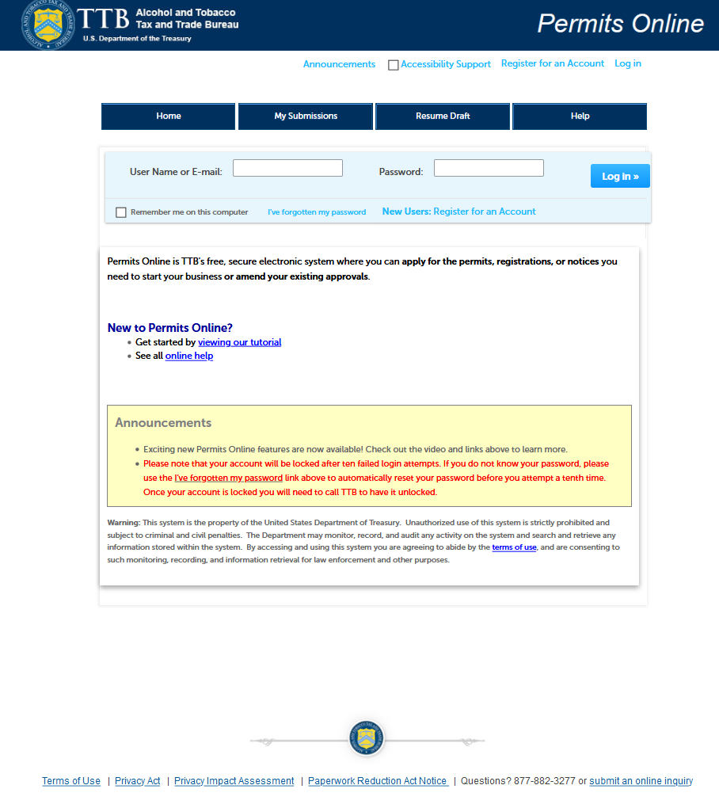

*The PONL Terms of Use, Privacy Act, Privacy Impact Assessment, and the Paperwork Reduction Act Notice statements for PONL are shown at the end of this document, beginning on page 14.*

**PONL Welcome and My Records Screen:**

*After logging on, on the Welcome screen, the user will select “Amend approved permits, registrations or notices from the selections shown:*

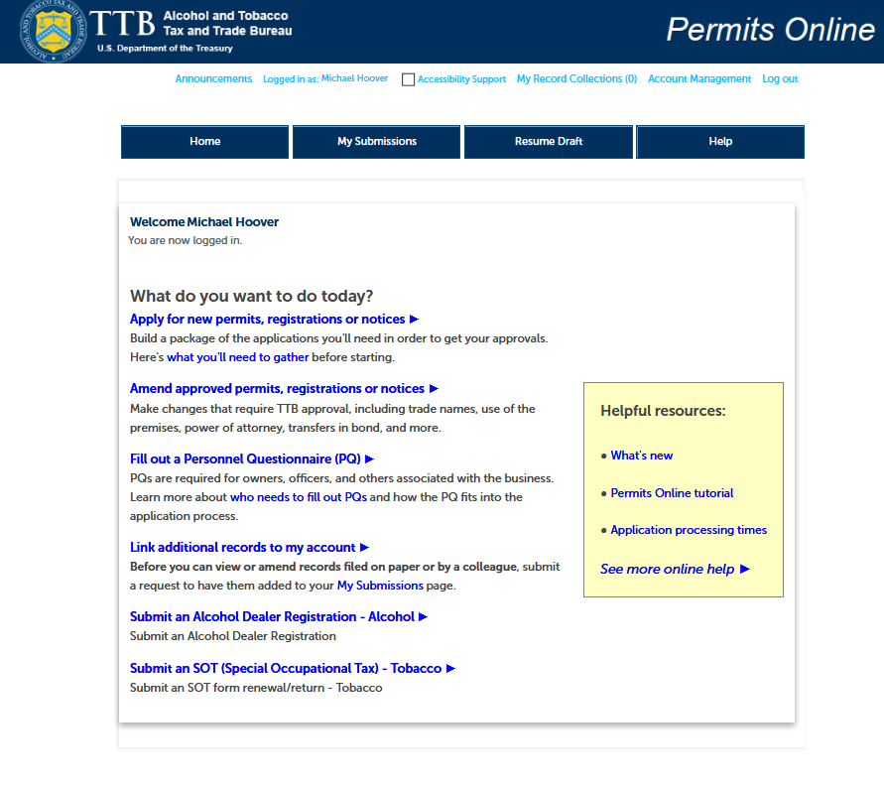

*The user will then see the “My Records” screen showing their active permits and entities. The user will select the Brewery Permit to be amended and click “Create Amendment” for that permit:*

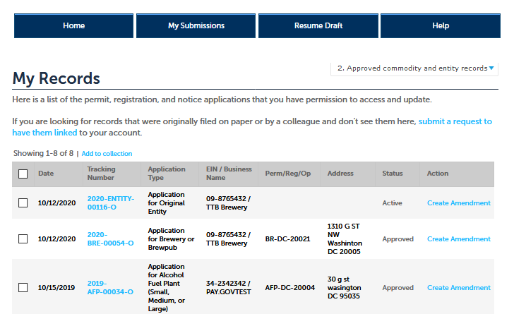

**Amendment Wizard – Step 1: Determine changes needed.**

*To apply for the small brewer’s bond exemption, the user selects “Yes” for the third question under “Amended Commodity Information.”*

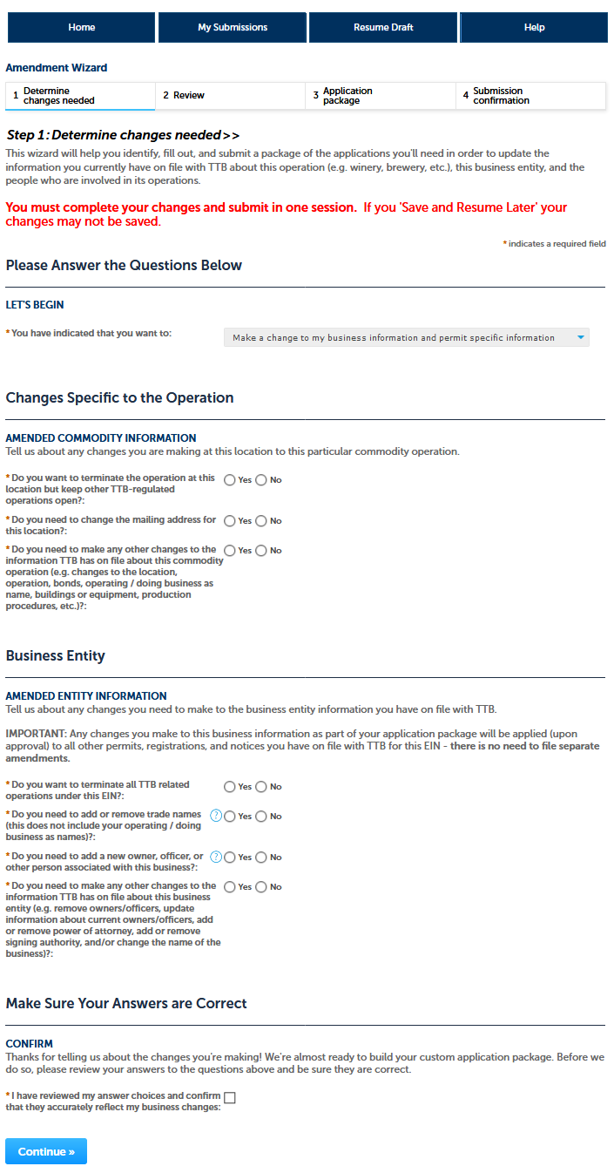

**Amendment Wizard – Step 2: Review.**

*The user reviews the answers provided in Step 1.*

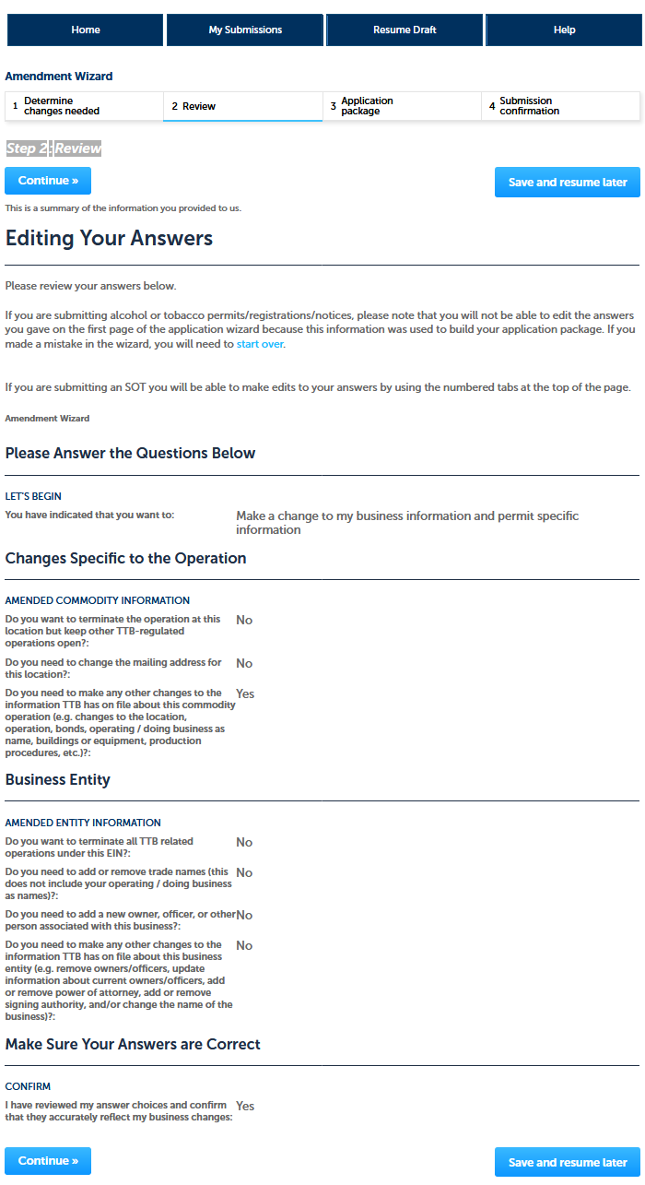

**Amendment Wizard – Step 3: Application Package.**

*This screen shows the user which applications require completion. In this case, the “Amended Application for Brewery or Brewpub.” The use clicks “Start” to begin the amendment application.*

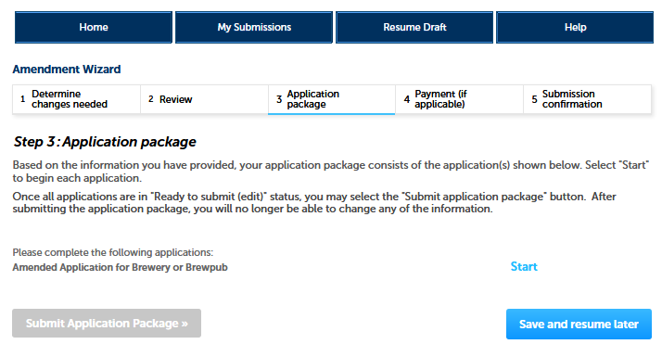

**Amended Application for Brewery or Brewpub – Step 1: Select amendment.**

*The user then will see the amendment screen, which begins:*

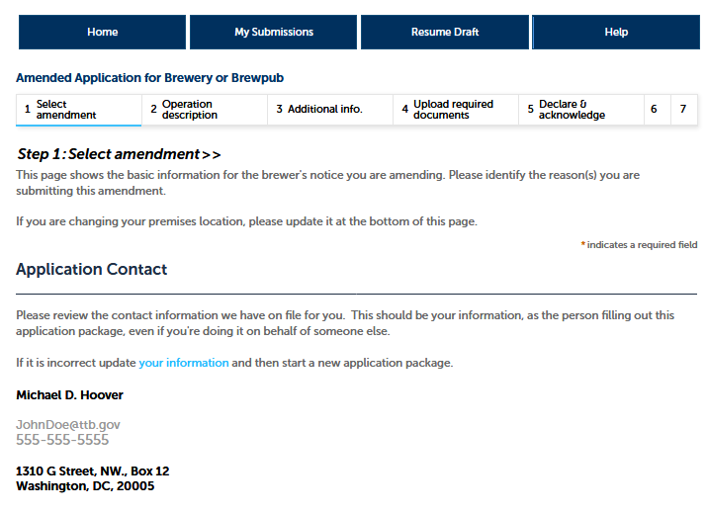

**Amended Application for Brewery or Brewpub – Step 1: Select amendment (continued).**

*Under “Reason for the Amendment,” the user selects “Bond No Longer Required.”*

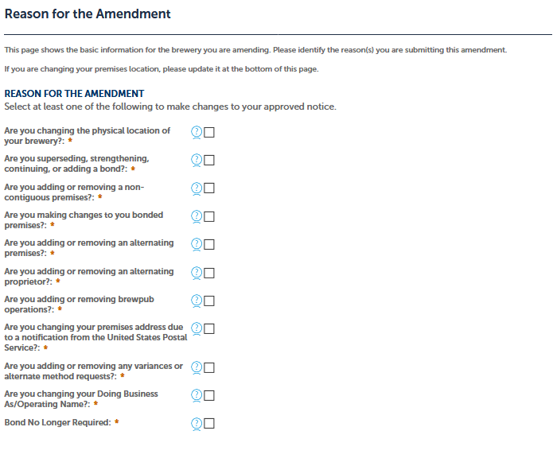

**Amended Application for Brewery or Brewpub – Step 1: Select amendment (continued).**

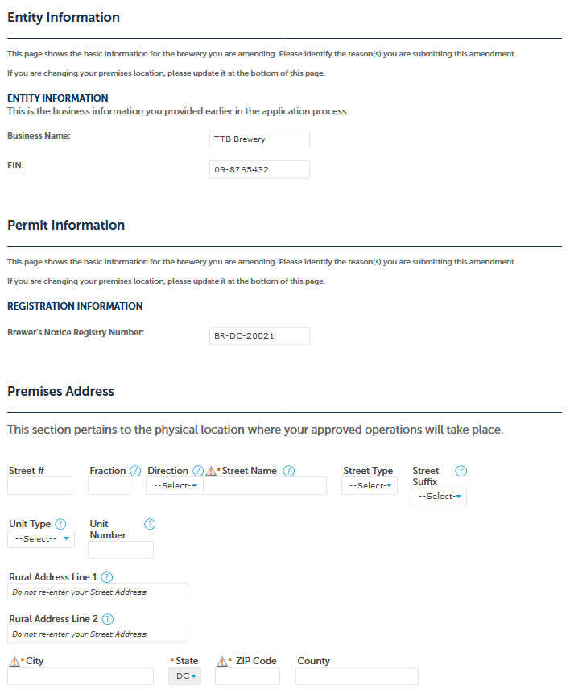

**Amended Application for Brewery or Brewpub – Step 2: Operation description.**

*Under “Brewery Information,” the user will certify that they do not require a bond.*

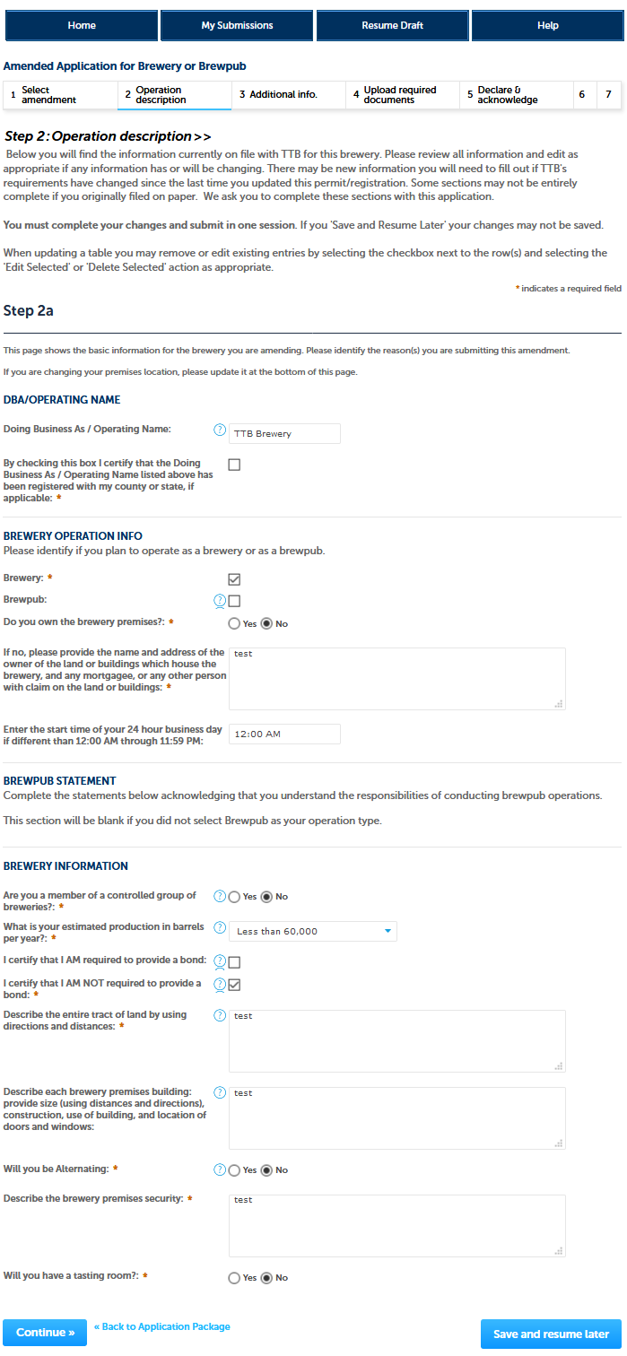

**Amended Application for Brewery or Brewpub – Step 3: Additional info.**

*Under “Brewer’s Bond,” the user will remove any existing uploaded brewer’s bond form (TTB F 5130.22, Brewer’s Bond, and TTB F 5130.25, Brewer’s Collateral Bond, approved under OMB No. 1513–0015).*

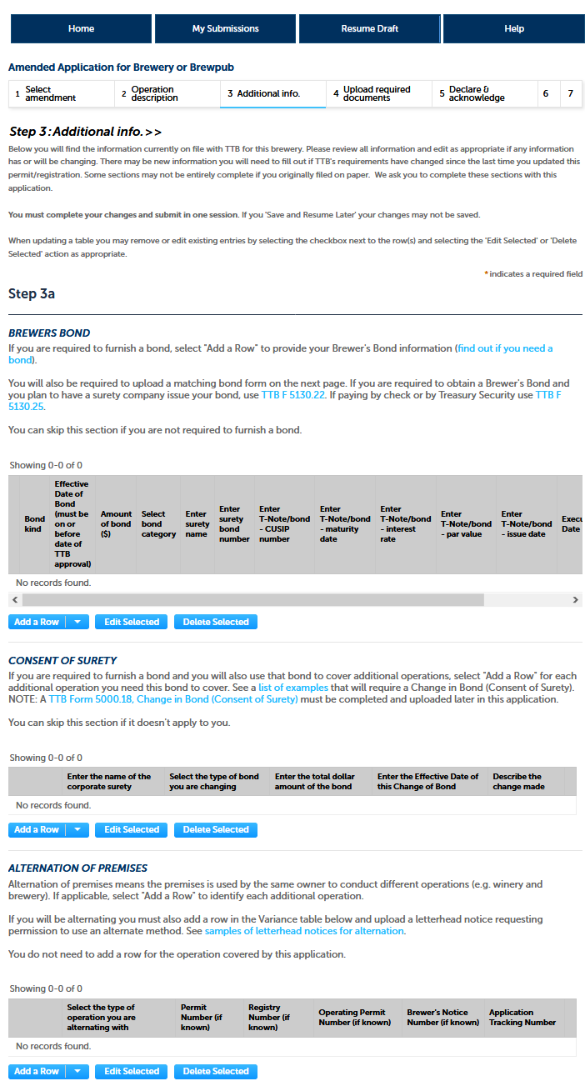

**Amended Application for Brewery or Brewpub – Step 3: Additional info (continued).**

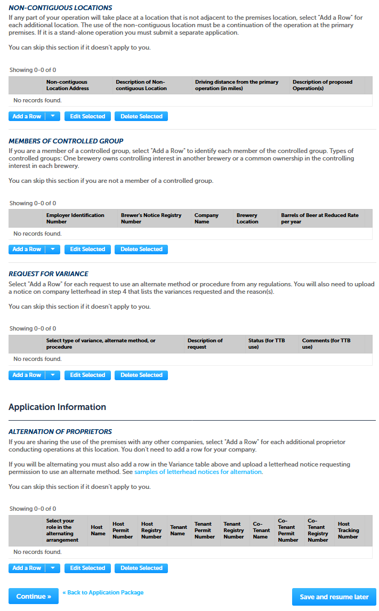

**Amended Application for Brewery or Brewpub – Step 4: Upload required documents.**

*This screen shows the documents, if any, the user must upload as part of this application. Bond exemption applications should not require uploading of any additional documents.*

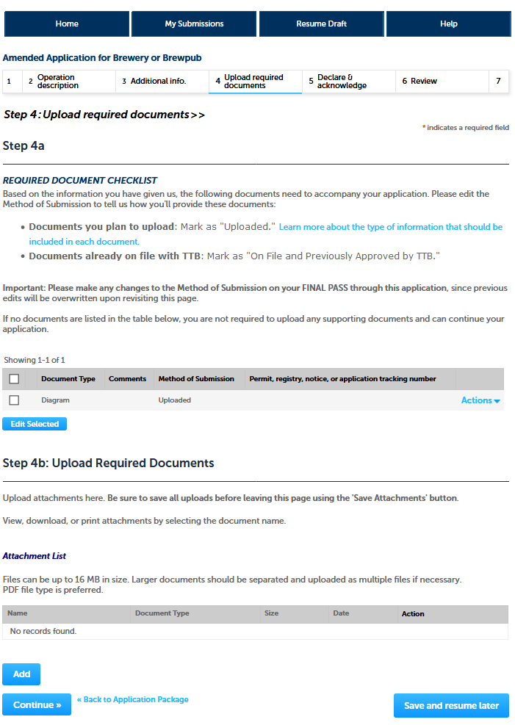

**Amended Application for Brewery or Brewpub – Step 5: Declare & acknowledge.**

*The user declares the application to be correct and truthful on this screen.*

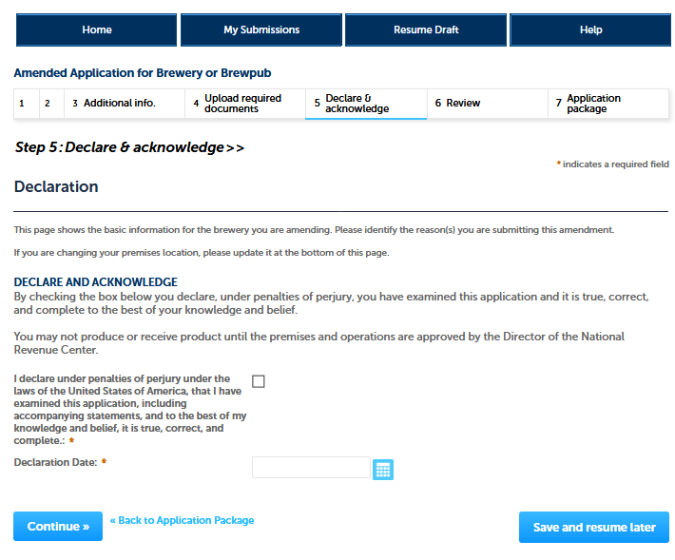

**Amended Application for Brewery or Brewpub – Step 5: Declare & acknowledge.**

*PONL next presents the user with a review screen:*

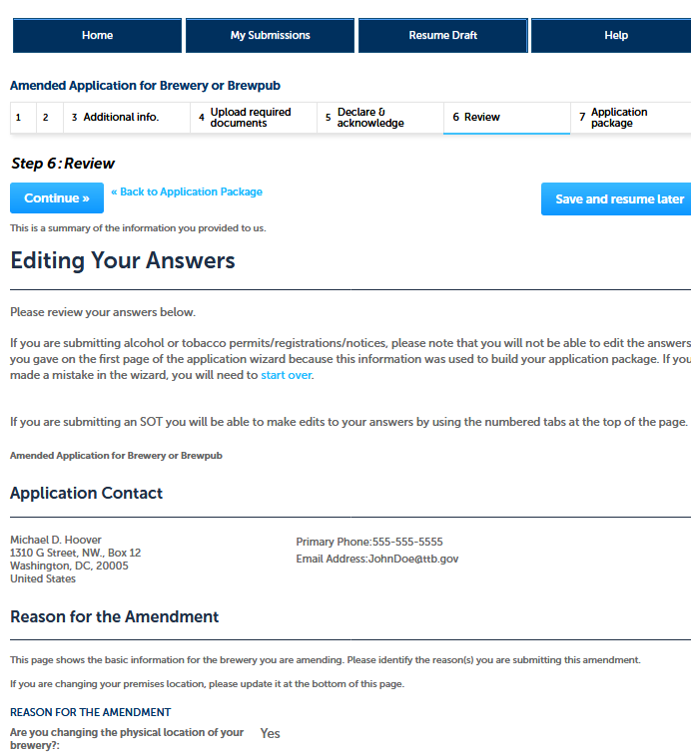

*[NOTE: Reminder of screen not shown.]*

**Amendment Wizard – Step 3: Application Package.**

*After reviewing their responses in the amendment application, and clicking “continue,” PONL presents the user with the application package submission screen. The user clicks “Submit Application Package.”*

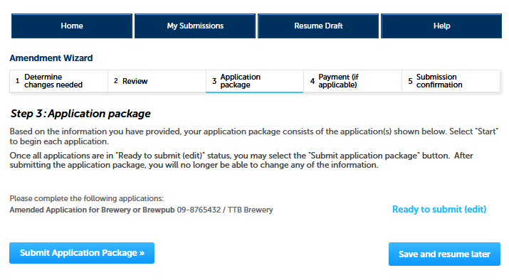

*After the PONL system receives the application package, the user will see a Submission Confirmation screen:*

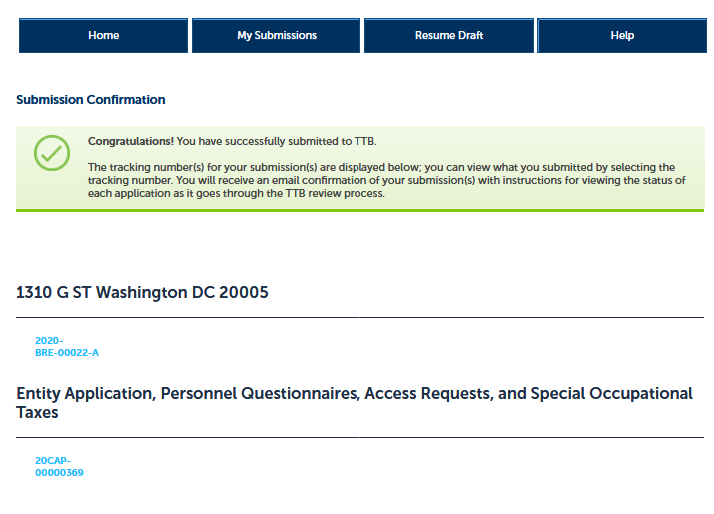

*End of Amendment Application Package. PONL public notices are shown below.*

**PONL Terms of Use Statement:**

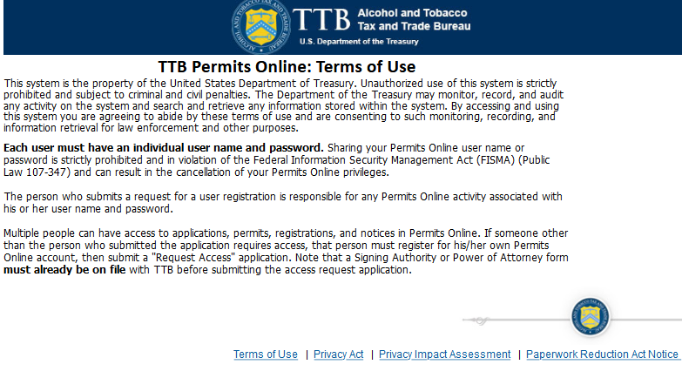

**PONL Privacy Act Notice:**

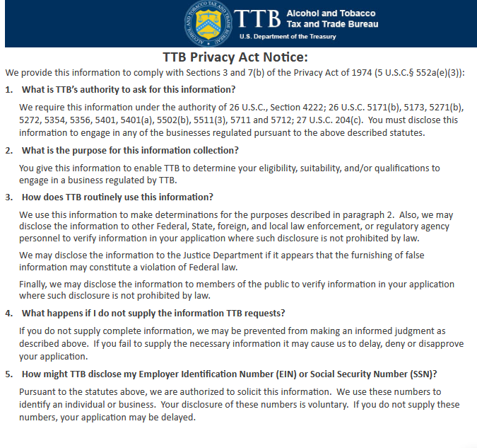

**PONL Privacy Act Assessment:**

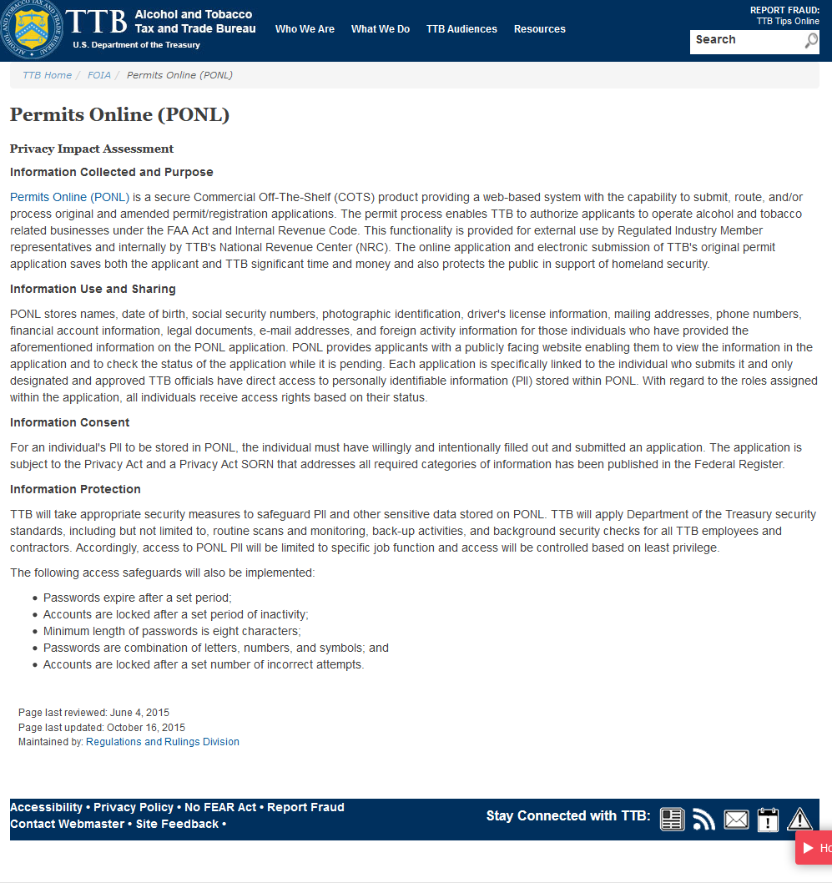

**PONL Paperwork Reduction Act Notice:**

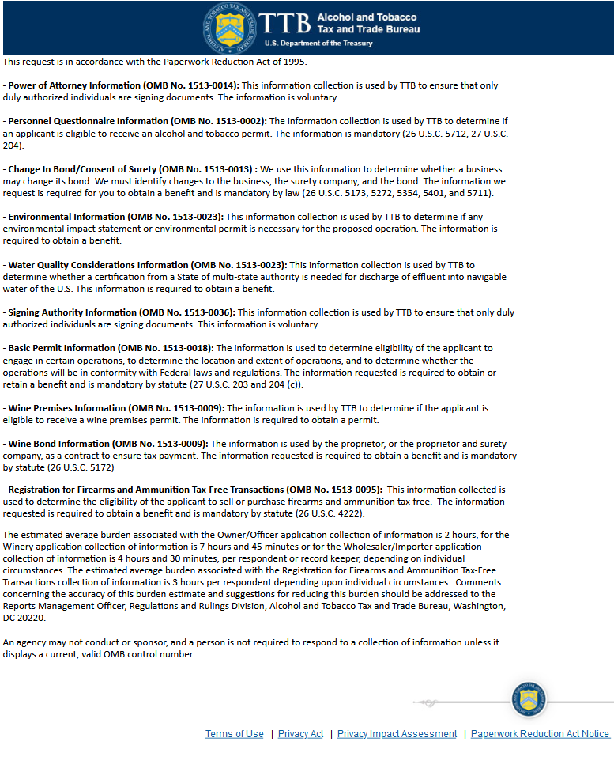

[END OF PONL SCREENS — AMENDED APPLICATION FOR BREWERY OR BREWPUB (BOND EXEMPTION)]