Permits Online (PONL) Application for Distilled Spirits Plant (DSP)
Screen Shots for Distilled Spirits Bond Information (OMB Control No. 1513–0125)
While the general Distilled Spirits Plant (DSP) application is approved under OMB No. 1513–0048, Distilled Spirits Plant Registration, the distilled spirits bond information collection within the general application is approved under OMB No. 1513–0125, Distilled Spirits Bond. The PONL DSP application screens relevant to OMB No. 1513–0125 are shown below:
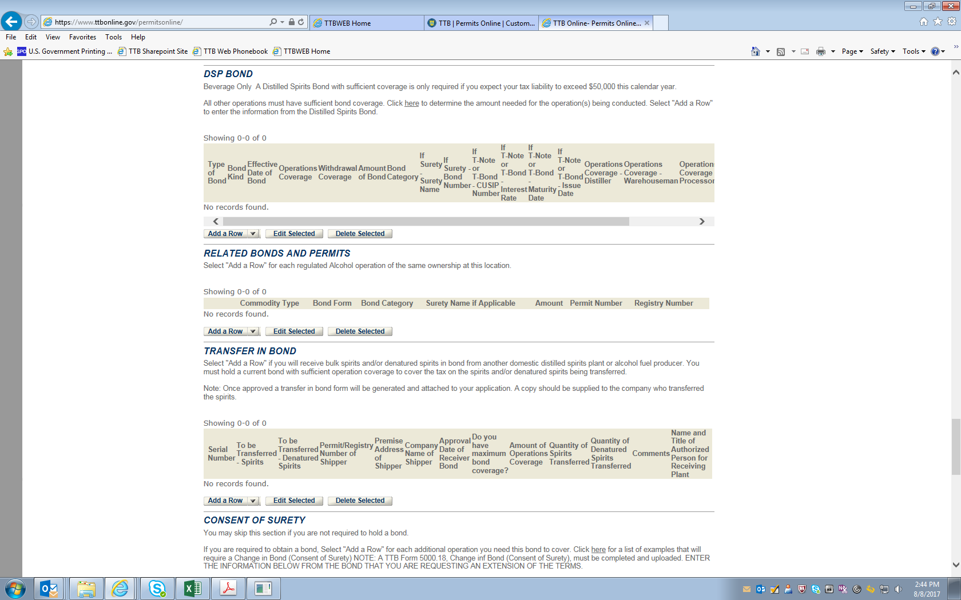
Under “DSP Bond,” clicking “Add a Row” results in this screen:
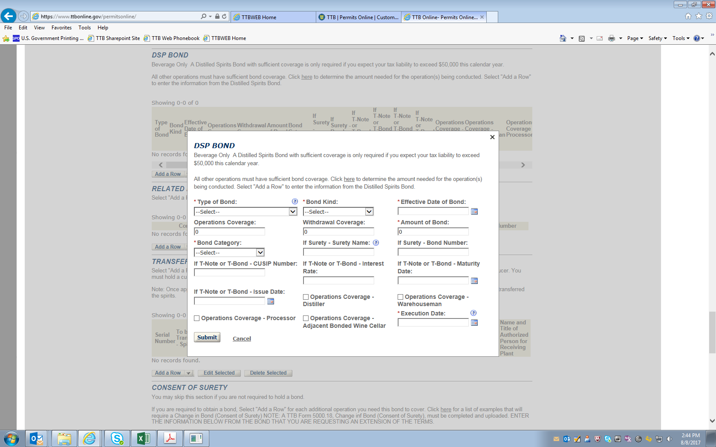

NOTE: In addition to the information above, a copy of the completed and signed Distilled Spirits Bond form, TTB F 5110.56, must be uploaded as an attachment.
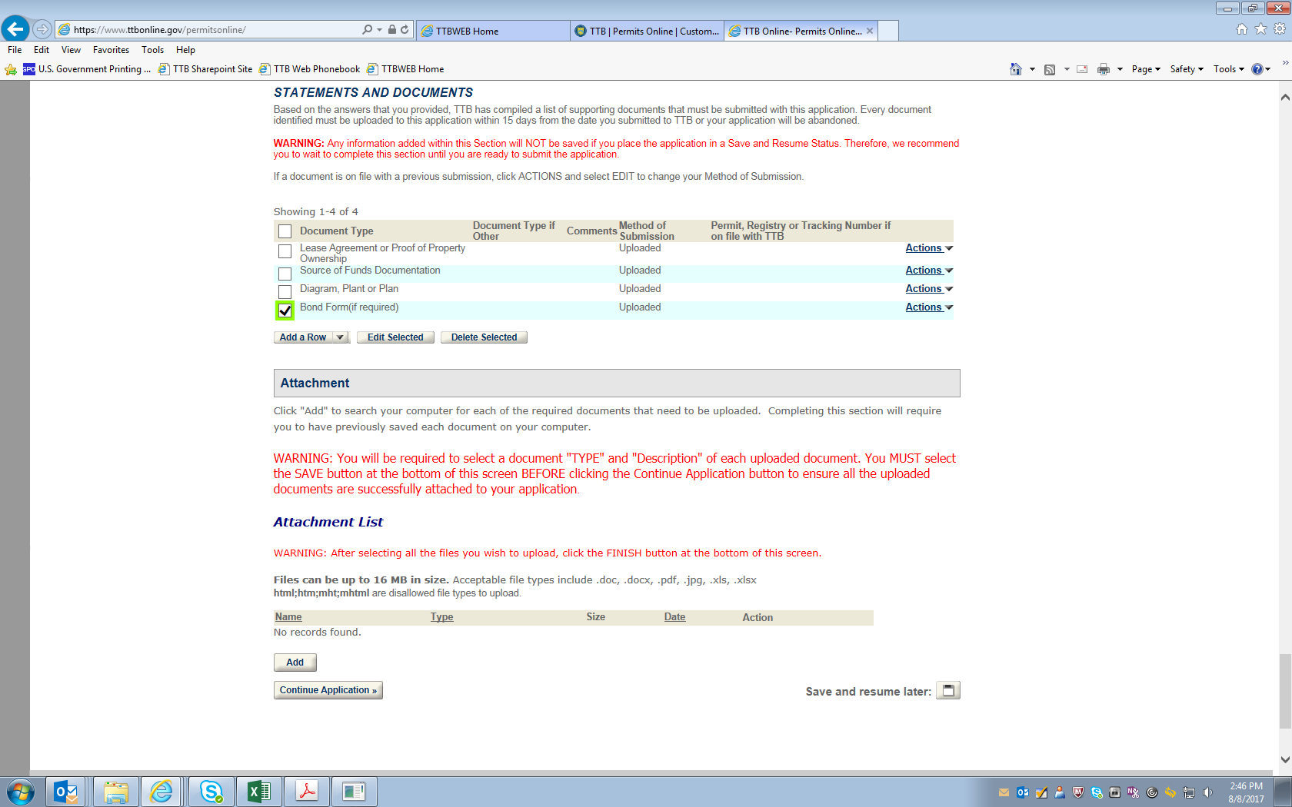
-- END --

