**Permits Online (PONL) Application for Alcohol Fuel Plant (AFP)**

**Screen Shots for Distilled Spirits Bond Information (OMB Control No. 1513–0125)**

While the general Alcohol Fuel Plant (AFP) application is approved under OMB No. 1513–0051, Application for an Alcohol Fuel Producer Permit Under 26 U.S.C. 5181, the AFP bond information collection within the general application is approved under OMB No. 1513–0125, Distilled Spirits Bond (an AFP is a type of DSP). The PONL DSP application screens relevant to OMB No. 1513–0125 are shown below:

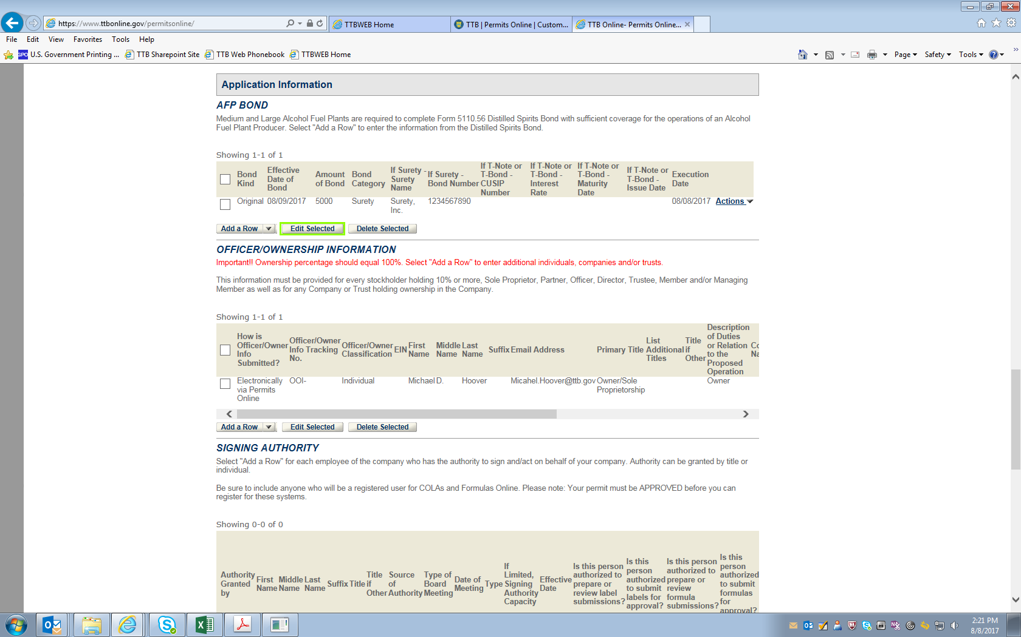

Under the “AFP Bond” heading, clicking “Add a Row” resulting in this screen:

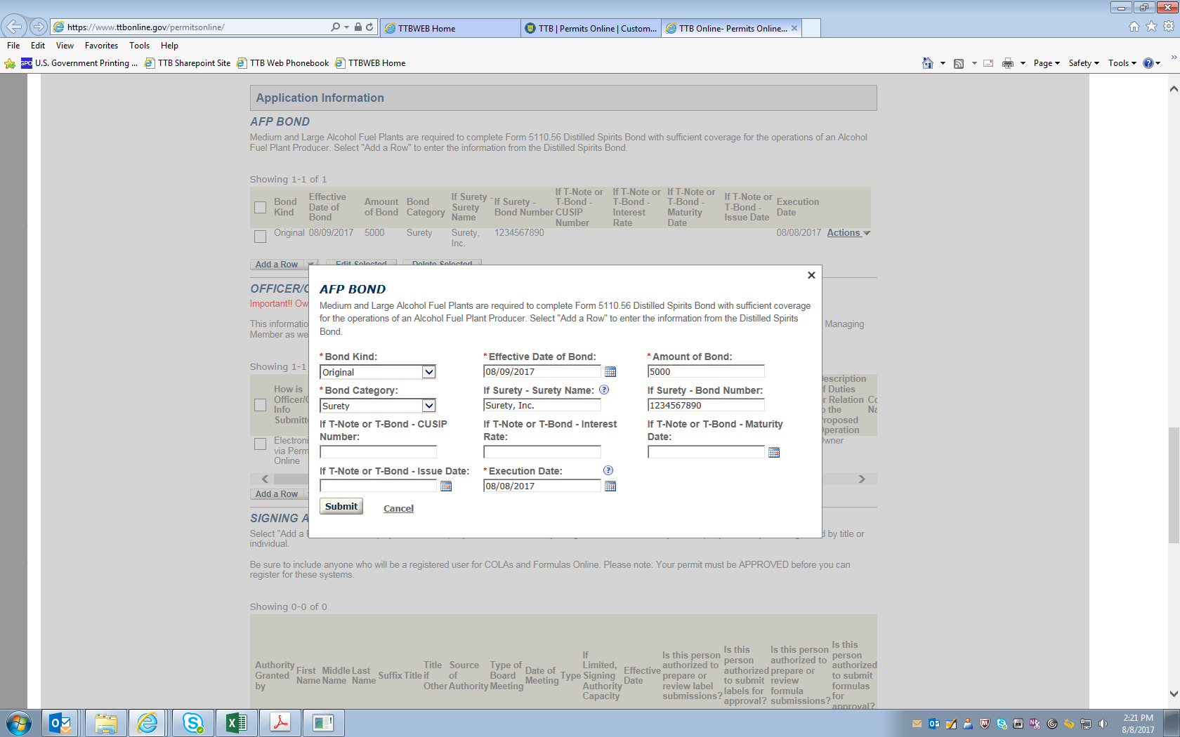

NOTE: In addition to the information above, a copy of the completed and signed Distilled Spirits Bond form, TTB F 5110.56, must be uploaded as an attachment.

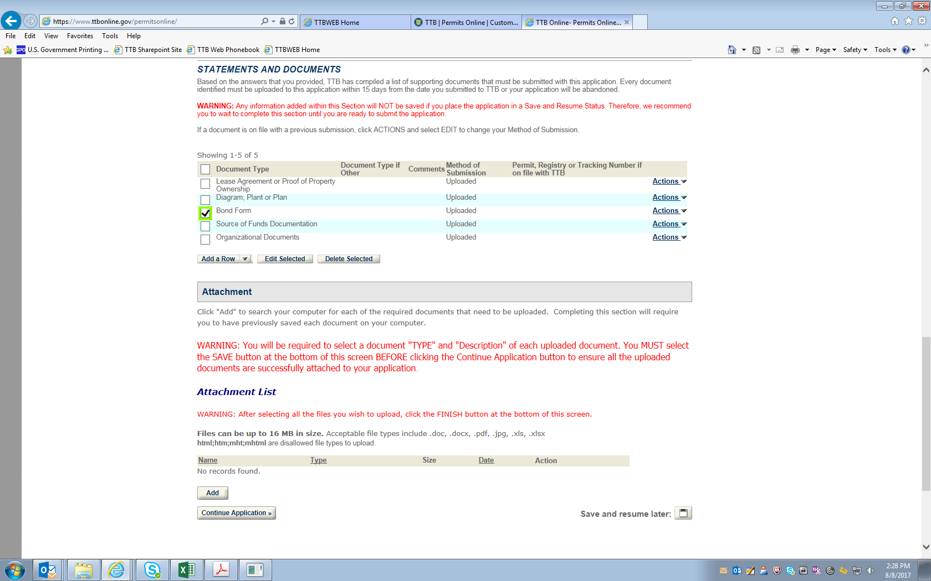

-- END --