Permits Online — Transfer in Bond Portion of the Distilled Spirits Plant (DSP) Application (OMB No. 1513–0038)
The respondent selects “Add a Row” under the Transfer in Bond heading:
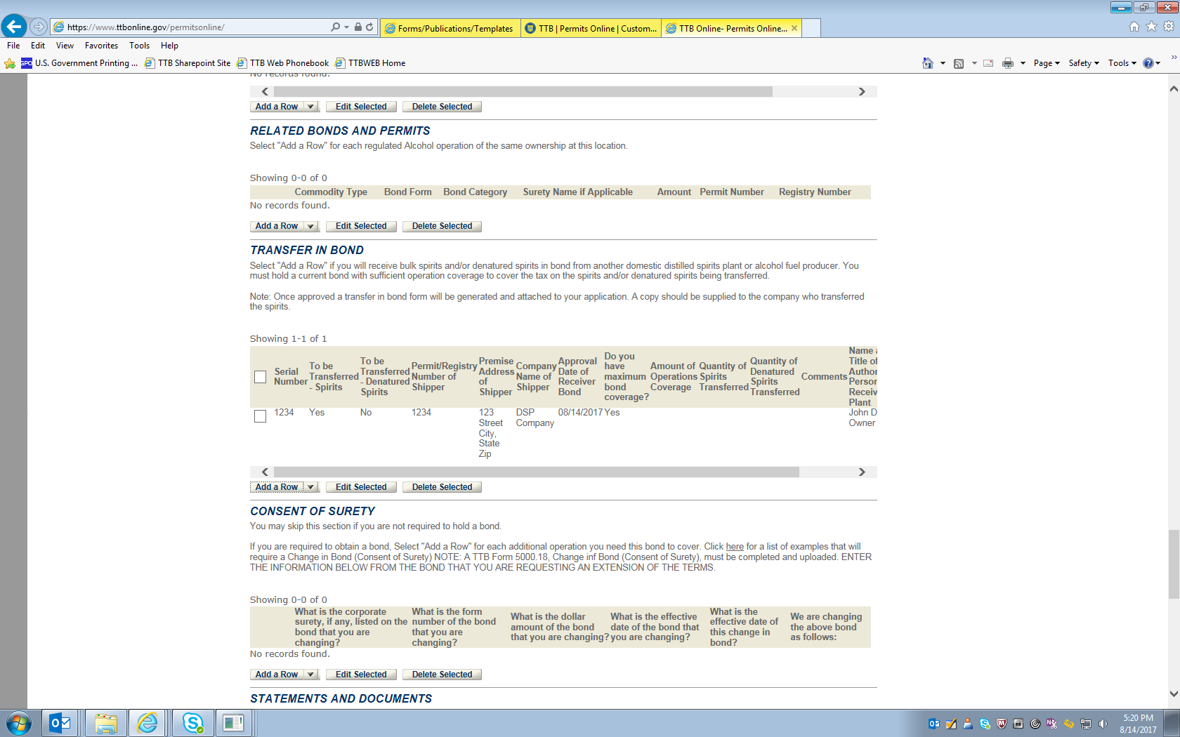

After selecting “Add a Row” under the Transfer in Bond heading, the respondent completes the Transfer in Bond information screen, as shown here:
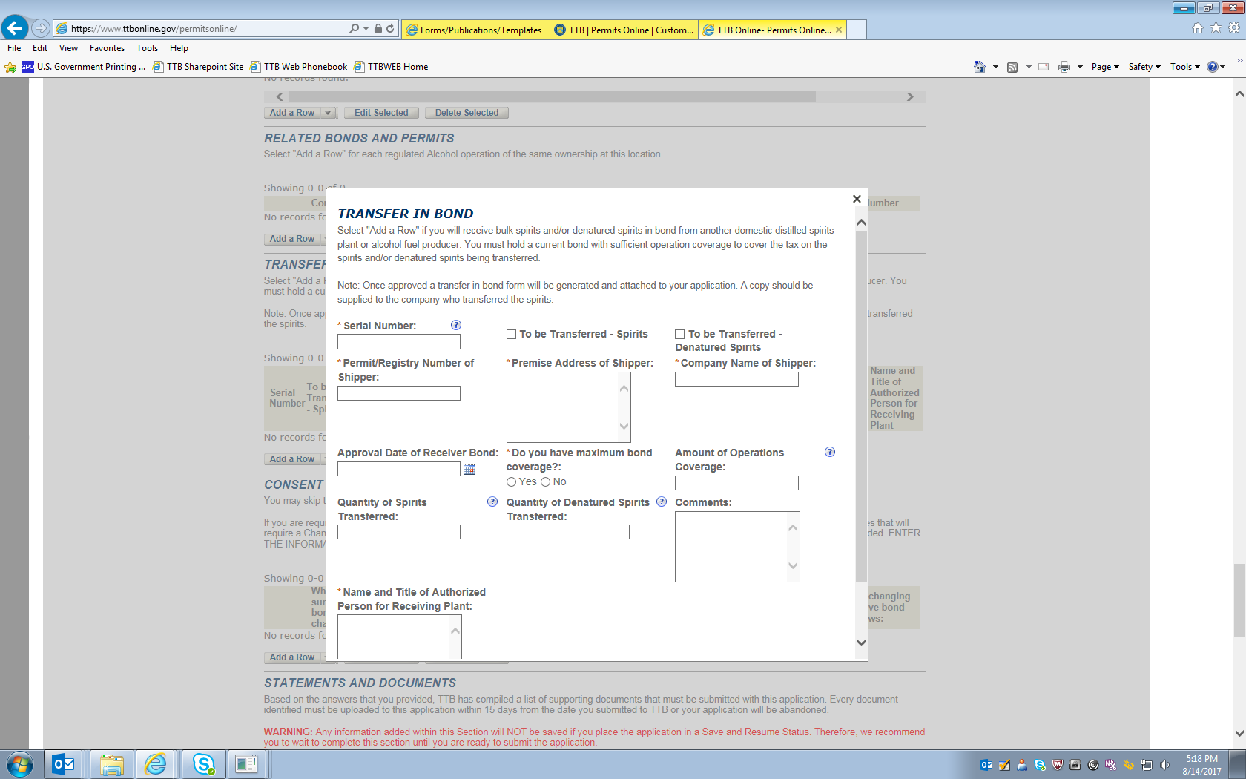
NOTE: The data entered on this screen, along with data identifying the receiving plant retrieved by the PONL system from stored data collected under other OMB control numbers, is equivalent to TTB F 5100.16, Application to Receive Spirits and/or Denatured Spirits by Transfer in Bond.
After completing the Transfer in Bond screen, the respondent will see a summary of the entered information on the Summary screen:

-- END --

