Permits Online (PONL) Application for New or Amended Brewery Application
Screen Shots for Brewer’s Bond and Brewer’s Bond Continuation Certificate; Brewer’s Collateral Bond and Brewer’s Collateral Bond Continuation Certificate (OMB Control No. 1513–0015)
While the PONL new and amended brewery applications are approved as part of the OMB No. 1513–0005, Brewer’s Notice, information collection approval, the Brewer’s Bond related sections within those PONL applications are approved under OMB No. 1513–0015, Brewer’s Bond and Brewer’s Bond Continuation Certificate; Brewer’s Collateral Bond and Brewer’s Collateral Bond Continuation Certificate. The PONL brewery application screens relevant to OMB No. 1513–0015 are shown below:
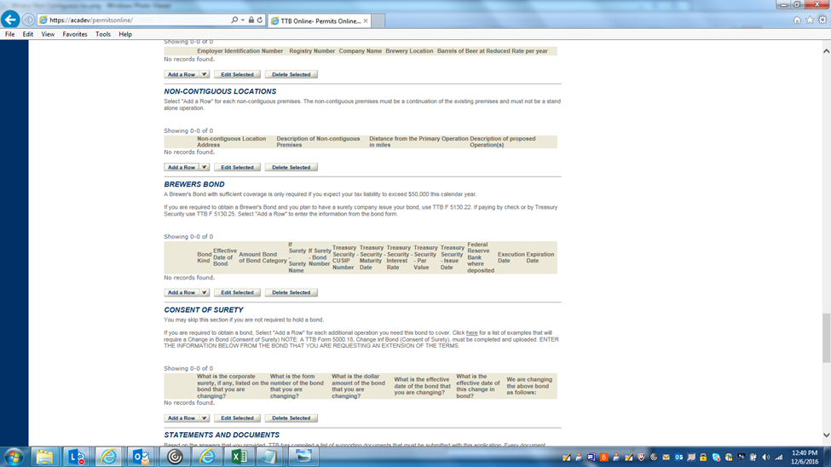
Under “Brewers Bond,” clicking “Add a Row” results in this screen:

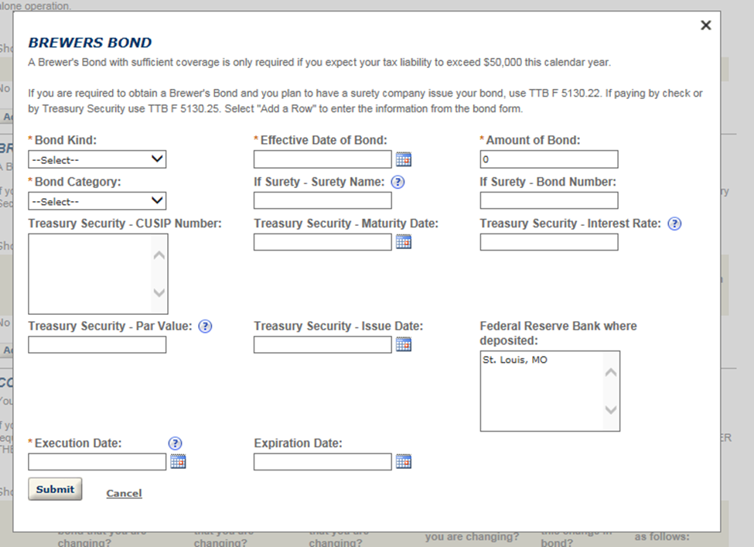

NOTE: In addition to the information above, the respondent must upload a copy of the relevant completed and signed brewer’s bond form (TTB F 5130.22, TTB F 5130.23, TTB F 5130.25, or TTB F 5130.27) as an attachment to their new or amended brewery application:

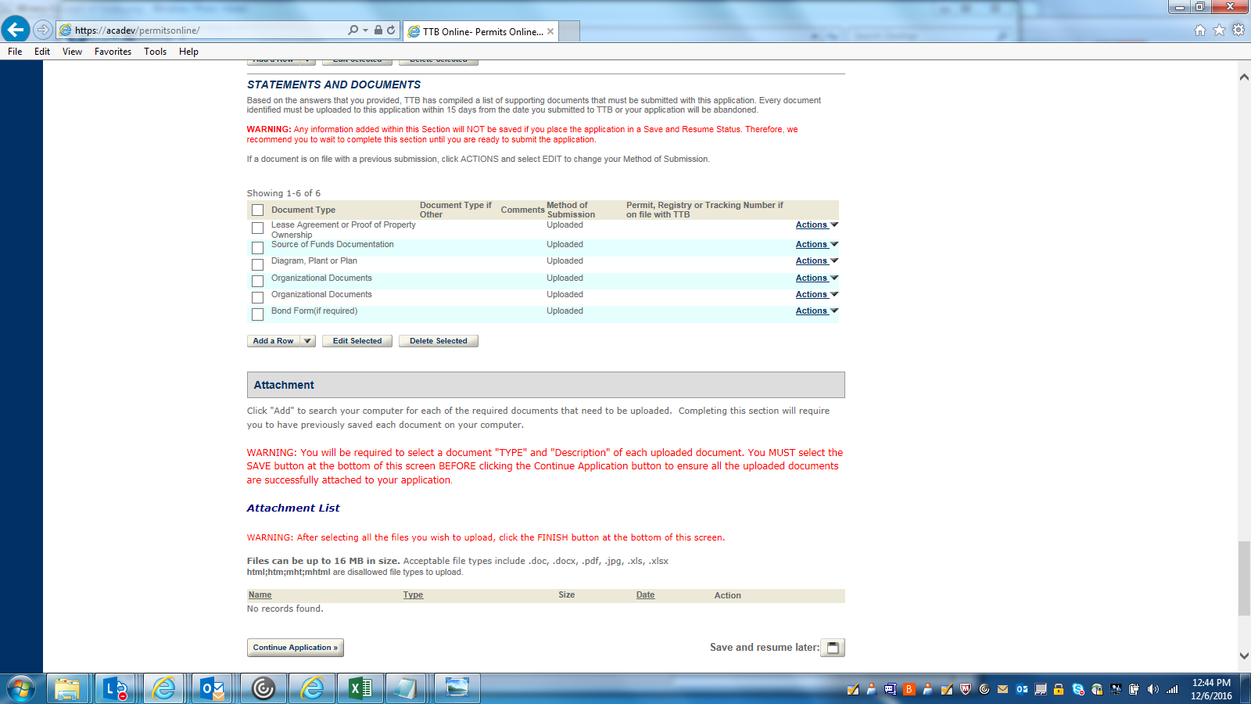

-- END --

