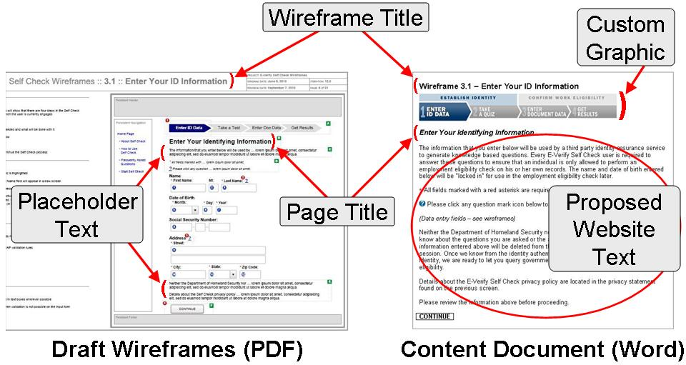

About the Draft Wireframes
- Most text in the wireframes is representative, intended only to depict the proposed screen design
- All of the interface elements (e.g. buttons, boxes for data entry) are shown

About this Content Document
- All of the text (with the exception of certain italicized notes) is being proposed for the myE-Verify website
- Only certain interface elements are shown in the content document

Let us know if you have any questions and thank you in advance for your time reviewing and commenting on the proposed myE-Verify content.

The myE-Verify team

Wireframe 1.1 – Account Information

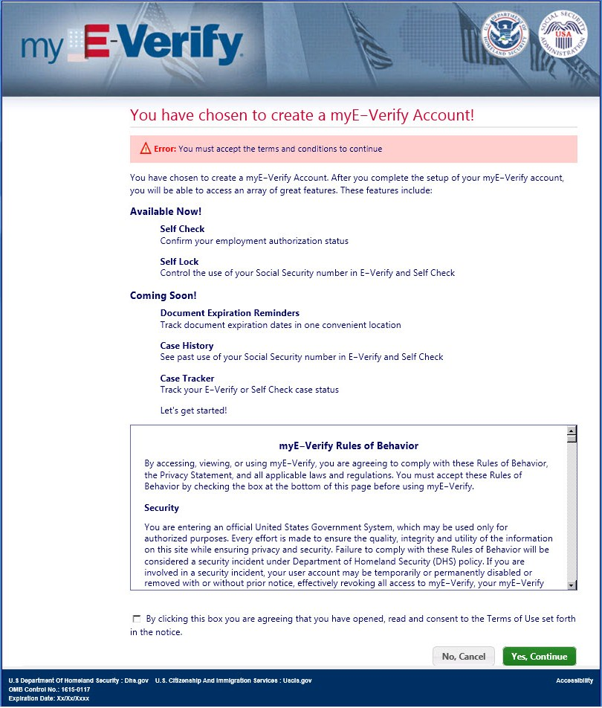
Paperwork Reduction Act

Wireframe 1.1 – Account Information (Rules of Behavior)
Language in the scroll box above

myE-Verify Rules of Behavior

By accessing, viewing, or using myE-Verify, you are agreeing to comply with these Rules of Behavior, the Privacy Statement, and all applicable laws and regulations. You must accept these Rules of Behavior by checking the box at the bottom of this page before using myE-Verify.

Security

You are entering an official United States Government System, which may be used only for authorized purposes. Every effort is made to ensure the quality, integrity and utility of the information on this site while ensuring privacy and security. Failure to comply with these Rules of Behavior will be considered a security incident under Department of Homeland Security (DHS) policy. In you are involved in a security incident, your user account may be temporarily or permanently disabled or removed with or without prior notice, effectively revoking all access to myE-Verify, your myE-Verify credential, username and password, and any myE-Verify data.

Unauthorized access is a violation of the laws of the United States and DHS policies, and may result in administrative, civil or criminal penalties. You must not attempt to access other users’ files or system files without prior authorization. Absence of access controls is not an authorization to access or a waiver of applicable laws, rules, regulations or DHS policies.

Your Use of myE-Verify

Your initial use of myE-Verify required completion of a Self Check query. E-Verify Self Check provides users with confidence that E-Verify will correctly confirm their identity and employment authorization when they start a new job; if Self Check is unable to confirm identity and employment authorization, it provides users with guidance on how to correct discrepancies in records at their convenience. The Terms of Use you agreed to when you used Self Check continue to apply during your use of these additional myE-Verify services.

Your continued use of myE-Verify is for the purpose of receiving a credential and setting up a user account, locking or unlocking your Social Security Number (SSN), and managing your myE-Verify account. In using these myE-Verify services, and any additional myE-Verify services later developed, you understand and agree that:
- Your access is at DHS’s discretion.

- Your use is subject to continuous monitoring in accordance with DHS policy.

- You will not circumvent or attempt to circumvent any passwords, security countermeasures or safeguards.

- Your account credential, username and password will be unique and associated directly with a single “live” individual.

- You will verify the information contained in your credential before using it and promptly notify USCIS of any errors.

- You will not maintain more than one account at any given time.

- You will not enter or attempt to enter another person’s information into myE-Verify without their authorization.

- You will take all reasonable measures to protect your credential, user name, password, and activation data (e.g., PIN), and immediately report to USCIS the loss, compromise or destruction of your credential, user name, password or activation data.

- You will not copy your credential, user name or password nor allow any of them to be used by any other person unless authorized.

- You will change or immediately request revocation of your credential, username or password if: (i) any data used to access your credential or the token containing your credential are insecure in any way; or (ii) any of the information contained in the credential, username or password or your identification and authentication information has been changed.

- Any device with which you will interact to use your credential or myE-Verify will have appropriate security controls installed and activated, and the latest updates applied.

- You will use myE-Verify, your credential, and any related service only in accordance with the applicable privacy terms, laws and regulations of this Rules of Behavior.

- You will promptly report any known/observed violations of or non-compliance with these Rules of Behavior including (but not limited to) observed IT security incidents, suspicions of security violations, or posting of inappropriate content, to USCIS.

You understand and agree to these Rules of Behavior and accept that your use of myE-Verify is subject to monitoring at all times in accordance with DHS policy.

Information You Submit
United States Citizenship and Immigration Services (USCIS) uses the information you supply to quickly authenticate your identity and to establish and provide you with a myE-Verify account, including the following features: (1) Self Lock; (2) Case History; (3) Case Tracker; and (4) Document Expiration Reminder. Note that initially, the Self Lock feature will be available; future myE-Verify releases will include additional features noted above.
Your use of myE-Verify requires USCIS to use a private sector third party Credential Service Provider (CSP) in order to establish and maintain an electronic credential to ensure that only you are able to access myE-Verify account features. This third party provides identity assurance services to USCIS in accordance with the terms and conditions of a Service Level Agreement (SLA). USCIS does not control or maintain the information gathered or utilized by myE-Verify from this CSP. USCIS receives a response from the CSP containing the result of the authentication and does not receive or store your SSN or date of birth as part of the myE-Verify account. This is why you may need to supply your SSN or date of birth again to use some of the myE-Verify account features such as Self Lock and Case History.
When establishing a myE-Verify account, the CSP will issue you a digital identity, in the form of a digital credential (“credential”), and the use of such credential is subject to these Rules of Behavior. A credential will only be issued to you once your identity has been confirmed. Depending on the nature of the credential, standard messaging rates or connect rates from your mobile phone carrier may apply for the delivery of credentials, (e.g., by SMS text message). USCIS and the CSP may collect and use technical data and related information, including but not limited to technical information about your device, system, and peripherals, that is gathered periodically to facilitate the provision of software updates and product support and to you related to this credential; this information will not be used for any other purpose.

The credential will be used to establish your identity when you try to access myE-Verify and other websites and applications controlled or maintained by USCIS or other DHS components. By agreeing to these Rules of Behavior, you authorize our CSP to provide identity assertions when you attempt to use your credential in these websites and applications. An identity assertion is a statement asserting your identity to USCIS or another governmental agency.

Accuracy, Completeness and Timeliness of Information on the Site

USCIS assumes no responsibility regarding the accuracy of the information that is provided by myE-Verify. You assume all risks of use and the consequences of using the information from the site and any affiliated site, whether accurate or inaccurate.

USCIS does not guarantee the availability of myE-Verify, nor for it to be operational nor to be available to the general public. USCIS does not guarantee that the CSP sites for identity assurance and for access to work authorization information will be accurate, operational or available to the general public. Neither USCIS nor the CSP shall be liable to you due to their inability to perform their obligations by reason of fire, earthquake, flood, labor disruption, lack of approved funding, government shutdown or any failure or delay of any transportation, power, computer or communications system or any other or similar cause beyond their control. The user assumes all risks of accuracy, operational status and of the availability of their credential and myE-Verify services. Only authorized personnel may alter Web pages.

USCIS makes no representations whatsoever about any other Web site as to content, accuracy, inaccuracy or reliability of the information gathered by the CSP provider from its sources. We have no role in selecting or culling out the information sources, but do rely on the expertise of the third party sites to gather relevant information. We will hold the CSP to the standards of security and privacy included in the terms of the Service Level Agreement and what is laid out in the security and privacy documentation for this service.

Your Liability

If you cause a technical disruption of the site or the systems transmitting the site to you or others by intentional or grossly negligent acts, you agree to be responsible for any and all civil and or criminal penalties, including but not limited to attorney’s fees, actual and consequential damages arising from the disruption of the sites, all efforts taken to correct and restore the site, and to defend the rights of the United States Government.

Jurisdiction

The federal laws of the United States govern the terms, conditions and use of this site, and all users irrevocably consent to the exclusive jurisdiction of the federal laws of the United States for any action to enforce these terms, conditions, and use of this site. You agree that all conduct arising out of our relating to access, and use shall be subject to the laws of the United States of America irrespective of your citizenship or residency, or your actual location at time of access. All claims arising out of or relating to these Rules of Behavior shall be litigated exclusively in United States Federal Courts and you consent to personal jurisdiction in those courts. You agree to cooperate with and provide all necessary information to DHS, USCIS or the CSP in order to facilitate full compliance with all laws.

This site has been designed to comply with the federal laws of the United States. If any materials on this site or use of this site are contrary to the law of the place where accessed and viewed, the site is not intended for access and view and shall not be used or viewed. Therefore, viewers are responsible for informing themselves of the laws of their specific jurisdiction and complying with them.

Accessibility

USCIS is committed to providing access to our Web pages for individuals with disabilities, both members of the public and federal employees. To meet this commitment, we will comply with the requirements of Section 508 of the Rehabilitation Act. Read more on the Department of Homeland Security Accessibility policy at www.dhs.gov.

DHS Seal, Insignia, Visual Identities and other Intellectual Property

Nothing in these Rules of Behavior shall be interpreted to provide authorization to use the official seal, insignia or other visual identities of the Department of Homeland Security. The DHS seal, insignia, or other visual identities shall not be used in any manner to imply endorsement of any commercial product or activity by DHS, USCIS or the United States Government. Use of the DHS seal without proper authorization violates federal law (e.g., 18 U.S.C. §§ 506, 701, 1017), and is against DHS’s policies governing usage of the seal.

Use of this site or the receipt of information from it does not grant any licenses to any copyrights, patents or any other intellectual property rights or the rights to any of the materials on the site or sites or materials accessed by use of the site. Read more on the Department of Homeland Security Intellectual Property Policy at www.dhs.gov.

You warrant that none of the information you provide to obtain a credential, or to access or use myE-Verify (including your e-mail address) infringes any copyright or the intellectual property rights of any third parties. You warrant that neither you nor any entity with whom you do business, is subject to trade sanctions, embargoes, or other restrictions under any applicable laws, and neither you nor any entity with whom you do business, is involved in an end use prohibited under any laws including but not limited to chemical or biological weapons proliferation of nuclear or missile technology proliferation, in either case without complying fully with all applicable laws and obtaining any and all required licenses. You further warrant that you are not subject to any U.S. government or other relevant government order suspending, revoking or denying export privileges.

Changes to These Terms

USCIS reserves the right, at its complete discretion, to modify or discontinue, temporarily or permanently, your credential or myE-Verify (or any part thereof) with or without notice. You agree that neither USCIS nor its CSP will be liable to you or to any third party for any modification, suspension or discontinuance of your credential or myE-Verify, and that USCIS is not liable for any data or information lost as a result of discontinuance of service. Termination of your myE-Verify account may include (a) revocation of your credential (either temporarily or permanently), without prior notice to you; (b) deletion of your username, password and all related information, files and content associated with or inside your account (or any part thereof) and (c) barring further use of myE-Verify. Further, you agree that all termination of myE-Verify shall be made in USCIS’s sole discretion and that USCIS shall not be liable to you or any third party for any termination of your account or access to myE-Verify.

USCIS also reserves the right to change these Rules of Behavior at any time by posting revised Rules of Behavior on the site. It is your responsibility to check periodically for any changes USCIS may make to these terms, conditions and use restrictions. If these Rules of Behavior do change, users will be notified by email and asked to re-read and re-acknowledge or risk the temporary disablement of their account at USCIS’s discretion, until they re-acknowledge the Rules of Behavior. Continued use of this site following the posting of changes to these terms, conditions and use restrictions means you accept the changes.

By using this website, you agree to be bound by any such revisions and should read these Rules of Behavior each time you seek access to myE-Verify.

Acknowledgment
I acknowledge that I have reviewed and understand my responsibilities, and will comply with the Rules of Behavior for myE-Verify.
myE-Verify Privacy statement at login:

Our Privacy Commitment to You

U.S. Citizenship and Immigration Services (USCIS) is committed to maintaining the privacy of your Personally Identifiable Information (PII) in accordance with USCIS standards. That is why establishing a myE-Verify account requires that you authenticate your identity at high level of assurance before we allow you to access myE-Verify account features that will provide you with access to and control of the use of your information in E-Verify and Self Check.

Privacy Act Statement

AUTHORITIES: Section 404 of the Illegal Immigration Reform and Immigrant Responsibility Act of 1996 authorizes us to collect your information.

PURPOSE: USCIS uses the information you supply to quickly authenticate your identity and to provide you with a myE-Verify account, including access to the following features: (1) Self Lock; (2) Case History; (3) Case Tracker; and (4) Document Expiration Reminder. USCIS uses a private sector Credential Service Provider (CSP) to establish and maintain your myE-Verify account. USCIS receives a response from the CSP containing the result of the authentication and does not receive or store your Social Security number (SSN) or date of birth as part of the myE-Verify account. This is why you may need to supply your SSN or date of birth again to use some myE-Verify account features such as Self Lock and Case History.

ROUTINE USES: The information you provide for a myE-Verify account will be shared with a private sector CSP under contract with USCIS for the purpose of identity authentication. A complete list of routine uses for this information is available in the DHS E-Authentication System of Records (DHS/ALL-0XX) which can be found at http://www.dhs.gov/privacy.

DISCLOSURE: Providing this information (including your SSN) is voluntary; however failure to provide the requested information will prevent you from authenticating your identity and obtaining a myE-Verify account.

Collection, Retention, and Use of Information About You
Individuals that successfully perform an E-Verify Self Check employment eligibility query and receive an employment authorized response may create a myE-Verify account. For additional information about our privacy practices in Self Check, please see the Self Check Privacy Statement (http://www.uscis.gov/self-check/our-commitment-privacy). If you decide to create an account you will be prompted to: enter contact information including your email address and phone number; create a username and password; select security questions and responses; and verify your two-factor passcode delivery methods (text or email address). You should be aware that by registering you have provided permission for the myE-Verify system to send you periodic service announcements and administrative messages via email. You may unsubscribe from these messages at any time.
Because myE-Verify allows access to sensitive data and features beyond employment eligibility status information, (e.g., Self Lock) we require two-factor authentication and an additional identity proofing quiz at a high level of assurance before we can provide you with access to myE-Verify account features. USCIS uses a third party private sector Credential Service Provider (CSP) to establish and maintain your myE-Verify account. As part of the account registration process, you will be presented with a quiz containing questions that only you should be able to answer. These questions are generated through the CSP based on commercial identity verification information (USCIS does not have access to the commercial information), collected by third-party companies from financial institutions, and other services providers. USCIS and the CSP may also collect and use technical data and related information, including but not limited to technical information about your device, system, and peripherals, that is gathered periodically to facilitate the provision of software updates and product support to you related to this Credential; this information will not be used for any other purpose.
In order to generate the quiz, some of the data you supplied during Self Check (i.e., name, date of birth, and SSN) will be passed to the CSP. You consent to providing such information, including PII to the CSP and agree to the CSP’s use, storage and sharing of such information to its affiliates and third parties as needed to confirm your identity, issue credentials or perform authentication services. PII will be used solely for issuing credentials and providing identity authentications, and will be held no longer than is necessary in order to provide you with such services. To ensure you are the same person who originally passed Self Check, these data elements cannot be altered. USCIS does not have access to your quiz questions or the answers you provide. USCIS receives a response from the CSP containing the result of the authentication and does not receive or store your SSN or date of birth as part of the myE-Verify account. This is why you may need to supply your SSN or date of birth again to use some myE-Verify account features such as Self Lock and Case History. If you successfully pass identity proofing, we will ask you to login using the username, password, and the one-time-passcode we sent to you.
The CSP maintains a record of your myE-Verify account on behalf of USCIS. USCIS maintains a record of Self Lock transactions in E-Verify including your name, SSN, date of birth, e-mail address, security questions and answers, and transaction date.
If you would like to learn more about how myE-Verify protects your privacy, please review the myE-Verify Privacy Impact Assessment available at www.dhs.gov/privacy.

We reserve the right to change this Privacy Statement at any time.

Paperwork Reduction Act

An agency may not conduct or sponsor an information collection, and a person is not required to respond to a collection of information unless it displays a currently valid OMB control number. The public reporting burden for this information collection is estimated at 5 minutes per response for the E-Verify Self Check – Identity Authentication Check, 5 minutes per response for the E-Verify Self Check – Self Check Query, 1 hour and 11 minutes per response for the E-Verify Self Check – Further Action Pursued, and 15 minutes per response for myE-Verify Account Creation. This time burden estimation includes the time for gathering the required documentation and information, reviewing the instructions, and completing and submitting the request. Send comments regarding the burden estimate or any other aspect of this information collection, including suggestions for reducing this burden to: U.S. Citizenship and Immigration Services, Regulatory Coordination Division, Office of Policy and Strategy, 20 Massachusetts Ave. N.W., Washington, D.C., 20529-2140; OMB Control No. 1615-0117. Do not mail your completed request to this address.

Wireframe 1.2 – Create Username and Password
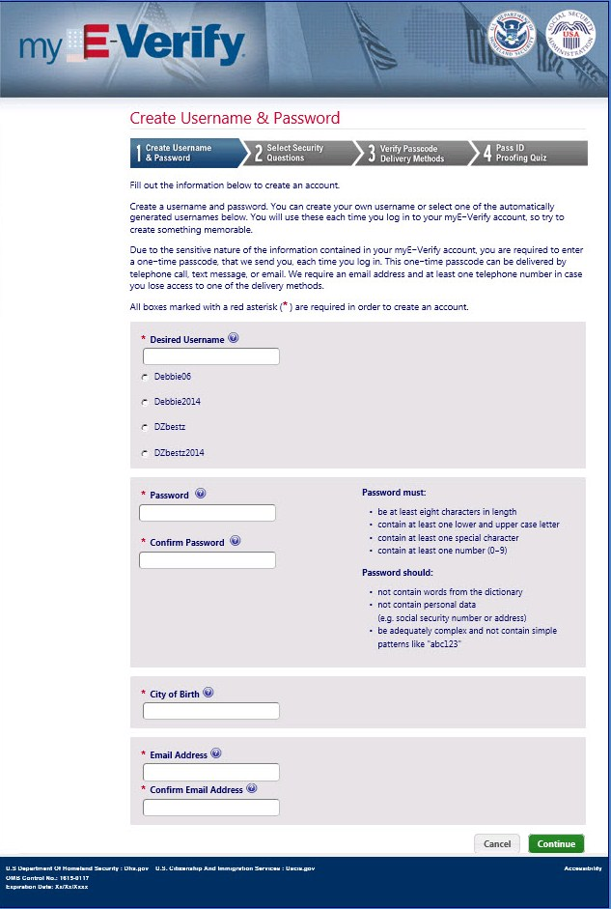
Paperwork Reduction Act

Wireframe 1.23 – Axiom Validation Error
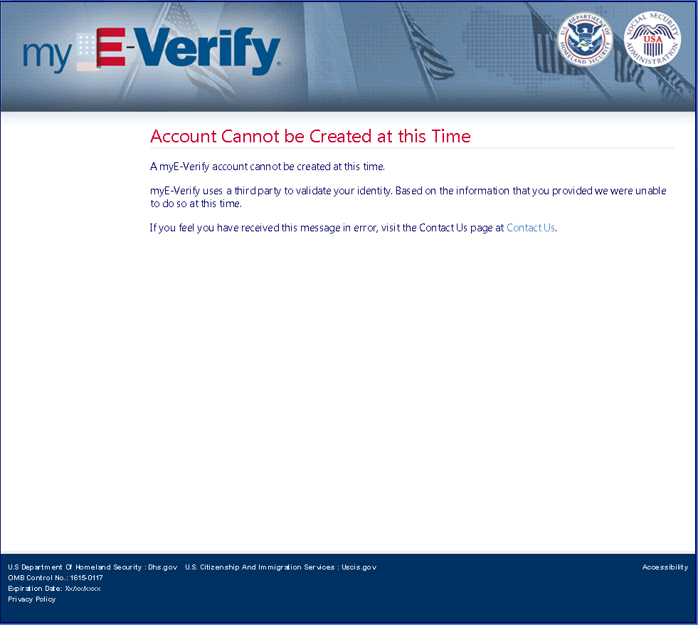
Paperwork Reduction Act

Wireframe 1.4 – Select Security Questions
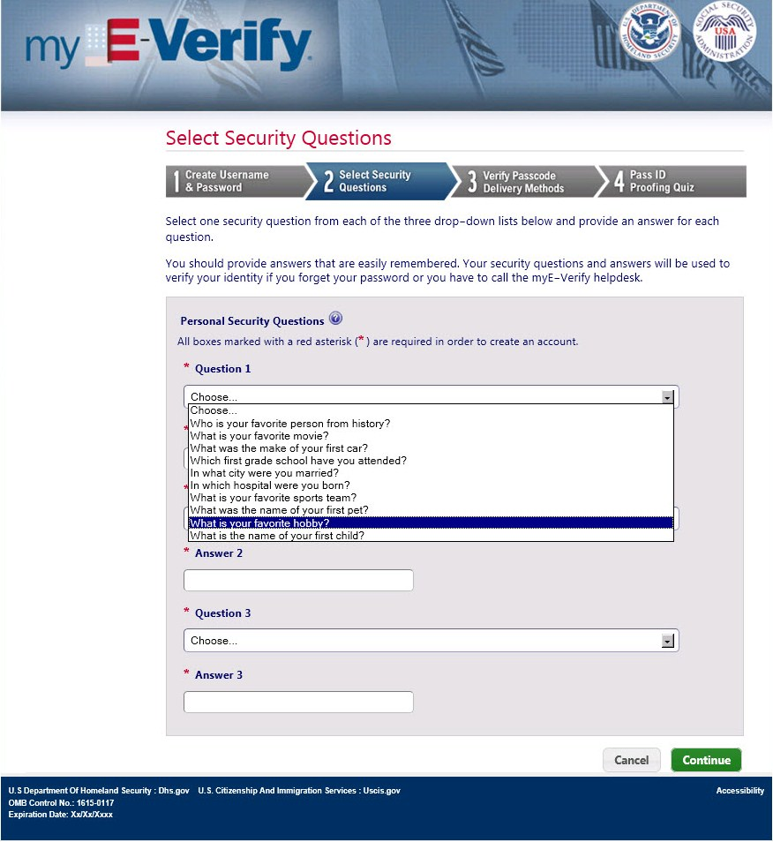
Paperwork Reduction Act

Wireframe 1.5 – Verify Passcode Delivery Methods
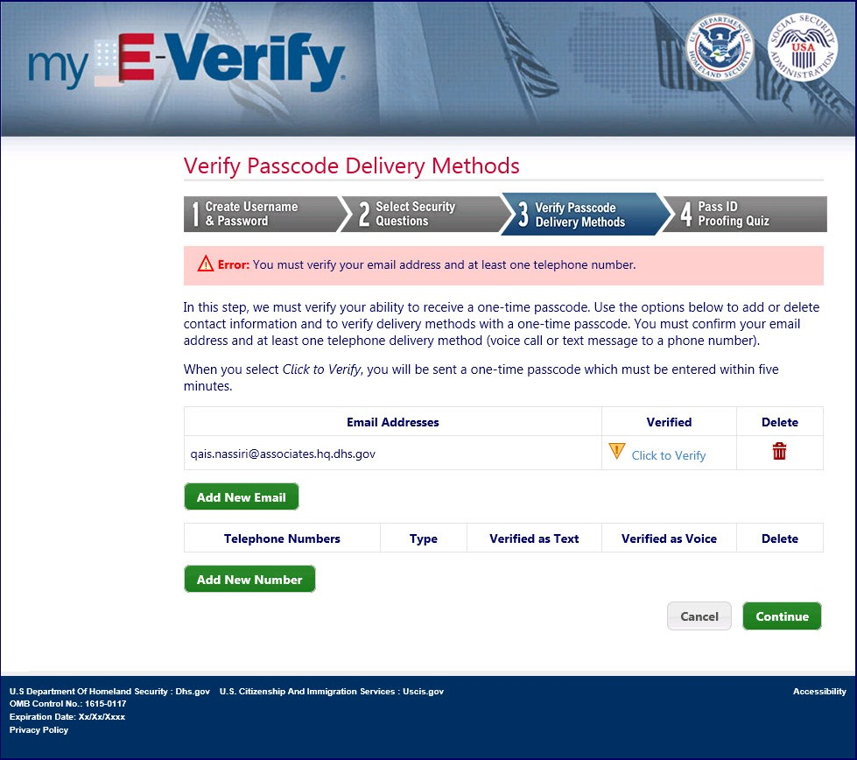
Paperwork Reduction Act

Wireframe 1.18 – Add Telephone (pop-up)
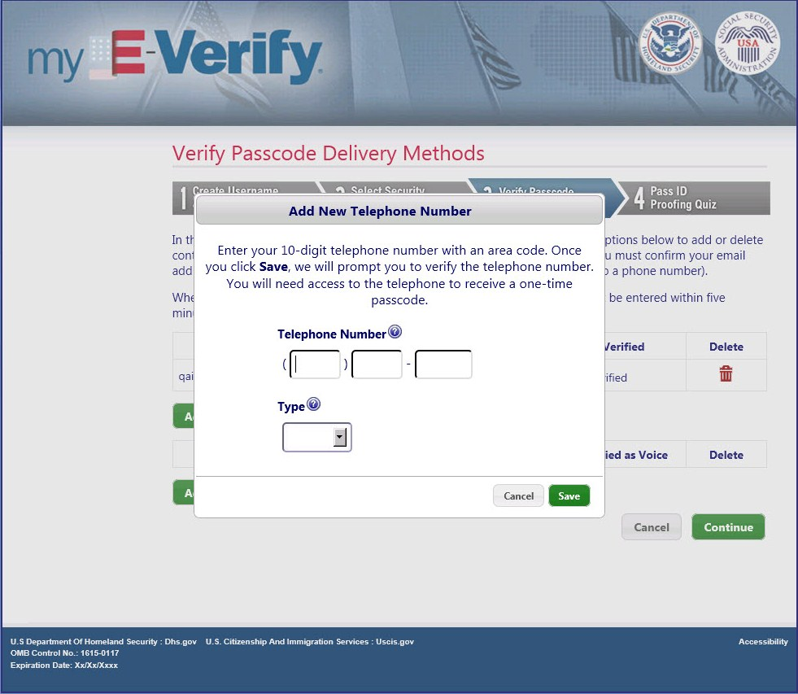
Paperwork Reduction Act

Wireframe 1.19 – Add Email Address (pop-up)
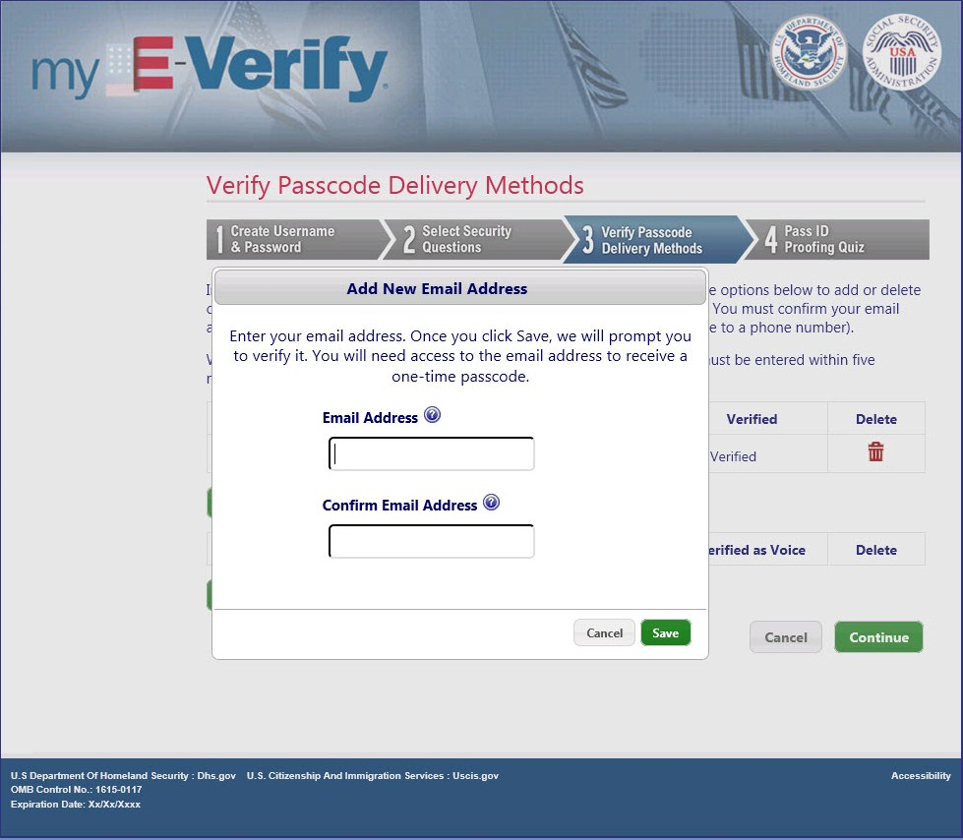
Paperwork Reduction Act

Wireframe 1.20 – Select Telephone Delivery Method (pop-up)
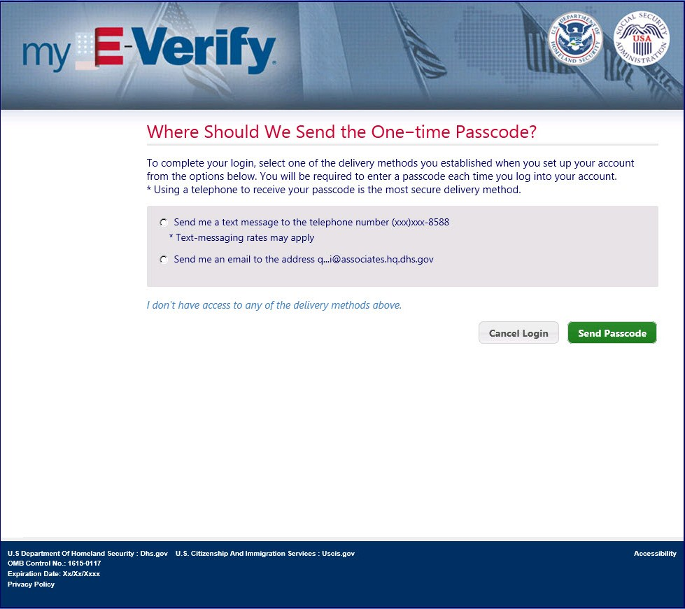
Paperwork Reduction Act

Wireframe 1.21 – Confirm Deletion (pop-up)
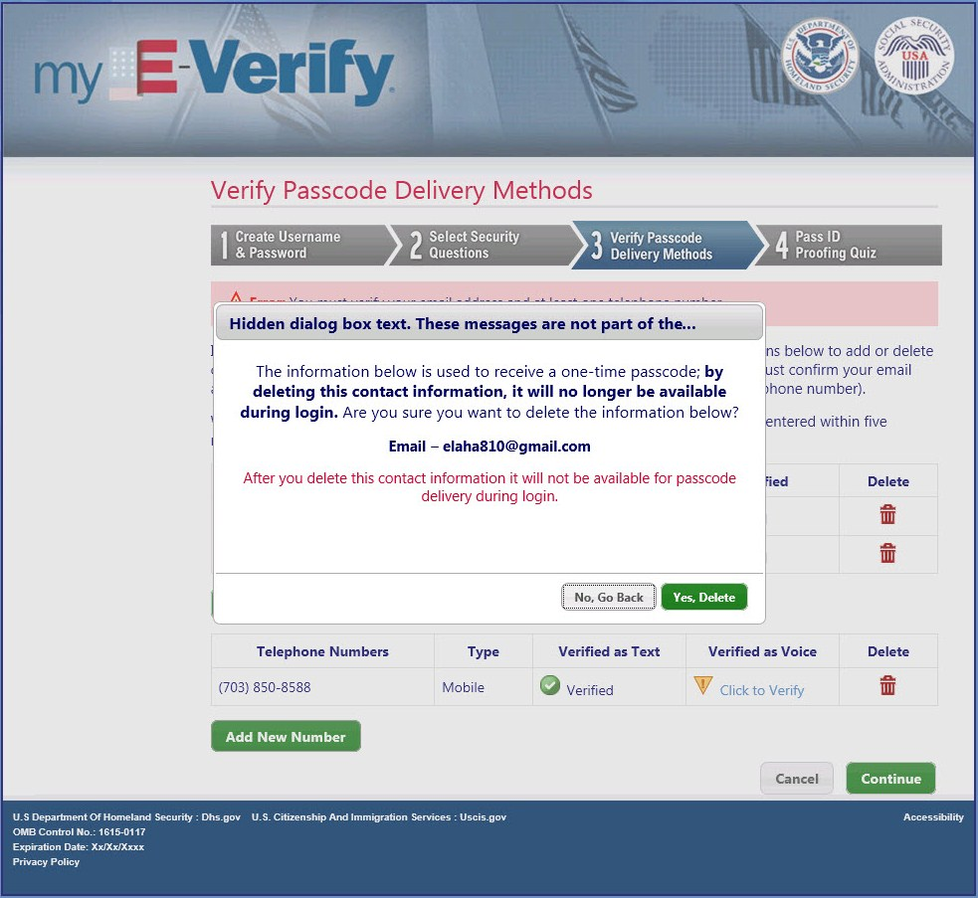
Paperwork Reduction Act

Wireframe 1.21 – Confirm Deletion (pop-up)
Paperwork Reduction Act

Wireframe 1.22 – Cannot Delete (pop-up)
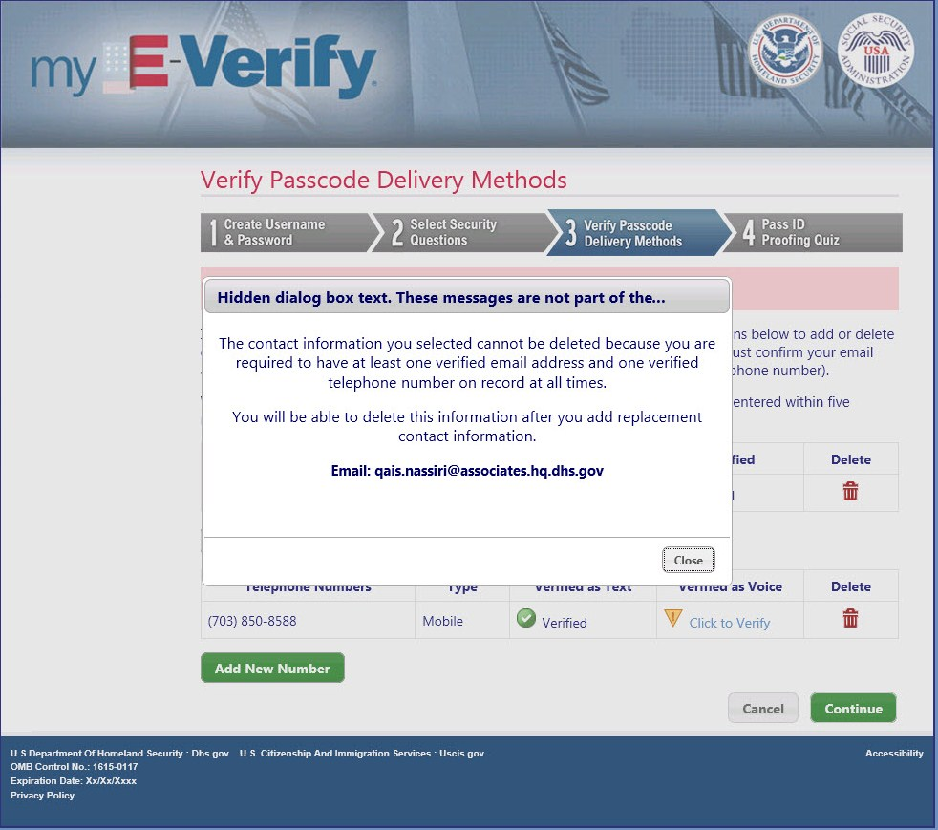
Paperwork Reduction Act

Wireframe 1.6 – Confirm Send
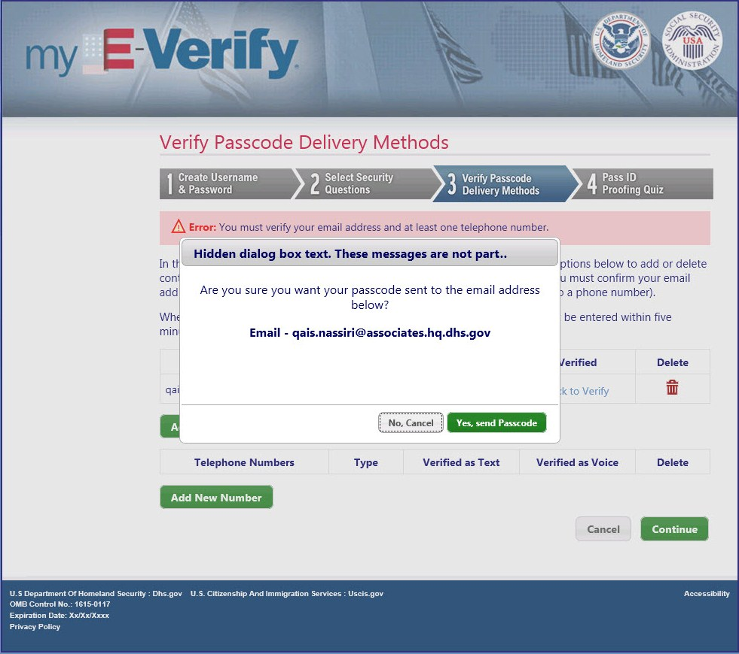
Paperwork Reduction Act

Wireframe 1.7 – Enter Passcode (pop-up)
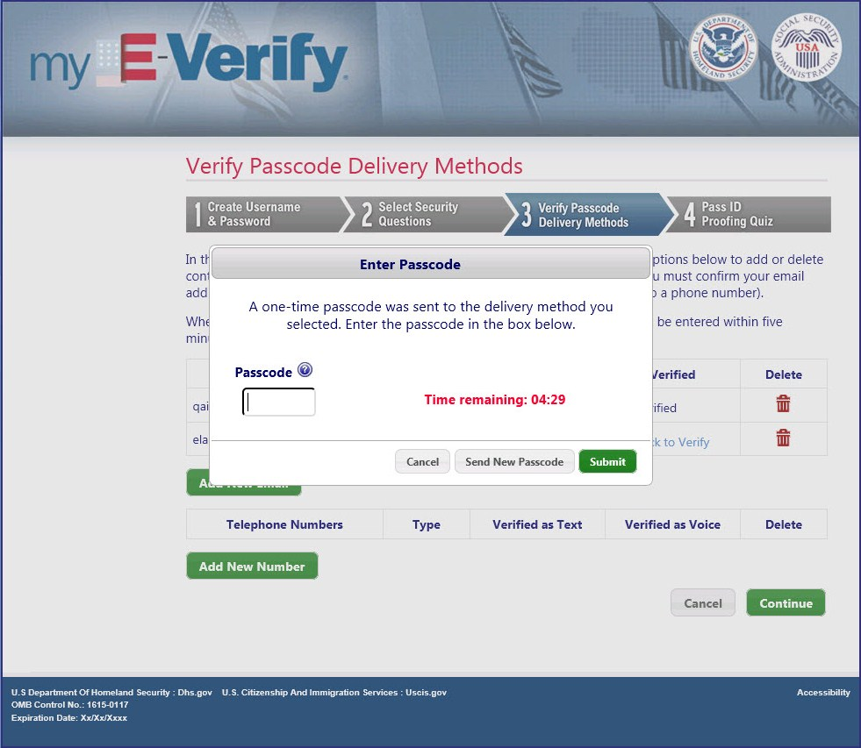
Paperwork Reduction Act

Wireframe 1.27 – Cancel Delivery Method (pop-up)
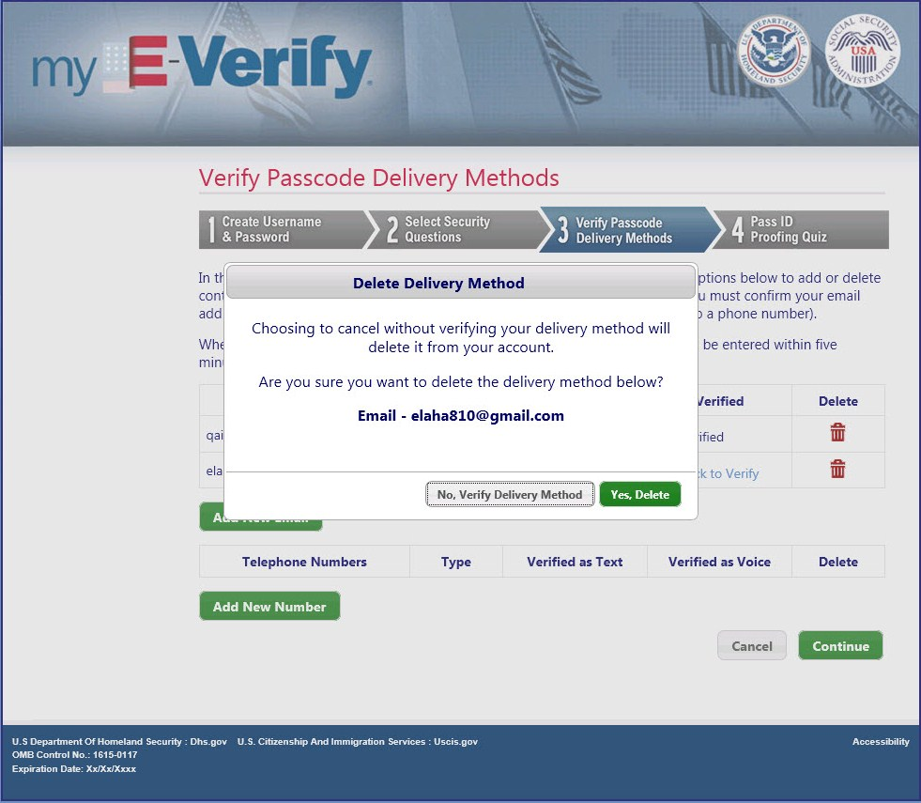
Paperwork Reduction Act

Wireframe 1.8 – ID Proofing Quiz Notice
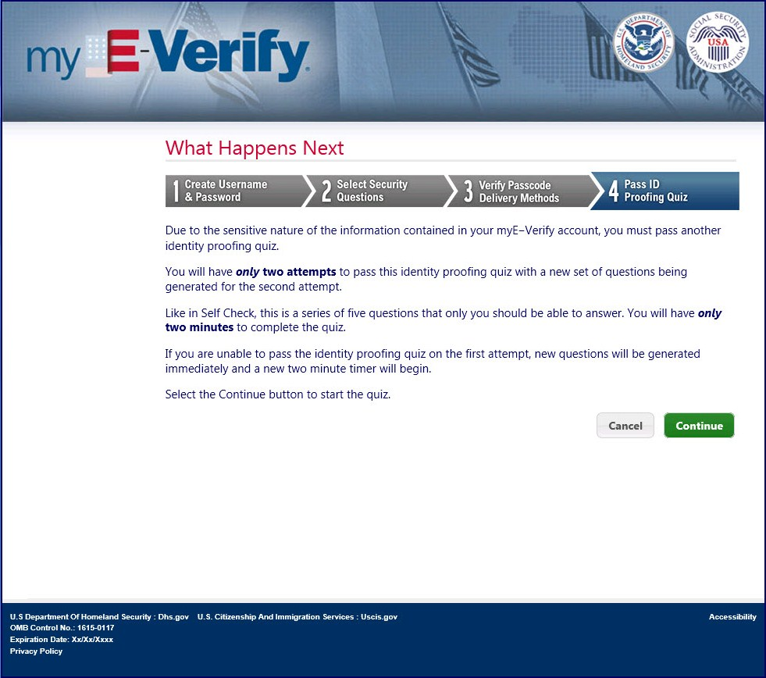
Paperwork Reduction Act

Wireframe 1.10 – ID Proofing Quiz
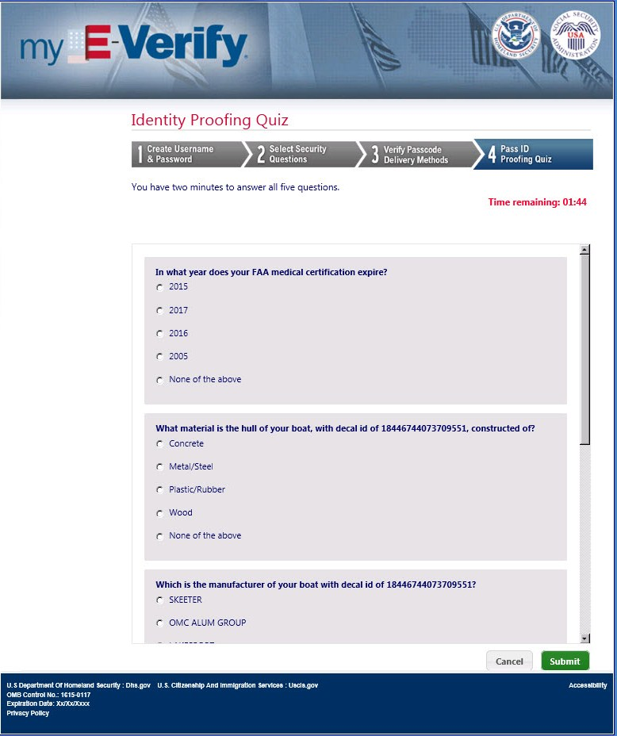
Paperwork Reduction Act

Wireframe 1.12 – Quiz Failed Twice
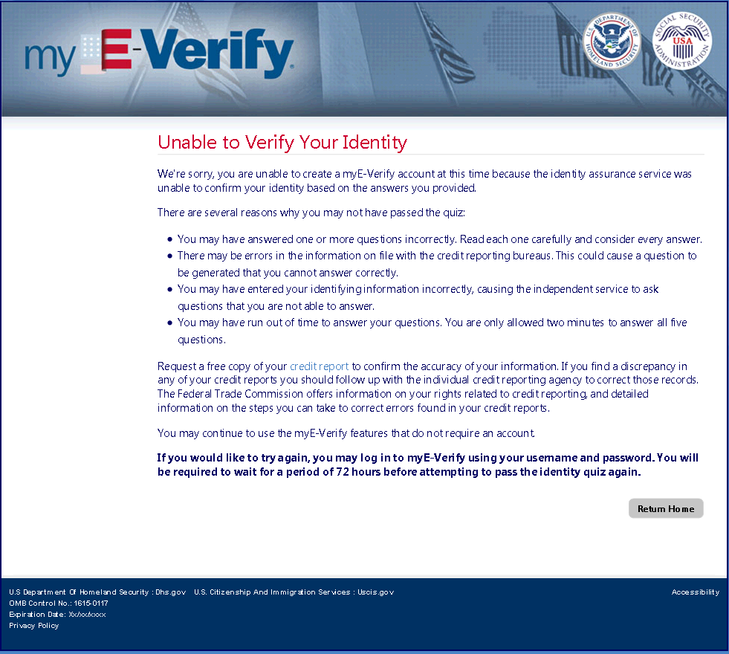
Paperwork Reduction Act

Wireframe 1.13 – Successful Account Creation
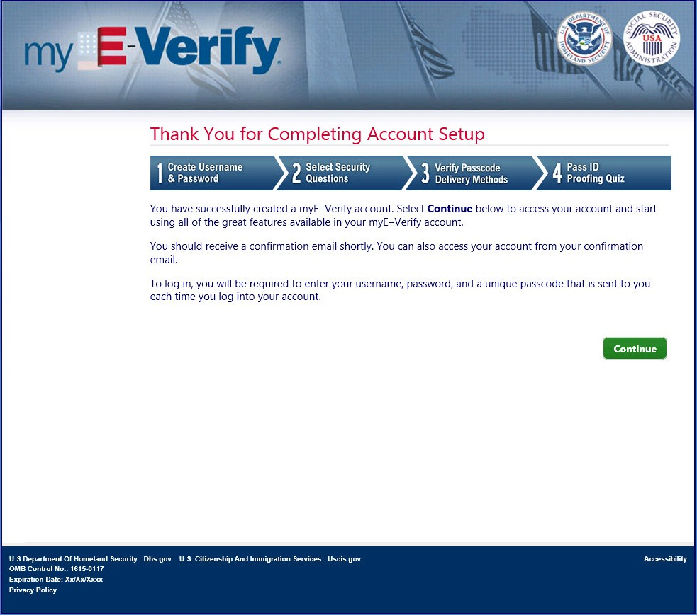
Paperwork Reduction Act

Wireframe 1.14 – Cancel Account Creation (pop-up)
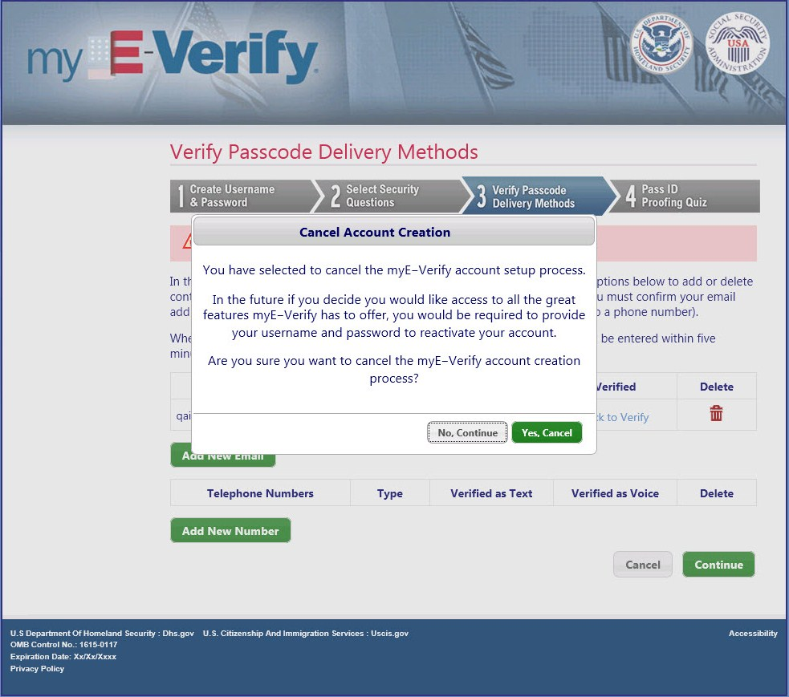
Paperwork Reduction Act

Wireframe 1.16 – Account Creation Canceled
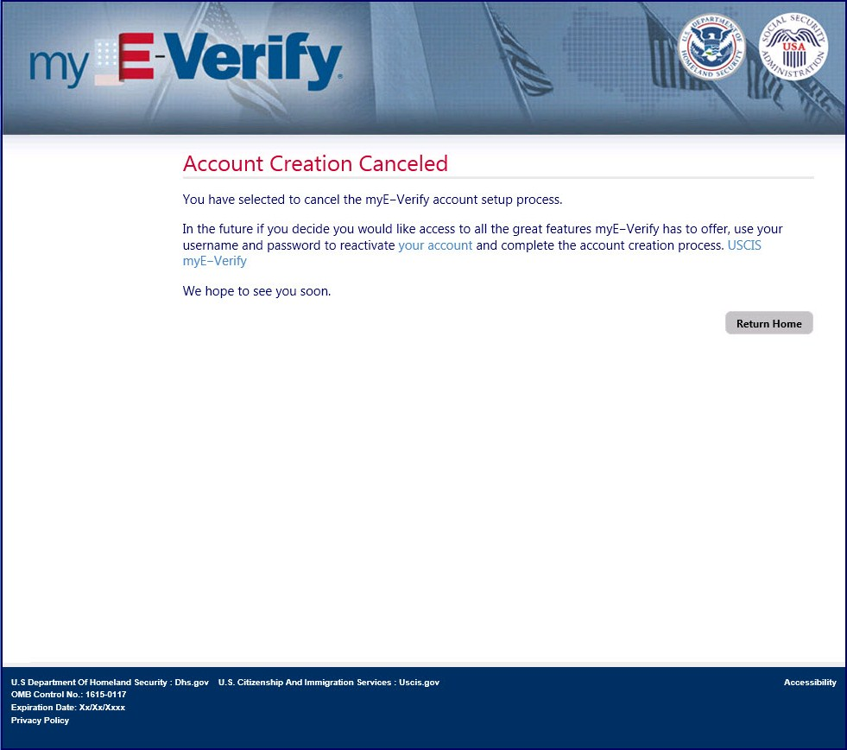
Paperwork Reduction Act

Wireframe 1.24 – Duplicate Account (SSN)
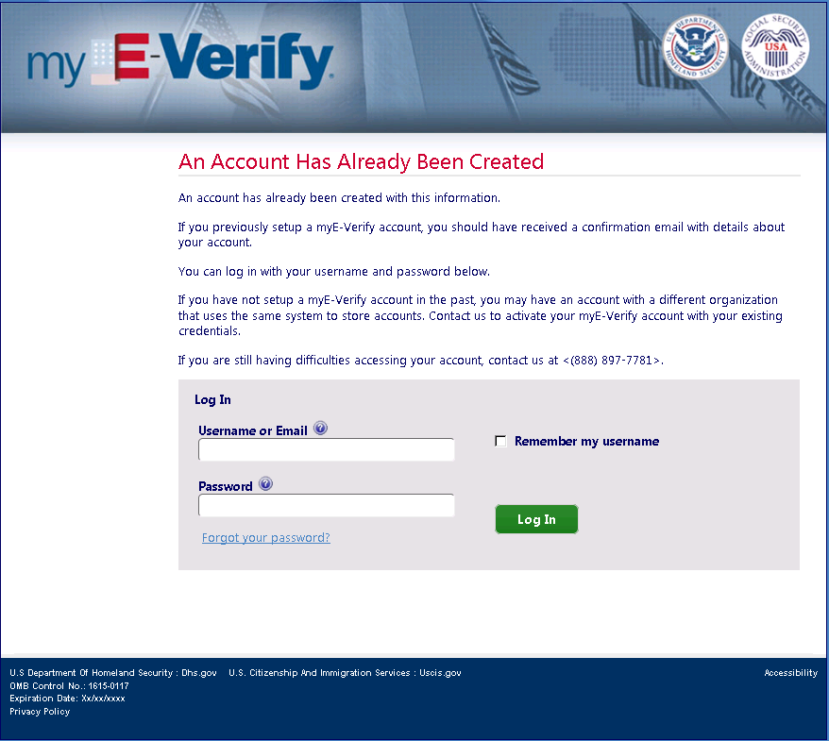
Paperwork Reduction Act

Wireframe 1.E.1 – Account Creation
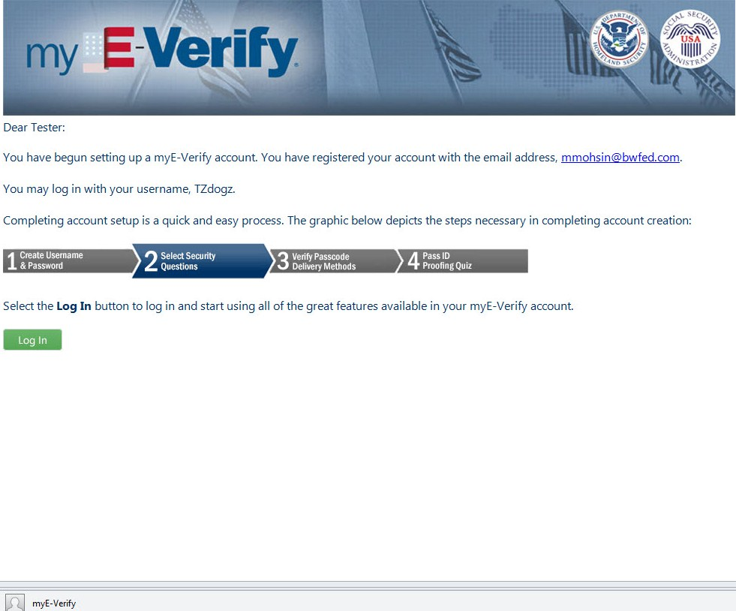

Wireframe 1.E.1 – Successful Account Creation
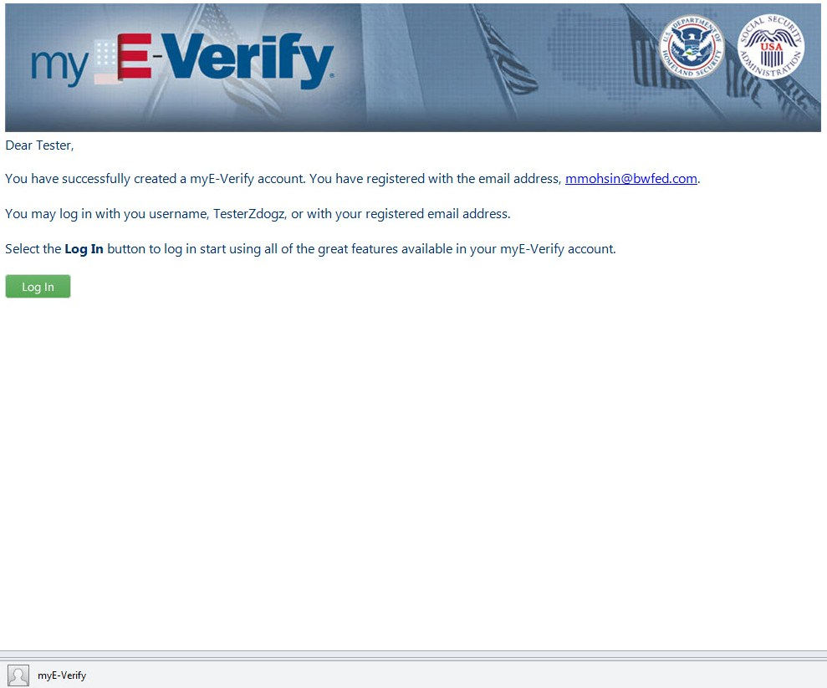

Wireframe 2.1 – myE-Verify Home Login Page (Not Logged In)
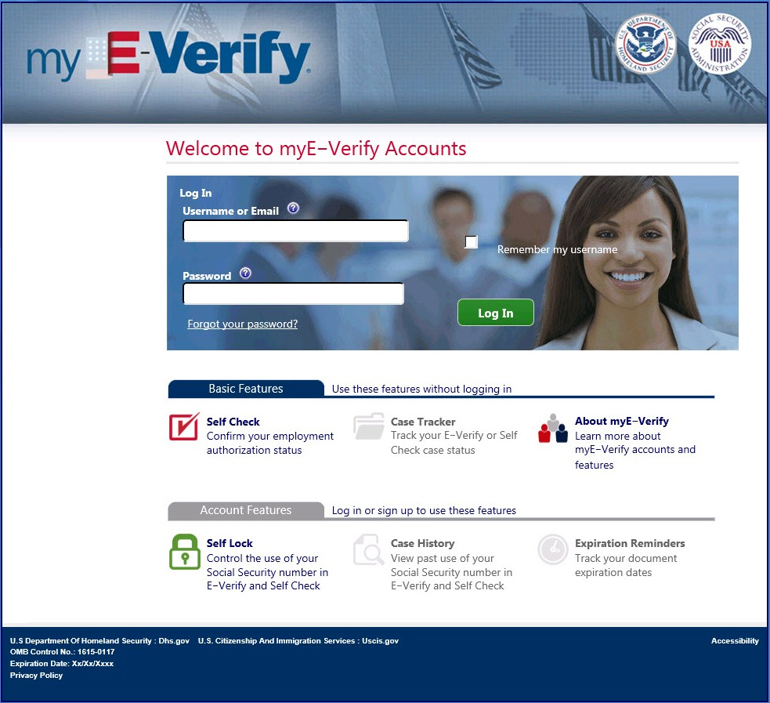
Paperwork Reduction Act

Wireframe 2.2 – Select Passcode Delivery Method
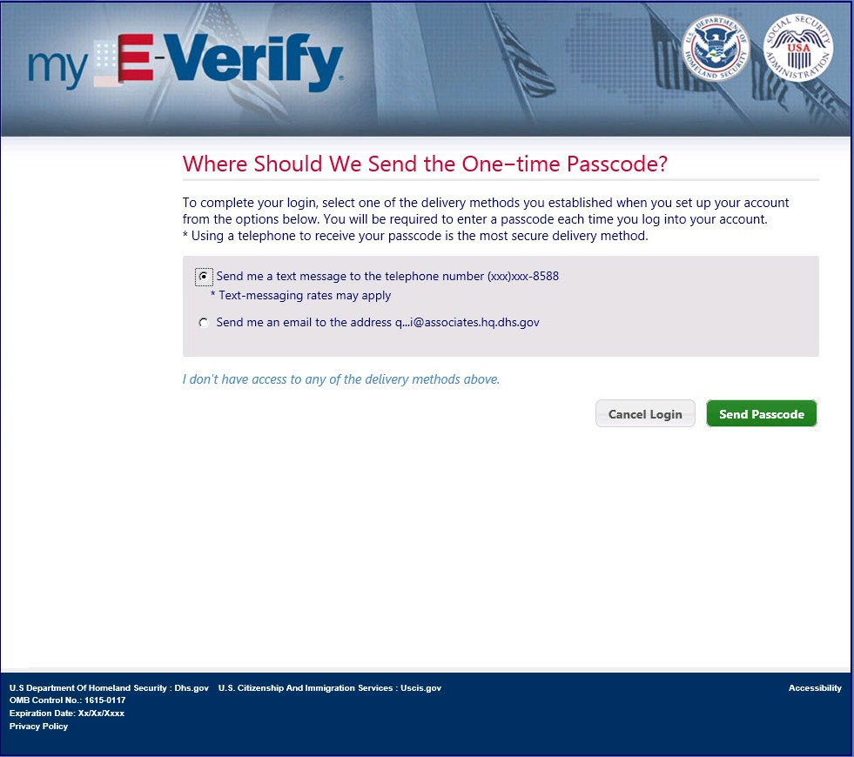
Paperwork Reduction Act

Wireframe 2.3 – Enter Passcode (pop-up)
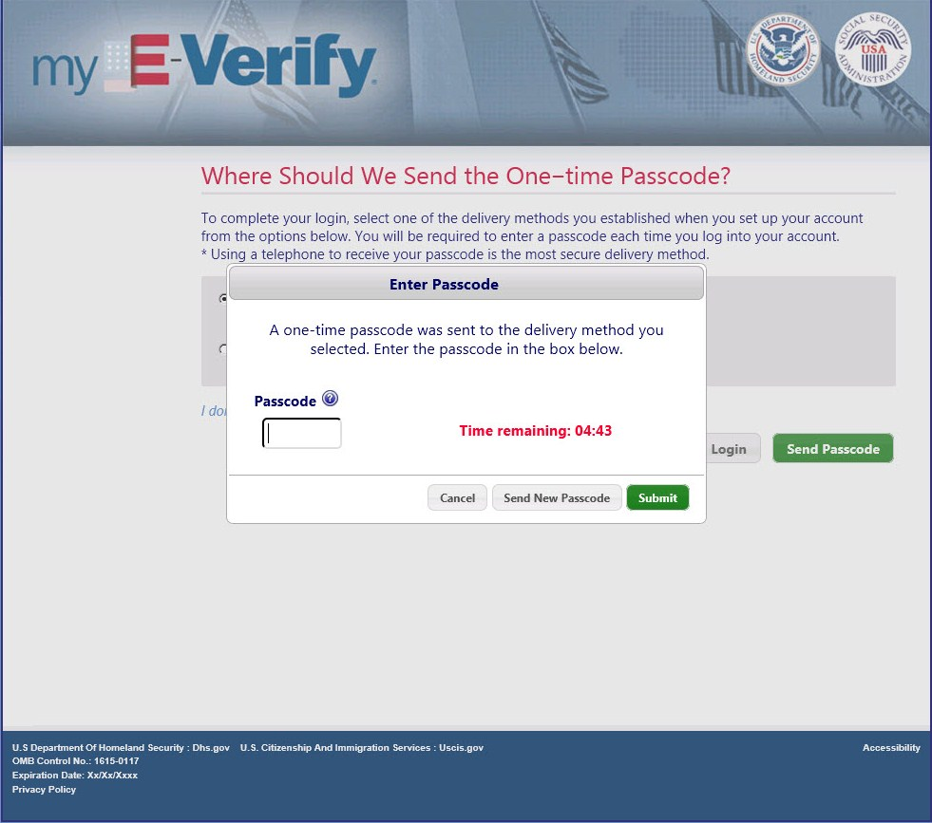
Paperwork Reduction Act

Wireframe 2.4A – Account Home (Full Accounts)
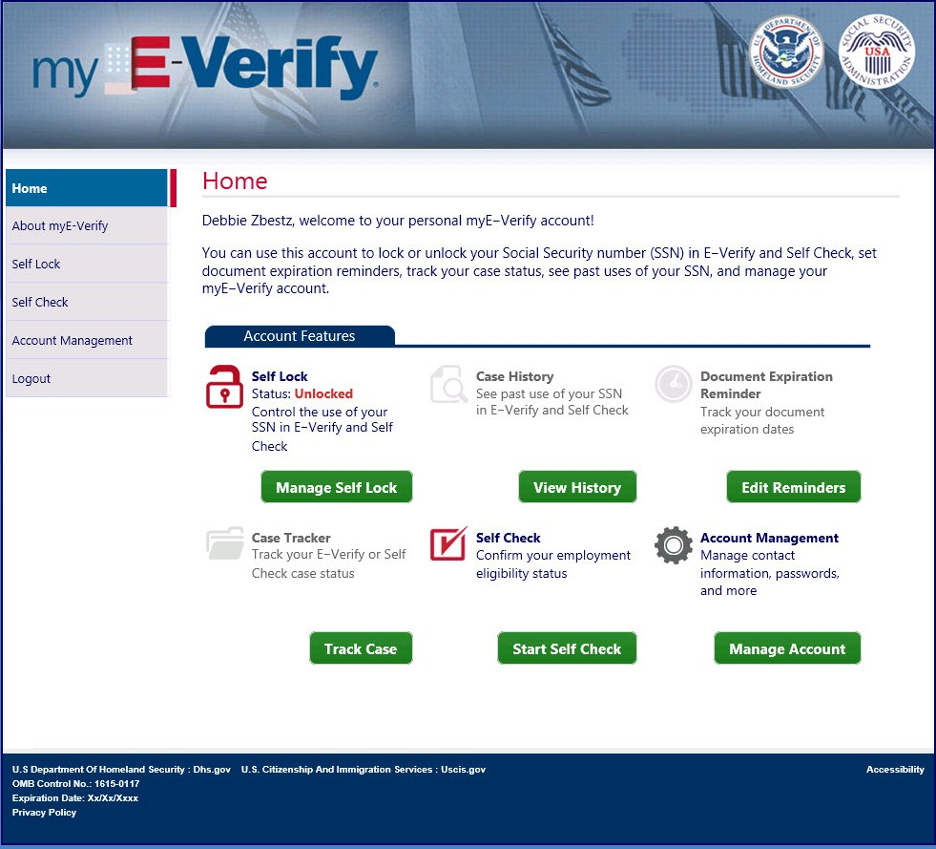
Paperwork Reduction Act

Wireframe 2.5 – Enter Username
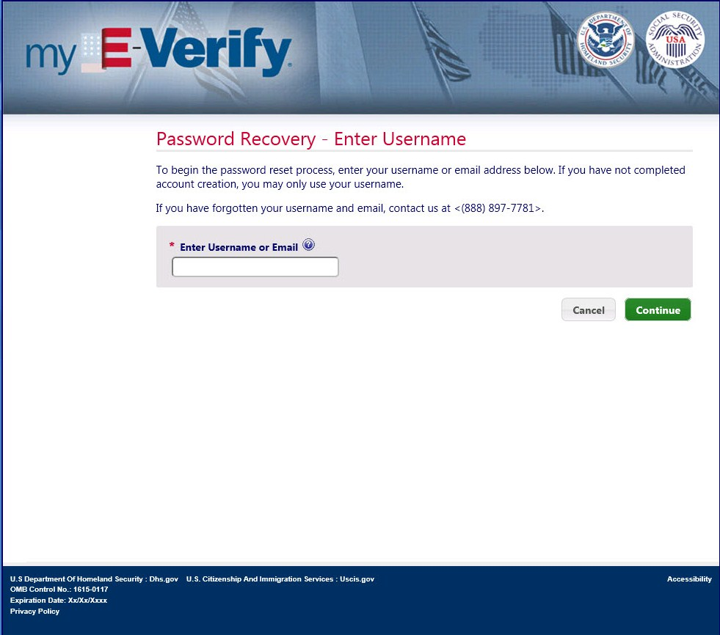
Paperwork Reduction Act

Wireframe 2.6 – Create New Password
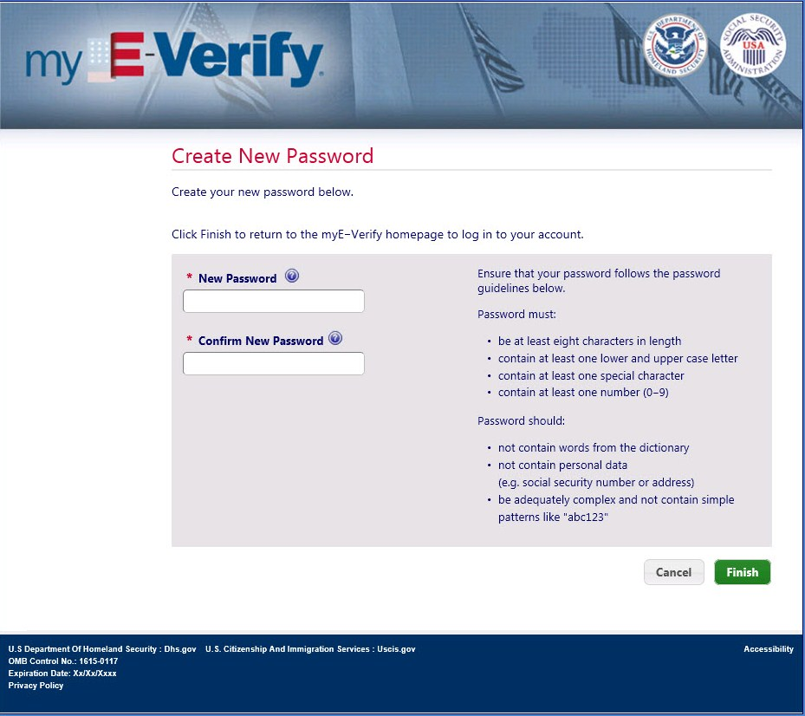
Paperwork Reduction Act

Wireframe 2.7 – Answer Security Questions
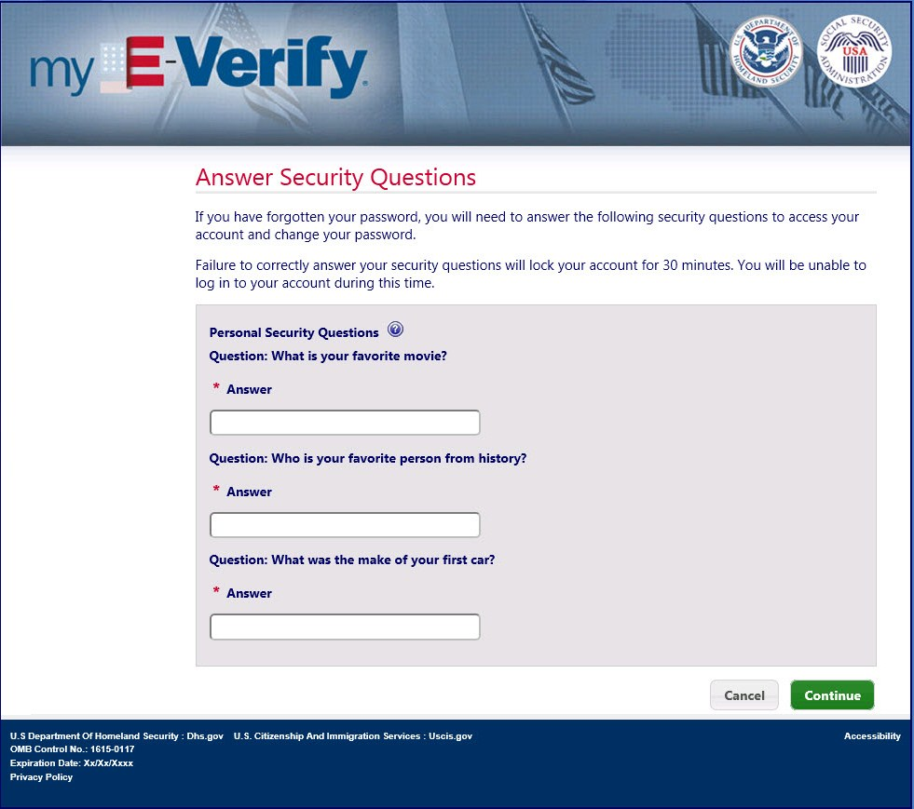
Paperwork Reduction Act

Wireframe 2.16 – Account Locked
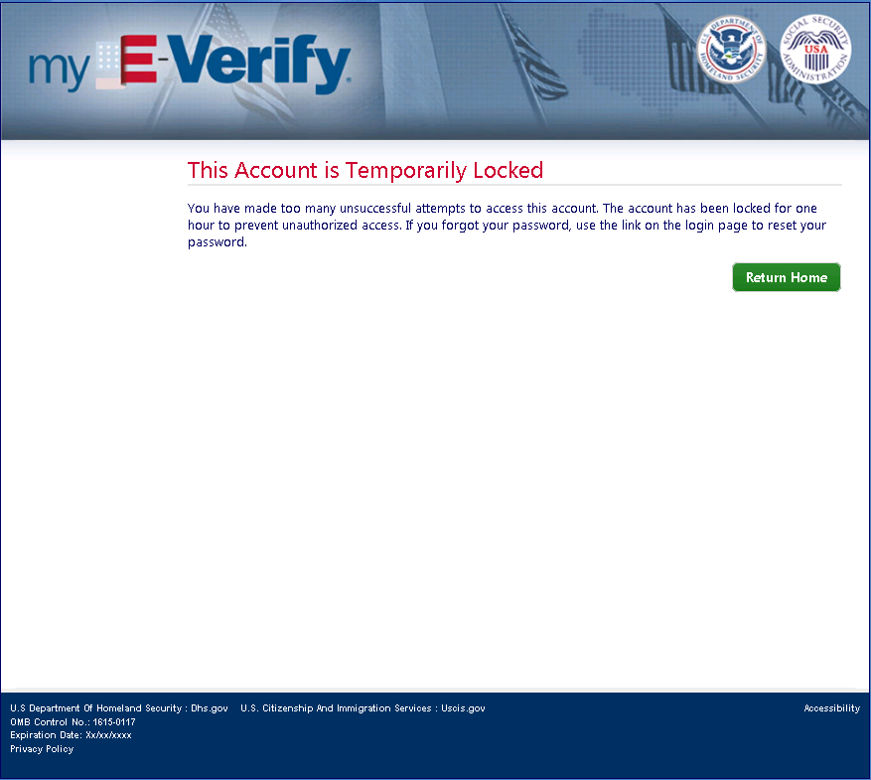
Paperwork Reduction Act

Wireframe 2.17 – Self Lock Info (pop-up)
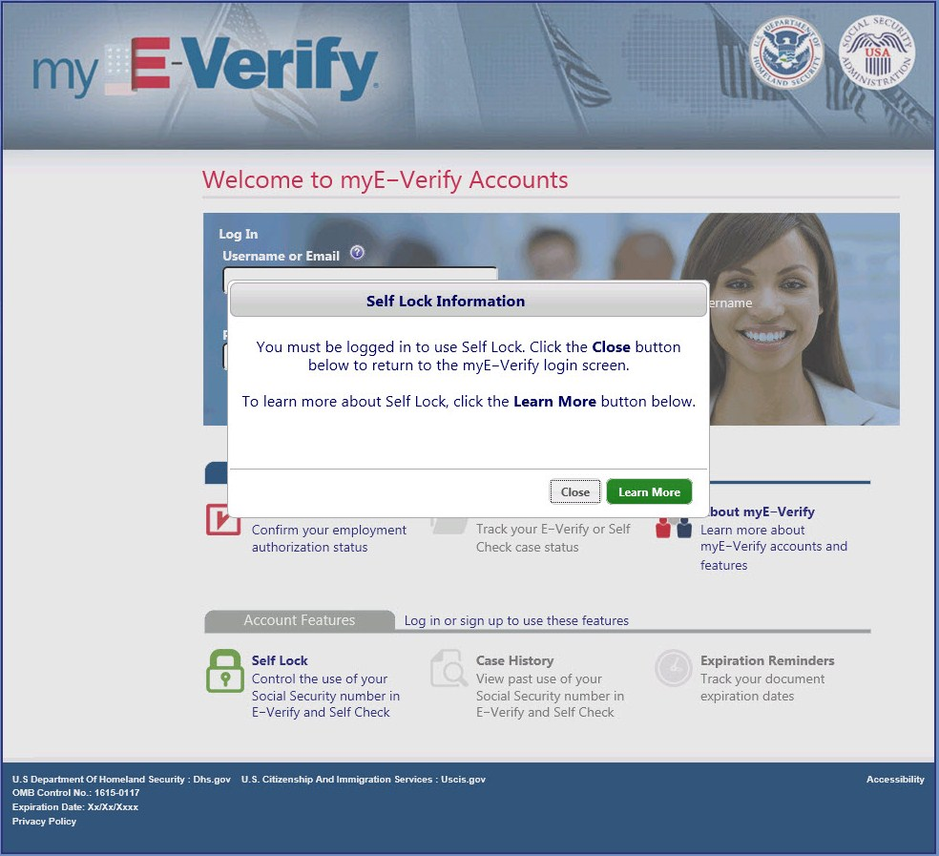
Paperwork Reduction Act

Wireframe 2.20 – Call Helpdesk
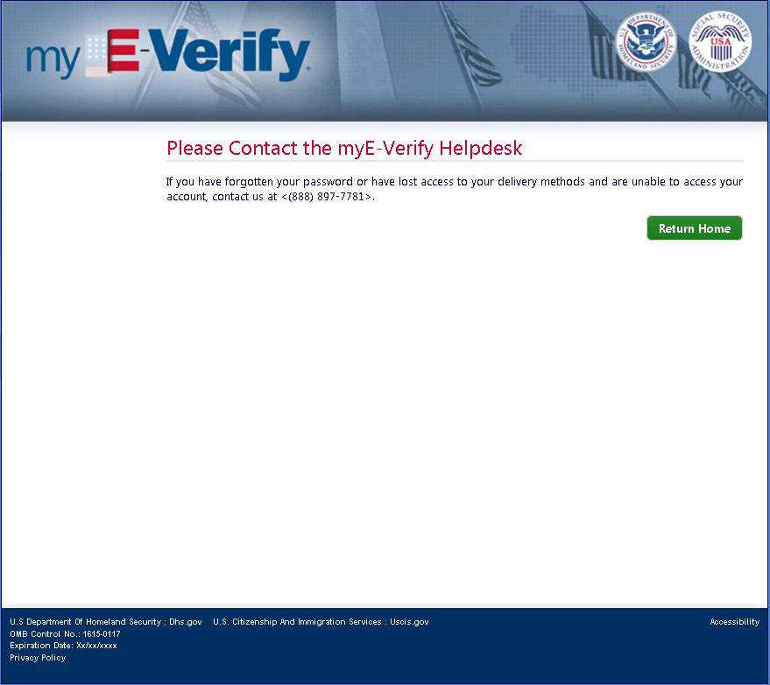
Paperwork Reduction Act

Wireframe 2.21 – Duplicate Account Transition (Self Check)
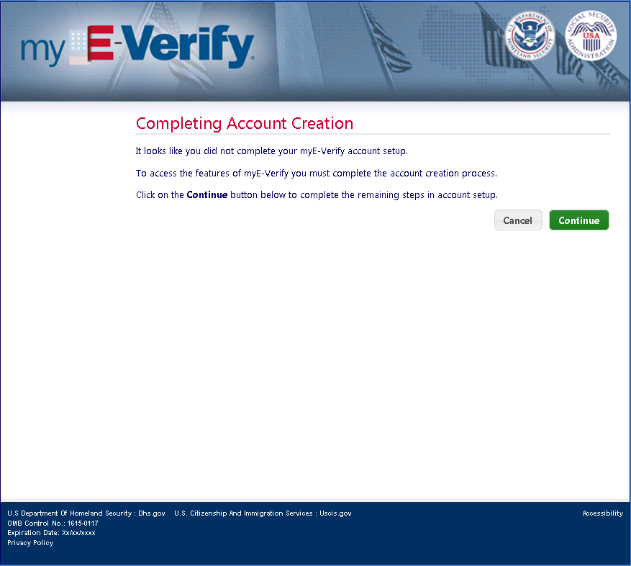
Paperwork Reduction Act

Wireframe 2.22 – SSN & DOB Entry (Direct Login)
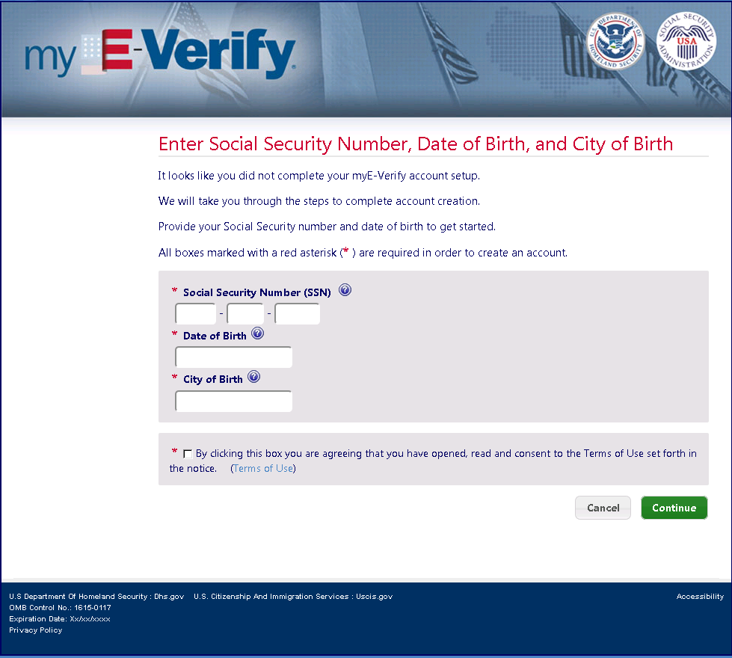
Paperwork Reduction Act

Wireframe 2.23 – myE-Verify Home (Not Logged In)
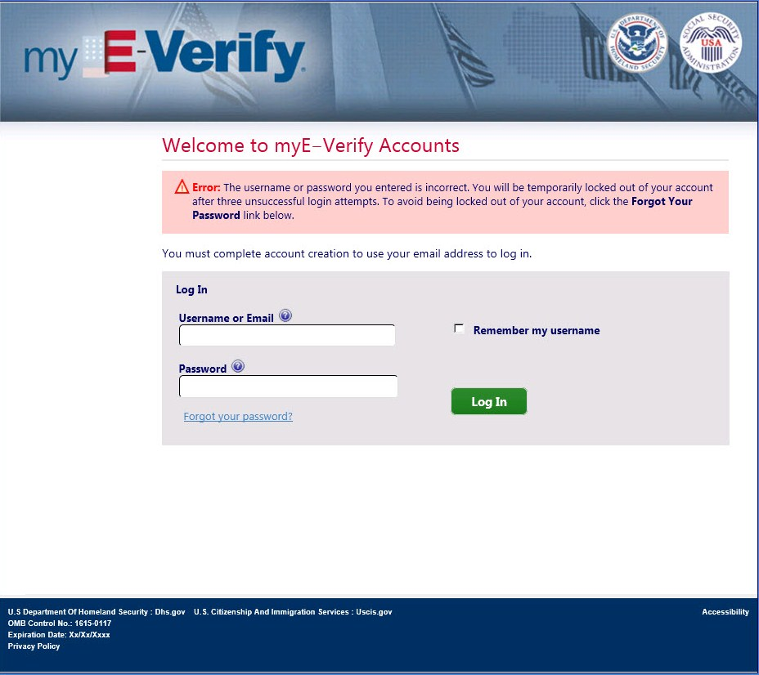
Paperwork Reduction Act

Wireframe 3.1 – Account Management Home
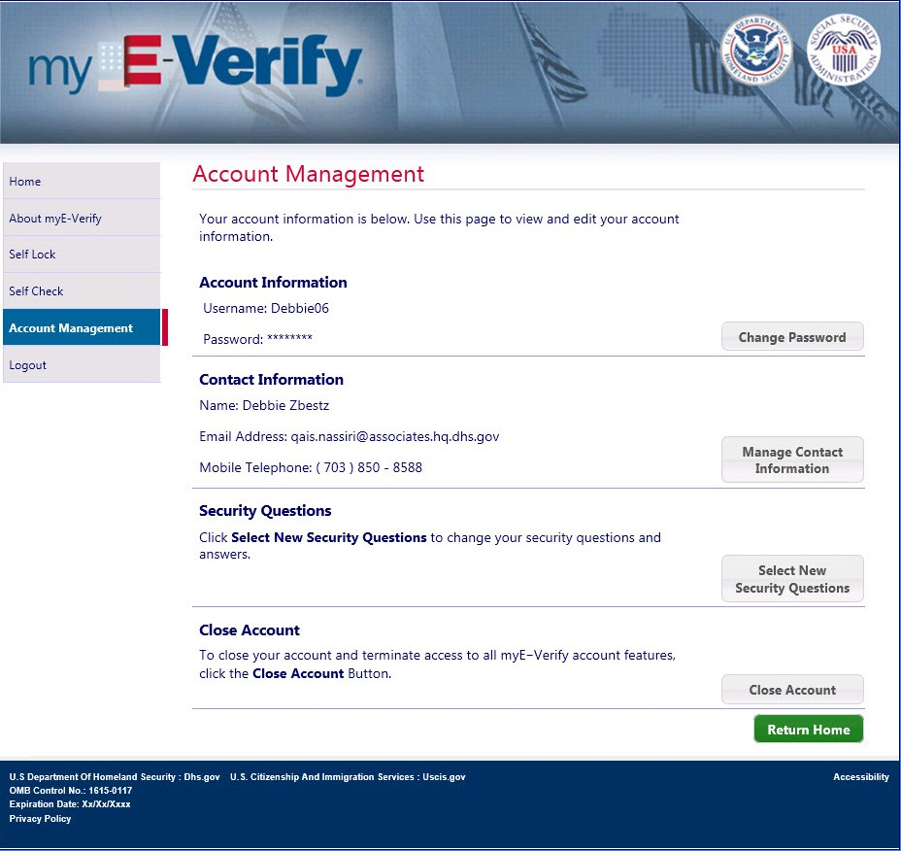
Paperwork Reduction Act

Wireframe 3.2 – Change Password
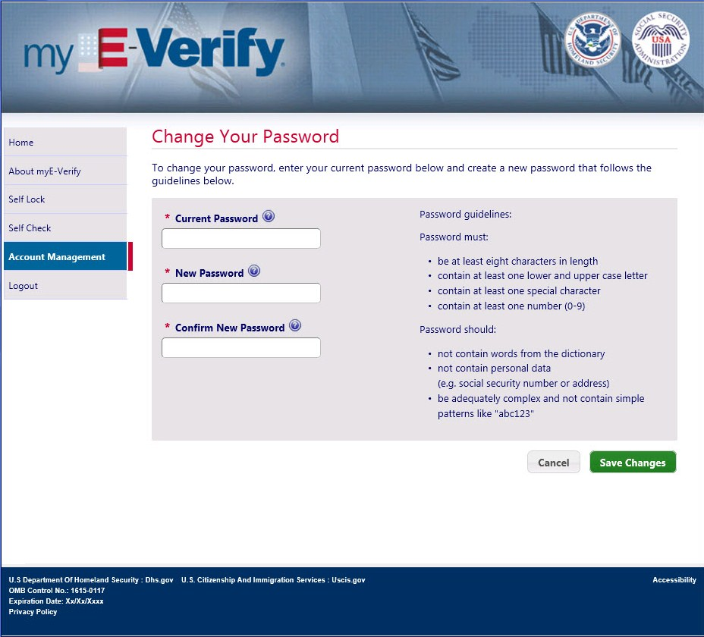
Paperwork Reduction Act

Wireframe 3.3 – Manage Contact Information
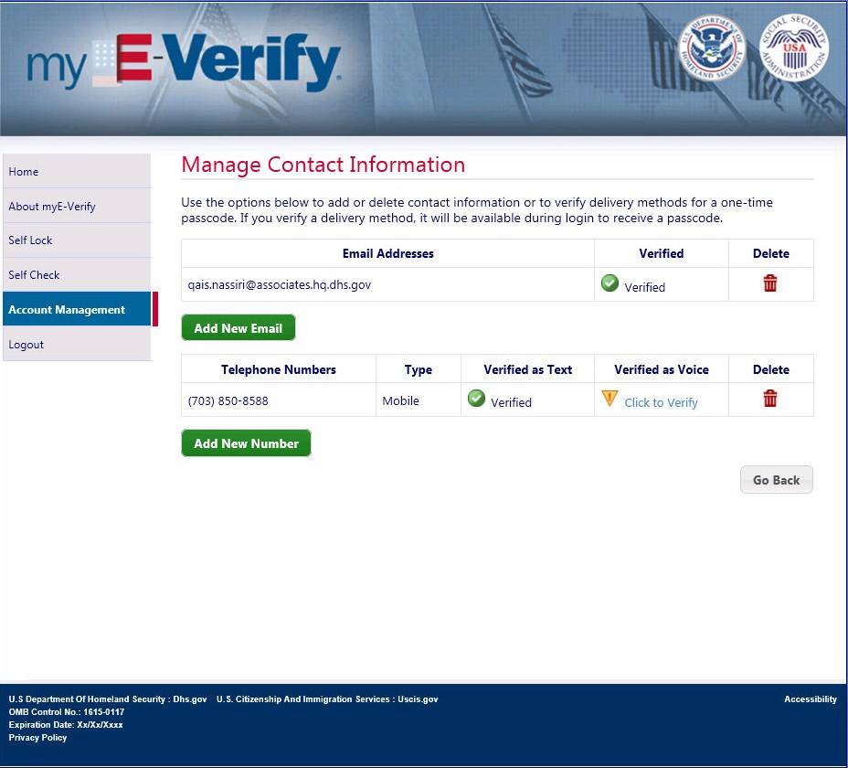
Paperwork Reduction Act

Wireframe 3.4 – Add New Telephone Number
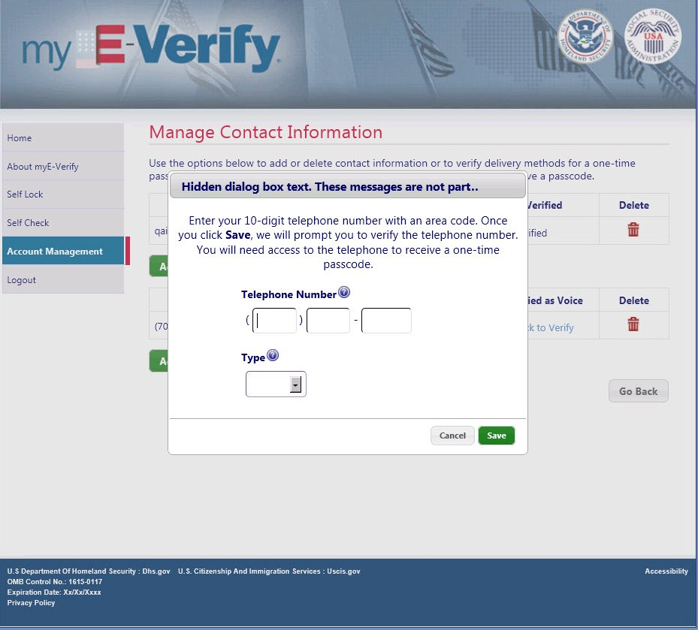
Paperwork Reduction Act

Wireframe 3.5 – Add New Email Address
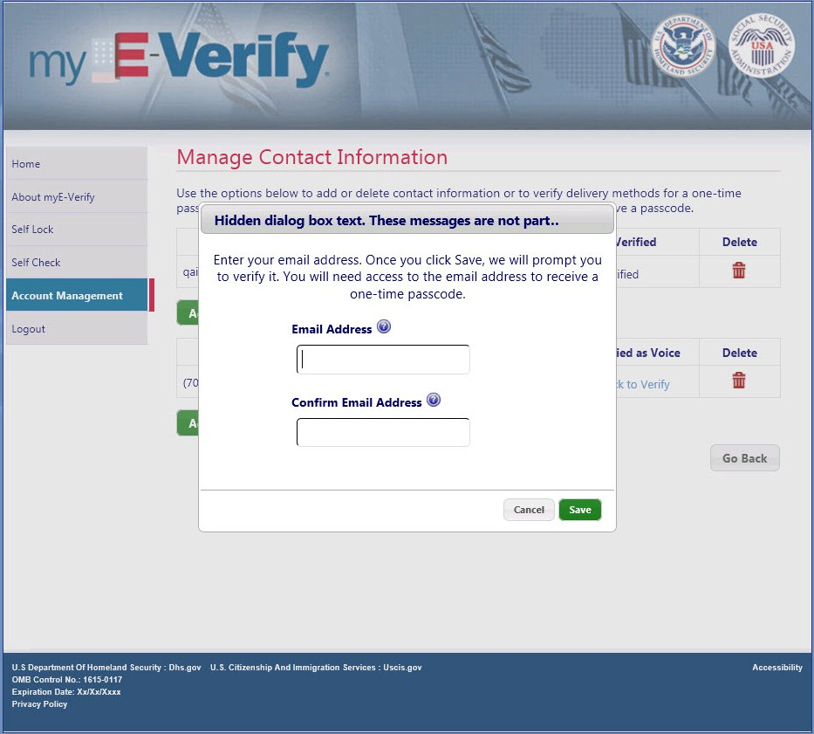
Paperwork Reduction Act

Wireframe 3.6 – Select Telephone Delivery Method (pop-up)
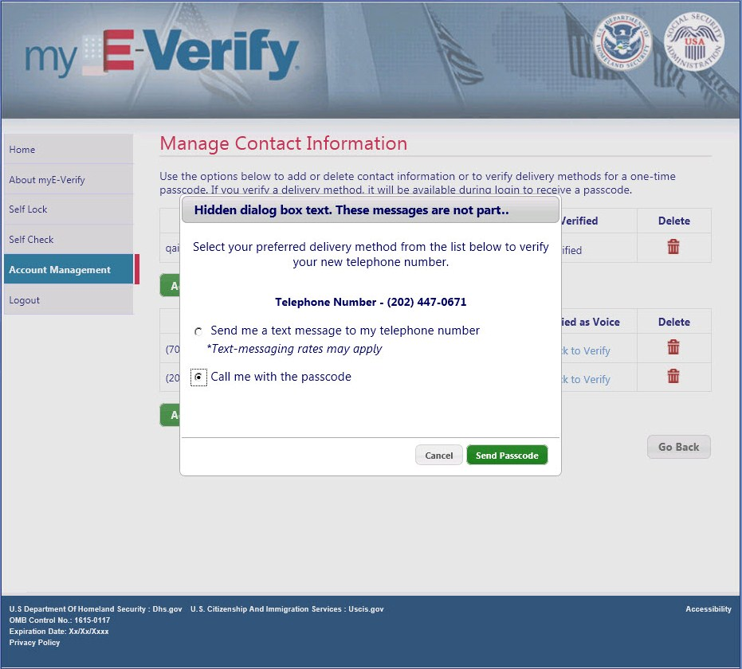
Paperwork Reduction Act

Wireframe 3.7 – Confirm Deletion (pop-up)
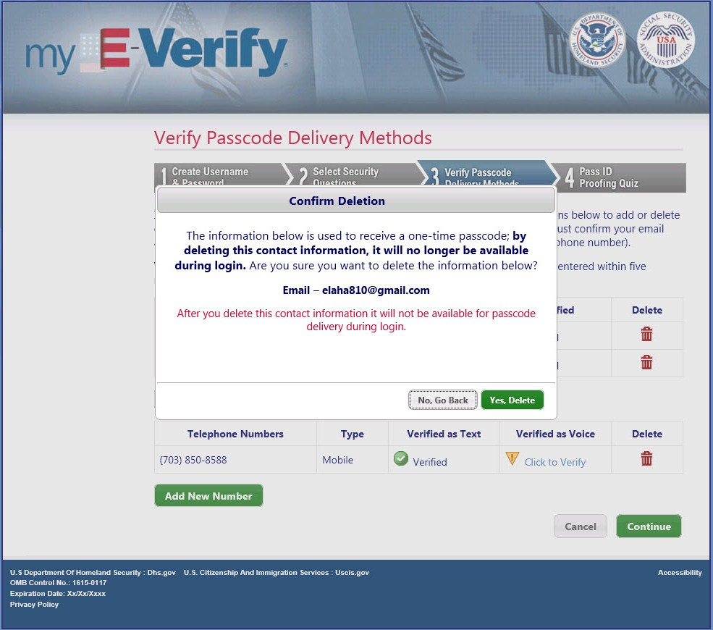
Paperwork Reduction Act

Wireframe 3.8 – Cannot Delete (pop-up)
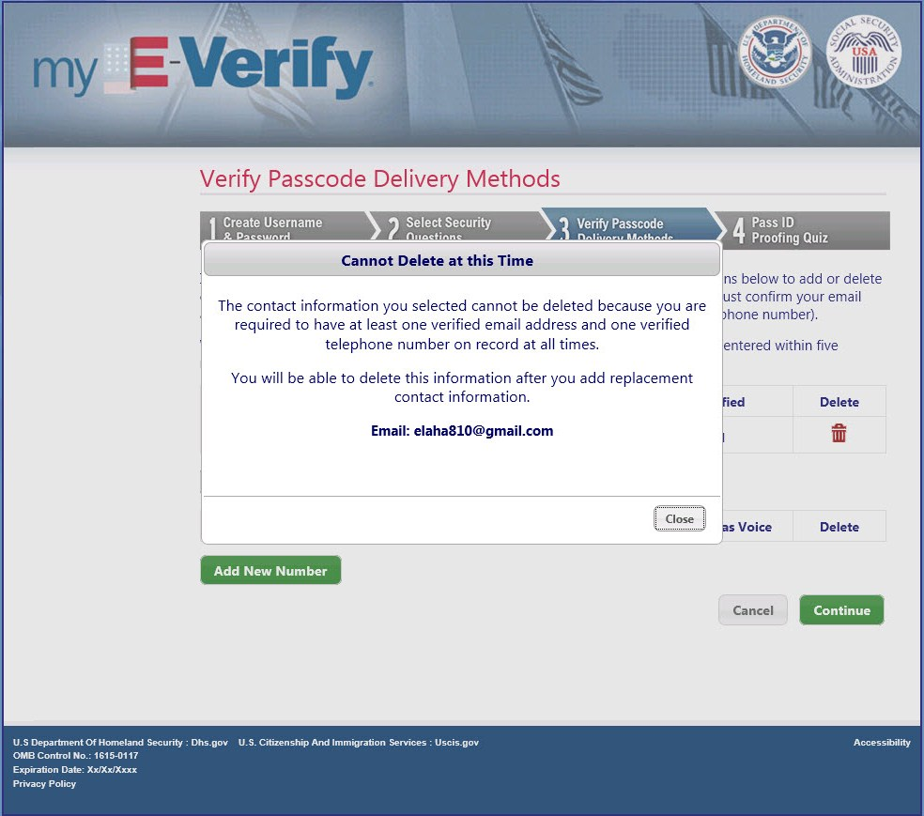
Paperwork Reduction Act

Wireframe 3.9 – Confirm Send (pop-up)
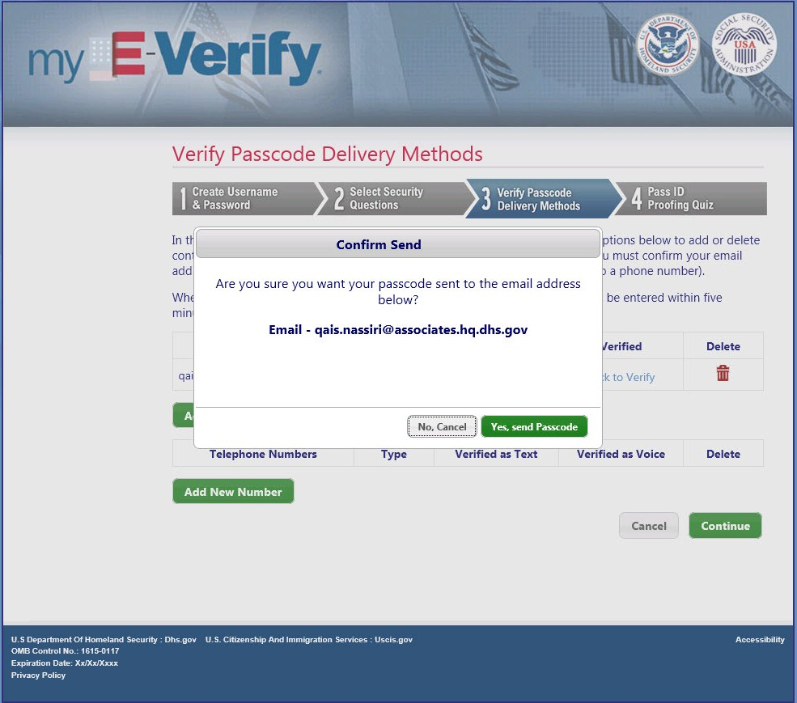
Paperwork Reduction Act
Wireframe 3.10 – Enter Passcode (pop-up)
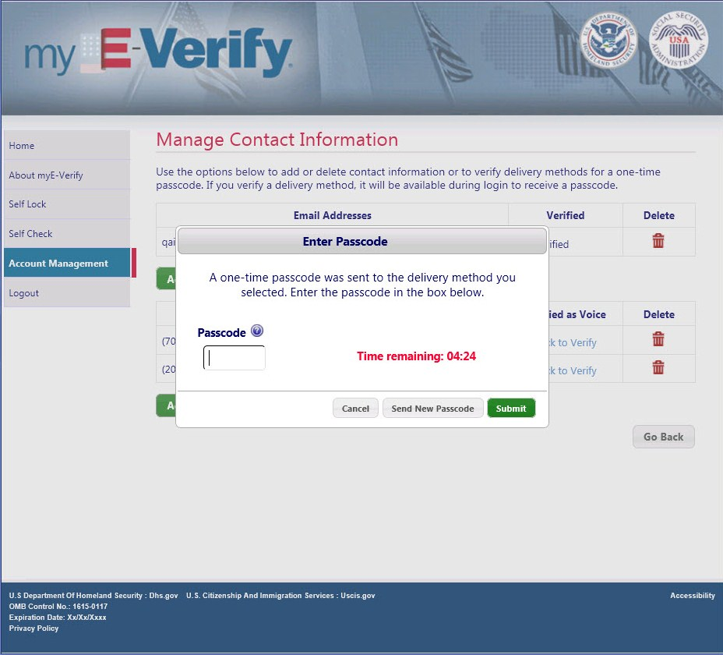
Paperwork Reduction Act

Wireframe 3.16 – Cancel Delivery Method (pop-up)
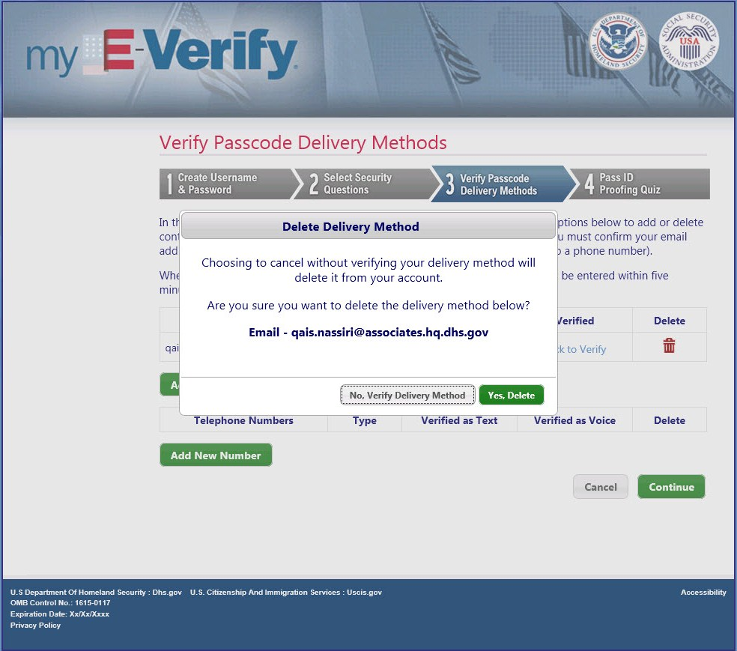
Paperwork Reduction Act

Wireframe 3.11 – Select New Security Questions
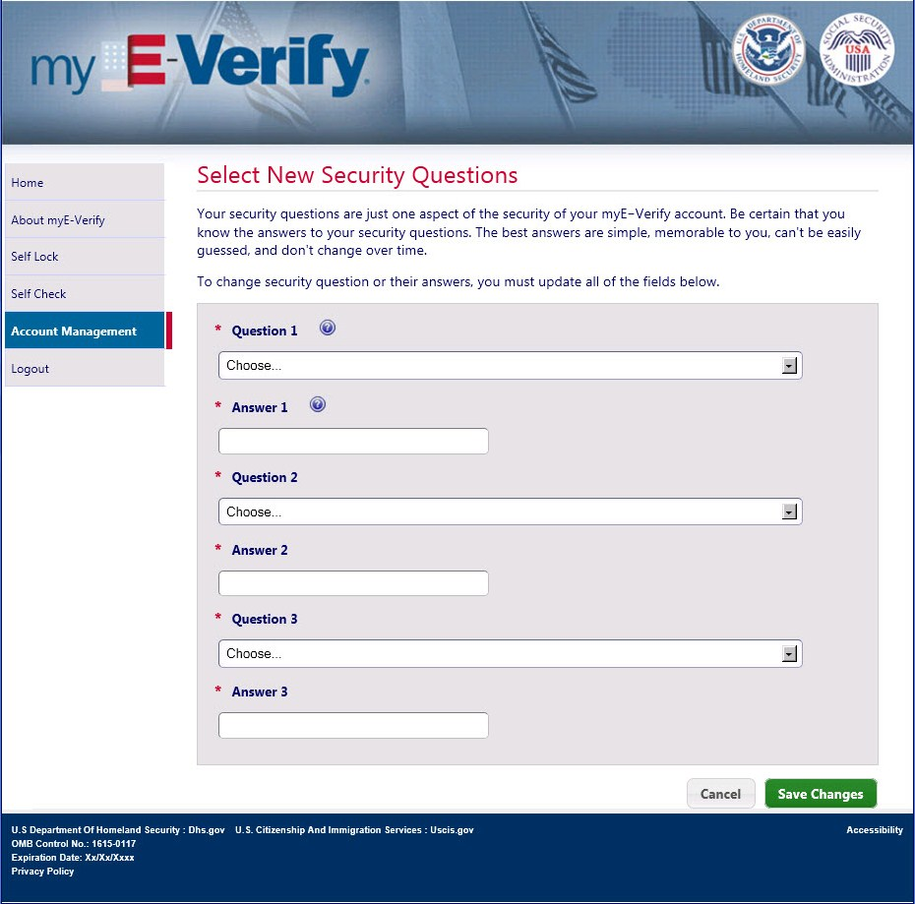
Paperwork Reduction Act

Wireframe 3.12 – Close Account
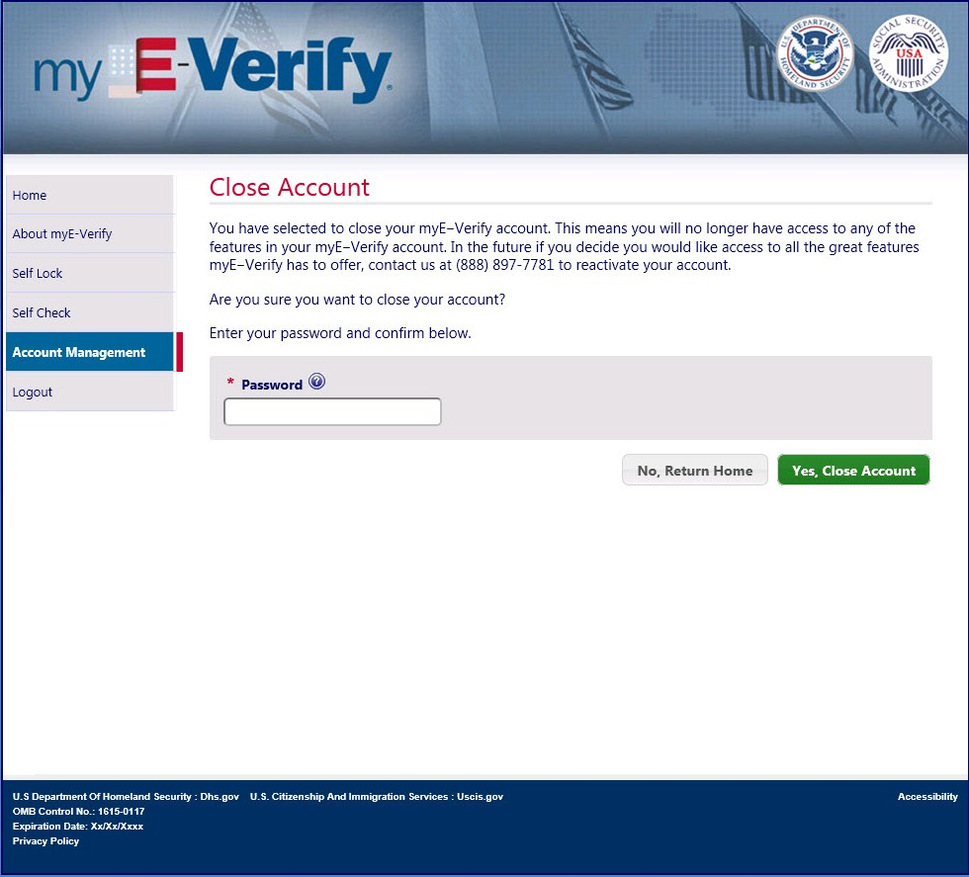
Paperwork Reduction Act

Wireframe 3.13 – Acknowledgement of Close
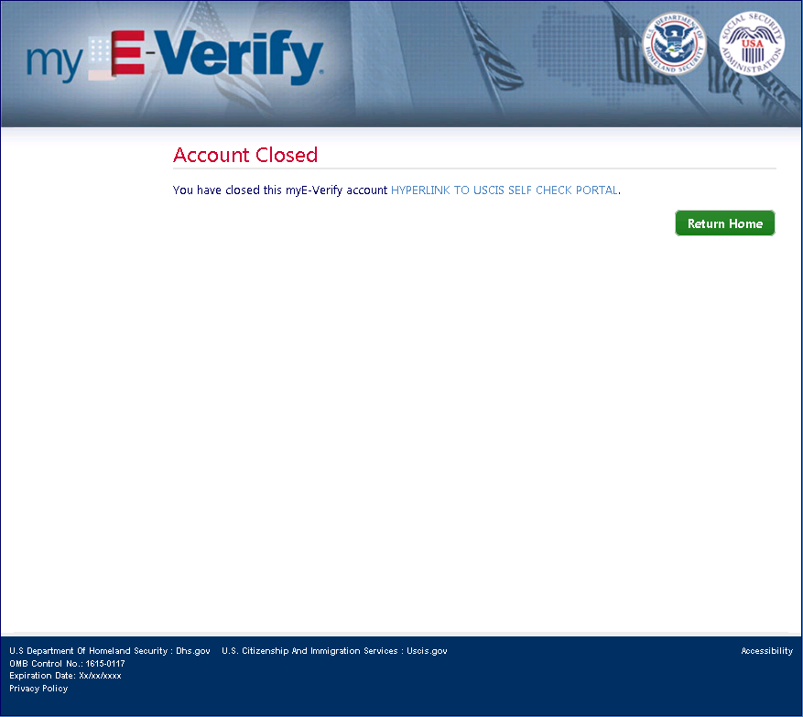
Paperwork Reduction Act

Wireframe 3.14 – System Unavailable
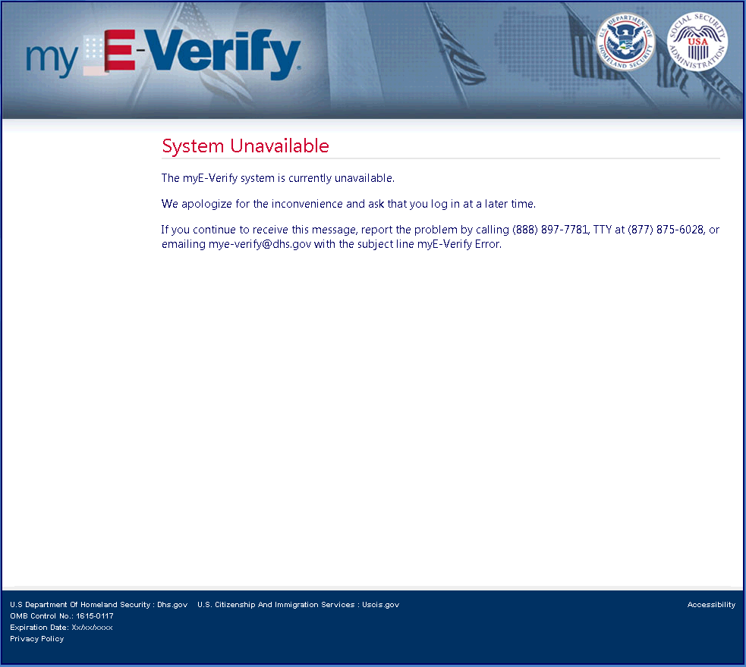
Paperwork Reduction Act

Wireframe 3.15 – Expired Password (pop-up)
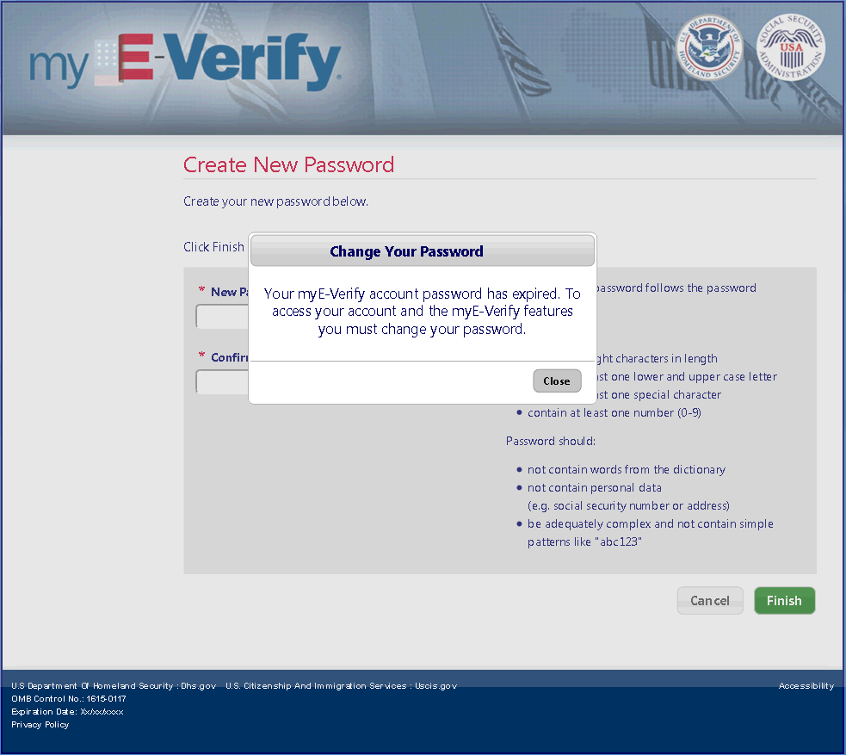
Paperwork Reduction Act

Wireframe 3.17 – System Error
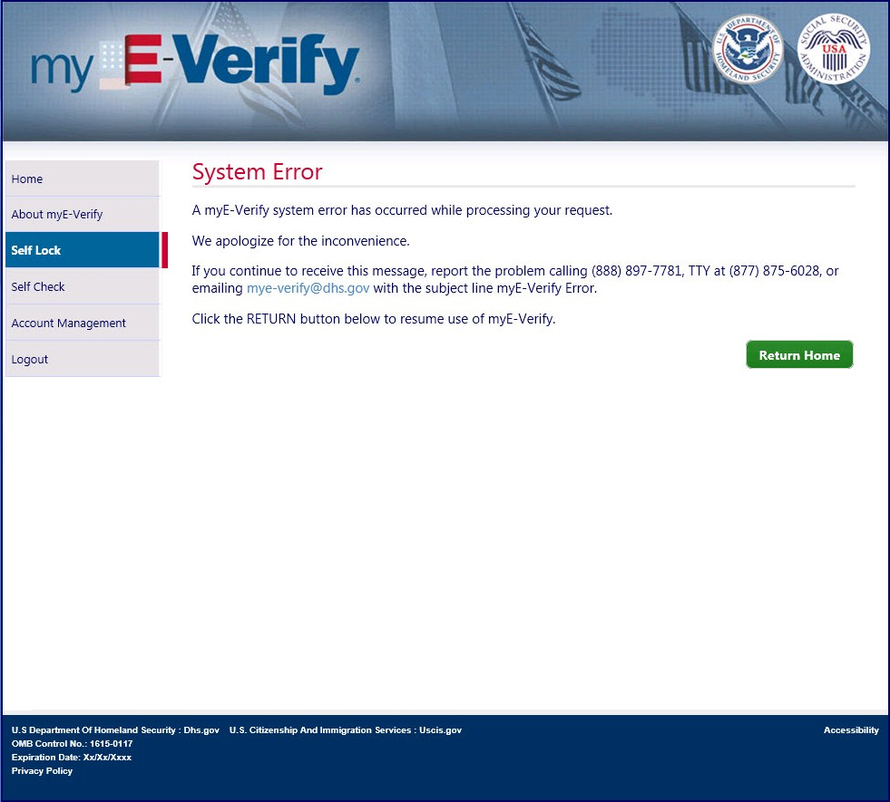
Paperwork Reduction Act

Email 3.E.1– Password Expiration Reminder (30day/15day/1day)
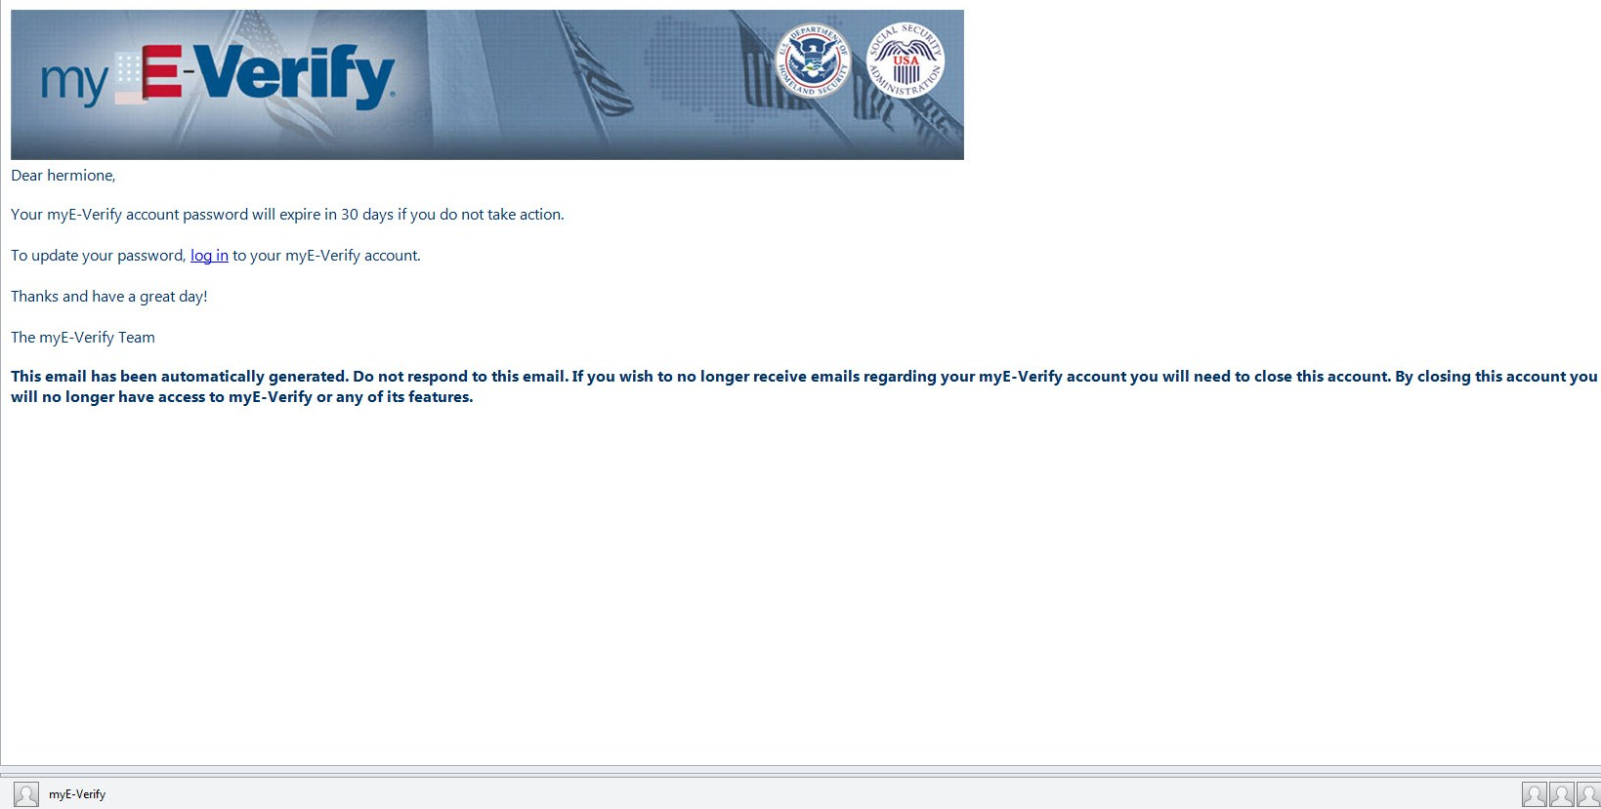

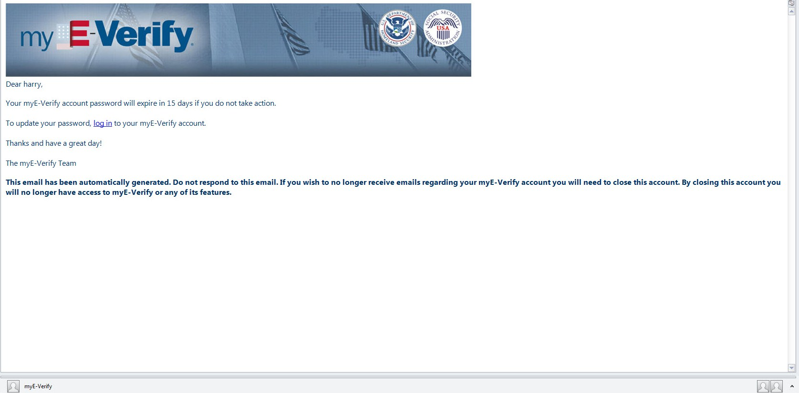

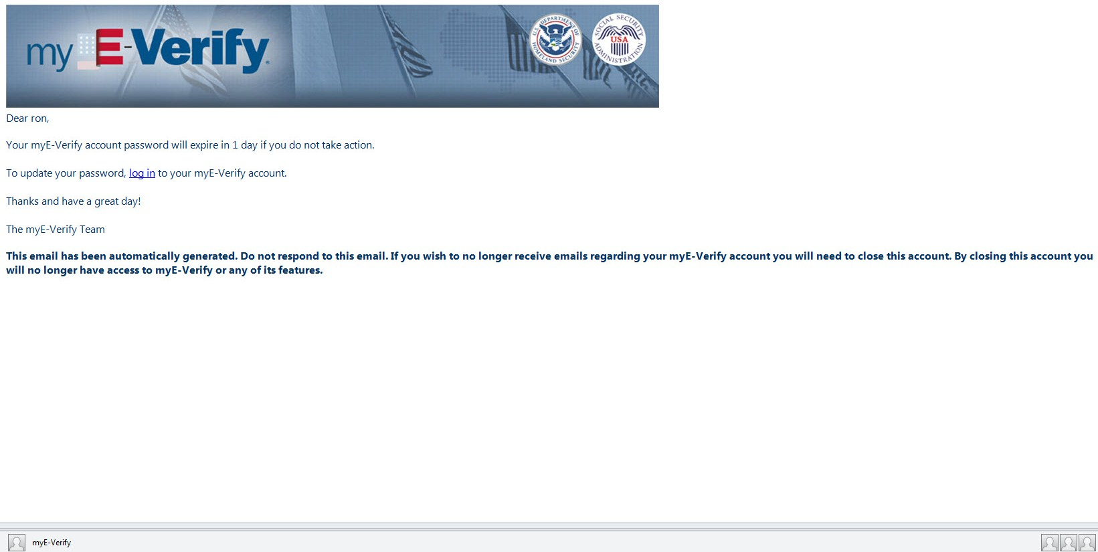

Email 3.E.2– Password Expired
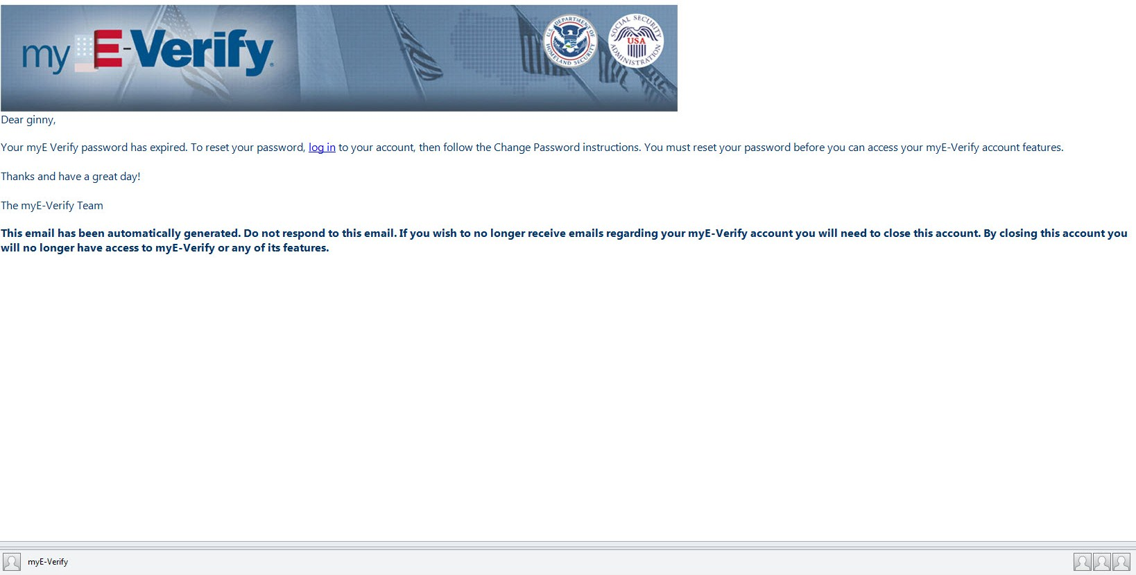

Email 3.E.3– Account Closure Warning (30day/15day/1day)
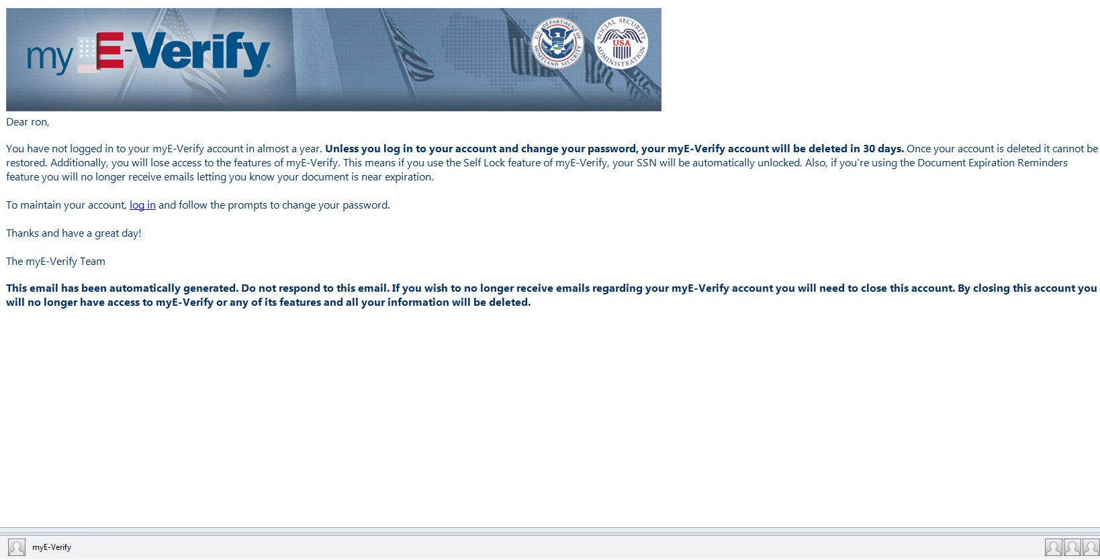

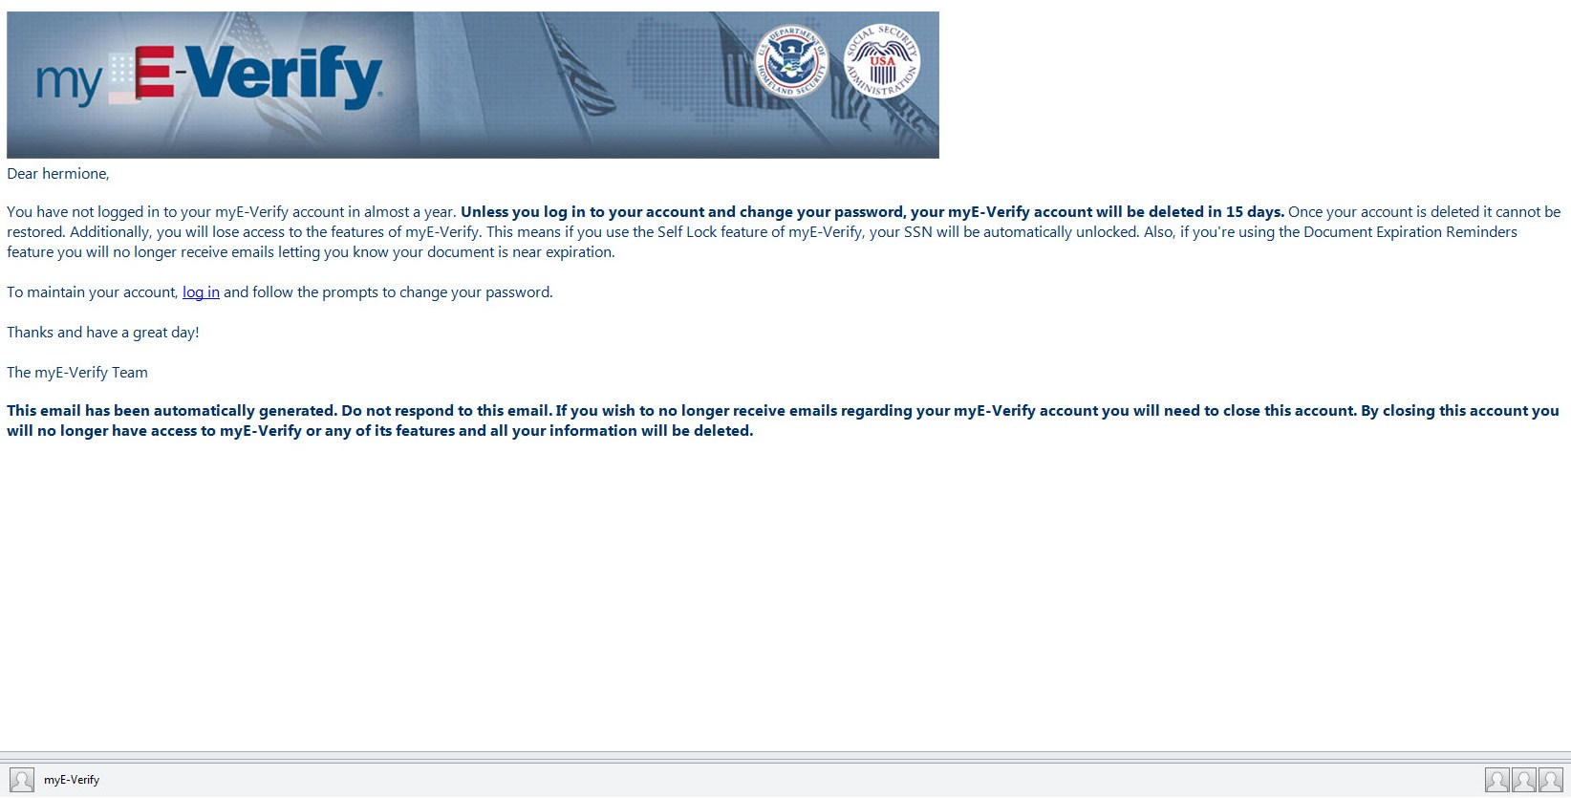

Email 3.E.4– Account Closed
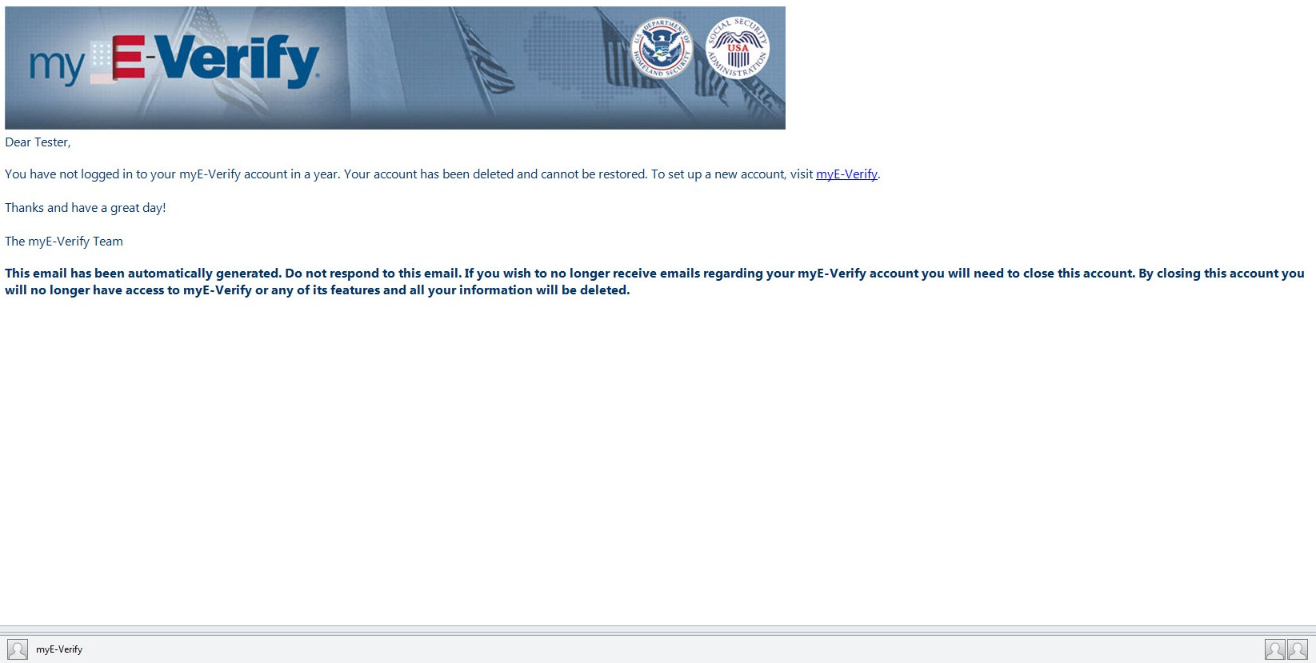

Wireframe 6.1 – Self Lock Home
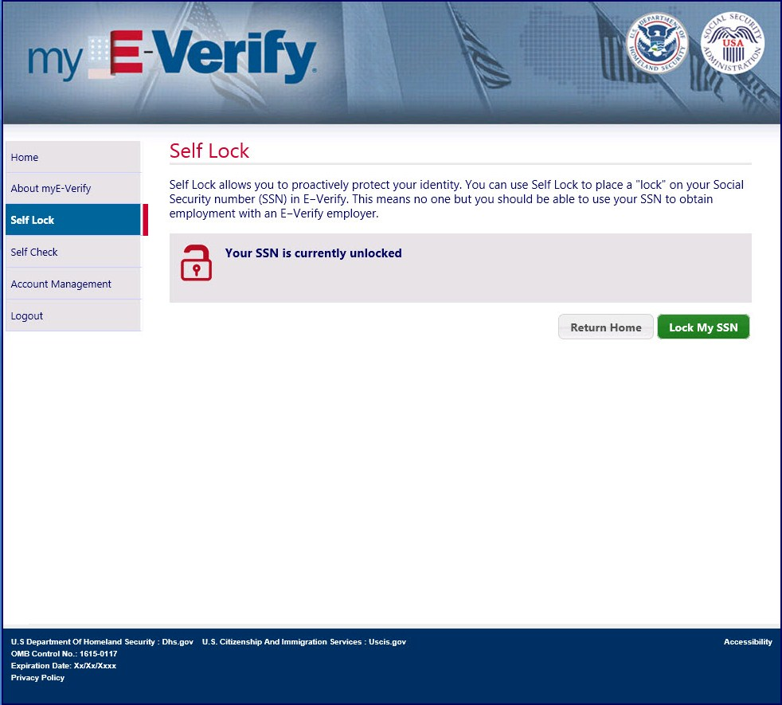
Paperwork Reduction Act

Wireframe 6.2 – Lock SSN
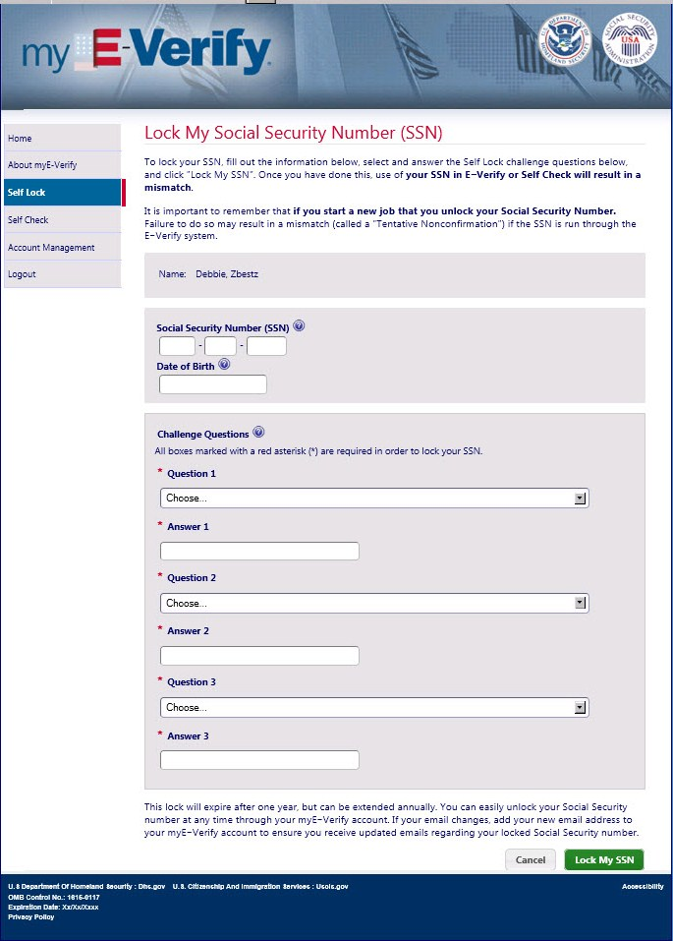
Paperwork Reduction Act

Wireframe 6.3 – Unlock Social Security number (SSN) (pop-up)
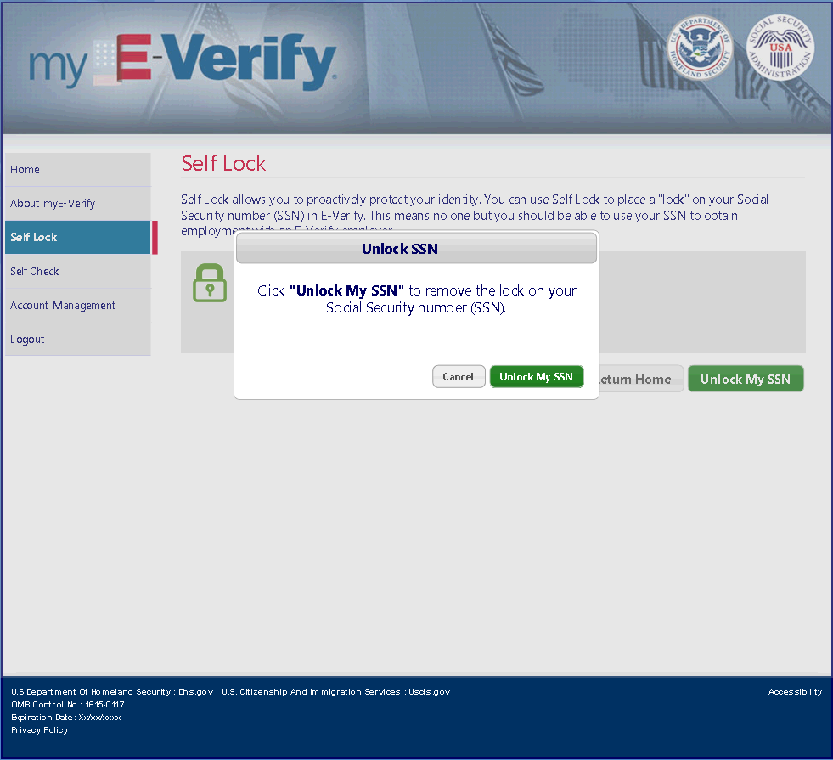
Paperwork Reduction Act

Wireframe 6.4 – Extend SSN Lock (pop-up)
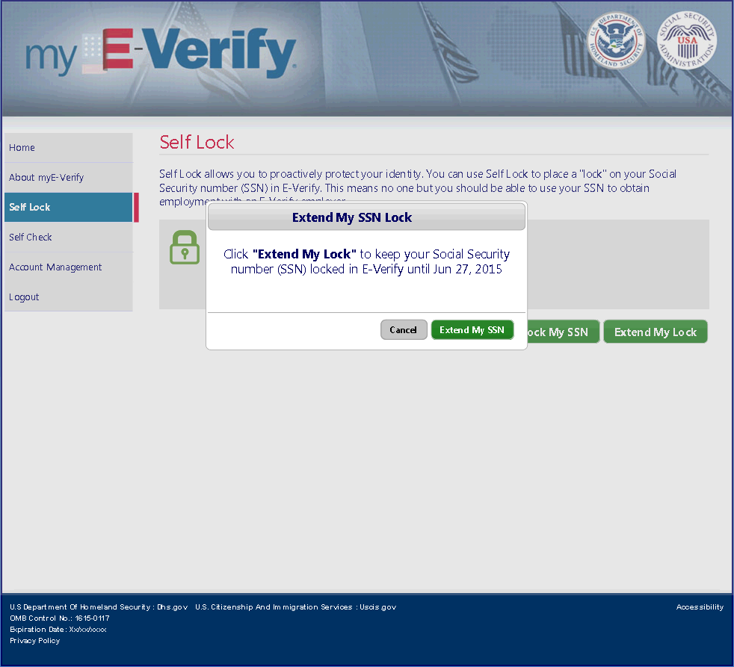
Paperwork Reduction Act

Wireframe 6.5 – Self Lock Unavailable
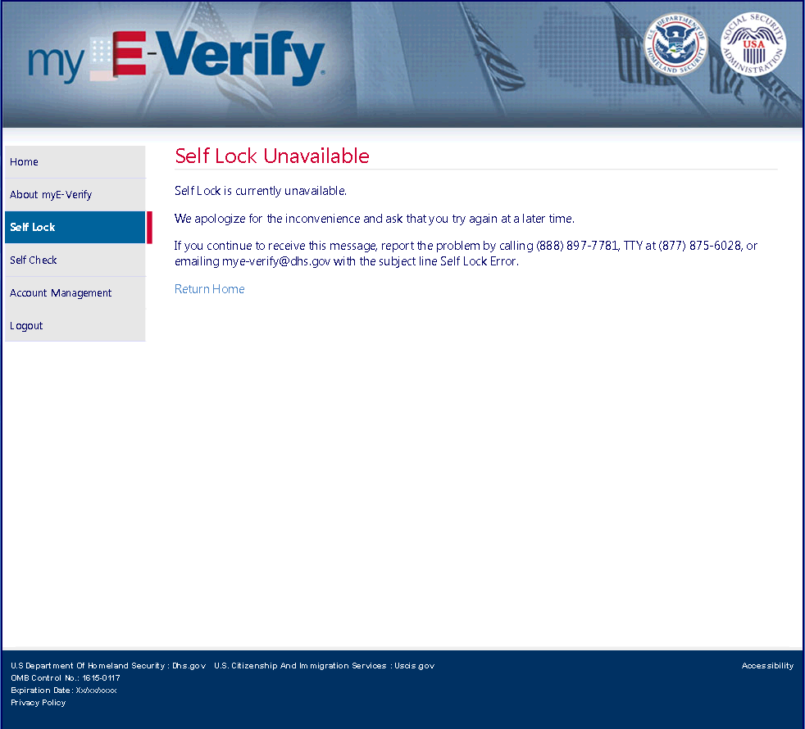
Paperwork Reduction Act

Email 6.E.1 – Social Security number (SSN) Locked
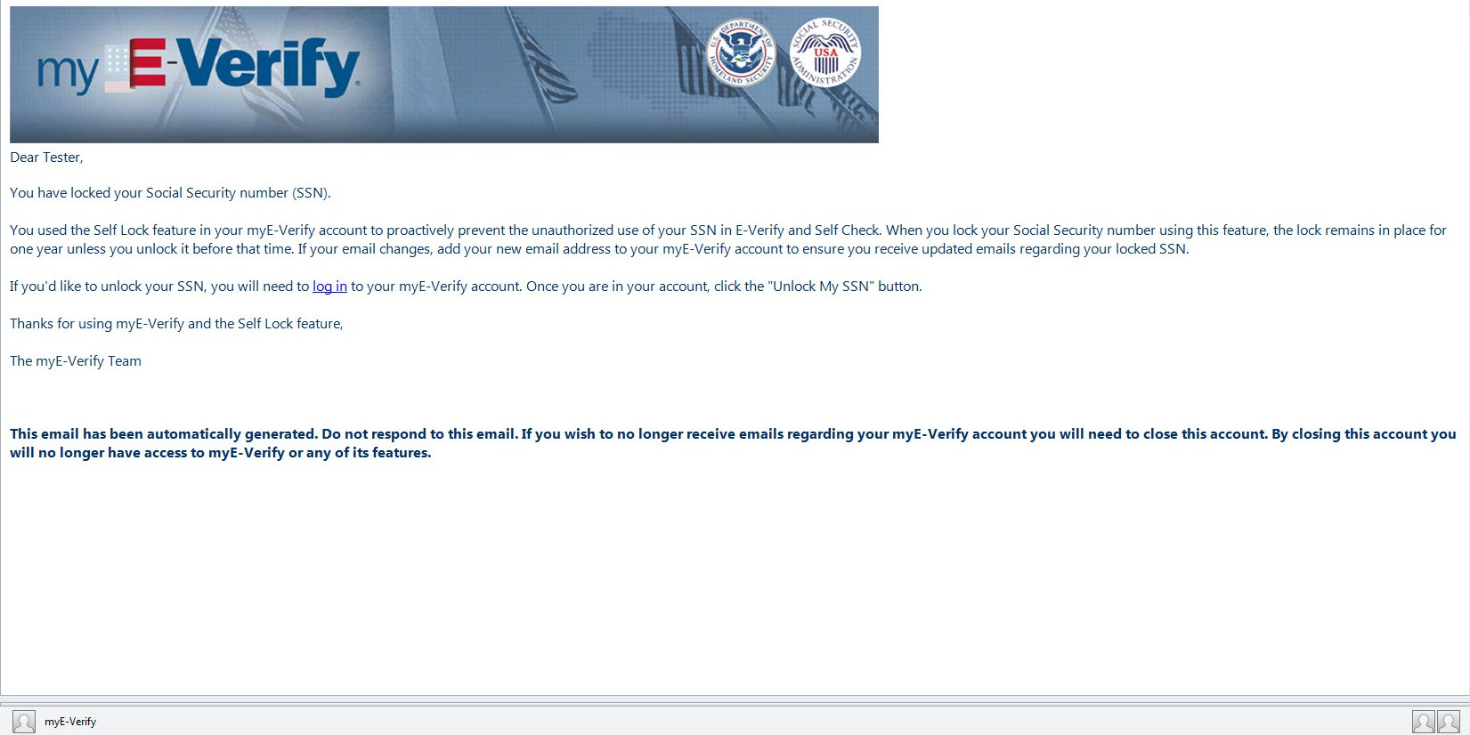

Email 6.E.2 – SSN Unlocked (via myE-Verify)
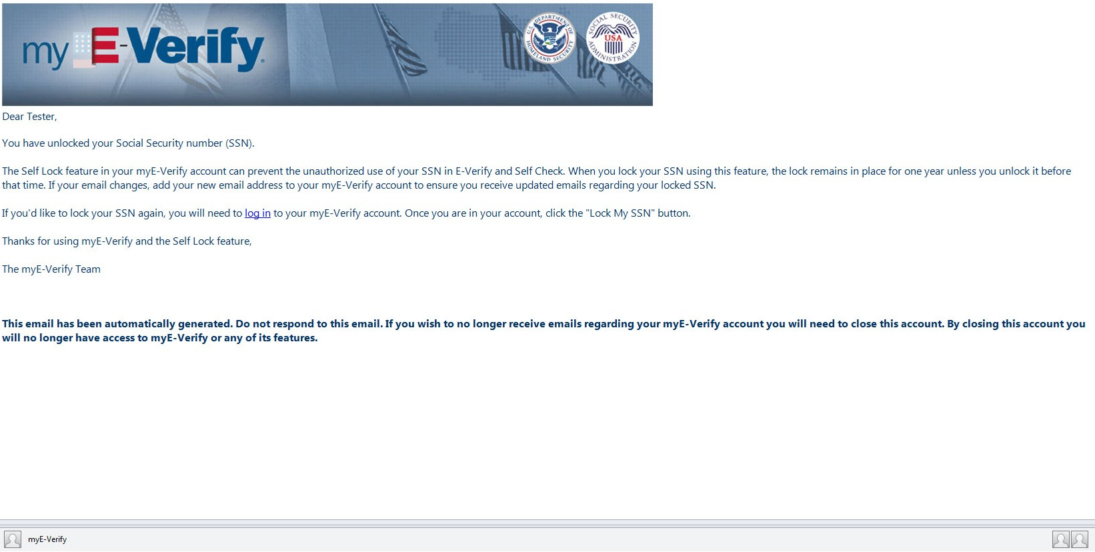

Email 6.E.3 – Lock Expiration Warning
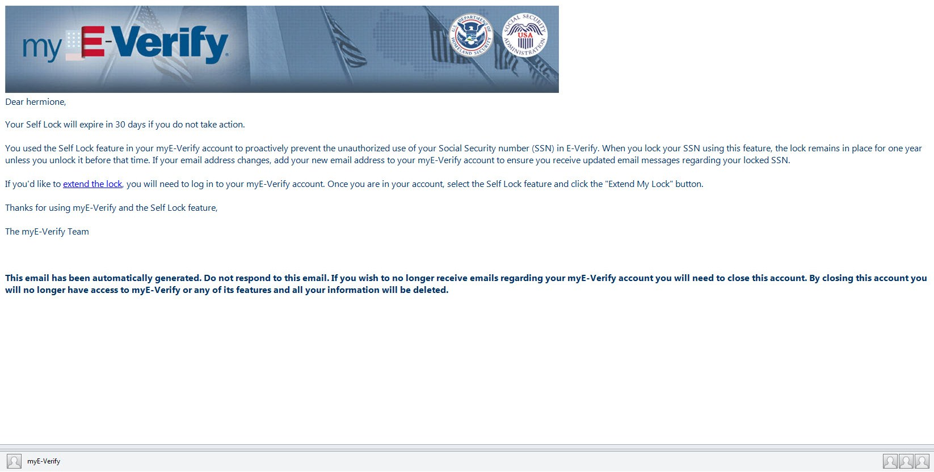

Email 6.E.4 – Social Security number (SSN) Unlocked (Lock Expired)
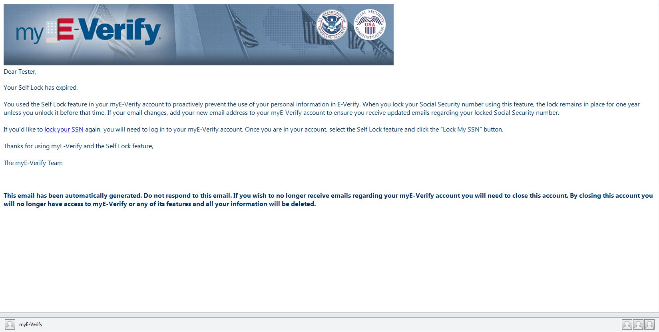

Email 6.E.5 – Social Security number (SSN) Lock Extended
