SUPPORTING STATEMENT

Guam-CNMI Visa Waiver Information
(Form I-736)
OMB No. 1651-0109

A. Justification

- Explain the circumstances that make the collection of information necessary. Identify any legal or administrative requirements that necessitate the collection. Attach a copy of the appropriate section of each statute and regulation mandating or authorizing the collection of information.

Public Law 110-229 provides for certain aliens to be exempt from the nonimmigrant visa requirement if seeking entry into Guam or the Commonwealth of the Northern Mariana Islands (CNMI) as a visitor for a maximum stay of 45 days, provided that no potential threat exists to the welfare, safety, or security of the United States, or its territories, and other criteria are met. Upon arrival at the Guam or CNMI Ports-of-Entry, each applicant for admission presents a completed paper Form I-736 to CBP, which collects information about the applicant’s identity and travel documents. CBP Form I-736 is provided for by 8 CFR 212.1(q).

Proposed Changes:

Please note that certain items on the new version remains identical to those in the original version. However, updates are necessary to be able to transition to automating Form I-736, Guam-CNMI Visa Waiver Information that is used in compliance with the Guam-CNMI Visa Waiver Program. The automation will facilitate CBP to gather information on travelers from Guam-CNMI Visa Waiver Program countries to determine their admissibility to enter Guam or the CNMI. In addition, CBP intends to migrate from paper I-736 to a mandatory automated environment; therefore, the collection of a paper form will no longer be acceptable. However, after the regulation implementing mandatory automation is published, CBP will grant a transition period of three months to facilitate travelers adjusting to the new collection method. At the end of the transition period, the paper I-736 form will become obsolete and travelers must input and submit in advance their personal information and respond to the eligibility questions using the new electronic format. The travelers’ information is pre-screened or vetted against law enforcement databases. Based on the results of the pre-screening, the application is approve or denied. The system generates a board or no board status message to the carrier indicating a denied or approved authorization to board before the flight. The applicant also receives a message with the application status: approved, denied, canceled or pending. All information will be saved in the newly created Guam-CNMI Visa Waiver Program database. Below is the proposed CBP Form I-736.

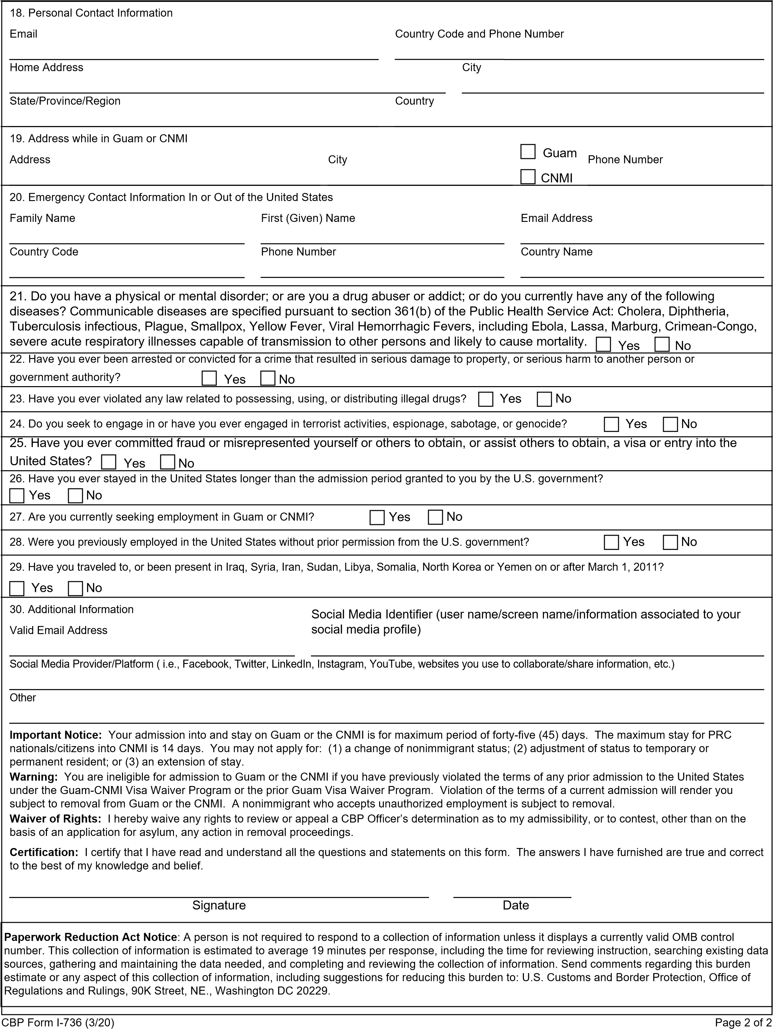
Proposed changes are highlighted in red.

Proposed Changes I-736
1. Surname/Family Name (exactly as in passport)
2. (Given) Name and Middle Name
3. Are you known by any other names or aliases? (y/n) If yes:
Alias Surname/Family Name
Alias First (Given) Name
Add another
4. Date of Birth (mm/dd/yyyy)
5. City of Birth
6. Country of Birth
7. Gender
8. Country of Citizenship
9. What is your National Identification Number?
10. Passport Number
- Issuing Country
- Passport Issuing Date, (mm/dd/yyyy)
- Passport Expire Date, (mm/dd/yyyy)
11. Have you ever been a citizen or national of any other country? (Y/N) If yes:
- provide the Country of Citizenship / Nationality.
12. Have you ever been issued a passport or national identity card for travel by any other country? (Y/N) If yes, then Personal, Official or Diplomatic;
- provide Issuing Country, Document Type, Document Number, and Expiration Date (mm/dd/yyyy)
- Add Another
13. Are you now a citizen or national of any other country? (Y/N) If yes, then
- provide the Country of Citizenship / Nationality
14. How did you acquire citizenship / nationality from this country?
15. Have you applied for an immigrant or nonimmigrant U.S. visa before? If yes, then:
- Place you applied
- Date you applied (mm/dd/yyyy)
- Type of visa Requested
- Was visa Issued? (Y/N) If no, then: was application withdrawn or denied (Y/N). If yes, then
has your Visa ever been cancelled? (Y/N)
16. Are you a member of the CBP Global Entry Program? (Y/N) If yes, provide the PASSID / Membership Number
17. Are you under the age of fourteen (14)? (Y/N) If yes:
- Father First (Given) Name
- Father Surname/Family Name
- Mother First (Given) Name
- Mother Surname/Family Name
18. PERSONAL CONTACT INFORMATION
- Email
- Country Code and Phone Number
- Home Address
- City
- State/Province/Region
- Country
19. ADDRESS WHILE IN Guam/CNMI
- Address
- City
- Guam or CNMI
- Phone Number
20. EMERGENCY CONTACT INFORMATION IN OR OUT OF THE United States.
- Surname/Family Name
- First (Given) Name
- Email Address
- Country Code
- Phone
- Country Name
21. Do you have a physical or mental disorder; or are you a drug abuser or addict; or do you currently have any of the following diseases? Communicable diseases are specified pursuant to section 361(b) of the Public Health Service Act: Cholera, Diphtheria, Tuberculosis infectious, Plague, Smallpox, Yellow Fever, Viral Hemorrhagic Fevers, including Ebola, Lassa, Marburg, Crimean-Congo, Severe acute respiratory illnesses capable of transmission to other persons and likely to cause mortality. (Y/N)
22. Have you ever been arrested or convicted for a crime that resulted in serious damage to property, or serious harm to another person or government authority? (Y/N)
23. Have you ever violated any law related to possessing, using, or distributing illegal drugs? (Y/N)
24. Do you seek to engage in or have you ever engaged in terrorist activities, espionage, sabotage, or genocide? (Y/N)
25. Have you ever committed fraud or misrepresented yourself or others to obtain, or assist others to obtain, a visa or entry into the United States? (Y/N)
26. Have you ever stayed in the United States longer than the admission period granted to you by the U.S. government? (Y/N)
27. Are you currently seeking employment in Guam or CNMI? (Y/N)
28. Were you previously employed in the United States without prior permission from the U.S. government? (Y/N)
29. Have you traveled to, or been present in Iraq, Syria, Iran, Sudan, Libya, Somalia, North Korea or Yemen on or after March 1, 2011? (Y/N)
30. Additional Information
-Social Media Identifier
-Valid Email
-Social Media Provider/Platform
-Other
Other changes:
Instructions: This form must be completed by every nonimmigrant visitor not in possession of a visitor’s visa, who is a citizen of one of the eligible countries *enumerated in 8 CFR 212.1(q) and is applying to enter and remain on Guam or the CNMI for a maximum stay of forty-five (45) days. This regulation applies only to entry into Guam or the CNMI; entry to any other part of the United States pursuant to this regulation is prohibited. Print legibly with pen in ALL CAPITAL LETTERS. Use English. Complete items # 1-30; and sign and date the bottom of this form after carefully reading all of the information. Children under the age of fourteen (14) must have their form signed by a parent, guardian, or other responsible adult. When all sections are completed, you must review for accuracy, read the certification section and sign or certify the form as applicable. This paper form must be presented to the U.S. Customs and Border Protection Officer until the electronic equivalent is required. * The airline can provide you with the current list of eligible countries.

Important Message: If you are a citizen or a national of any of the following countries: Australia, Brunei, Japan, New Zealand, South Korea, Singapore, United Kingdom or the geographical area of Taiwan with an approved and unexpired Electronic System for Travel Authorization, commonly known as ESTA, or a U.S. visa, you do not need to complete this form. Are you a citizen/national of the People’s Republic of China (PRC)? Warning: The maximum stay for PRC nationals/citizens paroled into the CNMI is 14 days.

Important Notice: Your admission into and stay on Guam or the CNMI is for maximum period of forty-five (45) days. The maximum stay for PRC nationals/citizens paroled into CNMI is 14 days. You may not apply for: (1) a change of nonimmigrant status; (2) adjustment of status to temporary or permanent resident; or (3) an extension of stay. Warning: You are ineligible for admission to Guam or the CNMI if you have previously violated the terms of any prior admission to the United States under the Guam-CNMI Visa Waiver Program or the prior Guam Visa Waiver Program. Violation of the terms of a current admission will render you subject to removal from Guam or the CNMI. A nonimmigrant who accepts unauthorized employment is subject to removal. Waiver of Rights: I hereby waive any rights to review or appeal a CBP Officer’s determination as to my admissibility, or to contest, other than on the basis of an application for asylum, any action in removal proceedings. Certification: I certify that I have read and understand all the questions and statements on this form. The answers I have furnished are true and correct to the best of my knowledge and belief.
Signature Date

Several elements will be added to the Form I-736: the foreign passport type, social media identifier, valid email address, and social media provider/platform. Adding these data elements will enhance the existing vetting process and provide CBP additional information to determine travelers’ admissibility to enter Guam or the CNMI under the Guam-CNMI Visa Waiver Program. CBP intends to migrate from the paper Form I-736 process to a mandatory automated process via rulemaking.

2. Indicate how, by whom, and for what purpose the information is to be used. Except for a new collection, indicate the actual use the agency has made of the information received from the current collection.

Information collected on CBP Form I-736 helps DHS determine whether an alien is eligible to travel to the United States’ insular possessions of Guam or CNMI under the Guam-CNMI VWP. The data elements and questions included in Form I-736 help gather information necessary to ensure that someone does not need to pursue a visa through the Department of State instead of being able to travel under this program.

- Describe whether, and to what extent, the collection of information involves the use of automated, electronic, mechanical, or other technological collection techniques or other forms of information technology, e.g. permitting electronic submission of responses, and the basis for the decision for adopting this means of collection. Also describe any consideration of using information technology to reduce burden.

The use of this form currently provides the most efficient means for collecting and processing the required data. On January 10, 2018, CBP modified the process by which a traveler arriving at Guam or CNMI can provide Form I-736 information. CBP provides travelers destined to Guam or CNMI with an electronic option to complete Form I-736. Specifically, CBP created a tab under the I-94 website to enable travelers arriving at Guam or CNMI to complete, sign and print Form I-736 prior to embarking on a carrier for travel to Guam or the CNMI. In order to navigate easily, CBP created a uniform resource locator (URL) that facilitates travelers with an easy access to the electronic form.

Form I-736 must be completed and signed by all eligible travelers under the Guam-CNMI VWP either manually or its electronic equivalent. Exceptions are if the traveler is in possession of a U.S. visa or in possession of an approved ESTA as applicable. Passengers destined to Guam or the CNMI must complete and present the form to the carrier prior to boarding. At this time, the electronic submission is not required. This form is automated and may be fillable, file able and printable as required by current regulations to be printed, signed and presented prior to boarding and surrender to a CBP Officer upon arrival at the ports of entry of either Guam or the CNMI. The automated English version can be found at https://i736.cbp.dhs.gov/I736/#/home
Also, a fillable, and printable version of the form can be filled out by passengers while in-transit to their destinations, such as on airplanes and in airports which is located: https://www.cbp.gov/newsroom/publications/forms?title=736.

4. Describe efforts to identify duplication. Show specifically why any similar information already available cannot be used or modified for use for the purposes described in Item 2 above.

This information is not duplicated elsewhere.

5. If the collection of information impacts small businesses or other small entities, describe any methods used to minimize burden.

This information collection does not have an impact on small businesses or other small entities.

- Describe consequences to Federal program or policy activities if the collection is not conducted or is conducted less frequently.

If this information was not collected, CBP would not be able to comply with Public Law 110-229 because an alien must apply for the benefits afforded under the Guam-CNMI Visa Waiver Program. In addition, the new elements enhance the information previously collected from travelers and allow DHS to better identify those who may seek to exploit the Guam-CNMI VWP to do harm to the United States. Extensive research by DHS and our interagency partners has determined that these additional data elements will increase the ability to stop these travelers before they attempt to travel to Guam or the CNMI.

7. Explain any special circumstances.

This information is collected in a manner consistent with the guidelines of 5 CFR 1320.6.

- If applicable, provide a copy and identify the date and page number of publication in the Federal Register of the agency's notice, required by 5 CFR 1320.8(d), soliciting comments on the information collection prior to submission to OMB. Summarize public comments received in response to that notice and describe actions taken by the agency in response to these comments. Specifically address comments received on cost and hour burden.

CBP published two Federal Register notices to solicit comments from the public including on June 16, 2020 (Volume 85 FR Page 37466) on which no comments were received, and on October 28, 2020 (Volume 85, Page 68354) on which no comments have been received.

9. Explain any decision to provide any payment or gift to respondents, other than remuneration of contractors or grantees.

There is no offer of a monetary or material value for this information collection.

10. Describe any assurance of confidentiality provided to respondents and the basis for the assurance in statute, regulation, or agency policy.

A Privacy Impact Assessment (PIA) entitled “Electronic System for Travel Authorization” (September 1, 2016); a SORN entitled “Electronic System for Travel Authorization” (September 2, 2016, 81 FR 60713); and a SORN entitled “Non-Immigrant Information System” (March 13, 2015, 80 FR 13398) are included in this information collection request. No assurances of confidentiality are provided to respondents.

11. Provide additional justification for any questions of a sensitive nature, such as sexual behavior and attitudes, religious beliefs, and other matters that are commonly considered private. This justification should include the reasons why the agency considers the questions necessary, the specific uses to be made of the information, the explanation to be given to persons from whom the information is requested, and any steps to be taken to obtain their consent.

As a result of Executive Order No. 13674, which was issued on July 31, 2014 (79 FR 45671), revising the list of quarantinable communicable diseases issued pursuant to section 361(b) of the Public Health Service Act, 42 U.S.C. 264(b). https://www.govinfo.gov/content/pkg/FR-2014-08-06/pdf/2014-18682.pdf

Do you have a physical or mental disorder; or are you a drug abuser or addict; or do you currently have any of the following diseases (communicable diseases are specified pursuant to section 361(b) of the Public Health Service Act, 42 U.S.C. 264(b)):
• Cholera
• Diphtheria
• Tuberculosis, infectious
• Plague
• Smallpox
• Yellow Fever
• Viral Hemorrhagic Fevers, including Ebola, Lassa, Marburg, Crimean-Congo
• Severe acute respiratory illnesses capable of transmission to other persons and likely to cause mortality

- Provide estimates of the hour burden of the collection of information.

FORM NUMBER/  TITLE | TOTAL ANNUAL BURDEN HOURS | NO. OF  RESPONDENTS | NO. OF RESPONSES PER RESPONDENT | TOTAL  RESPONSES | TIME PER  RESPONSE
I-736  Guam-CNMI Visa Waiver Information | 492,960 | 1,560,000 | 1 | 1,560,000 | 19 minutes  (.316 hours)

Public Cost

The estimated cost to the respondents is $23,218,416. This is based on the estimated burden hours (492,960) multiplied by (x) the average hourly wage rate for all-purpose air travelers ($47.10). CBP used the U.S. Department of Transportation’s (DOT) recommended hourly value of travel time savings for intercity, all purpose travel by air and high speed rail, which is provided in 2015 U.S. dollars. CBP assumes an annual growth rate of 0 percent; the 2015 U.S. dollar value is equal to the 2020 U.S. dollar value.

13. Provide an estimate of the total annual cost burden to respondents or record keepers resulting from the collection of information.

There are no record keeping, capital, start-up or maintenance costs associated with this information collection.

- Provide estimates of annualized cost to the Federal Government. Also provide a description of the method used to estimate cost, which should include quantification of hours, operational expenses (such as equipment overhead, printing, and support staff), and any other expense that would not have been incurred without this collection of information.

The estimated annual cost to the Federal Government associated with this collection is $8,483,529.60. This is based on the number of responses that must be reviewed (1,560,000) multiplied by (x) the time burden to review and process each response (5 minutes or .083 hours) = 129,480 hours multiplied by (x) the average hourly loaded rate for a CBP Officer ($65.52) = $8,483,529.60.

15. Explain the reasons for any program changes or adjustments reported in Items 12 or 13 of this Statement.

There are no increases or decreases in the estimated annual burden hours previously reported for this information collection due to the revisions on CBP Form I-736. There are changes to the information collected as stated under item one of this supporting statement.

16. For collection of information whose results will be published, outline plans for tabulation, and publication.

This information collection will not be published.

17. If seeking approval to not display the expiration date, explain the reasons that displaying the expiration date would be inappropriate

CBP will display the expiration date for OMB approval of this information collection.

18. “Certification for Paperwork Reduction Act Submissions.”

CBP does not request an exception to the certification of this information collection.

Collection of Information Employing Statistical Methods

No statistical methods were employed.

Source: U.S. Department of Transportation, Office of Transportation Policy. The Value of Travel Time Savings: Departmental Guidance for Conducting Economic Evaluations Revision 2 (2016 Update), “Table 4 (Revision 2 - 2016 Update): Recommended Hourly Values of Travel Time Savings for Intercity, All-Purpose Travel by Air and High-Speed Rail.” September 27, 2016. Available at https://www.transportation.gov/sites/dot.gov /files/docs/2016%20Revised%20Value%20of%20Travel%20Time%20Guidance.pdf. Accessed June 12, 2020.
CBP bases this wage on the FY 2020 salary and benefits of the national average of CBP Officer Positions, which is equal to a GS-11, Step 7. Source: Email correspondence with CBP’s Office of Finance on July 2, 2020.

