NATIONAL CENTER FOR EDUCATION STATISTICS NATIONAL ASSESSMENT OF EDUCATIONAL PROGRESS

National Assessment of Educational Progress (NAEP)2021

Appendix J2

2021 Teacher Questionnaires

OMB# 1850-0928 v.21

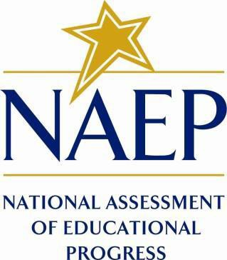

October 2020

Note: Appendix J2-1 through Appendix J2-14 have all been approved in Amendment 1, v.20. Appendix J2-15 and J2-16 are new in this amendment, and they are listed below in the Table of Contents as “New”.
Table of Contents
Teacher Questionnaires
Teacher Questionnaire Login Screens 3
Appendix J2-1: Summary of Changes Operational Grade 4 CORE 4
Appendix J2-2: Operational Grade 4 CORE 11
Appendix J2-3: Summary of Changes Operational Grade 8 CORE 19
Appendix J2-4: Operational Grade 8 CORE 27
Appendix J2-5: Summary of Changes Operational Grade 4 Mathematics 37
Appendix J2-6: Operational Grade 4 Mathematics 42
Appendix J2-7: Summary of Changes Operational Grade 8 Mathematics 49
Appendix J2-8: Operational Grade 8 Mathematics 56
Appendix J2-9: Summary of Changes Operational Grade 4 Reading 64
Appendix J2-10: Operational Grade 4 Reading 69
Appendix J2-11: Summary of Changes Operational Grade 8 Reading 74
Appendix J2-12: Operational Grade 8 Reading 79
Appendix J2-13: Summary of Changes Operational Grade 8 Social Studies 85
Appendix J2-14: Operational Grade 8 Social Studies 94
Appendix J2-15: Operational Grade 4 COVID-19 (New) 103
Appendix J2-16: Operational Grade 8 COVID-19 (New) 107

Teacher Questionnaire Login Screens
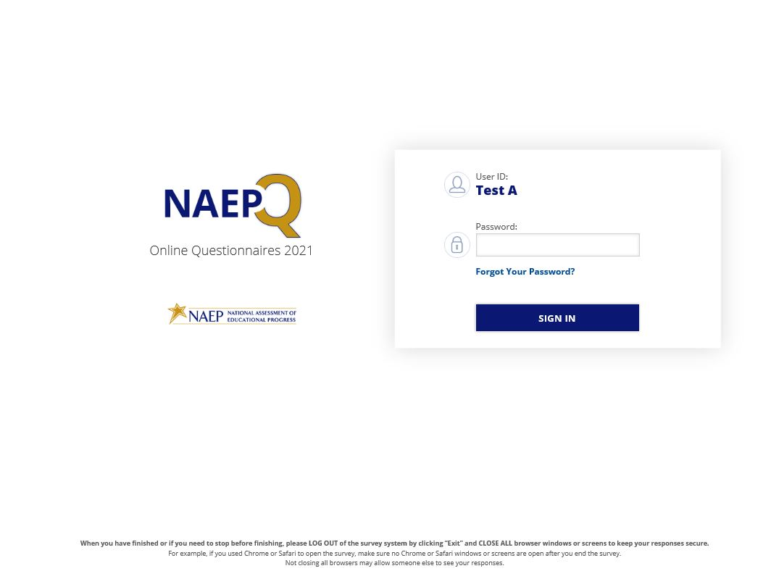
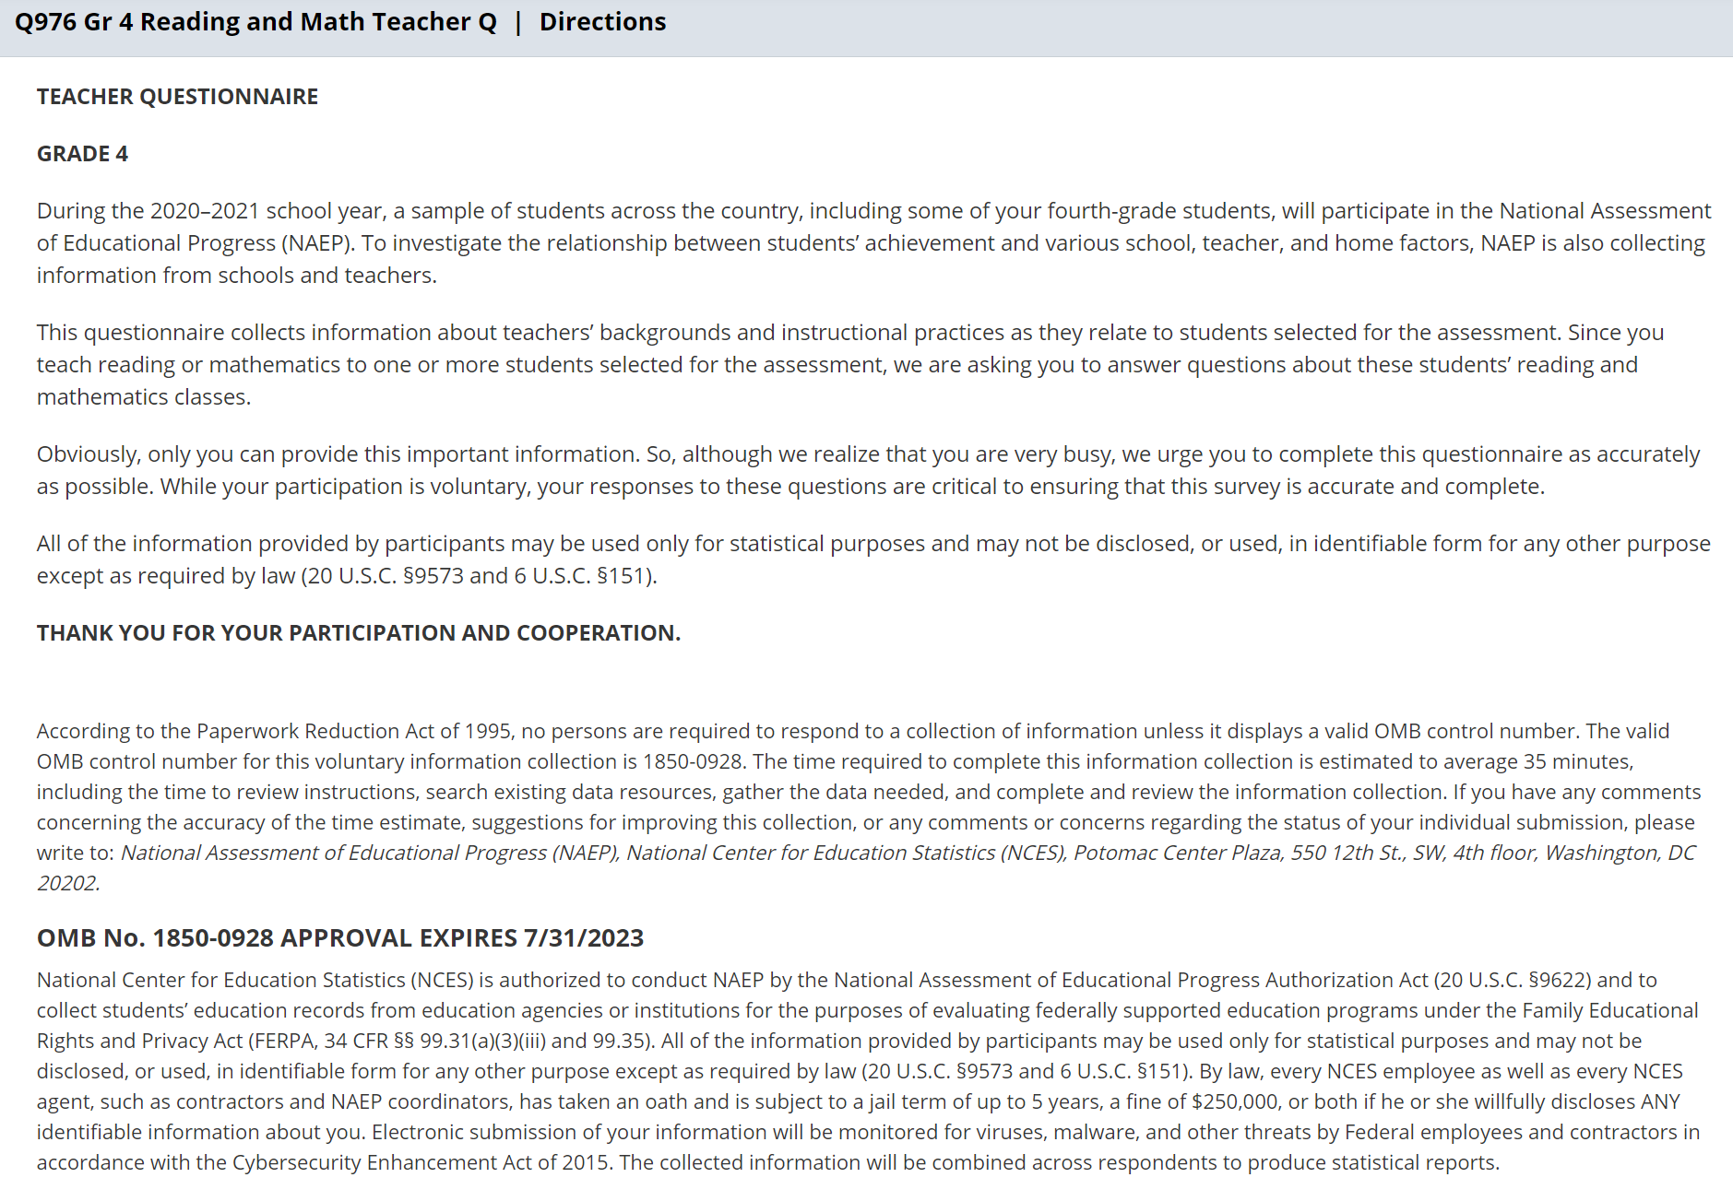

Appendix J2-1: Summary of Changes Operational Grade 4 CORE
2021 Operational Grade 4 Core Teacher

Previous item | 2021 item | D/A/ R/NC+ | Rationale
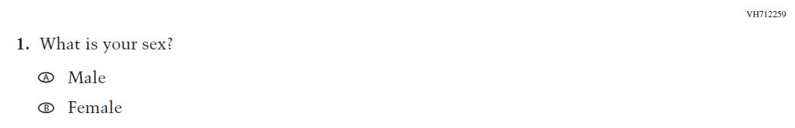  (2019 Grade 4) | 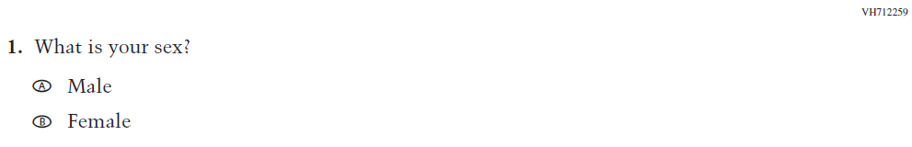  Issue: Gender | NC | N/A
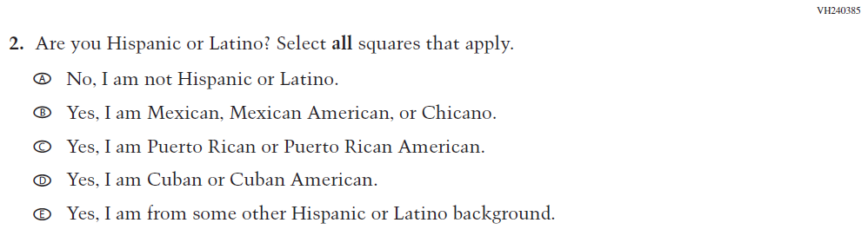  (2019 Grade 4) | 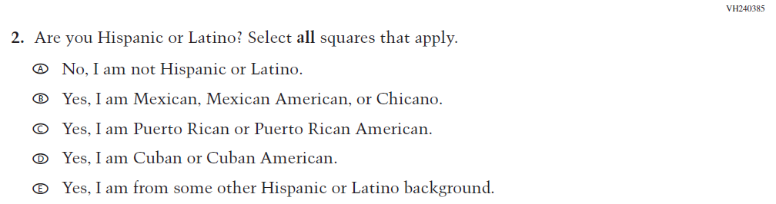  Issue: Race/Ethnicity | NC | N/A
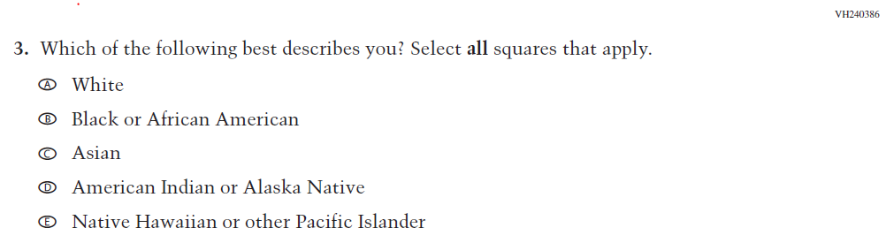  (2019 Grade 4) | 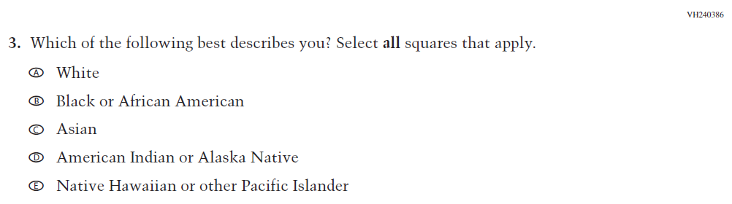  Issue: Race/Ethnicity | NC | N/A
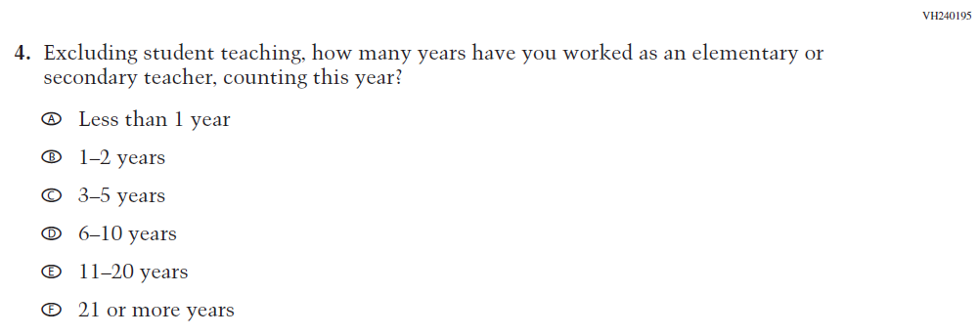  (2019 Grade 4) | 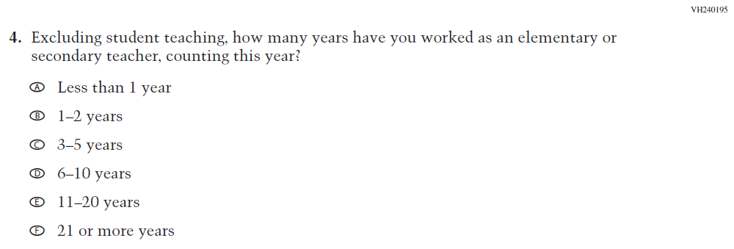  Issue: Teacher Preparation | NC | N/A

2021 Operational Grade 4 Core Teacher

Previous item | 2021 item | D/A/ R/NC+ | Rationale
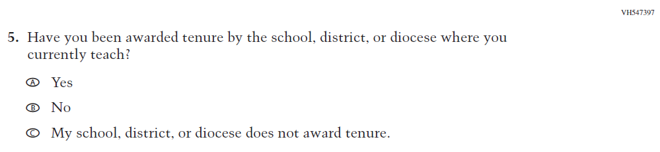  (2019 Grade 4) | 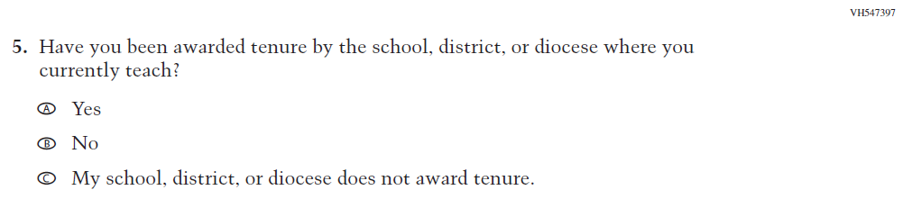  Issue: Teacher Preparation | NC | N/A
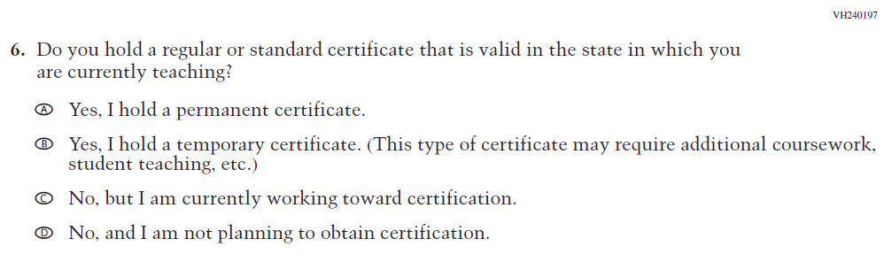  (2019 Grade 4) | 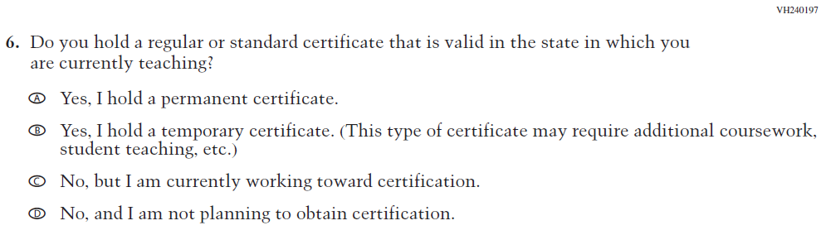  Issue: Teacher Preparation | NC | N/A
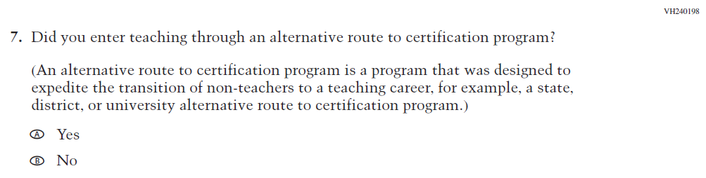  (2019 Grade 4) | 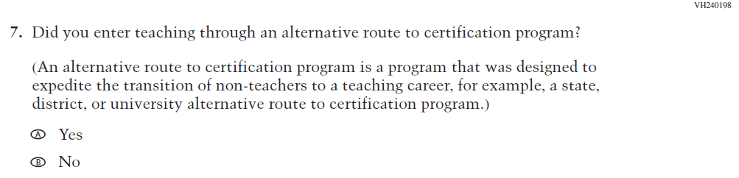  Issue: Teacher Preparation | NC | N/A

2021 Operational Grade 4 Core Teacher

Previous item | 2021 item | D/A/ R/NC+ | Rationale
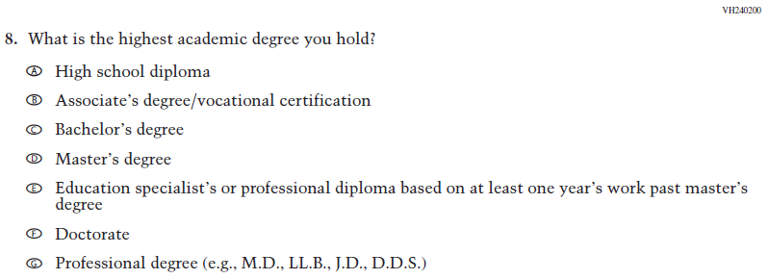  (2019 Grade 4) | Issue: Teacher Preparation | N/A | N/A
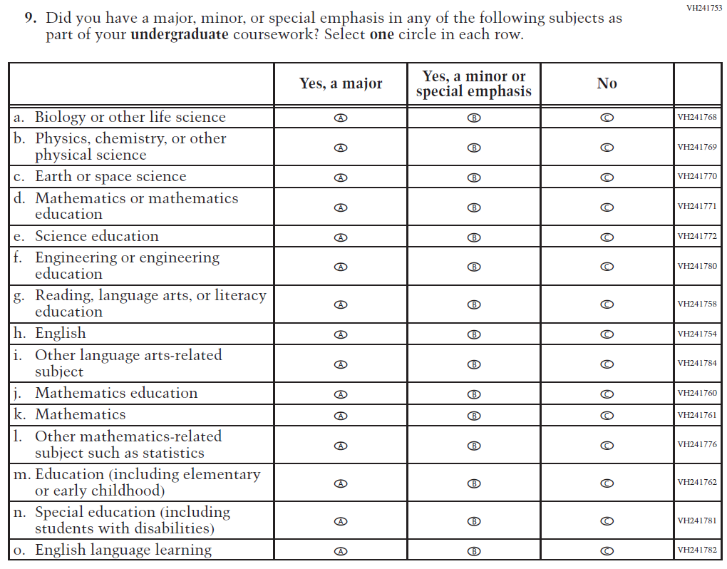  (2019 Grade 4) | 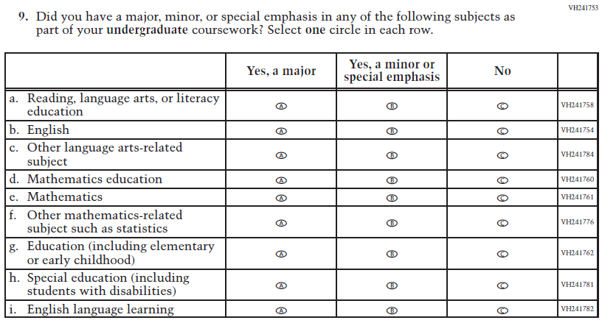  Issue: Teacher Preparation | R | This item is customized by subject and has been revised to remove sub-items for science.
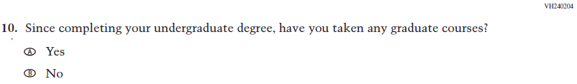  (2019 Grade 4) | Issue: Teacher Preparation | NC | N/A

2021 Operational Grade 4 Core Teacher

Previous item | 2021 item | D/A/ R/NC+ | Rationale
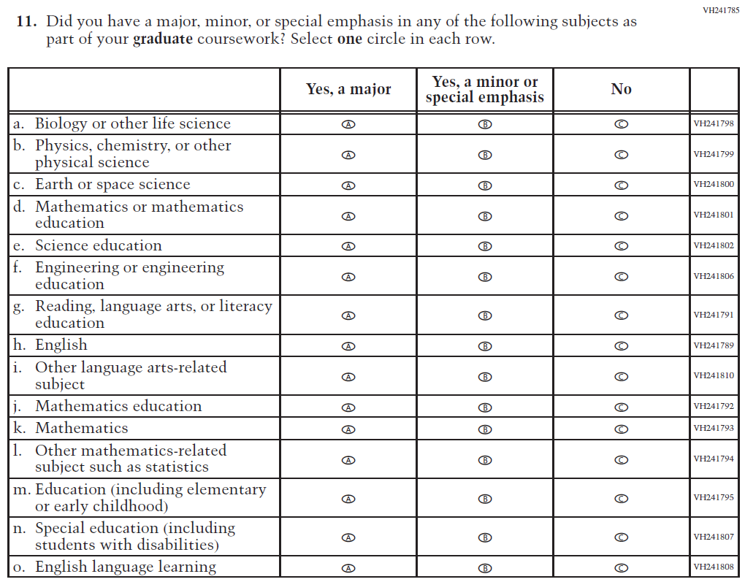  (2019 Grade 4) | 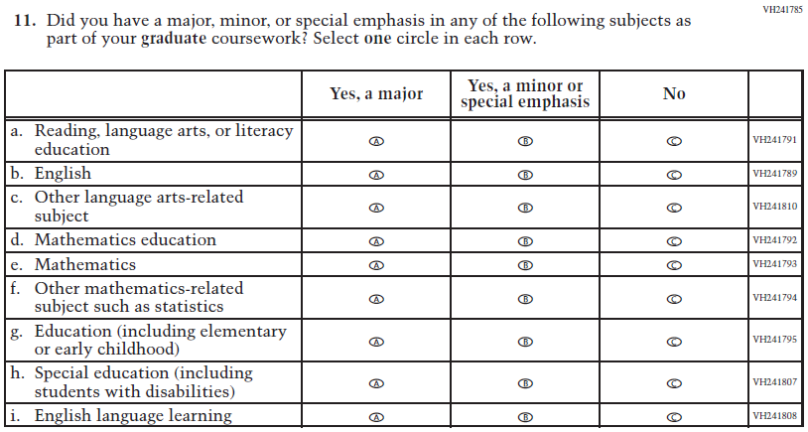  Issue: Teacher Preparation | R | This item is customized by subject and has been revised to remove sub-items for science.
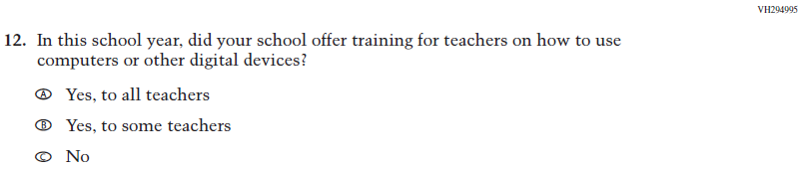  (2019 Grade 4) | 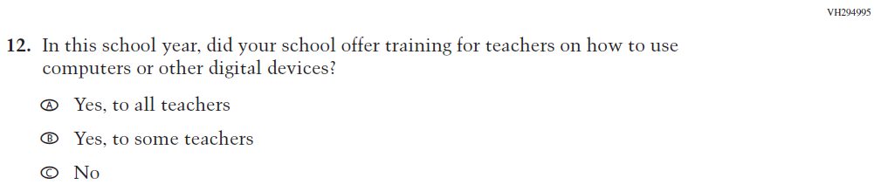  Issue: Technology Use | NC | N/A
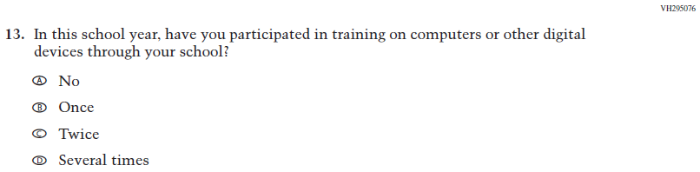  (2019 Grade 4) | Issue: Technology Use | NC | N/A
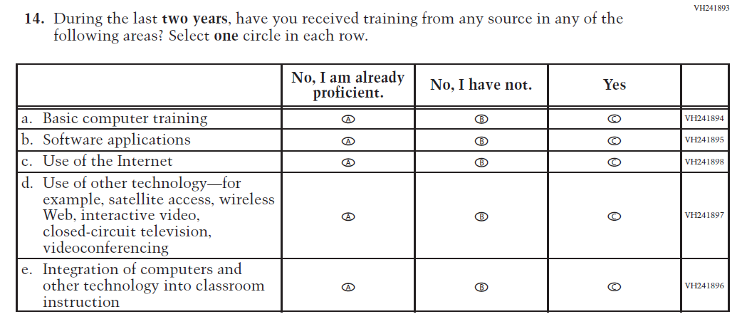  (2019 Grade 4) | 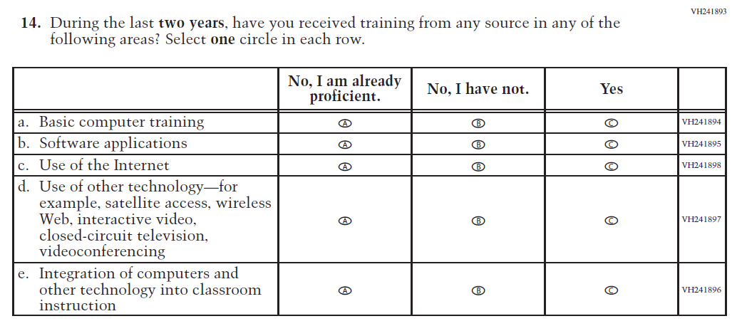  Issue: Teacher Preparation | NC | N/A
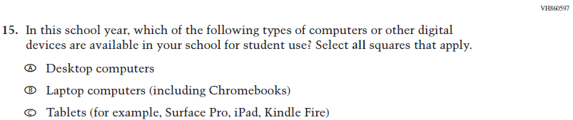  (2019 Grade 4) | Issue: Technology Use | NC | N/A
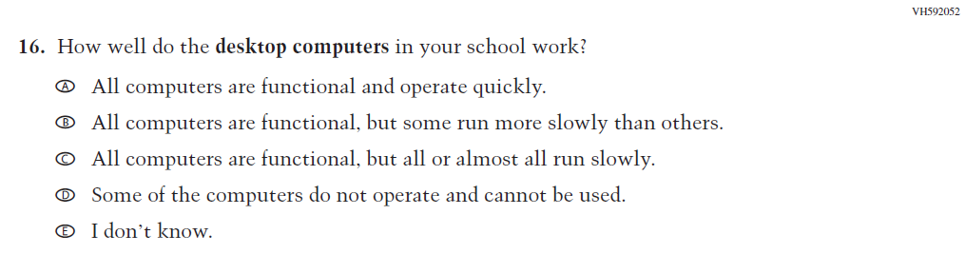  (2019 Grade 4) | Issue: Technology Use | NC | N/A
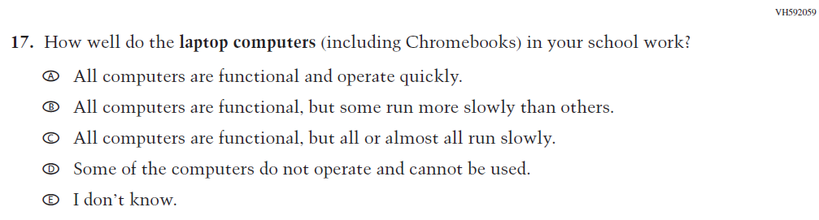  (2019 Grade 4) | Issue: Technology Use | NC | N/A

2021 Operational Grade 4 Core Teacher

Previous item | 2021 item | D/A/ R/NC+ | Rationale
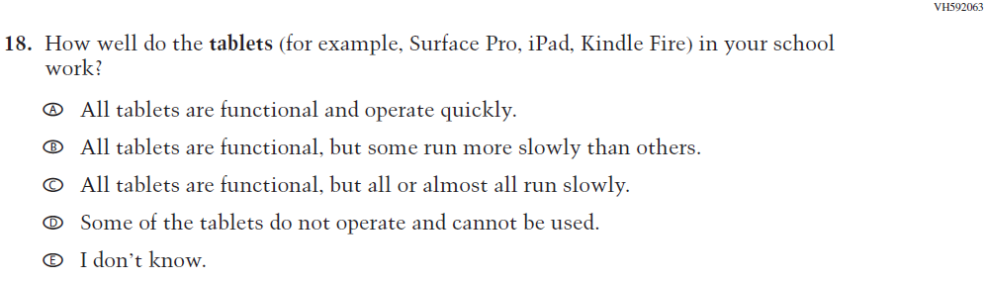  (2019 Grade 4) | Issue: Technology Use | NC | N/A
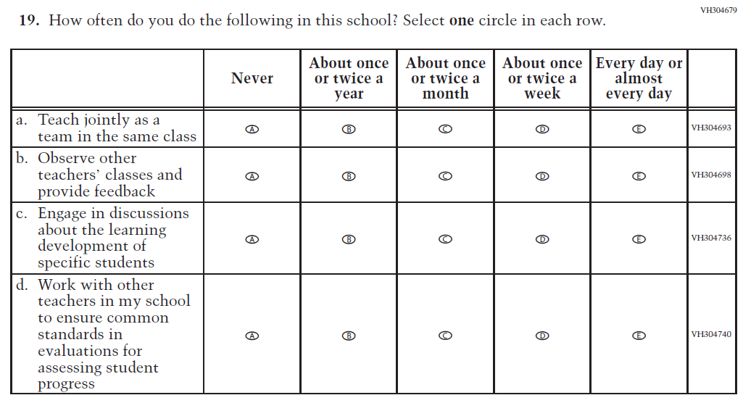  (2019 Grade 4) | Issue: School Climate | NC | N/A
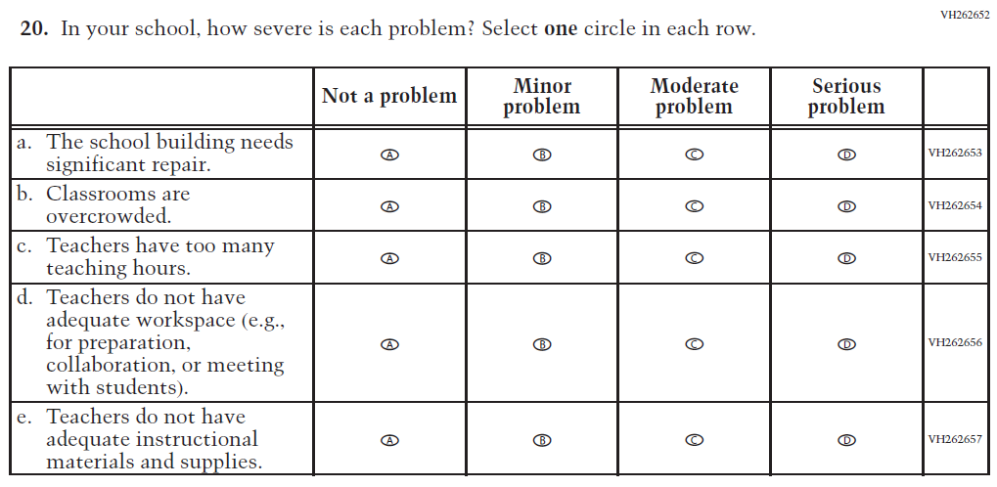  (2019 Grade 4) | Issue: School Climate | NC | N/A

2021 Operational Grade 4 Core Teacher

Previous item | 2021 item | D/A/ R/NC+ | Rationale
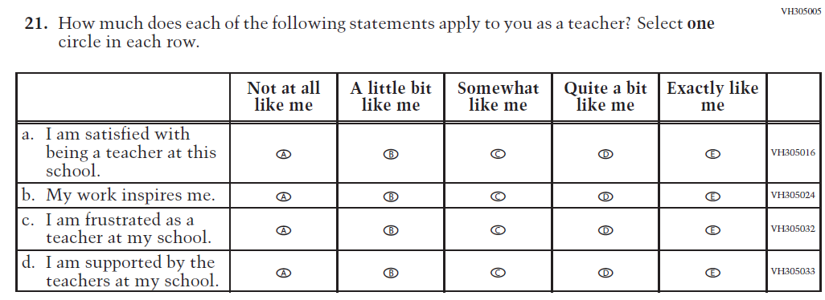  (2019 Grade 4) | Issue: School Climate | NC | N/A
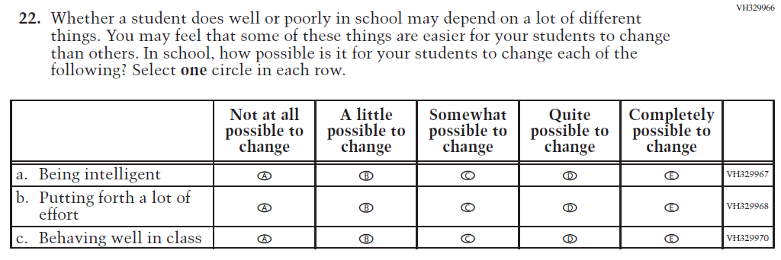  (2019 Grade 4) | Issue: Desire for Learning | NC | N/A

Appendix J2-2: Operational Grade 4 CORE
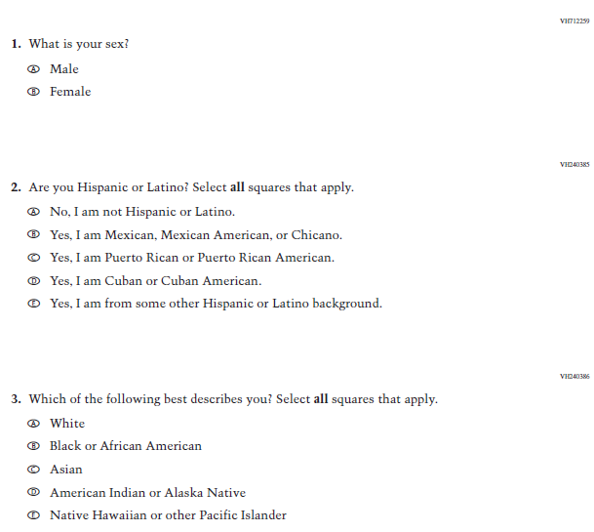

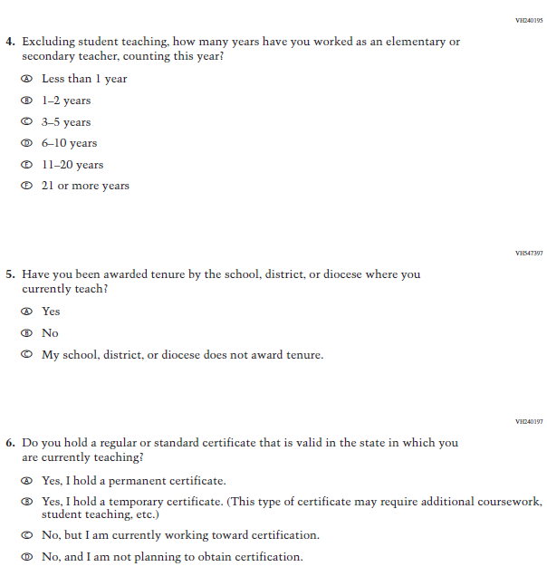
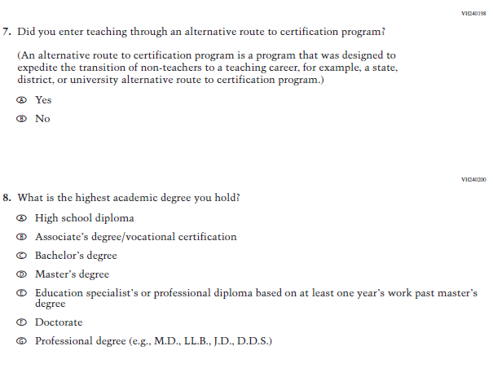
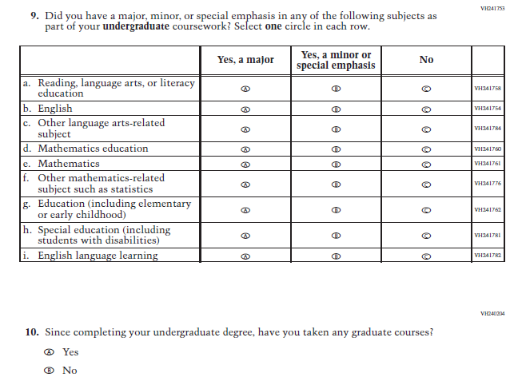
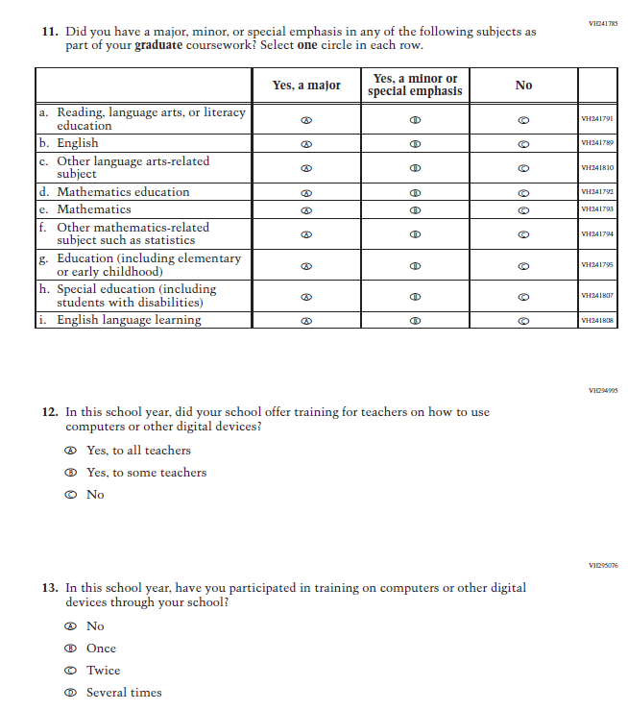

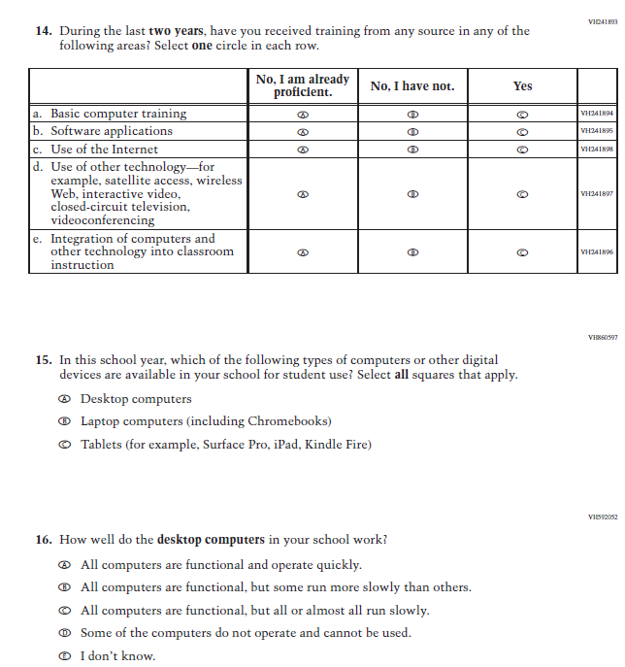

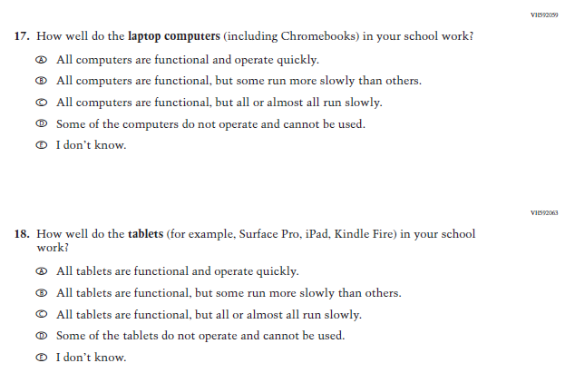

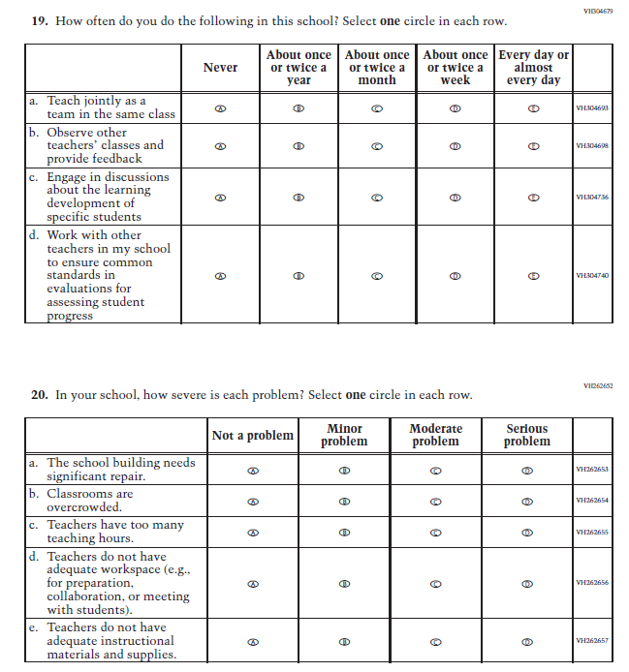

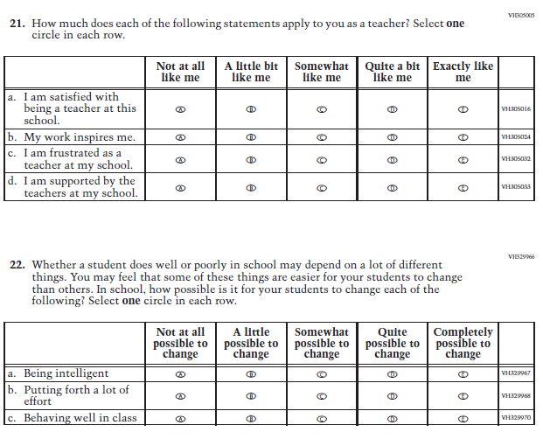

Appendix J2-3: Summary of Changes Operational Grade 8 CORE
2021 Operational Grade 8 Core Teacher

Previous item | 2021 item | D/A/ R/NC+ | Rationale
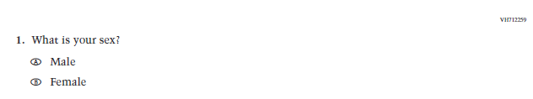  (2019 Grade 8) | Issue: Gender | NC | N/A
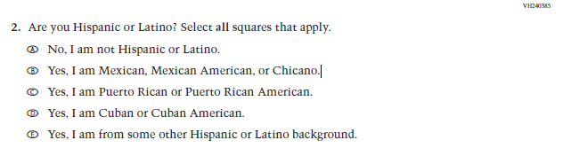  (2019 Grade 8) | Issue: Race/Ethnicity | NC | N/A
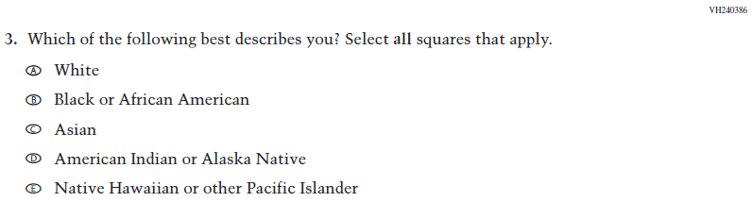  (2019 Grade 8) | Issue: Race/Ethnicity | NC | N/A
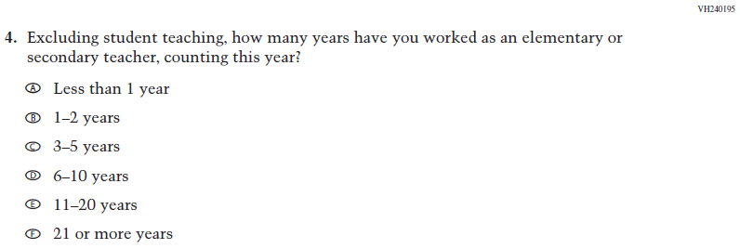  (2019 Grade 8) | Issue: Teacher Preparation | NC | N/A
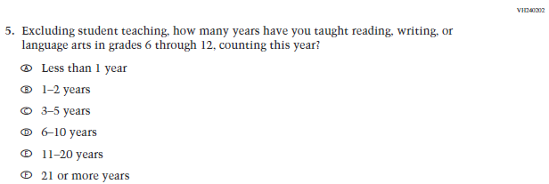  (2019 Grade 8) | Issue: Teacher Preparation | NC | N/A
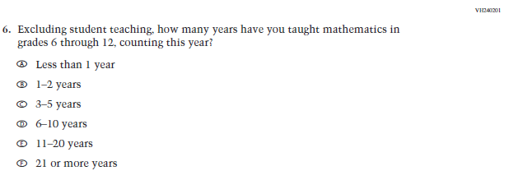  (2019 Grade 8) | Issue: Teacher Preparation | NC | N/A
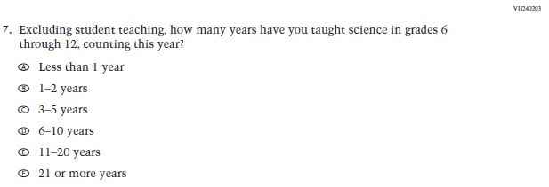  (2019 Grade 8) | N/A | D | The item was dropped because science will not be administered in 2021.
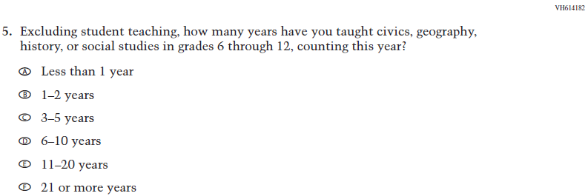  (2018 Grade 8) | 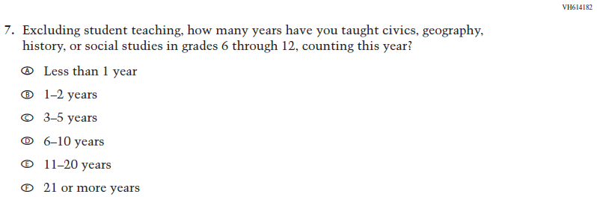  Issue: Teacher Preparation | NC | N/A
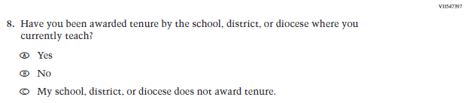  (2019 Grade 8) | Issue: Teacher Preparation | NC | N/A
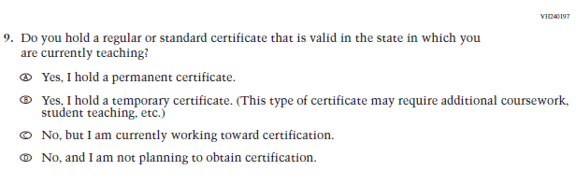  (2019 Grade 8) | Issue: Teacher Preparation | NC | N/A
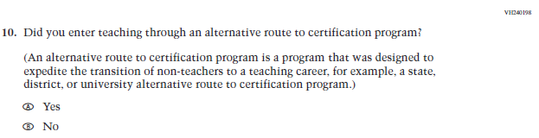  (2019 Grade 8) | Issue: Teacher Preparation | NC | N/A
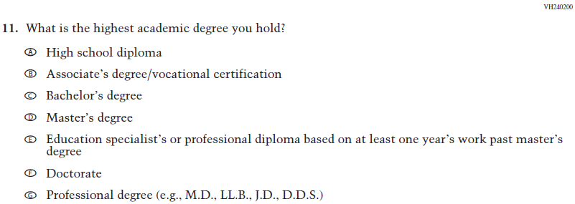  (2019 Grade 8) | Issue: Teacher Preparation | NC | N/A
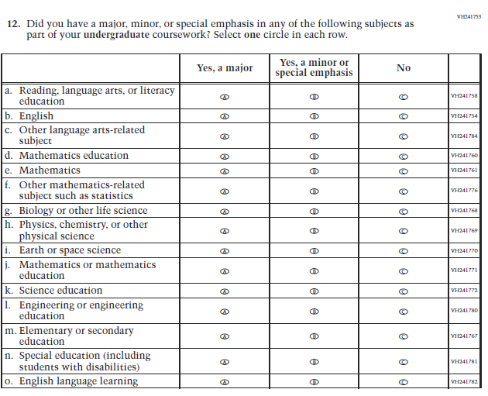  (2019 Grade 8) | 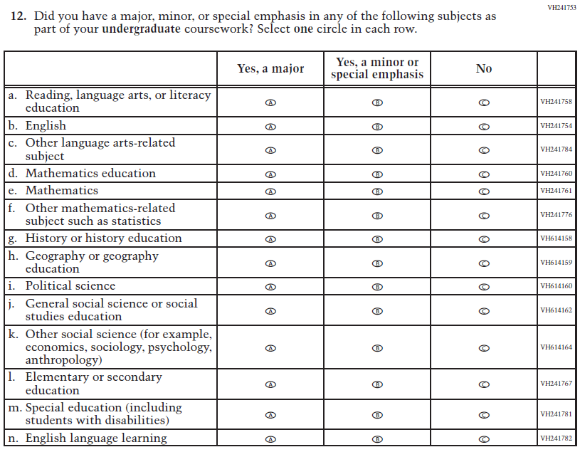  Issue: Teacher Preparation | R | This item is customized by subject and has been revised to remove sub-items for science and expanded to also include sub-items for social studies.
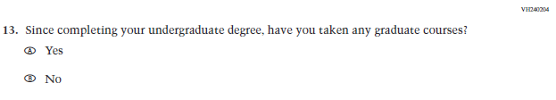  (2019 Grade 8) | Issue: Teacher Preparation | NC | N/A
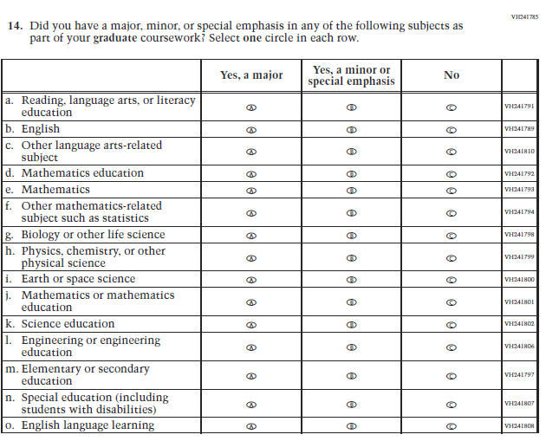  (2019 Grade 8) | 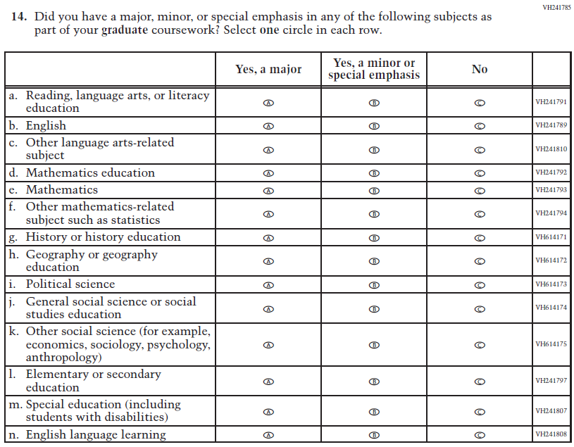  Issue: Teacher Preparation | R | This item is customized by subject and has been revised to remove sub-items for science and expanded to also include sub-items for social studies.
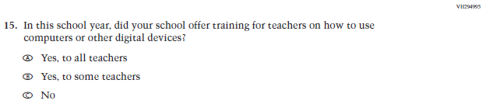  (2019 Grade 8) | Issue: Technology Use | NC | N/A
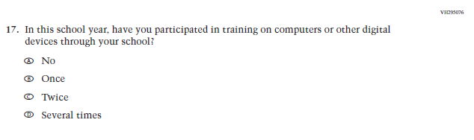(2019 Grade 8) | 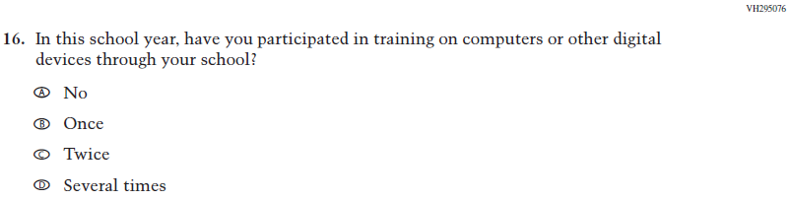  Issue: Technology Use | NC | N/A
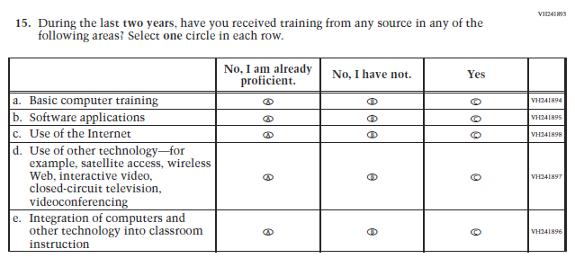  (2019 Grade 8) | 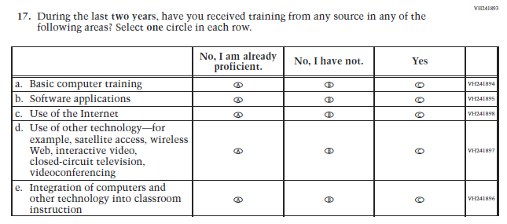  Issue: Teacher Preparation | NC | N/A
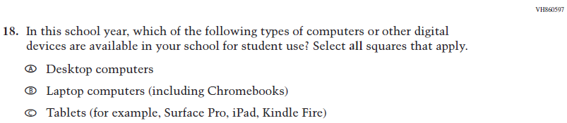  (2019 Grade 8) | Issue: Technology Use | NC | N/A
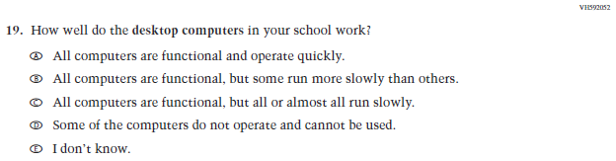  (2019 Grade 8) | Issue: Technology Use | NC | N/A
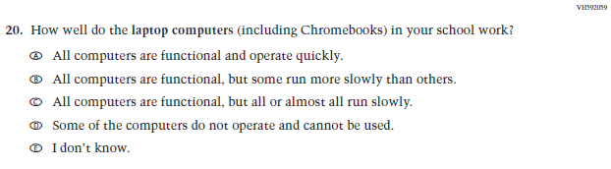  (2019 Grade 8) | Issue: Technology Use | NC | N/A
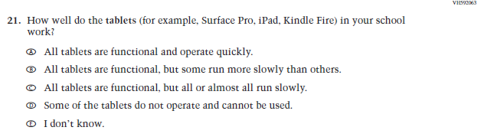  (2019 Grade 8) | Issue: Technology Use | NC | N/A
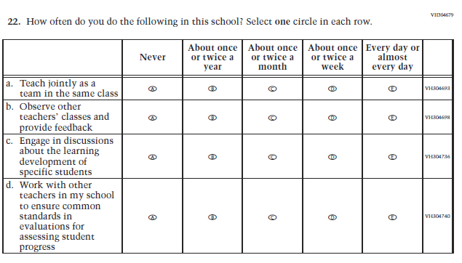  (2019 Grade 8) | Issue: School Climate | NC | N/A
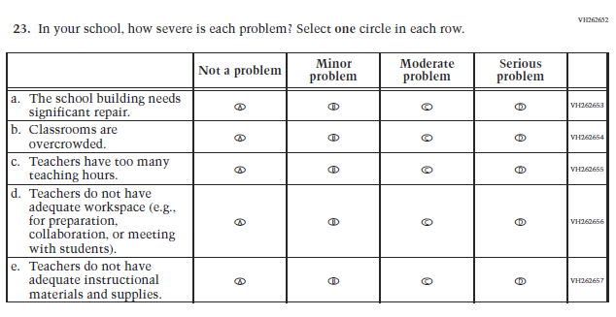  (2019 Grade 8) | Issue: School Climate | NC | N/A
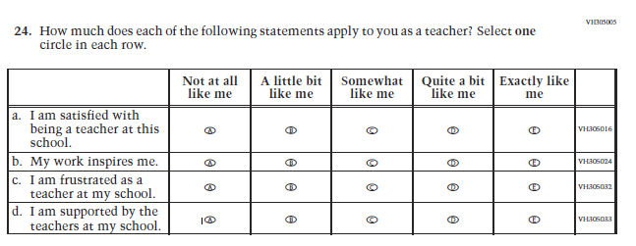  (2019 Grade 8) | Issue: School Climate | NC | N/A
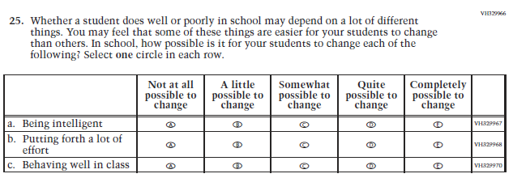  (2019 Grade 8) | Issue: Desire for Learning | NC | N/A

Appendix J2-4: Operational Grade 8 CORE
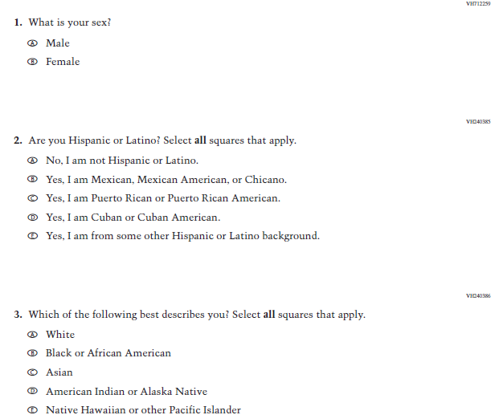

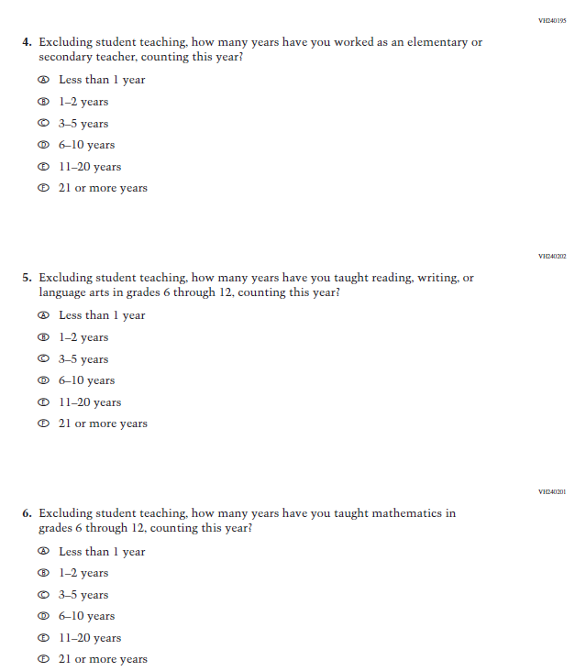
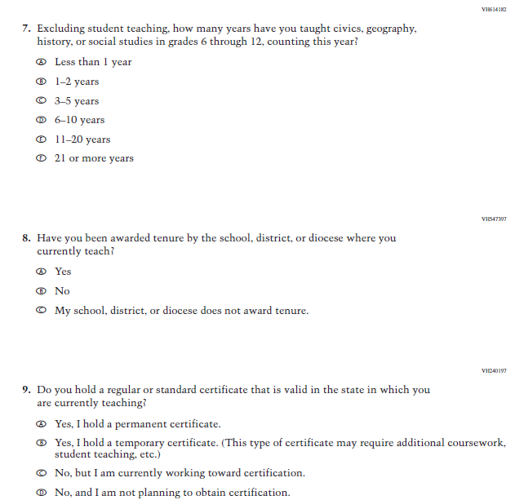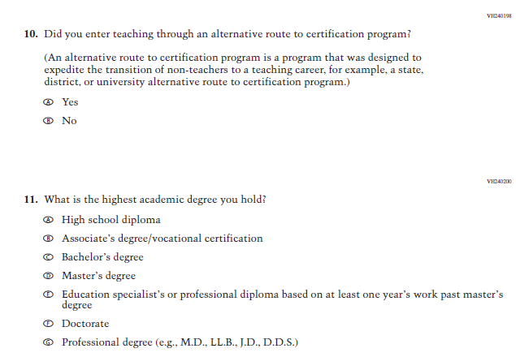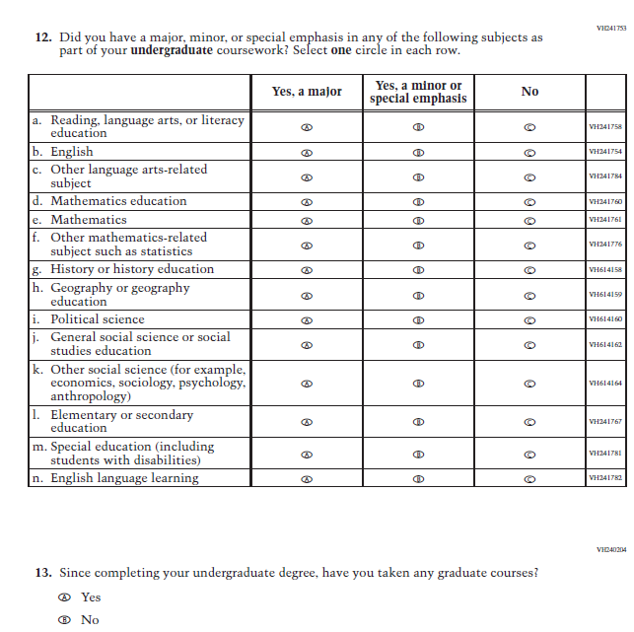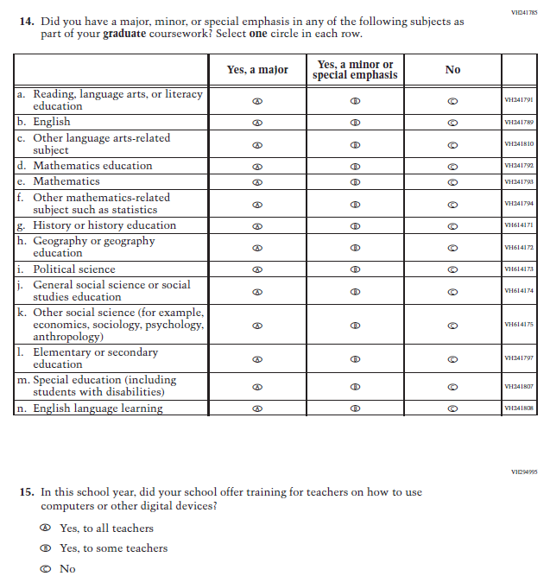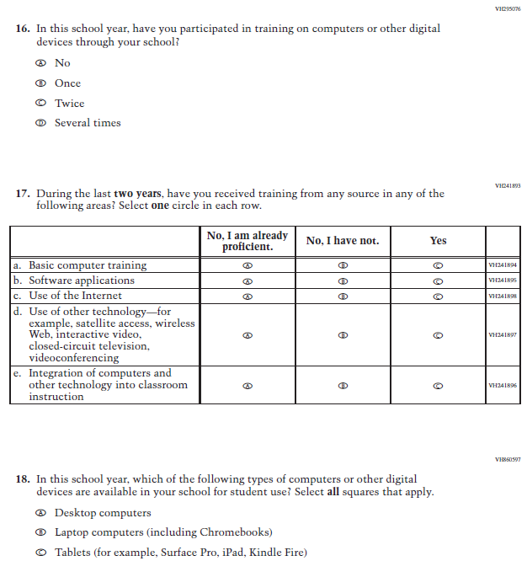
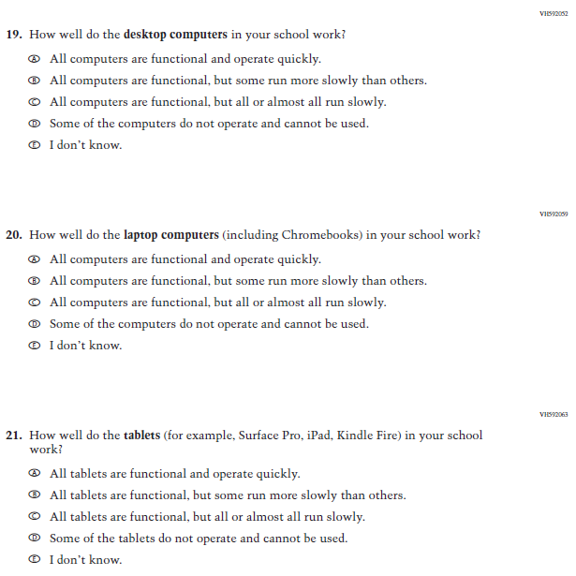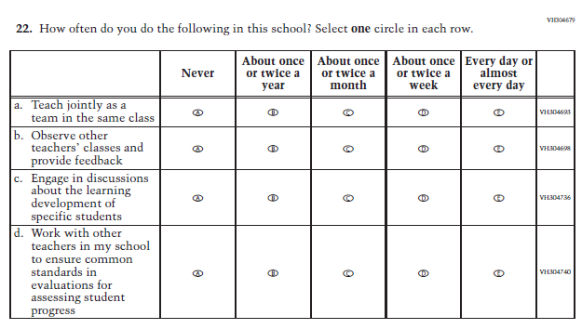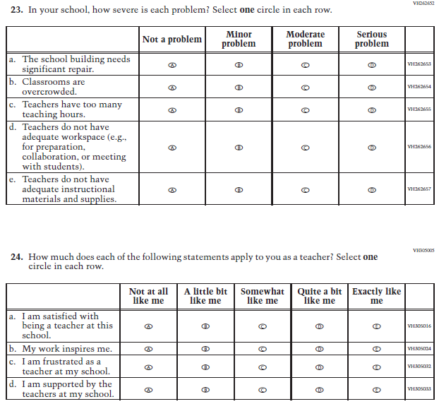
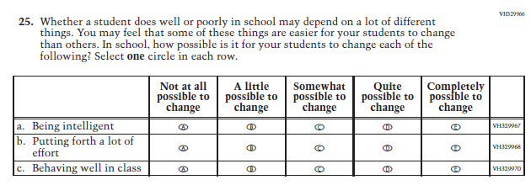

Appendix J2-5: Summary of Changes Operational Grade 4 Mathematics
2021 Operational Grade 4 Mathematics Teacher

Previous item | 2021 item | D/A/ R/NC+ | Rationale
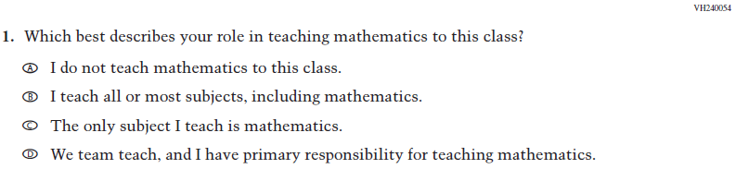  (2019 Grade 4) | Issue: Resources for Learning and Instruction | NC | N/A
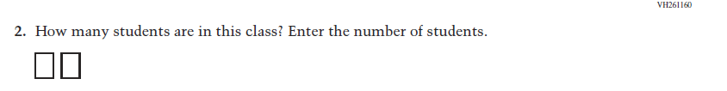  (2019 Grade 4) | Issue: Resources for Learning and Instruction | NC | N/A
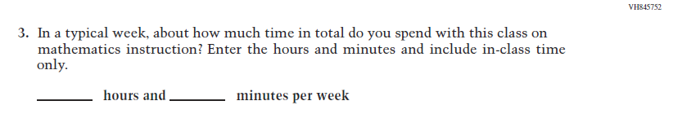  (2019 Grade 4) | Issue: Resources for Learning and Instruction | NC | N/A
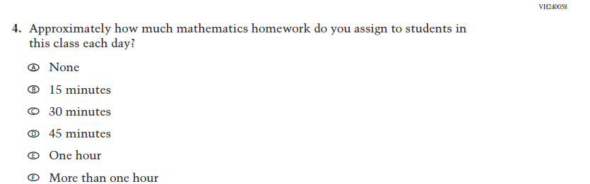  (2019 Grade 4) | Issue: Organization of Instruction | NC | N/A
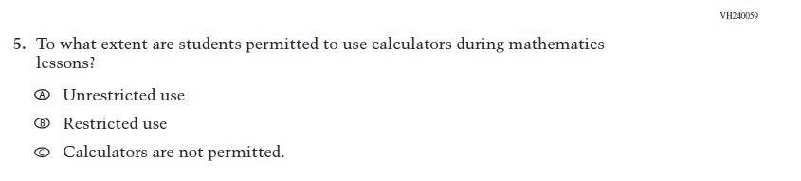  (2019 Grade 4) | Issue: Organization of Instruction | NC | N/A
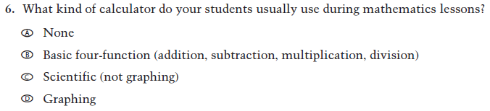  (2019 Grade 4) | Issue: Resources for learning and instruction | NC | N/A
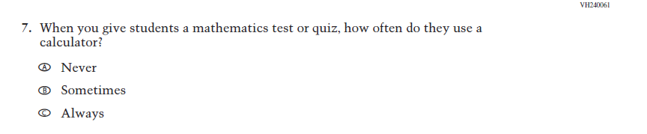  (2019 Grade 4) | Issue: Organization of Instruction | NC | N/A
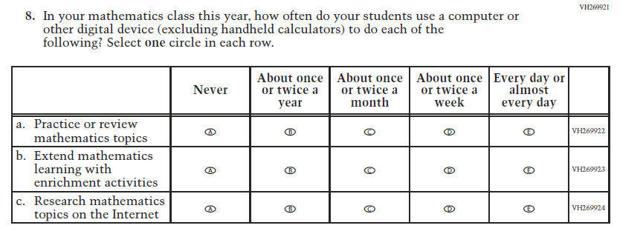  (2019 Grade 4) | Issue: Organization of Instruction | NC | N/A
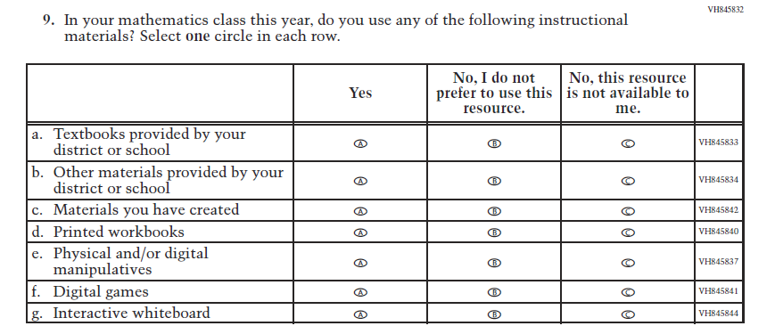  (2019 Grade 4) | Issue: Resources for Learning and Instruction | NC | N/A
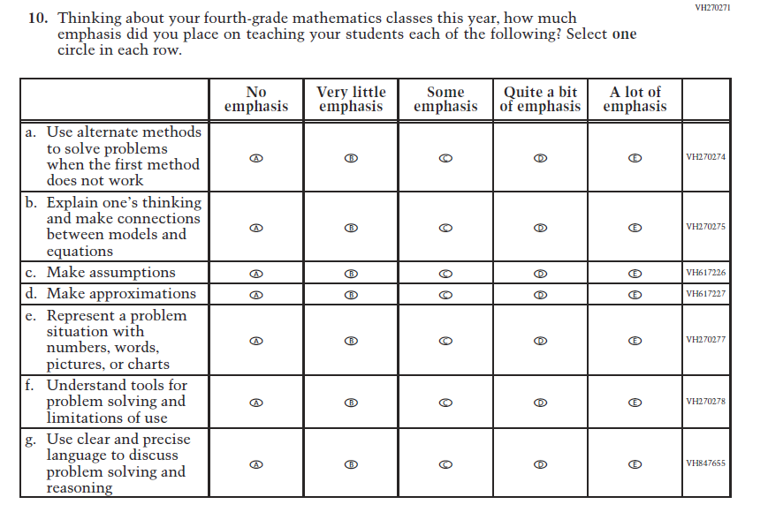  (2019 Grade 4) | Issue: Organization of Instruction | NC | N/A
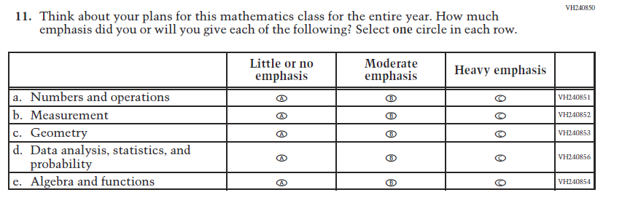  (2019 Grade 4) | Issue: Organization of Instruction | NC | N/A
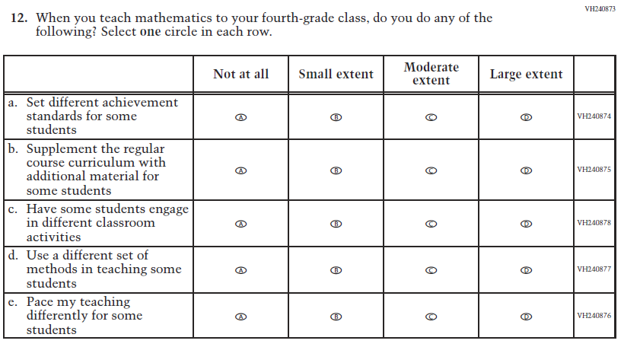  (2019 Grade 4) | Issue: Organization of Instruction | NC | N/A
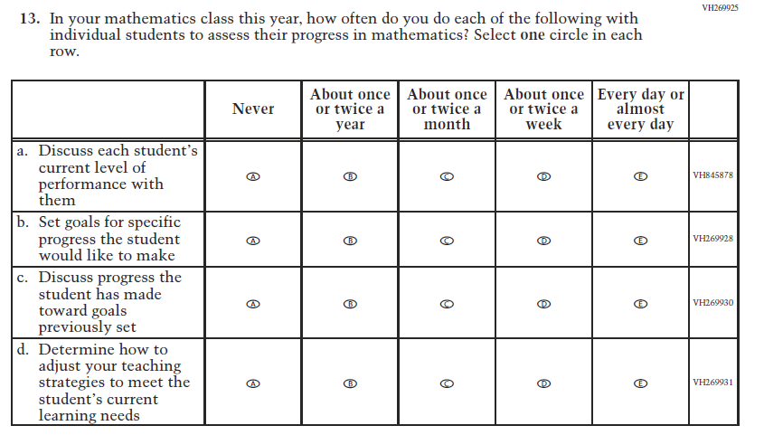  (2019 Grade 4) | Issue: Organization of Instruction | NC | N/A
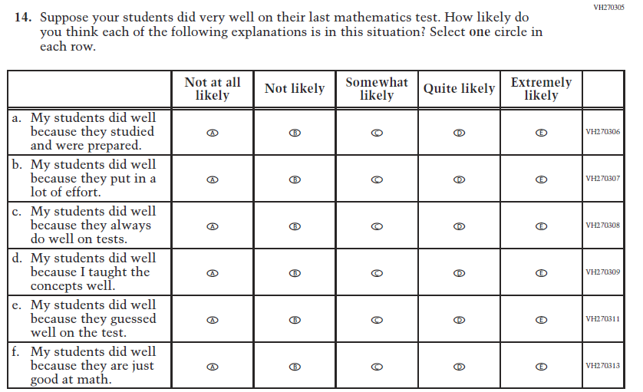  (2019 Grade 4) | Issue: Teacher Preparation | NC | N/A
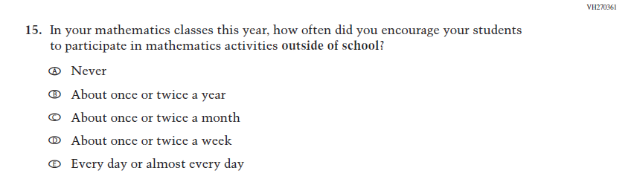  (2019 Grade 4) | Issue: Resources for Learning and Instruction | NC | N/A
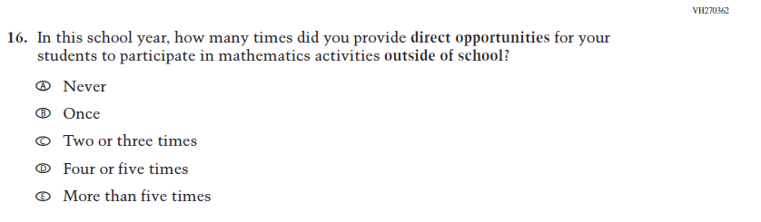  (2019 Grade 4) | Issue: Resources for Learning and Instruction | NC | N/A

Appendix J2-6: Operational Grade 4 Mathematics
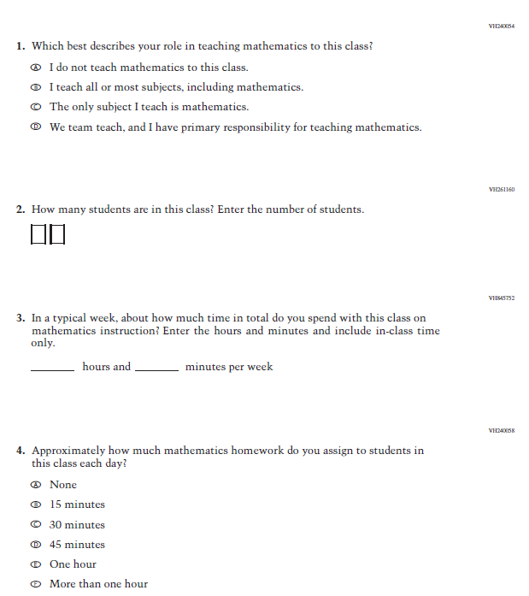

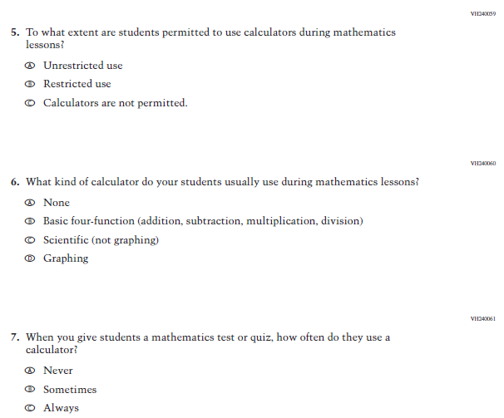

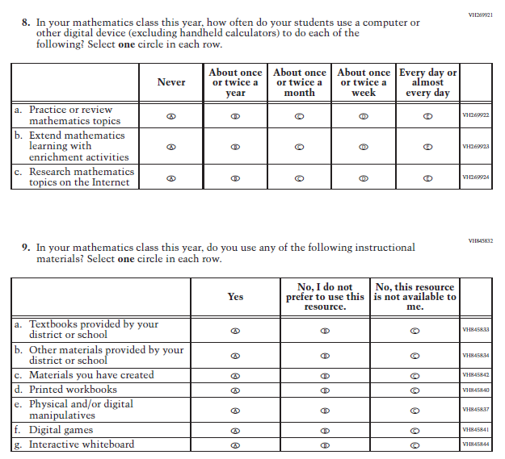

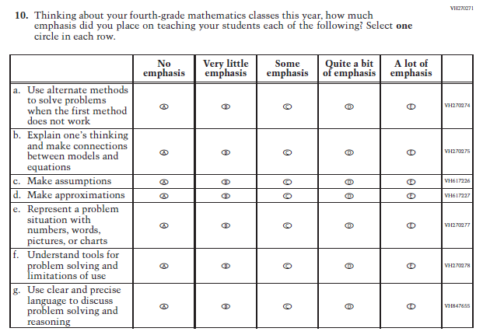
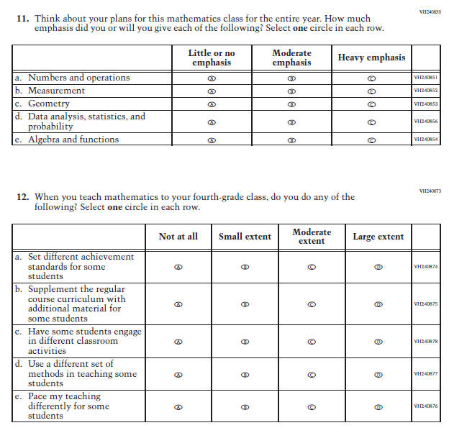
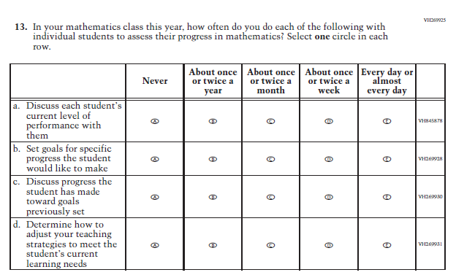

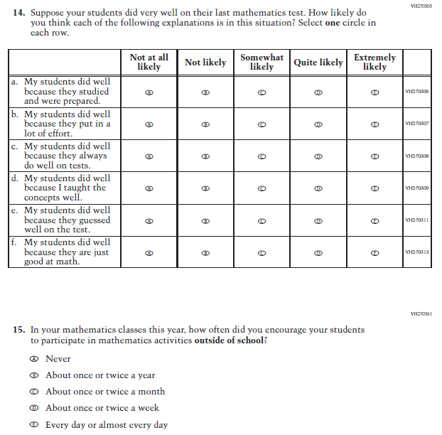
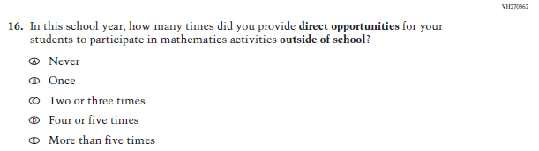

Appendix J2-7: Summary of Changes Operational Grade 8 Mathematics
2021 Operational Grade 8 Mathematics Teacher

Previous item | 2021 item | D/A/ R/NC+ | Rationale
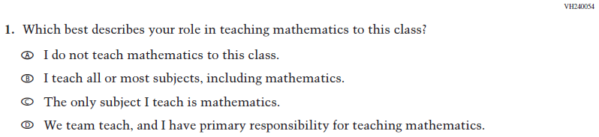  (2019 Grade 8) | Issue: Resources for Learning and Instruction | NC | N/A
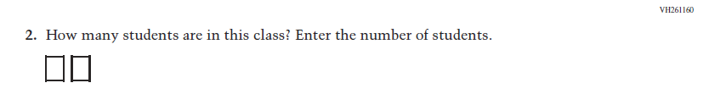  (2019 Grade 8) | 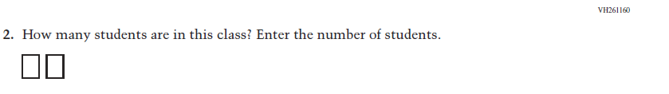  Issue: Resources for Learning and Instruction | NC | N/A
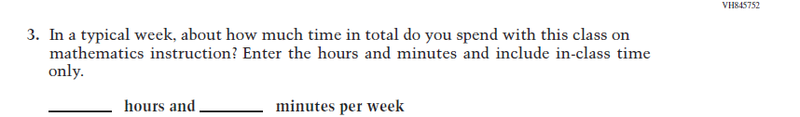  (2019 Grade 8) | Issue: Resources for Learning and Instruction | NC | N/A
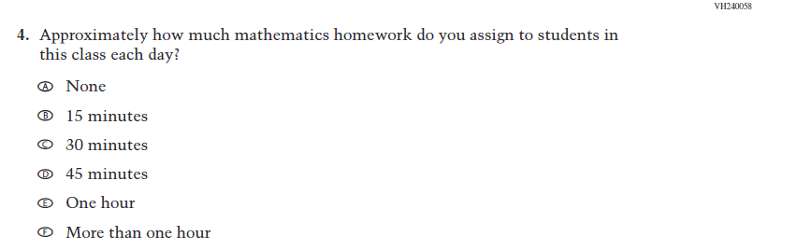  (2019 Grade 8) | Issue: Organization of Instruction | NC | N/A
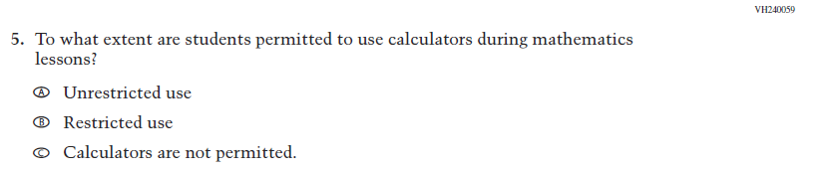  (2019 Grade 8) | Issue: Organization of Instruction | NC | N/A
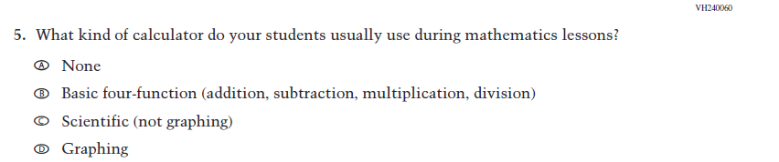  (2019 Grade 8) | 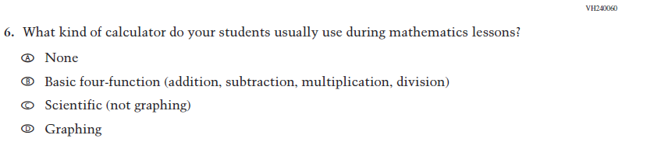  Issue: Resources for Learning and Instruction | NC | N/A
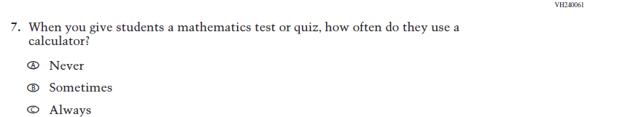  (2019 Grade 8) | Issue: Organization of Instruction | NC | N/A
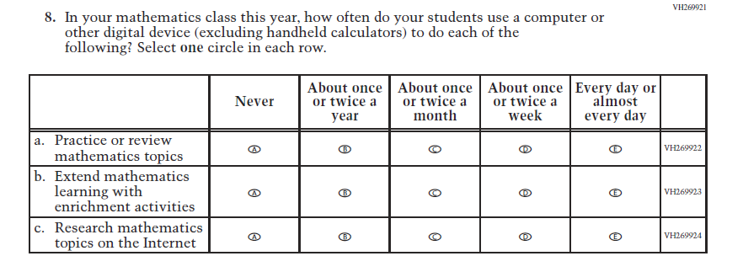  (2019 Grade 8) | Issue: Organization of Instruction | NC | N/A
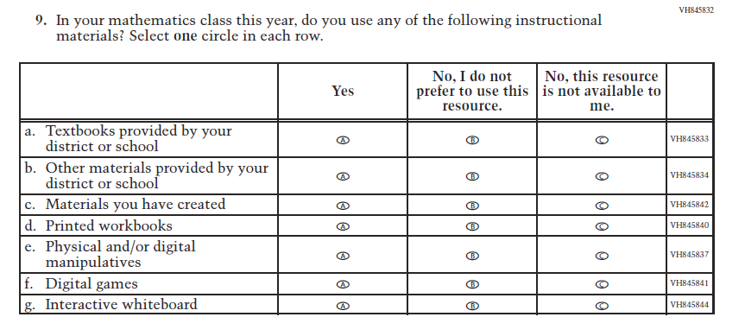  (2019 Grade 8) | Issue: Resources for Learning and Instruction | NC | N/A

2021 Operational Grade 8 Mathematics Teacher

Previous item | 2021 item | D/A/ R/NC+ | Rationale
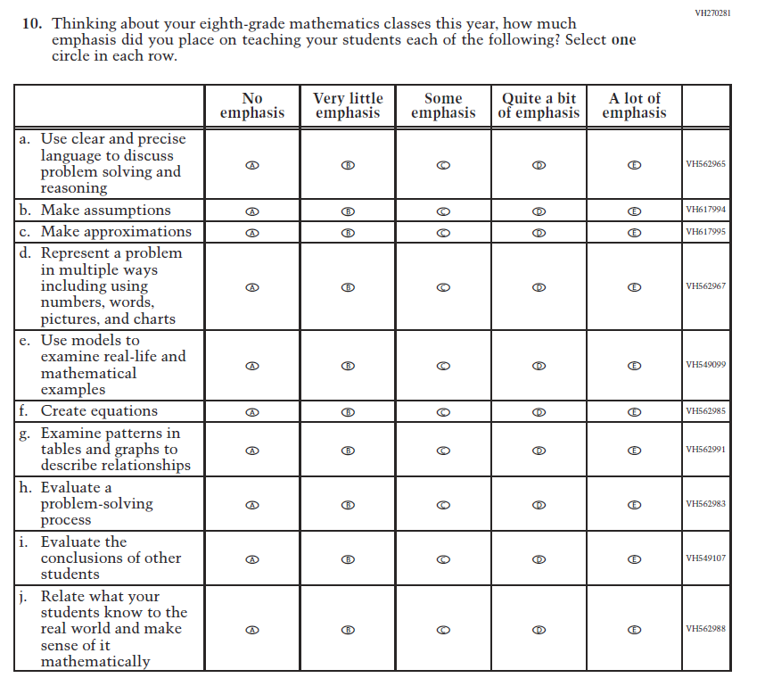  (2019 Grade 8) | Issue: Organization of Instruction | NC | N/A
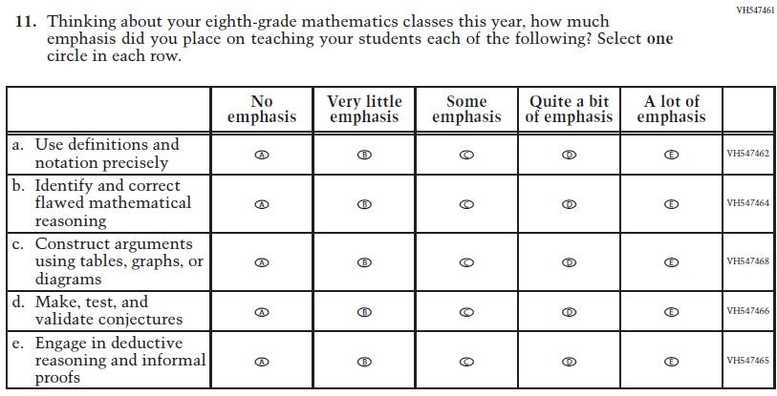  (2019 Grade 8) | Issue: Organization of Instruction | NC | N/A

2021 Operational Grade 8 Mathematics Teacher

Previous item | 2021 item | D/A/ R/NC+ | Rationale
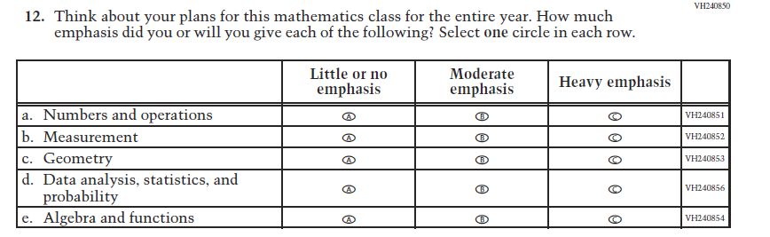  (2019 Grade 8) | Issue: Organization of Instruction | NC | N/A
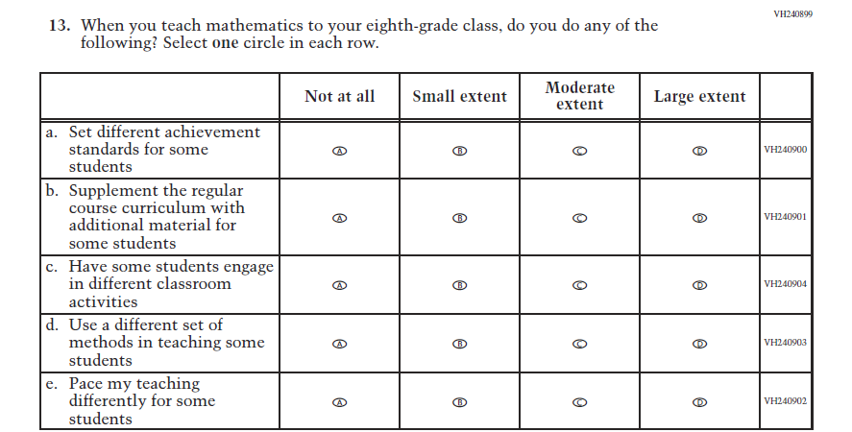  (2019 Grade 8) | Issue: Organization of Instruction | NC | N/A

2021 Operational Grade 8 Mathematics Teacher

Previous item | 2021 item | D/A/ R/NC+ | Rationale
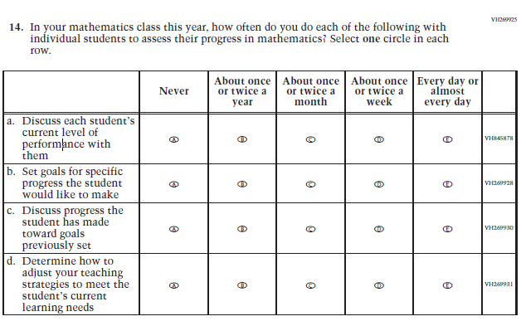  (2019 Grade 8) | Issue: Organization of Instruction | NC | N/A
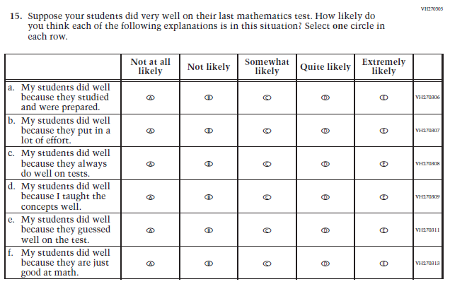  (2019 Grade 8) | Issue: Teacher Preparation | NC | N/A

2021 Operational Grade 8 Mathematics Teacher

Previous item | 2021 item | D/A/ R/NC+ | Rationale
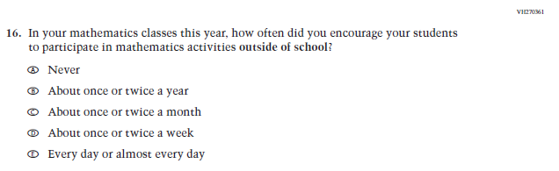  (2019 Grade 8) | Issue: Resources for Learning and Instruction | NC | N/A
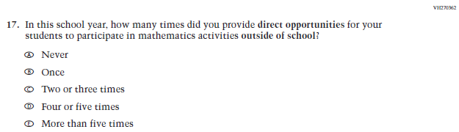  (2019 Grade 8) | Issue: Resources for Learning and Instruction | NC | N/A
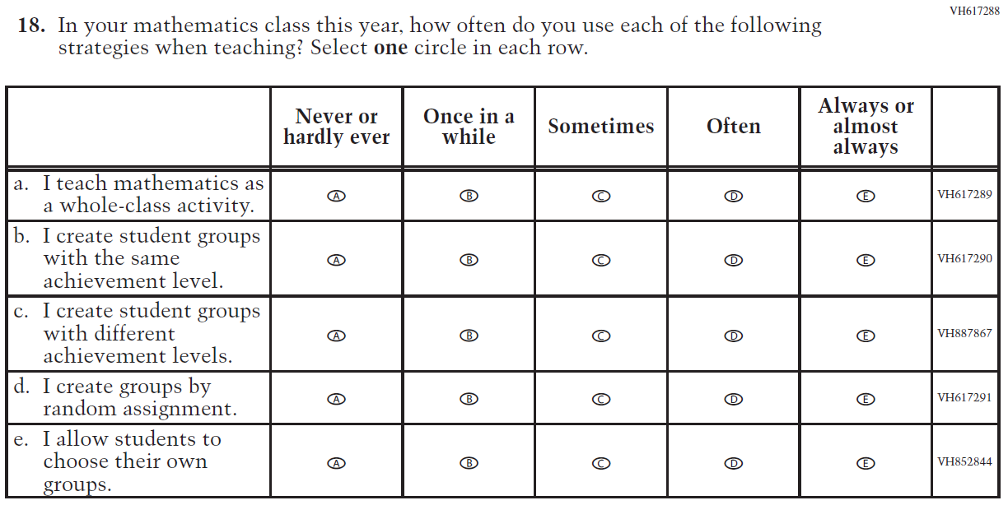  (2019 Grade 8) | Issue: Organization of Instruction | NC | N/A

Appendix J2-8: Operational Grade 8 Mathematics
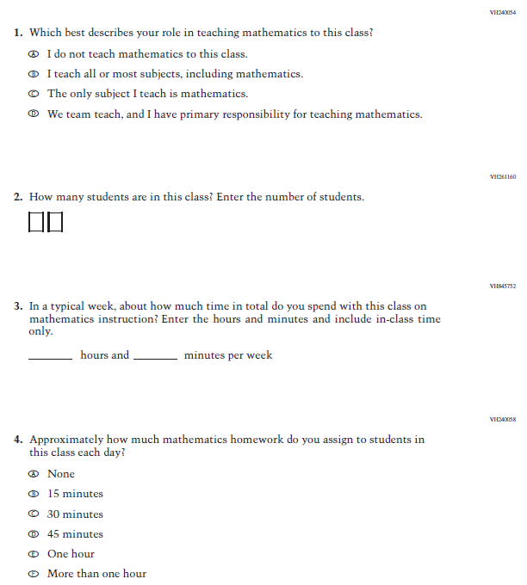

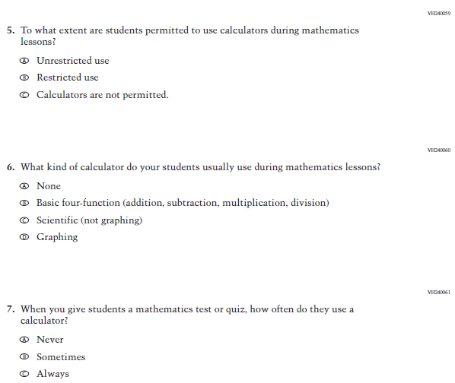
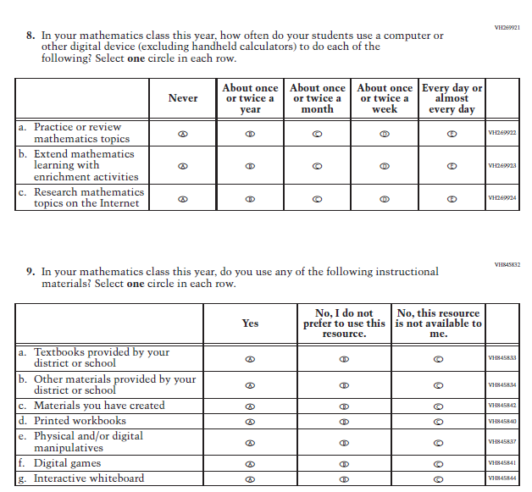

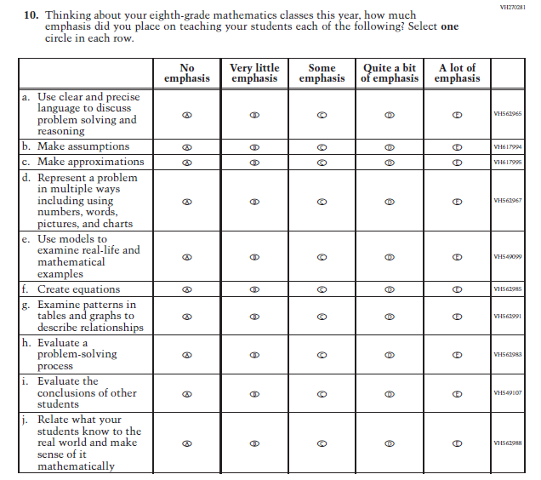
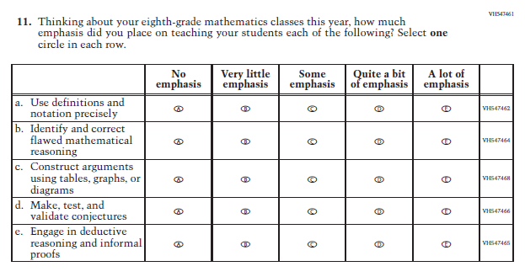
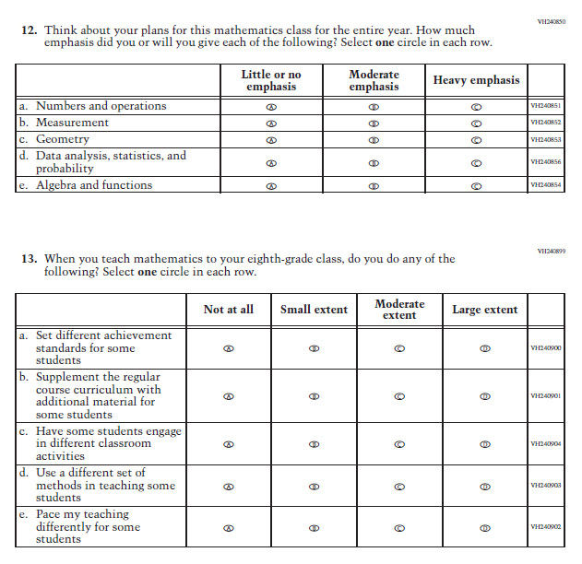
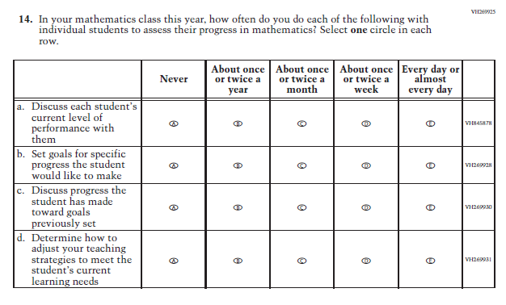
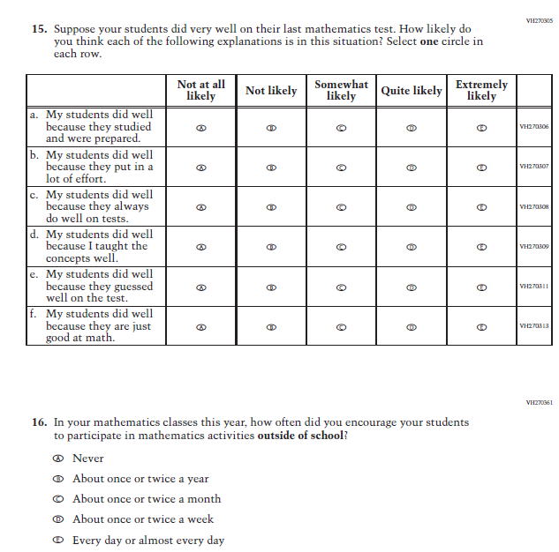
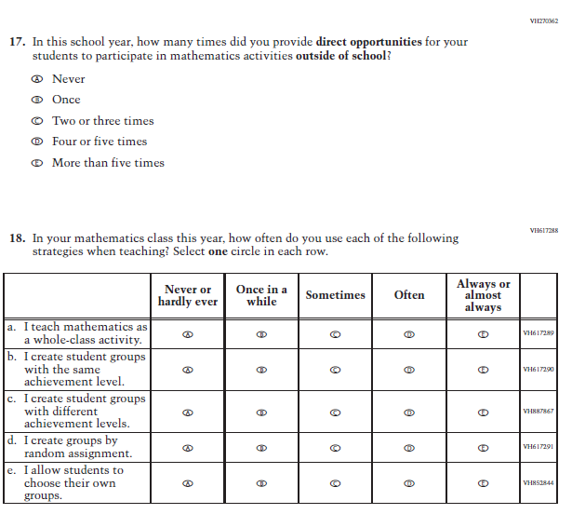

Appendix J2-9: Summary of Changes Operational Grade 4 Reading
2021 Operational Grade 4 Reading Teacher

Previous item | 2021 item | D/A/ R/NC+ | Rationale
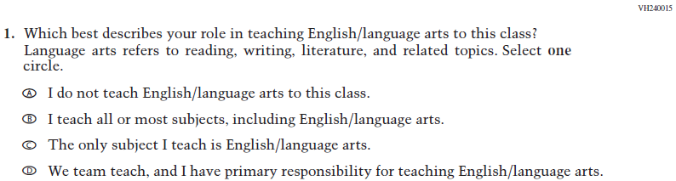  (2019 Grade 4) | Issue: Resources for Learning and Instruction | NC | N/A
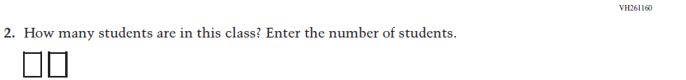  (2019 Grade 4) | Issue: Resources for Learning and Instruction | NC | N/A
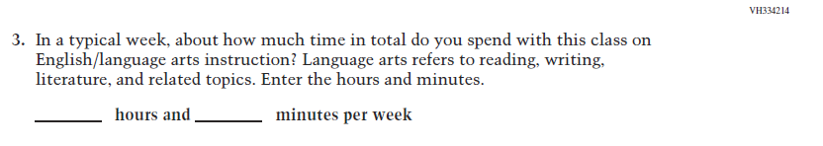  (2019 Grade 4) | Issue: Resources for Learning and Instruction | NC | N/A
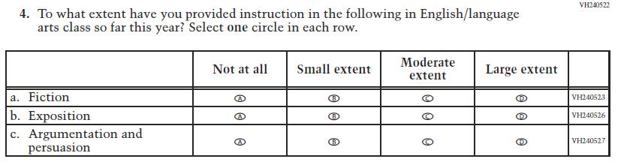  (2019 Grade 4) | Issue: Organization of Instruction | NC | N/A

2021 Operational Grade 4 Reading Teacher

Previous item | 2021 item | D/A/ R/NC+ | Rationale
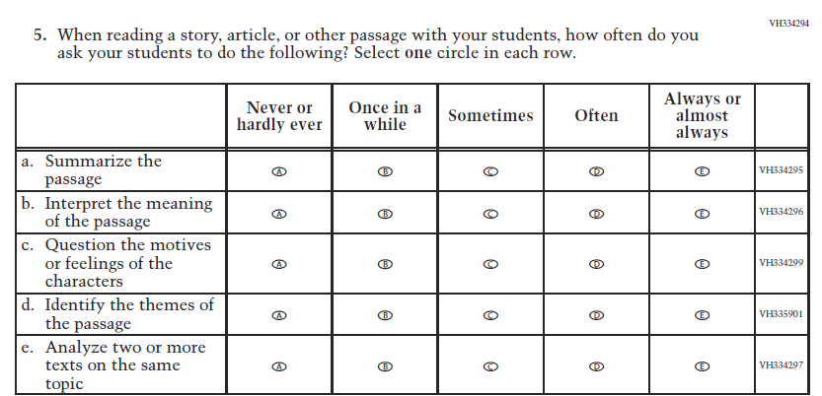  (2019 Grade 4) | Issue: Organization of Instruction | NC | N/A
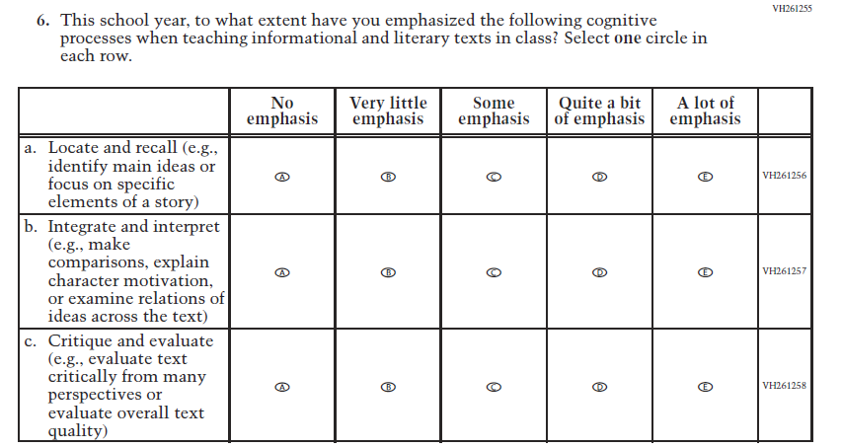  (2019 Grade 4) | Issue: Organization of Instruction | NC | N/A

2021 Operational Grade 4 Reading Teacher

Previous item | 2021 item | D/A/ R/NC+ | Rationale
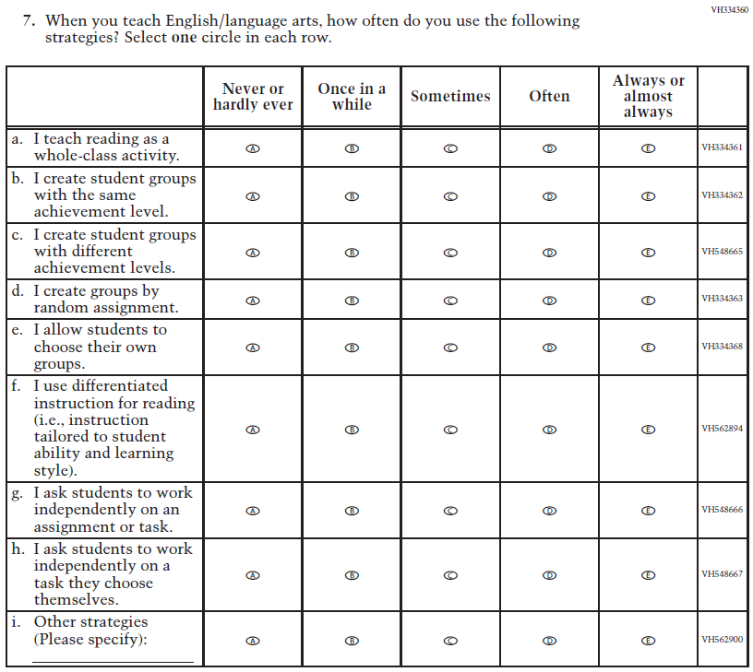  (2019 Grade 4) | Issue: Organization of Instruction | NC | N/A

2021 Operational Grade 4 Reading Teacher

Previous item | 2021 item | D/A/ R/NC+ | Rationale
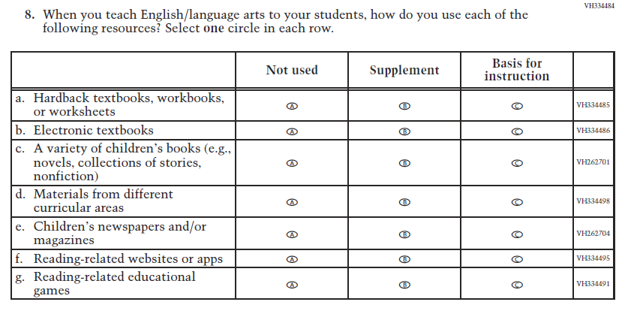  (2019 Grade 4) | Issue: Organization of Instruction | NC | N/A
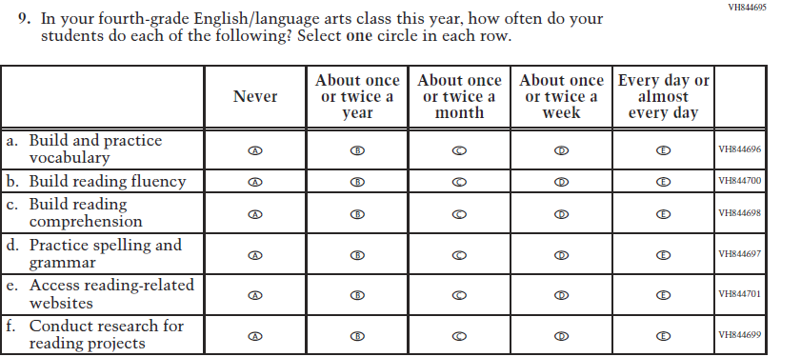  (2019 Grade 4) | Issue: Organization of Instruction | NC | N/A

2021 Operational Grade 4 Reading Teacher

Previous item | 2021 item | D/A/ R/NC+ | Rationale
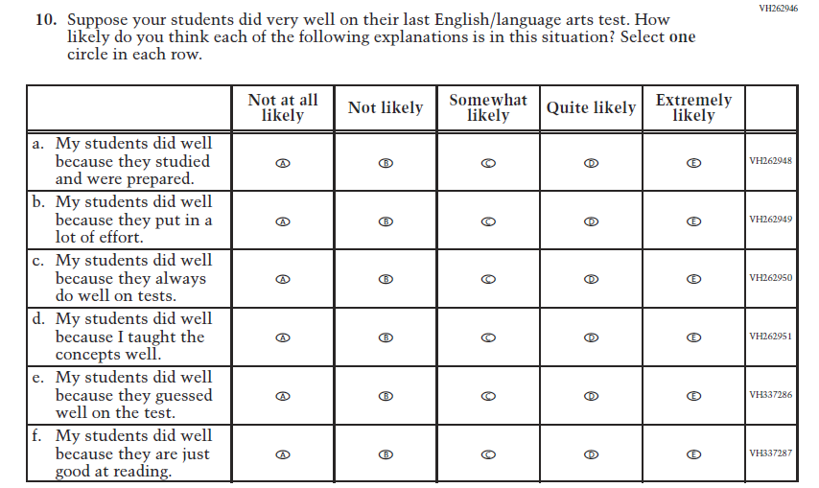  (2019 Grade 4) | Issue: Teacher Preparation | NC | N/A
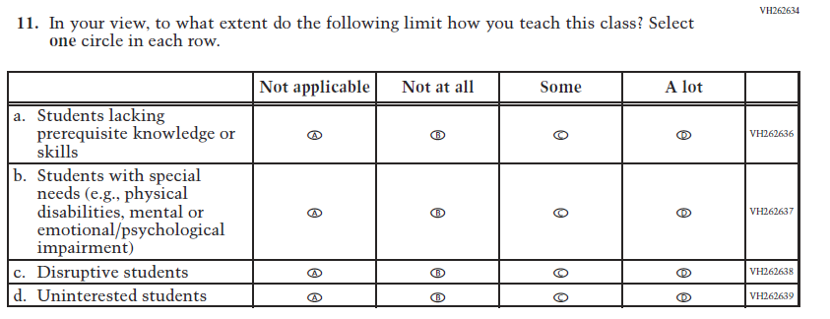  (2019 Grade 4) | Issue: Resources for Learning and Instruction | NC | N/A

Appendix J2-10: Operational Grade 4 Reading
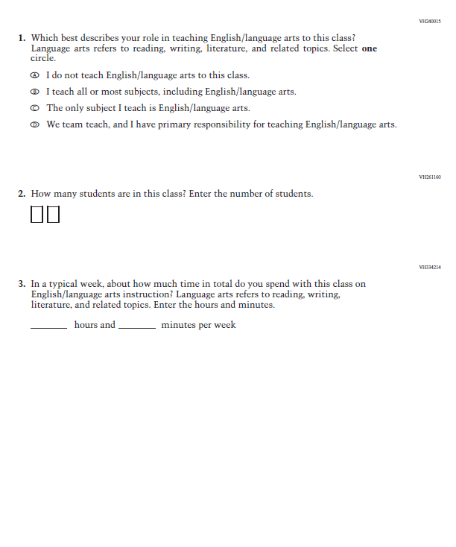

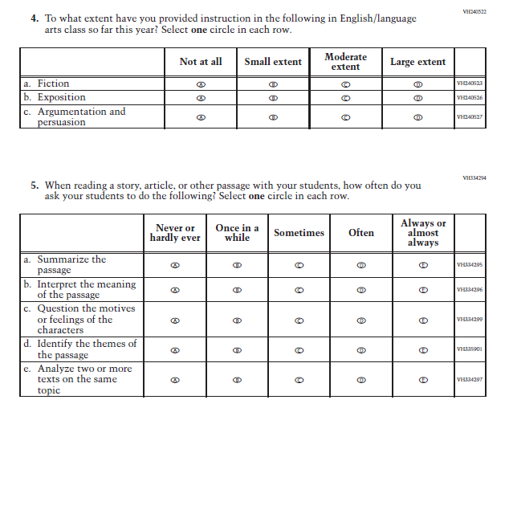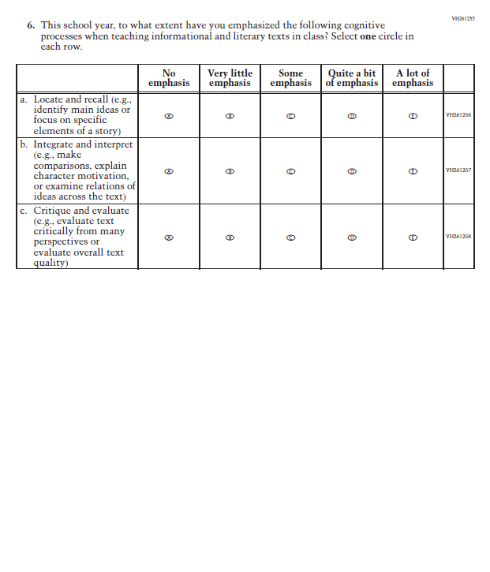
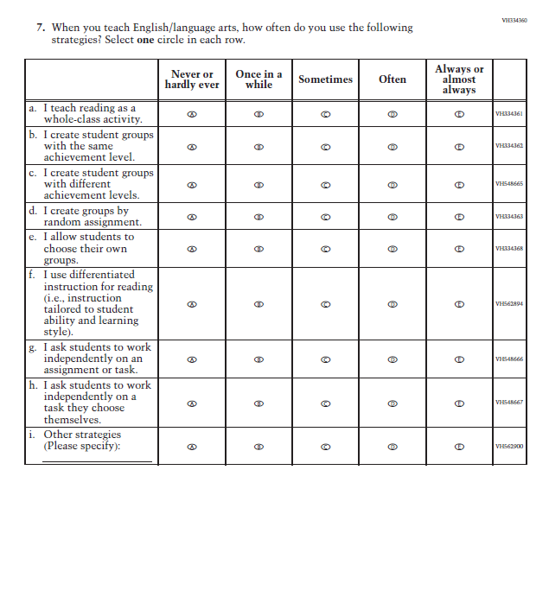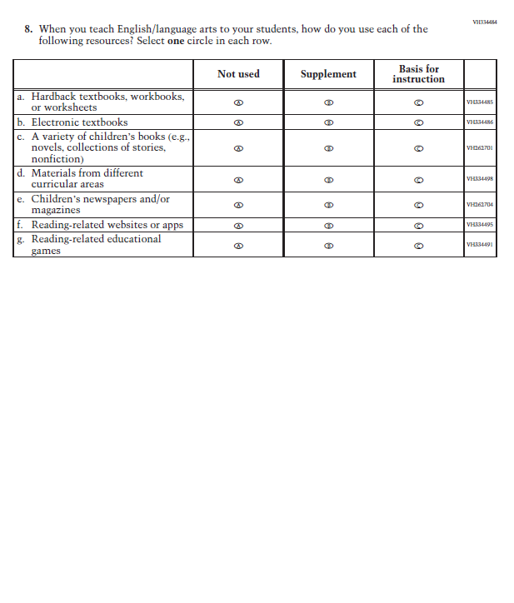

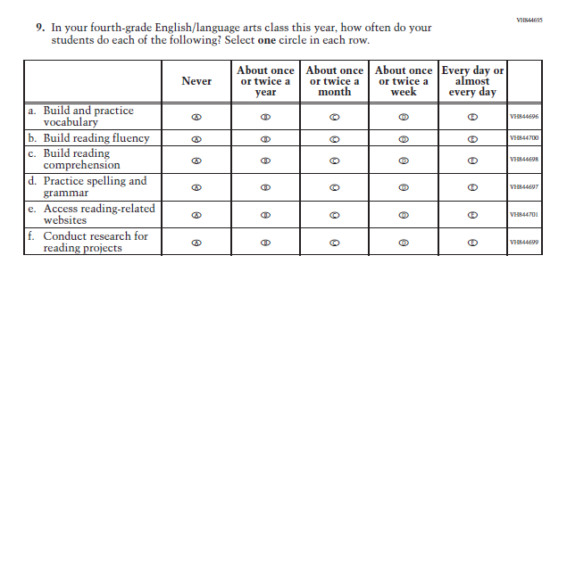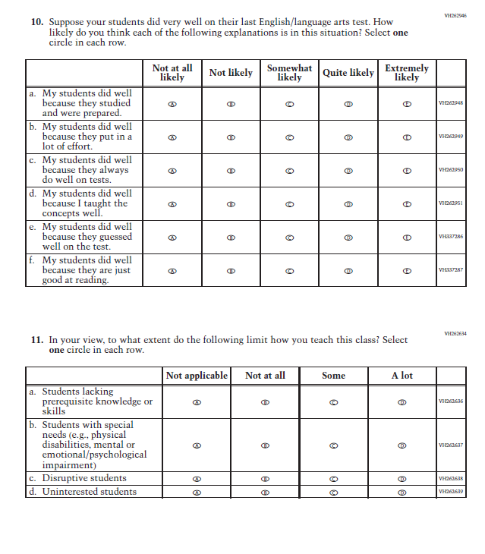

Appendix J2-11: Summary of Changes Operational Grade 8 Reading
2021 Operational Grade 8 Reading Teacher

Previous item | 2021 item | D/A/ R/NC+ | Rationale
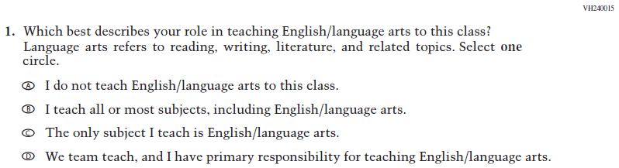  (2019 Grade 8) | Issue: Resources for Learning and Instruction | NC | N/A
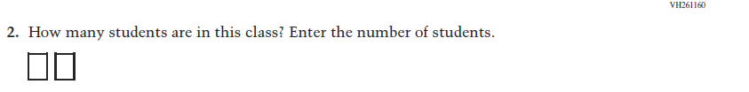  (2019 Grade 8) | Issue: Resources for Learning and Instruction | NC | N/A
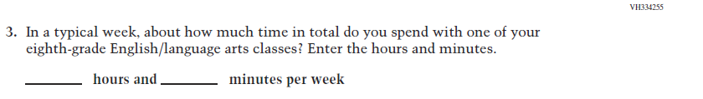  (2019 Grade 8) | Issue: Resources for Learning and Instruction | NC | N/A
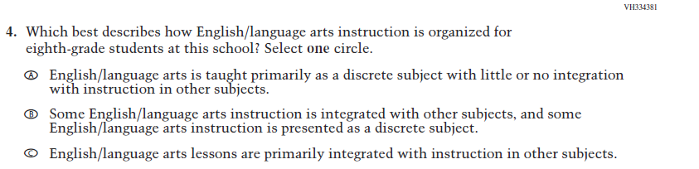  (2019 Grade 8) | Issue: Organization of Instruction | NC | N/A

2021 Operational Grade 8 Reading Teacher

Previous item | 2021 item | D/A/ R/NC+ | Rationale
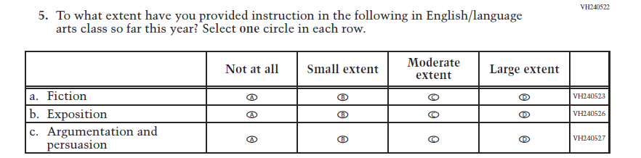  (2019 Grade 8) | Issue: Organization of Instruction | NC | N/A
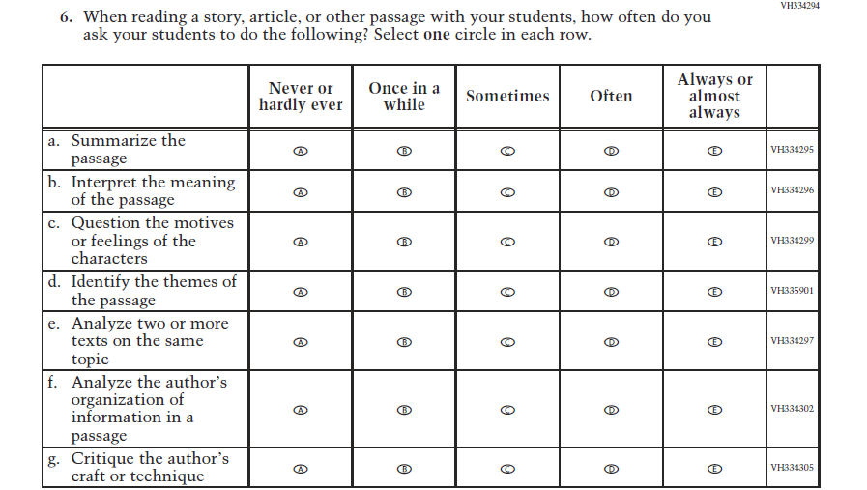  (2019 Grade 8) | Issue: Organization of Instruction | NC | N/A

.
2021 Operational Grade 8 Reading Teacher

Previous item | 2021 item | D/A/ R/NC+ | Rationale
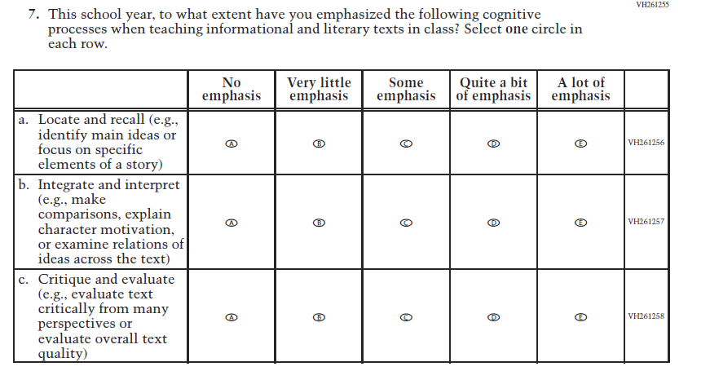  (2019 Grade 8) | Issue: Organization of Instruction | NC | N/A
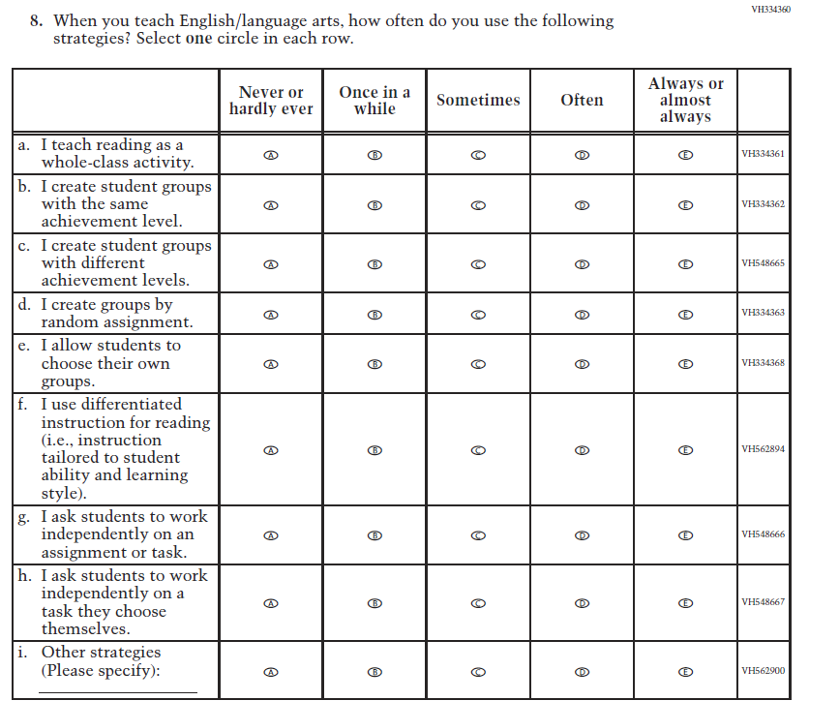  (2019 Grade 8) | Issue: Organization of Instruction | NC | N/A

2021 Operational Grade 8 Reading Teacher

Previous item | 2021 item | D/A/ R/NC+ | Rationale
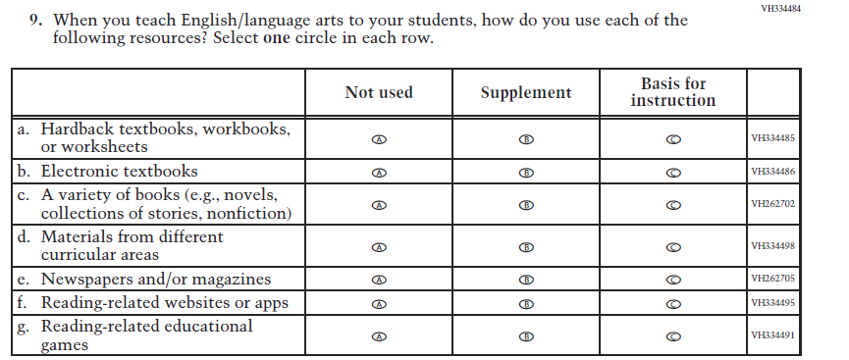  (2019 Grade 8) | Issue: Organization of Instruction | NC | N/A
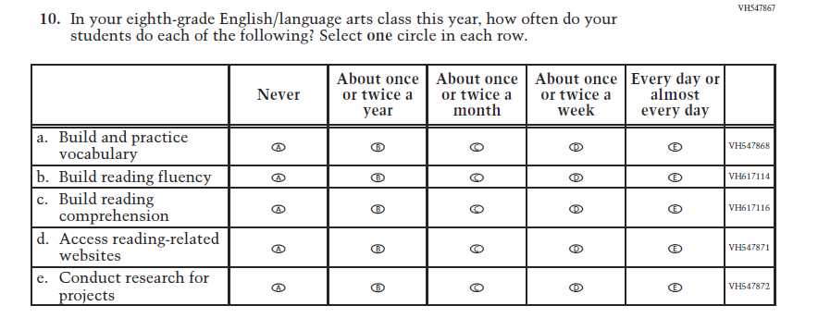  (2019 Grade 8) | Issue: Organization of Instruction | NC | N/A

2021 Operational Grade 8 Reading Teacher

Previous item | 2021 item | D/A/ R/NC+ | Rationale
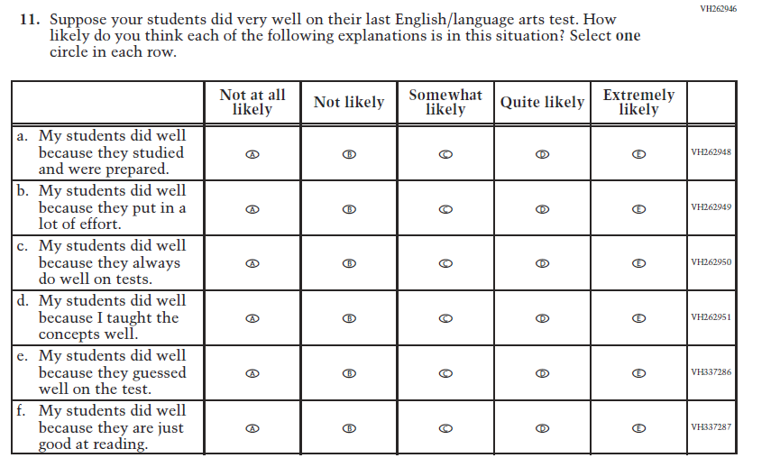  (2019 Grade 8) | Issue: Teacher Preparation | NC | N/A
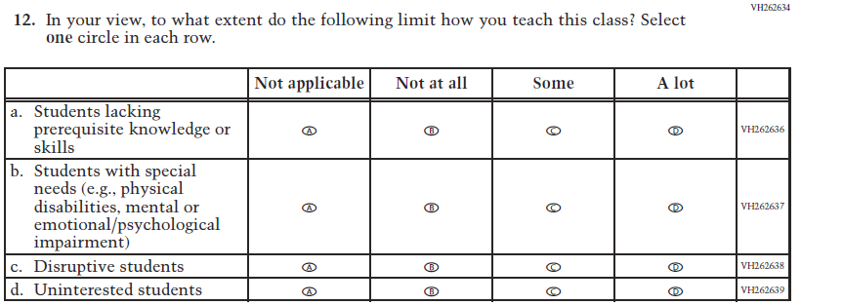  (2019 Grade 8) | Issue: Resources for Learning and Instruction | NC | N/A

Appendix J2-12: Operational Grade 8 Reading
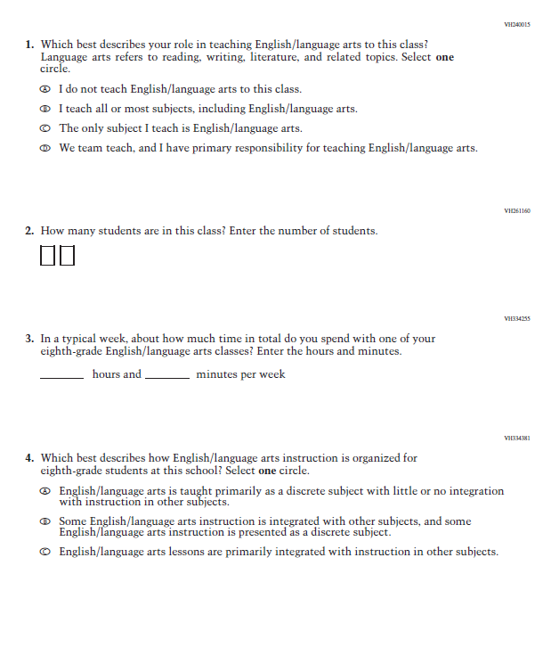

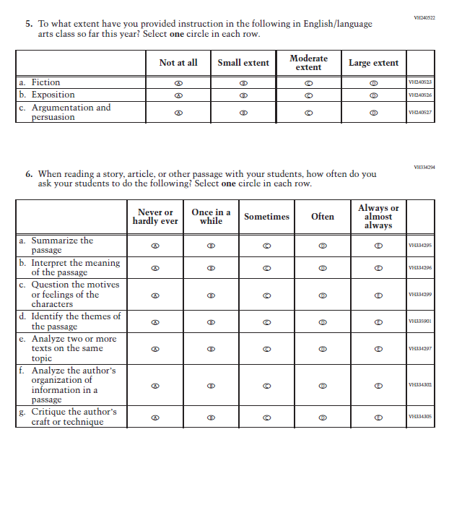

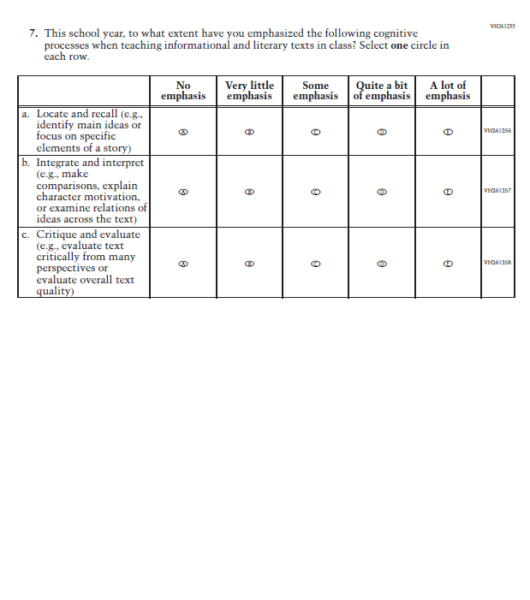

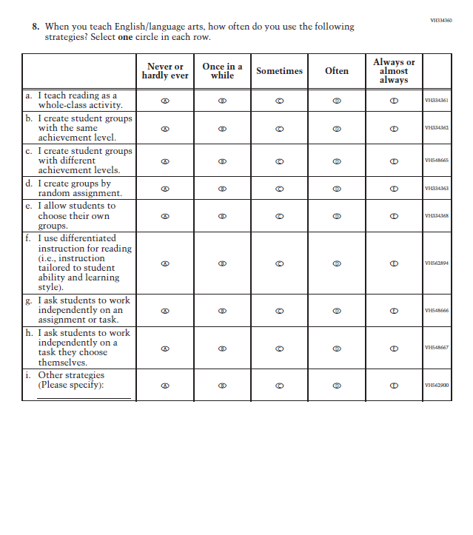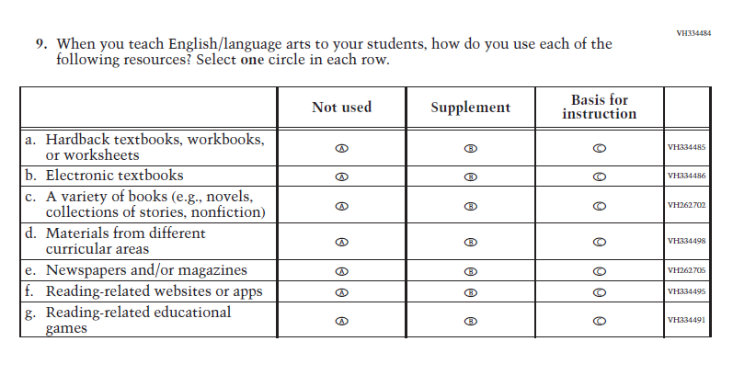

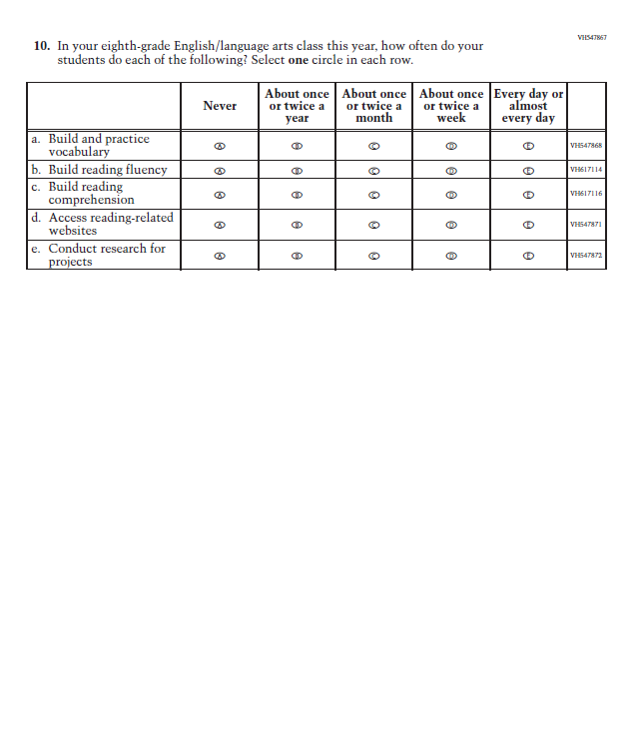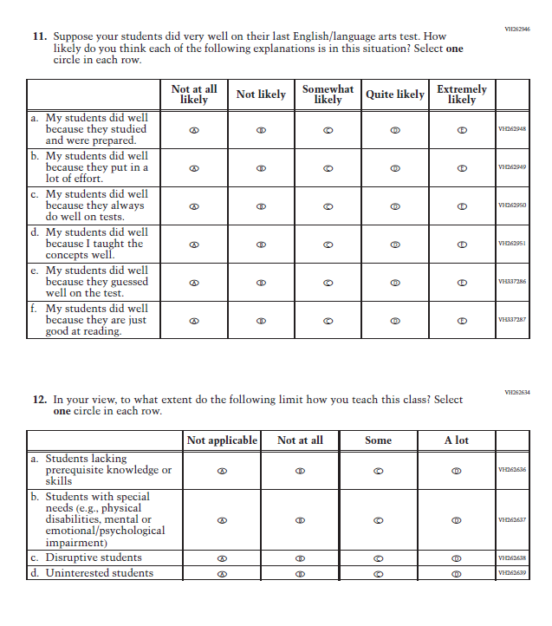

Appendix J2-13: Summary of Changes Operational Grade 8 Social Studies
2021 Operational Grade 8 Social Studies Teacher
Previous item | 2021 item | D/A/ R/NC+ | Rationale
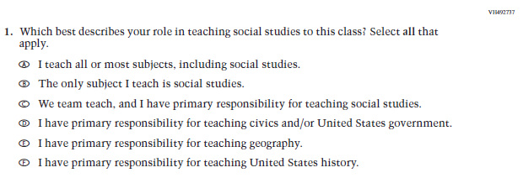  (2018 Grade 8) | Issue: Resources for Learning and Instruction | NC | N/A
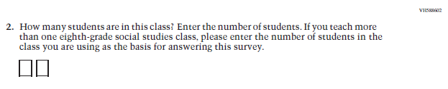  (2018 Grade 8) | Issue: Resources for Learning and Instruction | NC | N/A
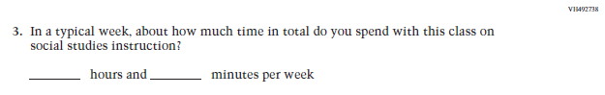  (2018 Grade 8) | Issue: Resources for Learning and Instruction | NC | N/A
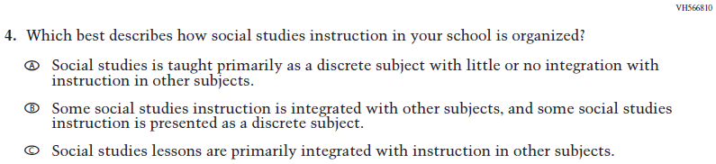  (2018 Grade 8) | Issue: Organization of Instruction | NC | N/A
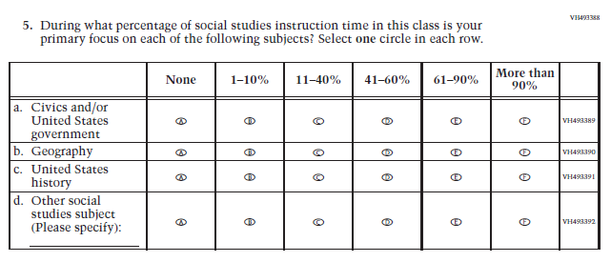  (2018 Grade 8) | Issue: Resources for Learning and Instruction | NC | N/A
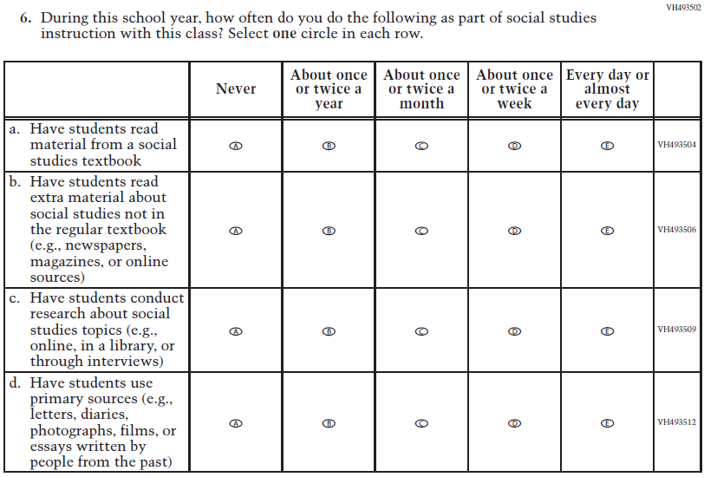  (2018 Grade 8) | Issue: Organization of Instruction | NC | N/A
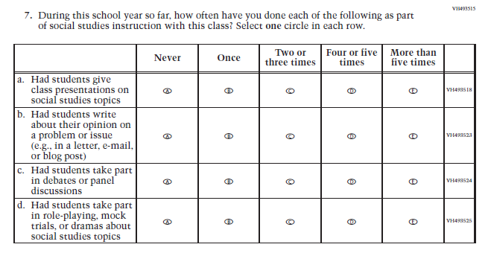  (2018 Grade 8) | Issue: Organization of Instruction | NC | N/A
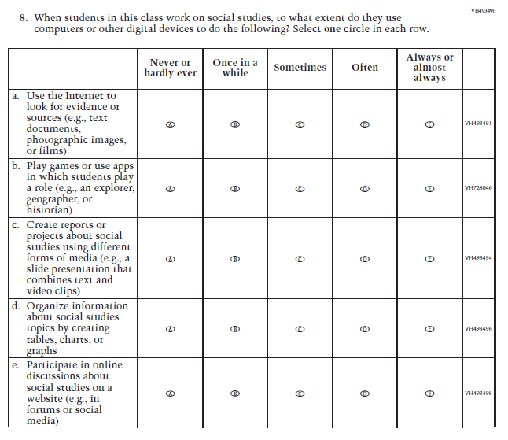  (2018 Grade 8) | Issue: Organization of Instruction | NC | N/A
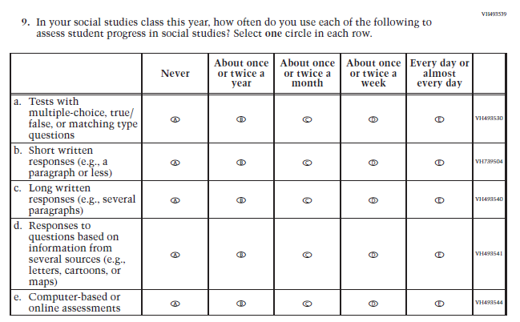  (2018 Grade 8) | Issue: Organization of Instruction | NC | N/A
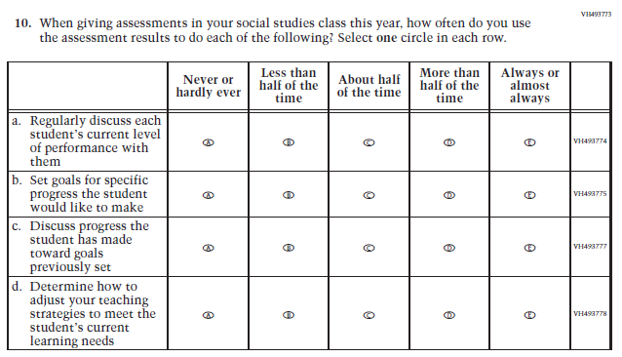  (2018 Grade 8) | Issue: Organization of Instruction | NC | N/A
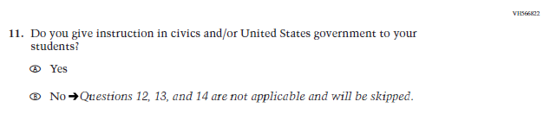  (2018 Grade 8) | 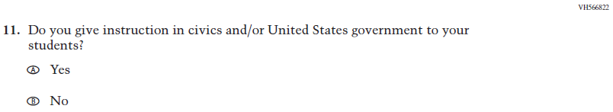  Issue: Organization of Instruction | NC | Please note skip pattern directions have been removed given the transition from PPT to DBA.
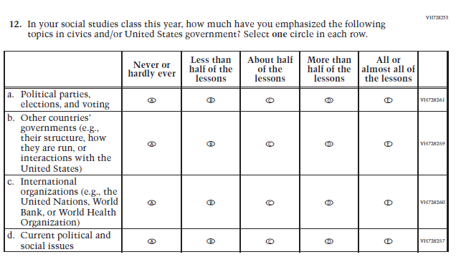  (2018 Grade 8) | Issue: Organization of Instruction | NC | N/A
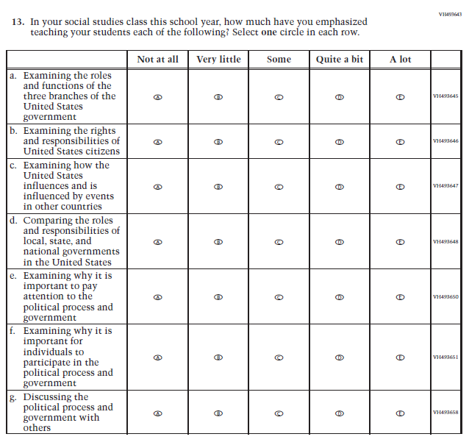  (2018 Grade 8) | Issue: Organization of Instruction | NC | N/A
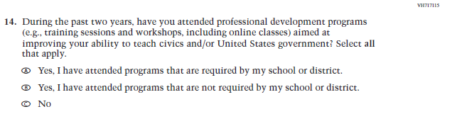  (2018 Grade 8) | Issue: Teacher Preparation | NC | N/A
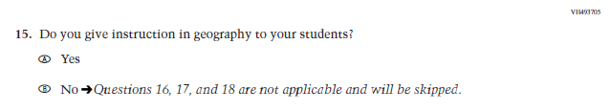  (2018 Grade 8) | N/A | D | The item was dropped because geography will not be administered in 2021.
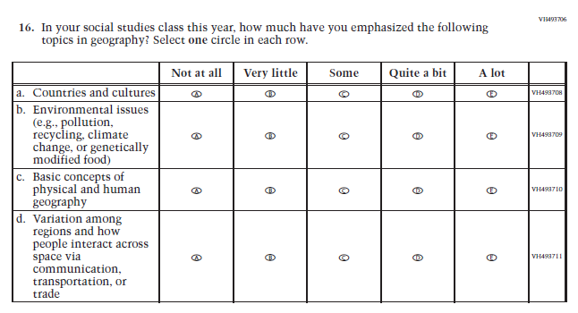  (2018 Grade 8) | N/A | D | The item was dropped because geography will not be administered in 2021.
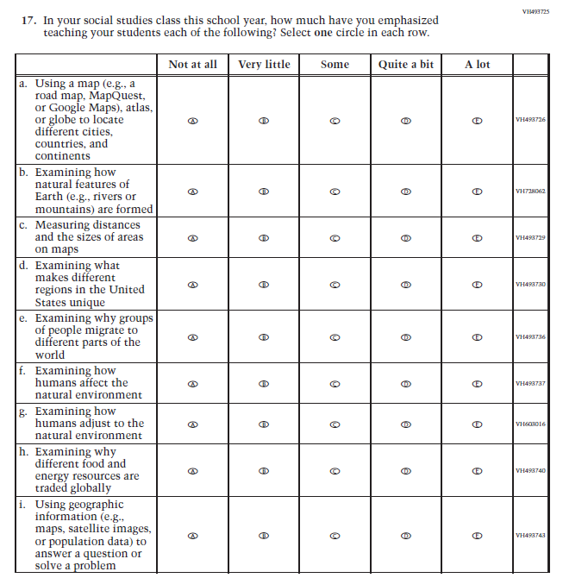  (2018 Grade 8) | N/A | D | The item was dropped because geography will not be administered in 2021.
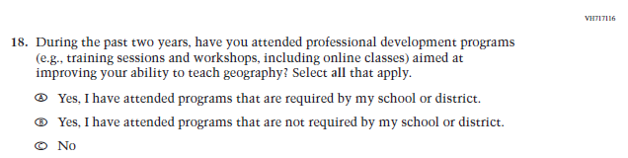  (2018 Grade 8) | N/A | D | The item was dropped because geography will not be administered in 2021.
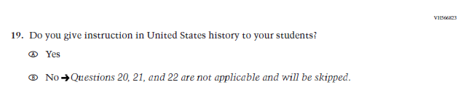  (2018 Grade 8) | 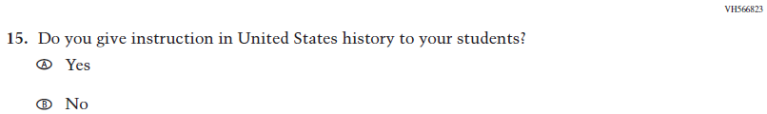  Issue: Organization of Instruction | NC | Please note skip pattern directions have been removed given the transition from PPT to DBA.
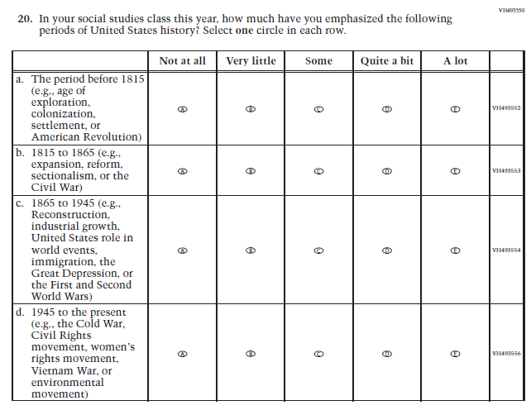  (2018 Grade 8) | 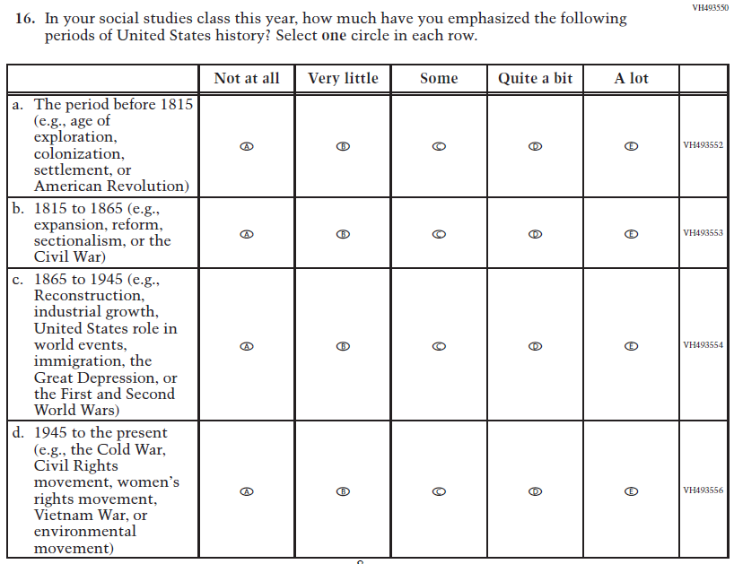  Issue: Organization of Instruction | NC | N/A
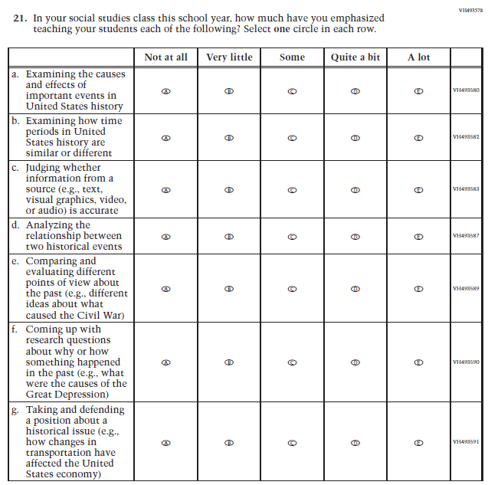  (2018 Grade 8) | 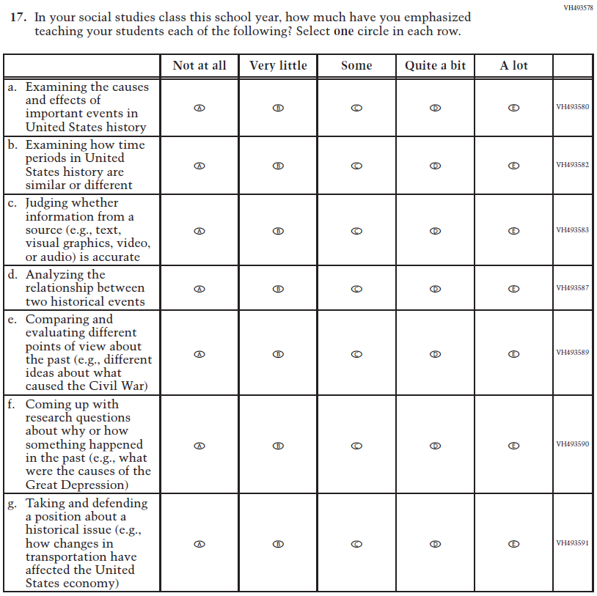  Issue: Organization of Instruction | NC | N/A
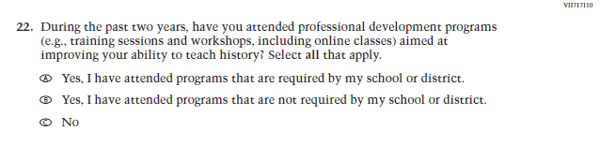  (2018 Grade 8) | Issue: Teacher Preparation | NC | N/A
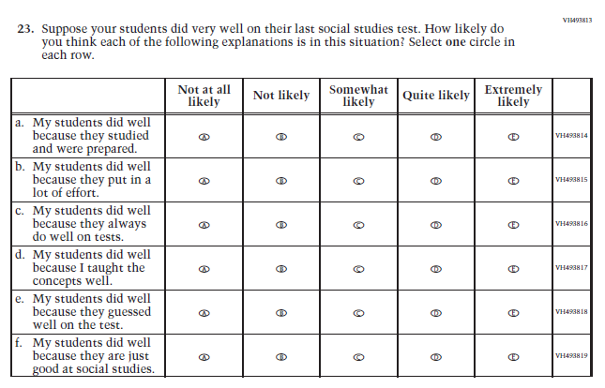  (2018 Grade 8) | 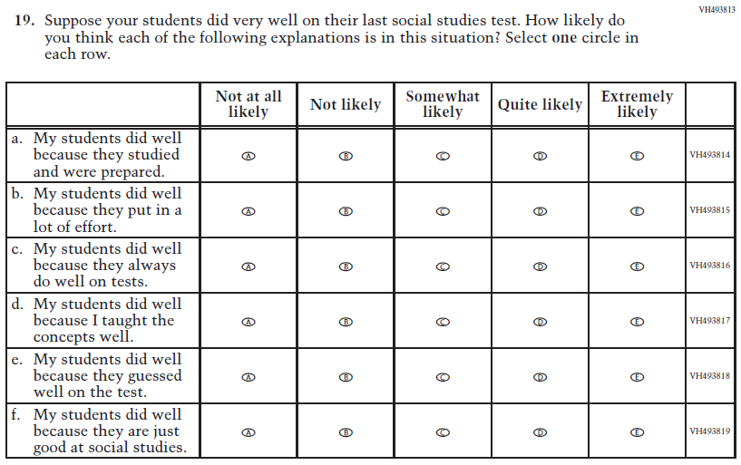  Issue: Teacher Preparation | NC | N/A

Appendix J2-14: Operational Grade 8 Social Studies
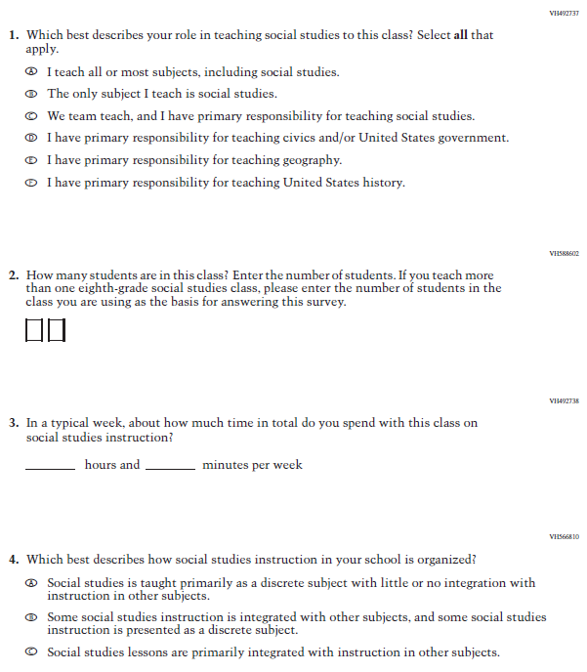

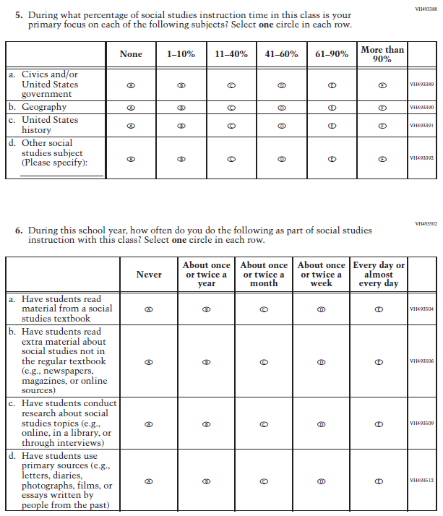

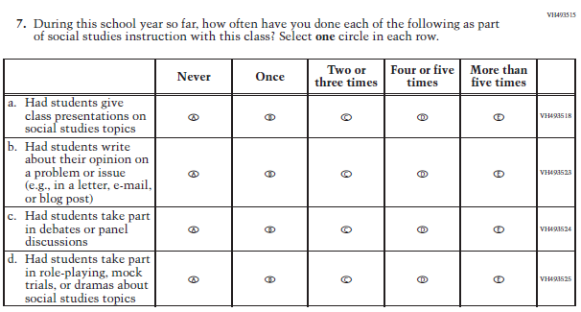
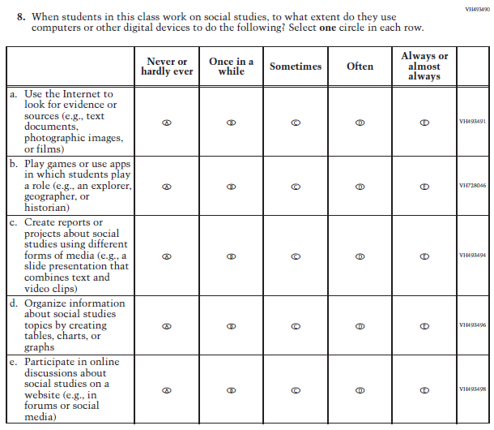

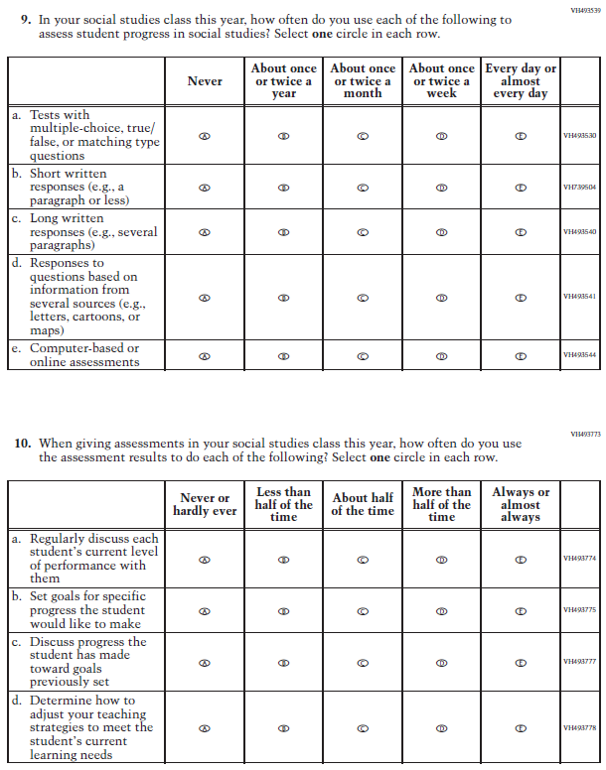

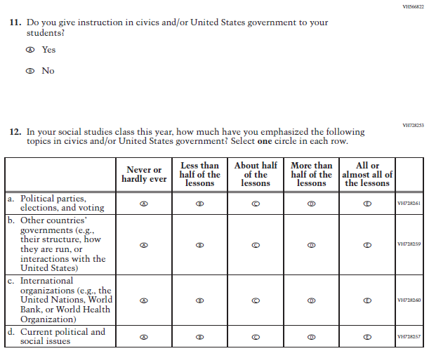

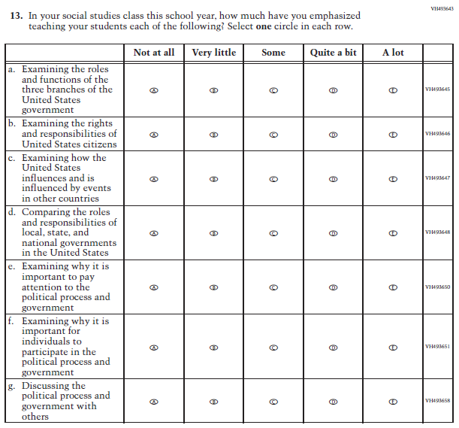

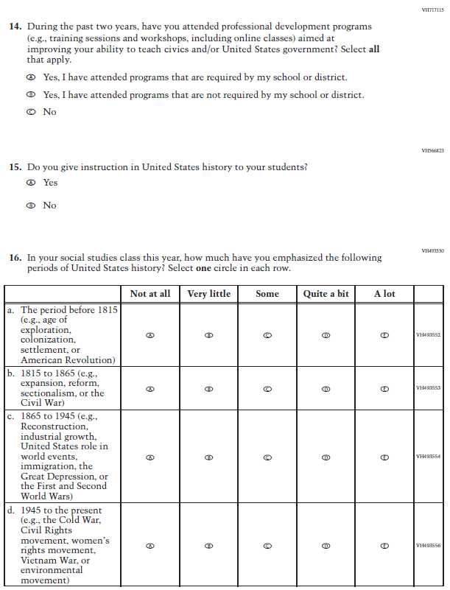

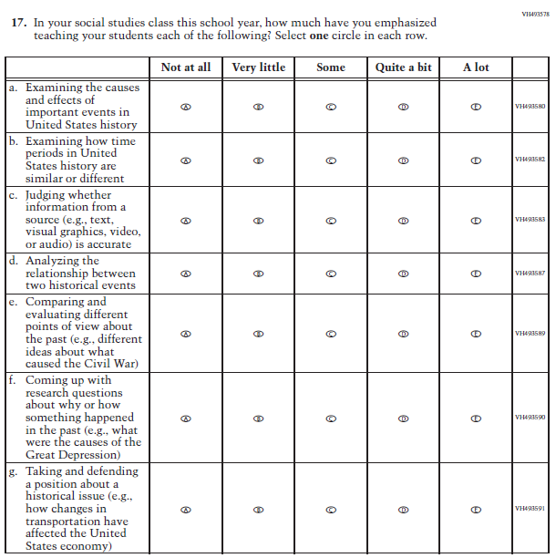

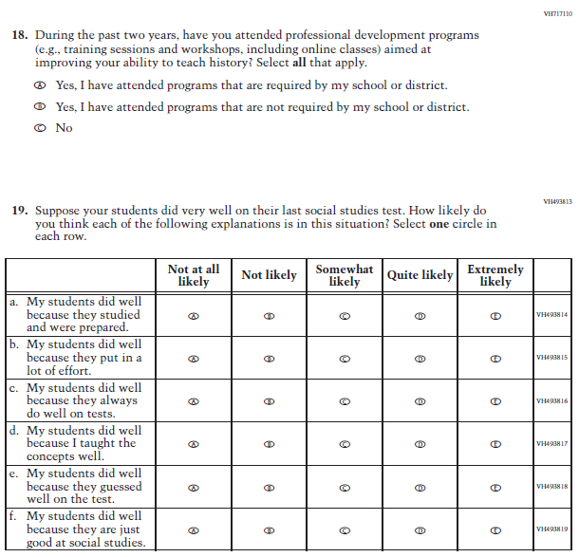

Appendix J2-15: Operational Grade 4 COVID-19 (New)
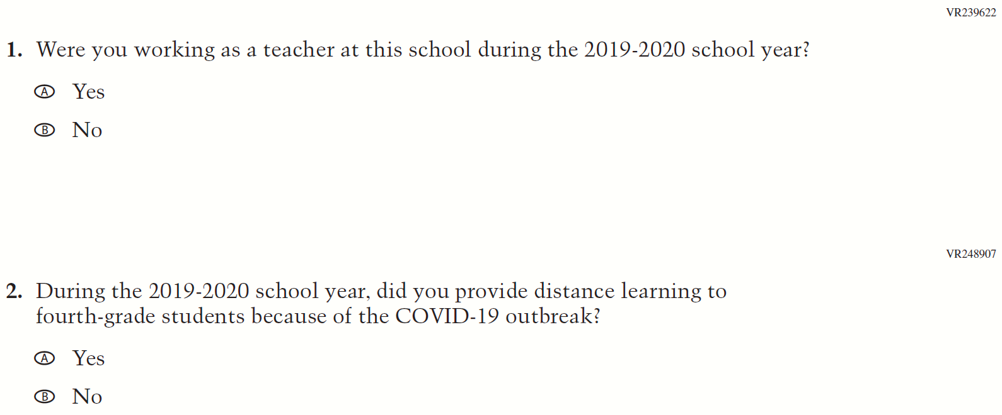
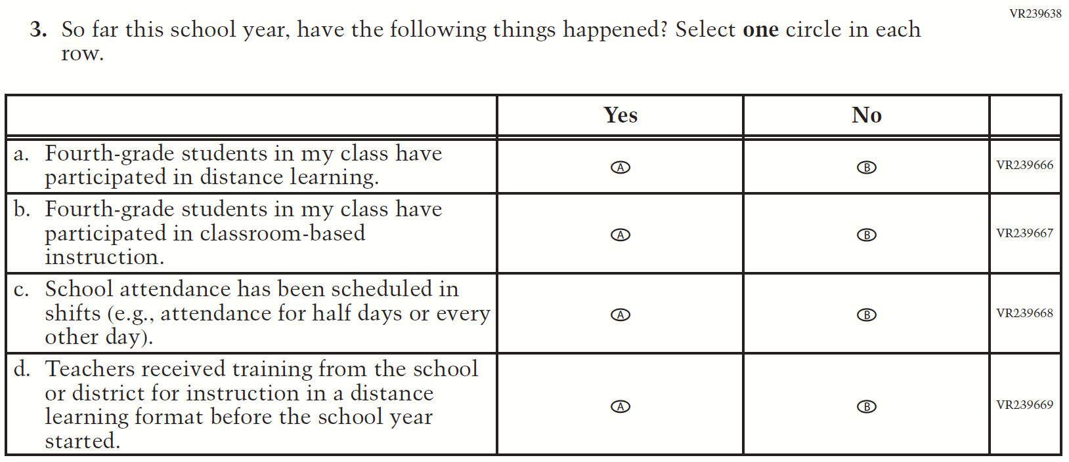
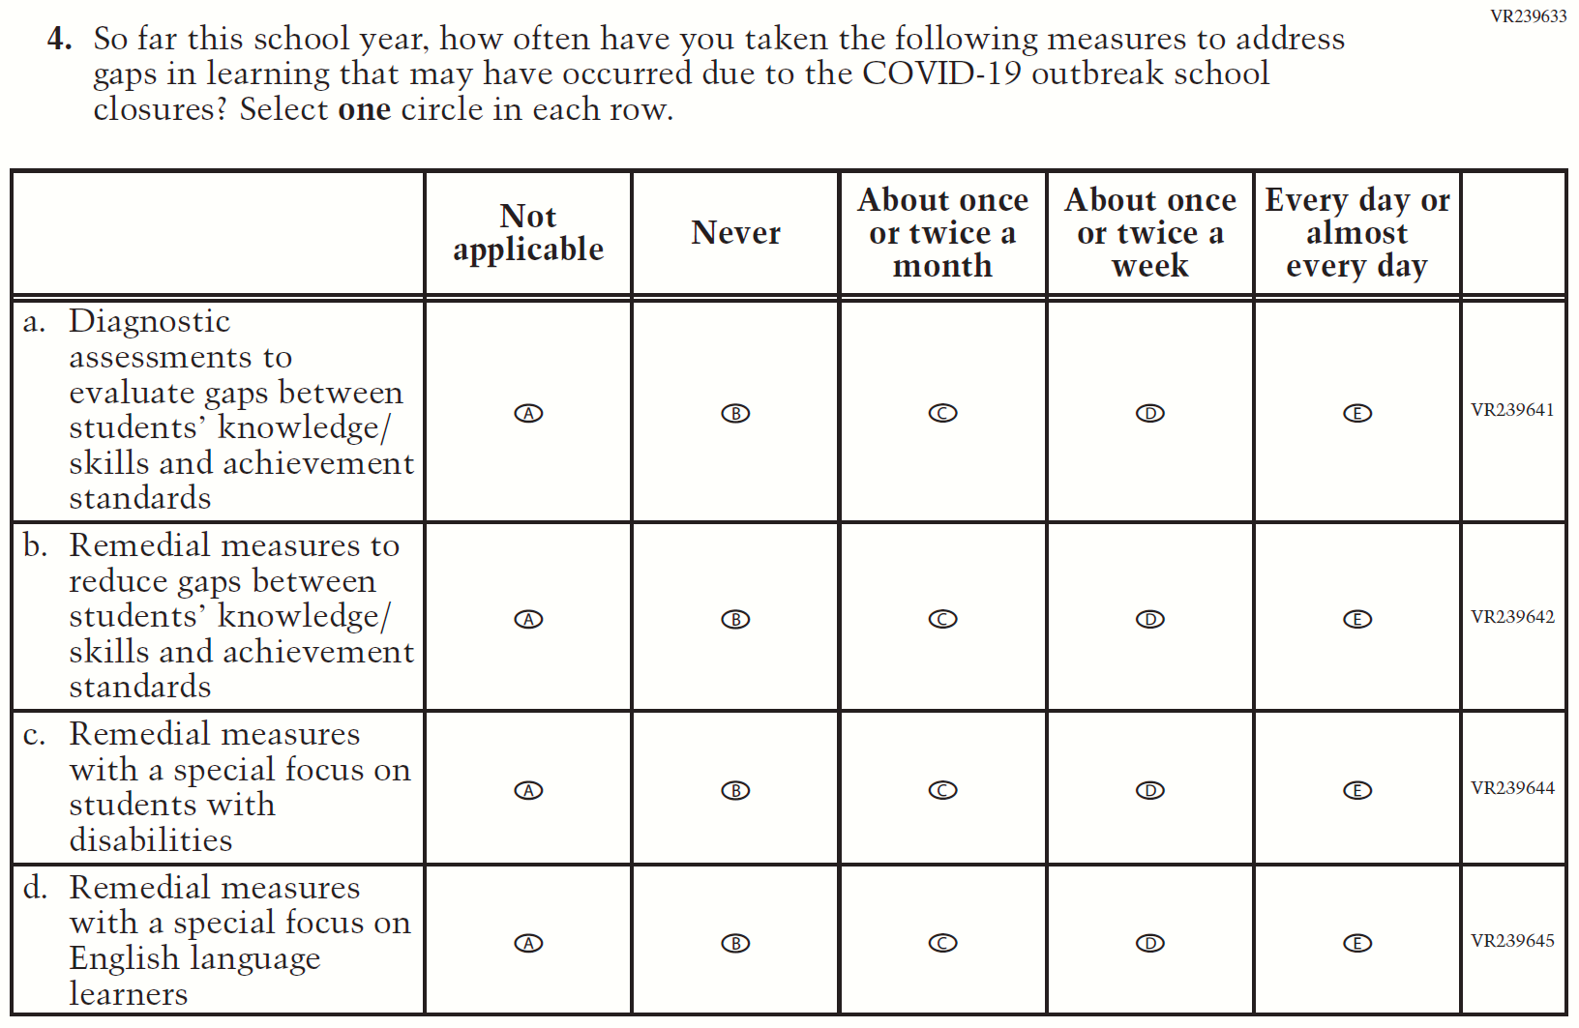
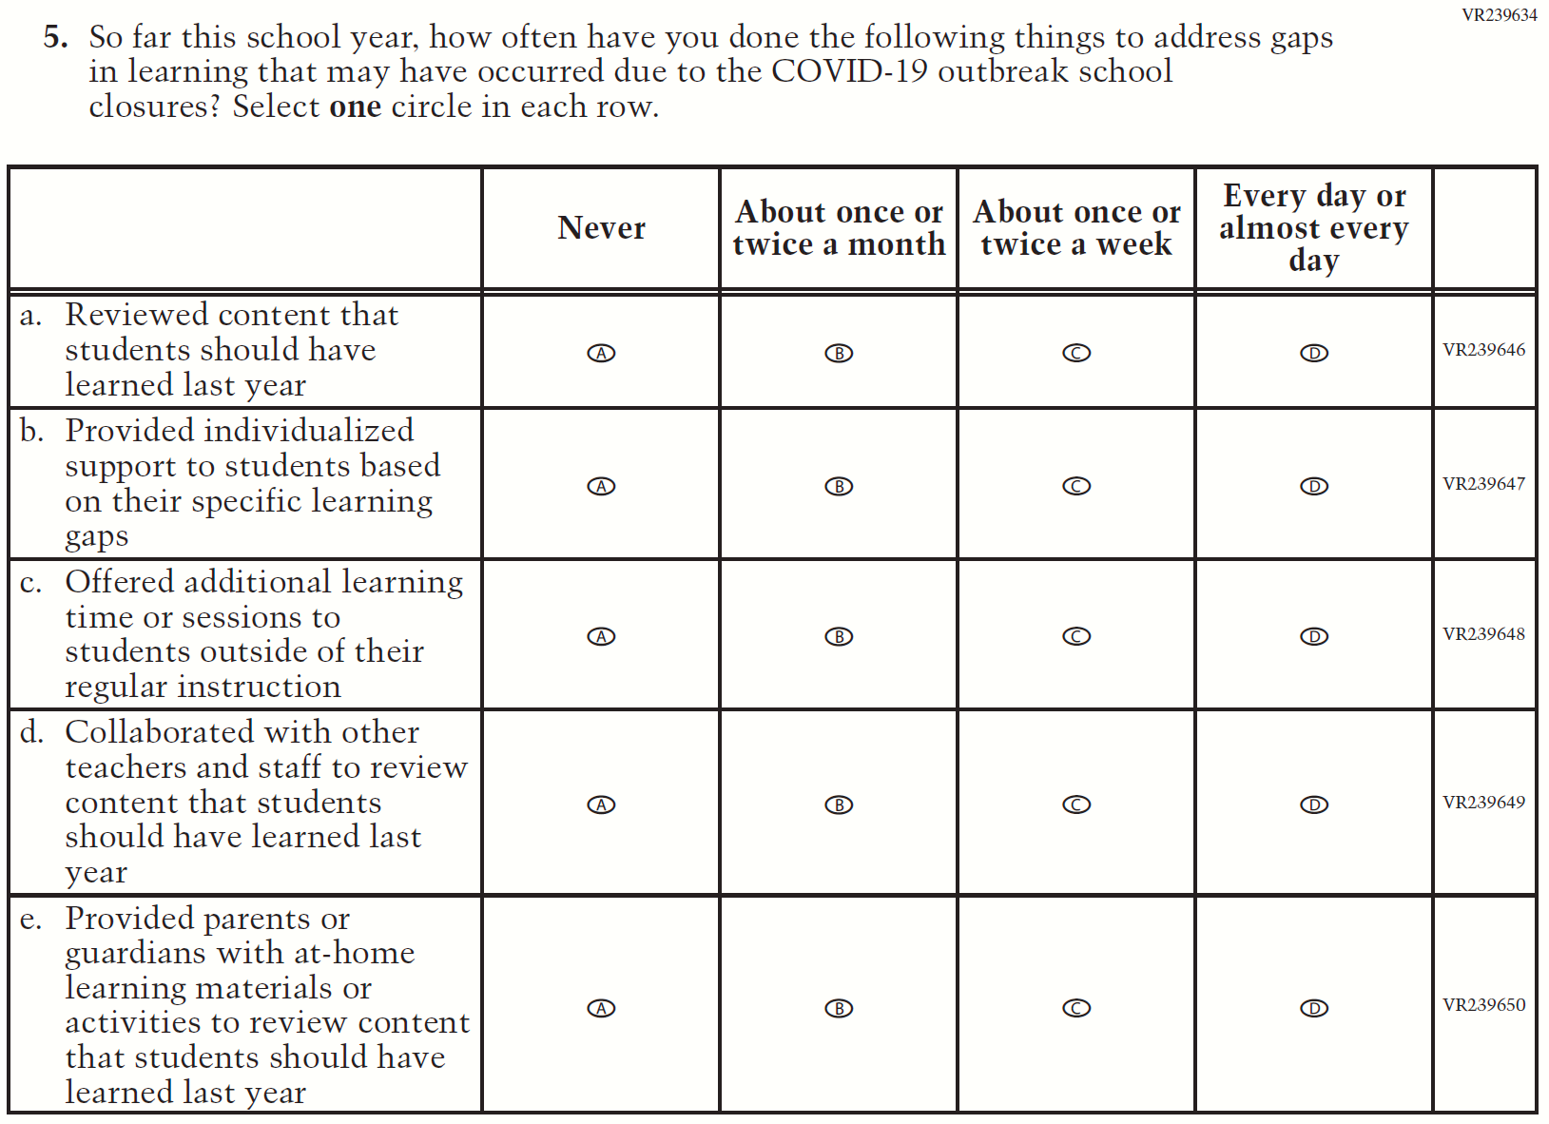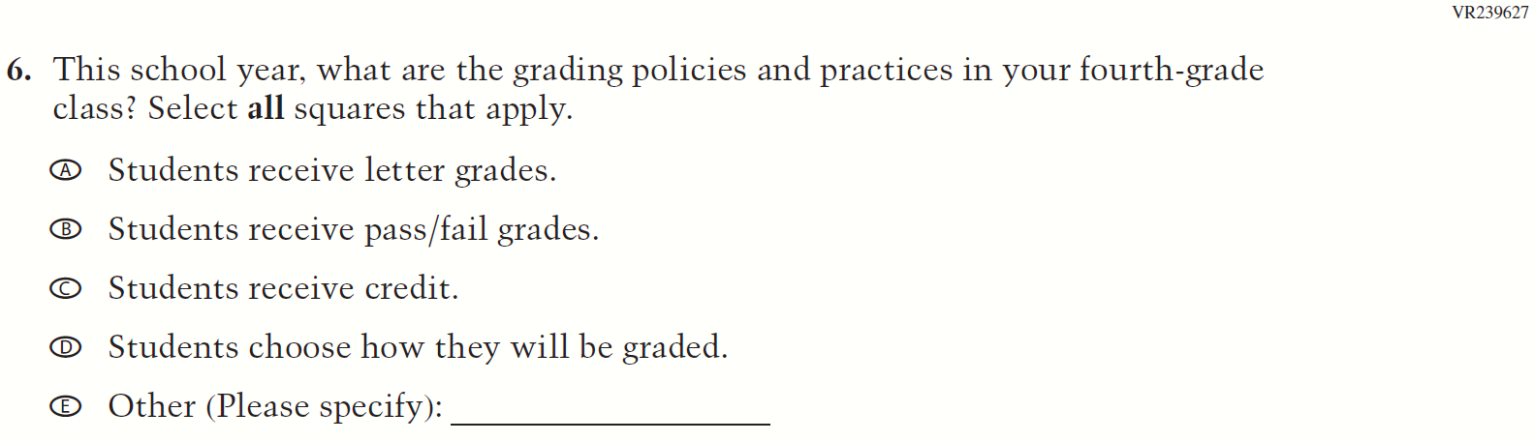
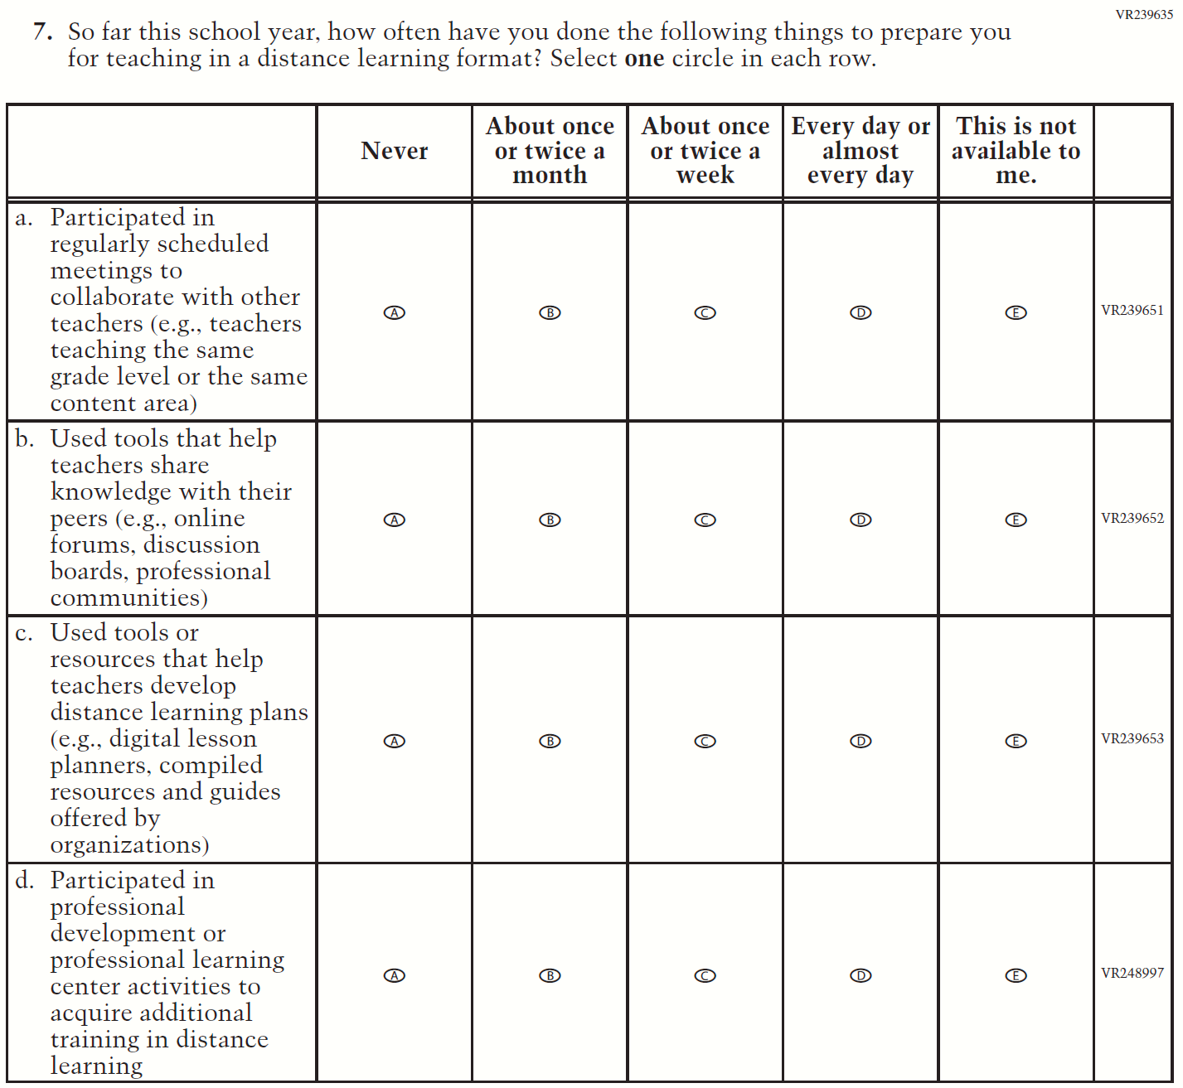
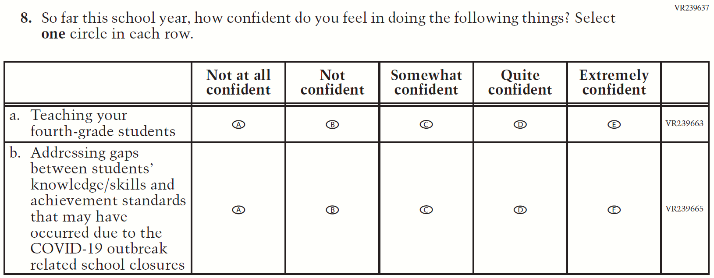
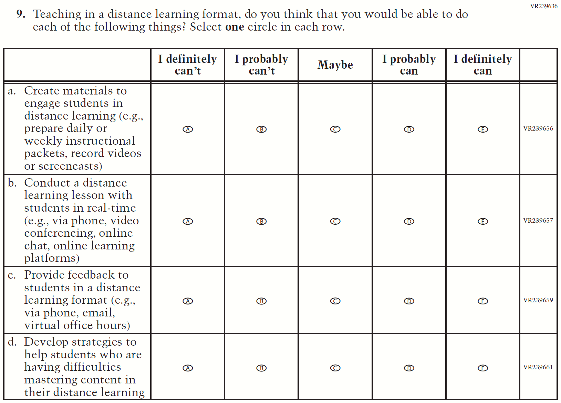

Appendix J2-16: Operational Grade 8 COVID-19 (New)
