Form HUD-9900, New Application

LOCATION | CURRENT TEXT | Revised Text
Form HUD-9900 page 1, Opening Sentence of document | This application is designed to be completed by applicants who are seeking approval to be a HUD-Approved Housing Counseling Agency. As of August 1, 2020, housing counseling required by or provided in connection with HUD programs must only be provided by HUD certified housing counselors working for participating agencies approved to provide such housing counseling by HUD’s Office of Housing Counseling. | Privacy Advisory: Authorities: The Office of Housing Counseling is responsible for administration of the Department’s Housing Counseling Program, authorized by Section 106 of the Housing and Urban Development Act of 1968 (12 U.S.C. 1701w and 1701x). New Certification Requirements Final Rule released December 14, 2016. Section 106 of the Housing and Urban Development Act of 1968 (12 U.S.C. 1701x) (Section 106) was amended by Subtitle D of title XIV of the Dodd-Frank Wall Street Reform and Consumer Protection Act (Pub. L. 111–203, 124 Stat. 1376, approved July 21, 2010). Principal Purpose: The mission of the Office of Housing Counseling (OHC) is to provide individuals and families with the knowledge they need to obtain, sustain, and improve their housing. Agencies that are eligible, meet program requirements, and provide the information requested on the form HUD-9900 may be approved to provide Comprehensive Housing Counseling Services that aid in the homeownership process. Disclosure: The information will not be disclosed outside HUD without your consent except to civil, criminal, or regulatory investigations or prosecutions, or to a Member of Congress or a congressional office in response to an inquiry. All the information requested on the form HUD-9900 is voluntary. The information is required to evaluate new applicants against Housing Counseling Program eligibility requirements only. If the information is not provided, the agency may not be considered for approval into HUD’s Housing Counseling Program. This application is designed to be completed by applicants who are seeking approval to be a HUD-Approved Housing Counseling Agency. As of August 1, 2021, housing counseling required by or provided in connection with HUD programs must only be provided by HUD certified housing counselors working for participating agencies approved to provide such housing counseling by HUD’s Office of Housing Counseling. Public Reporting Burden for this collection of information is estimated to be 8 hours per response, including the time for reviewing instructions, searching existing data sources, gathering and maintaining the data needed, and completing and reviewing the collection of information. This agency may not conduct or sponsor, and a person is not required to respond to a collection of information unless that collection displays a valid OMB control number. This information is collected in connection with HUD’s Housing Counseling Program and will be used to determine eligibility for Program participation under Section 106 of the Housing and Community Development Action of 1968.
LOCATION | CURRENT TEXT | Revised Text
Form HUD-9900, Page 10, Assurances and Certifications Section, | 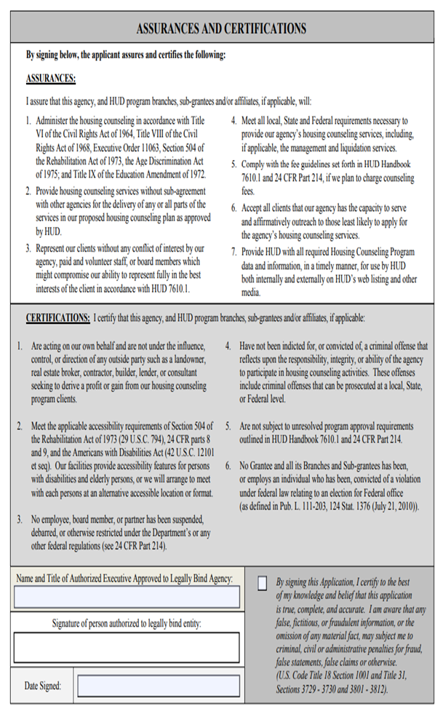 | Moved from Page 10 to Page 1;  CERTIFICATIONS  By signing below, the applicant assures and certifies the following: CERTIFICATIONS: I certify that this agency, and HUD program branches, sub-grantees and/or affiliates, if applicable, will: 1.Administer the housing counseling in accordance with Title VI of the Civil Rights Act of 1964, Title VIII of the Civil Rights Act of 1968, Executive Order 11063, Section 504 of the Rehabilitation Act of 1973, the Age Discrimination Act of 1975; and Title IX of the Education Amendment of 1972.2.Provide housing counseling services without sub-agreement withother agencies for the delivery of any or all parts of the services inour proposed housing counseling plan as approved by HUD.3.Represent our clients without any conflict of interest by our agency, paid and volunteer staff, or board members which might compromise our ability to represent fully in the best interests of the client in accordance with HUD 7610.1. 4.Meet all local, State and Federal requirements necessary to provide our agency’s housing counseling services, including, if applicable,the management and liquidation services.5.Comply with the fee guidelines set forth in HUD Handbook 7610.1and 24 CFR Part 214, if we plan to charge counseling fees.6.Provide HUD with all required Housing Counseling Program dataand information, in a timely manner, for use by HUD both internally and externally on HUD’s web listing and other media.7.Act on our own behalf and are not under the influence, control,or direction of any outside party such as a landowner, real estate broker, contractor, builder, lender, or consultant seeking to derive a profit or gain from our housing counseling program clients.8.Meet the applicable accessibility requirements of Section 504 of the Rehabilitation Act of 1973 (29 U.S.C. 794), 24 CFR parts 8 and 9,and the Americans with Disabilities Act (42 U.S.C. 12101 et seq). Our facilities provide accessibility features for persons with disabilities and elderly persons, or we will arrange to meet with each person at an alternative accessible location or format. 9.Ensure on an on-going basis that no employee, board member,or partner has been suspended, debarred, or otherwise restrictedunder the Department’s or any other federal regulations (see 24 CFR Part 214).10.Ensure on an on-going basis that such participants are not indicted for, or convicted of, a criminal offense that reflects upon the responsibility, integrity, or ability of the agency to participate in housing counseling activities. These offenses include criminal offenses that can be prosecuted at a local, State, or Federal level.11.Ensure that the agency is not subject to unresolved program approval requirements outlined in HUD Handbook 7610.1 and 24 CFR Part 214.12.Ensure that no Grantee nor its Branches and Sub-grantees employs an individual who has been, convicted of a violation under federal law relating to an election for Federal office (as defined in Pub. L. 111-203, 124 Stat. 1376 (July 21, 2010)).
LOCATION | CURRENT TEXT | Revised Text
Form HUD-9900, Page 10, Certification Signature Box | 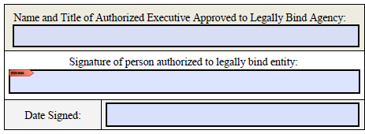 | Moved from page 10 to Page 1
LOCATION | CURRENT TEXT | Revised Text
Form HUD-9900, Page 10, Certification CheckBox | 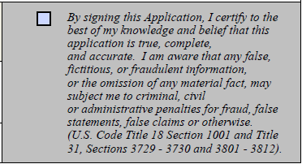 | Moved from page 10 to Page 1
LOCATION | CURRENT TEXT | Revised Text
Form HUD-9900, Page 10, Warning | WARNING: HUD will prosecute false claims and statements. Conviction may result in criminal and/or civil penalties. (18 U.S.C. 1001, 1010, 1012; 31 USC 3729, 3802) | Moved from page 10 to Page 1;  Warning: Anyone who knowingly or willfully makes false or fraudulent statements or representations in connection with the statements of information or certifications herein may be subject to criminal and/or civil penalties and may also be subject to administrative action by HUD. See, e.g., 18 U.S.C. § § 1001, 1010, 1012, 31 U.S.C. § 3801 et seq, 2 C.F.R. Parts 180 and 2424.
LOCATION | CURRENT TEXT | Revised Text
Form HUD-9900, Page 2, Types of HUD-Approved Organizations | National Intermediary Organization (Entity Type 2 only) – Provides, in multiple regions of the United States: (i) housing counseling services through its branches, sub-grantees and/or affiliates which are physically located in nine or more states; and (ii) provide raining, technical assistance, oversight, and pass-through funding to its network of branches, sub-grantees and/or affiliates.  Regional Intermediary Organization (Entity Type 2, 11, 12, 13, 14 & 15 only) – Provides, in a generally recognized region within the United States, such as the Southwest, Mid-Atlantic, New England: (i) housing counseling services through its branches, sub-grantees and/or affiliates, which are physically located in eight or fewer states; and (ii) provide training, technical assistance, oversight, and pass-through funding to its network of branches, sub-grantees and/or affiliates. | National Intermediary Organization (Entity Type 2 only) – Provides, in multiple regions of the United States: (i) housing counseling services through its branches, sub-grantees and/or affiliates, and (ii) provide raining, technical assistance, oversight, and pass-through funding to its network of branches, sub-grantees and/or affiliates.  Regional Intermediary Organization (Entity Type 2, 11, 12, 13, 14 & 15 only) – Provides, in a generally recognized region within the United States, such as the Southwest, Mid-Atlantic, New England: (i) housing counseling services through its branches, sub-grantees and/or affiliates, and (ii) provide training, technical assistance, oversight, and pass-through funding to its network of branches, sub-grantees and/or affiliates.
LOCATION | CURRENT TEXT | Revised Text
Pages 3-6, 8 | branches, sub-grantees/sub-recipients and affiliates | branches, sub-grantees and/or affiliates
LOCATION | CURRENT TEXT | Revised Text
Form HUD-9900, Page 4, Part 1, Section C. Screening of Ineligible Participants | Nonprofit agencies, Intermediaries, MSO, Nonprofit Universities, CDC, CHDO, Nonprofit Instrumentality of Gov’t/IOG Universities, PHA’s & State Universities (Entity type 1, 2, 3, 4, 5, 6, 7, 9, 10) ONLY must provide all the following:  - Provide a list of all counseling staff working in the housing counseling program, all current Board Members, supervisors and housing counselors, and  - For each individual listed, provide the agency office, the agency physical address, state their position title, length of employment, the name of board member’s employer and title, their duties, if staff member is full-time or part-time, paid or a volunteer and provide their physical home addresses, a contact number and  - In addition to providing items 1 & 2, self-certify to the following:  Self-Certification: Applicants unable or unwilling to self-certify will result in rejection of their application.  By checking this box, the Authorized Executive certifies that this entity is in compliance with other HUD program(s) for which the applicant is currently a participant.  a. Provide a list of the other HUD program(s) in which you are currently participating, the name of the HUD program Point of Contact (POC) and contact information.  OR Check this box if the Applicant does not participate in any other HUD programs. | Self-Certification: Applicants unable or unwilling to self-certify will result in rejection of their application.  By checking this box, the Authorized Executive certifies that the agency has vetted all housing counseling program related staff including, agency directors, board members, partners, officers, principals, and employees at all locations, including employees of sub-grantees/sub-recipients or affiliates listed in items #2 above and confirm that they are not suspended, debarred, or otherwise restricted; Indicted for or convicted of a criminal offense; Subject to unresolved findings as a result of HUD or other governmental audit or investigation, including any state & federal tax liens without a repayment plan in place, as per described in 24 CFR 214.103(c)(1)(2)(3). If needed, please refer to the “Learn More” section of the Housing Counseling Agency Eligibility Tool for information on Ineligible Participants: https://www.hudexchange.info/programs/ housing-counseling/housing-counseling-agency-eligibility-tool and (continued on next page)  Self-Certification: Applicants unable or unwilling to self-certify will result in rejection of their application.  By checking this box, the Authorized Executive certifies that this entity is in compliance with other HUD program(s) for which the applicant is currently a participant.  a. Provide a list of the other HUD program(s) in which you are currently participating, the name of the HUD program Point of Contact (POC) and contact information.  OR Check this box if the Applicant does not participate in any Other HUD programs.
LOCATION | CURRENT TEXT | Revised Text
Form HUD-9900, Page 7, Part 3, Resources Section B. Staff 1. | Self-certify to the following:  Nonprofit Entities and Government Entities (Entity type 1-16) must provide all the following:  Self-Certification: Applicants unable or unwilling to self-certify will result in rejection of their application.  By checking this box, the Authorized Executive certifies that the agency employs staff trained in housing counseling AND at least half the counselors have at least 6 months of experience in the job they will perform in the agency’s housing counseling program, and | Nonprofit Entities and Government Entities (Entity type 1-16) must provide all the following:  Self-Certification: Applicants unable or unwilling to self-certify will result in rejection of their application.  By checking this box, the Authorized Executive certifies that the agency employs individuals who will provide one-on-one housing counseling and/or oversee group education at its main office and branches that have passed the HUD Housing Counselor Certification Examination and are trained in the job that they will perform in the agency’s housing counseling program. A list of these individuals and evidence of examination passage will be provided to HUD upon request. and
LOCATION | CURRENT TEXT | Revised Text
Form HUD-9900, Page 10, Assurances and Certifications Section | Self-certify to the following:  Nonprofit Entities and Government Entities (Entity type 1-16) must provide all the following:  Self-Certification: Applicants unable or unwilling to self-certify will result in rejection of their application.  By checking this box, the Authorized Executive certifies that the agency employs staff trained in housing counseling AND at least half the counselors have at least 6 months of experience in the job they will perform in the agency’s housing counseling program, and  2. Self-certify to the following:  Self-Certification: Applicants unable or unwilling to self-certify will result in rejection of their application.  By checking this box, the Authorized Executive certifies that the agency has a written supervisory monitoring plan and quality control compliance procedures established for monitoring the work of housing counselors by reviewing client files with the housing counselor to determine the adequacy and effectiveness of the housing counseling. | Nonprofit Entities and Government Entities (Entity type 1-16) must provide all the following:  1. Self-certify to the following:  Self-Certification: Applicants unable or unwilling to self-certify will result in rejection of their application.  By checking this box, the Authorized Executive certifies that the agency employs staff trained in housing counseling AND at least half the counselors have at least 6 months of experience in the job they will perform in the agency’s housing counseling program, and  a. Self-Certify to the following:  Self -Certification: *Self-certification number one alpha(1a.) will become effective on or after the final compliance date for Housing Counselor Certification and will supersede self-certification number one listed above.  Applicants unable or unwilling to self-certify will result in rejection of their application.  By checking this box, the Authorized Executive certifies that the agency employs individuals who will provide one-on-one housing counseling and/or oversee group education at its main office and branches have passed the HUD Housing Counselor Certification Examination and are trained in the job that they will perform in the agency’s housing counseling program. A list of these individuals and evidence of examination passage will be provided to HUD upon request. and  Self-certify to the following:  Self-Certification: Applicants unable or unwilling to self-certify will result in rejection of their application.  2. By checking this box, the Authorized Executive certifies that the agency has a written supervisory monitoring plan and quality control compliance procedures established for monitoring the work of housing counselors by reviewing client files with the housing counselor to determine the adequacy and effectiveness of the housing counseling.

