- Login Screen:
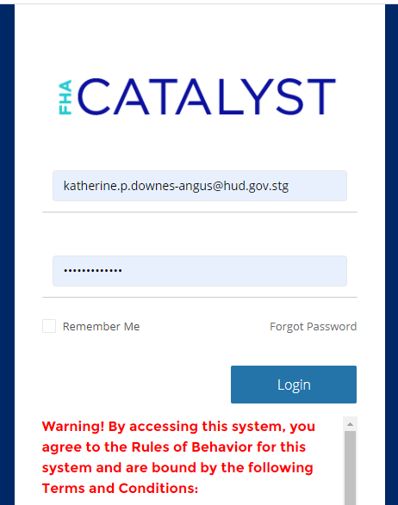

- Landing page:
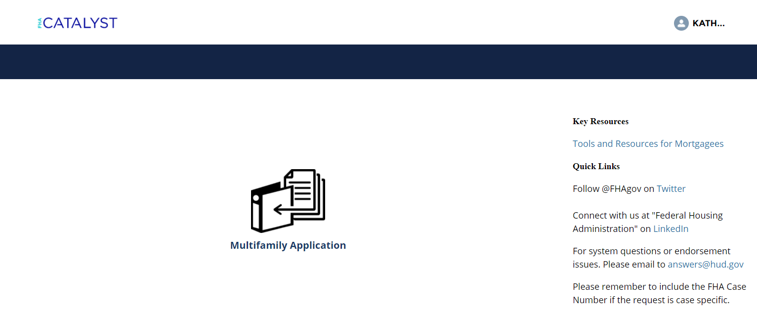
- Dashboard page:
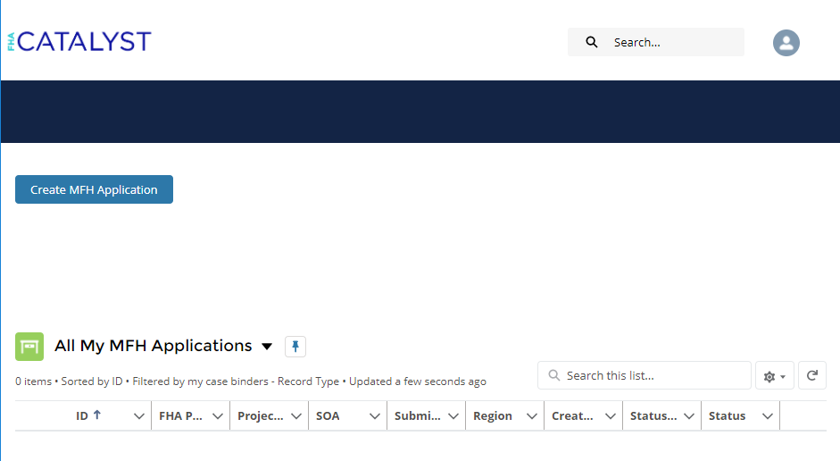
- Create MF Application page (pre-upload)*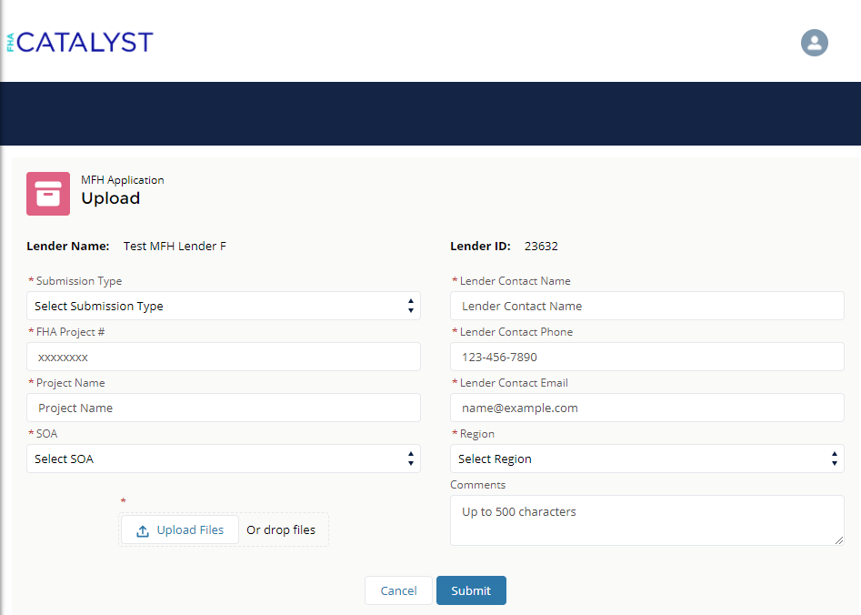
*See Appendix A for dropdown options

- Application Submission page (post-upload)
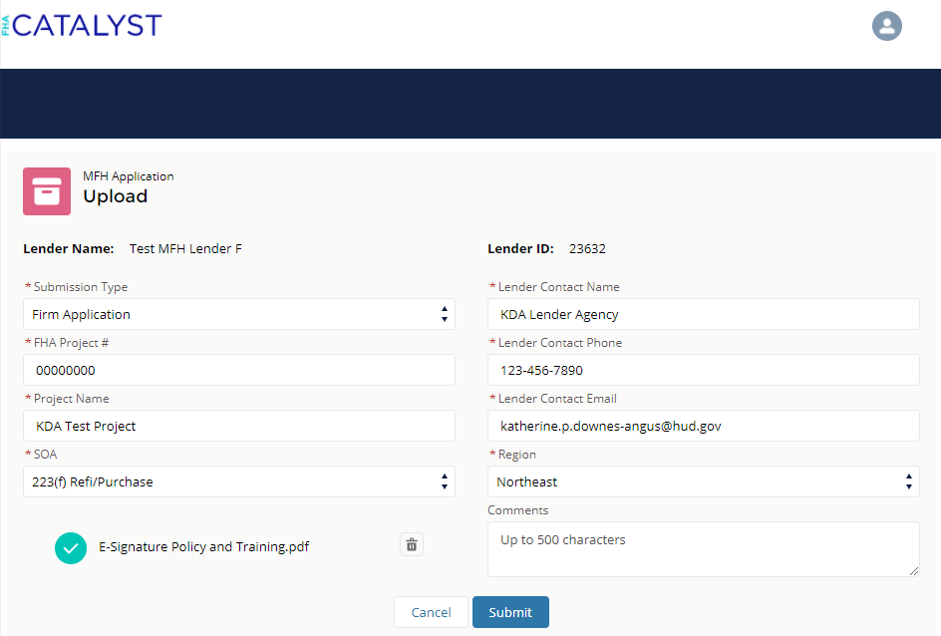
- Dashboard/Landing page (post-upload)
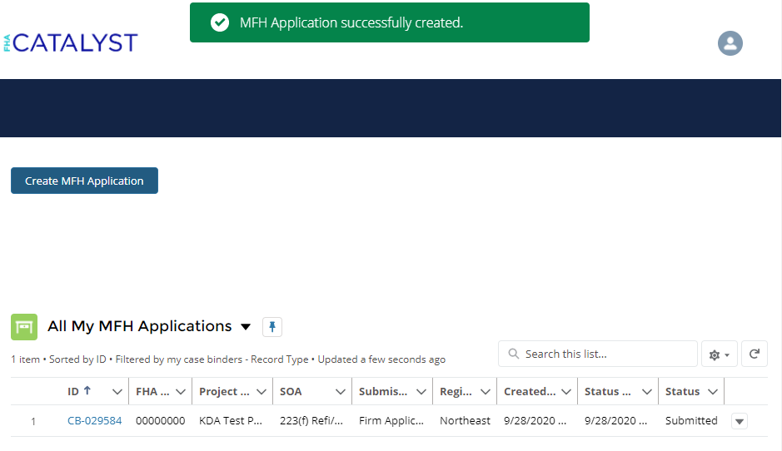

Appendix A: Dropdown Options
Field Name | Value
Submission Type | Pre-Application
 | Firm Application
 | Other Docs
SOA | 202 Elderly Capital Advance
 | 207 Mobile Home Park
 | 213 Coop NC/SR
 | 213(i) Coop NC/SR
 | 220 Urban Renewal NC/SR
 | 221(d)(4) NC/SR
 | 223(a)(7) Refi
 | 223(f) Refi/Purchase
 | 231 Elderly NC/SR
 | 241(a) Supplemental Loan
 | 542(b) QPE Risk-Sharing
 | 542(c) HFA Risk-Sharing
 | 811 Capital Advance
Region | Midwest
 | Northeast
 | Southeast
 | Southwest
 | West

