**Table of Contents**

EVALUATION SURVEYS 2

1. Standard Welcome Page & Participation Decision – ALL Surveys 2

2. Challenges and Internship Participant Survey – Survey Questions 3

## EVALUATION SURVEYS

1. Standard Welcome Page & Participation Decision – ALL Surveys  
   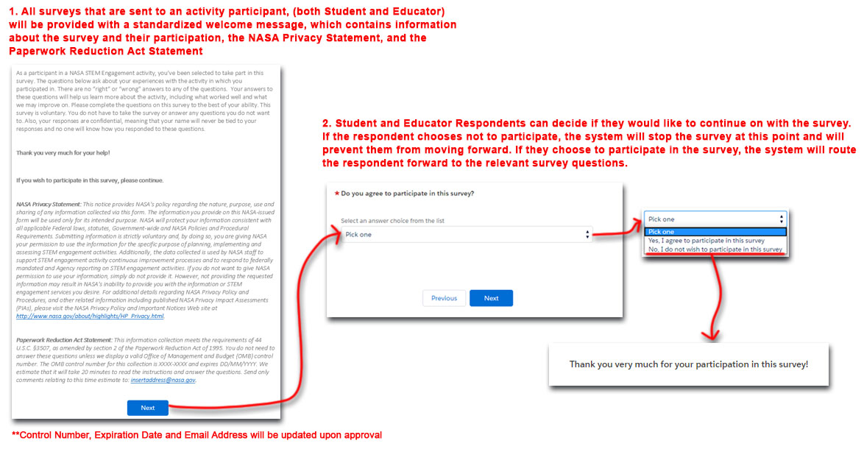
2. Challenges and Internship Participant Survey – Survey Questions