**Table of Contents**

EVALUATION SURVEYS 2

1. Standard Welcome Page & Participation Decision – ALL Surveys 2

2. Internship Applicants and Awardees Longitudinal Survey – Survey Questions 3

## EVALUATION SURVEYS

1. Standard Welcome Page & Participation Decision – ALL Surveys  
   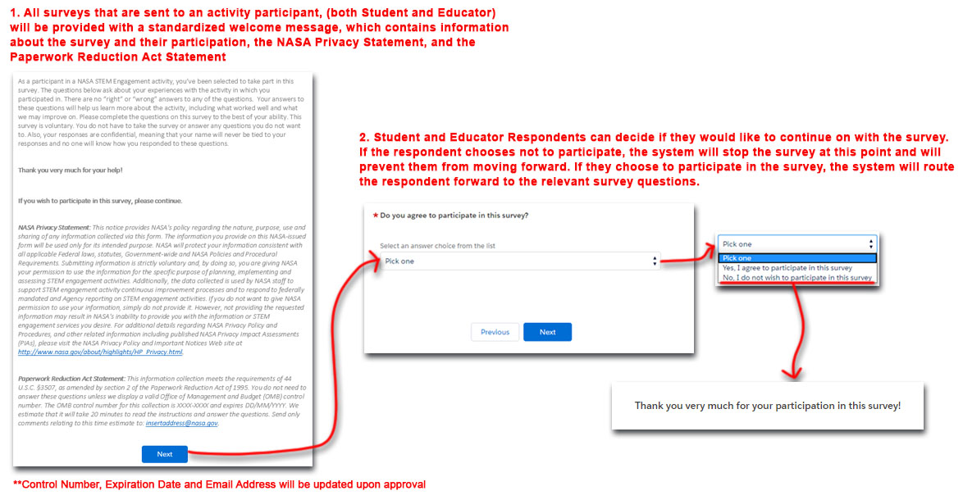
2. Internship Applicants and Awardees Longitudinal Survey – Survey Questions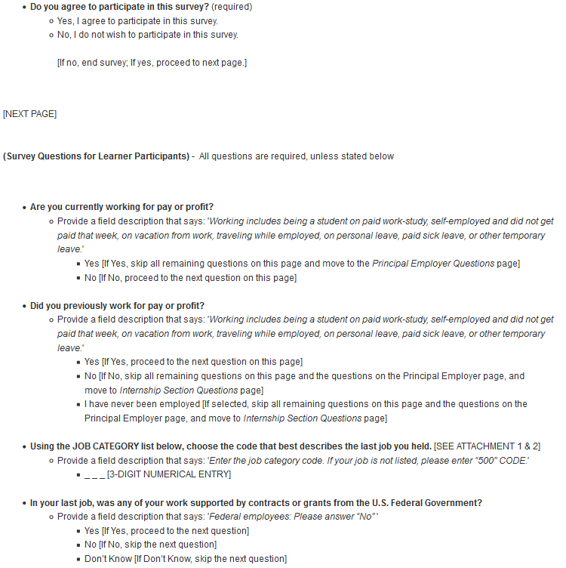

**Attachment 1 Attachment 2**

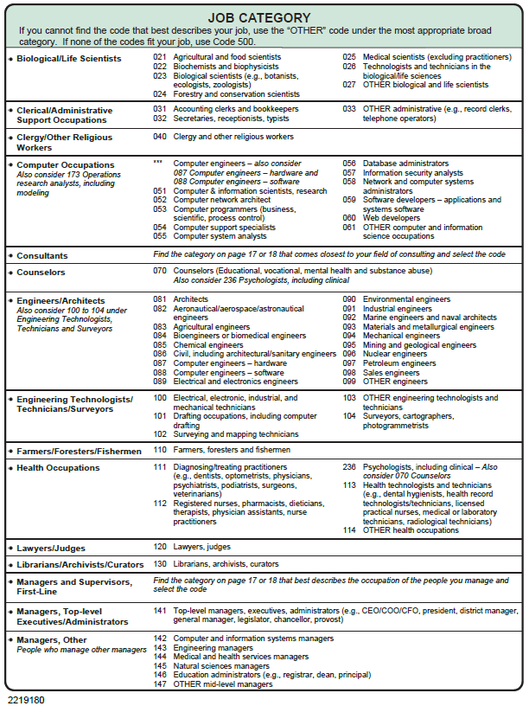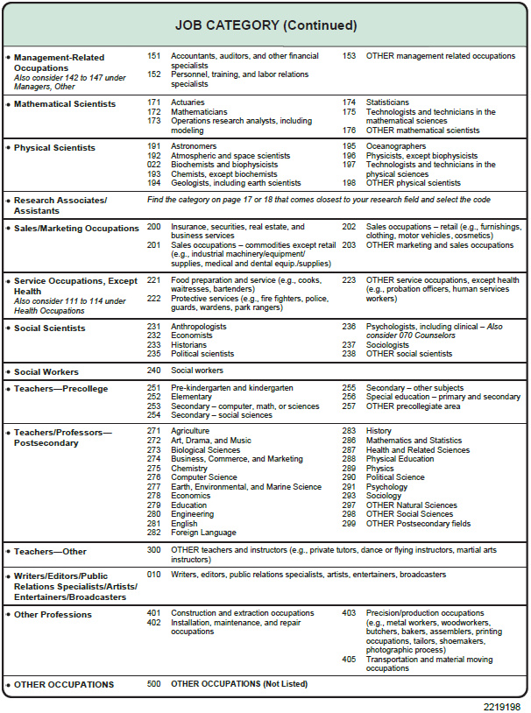

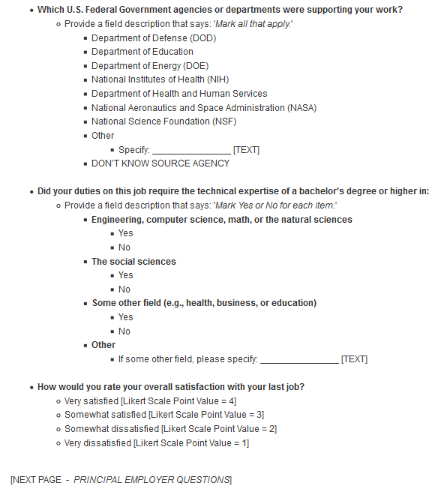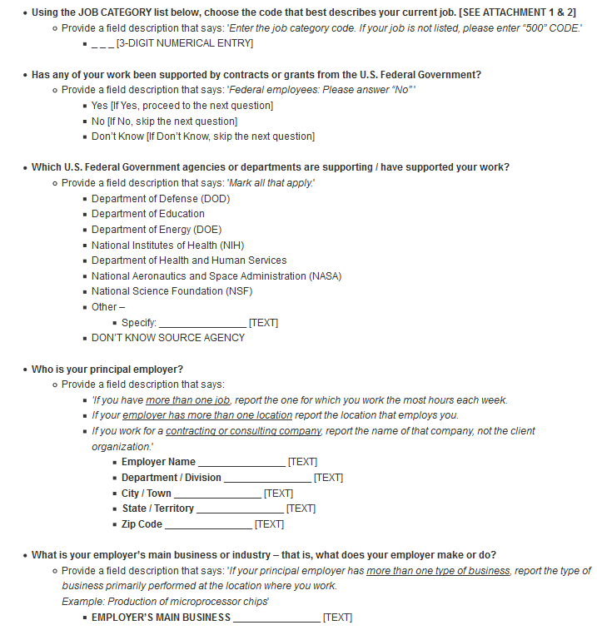

**Attachment 1 Attachment 2**



