Table of Contents
EVALUATION SURVEYS 2
1. Standard Welcome Page & Participation Decision – ALL Surveys 2
2. EPD Workshop Participant Satisfaction Survey – Survey Questions 3

EVALUATION SURVEYS
- Standard Welcome Page & Participation Decision – ALL Surveys
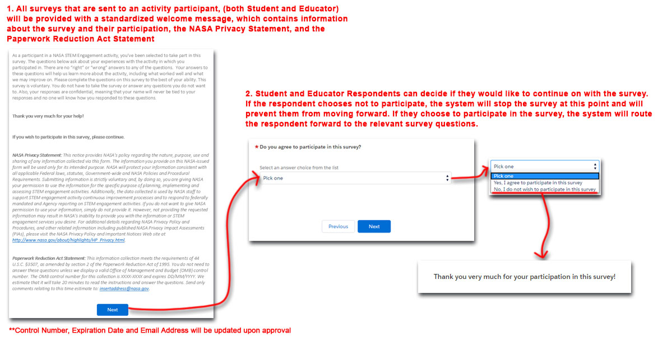
- EPD Workshop Participant Satisfaction Survey – Survey Questions
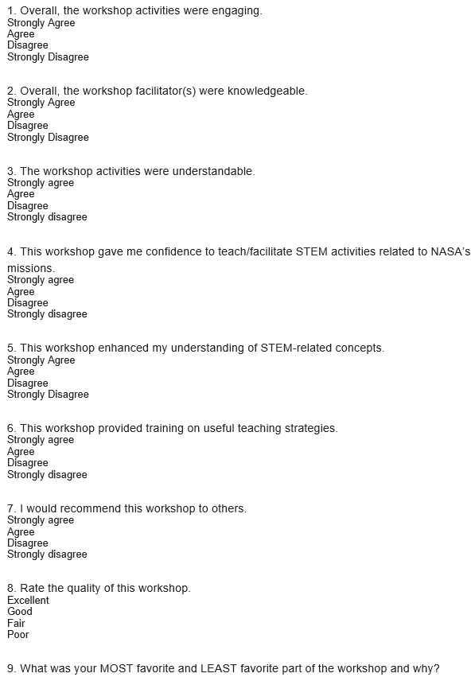

9. What was your MOST favorite part of the workshop and why?

10. What was your LEAST favorite part of the workshop and why?

