Table of Contents
EVALUATION SURVEYS 2
1. NASA Engineering Design Challenge (EDC) Passive Consent Notice – 21st Century Community Learning Centers 2
2. Welcome Page and Instructions 3
3. NASA Student Attitudes Towards STEM Survey - Survey Questions 4

EVALUATION SURVEYS
- NASA Engineering Design Challenge (EDC) Passive Consent Notice – 21st Century Community Learning Centers
Parent Consent Notice will be sent to parents of students to be surveyed
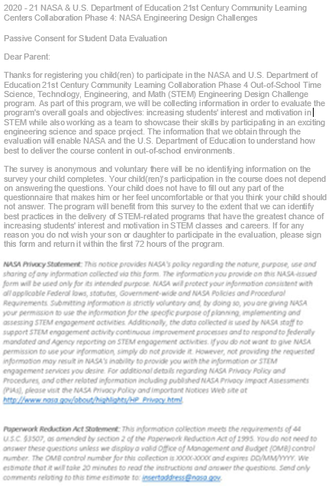

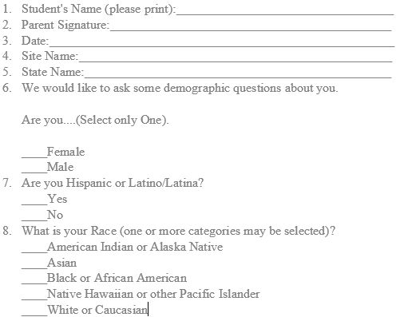

- Welcome Page and Instructions
1. Educators and Facilitators will be provided the welcome page and instructions
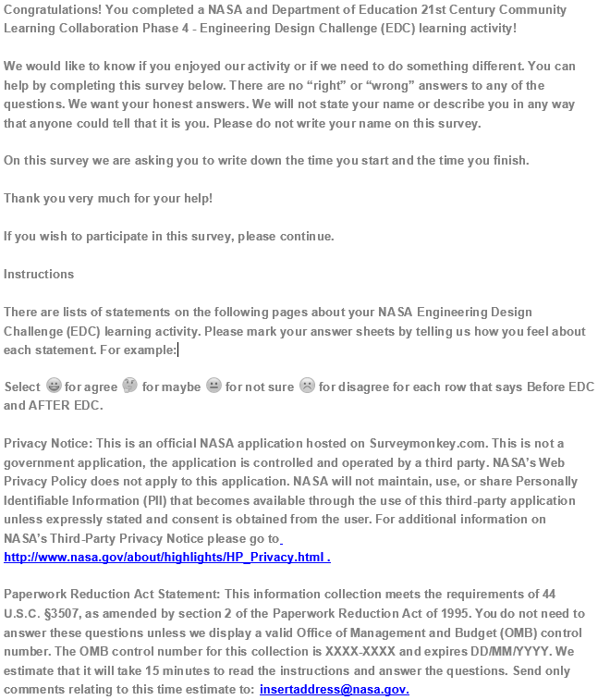

- NASA Student Attitudes Towards STEM Survey - Survey Questions
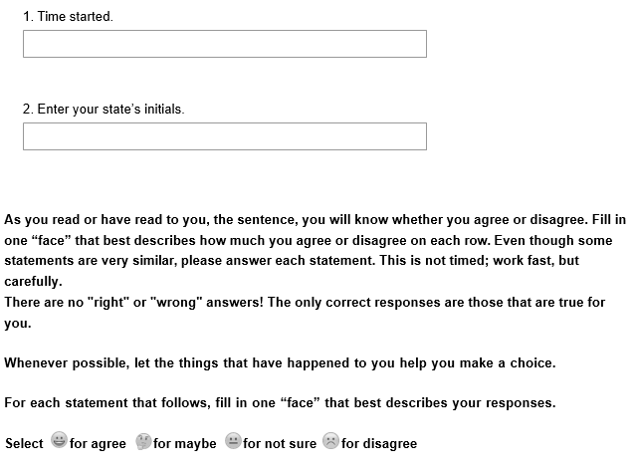

Student respondents will move to a series of questions related to Math
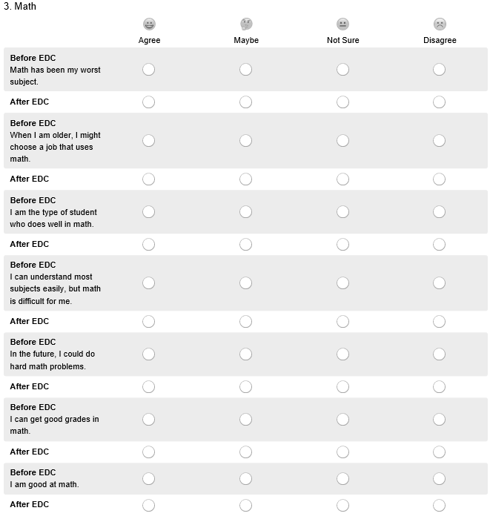

Student respondents will move to a series of questions related to Science
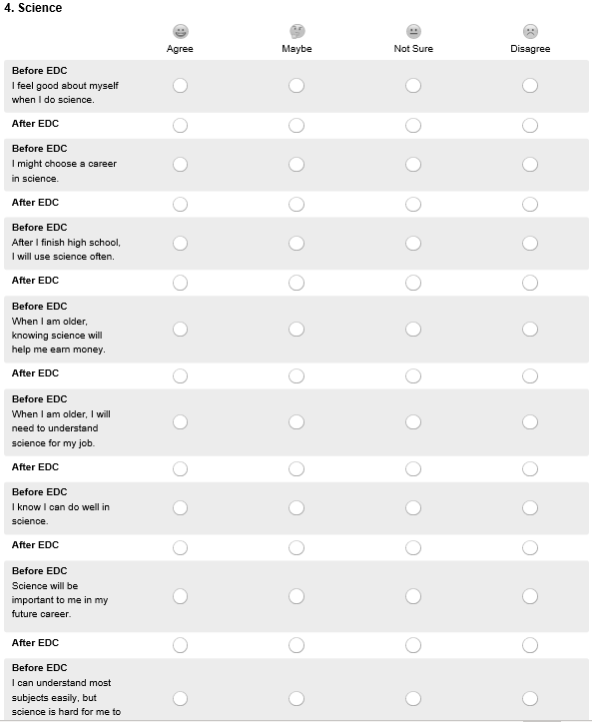
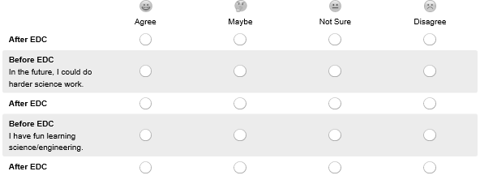

Student respondents will move to a series of questions related to Engineering and Technology

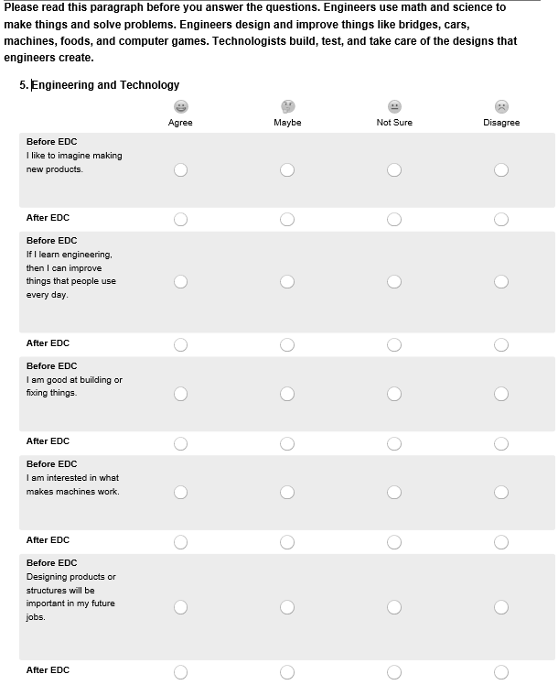
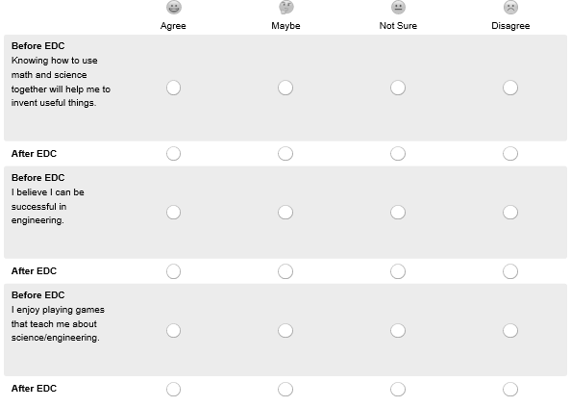

Student respondents will move to a series of questions related to 21st Century Learning

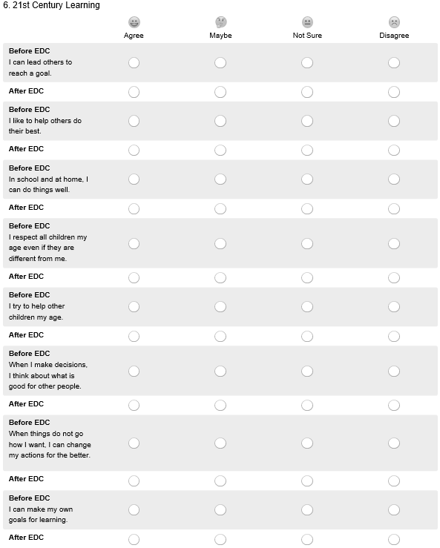
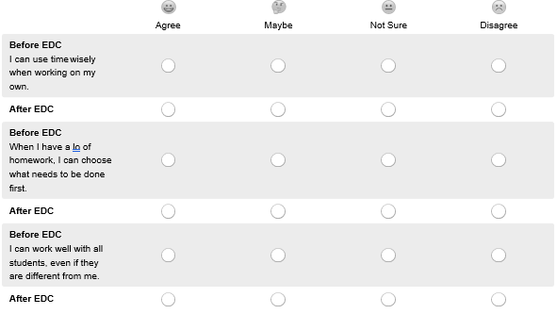

Student respondents will move to a series of questions related to themselves
