**Table of Contents**

EVALUATION SURVEYS 1

1. Welcome Page and Instructions 1

2. Educator Feedback Form (Post Implementation Survey) - Survey Questions 3

## EVALUATION SURVEYS

1. Welcome Page and Instructions

**1. Educators and Facilitators will be provided the welcome page and instructions**

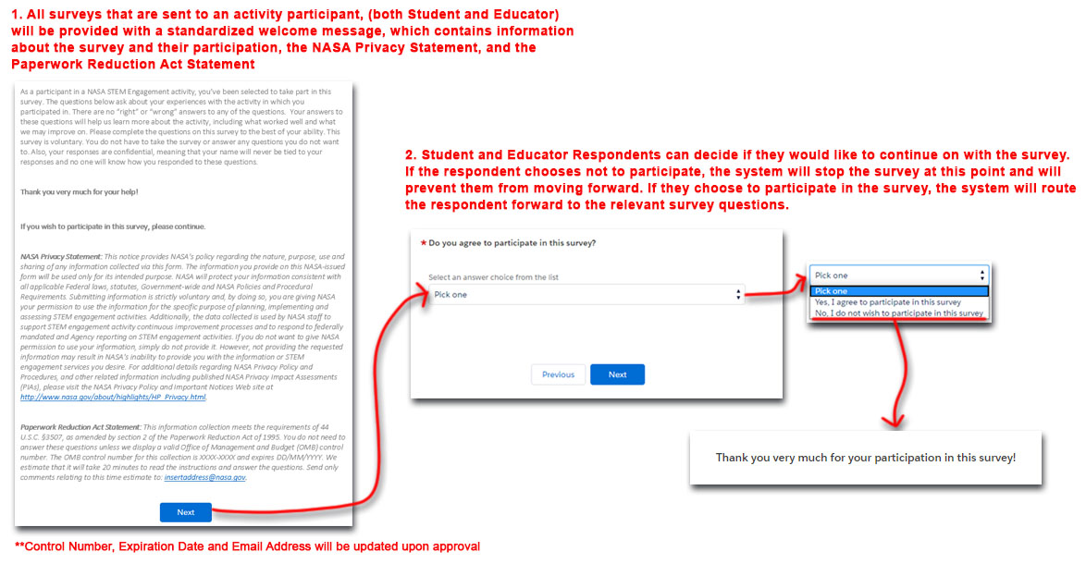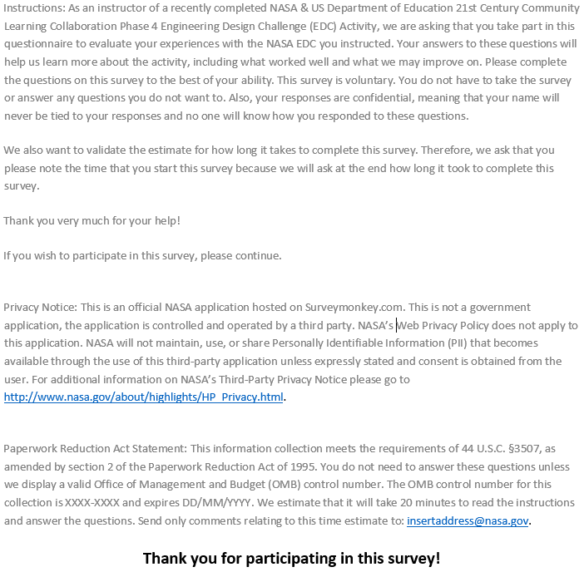



1. Educator Feedback Form (Post Implementation Survey) - Survey Questions