**Table of Contents**

EVALUATION SURVEYS 2

1. Welcome Page and Instructions 2

2. Pre-Training (Facilitator Confidence) Survey – Survey Questions 3

## EVALUATION SURVEYS

1. Welcome Page and Instructions

**1. Educators and Facilitators will be provided the welcome page and instructions**

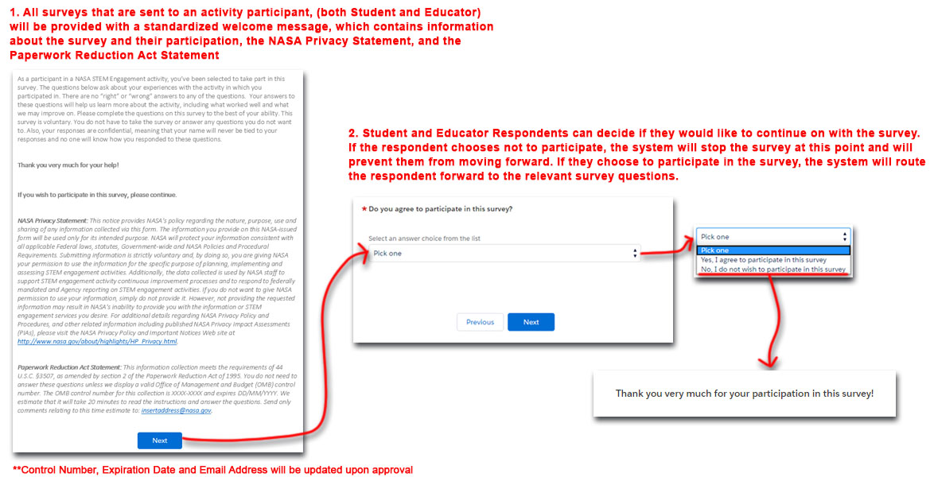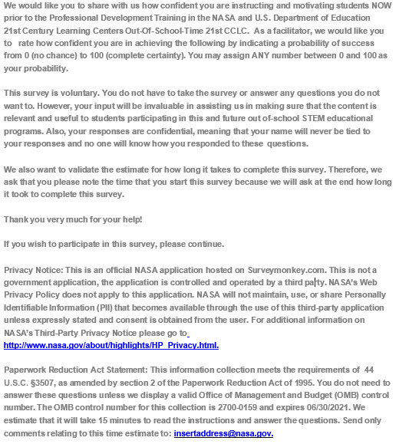



1. 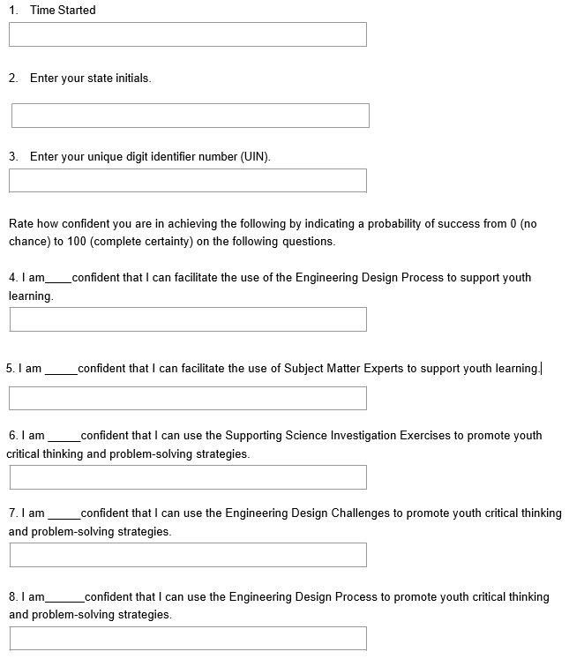Pre-Training (Facilitator Confidence) Survey – Survey Questions  
     
     
     
     
     
     
   