Table of Contents
EVALUATION SURVEYS 2
1. Welcome Page and Instructions 2
2. Post-Training Survey – Survey Questions 3

EVALUATION SURVEYS
- Welcome Page and Instructions
1. Educators and Facilitators will be provided the welcome page and instructions
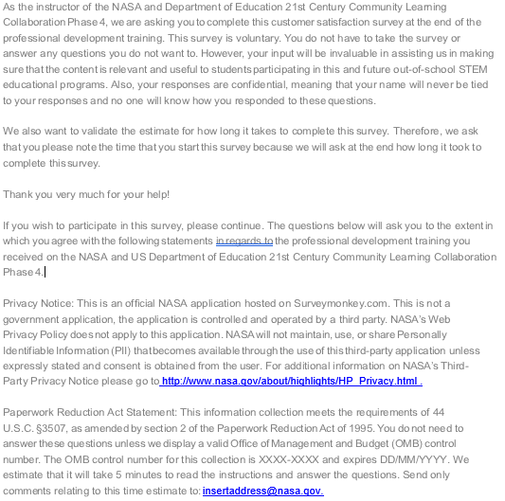

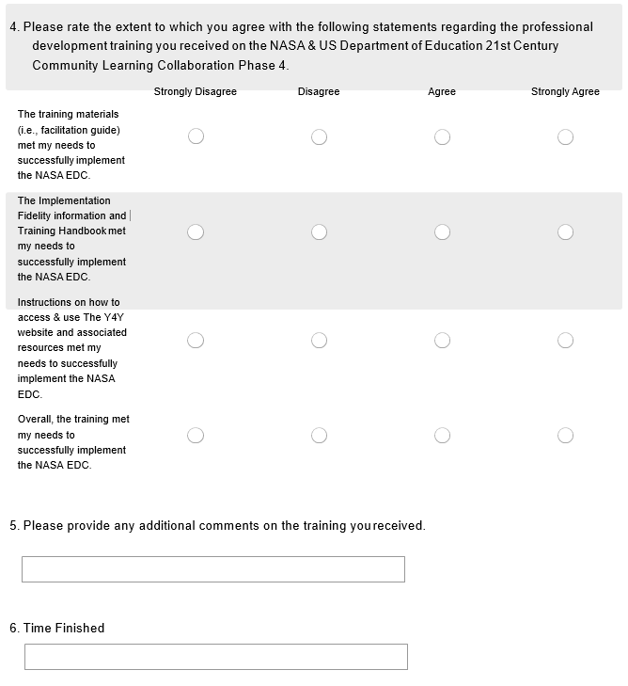
- Post-Training Survey – Survey Questions

