**Table of Contents**

EVALUATION SURVEYS 2

1. Welcome Page & Participation Decision – Parent Surveys 2

2. Parent Survey –Survey Questions 3

## EVALUATION SURVEYS

1. Welcome Page & Participation Decision – Parent Survey

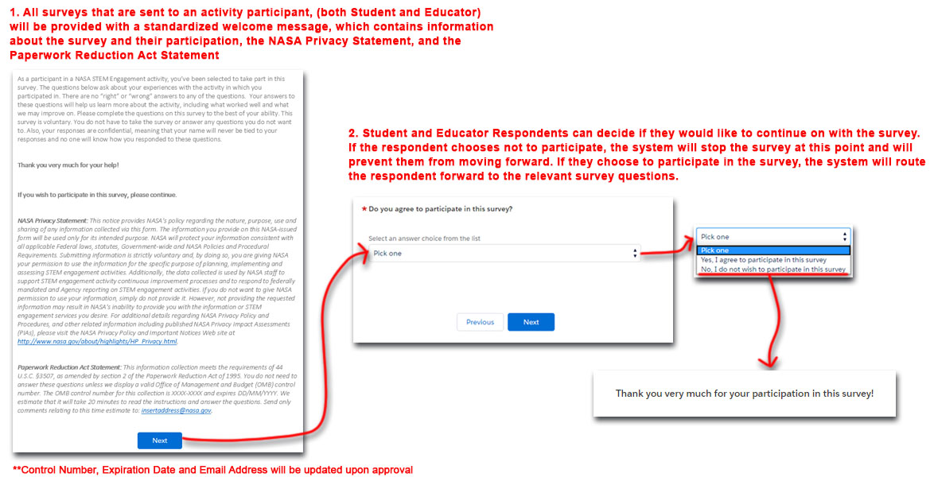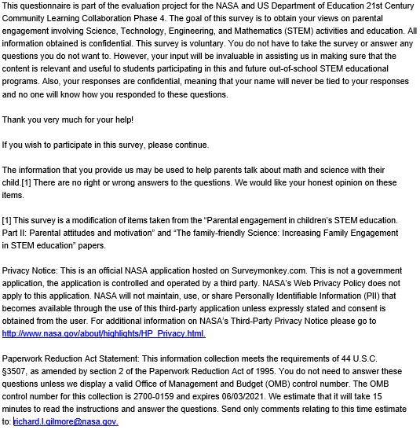

1. Parent Survey –Survey Questions  
   