Table of Contents
EVALUATION SURVEYS 2
1. Standard Welcome Page & Participation Decision – ALL Surveys 2
2. Student Participant Satisfaction Survey (Short Duration) – Survey Questions 3

EVALUATION SURVEYS
- Standard Welcome Page & Participation Decision – ALL Surveys
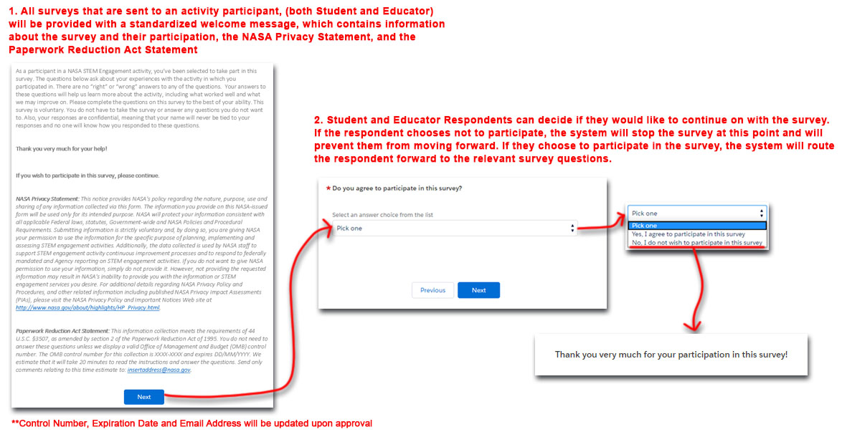
- Student Participant Satisfaction Survey (Short Duration) – Survey Questions
