December 21, 2020

Why am I getting this letter?

It’s time again to collect North Carolina agricultural water use data as described in legislation enacted in 2008, SL 2008-0143. Please complete the enclosed report form by January 11, 2021, via the Internet if possible, to avoid receiving follow-up contacts.

How will the data be used?

The information is used to document the water needs of farms during 2020, as well as accurately produce agricultural water use data for important decisions affecting you. We have previously conducted this survey eight times and have provided valuable water use data for the state. It has also put to rest many incorrect perceptions about agricultural water use. We need to again document your needs and provide the statewide water use estimates so the Commissioner of Agriculture and other farm organizations can protect agricultural interests as water policies are developed. Water management is still a major issue in North Carolina, and having good base line data for the year will be invaluable. .

The results of this survey will be kept confidential and will be available in aggregate form only. Your response is only used to compute state, county, and hydrologic area estimates, as well as document your farm’s water needs. The previous 2018 Water Use Survey results can be viewed on our web site at:
https://www.ncagr.gov/stats/environmental/WU2018.pdf

Thank you in advance for your support of our programs and North Carolina agriculture. If you have any questions or concerns, please do not hesitate to contact Karen Bryan at 919-707-3334 or Karen.Bryan@ncagr.gov.

Thank you,
What should I do next?
Complete your survey in one of
the following ways:
Online at agcounts.usda.gov beginning on December 21, 2020. Online reporting is fast, convenient, and secure. All you need is the 17-digit survey code on the enclosed form to begin.

By mail or fax. Complete the survey questionnaire and mail it back in the
return envelope provided or fax it to 855-270-2708.

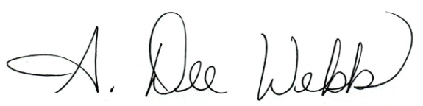
Dee Webb, Agricultural Statistics Division Director
North Carolina Department of Agriculture and Consumer Services

