OMB No.: 0915-0285. Expiration Date: XX/XX/20XX
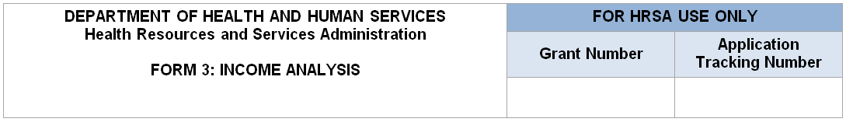
Note: The value in the Projected Income (d) column should equal the value in the Billable Visits (b) column multiplied by the value in the Income per Visit (c) column. If not, explain in the Comments/Explanatory Notes box. In the Prior FY Income (e) column, enter the income data from the health center’s most recent fiscal year audit or interim financial statement.
Part 1: Patient Service Revenue – Program Income
Payer Category | Patients by Primary Medical Insurance (a) | Billable Visits (b) | Income per Visit (c) | Projected Income (d) | Prior FY Income
- Medicaid
- Medicare
- Other Public
- Private
- Self Pay
- Total (Lines 1-5) | will auto-calculate in EHB | will auto-calculate in EHB | N/A | will auto-calculate in EHB | will auto-calculate in EHB
Part 2: Other Income – Other Federal, State, Local, and Other Income
- Other Federal | N/A | N/A | N/A
- State Government | N/A | N/A | N/A
- Local Government | N/A | N/A | N/A
- Private Grants/ Contracts | N/A | N/A | N/A
- Contributions | N/A | N/A | N/A
- Other | N/A | N/A | N/A
- Applicant (Retained Earnings) | N/A | N/A | N/A
- Total Other: (Lines 7-13) | N/A | N/A | N/A | will auto-calculate in EHB | will auto-calculate in EHB
Total Non-Federal (Non-Health Center Program) Income (Program Income Plus Other)
Payer Category | Patients by Primary Medical Insurance (a) | Billable Visits (b) | Income per Visit (c) | Projected Income (d) | Prior FY Income (e)
- Total Non-Federal (Lines 6+14) | N/A | N/A | N/A | will auto-calculate in EHB | will auto-calculate in EHB
Comments/Explanatory Notes (if applicable)
Public Burden Statement: Health centers (section 330 grant funded and Federally Qualified Health Center look-alikes) deliver comprehensive, high quality, cost-effective primary health care to patients regardless of their ability to pay. The Health Center Program application forms provide essential information to HRSA staff and objective review committee panels for application evaluation; funding recommendation and approval; designation; and monitoring. The OMB control number for this information collection is 0915-0285 and it is valid until XX/XX/XXXX. This information collection is mandatory under the Health Center Program authorized by section 330 of the Public Health Service (PHS) Act (42 U.S.C. 254b). Public reporting burden for this collection of information is estimated to average 1 hour per response, including the time for reviewing instructions, searching existing data sources, and completing and reviewing the collection of information. Send comments regarding this burden estimate or any other aspect of this collection of information, including suggestions for reducing this burden, to HRSA Reports Clearance Officer, 5600 Fishers Lane, Room 14N136B, Rockville, Maryland, 20857 or paperwork@hrsa.gov.

