OMB No.: 0915-0285. Expiration Date: X/XX/20XX
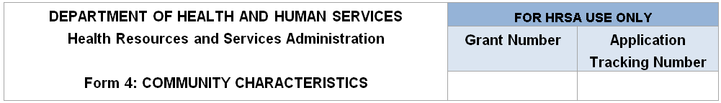
Note: Data on race and/or ethnicity collected on this form will not be used as an awarding factor.
Race and Ethnicity | Service Area Population | Service Area Population Percent | Target Population | Target Population Percent
Asian |  | will auto-calculate in EHB |  | will auto-calculate in EHB
Native Hawaiian |  | will auto-calculate in EHB |  | will auto-calculate in EHB
Other Pacific Islanders |  | will auto-calculate in EHB |  | will auto-calculate in EHB
Black/African American |  | will auto-calculate in EHB |  | will auto-calculate in EHB
American Indian/Alaska Native |  | will auto-calculate in EHB |  | will auto-calculate in EHB
White |  | will auto-calculate in EHB |  | will auto-calculate in EHB
More than One Race |  | will auto-calculate in EHB |  | will auto-calculate in EHB
Unreported/Declined to Report  (if applicable) |  | will auto-calculate in EHB |  | will auto-calculate in EHB
Total: | will auto-calculate in EHB | 100% | will auto-calculate in EHB | 100%

Hispanic or Latino Ethnicity | Service Area Population | Service Area Population Percent | Target Population | Target Population Percent
Hispanic or Latino |  | will auto-calculate in EHB |  | will auto-calculate in EHB
Non-Hispanic or Latino |  | will auto-calculate in EHB |  | will auto-calculate in EHB
Unreported/Declined to Report  (if applicable) |  | will auto-calculate in EHB |  | will auto-calculate in EHB
Total: | will auto-calculate in EHB | 100% | will auto-calculate in EHB | 100%

Income as a Percent of Poverty Level | Service Area Population | Service Area Population Percent | Target Population | Target Population Percent
Below 100% |  | will auto-calculate in EHB |  | will auto-calculate in EHB
100-199% |  | will auto-calculate in EHB |  | will auto-calculate in EHB
200% and Above |  | will auto-calculate in EHB |  | will auto-calculate in EHB
Unreported/Declined to Report (if applicable)
Total: | will auto-calculate in EHB | 100% | will auto-calculate in EHB | 100%

Principal Third Party Payment Source | Service Area Population | Service Area Population Percent | Target Population | Target Population Percent
Medicaid |  | will auto-calculate in EHB |  | will auto-calculate in EHB
Medicare |  | will auto-calculate in EHB |  | will auto-calculate in EHB
Other Public Insurance |  | will auto-calculate in EHB |  | will auto-calculate in EHB
Private Insurance |  | will auto-calculate in EHB |  | will auto-calculate in EHB
None/Uninsured |  | will auto-calculate in EHB |  | will auto-calculate in EHB
Total: | will auto-calculate in EHB | 100% | will auto-calculate in EHB | 100%

Special Populations and  Select Population Characteristics | Service Area Population | Service Area Population Percent | Target Population | Target Population Percent
Migratory/Seasonal Agricultural Workers and Families |  | will auto-calculate in EHB |  | will auto-calculate in EHB
People Experiencing Homelessness |  | will auto-calculate in EHB |  | will auto-calculate in EHB
Residents of Public Housing |  | will auto-calculate in EHB |  | will auto-calculate in EHB
School Age Children |  | will auto-calculate in EHB |  | will auto-calculate in EHB
Veterans |  | will auto-calculate in EHB |  | will auto-calculate in EHB
Lesbian, Gay, Bisexual, and Transgender |  | will auto-calculate in EHB |  | will auto-calculate in EHB
HIV/AIDS-Infected Persons |  | will auto-calculate in EHB |  | will auto-calculate in EHB
Individuals Best Served in a Language Other Than English |  | will auto-calculate in EHB |  | will auto-calculate in EHB
Other  Please Specify (maximum 200 Characters): ______________ |  | will auto-calculate in EHB |  | will auto-calculate in EHB

Public Burden Statement: Health centers (section 330 grant funded and Federally Qualified Health Center look-alikes) deliver comprehensive, high quality, cost-effective primary health care to patients regardless of their ability to pay. The Health Center Program application forms provide essential information to HRSA staff and objective review committee panels for application evaluation; funding recommendation and approval; designation; and monitoring. The OMB control number for this information collection is 0915-0285 and it is valid until XX/XX/XXXX. This information collection is mandatory under the Health Center Program authorized by section 330 of the Public Health Service (PHS) Act (42 U.S.C. 254b). Public reporting burden for this collection of information is estimated to average 1 hour per response, including the time for reviewing instructions, searching existing data sources, and completing and reviewing the collection of information. Send comments regarding this burden estimate or any other aspect of this collection of information, including suggestions for reducing this burden, to HRSA Reports Clearance Officer, 5600 Fishers Lane, Room 14N136B, Rockville, Maryland, 20857 or paperwork@hrsa.gov.

