OMB No.: 0915-0285. Expiration Date: XX/XX/20XX
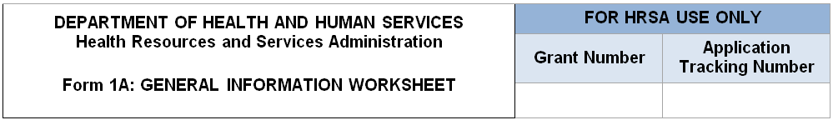

- Applicant Information
Applicant Name | Will pre-populate from the Grants.gov application forms
Fiscal Year End Date | Select from drop-down menu (e.g., January 31, March 31)
Application Type | Will pre-populate from the Grants.gov application forms
Grant Number | Will pre-populate from the Grants.gov application forms, if applicable
Business Entity  (Select one) | [_] Tribal  [_] Urban Indian  [_] Private, non-profit (non-Tribal or Urban Indian)  [_] Public (non-Tribal or Urban Indian)
Organization Type  (Select all that apply) | [_] All  [_] Faith based  [_] Hospital  [_] State government  [_] City/County/Local Government or Municipality  [_] University  [_] Community based organization  [_] Other - Specify: __________
- Proposed Service Area
Note: Applicants applying for Community Health Center (CHC) funding in Section A of the SF-424A: Budget Information form must serve at least one MUA or MUP. Provide the IDs for all MUAs and/or MUPs within the service area proposed in this application.
2a. Service Area Designation
Select MUA/MUP  (Each ID must be a 5 to 12 digits. Use commas to separate multiple IDs, without spaces.)  Find an MUA/MUP (http://muafind.hrsa.gov/) | [_] Medically Underserved Area (MUA): ID#____  [_] Medically Underserved Population (MUP): ID#____  [_] MUA Application Pending: ID#____  [_] MUP Application Pending: ID#____

2b. Service Area Type
Choose Service Area Type  You must select Urban or Rural. If you select Rural, Sparely Populated may also be selected, if applicable. | [_] Urban  [_] Rural  [_] Sparsely Populated - Specify population density by providing the number of people per square mile: ____________  (Provide a value ranging from 0.01 to 7.)

2c. Patients and Visits
Unduplicated Patients and Visits by Population Type
How many unduplicated patients are projected to be served by December 31, 2021? This projection is for calendar year 2021.)(

Refer to the Patient Target in the Service Area Announcement Table (SAAT) for the service area proposed in this application to ensure your total unduplicated patient projection meets eligibility requirements. The SAAT is available at the SAC/SAC-AA Technical Assistance web site.

Population Type | UDS/Baseline Value |  | Projected by December 31, 2021  (January 1 – December 31, 2021)
 | Patients | Visits | Patients | Visits
Total |  |  | Pre-populated from above
General Underserved Community
(Includes all patients/visits not reported in the rows below.)
Migratory and Seasonal Agricultural Workers and Families
Public Housing Residents
People Experiencing Homelessness
Patients and Visits by Service Type
Service Type | UDS/Baseline Value |  | Projected by December 31, 2021  (January 1 – December 31, 2021)
 | Patients | Visits | Patients | Visits
Total Medical Services
Total Dental Services
Behavioral Health Services
Total Mental Health Services
Total Substance U Disorder se
Services
Total Vision Services
Total Enabling Services

Public Burden Statement: Health centers (section 330 grant funded and Federally Qualified Health Center look-alikes) deliver comprehensive, high quality, cost-effective primary health care to patients regardless of their ability to pay. . paperwork@hrsa.gov per response, including the time for reviewing instructions, searching existing data sources, and completing and reviewing the collection of information. Send comments regarding this burden estimate or any other aspect of this collection of information, including suggestions for reducing this burden, to HRSA Reports Clearance Officer, 5600 Fishers Lane, Room 14N136B, Rockville, Maryland, 20857 or is estimated to average 1 hour). Public reporting burden for this collection of information42 U.S.C. 254bThe OMB control number for this information collection is 0915-0285 and it is valid until XX/XX/XXXX. This information collection is mandatory under the Health Center Program authorized by section 330 of the Public Health Service (PHS) Act ( for application evaluation; funding recommendation and approval; designation; and monitoring. objective review committee panelsThe Health Center Program application forms provide essential information to HRSA staff and

